

A Maturity Model to Assess Organization’s Readiness to Adopt a Sustainable Business Model

نموذج النضج لتقييم جاهزية المنظمة لاعتماد نموذج عمل مستدام

by
MOHAMED ALY AWWAD

Dissertation submitted in fulfilment
of the requirements for the degree of
MSc ENGINEERING MANAGEMENT
at
The British University in Dubai

March 2021
DECLARATION

I warrant that the content of this research is the direct result of my own work and that any use made in it of published or unpublished copyright material falls within the limits permitted by international copyright conventions.
I understand that a copy of my research will be deposited in the University Library for permanent retention.
I hereby agree that the material mentioned above for which I am author and copyright holder may be copied and distributed by The British University in Dubai for the purposes of research, private study or education and that The British University in Dubai may recover from purchasers the costs incurred in such copying and distribution, where appropriate.
I understand that The British University in Dubai may make a digital copy available in the institutional repository.
I understand that I may apply to the University to retain the right to withhold or to restrict access to my thesis for a period which shall not normally exceed four calendar years from the congregation at which the degree is conferred, the length of the period to be specified in the application, together with the precise reasons for making that application.

_______________________
Signature of the student

COPYRIGHT AND INFORMATION TO USERS
The author whose copyright is declared on the title page of the work has granted to the British University in Dubai the right to lend his/her research work to users of its library and to make partial or single copies for educational and research use.

The author has also granted permission to the University to keep or make a digital copy for similar use and for the purpose of preservation of the work digitally.

Multiple copying of this work for scholarly purposes may be granted by either the author, the Registrar or the Dean only.

Copying for financial gain shall only be allowed with the author’s express permission.

Any use of this work in whole or in part shall respect the moral rights of the author to be acknowledged and to reflect in good faith and without detriment the meaning of the content, and the original authorship.

ABSTRACT
Organizations’ Business Model (BM) plays a significant role in the world’s economy, society, and environment. Transforming from the classic BM into a Sustainable Business Model has become an accountable choice for organizations to strive and survive in the overpopulated world with scarce resource challenges. However, organizations need to identify the readiness prerequisites Critical Success Factors (CSFs) for the transition to ensure a successful transformation. In this research a Maturity Model (MM) will be developed based on literature review and outcomes from the research conducted with a panel of academics and practitioners’ experts The Delphi technique was employed to nominate the Critical Success Factors (CSFs) from the proposed Internal Organization Capabilities (IOC) with the experts.
The final model has been implemented on a UAE for-profit organization for validation and market feedback. The findings validated the proposed MM and suggested that it can be used as decision a making tool to guide the organization's strategy. The proposed MM also has descriptive, prescriptive, and comparative functions which can be enhanced as the model application expands. The research helps companies that already committed to sustainability to verify whether they are consistent in the implementation of a distinct sustainability strategy.

الملخص
يلعب نموذج الأعمال (BM) المتبع لدى المؤسسات دورًا مهمًا في اقتصاد العالم ، والمجتمع ، والبيئة. أصبح التحول من نموذج الأعمال الكلاسيكي إلى نموذج أعمال مستدام خيارًا يمكن أن يعتمد عليه بالنسبة للمؤسسات التى تسعى للبقاء في العالم المكتظ بالسكان مع تحديات الموارد النادرة. ومع ذلك ، تحتاج المنظمات إلى تحديد متطلبات الجاهزية و عوامل النجاح الحاسمة بهدف ضمان التحول الناجح. في هذا البحث سيتم تطوير" نموذج النضج" استنادًا إلى مراجعة الأدبيات ونتائج البحث الذي تم إجراؤه مع لجنة من الأكاديميين وخبراء الممارسين. تم استخدام تقنية "دلفي" لترشيح عوامل النجاح الحاسمة من خلال قدرات المنظمة الداخلية المقترحة مع الخبراء.وفقا لذلك تم تنفيذ النموذج النهائي على مؤسسة إماراتية ربحية للتحقق من صحة المعلومات وتعليقات السوق. أثبتت النتائج صحة أداة المشاركة المقترحة واقترحت أنه يمكن استخدامها كأداة لاتخاذ القرار لتوجيه استراتيجية المنظمة. يحتوي نموذج الأعمال(MM) المقترح أيضًا على وظائف وصفية وتعليمية ومقارنة يمكن تحسينها مع توسع تطبيق النموذج. يساعد البحث الشركات التي التزمت بالفعل بالاستدامة على التحقق مما إذا كانت متسقة في تنفيذ استراتيجية الاستدامة المتميزة.

Table of Contents
CHAPTER 1: INTRODUCTION 1
1.1 Research Background 1
1.2 Research Problem 2
1.3 Research Questions 2
1.4 Objectives 2
1.5 Relevance and Importance of The Research Issue 3
1.6 Research Contribution 4
1.7 Structure of The Dissertation 4
CHAPTER 2: LITERATURE REVIEW 6
2.1 Background 6
2.1.1 The necessity of global sustainability 6
2.1.2 Sustainability perspectives (definitions, approaches and history) 7
2.1.3 Fundamental generic approaches and frameworks 8
2.1.4 Principles, and sustainability goals 10
2.2 From CSR To SBM - Principles, And Practice 13
2.2.1 CSR debate 13
2.2.2 Business model (BM) 17
2.2.3 Sustainability business model (SBM) 20
2.2.4 Conceptual approach to identify the SBM characteristics 24
2.3 Business Case Of Sustainability 27
2.3.1 Organisational transformation into SBM 27
2.3.2 Sustainability can be a (win-win) alternative to corporates 32
2.3.3 Sustainability drivers 35
2.4 BM Role in Realizing Organisations Sustainability Goals 37
2.4.1 Business models vs. Business function 37
2.4.2 SBM role in realizing Enterprise Excellence” 38
2.4.3 The Role of BM in Sustainability Transitions 38
2.5 Developing New Dynamic Capabilities 40
2.6 The Need for Organization Readiness Assessment 41
2.7 Maturity Model For Sustainability Assessment 43
2.7.1 Maturity Model as an assessment tool 43
2.7.2 Review of maturity models for sustainability in literature 47
2.7.3 Corporate sustainability strategies 48
2.7.4 Review of the professional MM, maturity levels for sustainability in the literature 53
CHAPTER 3: RESEARCH METHODOLOGY 56
3.1 Scope 56
3.2 Design (Architecture) 58
3.2.1 Domain layers 60
3.2.2 Maturity Levels 62
3.3 Populate (CSFs selection) 62
3.3.1 Rating and weightage of the model components 63
3.4 Test (Evaluation) 66
3.4.1 Assessment Survey 67
3.5 Deploy – Case Study 69
3.5.1 Conducting the assessment 69
3.6 Maintain 70
CHAPTER 4: MODEL DEVELOPMENT 72
4.1 Scope 72
4.2 Design (Model Architecture) 73
4.2.1 Maturity Layers 74
4.2.2 Maturity Levels Definition 77
4.3 Populate (IOCs selection) 78
4.3.1 Rating and weightage of the model components 78
4.3.2 Final Maturity Model IOCs (definitions) 90
4.3.3 Scoring Sheet Sample 103
4.4 Testing (Model Evaluation) 112
4.4.1 Evaluation results 112
4.4.2 Experts’ feedback 114
4.5 Model Deployment – case study 115
4.5.1 Conducting the assessment 115
4.6 Maintenance 117
CHAPTER 5: IMPLEMENTATION OF THE PROPOSED MATURITY MODEL (Case study) 118
5.1 Implementation Of The Final MM – 118
5.1.1 About the company 118
5.2 The Assessment 118
5.2.1 Assessment results and observations 122
5.2.2 Proactive maturity assessment analysis 123
5.2.3 Company feedback on the proposed model importance and implementation 124
CHAPTER 6: CONCLUSION, RECOMMENDATIONS, AND SUGGESTIONS FOR FUTURE RESEARCH 125
6.1 Conclusion 125
6.2 Recommendations 129
6.3 Limitations 129
6.4 Suggestions for Future Research 130
CHAPTER 7: REFERENCES 132
CHAPTER 8: APPENDICES 141
8.1 Survey Questionnaire 141
8.2 Interview Questions 141

List of Tables
Table ‎3.1 MM Scoping choices 57
Table ‎3.2 Major Design Phase Decisions 58
Table ‎3.3: Likert Evaluation form 64
Table ‎3.4 Sample results of weight allocation step 65
Table ‎3.5 Model Evaluation Template 68
Table ‎4.1 Maturity Model Scoping phase outcomes 73
Table ‎4.2 Maturity Model Design Decisions 73
Table ‎4.3 Maturity Level Definitions 77
Table ‎4.4: The proposed sub domain components (List A) 79
Table ‎4.5: Round 1 shortlisting Average results 81
Table ‎4.6 The final nominated IOC – List C – Cultural attributes 84
Table ‎4.7 The final nominated IOC – List C – Structural attributes 85
Table ‎4.8 Cultural Maturity Average results of Weight Allocation 86
Table ‎4.9 Structural Characteristics Average results of Weight Allocation 88
Table ‎4.10 Definitions of the Mindset subdomain components 91
Table ‎4.11 Maturity Levels for Mindset 92
Table ‎4.12 Definition of Stakeholder Management subdomain component 93
Table ‎4.13 Maturity Levels for Stakeholder Management 93
Table ‎4.14 Value Creation components definitions 95
Table ‎4.15 Value Creation components maturity levels definitions 95
Table ‎4.16 Stakeholders Management components 96
Table ‎4.17 Maturity Levels for Stakeholder Management 97
Table ‎4.18 Performance management and reporting components 98
Table ‎4.19 Maturity Levels for Performance Management 99
Table ‎4.20 Operations components 100
Table ‎4.21 Maturity Levels for Operation 100
Table ‎4.22 Innovation components 101
Table ‎4.23 Maturity Levels for Technology/ Innovation 101
Table ‎4.24 Supply Chain components 102
Table ‎4.25 Maturity Levels for Supply Chain Management 103
Table ‎4.26 Assessment score sheet template 104
Table ‎4.27 The score sheet columns definitions 107
Table ‎4.28 Cultural Maturity Subdomain Score 110
Table ‎4.29 Score Summary Block 111
Table ‎4.30 Model Evaluation Results 113
Table ‎5.1 Organization sub domain Maturity examples 119
Table ‎5.2 Assessment Score Sheet 120
Table ‎5.3 Summary of the assessment 123

List of Figures

Figure ‎1.1 The Structure of the study 5
Figure ‎2.1 Sustainable and circular business models 9
Figure ‎2.2 The house of sustainability 12
Figure ‎2.3 Business Model Canvas 19
Figure ‎2.4 Business Model in practice 19
Figure ‎2.5 SBM characteristics 26
Figure ‎2.6 The need for organisation readiness assessment 41
Figure ‎2.7 The 4 stages of growth 45
Figure ‎2.8 The 5 levels of software process maturity 46
Figure ‎2.9 Creation of Value in the sustainability network 50
Figure ‎2.10 Evolution of a PMS along six dimensions” 51
Figure ‎2.11 Transition levels for areas of decisions and oriented performance 52
Figure ‎2.12 “The five levels of the capability maturity model 55
Figure ‎3.1 Model Development Phases 56
Figure ‎3.2 Example of Maturity Model Layers 61
Figure ‎4.1 Dimensions of the SBM 75
Figure ‎4.2 Maturity Model Layers 76
Figure ‎4.3 Cultural Internal Oraganization Capabilities 84
Figure ‎4.4 Structural Internal Oraganization Capabilities 86

List of Abbreviations
BM | Business Model
SBM | Sustainability Business Model
SMM | Sustainability maturity models
CS | Corporate Stability
ODC | Organisation Dynamic Capabilities
IOC | Internal Organisation Capabilities
MM | Maturity Model
DSP | The Dominant Socio-economic Paradigm
CSR | Corporate Social Responsibility
CSFs | Critical Success Factors
BM | British Petroleum
SEI | Software Engineering Institute
UAE | United Arab Emirates
CMM | Capability Maturity Models
CMMI | Capability Maturity Model Integration
OECD | Organization for Economic Cooperation and Development
GE | General Elections
UN | United Nation
WCED | World Commission on Environment and Development
UNCED | United Nation Conference on Environment and Development
NGO | Non-Governmental Organisation
SDG | Sustainable Development Goals
EFQM | European Foundation for Quality Management
SWOT | Strengths, Weaknesses, Opportunities and Threats
BACCM | The Business Analysis Core Concept Model
PMS | Performance Measurement Systems
HBS | Harvard Business School

INTRODUCTION

Research Background
Transforming the traditional Business Model (BM) into Sustainable Business Model (SBM) may appear as an imperative strategic choice for organizations to survive and strive due two main reasons. organizations are a main influencer in the dynamic world’s economy, sociality and environment and they are unescapably accountable for the global challenges such as scares resources and ecological degradation as outlined by (Aagaard, 2019). In addition, the traditional approach of conducting business as usual can neither be reliable nor can it be sustainable in the contemporary challenging conditions of scarce resources and increasing population (Aagaard, 2019).
Nonetheless, proactive organizations that believe in sustainability-based solutions are recommended to carry out the BM transition in a professional way accounting for the involved risks in such process in order to realize a successful transformation into an SBM. That being established, this research is trying to contribute to this subject through providing an assessment that would help organizations to assess their readiness to embark on such a transition plan. The assessment fills the gap in this topic by introducing a new Maturity Model framework to evaluate the Critical Success Factors (CSFs) that are relevant to this particular maturity subject.
This research focuses on developing a maturity model for the engineering industry in the UAE and demonstrate how this model can assess the readiness of the industry to adopt a sustainable business model. The research outlines the companies that are already committed to a sustainable business model and how these companies can adopt a sustainable business model in the future. Furthermore, the role of internal capabilities of organizations in adopting a Sustainable Business Model (SBM) are considered with respect to the UAE engineering industry

Research Problem
Business as usual cannot be the way forward for organizations to survive and strive in world’s current challenges. Proactive organizations understand the importance of the sustainability concept and embrace the sustainability principles in conducting business through transforming their business model into a SBM. However, the adoption of a sustainable business model (SBM) is a challenge that should undergo some risk assessment. Such assessment would help organizations to avoid embarking in such a transition before ensuring the relevant prerequisites are available. Hence, organizations need to assess their readiness level before they delve into such transition. Despite the expanded literature research in sustainability and business excellence topics, there are no dedicated assessment model that addresses the transition from the traditional BM into a SBM.

Research Questions
The research questions of this research are:
- What are the critical/ important internal organizational capabilities that contribute to a successful Sustainable Business Model (SBM) adoption/ transition?
- What are the relevant levels that can define the maturity of each organization capability?
- How the proposed assessment model can be implemented?

Objectives
Research objectives presumed for this study includes;
- To review the related literature and identify the most important Critical Success Factors (CSFs) (or the Internal Organizational Capabilities) that contribute to a successful SBM adoption/ transition
- To identify the relevant levels that can define the maturity of an organization capability
- To develop an assessment model that can be implemented on the engineering industry of UAE.
- To develop a maturity model (MM) for sustainable business model readiness assessment and test its functionality with a real case study.
- On the basis of the results, a roadmap for enhancing organization transition towards SBM is proposed.

Relevance and Importance of The Research Issue
The purpose of this research aims to develop a maturity model to assess organization readiness to adopt and implement a sustainable business model that allows manufacturing and service companies in the UAE industry market to contribute to sustainable development on the long run.
The organizational readiness assessment aims to provide answers for the two fundamental questions such as:
- What is the current maturity level of the organization’s dynamic capabilities that qualify the organization to adopt a sustainable business model (SBM) and initiate transition?
- What is the necessary development course of action to be undertaken before embarking on a sustainable business model (SBM) adoption phase?
The assessment model is developed based on CSFs nominations which have been taken from the relevant organization Dynamic Capabilities in the literature and integrate the final nominated capabilities into a maturity model frame work.
A failure to assess organizational readiness might lead to a significant loss of time and energy of managers dealing with resistance to adopt a SBM.

Research Contribution
This dissertation aims to contribute to theory and practice in the following manner;
- First, gathering of the already existing and acknowledged scientific concepts, such as strategic management, sustainable development and maturity models, and adapt them to the new problem context, i.e., business transformation towards Sustainable business model.
- Second, provide organizations with decision-support tool, besides structuring their field of action, aligns decisions regarding the transformation towards Sustainable business model with the paradigm of value-based management.

Structure of The Dissertation
The overall structure of the dissertation is shown in Figure 1.1, where desk research and literature review are presented in chapter two. Chapter 2 displays previous literature on Sustainable Business Model relevant topics such as sustainability and continuous improvement, Business Model, Organization Dynamic Capabilities and Maturity Model.
Chapter 3 explains the methodology that is adopted to develop the assessment maturity model. Chapter 4 demonstrates the implementation of the methodology in the light of empirical research findings for the critical success factors that contribute to successful sustainable business model transition. The final developed Maturity Model is presented in chapter 4 in addition to the assessment conduction steps. Chapter 5 includes a case study on a real model application with a UAE engineering organization. Finally, the results and findings are discussed in chapter 6 with the recommendations and conclusion.

Chapter 2
Stage 1: Desk Research/ Literature review
Sustainable business model framework
Maturity model
continuous improvement
Oragnization Dynamic Capabilities

Chapter 3: Methodology of Maturity Model development

Chapter 4:
Stage 2: Empirical Research
Model Development
Conceptual model
Survey/ Interview
Identifying CSF
Assessment Scoring

Chapter 5: Application (Case study based on the final maturity model revision and development
Analysis of results)

Chapter 6: Conclusion, recommendation and conclusion
Figure 1.1 The Structure of the study

LITERATURE REVIEW

Background

The necessity of global sustainability
The business as usual has become an obsolete strategy for organisations' survival given the rapid global growth due to the current increasing global population which consequently demands more resources (i.e., materials, energy, and land) coupled with more ecological impact (Bocken et al., 2014).
Furthermore, in 2012, different industrial activities have consumed about 1/3 of times resources on the planet to run their activities (WWF, 2012). This global forecast was described by the former World Wildlife Fund Deputy Director-General as an “unsustainable rate” regardless of the present consumption (Randers, 2012).
Business perception about the conservation of free natural capital has not practically changed despite the existing awareness of the importance of natural resources and environmental systems (Bocken et al., 2014). They rather recommended a "holistic approach" as the prospective requirement to confront sustainability issues. In other words, environmental, and social challenges should be tackled along with conventional economic challenges.
Moreover, considering the past literature so many authors discussed the core principles and values of prompting enterprise sustainability that include social and environmental responsibility as an important criterion and included them in their documentations and websites that are linked with UN Global Compact, the UN Principles of Responsible Management Education, the Global Reporting Initiative, the UN Agenda 2030 Sustainable Development Goals, Business Actions for Sustainable Development, the International Chamber of Commerce, the Organisation for Economic Cooperation and Development, and the World Business Council on Sustainable Development (Aagaard, 2019).

Sustainability perspectives (definitions, approaches and history)
The terms "sustainability" and "sustainable development" were coined in the early seventies due to rapid changes in the global population and a shortage of natural resources, as well as increased consumption rates (Poveda, 2017). Poveda (2017) noted that sustainability issues were raised at the 1972 UN Conference on Poverty Reduction and Balance. Thus, he stated in the literature that the sustainability idea of the uprising is not a modern one, but it was developed since the very beginning of human history. He had also assumed that the origin of these words has always been controversial in the literature.
The accepted definition of sustainability goes back to the World Commission on Environment and Development (WCED) (1987) as "Development meets current needs without compromising the ability of future generations to meet their needs" (Aagaard, 2019; Poveda, 2017; Stubbs Kohlin, 2008). On the other hand, (Poveda, 2017) described considering this report as a "transformation" in politics, economics, science, academic, and government fields. Furthermore, the author noted that the WCED report indicated two important messages; The "needs" as the basic needs of the world's poor and the "barriers" to the system's ability to meet these needs in the short and long term. Furthermore, a study conducted by (Stubbs and Cocklin, 2008) emphasised that the triple bottom lines’ view of the sustainable development between environment, society, and economy in terms of resources (energy, materials, waste and land) constrain; a fair share of the natural assets; equity over generations; and transformational of economical and societal advancement (Poveda, 2017). Society, economy and sustainability includes three pillars of security such as
- “Independency
- Inter-relation/inter-connection
- Equality”
Based on these characteristics, the definition of sustainable development has been developed as a way to find a balance between community, economy and environment. Based on a series of reports that include the Rio Summit (UNCED, 1992), Mitchell, May, and MacDonald (1995) showed 4 principles, emphasising that sustainability implementation is beyond environmental factors. The principles that were suggested include justice, the future, the environment and public participation (Poveda, 2017).

Fundamental generic approaches and frameworks
Scholars and researchers have taken a variety of approaches to promote sustainable development principles, especially those related to environmental issues, including (Poveda, 2017):
- “The use of energy
- Pollution of various resources (soil, water and land)
- Protect plants and animals
- Historical preservation of artifacts”
Other frameworks have also emerged and gained momentum; among others as shown in figure 2.1
- “the steady-state economy
- circular economy, which has been refined and developed by the following schools of thought
  - cradle to cradle (C2C)
  - natural capitalism
  - performance economy
  - bio -mimicry
  - blue economy
  - regenerative design
  - industrial ecology”
Furthermore, figure 2.1 shows the approach, which deals with changing the BM to adapt to new impositions of environmental, legislative, economic and social issues to inherent sustainability. Thus, companies aim to innovate the BM to adapt to new needs and work on an SBM that can take into account the concept of the triple model bottom line and can manage to deal with it. Thus, calling it an 'innovation of SBM. The analysis demonstrated that due to the effect of this innovative change, companies need to generate shared value, for all entities that are involved at different social, environmental and economic levels.
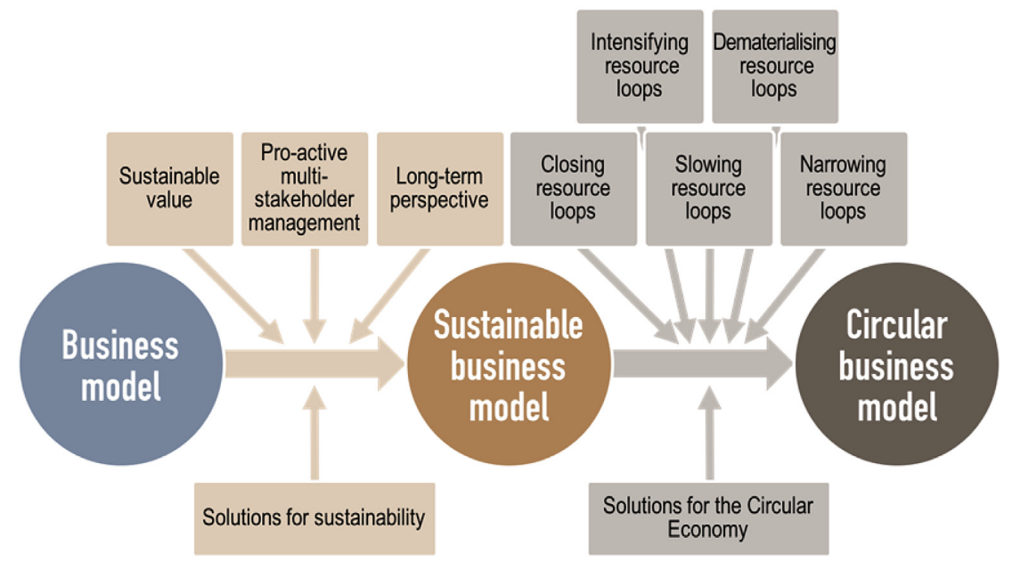
Figure 2.1 Sustainable and circular business models
(Geissdoerfer, Vladimirova and Evans, 2018)”

Another approach known as the circular economy is related to a concept which seeks to overcome the model of production and consumption, and which adopts a standard of production that is closed within an economic system, aiming to increase the efficiency for the use of resources focusing mainly on urban and industrial waste, also bringing the remanufacturing of products as an environmental and sustainable approach, and thereby enabling the transformation of waste into useful resources as per figure 2.1. “Promoting the maximum reuse of materials, goods and components aims to reduce the generation of waste to the greatest extent possible as shown in figure 2.1. (Lee et al., 2019).That figure showed that the” Circular Economy” and “Sustainability” are gaining more and more strength in the engineering industry and among policymakers, as it implies the adoption of cleaner production standards at the company level, an increase in responsibility and awareness of producers and consumers, the use of technologies and renewable materials (whenever possible) and the adoption of appropriate policies and tools that can be seen as a preventive approach to environmental issues (Alefari et al., 2020).

Principles, and sustainability goals
The efforts for sustainability from the side of individual entities such as private enterprises serve as a motivator in the aim of building a sustainable environment figure 2.2. For the purpose of attaining sustainability and implementing it in the culture of the organization, some guiding principles need to be adopted which are developed by the UN Global Compact UNGC.
The UN Global Compact includes 10 principles for adopting sustainable businesses practices in such a way that business should respect the human rights, avoid corruption, respects freedom and environment
UNs Sustainable Development Goals for agenda 2030: Furthermore, the Sustainable Development Goals (SDGs), also known as the Global Goals, were adopted by the UN in 2015 as a way to call for poverty, national security, peace and prosperity by 2030. The 17 SDGs combined, that recognizes that actions in one place affect the outcome in other places and that development must reconcile social, economic and social stability. UN SDG Brief description showed these development goals that include “no poverty, good health and well-being, quality education, gender equality, clean water and sanitation affordable and clean energy, energy for all, decent work ,economic growth, productive employment, decent work for all, industry, innovation, infrastructure reduce inequalities, sustainable cities and communities, responsible consumption and production, climate action, life below water, life on land, peace and justice, strong institutions partnerships for the goals”. Therefore, through “the pledge to Leave No One Behind”, countries have committed to fast-track progress for those furthest behind first. Thus, these goals are very much important for all the countries of the UN to be adopted while designing and adopting technology advancement and utilizing public financial resources to promote sustainable development in the environment (Aagaard, 2019).
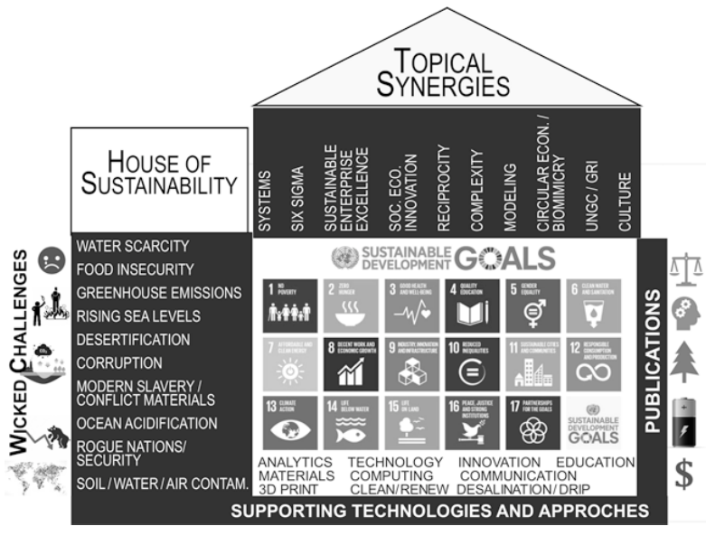
Figure 2.2 The house of sustainability
Source: (Aagaard, 2019)”

While many businesses define certain practices based on their history or competitive environment, others can be adopted by different organizations (Aagaard, 2019). Among the most common principles of social and regional development are the Ten Commandments of the UN Global Compact or the UN Global Compact. The UNGC voluntary plan is in line with the chief executive officer commitments commitment to meet the principles of promoting and taking steps to support the goals of the UN, including the 17 UN SDGs. The UN Director-General has about 16 principles. These principles are adopted by about 10,000 businesses among them the largest organization is included such as “Royal Dutch Shell plc, Microsoft, Intel, Rio Tinto plc, General Motors Company, Volvo, ABB Ltd., are unique. Nokia products, including Nokia Gamesa Renewable Energy, General Electric, Anheuser-Busch, Renault, Tesco plc, Arla Foods amba and LEGO”.

From CSR To SBM - Principles, And Practice
This section discusses the Corporate Social Responsibility (CSR) to Sustainable Business Model (SBM) and its principles, promises and practices that companies need to adopt in there CSR strategies for future sustainability. The (CSR) concept has been described as an organized business activity to support world sustainability. Moreover, basic principles are fundamental rules that govern the behaviors of socially responsible organizations that are planning or already have an SBM implementation in its culture and structure.

CSR debate
The Corporate Social Responsibility (CSR) concept has been always a controversial topic among academics and corporate personnel. (Brown, Bocken and Balkenende, 2018) described it as organized business activities to support world sustainability. In CSR most basic terms, (Brown, Bocken and Balkenende, 2018) look into whether businesses are supposed to consider social responsibilities and, how far should they do that. CSR has been discussed in the literature from different perspectives starting from the basic understanding of the term based on any organization’s roles and responsibility.
The definitions of CSR considered by various organizations, universities and researchers, stated that social inclusion is a way for an institution to conduct business attractively and effectively making community development. Moreover, (Visser 2011) noted that a company with strong management is the one that is able to meet the needs of different parties (shareholders, employees, suppliers, customers, communities, and governments) and is able to integrate them when planning their events, seeking to satisfy the needs of everyone. Social work enhances social cohesion and that culture and human dignity as a function of uplifting external and internal factors in the societies.
CSR activities cannot be sought solely for profit as argued by (Brown, Bocken and Balkenende, 2018) because that would compromise the ultimate CSR goals such as value creation, job satisfaction, organization reliability. The exercise of CSR is very important for the effective performance of the company in two dimensions: internal social management and external social management. Internal social responsibility focuses on the internal public of the company and its employees, while external social responsibility focuses on the community closest to the company or the place where it is situated. For (Brown, Bocken and Balkenende, 2018), the internal management actions of social responsibility comprise personnel hiring, selection, training and maintenance programs, or that include all those measures carried out by companies for the benefit of their employees, as well as other programs aimed for profit sharing. It is also highlighted that some companies extend their network of actions of internal social responsibility, the team of contractors, outsourced companies, suppliers and partnerships. In this way, socially responsible companies are not limited to respecting only consolidated workers' rights; but also, invest in improving working conditions, personal and professional development of its employees, strengthening relations with dialogue and communication, participation and respect for individuals. Every culture of responsible internal management affects the business as a whole, strengthening the organization’s performance with the external community through the most varied measures.
Social responsibility is the commitment that organizations must have in relation to society, being expressed through acts that are positive (Bashir et al., 2019). According to (WWF 2016), it is worth emphasizing that social responsibility is where the company decides its role in society, establishing its social performance to meet its goals and objectives. Making it necessary to reflect what are the impacts that social responsibility has in relation to the organizational context. The actions of social responsibility establish considerable impacts in the way that helps companies in conducting their business, because according to the current scenario in which we live society has a notable role in companies and it is up to organizations to promote actions that benefit the environment that surrounds them.
Competitiveness is a factor that makes the organization create and maintain high performance compared to the competitors. Such differentiation is linked to the concepts of competitiveness, which is nothing more than the competence of the organization to present superior results compared to the other competitors. Whereas, (Brown, Bocken and Balkenende, 2018) constituted that it consists of the company's ability to meet the stakeholder’s needs and expectations (being customers, suppliers, among others) in addition to the society that surrounds it. Therefore, if a company has corporate social responsibility policies that assist in the introduction of new markets, adding greater value to the organization towards its stakeholders, that is, relates social responsibility as a competitiveness factor, as well as that, conceptualizes CSR creates competitive advantage and that the concept is developed and motivated by such an advantage. This explains the reason for social responsibility which has become a competitive differential factor within organizations. (Brown, Bocken and Balkenende, 2018) claimed that the practice of social responsibility is linked to the motivation of employees and suppliers, improving organizational culture. Whereas, (Brown, Bocken and Balkenende, 2018) complements that social responsibility (CSR) obtains the loyalty of consumers and employees. That is, the socially responsible practices go beyond leveraging the organisation's image and they add value to the interested parties.
Basic principles are fundamental rules that govern the behaviors of a socially responsible organization. Its determination and application are in congruence with the concept, the objectives of corporate social responsibility and the needs of interest groups (Olszak and Mach-Król, 2018).
Organizations having ideal CSR strategies in addition to generating wealth, distribute it fairly among different stakeholders (Simetinger and Zhang, 2020).
- Publicly undertake to follow international standards as defined by the ILO (International Labor Organization) and the OECD (Organization for Economic Co-operation and Development) and involve stakeholders in tracking / monitoring their practices.
- Establish healthy relationships with different stakeholders, taking into account interests, through consultation and participation mechanisms.
- It seeks to develop its business in a way that benefits everyone, including the different groups that make up the production chain.
- In managing the business, seek to generate stable employment, contributing to the fair distribution of wealth and reducing the exclusion of large groups of citizens.
- Maintain the link between the debate on corporate social responsibility and the discussions about international trade.
- Contribute to the development of the society, in which it is a part, strengthening its democratic participation structures.
- Through sustainable management, innovate in reducing non-environmental impacts desired.
- To have a proactive performance in relation to the incorporation of society's expectations.
For all these reasons, companies and communities care for conscious consumption, that is, the use of goods and services that meet the needs of basic needs and bring a better quality of life to the population, at the same time; they minimize the use of natural resources, toxic materials, and the emission of pollutants, so as not to harm future generations. Only in this way, companies become true citizen companies, generating responsible consumers and continuously seeking the solution or, at least, the reduction of existing social needs.
On the other hand, the prospects in the debate surrounding the concept of CSR, which is focused on here, can also be explained by the increased focus on promotional (and intensive analysis of economic systems in today’s society compared to the past) common and popular. Following section presents brief introduces of the shared notion of Business Models (BM) and highlight the main trends. Next to that explore the Sustainable Business Model (SBM) topic will be explored.

Business model (BM)
The BM is described as the “search for new logics of the firm, new ways to create and capture value for its stakeholders, and focusing, primarily, on finding new ways to generate revenues and to define value propositions for customers, suppliers, and partners” (Casadesus-Masanell and Zhu 2013: 464). According to them, this definition captures the essence of four aspects that are at the core of the concept (Amit and Zott 2010b:2–3):
- Focus on how to work together, rather than what, when and where
- An overarching perspective of how the business is conducted, as opposed to focusing on specific opportunities, such as demonstrating procedures or tasks in a product market.
- Emphasis on creating value for all stakeholders in the action plan rather than selectively focusing on the value of the catch.
- Acknowledgement that accomplices can help the central firm conduct fundamental exercises in its plan of action.
Teece (2010) notes that a business model not only articulates the logic of and provides data and other evidence that demonstrates how firms create and deliver value to customers but also outlines the architecture of revenues, costs and profits associated with the firms delivering that value
Within the concept of a business model, a proverbial infinite number of principled starting points, organizational architectures and strategic frameworks can hence accommodate the value creation, capture and delivery—including sustainability- oriented ones (Brown, Bocken and Balkenende, 2018).
Osterwalder et al., (2005) defined, the BM comprises of four pillars:
- “Product
- Customer interface
- Infrastructure management
- Financial aspects”
These pillars are further broken-down into nine building blocks arranged in the famous BM canvas by Osterwalder et al., (2005) as shown in figure 2.3
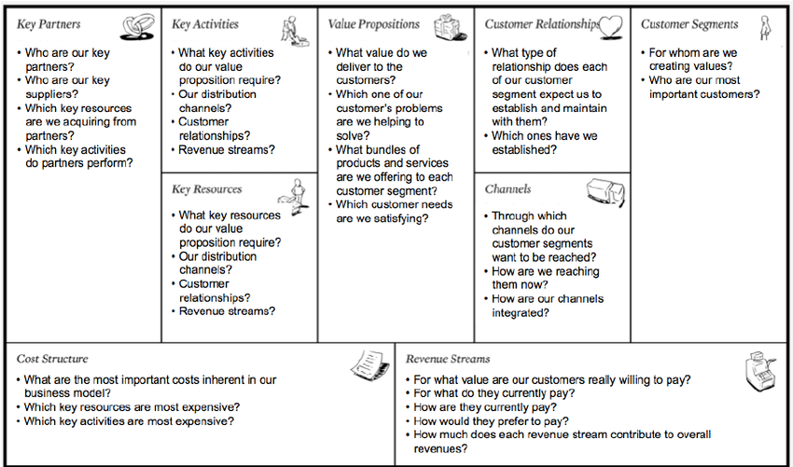
Figure 2.3 Business Model Canvas
Osterwalder et al., (2005)”
From another prospective, BM could be perceived as an embedded layer linking business strategy with the operational activities, hence the BM is described (in figure 2.4) by (Rauter, Jonker and Baumgartner, 2017) as the strategy in practice.
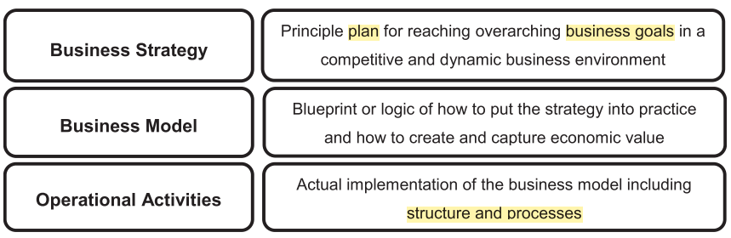
Figure 2.4 Business Model in practice
-(Rauter, Jonker and Baumgartner, 2017)”
Any traditional business organization has a specific BM which defines the main three elements (value proposition, value creation and delivery and value capturing). BM mirror the enterprise understating of the consumer needs, the way they want it and how it can be served in a profitable cycle. The BM is supposed to be the organization’s navigation compass to realize sustainable success in the market and hence, organizations need to be ready to develop and implement new innovative SBM successfully.
Probably no other topic in management research is discussed more often than business models “BM have the potential to bridge the gap between radical and systemic sustainable innovation and firm strategies” (Boons and Lüdeke- Freund, 2013); BMs can “span industry and firm boundaries” (Amit and Zott, 2001), and they are “serve as a positive and powerful role in corporate management” (Schafer et al., 2005). Regardless of the chosen role of the type of business in some contexts, researchers agree that, in general, the organizational business focuses on the way in which the organization gains profits from providing products and/or services. They also work to highlight important assets and relationships that incorporate values (Boons, Lüdeke-Freund, 2013; Osterwalder et al., 2005).
While the growing interest in business modes (e.g., Zott et al., 2011; Beltramello et al., 2013) and increasing exposure to the issue, moderate businesses continue to receive much criticism, for example, by their assumptions. absence of a principle-based theory.
Moreover, the transformation of BM to cope with the newly emerging technologies during the tough competition and globalization is highly critical to business survival (Gassmann, Frankenberger and Csik, 2017). Following this trend, (DaSilva and Trkman, 2014) noted that enterprises gradually are dynamically in the process of redesigning their BMs. They added, evidently reputable consultancy firms (such as McKinsey & Co, Bain & Co and the Boston Consulting Group) has been promoting their services to help corporations revolutionize their business models. Traditional BM is seen as old-fashioned due to the absence of sustainability and innovation aspects which are described as foundation elements of a BM (Lee and Casalegno, 2010). (Looijen, 2015) agreed and highlighted that BM is being analyzed critically which has been followed by many papers about BM innovation and suggesting for organizations to adopt sustainability into their classical BM.

Sustainability business model (SBM)
SBM that work in practice (e.g., business idea, business models, decision-making processes) is defined as the principles of promotion. This concept is based on the centralization of business development in all areas, which means that business practices must be conducted in a sustainable manner.
When it comes to value, the value creation management of business design approach can even be seen as what constitutes a BM, because the value creation and the value of acquisition are the result of creating value and can be a combination of promotion or product value in term of two conditions as outlined by (Bocken and Balkenende, 2018):
a) Sustainable in itself
b) Creating sustainable outcomes
To meet the conditions of sustainable itself it is relevant that SBM, the business is supposed to entail value creation in both business activities/ operations as well as output product. In other words, SBM can only be adopted if the company's goal is to provide sustainable development that is beneficial in term of its own as well as its stakeholders. (Stubbs and Cocklin, 2008) viewed SBM as raised views of modern life in terms of neoclassical views, which according to (Mol 2006), is defined as
"Relating to the condition of intent, (Stubbs and Cocklin, 2008) view SBMs as being underpinned by an ecological modernity perspective as an alternative world- view to the neoclassical perspective, which they, in line with (Mol 2006), defined as the centripetal movement of ecological interests, ideas and considerations within the social practices and institutional developments of modern societies. These results are in ecology-inspired and environment-induced processes of transformation and reform of those same core practices and central institutions, a process that began in earnest from the 1980s onwards” (Stubbs and Cocklin 2008).
Therefore, companies working with SBM want to make a profit, but unlike other firms, because they are not the only ones making a profit: "They pursue sustainability because it is the right thing to do' as well as the smart thing to do" (Lüdeke-Freund, 2011). In addition, the authors stated that SBMs look natural and helpful in protecting the environment and that SBMs incorporate both visual and robust-component perspectives. Furthermore, for considering the concept of SBM in a more detailed perspective a detailed overview of Stubs and Cocklin's work are discussed further.
The findings of (Stubbs and Cocklin, 2008)’s research noted that "a good BM should also increase quality and/or reduce environmental degradation (Rauter Jonker and Baumgartner, 2017). Whereas (Wells, 2013) noted the inclusion, longevity, cultural exploration, and implementation of these plans inform SBM to be effective. SBM does not only include only all the non-monetary value (such as environmental and social value) but also monetary value in term of creating profit through creating value.
In addition, SBM can be considered as a systematic, efficient and financial way to close the gap between public and private sectors by integrating partnerships and merging local businesses, construction, financial business, and affiliates of small businesses that can work together for the achievement of sustainable goals for the industry (Clinton and Wisnant, 2019).
The company’s success is no longer measured by its ability to produce, market share, quality, innovation or price, environmental and social issues have a great impact on consumer choice some years back. As in the current world scenario Organizations have acquired sustainable awareness, and initiated a behavior change process, giving best practices; so many have already received awards, certifications and seals sustainable, gaining credibility through which they change their customer preferences. However, (Mehran, 2016) on the other side claimed that it is essential that this sustainable proposal is present in all organizational processes, not only in the production, administration or product sectors. Therefore, regarding (Lüdeke-Freund, 2011) study that, before starting implementing SBM of introducing sustainability into the organizational structure, all activities and processes must be analyzed to identify those which are unsatisfactory, in order to improve good practices and decrease these negative ones.
Sustainable companies have a very important role in the search for sustainable development. Even though people do their sustainable duty, but it occurs at a small level. Whereas, sustainable companies, especially large organisations can reach a larger number of people through their products, advertisements and stakeholders and can generate a greater impact on a large number of people. Therefore, companies and society should work together for more conscious and sustainable development.
(Lüdeke-Freund, 2011) claimed that corporate sustainability does not only think about environmental, social aspects and economic, within a macro-management model where it is inserted. But there are also paramount requirements such as ethics, transparency, governance practice corporate effectiveness, employee well-being and supplier selection engaged with sustainability, which are characteristics that reveal the importance that sustainability within a company and the commitment to this whole process.
(Brown et al., 2018) also highlighted that many managers are the main element of change within a company, while they have limited vision, and some of them use weak strategies as the lack of preparation for change due to which there are failures that organization have to face in term of sustainable development. The lack of interest and commitment at the strategic level, sustainability lose strength that many companies need to understand. Therefore, those companies that were successful in their sustainable models owe much of the success to managers, at the strategic level, because when it is sustained at the top of the hierarchy its dissemination throughout organizational structure happens in an integral way.
On the other side, the decision to incorporate sustainability into its BM is implemented in many companies today, mainly for the manager, because it is up to him to decide and implement this BM to the organization. The SBM is also attractive and involves the visibility of the company and the brand, the possibility of increasing profit, innovation, and decrease costs in general.

Sustainability is an opportunity for companies to innovate, raise their market share, and add more products to the portfolio as argued by (Brown et al., 2018) in order to meet new markets and create sources of profit, develop new processes and technologies more that are more economical, as well as cooperate with the preservation of the environment, generating well-being and quality of life for the internal and external public.

Conceptual approach to identify the SBM characteristics
The neoclassical monetary perspective is today the dominant worldview, governed by unlimited economies (Cotgrove, 1982; Egri and Penfield, 1996). The main goal of the incorporations is to increase investor share value.
Normally, natural change is only required if it is the organization’s own responsibility (Purser, Park and Montuori, 1995), or if regulation dictates (external variables), or due to pressure from partners, and to acquire or maintain authoritative authenticity (Bansal and Roth, 2000). Pollution and waste are carried to the outside world and high markdown rates are used, which promotes asset accumulation rather than protecting people in the future (Srivastava, 1995). Competitive organizations only can acquire the finest human capital and natural resources in order to maximize their benefits. The value creation cycle reflects a direct take-over and waste strategy, which usually consists of incompetent concentration of energy and resources (McDonough and Braungart, 2002).
Based on the corporate sustainability literature a strong Environmental Management EM position could be translated at the organization level. Proactive organizations supporting EM sustainability perspective as advised by (Gladwin et al. 1995) concentrate on providing value as well as improving government assistance to their partners and reducing environmental impact. (Gladwin et al. 1995) hint at this as a shift (i.e., Green initiative) from “greening”, where the association is centered around instrumental or measurable goals (e.g., reducing pollution), to “sustaining”, focusing on outcomes such as protecting the environment and social framework. well-being and reliability. Associations plan not to harm the climate and partners, for example by preparing for a vicious circle, given the possibility that they may have to offer compensation in the event of harm (Hawken, 1993). This involves balancing destructive actions in one region with clearing commitments in another (for example, balancing unsafe emissions by buying carbon credits or planting trees).
The EM perspective echoes a long-term interpretation from the neoclassic perspective
- Low discount rates are employed to slow the depletion of natural resources, ensuring a more equitable distribution of resources across generations.
- Organizations take a stakeholder view of the firm rather than a shareholder view and acknowledge that nature and future generations are stakeholders.
- Firms design low-impact products that reduce the ecological footprint (minimise pollution, waste, resource usage, and energy) and/or move towards solutions or service-based businesses (Gouldson and Murphy, 1997; Hart, 1997; Jacobs, 1997).
- In a service-based model, value is delivered as a flow of services; for example,
- providing illumination rather than light bulbs (Lovins, and Hawken, 1999)”.
Organizations take a collaborative or “competitive” (competing and cooperating in the marketplace) approach to addressing issues of sustainability (Brandenburger and Nalebuff, 1996). The EM concepts of sustainability described above underpin the SBM.
Stubbs and Cocklin explained that company would be considered to have a SBM only when the sustainability principles are the basis of its decision-making process in that case both corporate sustainability and general BM concepts will be integrated. (Lüdeke-Freund, 2011) echoed, this analysis shows that organizations using SBM need to create internal and external internal systems in order to be able to access power-component strengths and to work with key stakeholders to achieve the stability of a divided component as per figure 2.5.
Organization seeking sustainability are supposed to, as suggested by (Wicks, 1996, p. 104), transform their traditional BM into a SBM. The SBM transformation cannot be compromised by introducing some social and ecological tasks (such as environmental protection, respect for culture and traditions).
An in-depth study was done by (Stubbs and Cocklin, 2008) based on two BM case studies Interface and Bendigo Bank to identify the main characteristics of a SBM. Figure 2.5 shows the integrated categories and attributes summary of the study findings.
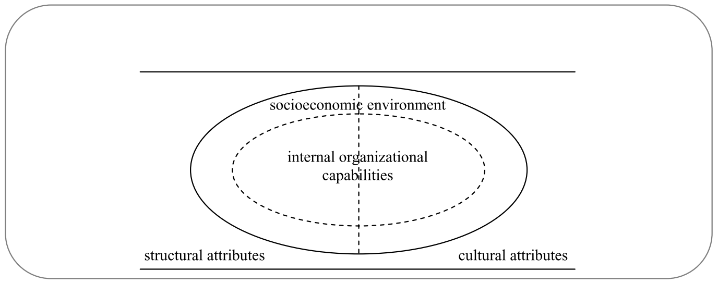
Figure 2.5 SBM characteristics
(Stubbs and Cocklin, 2008)”
In their study, (Stubbs and Cocklin, 2008) categorized the SBM characteristics in two levels; economical societal level and Internal Organizations Capabilities (IOCs). The economical societal level entails the external factors whereas the IOCs stands for the internal prerequisite factors that a proactive organization can foster them independently. The SBM characteristics entail cultural and structural attributes;
- Structural characteristics are linked to how the organization carry out its business activities on the day-to-day basis. What is the mechanism in place to guide the efficient and sustainable operation?
- Cultural characteristics talk about customs, values, and code of conducts that the management as well as the staff are operating by.
Both domains are practically overlaying, (Stubbs and Cocklin, 2008) conserves, the difference amongst structural and cultural and between internal and socioeconomic cannot be complete.

Business Case Of Sustainability

Organisational transformation into SBM
Normally organizations understand their own BM perfectly, (Linz, Müller-Stewens and Zimmermann, 2017). Despite that organizations make the continuous adjustments to maintain that BM resulted from environmental changes, they rarely question which type of BM they are operating on. Changes largely follow the external global trends such as digital shifts and customers preferences. Such trends expose the traditional BMs to a new level of challenges where gradual adjustments of the current BM cannot be the answer. In their argument, (Linz, Müller-Stewens and Zimmermann, 2017) calls for a radical BM change in the classic BM to more sustainable BMs where innovation and technology are key elements. Additionally, organizations need to have the agility to keep up with entrepreneurs and startups in the contemporary market who are taking bold initiatives in BM creations.
For instance, many people think they can survive by selling solutions instead of products, but we notice that only a few are really capable of managing such a fundamental transformation.
Due to several reasons, the current world has recently seen an increasing number of cases with minor adjustments to the BM. One cause might be the rise in new technologies, which has changed the strategic context profoundly, or new entrants, which might come from another competitive arena and have a completely new BM.
Google discovered manufacturing as a new growth sector. Benefiting from its Google Maps data, it entered the automotive market with its own self-driving concept car and is about to become a mobility competitor for the established car producers – not to be underestimated because Google has a different mental model understanding of what a car represents. The new strategic alliances of BMW with Chinese search giant Baidu, chipmaker Intel and suppliers show their commitment to producing fully autonomous cars by 2021 in preparation for the transformation of their classical BM.
Competition in technology has evolved from skill and a shift in the knowledge to a small business because today, start-ups, niche players, and small and medium-sized businesses have a way of challenging low-income players (Linz et al., 2017). Therefore, businesses need to find the best varieties. For example, there is no doubt that car companies can survive by simply making and selling cars. Some fear that they will be converted into deep-margin metal heads if they are unable to take advantage of entertainment and e-commerce services that may be offered on the steps within the future car. These “smart services” are often far from the main use of the product, which requires accounting to participate in their financial performance, and thus represents a major change in the automotive BM, including in-depth cultural change.
Many media companies have already gone through a transition. Print and over-the-counter advertising prices continue to drop. The content is still relevant, but the new delivery formats are different and magazines and newspaper subscriptions are limited for readers. Media companies face the challenge of making money for internal use in different formats and depending on usage; Blockchain technology can change the rules of the game.
"Radical" means they have to change the type of BM, especially for large parts of the company. This usually includes changes in the equipment and the importance of the firm's choice.
There are a number of reasons for the increase that has taken place in recent years where small changes to the BM, such as the addition of that advanced marketing strategy, are inadequate and in high demand (Linz, Müller-Stewens and Zimmermann, 2017).
A radical transformation is very challenging and often has a high risk, but in many cases, there are no other options available to a company that wants to remain successful in the long term.
In many established firms, including independent banks, electricity suppliers, television suppliers, bookstores, and many others, high-quality business is being criticized. They need to think about solutions and change their business models and the ways in which they manage, change and promote their business. Managers face difficult questions while considering changes in BM such as,
- How can we adapt different strategies from the front end to satisfy the needs of our customers?
- What are different strategies that can be adapted from the back end to satisfy the needs of our customers?
- What is the best monetization process to create sustainable value for the stakeholder of the company?
Business activities are accused to be the ultimate reason for the ecological and societal issues Schaltegger et al. (2016) noted. Thus, business as a major economic engine should not only be part of the solution but also contribute to the creation of a stable society (Hart 1997; Robinson 2004). This requires significant changes in business objectives and management (Roome and Louche, 2016; Bocken et al., 2014; Stubbs and Cocklin, 2008) so that BM can be considered in the promotion (Schaltegger et al., 2016). The traditional ways of using technology, media and technology are not enough to transform business and society too much into a "powerful force" (Schaltegger et al., 2016a: 3). Adjusting the BM to meet the requirements for promotion is not enough, because this method does not change the way the business is run (Rauter et al., 2017; Stubbs and Cocklin, 2008).
Therefore, to address this problem, different public organizations Boyd et al. (2009) are emerging which take economic value when conserving or restoring natural, social and economic resources. These "hybrid" organizations "use market methods to solve social and environmental problems" (Hoffman et al., 2012). Hybrid models include materials from a variety of ecosystems - market and local that enables to create and deliver economic, social and environmental benefits to those affected. Culturally, the organization pursues the social goal of creating objectives that benefit the community, while market value underpins revenue growth and efficiency (Lee and Battilana 2013; Smith et al., 2013).
One type of mixed-type approach is business as used by B Corp. Model. B Corp operates on a professional and economical basis, as opposed to the sole purpose of increasing profits and doing business as usual. Although a relatively small number of research cases were conducted at B Corps, they offer interesting areas of logical and social thinking (Stubbs, 2017b; Brown, Bocken and Balkenende, 2018).
Companies today try to survive in a more dynamic and transformative environment working with long-term economic, environmental and social goals and objectives in order to help all stakeholders survive (Zink, 2008). For an organization to live in an environment of rapid change, managers need to move from the old (top-down) strategy to the new system (from stage to center), trying to see the potential for change. It manifests itself, such as new threats and opportunities, and an interpretation of how it will affect the current situation by acting. Those who work at the border or on the side of the organization often serve as "value gauges" that begin to see consumer engagement in transformation (Zink, 2008).
The conception of Maturity Level evolution process conversed by (Gouvea and Machado, 2013), it is important to differentiate between the study of SBM strategies and the use of organizational analysis framework discussed by (Petrigrew, 2012). His research focuses on three main trends:
- Context,
- Content/structure
- Processes.
Correspondingly, (Pettigrew, 2012) approach is designed to describe and analyze context of the change. The influence of the context as an action and the interpretation of the outcome is made possible by treating the situation as an operation field with a wide range of analysis as referred to by (Pettigrew, 1987);
- Outer context considering the companies that operates in terms of the social, economic, political, and competitive environment.
- Inner context refers to the structure, corporate culture, and political context within the firm through which ideas for change have to proceed”.
Internal environment refers to the structure of companies and the political environment in which change strategies must be implemented. In this case, it is in any of the changes caused by the modified form, formed by the changes in the external environment organization, as well as the political and cultural thinking within them, although often reflected in the term analysis. This thinking continues to seriously undermine community-based interventions. Simple lines of line and tapes have to meet new levels of complexity. Inside means a change when you check the area of interest. A company may seek to change technology, organisational structures, products, services, manufacturing processes, or even a corporate culture (Pettigrew, 2012, 1987).
The process of conducting an organizational evaluation should go beyond explaining and defining methods of management and demonstrating how far and how far the steps can and do not affect the results. Change patterns refer to actions, behaviors, and practices from different parties as they seek to move companies from their positions to the desired future location (Pettigrew, 2012).

Sustainability can be a (win-win) alternative to corporates
Organizations can play a vital role in promoting development and growth. But why would they do this? What are the business reasons why managers should work for flexible change? What money? Can conservation companies help? What are the benefits beyond the cost of companies?
Fostering sustainable business operation naturally calls for significant upfront investing in resources, upgrade business practices, systems and technologies. Project (programs) may also be required to guide employees through intensive work (educating the stakeholders) or to develop complex products and services (value creation). It usually takes time to benefit from such investments which makes short term investments outweighs the benefits. However, over time, the benefits can be very helpful to a business case. But what are the benefits? Financial or non-financial? (Bauma, Wolters and Silvius, 2019)
Sustainability contributes in realizing business goals and performance improvements It is important to highlight that economic benefits are not the only element of the SBM business case. Further, (Figge 2001) added adopting sustainable strategies are proved to be cost-effective for the companies and also allow the company to adopt an eco-friendly environment. The sustainable process required less raw material, energy and other resources for operations and also generate less waste. Furthermore, the customer also gets benefited from this as this allows them to gain durable and reliable products and service that in turn increase shareholder value for the companies.
As considering example of one famous company General Electric's (GE) that initiated the GE Ecomagination programme that aims to provide sustainable and environmental products and services to the users. In 2010, GE decided to increase the commitment of its programme by investing US 10 billion in the R&D department of the company. Thus, doing this GE increased its position in the market as well among the customers.
Thus, based on a study by (Lozano, 2009), various authors have described other ways to achieve corporate stability in (CS), some of which include: clean technology transformation (Hart, 2000), product-to-work change is said to be the preferred business approach. Based on (Lovins et al., 2000); integrating ecological, environmental and data building data into the financial design (Reinhardt, 2004); as well as the integration of intelligent planning (Quazi, 2001). Generally, natural resources are based on location. Social workers are often the ones doing the most. The majority, with the exception of Doppelt (2003) and Dunphy et al. (2003) did not find a way to apply the theory of evolution. They did not suggest ways to introduce or reinforce CS in a coherent culture.
In addition to the estimated cost and actual cost, investments can also be invested in improving the business environment. For example, in 2010 British Petroleum (BP) oil spillage in the Gulf of Mexico caused more than $40 million for cleaning, court fees and government fines, not to mention damage to the image of BP. While this may seem like an unexpected delay in one of the major environmental risks for decades, this example illustrates the financial risk associated with a lack of focus on the real estate business.
Corporates have gained large dominance over the past twenty years in particular in a way that influences economy, and society as well as impact the environment (Lozano, 2009). He explained; power is a result of three factors;
A) The Dominant Socio-economic Paradigm (DSP),
B) Neoliberal capitalism (that treats natural assets as infinite and human capital as finite),
C) Trends like globalization, privatization, liberalization, and the ruthless pursuit for revenues.
On one hand these factors have enabled businesses to better address customer preferences and improve strategic efficiency as well as advancing corporates management skills. On the other hand, such phenomena have empowered some corporates to misuse their powers and commit violations such as escape taxes, governmental collusion, unfair trading and abusing natural resources, human rights and similar damaging acts (Lozano, 2009). As a consequence, he continued, these factors has often led to immediate effects on the corporates’ near and far future business sustainability such as insolvency or going out of business.
Therefore, corporates may consider “sustainability” concept as a better choice that would respond to challenges such as economic inequality, environmental deprivation, and social disparities for the current and coming generations. Lozano in 2009 defined sustainability as realizing the equilibrium between the triple bottom lines (economy, society and environment) along with the chronicle element (i.e., present and the future).
Economic crisis has been a good advocate for organizations to rethink about their business models and analyze critically the actual impact on the business sustainability. Diverse managerial conceptions have been developed based on sustainability theme, concepts such as integrated economic schemes (van Egmond, 2014), global supply chain, strategic business planning (Gauthier, 2017) and (Korže, 2018).
Sustainability concepts have been established in the literature as an important catalyst to gain and retain competitive advantage. Researches about sustainability implementation could be categorized into two groups;
A) higher management support, collaboration, rewarding schemes and human capital management are the key factors to realize sustainability on the first hand (Wilkinson, Hill and Gollan, 2001),
B) Organizations need to transform in order to be ready and adopt sustainability on the other hand (Kontic and Kontic, 2012).be flexible to prepare and receive support from other parties (Kontic and Kontic, 2012).

Sustainability drivers
Recent studies such as (Chesbrough, 2010; Zott et al., 2011), have been instrumental in clarifying the theory of the short-term BM and have promoted the discussion of short-term business sustainability (Bocken et al., 2014; Short et al., 2013). Whereas change-maker in organizations as agents of change has always been the subject of scientific guidance, it is not yet clear what exactly motivates some people to change BM or to promote or integrate locally into their business areas (Sommer, 2012; Schick et al., 2002). Continuing research on this issue is focused on the mechanisms by which firms effectively adapt to the many changes required to detect, test and ultimately implement other sustainable BMs" (Zollo et al., 2013). It will continue to be done. Better consideration of incentives and business models is essential to the end, both academically and in practice. (Rauter, Jonker and Baumgartner, 2017) addressed the following related questions in their research;
1) “What drivers (on the individual as well as on the organizational level) are required when changing BM into BM for sustainability?”
2) “In which specifics ways do companies consider the economic, environmental and social aspects of sustainability?”
Many companies are attracted by the advantages of adopting principles of corporate social responsibility in their goals and objectives. As stated by Mittal et al., (2018), the main benefits for companies would be:
- “Enhancement of the institutional image and the brand
- Greater consumer loyalty
- Greater ability to recruit and retain talent
- Flexibility and adaptability and longevity”
The rules of governance, management, corporate ethics and corporate governance, as well as forms of business consolidation, have been identified as important driving forces for courageous businesses.
The need to maintain competition and has not been the main driving force in building tough BM. Whereas, improving competitiveness and customer satisfaction is an important part of business operations and it is also beneficial in terms of providing economic benefit for the companies. This can be interpreted as an additional method of user-based business practices (Barney, 1991).
The company's ability to design products often attracts specific customers. It also shows that increasing profits is not the sole or full purpose of the companies involved in this study. Also interesting is the strong role played by leadership in running BM in greater stability or in realizing their potential.
Considering that leadership and practices are known to be critical to change, this conclusion is not surprising. The results suggest that although traditional types of businesses are still in use, they should be modified or supplemented to provide improvement. This becomes apparent, for example, when companies are no longer looking for a common goal of increasing profits, but also for comparing economic, social and climate goals. And again, new buildings can be introduced, such as trying to integrate targets Bocken (2014).
The organizations’ strategic drivers to take part in sustainability ventures into 4 main types (Brockhaus et al., 2017);
- Image Enhancer,
- Efficiency Maxi miser,
- Resource Acquirer, and
- True Believer.

BM Role in Realizing Organisations Sustainability Goals
The section discusses the importance of the business model and its contribution in achieving the sustainability goals of an organization on both macro and micro levels.

Business models vs. Business function
The importance of good business functions has been discussed in a number of articles. Good business functions design involves focusing on internal and external factors related to customers, suppliers and expanding sales space (Teece, 2010). Any BM has a clear business function that defines three pillars (value of choice, the value of design and delivery, and value of acquisition). Business functions show how the business minimises customer needs, how they operate, and how they can profitably interact with them. In an organisation, each business function should include strategies that organisations can use to develop and implement new business development models.
Changing BMs and shifting new technologies for competition in the global environment is critical to business survival (Gassmann, Frankenberger and Csik, 2017). Following these trends, (DaSilva and Trmanman, 2014) have found that businesses are slowly and in the right way changing their business. He added that well-known marketing companies (such as McKinsey & Co, Bain & Co, or Boston Consulting Group) are promoting their services to help companies revitalise their businesses functions.
Whereas, the traditional BM is considered useless due to the lack of promotional materials and skills, which are defined as important components of the BM (Lee and Casalegno, 2010). (Looijen, 2015) agreed and affirmed that BMs are being closely monitored, followed by several business functions for improving modelling and organisational recommendations to integrate continuity into their business models.

SBM role in realizing Enterprise Excellence”
Enterprise excellence and sustainability are considering being a near parallel concept. The ingenious use of enterprise excellence systems for high-quality systems has greatly increased production in a wide range of fields, including finance, ecology, operations and supply chain and more. Similarly, although the triple bottom line (TBL) is the backbone of business development, many promoters are interested in their people and planets with no profit (Aagaard, 2019).

The Role of BM in Sustainability Transitions
The argument is that emerging forces between new businesses and emerging markets play a key role in determining whether emerging changes will lead to systemic changes over time (Brown, Bocken and Balkenende, 2018). The idea of transforming BMs aims to help organisations make changes in the promotion and service, use and improve their value, product or service, and their systems to gain greater value by helping to maintain or streamline network, community and economic resources. The role of business in sustainable development is often linked to collaboration as well as efforts to reduce the risk of environmental degradation. These measures to improve the performance of corporations do not make a difference in improving the dynamics in the environment.
Cases such as the 2015 Volkswagen emissions scandal highlighted the need to move beyond social and climate change to more serious ways to transform into a prosperous society, economic development and a healthy society. Businesses are seen as an important factor in social change. In this shift, entrepreneurs may act as promoters, changing game rules and/or creating new markets (Loorbach And Wijsman, 2013). Real-life examples of innovative businesses such as Tesla, Uber, Airbnb are seen as changing market conditions and creating innovation. Thus, despite the destructive nature, the character of these true newcomers and their relationship in promotion is clear as an important model for companies seeking to design and significantly alter the value of chains and markets in which they work with their internal organizations in a secure manner (Stubbs and Kohlin, 2008).
Business transformation is one that can shape its position and create alternatives for large corporations. The BM will change after the installation of an alternative for setting up a system, structured and slightly modified in the original, advanced, and flexible initiatives. Like many economists, companies cannot compare prosperity with economic growth; the system as a whole must be protected. This is because companies openly switch to negative or perceived outsiders as they imply potential future investment.
• Transformational business reflects the views and needs of many stakeholders, some of whom are often involved in the value of construction. In other words, a steady donation (product or service) reaches out to those who target it through multiple relationships.
• Transformation BMs are aimed at social change that is not only necessary for their well-being but also the full reorganisation of the system. Reflection means that organisations are able to identify and remove barriers and opportunities that arise within this goal.
Transforming BM is not only concerned with the survival and success of organizations but also involves focusing on the goal of creating their own community. Furthermore, through explicit BM, entrepreneurs can influence markets and societies, or even shape them beyond.

Developing New Dynamic Capabilities
An organization in a free market economy, especially one that continues to grow globally, aims to fulfill its rational goals from the competition (Zink, 2008). Barney argues that "competition is a strong opportunity for the company to adopt an innovative approach that remains viable even in trying to imitate existing and future competitors" (Barney, 1991) as shown in figure 2.6. This means that an organization can provide greater value to consumers in the industry who have more options to choose from.
The traditional methods of reducing prices through resignation, exports to more expensive countries, or increased production through new technologies do not address the significant problems posed by a united economy during globalization. Above all, it is necessary to develop new technologies that promote the continued development of new products that offer greater value to consumers and other stakeholders. This is an innovative solution to the need for significant improvements in the system's system performance. Furthermore, the organization needs to take into account product life cycles that can provide them with a great opportunity to forecast their future moves and how to deal in the competitive market.
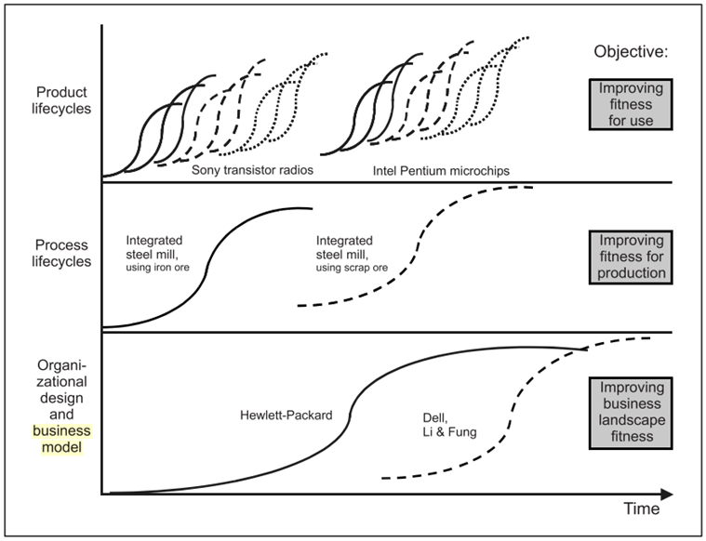
Figure .: “The need for organisation readiness assessment, Source: (Barney, 1991)”

Figure 2.6 The need for organisation readiness assessment
Source: (Barney, 1991)”

The Need for Organization Readiness Assessment
As it has been established that Organizational change is the necessary trend for business survival. Therefore, organizations are required to adopt decision-making tools to plan and manage the transition process. But how can an organization make a sound decision to adopt a sustainable BM? Introduction to MM. (Van Tulder et al., 2013) classified the sustainable organization transformation into gradual or radical change; businesses move between different phases attributed by several sustainability views, approaches, risks and agendas. Moreover, the critical success factors to develop that would ensure its readiness for sustainable BM transformation and assure shareholders consensus.
Furthermore, there are initial capabilities for an organisation to be developed before an SBM transformation (Mohammadi, Khanlari and Sohrabi., 2009). He elaborated undertaking such a transition initiative having the necessary qualifications in place could be a loss-making process as well as endangering the whole organization. He suggested assessing the readiness level to mitigate such risk.
Therefore, this research aims to provide sustainability entrepreneur organizations with a real-world analytical tool that may be applied to assess how ready an organization is to adopt a sustainable BM effectively. This assessment is arranged according to the observed organization maturity level - readiness to adopt an SBM. It is referred to as the key internal organizational capabilities; structural and cultural attributes. “Cultural attributes in terms of norms, values and attitudes. Structural attributes in terms of processes, organizational forms and structures, and business practices” (Stubbs and Cocklin, 2008).
There is an importance of identifying the organization current status which can be a valuable asset for managers to prioritize their sustainable initiative strategies (van Tulder et al., 2013). The author emphasized the benefit of a theoretical framework to organizations during this phase; it augments awareness of the current organization phase among various stakeholders. Each transition phase (maturity level) has its own characteristics, not inferior or superior to the other phases. The key judgment in identifying the correct phase matches its actual state to develop the relevant capabilities and facilitate the change.
Moreover, from the strategic management's point of view, it is helpful to differentiate between the plan and the actual situation that is of high importance in decision making. The MM assessment is hence a framework to reconsider the contemporary organization state including its internal and external stakeholders.
There are questions relating to the nature and form of the transition process towards sustainability. For example, they include the critical factors that an organization can develop to improve its maturity level and ensure a successful and structured transition. These capabilities can be arranged as building a sustainable BM (Lüdeke-Freund, 2010). Other questions that come up to the concept includes, what brings about the transition: inner motivation or external pressure? What are the roles of primary and secondary stakeholders? When can we be confident that change will stick? Does a company attempting sustainable initiatives due to external pressure have as much chance of reaching a tipping point as a company moving in this direction for intrinsic motives due to an active leader? Can an entrepreneur make this step alone, or must he or she involve stakeholders, and when is the best time to do this?
By utilizing MM assess their capacity and capabilities to implement a sustainable business model, organizations can have higher probabilities of success. Such assessment enables companies to strive towards an optimized BM in order to benefit according to their strategic goals, responsibility and spirit.

Maturity Model For Sustainability Assessment
The section includes a discussion on the MM for sustainability along with the assessment tools different maturity traditional schools of thoughts.

Maturity Model as an assessment tool
MMs were introduced to help organizations to evaluate and compare development (Fisher, 2004) and as a knowledgeable decision-making tool to enhance a particular dynamic capability (Ahern, Aaron and Richard, 2008). MM has been employed as a tool for organizations to assess their process, systems and capabilities to reduce expenses, enhance excellence and developing/ maintaining competitive advantages (de Bruin et al., 2005). The MMs provide an integrated action plan for organizations to evolve from one maturity level to the next one.
MMs are an instrumentally practical technique to convert complicated conceptions into organizational capabilities and to promote awareness for potential improvements. They are utilised as a tactical mean that enables organizations to supervise and manage their evolution. MM aim to assess the involvement, capabilities and proficiency of a designated field (de Bruin et al., 2005). MMs are designed to foresee the dynamic organizational capabilities step by step change along predictable, planned or reasonable evolution course (Chilik et al., 2019).
The MM could be categorised into two approaches according to Previous studies in Information Systems; Harvard Business School and Carnegie Mellon University (Wettstein and Kueng, 2002). In 1974, Nolan Model from Harvard Business School was based on the corporate expenditure scheme of electronic data processing (EDP). It was noted that cooperate budget expenditure can be plotted as S- curve with breakpoints resulted from business dynamics (i.e. setbacks). The model included four stages based on the four dimensions of growth; budget, software application, human resources expertise and management from laidback management methods to resource-based design and governance). The model four stages are; Initiation, Expansion, Formalisation, and Maturity (Wettstein and Kueng, 2002) as shown in figure 2.7.

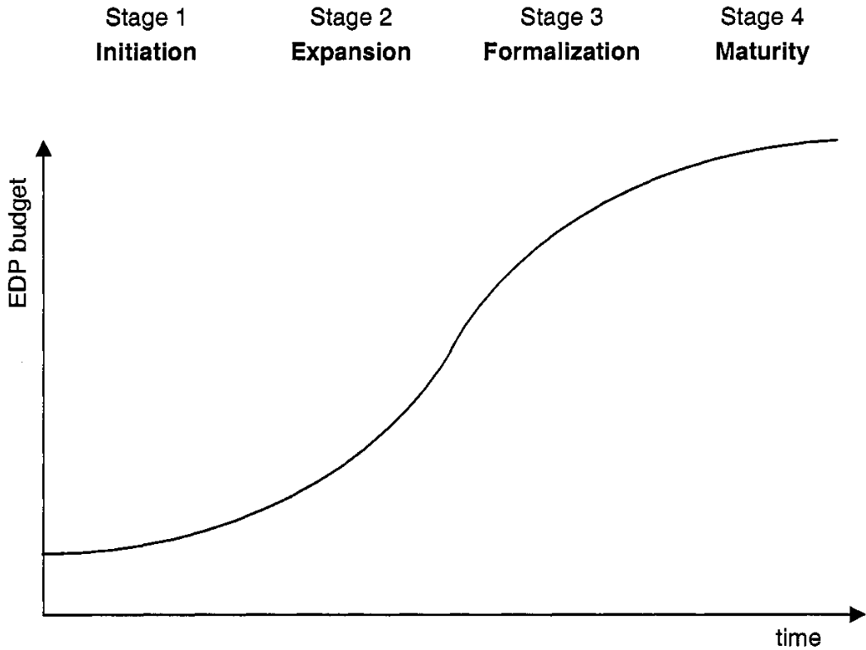
Figure 2.7 The 4 stages of growth
(proposed by GibsodNolan, 1974) (Source: Wettstein and Kueng, 2002)”

The other established MM was developed by Carnegie Mellon University - the Software Engineering Institute's SEI. EI has presented Capability Maturity Models (CMM) which focused on different capability maturity areas such as People Capability, Software Acquisition, Systems Engineering, and Integrated Product Development. CMM enabled software companies to enhance software processes by pinpointing the key success factors needed to improve the maturity of the principal processes over five maturity levels: Initial, Repeatable, Defined, Managed, and Optimising (Wettstein and Kueng, 2002) as shown in figure 2.8. CMM could be considered as the origin of most of the MMs that process maturity based (de Bruin et al., 2005). There are a couple of other MMs presented by the SEI, however, it is not the sole developer of the method. They noted, there are hundred-plus numbers of models were introduced by different institutes and professionals to assess different management areas such as Innovation, Program and Knowledge Management besides, IT Services, Enterprise Architecture and Strategy Alignment.
MMs were introduced in the 1980s for the American defense department to address unsuccessful software projects performance (Chilik et al., 2019) by Software Engineering Institute (SEI) based on the process maturity (de Bruin et al., 2005). The CMM can be considered as the origin of different models and the common evaluation method with a scale of five-point Likert (Ahern, Aaron and Richard, 2008).

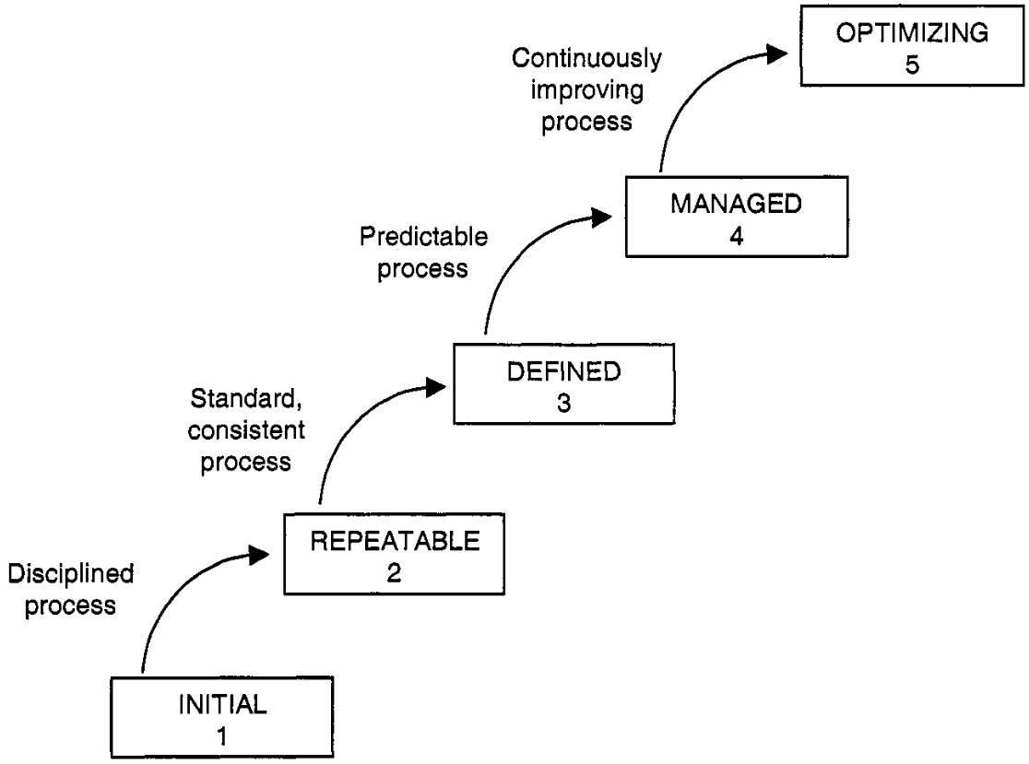
Figure 2.8 The 5 levels of software process maturity
Source: (Paulk et al., 1994, p. 16)”
The difference between the two schools of MMs considering the scope of the model and the dimension's measurements (Wettstein and Kueng, 2002) Harvard Business School (HBS) focused on the specific business unit while CMM addresses the processes within this business unit) HBS focused on the four variation factors and CMM was only interested in the quality of the process.
Sustainability maturity models (SMM) has been trending since the 1990s to guide organizational change towards sustainable business processes (Chilik et al., 2019). They elaborated, organizations have employed the SMM in multiple sustainability areas in both organization-wide or specific business function such as value chain, product design, and knowledge management (Baumgartner and Ebner, 2010)

Review of maturity models for sustainability in literature
The MM integrates Corporate Strategies in terms of sustainability, and competition and their contribution in Strategy Management improvement to achieve corporate sustainability goals (Baumgartner and Ebner, 2010). They defined four sustainability strategy profiles to cope with the ecological, social and economic challenges. These profiles could be useful to guide corporates to realize their sustainability strategies. As there are different types of the sustainability strategy that helps to provide a different way to deal with issues and challenges with sustainability issues (Robèrt et al., 2002).
- Introverted –risk management strategy: concentrates on the socio-economic environment-related legitimization.
- Extroverted – formal legal strategy: concentrates on external stakeholder management and operational permissions.
- Conservative – efficiency strategy: concentrates on efficient eco-friendly solutions.
- Visionary – integrated sustainability strategy: concentrates on business-related sustainability challenges via distinctive and innovative value propositions to maintain competitive advantages.
The four-level maturity framework proposed:
- Level 1 (Beginning) - basic sustainability concern– merely compulsory rulebooks and regulations are followed.
- Level 2 (Elementary) - complies with sustainability regulations in addition to some extra effort in sustainability best available techniques.
- Level 3 (Satisfactory) – considering additional efforts to satisfy the maturity of partial sustainability aspects. (Typically, higher than industry standard).
- Level 4 (Sophisticated) - implies an exceptional sustainability dedicated effort.
Techniques to help companies already working in the field of sustainable development realize their value in the implementation of an alternative approach. As part of this work, they focused on promoting issues that need to be addressed. The selected factors reflect the three stages of development in the company: environmental, social (internal and external) and economic. In total, Baumgartner and Ebner included 16 categories, each of which can occur at one of the four stages of development: beginner, primary, satisfactory or difficult. “A company’s pattern of maturity levels in regard to the aspects would then be compared to five distinct sustainability strategies: transformative extroverted strategy, conservative strategy, visionary strategy, conventional visionary strategy, or systemic visionary strategy. In order to assess the corporate sustainability strategies, templates based on the identified sustainability aspects at different maturity levels were developed (Baumgartner and Ebner, 2010)”

Corporate sustainability strategies
Other work combining the MM and sustainability such as (Baumgartner and Ebner, 2010) discusses the relationship between corporate sustainability strategies, corporate competitive strategies and sustainability aspects. They believed that can support a company in becoming a sustainable corporation. They developed profiles and MM for corporate sustainability strategies based on maturity levels and divided into “introverted, conservative, extroverted and visionary sustainability strategies.
The relationship of these systems to competitive cost leadership systems is assessed in terms of pricing, product differentiation and hybrid strategies. Therefore, the maturity level of corporate sustainability has a strong relationship with the competitive strategies of the organization and it also helps organizations in their strategic planning and deployment for developing a sustainable organization. Considering this at the same time, one can be sure that the proposed system is fully aligned with corporate culture (Baumgartner and Ebner, 2010).
The business SMM is suggested as an innovation strategy for the organizations for sustainable developed (Cagnin, Loveridge and Butler, 2013). This approach allows every organization to individually grow to a position by adopting five maturity levels and allows them to build a different function as well as organizational strategies parallel with sustainable development. the MM is based on the belief that business sustainability is a continuous process of growth, in which the company will always build to fulfill its vision of sustainability in a series of development plans, while in another phase initiate processes and measures how to improve it.
Figure 2.8 shows the creations of a sustainability value network that shows that the complementary element s that are required in sustainable development in an organization. The model is based on the important connection among the value activities towards sustainability in the network that are used to develop five maturity levels and allows building strategy build a strategy along the sustainability net to progress towards higher levels of sustainable development.

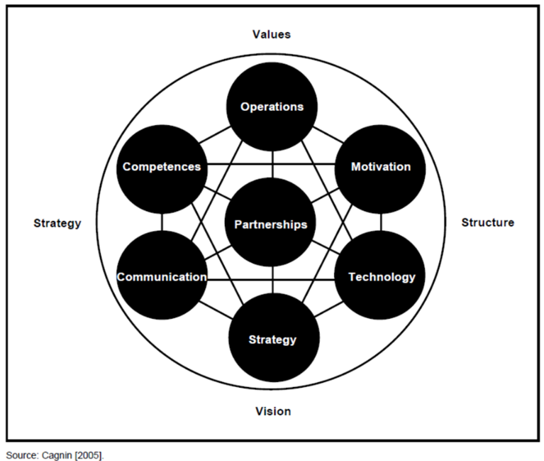
Figure 2.9 Creation of Value in the sustainability network
(Cagnin, Loveridge and Butler, 2013)
Project management maturity in “the maturity of processes” context is a measure of the organisation’s ability to perform project management and related processes in a controlled and optimised way. However, they argued, the process maturity approach does not adequately address the specific aspects and considerations of sustainability. The approach should be more focused. Hence, they chose to express a project’s sustainability maturity in terms of ‘depth’ of vision (Schipper, Rorije and Silvius, 2010).
They conversed the contribution that projects can make to the sustainable development of organizations. Therefore, they expected the concepts of sustainability are reflected in projects and project management. They discussed some aspects of sustainability applicable in the various standards of project management such as;
- “Sustainability in projects and project management is about integrating economic, environmental and social aspects in the management and delivery of projects”.
- “Sustainability in project management stretches the system boundaries of the project and project management.”
A MM can also be used as a framework for judging the Performance Measurement Systems (PMS) and it can also be used as an instrument improving the PMSs. As organisations are always working for their performance improvement by adopting new technologies, processes and instruments (Wettstein and Kueng, 2002). Figure 2.10 shows the Evolution of a PMS along six dimensions
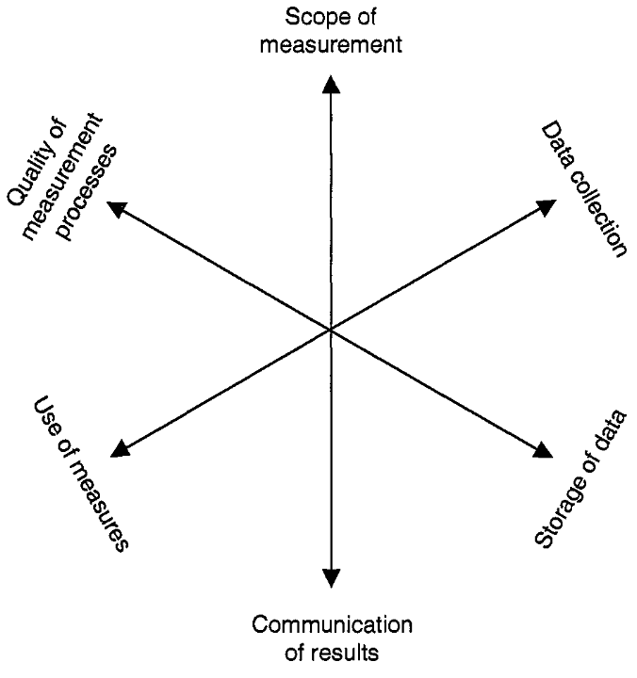
Figure 2.10 Evolution of a PMS along six dimensions”
(Wettstein and Kueng, 2002)
The previous studies propose a maturity framework for sustainability integration guided by sustainable operations capabilities evolution. This study showed that it is possible to detect change based on targeted fit and value guarding in a new way consistent with social responsibility to support systems integration into continuous and long-term value development (Machado et al., 2017). Figure 2.11 demonstrates the shift stages for decision ranges and performance goals.

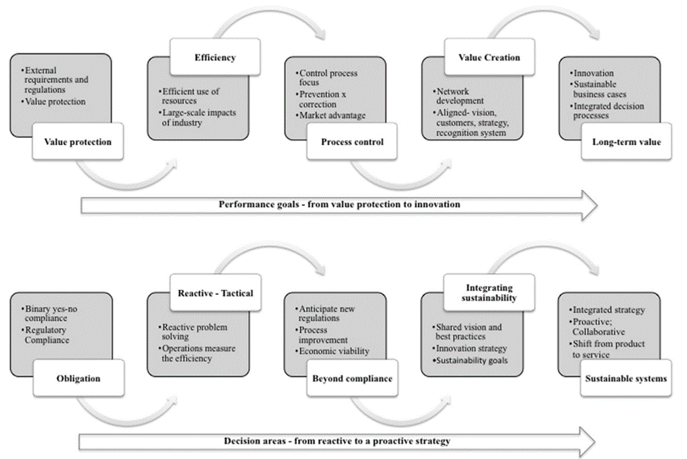
Figure 2.11 Transition levels for areas of decisions and oriented performance
(Machado et al., 2017)
Experts have identified important mechanisms to be considered at each stage and to measure the extent of the difference from the potential level to the planned level of growth. That is in line with the Capability Maturity Model Integration (CMMI). The system represents the company’s brand of the value chain and operational network and designed for manufacturing companies.

Review of the professional MM, maturity levels for sustainability in the literature
Consultancy firms and professional associations proposed some MMs to address corporate sustainability management implementation issues. (Gouvea and Machado, 2013) noted various maturity levels definition approaches to manage sustainability processes as laid out below;
- Industrial Research Institute (IRI) presented the MM framework to evaluate the value creation based on “Design for the environment” product and service innovation that support the triple bottom line. The model is organised in 4 straightforward stages: Beginner, enhanced, advancing, and leading.
- Deloitte consultancy firm assessed the level and criteria of efforts the managers are inventing to improve suitability maturity through four levels; Reactive (minimum effort), Effort to mitigate risks and expenses, efforts to develop a sustainable strategy and stakeholder management, and efforts to gain a competitive advantage for the organization-wide.
- FairRidge Group presented the “Sustainability Management Maturity Model (SM3)” focusing on operational excellence and innovate strategy maturity level. The model enables organizations to assess their infrastructure readiness to manage sustainability issues. The sustainable development model is based on combining strategic, operational measurement, brand and business improvement dimensions. The five levels of maturity; ‘business as usual’, ‘ad hoc response’, ‘plan and pilot’, ‘operationalize’, and ‘transform’. (Gouvea and Machado, 2013) drew from sustainability literature; sustainability is a strategic challenge that requires an integrated sustainable framework into the BM. Hence, individual efforts do not pay off compared to the holistic organizational approach.
- ATOS and SAP consultancies developed a sustainability maturity assessment model via continuously developing competences. The five levels; maturity level 1 – compliance; maturity level 2 - corporate social responsibility; maturity level 3 - process modification; maturity level 4 –continuous improvement; maturity level 5 - environmental excellence.
- AMR Research concluded that a holistic framework would be rather effective; however, it has not received the appropriate attention by researchers yet. The research also highlighted the clear vision and strong leadership is highly influential in maturity improvement.
AMR Research’s frame its SMM into five stages:
- sustainability not in focus (compliance),
- tactical sustainability (reporting),
- strategic transformation,
- structural normalization, and
- operational implementation.
Some concepts regarding maturity could be borrowed from CMMI, which has a large experience in studying such phenomenon in the software development industry. According to SEI (2010):
“A maturity level consists of related specific and generic practices for a predefined set of process areas that improve the organization’s overall performance. The maturity level of an organization provides a way to characterize its performance. Experience has shown that organizations do their best when they focus their process improvement efforts on a manageable number of process areas at a time and that those areas require increasing sophistication as the organization improves. A maturity level is a defined evolutionary plateau for organizational process improvement. Each maturity level matures an important subset of the organization’s processes, preparing it to move to the next maturity level. The maturity levels are measured by the achievement of the specific and generic goals associated with each predefined set of process areas.”
It is also important to set mechanisms for maturity levels transition, and according to SEI (2010) experience:
“Organizations can achieve progressive improvements in their maturity by achieving control first at the project level and continuing to the most advanced level - organization-wide performance management and continuous process improvement - using both qualitative and quantitative data to make decisions. Since improved organizational maturity is associated with improvement in the range of expected results that can be achieved by an organization, maturity is one way of predicting general outcomes of the organization’s next project.”
Maturity levels tend to be organized in five levels as shown in figure 2.12 that form a continuous development path from ‘compliance’ to ‘strategic’ integrated operational network. Capabilities or competences define the ‘operations vision’ related to every maturity level.
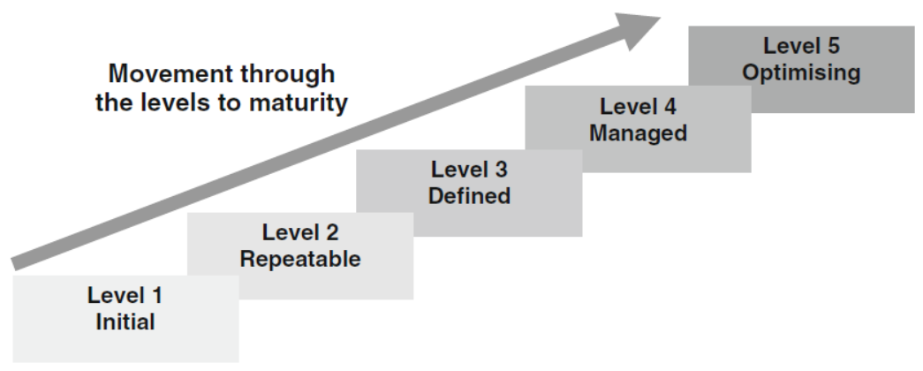
Figure 2.12 “The five levels of the capability maturity model
Source: (Glover 2012)”

RESEARCH METHODOLOGY
In this chapter the development methodology is discussed and the guidelines that are followed in the actual model development (chapter 4) are explained.
The proposed typical development framework denotes a scientifically proven guidance develop a functional Maturity Model (MM). Within a selected domain, the MM development stages will evolve from descriptive to prescriptive and comparative characteristic. The presented development phases are applicable to various trades, and the decisions in each phase would vary accordingly. The model development phases are summarized in Figure 3.1 as a typical framework.
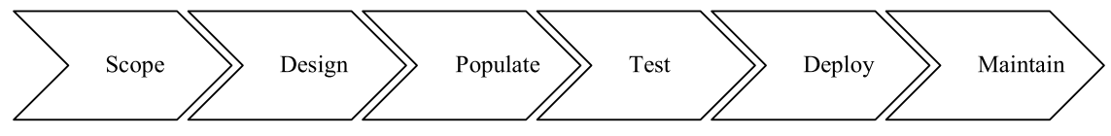
Figure 3.1 Model Development Phases
(de Bruin et al., 2005)
Despite the fact that these phases are common, (de Bruin et al., 2005) highlighted that they should progress in that sequence. For example, scoping decisions will guide the population phase and research methods used .the same goes on the testing phase. In addition, progression through particular phases (such as ‘design’, ‘populate’ and ‘test’) will be iterative, and depends on the ‘test’ outcomes, required to adjust decisions made in former phases. The following sections will discuss each phase in more details.

Scope
The main purpose of the scoping phase is to identify the external model implementation range precisely as put forward by (de Bruin et al., 2005). The scope phase addresses two main elements; the focus of the model and the stakeholder as outlined in table 3.1. It is understandable that the decisions made in this scoping phase will influence the next model development phases by determining the desired model scope, external boundaries will be set for the use and application of the model.
Table 3.1 MM Scoping choices
Source: (de Bruin et al., 2005).
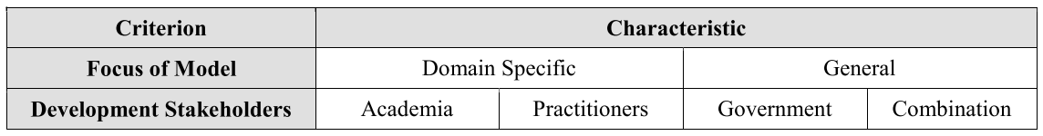
- the Focus of the Model
The focus of the model is the most important decision made in the first phase. In other words, the domain to which the maturity model would be directed and applied is known as model focus. Focusing of the model within a particular domain will also assist in the determination of the extent of specificity and extensibility of the model. Desk research can be conducted to identify the main domain of the model subject and the related literature topics in order to choose the designated area of research or the focus of the model.
- the stakeholders
Post the identification of the primary focus of the model, it becomes simpler to identify stakeholders who can contribute in the model development. Relevant stakeholders can be approached from various institutions such as academia, or field experts in a particular industry, non-profits and governments to facilitate and enrich the model development outcome. Stakeholders will contribute in the coming development phases such as model design and population phases.

Design (Architecture)
The second phase of the maturity model development entails the process of extend and expand the selected scope application. Table 3.2 shows the major decisions of the Design phase. The intended audience needs and ways of meeting these needs are included in the design of the model. These needs are reflected in reasons as to why the intended audience applied for the model, the ways in which the application of the model can be executed within discrete organizational structures, who is required for inclusion into the application process of the model and what outcomes can be expected post the model application.
Table 3.2 Major Design Phase Decisions
Source: (de Bruin et al., 2005).
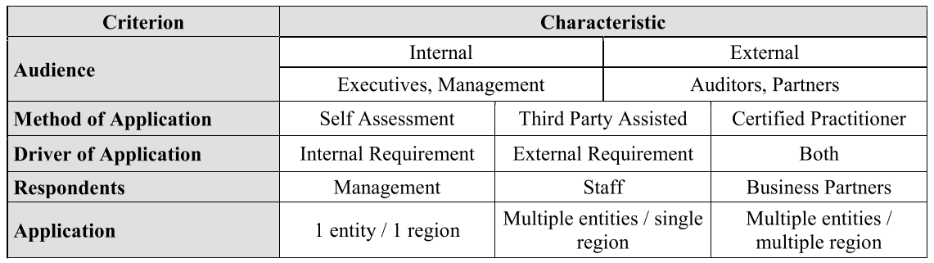
Table 2 outlines the possible choices for each criterion and the main outcomes expected from this phase are;
- Audience selection:
Audience who will use the model to assess the maturity of a particular subject. Audience can be internal staff of an organization who want to monitor the current maturity status of the organization. Audience can be also an external party such as business consultant who want to apply the model to assess the improvement plan for an organization.
- Method of application:
This decision will address who will conduct the model. The model can be conducted either via self-assessment in case the model audience is internal. Alternatively, the model can be conducted via third party in case of business consultancy or certified assessor such as freelancer specialists
- Model application drivers
During this phase, it is important to identify what are the drivers of applying such model to cater the outcomes of the model implementation according to the requirements whether it is internal or external.
- Respondents
This decision is to identify who are the relevant respondents for this model application; these respondents would be interviewed or asked to fill a survey as part of the model implementation. The selection of the respondents depends on the type of information required in the model assessment. Respondents could be chosen from the top management in case strategic information are needed or business partners and staff in case operational input is required from the field level.
- The application of the model
This selection will be made according to desired extend for the model application within a particular organization. For example, in case of a multinational organization with global operation, the developed maturity model could be required for a particular business unit in a certain country or it may be applicable for the organization wide in several subsidiaries.
Following to the former design selections some important considerations are important to be considered in this stage of model design which will be elaborated in the following sub sections;
- The balance between the model simplicity and practicality which involves the level of domain representation in the model architecture. That can be addressed through the multi layers approach or “stage- gate”.
- Another important element is, measuring and reporting the maturity to the audience for the selected domain. Maturity can be represented as a series of one-dimensional linear stages as it is widely agreed upon and has thus guided the groundwork for assessment in various used tools.

Domain layers
Balancing between developing a simple and practical useful model is essential to meet the needs of the audience. An oversimplified model may lack the competency to echo the domain complexities and may provide insufficient information meaningful to the audience. Alternatively, an extremely complicated model demonstrates the potential to limit the understanding of the audience and hence reduce interest which ultimately contributes to incorrect application of the model producing adverse outcomes. Therefore, the domain selected at the scoping phase needs to be broken-down into sub domain components which can be evaluated and reported during the model implementation at a particular organization.
For the assessment of maturity within complex domains, a ‘stage-gate’ approach is considered more viable (de Bruin et al., 2005). The stage-gate methodology is achieved through introducing supplementary layers (domain, domain components and sub-components) to allow assessing the maturity individually for a sum of separate parts besides the whole organization assessment.
Layered models provide insightful results enabling organizations to deeply study their strengths and weaknesses in particular domains and hence formulate improvement strategies thereby permitting increased allocation of resources efficiently. Following such an approach in the maturity model development, (de Bruin et al., 2005) suggested, allows the generation of more detailed customized reports for different targeted audience.
Figure 3.2 presents an illustration elaborating on ways in which these layers can be linked with the need of a variety of audiences within an organization. Layer 1 represents the domain as selected in the scoping stage. Layer 2 shows a domain component which is a key, autonomous aspect of an agreed domain essential to the maturity of the domain, for example, critical success factors. The reflection of domain components is evident in general stage definitions and model audiences are subjected to clustering of results. The domain sub-components as shown in layer 3, are specific areas of capability within the components of the domain which provide an in-depth detail allowing improvements in targeted levels of maturity. In order to minimize the perceived complexity of a model, it is essential to keep the number of domain components and sub-components low. This further ensures the independence of the components.
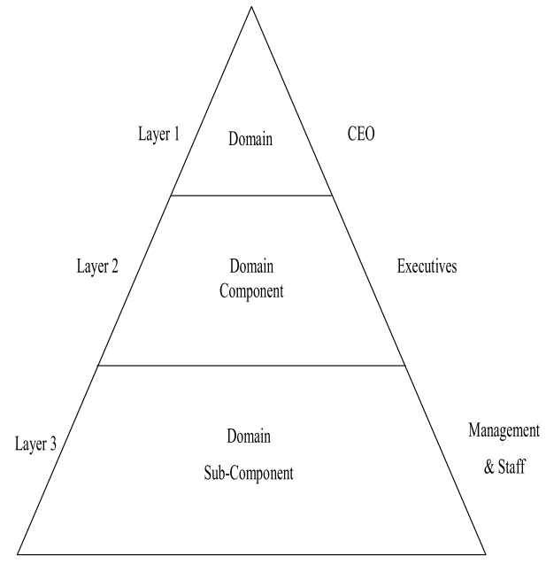
Figure 3.2 Example of Maturity Model Layers
Source: (de Bruin et al., 2005).
The supplementary layers can be proposed as relevant to the model subject and domain body of knowledge. Literature review can be another source to form the layered model on the basis of the previous verified works in the subject area.

Maturity Levels
Maturity levels connects the basic state to a well-developed mature stage that can describe logical, anticipated, or desired evolution and change path(s) as put by (Wettstein and Kueng, 2002). During the design phase, maturity levels should be identified and defined for the proposed model. In maturity model design, it is a common practice to give a number to each maturity stage and this number represents the maturity of that stage (i.e., stage 1= Maturity level 1) the next maturity stage will be represented as 2 and it means the next maturity stage which builds on the prerequisites from the previous stage (i.e., stage 1). This practice was initially presented by the CMM and found global acceptance later on. The total maturity stages may be different between models yet each level should be ultimately presented a clearly defined stage with a rational advancement through stages

Populate (CSFs selection)
Upon completion of the scope and design of proposed model, decisions related to the model content need to be made. The population phase main outcome is to identify what requires measurement within the assessment of maturity as well as how the measurement will be done.
An in-depth understanding of maturity is attained which enables efficient identification of articulated strategies of improvement by the identification of components of domains specifically for complex domains. Exploratory research methods, specifically the Delphi technique along with Nominal Group technique, case study interviews and focus groups are recommended for such application. The availability of resources as well as the stakeholders involved in the process of model development are certain factors on which the selection of the most suitable technique depends on.
Utilization of The Delphi method research helps in examining the consistency of the items of the maturity model. With the use of the Delphi method, the researcher may be able to make sure that any incomplete information was completed to avoid discrepancies in data analysis (Delbecq, A. L., Van de Ven, A. H., Gustafson, 1975). Moreover, Delphi search contribute to fine-tuned data as a result of anonymity, which enhanced the quality of the data collected for the study.
The Delphi method can be used in conjunction with multiple interviews to determine whether the items mentioned were consistent and widespread. The Delphi technique provided an opportunity for a number of professionals in the global area. Moreover, it was consistent with the current budget and available resources. It helped in identifying possible current problems.
Interviews are used to supplement the original design and to complete the already established ones and together with a complete list of the CSFs. The confirmation of selected materials from multiple evidence improves the extendibility of the final-stage growth factor. The main outcome from Delphi method is to achieve mutually exclusive and collectively exhaustive domain components and sub-components. In the following subsection explains how the final CSFs can be nominated and ranked. Over two steps of rating and weighing of the proposed list of sub domain components the CSFs will be shortlisted with weightages. This final subdomain components list will be the basis of the maturity level calculations.

Rating and weightage of the model components
A general list of the relevant sub-domain components shall be identified and arranged to be ranked (List A) in order to shortlist the CSFs (List C). The shortlisting will be done according to how each proposed sub domain component is relevant and important to achieve the maturity in the model subject the shortlisting will be carried out over several rounds of nomination by the selected panel of stakeholders (Stakeholders are identified in the scope phase).
STEP 1
The proposed sub domain components shall be voted in or out by the selected panel of contributing stakeholders to shortlist the most relevant components to the subject maturity model. The ranking can be done using Likert evaluation form as shown in Table 3.3.
Table 3.3: Likert Evaluation form
Source: (Salah, Paige and Cairns, 2014)
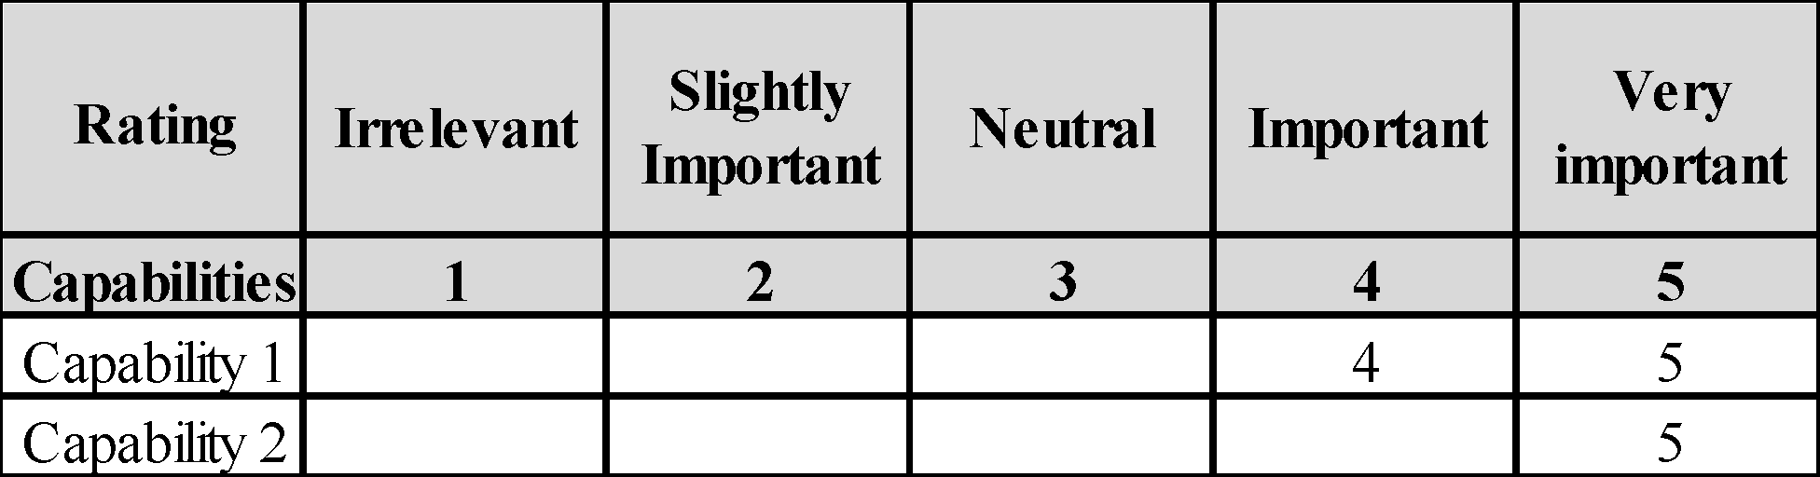
The following steps are typically how Delphi iterations are performed to achieve to the CSFs (List C)
- List A will be presented to the model development contributing stakeholders
- In round 1, all the proposed components (List A) will be ranked by each stakeholder
- Round 1 resolution will show the calculated average rank of each component
- A free round of discussion with the stakeholders on the results of round 1 to finalize the semi-final list
- All the low ranked subdomain components will be removed and a refined List B will be used for Round 2
- The same iteration will be done in Round 2 and List C will be achieved.
- The final nominated CSFs (List C) will be shared again with the stakeholders for feedback and confirmation
The final CSFs in List C will then be weighted in the following Step 2 to identify which components are more critical to achieve maturity.
STEP 2
In this step the nominated sub-domain components from the previous step will be rated by the experts according to their importance and criticality in subject maturity. This step is important in prioritizing the efforts in the analysis stage after the model implementation. The evaluator gives a numeric weight to each subcomponent so the accumulated maturity can be calculated. Each sub domain component weight represents how important this component can contribute in the maturity of the model subject. Table 3.4 shows sample of the weight results sheet.
Table 3.4 Sample results of weight allocation step
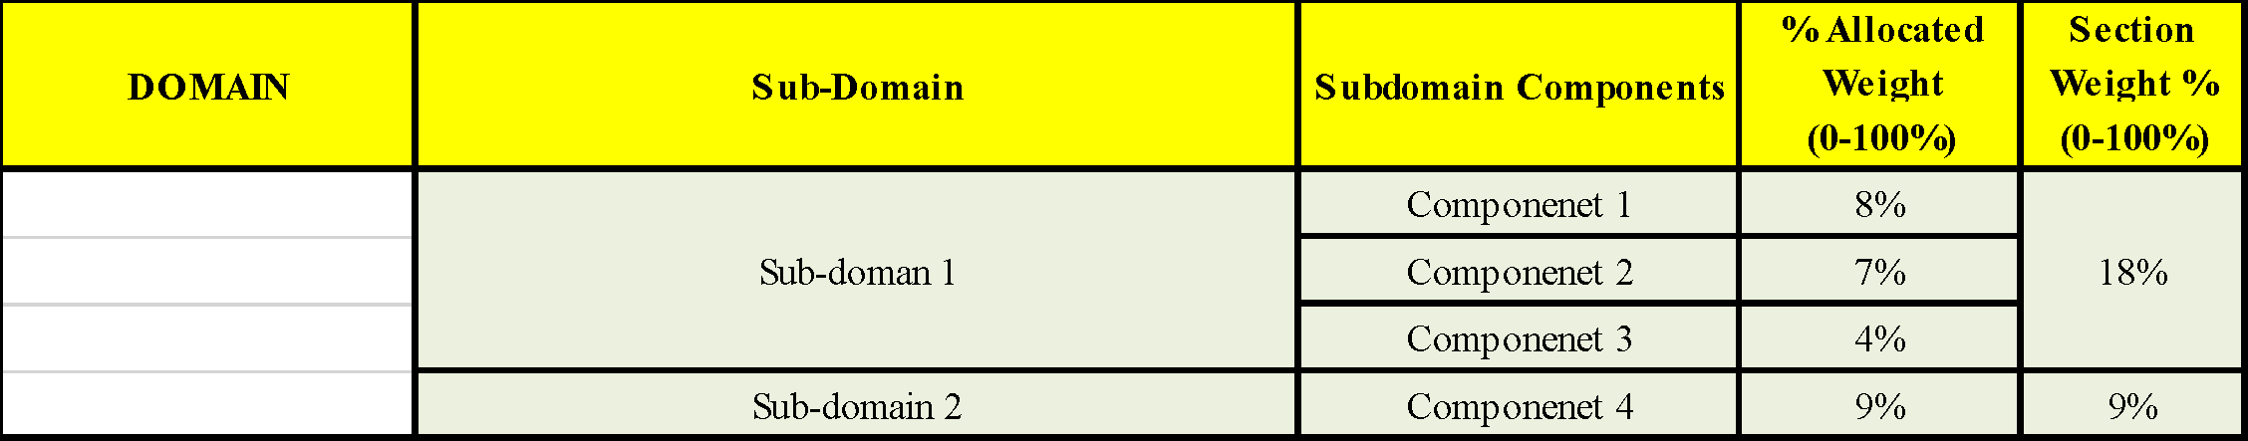
Table 4 shows an example of weightage of some subdomain components. As the example shows the domain is broken down into two further layers of subdomain and sub domain components. It is recommended for complex domains to identify domain sub-components. This extra detailed layer provides with the opportunity to develop assessment questions, allows for a richer analysis of the results of maturity and also facilitates improvements in the ability to present the results of maturity in a way which satisfies the target audience needs. Irrespective of the comprehensiveness of a literature review, it is unlikely to recognize adequate information to populate this detailed layer.
In step no.02, the weightage of each subdomain component will be allocated on the nominated sub domain components (List C) as per each component importance in the maturity subject as follows;
- Round 1: The model development stakeholders are asked to assign a numeric weighted value (%) for each component.
- All weightages will be combined in one table from all the stakeholders
- The average value of each component will be calculated
- The subdomain components will be allocated as per percentage of respective components
- The cumulative weightage and percentages of the model domain will be aggregated upstream on each sub domain level and assigned in the semi-final list
- Round 2: the semi-final list will be distributed with the stakeholders and comment or confirm on the list.
- The final list is generated as per the feedback from Round 2
Despite the fact that the MM is an assessment tool, it has to be evaluated too in order to ensure that tool (i.e., the MM) is fit for purpose. (Salah, Paige and Cairns, 2014). The final nominated CSFs will undergo the testing phase as will be discussed in the coming section.

Test (Evaluation)
After the model is populated, it is necessary to test the model for relevancy and rigorousness. Both the model construction and instruments need to be tested to ensure validity, reliability and generalizability (de Bruin et al., 2005). Maturity model testing phase focuses on three elements;
- The MM construct: the MM must be complete, simple, intuitive, easy to use, functional, functional, and user-friendly.
- The model instruments: the MM to be tested for validity and reliability [6].
- Maturity models should also emphasize essential qualities such that the model should be complete, simple, understandable, easy to use, operational, and efficient and its effect on the model audience
Testing manner varies between models, however, testing plays a vital role in maturity model development which supported the inclusion of the phase in a general framework.
Expert Evaluation form proposed by (Salah, Paige and Cairns, 2014) developed based on a comprehensive review of literature on design principles, promotion and analysis of growth patterns, and a review form designed to evaluate different assessment, design and equipment of a wide range. The following subsection elaborate the process of model assessment implementation to validate the model characteristics, such as flexibility, orderliness, and value.

Assessment Survey
In this sub section the assessment survey will be discussed. As soon as the primary MM is completed, it can be tested using a pilot evaluation survey to assess the reliability as well as expand the convergence of views and ultimately meet the design intentions. The survey function is to validate the proposed Model Construct and Instrument and ensure reliability.
The survey will be conducted in an interview set-up using the evaluation template and questionnaire (see table 3.5 and appendix).
The expert panel shall assess the proposed model in the following sequence;
- Assessor will be briefed about the study objectives and questions
- Assessor will be provided the model purpose, level definitions and nominated CSFs (the Internal Organization Capabilities) for review.
- Assessor will then use the evaluation template to rate the model “completeness, simplicity, understandability, ease of use, operationally, efficiency and impact on the environment and users”
- Assessor will be asked to answer the post survey questionnaire for additional feedback and recommendations.
Table 3.5 shows the evaluation template that will be used in this study model development Chapter 4 section 4.5 of this study as well as the appendix presenting the survey questionnaire.
Table 3.5 Model Evaluation Template
(Salah, Paige and Cairns, 2014)
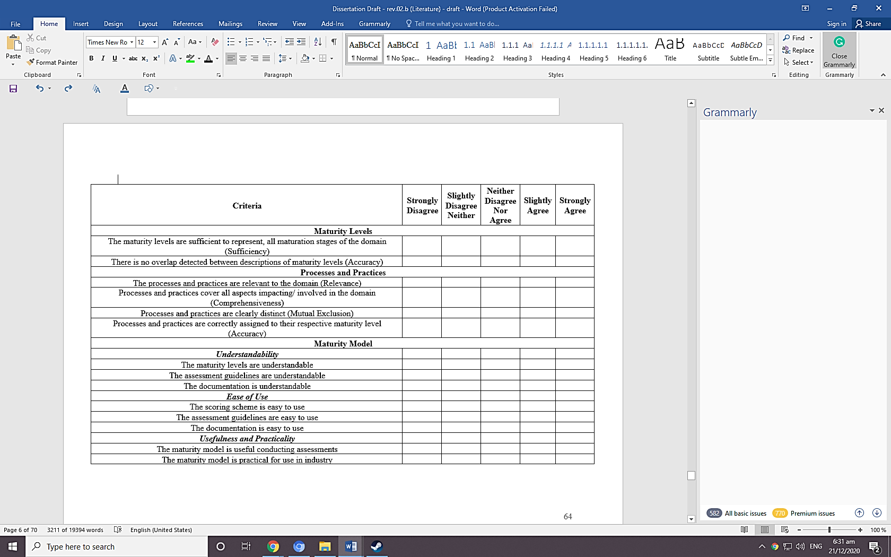

Deploy – Case Study
MM deployment means the actual model implementation with the selected “respondents”. Respondents are identified in the Design Phase. The main objectives of the deployment phase are to achieve global acceptance and standardize the model. Deployment can be done in collaboration with the initial model development stakeholders. (de Bruin et al., 2005) argued that achieving a broadly accepted model can be implemented by independent organizations is an enduring process regardless of the development model scope (domain-specific or general application). de Bruin et al., (2005) explained improving the scope definition needs to account for all the relevant parameters (use, industry, province, organization size, etc.) contribute positively to achieving a widely accepted model. The model applicability to various organizations as well as the ability to address the relevant entities that the model can add value to in the future implementation is the ultimate indicators of the model standardization and generalization.
Hence, in this phase, the proposed model should be applied on an actual organization case as relevant to the MM subject and the feedback should be recorded for improvement as per the market requirement. The following subsection elaborates about the model deployment conduction.

Conducting the assessment
Generally, the assessor who is conducting the assessment interview, shall follow the following sequence with the organization’s interviewees to implement the proposed model;
- the assessment starts with a briefing about the study objectives and the main outcomes expected from the research
- The respondents are provided with the following model assessment elements;
- The domain and sub domain components layers
- The definition of the four maturity levels.
- the definitions of domain and the sub domain components (CSFs)
- The maturity level criteria for each sub domain component
- The assessment score sheet
- The interviewee is asked to describe the maturity level of each sub domain component in light of the relevant maturity level definition/ attributes provided.
- The interviewee is asked to share an example that support their answer to make sure the selected maturity model is correct and mutually agreed on.
- In case that the interviewee does not have the particular knowledge about some domain component, they are requested to get the information from the relevant department with the supporting example.
- The level of maturity is then assigned for the particular sub domain component and move on the next component.
- After assigning the level of maturity for all the components, the calculations are carried out and then all scores are summarized
- Analyzing the score results and evaluating the organization maturity
- Proposing a recommendation with an action plan for the organization to improve the maturity level based on the current sub domain components’ maturity.

Maintain
The MM development framework aims ultimately to confirm the relevance of the model by maintaining the growth and implementation of the model. The main objectives from this phase are;
- Scale the model application
- Improve the model according to the feedbacks during scaling
- Achieve a universally acceptable standard model
Observably these objectives are logically dependent. In order to achieve a global standard model, the proposed model needs to be enhanced to cater for wider range of users and resolve different levels of the problem. That in turn entails a wide range of implementation across different organizations from various industries.
To achieve these objectives, it is suggested by (de Bruin et al., 2005) to involve additional resources. Resources are important to track interpolations from users and stakeholders along the maintenance phase. (de Bruin et al., 2005) added, resources may vary according to the model initial scope and accordingly some tools are suggested as follows;
- Training and certification for model implementation
- Web interface model to update the changes in domain
- Software development of the model versions

MODEL DEVELOPMENT
This chapter demonstrate the outcome of implementing MM model development phases as outlined in the methodology chapter 3. This developed MM is proposed to assess organizations readiness to adopt a SBM successfully. The following sections displays the customized development details in each phase as shown in figure 3.1.

Scope
The main outcome achieved in the scoping phase was to identify the external model implementation range. As highlighted in table 6 and elaborated below;
- The focus of the model: Specific domain; that is The ODC (Organization Dynamic Capabilities) for sustainability. The model scope is to assess the ODC for sustainability the model aims to contribute to addressing the literature gap in a specific domain that is ODC for sustainability to achieve a maturity model for sustainability to assess organizations readiness to transform their business model successfully to a sustainable business model while maintaining the organization resilience (table 4.1).
The domain is selected from desk research as relevant to the subject study. The literature review showed the there are no specific maturity models to assess organizational readiness to transform into a sustainable business model. Besides, the gaps of the available models in addressing (and proper testing) The ODC for sustainability (the domain) various issues. From the literature, it has been also established the need for more research to understand the SBM transition complications and to allow developing the domain capabilities as recommended by academic and professionals (de Bruin et al., 2005).
- The model development contributing stakeholders: a combination of academia in the field of sustainability and economy in addition to group of practitioners in the UAE engineering industry market from the operations and strategic management professions. Table 4.1 shows the purpose of the design that is to identify the subsidizing stakeholders who would contribute to the model development.
Table 4.1 Maturity Model Scoping phase outcomes
The major goal of this study is to develop a model particularly linking to the Organization Dynamic Capabilities domain which further enables organizations to better comprehend the transformation complexities occurring while converting a traditional BM into an SBM and hence allow for the enhancement of domain capabilities.

Design (Model Architecture)
This design phase builds on the successor scoping decisions to extend the framework and by applying the following designations as presented in table 4.2
Table 4.2 Maturity Model Design Decisions
For the proposed MM the following decisions were made (see table 7) as relevant to study to develop a maturity model to assess the readiness of organizations to transform into a SBM.
- Internal audience such as executives and management class are considered to use the model to assess the readiness to transform the BM. Internal management and executives are expected to benefit from this proposed model to analyze the Dynamic Capabilities required for the transition.
- The proposed model is considered as straight forward and does not require special tools to be conducted and hence the assessment can be applied by the organization staff, however it could be done through third party consultancy as well.
- The need of implementing this assessment is to identify the organization current maturity level as well as compare with other organization in the industry, hence the application drivers are considered both internal (self-check of the current status of the IOC) and external requirement (benchmarking and comparison with other organizations from the UAE engineering industry).
- The assessment respondents are suggested to be from the management class and business partners so they could answer the assessment questions in details as per their exposure level to different aspects of the business functions such as strategy, stakeholders’ management, value creation and investments in innovations.
- Finally, the application of this assessment is suggested to be carried out within one region of a particular organization business unit since each business unit may have different Business Model. Limiting the application to an individual business unit should allow for better analysis and accurate recommendations.
Further to the design selections, the following elements have been considered to fulfill the charted methodology

Maturity Layers
The outcome from the scoping phase, the Organizational Dynamic Capabilities was chosen as the focus domain of this model. Since the organization readiness to transform into a sustainable business model is a complex topic, the ‘stage-gate’ approach has been chosen to allow multiple domain maturity assessments. In order to provide a customized and practical assessment, this domain has been broken-down into additional layers (as shown in figure 4.2).
The literature of the Organization Dynamic Capabilities and sustainability, shows that; certain organizations adopt an SBM and these organizations are required to develop precise internal structural and cultural capabilities. These capabilities allow organizations to achieve sustainability at the firm level as well as promote collaboration among main stakeholders (Stubbs and Cocklin, 2008) as shown in figure 4.1.
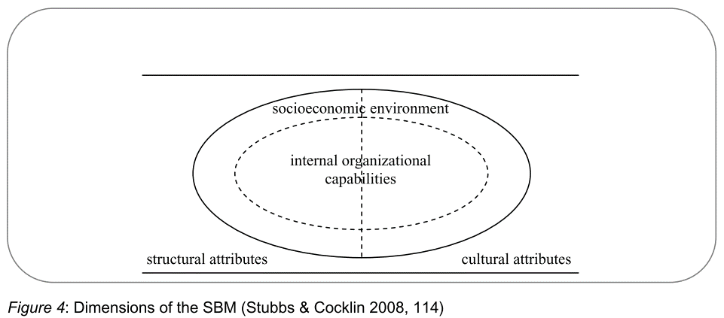
Figure 4.1 Dimensions of the SBM
(Stubbs and Cocklin, 2008)
Although internal capabilities of an organization allow significant progress in the direction of sustainability, it cannot be thoroughly achieved until the whole system of the organization acts sustainably. The structural and cultural attributes make up the socioeconomic system of an organization and changes to these attributes are vital to expedite sustainability at both the firm and system level. In view of that, as presented in Figure 4.1, the Organization Dynamic Capabilities for sustainability are defined as (the domain) where the top management outlines the strategy and sets business goals. The Domain is then identified by the maturity of discrete organization internal capabilities (domain components) where organization’s executives convert the principal strategy to the business model to generate and seize value. These domain components are broken down into (subdomain), which are in turn are assessed being the building blocks of the main pillars of the maturity model (subdomain-components), this layer where the operational activities take place to implement the business model

Sub domain components (Operation/ Execution level)

Internal Organization Capabilities (sub domain) - Executives (decision making)

sustainability mind set

stakeholder management (cultural)

Value creation

stakeholder management (structure)

supply chain

Innovation/ Technology

Performance management & reporting

OPERATION Management

Organization Dynamic Capabilities (Domain) - CEO level (strategy setting)
Figure 4.2 Maturity Model Layers
The three types of different spectators in each layer of the selected domain are shown in figure 4.2. After the first layer “domain” is identified, more elaboration will be done on the second layer “domain component” is the main layer which defines the mutually exclusive factors (critical success factors) that an organization’s maturity can be addressed. Layer 2 also defines which type of audience would be involved and could relate to the results of the assessment. The final layer (layer 3) is the “domain sub-components” which include the breakdown of the nominated critical success factors in more detail to allow pinpointing the required areas of improvements to achieve the maturity at the organization’s functions level.

Maturity Levels Definition
In this phase of the model development, maturity levels are identified. Four maturity levels are suggested for this model, to describe the maturity of the internal organization capability in the assessed organization. First level indicates the capability is hardly available and level four indicates that the capability is well established within the organization. The aggregation of each capability score shall indicate the overall readiness of the organization to transform successfully into SBM. The proposed maturity levels are adopted from the business analytics capability maturity model developed by (Cosic, Shanks and Maynard, 2012) which is based on the maturity scale introduced by “de Bruin 2009”, however, the proposed levels are limited to four levels only (see Table 4.3) for easier implementation by practitioners
Table 4.3 Maturity Level Definitions
(Cosic, Shanks and Maynard, 2012)
Maturity Levels | Definitions
Level 0 | Non-existent: this dynamic capability is not available within the organization
Level 1 | Initial: basic proof of the capability existence however, a lot of improvement is needed
Level 2 | Intermediate: the capability is well-developed however there is big chance for enhancement
Level 3 | Optimized: the capability is perfectly developed within the organisation and no further improvement is needed. At that stage, the capability can be called as fully mature

The individual levels’ definitions for each capability have been organization as per the nominated capabilities and represented in the following phase section 4.3.3.3

Populate (IOCs selection)
In this phase, the proposed IOCs (subdomain components) will be shortlisted and rated by the expert panel in order to achieve to the final nominated and weighted CSFs list. The Delphi method has been employed to ensure that the final list includes mutually exclusive and integrated components that are most relevant and important to Sustainable Business Model transition context. Henceforth, the main outcomes of this phase are as follows;
- What is required to be measured? The final nominated subdomain components list of the proposed IOCs. Also, the weightages of each internal organization capability as rated by the experts
- How the measurement process will be done: the score sheet is proposed and explained in the following section
From the previous phase, the domain has been identified as the dynamic capabilities for sustainability and the subdomain was identified as the internal organization capabilities (including structural and cultural attributes. The proposed list of IOCs was a product of the desk research in topics such as sustainability, SBM, Business Excellence, and Dynamic Capabilities. The following steps are the process of fine tuning of this list as relevant and important to the transition into a SBM prerequisites.

Rating and weightage of the model components
A general list (List A) of the relevant IOCs (sub-domain components) were reviewed by the experts (the model development stakeholders) to evaluate which internal organizational capabilities are most relevant and should be considered as the most critical and effective in the organization business model transformation to sustainability.
The evaluation has been achieved in two steps;
Step 1 – Capability relevant and significance
- List A (as shown in table 4.4) has been distributed with the expert panel
Table 4.4: The proposed sub domain components (List A)
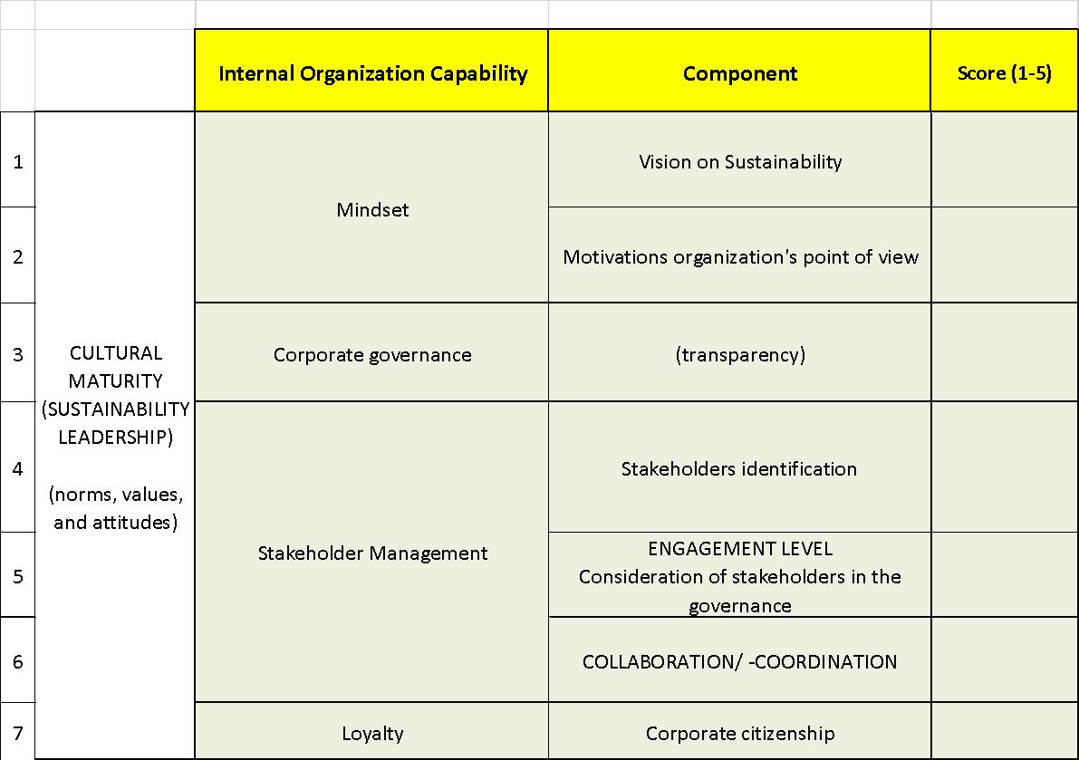
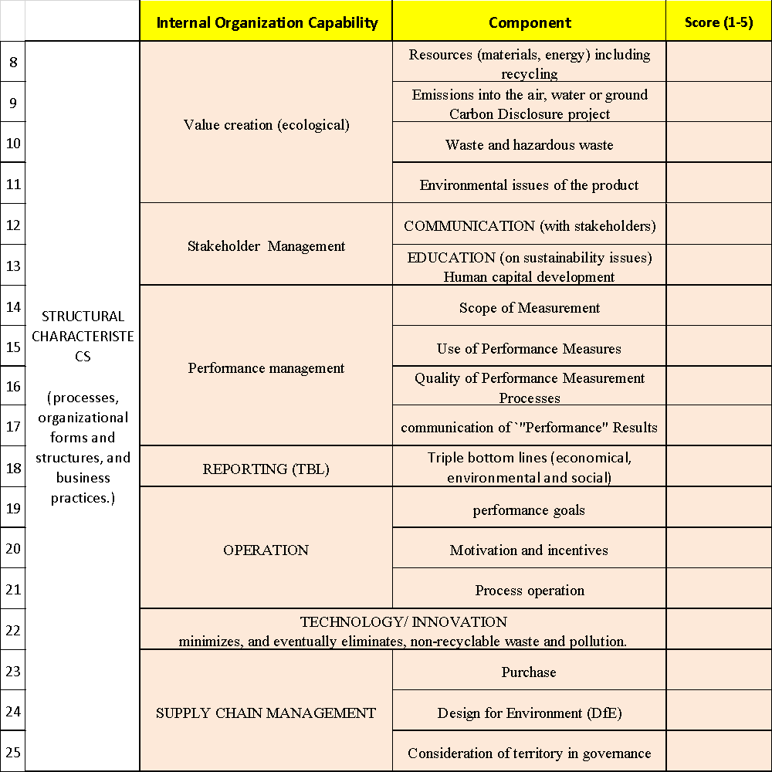
- In round 1, all the proposed components (List A) have been ranked by each expert separately
- Round 1 resolution will show the calculated average rank of each component (see table 4.5)

Table 4.5: Round 1 shortlisting Average results
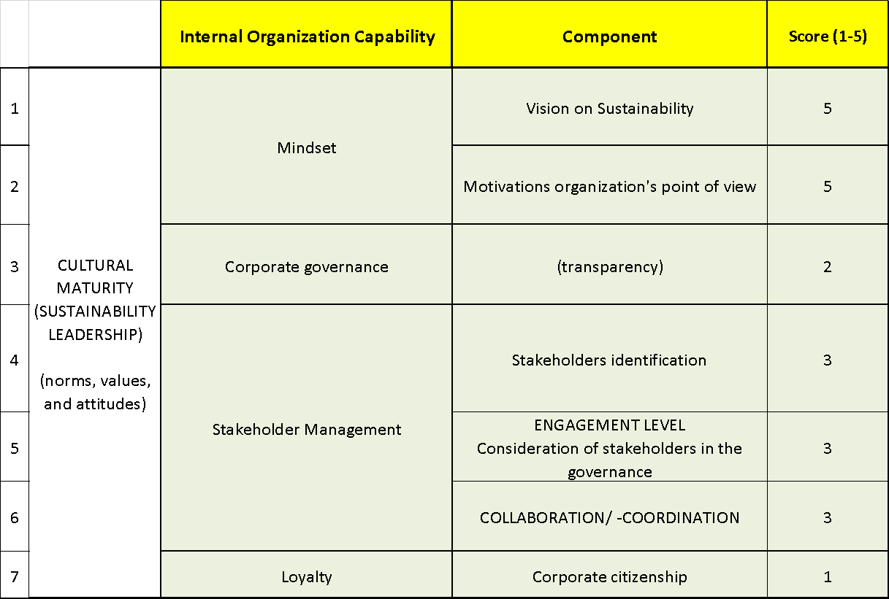
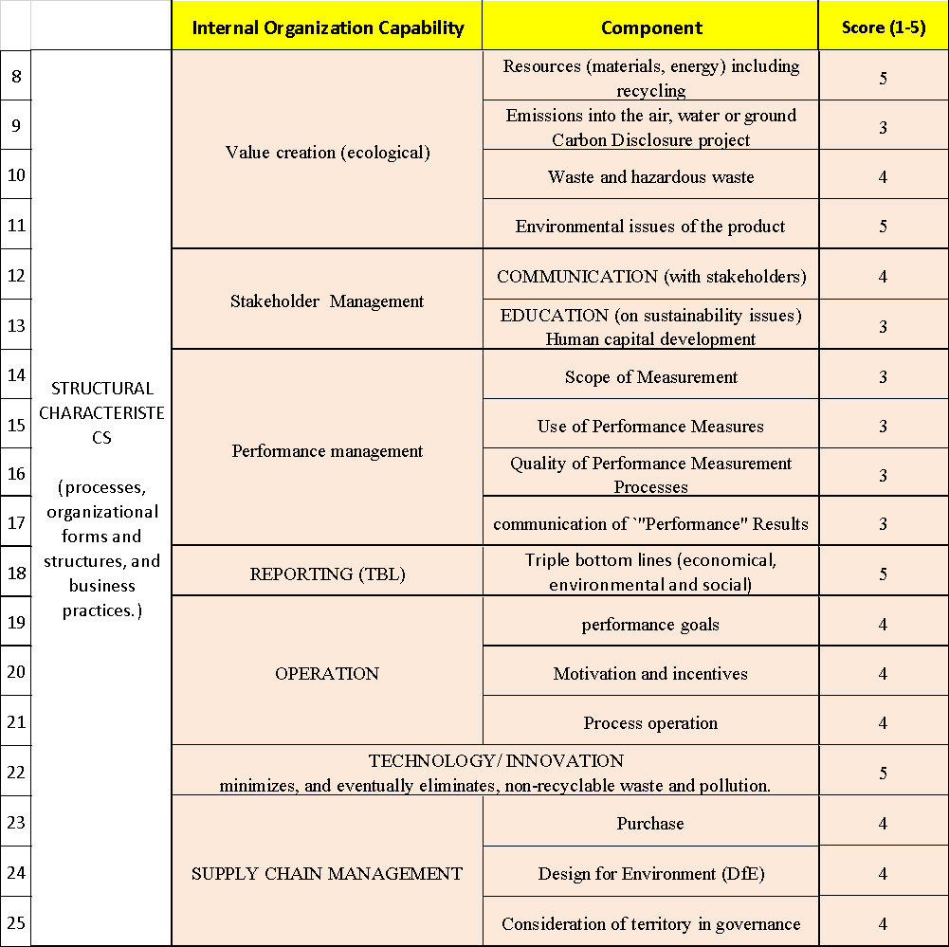
- The resolutions from the discussion with the experts on the results of round 1 were as below
- Triple Bottom Line Reporting capability is very important however it can be combined with Performance Management subdomain
- Some of the Stakeholders’ management subdomain components (i.e., communication/ collaboration and engagement) can be merged into a single component to simplify the model
- Corporate governance and transparency is not very relevant to the SBM transition and hence it can be removed
- Performance goals can be more relevant to the cultural attribute than structural
- Corporate citizenship and Locality are not very critical to the SBM transition and hence it can be removed
- Some of the Stakeholders’ management subdomain components can be moved from cultural to structural attributes as they fit better in this category.
- All the low ranked subdomain components will be removed and a refined List B will be used for Round 2
- The same iteration will be done in Round 2 and List C will be achieved.
- The final nominated CSFs (List C) will be shared again with the stakeholders for feedback and confirmation (See tables 4.6 & 4.7)
Typically, the quantity of domain components and sub-components is advised to be minimal to allow easy application yet it should be inclusive to cover all the relevant components are considered (de Bruin et al., 2005). For the proposed model, 8 subdomain components were identified from the literature and nominated by the practitioners and academia. Each domain component includes a maximum number of 4 sub-components with a total of 22 sub-components (List A, Tables 4.6 & 4.7) and (Figures 4.3& 4.4).

Table 4.6 The final nominated IOC – List C – Cultural attributes
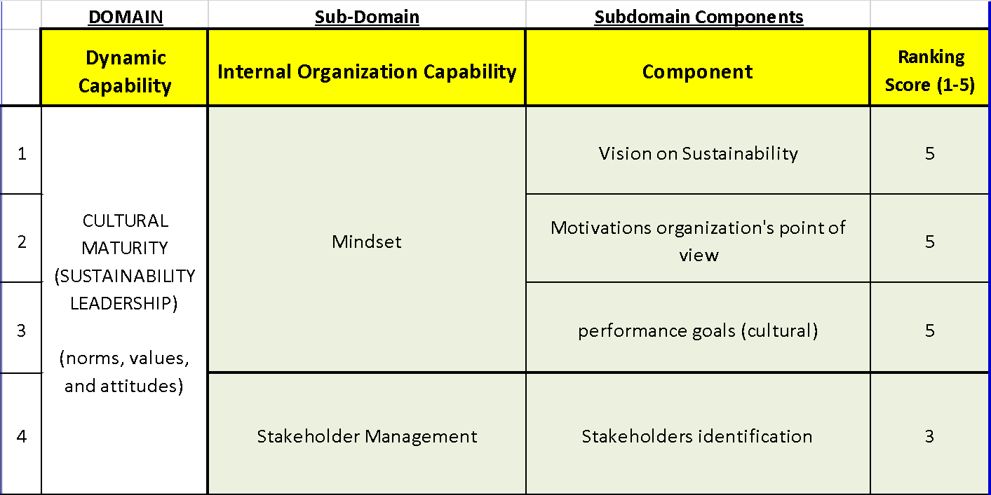

CULTURAL INTERNAL ORAGANIZATION CAPABILITIES
(Sub-Domain Compenents)

Mindset

Vision

Motivation

Performance goals

Stakeholdes Management

Identification
Figure 4.3 Cultural Internal Oraganization Capabilities

Table 4.7 The final nominated IOC – List C – Structural attributes
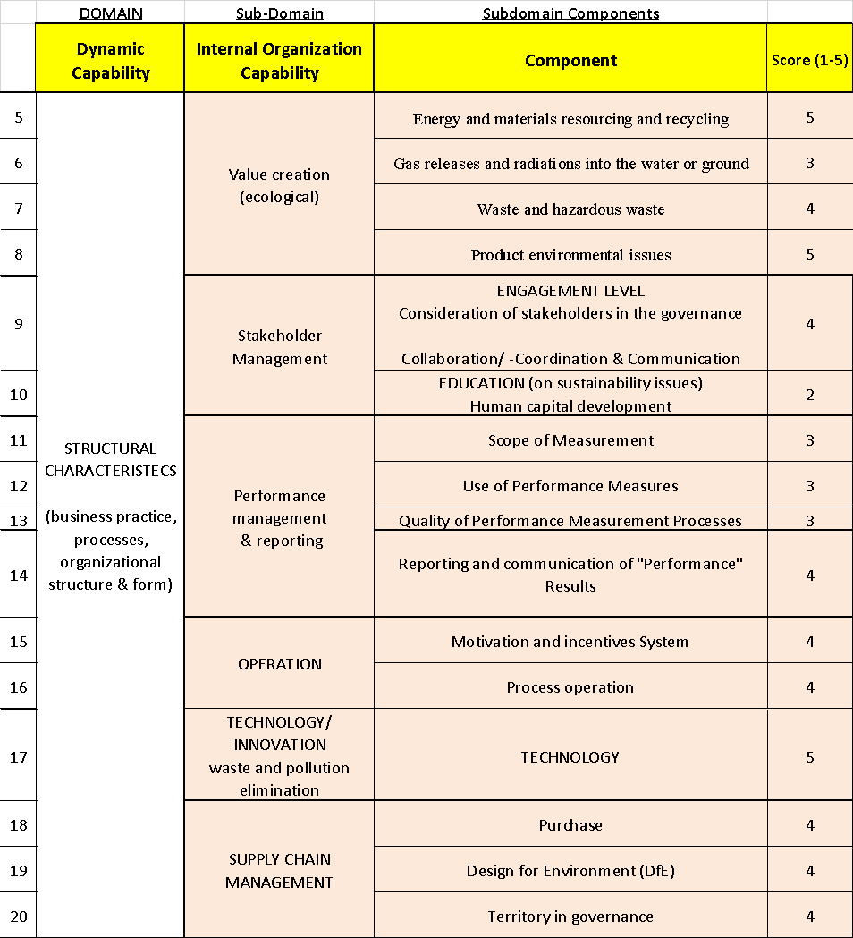

Figure 4.4 Structural Internal Oraganization Capabilities

STRUCTURAL INTERNAL ORAGANIZATION CAPABILITIES
(Sub-Domain Compnents)

Value creation

Resources (materials, energy)

Emissions

Waste and hazardous

Product environmental issues

Stakeholdes Management

Engagement

Education

Operation

Motivation and incentives System

Process operation

Performance

Scope of Measurement

Use of Performance Measures

Quality of Performance Measurement

Reporting and communication of `"Performance"

Technology

Innovation

Supply chain

Purchase

Design

Terirtorry Governance
Step 2 – Sub-domain component importance (weight allocation)
The outcome list (List C) of the most relevant capabilities nominated in the previous step will be reviewed to rank them from the importance and criticality point of view. The Organization’s internal capabilities weight allocation is distributed so all capabilities cumulatively complete 100%. The model has been reviewed by the expert panel from business professionals and academic and the average of all the results is presented in the following tables 4.8 & 4.9.

Table 4.8 Cultural Maturity Average results of Weight Allocation
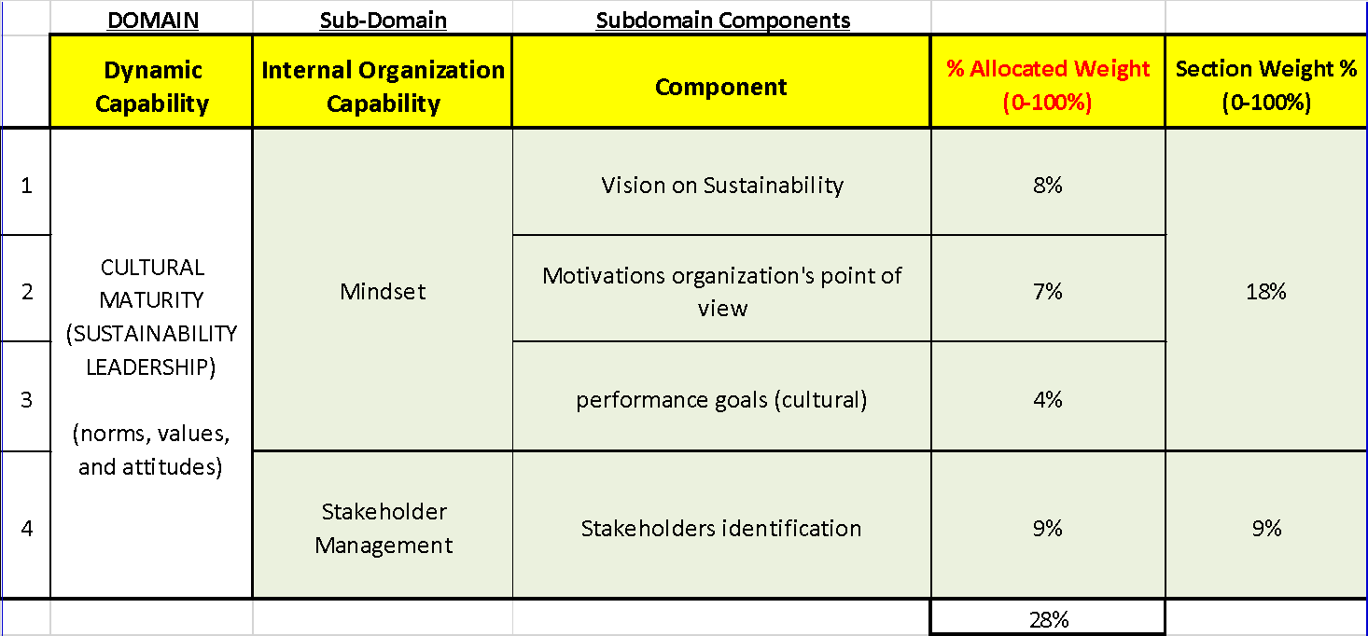

Table 4.9 Structural Characteristics Average results of Weight Allocation
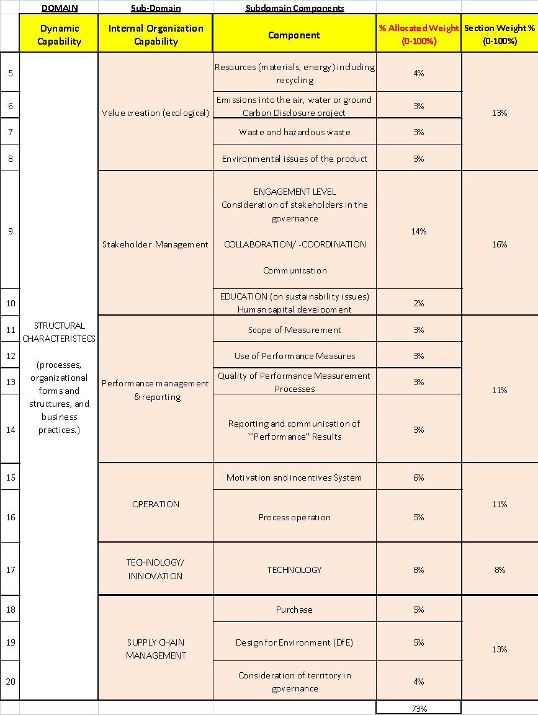
As the results show, the cultural attribute represents more than 25% of the capabilities as it includes the vision and motivation of the organization directors and shareholders. The majority of the required (as per the expert evaluation) can be categorized as structural attributes which have to do with the organization policy, streamline system in place (how the organization ensures the flow of the business processes)

Final Maturity Model IOCs (definitions)
The final rated and nominated IOCs are going to be discussed here as they represent the main elements of the proposed MM. There are two main domains under the domain of Organizational Dynamic Capabilities; the first domain is the cultural characteristics of the organization which includes the organization’s norms, values, and attitudes. The second domain is the structural characteristics which includes the organization’s processes, organizational forms and structures, and business practices. Furthermore, each subdomain component maturity levels definitions as per the four proposed maturity levels defined in section 4.2.2. The presented tables in this section can be shared with the organization conducting the assessment for self-assessment application as well.

Cultural attributes (sustainability leadership)
Cultural attributes include mindset and stakeholder management as presented in table 4.6 & figure 4.4. This subsection will provide some brief definitions of each sub domain component.
Mindset refers to the perceptions of the organization concerning sustainability, in that the goals of the organizations should be clear and precise to have a clear direction of where the organization is heading toward. The brief definitions of this subdomain components are gathered from literature (Van Tulder, et, al. 2013) in Table 4.10 Next table 4.11 presents the description of each maturity level of these components

Table 4.10 Definitions of the Mindset subdomain components
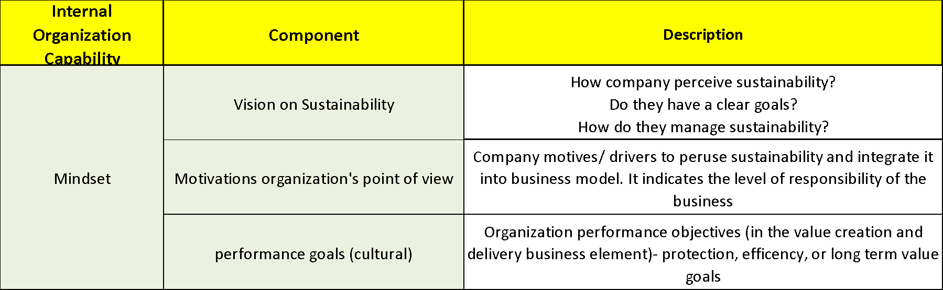

Table 4.11 Maturity Levels for Mindset
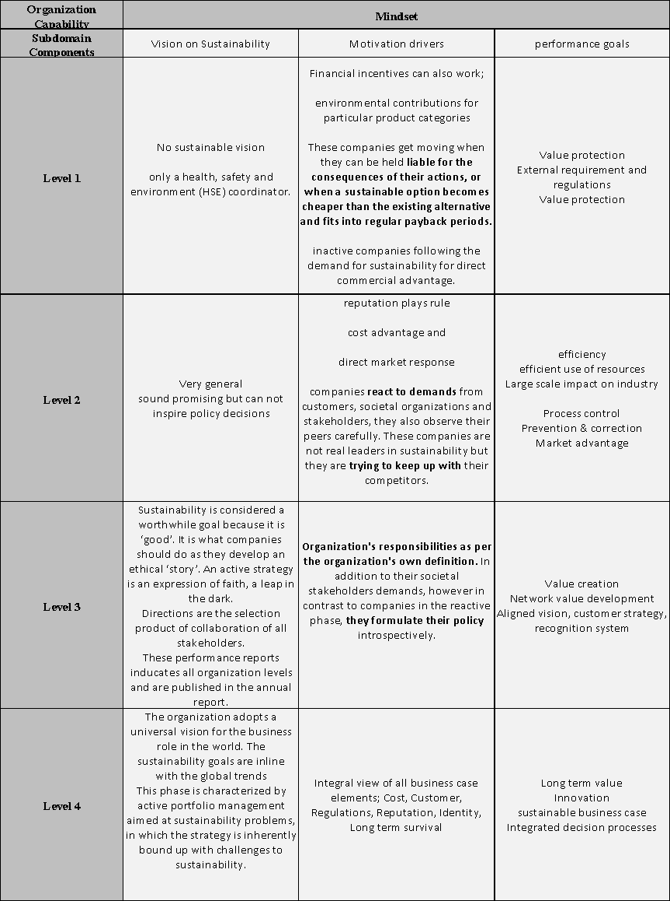
Stakeholder management in terms of cultural attributes relates to the people that are included as per the preferences of the organization management. The brief definitions of this subdomain components is gathered from literature (Baumgartner and Ebner, 2010) and (Van Tulder, et, al. 2013) in Table 4.12 Next table 4.13 presents the meaning of each maturity level of these components
Table 4.12 Definition of Stakeholder Management subdomain component
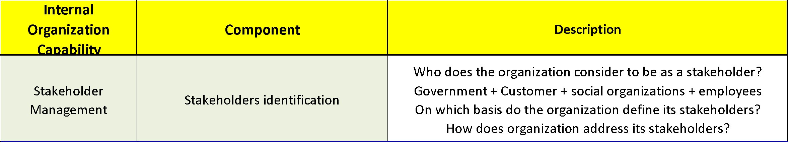
Table 4.13 Maturity Levels for Stakeholder Management
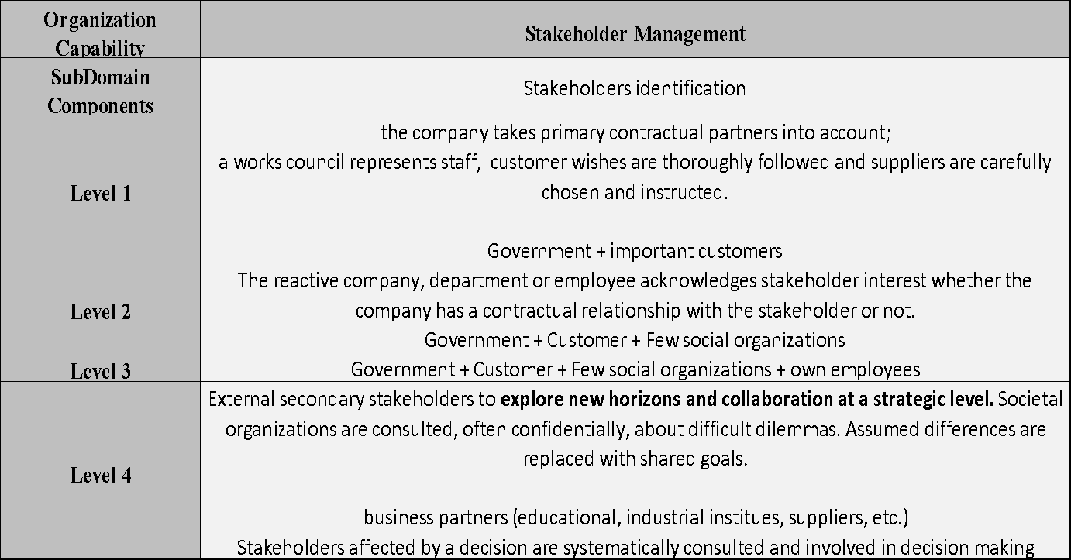

Structural attributes
Structural characteristics or attributes involve various sub-domains (see table 4.7 & figure 4.4) also characterized as internal organizational capabilities. The internal capabilities of an organization under structural attributes include value creation, stakeholder management, performance management, operation, technology/innovation and supply chain management. Following part of this subsection each subdomain will be elaborated.
Value creation Sub Domain involves the management of resources, emissions, waste and the life cycle of products. In order to adhere to value creation, certain laws need to be complied with. That further enables in effective waste management. Moreover, the design of a product is required to be in alignment with the environmental considerations to allow companies to create for themselves values in the eyes of customers. The brief definitions of this subdomain components are gathered from literature (Baumgartner and Ebner, 2010) in Table 4.15 Next table 4.16 presents the description of each maturity level of these components

Table 4.14 Value Creation components definitions
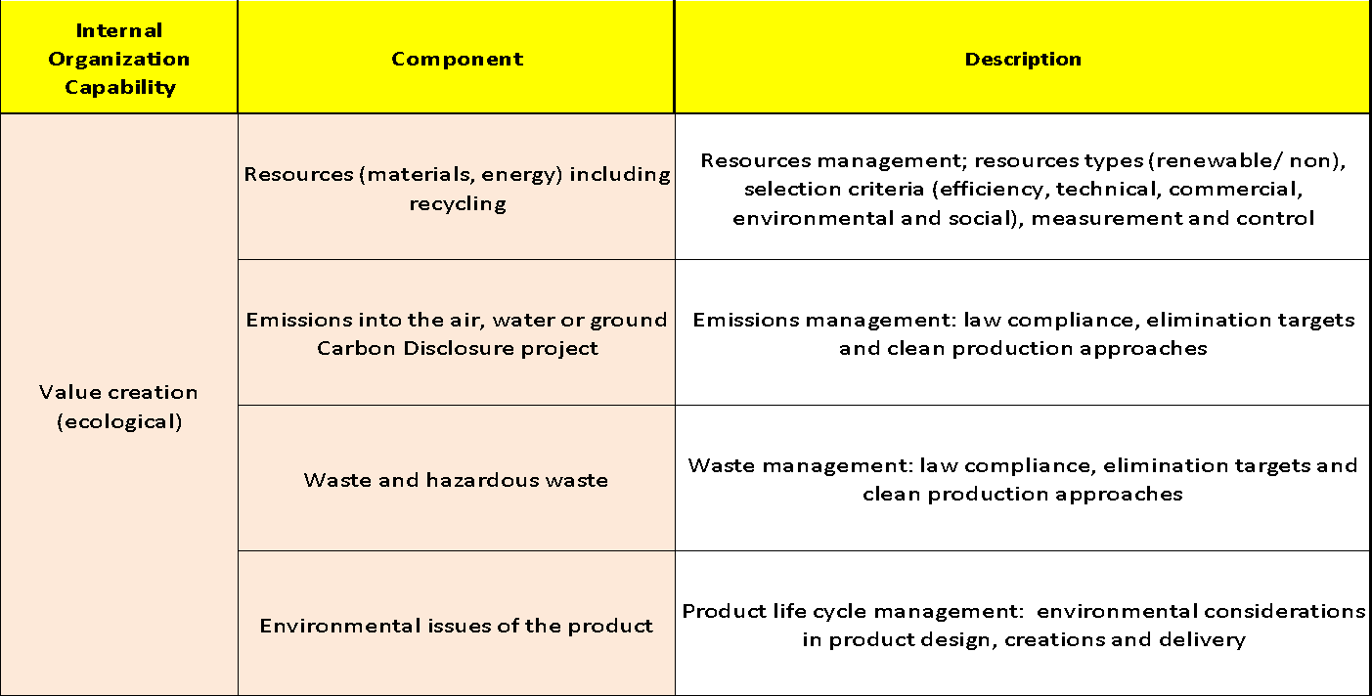
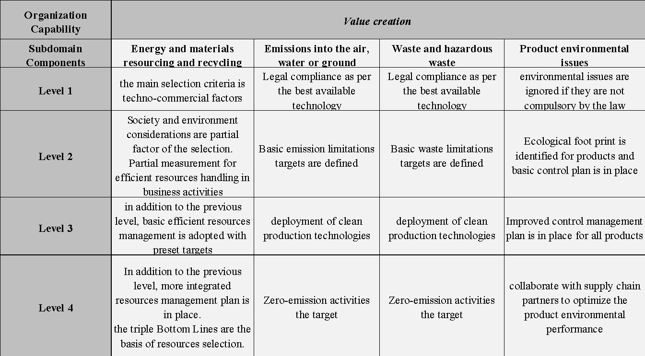
Table 4.15 Value Creation components maturity levels definitions

Stakeholder management Sub-Domain, organizations are required to constantly coordinate and communicate with potential stakeholders to increase awareness concerning sustainability issues as well as educate them about how sustainability can be achieved and is relevant to the organization. The brief definitions of this subdomain components are gathered from literature (Baumgartner and Ebner, 2010) and (Van Tulder, et, al. 2013) in Table 4.16 Next table 4.17 presents the description of each maturity level of these components
Table 4.16 Stakeholders Management components
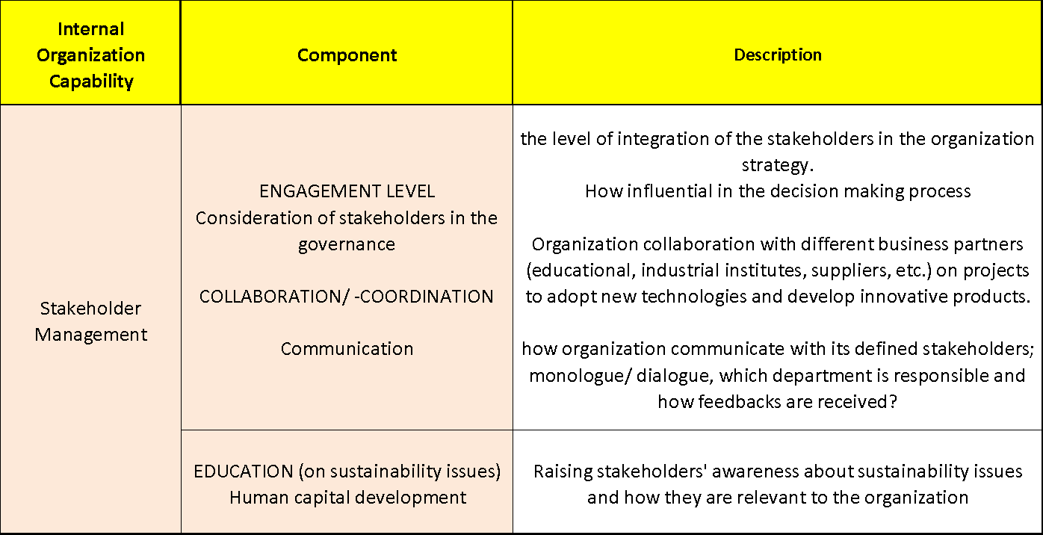

Table 4.17 Maturity Levels for Stakeholder Management
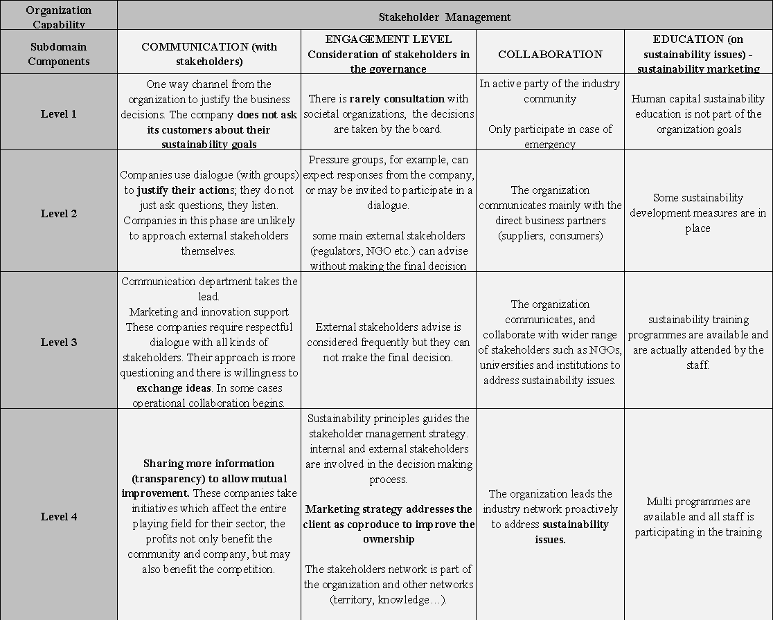
Performance management Sub-Domain relates to the concept of incorporating sustainable measures into business operations such as decision-making, research and internal communication among many other areas together with reporting the outcomes of certain included measures. Through performance measurement, organizational leaders and managers can devise corrective actions to rectify possible mistakes as a result of irrelevant decisions. The brief definitions of this subdomain components are gathered from literature (Baumgartner and Ebner, 2010) and (Wettstein and Kueng, 2002) in Table 4.18. Next table 4.19 presents the description of each maturity level of these components

Table 4.18 Performance management and reporting components
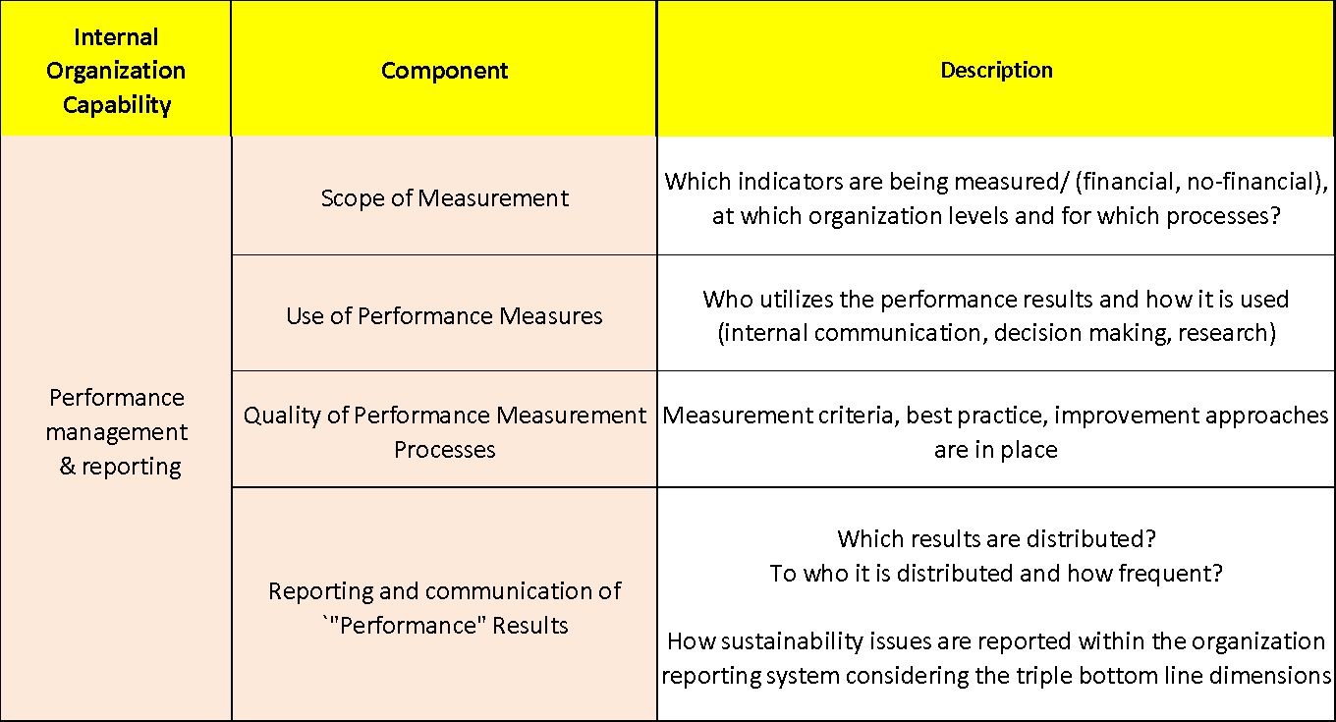
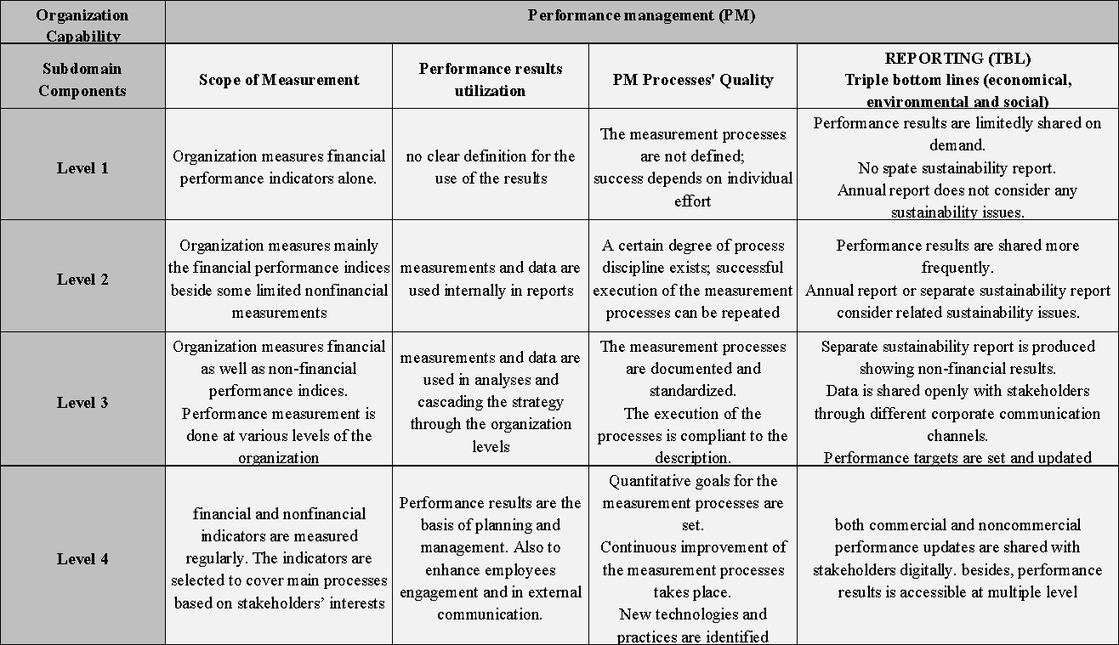
Table 4.19 Maturity Levels for Performance Management

Operation subdomain: How organization carry out business activities on the day-to-day scale on different levels and how far sustainability concepts are embedded in such activities. What are the incentive scheme is in place to motivate employees to commit to such culture.
The brief definitions of this subdomain components are gathered from literature (Machado et al., 2017), (Baumgartner and Ebner, 2010) and (Cagnin, Loveridge and Butler, 2013) in Table 4.20. Next table 4.20 presents the description of each maturity level of these components
Table 4.20 Operations components
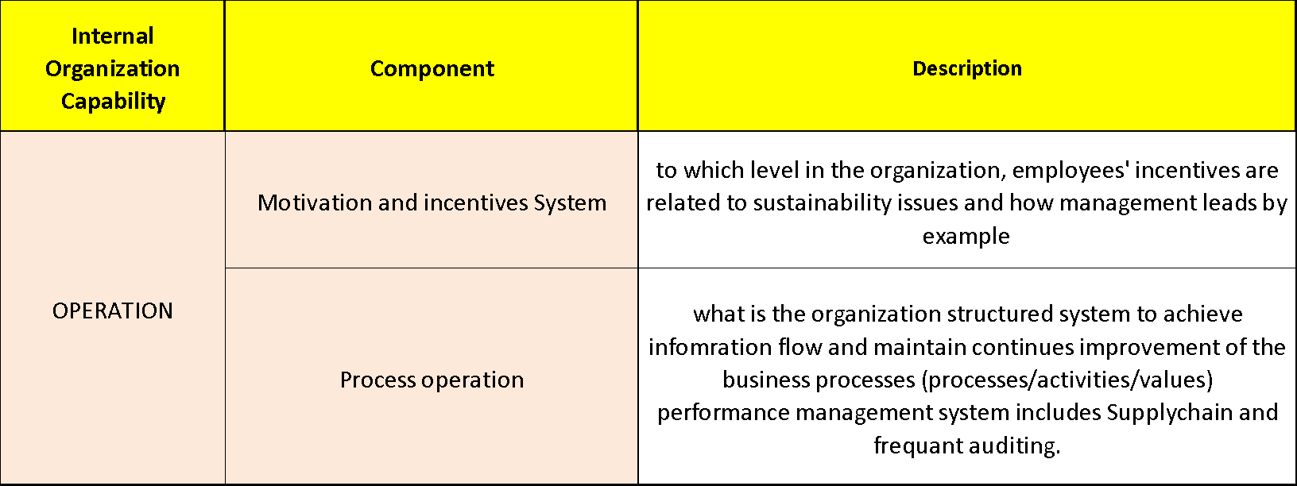
Table 4.21 Maturity Levels for Operation
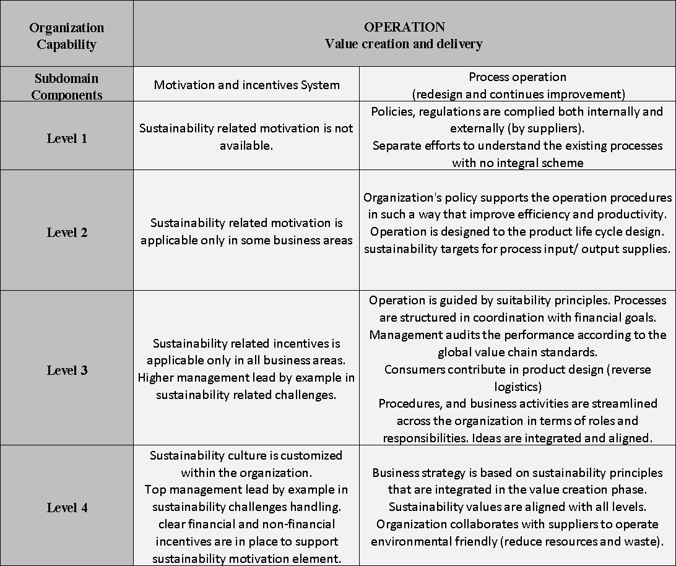
Technology/Innovation entails investments in the department of Research and Development. This allows for the attainment of sustainable solutions through innovative initiatives which ultimately contribute to cleaner production. The brief definitions of this subdomain components are provided in Table 4.22. Next table 4.23 explains the description of each maturity level of these components
Table 4.22 Innovation components
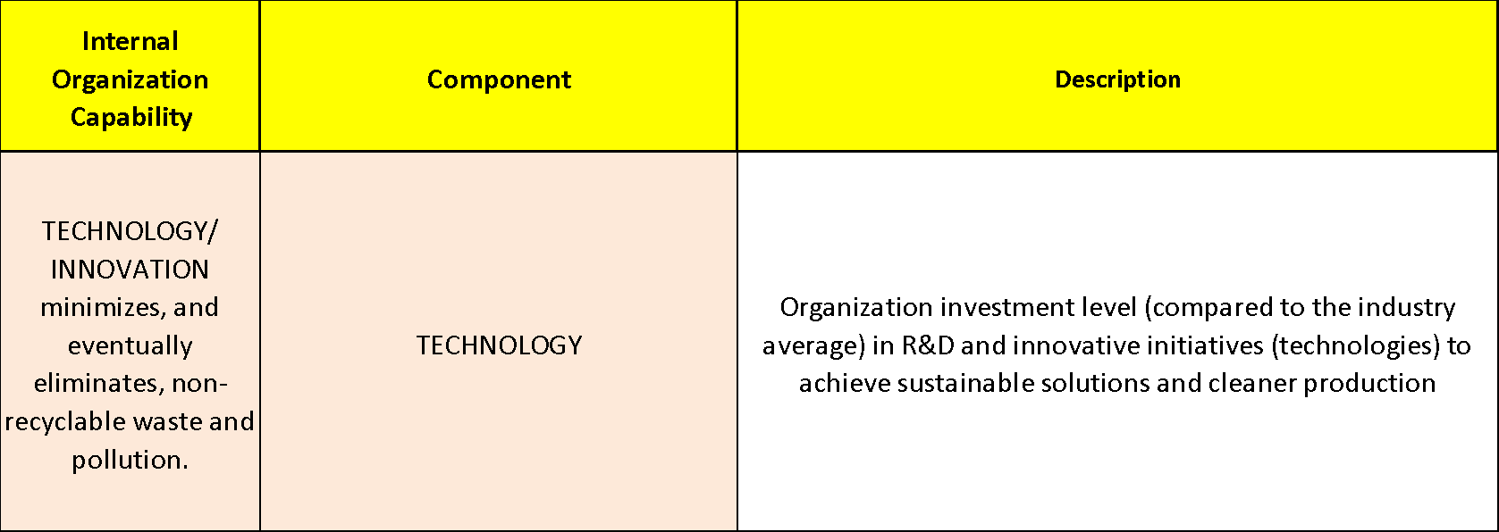
Table 4.23 Maturity Levels for Technology/ Innovation
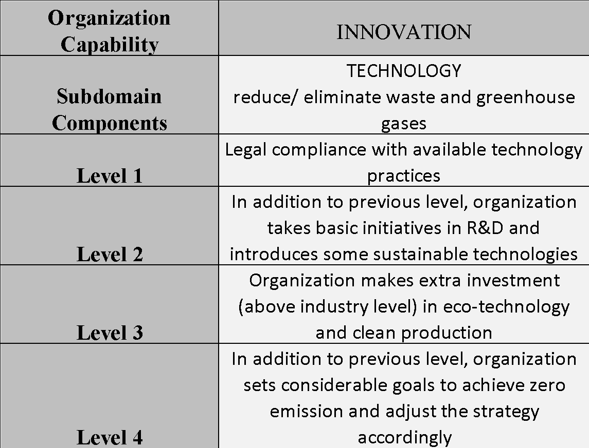.
Supply Chain Management: With respect to supply chain management, it is noted that suppliers are required to invest in materials that are environmentally and socially friendly. This will further aid in the involvement of suppliers in the proper designing and manufacturing of the product considering the environmental footprint. The brief definitions of this subdomain components are provided in Table 4.24. Next table 4.25 explains the description of each maturity level of these components
Table 4.24 Supply Chain components
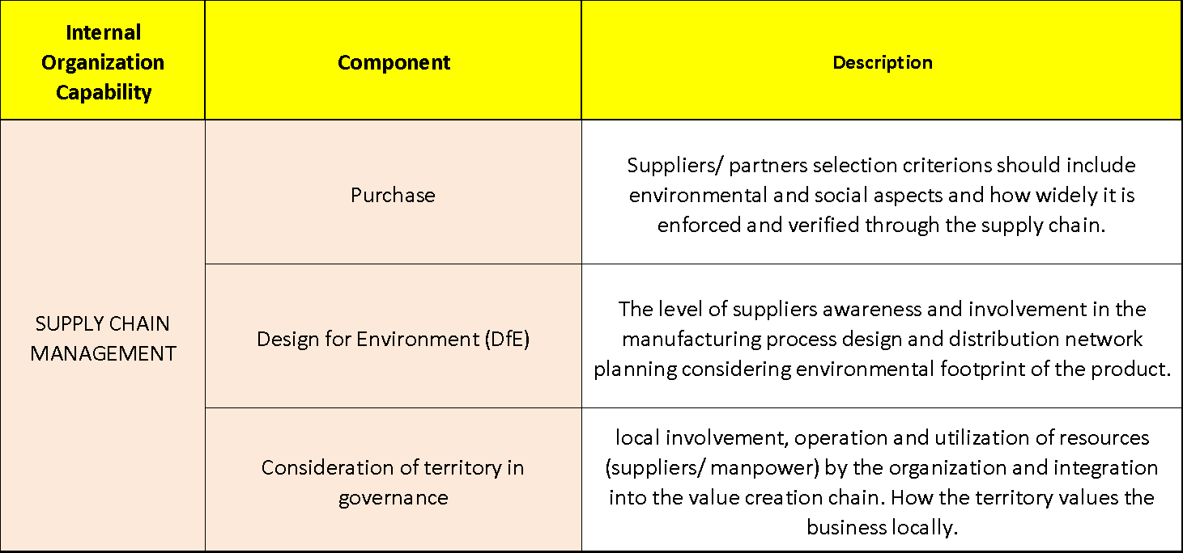

Table 4.25 Maturity Levels for Supply Chain Management
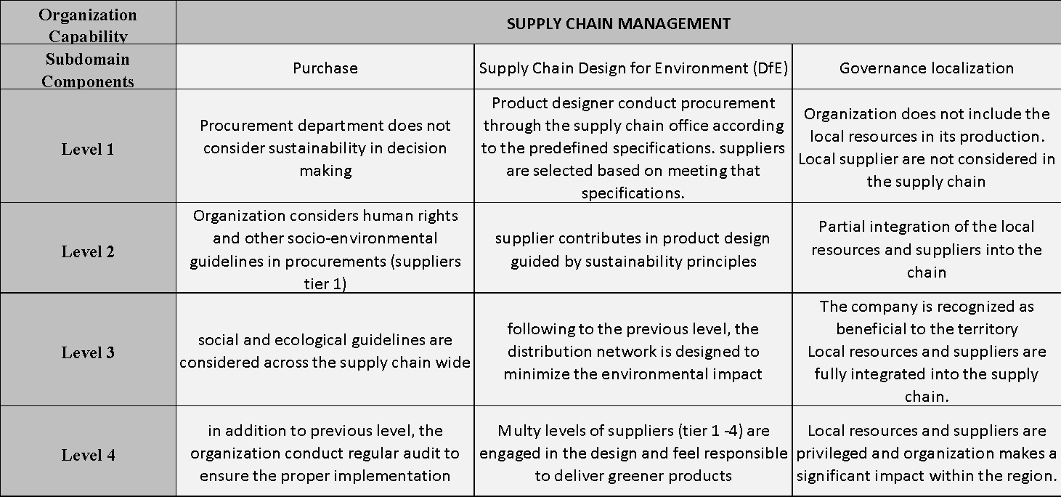

Scoring Sheet Sample
A score sheet is proposed to carry out the assessment of the proposed model. The score sheet provides a tool to implement the assessment practically; evaluate the level of maturity for each subdomain component and aggregate the score to the whole domain covering all the organization’s internal capabilities. This score sheet has been fine-tuned with the model respondents as per the interviewees’ comments and the final proposal will be discussed in this section.
- Assessment score sheet template
The assessment score sheet empty template is shown in table 4.26. that is the template that will be handed out to the assessors to conduct the maturity level assessment.

Table 4.26 Assessment score sheet template
- Structure of the sheet
The structure of the assessment sheet is elaborated in the following table 4.27. each column is described and the calculation formulars are provided.

Table 4.27 The score sheet columns definitions
Internal Org. Capability |  |  | the Domain
Sub domain components |  |  | The final nominated 22 IOCs components
Maturity levels (0-3) |  |  | Non existence
 |  |  | initial
 |  |  | intermediate
 |  |  | optimized
Example |  |  | A demonstration of the available level of maturity for each IOC
Recommendations |  |  | A dedicated recommendation to improve the maturity level of a particular IOC
A | Score (0-3) |  | the actual score of the evaluated IOC as per the current maturity level
B | % Allocated Weight |  | the allocated weightage in percentage as recommended by the experts in the population phase
C=A*B | Cal Score |  | The calculated score that is the product of the actual score into the allocated weight percentage.
D=B*3 | 3 of 3 |  | The allocated weight into the maximum maturity score for any IOCs (i.e., 3).  This will be used as denominator in the next calculation.
E=C/D | % Calculated Score |  | The summation of actual calculated scores for all subdomain components in this section. This score represents the maturity level in percentage %
F= B1+B2+B3 | Allocated Subdomain Weight % |  | the allocated weightage in percentage as recommended by the experts in the population phase
G= C1+C2+C3 | Subdomain Cal. Maturity (out of 3) |  | The summation of actual calculated scores for all subdomain components in this section. This score represents the maturity level with respect to 3 as the maximum level
H= Et*F | Calculated subdomain Maturity | % of section weightage | The product of the actual score into the allocated score in %
K=C/D | Calculated subdomain Maturity | overall % | The calculated score in percentage.
L=F-H | Development range | Development range | The difference between the calculated and allocated maturity (out of 3)
M=L/F | Development range | overall % | The difference between the calculated and allocated maturity (represented in %)

- Calculation principles
The total score of all the mature subdomain components is 3 out of 3 given that the maturity levels range from 0 to 3 (i.e., 0, 1, 2 & 3). Hence there are two ways in representing the score (S);
- Subdomain score in terms of the maturity levels scale (0-3), 3 being the maximum score for the matured subdomain component (i.e., Level 4). S1, S2 … and Cumulative S out of 3 for the overall internal organization capabilities domain. This score representation might be difficult in interpretation by higher management level without understanding the structure of the model and the score sheet details.
- Subdomain score in terms of to the allocated weights. For example, if the subdomain allocated weightage is 18%, and the actual subdomain components’ maturity score cumulatively is 13%, that means this subdomain component lacks around 5% of improvement to reach to the top score (18%) of maturity for this particular subdomain. The percentage representation of that score (13% out of 18%) is 72% if one wants to understand the absolute meaning of this 13%
- Calculation example
In the following example presented in table 4.28, only one subdomain is presented to demonstrate the scoring process and the necessary calculations. In this sample, the evaluation results to the maturity level assessment for the particular subdomain component is filled manually in the “Score (0-3) column A.
Column B shows the previously allocated weightages for each subdomain component (i.e., internal organization capability) and summation of all these subdomain components (vision, mission and performance) weights is shown in column F (18%=8%+7%+4%).
Column C is the product of columns A*B (2*8%) is the calculated maturity score for this particular subdomain component (0.16). hence the maturity score of the “vision on sustainability” is 0.16. The vertical summation of column C (0.39) represents the subdomain maturity score the same is presented in column G.
Table 4.28 Cultural Maturity Subdomain Score
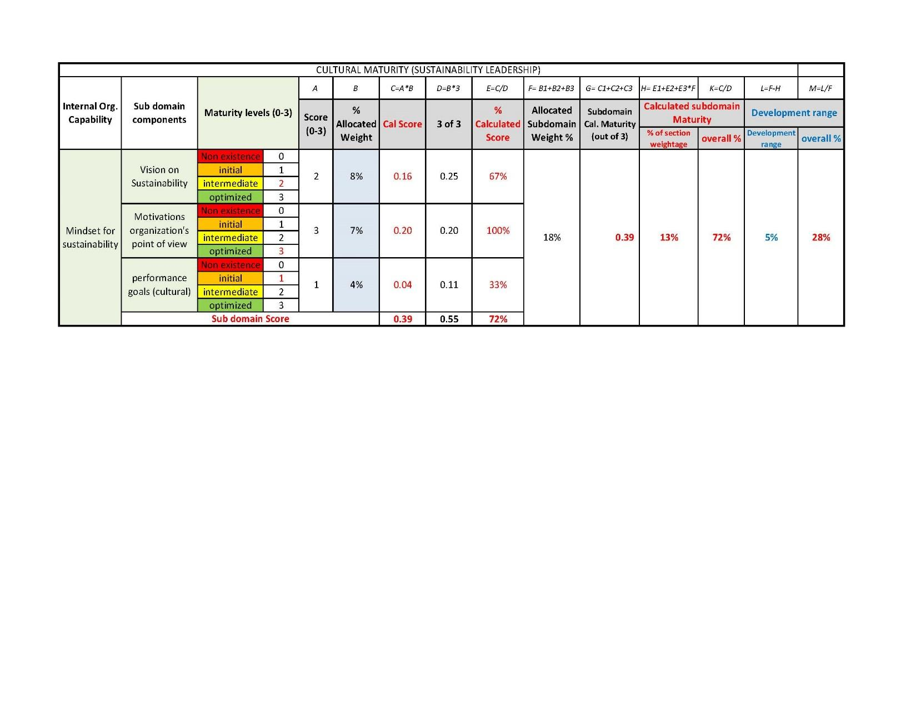
To represent the individual subdomain component maturity number (column C) with respect to the subdomain complete maturity, this maturity score should be divided over the total subdomain section score (Column D, i.e., 0.25) and hence the calculated maturity percentage for this subdomain component is 0.16/0.25= 67%. To calculate the subdomain maturity percentage level simply the summation of column C divided by the summation of column D (i.e., 100* 0.39/0.55=72%) this is presented in column K. Column K is easier to be understood by higher management levels and simpler in presentations of the maturity level of a particular subdomain, and hence it shall be used in the overall score sheet summary.
Column H shows the maturity score for the subdomain level out of the allocated weightage (i.e. 18%) by multiplying the subdomain maturity percentage level (column K) into the total allocated weightage column F (i.e. 72%*18%= 13%).
The last two columns helped assessor pinpoint the development areas. Column L is the difference between the complete maturity score allocated for this subdomain and the actual calculated score as per the current organization maturity (i.e., 18%-13%=5%). Column M is the presentation of column L in percentage (L/F) for easier understanding by higher management levels
The final score summary block will include the following
- Assessment Summary block
In this block, the calculated scores for all subdomains in the score sheet will be summarized in order to be analyzed. The summary results of the sub-domain maturity level score is arranged in both views
- The overall maturity scale (0-3) and
- The percentages (for easier representation and understanding).
The difference between the component allocated weight and the score based on the actual assessment is provided to show the variance before commencing the transition stage. The summary of the all-sub-domain components’ maturity levels are presented in table 4.29.
Table 4.29 Score Summary Block
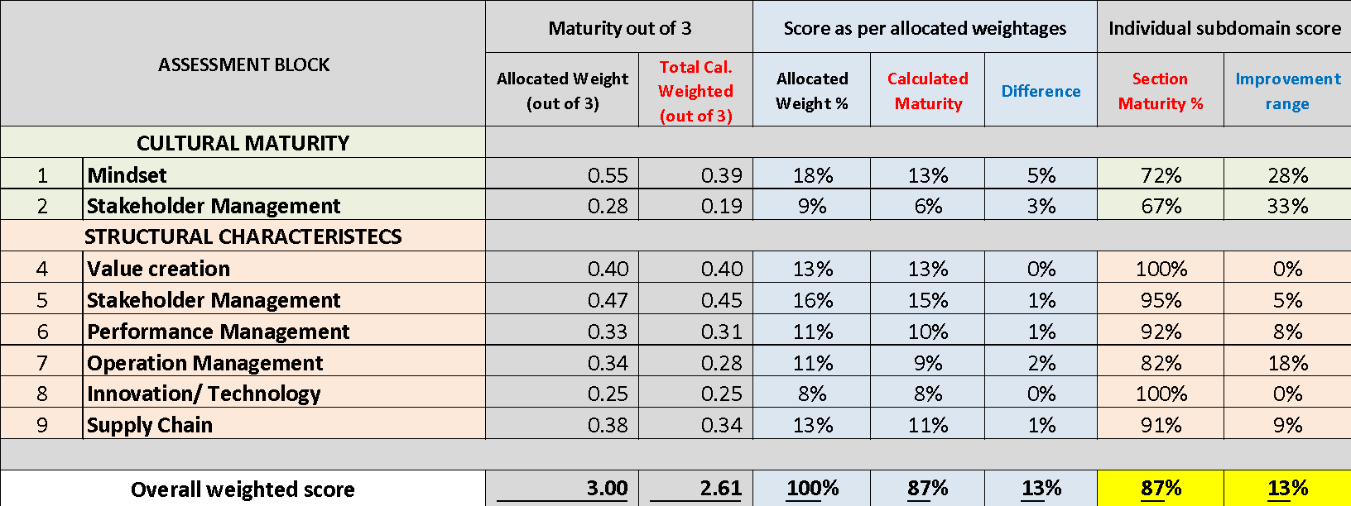
The table summarizes the results from two perspectives;
  - The maturity of the sub-domain component in relation of the overall score of all the sub-domain components (out of 3 or out 100%) (i.e., 9% out of 11% for the operation management) and
  - ii) the individual maturity score within on specific section (or sub domain) i.e., 82% out of 100% for the operation management)
The summary block also provides details about the possible range of improvement for each assessed subdomain component (i.e., IOC). (The operation management can be improved by 18% to achieve maturity in this subdomain component)

Testing (Model Evaluation)
As concluded from the scoping stage, the selected stakeholders as expert panel including business academics and engineering professionals were invited to evaluate the proposed model overall. The assessment has been conducted in interview set up to get an in-depth feedback (see appendix for interview questions). The assessment survey conduction will be done as per the sequence elaborated in the Methodology chapter 3, section 3.4.1 with the following briefings;
- The Scope is defined in section 4.1
- The maturity level definitions are presented in section 4.2.2
- Nominated Internal Organization Capabilities as CSFs are presented in section 4.3.2
- Assessors evaluated the above results using the evaluation template (table 3.5)
- The average cumulative results for the construction of the model are shown in section 4.3.1
- General feedback is presented in the following results title.

Evaluation results
The average cumulative results for the construction of the model are shown in Table 4.30
Table 4.30 Model Evaluation Results
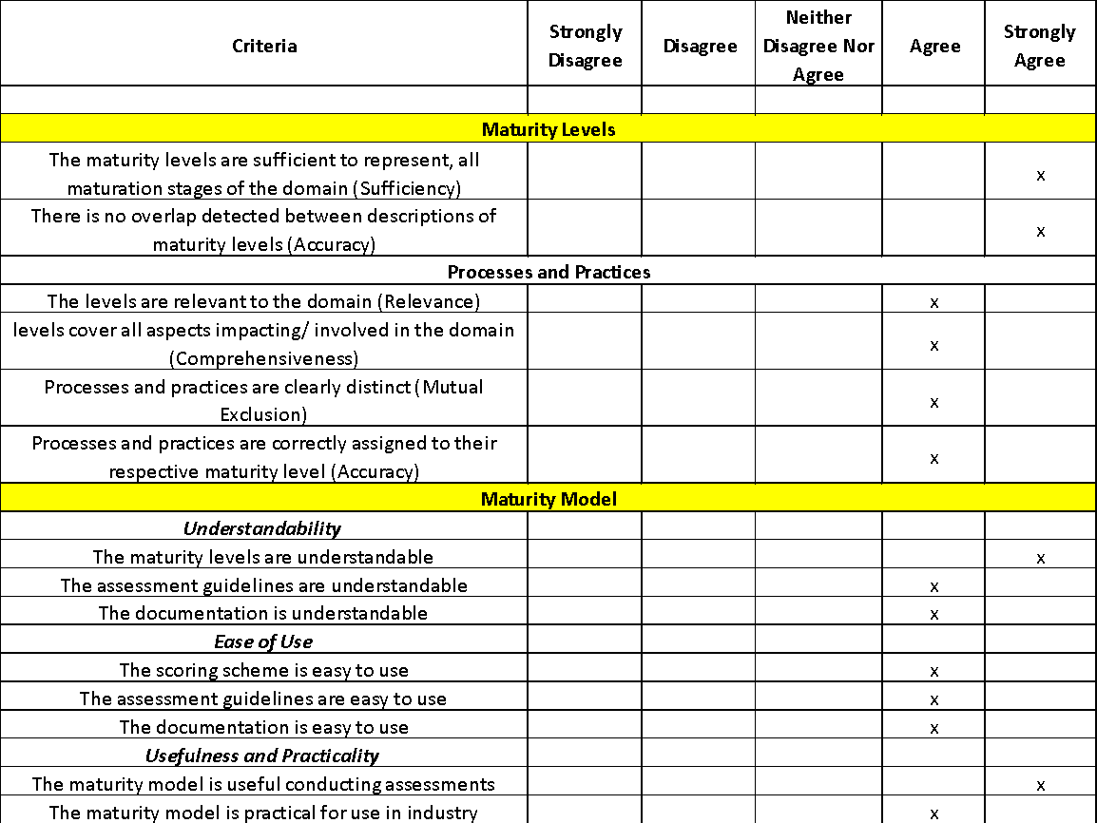

Experts’ feedback
The experts’ responses on the survey questionnaire are highlighted as follows;
- The description of the maturity levels appears to be comprehensive, simple and sufficient for the audience and users, further, most of the participants showed consent about the maturity levels and suggested no additional levels to be included. The structure and components are satisfying after the revisions (Delphi technique); however, it was suggested that an employee-wide survey could be conducted to also generate bottom-up insights.
- On the proposed domain sub-components “sustainability mindset” it was suggested to assess the historical pattern of the organization as it would give deeper insight about why the organization is pursuing a sustainable business model
- The scoring scheme structure and presentation was a controversial subject as some experts evaluate it as very comprehensive and others suggested to simplify further for easier implementation by third party companies in case of organization self-assessment.
- Another suitable suggestion for improvement was to convert the model into a software application so it could be reviewed annually along with the annual report process.
Model Testing Conclusion
The proposed maturity model has been evaluated by a panel of experts to validate the model construction and contents are valid, reliable and can be standardized.
Experts recommended the initial shortlisted sub domain components and maturity levels are covering the model scope and the domain representation is in line with the relevant subject literature of sustainability business model transformation. The experts’ consensus was such that the proposed model capable of measuring what it was intended they measure (organization readiness) and can provide a reliable and repeatable results
From the findings and based on the theoretical and practical conclusions, the model is sound, complete and it can be used by organizations to assess their readiness for adopting a sustainable business model.

Model Deployment – case study
After the proposed model was verified in the testing phase for construct and instruments, the model was deployed to organizations to be implemented. The model deployment has been done over two steps; the first step was done with the testing collaborating companies (Dell & Novo) second step was done with an independent organization from the design and testing phases (Etihad airways). Etihad case study shall be presented and discussed in the following chapter 5 (case study) with more elaboration.

Conducting the assessment
- The assessment started with a briefing about the study objectives and the main outcomes expected from the research.
The assessment begins with a briefing about the study objectives to help organizations assess their readiness to change their traditional business model and adopt a sustainable one. Then the briefing continues to explain the structure of the model in terms of the domain being the Organizational Dynamic Capabilities divided into “Structural and Cultural attributes” and the sub domain components represented by the nominated Internal Organization Capabilities that are supposed to be critical requirements for the organization during the transition.
- The respondents are provided with the following model assessment elements;
- The domain and sub domain components layers (figure 4.4 & 4.5)
- The definition of the four maturity levels as presented in section 4.2.2.
- the definitions of domain and the sub domain components (CSFs) Section 4.3.2:
- The maturity level criteria for each sub domain component Section 4.3.2
- The assessment score sheet (Section 4.3.3)
- The interviewee is asked to describe the maturity level of each sub domain component in light of the relevant maturity level definition/ attributes as applicable.
- The interviewee is asked to share an example that support their answer to make sure the selected maturity model is correct and mutually agreed on.
- Some respondents are requested to get the information from the relevant department with the supporting example to fulfill certain sub domain components.
- The level of maturity is then assigned for the particular sub domain component and move on the next component.
- After assigning the level of maturity for all the components, the calculations are carried out and then all scores are summarized
- Analyzing the score results and evaluating the organization maturity
- Proposing a recommendation with an action plan for the organization to improve the maturity level based on the current sub domain components’ maturity.
After assigning the level of maturity for all the components, the calculations are carried out as explain in section 4.3.3 and then all scores are summarized in the assessment summary block as shown in the following Chapter 5 (the case study)

Maintenance
This phase of the model development is not applicable for this research as it can be done only after the model is standardized. Some recommendations are provided in the conclusion chapter 6 for future research in order to achieve model globalization.

IMPLEMENTATION OF THE PROPOSED MATURITY MODEL (Case study)

Implementation Of The Final MM –
Within this section, the author presents the case study of applying the developed Maturity Model into a real corporate example in the UAE market. The goal of such practice was to analyze the functionality and get sense of the market feedback (testing and feedback).
Etihad Airways Case Study

About the company
Etihad is the second-largest UAE flag carrier since 2003, head office in the capital Abu Dhabi. The company runs over a thousand flights a week between passengers and cargo to almost all the destinations all over the globe. Etihad airways acknowledge its responsibility towards the society through four main principles; Benevolent supports, education initiatives, housing and development. Etihad also realizes its role in the environment and becoming more sustainable is one of its clear goals (Etihad.com).

The Assessment
As discussed in section 4.5 within chapter 4, Model deployment; the assessment starts with a briefing about the study objectives, the structure of the model, the assessment, definitions of the maturity levels and sub domain components.
The assessment was conducted with panel from the sustainability and development team. The assessment followed a presentation set up with the panel followed by one-to-one online interviews with each member of the panel. The panel members were presented with the assessment score sheet along with the definitions of both the domain and sub domain components i.e., Internal Organization Capability (IOC) maturity level definition (as presented in section 4.3).
Each interviewee was asked to assess the maturity level of the sub domain component (IOC) against the relevant maturity level definition/ attributes. Some of the examples provided during the interview to support the selected maturity level are shown in table 5.1 for demonstration.
Table 5.1 Organization sub domain Maturity examples
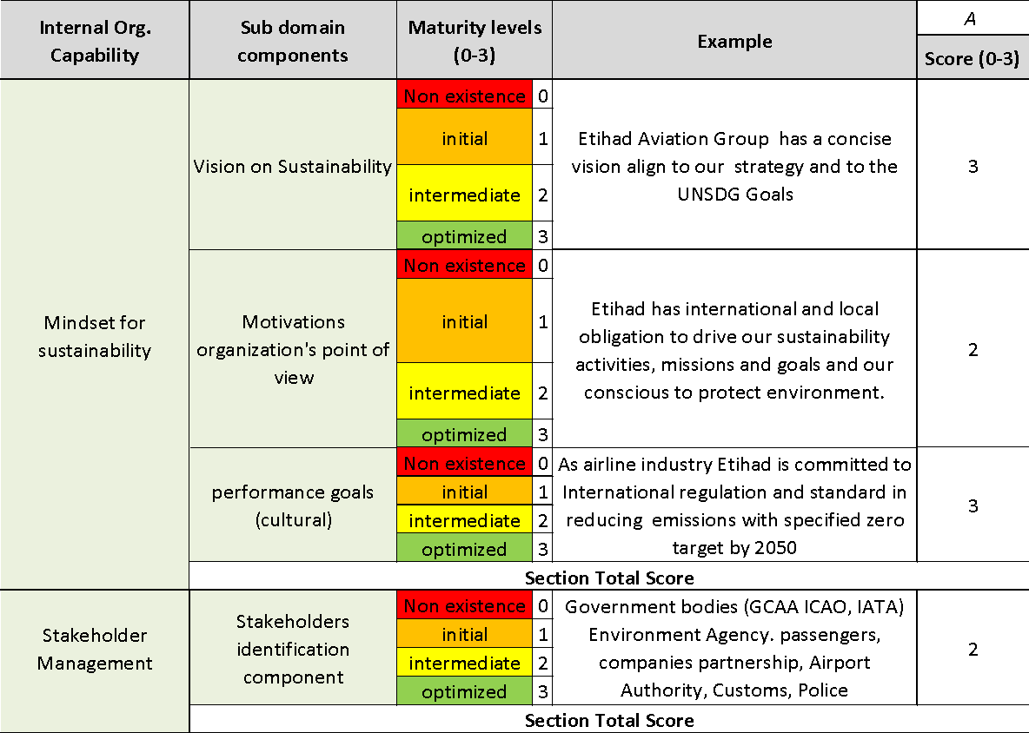
The level of maturity is then assigned for the particular sub domain component and move on the next component. Table 5.2 shows the maturity rating for different subdomain components as per the assessment interviews with Etihad’s team.
Table 5.2 Assessment Score Sheet
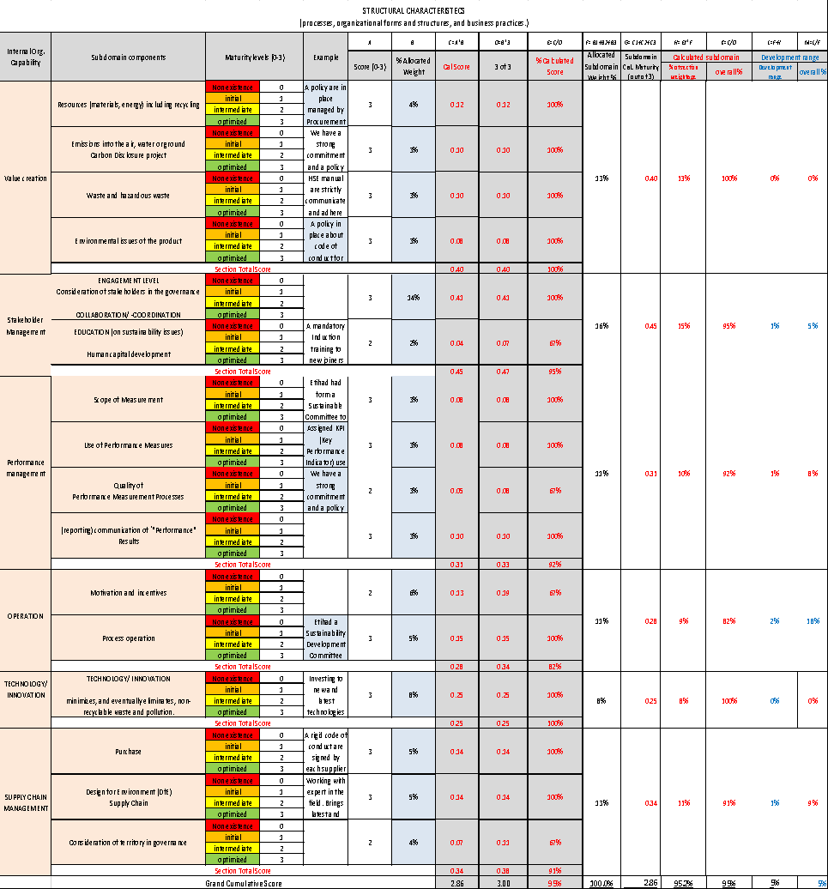

After assigning the level of maturity for all the components, the calculations are carried out as explained in section 4.3.3 and then all scores are summarized in the assessment summary block as shown in table 5.3

Assessment results and observations
The summary of the all-sub-domain components’ maturity levels are presented in table 5.3.
The summary results of the sub-domain maturity level score arranged in both views are;
- The overall maturity scale (0-3): 2.86
- The percentages: 95%
- Further the difference between the component allocated weight and the score based on the actual assessment is: 5%
The assessment block (table 5.3) summarizes the results from two perspectives;
- the maturity of the sub-domain component in relation of the overall score of all the sub-domain components
- (0.4 out of 0.4 or 13% out of 13% for example for the value creation component)
- (9% out of 11% for the operation management)
- the individual maturity scores within on specific section (or sub domain)
- 100% out of 100% for the value creation capability
- 82% out of 100% for the operation management capability
The summary block also provides details about the possible range of improvement for each assessed subdomain component (i.e., IOC).
- The value creation capability is matured
- The operation management capability can be improved by 18% to achieve maturity in this subdomain component
Table 5.3 Summary of the assessment
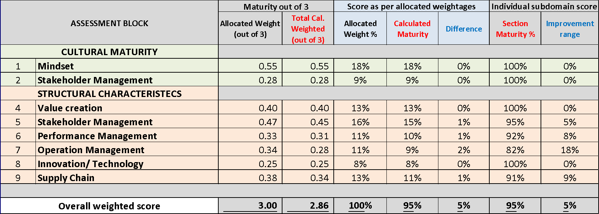

Proactive maturity assessment analysis
- WEIGHTED SCORE: 2.86
Comments: What does this mean? How should my organization 'feel' like at this level?
- MATURITY LEVEL: Intermediate; the capabilities are well developed but there is much room for improvement
Although there is an enhanced development of capability, there is always need for improvement.
One suggested improvement strategy is to look at the high weightage (important) subdomain components which are not mature (low in the score) and analyzing of the results from the components breakdown scores
Recommendation
- Short term acceleration plan: Stakeholder’s management (education about sustainability issues) and supply chain (improvement of the mutual relationship with the local parties and prioritizing local resources. Collaboration should be recognized by the government of the operating countries)
- Long term optimization plan: Performance management and operation management

Company feedback on the proposed model importance and implementation
Etihad team were very cooperative and embraced to the model concept. A dedicated employee was assigned to provide the details for each IOC. Etihad team considered this assessment to be a unique tool that is crucial for strategic decision-making within their organization. The assessment was able to evaluate their organization’s dynamic capability in developing and maintaining the required critical success factors such as IOC. They were able to pinpoint the internal strengths and weakness for each sub domain component and refer to this to plan/guide strategic improvement. That prioritized planning consequently enables the company to efficiently allocate their resources to achieve the company objectives such as successful business model transition.
Etihad also acknowledged the importance of the assessment model to identify their current level of Dynamic Organization Capability and the possibility of using that as an internal benchmark as a proxy on company development and externally if this model is to be used by similar organizations within the industry. Etihad praised the ease and clarity of the model and also expressed interest in purchasing the final version to apply it, across the organization, to guide quality improvement and sustainable excellence.

CONCLUSION, RECOMMENDATIONS, AND SUGGESTIONS FOR FUTURE RESEARCH

Conclusion
- Outcome
In this research a Maturity Model (MM) has been developed. The model developed in this study presents the nominated Internal Organizations Capabilities (IOC) and explains how these capabilities can be used to maintain a successful sustainable business model.
The model was able to identify the organization current status of the internal organizational capabilities required for a successful transition and was used to advice/ suggest a course of action for the organization the improve to reach to the maturity level required for the successful transition. The proposed model hence provided a roadmap for enhancing organization transition towards SBM after the analysis of the assessment results
- Objectives of the study
In this dissertation, a maturity model has been proposed to assess the organizational readiness to transform into a sustainable business model. The model objective is to assess the readiness of an organization to adopt a sustainable business model (SBM) and transform from traditional business model.
As the different world countries have achieved different levels of success in implementing sustainability in their local engineering industries. Whereas, there are still difficulties in benchmarking them based on their achievements because of the absence of clearly defined measures and scales that all countries can refer to. Therefore, this work aims to provide a new concept of mature sustainability in the UAE engineering industry. It also introduces a maturity model that is used as an evaluation tool to test how the business is mature in a country such as UAE is doing in regards to its sustainability adoption in the engineering sector.
- MM Structure
The Readiness Assessment MM includes 22 IOCs were nominated (list C) as the CSFs. The nominated IOCs are categorized as Cultural and Structural attributes. The critical success factors were nominated after two rounds of experts’ evaluations of the selected internal organizational capabilities that are considered relevant and important in helping organizations to transform into a sustainable business model.
The IOCs are assessed against four maturity levels. These four Maturity Levels are suggested for this model, to describe the maturity of the internal organization capability in the assessed organization. The proposed levels are limited to four levels only (see Table 8) for easier implementation by practitioners
This assessment can be conducted either by a third party or could be used as self-assessment.
- About the methodology
The model development was done by identifying the focus domain criteria as the Dynamic Capabilities and the IOC as the subdomain. The model was developed in collaboration with a panel of field experts and academia. The Delphi method has been utilized in the research which helped in examining the consistency of the items of the maturity model. The panel nominated the most relevant and important IOC through a course of iterative process of evaluation and shortlisting. The final nominated IOC are considered as the Critical Success Factors for the organization during the transition process.
- Benefits of the developed MM
The developed model can be used in three integral functions that are prescriptive, descriptive and comparative.
- Ultimately, this model can be used as a decision making to guide organization whether or not to commence in the transition and which internal organization capabilities are required to be developed for a successful transition.
- This MM is an organizational tool to assess their current needed internal capabilities maturity. As per the results, the organization may prioritize their efforts to tackle the necessary development areas to improve the related capabilities and hence reach maturity and be in a better place to transform its business model.
- The model can be utilized on a frequent period to monitor the effects of various inputs to improve a particular internal capability and analyze the course of maturation consciously. Moreover, the layered model will allow organizations to better understand their strengths and weaknesses in a particular domain and hence aim at improving specific strategies that will aid in the efficient and optimal allocation of resources.
- Organizations can make comparisons of their maturity with potential competitors as valuable benchmarks are provided if a couple of organizations use the MM to assess their IOC.
- MM Implementation outcomes
The final version of the model was then implemented with an organization in the UAE market to test the applicability and functionality of the model. The employment of case studies allowed to analyze the results in relation to information obtained from secondary research and assimilate effective feedback on the proposed model application.
Proactive organizations keen on sustainability, can utilize this model to assess the level of their organizational Dynamic Capabilities that are necessary to have a sustainable business model. The model also can be useful for the development of sustainability; however, more efforts are required to improve the developed model to achieve standardization of the model application.

Recommendations
Some companies are striving to improve themselves to enter the phase of maturity and adopt the sustainable business model. The market is changing rapidly which is ultimately increasing competition hence making it essential for companies to attend to building personal competitiveness for survival in the market. According to de Bruin et al (2005), for a company to maintain its competitiveness in the market, it is imperative to create alliances between manufacturing companies in the smart manufacturing industries. Since this research focused on the engineering industry of the UAE, the model can be implemented to allow manufacturing and service companies to contribute to sustainable development in the long run.
Organizations need to provide a proof/example to support their selected score. This helps the managing department of organizations to assess the subdomains in which they require improvements and hence formulate strategies that will facilitate the process of improvement. Moreover, the maturity model defines the level of maturity for each subdomain and it is for this reason that the organizations need to provide justifications for their selected score to properly evaluate the internal capabilities of particular organizations.

Limitations
Although this study managed to thoroughly elaborate on the implementation of a sustainable business model in the engineering industry in the UAE, there are various drawbacks to the research that compromise its validity and reliability. First, the research attended only to the engineering industry of the UAE which limited the validity of the obtained results. The multiple application facility of the model with different organizations helps the future deployment of the maturity model to get closer towards global acceptance and model standardization.
In the SBM Transition subject maturity model, the literature review is considered to be sufficient only to provide prior learning and other promotional methods are required. In growing subject such as the sustainable business model, it might not be practical to collect enough evidence from current sources to compile a complete list of domain components. Since the research subject is relatively new and has not been particularly discussed in previous studies, the nominated critical success factors CSFs could be considered as a theatrical preparatory list for further research and development. Nonetheless, the existing literature helped to provide proven important factors demonstrated in previous general maturity model for sustainability.
This study, it is trying to build on the previously developed maturity model for sustainability (as discussed in the literature chapter) and consolidate all relevant components into the final developed subdomain components of the model. Thus, this study, attempts to take advantage of the pre-designed type of enhancement and by combining all the elements in an integrated framework. The transitions of the SBM component of the larger framework were identified through a comprehensive review of the literature and resulted in integrated literature through interviews and case studies organizations.
Further, this research has also demonstrated maintenance limitations. The goal of the proposed maturity model is to achieve standardization and general acceptance. However, the required means for the ongoing development and usage of the model is impacting these goals. Mass model application is hence required and that can be achieved through online application via online portals to monitor the deployment issues, users’ feedback and software updates.

Suggestions for Future Research
Suggestions for the MM maintenance: the required means for the model’s ongoing development and usage impacts the goal of the proposed maturity model in terms of achieving standardization and general acceptance. Mass model application is hence required and that can be achieved through online application via online portals to monitor the deployment issues, users’ feedback and software updates.
Besides, the researcher focused primarily on the engineering industry in the UAE. However, sustainability is required to be maintained across various industries in the market to ensure optimal resource allocation and hence successful operations and performance together with market competitiveness. For this reason, future research can be conducted focusing on different industries such as infrastructure, automobile and garments among many others. This will allow other researchers to study the implementation of a sustainable business model across different companies and hence generalize the results among industries with similar operations.
Future studies should also account for executives and senior managers to further reveal the cross-effect of using such a research design. Doing so could offer deeper insight into the influence of maturing models, that is, in terms of technologies, processes, and management, on companies’ decision to adopt smart manufacturing.

REFERENCES
Aagaard, A. and Lodsgård, L., 2019. Leveraging Sustainable Business Model Innovation Through Business-NGO Collaboration. Sustainable Business Models, pp.211-238.
Ababneh, T., (2019). Developing a Fragility Framework for Supply Chain and Outsourcing Engineering Services in UAE (Doctoral dissertation, The British University in Dubai (BUiD)).
Afrazeh, M.H. and Hajiyakhchali, S., (2017). Designing a Program Management Maturity Model (ELENA). In 10th Dubai International Conference on Literature, History, Humanities and Interdisciplinary Studies (LHHIS-17). Dubai.
Ahern, D.M., Clouse, A. and Turner, R., (2004). CMMI distilled: a practical introduction to integrated process improvement. Addison-Wesley Professional.
Al-dujaili, M.A.A., 2014. The Role of Companies in Accomplishing Environmental Sustainability Engineering. Chem. Eng, 39, pp.535-540.
Alameeri, A., Ajmal, M.M., Hussain, M. and Helo, P., (2018). Sustainable management practices in UAE hotels. International Journal of Culture, Tourism and Hospitality Research.
Alameeri, A., Ajmal, M.M., Hussain, M. and Helo, P.T., (2017). Sustainability practices in the aviation sector: a study of UAE-based airlines. International Journal of Sustainable Society, 9(2), pp.119-147.
Alfaro, M., Almanei, M. and Salonitis, K., (2020). Lean manufacturing, leadership and employees: the case of UAE SME manufacturing companies. Production & Manufacturing Research, 8(1), pp.222-243.
Al-Hajj, A. and Hamani, K. (2011) ‘Material waste in the UAE construction industry: Main causes and minimization practices’, Architectural Engineering and Design Management. doi: 10.1080/17452007.2011.594576.
Allais, R., Roucoules, L. and Reyes, T. (2017) ‘Governance maturity grid: a transition method for integrating sustainability into companies?’, Journal of Cleaner Production. doi: 10.1016/j.jclepro.2016.02.069.
Almazrouei, M., Khalid, K., Abdallah, S. and Davidson, R., (2019). Assessing the health, safety, and environment culture in the United Arab Emirates oil and gas industry. Journal of Engineering, Design and Technology.
Al-Yami, A. and Sanni-Anibire, M.O., (2019). BIM in the Saudi Arabian construction industry: state of the art, benefit and barriers. International Journal of Building Pathology and Adaptation.
AlZawati, O.K., Alsyouf, I. and Bashir, H., (2020). An exploratory study of common issues and key differences between the European Foundation for Quality Management and the United Arab Emirates Public Sector Excellence Model: public sector organisation results. International Journal of System Assurance Engineering and Management, pp.1-14.
Barney, J. 1991 'Firm Resources and Sustained Competitive Advantage', Journal of Management, 17(1), pp. 99–120.
Bashir, H., Ojiako, U. and Garbie, I., (2019). Joint venture versus non-joint venture projects in the UAE construction industry: a comparison of the usage of project management practices and performance. International Journal of Project Organisation and Management, 11(3), pp.243-266.
Basl, J. (2018) ‘Analysis of industry 4.0 readiness indexes and maturity models and proposal of the dimension for enterprise information systems’, in Lecture Notes in Business Information Processing. doi: 10.1007/978-3-319-99040-8_5.
Battistella, C., Cagnina, M.R., Cicero, L. and Preghenella, N. (2018). Sustainable business models of SMEs: Challenges in the yacht tourism sector. Sustainability, 10(10), p.3437.
Baumgartner, R. J. and Ebner, D. (2010) ‘Corporate sustainability strategies: Sustainability profiles and maturity levels’, Sustainable Development. doi: 10.1002/sd.447.
Bocken, N. M. P. et al. (2014) 'A literature and practise review to develop sustainable business model archetypes', Journal of Cleaner Production. Elsevier Ltd, 65, pp. 42–56.
Bocken, N.M. and Geradts, T.H., (2020). Barriers and drivers to sustainable business model innovation: Organisation design and dynamic capabilities. Long Range Planning, 53(4), p.101950.
Bongomin, O., Nganyi, E.O., Abswaidi, M.R., Hitiyise, E. and Tumusiime, G., (2020). Sustainable and Dynamic Competitiveness towards Technological Leadership of Industry 4.0: Implications for East African Community. Journal of Engineering, 2020.
Boons, F. and Lüdeke-Freund, F. (2013) 'Business models for sustainable innovation: State-of-the-art and steps towards a research agenda', Journal of Cleaner Production. Elsevier Ltd, 45, pp. 9–19.
Bouma, J. J., Wolters, T. and Silvius, A. J. G. (2019) Sustainability In Project Management, Corporate Sustainability.
Brockhaus, S. et al. (2017) 'Motivations for environmental and social consciousness: Reevaluating the sustainability-based view', Journal of Cleaner Production, 143, pp. 933–947.
Brown, P., Bocken, N. and Balkenende, R. (2018) Sustainable Business Models. Edited by L. Moratis, F. Melissen, and S. O. Idowu. Cham: Springer International Publishing (CSR, Sustainability, Ethics & Governance).
Cagnin, C. H., Loveridge, D. and Butler, J. (2013) ‘Business Sustainability Maturity Model’, Computer Communication Review.
Canetta, L., Barni, A. and Montini, E., (2018, June). Development of a Digitalisation Maturity Model for the manufacturing sector. In 2018 IEEE International Conference on Engineering, Technology and Innovation (ICE/ITMC) (pp. 1-7). IEEE.
Cartwright, R. (2010) 'Book Reviews: Book Reviews', Perspectives in Public Health, 130(5), pp. 239–239.
Chen, J., Kolmos, A. and Du, X., (2020). Forms of implementation and challenges of PBL in engineering education: A review of the literature. European Journal of Engineering Education, pp.1-26.
Chilik, I. et al. (2019) 'Assessment of Sustainability Maturity Models for Business Transformation', Masters degree thesis.
Chohan, S.R., Hu, G., Si, W. and Pasha, A.T., (2020). Synthesising e-government maturity model: a public value paradigm towards digital Pakistan. Transforming Government: People, Process and Policy.
Chonsawat, N. and Sopadang, A., (2019, March). The development of the maturity model to evaluate the smart SMEs 4.0 readiness. In Proceedings of the International Conference on Industrial Engineering and Operations Management, JW Marriott Hotel Bangkok, Bangkok, Thailand (pp. 5-7).
Cinite, I., Duxbury, L. E. and Higgins, C. (2009) ‘Measurement of perceived organizational readiness for change in the public sector’, British Journal of Management. doi: 10.1111/j.1467-8551.2008.00582.x.
Clinton, L. and Whisnant, R. (2019) 'Business Model Innovations for Sustainability', in Managing Sustainable Business. Dordrecht: Springer Netherlands, pp. 463–503.
Cosic, R., Shanks, G. and Maynard, S. (2012) ‘Towards a business analytics capability maturity model’, in ACIS 2012 : Proceedings of the 23rd Australasian Conference on Information Systems, pp. 1–11.
Dalkey, N. and Helmer, O. (1963) ‘An Experimental Application of the DELPHI Method to the Use of Experts’, Management Science. doi: 10.1287/mnsc.9.3.458.
DaSilva, C. M. and Trkman, P. (2014) 'Business model: What it is and what it is not', Long Range Planning. Elsevier Ltd, 47(6), pp. 379–389.
de Bruin, T. et al. (2005) ‘Understanding the main phases of developing a maturity assessment model’, ACIS 2005 Proceedings - 16th Australasian Conference on Information Systems.
Delbecq, A. L., Van de Ven, A. H., Gustafson, D. H. (1975) ‘Group techniques for program planning. Chapter 3 - Guidelines for Conducting NGT Meetings’, in Group techniques for program planning.
Deng, Y., Li, J., Wu, Q., Pei, S., Xu, N. and Ni, G., (2020). Using Network Theory to Explore BIM Application Barriers for BIM Sustainable Development in China. Sustainability, 12(8), p.3190.
Facchini, F., Oleśków-Szłapka, J., Ranieri, L. and Urbinati, A., (2020). A maturity model for logistics 4.0: An empirical analysis and a roadmap for future research. Sustainability, 12(1), p.86.
Felch, V., Asdecker, B. and Sucky, E., (2019). Maturity models in the age of Industry 4.0–Do the available models correspond to the needs of business practice?.
Fisher, D. M. (2004) 'The business process maturity model: a practical approach for identifying opportunities for optimisation', Business Process Trends, 9(4), pp. 11–15. Available at: http://www.bpmg.orgwww.bptrends.com/publicationfiles/10-04 ART BP Maturity Model - Fisher.pdf.
Gassmann, O., Frankenberger, K. and Csik, M. (2017) 'The business model navigator. 55 models that will revolutionise your business. Oliver Gassmann, Karolin Frankenberger, Michaela Csik.', p. 387.
Gauthier, J. (2017) 'Sustainable business strategies: typologies and future directions', Society and Business Review, 12(1), pp. 77–93.
Geissdoerfer, M., Vladimirova, D. and Evans, S. (2018) ‘Sustainable business model innovation: A review’, Journal of Cleaner Production. doi: 10.1016/j.jclepro.2018.06.240.
Gerges, M., Austin, S., Mayouf, M., Ahiakwo, O., Jaeger, M., Saad, A. and El Gohary, T., (2017). An investigation into the implementation of Building Information Modeling in the Middle East. Journal of Information Technology in Construction, 22, pp.1-15.
Gimenez, R., Labaka, L. and Hernantes, J. (2017) ‘A maturity model for the involvement of stakeholders in the city resilience-building process’, Technological Forecasting and Social Change. doi: 10.1016/j.techfore.2016.08.001.
GLASS, G. V (1976) ‘Primary, Secondary, and Meta-Analysis of Research’, Educational Researcher. doi: 10.3102/0013189x005010003.
Glykas, M. and George, J., 92017). Quality and Process Management Systems in the UAE Maritime Industry. International Journal of Productivity Management and Assessment Technologies (IJPMAT), 5(1), pp.20-39.
Godina, R., Ribeiro, I., Matos, F., T Ferreira, B., Carvalho, H. and Peças, P., (2020). Impact Assessment of Additive Manufacturing on Sustainable Business Models in Industry 4.0 Context. Sustainability, 12(17), p.7066.
Gouvea, S. E. and Machado, C. G. (2013) 'Sustainable operations maturity models characterisation', (2013), pp. 1–10.
Hailemarkos, H.T., (2020). Ethiopian Construction Project Management Maturity Model Determination and Correlational Prediction of Project Success.
Hamidi, S.R., Aziz, A.A., Shuhidan, S.M., Aziz, A.A. and Mokhsin, M., (2018, March). SMEs maturity model assessment of IR4. 0 digital transformation. In International Conference on Kansei Engineering & Emotion Research (pp. 721-732). Springer, Singapore.
Hargaden, V., Papakostas, N., Newell, A., Khavia, A. and Scanlon, A., (2019, June). The role of blockchain technologies in construction engineering project management. In 2019 IEEE International Conference on Engineering, Technology and Innovation (ICE/ITMC) (pp. 1-6). IEEE.
Herr, C.M. and Fischer, T., (2019). BIM adoption across the Chinese AEC industries: An extended BIM adoption model. Journal of Computational Design and Engineering, 6(2), pp.173-178.
Igartua, J.I., Retegi, J. and Ganzarain, J., (2018). IM2, a maturity model for innovation in SMEs. Dirección y Organización, (64), pp.42-49.
Jesus, C.D. and Lima, R.M., (2020). A literature search of key factors for the development of generic and specific maturity models for industry 4.0. Applied Sciences, 10(17), p.5825.
Kontic, L. and Kontic, J. (2012) 'Sustainability and Readiness for Change : bank', XIV(32), pp. 537–549.
Korže, A. V. (2018) 'Understanding sustainable development', Geografija v Soli, 26(1), pp. 14–22. doi: 10.1080/00207233.2018.1453385.
Lari, D.A.D.A., Lari, F.A.D. and Lari, M.A.D.A., (2020). Influence of Information System Factors to Operational Performance Sustainability of UAE Manufacturing Sector. International Journal of Sustainable Construction Engineering and Technology, 11(2), pp.157-163.
Lee, D., Gu, J.W. and Jung, H.W., (2019). Process maturity models: Classification by application sectors and validities studies. Journal of Software: Evolution and Process, 31(4), p.e2161.
Lee, K. J. and Casalegno, F. (2010) 'An explorative study for business models for sustainability', PACIS 2010 - 14th Pacific Asia Conference on Information Systems, pp. 423–432.
Loo, R. (2002). The Delphi method: a powerful tool for strategic management. Policing: An International Journal of Police Strategies & Management.
Machado, C. G. et al. (2017) ‘Framing maturity based on sustainable operations management principles’, International Journal of Production Economics. doi: 10.1016/j.ijpe.2017.01.020.
Mirzabaev, A., Annagylyjova, J. and Amirova, I. (2019) ‘Environmental degradation’, in The Aral Sea Basin: Water for Sustainable Development in Central Asia. doi: 10.4324/9780429436475-6.
Mohammadi, K., Khanlari, A. and Sohrabi, B. (2009) ‘Organizational readiness assessment for knowledge management’, International Journal of Knowledge Management, 5(1), pp. 29–45. doi: 10.4018/jkm.2009010103.
Murphy et al. (1998) ‘Consensus development methods, and their use in clinical guideline development.’, Health Technology Assessment. doi: 10.3310/hta2030.
Ono, R. and Wedemeyer, D. J. (1994) ‘Assessing the validity of the Delphi technique’, Futures. doi: 10.1016/0016-3287(94)90016-7.
Parry, Z. (2014) ‘Book Review: Business Model Generation: A Handbook for Visionaries, Game Changers, and Challengers’, The International Journal of Entrepreneurship and Innovation. doi: 10.5367/ijei.2014.0149.
Powell, C. (2003) ‘The Delphi technique: Myths and realities’, Journal of Advanced Nursing. doi: 10.1046/j.1365-2648.2003.02537.x.
Rauter, R., Jonker, J. and Baumgartner, R. J. (2017) ‘Going one’s own way: drivers in developing business models for sustainability’, Journal of Cleaner Production, 140, pp. 144–154. doi: 10.1016/j.jclepro.2015.04.104.
Richards, J. I. and Curran, C. M. (2002) ‘Oracles on “advertising”: Searching for a definition’, Journal of Advertising. doi: 10.1080/00913367.2002.10673667.
Rowe, G. and Wright, G. (1999) ‘The Delphi technique as a forecasting tool: Issues and analysis’, International Journal of Forecasting. doi: 10.1016/S0169-2070(99)00018-7.
Salah, D., Paige, R. and Cairns, P. (2014) ‘An evaluation template for expert review of maturity models’, Lecture Notes in Computer Science (including subseries Lecture Notes in Artificial Intelligence and Lecture Notes in Bioinformatics), 8892, pp. 318–321.
Stubbs, W. and Cocklin, C. (2008) ‘Conceptualizing a “sustainability business model”’, Organization and Environment, 21(2), pp. 103–127. doi: 10.1177/1086026608318042.
Teece, D. J. (2010) 'Business models, business strategy and innovation', Long Range Planning, 43(2–3), pp. 172–194.
Van de, A. H. and Delbecq, A. L. (1974) ‘The Effectiveness of Nominal, Delphi, and Interacting Group Decision Making Processes.’, Academy of Management Journal. doi: 10.2307/255641.
van Tulder, R. et al. (2013) Managing the Transition to a Sustainable Enterprise, Managing the Transition to a Sustainable Enterprise. doi: 10.4324/9781315879956.
Ven, A.H.V.D. and Delbecq, A.L. (1974). The effectiveness of nominal, Delphi, and interacting group decision making processes. Academy of Management Journal, 17(4), pp.605-621.
Wettstein, T. and Kueng, P. (2002) ‘A maturity model for performance measurement systems’, (199 1).
Woudenberg, F. (1991) ‘An evaluation of Delphi’, Technological Forecasting and Social Change. doi: 10.1016/0040-1625(91)90002-W.
Yousuf, M. I. (2007) ‘Using Experts` Opinions Through Delphi Technique - Practical Assessment, Research &amp; Evaluation’, Practical Assessment, Research and Evaluation.
Linz, C., Müller-Stewens, G. and Zimmermann, A. (2017) 'Radical Business Model Transformation', p. 261.
Looijen, A. (2015) The Transition from Normal Business Models to Sustainable Business Models in the High - ­ ‐ Tech Food & Beverages Industry. Wageningen University and Research Centre.
Loorbach, D. and Wijsman, K. (2013) 'Business transition management: Exploring a new role for business in sustainability transitions', Journal of Cleaner Production, 45(April), pp. 20–28. doi: 10.1016/j.jclepro.2012.11.002.
Lozano, R. (2009) 'Orchestrating organisational change for corporate sustainability (Unpublished doctoral dissertation)', (August), pp. 1–422.
Lüdeke- Freund, F. (2010) 'Towards a Conceptual Framework of Business Models for Sustainability', Knowledge Collaboration & Learning for Sustainable Innovation ERSCP-EMSU conference, Delft, The Netherlands, 49(0), pp. 1–28.
Lüdeke-Freund, F. (2011) Business Model Concepts in Corporate Sustainability Contexts: From Rhetoric to a Generic Template for 'Business Models for Sustainability', SSRN Electronic Journal.
Machado, C. G. et al. (2017) 'Framing maturity based on sustainable operations management principles', International Journal of Production Economics. Elsevier B.V., 190(February 2016), pp. 3–21.
Makhanya, B.B., Nel, H. and Pretorius, J.H.C., (2018, December). Benchmarking quality management maturity in the industry. In 2018 IEEE International Conference on Industrial Engineering and Engineering Management (IEEM) (pp. 575-579). IEEE.
Makhanya, B.B., Nel, H. and Pretorius, J.H.C., (2018, December). Benchmarking quality management maturity in the industry. In 2018 IEEE International Conference on Industrial Engineering and Engineering Management (IEEM) (pp. 575-579). IEEE.
Mehran, D., (2016). Exploring the Adoption of BIM in the UAE Construction Industry for AEC Firms. Procedia Engineering, 145, pp.1110-1118.
Mittal, S., Khan, M.A., Romero, D. and Wuest, T., (2018). A critical review of smart manufacturing & Industry 4.0 maturity models: Implications for small and medium-sized enterprises (SMEs). Journal of manufacturing systems, 49, pp.194-214.
Mittal, S., Romero, D. and Wuest, T., (2018, August). Towards a smart manufacturing maturity model for SMEs (SM 3 E). In IFIP international conference on advances in production management systems (pp. 155-163). Springer, Cham.
Mohammadi, K., Khanlari, A. and Sohrabi, B. (2009) 'Organisational readiness assessment for knowledge management', International Journal of Knowledge Management, 5(1), pp. 29–45.
Murali, S.R. and Aggarwal, D., (2020). A Study on the Impact of Transformational Leadership Style on Employee Engagement and Employee Performance in ICT Industry–(a Study With Reference to the ICT Industry in the United Arab Emirates). International Journal of Management, 11(5).
Oleśków-Szłapka, J. and Stachowiak, A., (2018, September). The framework of logistics 4.0 maturity model. In International Conference on Intelligent Systems in Production Engineering and Maintenance (pp. 771-781). Springer, Cham.
Olszak, C.M. and Mach-Król, M., (2018). A conceptual framework for assessing an organisation's readiness to adopt big data. Sustainability, 10(10), p.3734.
Osterwalder, A. et al. (2010) 'Business Model Generation: book review', Business Model Generation, 5(7), p. 288. Available at: http://www.amazon.com/Business-Model-Generation-Visionaries-Challengers/dp/0470876417.
Pacchini, A.P.T., Lucato, W.C., Facchini, F. and Mummolo, G., (2019). The degree of readiness for the implementation of Industry 4.0. Computers in Industry, 113, p.103125.
Poveda, C. A. . (2017) Sustainability Assessment: A Rating System Framework for Best Practices.
Rafael, L.D., Jaione, G.E., Cristina, L. and Ibon, S.L., (2020). An Industry 4.0 maturity model for machine tool companies. Technological Forecasting and Social Change, 159, p.120203.
Randers, J. (2012). A global forecast for the next forty years THE FUTURE IN PRACTICE THE STATE OF SUSTAINABILITY LEADERSHIP 2012', The Future in Practice, p. 15. Available at: http://www.2052.info/wp-content/uploads/2014/01/p120801-2052-A-global-forecast-15p-illustrated-CPSL.pdf.
Rashid, N. and Khan, S.U., (2018). Agile practices for global software development vendors in the development of green and sustainable software. Journal of Software: Evolution and Process, 30(10), p.e1964.
Rauter, R., Jonker, J. and Baumgartner, R. J. (2017) 'Going one's own way: drivers in developing business models for sustainability', Journal of Cleaner Production. Elsevier Ltd, 140, pp. 144–154.
Robèrt, K. H. et al. (2002) 'Strategic sustainable development - Selection, design and synergies of applied tools', Journal of Cleaner Production, 10(3), pp. 197–214.
Sabiu, B.Y., Mohamed, S.F. and Mahmood, Y.W., (2020, July). Towards A Readiness Assessment Model for Value Management in Construction Industry. In IOP Conference Series: Materials Science and Engineering (Vol. 884, No. 1, p. 012040). IOP Publishing.
Sadath, L., Karim, K. and Gill, S., (2018, June). Extreme programming implementation in academia for software engineering sustainability. In 2018 Advances in Science and Engineering Technology International Conferences (ASET) (pp. 1-6). IEEE.
Salah, D., Paige, R. and Cairns, P. (2014) 'An evaluation template for expert review of maturity models', Lecture Notes in Computer Science (including subseries Lecture Notes in Artificial Intelligence and Lecture Notes in Bioinformatics), 8892, pp. 318–321.
Salam, M. and Khan, S.U., (2018). Challenges in the development of green and sustainable software for software multisourcing vendors: Findings from a systematic literature review and industrial survey. Journal of Software: Evolution and Process, 30(8), p.e1939.
Schipper, R., Rorije, H. and Silvius, A. J. G. (2010) 'Creating Sustainable Change: A new paradigm in Project Management BT - 24th World Congress of the International Project Management Association (IPMA)', in.
Available at: http://www.hu.nl/~/media/HU-PORTAL/Images/Duurzaam/Description.ashx.
Silvius, G. and Schipper, R., (2020). Sustainability Impact Assessment on the project level; A review of available instruments. The Journal of Modern Project Management, 8(1).
Simetinger, F. and Zhang, Z., (2020). Deriving secondary traits of industry 4.0: A comparative analysis of significant maturity models. Systems Research and Behavioral Science, 37(4), pp.663-678.
Sirohi, R., Tarafdar, A., Singh, S., Negi, T., Gaur, V.K., Gnansounou, E. and Bhartiraja, B., (2020). Green processing and biotechnological potential of grape pomace: current trends and opportunities for sustainable biorefinery. Bioresource Technology, p.123771.
Stubbs, W. and Cocklin, C. (2008) 'Conceptualising a "sustainability business model"', Organisation and Environment, 21(2), pp. 103–127.
Teece, D. J. (2010) 'Business models, business strategy and innovation', Long Range Planning, 43(2–3), pp. 172–194.
van Egmond, K. (2014) 'Sustainable Economy', in Sustainable Civilisation. London: Palgrave Macmillan UK, pp. 193–209.
Van Tulder, R., Van Tilburg, R., Francken, M. and Da Rosa, A., (2013). Managing the transition to a sustainable enterprise: Lessons from frontrunner companies. Routledge.
Werani, T. and Freiseisen, B. (2016) 'How should successful business models be configured ? Results from an empirical study in business-to-business markets and implications for the change of business models', Journal of Business Economics. Springer Berlin Heidelberg, 86(6), pp. 579–609.
Wettstein, T. and Kueng, P. (2002) 'A maturity model for performance measurement systems', (199 1).
Wilkinson, A., Hill, M. and Gollan, P. (2001) 'The sustainability debate', International Journal of Operations and Production Management, 21(12), pp. 1492–1502.
Wwf (2012) 'Living Planet Report. Summary Booklet', Environmental Conservation, 26(04), pp. 250–251.
Zaini, N., Zaini, A.A., Tamjehi, S.D., Razali, A.W. and Gui, H.C., (2020), May. Implementation of Building Information Modeling (BIM) in Sarawak Construction Industry: A Review. In IOP Conference Series: Earth and Environmental Science (Vol. 498, No. 1, p. 012091). IOP Publishing.
Zink, K. J. (2008) Corporate Sustainability as a Challenge for Comprehensive Management. Edited by K. J. Zink. Heidelberg: Physica-Verlag HD (Contributions to Management Science).

APPENDICES

Survey Questionnaire

Interview Questions
