
Developing a Framework for Measuring Organisational Cyber Resilience Against External and Internal Cyber Threats

تطوير إطار لقياس المرونة السيبرانية للمؤسسات ضد التهديدات السيبرانية الداخلية والخارجية

by
SAEED HAMDAN MOHAMED RASHED ALSHEHHI

A thesis submitted in fulfilment
of the requirements for the degree of
DOCTOR OF PHILOSOPHY IN PROJECT MANAGEMENT
at
The British University in Dubai

July 2020


Developing a Framework for Measuring Organisational Cyber Resilience Against External and Internal Cyber Threats

تطوير إطار لقياس المرونة السيبرانية للمؤسسات ضد التهديدات السيبرانية الداخلية والخارجية

by

SAEED HAMDAN MOHAMED RASHED ALSHEHHI

A thesis submitted to the Faculty of Engineering and Informatics
in fulfilment of the requirements for the degree of
DOCTOR OF PHILOSOPHY IN PROJECT MANAGEMENT

at
The British University in Dubai
July 2020

Thesis Supervisor
Dr Khalid Al Marri

Approved for award:

____________________________ ________________________
Name Name
Designation Designation

____________________________ ________________________
Name Name
Designation Designation

Date: ____________

DECLARATION

I warrant that the content of this research is the direct result of my own work and that any use made in it of published or unpublished copyright material falls within the limits permitted by international copyright conventions.
I understand that a copy of my research will be deposited in the University Library for permanent retention.
I hereby agree that the material mentioned above for which I am author and copyright holder may be copied and distributed by The British University in Dubai for the purposes of research, private study or education and that The British University in Dubai may recover from purchasers the costs incurred in such copying and distribution, where appropriate.
I understand that The British University in Dubai may make a digital copy available in the institutional repository.
I understand that I may apply to the University to retain the right to withhold or to restrict access to my thesis for a period which shall not normally exceed four calendar years from the congregation at which the degree is conferred, the length of the period to be specified in the application, together with the precise reasons for making that application.

_______________________
Signature of the student

COPYRIGHT AND INFORMATION TO USERS
The author whose copyright is declared on the title page of the work has granted to the British University in Dubai the right to lend his/her research work to users of its library and to make partial or single copies for educational and research use.

The author has also granted permission to the University to keep or make a digital copy for similar use and for the purpose of preservation of the work digitally.

Multiple copying of this work for scholarly purposes may be granted by either the author, the Registrar or the Dean only.

Copying for financial gain shall only be allowed with the author’s express permission.

Any use of this work in whole or in part shall respect the moral rights of the author to be acknowledged and to reflect in good faith and without detriment the meaning of the content, and the original authorship.

Abstract
This dissertation empirically examines the level of resilience and readiness for cyber-risks in public sector organisations within the United Arab Emirates (UAE) to provide managers with proactive mechanism to improve the cyber-resilience of their organisations. Moreover, the study aims to synthesize the extant literature and identifies new framework that filling the gaps in the current practices.
The importance of this study stemmed from the fact that cyber threats are becoming a significant global concern prompting the importance of developing a reliable resilience mechanism to counter cyber threats and risks in the UAE public sector organisations.
Therefore, the study addressed four distinct challenges in order to develop the framework for the UAE; providing tools for the management, accepting the human factors of cyber-security, exploring the correlation between the risks, and examining the moderating effect of organisational resilience on cyber-risk.
Using a positivist/realist philosophy and an inductive approach to the data. The quantitative approach was chosen to quantify the attributes of the study variables with a motive to prove the tested hypothesis.
A qualitative analysis would not have allowed this unless the same person carried out the later examination. Having a number or percentage gives the manager a clearer picture. This approach has been successfully used in other research into cyber-resilience. The relevant epistemology and ontology for the research are also explained fully in the methodology section.
An online questionnaire was used to gather quantitative data from employees in different UAE public sector organisations. Exploratory factor analysis (EFA) and multiple regression analysis were used to analyse 207 variables.
The EFA was used to evaluate the underlying factor structure of a correlation matrix, and to build a theory. This helped to identify the latent factors underlying the manifest variables, and the relationships between latent and manifest variables. After the EFA, a multilinear regression analysis was used to further examine the study hypotheses that emerged from the factor analysis.
The findings suggest that all the public sector organisations in the UAE have a satisfactory level of resilience to potential cyber-threats. There was a high level of awareness among UAE public sector employees of cyber-threats and risks, which could contribute to readiness and resilience to cyber-threats or attacks. This suggests that there may be a relationship between the level of employee awareness and readiness to deal with cyber-threats, and the organisations’ overall resilience and readiness.
This study contributes to the literature on cyber-resilience best practices. It provides organisations in the UAE public sector with a conceptual model to enable them to evaluate and identify potential weaknesses in their readiness for and resilience to cyber-threats. The feedback from the pilot study suggests that the specialists spoken to believe that this is one of the first empirical studies to establish a relationship between the level of employee awareness and readiness to deal with cyber-threats, and the level of organisational resilience and readiness in UAE public sector organisations.

نبذة مختصرة
تدرس هذه الأطروحة تجريبياً قياس مستوى المرونة والاستعداد لمؤسسات القطاع العام العاملة في دولة الإمارات العربية المتحدة أمام التهديدات والهجمات السيبرانية الداخلية والخارجية.
حيث تهدف الدراسة إلى تقييم الوضع الحالي لمستوى مرونة هذه المؤسسات وقدرتها على التصدي لمختلف التهديدات والمخاطر السيبرانية، وتزويد المدراء بآلية لتحسين مستوى المرونة والاستجابة لهذه المخاطر بشكل استباقي.
واعتمد الباحث نموذجا افتراضيا جديدا يمثل تحسينا للإصدارات الحالية المتاحة، تم بناؤه بعد مراجعة وتحليل الأدبيات المنشورة ذات العلاقة بموضوع التهديدات والهجمات السيبرانية الداخلية والخارجية ودمجها مع البيانات الجديدة التي تم جمعها من خلال الاستبيانات، وتركز مشكلة البحث على أربع محاور تتمثل بتوفير أدوات للإدارة، وقبول العوامل البشرية للأمن السيبراني، وتقييم مستوى العلاقة الاحصائية بين المخاطر، ودراسة عامل التأثير المعتدل للمرونة التنظيمية على المخاطر الإلكترونية
تتناول الدراسة تقييم مستوى المرونة والاستعداد لمؤسسات القطاع العام من خلال الاعتماد على فلسفة الوضعية / الواقعية نظرا لوجود الباحث في قلب الميدان ، تتبنى منهج استقرائي للبيانات من خلال استبيان تم تطويره ومشاركته مع عينه الدراسة لجمع البيانات الكمية واستخدام كل من تحليل العوامل وتحليل بيانات الانحدار، عن طريق الانحدار المتعدد لتحليل عدد 207 متغير، بالإضافة لاستخدام تحليل العوامل الاستكشافية (EFA) لتقييم هيكل العوامل الأساسية لمصفوفة الارتباط وبناء النظرية ولتحديد العوامل الباطنية والكامنة وراء المتغيرات الظاهرة بالإضافة إلى أنماط العلاقات ما بين المتغيرات الباطنية والظاهرة .
تشير النتائج إلى أن جميع مؤسسات القطاع العام في دولة الإمارات العربية المتحدة لديها مستوى مقبول من المرونة لمواجهة التهديدات السيبرانية المحتملة، كما تكشف النتائج عن وجود مستوى عالي من الوعي بين موظفي القطاع العام في الدولة بالتهديدات والمخاطر السيبرانية، والتي يمكن أن تكون عاملا آخر يساهم في رفع جاهزية مؤسسات القطاع العام ومرونتها أمام التهديدات أو الهجمات السيبرانية ، مما يشير إلى وجود علاقة إيجابية بين مستوى وعي الموظفين وجاهزيتهم للتعامل مع التهديدات السيبرانية ومستوى مرونة وجاهزية المؤسسات .
تساهم هذه الدراسة في المرجعيات الأدبية ذات العلاقة بموضوع المرونة السيبرانية، وتزود المؤسسات العاملة في القطاع العام في دولة الإمارات العربية المتحدة بنموذج مفاهيمي لتقييم وتحديد الضعف المحتمل في الجاهزية والمرونة تجاه التهديدات السيبرانية، بالإضافة إلى أنها واحدة من أوائل الدراسات التجريبية لقياس العلاقة ما بين مستوى وعي الموظفين وجاهزيتهم للتعامل مع التهديدات السيبرانية ومستوى الاستعداد والمرونة في مؤسسات القطاع العام العاملة في الدولة.

Acknowledgements

I would like to express my special thanks of gratitude to my director of studies (DOS), Dr Khalid Almarri whose guidance, support and encouragement has been invaluable throughout the process. He has taught me the methodology to carry out the research and to present the research works as clearly as possible. It was a great privilege and honor to work and study under his guidance. I am extremely grateful for what he has offered me.

Thanks also to my caring, loving, and supportive wife: my deepest gratitude. Your encouragement when the times got rough are much appreciated and noted. It was a great comfort and relief to know that you were always there when needed. My heartfelt thanks.

Contents
Abstract
Acknowledgements
Contents i
List of Appendices viii
List of Figures ix
List of Tables xiii
Glossary and Abbreviations xviii
Chapter 1 Introduction 1
1.1 Introduction 1
1.2 Rationale and Background of Study 1
1.3 Research Problem Statement 5
1.4 Research Aim and Objectives 7
1.5 Research Question(s) 8
1.6 Organisation and Structure of the Research Study 9
1.7 Summary 10
Chapter 2 Literature Review 11
2.1 Introduction 11
2.2 Definitions of Cyber Resilience 11
2.2.1 A Taxonomy of Cyber-Risk, Cyber-Resilience, and Cyber-Security 12
2.3 Cyber-risk and Security 13
2.3.1 Cyber-Security and IT Departments 14
2.4 Existing Frameworks for Cyber-Risk Management 15
2.4.1 Basics of Cyber-Risk Management 16
2.4.2 Resilience 16
2.5 Emerging Cyber-Risks 18
2.6 Patterns of cyber-attacks 18
2.6.1 The GCHQ Simplified Process 19
2.6.1.1 Survey 19
2.6.1.2 Delivery 20
2.6.1.3 Breach 20
2.6.1.4 Affect 20
2.7 Trends 20
2.8 Terrorism and cyber-attacks 22
2.9 The Development of Cyber-Risk Management Frameworks 22
2.9.1 The Importance of a CRM Framework 25
2.9.2 Past and Present Challenges to CRM 29
2.9.3 Risk Detection and Evaluation in CRM 30
2.9.4 Data Mining and other Legal Activities 32
2.9.5 CRM and Strategic Planning 33
2.9.6 Using CRM to ‘Add Value’ 34
2.9.7 The Need for a Culture of CRM 35
2.9.8 CRM Frameworks and Board Level Involvement 38
2.9.9 The Cultural Aspects of CRM Implementation 39
2.9.10 The Dubai Vision of Cyber Safety 39
2.10 ERM Issues in the Financial Sector 40
2.11 Gap in CRM – Why a New Framework is Required 43
2.12 Summary 46
Chapter 3 Conceptual Framework 49
3.1 Introduction 49
3.2 Theoretical Development 49
3.2.1 Theoretical Perspective 50
3.2.1.1 Cyber-Risk Management (CRM) 50
3.2.1.2 Vulnerabilities and Weaknesses 50
3.2.1.3 Response in Place 51
3.2.1.4 Organisational Resilience 51
3.2.2 Cyber-Risk and External and Internal Threats 52
3.2.2.1 External Factors 53
3.2.2.1.1 Cyber Terrorism 53
3.2.2.1.2 Hacktivism 55
3.2.2.1.3 Phishing 57
3.2.2.1.4 Financial Fraud 58
3.2.2.1.5 Criminal Acts 60
3.2.2.2 Internal Threats 61
3.2.2.2.1 Threat Awareness 61
3.2.2.2.2 Risk Culture 62
3.2.2.2.3 Laziness 64
3.2.2.2.4 Financial Fraud 66
3.2.2.2.5 Criminal Acts 67
3.2.2.3 Vulnerabilities and Weaknesses 67
3.2.2.3.1 Human Factors as a Vulnerability or Weakness 69
3.2.2.3.2 Process as a Vulnerability or Weakness 70
3.2.2.3.3 Technology as a Vulnerability or Weakness 71
3.2.2.4 Values at Risk 72
3.2.2.4.1 Assets 72
3.2.2.4.2 Public Safety 73
3.2.2.5 The Response 75
3.2.2.5.1 OPSEC Training 79
3.2.2.6 A Summary of the Theoretical Perspectives 80
3.3 Proposed Conceptual Framework 80
3.3.1 Development of the Framework 80
3.4 Conclusion 83
Chapter 4 Methodology 85
4.1 Introduction 85
4.2 Layers of Research 85
4.3 Research Philosophy 86
4.4 Research Paradigm 87
4.5 Methodology 88
4.6 Research Design 89
4.7 Sample Selection 89
4.7.1 Justification of Sample Size 90
4.7.2 Demographic Information of Sample Population 91
4.8 Basis of Questionnaire 93
4.8.1 Data Collection – Designing the Instrument 94
4.8.2 Data Collection – Validating the Instrument 95
4.9 Justification or Rationale 95
4.10 Quantitative Data Analysis 97
4.11 Research Method Justification 97
4.11.1 Thematic Literature Review and Risk Clustering 99
4.11.2 Identifying Assets at Risk 99
4.11.3 Identifying Strategies for Mitigation and Resilience 100
4.12 The Pilot Study 100
4.12.1 The Pre-Pilot Surveys 100
4.12.2 Pilot Study Details 100
4.12.2.1 Initial Contacts and Gaining Access 102
4.12.3 The Pilot Survey 102
4.12.4 Use of the Pilot Study 103
4.13 Data Collection 103
4.13.1 Descriptive and Correlation Analysis 103
4.13.2 Exploration of Possibilities and Framework Construction 103
4.14 Ethical Considerations 103
4.15 Analysis of Data 104
4.16 Summary 104
Chapter 5 Data Analysis 106
5.1 Introduction 106
5.2 Checking and Replacing Missing Values 106
5.3 Test of Outliers 108
5.4 Reliability Test 109
5.5 Assessing Statistical Normality 110
5.6 Reliability of scales 111
5.7 Descriptive Statistics 112
5.8 Summary of Descriptive Statistics 121
5.9 Exploratory Factor Analysis (EFA) 121
5.9.1 Key External Threats - Cyber Attack (KECA) 122
5.9.2 Key External Threats – Hacktivism (KEH) 125
5.9.3 Key External Threats – Phishing (KEP) 128
5.9.4 Key External Threats - Financial Fraud (KEFF) 129
5.9.5 Key External Threats - Criminal Acts (ETCA) 131
5.9.6 Key Internal Threats - Lack of Awareness (KILA) 133
5.9.7 Key Internal Threats - Risk Culture and Laziness (KIRC) 135
5.9.8 Key Internal Threats - Financial Fraud (KIFF) 137
5.9.9 Key Internal Threats - Criminal Acts (ITCA) 138
5.9.10 Vulnerabilities and Weaknesses (VW) 139
5.9.11 Organisational Vulnerabilities and Weaknesses: Physical and Digital Assets (VWP) 141
5.9.12 Responses in Place (RP) 143
5.9.13 Organisational Resilience (OR) 145
5.9.14 Summary 147
5.10 Simple and Multiple Regression Analysis 147
5.10.1 The Relationship Between Vulnerabilities and Weaknesses and External Threats 149
5.10.1.1 Testing for Collinearity of the Independent Variables 150
5.10.1.2 Examining Residuals using Scatter Plots 151
5.10.2 The Relationship Between Vulnerabilities and Weaknesses and Internal Threats 153
5.10.2.1 Testing for Collinearity of the Independent Variables 154
5.10.2.2 Examining Residuals using Scatter Plots 155
5.10.3 The Relationship Between Vulnerabilities and Weaknesses and Having a Response in Place 156
5.10.3.1 Testing for Collinearity of the Independent Variables 157
5.10.3.2 Examining Residuals using Scatter Plots 158
5.10.4 The Relationship Between Vulnerabilities and Weaknesses and Organisation Resilience 159
5.10.4.1 Testing for Collinearity of the Independent Variables 160
5.10.4.2 Examining Residuals using Scatter Plots 161
5.10.5 The Relationship Between Vulnerabilities and External Threats is Moderated by Having a Response in Place 162
5.10.5.1 Testing for Collinearity of the Independent Variables 163
5.10.5.2 Examining Residuals using Scatter Plots 163
5.10.5.3 The relationship between vulnerabilities and weaknesses and external threats, moderated by organisation resilience 166
5.10.5.4 Testing for Collinearity of the Independent Variables 167
5.10.5.5 Examining Residuals using Scatter Plots 167
5.10.6 The Relationship Between Vulnerabilities and Internal Threats Moderated by Having a Response in Place 170
5.10.6.1 Testing for Collinearity of the Independent Variables 171
5.10.6.2 Examining Residuals using Scatter Plots 171
5.10.7 The Relationship Between Vulnerabilities and Weaknesses and Internal Threats Moderated by Organisation Resilience 173
5.10.7.1 Testing for Collinearity of the Independent Variables 174
5.10.7.2 Examining Residuals using Scatter Plots 175
5.10.7.3 Regression 177
5.10.7.4 Testing for Collinearity of the Independent Variables 178
5.10.7.5 Examining Residuals using Scatter Plots 179
5.10.7.6 Regression 182
5.10.7.7 Testing for Collinearity of the Independent Variables 183
5.10.7.8 Examining Residuals using Scatter Plots 183
5.10.7.9 Regression 186
5.10.7.10 Testing for Collinearity of the Independent Variables 187
5.10.7.11 Examining Residuals using Scatter Plots 188
5.10.7.12 Testing for Collinearity of the Independent Variables 192
5.10.7.13 Examining Residuals using Scatter Plots 192
5.11 Summary 195
Chapter 6 Discussion 197
6.1 Introduction 197
6.2 Research Overview – External and Internal Cyber-Threat Constructs 197
6.2.1 Threats 197
6.2.2 Vulnerabilities and Weaknesses 198
6.2.3 Values at Risk 199
6.2.4 Responses 199
6.2.5 Capacity (Resilience) 199
6.3 Descriptive Analysis Findings 200
6.4 Validity of the Results 200
6.5 Frequencies of the Research Constructs 200
6.6 Association Findings 201
6.7 Discussion of Regression Analysis 202
6.7.1 Direct Effect on Vulnerabilities and Weaknesses of External and Internal Threats, Having a Response in Place and Organisational Resilience 202
6.7.2 Direct Effect of External Threats, Having a Response in Place, and Organisational Resilience on Organisational Vulnerabilities and Weaknesses 203
6.7.3 Direct Effect of Internal Threats, Having a Response in Place, and Organisational Resilience on Organisational Vulnerabilities and Weaknesses 204
6.7.4 Organisational Resilience as a Moderator of the Relationship Between Internal and External Threats and Vulnerabilities and Weaknesses 205
6.7.5 Hypotheses 206
6.7.5.1 Hypothesis One (H1) Vulnerabilities and weaknesses are associated with external threats 207
6.7.5.2 Hypothesis Two (H2) Vulnerabilities and weaknesses are associated with internal threats 207
6.7.5.3 Hypothesis Three (H3) Vulnerabilities and weaknesses are associated with responses in place 207
6.7.5.4 Hypothesis Four (H4) Having responses in place moderates the association between vulnerabilities and weaknesses and internal threats 207
6.7.5.5 Hypothesis Five (H5) Having responses in place moderates the association between vulnerabilities and weaknesses and external threats 207
6.7.5.6 Hypothesis Six (H6) Vulnerabilities and weaknesses are associated with organisational resilience 207
6.7.5.7 Hypothesis Seven (H7) Organisational resilience moderates the association between vulnerabilities and weaknesses and internal threats 208
6.7.5.8 Hypothesis Eight (H8) Organisational resilience moderates the association between vulnerabilities and weaknesses and external threats 208
6.8 Discussion of Findings and Results 208
6.8.1 Regression Test Conclusions 208
6.9 Validation of the New Framework 209
6.9.1 Cyber-Resilience and -Security in the UAE Public Sector Before 209
6.9.2 Cyber-Resilience and -Security in the UAE Public Sector After 209
6.9.3 Testing and Validating the New Framework 210
6.9.4 Acceptance of Validated Framework 210
6.10 Summary 211
Chapter 7 Conclusion and Recommendations 212
7.1 Introduction 212
7.2 An Overview of the Research 212
7.3 The Accomplishment of the Research Objectives 212
7.3.1 To Identify Emerging Cyber-Risks and Examine the Association Between Cyber-Risk Awareness and Resilience. 213
7.3.2 To Create a Conceptual Framework for Assessing Resilience to Cyber-Risks 213
7.3.3 To examine the relationship between Organizational Vulnerability and Weaknesses, and the External/ Internal Cyber-Threats, and the moderating effect of resilience and response of the organization. 213
7.3.4 To report the findings and conclusions in an understandable format. 214
7.4 Key Findings 215
7.5 Research Novelty and Contribution 215
7.5.1 Contributions to Theory 216
7.5.2 Contributions to Practice 217
7.5.3 Contributions to Methodology 218
7.6 Research Achievement 218
7.7 Research Implications 219
7.7.1 Implications for Research and Theory 219
7.7.2 Implications for Management and Practice. 220
7.8 Research Limitations 221
7.8.1 Methodological Limitations and Recommendations 221
7.8.1.1 Limitation of Sample Size 222
7.8.2 Limitations for the Researcher and Recommendations 222
7.9 Future Research Agenda 223
7.10 Summary of Conclusions 224
References 226
Appendices 242

List of Appendices
Appendix 1: The Introduction to ISO/IEC 27032:2012 242
Appendix 2: The relevant ISO/IEC 27k standards 244
Appendix 3: Sample of Questionnaire 245
Appendix 4: Tables of descriptive statistics from the dataset 257

List of Figures
Figure 1-1: The five pillars of “the UAE National Cybersecurity Strategy” (TRA, 2020). 3
Figure 2-1: Different reactions to attack define the level of resilience. Source: adapted from Renn (2013) 17
Figure 2-2: Lockheed Martin's Cyber Kill Chain®. Source: adapted from Hutchins, Cloppert and Amin (2011, p. 9) 19
Figure 2-3: GCHQ's Simplified Process. Source: adapted from GCHQ (2015) 19
Figure 2-4: Frequency of successful cyber-attacks worldwide. Source: adapted from Imperva (2019) 21
Figure 2-5: Cyber-attacks by sector (USA), 2016. Source: data from Control Risks (2016) 21
Figure 2-6: The concept of PaaS. Source: adapted from Li et al. (2013, p. 80) 23
Figure 2-7: Cyber-risk framework. Source: adapted from World Economic Forum (2012, p. 13) 25
Figure 2-8: CRM framework and process based on BS ISO recommendations. Source: adapted from BSI/ISO (2016) 25
Figure 2-9: A simple neural network. Source: Shiffman (2012) 26
Figure 2-10: Deep or complex neural networks. Source: Shiffman (2012) 26
Figure 2-11: The link between risks, event response and recovery. 29
Figure 2-12: Kosub's suggested process for CRM. Source: adapted from Kosub (2015) 37
Figure 2-13: Yayla and Hu's (2014) model for research on the effect of board level knowledge on the performance of firms 38
Figure 2-14: Dubai's cyber-safety tree. Source: Dubai Electronic Security Centre (2017, p. 10) 40
Figure 2-15: The relationship between the timing of threat detection and the strength of system resilience. Current frameworks are aimed at detection or intervention at point B, but should be aiming at point A. 44
Figure 3-1: Cyber-risk preparedness factors. Source: Allianz (2015, p. 28) 52
Figure 3-2: The Institute of Risk Management’s view of a 'risk culture'. Source: Institute of Risk Management (2014) 63
Figure 3-3: Tran et al.'s Resilience Model. Source: adapted from Tran et al. (2016, p. 22) 77
Figure 3-4: Linking the Hypotheses to the Elements of the Framework 82
Figure 3-5: The conceptual framework 82
Figure 4-1: The research onion. Source: adapted from Saunders, Lewis, and Thornhill (2012, p. 83) 86
Figure 4-2: The Research Design Process Used 89
Figure 4-3: Management level of participants 91
Figure 4-4: Years of experience of participants 92
Figure 4-5: Age range of participants 92
Figure 4-6: Educational level of participants 93
Figure 4-7: Flowchart of the research process 99
Figure 5-1: Key External Threats - Cyber Attack (KECA). n = 104. See Table 0-3 in Appendix 4 for Code or item explanation 113
Figure 5-2: Key External Threats – Hacktivism (KEH). n = 104. See Table 0-3 in Appendix 4 for Code or item explanation 114
Figure 5-3: Key External Threats – Phishing (KEP). n = 104. See Table 0-3 in Appendix 4 for Code or item explanation 114
Figure 5-4: Key External Threats - Financial Fraud (KEFF). n = 104. See Table 0-3 in Appendix 4 for Code or item explanation 115
Figure 5-5: Key External Threats - Criminal Acts (ETCA). n = 104. See Table 0-3 (Appendix 4) for Code or item explanation 115
Figure 5-6: Key Internal Threats - Lack of Awareness (KILA). n = 104. See Table 0-3 Appendix 4 for Code or item explanation 116
Figure 5-7: Key Internal Threats - Risk Culture and Laziness (KIRC). n = 104. See Table 0-3 (Appendix 4) for Code or item explanation 117
Figure 5-8: Key Internal Threats - Financial Fraud (KIFF). n = 104. See Table 0-3 (Appendix 4) for Code or item meaning 117
Figure 5-9: Key Internal Threats - Criminal Acts (ITCA). n = 104. See Table 0-3 (Appendix 4) for Code or item explanation 118
Figure 5-10: Vulnerabilities and Weaknesses (VW). n = 104. See Table 0-3 (Appendix 4) for Code or item explanation 119
Figure 5-11: Organisation vulnerabilities and weaknesses: physical and digital assets (VWP). n = 104. See Table 0-3 (Appendix 4) for Code or item explanation 119
Figure 5-12: Responses in Place (RP). n = 104. See Table 0-3 (Appendix 4) for Code or item explanation 120
Figure 5-13: Organisation Resilience (OR). n = 104. See Table 0-3 in Appendix 4 for Code or item explanation 121
Figure 5-14: Overall structure of the analysis model 149
Figure 5-15: Histogram of the frequency of the standardised residuals for VW 152
Figure 5-16: ‎Normal P-P plot of regression standardised residual for the dependent variable for VW 153
Figure 5-17: Histogram of the frequency of the standardised residuals for VW 155
Figure 5-18: Normal P–P plot of regression standardised residual for the dependent variable for VW 156
Figure 5-19: Histogram of the frequency of the standardised residuals for VW 158
Figure 5-20: ‎Normal P–P plot of regression standardised residual for the dependent variable for VW 159
Figure 5-21: Histogram of the frequency of the standardised residuals for VW 161
Figure 5-22: Normal P–P plot of regression standardised residual for the dependent variable for VW 162
Figure 5-23: Scatter plot for residual results from the model for VW 164
Figure 5-24: Scatter plot for residual results from the model for VW 165
Figure 5-25: Histogram of the frequency of the standardised residuals for VW 165
Figure 5-26: Normal P–P plot of regression standardised residual for the dependent variable 166
Figure 5-27: Scatter plot for residual results from the model for VW 168
Figure 5-28: Scatter plot for residual results from the model for VW 168
Figure 5-29: Histogram of the frequency of the standardised residuals for VW 169
Figure 5-30: Normal P–P plot of regression standardised residual for the dependent variable 169
Figure 5-31: Scatter plot for residual results from the model for VW 172
Figure 5-32: Scatter plot for residual results from the model for VW 172
Figure 5-33: Histogram of the frequency of the standardised residuals for VW 173
Figure 5-34: Normal P–P plot of regression standardised residual for the dependent variable 173
Figure 5-35: Scatter plot for residual results from the model for RP and VW and OR scales 176
Figure 5-36: Scatter plot for residual results from the model for RP and VW and OR scales 176
Figure 5-37: Histogram of the frequency of the standardised residuals for RP and VW and OR scales 177
Figure 5-38: Normal P–P plot of regression standardised residual for the dependent variable RP 177
Figure 5-39: Scatter plot for residual results from the model for VW 180
Figure 5-40: Scatter plot for residual results from the model for VW 180
Figure 5-41: Scatter plot for residual results from the model for VW 181
Figure 5-42: Histogram of the frequency of the standardised residuals for VW 181
Figure 5-43: Normal P–P plot of regression standardised residual for the dependent variable 182
Figure 5-44: Scatter plot for residual results from the model for VW and RP 184
Figure 5-45: Scatter plot for residual results from the model for VW and IRF 184
Figure 5-46: Scatter plot for residual results from the model for VW and IRF*RP 185
Figure 5-47: Histogram of the frequency of the standardised residuals for VW 185
Figure 5-48: Normal P–P plot of regression standardised residual for the dependent variable 186
Figure 5-49: Scatter plot for residual results from the model for VW 188
Figure 5-50: Scatter plot for residual results from the model for VW 189
Figure 5-51: Scatter plot for residual results from the model for VW 189
Figure 5-52: Histogram of the frequency of the standardised residuals for VW 190
Figure 5-53: Normal P–P plot of regression standardised residual for the dependent variable 190
Figure 5-54: Scatter plot for residual results from the model for VW 193
Figure 5-55: Scatter plot for residual results from the model for VW 193
Figure 5-56: Scatter plot for residual results from the model for VW 194
Figure 5-57: Histogram of the frequency of the standardised residuals for VW 194
Figure 5-58: Normal P–P plot of regression standardised residual for the dependent variable 195

List of Tables
Table 2-1: The current list of applicable ISO/IEC 27k standards related to business use 15
Table 2-2: A consequences table. The financial damages in this table represent the absolute minimum cost. Source: Fowler (2015, p. 101) 27
Table 2-3: The most common events in a cyber-attack. Note: several of these can occur simultaneously. Source: Fowler (2015, p. 99) 28
Table 2-4: Variation of Covey's four quadrants showing an assessment of the literature on existing CRM frameworks. This allowed the researcher to develop an alternative framework, avoiding any of the difficulties of existing frameworks. Source: adapted from Covey (1999); Keith (2014) 43
Table 3-1: Some of the risks associated with cyber-terrorism. 54
Table 3-2: Some of the risks associated with hacktivism. 56
Table 3-3: Some of the risks associated with phishing 58
Table 3-4: Some possible forms of financial fraud (cyber-risks). 59
Table 3-5: Some possible criminal acts. 60
Table 3-6: Some risks arising from not being threat aware. ª see Table 3-2 62
Table 3-7: Some of the risks involved in not being 'risk aware'. 64
Table 3-8: A few of the risks of laziness 66
Table 3-9: The changes observed in cyber-attacks over time (Smith, 2015, p. 112) 66
Table 3-10: Some of the vulnerabilities caused by being connected to a network. 71
Table 3-11: Some of the assets that may be put at risk by cyber-attack. 74
Table 3-12: Some of the public safety issues which may be put at risk by cyber-attack. 75
Table 3-13: Possible first responses to cyber-attack. 78
Table 3-14: The response sequence 80
Table 4-1: Differences between quantitative and qualitative methods. Source: adapted from McDaniel and Gates (2001) 96
Table 4-2: The pilot survey participants’ demographic data 101
Table 5-1: Cronbach’s Alpha values for the study measures 110
Table 5-2. Reliability statistics of the scales 112
Table 5-3: Total variance explained by the components of KECA 122
Table 5-4: Kaiser–Meyer–Olkin test and Bartlett's test for sphericity for KECA 123
Table 5-5: Cronbach’s alpha, number of questions and rotated component matrix for KECA 124
Table 5-6: Average variance extracted (AVE), composite reliability (CR), maximum shared variance (MSV) and average shared variance (ASV) of the scale KECA. 125
Table 5-7: Total variance explained by the components of KEH 126
Table 5-8: Kaiser–Meyer–Olkin test and Bartlett's test of sphericity for KEH 126
Table 5-9: Cronbach’s alpha, number of questions and rotated component matrix for KEH 127
Table 5-10: Average variance extracted (AVE), composite reliability (CR), maximum shared variance (MSV) and average shared variance (ASV) for KEH 127
Table 5-11: Total variance explained by the components of KEP 128
Table 5-12: Kaiser–Meyer–Olkin test and Bartlett's test of sphericity for KEP 128
Table 5-13: Cronbach’s alpha, number of questions and rotated component matrix for KEP 128
Table 5-14: Average variance extracted (AVE), composite reliability (CR), maximum shared variance (MSV) and average shared variance (ASV) for KEP 129
Table 5-15: Total variance explained by the components of KEFF 129
Table 5-16: Kaiser–Meyer–Olkin test and Bartlett's test of sphericity for KEFF 129
Table 5-17: Cronbach’s alpha, number of questions and rotated component matrix for KEFF 130
Table 5-18: Average variance extracted (AVE), composite reliability (CR), maximum shared variance (MSV) and average shared variance (ASV) for KEFF 130
Table 5-19: Total variance explained by the components of ETCA 131
Table 5-20: Kaiser–Meyer–Olkin test and Bartlett's test for sphericity for ETCA 131
Table 5-21: Cronbach’s alpha, number of questions and rotated component matrix for ETCA 132
Table 5-22: Average variance extracted (AVE), composite reliability (CR), maximum shared variance (MSV) and average shared variance (ASV) for ETCA 132
Table 5-23: Total variance explained by the components of KILA 133
Table 5-24: Kaiser–Meyer–Olkin test and Bartlett's test of sphericity for KILA 133
Table 5-25: Cronbach’s alpha, number of questions and rotated component matrix for KILA 134
Table 5-26: Average variance extracted (AVE), composite reliability (CR),maximum shared variance (MSV) and average shared variance (ASV) for KILA 134
Table 5-27: Total variance explained by the components of KIRC 135
Table 5-28: Kaiser–Meyer–Olkin test and Bartlett's test of sphericity for KIRC 135
Table 5-29: Cronbach’s alpha, number of questions and rotated component matrix for KIRC 136
Table 5-30: Average variance extracted (AVE), composite reliability (CR), maximum shared variance (MSV) and average shared variance (ASV) for KIRC 136
Table 5-31: Total variance explained by the components of KIFF 137
Table 5-32: Kaiser–Meyer–Olkin test and Bartlett's test of sphericity for KIFF 137
Table 5-33: Mean, standard deviation, communalities and rotated component matrix for KIFF survey. 137
Table 5-34: Average variance extracted (AVE), composite reliability (CR), maximum shared variance (MSV) and average shared variance (ASV) of KIFF 138
Table 5-35: Total variance explained by the components of ITCA 138
Table 5-36: Kaiser–Meyer–Olkin test and Bartlett's test of sphericity for ITCA 138
Table 5-37: Cronbach’s alpha, number of questions and rotated component matrix for ITCA 139
Table 5-38: Average variance extracted (AVE), composite reliability (CR), maximum shared variance (MSV) and average shared variance (ASV) for ITCA 139
Table 5-39: Total variance explained by the components of VW 139
Table 5-40: Kaiser-Meyer-Olkin test and Bartlett's test of sphericity for VW 140
Table 5-41: Cronbach’s alpha, number of questions and rotated component matrix for VW 140
Table 5-42: Average variance extracted (AVE), composite reliability (CR), maximum shared variance (MSV) and average shared variance (ASV) for VW 141
Table 5-43: Total variance explained by the components of VWP 141
Table 5-44: Kaiser–Meyer–Olkin test and Bartlett's test of sphericity for VWP 142
Table 5-45: Cronbach’s alpha, number of questions and rotated component matrix for VWP 142
Table 5-46: Average variance extracted (AVE), composite reliability (CR), maximum shared variance (MSV) and average shared variance (ASV) for VWP 143
Table 5-47: Total variance explained by the components of RP 143
Table 5-48: Kaiser-Meyer-Olkin test and Bartlett's test of sphericity for RP 143
Table 5-49: Cronbach’s alpha, number of questions and rotated component matrix for RP 144
Table 5-50: Average variance extracted (AVE), composite reliability (CR), maximum shared variance (MSV) and average shared variance (ASV) for RP 144
Table 5-51: Total variance explained by the components of OR 145
Table 5-52: Kaiser–Meyer–Olkin test and Bartlett's test of sphericity for RP 145
Table 5-53: Mean, standard deviation, communalities and rotated component matrix for OR 146
Table 5-54: Average variance extracted (AVE), composite reliability (CR), maximum shared variance (MSV) and average shared variance (ASV) for OR 146
Table 5-55: Regression model summary for VW 150
Table 5-56: Analysis of Variance ª of the model for VW 150
Table 5-57: Coefficients ª of the regression model VW 150
Table 5-58: Testing the collinearity between variables for VW 151
Table 5-59: Residual statistics ª of the model regression for VW 151
Table 5-60: Regression model summary for VW 153
Table 5-61: Analysis of variance ª of the model for VW 154
Table 5-62: Coefficients ª of the regression model VW 154
Table 5-63: Testing the Collinearity between variables for VW 154
Table 5-64: Residual statistics ª of the model regression for VW 155
Table 5-65: Regression model summary for VW 156
Table 5-66: Analysis of variance ª of the model for VW 157
Table 5-67: Coefficients ª of the regression model VW 157
Table 5-68: Testing the collinearity between variables for VW 157
Table 5-69: Residuals ª of the regression model VW 158
Table 5-70: Regression model summary for VW 159
Table 5-71: Analysis of variance of the model for VW 160
Table 5-72: Coefficients ª of the regression model VW 160
Table 5-73: Testing the Collinearity between variables for VW 160
Table 5-74: Residual statistics of the model regression for VW 161
Table 5-75: Regression model summary for VW 163
Table 5-76: Analysis of variance of the model for VW 163
Table 5-77: Coefficients of the regression model VW 163
Table 5-78: Testing the collinearity between variables for VW 163
Table 5-79: Residual statistics ª of the model regression for VW 164
Table 5-80: Regression model summary for VW 166
Table 5-81: Analysis of variance of the model for VW 167
Table 5-82: Coefficients ª of the regression model VW 167
Table 5-83: Testing the collinearity between variables for VW 167
Table 5-84: Residual statistics of the model regression for VW 168
Table 5-85: Regression Model Summary for VW 170
Table 5-86: Analysis of Variance ª of the model for VW 170
Table 5-87: Coefficients ª of the regression model VW 171
Table 5-88: Testing the collinearity between variables for VW 171
Table 5-89: Residual statistics of the model regression for VW 171
Table 5-90: Regression model summary for VW 174
Table 5-91: Analysis of variance of the model for VW 174
Table 5-92: Coefficients of the regression model for VW 174
Table 5-93: Testing the collinearity between variables for VW 175
Table 5-94: Residual statistics of the model regression for VW 175
Table 5-95: Regression model summary for VW 178
Table 5-96: Analysis of variance ª of the model for VW 178
Table 5-97: Coefficients ª of the regression model for VW 178
Table 5-98: Testing the collinearity between variables for VW 179
Table 5-99: Residual statistics of the model regression for VW 179
Table 5-100: Regression model summary for VW 182
Table 5-101: Analysis of variance of the model for VW 183
Table 5-102: Coefficients of the regression model for VW 183
Table 5-103: Testing the collinearity between variables for VW 183
Table 5-104: Residual statistics of the model regression for VW 184
Table 5-105: Regression Model Summary for VW 187
Table 5-106: Analysis of variance of the model for VW 187
Table 5-107: Coefficients ª of the regression model for VW 187
Table 5-108: Testing the collinearity between variables for VW 187
Table 5-109: Residual statistics of the model regression for VW 188
Table 5-110: Regression model summary for VW 191
Table 5-111: Analysis of variance of the model for VW 191
Table 5-112: Coefficients of the regression model for VW 191
Table 5-113: Testing the collinearity between variables for VW 192
Table 5-114: Residual statistics of the model regression for VW 192
Table 6-1: The research hypotheses and outcomes 206
Table 0-1: Descriptive statistics of the original dataset. See Table 0-3 for explanation of codes 260
Table 0-2: The original mean and 5% trimmed mean values, difference between them, minimum, maximum, skewness and kurtosis for the study variables 264
Table 0-3: Codes for Internal Threats and Cronbach’s Alpha for the study measures using the primary data 265
Table 0-4: Codes for Vulnerabilities and Weaknesses and Cronbach’s Alpha for the study measures using the primary data 266
Table 0-5: Codes for Responses in Place and Cronbach’s Alpha for the study measures using the primary data 266
Table 0-6: Codes for Organisational Resilience and Cronbach’s Alpha for the study measures using the primary data 267
Table 0-7: Codes for Key External Threats and Cronbach’s Alpha for the study measures using the primary data 269

Glossary and Abbreviations

ARITO Accurate Risk Impact Tolerance
BSI British Standards Institution
CERT Computer Emergency Response Teams
CI Critical Infrastructure
CIA (USA)Central Intelligence Agency
CIIP Critical Information Infrastructure Protection
CIO Chief Information Officer
COSO Committee of Sponsoring Organisations
CRAAC Context-Risk-Aware Access Control
CRM Cyber Risk Management
CRRM Cyber Risk Resilience Model
CSIRT Computer Security Incident Response Team
CVE Common Vulnerabilities and Exposures
DDOS Distributed Denial of Service
DNS Domain Name Server
DOS Denial of Service
ERF External Risk Factors
ERM Enterprise Risk Management
EU European Union
GCHQ (UK) Government Communication Headquarters
IaaS Infrastructure as a Service
ICS Industrial Control Systems
ICT Information and Communication Technology
ID (User) Identity
IDAC International Digital Asset Classification
IDS Intrusion Detection System
IoT Internet of Things
IPS Intrusion Prevention Sensor
IRF Internal Risk Factors
IRM Institute of Risk Management
ISG Information Security Governance
ISMS Information Security Management System
ISO International Standards Organisation
IT Information Technology
LMS Learning Management System
MEA Middle East Area
MENA Middle East and North Africa
MITM Man in the Middle (Attack)
OPSEC Operations Security
ORe Organisational Resilience
OS Operating System
OSA Over-The-Shoulder Attack
PaaS Platform as a Service
PDCA Plan, Do, Check, Act Cycle (Also Called PDSA Or Deming Cycle)
PDOS Personal Denial of Service
PRA Probability Risk Analysis
RFID Radio Frequency Identification
RM Risk Management
RP Response in Place
RQ Research Question
SaaS Software as a Service
SCADA Supervisory Control and Data Acquisition
SD System Dynamics
SIA Security, Intelligence and Analytics
SIEM Security Information and Event Management
SME Small to Medium-Sized Enterprise
TRA Telecommunication Regulation Authority
UAE United Arab Emirates
UAV Unmanned Aerial Vehicle (Drone)
UN United Nations
USP Unique Selling Point
UTM Unified Threat Management
VW Vulnerabilities and Weaknesses

Introduction

Introduction
This research thesis investigates the impact of the adoption of cyber-risk resilience practices within public sector organisations in the United Arab Emirates (UAE). The key objective of this investigation was to explore and assess the level of awareness and readiness among public sector employees and officials about reducing the negative effect of cyber-attacks on business continuity, and therefore support the adoption of cyber-risk resilience practices in public sector organisations in the UAE. This is important because the government aims to change the economy in the UAE, with greater reliance on information and communication technology (ICT).
The message about the importance of cyber-security and the need for organisational resilience is not new and has been researched for several decades (Button and Cross, 2017). However, the message does not seem to have been fully understood, because carelessness remains one of the major weaknesses or vulnerabilities of companies operating in e-commerce (Amoroso, 2011). It is also true that increasing awareness among individuals of the risks involving technology decreases the vulnerability to attack (Deloitte, 2011). This research provides an insight into this and other phenomena, and a framework to reduce their effect. The investigation also gives an insight into emerging threats to cyber-security and measures existing levels of organisational resilience in the public sector in the UAE.
This opening chapter provides a brief introduction to the thesis. Section 1.2 gives the rationale and background for the research, detailing the situation in the UAE’s public sector and the reasons for the project. This leads naturally to Sections 1.3 and 1.4, the problem statement and research questions. Section 1.5 sets out the research objectives and Sections 1.6 and 1.7 set out the structure of the research and summarise the chapter.

Rationale and Background of Study
In the past few decades, many researchers (see, inter alia, Hopkin, 2018; McCumber, 2004; Mckenna, Staheli and Meyer, 2015) have argued that cyber-resilience is more important than cyber-security, because if a system is accessible, it is, by definition, not secure (Schneier, 2012). Resilience cannot prevent an attack, but it can give the organisation an opportunity to mitigate the outcome of an attack and quickly recover.
To help citizens and businesses to develop a safe and secure cyber-infrastructure, the Telecommunications Regulatory Authority (TRA) in the UAE launched “The UAE’s National Cybersecurity Strategy” (TRA, 2020) in 2020. The TRA is responsible for the ICT sector and digital transformation in the country. The strategy is based on five pillars (see Figure ‎1-1) and 60 initiatives. This research aims to create a usable framework to improve cyber-resilience within government organisations and the public sector in the UAE and increase the levels of awareness of cyber-threats among UAE public sector employees.
There are specific concerns about cybersecurity in the UAE. The government, private sector, and other key elements of Emirati society believe they are vulnerable to malicious cyberattacks usually directed against Western states and more fully developed economies (Darkmatter, 2020; Kaspersky, 2018). The UAE’s new Cyber Security Centre (TRA, 2020) alleges that the country is now the second most targeted in the world, following the United States, and is under constant threat from criminals, intelligence agencies, terrorist groups, and hacking collectives such as Anonymous. The centre suggests that state-owned energy companies are particularly vulnerable. In 2015, the Kaspersky Security Bulletin (Kaspersky, 2018) ranked the UAE as 19th most vulnerable, and showed that two million citizens believed that they had been targeted, with 20% believing their information had been compromised online. The local cybersecurity firm, Dark Matter (Darkmatter, 2020), reported that the UAE is the subject of 5% of all global cyber-attacks and that such attacks have increased by 500% over the past five years. Figures of this magnitude clearly indicate that the UAE perceives itself as vulnerable to attack. It is therefore logical for the government, via the TRA, to instigate protective measures against attacks on critical infrastructure. There is, however, one positive aspect of this perception of threat: it implies a greater level of cyber-risk awareness.

Figure ‎1-1: The five pillars of “the UAE National Cybersecurity Strategy” (TRA, 2020).
Many scholars have examined cyber-resilience (e.g. Ayyub, 2014; Haimes, 2009; Renn, 2013; Tran et al., 2016), and there are a number of proposed cyber-security frameworks (e.g. BSI/ISO, 2016; COSO, 2015a). However, there has been no attempt to combine the two fields into a single conceptual framework. Thus, part of the contribution of this study is to do exactly that – not a new concept per se, but a previously unattempted solution. By this study of the interaction between different variables it was possible to measure the moderating effect that different variables have on cyber-resilience. Cyber-security specialists such as Fowler (2015) and Schneier (2000; 2012) acknowledged the importance of cyber-resilience, but existing cyber-risk management (CRM) frameworks concentrate on detection and mitigation, both of which are improved in a resilient system (Ayyub, 2014). Previous research has therefore provided insights, but not considered the specific requirements of the UAE public sector, which have been developed into the pillars in Figure ‎1-1. The lack of emphasis on cyber-resilience and the connected concept of cyber-risk awareness (Schlesinger, 2016), suggests that the existing conceptual frameworks for cyber-security are not sufficiently robust or holistic (Atoum, Otoom and Abu Ali, 2014). This interconnection of vital aspects in CRM has been neglected by research, so that existing solutions are either response-based (Niblett, 2016) or resilience-based (Tran et al., 2016), but not both.
Most research has therefore concentrated on one or the other, and the existing standards and recommendations (e.g. BSI, 2005; BSI/ISO, 2016; COSO, 2015a; 2015b) do not strongly emphasise cyber-resilience or cyber-risk awareness. They are therefore of limited use in the UAE. This deficiency in specific areas, combined with the perceived level of threat in the UAE (Darkmatter, 2020; Kaspersky, 2018) has led to the need for further research.
There is, in fact, a significant research gap. Previous work by the many scholars examining cyber-security and cyber-risk, including Al Mazari et al. (2016), Amin (2017), Goodman (2016), and van Schaik et al. (2017), has not sufficiently connected the areas of cyber-resilience and cyber-risk awareness. There is a missing link that permits a measurement of cyber-resilience in the organisation and how this is linked to both cyber-risk awareness and reduced weaknesses and vulnerabilities. It is not, at first, easy to understand how such an essential part of the structure could have been omitted for so long. However, when the literature is examined more closely, it appears that there has always been an understanding that the issues of reaction and resilience should be dealt with separately rather than in an integrated way. Researchers studying improvement in response times (e.g. Sedjelmaci, Senouci and Ansari, 2017) therefore did not need to interact with researchers studying cyber-resilience (e.g. Ayyub, 2014) or cyber-risk awareness (e.g. Yayla and Hu, 2014). This omission increases the attraction of working across the disciplines and combining theories into a new, stronger, framework that will assist the UAE’s public sector and critical infrastructure.
The professed intention of the UAE government is to make the country into a “safe cyberspace” zone to attract foreign direct investment in high-tech and online industries (UAE Government, 2020a). This means that the need for action is urgent. The critical infrastructure and the public sector must both be seen to be safe and resilient against cyber-attacks of any magnitude. This provides the rationale for this research, because, in simple terms, it is necessary to examine and understand a problem before attempting to resolve it. Addressing the lack of cyber-risk awareness and cyber-resilience in the UAE’s public sector is an interesting and important area of research. It could be argued that it should be urgently addressed, and this research is intended to both expose and fill the research gap in a timely manner.
This research therefore addresses a combination of the existing detect/respond frameworks and an awareness and resilience model. CRM and cyber-resilience are connected (Hessami, Jahankhani and Nkhoma, 2015), and this study shows the importance of a CRM framework. It also examines the connections and interactions between people, processes, and technology, the presence of weaknesses and vulnerabilities, and the responses in place to protect the organisations, including their consistency with Islamic values (Hammoudeh, 2012). By examining these aspects, and interpreting previous studies, the intent is to close the gap between the “standard” model from the British Standards Institution and International Standards Organisation (BSI/ISO, 2016) and the “resilience” model of Renn (2013).
This is part of the rationale for the research because none of the existing CRM frameworks fits the needs of the UAE public sector. Primary data were collected from employees and management within the UAE public sector who were actively using or entering digital data. The analysis of these data was used to construct a new conceptual framework that is both robust and dynamic and will permit managers to take a proactive role in the improvement of cyber-risk awareness and cyber-resilience in the UAE’s public sector organisations and critical infrastructure.

Research Problem Statement
The benefits of cyber-resilience have been championed by researchers including Ayyub (2014), Haimes (2009), Renn (2013), Sano et al. (2016), Tran et al. (2016), and Mierzejewska and Wdowicka (2019). These benefits are particularly important for critical infrastructure and the public sector. There are several strategies and standards for dealing with cyber-risk in companies and organisations, but most concentrate on detection and mitigation rather than building resilience. This includes the approaches suggested by Chatham House (2019) and Li, Pak, and Bi (2020). To overcome this, this research offers both prescriptive and proscriptive guidance to the UAE public sector about the following research problems:
- Managers in the UAE public sector currently do not have any system to measure current levels of cyber-resilience. Hubbard and Seiersen (2016), and Renn (2013) both suggested ways in which this could be done, but a mechanism is needed in the UAE, particularly with the growth of the IoT, where security is a major concern (Li et al., 2019).
- Human factors are always a weakness in any cyber-system (Schneier, 2000; 2012; 2017), although systems also contain technological and organisational factors. Identifying the human, technological, and organisational factors specific to the UAE public sector is necessary if they are to be addressed. Each needs to be considered relative to the values of the organisation. Assessing these individual factors in its most detailed form has considerable individual personality traits (Hadlington and Chivers, 2020), which would be too complex to apply at this level.
- It is important to explore the correlations between internal risks, external risks, weaknesses and vulnerabilities, responses, and resilience. An understanding of the links and correlation between these factors will ensure that any strategies suggested to improve the level of cyber-resilience of the UAE public sector and critical infrastructure will be fully effective. Measuring the resilience of critical infrastructure is important to this research, and therefore Rehak’s (2020) framework will be adopted within the new framework.
- There is also a need to explore and examine the moderation effect of organisational resilience and responses on the relationship between cyber-threats and vulnerabilities/weaknesses. This will lead to a better understanding of the interaction between the factors and enable proactive management of emerging cyber-risks and improved resilience.
These research problems therefore focus on the adoption of cyber-risk resilience practices and draw on the need to assess the public sector’s current cyber-resilience status, as well as awareness of risks and readiness to manage them among public sector employees. It also examines how to improve the adoption of cyber-resilience practices in UAE public sector organisations (e.g. Cyber risk and resilience ISO/IEC 27001 Standards (ISO/IEC, 2012)), including hospitals where protection is essential (Owens, 2020), and perhaps in private sector organisations (Podhorec, 2012; Purser, 2011; Sommestad, Ekstedt and Holm, 2013). Previous studies have suggested that the adoption of cybersecurity resilience practices is a potential solution for public sector organisations to drive efficiency and to ensure risk prevention (Podhorec, 2012; Purser, 2011). Purser (2011) stressed the importance of sustaining the ability and efficiency of those organisations using cybersecurity standards, which actualise resilience as the first defence against cyberattacks and maintaining business continuity and recovery from such events, a resilience which is also enhanced by sharing information regarding persistent threats (Lv, Chen, and Hu, 2019).

Research Aim and Objectives
The overall aim of this research was to create a new conceptual cyber-resilience framework tailored to the needs of the UAE public sector and critical infrastructure. It also aimed to provide tools to support managers in the UAE public sector in assessing their internal and external cyber threats and is relations with response in place and resilience measures.. Explicitly the aim of the research is:
To create a new conceptual framework for Measuring Organisational Cyber Resilience Against External and Internal Cyber Threats for the UAE public sector.

The following research objectives were developed to achieve the aim of this study:
- To identify emerging cyber-risks and examine the association between cyber-risk awareness and resilience.
- To create a conceptual framework for assessing resilience to cyber-risks.
- To examine the relationship between Organizational Vulnerability and Weaknesses, and the External/ Internal Cyber-Threats, and the moderating effect of resilience and response of the organization.
- To report the findings and conclusions in an understandable format.
These research objectives have been carefully constructed to give full and valid answers to the research questions. By creating and applying the new conceptual framework, public sector managers in the UAE will be able to adopt best practices for cyber-resilience. The research also helps to demonstrate the best ways to use organisational culture to address the challenges of increasing cyber-risks.
After a critical review of the literature to develop an understanding of the current gaps in cyber-resilience practices, data were gathered to enable these objectives to be achieved. The reference framework looks at the relationship between cyber-resilience practices and level of compliance with those practices, and at how organisational culture and employee awareness influence that relationship.

Research Question(s)
This research addressed several questions:
RQ1. How can resilience to cyber-risk be measured and developed whilst also maintaining existing responses in place and without increasing vulnerabilities and weaknesses?
This information emerged from the latest reports and research examined in the literature review. The review also considered whether these new strategies were compatible with existing frameworks.
RQ2. How can a framework for managing cyber-risks that is relevant to the dependent variables in this study, (response in place, organisational resilience, and vulnerabilities and weaknesses) be synthesised from existing standards?
BSI (BSI, 2005), ISO (BSI/ISO, 2016), and Committee of Sponsoring Organisations (COSO) (COSO, 2015b) all offer possibilities, and the literature review explored whether there were other ‘customised’ frameworks.
In order to answer these questions, it is first necessary to answer some questions from the literature and the data. These are not, strictly, research questions, but are sub-questions that need to be answered first. These are:
- What are the emerging cyber-risks that will affect the independent variables in this study (internal and external cyber-risks)? The required data for this question was gathered from a systematic review of the literature about cyber-risk.
- How can cyber-risks be classified within the existing divisions into internal and external? The literature review explored whether any existing classification was adequate, or whether, because of the developing nature of cyber-risks, an entirely new classification scheme was needed.
- What strategies, related to having responses in place and organisational resilience, are emerging to deal with internal and external cyber-risks?
A review of articles on resilience, for example those by Haimes (2009) and Ayyub (2014), as well on the possibility of cyber-risk insurance (Mukhopadhyay et al., 2013) provided useful information.

Organisation and Structure of the Research Study
The structure of the thesis is as follows. This chapter sets out the background and rationale, introduces the research aims and objectives, and sets the research question and agenda. Chapter Two presents a critical and systematic review of the literature on cyber-resilience, risk, and the major concepts used in this study. It identifies answers to the research questions, as well as ways in which risk and resilience may be linked. It also explores some of the previous work on definitions and taxonomies for cyber-risk and resilience. It therefore provides definitions of the concepts, provides a critical analysis of extant literature, and provides a rationale for the need of a new framework.
Chapter Three supplies the conceptual framework developed from the literature. In essence it explains the concept of the framework, details the theoretical perspective, and details the framework. Chapter Four explains the epistemology and ontology behind the research and details the methodology used to gather and analyse the data and gives an overview of the ontology and epistemology of the research, details the data collection and analysis methods, and discusses the ethical considerations.
Chapter Five explains data collection and analysis. It then provides a detailed analysis of the collected data, presents the data graphically, and investigates the reliability of the data. The data are then discussed in detail in Chapter Six, which gives an overview of the findings, explains validity of findings, summarises the regression analysis, with the Conclusions and Recommendations in Chapter Seven, which explains the accomplishment of the objectives, details the contribution of the research, explains the implications of the research, details the limitations, and proposes future and further research.

Summary
The chapter has introduced the research, detailing the background factors for the UAE public sector. This has defined the need for additional research into cyber-risk awareness and cyber-resilience to bring the UAE’s public sector into line with the governmental aim to make the country into a “safe cyber-space” zone. Sections on the background and rationale considered deficiencies in the existing research, with an emphasis on the gap between the two current approaches to cyber-security. The discovery of a research gap allowed discussion on how this study will fill that gap, setting out the research problem statement.
The problem statement set out specific areas that need investigating before it is possible to create a new conceptual framework or answer the research questions. These are not unique to the UAE and could be amended to fit the needs of another country, although the connection to the public sector and critical infrastructure would remain. The chapter then set out the research questions linked to the dependent and independent variables of the research – internal and external risks, vulnerabilities and weaknesses, response in place, and organisational resilience. The next chapter provides a detailed review of the literature in this area.

Literature Review

Introduction
The purpose of this study was to investigate how cyber-resilience affects cyber-risk readiness in UAE public sector organisations, and to determine if employees’ skills and capabilities moderate the relationship between cyber-risk and adoption of resilience practices. This study reviews the literature on these concepts. It provides: (a) definitions and theory of cyber-security, (b) an examination of the existing cyber-security frameworks, (c) a review of the literature on emerging cyber-risks, (d) a review of literature on patterns of cyber-attacks, (e) an analysis of research on the relationship between cyber-attack practices and CRM, and (f) a summary of the current gaps and answers to the research questions.
The chapter presents a systematic review of the literature, selected through a library search of academic journals and databases using Boolean operators and keywords. The search for “Cyber+resilience+UAE+attack” provided 129 items, some of which were not usable because they were newspaper reports or were from a different area of study (photovoltaics). Further references were identified from the reference lists in useful articles.

Definitions of Cyber Resilience
Cyber resilience has a simple definition – it is the ability of a company or government body to recover from a major cyber-attack. When discussing resilience in general, Renn (2013) suggests that it is something that every company should strive for, but cyber resilience is particularly important for a nation’s CI. It is increasingly likely that governments and public sector bodies will be subject to cyber-attack (Darkmatter, 2020), and cyber-terrorism is a growing threat (Al Mazari et al., 2016). If the public sector bodies are not cyber resilient an attack could result in catastrophic losses.
Losses of that magnitude would cripple or bankrupt a private company, but the consequences for governmental bodies are far worse, so cyber resilience becomes essential (Rehak, 2020). For this reason, in CI and the public sector, cyber resilience can be defined as the ability to continue to operate in the face of a concerted cyber-attack. Vulnerable institutions, such as hospitals (Argaw et al., 2019; Owens, 2020), and other institutions that make use of softwarised networks (Ciavaglia, Chemouil, and Maggs, 2019) therefore need to put cyber resilience ahead of other cyber-security issues.

A Taxonomy of Cyber-Risk, Cyber-Resilience, and Cyber-Security
Since the research proposes a conceptual framework for measuring and improving cyber resilience in the public sector companies, the meaning of these three terms must be made clear from the outset – although all are accepted terminology in the journals and books reviewed, small nuances of meaning could lead to misunderstandings in the findings and conclusions of the research. Therefore, the exact meaning of each phrase, as used throughout this thesis, is detailed here.
- Cyber-Risk:
Cyber-Risks many of which are listed in the Tables in Appendix 4, have rarely been examined on an inter-company basis (Ghadge, Weiß, Caldwell, and Wilding, 2019). They are defined, for the purpose of this research, as any risk associated with the integrity of confidential data in any connected system. As systems become increasingly connected through the IoT, existing threats may become a greater risk, so that continuous assessment is essential (Kandasamy, Srinivas, Achuthan, and Rangan, 2020). As Radanliev et al. (2020) point out, Artificial Intelligence (AI) combined with the industrial IoT is a potential cyber-risk.
- Cyber-Resilience:
Within this research, the definition of cyber-resilience used is that provided by Zhang, Collins, and O'Connor-Close, (2020, p. iii):
“Cyber resilience is the ability to withstand, contain, and rapidly recover from a cyber incident by anticipating and adapting to cyber threats and other relevant changes in the environment.”
This definition clearly separates resilience from security, and the separation allows a better insight into how the two can be combined. Thus, ideas for construction of resilience models (Madni, Erwin, and Sievers, 2020), and for the combination of optimisation and resilience (Bécue, Maia, Feeken, Borchers, and Praça, 2020) can also be utilised in the new conceptual framework.
- Cyber-Security:
To define cyber-security for this research was not straight forward:
“In recent years, 'Cyber Security' has emerged as a widely-used term with increased adoption by practitioners and politicians alike. However, as with many fashionable jargon, there seems to be very little understanding of what the term really entails” (Schatz, Bashroush, and Wall, 2017, p. 53)
Essentially, it contains elements of physical data security, which is the domain of the IT department, and elements of personal behaviour and attitude, which is not. As technology changes, there can be uncertainties of problem definition (Lewallen, 2020), but the essential aspect of cyber-security is that it takes place in an imaginary place – cyber-space. Thus, it is not simply the security of the data, but the security of the data whilst it is being used. If the data can be misused or misappropriated, it is not secure, regardless of access security etc. the vulnerabilities to attack mainly occur when the connected system is being used legitimately, so that continuous monitoring is necessary.

Cyber-risk and Security
The global Allianz survey (Allianz, 2016) placed cyber-risk among the top three business risks for 2016, and in the list of the emerging risks of the future. Growing dependence on digital business practices means that enterprises of all sizes also have an increasing appetite for protection against cyber-risks (COSO, 2015a). All enterprises need to understand cyber-risks and develop robust guidance to bolster information security and reduce vulnerability to cyber-attacks (COSO, 2015b). Enterprises and public sector bodies both face a daily and wide-ranging cyber-war that is endangering their security and operational effectiveness (Chatham House, 2019).
There is an obvious need for security against cyber-risks, but it is also true that any security measures are a compromise. If data are secure, they cannot be accessed, and if data are accessible, they cannot be secure (Schneier, 2000; 2017). This conundrum is directly related to the aim of this thesis, because it is hoped that an awareness of this issue will make employees change their behaviour.
Cyber-risk is a major risk that is still developing and growing. The tendency to dismiss it as ‘an IT problem’ must be overcome before it is possible to correctly assess the risks, and to build in some resilience (Ayyub, 2014; Haimes, 2009). Insurance against cyber-risk may be possible (Mukhopadhyay et al., 2013), but resilience, the ability to continue operating, is necessary (Haimes, 2009). It is also essential to have a response team that knows what to do in the face of a cyber-attack (Yoon et al., 2016). The difficulty is that before the risk can be assessed, it must first be fully understood, and the organisation must take a holistic view of cyber-security (Atoum, Otoom and Abu Ali, 2014). Simple systems back-ups are insufficient and could even perpetuate a cyber-attack (Hofmann and Freise, 2011). Resilience requires the ability for both back-up and recovery (Atoum, Otoom, and Abu Ali, 2014).
The true meaning of resilience is therefore how quickly the business or government department can return to ‘business as usual’. The different views on governance to prevent cyber-attacks (e.g. Deloitte, 2011; Risk Nexus, 2014) therefore have little to do with resilience. Attacks have become more frequent and more advanced (Bendovschi, 2015; Saini, Rao and Panda, 2012), and standards organisations have struggled to keep up. The ISO and BSI (BSI/ISO, 2016) offer a ‘best practice framework’ for ‘information security’ in the form of ISO/IEC 27001 (BSI, 2005). COSO offers guidance for assessing cyber-risks (COSO, 2015b). However, it is not clear whether these frameworks are either sufficient for the needs of organisations, or resilient enough for general application.

Cyber-Security and IT Departments
Even among senior management at board level, there is also often the misconception that information security is purely a technical and operational matter that can only be managed by the IT staff (Trim and Lee, 2017). This misunderstanding inhibits critical analysis of security risks. Cyber-risks ought to be an integral part of enterprise risk management (ERM) strategies, which need to be managed from strategic, operational, and economic perspectives. The UK Government Communications Headquarters (GCHQ, 2015) has estimated that approximately 80% of cyber-attacks could be prevented or mitigated by basic information risk management.
The next section examines the literature directly related to existing frameworks of cyber-risk management (CRM) to show how and why these frameworks have been developed. It also considers the inherent weaknesses in these frameworks to lay the foundation for a proposed new framework. It then considers how to develop a more risk-aware culture among users of IT systems and spread the belief that cyber-security is not simply the responsibility of the IT department. Finally, it explores measures that are intended to ensure business continuity to test the relevance of existing frameworks.

Existing Frameworks for Cyber-Risk Management
The potential magnitude or severity of the risks means that every company that is connected to the internet (even if only through e-mail) needs to have some kind of cyber-protection or framework for detecting cyber-attack (GCHQ, 2015). There are British, European, and International standards for cyber-security (the European ISO/IEC 27k series of standards all cover security, ISO/IEC 27032:2012 is specifically about cyber-security, and other relevant ISO/IEC 27k standards are listed in Table ‎2-1 and Appendix 2).). The introduction to this standard is shown in Appendix 1. Many companies also have their own ‘company standard’, usually based on one or more of the international guidelines.
These security guidelines do not address either of the concerns of this research, which are employee and public awareness and resilience. The full adoption or uptake of these standards and their incorporation into company standards will not, on their own, fulfil the requirements of a new CRM framework for the UAE. They will probably help to reduce the chances of attack but will only mitigate some of the effects. IT security techniques (Table ‎2-1) are clearly insufficient, because it should already be clear that resilience and awareness are not IT department problems.
ISO/IEC Standard Number | Area | Title
27031:2011 | IT Security techniques. | Guidelines ICT readiness
27032:2012 | IT Security techniques. | Guidelines cybersecurity
27033:2010+ | IT Security techniques. | Network security
27034:2011+ | IT Security techniques. | Application security
27035:2016 | IT Security techniques. | Incident management
27036:2013 | IT Security techniques. | Supplier relationships
27037:2012 | IT Security techniques. | Digital evidence
27038:2014 | IT Security techniques. | Digital redaction
27039:2015 | IT Security techniques. | Selection of IDPS
27040:2015 | IT Security techniques. | Storage security
27041:2015 | IT Security techniques. | Guidance: investigative methods
27042:2015 | IT Security techniques. | Guidelines: digital evidence
27043:2015 | IT Security techniques. | Incident investigation
27050:2016 | IT Security techniques. | Electronic discovery
Table ‎2-1: The current list of applicable ISO/IEC 27k standards related to business use
Note: ISO 277099:2016 Health informatics — Information security management in health using ISO/IEC 27002 is specifically for hospitals and healthcare

Basics of Cyber-Risk Management
Cyber-risks need to be managed in the same way that other risks are managed, because they cannot be eliminated (Schneier, 2000). Cyber-risks therefore need to be incorporated into enterprise risk management frameworks (Keith, 2014). Current practice varies, with some companies acting this way and others keeping cyber-risks in a separate category (Falkner and Hiebl, 2015). Cyber-risks may be measured differently from financial or other business risks, but they must be managed in a similar way, with the calculation being based on either of the following formulae:
1: PRA calculation
$$R_{isk}=T_{hreat}×V_{ulnerability}×C_{onsequence}$$

--OR—
2: Alternative risk calculation
$$R\left(isk\right)=\frac{\left(\left(M_{eans}+M_{otive}\right)×O_{pportunity}\right)×B_{usiness impact}}{C_{ontrols}}$$
Risk management theory gives four possible reactions to calculated or perceived risk: Acceptance, Avoidance, Reduction or Transfer (Hopkin, 2018). These four reactions also apply to cyber-risk.

Resilience
Renn (2013) defined resilience as the way that a company or individual behaves after any kind of shock or attack. He suggested that there were four possible outcomes (see Figure ‎2-1):
- Robust behaviour – the company or individual operates at the same level before and after the attack.
- Ductile behaviour – the company or individual recovers but not to quite the same level as before the attack.
- Collapsing behaviour – the company or individual does not recover from the attack.
- Adaptive behaviour – the desired result. The company or individual has recovered from the attack but also learnt from it and is therefore in a stronger position than before.
System Performance MOP x
Time
recover
Elasticity
Threshold X
absorb
Resilience Loss
Shock
adapt (learn)
transform
[4] adaptive behaviour
[1] robust behaviour
[2] ductile behaviour
[3] collapsing behaviour
Figure ‎2-1: Different reactions to attack define the level of resilience. Source: adapted from Renn (2013)
For cyber-risks, companies must aim for adaptive behaviour. There are at least three possible ways of measuring resilience from Figure ‎2-1. The first would be to regard the elasticity threshold as ‘zero resilience’, so that [1], [2], and [4] are all positive, and [3] is 100% negative. The second view would be to accept that a return to previous conditions [1] represents zero, so that only adaptive behaviour would have a positive value, the others representing (approximately) −30% and −100%. The third logical way of measuring resilience would be to accept ductile behaviour as being the acceptable level of zero, with anything less being negative, and anything more being positive.
The first of these ways of measuring would perhaps work well in a theoretical model but could lead to complacency: as long as the calculated figure is positive, there is no need for action or improvement. Using this as the criterion, the ideal measurement option would be the second option, so that unless the company manages to do at least as well as before the attack, resilience is negative. The third option could also lead to complacency, although to a smaller degree. For the purposes of the new framework, zero resilience will mean the return to a stable state as if the attack had never occurred and will be regarded as the lowest acceptable figure. Any negative figure represents failure, even if it leads to ductile behaviour.
When developing a framework for the UAE, it is also necessary to consider resilience and IT acceptance in the context of culture (Al-Gahtani, Hubona and Wang, 2007; French, 2007), use (Efthymiopoulos, 2016), and globalisation (Held and McGrew, 2003). Despite these possible variations, the new framework must aim for adaptive behaviour. To do this, the Chief Information Security Officer must ensure that reporting procedures, including a ‘secure printer’ process, are all operational and easily understood by staff (Fowler, 2015). The ‘secure printer’ is normally within the computer room or the Chief Information Security Officer’s office and is set up to print out details of every unauthorised access attempt, every attempt to bypass security, and every forced shut-down of a computer or printer (BSI, 2005). The existence of a secure print system of this type tends to reduce the risks of internal attacks, simply because it will record when the incident occurred, and whose ID was being used for the attempt (Almarhabi, 2016).

Emerging Cyber-Risks
Cyber-risk is a continually evolving field. Patterns and trends are regularly reviewed (e.g. Amoroso, 2011; Bendovschi, 2015; Fransen, Smulders and Kerkdijk, 2015), which helps to identify emerging risks. However, these cannot be reported before they occur. It is possible that the significance of a new type of attack may be overlooked, particularly if it does not appear to fit into an existing category. The fact that cyber-attacks follow a ‘pattern’ is widely accepted (GCHQ, 2015), and much of the advice offered by specialists relates to identifying and breaking that ‘pattern’ (Adams and Makramalla, 2015).

Patterns of cyber-attacks
To help identify patterns of attacks, Lockheed Martin created the Cyber Kill Chain® (Hutchins, Cloppert and Amin, 2011), shown in Figure ‎2-2. This is considered by many to be one of the clearest examples describing the process (GCHQ, 2015). GCHQ uses a simplified version of this model to describe the process (see Figure ‎2-3). The strong point made by all who suggest that attacks follow a pattern is the reconnaissance or survey phase. Cyber-attacks are rarely random or ‘spur-of-the-moment’. Instead, they are usually well-researched and planned in advance. The earlier the pattern can be identified, the better the chance of preventing the attack or mitigating its effects. The next few sub-sections consider the GCHQ (2015) model phase by phase including the way that it interacts with other frameworks.
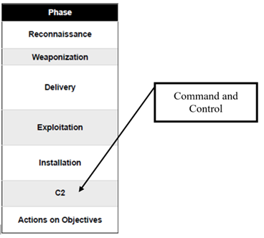
Figure ‎2-2: Lockheed Martin's Cyber Kill Chain®. Source: adapted from Hutchins, Cloppert and Amin (2011, p. 9)

Figure ‎2-3: GCHQ's Simplified Process. Source: adapted from GCHQ (2015)

The GCHQ Simplified Process

Survey
According to GCHQ (2015), this phase always precedes a cyber-attack. It is the ideal time to find out about a future attack, but it is also the hardest time to detect unusual behaviour. The initial enquiries made during the survey phase will seem perfectly innocuous, and may include information like company office hours, staff numbers, and means of contacting the company electronically. These items would not usually be concealed or considered secret. Unfortunately, sometimes the electronic response to the request may unintentionally reveal system weaknesses:
Any information which is published for open consumption should be systematically filtered before it is released to ensure that anything of value to an attacker (such as software and configuration details, the names/roles/titles of individuals and any hidden data) is removed (GCHQ, 2015, p. 11)

Delivery
Prevention of delivery is one area where the IT department can and does have a role in cyber-security (Subashini and Kavitha, 2011). The enforcement of password protocols, and control of configuration and access all reduce the opportunity for an attacker to find a way to exploit their knowledge of the system (Hancock et al., 2016). GCHQ (2015) suggested several ways to mitigate delivery, but this is also an area where an active watch must be kept on the behaviour of external websites, even when these are trusted (GCHQ, 2015). If unusual behaviour is detected in this phase, an attack can probably be prevented.

Breach
This is the ‘normal’ detection point of a cyber-attack. Existing frameworks tend to accept that this is where action must be taken, and their aim is to prevent it getting any worse. Again, this concentration on mitigation (GCHQ, 2015) is good, and has been extensively tried and tested. However, the aim of a new framework must be to shift this detection point to an earlier phase, either delivery or survey.

Affect
If the attack is not detected before this phase, then it is only the resilience of the organisation that will make recovery possible. However, “[i]f all the measures for the survey, delivery and breach stages are consistently in place, the majority of attacks using commodity capability are likely to be unsuccessful” (GCHQ, 2015, p. 12).
The possibility remains that this will be the detection or intervention point. Existing frameworks recommend that if this point is reached, “a full defence-in-depth strategy” (GCHQ, 2015, p. 12) should be used. The point of the resilience framework is that this point must never be reached.

Trends
There has been an increase in cyber-attacks in recent years, as Figure ‎2-4 shows. Attacks by sector (Figure ‎2-5) show the importance of the issue to both companies and government departments within the UAE.

Figure ‎2-4: Frequency of successful cyber-attacks worldwide. Source: adapted from Imperva (2019)

Figure ‎2-5: Cyber-attacks by sector (USA), 2016. Source: data from Control Risks (2016)
This growth of attacks against government infrastructure is supported by the increase in cyber-terrorism, which is discussed further in the next section. This may be affected by ‘gullibility’: hackers or cyber-attackers may have been convinced by their backers that they are ‘doing the right thing’ by sabotaging government infrastructure. This may be combined with the popular growth of ‘conspiracy theories’ (Wood, 2015). However, the reason is less important than the trend itself. The moral aspects of activism and terrorism are beyond the scope of this thesis, but acceptance of the idea that they are growing can influence the way in which individual companies or governments approach cyber-security.

Terrorism and cyber-attacks
Cyber-terrorism is seen as another growth area for the future. Governments around the world are increasingly online and causing disruption to a government to which you are opposed is one of the aims of terrorism (Weimann, 2004). Cyber-terrorism is the same as any other form of terrorism except for its delivery (Zubrzycki, 2016). Like most other forms of terrorism, it needs funding, which often comes from other criminal sources (C.P. Clarke, 2016; R. A. Clarke, 2016). However, from the point of view of cyber-attacks, “[w]hether or not a cyber-attack against vital information infrastructure is viewed as an act of terrorism depends on the intent” (Heickerö, 2014, p. 555).
Although this is an emerging threat, it is more likely to be aimed at ‘establishment’ websites and information hubs than ordinary commercial companies. However, this does not mean that ordinary companies can be complacent about the risk. An awareness that it may occur should be built into any new framework.

The Development of Cyber-Risk Management Frameworks
When it was first realised that cyber-risks applied to ‘ordinary’ companies as well as ‘high tech’ companies, the idea of critical infrastructure became common, defined as:
[P]hysical and cyber-based systems that are essential for day-to-day operation of the economy and government. [Examples include banking,] [e]lectric power production and distribution, water treatment and supply, gas and oil production and distribution, and telecommunication” (Ralston, Graham and Hieb, 2007, p. 583)
Companies with critical infrastructure are also suppliers and clients of other companies. Where there is greater connectedness, there is also greater risk. In a globalised business world (Held and McGrew, 2003), cyber-security is no longer a matter of national importance, but affects everyone. Cyber-crime is truly international, as proved by the banking attacks in 2016 (Sky News, 2016).
Another emerging risk with a major effect on connectivity and therefore on security is the concept of Platform as a Service (PaaS) (Li et al., 2013). This approach, suggested for ‘smart cities’, increases the level of access to company data (see Figure ‎2-6). This also adds the Internet of Things (IoT), with all its connected devices, and Infrastructure as a Service (IaaS). This is currently far less secure than the internet itself. This could severely affect systems that have not considered attack from that direction.

Vertical
Applications
Middleware
IoT Infrastructure
Vertical
Applications
Middleware
IoT Infrastructure
Smart-City Service-Delivery Platform
Virtual Vertical
Third Party Applications
Applications
Application Hosting
Applications
Data Processing
IoT IaaService
IoT Infrastructure Integration
Metering/ Billing
Tenant management
IoT Infrastructure
IoT Infrastructure
…
Platform Provider
Solution Provider
Solution Provider
Solution Provider
Solution Provider
Application Provider
Figure ‎2-6: The concept of PaaS. Source: adapted from Li et al. (2013, p. 80)
This approach to usage must also be considered as part of risk management. “Traditional ‘silo’ risk management has focused on managing primarily financial and hazard risks through hedging and insurance” (Keith, 2014, p. 20) and the ‘silo’ approach means that it is domain-dependent, or vertical (Li et al., 2013). This also fits well with the idea behind the need for a new, comprehensive CRM framework and emphasises the importance of increasing levels of awareness and resilience to cyber-attack.
Several responses have been developed for these risks, where traditional approaches such as Probability Risk Assessment (PRA) are considered insufficient. PRA is an excellent way of assessing risk, provided the assessor is aware of the risks. However, many cyber-risks are unique or not previously seen, so the assessor is often not truly aware of the risks. Ralston, Graham and Hieb (2007) suggested that the best of these new responses is hierarchical holographic modelling (HHM), which can be combined with risk filtering, ranking and management (RFRM). Both these approaches are valid but require substantial research by the organisation before use. This means that they may form a part of a new framework and can probably be successfully combined with other approaches but are not sufficient on their own.
Some of the effects of cyber-risks are shown in Figure ‎2-7. This is not a comprehensive list of every threat and response but shows that cyber-risk is more than ‘just an IT problem’. Cyber-risk management (CRM) is therefore a vital part of any enterprise that is reliant on computers at any level. It also illustrates the ‘traditional’ view where the threats, vulnerabilities and responses are all made up of separate ‘domains’ (e.g. ‘Hacktivism’, ‘people’, ‘policies’) demonstrating one of the weaknesses described in another context by (Li et al., 2013; 2019).
The various standards for cyber-security (Table ‎2-1 and Appendix 2) all prescribe actions to mitigate attacks, rather than to measure resilience or prevent attacks. It is therefore essential that emerging trends are considered alongside the existing frameworks that for cyber-risk management. The risk framework shown in Figure ‎2-7 does not suggest any method of mitigating the threats or reducing the damage to the ‘values’. It clearly acknowledges that accidents and poor practices both increase vulnerability, but that both are spread across the entire spectrum. Neither is therefore the whole cause of that vulnerability. The next stage for most enterprises would be to look at the recommendations in BS ISO/IEC 27001:2005 (BSI, 2005) (and ISO 31000:2009) to create an applicable framework similar to Figure ‎2-8. This clearly shows the dynamic nature of a CRM framework, operating on an endless cycle of assessment and development. Figure ‎2-8 describes a general risk management framework and process, but essentially ERM must include CRM and CRM must be taken as seriously as any other risk to the enterprise. This framework is, and must be, based on a continuous cycle such as the Plan, Do, Check, Act (PDCA) cycle (also known as the Deming cycle (Deming, 2000) or Plan-Do-Study-Act (PDSA) cycle), because the process must be continuous, and not applied once and then ignored.
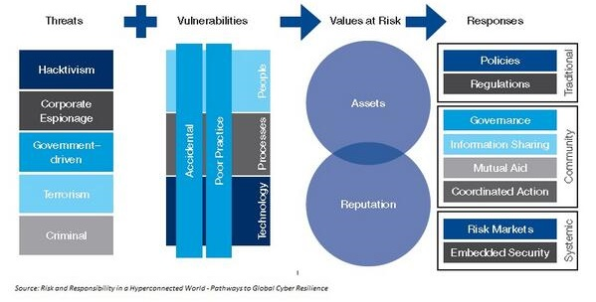
Figure ‎2-7: Cyber-risk framework. Source: adapted from World Economic Forum (2012, p. 13)
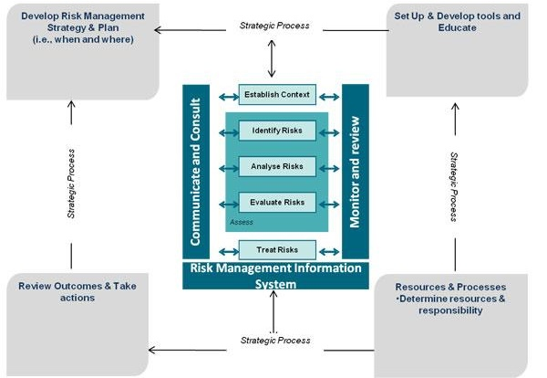
Figure ‎2-8: CRM framework and process based on BS ISO recommendations. Source: adapted from BSI/ISO (2016)

The Importance of a CRM Framework
It is essential to manage cyber-risks because of the level of interconnectivity in the modern business world and the consequent multiplication of risk. The computer systems of suppliers, their suppliers, customers and their customers are all linked in what is essentially a ‘neural network’. In its simplest form, with one supplier and one customer, it may look something like Figure ‎2-9. However, as suppliers and customers are added, it will begin to look more like those shown in Figure ‎2-10.
This multiplication of connections highlights both the importance and the difficulty of developing a ‘one size fits all’ framework for protection. It also shows the potential size of the problem. If devices such as smart phones are connected to these networks, background “apps” can compromise security even further (Efthymiopoulos, 2016). These devices also complicate the connected structure by connecting across layers, so that in Figure ‎2-10 a smartphone could connect layer three directly to layer one, multiplying the risk by the number of connections in each layer.
input
output
A
B
C
D
Figure ‎2-9: A simple neural network. Source: Shiffman (2012)
Figure ‎2-10: Deep or complex neural networks. Source: Shiffman (2012)

The direct relevance of some of the literature to the development of CRM frameworks is not always obvious. The next section provides a table that links the subject areas of the studies examined to their relevance to other areas. Fowler (2015) gave Table ‎2-2 as an example of the minimum costs of cyber-attacks in terms of reputation, financial cost, and the effect on operations. From news reports, it is also clear that once a company has been attacked, it becomes a target for future attacks (BBC, 2011; Sky News, 2016). The figures in this table suggest that it is worthwhile looking at a list of common ‘events’ (Table ‎2-3) and their possible consequences. Any cyber-attack will consist of several of these events occurring at the same time.
 | Consequence
Size of incident | Reputational damage | Financial damage (US$) | Operational damage
Incidental | Limited | < $500 | < 9% degraded service
Minor | Local/regional short-term negative exposure | $500–$1,000 | 10–49% degraded service
Moderate | Local/regional medium-term negative exposure | $1,000–$19,000 | > 50% degraded service
Major | National negative publicity | $20,000–$40000 | Complete loss of service
Critical | Global negative publicity, long-term negative exposure | > $50,000 | Complete loss of service and loss of employee productivity
Table ‎2-2: A consequences table. The financial damages in this table represent the absolute minimum cost. Source: Fowler (2015, p. 101)
Fowler (2015) stressed the necessity of planning to deal with events as well as trying to prevent them. All these events, including accidental or unintentional data disclosure, can be reduced or mitigated by the application of a suitable framework. When dealing with an attack, the business continuity plan must address both cyber-risks and operational risks, and a disaster recovery plan is advisable in any company that relies heavily on technology. The link between operational or cyber-risks, events, response and recovery is clearly shown in Figure ‎2-11. This also shows the need to plan for a cyber-attack and have an appropriate response for recovery or continuity in place before the attack. The framework for preventing attacks and events must include staff awareness, with the emphasis on individual liability for the data each person handles.
it is important to include human resources management in a CRM framework. Governments and industry may work together to “secure cyber-space” (Obama 2009, cited in Clinton, 2015, p. 53) but a totally secure system would still not be risk-free. The simple fact is that, at its base, every cyber-threat or risk has a human element. Fraud, property theft, and the creation of malware and viruses are all human actions (Fowler, 2015). To consider them in any other light will detract from how the risk is considered. Regardless of ‘fail safes’, people leave live terminals unattended, and can be fooled into handing out bank details or other security information.
Event | Possible Consequences
Loss of service availability | Loss of revenue  Loss of customer confidence  Loss of employee productivity
Web application compromise | Loss of revenue  Loss of data integrity  Loss of customer confidence
Electronic financial fraud | Loss of revenue  Loss of data integrity  Loss of customer confidence
Malware/virus outbreak | Loss of service availability  Loss of data integrity  Loss of employee productivity
Physical theft of an electronic asset | Financial loss  Loss of customer confidence
Unintentional data disclosure | Loss of revenue  Loss of service availability  Loss of data integrity  Loss of employee productivity  Loss of customer confidence
Intellectual property theft | Loss of competitive advantage  Loss of customer confidence
Table ‎2-3: The most common events in a cyber-attack. Note: several of these can occur simultaneously. Source: Fowler (2015, p. 99)
These ‘human factors’ explain why it is important to establish a culture of cyber-risk management, and why Chief Security Officers and Chief Information Security Officers need to understand both people management and computer management. They are also why awareness must be at the top of the agenda when discussing a new framework. Essentially, organisations must consider “insider threats” (Sticha and Axelrad, 2016).
Cyber-attacks are often ‘opportunist’ events (i.e. although carefully planned, attackers wait for the right opportunity to breach security) (Fowler, 2015). Following security procedures (e.g. swipe cards, password changes) substantially reduces the risk, and that must be seen as a personal problem for every single staff member who accesses the system at work, at home or on a smart phone (Lesjak et al., 2016). An awareness at board level that this is not enough to prevent determined professional attacks must lead to the adoption of a suitable and reasonable CRM framework (Yayla and Hu, 2014). This combination of ‘physical’ and ‘cyber’ security is behind the proposal of Hessami, Jahankhani and Nkhoma (2015) for RECYPHER, or Responsive Cyber-Physical Risk Management, an idea that clearly has merit and may be a part of any proposed framework.
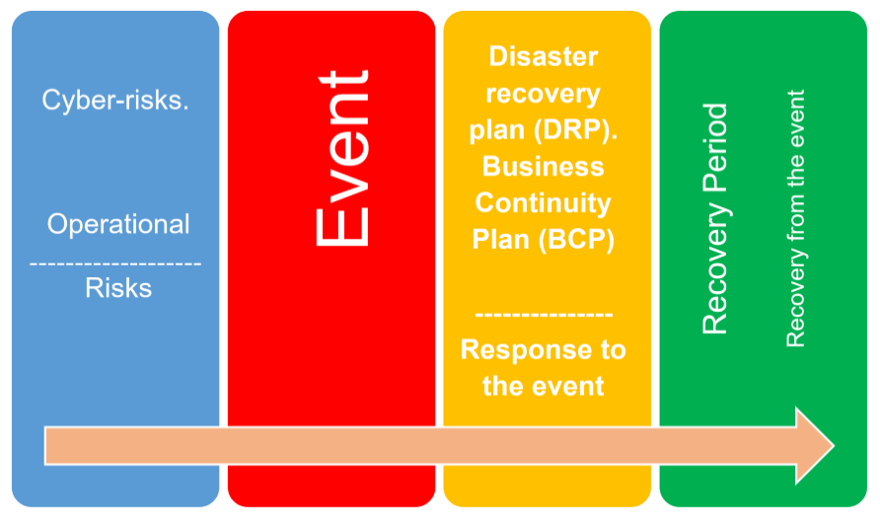
Figure ‎2-11: The link between risks, event response and recovery.

Past and Present Challenges to CRM
One of the major challenges that has always faced CRM is the attitude that data security is an IT problem, rather than a matter for the individuals handling data (Amoroso, 2011). This challenge remains unaddressed in many companies. There is certainly some IT responsibility if there is no security protocol in place on the use of smart phones, tablets, and lap-tops to access company systems (Waldron, 2008).
Another challenge facing CRM is event frequency. It is necessary to have or introduce continuous surveillance of the system for errors or attacks (Julisch, 2013). However, the person overseeing the surveillance is unable to predict what, when or where the next attack will be. The purpose of CRM is to retain resilience to attack, so first responders need to be available at all times (Yoon et al., 2016) to step in and control the event. There are also clear indications that cyber-risks are not lessening despite the efforts of companies to introduce CRM frameworks. Indeed, some commentators have suggested that the growth is almost exponential (Raiu, 2012). As fast as frameworks or devices are created to protect companies from cyber-attack, attackers develop new ways to get around them and attack (Schneier, 2015). It seems logical that when attackers have to put in more effort, they will attempt to do more damage during an attack (Andress and Winterfield, 2011). This means that managers need to be increasingly aware. Sticha and Axelrad (2016) found that there were fewer insider threats from disgruntled staff who tried to conceal counterproductive behaviour than from those who simply carried out the actions with no attempt at concealment. One single study cannot be considered definitive, but it is worth mentioning their conclusion that the level of counterproductive behaviour, concealed or otherwise, is not the sole indicator of risk.
Sticha and Axelrad used their own system dynamics model in conjunction with a Bayesian belief network, which they suggested was “a good tool to use for prediction” because it “characterizes probabilistic relationships among indicator variables”. They acknowledged that their result was counter-intuitive but suggested that this should encourage risk managers to look deeper and more closely at employee behavioural patterns (Sticha and Axelrad, 2016, p. 351).

Risk Detection and Evaluation in CRM
The increasing complexity of ICT and the apparent ‘randomness’ of cyber-attacks means that detecting and evaluating the risk of attack is not easy. Methods suggested to predict where and when an attack will happen include game theory (Fielder et al., 2016). This approach, where risks and possibilities are considered from the viewpoints of both ‘defence’ and ‘attack’, has serious limitations. The most serious disadvantage of the game theory approach is that it engages in too many trade-offs. Risk managers who seek the “least-worst” option rather than the best will be more likely to succeed, but at a cost of never knowing how well the company could have performed.
Despite this possible drawback, “attacker-centric game theory” (Adams and Makramalla, 2015) may be very helpful when trying to assess future risks. Getting to know your own systems and those of your ‘enemy’ can reduce risk and increase resilience simultaneously. Using game theory is not the same as ‘gamification’ (Dale, 2014). It is essential that risk managers do not trivialise the job of defending the system into a ‘game’ that you sometimes lose. However, as well as identifying future threats, game theory can also help to indicate possible insider threats (Casey et al., 2016) and deter them. Combining game theory with the SD and Bayesian Belief Network (BBN) approach (Sticha and Axelrad, 2016) may prove a better tool than either on its own.
Fransen, Smulders and Kerkdijk (2015) proposed a system of joint infrastructure and data sharing, which they called cyber-security information exchange. They noted that “cyber-attacks are continuously becoming more sophisticated… and employ(s) specific stealth techniques to avoid detection” (Fransen, Smulders and Kerkdijk, 2015, p. 106). This means that information sharing could be a useful tool in the fight against cyber-crime. This suggestion has merit, but raises questions about what, when, and how to share, and particularly how, because CRM policy is mainly focused on preventing access to information.
This division between shared and private data is at the heart of any CRM policy (Shields, 2015). The risk managers’ job is to find a position with the fewest trade-offs between privacy and accessibility. A good Chief Information Officer or Chief Information Security Officer will also need to be able to inform the board about any problems that have occurred (Yayla and Hu, 2014), including what percentage were due to accident, carelessness, deliberate attacks, or because of lack of awareness of a specific risk (Korpela, 2015). Risk identification or recognition (Shields, 2015) must take place before defence can be considered.
IT managers may feel that they have covered the risks with automated intrusion detection systems (IDS) (or intrusion prevention systems, IPS) and ‘unified threat management’ (UTM) (Raywood, 2012). Nevertheless, as has repeatedly been proven by events, a security incident and event management (SIEM) policy or system is about managing people, not installing hardware (Leonard, 2015). Board-level Chief Information Officers or Chief Information Security Officers therefore need to be conversant with both the technical ICT terminology and systems and with the operation and conventions of human resources management (HRM).
The underlying point for cyber-risk resilience is that the ability to recover from an attack is far more important than the ability to prevent one. The level of resilience must have a human element as well as an electronic one, and so information management must include people (Waldron, 2008). ‘Knowledge management’ in an electronically connected company (Valkokari, Paasi and Rantala, 2012) is still about individuals. Good knowledge management will help build resilience, because the knowledge map will allow the right people to be used (Gonzalez and Martins, 2014) in a disaster. Knowledge management, particularly in small and medium-sized businesses, is also a performance indicator (Roxas, Battisti and Deakins, 2014), so the connection with resilience is a clear indicator of its importance to CRM.

Data Mining and other Legal Activities
Data mining is one of the ‘grey areas’ of cyber-attack, particularly with the IoT. Much information has now become public that was previously considered confidential (Chen et al., 2015). ‘Data mining’, strictly speaking, is legal. It consists of accessing data that have not been protected and are therefore in the public domain. However, the connection to more serious cyber-attacks arises because of the reconnaissance or survey phase of cyber-attacks. If this preparation can be hidden within apparently innocuous ‘data mining’, it is much harder to detect or prevent.
The advent of the IoT has meant that there are now detailed data available about the way that products are actually used in the real world (Chen et al., 2015). Many of these data are unprotected, and in the public domain and mining these data is totally legal. However, determined hackers have used weaknesses discovered during data mining to compromise systems (Chen et al., 2015; Li et al., 2013). As soon as that is considered, data mining becomes a cyber-threat. This highlights one of the ‘grey areas’ of cyber-security: is it ethical to employ ‘hackers’ to improve your own security (Peterson, 2015)? If so, should they look only at your own weaknesses, or those of other companies that you may not wish to replicate?
Data mining and the general browsing of competitors’ products is legal but may be a double-edged sword. The realisation that your competitor has left an open doorway into the computer system may be too much temptation for an individual in your organisation, and suddenly, your company has become the cyber-criminal. It is therefore essential for CRM to consider not only how your own security may be breached, but also the response and reaction if an internal user becomes a threat to others, and therefore, indirectly to their own company. There must also be robust guidelines about what level of data mining is acceptable, and the actions to be taken in the event of discovering a ‘gap’ in someone else’s defences. These may include a procedure for informing them immediately, to minimise any damage to them. This may seem altruistic, but it helps both parties, and needs to become the industry standard response as connectivity increases with the IoT.

CRM and Strategic Planning
Adding CRM to the long-term strategic plans has always been suggested by cyber-security experts (Fowler, 2015), as well as prompted by the need to provide a response strategy (Waldron, 2008). Data systems can only be totally secure if they are not connected to anything and only viewed by one employee. Even then, there may be human errors or trust issues. If that premise is accepted, strategic planning needs to be on the basis that ‘our system is not completely secure but is open to attack’ (Schneier, 2000; 2012). Total internet security may be an aim, but so far is a long way from realisation (Clinton, 2015).
The difference between CRM and ordinary risk management is that ‘ordinary’ events, even extremely serious events such as earthquakes and floods, can be foreseen or imagined. A concentrated distributed denial of service (DDoS) attack (Bendovschi, 2015) would cause similar damage to a major flood, because it would prevent anyone in the company from accessing the system. With no emails, no CAD/CAM operations (in manufacturing), and no news feeds or financial information (banking and finance), the system would effectively be ‘flooded’. However, unlike a flood, the DDoS attack could occur at any time, night, or day, and is only one of many possibilities (Fowler, 2015). Some of these possibilities are also unknown. A new framework needs to protect against attacks that cannot be imagined or are dismissed as trivial.
This clearly raises the question “how do you imagine the unimaginable?”. This is the hardest question that the CRM must answer. This lack of knowledge about future attacks means that the CRM policy must be robust enough to counter any existing or historical cyber-attack (Waldron, 2008). Long-term strategies for cyber-risks need to consider whether insurance is necessary (Mukhopadhyay et al., 2013), or even possible. It must also consider future possibilities like smart-grids (Liu et al., 2012) and smart cities (Efthymiopoulos, 2016), and how these may affect existing security measures. The person in charge of the CRM therefore needs to be and remain completely up to date on current trends in cyber-attack (Bendovschi, 2015).
The consideration of security (physical and cyber-security) in smart grids is already a reality (Habash, Groza, and Burr, 2013). This is clearly an efficient method of transmitting data over long distances, with a “proposed framework [that] calls for a coordinated assessment of cyber and physical risks keeping the whole grid security goals in mind” (Habash, Groza and Burr, 2013, p. 1070).
Efthymiopoulos’s (2016) work on smart cities must also be critically considered when planning for future framework development. This is an area of increasing importance because it increases the connectedness of individuals, governments, and businesses. To omit such an important sector from any resilience plans would be a serious error, and it may even be possible to use the latent capacity of these grids and cities as a part of the resilience response.
Strategic planning is also linked to business ethics, and what is acceptable or unacceptable practice. This situation arises when considering, for example, data mining. It may be helpful for governments to provide official definitions to prevent situations arising where “what I do is simply data mining, but what you do is cyber-theft” even though both are doing the same thing. There will always be companies that go beyond limits, but if those limits have been agreed across an industry, it is possible to take action to stop breaches.
CRM can also be used to add value, which means that it is essential for strategic planning. Strategic planning is easier in a company with a ‘culture’ of CRM. However, regardless of the size of the company, CRM should be an essential part of the ERM. It is likely that ICT will be part of everybody’s life for the foreseeable future (Hatch, 2011) so CRM will also need to be part of strategic planning. Hatch (2011) considered this from an educational viewpoint, but the thrust of her argument applies equally to business. It is essential to make the best use of the tools that are available, and to be aware of the possible dangers of doing so.

Using CRM to ‘Add Value’
Falkner and Hiebl (2015) suggested that small to medium-sized enterprises (SMEs) are less likely than larger companies to use any form of risk management because of a lack of resources. By extension, the implication is that they have no CRM policies, although:
potential impact of implementation failure [is] relatively higher – especially if SMEs opt for open-source software vendors and not for large for-profit software vendors… [and that] all gaps in online security have an impact on reputation and customer trust (Falkner and Hiebl, 2015, pp. 130–131)
This issue has added importance because SMEs are a major driving force of the economy of both developed and developing countries. Gama and Geraldes (2012) suggested that in the EU, SMEs provide around 99% of economic activities and two-thirds of private sector jobs.
The very companies that most need ‘non-financial risk management’ (Wong, 2014) are therefore the least likely to have it. In turn, this means that any SME adopting the framework proposed could claim it as a unique selling point to potential investors, thus ‘adding value’ to their investment package.
There is one difficulty with viewing risk management as ‘risk minimisation’: it tends to minimise creativity too (Ehsan, 2013). To add value requires creativity, so in this context, risk management needs to be viewed as the ability to respond when an incident occurs (Ehsan, 2013). This approach initially seems the opposite of what has been proposed so far, which is all about the prevention or minimisation of major cyber-attacks. However, it is compatible. In the engineering and production areas of a company, it is important to promote creativity, but cyber-security can be maintained by setting up a ‘creation zone’, where any attack on the system cannot spread into the main computer system.
Another way in which CRM can be used to add value is through the idea of “cyber-intelligence” (Borum et al., 2015). The firm that has gained enough knowledge to be able to predict and respond to the next cyber-attack will also be in a position to predict and react to market changes. This is because the ‘intelligence’ (in the military sense) required to predict attacks is similar to the intelligence required to predict market changes. The first clear indication of a requirement for the new framework begins to emerge here: a CRM framework must include flexibility so that creativity is not stifled, and an ‘intelligence network’ that will feed information about important trends and details to the risk manager.

The Need for a Culture of CRM
The need for a culture of CRM can also be seen from the point of view of ‘added value’. Until all companies, small or large, accept that it is a necessity rather than a free choice, and bring in a corporate culture of risk management including CRM, it seems unlikely that progress will be made in this area (Institute of Risk Management, 2014).
Warner and Sloan (2016, p. 1) took a similar view, saying; “Security experts have long explained how to defend better. So why does society tolerate a significant loss that it has the means to avoid?”. They suggested that part of the answer is a reluctance to accept the cost, and partly the need for a culture of CRM. The ‘cost’ is not simply financial but includes aspects such as the additional time required for security measures. It also considers the idea that estimates of the levels of loss are likely to be underestimates because of the lack of information available.
Shackelford, Fort and Charoen (2016) put CRM into the same category as corporate social responsibility, which also required a culture to be developed before it was truly effective. This view is based on the idea that in future, as the levels of connection increase, cyber-security at the company level will affect national security. Companies will therefore find it is in both their own best interests and the best interests of their host country to instigate a culture of CRM.
This idea of the level of importance of cyber-security is upheld by experts from America’s Central Intelligence Agency (CIA) (Borum et al., 2015, p. 317). The CIA noted that Investing in technology, firewalls and intrusion detection systems is necessary, but insufficient. The agency made a strong case for cyber-security to include cyber-intelligence, as described in Section 2.3.4. However, the level to which this is pursued is a matter for individual companies, because the point at which ‘gathering intelligence’ and ‘data mining’ become ‘cyber-spying’ and ‘cyber-attacks’ is a matter of ethics and viewpoint. This dichotomy leads towards another necessary part of a CRM framework: guidance on acceptable and unacceptable behaviour (e.g. data mining vs. cyber-attack). That guidance needs to go into more depth than simply saying “what is not protected is a fair target”. Information security also needs to become as much a part of the organisational culture as physical security (Yildirim, 2016). Nobody would think of leaving the factory open and unlocked after everyone has gone home, and access is usually restricted during working hours. However, a visiting executive from a rival company can often access the computer system from a smartphone simply because no-one has bothered to make the system secure (or worse, an entrance has been left open by someone who “didn’t think” that it was a problem) (Cain et al., 2016).
This growth of a culture of cyber-risk awareness may be assisted by executives other than the Chief Information Security Officer visiting trade fairs and cyber-security fairs (Larson, 2015). One difficulty with these events is that board members who really need information about the latest threats are actually the least likely to attend. Part of developing a culture of CRM needs to be incentives for the board and senior managers to learn about the subject. They will then (hopefully) become more enthusiastic, which will encourage more junior managers to learn more.
In creating this culture of risk awareness, it should be remembered that “cyber-risks are amongst the most underestimated business risks” (Kosub, 2015, p. 631). This theme has emerged strongly from the literature review. Kosub (2015) concentrated on the process of CRM, using existing frameworks, but included the need for a risk culture. Kosub’s proposed process is shown in Figure ‎2-12. He placed risk culture last in the process but noted that this simply reflects the logical progression for a company setting up CRM for the first time, rather than the relative importance.

Figure ‎2-12: Kosub's suggested process for CRM. Source: adapted from Kosub (2015)

The process is important, but the BSI/ISO (BSI/ISO, 2016) standards and other frameworks provide a scaffolding to support it. The purpose of this study is to produce an improved framework that will permit a process such as Kosub’s (2015) to operate without difficulty and to become a natural part of the company’s ERM.

CRM Frameworks and Board Level Involvement
If the networks used for the transmission were limited to software-defined networks, it is unlikely that additional support or framework would be required. These networks are naturally resilient and tend to become even stronger when they are attacked (Ahmed et al., 2015).
Yayla and Hu (2014) emphasised the need for a knowledgeable Chief Information Officer (CIO) on the board. These officers must keep abreast of all developments in ICT and know the company’s ICT systems in detail. They suggested that “research has shown a lack of board of directors’ oversight on CIO- and IT-related issues” (Yayla and Hu, 2014, p. 401).
This is clearly a serious issue, because ‘CIO- and IT-related issues’ are now such a large part of the activities of almost every company. If the board does not know there is a risk, it cannot be managed. It therefore also seems advisable to suggest that all members of the board should have a certain level of computer literacy. Yayla and Hu’s (2014) model for research is shown in Figure ‎2-13.
Figure ‎2-13: Yayla and Hu's (2014) model for research on the effect of board level knowledge on the performance of firms
Note: H1 is the negative effect of low knowledge at board level, H2 is the positive effect of board-level IT knowledge, H3 is how the negative effect is lessened if the company has a lower level of IT use, and H4 is how board IT awareness improves performance if the industry is IT-intensive. In simple terms, greater IT intensity leads to a greater need for board-level awareness of cyber-risk and -resilience.
Yayla and Hu (2014, p. 426) noted “The board of directors’ IT awareness has a significant effect on firms’ performance”. This view that the board must have a higher level of IT awareness has also been upheld by others. Clinton (2015) suggested that it is best practice for this to be the case, and Borum et al. (2015) also insisted that IT awareness is essential for cyber-intelligence. It therefore seems reasonable to suggest that a mainstay of the new framework will be education/training at board level to ensure that all members of the board have an adequate level of IT knowledge and cyber-risk awareness.
Board members can then lead the drive to introduce the required culture of CRM. In this case, a top-down approach is necessary, rather than a bottom-up one, because it will save time and also be generally more accepted both by board members and junior staff. The reason for this is intuitive; if you begin at the bottom, by the time it reaches board level, the ‘ground level’ employees will already be thinking of it as ‘just another management time-wasting programme’. However, if it begins at the top, these employees can see that it is already being implemented and taken seriously by senior managers.

The Cultural Aspects of CRM Implementation
In some of the countries in the Middle East area or the slightly wider Middle East and North Africa region there is a strong dichotomy between modern, global business practices (including the use of ICT) and the traditional, Islamic and family-based way of life. Tomlinson (2003) suggested that this can lead to conflict over identity. However, it is also a difficulty in relation to security issues. There may be a level of resentment (Hammoudeh, 2012) of the need for passwords and security measures if people have given their word that the information is confidential.

The Dubai Vision of Cyber Safety
The Dubai Electronic Security Centre (2017) published a vision (see Figure ‎2-14) that is intended to make Dubai electronically and physically:
The Most Secure Place: A feeling among residents and workers living in Dubai and tourists visiting Dubai, that the city is a safe and secure place and that any personal security concerns are dealt with efficiently and transparently by law enforcement authorities (Dubai Electronic Security Centre, 2017, p. 9).
The intent is to bring this about using the principles of risk awareness, and a rapid response to new or emerging physical or electronic threats.

ERM Issues in the Financial Sector
The cyber-risks defined as a part of the overall Enterprise Risk Management (ERM) process are particularly applicable to the banking and financial sector. In this sector, an integrated strategic ERM alignment framework was proposed by Keith (2014) in a thesis. There are parts of the UAE public sector where these financial issues are relevant.
This critique of Keith’s (2014) thesis examines its objective and purpose, as well as presentation of the theory, the research approach used, the way that it was reported, and how the results were presented. To understand the research methodology, other authors were also consulted (Crotty, 1998; Bryman, 2008). The arguments used by Keith (2014) are set out below.
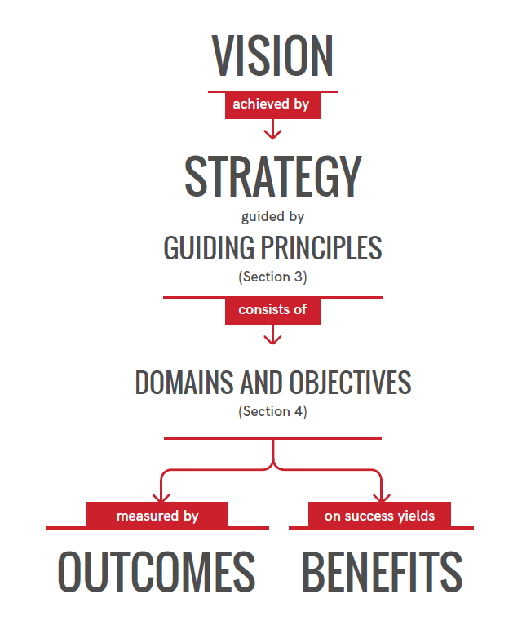
Figure ‎2-14: Dubai's cyber-safety tree. Source: Dubai Electronic Security Centre (2017, p. 10)
The purpose of Keith’s (2014) research was very clearly laid out, and her research questions were a logical extension of her aims and objectives. She aimed to validate a ‘strategic alignment framework’ for ERM in the financial sector, and her deconstruction and examination of the existing ERM frameworks provides a strong basis or foundation for that financial ERM.
Keith examined the theories behind the existence and development of ERM from the 1990s to the present and identified how the traditional ‘silo’ or vertical ERM has developed and how it differs from the simple ‘risk management’ that preceded it. Several theorists were identified as driving the change from risk management to ERM, and the idea that ‘audit’ should ensure that ERM procedures are followed correctly, but that ‘compliance’ should work with risk assessors to ensure that the ERM procedures proposed are suitable and adequate (fit for purpose).
The rationale for the research was that ERM developed very quickly, particularly since the global financial crisis of 2008. However, very little academic research had been completed into whether the ‘silo’ approach was still valid and appropriate or whether a wider, strategic, tactic was needed. This rationale also helped to identify the gap in the existing research: that previous studies into the growth and development of ERM all concentrated on the existing ‘silo’ or ‘domain dependent’ risk management programs rather than examining the strategic view.
Keith (2014) aimed to close this gap by trying to find an ERM approach to link and integrate these separate domains or silos, and deal with them simultaneously. This would allow risk managers to consider the risks faced by the company as a whole, instead of breaking them down into categories such as financial, operational, and hazard. Most previous studies tended to follow the traditional path of separation rather than the suggested route of integration.
To bring about this integrated approach, Keith (2014) began by examining the philosophy behind the research. She noted that different researchers have different world-views, the ““Weltanschauung, … that guides [their] actions” (Crotty, 1998, p. 94), and that this leads to different research paradigms. The major two paradigms identified were positivism and phenomenology, where positivism takes a deductive approach and phenomenology an inductive approach. These vary in several ways, and Keith fully justified her choice of an interpretivist philosophy, which is largely deductive, but which includes some inductive aspects. One useful idea in her literature review is a variation on Covey’s (1999) ‘four-quadrant’ approach. He originally used this for time management, but Keith’s (2014) adaptation was a useful variation to discover any difficulties or drawbacks of existing frameworks (see Table ‎2-4). This approach has been adapted for the development of the new framework described in Chapter 4. Existing standards (Table ‎2-1) were also considered in relation to both existing and proposed frameworks.
Overall, Keith (2014) clearly explained her methodology in both parts of the research, part one being the ‘desk-top’ research, including the literature review and part two the descriptive research involving questionnaires to gather first-hand data. This allows the reader to clearly differentiate the limitations of each discrete section of the research and to reach an opinion about its overall validity and reliability. This information is also useful to any other researcher and informs their approaches. It is clear from the literature review that the major problem facing Keith (2014) was the same as in any rapidly changing field: the most recent research papers can supersede research before it has been completed, so that the researcher has to update their work almost continuously.
Keith’s (2014) presentation was clear, and the possible impact of her suggested framework was also made plain. The quadrants show the main drawbacks of existing frameworks or approaches. Separating academic and industry-based contributions allowed the identification of the ‘research gap’. In effect, a new framework would have to concentrate on whichever quadrant has the least supporting evidence, because this is the ‘gap’ which must be filled. It logically follows that areas where existing frameworks are weak will be strengthened, without weakening in any way those areas which are already strong. Where the research philosophy or outcome could reasonably be fitted into more than one quadrant, this was done, adding to the robustness of the findings. It is clear that these divisions were to some degree arbitrary because they were based on the perceptions of the researcher but providing the criteria behind the classification means that they can be considered valid.
The literature suggests that a new framework must include some way of measuring ‘resilience’, which was not one of the considerations covered by Keith (2014). Part of her approach has therefore been adapted here, but it is supported by additional considerations about resilience laid out in existing frameworks and the Introduction on the gap in existing research, and particularly in Figure ‎2-1, which details the concept of resilience measurement.

Gap in CRM – Why a New Framework is Required
CRM is a well-established area, but risk management in general, and CRM in particular, have only recently begun to consider the overall importance of resilience (Zhang, Collins, and O'Connor-Close, 2020). This has therefore allowed a research gap to develop, which is discussed below, and which, in turn has led to the need for this research and for a new conceptual framework that incorporates risk management, cyber-security, and cyber-resilience.
 | Research Philosophy
Research Outcomes |  | Visionary | Implementational
Research Outcomes | Descriptive | Quadrant I | Quadrant III
Research Outcomes | Descriptive | Describes CRM definitions and discusses the links to organisational factors.  The literature definitions are sometimes unclear, with borderline activities (e.g. Data mining or cyber theft?) needing to be made clear in any replacement framework.  Essential issues of employee behaviour often too detailed to apply in the “real world” – a generalised description of counter-productive behaviour is needed, and a better analysis of whether actions are deliberate or accidental will help prediction and prevention. | Describes the process of CRM implementation and discusses some practical guidelines.  The literature suggests staff training and management awareness as being essential, but no transferable guidance on how to achieve this in the UAE.  Advances in the IoT represent new threats, but an integrated CRM is needed for the new resilience framework.  Concentrates on either resilience -OR- security, need to resolve dichotomy.
Research Outcomes | Prescriptive | Quadrant II | Quadrant IV
Research Outcomes | Prescriptive | Provides prescriptive CRM approach and discusses the links to organisational factors.  The industry standards (BSI/ISO standards, COSO, etc) are provided here, but they have gaps and flaws.  Industry security specialists (e.g. Schneier, Fowler) provide the basis for security -OR- resilience, and the vision to combine the two is needed for the new framework.  Combining disparate views is the purpose of the research – the philosophy of visionary prescriptive (or proscriptive) action will bring a more positive outcome. | Provides prescriptive CRM approach and discusses the implementation process.  The results synthesised from the other three quadrants of the literature will allow the creation of a new, robust, resilience framework.  The new CRM/Resilience approach both prescribes and proscribes, details measurement principles and training regimes, and provides a framework that can be implemented for CI and the public sector.  People/Public/Private (3P) approach considered ideal.
Table ‎2-4: Variation of Covey's four quadrants showing an assessment of the literature on existing CRM frameworks. This allowed the researcher to develop an alternative framework, avoiding any of the difficulties of existing frameworks. Source: adapted from Covey (1999); Keith (2014)
The existing frameworks and standards largely concentrate on mitigation after an attack, although some also include preventative measures. This mitigation is undoubtedly linked to resilience, but one of the aims of the new framework is that it must provide a way of measuring resilience, which these do not provide. Information about the patterns of cyber-attack, particularly the cyber kill chain® (Hutchins, Cloppert, and Amin, 2011), emphasises when threats are detected earlier, it is easier to either prevent them or recover from them (improved resilience).
Logically, this indicates that the existing frameworks are not detecting or intervening soon enough. Figure ‎2-15 shows this graphically. It indicates that although the existing frameworks discuss early detection, their main purpose is mitigation, or not allowing the attack to proceed past point ‘B’ in the diagram. The ‘gap’ between the current situation (‘B’) and the ideal situation (‘A’) is the area where the proposed new framework must operate.
In Table ‎2-4, the layout shows the classification of the literature reviewed and the way in which difficulties needed to be overcome. The first column, the visionary aspect of the research philosophy, revealed problems for the outcome in both descriptive and prescriptive literature. Thus, the final quadrant, the implementational philosophy and the prescriptive outcome can be combined. Ito et al. (2016) suggest that for any initiative to work in the public sector a 3P approach is needed – i.e. People, Public, Private – and that is incorporated in this research.
The next section discusses the theory behind the new framework, which is developed in more detail in later chapters. It uses previous definitions of resilience to accept that the minimum requirement is a return to the pre-attack state. The various factors multiplied together and added or subtracted as required will give a measure of any individual company’s ability to recover from a cyber-attack of a given severity.

Further Left: Better Resilience Further Right: Worse Resilience
B
A
Figure ‎2-15: The relationship between the timing of threat detection and the strength of system resilience. Current frameworks are aimed at detection or intervention at point B, but should be aiming at point A.
If the new framework is to target detection and intervention at point ‘A’ (Figure ‎2-15) and also to provide a measure of the system’s resilience, it will need to improve on the requirements of ISO/IEC 27039:2015. It will also need to introduce a measurement of resilience, and this needs to consider the theoretical effect of every known type of attack detected in each of the four stages. When measured in this way, the actual resilience R_{A}, will be equal to the company resilience OR (a quantity not yet measured) minus the result of multiplying the risk factor RF by the effect factor EF and the detection point factor F_{DP}.
3: Calculation of actual resilience
$$R_{A}=OR-\left(R_{F}×E_{F}×F_{DP}\right)$$
The risk factor RF is the likelihood of a particular event. The effect factor EF is based on the financial cost of repairing the damage done by the attack, which will double every time a new phase is entered or left (i.e. in ‘Survey’ F_{DP} = between 0 and 1; in ‘Delivery’ F_{DP} = between 2 and 4; in ‘Breach’ F_{DP} = between 8 and 16; and in ‘Effect’ F_{DP} = between 32 and 64). The company resilience R_{C} will be dependent on several factors, including the number N_{AP}, and security S_{AP}, of its access points, and the ‘divisionalisation’ of the company data C_{RF}. These factors would also be given points scores to be multiplied together. This would be designed in such a way that a company scoring very strongly in every aspect of detection, protection and recovery would still be able to show some resilience even if it scored the worst possible results for RF, EF, and F_{DP}. This means that in the theoretical scoring system proposed, a score of zero for resilience factors is poor and 20 is good, and low values for risk ratings are good and high figures bad. The actual finalisation of the scoring or rating of these events or factors will need to be completed after research into resilience measurement is completed. However, a brief visualisation could be calculated as:
4: An example of the calculation of resilience
$$R_{A}=ORe-\left(R_{F}×E_{F}×F_{DP}\right)=\left(N_{AP}×S_{AP}×C_{RF}\right)-\left(10×10×64\right)=\left(20×20×20\right)-\left(6400\right)=\left(8000\right)-\left(6400\right)=1600$$
The initial review of the literature on cyber-risk and the current standards for resilience frameworks shows that the current standards do not accurately represent the increasing risks of cyber-attack. A new framework is needed that overcomes some of the shortfalls of the existing frameworks by giving companies a way to measure their theoretical resilience to various types of threat and indicates the areas where they are most threatened. This would allow managers to take a pro-active view of cyber-security and to identify their current strengths and weaknesses.
At this stage, the concept of scoring resilience by using vulnerability to attack, multiplied by opportunities for attack and the detection/intervention method currently in use, has been suggested as one way to measure resilience. A form of measurement is essential to the success of the proposed framework. It has also been suggested that the best definition of resilience is the ability to return to at least the same position after an attack as before. Thus, a company with a very small negative resilience will still be able to operate, but the aim must always be to have a strong positive resilience, allowing recovery to a better position than before the attack. This positive resilience factor also reduces the chance of any future attempt being successful, because of what has been learnt during the process.

Summary
There are a number of elements considered necessary for a workable framework. The next chapter draws on these to describe the development of a conceptual framework. This chapter sets out the main supports required and what is needed to complete and strengthen it.
Risk management requires the assessor to look at what could possibly happen and consider how likely it is to occur. The consequences of an occurrence combined with the likelihood or frequency will determine the management response (Amoroso, 2011). CRM is slightly more complex in that the possibilities are often unknown until they occur, and the consequences can often be more extensive (for an example of this, it is only necessary to consider the ‘Sony Hack’ described by Boorstin in 2015). The existing guidance and frameworks provide a picture of what the new framework must include if it is to be effective. First, improvements in risk awareness and the introduction of a culture of cyber-risk management must begin at board level and filter down rather than the opposite. However, that approach also requires a Chief Information Security Officer who is extremely knowledgeable about ICT and cyber-risks, and who also has the ability to lead and teach those at executive level and below in the complexities required to combine physical security of hardware, electronic security of company data, internet security at all levels, and accessibility. The last of these is the hardest to reconcile with cyber-security because customers and staff require easy access to data, but easier access means greater cyber-risk.
The next main supporting arm of the new framework is the necessity to regularly test both the system’s exposure to risk, and its apparent resilience to that exposure. The ideas of resilience and adherence to policy were then discussed, and the need for the “secure printer” and similar ideas were also put forward and explained as part of the necessary procedures for system security.
These two pillars will support most of the framework. They are both essential and will work together to deliver risk reduction and control. They are not enough to ensure that the company is not at risk from cyber-attack, but by raising awareness and demonstrating that every ‘unusual’ event in the computer system will be immediately investigated, insider risks are controlled. The rest of the CRM framework will consist of documentation of a protocol for every step of the process, and regularly updated risk assessments as new risks emerge. This documentation of the process is an important part of the framework because it allows and encourages the Chief Information Security Officer to test for exposure to existing risk and to consider the possibility of attacks from a new or unexpected direction.
In summary, the process is supported by the framework, but in turn provides information that could demonstrate weaknesses in the framework itself. The two must therefore be compatible and work closely together. Thus, to create the new conceptual framework, the original problem statement had to be viewed in the light of a critical review of the literature. The first issue presented in the problem statement was the lack of a means of measuring cyber-resilience in the UAE’s public sector. The literature presented several ideas of how this could be provided (e.g. Hubbard and Seiersen, 2016; Renn, 2013; Li et al., 2013), but even in the latest articles, questions are raised about how best to measure cyber-resilience (Madni, Erwin, and Sievers, 2020; Mierzejewska and Wdowicka, 2019), or even about the meaning of terminology used (Lewallen, 2020). These questions and differences of opinion have therefore been at the forefront of the design of the conceptual framework, and the importance of the definition (p. 12) was emphasised.
The next element of the problem statement, human factors, was also extremely diverse in the literature, from the simple acceptance that they are a factor (Dutt, Ahn, and Gonzalez, 2013), to the investigation and analysis of personality traits (Hadlington and Chivers, 2020). The former view is insufficient for the new framework, and the latter too complex to be applied to every public sector employee. Therefore, this aspect required special attention in the development of the framework, but making use of broad, cultural attitudes of the individual employees (Hopkyns, 2017; Sulaymani, Fleer, and Chapman, 2018).
The final two problem elements, the correlations between the risks, etc., and the moderating effect of organisational resilience, although mainly covered by the new data were also explored in the literature – the latest views on cyber-risks in supply chains (Ghadge, Weiß, Caldwell, and Wilding, 2019), the IoT (Kandasamy, Srinivas, Achuthan, and Rangan, 2020), and Artificial Intelligence (Radanliev et al., 2020) were of particular importance in the design and development of the new conceptual framework.
From all of these disparate views on resilience, risk, and security in cyber-systems, and the already stated issue that the existing frameworks tend to concentrate on either/or rather than both, the basic starting point for the new framework was laid, and the next chapter expands upon these points.

Conceptual Framework

Introduction
Cyber-criminals continue to develop new forms of attack at least as fast as new forms of protection develop (Bendovschi, 2015). It is therefore essential that those at every level of every organisation are aware of the possibility of these attacks (Korpela, 2015). A truly resilient IT system needs a framework of best practice, not only of ‘information security’ (BSI, 2005) and ‘assessing cyber-risks’ (COSO, 2015a; 2015b), but also of disaster recovery procedures, and disaster prevention considerations (Jung and Chung, 2015). This could make the difference between recovery and non-recovery for a business or institution. The cost of having the entire IT system shut down, even for a short period, is likely to be significant for any company. It is therefore essential to keep any shutdown as short as possible.
This chapter begins by examining some of the groups, or categories, of cyber-risk threats from inside and outside the system. It then considers the concept of vulnerabilities in a context that fits the proposed framework. Some perceived vulnerabilities may turn out to be trivial, but others that are initially overlooked or dismissed as unimportant may prove to be vital (Schneier, 2000). The chapter then examines the interaction between vulnerabilities and risks.
This gives a rationale for the importance of preparing a ‘response’, and explains why this is always necessary, and reliance on prevention and detection can never be sufficient in a real system. In a resilience model, such as this, the response needs to be both proportionate and appropriate.

Theoretical Development
The theoretical development of the new conceptual framework has two parts. Section ‎0 is the theoretical perspective drawn from the literature and relating this to the research questions. This, in turn, permits hypotheses to be made which are then incorporated into the framework. If a hypothesis is proven, then the related section of the framework can be considered to be working effectively. The hypotheses are tested, and the testing process explained in ‎Chapter 6, but they are developed from the questions and the theory in this chapter.
Section ‎3.2.2 examines the theoretical perspective of each of the variables in the data collection questionnaire and the new conceptual framework. These variables are also linked to the hypotheses developed in section ‎0, thus closely linking the perspective of the literature to the perspective of the data. When the theoretical development of the new conceptual framework has been particularised in these two sections, the proposed framework itself is presented in section ‎3.2.2.6.

Theoretical Perspective
This research examined the problem from several different theoretical viewpoints. The sub-sections below consider these theoretical viewpoints. There is no conflict between these viewpoints, so they can be combined easily to give an overall view. However, the framework proposed in this research combines theoretical viewpoints in a new way and should therefore increase knowledge and improve practice.

Cyber-Risk Management (CRM)
The research considers the existing theoretical frameworks on CRM and does not reject them. However, it combines the most relevant elements of each into a new, stronger and more effective framework. The existing models do not emphasise increasing organisational cyber-resilience. This puts risk managers at a disadvantage because the literature acknowledges the importance of resilience (e.g. Ayyub, 2014). Applying the proposed framework should therefore lead to improvements in CRM, because it supplies a missing factor.
However, using any CRM framework must be an improvement over not applying one at all. This research therefore improves the existing position by showing managers how to proactively improve cyber-risk awareness and cyber-resilience without losing any aspects of their existing CRM policy.

Vulnerabilities and Weaknesses
The research examined the existing frameworks and literature by considering weaknesses and vulnerabilities. This is the main area of interest to the research and the examination led to the research hypotheses incorporated in the new framework and introduced at the relevant points of this section. Overall, most of the weaknesses and vulnerabilities of a system relate to human factors (Schneier, 2012). However, system and technological weaknesses are also possible. The new framework aims to reduce the weaknesses and remove some vulnerabilities through a proactive educational management approach. If, as proposed by Schlesinger (2016), most people are unaware of the dangers, then education and improved cyber-risk awareness must be one of the keys to future security.
Pushing back the boundaries of vulnerability and weakness leads to greater resilience. Encouraging managers to take a more holistic view increases the level of protection (Atoum, Otoom and Abu Ali, 2014; Ayyub, 2014). A better understanding of the interaction between weaknesses/vulnerabilities and both threats and response should allow managers to discover any weakness or vulnerability before it becomes an issue. This leads to the first two hypotheses: (H1): Vulnerabilities and weaknesses are associated with external threats, and (H2): Vulnerabilities and weaknesses are associated with internal threats.

Response in Place
Responding to any cyber-attack is essential (Andress and Winterfield, 2011; Bendovschi, 2015), but simple logic dictates that it is not possible to respond to an attack until it has been detected. Having a prompt and appropriate response in place is an essential part of any framework, but this research aimed to make earlier detection possible. The argument here is that increased cyber-risk awareness must improve the chances of early detection and therefore early and appropriate response. In this respect, Hypotheses 3, 4, and 5 were generated: (H3): Vulnerabilities and weaknesses are associated with having responses in place (H4): Having responses in place moderates the association between vulnerabilities and weaknesses and internal threats, and (H5): Having responses in place moderates the association between vulnerabilities and weaknesses and external threats.
The study considered having a response in place as a moderator between threats and weaknesses/vulnerabilities. It also considered the effect of this on increasing cyber-resilience. It concluded that having a response in place is a vital element of both CRM and improved cyber-resilience.

Organisational Resilience
Cyber-Resilience is defined in section ‎2.2.1, and here, that definition is applied to every aspect of the public sector organisations that this research is aimed at (Haimes, 2009). The literature and theories of resilience raise the final three hypotheses, 6, 7, and 8, each of which is connected to organisational resilience (ORe): (H6): Vulnerabilities and weaknesses are associated with organisational resilience, (H7): Organisational resilience moderates the association between vulnerabilities and weaknesses and internal threats, and (H8): Organisational resilience moderates the association between vulnerabilities and weaknesses and external threats

Cyber-Risk and External and Internal Threats
The cyber-risks faced by a company may be from both outside (external threats) or inside the company (internal threats). These can also be sub-divided. This section gives examples of each type of risk, and where it has been encountered. A list of this nature must always be incomplete, however, because it is not possible to know about every risk, whether internal or external. Cyber-risks are continually evolving and changing, which is why information sharing and awareness training are so important.
In many cases companies are simply not prepared for cyber-risks (Allianz, 2015), for a range of reasons (see Figure ‎3-1).These apply to any cyber-risk in any category of threats or vulnerabilities. In the following sections, each of the threats listed in the new framework will be considered individually.
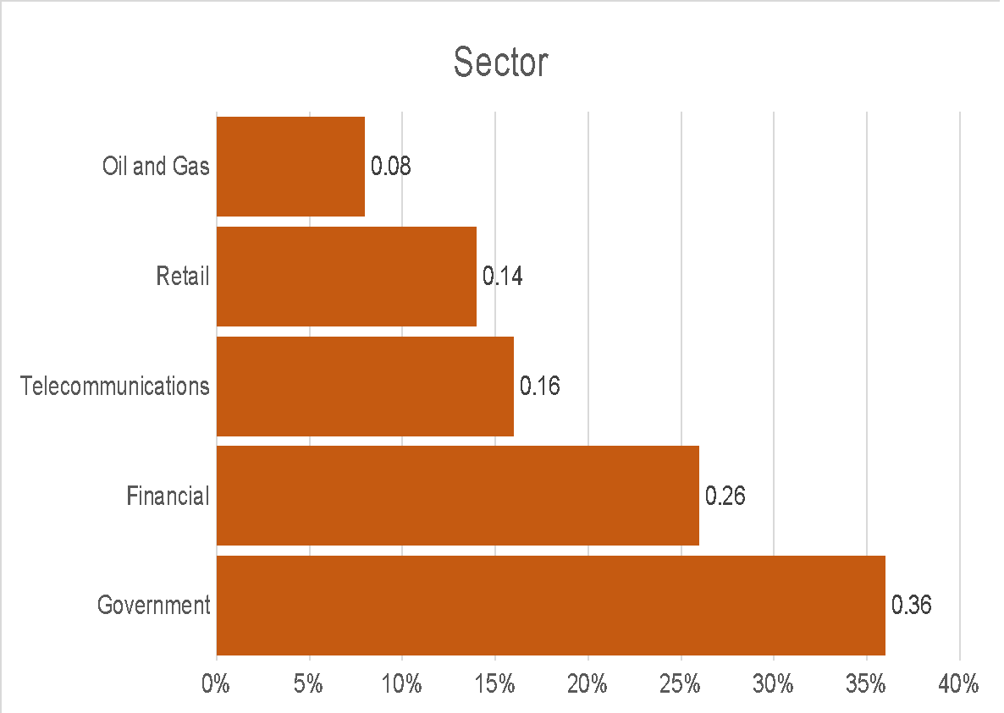
Figure ‎3-1: Cyber-risk preparedness factors. Source: Allianz (2015, p. 28)
The percentages shown in Figure ‎3-1 are calculated in such a way that the higher the figure, the greater the chance of a successful attack the calculation is:
$$Factor=\frac{(likelihood of an attack-readiness for an attack)}{likelihood of an attack}$$
Thus, if a company were 96% likely to be attacked but 88.32% prepared, they would have a factor of 0.08 or 8%, or if they had a 95% likelihood of attack and were 60.8% ready, the factor would 0.36 or 36%. So, in the oil and gas industry there is a high risk of attack, but also a high level of preparedness, whereas the government sector is very slightly less likely to be attacked, but much less prepared for it.
This type of risk factor calculation is often used by insurers and risk assessors as a guide to relative risk in different organisations or sectors of industry (Chatham House, 2019). Thus, from Figure ‎3-1 it is clear that, although the likelihood of an attempted cyber-attack is similar in both cases, the government sector represents a much higher risk to insurers than the oil and gas sector. The sector most likely to be attacked is, in fact, the financial sector (Allianz, 2016), but it still presents a lower relative risk than government.

External Factors
Hypothesis one (H1): Vulnerabilities and weaknesses are associated with external threats, was developed from the theories above and the literature in the sections below (‎3.2.2.1.1 through to ‎3.2.2.1.5). It cannot be claimed that this is a definitive list of external cyber threats because new threats could develop at any time. However, the hypothesis will still be applicable to any new external threat.

Cyber Terrorism
Cyber-terrorism is considered a major problem, particularly for western governments (Weimann, 2004). Whether a cyber-attack is defined as terrorism depends on the intent, rather than the target (Heickerö, 2014). Heickerö (2014) suggested that computer viruses could be distributed by cyber-terrorists, but unless the attack was ‘claimed’, no-one would know. Likewise, information stolen during hacking could be used in terrorist attacks, but that does not necessarily mean that the original hack was terrorism. There is not currently an agreed definition of either cyber-terrorism or cyber-warfare. This is an evolving field so is currently defined on a case-by-case basis by the authorities concerned. Some of the many risks associated with cyber-terrorism are given (with sources) in Table ‎3-1.

Cyber-terrorism risks | Reference
Complete or partial loss of service in financial systems | Heickerö (2014); Colin (2017)
Attack on ‘next generation’ air-traffic control | Colin (2017)
Access to/theft of sensitive military or commercial data | Infosec institute (2016)
Hacking the process of pharmaceutical or other manufacture | Colin (2017)
Takeover/shutdown of nuclear power plant | Heickerö (2014); Colin (2017)
Attack on hospital life support systems | R. A. Clarke (2016)
Re-targeting of military weapons or civilian UAVs. | Greenberg (2015)
Psychological effects of cyber-terrorism. | Gross, Canetti, and Vashdi (2016)
Small- and large-scale attacks. | Al Mazari et al. (2016)
Total cyber-war. | R. A. Clarke (2016)
Table ‎3-1: Some of the risks associated with cyber-terrorism.
Even companies who do not use or are not listed on the Stock Exchange would be affected by a cyber-terrorist strike at this or other financial institutions, simply because of the chaos and uncertainty that would be caused (Allianz, 2016). A loss of service within a company is probably less likely to be defined as ‘terrorism’ than a loss of service at a national or international institution (Weimann, 2004). Each of the other listed cyber-terrorism risks would probably also have ‘knock-on’ effects for ordinary businesses. The true extent of the damage caused by a cyber-terrorist attack remains, thankfully, unknown, but this is an area worthy of investigation (Heickerö, 2014).
No cyber-terrorism acts have yet been admitted or claimed, but potential targets (see Table ‎3-1) include:
financial systems, civilian air traffic, health care, and energy systems such as nuclear power plants … Targets of specific interest for computer and network operations include command and control functions for systems critical to society (Supervisory Control and Data Acquisition [SCADA] systems) (Heickerö, 2014, pp. 556–558).
One major difficulty is that “The line between terrorism and ‘ordinary’ criminality is vague” (Heickerö, 2014, p. 563). This point was echoed by Clarke (2016) and Zubrzycki (2016), so in effect, any cyber-attack could be connected with terrorism, organised crime, and/or cyber-terrorism. Researchers on cyber-terrorism agree, however, that there are increasing opportunities for it, and that the technology or cost of carrying out an attack is reducing (Clarke, 2016; Heickerö, 2014; Weimann, 2004).

Hacktivism
Hacktivism, combining the words hacking and activism is gaining unauthorised access to and disrupting a computer system for political or socially motivated purposes. It used to be considered the biggest risk, although attacks were “fairly rudimentary” (Allianz, 2015, p. 7) as recently as 15 years ago. Although more sophisticated now, the risk is difficult to estimate.
Attacks on computer or network infrastructure continue to occur, but many are not reported “due to fears about loss of reputation or lack of legal requirements” (Allianz, 2015, p. 7). This lack of reporting makes it very difficult to accurately assess the risk, except that it is probably underestimated. Figure ‎3-1 shows that many companies underestimate cyber-risks even though these risks continue to grow rapidly (Allianz, 2015).
Within the broad description of ‘hacktivism’ there are certain specific risks. Some of the emergent and common risks are shown in Table ‎3-2. These probably require a little explanation. ‘Clicktivism’ is a controversial policy of using the internet to take direct, usually militant action for a political or social purpose (Halupka, 2014). ‘Clicktivism’ is defined as “a lazy or overly convenient alternative to the effort and legitimacy of traditional engagement” (Halupka, 2014, p. 116), but it is relevant to hacktivism because:
the current derogatory use of the term clicktivism doesn’t do justice to the simultaneous evolution of developing technology and new modes of participation. To this end, the aim here is to better understand clicktivism as a legitimate political act, and in so doing establish a more systematic approach to its identification, and use in future research (Halupka, 2014, p. 116).
Halupka (2014) suggested that clicktivism is a form of ‘legitimate protest’, or non-violent use of digital tools to promote an idea or protest against a new public policy or law. It can, however, lead to unfortunate results for the target. An example of this has recently been seen in ‘popular’ culture, where a member of a band was linked to the female author of a popular book, which immediately began to receive one-star reviews instead of the previous five-star reviews (reported by Amazon, May 2017).
Overloading a system to cause denial of service (DoS) is well-known, but despite safeguards and increased awareness it still occurs frequently (Bartolacci, LeBlanc, and Podhradsky, 2014). It is especially likely to happen to those using outdated or old IT. ‘Doxing’ is a fairly recent threat, and
is the intentional public release onto the Internet of personal information about an individual by a third party, often with the intent to humiliate, threaten, intimidate, or punish the identified individual (Douglas, 2016, p. 199).
‘Slacktivism’ is supporting as social or political cause using social media or online petitions that cause disruption but require very little effort or commitment on the part of the instigator, and ‘Slacktivism’ is related to ‘clicktivism’ (Halupka, 2014), and it is also often underestimated, because of the derogatory image that it has been given (Halupka, 2014). Website vandalism is also not new, but in its latest form often causes the breakdown of infrastructure in ‘smart cities’. It involves “intentional breakdown, or sabotage, which forms part of the tactics of protest against urban development” (Hoyng, 2016, p. 398). The link to ‘hacktivism’ is in its association with protest.
Hacktivism risks | Reference
Generating support for activism using social media (clicktivism) | Halupka (2014)
Preventing legitimate users from accessing apps and services (DoSing) | de Laat (2015)
Publishing private or personal information or documents (dox) (doxing or doxxing) | Douglas (2016)
Encouraging the signing of an online petition or joining a campaign group (slacktivism) | Halupka (2014)
Website vandalism | de Laat (2015); Hoyng (2016)
Document leaks | Drmola, Bastl, and Mares (2015)
Computer-assisted crimes ª | Smith and Rupp (2002)
Vengeance, sabotage, and fraud | Smith and Rupp (2002)
Environmental damage | Pawlowski and Jung (2015); Raikov (2009)
Generating excess traffic that interferes with legitimate computer usage (DDoS attacks) | de Laat (2015)
Reputational damage | Silic and Back (2016); Smith and Rupp (2002)
Cyber-bullying. | de Laat (2015); Halupka (2014)
Table ‎3-2: Some of the risks associated with hacktivism.
^{a.} Very broad but may include such things as downloading pornography to company files and using the computers of one company to attack another.
There is disagreement among hackers about what ‘hacktivism’ includes. However, like cyber-terrorism, the definition is often linked to the purpose (Halupka, 2014). Computer-assisted crime is included in Table ‎3-2 because it can often be the aim of hacktivists to show that an individual within an organisation is ‘unfit’ or simply hypocritical. If that individual’s log-in or computer is used to access pornography (Smith and Rupp, 2002) or to disrupt another company, the hacktivist has been successful. This also applies to the ‘vengeance, sabotage or fraud’ category: hacktivism could be motivated by any of these, so the attack may be non-specific. Environmental damage would not usually be hacktivists’ intent, but by hacking processes that they do not understand, they may do considerable harm (Hamelink, 2000). The difficulty is that until an event can be publicly proven to have been the work of a hacktivist, the company reputation is badly harmed.
Hacktivism, like any kind of extremist behaviour, may border on terrorist behaviour (de Laat, 2015) and may also involve cyber-bullying. Responding to cyber-bullying needs care, because mishandling can exacerbate the problem and involve an increasing number of people in the cycle (Betts, 2016).

Phishing
Phishing is seen by analysts as one of the fastest-growing cyber-risks (Recorded Future, 2015), because it relies on ‘human error’. Phishing is increasingly aimed at senior managers within a company and is intended to take advantage of their busy schedules to trick them into accepting the bona fides of the sender, and inadvertently giving away details that give the attacker an ‘access gateway’. This may do no direct damage to the company but may harm the reputation of the recipient. For example, news outlets recently reported that the managing director of a national company in the UK was fooled into believing an email was from the chairman, and his response was ridiculed on Facebook (Rodionova, 2017).
The increased connectivity of the IoT, and the increase in personal information legally available by ‘data mining’, make it easier for phishing to be targeted at a specific individual. The names and details of individuals can be discovered, and their interests can be estimated from the kind of connected devices they use (see Table ‎3-3). There is also a connection here to doxing (Douglas, 2016), because this may be how the personal information was gained by the phisher. Phishing may therefore be the result of a different risk (such as doxing) and may also be used for more than one purpose, including cyber-bullying.

Phishing risks | Reference
Hijack individual identities | Crosman (2016); Schneier (2000)
Scam contacts in a user’s personal and business network | Hoelscher (2017)
Steal directly from individuals’ accounts | Hoelscher (2017); Lesjak et al. (2016)
Diverting traffic/business to a fake website by altering domain name (DNS poisoning) | Hoelscher (2017)
Diverting traffic/business to a fake website by modifying ‘host’ files (host file pharming) | Hoelscher (2017)
Putting company reputation at risk | Silic and Back (2016)
Financial losses | Cohen (2013); Hong (2012); Silic and Back (2016)
Corporate and industrial espionage | Grow, Epstien, and Tschang (2008)
Stealing classified or confidential information | Hesseldahl (2011)
Revealing organisational secrets | Healey (2013)
Cyber-bullying | Betts (2016); de Laat (2015); Halupka (2014)
Table ‎3-3: Some of the risks associated with phishing
All large companies are vulnerable to this kind of attack (Crosman, 2016). Lesjak et al. (2016) also warned that industry must tighten security if the IoT is going to reach its potential, and this view was shared by Farooq et al. (2015). Radio Frequency ID (RFID) technology is increasingly used for physical entry systems, but more importantly, for contactless credit-card transactions (Fan et al., 2017; Fernández-Caramés et al., 2017). Some Man in the Middle (MitM) attacks aim to poison domain name servers (DNS) (Hoelscher, 2017), and the severity depends on the company business area (Shulman and Waidner, 2014).

Financial Fraud
Increasingly, cyber-criminals are targeting smart devices to obtain details of credit cards and payment cards saved in ‘mobile wallets’ (Allianz, 2015). These are used by both individuals and corporate users. Personal credit and debit cards often have a fairly low limit, and large transactions may stand out sufficiently that they are held for further security checks. However, company credit or debit cards not only have a higher limit, but are also used for large and small transactions, so it is less likely that a transaction will stand out. PWC (2014) identified ‘asset misappropriation’ as the biggest risk, but noted that others exist, and that by the time a risk is realised, it is already too late.
The scanning and cloning of RFID credit cards and entry passes is, potentially, a serious risk to all businesses, whether manufacturing, banking, or retail (Fan et al., 2017) (see Table ‎3-4). Even as new security authentication devices are proposed, such as by Fan et al. (2017), the internet becomes awash with ways to subvert the technology, some of which are very effective (Fernández-Caramés et al., 2017). This is an area, however, where simple precautions are often sufficient, and what is essential is awareness. This is a recurrent theme in cyber-risk, that those who are more aware are less likely to be affected (Korpela, 2015).
Financial fraud has also appeared as a risk in other tables, but often as a side effect or by-product of the main attack. However, when the attacker specifically sets out to defraud the company or individual, they do not necessarily use hacking or phishing to gain access. Cyber-fraud is more likely to involve an apparently legitimate customer or supplier (PWC, 2014).
Button and Cross (2017) described many different financial fraud risks but emphasised that there is often a level of gullibility involved, returning once more to the ‘human factor’. Skimming and sniffing are both in the same grouping as RFID cloning, and are, in general fraud of automated teller machines (ATM) (cashpoints), or internal fraud by retail employees. However, they can also be an external risk and are therefore included in both categories. Fraud could also be included in the ‘illegal acts’ category. However, because it is a field in its own right, it is included separately to avoid confusion, even though it is always illegal.
Financial fraud risks | Reference
Cloning or copying of access or payment tags | Fan et al. (2017); Fernández-Caramés et al. (2017)
Asset misappropriation | PWC (2014)
Money-laundering | PWC (2014); Schneier (2000)
Bribery | PWC (2014)
Other fraud | PWC (2014)
Other theft | Hesseldahl (2011)
Reputational damage | Kaul et al. (2015); Raikov (2009); Silic and Back (2016); Smith and Rupp (2002)
Prosecution of company and/or directors | Abu‐Musa (2010)
Consumer investment fraud | Button and Cross (2017)
Employment fraud | Button and Cross (2017)
Phantom debt collection | Button and Cross (2017)
Charity fraud | Button and Cross (2017)
“Jackal” fraud | Button and Cross (2017)
Skimming and sniffing | Button and Cross (2017)
Table ‎3-4: Some possible forms of financial fraud (cyber-risks).
Note: Bribery could either internal or external and is not a unidirectional risk (PWC, 2014). Any financial fraud can also be a cyber-risk and will be a criminal act.

Criminal Acts
This is a very broad category (see Table ‎3-5), and many of the risks already described involve criminality. However, this category includes ‘malware’ and similar products, which provide no financial gain for the criminal, but still cause large losses for the company attacked. Business interruption is likely to be the biggest cost. Even when the company’s own IT is not breached, a supplier may fail to deliver, or a courier may fail to collect. The entire supply chain is at risk from one business being interrupted in this way (Allianz, 2015).
Criminal Acts risks | Reference
Malware | Allianz (2015)
Business interruption | Allianz (2015); Control Risks (2016)
Supply chain disruption | Ciolan (2014); Risk Nexus (2014)
Critical infrastructure attack | Ciolan (2014)
Malicious attack | de Laat (2015)
Financial losses | Silic and Back (2016)
Skimming | Button and Cross (2017)
Illegal access to a system | Gheorghe-Iulian (2011)
Illegal interception of data | Gheorghe-Iulian (2011)
Disruption of a computer system | Gheorghe-Iulian (2011)
Forgery | Gheorghe-Iulian (2011)
Access to or creation of child pornography | Gheorghe-Iulian (2011)
Table ‎3-5: Some possible criminal acts.
Note: Most of the other risks already discussed could also be classified as criminal acts.
These risks are all related and are also being accelerated by the IoT and increased connectivity (Schatz, Bashroush, and Wall, 2017). Both the framework (Figure ‎3-5) and the text have considered internal and external risks separately, but risk specialists such as Allianz (2015; 2016), Control Risks (2016), Deloitte (2011), Institute of Risk Management (2014), Recorded Future (2015) and Risk Nexus (2014) have all suggested that there is little difference. Except for insurance purposes, the source of the risk may actually be irrelevant, although resilience is perhaps at slightly greater risk from internal threats.
Gheorghe-Iulian (2011) discussed specific aspects of the Romanian legal code, but as he notes, all of the specific crimes mentioned have now become illegal throughout Europe, and indeed throughout most of the world. In many cases, this has involved the passing of specific laws covering cyber-crime. Even where there was already a prohibition, it often needed re-wording or re-forming to be valid against cyber-crime.
The other major factor involved is the level to which companies have become dependent on ICT:
The resilience of communication and electronic systems has become indispensable for all critical services in most countries. Telecommunications themselves are vital for the functionality of the present-day society and with the rise of ICT, critical infrastructure protection (CIP) and critical information infrastructure protection (CIIP) have become intertwined with cybersecurity (Ciolan, 2014, p. 123)
This is an external risk, but at a national or government level, not at a company level. If these infrastructure components are disrupted by criminal acts, or acts of war and insurrection, company resilience could be compromised if there is total reliance on ICT. If there are alternative systems, then this risk is reduced.

Internal Threats
Hypothesis two (H2): Vulnerabilities and weaknesses are associated with internal threats was developed from the theory and literature on internal threats. Again, the list here cannot be considered definitive – the rapid changes and fluid situation in technology prevents that, but the following sections are a strong guide to the current situation.

Threat Awareness
Threat awareness is another area where ‘human error’ is the biggest ingredient of the risk. Some managers and employees may not even be aware of existing or common risks. Certainly very few are likely to be aware of emerging risks, and none of ‘hidden risks’ (Allianz, 2015), because, by their nature, no-one is aware of them until they emerge (see Table ‎3-5). One example of a hidden risk is mergers or acquisitions, because it is not possible to know the effect of combining data systems ahead of time. Data could be corrupted or lost, and one system may be more vulnerable to attack than the other. During the merging of data, there is also increased risk of infiltration by hackers. However, “current or former employees and contractors are the second greatest cybersecurity threat, exceeded only by hackers” (Greitzer et al., 2008, p. 61)
Amoroso (2011) emphasised that awareness of risks is the first step to prevention or mitigation. This point has been reiterated by a number of authors: it is only possible to avoid known risks (Korpela, 2015). Yildirim (2016) also stressed the importance of information security awareness covering all information, not just digital information:
“Security awareness, as the term is commonly used in government and industry, is essential security education for members of employee populations that has immediate or practical application to the workplace and beyond. It suggests an awareness of possible risk, danger, or real threats to life, safety, or valued assets” (Yildirim, 2016, pp. 213-214).
Risks of Not Being Threat Aware | Reference
Increased chance of phishing ª | Hoelscher (2017)
‘Laissez faire’ attitude to data security | Greitzer et al. (2008)
More human error | Allianz (2016); Dutt, Ahn, and Gonzalez (2013)
Business interruption | Amoroso (2011); Ciolan (2014)
Inadvertent business information leaks | Yayla and Hu (2014)
Belief that data security is ‘built-in’ or someone else’s job | Schlesinger (2016)
Connection to personal apps through company computers | Schlesinger (2016)
Connection to unsafe sites | Schneier (2017); Silic and Back (2016)
Use of personal social media for business purposes | Silic and Back (2016)
Increased risk of cyber-bullying | Betts (2016); de Laat (2015; Halupka (2014)
Table ‎3-6: Some risks arising from not being threat aware. ª see Table ‎3-2
This general threat awareness is the first step towards the next internal factor: developing a risk culture.

Risk Culture
Overall, it is essential to create a company-wide awareness of cyber-threats (Korpela, 2015), including at board level (Yayla and Hu, 2014). Awareness does not remove the risk, but it makes it easier to control or mitigate (Yildirim, 2016).A ‘risk-awareness culture’ (see Figure ‎3-2) is therefore essential in every company (Amoroso, 2011).
In addition to introducing this culture of awareness of both threats and risks, it is also essential to maintain awareness. Annual training will maintain this culture, provided the content is “the shortest communication program which has the greatest impact” (Yildirim, 2016, p. 215), and is regularly updated with feedback on effectiveness. An annual update also permits the introduction of any new compliance requirements or legal requirements on cyber-security.
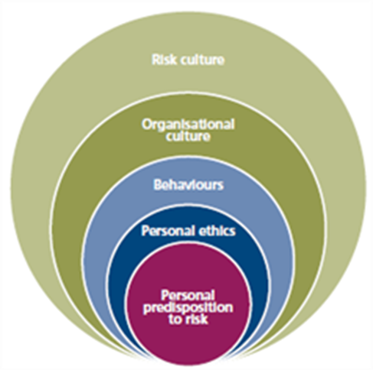
Figure ‎3-2: The Institute of Risk Management’s view of a 'risk culture'. Source: Institute of Risk Management (2014)
In addition to creating a risk culture, and ensuring employees and suppliers are threat aware, it is also essential to create an environment where ‘insider’ threats are specifically considered (Ortiz, Reinerman-Jones, and Matthews, 2016). This is for two main reasons: first, a high percentage of cyber-attacks are from insiders, and second, current cyber-security training often does not deal adequately with this subject. It may be helpful to use a 3D gaming environment, where the ludology of ‘serious games’ (Djaouti et al., 2012) can be used to create endless scenarios. Ortiz, Reinerman-Jones, and Matthews (2016, p. 269) commented “Serious games are valuable based upon their capacity to duplicate logistically difficult, dangerous, or elaborate situations in a practical, safe environment”.
The ‘human factor’ of security is the basis for this need, but ideally, cyber-security training should take place in a partitioned virtual environment that will give users the impression that they are dealing with real company applications in real time. This is linked to the first point but goes deeper. In a risk culture, all employees and managers learn to act in a way which reduces all risks, not just cyber-risks (see Table ‎3-6). This means that every aspect of the business is less vulnerable to serious risk. It also improves resilience by having staff who know how to react to problems. There is still a risk from staff who leave the company (Lu et al., 2013; Vashisth and Kumar, 2013), but this is largely an area of physical security, and as such is part of the Chief Information Security Officer’s domain. The risk from former employees remains an insider risk (Ortiz, Reinerman-Jones and Matthews, 2016), however, so the Chief Information Security Officer must also have received training about insider threats. All cyber-security staff and computer users must be aware of the insider risk and should report any behaviour or usage that appears unusual.
Risks of not having a ‘risk culture’ | Reference
Physical and cyber risks | Atoum, Otoom, and Abu Ali (2014)
DDoS attacks ª | de Laat (2015)
Phishing ^{b} attacks | Hoelscher (2017)
Loss of “trade secrets” | Amoroso (2011)
Staff loyalty | Vashisth and Kumar (2013)
Drop in profit level | Djemame et al. (2011); Kusic and Kandasamy (2007)
Discrimination and privacy issues. | Hajian et al. (2015)
Lack of suitable access control such as “Context Risk Aware Access Control (CRAAC)”. | Ahmed and Zhang (2010)
Alteration of data integrity. | Gheorghe-Iulian (2011)
Forgery | Gheorghe-Iulian (2011)
Ineffective cyber-security training. | Ortiz, Reinerman-Jones, and Matthews (2016); Yildirim (2016)
Awareness limited to external threats only. | Ortiz, Reinerman-Jones, and Matthews (2016); Yildirim (2016)
Table ‎3-7: Some of the risks involved in not being 'risk aware'.
Note: All the risks from Table ‎3-5 also apply. ª see Table ‎3-1. ^{b} see Table ‎3-2
Ahmed and Zhang (2010) proposed an access control system (Context Risk Aware Access Control, or CRAAC). In conjunction with a ‘risk culture’ within the company, this substantially reduces the risks of staff having inappropriate access or unwittingly revealing company data or secrets. The final two risks in Table ‎3-7 are both criminal acts. However, without a risk culture within the organisation, both are far more likely to occur, and both are potentially damaging for the organisation and its reputation in the business world. Dubai aims to be seen as one of the safest places in the world to carry out e-business and other cyber activity (Dubai Electronic Security Centre, 2017). It intends to achieve this by inculcating a risk culture in companies throughout the country.

Laziness
Human error is, as discussed previously, a large factor in any cyber-security or resilience framework:
“Whereas technical problems typically can be fixed with an update, people problems require education and learning, as well as an interest in addressing the issue or problem. In theory, people problems should be the easier of the two to fix. In practice, however, this is rarely the case” (Hypponen and Nyman, 2017, p. 8).
Hypponen and Nyman (2017) suggested that wherever passwords are used, the software should force the user to change them regularly, not simply allow this. They pointed out that people are inherently lazy, noting that many people’s VCR clock often “showed a blinking “12:00” rather than the current time” (Hypponen and Nyman, 2017, p. 8). This highlights how little people are prepared to interact with technology unless it is essential. They suggested that laziness is one of the greatest dangers of the IoT, with users rarely changing default passwords and seldom applying updates. This is s a ‘people issue’ not a ‘technical issue’, because an update was available but was not applied (Table ‎3-8 shows some of the risks arising from laziness).
The largest areas of risk of laziness are those of exposure to other risks, including fraud, criminal acts and phishing. PDoS attacks are likely to be malicious attempts to expose laziness in other employees. Over-the-shoulder attacks (OSA), where passwords are observed by a third party standing near the operator (Cain et al., 2016), are also made more likely by laziness. Dedicated and thorough operators are also likely to be more attentive and notice that they are being observed. OSA attacks can be minimised by using ‘gesture passwords’ and ‘swipe passwords’ (Cain et al., 2016), provided that these are also made secure. Laziness can also be overcome to a degree by using biometrics (Griffin, 2016) for system access, because an iris or fingerprint scan can neither be written down nor ‘lent’ to another person. Biometrics also reduce the importance of changing passwords regularly, for the same reason. However, it remains essential to closely manage access control so that former employees do not retain access, and new employees have sufficient access.
The final difficulty with laziness as a risk factor is that it appears to be inherent human behaviour. Cross-cultural studies of password complexity vs. utility (Hancock et al., 2016) showed that “[d]emographic factors (gender, age, marital status, number of children, work experience, computer literacy, and handedness) appear to have virtually no influence on the strength or memorability of selected passwords” (Hancock et al., 2016, p. 323). Cultural differences in writing down or saving passwords were negligible. However, Hancock et al. (2016) suggested that training employees in the creation and use of passwords is helpful.

Financial Fraud
Internal risk of financial fraud can usually be addressed through proper auditing and accounting procedures. However, if staff members are sufficiently computer literate to carry out a fraud, they are probably also sufficiently ‘accounting literate’ to hide it. Using extremely strict criteria differentiating ‘computer misuse’ from ‘computer fraud’, the UK’s Office of National Statistics (2017) has estimated that computer fraud is one of the fastest growing areas of crime.
Smith (2015) mainly considered international cyber-crime, but his analysis of the RBS World Pay fraud (Smith, 2015, pp. 109–110) demonstrates how easily an outsider could use a system weakness. It is therefore logically even easier for an insider to do so. Smith (2015) also indicated that the purpose of cyber-attacks has changed (Table ‎3-9), in line with other findings already discussed. The other financial fraud risks are the same internally as externally and are therefore shown in Table ‎3-3.
Unfortunately, although internal and external risks are very similar, internal risks are often much harder to detect (Schneier, 2012). However, thorough audit procedures and financial governance should be sufficient in most cases to prevent the risks being realised in practice.
Risks of Laziness | Reference
Passwords not changed | Hypponen and Nyman (2017)
Casual snooping undetected | de Laat (2015)
Business interruption | Fowler (2015)
DDoS attacks ª | de Laat (2015)
Increased fraud | PWC (2014)
Connection to unauthorised applications and sites | Schneier (2017); Silic and Back (2016)
Personal Denial of Service (PDoS) attacks | Bartolacci, LeBlanc and Podhradsky (2014)
Exposure to phishing ^{b} | Halupka (2014); Healey (2013)
Exposure to criminal acts | Allianz (2015); Button and Cross (2017); Control Risks (2016); Gheorghe-Iulian (2011)
Exposure to fraud | Abu‐Musa (2010); Button and Cross (2017)
Increased risk of ‘over-the-shoulder’ (OSA) attacks | Cain et al. (2016)
Table ‎3-8: A few of the risks of laziness
ª see Table ‎3-1. ^{b} Table ‎3-2.
Type of attack | 1990–1999 (%) | 2000–2009 (%)
Sport (i.e. for fun) | 75 | 28
Monetary gain | 25 | 62
Retaliation | – | 9
Table ‎3-9: The changes observed in cyber-attacks over time (Smith, 2015, p. 112)

Criminal Acts
Of the potential internal risks, criminal acts in the form of retaliation or revenge are the fastest-growing concern (see Table ‎3-9). This kind of attack was virtually unknown before the year 2000 (Smith, 2015). The growth of social media may have a connection to this, but it is, essentially, ‘situational’ crime (Hinduja and Kooi, 2013). It may also be exacerbated by the attitude amongst some students that this does not constitute an illegal or immoral act (PytlikZillig et al., 2015). This is one of the factors that has increased the awareness of cyber-risk in the USA (Morency, 2015). The other risks of criminal acts are identical to the external threats shown in Table ‎3-4.
To avoid criminal acts from within, systems need to be robust enough to prevent financial gain. Human resources management also has a role to ensure that employee grievances are dealt with before they grow too large. It would be difficult, if not impossible, to prevent a retaliation attack from inside, but it can be prevented from ‘coming back’ to the company by having strict rules on the use of social media in the workplace.

Vulnerabilities and Weaknesses
Although all eight hypotheses relate to weaknesses and vulnerabilities, the remaining six are connected to response and resilience, so have been added to section ‎3.2.2.5. Weaknesses and vulnerabilities are not quite the same thing, in cyber-security:
“a vulnerability is understood as the confluence of three elements that in themselves combine the inward and the outward looking perspective: a system susceptibility or flaw, an attacker’s knowledge of and access to the flaw, and an attacker’s capability to exploit the flaw” (Dunn Cavelty, 2014, p. 704).
Weaknesses, or flaws, are therefore only part of a vulnerability. A weakness that is not accessible, or which cannot be exploited does not become a vulnerability. In the framework (Figure ‎3-5), vulnerabilities have been divided into ‘human, asset’, with ‘accidental’ and ‘poor practice’ across all three. There are several ways of assessing vulnerabilities. The recent ‘Common Vulnerabilities and Exposures’ (CVE®) (MITRE, 2017) is a standard for identifying known vulnerabilities, and is a useful resource for checking for an existing “weakness in the computational logic” (MITRE, 2017, p. 3). The difficulty, however, is that a ‘patch’ may be issued (and implemented) to fix a process or a piece of technology but cannot be used to overcome ‘people’ vulnerabilities (Schneier, 2000).
Cyber-security can be viewed as a process or chain, and there is an old saying that “a chain is as strong as its weakest link” (Schneier, 2000). The weakest link is almost always the people. ‘Social engineering’ (Heartfield and Loukas, 2016) has been the underlying method of many cyber-attacks. It makes sense to emphasise this aspect of cyber-security, with improved practices and better control of accidental issues:
“because even the strongest technical protection systems can be bypassed if the attacker successfully manipulates the user into divulging a password, opening a malicious email attachment or visiting a compromised website” (Heartfield and Loukas, 2016, p. 37).
Technology and procedures remain very important, because where safeguards are stronger, it is less likely that ‘social engineering’ will be used. The next few sections examine weaknesses and vulnerabilities across human factors, process factors, and technology factors. This makes the situation much clearer than trying to put these all together, although there is a level of interaction between the three. The growth of the IoT is an example of this. Many users may not even realise that their device is connected, and therefore cannot be expected to know the risks involved (Schlesinger, 2016).
The major difficulty, noted by Schneier (2000; 2015), is that when a system is more complex, it is less secure. In effect, this means that society increasingly relies on the security of systems that are too complex to be truly secure. A secure system is not easy to use, and an easy-to-use system is not secure. Cyber-security is about balancing these two (Schneier, 2012), and resilience is about recovering from the inevitable unpreventable attacks (Sano et al., 2016). Both vulnerabilities and weaknesses must therefore be assessed on a case-by-case basis. Every company will have different weaknesses and vulnerabilities, some of which may be mitigated through proper audited procedures and practices, and others reduced by technology, but they will always be present.
Table ‎3-10 lists some vulnerabilities, and also indicates part of the difficulty: there are so many connected or ‘smart’ devices in use, and every one of them is potentially a vulnerable point in the network. It is essential to conduct an audit of connected devices within the company before assessing whether there are weaknesses or vulnerabilities. This exercise must be repeated regularly because new smart devices are constantly being introduced. Other aspects of vulnerability that require regular auditing are the authentication methods, whether passwords are changed regularly, and whether they are being written down by employees instead of being remembered.
One suggestion by Eich et al. (2016), for secure management of passwords using cloud services may reduce the vulnerability, but still requires regular password changes, and does not prevent employees writing down their ‘master’ password to the drop box. It is a secure system for password management but suffers from the same weakness as all password management systems: once the user is authenticated, they have access to all their services and passwords (Schneier, 2000). An alternative that may overcome the inherent insecurity of the IoT (Schneier, 2017) is the use of biometrics (Griffin, 2016). Biometrics are one of the most secure access systems, hence their use for passports, but fail to address the lack of experience of IT security among many of the companies developing connected technology via the IoT (Schneier, 2017). Biometrics can therefore reduce the vulnerability, but do not address the weakness.
Table ‎3-10 can only show known vulnerabilities. However, the IoT is highlighting previously unknown vulnerabilities (Jing et al., 2014; Schneier, 2017). This is partly because of the technical inexperience of the manufacturers and their haste to become connected (Schneier, 2017). This specific area of vulnerability will therefore continue to grow at the same rate as the IoT itself.

Human Factors as a Vulnerability or Weakness
It has been repeatedly stressed that the biggest weakness in cyber-security tends to be human behaviour. The difficulty is that systems must be usable as well as secure, but the requirements of these two are incompatible. As Hancock et al. (2016, p.315) commented, “Requirement 1: Passwords must be impossible to remember. Requirement 2: Memorize all passwords”.
There has also been such an emphasis on the technology that the purpose has been almost forgotten. Designers need to focus on what the product is for, rather than incorporating technology because it is available (Lathrop, Trent and Hoffman, 2016). This would also alter the security focus. Designers of technology and programmers need to consider what ‘real world’ users will do, rather than what a security consultant would do.
In areas where automation or computerisation can realistically be used to replace human interaction, such as network intrusion detection (Dutt, Moisan and Gonzalez, 2016), human error can be almost eliminated. However, in most systems and processes, the human element still represents both the weakness and the vulnerability of the system. Richards and Norcio (2016, p.305) noted that “considering usability and security in tandem creates an intractable problem”. The requirements of human-centred computing and human–computer interaction do not fully overcome that problem.
Often in cyber-security, a solution is suggested to overcome a specific security issue, such as contextualising mnemonics for passwords (McEvoy and Still, 2016). However, this is actually a human failing rather than a computer problem.

Process as a Vulnerability or Weakness
A quick examination of any computer that is switched on and connected will show that it is running many processes (i.e. programmes that are currently running). Most of these in a company or organisation will have been legitimately purchased from a trusted vendor or created ‘in house’. However, that does not mean that they are automatically reliable or secure. Schneier (2000) set out two linked but separate facts; first, that world-wide research reveals that it is reasonable to expect 5 to 15 errors per thousand lines of code (after testing and issue to the public), and second, that Windows 2000™, at that time the latest version, had 35–50 million lines of code. Any error in the code has the potential to be exploited, and updates and patches are often not applied, giving a range of 175,000 to 500,000 possible weaknesses just in the operating system.
The figures have not changed in the intervening years, but the number of lines of code has continued to grow. To put this into even better perspective, in 2017, whilst encouraging users to update to Windows 10™, Microsoft revealed newly discovered vulnerabilities on Windows 2003 and Windows NT (Microsoft, 2017). Support for NT ended in 2015, but two years later, new vulnerabilities were still being discovered. NT was introduced in 1992, and ‘only’ had 4,000,000 lines of code (Schneier, 2000).

Vulnerability or Weakness | Reference
Any computer or device connected to a network is vulnerable | Hypponen and Nyman (2017)
IoT ª devices | Bode (2015); Corfield (2017); Greenberg (2015; 2016); Hypponen and Nyman (2017)
The lack of experience in security engineering among new software companies | Hypponen and Nyman (2017)
IoT vulnerabilities have been shown to affect the stability of the Internet itself | Hypponen and Nyman (2017); Schneier (2017)
A vulnerable IoT device can become a bridge between private and public networks | Hypponen and Nyman (2017); Schneier (2017)
Probing IP ports for vulnerabilities | Hinduja and Kooi (2013)
Strategies to reduce vulnerability include authentication, encryption, intrusion detection and access control systems | Hinduja and Kooi (2013)
Situational crime prevention as a tool to reduce vulnerability | Hinduja and Kooi (2013)
Timing of attacks – vulnerability “out of hours” | Hinduja and Kooi (2013)
A cyber-security policy that is anti-vulnerability and also with strong considerations for privacy and data protection | Dunn Cavelty (2014)
Unsuitable access levels for users | Silic and Back (2016)
Openness to social engineering or other phishing | Grow, Epstien, and Tschang (2008)
Private/public cloud connections | Sharma and Bohra (2015); Subashini and Kavitha (2011); Velte, Velte, and Elsenpeter (2010)
Misuse or non-application of CRAAC ^{b} | Ahmed and Zhang (2010)
Continued use of personal web-based email sites (Gmail, Yahoo etc.) | Schneier (2017); Silic and Back (2016)
Discrimination and privacy issues | Hajian et al. (2015)
Table ‎3-10: Some of the vulnerabilities caused by being connected to a network.
Note: ^{a.} Internet of Things. ^{b} see Table ‎3-9
It follows that all applications, programmes and processes on a connected computer may have unknown weaknesses and vulnerabilities. This is why security data sharing (Skopik, Settanni and Fiedler, 2016) is more important than ever. It is harder to secure more complex code and processes (Schneier, 2000; 2012; 2015; 2017), which makes it more likely that an attacker will find the weak spot.

Technology as a Vulnerability or Weakness
Technology is currently the worst area for both weaknesses and vulnerabilities because new technology allows unsuitable, or potentially unsuitable, devices to connect to otherwise secure systems. Even as weaknesses and vulnerabilities are discovered and corrected in the IoT, new devices with new vulnerabilities are connected (Bode, 2015; Corfield, 2017; Greenberg, 2015; 2016; Hypponen and Nyman, 2017; Schneier, 2017). Reliance on technology has become essential, but it is necessary to understand that connecting new devices will have previously unseen effects, because the new devices work in ways that legacy systems cannot expect or foresee.

Values at Risk
The term ‘values at risk’ in the framework has no connection or correlation with ‘Value at Risk accounting’. This is a statistical method for comparing the risk of investments. This section, however, will deal with the individual assets and values (such as the reputation, or ‘good name’ of the company) which may be placed at risk if cyber-security is breached, or cyber-resilience fails.

Assets
Not all company assets are tangible items that could be stolen or used for personal gain. ‘Goodwill’ is a good example of an intangible asset. However, all company assets need to be protected as far as possible. Assets that could be affected by exposure to cyber-crime must be protected especially well. Each of the threats discussed earlier can also lead to the devaluation of company assets, or to them being appropriated for the personal benefit of the attacker. However, cyber-attacks may also be used to destroy or compromise the non-financial assets of the company. These are just as important as the financial assets, because the company cannot operate with no workers or succeed with a poor reputation. This means that if a cyber-attack cannot be prevented, detected before damage has occurred, or mitigated after damage has occurred, the result could be disastrous. In many cases (Dunn Cavelty, 2014; Schneier, 2000; Warner and Sloan, 2016), prevention is not possible, so it follows that detection and action (mitigation) are essential. The assets most at risk are listed in Table ‎3-11.
Although ‘zero-day attacks’ (van Schaik et al., 2017) are not, in themselves, asset attacks, they are included in this table because they are potentially disruptive to all assets of the company, both real and virtual. Ruan (2017) suggested the importance of setting up two international classification bodies, one to identify digital assets (International Digital Asset Classification, IDAC) and the other to classify different types of cyber-attack (International Classification of Cyber Incidents, ICCI). Both these would be helpful in identifying what assets are at risk, and for the metrics and statistics on cyber-attacks, which may be used to reduce risks. Digital assets are currently often assumed to be hardware and software, but also include data and other abstract concepts (Ruan, 2017). Without a proper taxonomy, it is virtually impossible to estimate their value, but “[d]igital assets include Intellectual Property (IP), Personally Identifiable Information (PII), Mergers and Acquisitions (M&A) data, customer records, access credentials, encryption keys, business critical IT services, [and] cloud services” (Ruan, 2017, p. 81).
All these assets are difficult to quantify in terms of value, and their loss could have serious consequences beyond the financial impact. All digital assets have potentially three different forms of value: Intrinsic, market, and subjective value. Ruan (2017) suggested that this is why the IDAC is essential. The other items in Table ‎3-11 reflect some of Ruan’s (2017) areas of concern that may have been overlooked by those assessing risk. This widened range of digital assets will indicate the importance of PRA and risk assessment, because it is very easy to overlook the value of items that have no price. Risk assessment can consider the simple fact that price and value are not necessarily related, and that priceless is actually the opposite of valueless.
Many of the items in Table ‎3-11 may either have been overlooked as assets or require further definition in a specific situation. The table is intended to show the broad categories of ‘assets’ rather than list every item that has been defined as an asset in the literature. The breadth of the categories is also why an IDAC is important because it will make it possible to categorise and price digital assets. This is also a difficulty with ‘intangible assets’ because it is hard to put a real value on these assets. In either case, users may easily underestimate their value unless they have been informed and educated by the organisation. There are many assets that may be at risk, but the concentration or focus of this work will be on government communication computer networks.

Public Safety
Public safety is both vague and specific at the same time. The security of ‘public safety communications’ (Uncapher, 2016) is one example. Government agencies (police, fire service, ambulance and similar) are specifically advised how to protect data relating to the public, but databases of supposedly private information are also bought and sold daily (Schneier, 2000) (although new European data protection laws have reduced this substantially).
Assets at Risk | Reference
Financial assets. These may include company credit card details including CVV^{a,} intellectual property (IP), customer financial details, company bank accounts. | Ashrafi and Ng (2009); Oliver (2015); Philippsohn and Thomas (2003); Ruan (2017); Shakarian, Shakarian, and Ruef (2013); Tsigkritis and Spanoudakis (2013)
Physical assets. These may include computer hardware, company property, deeds for real estate, inventory, vehicles. | Rubio-Hernan, De Cicco, and Garcia-Alfaro (2017)
Intangible assets. These may include:
Customer confidence/goodwill, IP, programmes, and applications. | Fowler (2015); Kaplan et al. (2015); Ross (2000); Shields (2015); Turkyilmaz et al. (2011)
Digital assets. These should be defined by an International Digital Asset Classification (IDAC). | Ruan (2017)
Knowledge as an asset.
The knowledge held by engineers is an asset, and it is at risk through several cyber-attack routes. | Ross (2000); Turkyilmaz et al. (2011)
Other items that affect the valuation of the company, including:
Productivity/sales, staff confidence/morale leading to high staff turn-over, data integrity, 3D printing data, bitcoins, cyber-physical systems (e.g. drones), critical business applications, communications equipment. | Awan, Burnap, and Rana (2015); Fowler (2015); Hinde (2003); Kaplan et al. (2015); Ruan (2017); van Schaik et al. (2017)
Table ‎3-11: Some of the assets that may be put at risk by cyber-attack.
Note ^{a.} the CVV is the security code of three digits on the back of the card.

European data protection laws mean that a company handling data about any European citizen is required to keep customers’ personal data safe and secure. This means that an event like the ‘Sony hack’ (Boorstin, 2015) would not be survivable by an SME operating in Europe. Sony only survived by being big enough to carry the cost, not through system-built resilience. The difficulty is that customers (the public) want a system that is easy to use, and that does not continually ask for passwords or verification (Schneier, 2000; 2012), but such a system cannot, by definition, be secure.
The increase in smart cities, smart meters, smart transport and similar technology-based public facilities will inevitably lead to increased opportunities for cyber-attack (Schatz, Bashroush, and Wall, 2017). The list in Table ‎3-12 covers many public safety issues, but there will be more in the future, as cities become increasingly automated. Already, newspapers often carry stories about loss of sensitive data by the police and courts, or the release of prisoners because of ‘computer error’ (Khomami, 2017). As prison services become increasingly computerised (Baumer, O'Donnell, and Hughes, 2009), incidents of this type may increase, or be brought about by a cyber-attack on prison service computer systems. The same situation could also apply to the police and courts, and the risk from identity fraud could also extend into this area, even with the increased use of biometric identification methods.
Some of the issues in Table ‎3-12, such as predictive policing (Mantello, 2016), are potentially public safety issues even without a cyber-attack. However, where such systems are used, the potential damage to public safety and confidence in the company (or government) involved border on the catastrophic. Where there is greater automation, there is also greater potential for damage.
Public Safety Issues | Reference
Revealing personal details of security forces members. | DeRose (2017), and a non-academic reference Police1 (2017)
Public transportation attacks | Hashem et al. (2016); Jung and Chung (2015); Kim and Lee (2015)
Car hacking | Greenberg (2016); Kim and Lee (2015)
Healthcare attacks | Awan, Burnap, and Rana (2015); Seifert and Reza (2016)
Interception of sensitive data (Man in the Middle (MitM) (or Sinkhole) attacks) | Huang et al. (2017)
Security response hacking | Raths (2016)
IoT ª product hacking | Greenberg (2016); Kaul et al. (2015)
Product recall spoofing | Mackalski and Belisle (2015)
Product recall hacking/blocking | Mackalski and Belisle (2015)
Hacking of student qualifications | Varella (2016)
‘Prescient’ crime prevention (predictive policing) | Mantello (2016)
Heritage protection | Gribaudo, Iacono, and Levis (2017)
Attacks on water and wastewater systems | Panguluri, Phillips, and Cusimano (2011)
Incorrect release of offenders from prison | Baumer, O'Donnell, and Hughes (2009)
Table ‎3-12: Some of the public safety issues which may be put at risk by cyber-attack.
ª see Table ‎3-10.

The Response
The new framework for resilience (Figure ‎3-5) emphasises detection and response. Security (Schneier, 2000; 2012) keeps most attacks from penetrating to the point where damage may be done, including internal audit procedures to deter or catch threats from inside the company, but some attacks will still occur. Even the idea of using more than one operating system (OS) (Sano et al., 2016), although inspired, does not in itself prevent attacks. Thus, it is the response and the resilience which are the two factors that are most important, and the remaining hypotheses were developed with this in mind from the theory above and the literature below. These remaining hypotheses are: (H3): Vulnerabilities and weaknesses are associated with having responses in place, (H4): Having responses in place moderates the association between vulnerabilities and weaknesses and internal threats, (H5): Having responses in place moderates the association between vulnerabilities and weaknesses and external threats, (H6): Vulnerabilities and weaknesses are associated with organisational resilience, (H7): Organisational resilience moderates the association between vulnerabilities and weaknesses and internal threats, and (H8): Organisational resilience moderates the association between vulnerabilities and weaknesses and external threats.
Detection without response is also useless, and response without detection is illogical (Schneier, 2000). This means that cyber-security must assume that an attack will occur, detect the attack at the earliest possible point, respond to the attack in an appropriate manner, and prevent any damage from spreading (GCHQ, 2015). These are simple aims, but the difficulty is in the execution, which is why detection and research into detection (Vasudevan and Selvakumar, 2016) are important. It is also why security information sharing (Skopik, Settanni and Fiedler, 2016) is also important: when companies know more about the kind of attack that may take place, it is easier to defend against that attack. Advanced persistent threats (Rass, König and Schauer, 2017) are only known to be advanced and persistent because knowledge of them has been shared.
This is the premise behind outsourcing data security (Schneier, 2000; 2012; 2015). It is an important consideration, because any real security costs money, but it is possible for an ‘outsider’ to monitor more than one system. Detection requires the system to be monitored 24 hours per day, 365 days per year. Some of the existing responses to cyber-attack are set out in Table ‎3-13. They include legal responses, because laws may need to be amended to cover new attacks (Hathaway et al., 2012). They also include military responses, because both the USA and the UK have legally recognised that a cyber-attack may be against their defensive or offensive capabilities (Payne and Finlay, 2017). There is still much debate about what constitutes the ‘use of force’ (Dev, 2015; Herzog, 2011). Legal and military responses, however, are little use in terms of resilience. Knowing that the attack was illegal, or that it constituted an act of war does not help the end-user to recover (Dev, 2015). An act of war could even, in a worst-case scenario, render resilience obsolete, which emphasises the need to define such simple concepts as ‘the use of force’ (Clarke R. A., 2016).
Table ‎3-13 includes some proposed response options, accurate risk impact tolerance (ARITO) (Shameli-Sendi and Dagenais, 2014) and a cyber-risk resilience model (Tran et al., 2016). The first works with adaptive intelligence (as opposed to artificial intelligence) and automatic intrusion detection systems to decide on the likely impact of a cyber-attack and respond accordingly. The second is also adaptive, but the emphasis at every stage of its process is the recovery and resilience of individual nodes within the network. This is briefly shown below in Figure ‎3-3.
The response process remains the same throughout identify, quantify, assess and respond. It is not possible to quantify a threat or risk that has not been identified, nor to assess one that has not been quantified. Response without detection is an impossible concept, so the order must remain constant. This means that resilience is a function of response but needs to be tested in the same way as protective measures.
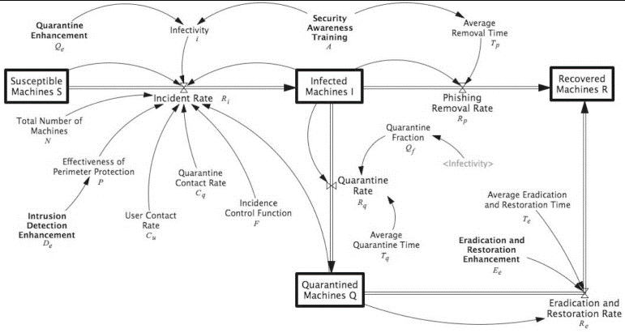
Figure ‎3-3: Tran et al.'s Resilience Model. Source: adapted from Tran et al. (2016, p. 22)
Response to a cyber-attack must be a ‘whole business’ response (Rossi, 2015; Schneier, 2000). Every division or department must be involved. This is partly because of the interconnectedness of departments within a company, but also because, directly or indirectly, every department will be affected by the attack. The first response may remedy the situation, but there also needs to be a secondary response: an enquiry. For resilience, it is essential to know as much as possible about how, where, when, and why the attack took place, but this is less important than avoiding business interruption.
Response | Reference
Legal ª | Dev (2015); Hathaway et al. (2012); Payne and Finlay (2017); Peng et al. (2006)
Military ^{b} | Dev (2015); Herzog (2011); Payne and Finlay (2017)
Accurate Risk Impact Tolerance (ARITO)^{c} | Shameli-Sendi and Dagenais (2014)
Cyber Risk Resilience Model (CRRM)^{d} | Tran et al. (2016)
Pull compromised system ‘offline’ | Caldwell (2016)
Load backup data (if not compromised) | Andress and Winterfield (2011)
System shutdown (total or partial) | Caldwell (2016)
Incorporation of an Information Security Governance (ISG) Framework | Abu‐Musa (2010)
Table ‎3-13: Possible first responses to cyber-attack.
Notes: ª Necessary, but too late for resilience. ^{b} Although extreme, ‘cyber war’ presumes a military response, but further definition of thresholds of ‘use of force’ are required. ^{c} A proposed response model.
Abu-Musa (2010) stressed the importance of an information security governance (ISG) framework because:
a governance approach to information security could provide a better framework to meet new requirements and to manage risks within the enterprise. It could help to communicate more effectively within the enterprise as well as with external parties, including regulators. Furthermore, it could help to further the security profession by clearly establishing governance and protection roles and responsibilities” (Abu‐Musa, 2010, p. 230).
This is consistent with the new resilience framework; in that it must be a governance issue. It is as important as any existing governance, and realistically all cyber-security within a company should be treated as though it were a statutory requirement.
From the beginning of a cyber-attack, the first automatic response of the system must be to stop the attack from spreading (Baldwin et al., 2017). This must also be the goal of the Computer Security Incident Response Team (CSIRT) (Steinke et al., 2015). This team must coordinate the response and have a strategy that does not include counterattack. This is often the ‘knee-jerk’ reaction to any attack, but it is unlikely to be legal, and may do further harm to the company reputation. Cyber-attacks are growing more sophisticated year-on-year (Niblett, 2016). Coupled with the proposed use of unmanned aerial vehicles (drones) for business delivery systems, the potential harm from the attack is also increased. A thief taking control of a delivery drone would cost money, but a terrorist doing so could have much more serious consequences (Sedjelmaci, Senouci and Ansari, 2017).
The response sequence shown in Table ‎3-14 has been developed to build on this. The framework is intended to improve resilience and reduce the effect of attacks, and this sequence is a prioritisation of actions within the framework. The main difficulty with resilience and response is the changeable nature of cyber-attacks. For example, DNS poisoning (Shulman and Waidner, 2014) requires a different response strategy from a DDoS attack via an internet-connected appliance (Jing et al., 2014), or hackers taking control of building automation (Fisk, 2012). However, the sequence of response remains the same, and the potential damage or severity of the attack does not affect the order of response. The ideal ‘adaptive response’ outlined in the literature review, which is the core of resilience, is also not directly dependent on the severity of the attack or its potential effect. The actual effect must be controlled, which requires a flexible and adaptive strategy for every attack, and a regular assessment of vulnerabilities and weaknesses. Of course, it is not possible to predict previously unknown attacks, but resilience requires detection and response before there is excessive damage.

OPSEC Training
In Operational Security (OPSEC), recent training has begun to include ‘online operations’, with specific emphasis on hacktivism and cyber-terrorism (de Laat, 2015; Weimann, 2004). This may be a positive step for the future, but it is still too early to judge.

Response Sequence |  | Effect on Resilience | Reference
1. | Alert CSIRT at first detection | Necessary, but neutral | Sedjelmaci, Senouci, and Ansari (2017); Steinke et al. (2015); Yoon et al. (2016)
2. | Isolate affected system/computer | Essential, positive | Tran et al. (2016)
3. | Ensure business continuity through other media or systems | Essential, positive | Rossi (2015); Schneier (2000)
4. | Use selected form of CRRM to begin recovery | Essential, positive | Tran et al. (2016)
5. | Find legal position | Neutral, but can affect liability and cost | Dev (2015); Hathaway et al. (2012)
6. | Enquiry | Neutral now, but essential to prevent future events. | Baldwin et al. (2017)
Table ‎3-14: The response sequence

A Summary of the Theoretical Perspectives
These theoretical perspectives and additional literature regarding risks provide a better understanding of the possible connections and associations in cyber-security and resilience. They have permitted the creation of eight hypotheses, and these can be tested to validate the framework. By combining theories of risk management, vulnerabilities/weaknesses, and response, it has been possible to create a framework to improve cyber-resilience in the critical infrastructure and public sector of the UAE.

Proposed Conceptual Framework
Following the literature review, the framework in Figure ‎3-5 was developed as a first step towards creating a suitable framework for use in the UAE public sector. This framework was tested and validated further in this study, and the results are covered in future chapters. The framework covers the same areas as existing frameworks but includes some elements that have not previously been placed together. It therefore combines the best parts of other frameworks into one improved and specific framework for the UAE public sector.

Development of the Framework
The process for developing the framework followed the following logical steps:
- Construct a base.
This is the top row of Figure ‎3-5: Threats, vulnerabilities and weaknesses, response, resilience. Within each base section, the structure and contents are then added, sectionalised for ease of understanding and definition.
- Utilise an existing framework (BSI 27001:2005+) (BSI, 2005) as a guide.
The framework defines what is protected and how, and includes the means for measuring resilience (Habash, Groza, and Burr, 2013; Trim and Lee, 2017). Initially, an existing framework will only abrogate problems from one response area – system being the most commonly adopted (Cherdantseva et al., 2016). Thus, the framework is extended to cover the other areas.
Feedback from the framework then assists in the generation of resilience (Madni, Erwin, and Sievers, 2020). Ensuring that this feedback loop is effective will improve both security and resilience (Chatham House, 2019).
- Using the hypotheses generated above, examine the following questions
    - What does the framework fail to do?
    - What can be added to ensure that this is done?
    - Does any other framework include this?
    - Are any of the risk factors (IRF or ERF) overlooked/omitted?
    - How can these be incorporated?
- Modify the existing framework in alignment with the step above.
This is the hardest part of the development, since it involves a comparison and synthesis of two or more existing frameworks. Essentially, a framework that does ‘a’ well but fails to do ‘b’ cannot be fixed by simply adding a component from another framework that does ‘b’ well, because invariably there will then be an incompatibility that reduces the efficacy in some other area (‘c’).
Because of this, the development is slow and meticulous, searching for ways to remove incompatibilities between two philosophies – protection and resilience.
- Repeat the third and fourth steps until completion.
Completion is reached when the resilience of the system and the protection of the system are balanced, and every hypothesis has been tested and proven.
This iterative process and the development, application, and testing of the hypotheses during the development of the framework is visualised in Figure ‎3-4. The different colours are used so that it is clear that they are not connected where they cross over. This Figure also makes clear the annotations of the hypotheses on the main framework in Figure ‎3-5.
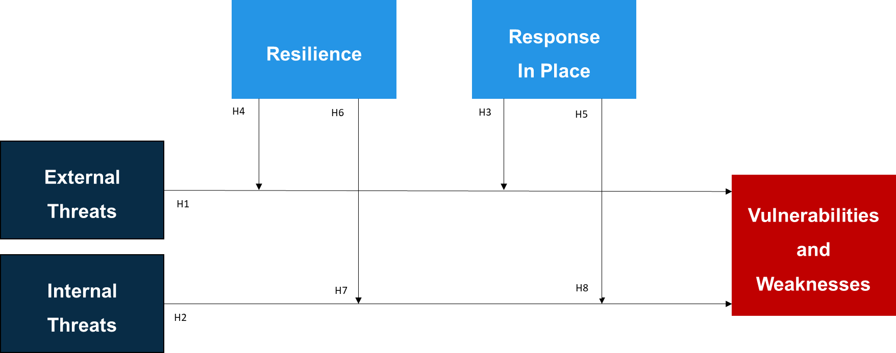
Figure ‎3-4: Linking the Hypotheses to the Elements of the Framework
.
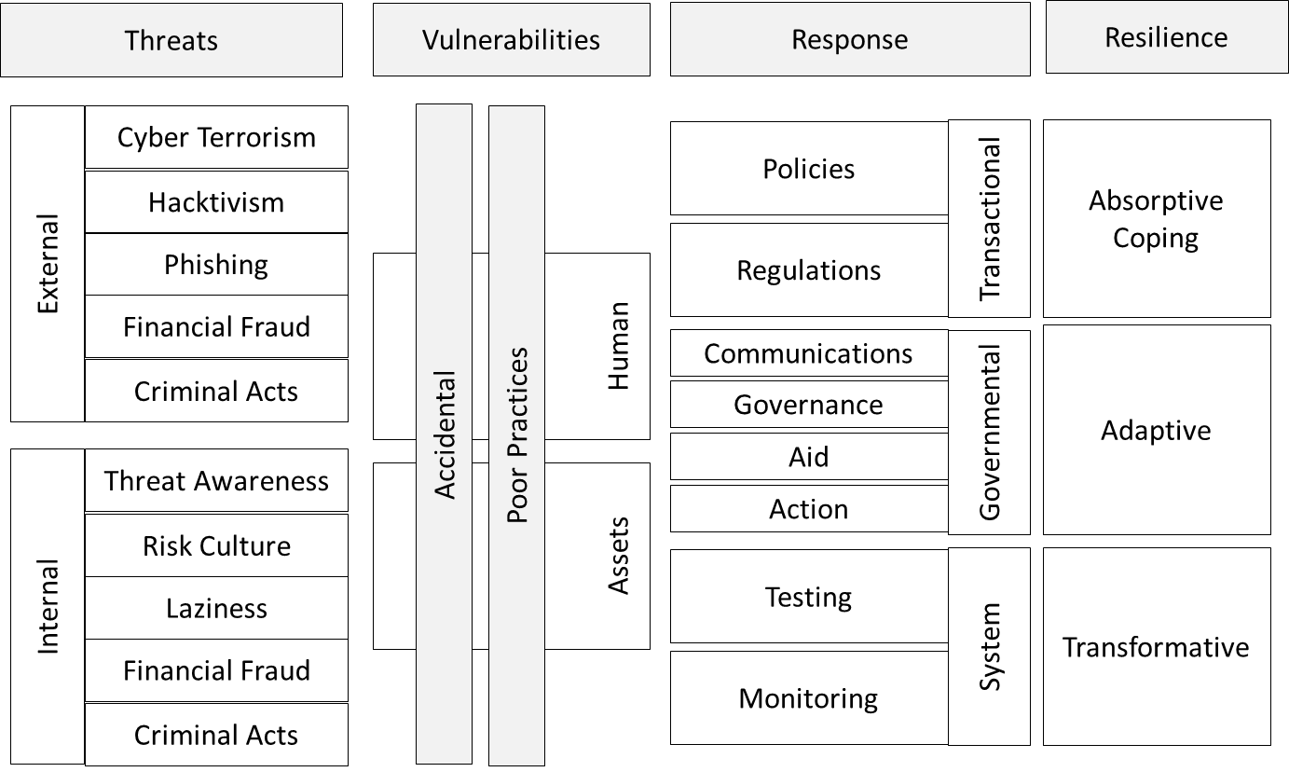
Vulnerabilities & Weaknesses
Figure ‎3-5: The conceptual framework
The study hypotheses are:
H1: Vulnerabilities and weaknesses are associated with external threats.
H2: Vulnerabilities and weaknesses are associated with internal threats.
H3: Vulnerabilities and weaknesses are associated with having responses in place
H4: Having responses in place moderates the association between vulnerabilities and weaknesses and internal threats.
H5: Having responses in place moderates the association between vulnerabilities and weaknesses and external threats.
H6: Vulnerabilities and weaknesses are associated with organisational resilience
H7: Organisational resilience moderates the association between vulnerabilities and weaknesses and internal threats.
H8: Organisational resilience moderates the association between vulnerabilities and weaknesses and external threats
These hypotheses were applied to the framework to test its stability and robustness and ensure that it is fit for purpose. Testing the hypotheses against the data collected was used to add to the validation, ensuring that the UAE public sector is more resilient and more cyber-risk aware.

Conclusion
This chapter has assembled a provisional new framework (Figure ‎3-5) and detailed some of the internal and external cyber-risks that have been observed in various categories. This does not claim to be a comprehensive list, not least because “Today’s incidents, yesterday’s strategies – As the digital channel in financial services continues to evolve, cybersecurity has become a business risk, rather than simply a technical risk” (PWC, 2014, p. 11). Many potential risks are out-of-date before they have ever been realised, but others will emerge. Being aware that there may be a risk is the first step towards being aware that there is a risk; and awareness of risks helps to reduce them.
In the final analysis, risk resilience or risk recovery is more practical than risk prevention. Risks can never be completely prevented, but it is essential to be able to recover and keep the organisation running. Similarly, attacks cannot be fully prevented, so detection and reaction are vital elements of cyber-security. It would be possible to make a completely secure database of customer information, but only in a non-networked, stand-alone computer, with no printer or screen, that was turned off. This would not be very useful. Instead, it is necessary to combine usability, prevention, and a robust detection system that reacts to attack.

Methodology
This chapter presents the research methodology used in this study. It describes the methodological approach, research philosophy, research paradigm, approach to data collection design and methods, and choice of data analysis tools. The chapter also includes a justification for the choice of quantitative method. It clarifies the pilot study approach and sampling method adopted and details the ethical approach to the research.

Introduction
Much of the information needed to address the research aim is quantitative in nature, for example, how many users are risk-aware, and know how they should behave. It was therefore logical to create a questionnaire to ask those questions in language that can be understood by any user.
This is survey methodology (Groves et al., 2009), but avoiding any questions that could have qualitative replies. The questionnaire therefore did not ask for opinions, and only gathered an overview of what respondents know, do, and have seen others do. The data required were broken down into several hypotheses, which were tested after data analysis, and the results used to address the aim of the research. The underlying philosophy and approach to the research are laid out below.
The purpose of this chapter is to explain the choices that were made about data collection and analysis. It will also help other researchers to replicate the research if necessary, because they will be fully aware of the underlying assumptions.

Layers of Research
Saunders, Lewis, and Thornhill (2012) compared the research process to an onion, because of the many layers involved (see Figure ‎4-1). The base layer, underlying the entire project, is the philosophy on which it is based: positivism, realism, interpretivism, or pragmatism. This determines how the researcher approaches the questions and the data and is connected to their ‘worldview’ (Crotty, 1998). In a positivist/realist paradigm, like this project, the basis is that things exist regardless of whether we know about them, and research is carried out to discover more.
The next layer of the research ‘onion’ is the approach of the researcher, which could be deductive or inductive. In this research, the answers were deduced from the data. Beyond this layer, there are choices about the actual research, and in this case, the decision was to use a single, quantitative methodology, based on a questionnaire. This means that the strategy used was a survey (Groves et al., 2009). It did not consider change over time, so was cross-sectional, rather than longitudinal. The final layer of Saunders, Lewis, and Thornhill’s (2012) onion is the collection and analysis of the data, where the conclusions are shaped and guided by the choices made in the outer layers.
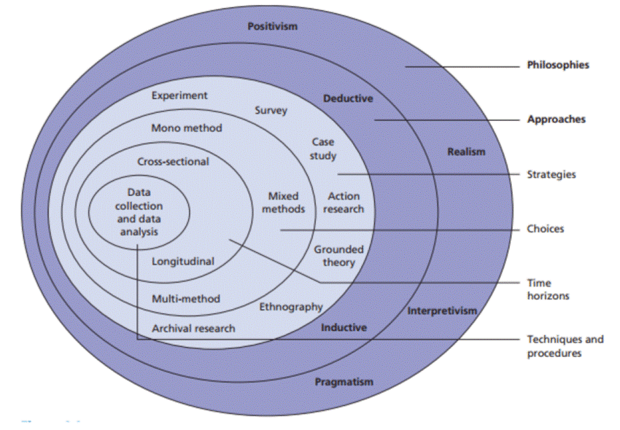
Figure ‎4-1: The research onion. Source: adapted from Saunders, Lewis, and Thornhill (2012, p. 83)
This analogy of an onion with multiple layers gives a clear picture of the process, and the way that choices are affected by the viewpoint of the researcher, and also how that viewpoint affects the type of questions asked and how the data are analysed.

Research Philosophy
This research, as stated above, was conducted with a positivist/realist philosophy, a standpoint more commonly found in law and legal studies (Cross, 1997) or the Social Sciences (Cupchick, 2001). As Cross (1997, p. 10) puts it:
Positivism in some senses declares only that what is, is. … Deeper positivism is descriptive and attempts to explain why and how the law develops. Realism is the best-established form of such positivism.
The application to this research is that it is trying to explain a situation that “is” and find the “why and how”. Cupchick (2001) describes a very similar viewpoint as “Constructivist Realism”, and Ferraris (2015) discusses “Transcendental Realism”. In each case they are trying to move away from positivism whilst still keeping its basic assumptions. The research is also quantitative in its approach, because the intent is to measure the resilience of the organisation (Haimes, 2009) for two reasons. The first is to provide an objective measurement of the current position, and the second is to allow managers in the organisation to make a direct comparison in any future assessment of resilience after any changes have been made. The approach that this research takes towards the data analysis and the findings is similar to critical realism – although critical realism is not a popular academic view (de Bernardi, 2018). Realism, whether positivist (Cross, 1997), constructivist (Cupchick, 2001), Transcendental (Ferraris, 2015), or critical (de Bernardi, 2018) has a place in research because “The role of the critical realist is to point out [the] situation and to try to change it” (de Bernardi, 2018, p. 388).

Research Paradigm
A research paradigm is constructed based on assumptions and propositions. The researcher investigates and explores these assumptions in reality. The word paradigm originated from the Greek word “paradeigma”, which means patterns. Thomas Kuhn (1970) first used the word paradigm to represent a conceptual framework developed by a group of researchers to provide them with a suitable model for exploring problems and finding solutions. Other researchers such as Patton (1990) defined paradigm as a process of breaking down real-world problems or complexity into smaller pieces to enable easy investigation and examination. Guba (1990) introduced it as a framework to support researchers to interpret and understand research problems, guided by “a set of beliefs and feelings about the world and how it should be understood and studied” (Guba, 1990, p. 17). Miller and Brewer (2003, p.220) described it as a “theoretical structure or a framework of thought that acts as a template or an example to be followed”. The concept was described by Creswell (2003) as a way for researchers to think, communicate, perceive, and see the world, taking into consideration the limits of what can be tested at any one time. Some variables cannot be tested without defining a specific research paradigm. These definitions therefore suggest that a paradigm is a framework of a structured and systematic way of thinking to support researchers in examining their problem or proposition using a well-organised process. It helps researchers to define the type of questions to be asked, and the type of methodology to be used in examining the research questions. Researchers’ findings are therefore examined and defined by the paradigm adopted.
Guba (1990) stated that these paradigms are categorised and classified by the way their advocates responded to three philosophical questions:
- Ontological consideration (What is the nature of the knowledge under study?)
- Epistemological considerations (What is the nature of the relationship between the knower ‘the inquirer’ and the known ‘or knowable’?)
- Methodological considerations (How should the inquirer go about finding out knowledge?) (Guba, 1990, p. 18)
The next section describes the research methodology used in this study.

Methodology
The study examined UAE public sector organisations. It relied on primary data collected from participants, secondary data from the field literature and documents published by the UAE government. A survey was used to investigate the current cyber-resilience status of UAE public sector organisations.
The information was gathered from questionnaires distributed to 200 participants, all of whom were public sector employees. The next few sections justify the chosen methodology and data collection methods used in this research. It includes an explanation of the methodological framework, the data collection methods, the data analysis process, and the type of study sample.
There are two basic elements that affect the choice of the data collection instrument: the research approach (qualitative or quantitative) and the research questions. Researchers must ensure that the data collection method generates data that can address the research questions and fit the philosophical assumptions underlying the overarching research paradigm (Snape and Spencer, 2003).

Research Design
The research design process followed the sequence presented below in Figure ‎4-2 below. This arrangement of steps proved to be efficient, and the final design effective. As the Figure shows this was a complex process, with several process running concurrently – sending out the pilot questionnaire, choosing descriptive analysis methods, and choosing regression analysis methods. This meant that, by the time data was collected from the main survey questionnaire, all of the analysis procedures were in place, and there was a continuous flow of the research.
1.
Prepare Questionnaire
Send out pilot survey
Examine Descriptive Anal. methods
Test analysis method
OK
No
OK
No
Examine Regression Anal. methods
Test analysis method
OK
No
Send out Main Survey
Yes
Yes
Yes
Data From Survey
Use Hayes Macro for SPSS
Use Chosen Analysis Method
Extract
Display Analysis
Results
End Research
1.
Decide on Philosophy.
Decide on Approach
Decide on Strategy
Decide Choices
Decide on Time Horizon
Decide on Techniques and Procedures

Figure ‎4-2: The Research Design Process Used

Sample Selection
The sample was designed to be as representative of the organisation as possible. The ideal would be to distribute it to every computer user in the organisation and assess the validity and reliability from to the final response rate (Bannigan and Watson, 2009). However, the design of the questionnaire also has an effect on the response level, so care must be taken to ensure that it will provide the highest possible response rate (De Bruijne and Wijnant, 2014).
IT users within an organisation may be skewed towards management and clerical staff. However, answers provided by manual workers were also considered valid. The overall bias of the sampling towards office workers would tend to reduce the number of responses from manual workers but would not affect their validity. The decision was made to use purposive sampling (Denscombe, 2007), and aim specifically at three levels of management, operational management, middle management, and executive management.
Purposive sampling was essential to support the rationale for this study (Polit and Hungler, 1999). Denscombe (2007) noted that purposive sampling is used when the researcher knows and can select participants who are likely to provide the most valuable data. “The advantage of purposive sampling is that it allows the researcher to home in on people or events which there are good grounds for believing will be critical for research” (Denscombe, 2007, p. 17). Patton (1990) highlighted that the strength of purposive sampling lies in the selection of information-rich cases to deliver a deep study analysis and understanding.
Thus, the questionnaire was delivered to the areas of the organisations that were most likely to a. respond, and b. provide rich data. Within this the decision was taken that it would be sent to the largest possible number of potential participants. It follows from this that the purposive sampling was intended to provide a clear answer to the research question because the people being asked were the specific people that are likely to be affected by cyber-attacks and resilience.

Justification of Sample Size
Since the study aims at empirically examines the level of resilience to and readiness for cyber-risks in UAE public sector organisations. As abovementioned, the study used a purposive sampling, in which the targeted study population covered 13 UAE federal ministers, excluding sovereign and state ministries due to data and privacy restriction.
Although, the intent of the research is to produce a framework to support UAE public sector management, it was clearly not possible to survey the entire public sector, thus the invitations to participate in the study survey were emailed to 13 UAE federal ministers, and targeting 200 employees working at the support business departments (HR, Finance, IT .. etc) in those ministries.
According to Hair, Anderson et al. (1995) to test the study assumption and research conceptual model and verify the relationship between variable the suggested samples size should be 100 or greater, also MacCallum et al., (1999a; 2001b) point that the study sample size should be greater than 100 cases, while Gorsuch (1983) recommended a minimum sample size of 100. Thus, the researcher have identified the sample size in line with the literature to be able to make inferences regarding the population.

Demographic Information of Sample Population
The decision to limit the distribution to the management was justified by the technical nature of the data to be gathered and the responses from the pilot study. The initial demographic division of the data demonstrated that of the 104 participants, 64% were male and 36% were female. The remaining demographic questions, job level, experience, age, and educational level are summarised graphically in Figure ‎4-3 to Figure ‎4-6.
These demographic figures are close to the perceived levels in the UAE public sector with nearly twice as many men as women. The managerial level also approximately equates to the structure of these organisations, as do the levels of qualification. The remaining two factors, age and length of experience are loosely connected, and, again, represent a demographic similar to the perceived view of these organisations.
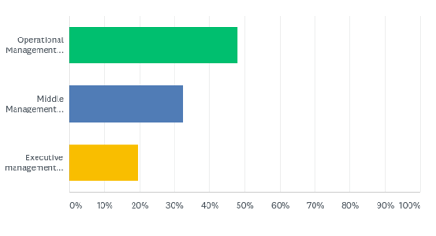
32.5%
19.6%
47.9%
Figure ‎4-3: Management level of participants
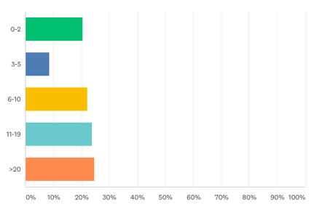
8.6%
22.2%
23.9%
24.8%
20.5%
Figure ‎4-4: Years of experience of participants
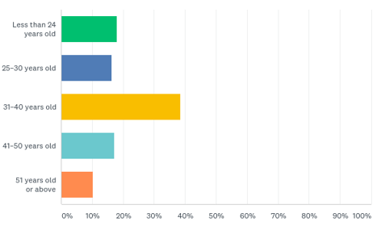
18.0%
16.2%
38.5%
17.1%
10.3%
Figure ‎4-5: Age range of participants
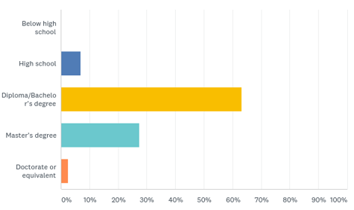
2.6%
27.4%
63.3%
6.6%
00.0%
Figure ‎4-6: Educational level of participants
The sample was therefore considered representative of the structure of the UAE public sector, which increased the level of confidence in the data.

Basis of Questionnaire
A copy of the questionnaire is included in Appendix 3, and the following sections explain how this data collection instrument was constructed.
The questions will be based around the hypotheses:
- H1: Vulnerabilities and weaknesses are associated with external threats.
- H2: Vulnerabilities and weaknesses are associated with internal threats.
- H3: Vulnerabilities and weaknesses are associated with having responses in place
- H4: Having responses in place moderates the association between vulnerabilities and weaknesses and internal threats.
- H5: Having responses in place moderates the association between vulnerabilities and weaknesses and external threats.
- H6: Vulnerabilities and weaknesses are associated with organisational resilience
- H7: Organisational resilience moderates the association between vulnerabilities and weaknesses and internal threats.
- H8: Organisational resilience moderates the association between vulnerabilities and weaknesses and external threats
These are ‘user-friendly’ hypotheses developed from the sections about the new framework. They were intended to support the collection of data that could be used to establish the current situation about technology users within public sector organisations.
Designers of web-based surveys have advised that open-ended questions should be avoided (Barnes, 2017) to improve the response rate. However, this questionnaire aimed to gather quantitative data, so these questions were avoided anyway, because they are more suitable for qualitative data. The survey included an ‘informed consent’ section setting out that respondents could choose not to answer or participate, and that all entries would be anonymous. Participants wishing to receive information about the outcome of the research were asked to contact the researcher via email to request this.

Data Collection – Designing the Instrument
Having followed the advice of Barnes (2017), De Bruijne and Wijnant (2014), and others, a questionnaire was carefully designed to collect data for the research. The instrument was piloted as described below, and a copy can be found in Appendix 3. However, the initial stages of design involved examining other questionnaires that had been used for similar data collection and adapting the questions to suit the questions. In the questionnaire there were two distinct sections, one for external threats and one for internal threats, and a total across both sections, of 204 questions, each representing one of the independent variables to be compared with the three dependent variables, Response in Place (RP), Organisational Resilience (ORe), and Vulnerabilities and Weaknesses (VW).
The answers to the questions were on a Likert scale, and asked the opinion of the respondent regarding the likelihood of each type of internal or external risk. Within the two sections, the risks were divided into categories (see Tables in Appendix 4) to make it possible to analyse the data once collected. The questions were designed to be understood by the targeted participants but without being over-simplified, which was where the pilot study was particularly useful.

Data Collection – Validating the Instrument
One of the checks of the validity of a questionnaire is the pilot study (Groves et al., 2009), but in addition to that the questions were first shown to a cyber-security expert to ensure that the questions coincided with the concepts to be measured, which is regarded as the main measure of validity of a questionnaire (Brinkman, Haakma, and Bouwhuis, 2009). Once the validity was established, the main questionnaire was put online, and participants were invited.

Justification or Rationale
The main objective of this study was to describe the cyber-resilience practices inside UAE public sector organisations. The study also aimed to develop a better understanding of the gaps and factors that were identified as important from the literature. However, the effect of the gaps and challenges on the adoption of cyber- resilience practices inside UAE public sector organisations remains undefined and unclear. The study was therefore descriptive, involving an empirical quantitative method. It was considered that this design would enable the researcher to assess when factors had affected cyber-resilience practices inside the study organisations.
The literature review chapter suggested that there were several factors that could affect the successful adoption of cyber-resilience practices. Those factors vary in their impact, so a quantitative descriptive study was chosen to identify the impact of different factors on the successful adoption of cyber-resilience practices. Cooper and Schindler (2006) suggested that researchers should use descriptive studies when the causes of the phenomenon being studied are not clearly addressed or when they are uncertain what approach to use to examine the research problem, especially when the problem’s causes are not well defined. Cooper and Schindler also noted that this exploration saves time and money by developing a deep understanding of the research problem before deploying more extensive studies.
There is still a lack of knowledge of the key components affecting knowledge management practices inside public sector organisations, or how these practices should be addressed and managed in the public sector. This lack of understanding has several causes, including public sector organisations’ governance of internal process, inertia, routines, the law, and national culture. Managers may therefore not be able to drive change as smoothly as in the private sector. This study used a quantitative method to gain deeper understanding of the research phenomenon (Bryman, 1988), and to collect numerical values describing and measuring the relationships between variables (Bryman and Bell, 2015). Table ‎4-1 describes the differences between quantitative and qualitative methods.
This study aimed to evaluate three theoretical propositions and the proposed theoretical framework in UAE public sector organisations. The study therefore started inductively, by building a theory, and then went on to test it using a deductive approach (Gummesson, 2003). This gave the opportunity to evaluate the theoretical framework and the study propositions by drawing new insights from the collected data using a questionnaire with Likert-type scales (Saunders, Lewis and Thornhill, 2012). This requires a quantitative methodology. The structural aspects of the research's model required the use of quantitative methods to be able to describe the internal organisational context that affects the adoption of cyber-resilience practices in the public sector. A questionnaire can capture a quantitative perspective and assess the organisational environment and individual interpretations of the situation. It was therefore considered the most useful method of research.
 | Qualitative Research | Quantitative Research
Type of questions | Probing | Limited probing
Sample size | Small | Large
Amount of information from each respondent | Substantial | Varies
Requirements for administration | Interviewer with special skills | Interviewer with fewer special skills
Type of analysis | Subjective and interpretive | Statistical and summation
Hardware | Tape recorders, projection devices, video recorders, pictures; and discussion guides. | Questionnaires, computers and printouts
Degree of reliability | Low | High
Researcher training | Psychology, sociology, social psychology, consumer behaviour, marketing and marketing research | Statistics, decision models, decision support systems, and computer programming
Type of research | Exploratory | Descriptive or causal
Table ‎4-1: Differences between quantitative and qualitative methods. Source: adapted from McDaniel and Gates (2001)

Quantitative Data Analysis
Quantitative data were collected in this study. Some authorities have suggested that qualitative research has more credibility (Miles, Huberman and Saldaña, 2014; Silverman, 2000), but the subject of this study lent itself better to quantitative methods, because it was not looking for ‘why’ users act in specific ways, but strictly ‘how many’ of them do so.
The choice of quantitative methods was also supported by other authorities (e.g. Bryman, 1988; 2008 and Niglas, 2000). It is also easier to analyse quantitative data because it is numerical rather than words, phrases, and ideas. This, in turn, means that it is possible to analyse much larger quantities of data, so that a wider range of participants can be included, which may increase the validity and reliability of the work.

Research Method Justification
Data in this research were gathered through a survey of the staff who use, or have access to, data and software used by their organisation. This survey consisted of a web-based questionnaire, providing quantitative data about the levels of awareness within the organisation, and the number of employees who know what to do, and to whom they should report suspicions/concerns. This enabled an assessment of the effectiveness of any systems or frameworks already in place.
The analysis of the data was designed to show the weaknesses in current frameworks and indicate areas where the new framework will improve on the existing situation. The questions were not open-ended and did not try to lead the participant into giving the “right” answer. The instruction sheet made clear that there was no “right” or “wrong” answer to any question, and the purpose of the questionnaire was to find out how many employees were aware of policies and procedures, and whether these are adequate.
Figure ‎4-7 provides a flow chart showing the stages of the research. The numbers in the boxes refer to the sub-section numbers in this chapter, and the chart provides a visual representation of why the process had to follow this sequence. A brief examination of the flow chart will show that arranging the boxes in any other order would not be logically possible, because each step is determined by the step before. This logical, stepwise procedure was also used in the creation of the conceptual framework in Figure ‎3-5. This therefore ensures that the new framework will be valid and useable in the UAE public sector. The following sub-sections describe the processes involved in the construction of the framework and are in the same logical order as Figure ‎4-7.
This flow chart does not show the pilot study (described below) as this was completed before the first step of Figure ‎4-7. It is, however, clearly shown in the flow chart showing the research design process (Figure ‎4-2). In effect, the pilot study validates this flow chart, as without the pilot study the research collapses here because the questionnaire is untested and unvalidated. This chart of the stages of the research assumes a validated data collection instrument, and thereby also assumes a pilot study before the main study begins. The pilot study is therefore described immediately following the identification of strategies for mitigation and before data collection. It does not interrupt the flow, since it is essential to the flow, but is described at the point it naturally occurs.

4.11.1 Thematic literature review to extract risks
4.11.2a Expert opinion used to cluster risks as human, process, or technology
4.11.2b Thematic review with expert opinion used to discover assets at risk
4.11.3 Thematic review with expert opinion used to identify strategies for mitigation and resilience.
4.13 Data collection - a Likert-type scale questionnaire used to collect data from the public sector
4.13.1a Descriptive analysis used to describe clean data
4.13.1b Correlation analysis to find the association between external and internal threats with vulnerabilities
4.13.2a Several possibilities explored to model relationships between vulnerabilities, response in place and resilience
4.13.2b Based on these steps a framework will be developed for the assessment of vulnerability to cyber-risks
Figure ‎4-7: Flowchart of the research process

Thematic Literature Review and Risk Clustering
This was used to identify the cyber-risks, and to consider the possibility of new risks or the recurrence of old risks. The risks were clustered into human, process, or technology risks, drawing on expert opinion. If opinion was divided on the classification of a particular risk, it was included in more than one category.

Identifying Assets at Risk
A combination of the literature review with expert opinion was used to identify values or assets at risk.

Identifying Strategies for Mitigation and Resilience
The systematic literature review was also used to identify the strategies required for mitigation of risks and resilience to risks.

The Pilot Study
Before issuing invitations to participate in the main study, the questionnaire was piloted – the pilot study is very important (van Teijlingen and Hundley, 2001), because it enables the researcher to ensure that questions are being understood and can be answered. When creating a questionnaire, it is very easy to assume that the participant will understand what is being asked, but that assumption is often false, because the participant is not looking for problems or difficulties and can therefore misunderstand the aim of a question. If the questionnaire is well designed, very few, if any changes will be needed before the main survey. That was the case here, as the following sections demonstrate.

The Pre-Pilot Surveys
Before starting the pilot study, the researcher shared the questionnaires with an external specialist in statistics to make sure that the content was relevant to the study purposes and fit quantitative data analysis standards. The questionnaire was also discussed extensively with senior and junior academics to ensure that the questions were suitable.
The researcher also ran a trial survey with two work colleagues to test the data collection processes, and to estimate the time needed to complete the survey, which was around one hour. This part of the pre-pilot enabled the questionnaire to be edited and any misleading questions to be amended. The next section describes the pilot study itself, and the procedures followed to gather data.

Pilot Study Details
To ensure the survey quality and the cohesiveness of the questions, a pilot study was carried out involving six participants from three selected public sector organisations. The selected organisations were chosen using the following criteria: located in Abu Dhabi, with more than 200 employees, and clear structural organisational divisions (top, middle, and functional management). The data gathered in this pilot study was therefore limited to those organisations, and the number who were willing to participate after sending an email invitation via the HR Departments. After several communications, only four of the 12 people invited to participate had fully completed the survey. Six invitees declined to participate because of work commitments and the survey length. The deadline was extended, but they still declined to participate.
Overall, two pilot surveys were eventually received from top managers, one from a middle manager, and three from operational managers. This therefore reflected the purposive sampling that was used within the study organisations. Despite the low number of responses, the pilot study was useful, and supported the study. The next section discusses the ethical considerations considered in this research and the steps used in the pilot study.
The demographic information about the six participants in the pilot study is shown in Table ‎4-2. This included information on current position, age, gender, education level, years of experience, and type of experiences. For privacy reasons, the names of participants and organisations were removed. As can be seen from Table ‎4-2, 33.3% of the participants were from the top management, 16.7% from middle management managers, and 50% were operational level managers.
Participants Position | Age Range | Gender | Positions Hierarchy | Public Sector Years of Experience
Executive Director | 40–50 | Male | Top management | 23 years
Executive Manager | 30–40 | Male | Middle management | 14 years
Executive Director | 40–50 | Male | Top management | 22 years
Senior Projects Manager | 30–40 | Male | Operational management | 12 years
Operational Manager | 30–40 | Male | Operational management | 10 years
Project Manager | 20–30 | Male | Operational management | 9 years
Table ‎4-2: The pilot survey participants’ demographic data
All the pilot study participants had management responsibilities, but at different levels. This allowed the researcher to check that the questionnaire exposed contrasts in perspectives at different levels of management. The next section describes the process of making initial contact and gaining access to the organisations and the study participants.

Initial Contacts and Gaining Access
For the pilot study, the researcher initially contacted the potential participants by email with help from the organisations’ HR Departments. In total, 12 invitations were sent to potential participants working at managerial level, to explain about the research objective, aims, and significance. In particular, it explained that the study might help to improve cyber-security resilience and reduce the organisation’s future risks. The email stated that the survey would take between 10 and 20 minutes to complete. The participants were asked to submit their completed survey to the researcher within 10 working days of the email date.
To improve the success of the data gathering process, the researcher and the HR managers organised a meeting to provide the six potential participants with a general overview of the research objectives, aims, and significance. This first contact with participants was very useful to make sure that the participants were aware of the study’s purpose, and to answer any questions or address concerns. During this meeting, the researcher also highlighted the consent procedure and the rights of the participants. The meeting concluded by asking the participants to return their completed questionnaires within 10 working days.
The pilot study therefore took around 1 month to set up, including communicating with the pilot study organisations, arranging to meet potential participants, and holding the meeting. The next sections explain the pilot study and the data collection processes.

The Pilot Survey
Polit, Beck, and Hungler (2001) suggested that pilot studies were used by researchers as a small-sample trial to investigate feasibility of surveys. They are often used when there is little prior knowledge about the subject (Chenail, 2011), or to pre-test a data gathering instrument (Baker, 1994). In this study, the pilot study was used to examine the data gathering procedures, and apply all the steps of scheduling, filling the research consent forms and carrying out surveys. The pilot study provided an opportunity to test the quality of the survey statements and identify any possible biases. It was possible to test the survey questions and ask the participants for feedback on the statements, and particularly their clarity. it also provided practice in data gathering, analysis, and aligning the survey statements with the conceptual framework for the research (Robson, 2002; Yin, 2003).
At the end of the pilot study, all participants were asked for feedback on the survey questions. This suggested the need for significant improvement on the survey length, and the structure of the questions. The next section describes the data gathering steps used during the pilot study.

Use of the Pilot Study
The pilot study was used only to test and evaluate whether the survey questions could achieve the study objectives and aims. None of the pilot study data were used in the main study. Instead, the results were used to improve the survey questions, revise the survey more generally, and eliminate any unclear questions before the actual study.

Data Collection
Data were collected from public sector organisations using a questionnaire with a Likert-type scale. The precise scale was determined during questionnaire pilot testing.

Descriptive and Correlation Analysis
The clean data were initially analysed using descriptive analysis methods. Correlation analysis was used to discover the relationship or association between risks and assets at risk. The data were also analysed statistically to provide tables and graphical displays of the data. The results of the analysis were discussed in depth and relevant conclusions drawn, set out in the two final chapters of this thesis.
Considering that this research required a moderating interaction of variables (moderation), it was best to utilise Hayes’ Process Macros for SPSS (Hayes, 2018). The intent was to observe the slope of the regression lines and pick a precise point where moderator interaction would occur.

Exploration of Possibilities and Framework Construction
Several possibilities were explored to model the relationships between risk, assets, strategies, and resilience. Based on steps ‎4.11.1 to ‎4.13.1, a framework was developed for the assessment of vulnerability to cyber-risks.

Ethical Considerations
The research proposal was submitted for viewing to the university and was found to be acceptable. The research does not deal with children or vulnerable adults. In addition, the questionnaire was completely anonymous, and there is no way to identify any individual from the answers they gave. The research was carried out ethically in all other ways as well, without bias or altering the results to reach a desirable conclusion.

Analysis of Data
The data gathered were statistically analysed, using SPSS. The data were quantitative, so a numerical analysis was required. It was not necessary to delve into the conceptual meanings of the responses, because the questions were answered on a Likert-type scale. This uses the convention of giving the answer an importance rating, but advice varies on how many options should be given. Many scales use an odd number with a neutral position in the middle, but some researchers advise that this neutral option may become the default answer for users who do not consider the question in depth (Bryman, 1988; Creswell, 2003).
Questions using a Likert-type scale often use either a five- or seven-point scale. In this study, these were used, with the proviso that if the pilot questionnaire indicated that an excessive number of users were likely to default to the neutral option, this might be modified. The next consideration was the number of questionnaires to be issued. Response rates vary (De Bruijne and Wijnant, 2014), and < 30% return rate are not unusual (Barnes, 2017). The wording and the design of the data collection instrument has a bearing on the response rate, as does the delivery method. De Bruijne and Wijnant (2014) suggested that SMS and web-based survey questionnaires may get a higher response. However, a web-based questionnaire distributed by internal email in the target organisations was expected to give a reasonable response rate.

Summary
This chapter describes the research methodology used to gather the data for this study and explained the rationale behind the choice. It has discussed possible response rates to the questionnaire and given an indication of the type of question that needs to be asked. It has also provided details of the paradigm in which the research is carried out, and the ‘layers’ involved in research (Saunders, Lewis and Thornhill, 2012). The steps required to complete the project have been itemised, so that it would be possible for another person to replicate the research if necessary.
Questionnaire response rates are often very low, less than 30% (Barnes, 2017), so the study aimed to canvass the largest possible number of users within a particular organisation or company. This was considered to give the best chance of providing valid and reliable research results. This potentially large amount of data was considered to be readily analysable because of the choice to gather quantitative data. This is one of the major areas of differentiation between quantitative and qualitative research: the former asks as many people as possible and analyses the numbers, and the latter surveys a few people in great depth and detail and analyses the words and phrases used.
The numerical data collected are more easily displayed and analysed. With qualitative data, there can be differences of opinion about the meaning of words or phrases, so that two analysts may come up with different results. With quantitative data, however, the analysis is based, for example, on the number of respondents who ticked box ‘A’ or box ‘B’. There is no room for argument or disagreement, so that a re-examination of the data by another analyst will reach the same conclusions.
This is arguably one of the strengths of quantitative research. There is no ambiguity or compromise on meaning. The participants may alter their view if they were asked again, but their responses provide a clear snapshot of their opinions at the time of the survey. The analysis is also not dependent on the view of the researcher, although the way in which statistics are presented could change readers’ perceptions of their meaning. The data collection instrument needs careful design to ensure that the questions are readily understood by the participants, and that clear concise instructions are given about the response process – for example, making it clear whether a box should be ticked or marked with a cross, or even filled in completely (, , or ), because differences in understanding about this could lead to the wrong answer being given. Tick and cross options can also confuse some users, if they have to tick to disagree, for example.

Data Analysis

Introduction
This chapter describes the quantitative data analysis used in this study. It includes details of the descriptive analysis, and the linear and multiple regression analysis used to analyse the survey data. It explains and interprets the results and suggests relationships between the latent variables. It also sets out how exploratory factor analysis (EFA) was used in the study. The sampling and sample size are discussed in the previous chapter, and there were a total of 104 valid responses, which form the basis of this analysis.
The chapter begins by explaining the necessary steps before the analysis begins; any missing values must be replaced using an appropriate method, any outlying values must be considered in context and perhaps eliminated, the data must be tested for reliability, assessed for “normality” – i.e. statistical normality – and the scales used for measurement checked for reliability. Each of these steps is described below.

Checking and Replacing Missing Values
Considerable effort is usually made when planning and conducting any research to ensure that data are complete, but some data loss is almost inevitable, and can affect the results (Hair, Black, and Babin, 2010). Statistical analysis usually aims to make valid inferences about a population of interest. Missing information may therefore result in loss of efficiency, complications in the analysis of missing data, and skewed estimators that may affect the validity of the process (Kaiser, 1958).
Hair, Black and Babin (2010) stated that to ensure a high level of credibility of research data, it is vital to minimise any possible violation of the regression analysis requirements. Scholars have therefore used various tests to improve the precision of regression analysis, such as testing missing values and outliers (Tabachnick and Fidell, 2007). Tabachnick and Fidell (2007) provided two ways to analyse missing data: evaluating their size or their randomness. Non-random missing values may affect the ability to generalise the study results. Hair, Black and Babin, (2010) suggested that information about missing data should be provided for all study variables.
This research used 207 variables divided into groups as follows:
- External Risk Factors (ERF)
  - Key External Threats - Cyber Attack (KECA)
    - 15 variables
  - Key External Threats – Hacktivism (KEH)
    - 16 variables
  - Key External Threats – Phishing (KEP)
    - 9 variables
  - Key External Threats - Financial Fraud (KEFF)
    - 14 variables
  - Key External Threats - Criminal Acts (ETCA)
    - 22 variables
- Internal Risk Factors (IRF)
  - Key Internal Threats - Lack of Awareness (KILA)
    - 26 variables
  - Key Internal Threats - Risk Culture and Laziness (KIRC)
    - 19 variables
  - Key Internal Threats - Financial Fraud (KIFF)
    - 7 variables
  - Key Internal Threats - Criminal Acts (ITCA)
    - 8 variables
- Vulnerabilities and Weaknesses (VW)
  - Vulnerabilities and Weaknesses (VW)
    - 14 variables
  - Organisation Vulnerabilities and Weaknesses Physical and Digital Assets (VWP)
    - 15 variables
- Responses in Place
  - Responses in Place
    - 19 variables
- Organisation Resilience (ORe)
  - Organisation Resilience (OR)
    - 22 variables
(see Table ‎0-2 for fully detailed list). Of these variables, 87 had missing data, with the proportion ranging from 3.8% to 5.8% (Appendix 4, Table ‎0-1 to Table ‎0-7). Hair, Black and Babin (2010) suggested that variables with 15% of data missing were candidates for deletion. Appendix 4, Table ‎0-1 shows that there are no variables with important missing data. The variables with missing data were all items in the scales: KILA, KIRC, KIFF, ITCA, VW, VWP, RP and OR. All variables were therefore retained and Appendix 4, Table ‎0-1 shows descriptive statistics of the original dataset.
Missing data analysis should include evaluation of the randomness of the missing data (Hair, Black, and Babin, 2010). Little’s Missing Completely at Random (MCAR) (Little, 1988) test was used to assess the randomness of the pattern of the missing data. A non-significant result (p-value is higher than 0.05) suggests that data are missing at random (Tabachnick and Fidell, 2007). The result of Little’s test was Chi-Square = 138.455, DF = 149, Sig. = 0.721. There was therefore no significant difference between the pattern of the data and the pattern anticipated for random missing data. Any type of solution can therefore be used to treat the missing data (Hair, Black and Babin, 2010).
This study used the Expectation–Maximisation (EM) algorithm to substitute all missing data with the maximum likely values through the Missing Value Analysis (MVA) function. As an outcome, the data set in this research did not include any missing values. Items RP16, VW6, RP13 and OR3 had minimum values of −0.26, 0.36, 0.43 and 0.76, and VW13, RP11, OR7, OR14, VW5 and RP15 had values of 6.02, 5.66, 5.25, 5.24, 5.03 and 5.02. These values were therefore under and over the limit values (1 and 5), so were estimated again. The result of this second set of missing values (Little’s MCAR test) was a Chi-Square = 11.838, DF = 10, Sig. = 0.2961. As with the first result, there was no significant difference between the pattern of the data and the pattern anticipated for random missing data. The second estimation for the above values were between 1 and 5, which were considered possible values.

Test of Outliers
In social science, the quality of the data is very important and considered a basic condition for effective control of the research (Bryman, 1988). One possible problem is outliers. An outlier is an observation that deviates significantly from other observations and may therefore be generated by a different mechanism. These values may appear invalid but may actually be correct and vice versa (Tabachnick and Fidell, 2007).
Outliers are observations whose characteristics vary significantly from the others. They cannot be categorically considered beneficial or problematic but must be considered in the context of the analysis. The type of information they can provide must be evaluated. In particular, they may not be representative of the population and can therefore seriously distort the behaviour of statistical constructs. However, they also may be indicative of the characteristics of a valid segment of the population and therefore show that the sample is not fully representative (Vasudevan and Selvakumar, 2016).
Table ‎0-2 (Appendix 4) shows the original mean, the 5% trimmed mean, the difference between original mean and 5% trimmed mean, minimum, maximum, skewness and kurtosis of data after the imputation for missing values. The largest absolute difference between original mean and 5% trimmed mean was [−0.12] = 0.12. Comparing the 5% trimmed mean with the original mean showed that there were no outliers in the data set. There was therefore no need to remove any variables, and the same pool of respondents was used (104 respondents).

Reliability Test
The instruments used for data collection need to provide valid and reliable information. The value and quality of a study depends on the data reliably reflecting the events investigated (Barnes, 2017). It is therefore important to test for reliability to assess how accurately the items, reagents or tasks represent the universe from which they were selected. Reliability qualifies the accuracy with which a set of test scores measures the desired subject (Nunnally and Bernstein, 1994).
Reliability describes the consistency or stability of a measure. A technical definition of reliability that helps solve both theoretical and practical problems starts from the size of measurement error in a measuring instrument, considering both the systematic variance and the variance by chance. Reliability is defined as the relative absence of measurement errors in a measuring instrument. An observed or measured score is therefore the sum of a real or true score plus an error or measurement error score (Nunnally and Bernstein, 1994).
The results of the reliability analysis of this research are shown in Appendix 4. The tables show an adequate level of internal consistency (Hair, Black and Babin, 2010). They also show whether the internal consistency could be enhanced if one item is removed from the set. The Cronbach’s alpha values support the item set including all factors (see Table ‎5-1). The value of Cronbach’s alpha for each measurement item was higher than 0.75 (Nunnally and Bernstein, 1994), so all the items were considered reliable and were included.
Factor | Cronbach’s Alpha (α)
Key Internal Threats - Lack of Awareness | 0.975
Key Internal Threats - Risk Culture and Laziness | 0.975
Key Internal Threats - Financial Fraud | 0.911
Key Internal Threats - Criminal Acts | 0.894
Vulnerabilities and Weaknesses | 0.795
Organisational vulnerabilities and weaknesses: physical and digital assets | 0.934
Responses in Place | 0.914
Organisation Resilience | 0.963
Key External Threats – Cyber Attack | 0.914
Key External Threats – Hacktivism | 0.940
Key External Threats – Phishing | 0.941
Key External Threats – Financial Fraud | 0.943
Key External Threats – Criminal Acts | 0.960
Table ‎5-1: Cronbach’s Alpha values for the study measures

Assessing Statistical Normality
Statistical normality means the closeness to a particular probability distribution, the so-called normal distribution, or Gaussian bell (Tabachnick and Fidell, 2007). This distribution is characterised by its symmetry around a mean, which coincides with the median. The great advantage of the normal distribution is that it allows probabilities to be calculated of the appearance of data from that distribution, which results in the possibility of inferring population characteristics from data obtained from a sample.
Descriptive analysis provides information about the distribution of the responses to continuous variables. It is authoritative to assess normality and reveal any disturbances of normality assumptions, which is important when considering whether statistical tests are valid. Skewness and kurtosis are frequently used to check the assumptions of normality in research data. The skewness test evaluates the symmetry of distribution. Values of skewness below zero show that the scale is left-skewed, and values above zero show a right-skew. Non-zero values of skewness all indicate that the mean is not in the centre of the distribution (Aluja, Blanch, and García, 2005).
A rule of thumb suggests that the calculated values for skewness and kurtosis should be between ±1 for normality (Aluja, Blanch and Garcia, 2005). The Tables in Appendix 4 show all variables with their corresponding skewness and kurtosis values. Most of the research variables did not disturb the assumption of normality (201 items for skewness and 166 items for kurtosis were within the rule of ±1) (Aluja, Blanch, and Garcia, 2005). Newsom, Jones, and Hofer (2005) suggested that the distribution could be recognised as normal if the values of skewness were less than or equal to 2. In this study, the data peak was −1.6, which therefore conformed to this rule. Kurtosis provides information about the peak of distribution and should be less than or equal to 3. In this study, the data peak value was 2.6. Normality was therefore assumed for the research data (George and Mallery, 2010).

Reliability of scales
In social science and technology, developing and applying written instruments is used to quantify personal attributes of a group of individuals (Bryman, 2008). If the same instrument is applied more than once to the same people, it is likely that different results will be obtained. In other words, the repeated application of these instruments will give a series of scores with a certain degree of variability. When the variability is greater, the accuracy of the conclusions and generalisations derived from the results is likely to be lower. It is therefore important to control the variability of scores in the process of building written instruments (Nunnally and Bernstein, 1994). Several approaches to quantifying this type of variability have been discussed in the literature, and a number of formulae have been used to assess the reliability. There are seven widely used coefficients that quantify reliability in four different ways: internal consistency, stability, equivalence, and precision. Cronbach's alpha coefficient is one of those formulae and is the most commonly used numerical resource to assess internal consistency.
Table ‎5-2 shows the reliability of all scales. George and Mallery (2010) indicated that there is no established interpretation of an acceptable alpha value but a rule of thumb in most situations is that alpha values greater than 0.9; 0.8; 0.7; 0.6; 0.5 and less than 0.5 are excellent, good, acceptable, questionable, poor and not acceptable. Cronbach’s alpha for the scales was therefore acceptable for VW, good for ITCA and excellent for the other scales, indicating good reliability.
Scales | Cronbach's Alpha | No. of Items
Key External Threats - Cyber Attack (KECA) | 0.914 | 14
Key External Threats – Hacktivism (KEH) | 0.940 | 15
Key External Threats – Phishing (KEP) | 0.941 | 8
Key External Threats - Financial Fraud (KEFF) | 0.943 | 13
Key External Threats - Criminal Acts (ETCA) | 0.960 | 21
Key Internal Threats - Lack of Awareness (KILA) | 0.975 | 25
Key Internal Threats - Risk Culture and Laziness (KIRC) | 0.975 | 18
Key Internal Threats - Financial Fraud (KIFF) | 0.911 | 7
Key Internal Threats - Criminal Acts (ITCA) | 0.894 | 7
Vulnerabilities and Weaknesses (VW) | 0.795 | 13
Organisation vulnerabilities and weaknesses physical and digital assets (VWP) | 0.934 | 14
Responses in Place (RP) | 0.914 | 18
Organisation Resilience (ORe) | 0.963 | 21
Table ‎5-2. Reliability statistics of the scales

Descriptive Statistics
The Tables in Appendix 4 and Figure ‎5-1 to Figure ‎5-13 show the responses to the survey. The data frequencies are shown in tables for all instruments. These presentations show all probable values of the variable along with either the frequency (count) or relative frequency (percentage). Relative frequencies are more often used because they enable comparisons with the sample size. They are calculated by dividing the number of answers for a specific category by the total number of answers. Frequency tables can show either the raw frequencies or relative frequencies (SOS, 2015). The all surveys item of this study covers all the original responses without missing value imputation.
The most common response for Key External Threats - Cyber Attack (KECA) was ‘likely’ with a mean frequency of 34.1 (32.8% of respondents). That means that respondents thought that an external cyber-attack was likely, and the smallest group thought it was very unlikely, with a mean of 10.1 (9.8%). The sub-variable with the biggest response (43 respondents, 41.35%) was that KECA2 (Security systems disconnected from each other) was likely and just three respondents (2.9%) thought that KECA4 (Disrupted services) was very unlikely (Table ‎0-7 of Appendix 4 and Figure ‎5-1).
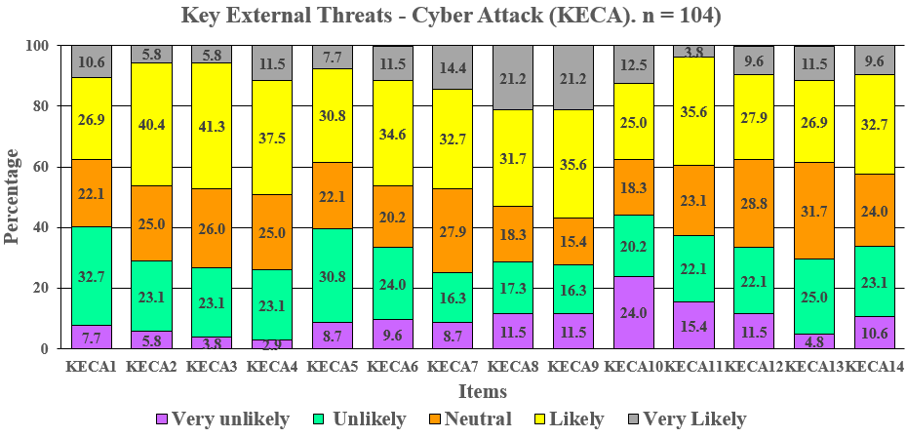
Figure ‎5-1: Key External Threats - Cyber Attack (KECA). n = 104. See Table ‎0-3 in Appendix 4 for Code or item explanation
The participants were asked to say how likely it was that their organisation would be affected by key external threats. The responses showed that respondents were very aware of the level of cyber-risk to their organisations. There was also a low level of trust in their organisations’ resilience to external cyber-attacks, because only 2.9% thought that it was very unlikely that attacks would disrupt their organisation’s services. Many public sector employees were therefore aware of the likely impact of key external threats on their organisations.
In total, a mean of 34.9 respondents (33.5%) thought that Key External Threats – Hacktivism (KEH) was likely. A mean of just 8.1 (7.8%) thought it was very unlikely. A mean of 48 (46.2%) respondents thought that KEH15 (Insufficient protection against reverse engineering) was likely and only three (2.9%) that KEH2 (Traffic: overloading system with traffic is harmful) was unlikely (Table ‎0-7 of Appendix 4 and Figure ‎5-2).
The most common response for Key External Threats – Phishing (KEP) was ‘likely’ with a mean of 35.6 (34.3% of respondents). The least common was very unlikely with a mean of 7.3 (7.0%). A mean of 45 (45.3%) thought that KEP4 (Loss of confidential information for fraudulent purposes (whaling scams)) was likely and only a mean of three (2.9%) thought it very unlikely (Table ‎0-7 of Appendix 4 and Figure ‎5-3).
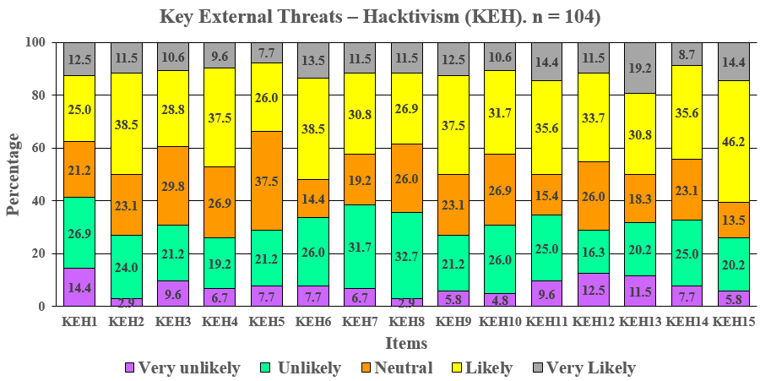
Figure ‎5-2: Key External Threats – Hacktivism (KEH). n = 104. See Table ‎0-3 in Appendix 4 for Code or item explanation

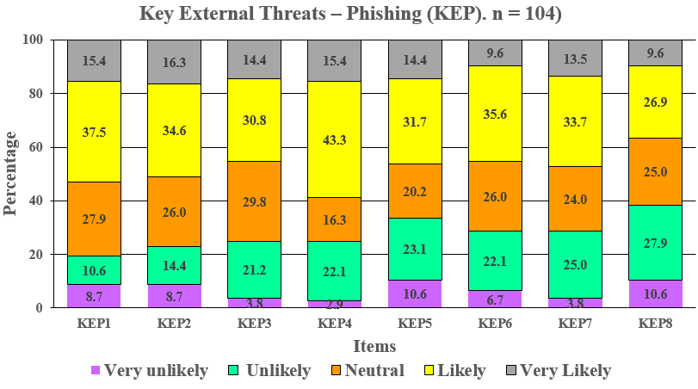
Figure ‎5-3: Key External Threats – Phishing (KEP). n = 104. See Table ‎0-3 in Appendix 4 for Code or item explanation
Similarly, the most popular response for Key External Threats - Financial Fraud (KEFF) was likely with a mean frequency of 31.5 (30.3% of respondents). The lowest mean was very unlikely (8.9, 8.6%). KEFF2 (Asset misappropriation (stealing information)) was considered likely by a mean of 54 (51.9%) of respondents and a mean of just two (1.9%) thought KEFF3 (Human errors and trust issues) was very unlikely (Table ‎0-7 of Appendix 4 and Figure ‎5-4).
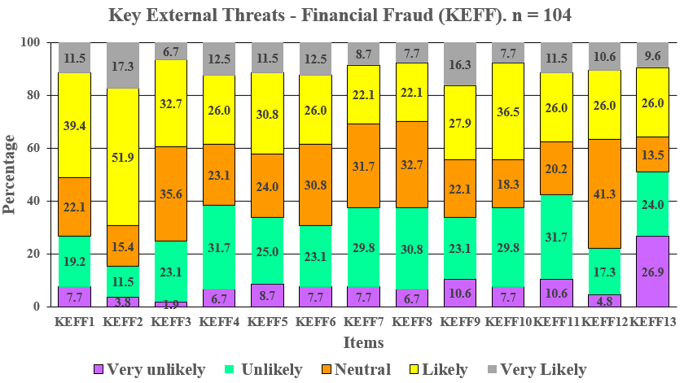
Figure ‎5-4: Key External Threats - Financial Fraud (KEFF). n = 104. See Table ‎0-3 in Appendix 4 for Code or item explanation

The most common response for Key External Threats - Criminal Acts (ETCA) was likely with a mean frequency of 30.7 (29.5 % of respondents). The lowest mean was for very unlikely (10.0, 9.6%). ETCA14 (Use of erroneous and/or unreliable data) was considered likely by a mean of 44 (42.3%) respondents). ETCA17 (Large-scale and/or inappropriate data mining and/or surveillance) and ETCA19 (Social engineering attack) were only considered very unlikely by a mean of two (1.9%) respondents) (Table ‎0-7 of Appendix 4 and Figure ‎5-5).
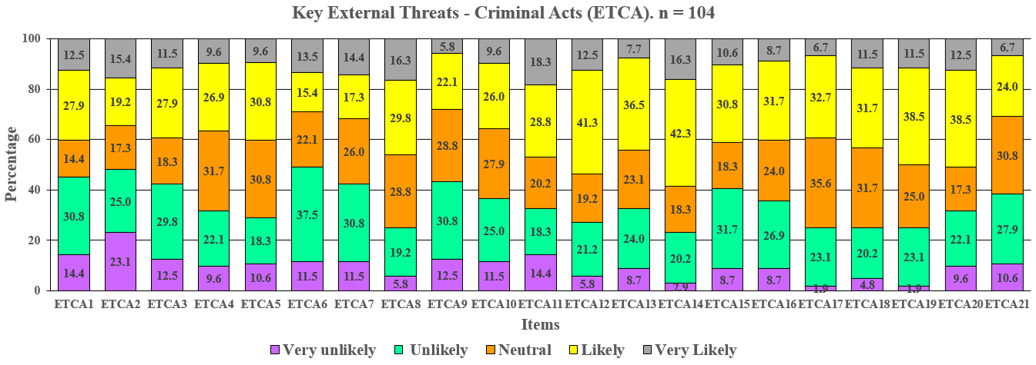
Figure ‎5-5: Key External Threats - Criminal Acts (ETCA). n = 104. See Table ‎0-3 (Appendix 4) for Code or item explanation

A mean of 34.4 (33.1%) thought that Key Internal Threats - Lack of Awareness (KILA) was likely. The lowest mean was very unlikely (10.7, 10.3%). KILA10 (Lack of reporting policy) was considered likely by a mean of 55 (52.9%) respondents. The smallest groups of respondents (three, or 2.9% in each case) were those who considered KILA3 was very likely, and that KILA4 (Lack of situational awareness materials) and KILA5 (Security threats are not gathered and shared) were very unlikely (Table ‎0-3 of Appendix 4 and Figure ‎5-6).
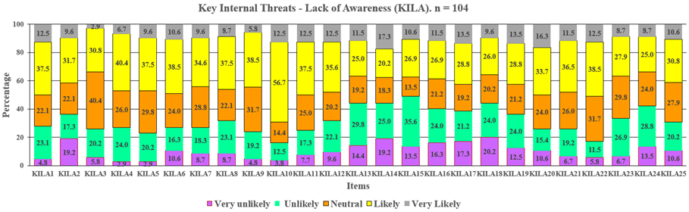
Figure ‎5-6: Key Internal Threats - Lack of Awareness (KILA). n = 104. See Table ‎0-3 Appendix 4 for Code or item explanation
The highest mean for Key Internal Threats - Risk Culture and Laziness (KIRC) was likely (28.7, 27.6%). The lowest mean for this variable was very unlikely (11.9, 11.4 %). KIRC4 (Lack of risk culture causes deficiency of appropriate access control) and KIRC8 (No regular software upgrades and update patching) were thought likely by the biggest groups of respondents (36, 34.6%) and KIRC18 (Lack of clearly defined system users authority) was considered very unlikely by the fewest respondents (six, 5.8%) (Table ‎0-3 of Appendix 4 and Figure ‎5-7).
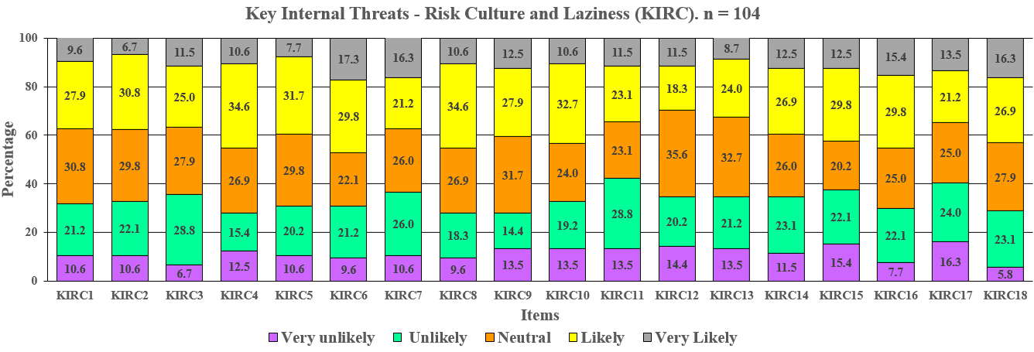
Figure ‎5-7: Key Internal Threats - Risk Culture and Laziness (KIRC). n = 104. See Table ‎0-3 (Appendix 4) for Code or item explanation

The highest mean for Key Internal Threats - Financial Fraud (KIFF) was likely (31.6 (30.4%) respondents. The lowest mean was very unlikely (9.6, 9.2%). Among the sub-variables, the biggest group thought that KIFF5 (Theft of hardware) was likely (38, 36.5% respondents) and the smallest that KIFF6 (Mistakes by employees) was very likely (five, 4.8%) (Table ‎0-3 of Appendix 4 and Figure ‎5-8).
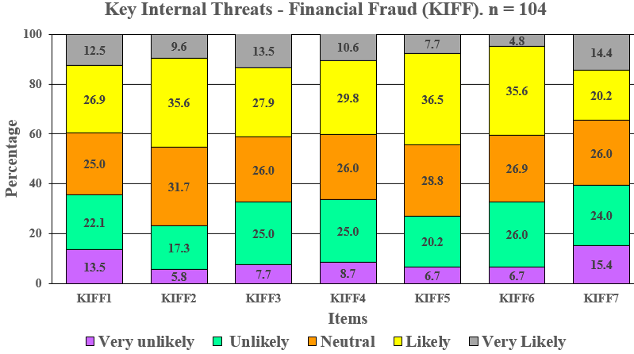
Figure ‎5-8: Key Internal Threats - Financial Fraud (KIFF). n = 104. See Table ‎0-3 (Appendix 4) for Code or item meaning
The highest mean for Key Internal Threats - Criminal Acts (ITCA) was again likely, with a mean frequency of 29.4 (28.3%) respondents. The lowest mean was very unlikely (5.9, 5.6%). The most popular option among the sub-variables was that ITCA2 (Revenge attacks by outsiders) was likely (41, 39.4%), and the least popular was that the same variable was very unlikely (two, 1.9%) (Table ‎0-3 of Appendix 4 and Figure ‎5-9).
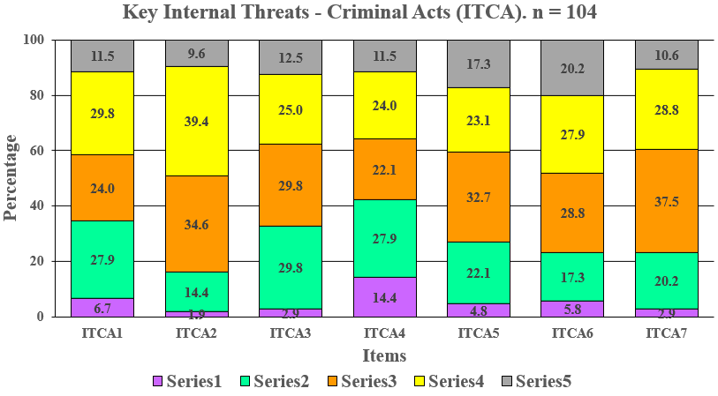
Figure ‎5-9: Key Internal Threats - Criminal Acts (ITCA). n = 104. See Table ‎0-3 (Appendix 4) for Code or item explanation
The highest mean for Vulnerabilities and Weaknesses (VW) was likely (31.0, 29.8% of respondents). The lowest mean was very unlikely (10.7, 10.3%). Among the sub-variables, the biggest groups thought that VW5 (We lack a system for independent testing) and VW10 (Utility programs and applications are restricted) were likely (44, 42.3%). The least popular responses were for VW8 (E-mail protection mechanisms are present) being very likely and VW10 being very unlikely, both chosen by a mean of three (2.9%) (Table ‎0-4 of Appendix 4 and Figure ‎5-10).
The highest mean for organisation vulnerabilities and weaknesses: physical and digital assets (VWP) was for likely (27.4, 26.4%). The lowest mean was very likely (9.9, 9.5%). The most common option among the sub-variables was the neutral response for VWP3 (Hard disks) (37, 35.6%) and the least common was that VW1 (Computers) was unlikely (four, 3.8%) (Table ‎0-4 of Appendix 4 and Figure ‎5-11).
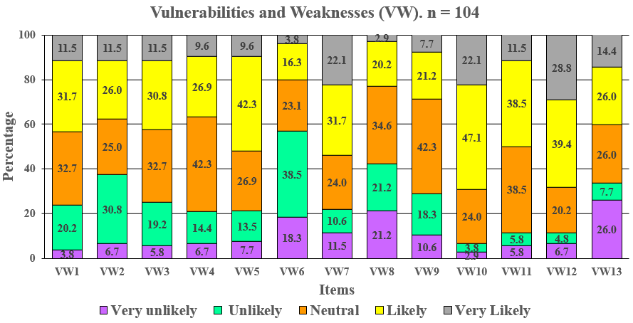
Figure ‎5-10: Vulnerabilities and Weaknesses (VW). n = 104. See Table ‎0-3 (Appendix 4) for Code or item explanation

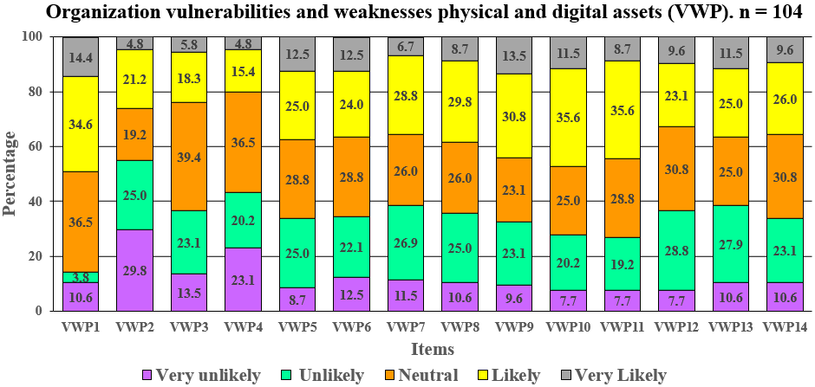
Figure ‎5-11: Organisation vulnerabilities and weaknesses: physical and digital assets (VWP). n = 104. See Table ‎0-3 (Appendix 4) for Code or item explanation
The highest mean for Responses in Place (RP) was likely (35.2, 33.8%). The lowest mean was very unlikely (5.1, 4.9%). The most popular response among sub-variables was that RP7 (Monitor user access logs) was very likely (48, 46.2%) and the least common was that RP18 (Use real-time day-to-day monitoring) was very unlikely (one, 1.0%) (Table ‎0-5 of Appendix 4 and Figure ‎5-12).

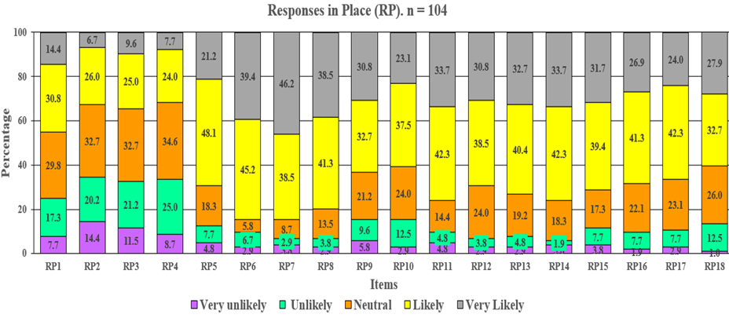
Figure ‎5-12: Responses in Place (RP). n = 104. See Table ‎0-3 (Appendix 4) for Code or item explanation

The highest mean for Organisational Resilience (OR) was likely (38.0, 36.6%). The lowest mean was very unlikely (2.3, 2.2%). On sub-variables, the biggest groups of respondents (46, 44.2%) thought that OR12 (Monitor user access logs), and OR15 (A formal backup and recovery plan exists for all critical business communications in our organisation) were likely, and the least popular responses were that OR7 (A normal network activity baseline is established), OR12, OR15, OR16 (All internal or external audits and testing are formally tracked and resolved to mitigate risk), and OR17 (The people responsible for analysing and responding to an incident are easily reachable) were very unlikely, each chosen by a mean of just one respondent (1.0%) (Table ‎0-6 of Appendix 4 and Figure ‎5-13).
Most of the main variables were therefore considered ‘likely’ by the largest group of respondents, and ‘very unlikely’ by the smallest group.

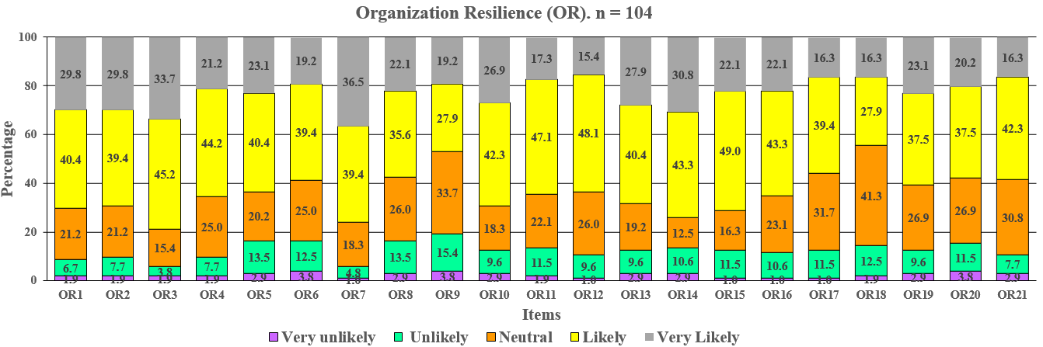
Figure ‎5-13: Organisation Resilience (OR). n = 104. See Table ‎0-3 in Appendix 4 for Code or item explanation

Summary of Descriptive Statistics
Missing data was evaluated, and EM was used to substitute missing data. The study data set therefore included no missing values, but four items were under and six items over the limit values (1 and 5), so were estimated again. Little’s MCAR test again showed no significant differences. The second estimations for these values were between 1 and 5 and were considered possible values. Outliers were determined using the absolute value of difference between original mean and 5% trimmed mean. The largest absolute difference was [−0.12] = 0.12. There were therefore no outliers in the research data set, and no variables were removed. The Cronbach’s alpha values were all above 0.75, suggesting that all factors and items should be included. The frequency and percent of each scale was calculated for the five possible answers (very unlikely, unlikely, neutral, likely, and very likely). Most variables did not disturb the assumption of normality using the rule of ±1. A few variables were slightly over this threshold (seven for skewness and 41 for kurtosis) but all had values of less than two for skewness and three for kurtosis, so normality can be assumed.

Exploratory Factor Analysis (EFA)
This section describes the use of exploratory factor analysis (EFA) to evaluate the underlying factor structure of the correlation matrix. The analysis was also used to build the theory. There was very little information about the construct under study, so the EFA was used to identify the latent factors underlying the manifest variables, as well as the patterns of relationships between latent and manifest variables. After the EFA, a regression analysis was performed using the EFA results.
The EFA used the Principal Component Analysis extraction method and Varimax with Kaiser Normalisation rotation on the results from 104 participants to determine the factor structure of the items in the 14 scales. Items with primary factor loadings ≥ 0.50 were retained. Varimax rotation was selected because it is a good method of orthogonal rotations that produces factors that are uncorrelated (i.e., maintain a 90º angle between axes) (Kaiser, 1958). Oblique methods allow the factors to correlate (i.e., allow the X and Y axes to assume a different angle than 90º) (Nunnally and Bernstein, 1994). There is also an argument that the mathematics is simpler in Varimax rotation, which made a significant difference during much of the 20th century when EFA was performed by hand or with much more limited computing power (Osborne, 2015). Kaiser (1958) suggested normalizing factor loadings before rotating them, and then de-normalizing them after rotation.

Key External Threats - Cyber Attack (KECA)
Principal component analysis was used to reduce the number of variables to a smaller number of components. The total variance table (Table ‎5-3) explains the selection of the three main components. Only the first three factors had eigenvalues greater than 1 and explained 68.2% of the variance. This means that these three factors describe 68.2% of the variance in the original problem, resulting in the loss of 31.8% of the original information represented by the 14 initial variables. The cumulative percentage of variance explained by the first, second and third components was 29.9%, 51.6% and 68.2%, or 6.7, 1.8 and 1.0 variables.
Latent Variables | Initial Eigenvalues |  |  | Extraction Sums of Squared Loadings |  |  | Rotation Sums of Squared Loadings
Latent Variables | Total | % of Variance | Cumulative % | Total | % of Variance | Cumulative % | Total | % of Variance | Cumulative %
1 | 6.695 | 47.821 | 47.821 | 6.695 | 47.821 | 47.821 | 4.188 | 29.918 | 29.918
2 | 1.842 | 13.160 | 60.981 | 1.842 | 13.160 | 60.981 | 3.031 | 21.651 | 51.569
3 | 1.013 | 7.234 | 68.215 | 1.013 | 7.234 | 68.215 | 2.330 | 16.646 | 68.215
4 | 0.703 | 5.024 | 73.239
Extraction Method: Principal Component Analysis.
Table ‎5-3: Total variance explained by the components of KECA

The Kaiser–Meyer–Olkin (KMO) value measures the adequacy of the sample and indicates how appropriate it is to apply factor analysis. Values between 0.5 and 1.0 indicate that it is appropriate (Williams et al., 2010, Eyduran et al., 2010). Bartlett’s Sphericity Test measures the adequacy of data for factor analysis. It is used to test the null hypothesis that the variables are not correlated in the population, and therefore checks if the correlation matrix is an identity matrix. Results with a high-test value and a reliability of less than 0.05 can be considered valid (Hidayah et al. 2020; Iqrammah and Rijanto 2019). The KMO value of 0.851 was within the scope of factor analysis. For Bartlett’s test of sphericity, the Chi-square value was 839.6 with 91 degrees of freedom and the result was significant at ≤0.001 (Table ‎5-4). This showed that the data were suitable for factor analysis.
Kaiser–Meyer–Olkin Measure of Sampling Adequacy |  | 0.851
Bartlett's Test of Sphericity | Approximation Chi-Square: | 839.6
Bartlett's Test of Sphericity | Degree of freedom: | 91
Bartlett's Test of Sphericity | Significance: | 0.000
Table ‎5-4: Kaiser–Meyer–Olkin test and Bartlett's test for sphericity for KECA
Table ‎5-5 shows the matrix of factors and factor loads, that is, the correlation between each variable and that factor. Loads indicate the degree of correspondence between the variable and the factor. High loads indicate that the variable is representative of the factor. For example, the variable KECA1 (Breaches making computers and internet unusable) is attributable to Factor 1, because KECA1 has the greatest load in that factor (0.792). KECA8 (Social networking) is attributable to Factor 2 with a factor load of 0.807. It is desirable that each variable should load to a single factor, ideally with a load of more than 0.5 and hopefully close to 1 (Finch, 2019; Kline, 2014). However, values of 0.4 are considered reasonable.
Assigning each variable to the component or factor with the largest loading gives Table ‎5-5. This study found three new latent clusters of Key External Threats - Cyber Attack (KECA). The elements that cause each cluster are shown in Table ‎5-5. There were seven variables allocated to the first new latent cluster (KECAN1), on ‘attack systems’, four assigned to the second new latent cluster (KECAN2), on ‘social interaction’ and three to the third (KECAN3), on ‘direct interaction’. The three new latent clusters had a reliability of >0.8, which is considered satisfactory (Finch, 2019; Kline, 2014).
Item | Component matrix ^{a b}
Item | 1 |  | 2 | 3 | Cronbach’s Alpha | No of Questions | New Code | New Description
KECA1 |  | 0.792 |  |  | 0.885 | 7 | KEKAN1 | Attack systems
KECA3 |  | 0.778
KECA4 |  | 0.732
KECA5 |  | 0.723
KECA14 |  | 0.709
KECA2 |  | 0.690
KECA13 |  | 0.587
KECA8 |  |  | 0.807 |  | 0.839 | 4 | KEKAN2 | Social interaction
KECA9 |  |  | 0.741
KECA7 |  |  | 0.697
KECA6 |  |  | 0.613
KECA10 |  |  |  | 0.840 | 0.817 | 3 | KEKAN3 | Direct interaction
KECA12 |  |  |  | 0.653
KECA11 |  |  |  | 0.634
ª Rotation converged in 15 iterations
^{b} Extraction Method: Principal Component Analysis. Rotation Method: Varimax with Kaiser Normalisation.
Table ‎5-5: Cronbach’s alpha, number of questions and rotated component matrix for KECA
It is necessary to establish convergent and discriminant validity as well as reliability to check the EFA. If the factors do not have adequate validity and reliability, then testing the causal model will be useless. Measures that are used for establishing validity and reliability include composite reliability (CR), average variance extracted (AVE), maximum shared variance (MSV) and average shared variance (ASV).
CR is a measure of the reliability of the survey. Its cut-off value is >0.7. AVE is a strict measure of convergent validity. It is a more conservative measure than the CR. The cut-off value is >0.5 (Hasani and Pasdar 2017). Discriminant validity is assumed if MSV < AVE or ASV < AVE. Table ‎5-6 shows CR and AVE for each factor and MSW and ASV values. CR varied from 0.755 to 0.881, but all values were higher than 0.7. AVE ranged from 0.511 to 0.516, and all values were higher than 0.5. MSV (0.566) > AVE and ASV (0.477) < AVE. (Hasani and Pasdar 2017; Ettis and Kefi, 2016; Hamari and Koivisto, 2014). There were therefore no problems with either convergent or discriminant validity. If there are problems with convergent validity, it means that the factor is not well-explain by its component variables. If discriminant validity problems arise, this means that one or more variables have a greater correlation with variables outside their parent factor than with those within their parent factor. In this case, as Table ‎5-6 shows, MSV was slightly greater than AVE (Ettis and Kefi, 2016; Hamari and Koivisto, 2014). These indices were calculated following Fornell and Larcker (1981) using Excel for Windows 2019.
Parameters | Factor 1 | Factor 2 | Factor 3
Composite reliability | 0.881 | 0.808 | 0.755
Average variance extracted | 0.516 | 0.515 | 0.511
Maximum shared variance | 0.566
Average shared variance | 0.477
Table ‎5-6: Average variance extracted (AVE), composite reliability (CR), maximum shared variance (MSV) and average shared variance (ASV) of the scale KECA.
The second latent variable cluster KECAN2 has previously been described in the literature. Dutt, Moisan, and Gonzalez (2016) noted that in business areas where automation or computerisation can realistically replace human interaction, such as network intrusion detection, human error is almost eliminated. However, in most systems and processes, the human element still represents both the weakness and the vulnerability of the system. In fact, “Considering usability and security in tandem creates an intractable problem” (Richards and Norcio, 2016, p. 305), and the requirements of human-centred computing and human–computer interaction do not fully overcome that problem.
The researcher’s 18 years of experience in public sector organisations suggests that applying best practice and security procedures in these organisations is not an easy task. Many factors affect the quality of organisations’ best practice, such as employee retention, lack of awareness, social interaction among colleagues, bureaucratic culture, routines, data access control and executives’ lack of awareness (Chang and Lin, 2007; Knapp, 2006; Chang and Ho, 2016).

Key External Threats – Hacktivism (KEH)
The total variance table (Table ‎5-7) explains the selection of two main components for this element. Only the first two factors had eigenvalues greater than 1 and explained 62.3% of the variance, resulting in the loss of 37.7% of the original information represented by the 15 initial variables. In other words, only two factors are relevant to summarise the original variables of the problem. The cumulative percentage of variance explained by the first and second components was 37.7% and 62.3%, across 8.3 and 1 variables.
Latent Variables | Initial Eigenvalues |  |  | Extraction Sums of Squared Loadings |  |  | Rotation Sums of Squared Loadings
Latent Variables | Total | % of Variance | Cumulative % | Total | % of Variance | Cumulative % | Total | % of Variance | Cumulative %
1 | 8.324 | 55.493 | 55.493 | 8.324 | 55.493 | 55.493 | 5.662 | 37.748 | 37.748
2 | 1.017 | 6.777 | 62.270 | 1.017 | 6.777 | 62.270 | 3.678 | 24.522 | 62.270
3 | 0.906 | 6.037 | 68.307
Extraction Method: Principal Component Analysis.
Table ‎5-7: Total variance explained by the components of KEH
The KMO value of 0.930 was within the scope of factor analysis (0.5–1.0). For Bartlett’s test of sphericity, the Chi-square value was 1012.6 with 105 degrees of freedom and the result was significant at ≤0.001 (Table ‎5-8). The data were therefore suitable for factor analysis.
Kaiser–Meyer–Olkin Measure of Sampling Adequacy |  | 0.930
Bartlett's Test of Sphericity | Approximation Chi-Square: | 1012.6
Bartlett's Test of Sphericity | Degree of freedom: | 105
Bartlett's Test of Sphericity | Significance: | 0.000
Table ‎5-8: Kaiser–Meyer–Olkin test and Bartlett's test of sphericity for KEH

Table ‎5-9 shows the factor loads. For example, the variable KEH4 (Improper software integration can be used as a cyber-attacking backdoor) is attributable to Factor 1, with a load of 0.821. KEH14 (Lack of sufficiently skilled IT staff and security tools) is attributable to Factor 2 with a factor load of 0.768. All items had loads greater than 0.5.

Assigning each variable to the component or factor with the largest loading gave Table ‎5-9. This found two new latent clusters for Key External Threats - Hacktivism (KEH). There were 11 variables assigned to the first new latent cluster (KEHN1), ‘non-violent use of digital tools’, and four to the second (KEHN2), ‘lack of preparedness’. The two new latent clusters had a reliability of >0.8, which was satisfactory.

Item | Component matrix ^{ab} |  | Cronbach’s Alpha | No. of Questions | New Code | New Description
Item | 1 | 2
KEH1 | 0.580 |  | 0.929 | 11 | KEHN1 | Non-violent use of digital tools
KEH3 | 0.748
KEH4 | 0.821
KEH5 | 0.668
KEH6 | 0.795
KEH7 | 0.648
KEH8 | 0.734
KEH9 | 0.549
KEH10 | 0.669
KEH15 | 0.636
KEH11 |  | 0.738 | 0.844 | 4 | KEHN2 | Lack of Preparedness
KEH12 |  | 0.758
KEH13 |  | 0.766
KEH14 |  | 0.768
ª Rotation converged in 3 iterations
^{b} Extraction Method: Principal Component Analysis. Rotation Method: Varimax with Kaiser Normalisation.
Table ‎5-9: Cronbach’s alpha, number of questions and rotated component matrix for KEH
Table ‎5-10 shows CR and AVE for each factor and MSW and ASV values. CR varied from 0.843 to 0.908, with all values higher than 0.7. AVE ranged from 0.477 to 0.574, with the value for Factor 1 lower than 0.5. MSV (0.694) > AVE and ASV (0.554) < AVE (Factor 2). There were therefore problems with convergent validity for Factor 1 but not for Factor 2, and no problems with discriminant validity, because MSV > AVE. This suggests that Factor 1 may not be well explained by its observed variables, although this problem is only small.
Parameters | Factor 1 | Factor 2
Composite reliability | 0.908 | 0.843
Average variance extracted | 0.477 | 0.574
Maximum shared variance | 0.694
Average shared variance | 0.554
Table ‎5-10: Average variance extracted (AVE), composite reliability (CR), maximum shared variance (MSV) and average shared variance (ASV) for KEH
Both new latent clusters have been identified in previous studies. Halupka (2014) noted that non-violent use of digital tools can be a form of ‘legitimate protest’, to promote an idea or protest against a new public policy or law, but that this can lead to unfortunate results for the target. Lack of preparedness inside the organisation is often related to lack of proper assessment of the organisation’s cyber-security, before any threat is identified (Atoum, Otoom and Abu Ali, 2014).

Key External Threats – Phishing (KEP)
The total variance table (Table ‎5-11) explains the selection of the single main component. Only the first factor had an eigenvalue greater than 1, but this expressed 71.2% of the variance, resulting in the loss of only 28.8% of the original information represented by the eight initial variables. This factor also covered 5.7 variables.
Latent Variables | Initial Eigenvalues |  |  | Extraction Sums of Squared Loadings
Latent Variables | Total | % of Variance | Cumulative % | Total | % of Variance | Cumulative %
1 | 5.693 | 71.158 | 71.158 | 5.693 | 71.158 | 71.158
2 | 0.678 | 8.477 | 79.635
Extraction Method: Principal Component Analysis.
Table ‎5-11: Total variance explained by the components of KEP
The KMO value of 0.890 obtained was within the range for factor analysis (0.5–1.0). Bartlett’s test of sphericity gave a Chi-square value of 706.7 with 28 degrees of freedom and was significant at ≤0.001 (Table ‎5-12). The data were therefore suitable for factor analysis.
Kaiser–Meyer–Olkin Measure of Sampling Adequacy |  | 0.890
Bartlett's Test of Sphericity | Approximation Chi-Square: | 706.7
Bartlett's Test of Sphericity | Degree of freedom: | 28
Bartlett's Test of Sphericity | Significance: | 0.000
Table ‎5-12: Kaiser–Meyer–Olkin test and Bartlett's test of sphericity for KEP
Table ‎5-13 shows the factor loads. All items had a load of more than 0.7. There was only one new latent cluster for Key External Threats - Phishing (KEP), with eight variables allocated to this cluster, named ‘electronic phishing’. The new latent cluster had a reliability of >0.9, which is excellent.
 | Component matrix ^{a b} | Cronbach’s Alpha | No. of Questions | New Code | New Description
Item | 1
KEP1 | 0.839 | 0.941 | 8 | KEPN1 | Electronic Phishing
KEP2 | 0.867
KEP3 | 0.892
KEP4 | 0.827
KEP5 | 0.862
KEP6 | 0.813
KEP7 | 0.852
KEP8 | 0.792
ª 1 component extracted
^{b} Extraction Method: Principal Component Analysis. Rotation Method: Varimax with Kaiser Normalisation.
Table ‎5-13: Cronbach’s alpha, number of questions and rotated component matrix for KEP
Table ‎5-14 shows CR and AVE for the only factor and MSW and ASV values. CR was 0.952, which is higher than 0.7, and AVE was 0.712, which is higher than 0.5. MSV (0.788) > AVE and ASV (0.711) < AVE (Factor 12). There were therefore no problems with convergent validity. For discriminant validity, MSV > AVE, but ASV was lower than AVE. According to Button and Cross (2017), electronic phishing is a ‘human factor’, and plays a key role in loss of confidential information for fraudulent purposes.
Parameters | Factor 1
Composite reliability | 0.952
Average variance extracted | 0.712
Maximum shared variance | 0.788
Average shared variance | 0.711
Table ‎5-14: Average variance extracted (AVE), composite reliability (CR), maximum shared variance (MSV) and average shared variance (ASV) for KEP

Key External Threats - Financial Fraud (KEFF)
The total variance table (Table ‎5-15) clarifies the selection of two main components. Only the first two factors had eigenvalues greater than 1 and explained 68.6% of the variance, resulting in the loss of 31.4% of the original information represented by the 13 initial variables. The cumulative percentage of variance explained by the first and second components was 46.3% and 68.6%, across 7.8 and 1.2 variables.
Latent Variables | Initial Eigenvalues |  |  | Extraction Sums of Squared Loadings |  |  | Rotation Sums of Squared Loadings
Latent Variables | Total | % of Variance | Cumulative % | Total | % of Variance | Cumulative % | Total | % of Variance | Cumulative %
1 | 7.771 | 59.779 | 59.779 | 7.771 | 59.779 | 59.779 | 6.023 | 46.330 | 46.330
2 | 1.150 | 8.849 | 68.628 | 1.150 | 8.849 | 68.628 | 2.899 | 22.298 | 68.628
3 | 0.660 | 5.081 | 73.708
Extraction Method: Principal Component Analysis.
Table ‎5-15: Total variance explained by the components of KEFF
The KMO value of 0.921 obtained was within the range for factor analysis (0.5–1.0). Bartlett’s test of sphericity gave a Chi-square value of 996.7 and 78 degrees of freedom and was significant at ≤0.001 (Table ‎5-16). The data were therefore suitable for factor analysis.
Kaiser–Meyer–Olkin Measure of Sampling Adequacy |  | 0.921
Bartlett's Test of Sphericity | Approximation Chi-Square: | 996.7
Bartlett's Test of Sphericity | Degree of freedom: | 78
Bartlett's Test of Sphericity | Significance: | 0.000
Table ‎5-16: Kaiser–Meyer–Olkin test and Bartlett's test of sphericity for KEFF
Table ‎5-17 shows the factor load. All items had loads higher than 0.6. Each variable was assigned to the component or factor with the largest loading. There were two new latent clusters of Key External Threats - Financial Fraud (KEFF). There were 10 variables allocated to the first (KEFFN1), on ‘economic fraud’ and three assigned to the second (KEFFN2), ‘fiscal scams’. The two new latent clusters had a reliability of >0.8, which was good.
 | Component matrix ^{a b} |  | Cronbach’s Alpha | No. of Questions | New Code | New Description
Item | 1 | 2
KEFF7 | 0.856 |  | 0.944 | 10 | KEFFN1 | Economic fraud
KEFF11 | 0.853
KEFF13 | 0.812
KEFF9 | 0.787
KEFF8 | 0.785
KEFF6 | 0.709
KEFF4 | 0.704
KEFF5 | 0.686
KEFF10 | 0.685
KEFF12 | 0.682
KEFF2 |  | 0.838 | 0.792 | 3 | KEFFN2 | Fiscal Scam
KEFF3 |  | 0.791
KEFF1 |  | 0.718
ª Rotation converged in 3 iterations
^{b} Extraction Method: Principal Component Analysis. Rotation Method: Varimax with Kaiser Normalisation.
Table ‎5-17: Cronbach’s alpha, number of questions and rotated component matrix for KEFF
Table ‎5-18 shows CR and AVE for each factor and MSW and ASV values. CR varied from 0.826 to 0.931, all higher than 0.7, and AVE ranged from 0.576 to 0.614, again all higher than 0.5. MSV (0.730) > AVE and ASV (0.597) < AVE (Factor 2) but AVE < ASV for Factor 1. There were therefore no problems with convergent validity. However, Factor 1 showed potential problems with discriminant validity. This suggests that some of its variables were more closely correlated with the variables outside the parent factor than with others within it. However, the difference was very small.
Parameters | Factor 1 | Factor 2
Composite reliability | 0.931 | 0.826
Average variance extracted | 0.576 | 0.614
Maximum shared variance | 0.730
Average shared variance | 0.597
Table ‎5-18: Average variance extracted (AVE), composite reliability (CR), maximum shared variance (MSV) and average shared variance (ASV) for KEFF
Financial fraud is very similar to electronic phishing. Button and Cross (2017) described many different financial fraud risks such as economic fraud or fiscal scams but emphasised that there is often a level of gullibility involved, returning once more to the ‘human factor’.

Key External Threats - Criminal Acts (ETCA)
The total variance table (Table ‎5-19) explains the selection of three main components. The first three factors had eigenvalues greater than 1 and comprise 67.9% of the variance, resulting in the loss of 32.1% of the original information represented by the 21 initial variables. The cumulative percentage of variance explained by the first, second and third components were 29.3%, 49.3% and 67.9%, across 11.7, 1.4 and 1.1 variables.
Latent Variables | Initial Eigenvalues |  |  | Extraction Sums of Squared Loadings |  |  | Rotation Sums of Squared Loadings
Latent Variables | Total | % of Variance | Cumulative % | Total | % of Variance | Cumulative % | Total | % of Variance | Cumulative %
1 | 11.764 | 56.018 | 56.018 | 11.764 | 56.018 | 56.018 | 6.159 | 29.327 | 29.327
2 | 1.400 | 6.667 | 62.684 | 1.400 | 6.667 | 62.684 | 4.191 | 19.955 | 49.283
3 | 1.089 | 5.186 | 67.871 | 1.089 | 5.186 | 67.871 | 3.903 | 18.588 | 67.871
4 | 0.854 | 4.066 | 71.937
Extraction Method: Principal Component Analysis.
Table ‎5-19: Total variance explained by the components of ETCA

The KMO value of 0.908 was within the range for factor analysis (0.5–1.0). Bartlett’s test of sphericity gave a Chi-square value of 1798.6, with 210 degrees of freedom and the result was significant at ≤0.001 (Table ‎5-20). The data were therefore suitable for factor analysis.
Kaiser–Meyer–Olkin Measure of Sampling Adequacy |  | 0.908
Bartlett's Test of Sphericity | Approximation Chi-Square: | 1798.6
Bartlett's Test of Sphericity | Degree of freedom: | 210
Bartlett's Test of Sphericity | Significance: | 0.000
Table ‎5-20: Kaiser–Meyer–Olkin test and Bartlett's test for sphericity for ETCA
Table ‎5-21 shows the factor load. All items had a load higher than 0.5, except ETCA17 (0.489). There were three new latent clusters of Key External Threats - Criminal Acts (ETCA). Ten variables were assigned to the first new latent cluster (ETCAN1), ‘felonious actions’, five to the second (ETCAN2), ‘unauthorised access’ and six to the third (ETCAN3), ‘criminal acts’. The three new latent clusters had a reliability of >0.87, which was satisfactory (Table ‎5-21).
Item | Component matrix ^{ab} |  |  | Cronbach’s Alpha | No. of Questions | New Code | New Description
Item | 1 | 2 | 3
ETCA2 | 0.802 |  |  | 0.942 | 10 | ETCAN1 | Felonious actions
ETCA3 | 0.798
ETCA1 | 0.762
ETCA4 | 0.754
ETCA5 | 0.723
ETCA10 | 0.678
ETCA11 | 0.644
ETCA6 | 0.624
ETCA7 | 0.590
ETCA9 | 0.573
ETCA16 |  | 0.761 |  | 0.905 | 5 | ETCAN2 | Unauthorised Access
ETCA13 |  | 0.738
ETCA21 |  | 0.701
ETCA15 |  | 0.679
ETCA20 |  | 0.597
ETCA8 |  |  | 0.795 | 0.870 | 6 | ETCAN3 | Criminal acts
ETCA18 |  |  | 0.706
ETCA19 |  |  | 0.641
ETCA12 |  |  | 0.633
ETCA14 |  |  | 0.562
ETCA17 |  |  | 0.489
ª Rotation converged in 10 iterations
^{b} Extraction Method: Principal Component Analysis. Rotation Method: Varimax with Kaiser Normalisation.
Table ‎5-21: Cronbach’s alpha, number of questions and rotated component matrix for ETCA
Table ‎5-22 shows CR and AVE for each factor and MSW and ASV values. CR varied from 0.807 to 0.904, all higher than 0.7, and AVE ranged from 0.416 to 0.489, all below 0.5. MSV (0.686) > AVE and ASV (0.560) > AVE for all factors. There were therefore potential problems for convergent validity and discriminant validity for all factors.
Criminal acts may not be driven by financial gain for the criminal but can still cause large losses for the company attacked. Awareness of the risks is the first step in preventing or mitigating any possible breach or attacks (Amoroso, 2011). Ciolan (2014) noted the importance of improving both the level of individual awareness and protection for critical infrastructure and critical information infrastructure.
Parameters | Factor 1 | Factor 2 | Factor 3
Composite reliability | 0.904 | 0.825 | 0.807
Average variance extracted | 0.489 | 0.487 | 0.416
Maximum shared variance | 0.686
Average shared variance | 0.560
Table ‎5-22: Average variance extracted (AVE), composite reliability (CR), maximum shared variance (MSV) and average shared variance (ASV) for ETCA

Key Internal Threats - Lack of Awareness (KILA)
The total variance table (Table ‎5-23) explains the selection of two main components comprising 69.4% of the variance and resulting in the loss of 30.6% of the original information from by the 25 initial variables. The cumulative percentage of variance explained by the first and second components was 37.9% and 69.4%, across 15.8 and 1.6 variables.

Component |  | Initial Eigenvalues |  |  | Extraction Sums of Squared Loadings |  |  | Rotation Sums of Squared Loadings
 |  | Total | % of Variance | Cumulative % | Total | % of Variance | Cumulative % | Total | % of Variance | Cumulative %
1 | 15.769 |  | 63.076 | 63.076 | 15.769 | 63.076 | 63.076 | 9.482 | 37.927 | 37.927
2 | 1.569 |  | 6.276 | 69.352 | 1.569 | 6.276 | 69.352 | 7.856 | 31.425 | 69.352
3 | 0.996 |  | 3.986 | 73.338
Extraction Method: Principal Component Analysis
Table ‎5-23: Total variance explained by the components of KILA

The KMO value of 0.931 obtained was within the range for factor analysis (0.5–1.0). Bartlett’s test of sphericity gave a Chi-square value of 2670.4, with 300 degrees of freedom and was significant at ≤0.001 (Table ‎5-24). The data were therefore suitable for factor analysis.

Kaiser–Meyer–Olkin Measure of Sampling Adequacy |  | 0.931
Bartlett's Test of Sphericity | Approximation Chi-Square: | 2670.4
Bartlett's Test of Sphericity | Degree of freedom: | 300
Bartlett's Test of Sphericity | Significance: | 0.000
Table ‎5-24: Kaiser–Meyer–Olkin test and Bartlett's test of sphericity for KILA

Table ‎5-25 shows the factor load. All items had a load greater than 0.5. There were therefore two new latent clusters for Key Internal Threats - Lack of Awareness (KILA). A total of 15 variables were assigned to the first (KILAN1), on ‘lack of protocol access’ and ten to the second (KILAN2), or ‘lack of security supervision’. The two new latent clusters had a reliability of >0.95, which is excellent.

Item | Component matrix ^{ab} |  | Cronbach’s Alpha | No. of Questions | New Code | New Description
Item | 1 | 2
KILA11 | 0.807 |  | 0.962 | 15 | KILAN1 | Lack of protocol access
KILA6 | 0.805
KILA21 | 0.785
KILA5 | 0.768
KILA22 | 0.761
KILA12 | 0.750
KILA20 | 0.724
KILA9 | 0.720
KILA1 | 0.686
KILA10 | 0.676
KILA7 | 0.675
KILA3 | 0.653
KILA8 | 0.644
KILA23 | 0.588
KILA4 | 0.550
KILA14 |  | 0.847 | 0.956 | 10 | KILAN2 | Lack of security supervision
KILA18 |  | 0.839
KILA15 |  | 0.828
KILA13 |  | 0.811
KILA16 |  | 0.751
KILA17 |  | 0.716
KILA19 |  | 0.713
KILA24 |  | 0.672
KILA25 |  | 0.597
KILA2 |  | 0.535
ª Rotation converged in 3 iterations
^{b} Extraction Method: Principal Component Analysis. Rotation Method: Varimax with Kaiser Normalisation.
Table ‎5-25: Cronbach’s alpha, number of questions and rotated component matrix for KILA
Table ‎5-26 shows CR and AVE for each factor and MSW and ASV values. CR varied from 0.921 and 0.938, all higher than 0.7, and AVE ranged from 0.504 to 0.544, all higher than 0.5. MSV (0.742) > AVE and ASV (0.630) > AVE for both factors. There were therefore problems with discriminant validity for both factors due to the highly relation among both factors, which theoretically should not be.
Parameters | Factor 1 | Factor 2
Composite reliability | 0.938 | 0.921
Average variance extracted | 0.504 | 0.544
Maximum shared variance | 0.742
Average shared variance | 0.630
Table ‎5-26: Average variance extracted (AVE), composite reliability (CR),maximum shared variance (MSV) and average shared variance (ASV) for KILA
Awareness of the risks is the first step to prevent or mitigate any possible breach or attacks (Amoroso, 2011). This is particularly true internally, where ‘human error’ is the biggest ingredient of risk. Some managers and employees may not even be aware of existing or common risks, very few are likely to be aware of emerging risks, and none at all of ‘hidden risks’ (Allianz, 2015).

Key Internal Threats - Risk Culture and Laziness (KIRC)
The total variance table (Table ‎5-27) explains the selection of one main component, which make up 70.1% of the variance. This results in the loss of 29.9% of the original information from the 18 initial variables. The first component drew on 12.6 variables.
Latent Variables | Initial Eigenvalues |  |  | Extraction Sums of Squared Loadings
Latent Variables | Total | % of Variance | Cumulative % | Total | % of Variance | Cumulative %
1 | 12.614 | 70.077 | 70.077 | 12.614 | 70.077 | 70.077
2 | 0.740 | 4.109 | 74.186
Extraction Method: Principal Component Analysis
Table ‎5-27: Total variance explained by the components of KIRC

The KMO value of 0.934 obtained was within the range for factor analysis (0.5–1.0). Bartlett’s test of sphericity gave a Chi-square value of 2049.2 with 153 degrees of freedom and was significant at ≤0.001 (Table ‎5-28). The data were therefore suitable for factor analysis.
Kaiser–Meyer–Olkin Measure of Sampling Adequacy |  | 0.934
Bartlett's Test of Sphericity | Approximation Chi-Square: | 2049.2
Bartlett's Test of Sphericity | Degree of freedom: | 153
Bartlett's Test of Sphericity | Significance: | 0.000
Table ‎5-28: Kaiser–Meyer–Olkin test and Bartlett's test of sphericity for KIRC
Table ‎5-29 shows the factor loads, which were all higher than 0.7. There was only one new latent cluster for Key Internal Threats - Risk Culture and Laziness (KIRC), with 18 variables allocated to it (KIRCN1). It was therefore described as ‘risk culture and laziness’. The cluster had a reliability of >0.98, which was excellent (Table ‎5-29).

Item | Component matrix ^{ab} | Cronbach’s Alpha | No. of Questions | New Code | New Description
Item | 1
KIRC15 | 0.917 | 0.975 | 18 | KIRCN1 | Risk Culture and Laziness
KIRC12 | 0.886
KIRC9 | 0.884
KIRC10 | 0.875
KIRC5 | 0.869
KIRC8 | 0.868
KIRC4 | 0.866
KIRC13 | 0.859
KIRC6 | 0.838
KIRC11 | 0.838
KIRC17 | 0.832
KIRC14 | 0.825
KIRC18 | 0.804
KIRC1 | 0.793
KIRC2 | 0.784
KIRC16 | 0.773
KIRC3 | 0.769
KIRC7 | 0.767
ª 1 component extracted
^{b} Extraction Method: Principal Component Analysis. Rotation Method: Varimax with Kaiser Normalisation.
Table ‎5-29: Cronbach’s alpha, number of questions and rotated component matrix for KIRC
Table ‎5-30 shows CR and AVE for each factor and MSW and ASV values. CR was 0.977, which is higher than 0.7, and AVE was 0.701 so higher than 0.7. MSV (0.841) > AVE and ASV (0.701) ≤ AVE. There were problems with discriminant validity because MSV > AVE.
The difficulty with risk culture and laziness as a risk factor is that it appears to be inherent human behaviour. For example, cross-cultural studies of password complexity vs. utility (Hancock et al., 2016) found that demographic factors did not seem to affect password selection, or practice in writing down or saving passwords.
Parameters | Factor 1
Composite reliability | 0.977
Average variance extracted | 0.701
Maximum shared variance | 0.841
Average shared variance | 0.701
Table ‎5-30: Average variance extracted (AVE), composite reliability (CR), maximum shared variance (MSV) and average shared variance (ASV) for KIRC

Key Internal Threats - Financial Fraud (KIFF)
The total variance table (Table ‎5-31) supports the selection of a single main component, which explained 65.8% of the variance, but resulted in the loss of 34.2% of the original information from the seven initial variables. The component explained 4.6 variables.
Latent Variables | Initial Eigenvalues |  |  | Extraction Sums of Squared Loadings
Latent Variables | Total | % of Variance | Cumulative % | Total | % of Variance | Cumulative %
1 | 4.607 | 65.808 | 65.808 | 4.607 | 65.808 | 65.808
2 | 0.704 | 10.056 | 75.864
Extraction Method: Principal Component Analysis.
Table ‎5-31: Total variance explained by the components of KIFF
The KMO value of 0.894 was within the range for factor analysis (0.5–1.0). Bartlett’s test of sphericity gave a Chi-square value of 454.0, with 21 degrees of freedom, and was significant at ≤0.001 (Table ‎5-32). The data were therefore suitable for factor analysis.
Kaiser–Meyer–Olkin Measure of Sampling Adequacy |  | 0.894
Bartlett's Test of Sphericity | Approximation Chi-Square: | 454.0
Bartlett's Test of Sphericity | Degree of freedom: | 21
Bartlett's Test of Sphericity | Significance: | 0.000
Table ‎5-32: Kaiser–Meyer–Olkin test and Bartlett's test of sphericity for KIFF

Table ‎5-33 shows the factor loads, which were all higher than 0.6. There was only one new latent cluster for Key Internal Threats - Financial Fraud (KIFF). This had seven variables allocated to it (KIFFN1), and it was described simply as ‘internal financial fraud’. It had a reliability of >0.9, which is excellent.
Item | Component matrix ^{ab} | Cronbach’s Alpha | No. of Questions | New Code | New Description
Item | 1
KIFF1 | 0.860 | 0.911 | 7 | KIFFN1 | Internal Financial Fraud
KIFF3 | 0.851
KIFF6 | 0.837
KIFF4 | 0.836
KIFF5 | 0.834
KIFF7 | 0.757
KIFF2 | 0.688
ª 1 component extracted,
^{b} Extraction Method: Principal Component Analysis. Rotation Method: Varimax with Kaiser Normalisation.
Table ‎5-33: Mean, standard deviation, communalities and rotated component matrix for KIFF survey.
Table ‎5-34 shows CR and AVE for each factor and MSW and ASV values. CR was 0.931, which is greater than 0.7 and AVE was 0.658, which is greater than 0.5. MSV (0.739) > AVE and ASV (0.658) ≤ AVE. There were therefore problems with discriminant validity (MSV > AVE).
Parameters | Factor 1
Composite reliability | 0.931
Average variance extracted | 0.658
Maximum shared variance | 0.739
Average shared variance | 0.658
Table ‎5-34: Average variance extracted (AVE), composite reliability (CR), maximum shared variance (MSV) and average shared variance (ASV) of KIFF

Key Internal Threats - Criminal Acts (ITCA)
The total variance table (Table ‎5-35) justifies the selection of only one main component. This explained 62.1% of the variance, resulting in the loss of 37.9% of the original information from the seven initial variables, because the new factor only explained 4.3 variables.
Latent Variables | Initial Eigenvalues |  |  | Extraction Sums of Squared Loadings
Latent Variables | Total | % of Variance | Cumulative % | Total | % of Variance | Cumulative %
1 | 4.346 | 62.082 | 62.082 | 4.346 | 62.082 | 62.082
2 | 0.823 | 11.762 | 73.844
Extraction Method: Principal Component Analysis.
Table ‎5-35: Total variance explained by the components of ITCA
The KMO value of 0.849 was within the range for factor analysis (0.5–1.0). Bartlett’s test of sphericity gave a Chi-square value of 428.2, with 21 degrees of freedom, and was significant at ≤0.001 (Table ‎5-36). The data were therefore suitable for factor analysis.
Kaiser–Meyer–Olkin Measure of Sampling Adequacy |  | 0.849
Bartlett's Test of Sphericity | Approximation Chi-Square: | 428.2
Bartlett's Test of Sphericity | Degree of freedom: | 21
Bartlett's Test of Sphericity | Significance: | 0.000
Table ‎5-36: Kaiser–Meyer–Olkin test and Bartlett's test of sphericity for ITCA
Table ‎5-37 shows the factor loads, which were all higher than 0.6. There was only one new latent cluster for Key Internal Threats - Criminal Acts (ITCA) (ITCAN1), with seven variables assigned to it. It was therefore described as ‘internal criminal acts’. The cluster had a reliability >0.89, which is satisfactory (Table ‎5-37).
Item | Component matrix ^{ab} | Cronbach’s Alpha | No. of Questions | New Code | New Description
 | 1
ITCA3 | 0.892 | 0.894 | 7 | ITCAN1 | Internal Criminal Acts
ITCA1 | 0.840
ITCA5 | 0.823
ITCA6 | 0.810
ITCA2 | 0.780
ITCA4 | 0.725
ITCA7 | 0.615
ª 1 component extracted.
^{b} Extraction Method: Principal Component Analysis. Rotation Method: Varimax with Kaiser Normalisation.
Table ‎5-37: Cronbach’s alpha, number of questions and rotated component matrix for ITCA
Table ‎5-38 shows CR and AVE for each factor and MSW and ASV values. CR was 0.919, which is higher than 0.7, and AVE was 0.621, which is higher than 0.5. MSV (0.780) > AVE and ASV (0.620) < AVE. There were therefore problems with discriminant validity (MSV > AVE).
Parameters | Factor 1
Composite reliability | 0.919
Average variance extracted | 0.621
Maximum shared variance | 0.780
Average shared variance | 0.620
Table ‎5-38: Average variance extracted (AVE), composite reliability (CR), maximum shared variance (MSV) and average shared variance (ASV) for ITCA

Vulnerabilities and Weaknesses (VW)
The total variance table (Table ‎5-39) clarifies the selection of the four main components, which explained 67.6% of the variance. This resulted in the loss of 32.4% of the original information represented by the 13 initial variables. The cumulative percentage of variance explained by the first, second, third and fourth components was 24.5%, 41.8%, 59.1% and 67.6%, or 4.4, 2.1, 1.2 and 1.1 variables.
Latent Variables |  | Initial Eigenvalues |  |  | Extraction Sums of Squared Loadings |  |  | Rotation Sums of Squared Loadings
 |  | Total | % of Variance | Cumulative % | Total | % of Variance | Cumulative % | Total | % of Variance | Cumulative %
1 | 4.409 |  | 33.914 | 33.914 | 4.409 | 33.914 | 33.914 | 3.180 | 24.462 | 24.462
2 | 2.088 |  | 16.062 | 49.977 | 2.088 | 16.062 | 49.977 | 2.252 | 17.323 | 41.786
3 | 1.194 |  | 9.188 | 59.165 | 1.194 | 9.188 | 59.165 | 2.248 | 17.295 | 59.081
4 | 1.093 |  | 8.408 | 67.573 | 1.093 | 8.408 | 67.573 | 1.104 | 8.491 | 67.573
5 | 0.811 |  | 6.239 | 73.812
Extraction Method: Principal Component Analysis.
Table ‎5-39: Total variance explained by the components of VW
The KMO value of 0.785 was within the range for factor analysis (0.5–1.0). Bartlett’s test of sphericity gave a Chi-square value of 508.4 with 78 degrees of freedom and was significant at ≤0.001 (Table ‎5-40). The data were therefore suitable for factor analysis.
Table ‎5-41 shows the factor loads. VW6 (Anti-virus and anti-malware tools are used to detect attacks) was the only variable forming Factor 4 with a load of 0.956. All items had a load greater than 0.5.
Kaiser-Meyer-Olkin Measure of Sampling Adequacy |  | 0.785
Bartlett's Test of Sphericity | Approximation Chi-Square: | 508.4
Bartlett's Test of Sphericity | Degree of freedom: | 78
Bartlett's Test of Sphericity | Significance: | 0.000
Table ‎5-40: Kaiser-Meyer-Olkin test and Bartlett's test of sphericity for VW
There were four new latent clusters of Vulnerabilities and Weaknesses (VW). The determinants in each cluster are shown in Table ‎5-41. There were four variables assigned to the first cluster (VWN1), on ‘system usage’. The second cluster (VWN2), on social protection, had five variables. There were three variables allocated to the third cluster (VWN3), on ‘functioning weakness’ and only one allocated to the fourth cluster (VWN4), on ‘protective software’. Three of the four new latent clusters had a reliability >0.7, which is good.
Item | Component matrix ^{ab} |  |  |  | Cronbach’s Alpha | No. of Questions | New Code | New Description
Item | 1 | 2 | 3 | 4
VW1 | 0.884 |  |  |  | 0.877 | 4 | VWN1 | System usage
VW2 | 0.836
VW3 | 0.827
VW4 | 0.712
VW9 |  | 0.743 |  |  | 0.711 | 5 | VWN2 | Social protection
VW13 |  | 0.738
VW7 |  | 0.596
VW8 |  | 0.579
VW5 |  | 0.536
VW12 |  |  | 0.815 |  | 0.770 | 3 | VWN3 | Functioning weakness
VW11 |  |  | 0.807
VW10 |  |  | 0.788
VW6 |  |  |  | 0.956 | NA | 1 | VWN4 | Protective Software
ª Rotation converged in 5 iterations.
^{b} Extraction Method: Principal Component Analysis. Rotation Method: Varimax with Kaiser Normalisation.
Table ‎5-41: Cronbach’s alpha, number of questions and rotated component matrix for VW
Table ‎5-42 shows CR and AVE for each factor and MSW and ASV values. CR varied from 0.777 to 0.914, all higher than 0.7, and AVE ranged from 0.415 to 0.914. All factors except Factor 2 (0.415) had AVE values higher than 0.5. MSV (0.570) was greater than AVE only for Factor 2 and ASV (0.326) < AVE for all factors. Factor 2 therefore had both convergent and discriminant validity problems. However, AVE was only slightly lower than 0.5.
According to Sano et al. (2016), resilience is about recovering from unpreventable attacks. Both vulnerabilities and weaknesses must be assessed on a case-by-case basis because every company will have different weaknesses and vulnerabilities. Some of these may be mitigated through proper audited procedures and practices, and others reduced by technology, even though they will always be present.
Parameters | Factor 1 | Factor 2 | Factor 3 | Factor 4
Composite reliability | 0.889 | 0.777 | 0.845 | 0.914
Average variance extracted | 0.668 | 0.415 | 0.645 | 0.914
Maximum shared variance | 0.570
Average shared variance | 0.326
Table ‎5-42: Average variance extracted (AVE), composite reliability (CR), maximum shared variance (MSV) and average shared variance (ASV) for VW

Organisational Vulnerabilities and Weaknesses: Physical and Digital Assets (VWP)
The total variance table (Table ‎5-43) explains the selection of two main components. which constitute 68.3% of the variance. This resulted in the loss of 31.7% of the original information from the 14 initial variables. The cumulative percentage of variance explained by the first and second components was 52.1% and 68.3%, across 8.1 and 1.5 variables.
Component | Initial Eigenvalues |  |  | Extraction Sums of Squared Loadings |  |  | Rotation Sums of Squared Loadings
Component | Total | % of Variance | Cumulative % | Total | % of Variance | Cumulative % | Total | % of Variance | Cumulative %
1 | 8.084 | 57.742 | 57.742 | 8.084 | 57.742 | 57.742 | 7.337 | 52.409 | 52.409
2 | 1.477 | 10.550 | 68.293 | 1.477 | 10.550 | 68.293 | 2.224 | 15.884 | 68.293
3 | 0.938 | 6.702 | 74.995
Extraction Method: Principal Component Analysis
Table ‎5-43: Total variance explained by the components of VWP
The KMO value of 0.896 was within the range for factor analysis (0.5–1.0). Bartlett’s test of sphericity gave a Chi-square value of 1195.7 with 91 degrees of freedom and was significant at ≤0.001 (Table ‎5-44). The data were therefore suitable for factor analysis.
Kaiser–Meyer–Olkin Measure of Sampling Adequacy |  | 0.896
Bartlett's Test of Sphericity | Approximation Chi-Square: | 1195.7
Bartlett's Test of Sphericity | Degree of freedom: | 91
Bartlett's Test of Sphericity | Significance: | 0.000
Table ‎5-44: Kaiser–Meyer–Olkin test and Bartlett's test of sphericity for VWP
Table ‎5-45 shows the factor loads, which were all greater than 0.5. There were two new latent clusters for Organisational vulnerabilities and weaknesses: physical and digital assets (VWP). Ten variables were assigned to the first cluster (VWPN1), on ‘electronic insecurity’, and four to the second (VWPN2), ‘physical weaknesses’. The first factor had excellent reliability of >0.9, but the reliability of the second was only acceptable (0.547) (Table ‎5-45).
Item | Component matrix ^{ab} |  | Cronbach’s Alpha | No. of Questions | New Code | New Description
Item | 1 | 2
VWP6 | 0.888 |  | 0.958 | 10 | VWPN1 | Electronic insecurity
VWP9 | 0.886
VWP10 | 0.868
VWP5 | 0.861
VWP7 | 0.846
VWP11 | 0.835
VWP8 | 0.815
VWP13 | 0.766
VWP12 | 0.758
VWP14 | 0.755
VWP4 |  | 0.745 | 0.547 | 4 | VWPN2 | Physical  Weaknesses
VWP2 |  | 0.713
VWP3 |  | 0.650
ª Rotation converged in 3 iterations.
^{b} Extraction Method: Principal Component Analysis. Rotation Method: Varimax with Kaiser Normalisation.
Table ‎5-45: Cronbach’s alpha, number of questions and rotated component matrix for VWP
Table ‎5-46 shows CR and AVE for each factor and MSW and ASV values. CR varied from 0.523 to 0.956, so the value for Factor 2 was lower than 0.7. AVE ranged from 0.447 to 0.688, with Factor 2 lower than 0.5. MSV (0.808) > AVE and ASV (0.573) > AVE for Factor 2. There were therefore problems with reliability, convergent validity, and discriminant validity for Factor 2.

Parameters | Factor 1 | Factor 2
Composite reliability | 0.956 | 0.523
Average variance extracted | 0.688 | 0.447
Maximum shared variance | 0.808
Average shared variance | 0.573
Table ‎5-46: Average variance extracted (AVE), composite reliability (CR), maximum shared variance (MSV) and average shared variance (ASV) for VWP

Responses in Place (RP)
The total variance table (Table ‎5-47) validates the selection of three main components, which explained 69.6% of the variance. This resulted in the loss of 30.4% of the original information from the 18 initial variables. The cumulative percentage of variance explained by the first, second and third components was 32.1%, 52.5% and 69.6%, across 8.3, 3.1 and 1.1 variables.
Latent Variable | Initial Eigenvalues |  |  | Extraction Sums of Squared Loadings |  |  |  | Rotation Sums of Squared Loadings
Latent Variable | Total | % of Variance | Cumulative % | Total | % of Variance | Cumulative % | Total |  | % of Variance | Cumulative %
1 | 8.348 | 46.381 | 46.381 | 8.348 | 46.381 | 46.381 | 5.772 |  | 32.066 | 32.066
2 | 3.052 | 16.958 | 63.339 | 3.052 | 16.958 | 63.339 | 3.683 |  | 20.464 | 52.529
3 | 1.135 | 6.304 | 69.643 | 1.135 | 6.304 | 69.643 | 3.080 |  | 17.114 | 69.643
4 | 0.894 | 4.967 | 74.610
Extraction Method: Principal Component Analysis
Table ‎5-47: Total variance explained by the components of RP
The KMO value of 0.897 was within the range for factor analysis (0.5–1.0). Bartlett’s test of sphericity gave a Chi-square value of 1370.8 with 153 degrees of freedom and was significant at ≤0.001 (Table ‎5-48). The data were therefore suitable for factor analysis.
Kaiser–Meyer–Olkin Measure of Sampling Adequacy |  | 0.897
Bartlett's Test of Sphericity | Approximation Chi-Square: | 1370.8
Bartlett's Test of Sphericity | Degree of freedom: | 153
Bartlett's Test of Sphericity | Significance: | 0.000
Table ‎5-48: Kaiser-Meyer-Olkin test and Bartlett's test of sphericity for RP
Table ‎5-49 shows the factor loads, all of which were greater than 0.6. There were three new latent clusters for Responses in Place (RP). Ten variables were assigned to the first cluster (RPN1), on ‘login at network use’, four to the second (RPN2), on ‘identification of computer usage’ and four to the third (RPN3), on ‘protection measures’. The three new latent clusters had a reliability >0.87, which is satisfactory (Table ‎5-49).
Item | Component matrix ^{ab} |  |  | Cronbach’s Alpha | No. of Questions | New Code | New Description
Item | 1 | 2 | 3
RP15 | 0.826 |  |  | 0.935 | 10 | RPN1 | Login at network use
RP17 | 0.824
RP16 | 0.821
RP14 | 0.769
RP10 | 0.673
RP13 | 0.672
RP12 | 0.665
RP18 | 0.656
RP11 | 0.634
RP9 | 0.608
RP7 |  | 0.791 |  | 0.866 | 4 | RPN2 | Identification of computer usage
RP5 |  | 0.782
RP8 |  | 0.723
RP6 |  | 0.692
RP3 |  |  | 0.913 | 0.892 | 4 | RPN3 | Protection measures
RP4 |  |  | 0.895
RP2 |  |  | 0.843
RP1 |  |  | 0.814
ª Rotation converged in 3 iterations.
^{b} Extraction Method: Principal Component Analysis. Rotation Method: Varimax with Kaiser Normalisation.
Table ‎5-49: Cronbach’s alpha, number of questions and rotated component matrix for RP
Table ‎5-50 shows CR and AVE for each factor and MSW and ASV values. CR varied from 0.835 and 0.924, all higher than 0.7. AVE ranged from 0.518 to 0.752, all higher than 0.5. MSV (0.664) > AVE, except for Factor 3 and ASV (0.443) < AVE for all factors. There were therefore problems for discriminant validity principally in Factors 1 and 2.
Parameters | Factor 1 | Factor 2 | Factor 3
Composite reliability | 0.914 | 0.835 | 0.924
Average variance extracted | 0.518 | 0.560 | 0.752
Maximum shared variance | 0.664
Average shared variance | 0.443
Table ‎5-50: Average variance extracted (AVE), composite reliability (CR), maximum shared variance (MSV) and average shared variance (ASV) for RP
Researchers like Schneier (2012) and Sano et al. (2016) have emphasised the importance of detection and response. They noted that in-depth security keeps most attacks from penetrating to the point where damage may be done. Suitable measures include internal audit procedures to deter or catch threats from inside the company, but some attacks will still occur. Even the idea of using more than one operating system does not prevent attacks. Cyber-security must therefore assume that an attack will occur, detect the attack as early as possible, respond to the attack appropriately, and prevent any damage from spreading. Detection and research into detection (Vasudevan and Selvakumar, 2016) are therefore very important.

Organisational Resilience (OR)
The total variance table (Table ‎5-51) describes the selection of the three main components. These factors explained 70.4% of the variance, resulting in the loss of 29.6% of the original information from the 21 initial variables. The cumulative percentage of variance explained by the first, second and third components was 34.3%, 53.2% and 70.4%, across 12.2, 1.4 and 1.2 variables.
Latent Variable | Initial Eigenvalues |  |  | Extraction Sums of Squared Loadings |  |  | Rotation Sums of Squared Loadings
Latent Variable | Total | % of Variance | Cumulative % | Total | % of Variance | Cumulative % | Total | % of Variance | Cumulative %
1 | 12.170 | 57.952 | 57.952 | 12.170 | 57.952 | 57.952 | 7.206 | 34.317 | 34.317
2 | 1.370 | 6.526 | 64.479 | 1.370 | 6.526 | 64.479 | 3.957 | 18.843 | 53.160
3 | 1.244 | 5.926 | 70.404 | 1.244 | 5.926 | 70.404 | 3.621 | 17.245 | 70.404
4 | 0.876 | 4.172 | 74.576
Extraction Method: Principal Component Analysis
Table ‎5-51: Total variance explained by the components of OR
The KMO value of 0.930 was within the range for factor analysis (0.5–1.0). Bartlett’s test of sphericity gave a Chi-square value of 1012.6 with 105 degrees of freedom and was significant at ≤0.001 (Table ‎5-52). The data were therefore suitable for factor analysis.
Kaiser–Meyer–Olkin Measure of Sampling Adequacy |  | 0.924
Bartlett's Test of Sphericity | Approximation Chi-Square: | 1839.8
Bartlett's Test of Sphericity | Degree of freedom: | 210
Bartlett's Test of Sphericity | Significance: | 0.000
Table ‎5-52: Kaiser–Meyer–Olkin test and Bartlett's test of sphericity for RP

Table ‎5-53 shows the factor loads. There were three new latent clusters for organisational resilience (OR). In total, 14 variables were allocated to the first cluster (ORN1) on ‘secure connection’. Three variables were assigned to the second cluster (ORN2), on ‘control of problems’ and four to the third (ORN3), on ‘connection measures’. The three new latent clusters had a reliability of >0.8, which is satisfactory (Table ‎5-53).

Item | Component matrix ^{ab} |  |  | Cronbach’s Alpha | No. of Questions | New Code | New Description
Item | 1 | 2 | 3
OR8 | 0.803 |  |  | 0.954 | 14 | ORN1 | Secure connection
OR13 | 0.790
OR10 | 0.761
OR5 | 0.759
OR12 | 0.734
OR7 | 0.724
OR9 | 0.707
OR15 | 0.686
OR16 | 0.659
OR14 | 0.647
OR6 | 0.628
OR19 | 0.546
OR21 | 0.536
OR11 | 0.521
OR17 |  | 0.832 |  | 0.835 | 3 | ORN2 | Control of problems
OR18 |  | 0.773
OR20 |  | 0.698
OR2 |  |  | 0.861 | 0.889 | 4 | ORN3 | Connection Measures
OR1 |  |  | 0.827
OR3 |  |  | 0.690
OR4 |  |  | 0.625
ª Rotation converged in 3 iterations.
^{b} Extraction Method: Principal Component Analysis. Rotation Method: Varimax with Kaiser Normalisation.
Table ‎5-53: Mean, standard deviation, communalities and rotated component matrix for OR
Table ‎5-54 shows CR and AVE for each factor and MSW and ASV values. CR varied from 0.813 to 0.924, all higher than 0.7, and AVE ranged from 0.469 to 0.752, with only Factor 1 lower than 0.5. MSV (0.728) > AVE except for Factor 3 and ASV (0.579) > AVE for Factor 1. There were therefore problems with convergent validity for Factor 1 but not Factors 2 and 3, and problems with discriminant validity for Factors 1 and 2.
Parameters | Factor 1 | Factor 2 | Factor 3
Composite reliability | 0.924 | 0.813 | 0.924
Average variance extracted | 0.469 | 0.592 | 0.752
Maximum shared variance | 0.728
Average shared variance | 0.579
Table ‎5-54: Average variance extracted (AVE), composite reliability (CR), maximum shared variance (MSV) and average shared variance (ASV) for OR

Summary
The Cronbach’s alpha coefficients indicated good reliability of all scales (ITCA = 0.894, VW = 0.795, and the remaining scales >0.900). The number of individual factors for each scale was between one and four, and the explained percentage of variation was always greater than 60%. The KMO values were always >0.785 and the probability of chi-square was always less than 0.001, indicating that the data were suitable for factor analysis. The communalities were mostly above 0.6 and of those that were below, very few were below 0.4. The composite reliability was generally greater than the cut-off limit of 0.7. Most of the scales also showed convergent validity, with few exceptions, as well as discriminant validity, especially when compared to the ASV.

Simple and Multiple Regression Analysis
This section describes the multi-linear regression stepwise analysis used for the dependent variables as functions of the independent variables. It further examines the study hypotheses. A three-step analysis model was used (Figure ‎5-14), where the first step was to analyse the raw data to identify the principal components of the input data.
Step two was to identify the new code clusters using both outlier and space division, to forecast the outliers and extract new latent variable clusters (factor extraction). The last step was applying the multi-linear regression stepwise analysis and model creation and verification, before variable prediction and interpretation. The purpose of the multi-linear models was to map variation in having responses in place and organisational resilience against vulnerabilities and weaknesses and key external and internal threats for UAE public sector organisations. The variation variables were entered or removed at different stages of the simulation (see Appendix 4). All the key external threats were grouped as ERF, and the internal threats as IRF. The relationship between both ERF and IRF with having a response in place, and organisation resilience was then examined. Several methods were used to test the causes of variations among the variables, assuming a linear form of relations by applying the following model equations:
1 – (External)
$$VW=\text{ERF}$$
2 – (Internal)
$$VW=\text{IRF}$$
3 – (Response in Place)
$$VW=\text{RP}$$
4 – (Organisational Resilience)
$$VW=\text{OR }$$
5 – (Internal + Organisational Resilience)
$$VW=\text{IRF +OR}$$
6 – (External + Organisational Resilience)
$$VW=\text{ERF +OR}$$
7 – (Internal + Response in Place)
$$VW=\text{IRF +RP}$$
8 – (External + Response in Place)
$$VW=\text{ERF +RP}$$
9 – (External + Proportionate Response)
$$Regression VW=\text{ERF +RP+(RP*ERF)}$$
10 – (Internal + Proportionate Response)
$$Regression VW=\text{IRF +RP+(RP*IRF)}$$
11– (External + Proportionate Organisational Resilience)
$$Regression VW=\text{ERF +OR+(ORe*ERF)}$$
12 – (Internal + Proportionate Organisational Resilience)
$$Regression VW=\text{IRF +OR+(OR*IRF)}$$
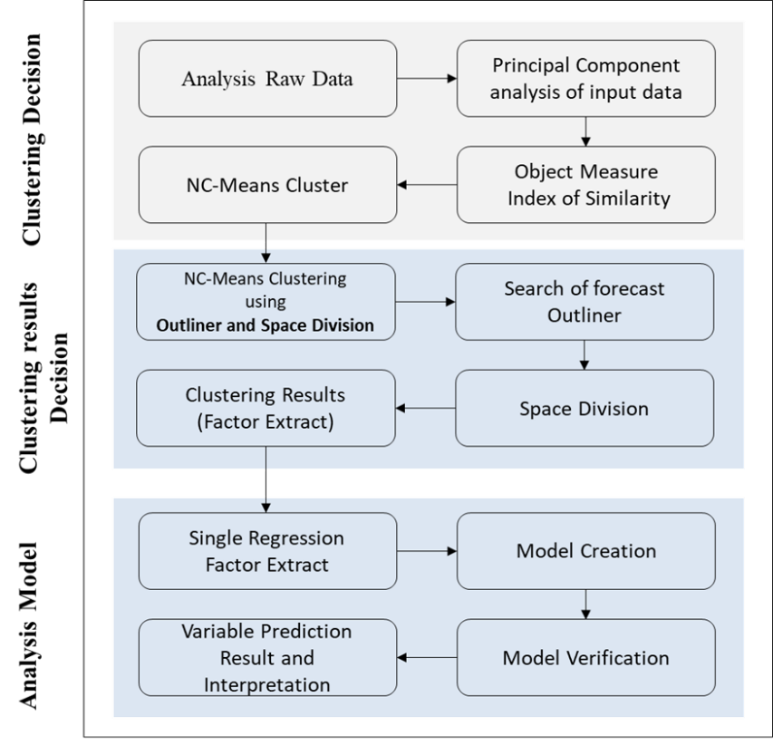
Figure ‎5-14: Overall structure of the analysis model

The Relationship Between Vulnerabilities and Weaknesses and External Threats
1 – (External) VW = ERF
In Table ‎5-55, the R (multiple correlation coefficients) value of 0.659 shows a good level of prediction. The R-square (coefficient of determination) value of 0.434 suggests that 43.4% of the variance in vulnerabilities and weaknesses in the UAE public sector organisations can be predicted by external threats such as cyber-attack, hacktivism, phishing, financial fraud, and criminal acts. It shows that there is a strong relationship between vulnerabilities and weaknesses in the UAE public sector organisations and the predictor variables (ERF).
Model | R | R Square | Adjusted R Square | Std. Error of the Estimate | Change Statistics
 |  |  |  |  | R Square Change | F Change | df1
1 | .659ª | .434 | .428 | .44894 | .434 | 78.191 | 1
^{a .}Dependent Variable: VW
Table ‎5-55: Regression model summary for VW
The analysis of variance (ANOVA) (Table ‎5-56) gave an F-statistic for the model of 78.191. This suggests that there is a significant linear regression association between the vulnerabilities and weaknesses in the organisations and the predictor variables (ERF). The F statistic indicates that the R-square was statistically significant at p <0.05.
Model |  | Sum of Squares | Df | Mean Square | F | Sig.
1ª | Regression | 15.759 | 1 | 15.759 | 78.191 | .000^{b}
1ª | Residual | 20.558 | 102 | .202
1ª | Total | 36.317 | 103
^{a.} Dependent Variable: VW
^{b.} Predictors: (Constant), ERF
Table ‎5-56: Analysis of Variance ª of the model for VW
The F-ratio also shows that the overall regression model is a good fit for the data because the predictor variables predict the response variable, F = 78.191, p <0.005 (see Table ‎5-57). The regression model explains all the response data variability around its mean. The F-value is significant at 95%, even though the R-square value of 0.434 suggests that only 43.4% of the variation in standard deviation is explained by the explanatory variables. The p-value associated with the F value is 0.000, less than the alpha level of 0.05, indicating that the predictor ERF variables dependably predict the response variable.
Model |  | Unstandardised Coefficients |  | Standardised Coefficients | t | Sig.
 |  | B | Std. Error | Beta | t | Sig.
1ª | (Constant) | 1.607 | .186 |  | 8.651 | .000
1ª | ERF | .502 | .057 | .659 | 8.843 | .000
^{a.} As above, Dependent Variable: VW
Table ‎5-57: Coefficients ª of the regression model VW

Testing for Collinearity of the Independent Variables
Collinearity (or multicollinearity) is where one of the independent variables is a linear function of other independent variables. It is shown by the eigenvalues of the non-centred and scaled vector product matrix, the condition indices, and the proportions of the variance decomposition together with the variance inflation factors (IVF) and the tolerances for the individual variables (Aiken et al., 2012). The collinearity results for the independent variables in this study are shown in Table ‎5-58.
Collinearity Diagnostics ª
Model | Dimension | Eigenvalue | Condition Index | Variance Proportions
 |  |  |  | (Constant) | ERF
1 | 1 | 1.972 | 1.000 | .01 | .01
1 | 2 | .028 | 8.318 | .99 | .99
^{a.} Dependent Variable: VW
Table ‎5-58: Testing the collinearity between variables for VW
Condition index is used to interpret the results (West et al., 2012), which is the square root of the quotient between the maximum and the minimum eigenvalues. This assesses whether there is collinearity among the independent variables or not. If the condition index is greater than 30, there is a high collinearity. If it is greater than 10 and less than 30, the collinearity is moderate, and if it is less than 10, there is no collinearity. Weiner et al. (2013, p134) noted that a “condition index greater than 30 for a given root (dimension) coupled with at least two variance proportions for individual variables greater than 0.5” indicate the existence of collinearity. Table ‎5-58 shows that the condition index for all variables was less than 10, so there was no evidence of any collinearity in the selected regression model.

Examining Residuals using Scatter Plots
Most of the assumptions of multiple regression cannot be confirmed, but it is possible to perceive deviations from these assumptions (Smith, 2014). Outliers (that is, extreme observations) can produce a shift in the estimates, "shifting" the regression line and producing a change in the regression coefficients. The elimination of just one extreme observation can often lead to a totally different result (West et al., 2012).
The residual statistics obtained from the regression analysis are shown in Table ‎5-59 The residual mean is zero.
Residual Statistics ª
 | Minimum | Maximum | Mean | Std. Deviation | N
Predicted Value | 2.1090 | 4.0253 | 3.2024 | .39115 | 104
Residual | −1.89893 | 1.02106 | .00000 | .44675 | 104
Std. Predicted Value | −2.795 | 2.104 | .000 | 1.000 | 104
Std. Residual | −4.230 | 2.274 | .000 | .995 | 104
^{a.} Dependent Variable: VW
Table ‎5-59: Residual statistics ª of the model regression for VW
The assumption of error term independence was also not violated. The histogram of the residuals enables a visual check of normality, which should be considered when interpreting statistical results. Figure ‎5-15 shows that the distribution is bell-shaped and has less gap in the centre, which may, in part, be a consequence of the defined intervals.

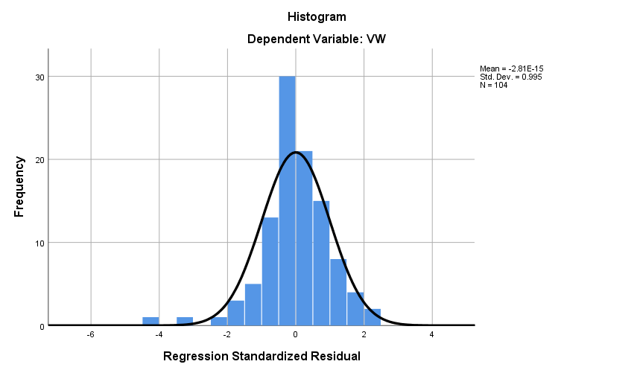
Figure ‎5-15: Histogram of the frequency of the standardised residuals for VW

Finally, the probability–probability (P–P) diagram (Figure ‎5-16) compares the accumulated frequency for the typified residuals with the expected probability for a normal distribution. The differences were not significant in this graph, so Figure ‎5-16 shows that there is a normal distribution.
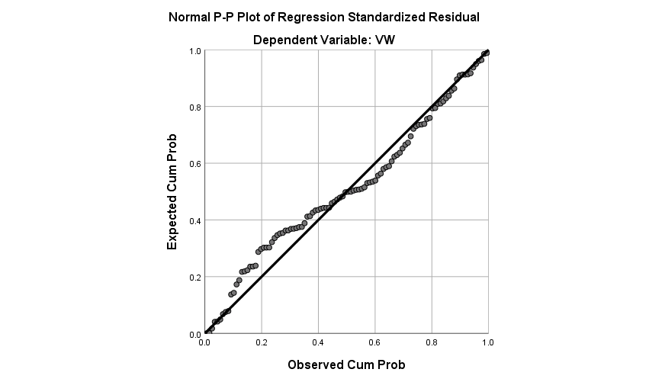
Figure ‎5-16: ‎Normal P-P plot of regression standardised residual for the dependent variable for VW

The Relationship Between Vulnerabilities and Weaknesses and Internal Threats
2 – (Internal) VW = IRF
In Table ‎5-60, the R (multiple correlation coefficients) value of 0.792 shows a good level of prediction. The R-square (coefficient of determination) value of 0.627 shows that 62.7% of the variance in vulnerabilities and weaknesses in the UAE public sector organisations can be predicted from internal threats such as lack of awareness, risk culture and laziness, financial fraud, and criminal acts. It shows that there is a strong relationship between vulnerabilities and weaknesses in the UAE public sector organisation and the predictor variable IRF. The R-square value of 62.7% also shows that the data are fitted to the regression line.
Model Summary ^{b}
Model | R | R Square | Adjusted R Square | Std. Error of the Estimate | Change Statistics
 |  |  |  |  | R Square Change | F Change | df1
1 | .792ª | .627 | .624 | .36420 | .627 | 171.797 | 1
^{a.} Dependent Variable: VW
^{b.} Predictors: (Constant), IRF
Table ‎5-60: Regression model summary for VW

The results of the ANOVA are shown in in Table ‎5-61. The F-statistic of the model was 171.797, which indicates a significant linear regression association between vulnerabilities and weaknesses in the UAE organisations and the predictor variables (IRF). The F-statistic of 171.797 indicates the R-square was statistically significant at p <0.05.
ANOVA ª
Model |  | Sum of Squares | df | Mean Square | F | Sig.
1 | Regression | 22.787 | 1 | 22.787 | 171.797 | .000^{b}
1 | Residual | 13.529 | 102 | .133
1 | Total | 36.317 | 103
^{a.} Dependent Variable: VW
^{b.} Predictors: (Constant), IRF
Table ‎5-61: Analysis of variance ª of the model for VW
The F-ratio also shows that the overall regression model is a good fit for the data because the predictor variables statistically predict the response variable, F =171.797, p <0.005. The regression model explains all the response data variability around its mean. The F-value is significant at 95%, even though the R-square value of 0.627 indicates that only 62.7% of the variation in standard deviation is explained by the explanatory variables. The p-value associated with the F value is 0.000 indicating that the predictor IRF variables dependably predict the response variable (see Table ‎5-62).
Coefficients ª
Model |  | Unstandardised Coefficients |  | Standardised Coefficients | t | Sig.
 |  | B | Std. Error | Beta | t | Sig.
1 | (Constant) | 1.511 | .134 |  | 11.284 | .000
1 | IRF | .542 | .041 | .792 | 13.107 | .000
^{a.} Dependent Variable: VW
Table ‎5-62: Coefficients ª of the regression model VW

Testing for Collinearity of the Independent Variables
The collinearity results for the independent variables are given in Table ‎5-63.
Collinearity Diagnostics ª
Model | Dimension | Eigenvalue | Condition Index | Variance Proportions
 |  |  |  | (Constant) | IRF
1 | 1 | 1.964 | 1.000 | .02 | .02
1 | 2 | .036 | 7.363 | .98 | .98
^{a.} Dependent Variable: VW
Table ‎5-63: Testing the Collinearity between variables for VW
The condition index was less than 10, so there is no evidence of any collinearity in the selected regression model.

Examining Residuals using Scatter Plots
The residual statistics obtained from the regression analysis are shown in Table ‎5-64.
Residual Statistics ª
 | Minimum | Maximum | Mean | Std. Deviation | N
Predicted Value | 2.0684 | 4.2192 | 3.2024 | .47036 | 104
Residual | −.99645 | .78080 | .00000 | .36243 | 104
Std. Predicted Value | −2.411 | 2.162 | .000 | 1.000 | 104
Std. Residual | −2.736 | 2.144 | .000 | .995 | 104
^{a.} Dependent Variable: VW
Table ‎5-64: Residual statistics ª of the model regression for VW

The assumption of error term independence is not violated. Figure ‎5-17 shows that the distribution is bell-shaped and has less gap in the centre, which may in part be a consequence of the defined intervals.
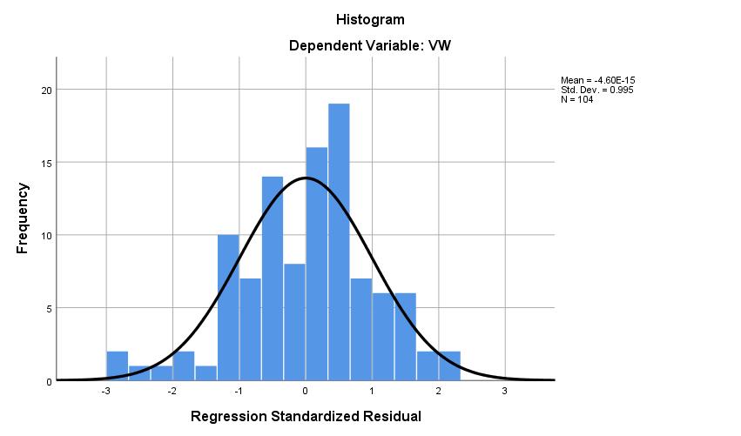
Figure ‎5-17: Histogram of the frequency of the standardised residuals for VW
Finally, the P–P diagram (Figure ‎5-18) shows that there is a normal distribution.
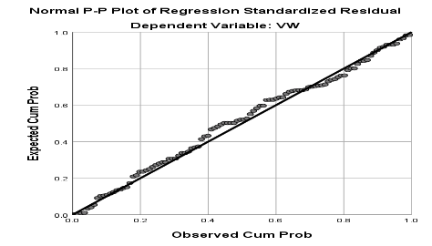
Figure ‎5-18: Normal P–P plot of regression standardised residual for the dependent variable for VW

The Relationship Between Vulnerabilities and Weaknesses and Having a Response in Place
3 – (Response in Place) VW = RP
In Table ‎5-65, the R (multiple correlation coefficients) shows a value level prediction of 0.348. The R-square (coefficient of determination) value of 0.121 shows that 12.1% of the variance in vulnerabilities and weaknesses in the UAE public sector organisations can be predicted from Response in Place actions taken by these organisations to reduce risks. There is therefore is a strong relationship between vulnerabilities and weaknesses in the UAE public sector and the predictor variable (RP).
Model Summary ^{b}
Model | R | R Square | Adjusted R Square | Std. Error of the Estimate | Change Statistics
 |  |  |  |  | R Square Change | F Change | df1
1 | .348ª | .121 | .112 | .55944 | .121 | 14.038 | 1
^{a.} Dependent Variable: VW
^{b.} Predictors: (Constant), IRF
Table ‎5-65: Regression model summary for VW
The results of the ANOVA are shown in Table ‎5-66. The F-statistic of the model was 14.038, indicating a significant linear regression association between the vulnerabilities and weaknesses in the UAE organisations and the predictor variables on response in place. The F statistic indicates that the R-square was statistically significant at p <0.05.
ANOVA ª
Model |  | Sum of Squares | df | Mean Square | F | Sig.
1 | Regression | 4.394 | 1 | 4.394 | 14.038 | .000^{b}
1 | Residual | 31.923 | 102 | .313
1 | Total | 36.317 | 103
^{a.} Dependent Variable: VW
^{b.} Predictors: (Constant), RP
Table ‎5-66: Analysis of variance ª of the model for VW
The F-ratio also shows that the overall regression model is a good fit for the data because the predictor variables statistically predict the response variable, F =14.038, p <0.005. The regression model explains all the response data variability around its mean. The F-value is significant at 95%, even though the relatively low R-square value of 0.121 indicates that only 12.1% of the variation in standard deviation is explained by the explanatory variables. The p-value associated with the F value is 0.000 indicating that the predictor variables dependably predict the response variable (see Table ‎5-67).
Coefficients `ª
Model |  | Unstandardised Coefficients |  | Standardised Coefficients | t | Sig.
 |  | B | Std. Error | Beta | t | Sig.
1 | (Constant) | 2.054 | .311 |  | 6.595 | .000
1 | RP | .310 | .083 | .348 | 3.747 | .000
^{a.} Dependent Variable: VW
Table ‎5-67: Coefficients ª of the regression model VW

Testing for Collinearity of the Independent Variables
The results for the collinearity testing for the independent variables are in Table ‎5-68.
Collinearity Diagnostics ª
Model | Dimension | Eigenvalue | Condition Index | Variance Proportions
 |  |  |  | (Constant) | RP
1 | 1 | 1.984 | 1.000 | .01 | .01
1 | 2 | .016 | 11.265 | .99 | .99
^{a.} Dependent Variable: VW
Table ‎5-68: Testing the collinearity between variables for VW
Table ‎5-68 shows that the condition index was greater than 10 and less than 30, so there is some evidence to suggest the existence of moderate collinearity in the selected regression model (Dormann, 2013).

Examining Residuals using Scatter Plots
The residual statistics from the regression analysis are shown in Table ‎5-69. The results check the residual mean is zero.
Residual Statistics ª
 | Minimum | Maximum | Mean | Std. Deviation | N
Predicted Value | 2.4157 | 3.6046 | 3.2024 | .20653 | 104
Residual | -1.71107 | 1.39540 | .00000 | .55672 | 104
Std. Predicted Value | -3.809 | 1.947 | .000 | 1.000 | 104
Std. Residual | -3.059 | 2.494 | .000 | .995 | 104
a. Dependent Variable: VW
Table ‎5-69: Residuals ª of the regression model VW

The assumption of error term independence was not violated. Figure ‎5-19 shows that the distribution is bell-shaped and has less gap in the centre that may in part be a consequence of the defined intervals.

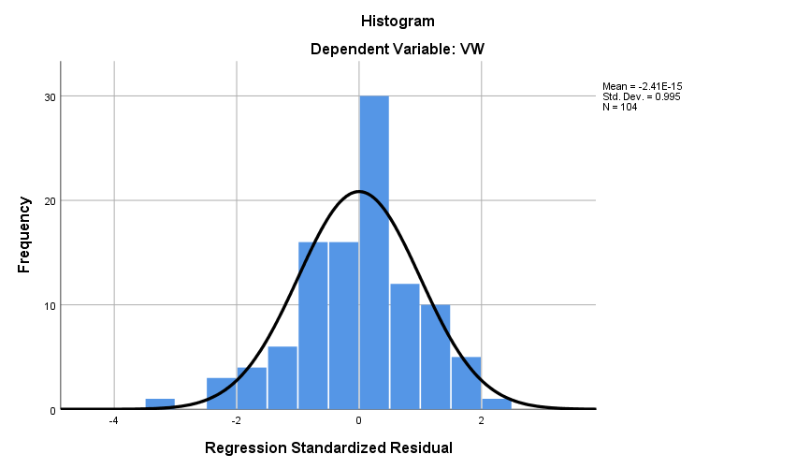
Figure ‎5-19: Histogram of the frequency of the standardised residuals for VW
Finally, the P–P diagram (Figure ‎5-20) also shows that there is a normal distribution.
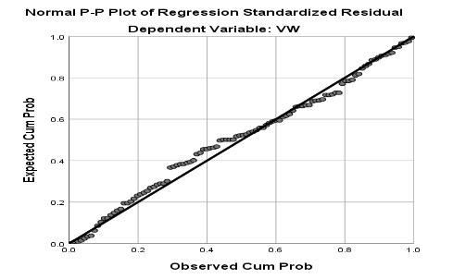
Figure ‎5-20: ‎Normal P–P plot of regression standardised residual for the dependent variable for VW
.

The Relationship Between Vulnerabilities and Weaknesses and Organisation Resilience
4 – (Organisational Resilience) VW = ORe
In Table ‎5-70, the R (multiple correlation coefficients) shows a value level prediction of 0.142. The R-square (coefficient of determination) value of 0.020 shows that 0.20% of the variance in vulnerabilities and weaknesses in the UAE public sector organisations can be predicted from organisation resilience actions taken by public sector organisation to reduce cyber-risks. There is therefore a weak relationship between vulnerabilities and weaknesses in the UAE public sector organisations and the predictor variable (ORe).
Model Summary ^{b}
Model | R | R Square | Adjusted R Square | Std. Error of the Estimate | Change Statistics
 |  |  |  |  | R Square Change | F Change | df1
1 | .142ª | .020 | .011 | .59064 | .020 | 12.104 | 1
^{a.} Dependent Variable: VW
^{b.} Predictor: (Constant) ORe
Table ‎5-70: Regression model summary for VW
The results of ANOVA are shown in Table ‎5-71. The F-statistic of the model was 12.104, which indicates a non-significant linear regression association between vulnerabilities and weaknesses in the UAE organisations and the predictor variable (organisational resilience). The F statistic also indicates that the R-square was statistically not significant at p <0.05.
ANOVA ª
Model |  | Sum of Squares | df | Mean Square | F | Sig.
1 | Regression | .734 | 1 | .734 | 12.104 | 0.00015
1 | Residual | 35.583 | 102 | .349
1 | Total | 36.317 | 103
^{a.} Dependent Variable: VW
^{b.} Predictors: (Constant), ORe
Table ‎5-71: Analysis of variance of the model for VW
The F-ratio shows that the overall regression model is a poor fit for the data because the predictor variables do not statistically predict the response variable, F = 12.104, p >0.005. The regression model explains all the response data variability around its mean. The F-value is not significant at 95%. The p-value associated with the F value is 0.150, indicating that the predictor variables do not dependably predict the response variable (see Table ‎5-72).
Coefficients ª
Model |  | Unstandardised Coefficients |  | Standardised Coefficients | t | Sig.
 |  | B | Std. Error | Beta | t | Sig.
1 | (Constant) | 2.785 | .294 |  | 9.476 | .000
1 | ORe | .112 | .077 | .142 | 11.451 | 0.00015
^{a.} Dependent Variable: VW
Table ‎5-72: Coefficients ª of the regression model VW

Testing for Collinearity of the Independent Variables
The collinearity results for the independent variables of the study are in Table ‎5-73.
Collinearity Diagnostics ª
Model | Dimension | Eigenvalue | Condition Index | Variance Proportions
 |  |  |  | (Constant) | ORe
1 | 1 | 1.980 | 1.000 | .01 | .01
1 | 2 | .020 | 10.048 | .99 | .99
^{a.} Dependent Variable: VW
Table ‎5-73: Testing the Collinearity between variables for VW
Table ‎5-73 shows that the variables have a condition index slightly over 10 (10.048), so the variable had a slight collinearity.

Examining Residuals using Scatter Plots
The residual statistics from the regression analysis are in Table ‎5-74.
Residual Statistics ª
 | Minimum | Maximum | Mean | Std. Deviation | N
Predicted Value | 2.8969 | 3.3466 | 3.2024 | .08442 | 104
Residual | −2.01748 | 1.65877 | .00000 | .58776 | 104
Std. Predicted Value | −3.619 | 1.708 | .000 | 1.000 | 104
Std. Residual | −3.416 | 2.808 | .000 | .995 | 104
^{a.} Dependent Variable: VW
Table ‎5-74: Residual statistics of the model regression for VW

The assumption of error term independence is not violated. Figure ‎5-21 shows that the distribution is bell-shaped and has less gap in the centre that may in part be a consequence of the defined intervals.
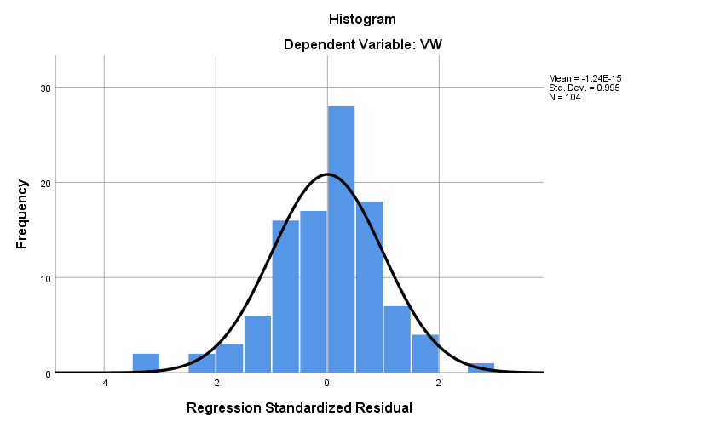
Figure ‎5-21: Histogram of the frequency of the standardised residuals for VW
Finally, the P–P diagram (Figure ‎5-22) shows that there is a normal distribution.
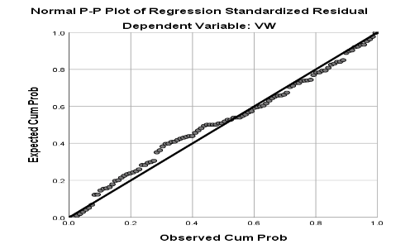
Figure ‎5-22: Normal P–P plot of regression standardised residual for the dependent variable for VW

The Relationship Between Vulnerabilities and External Threats is Moderated by Having a Response in Place
8 – (External + Response in Place) VW = ERF + RP
This section examines how the relationship between vulnerabilities and weaknesses and external threats (ERF) is moderated by having responses in place. It therefore explores the level to which these variables together affect vulnerabilities and weaknesses. A regression model was developed to assess this association. Table ‎5-75 shows that the R (multiple correlation coefficients) value of 0.692 shows a good level of prediction. The R-square (coefficient of determination) value of 0.479 suggests that 47.9% of the variance in vulnerabilities and weaknesses in the UAE public sector organisations can be predicted from key external threats including cyber-attack, hacktivism, phishing, financial fraud, and criminal acts, but that this is moderated by the level of response in place.
The ANOVA results are displayed below in Table ‎5-76, overleaf, and the coefficients in Table ‎5-77.

Model Summary ^{b}
Model | R | R Square | Adjusted R Square | Std. Error of the Estimate | Change Statistics
 |  |  |  |  | R Square Change | F Change | df1
1 | .692ª | .479 | .469 | .43287 | .479 | 46.410 | 2
^{a.} Dependent Variable: VW
^{b.} Predictors: (Constant), RP, ERF
Table ‎5-75: Regression model summary for VW
ANOVA ª
Model |  | Sum of Squares | df | Mean Square | F | Sig.
1 | Regression | 17.392 | 2 | 8.696 | 46.410 | .000^{b}
1 | Residual | 18.925 | 101 | .187
1 | Total | 36.317 | 103
^{a.} Dependent Variable: VW
^{b.} Predictors: (Constant), RP, ERF
Table ‎5-76: Analysis of variance of the model for VW
Coefficients ª
Model |  | Unstandardised Coefficients |  | Standardised Coefficients | t | Sig. | Correlations
 |  | B | Std. Error | Beta | t | Sig. | Zero-order
1 | (Constant) | 1.002 | .272 |  | 3.685 | .000
1 | ERF | .467 | .056 | .612 | 8.329 | .000 | .659
1 | RP | .194 | .066 | .217 | 2.952 | .004 | .348
^{a.} Dependent Variable: VW
^{b.} Predictors: (Constant), RP, ERF
Table ‎5-77: Coefficients of the regression model VW

Testing for Collinearity of the Independent Variables
The collinearity results for the independent variables are in Table ‎5-78.
Collinearity Diagnostics ª
Model | Dimension | Eigenvalue | Condition Index | Variance Proportions
 |  |  |  | (Constant) | ERF | RP
1 | 1 | 2.947 | 1.000 | .00 | .01 | .00
1 | 2 | .038 | 8.860 | .05 | .93 | .21
1 | 3 | .015 | 14.002 | .94 | .06 | .79
^{a.} Dependent Variable: VW
Table ‎5-78: Testing the collinearity between variables for VW
The condition index for all variables but one was less than 10. The remaining variable had a condition index greater than 10 and less than 30, showing moderate collinearity.

Examining Residuals using Scatter Plots
The residual statistics from the regression analysis are shown in Table ‎5-79. Figure ‎5-23 and Figure ‎5-24 also show that there is no pattern of behaviour of the residuals with respect to Y. These variables were systematic, and the assumption of error term independence is not violated.
Residual Statistics ª
 | Minimum | Maximum | Mean | Std. Deviation | N
Predicted Value | 2.0211 | 4.1754 | 3.2024 | .41092 | 104
Residual | −1.52584 | 1.20461 | .00000 | .42864 | 104
Std. Predicted Value | −2.875 | 2.368 | .000 | 1.000 | 104
Std. Residual | −3.525 | 2.783 | .000 | .990 | 104
^{a.} Dependent Variable: VW
Table ‎5-79: Residual statistics ª of the model regression for VW
Figure ‎5-25 shows that the distribution is bell-shaped and has less gap in the centre that may in part be a consequence of the defined intervals.
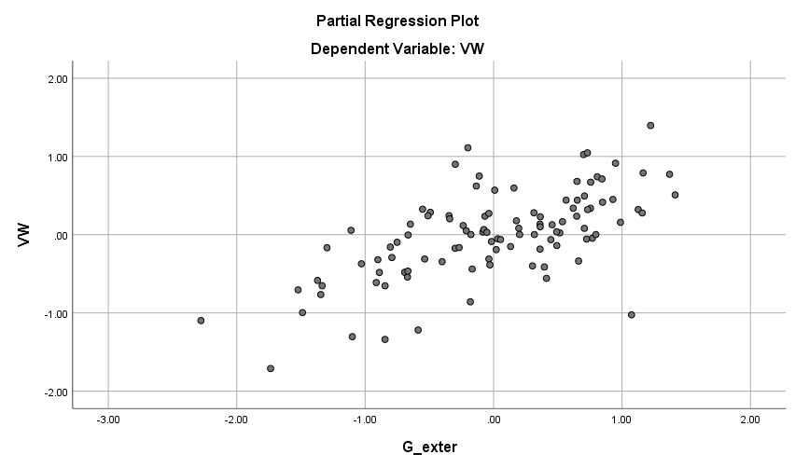
Figure ‎5-23: Scatter plot for residual results from the model for VW
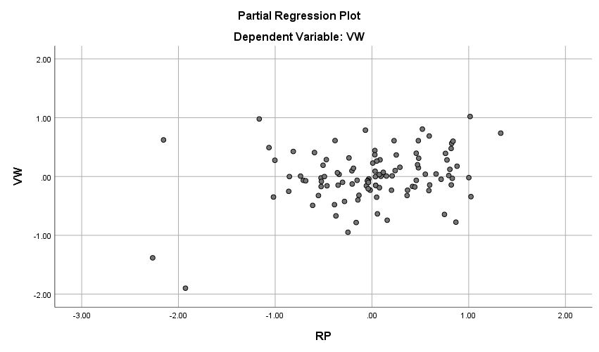
Figure ‎5-24: Scatter plot for residual results from the model for VW

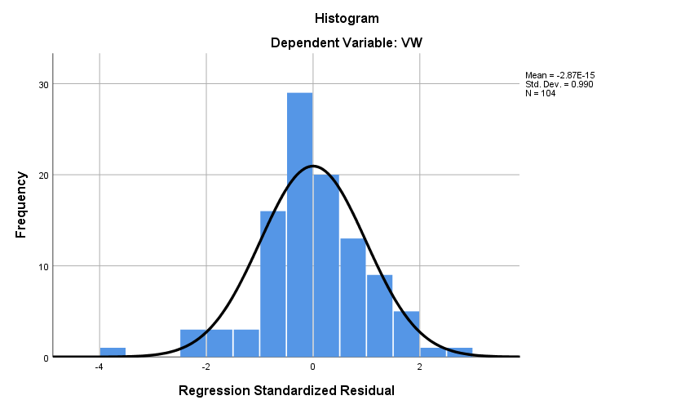
Figure ‎5-25: Histogram of the frequency of the standardised residuals for VW

Finally, the P–P diagram (Figure ‎5-26) shows that there is a normal distribution.
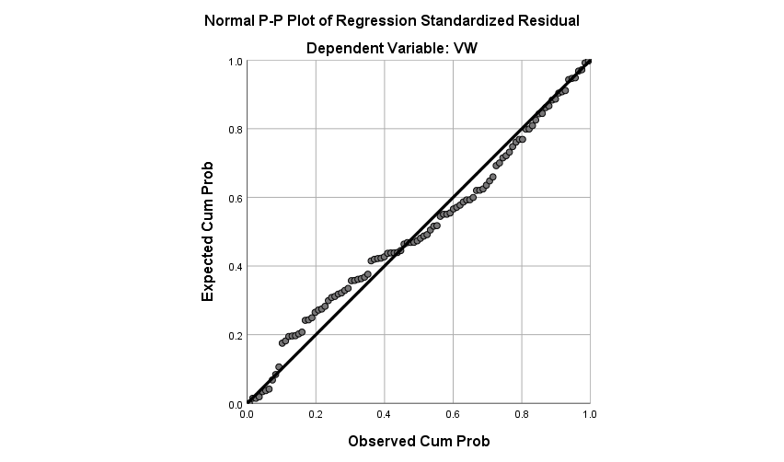
Figure ‎5-26: Normal P–P plot of regression standardised residual for the dependent variable

The relationship between vulnerabilities and weaknesses and external threats, moderated by organisation resilience
Regression
6 – (External + Organisational Resilience) VW = ERF + ORe
This section considers the effect of organisational resilience on the relationship between vulnerabilities and weaknesses and external threats (ERF). A regression model was developed to assess this association. The regression output in Table ‎5-80 shows that together, external threats and organisational resilience explained 44.8% of the variance in vulnerabilities and weaknesses. This variance is statistically significant because the F-value is 41.051, with two degrees of freedom and p-value of 0.000 (Table ‎5-80).
Model Summary ^{b}
Model | R | R Square | Adjusted R Square | Std. Error of the Estimate | Change Statistics
 |  |  |  |  | R Square Change | F Change | df1
1 | .670ª | .448 | .437 | .44536 | .448 | 41.051 | 2
^{a.} Dependent Variable: VW
^{b.} Predictors: (Constant), ORe, ERF
Table ‎5-80: Regression model summary for VW
The ANOVA results and the coefficients are displayed in Table ‎5-81 and Table ‎5-82.
ANOVA ª
Model |  | Sum of Squares | df | Mean Square | F | Sig.
1 | Regression | 16.284 | 2 | 8.142 | 41.051 | .000^{b}
1 | Residual | 20.033 | 101 | .198
1 | Total | 36.317 | 103
a. Dependent Variable: VW
b. Predictors: (Constant), ORe, ERF
Table ‎5-81: Analysis of variance of the model for VW

Coefficients ª
Model |  | Unstandardised Coefficients |  | Standardised Coefficients | T | Sig. | Correlations
 |  | B | Std. Error | Beta | T | Sig. | Zero-order
1 | (Constant) | 1.263 | .280 |  | 4.504 | .000
1 | ERF | .499 | .056 | .655 | 8.854 | .000 | .659
1 | ORe | .095 | .058 | .120 | 11.627 | .000107 | .142
^{a.} Dependent Variable: VW
^{b.} Predictors: (Constant), ORe, ERF
Table ‎5-82: Coefficients ª of the regression model VW

Testing for Collinearity of the Independent Variables
The collinearity results for the independent variables are in Table ‎5-83.
Collinearity Diagnostics ª
Model | Dimension | Eigenvalue | Condition Index | Variance Proportions
 |  |  |  | (Constant) | ERF | ORe
1 | 1 | 2.937 | 1.000 | .00 | .01 | .00
1 | 2 | .047 | 7.918 | .01 | .70 | .33
1 | 3 | .016 | 13.618 | .99 | .29 | .67
a. Dependent Variable: VW
Table ‎5-83: Testing the collinearity between variables for VW
The condition index for all variables but one was less than 10. The remaining variable had a condition index greater than 10 and less than 30, indicating moderate collinearity.

Examining Residuals using Scatter Plots
The residual statistics obtained from the regression analysis are shows in Table ‎5-84. Figure ‎5-27 and Figure ‎5-28 show that there is no pattern of behaviour of the residuals with respect to Y. The assumption of error term independence is therefore not violated.

Residual Statistics ª
 | Minimum | Maximum | Mean | Std. Deviation | N
Predicted Value | 2.2058 | 4.1197 | 3.2024 | .39762 | 104
Residual | -1.73817 | 1.11834 | .00000 | .44101 | 104
Std. Predicted Value | -2.506 | 2.307 | .000 | 1.000 | 104
Std. Residual | -3.903 | 2.511 | .000 | .990 | 104
^{a.} Dependent Variable: VW
Table ‎5-84: Residual statistics of the model regression for VW
Figure ‎5-29 shows that the distribution is bell-shaped and has less gap in the centre that may in part be a consequence of the defined intervals.
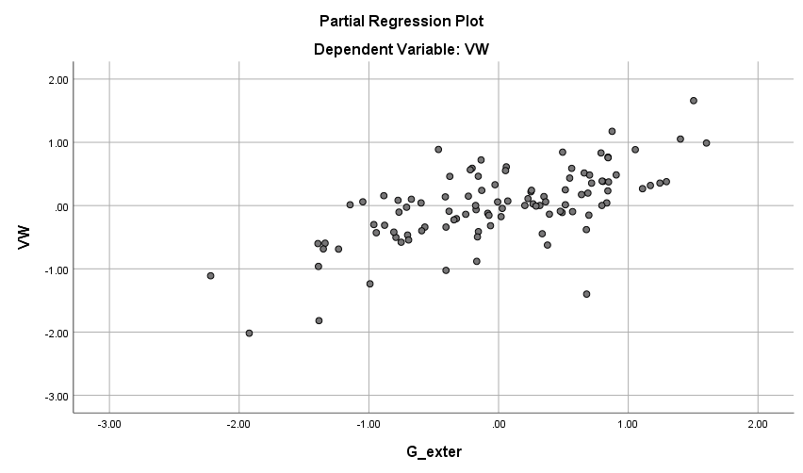
Figure ‎5-27: Scatter plot for residual results from the model for VW
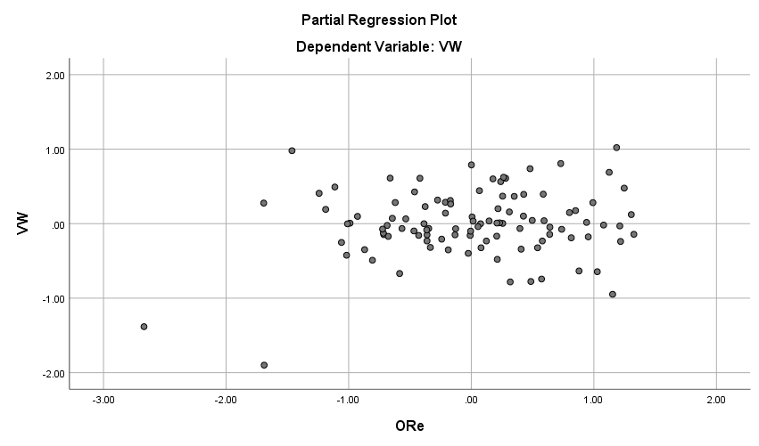
Figure ‎5-28: Scatter plot for residual results from the model for VW

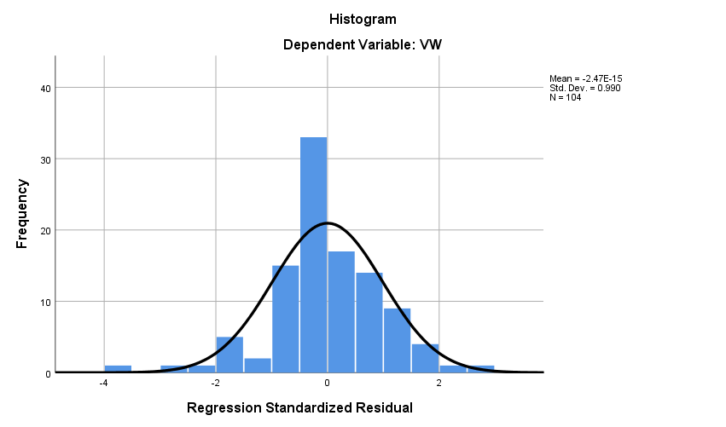
Figure ‎5-29: Histogram of the frequency of the standardised residuals for VW
Finally, the P–P diagram (Figure ‎5-30) shows that there is a normal distribution.
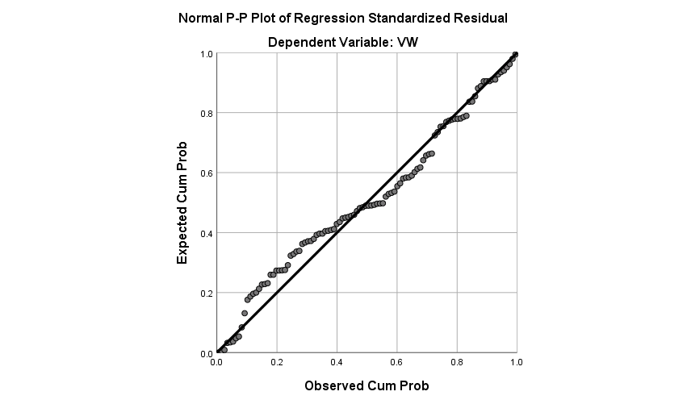
Figure ‎5-30: Normal P–P plot of regression standardised residual for the dependent variable

The Relationship Between Vulnerabilities and Internal Threats Moderated by Having a Response in Place
7 – (Internal + Response in Place) VW = IRF + RP
This section describes the effect of having a response in place on the relationship between vulnerabilities and weaknesses and internal threats (IRF). A regression model was developed to assess this association. Table ‎5-85 shows that the R (multiple correlation coefficients) value of 0.803 shows a good level of prediction. The R-square (coefficient of determination) value of 0.644 shows that 64.4% of the variance in vulnerabilities and weaknesses in the UAE public sector organisations can be predicted from internal threats, including lack of awareness, risk culture and laziness, financial fraud, and criminal acts. There is a strong relationship between vulnerabilities and weaknesses in the UAE public sector organisation and the predictor variables (IRF) moderated by having a response in place (RP). The variance proportion is statistically significant because the F-value is 91.513, with two degrees of freedom and p-value of 0.000 (Table ‎5-86). The relation between organisational vulnerabilities and weaknesses in the UAE public sector and IRF is therefore moderated by the response in place in those organisations.
Model Summary ^{b}
Model | R | R Square | Adjusted R Square | Std. Error of the Estimate | Change Statistics
 |  |  |  |  | R Square Change | F Change | df1
1 | .803ª | .644 | .637 | .35758 | .644 | 91.513 | 2
^{b.} Predictors: (Constant), RP, IRF
Table ‎5-85: Regression Model Summary for VW

ANOVA ª
Model |  | Sum of Squares | df | Mean Square | F | Sig.
1 | Regression | 23.402 | 2 | 11.701 | 91.513 | .000^{b}
1 | Residual | 12.914 | 101 | .128
1 | Total | 36.317 | 103
^{a.} Dependent Variable: VW
^{b.} Predictors: (Constant), RP, IRF
Table ‎5-86: Analysis of Variance ª of the model for VW

The Table below (Table ‎5-86) shows the coefficients of the regression model used for the Tables above.

Coefficients ª
Model |  | Unstandardised Coefficients |  | Standardised Coefficients | t | Sig. | Correlations
 |  | B | Std. Error | Beta | t | Sig. | Zero-order
1 | (Constant) | 1.145 | .213 |  | 5.385 | .000
1 | IRF | .516 | .042 | .754 | 12.193 | .000 | .792
1 | RP | .121 | .055 | .136 | 2.193 | .031 | .348
^{a.} Dependent Variable: VW
Table ‎5-87: Coefficients ª of the regression model VW

Testing for Collinearity of the Independent Variables
The collinearity results for the independent variables are in Table ‎5-88.
Collinearity Diagnostics ª
Model | Dimension | Eigenvalue | Condition Index | Variance Proportions
 |  |  |  | (Constant) | IRF | RP
1 | 1 | 2.940 | 1.000 | .00 | .01 | .00
1 | 2 | .044 | 8.145 | .09 | .99 | .12
1 | 3 | .016 | 13.729 | .91 | .00 | .88
^{a.} Dependent Variable: VW
Table ‎5-88: Testing the collinearity between variables for VW
The condition index for all variables but one was less than 10. The remaining variable had a condition index greater than 10 and less than 30. This indicates moderate collinearity.

Examining Residuals using Scatter Plots
The residual statistics from the regression analysis are shown in Table ‎5-89. The results check the residual mean is zero. Figure ‎5-31 and Figure ‎5-32 show that there is no pattern of behaviour of the residuals with respect to Y. The assumption of error term independence is therefore not violated.
Residual Statistics ª
 | Minimum | Maximum | Mean | Std. Deviation | N
Predicted Value | 1.8162 | 4.3270 | 3.2024 | .47666 | 104
Residual | −.85228 | .67297 | .00000 | .35409 | 104
Std. Predicted Value | −2.908 | 2.359 | .000 | 1.000 | 104
Std. Residual | −2.383 | 1.882 | .000 | .990 | 104
^{a.} Dependent Variable: VW
Table ‎5-89: Residual statistics of the model regression for VW
Figure ‎5-31, Figure ‎5-32, and Figure ‎5-33 show that the distribution is bell-shaped and has less gap in the centre that may in part be a consequence of the defined intervals.
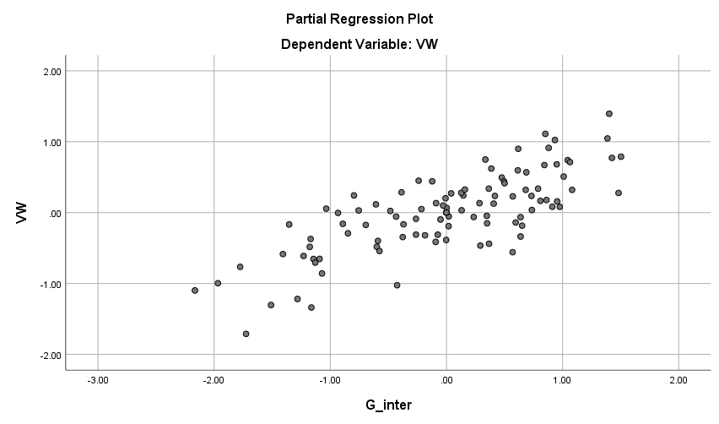
Figure ‎5-31: Scatter plot for residual results from the model for VW

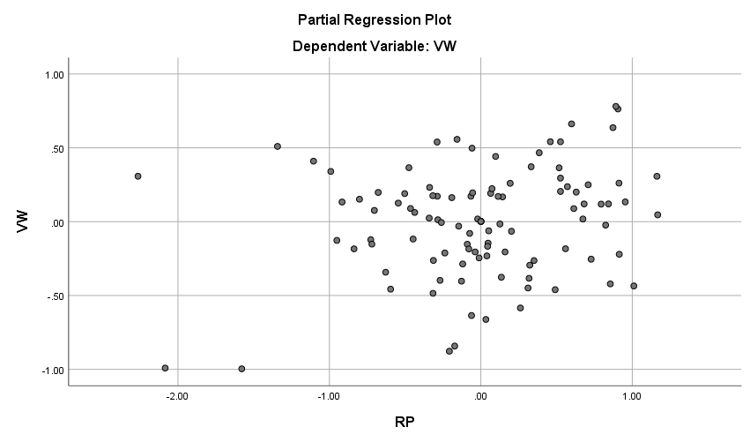
Figure ‎5-32: Scatter plot for residual results from the model for VW

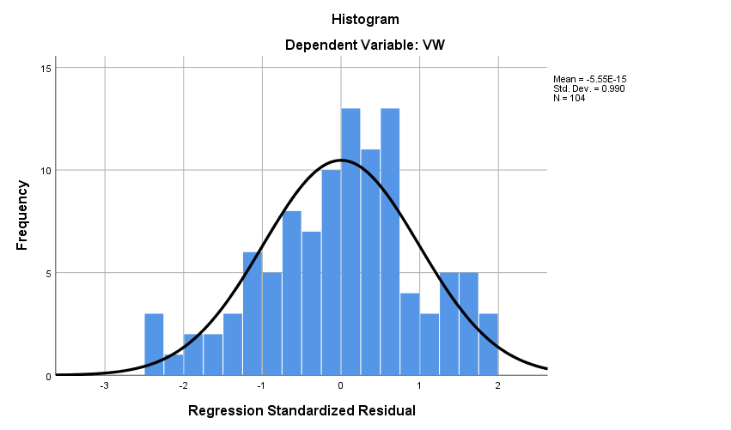
Figure ‎5-33: Histogram of the frequency of the standardised residuals for VW
Finally, the P–P diagram (Figure ‎5-34) shows that there is a normal distribution.
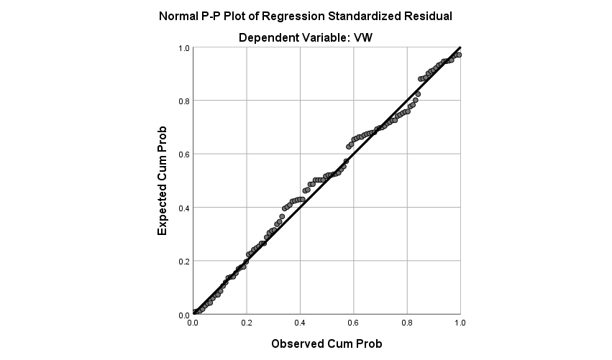
Figure ‎5-34: Normal P–P plot of regression standardised residual for the dependent variable

The Relationship Between Vulnerabilities and Weaknesses and Internal Threats Moderated by Organisation Resilience
5 – (Internal + Organisational Resilience) VW = IRF + OR
This section examines the effect of organisational resilience on the relationship between vulnerabilities and weaknesses and internal threats. A regression model was developed to assess this association. The regression output in Table ‎5-90 shows that together, internal threats and organisational resilience explained 63.2% of the variance in vulnerabilities and weaknesses. This variance proportion was statistically significant because the F-value is 86.681 with two degrees of freedom and p-value of 0.000 (Table ‎5-91).
Model Summary ^{b}
Model | R | R Square | Adjusted R Square | Std. Error of the Estimate | Change Statistics
 |  |  |  |  | R Square Change | F Change | df1
1 | .795ª | .632 | .625 | .36382 | .632 | 86.681 | 2
^{b.} Predictors: (Constant), OR, IRF
Table ‎5-90: Regression model summary for VW
ANOVA ª
Model |  | Sum of Squares | Df | Mean Square | F | Sig.
1 | Regression | 22.948 | 2 | 11.474 | 86.681 | .000^{b}
1 | Residual | 13.369 | 101 | .132
1 | Total | 36.317 | 103
^{a.} Dependent Variable: VW
^{b.} Predictors: (Constant), OR, IRF
Table ‎5-91: Analysis of variance of the model for VW
Coefficients ª
Model |  | Unstandardised Coefficients |  | Standardised Coefficients | t | Sig. | Correlations
 |  | B | Std. Error | Beta | t | Sig. | Zero-order
1 | (Constant) | 1.328 | .213 |  | 6.235 | .000
1 | IRF | .537 | .041 | .786 | 12.954 | .000 | .792
1 | OR | .053 | .048 | .067 | 11.100 | .000274 | .142
^{a.} Dependent Variable: VW
Table ‎5-92: Coefficients of the regression model for VW

When all the research constructs above were considered together only organisational resilience positively and significantly contributed to the effect of IRF (Table ‎5-92).

Testing for Collinearity of the Independent Variables
The collinearity results for the independent variables are in Table ‎5-93.

Collinearity Diagnostics ª
Model | Dimension | Eigenvalue | Condition Index | Variance Proportions
 |  |  |  | (Constant) | IRF | ORe
1 | 1 | 2.929 | 1.000 | .00 | .01 | .00
1 | 2 | .053 | 7.442 | .03 | .84 | .23
1 | 3 | .018 | 12.875 | .97 | .15 | .77
^{a.} Dependent Variable: VW
Table ‎5-93: Testing the collinearity between variables for VW

Table ‎5-93 shows that the condition index for all variables but one was less than 10. The remaining variable had a condition index greater than 10 and less than 30, indicating moderate collinearity.

Examining Residuals using Scatter Plots

The residual statistics from the regression analysis are shown in Table ‎5-94. The results check the residual mean is zero. Figure ‎5-35 to Figure ‎5-37 show that there is no pattern of behaviour of the residuals with respect to Y. These variables were systematic, and the assumption of error term independence is not violated.
Residual Statistics ª
 | Minimum | Maximum | Mean | Std. Deviation | N
Predicted Value | 1.9341 | 4.2761 | 3.2024 | .47201 | 104
Residual | −.91312 | .74817 | .00000 | .36027 | 104
Std. Predicted Value | −2.687 | 2.275 | .000 | 1.000 | 104
Std. Residual | −2.510 | 2.056 | .000 | .990 | 104
^{a.} Dependent Variable: VW
Table ‎5-94: Residual statistics of the model regression for VW

Figure ‎5-35, Figure ‎5-36, and Figure ‎5-37 show that the distribution is bell-shaped and has less gap in the centre that may in part be a consequence of the defined intervals.
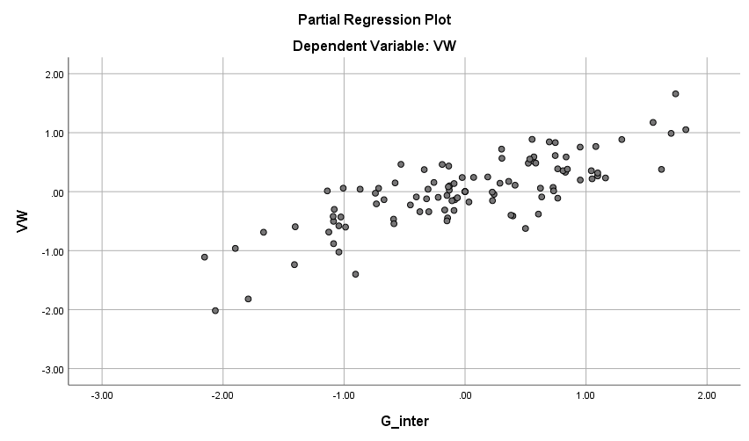
Figure ‎5-35: Scatter plot for residual results from the model for RP and VW and OR scales

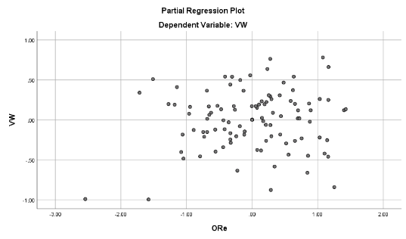
Figure ‎5-36: Scatter plot for residual results from the model for RP and VW and OR scales

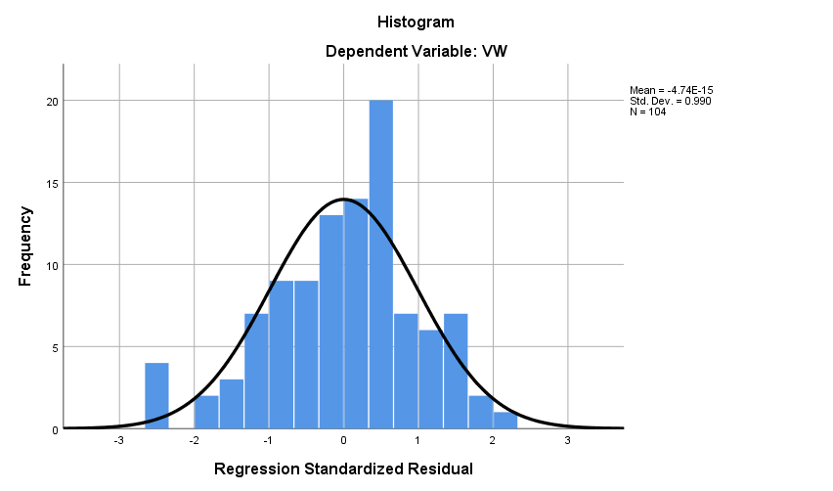
Figure ‎5-37: Histogram of the frequency of the standardised residuals for RP and VW and OR scales

Finally, the P–P diagram (Figure ‎5-38) also shows that there is a normal distribution.
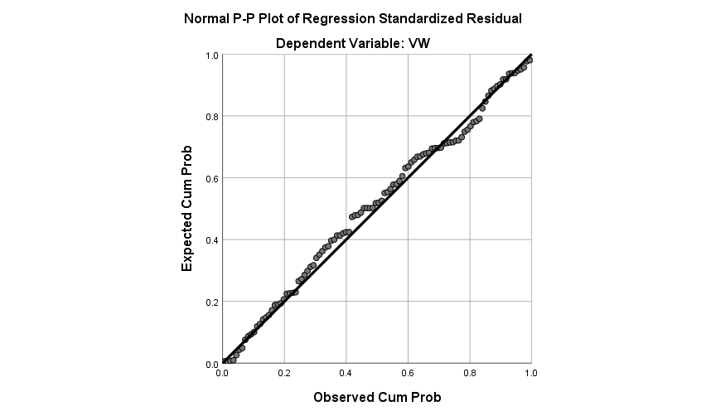
Figure ‎5-38: Normal P–P plot of regression standardised residual for the dependent variable RP

Regression
9 – (External + Proportionate Response) VW = ERF + RP + RP*ERF
A multiple regression was used to estimate the parameters in the model equation (VW = ERF + RP + RP*ERF). The purpose of the multi-linear models was to map the variation in RP onto variation in the relationship between vulnerabilities and weaknesses and external threats in UAE public sector organisations. The variation variables were all entered at different stages of the simulation. The regression results in Table ‎5-95 shows that ERF moderated by having a response in place explained 48.2% of the variance in vulnerabilities and weaknesses. This variance proportion was statistically significant because the F-value of predictors (ERF*RP, RP, ERF) was 31.046, with three degrees of freedom and p-value of 0.000. The results indicate that all the variation variables in the model are significant and the goodness-of-fit for the estimated regression equation for the generated model is supported by an R-square value of 0.482. Table ‎5-96 and Table ‎5-97 provide the remaining detail.
Model Summary ^{b}
Model | R | R Square | Adjusted R Square | Std. Error of the Estimate | Change Statistics
 |  |  |  |  | R Square Change | F Change | df1
1 | .694ª | .482 | .467 | .43363 | .482 | 31.046 | 3
^{a.} Dependent Variable: VW
^{b.} Predictors: (Constant), ERF*RP, RP, ERF
Table ‎5-95: Regression model summary for VW
ANOVA ª
Model |  | Sum of Squares | df | Mean Square | F | Sig.
1 | Regression | 17.513 | 3 | 5.838 | 31.046 | .000^{b}
1 | Residual | 18.804 | 100 | .188
1 | Total | 36.317 | 103
^{a.} Dependent Variable: VW
^{b.} Predictors: (Constant), ERF*RP, RP, ERF
Table ‎5-96: Analysis of variance ª of the model for VW
Coefficients ª
Model |  | Unstandardised Coefficients |  | Standardised Coefficients | t | Sig. | Correlations
 |  | B | Std. Error | Beta | t | Sig. | Zero-order
1 | (Constant) | 1.646 | .847 |  | 11.944 | .000055
1 | ERF | .252 | .273 | .331 | 5.925 | .000357 | .659
1 | RP | .027 | .218 | .030 | 7.123 | .000903 | .348
1 | ERF*RP | .055 | .069 | .374 | 3.803 | .000424 | .678
^{a.} Dependent Variable: VW
Table ‎5-97: Coefficients ª of the regression model for VW

Testing for Collinearity of the Independent Variables
The collinearity results for the independent variables are in Table ‎5-98.

Collinearity Diagnostics ª
Model | Dimension | Eigenvalue | Condition Index | Variance Proportions
 |  |  |  | (Constant) | ERF | RP | ERF*RP
1 | 1 | 3.912 | 1.000 | .00 | .00 | .00 | .00
1 | 2 | .060 | 8.048 | .02 | .00 | .01 | .02
1 | 3 | .027 | 12.071 | .01 | .03 | .04 | .01
1 | 4 | .001 | 78.249 | .97 | .96 | .95 | .97
^{a.} Dependent Variable: VW
Table ‎5-98: Testing the collinearity between variables for VW
Table ‎5-98 shows that the condition index for all but two variables was less than 10. One dimension had a condition index greater than 10 and less than 30, indicating moderate collinearity, and one had a condition index greater than 30, indicating high collinearity.

Examining Residuals using Scatter Plots
The residual statistics from the regression analysis are shown in Table ‎5-99. The results check the residual mean is zero. Figure ‎5-39, Figure ‎5-40, and Figure ‎5-41 show that there is no pattern of behaviour of the residuals with respect to Y. This means that the assumption of error term independence is not violated.

Residual Statistics ª
 | Minimum | Maximum | Mean | Std. Deviation | N
Predicted Value | 2.2153 | 4.2754 | 3.2024 | .41235 | 104
Residual | −1.43580 | 1.18048 | .00000 | .42727 | 104
Std. Predicted Value | −2.394 | 2.602 | .000 | 1.000 | 104
Std. Residual | −3.311 | 2.722 | .000 | .985 | 104
^{a.} Dependent Variable: VW
Table ‎5-99: Residual statistics of the model regression for VW

Figure ‎5-42 shows that the distribution is bell-shaped and has less gap in the centre that may in part be a consequence of the defined intervals.
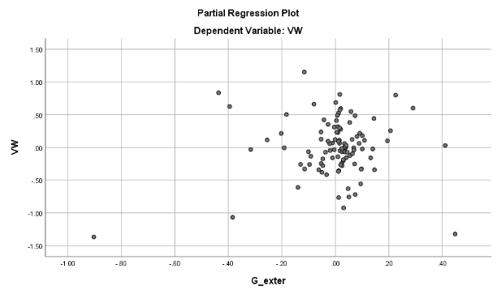
Figure ‎5-39: Scatter plot for residual results from the model for VW

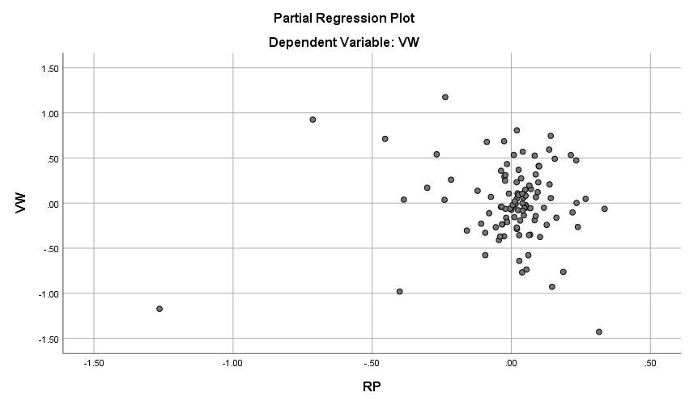
Figure ‎5-40: Scatter plot for residual results from the model for VW

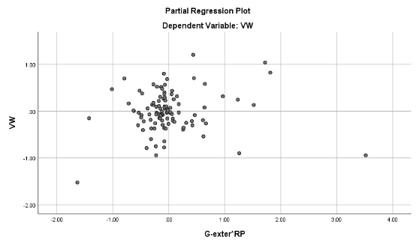
Figure ‎5-41: Scatter plot for residual results from the model for VW

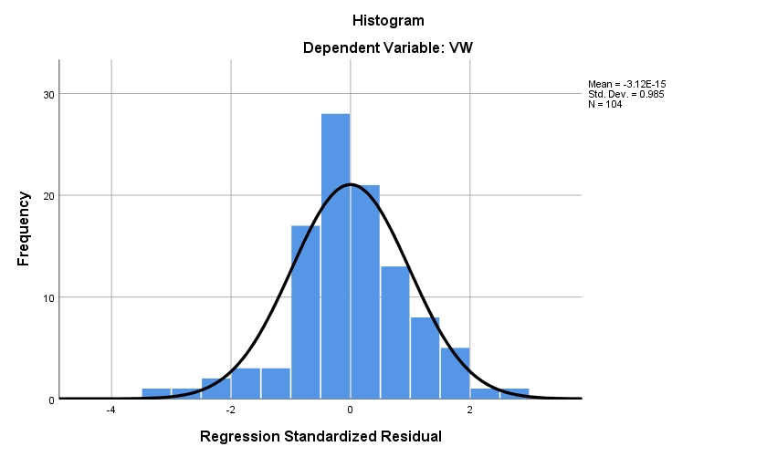
Figure ‎5-42: Histogram of the frequency of the standardised residuals for VW

Finally, the P–P diagram (Figure ‎5-43) also shows there is a normal distribution.
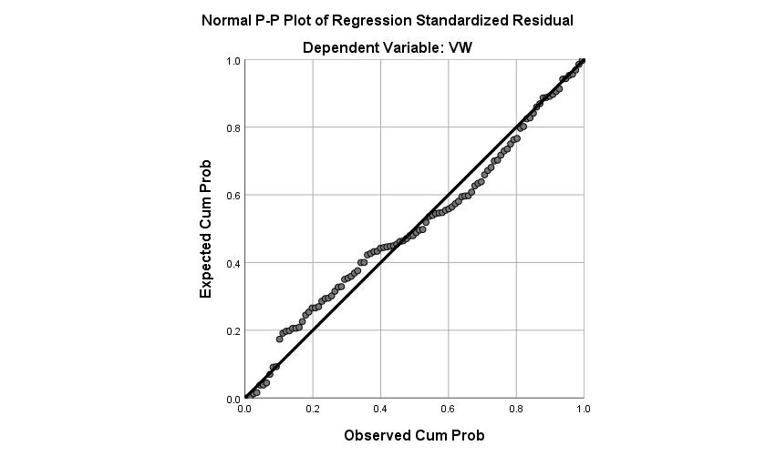
Figure ‎5-43: Normal P–P plot of regression standardised residual for the dependent variable

Regression
5 – (Internal + Organisational Resilience) VW = IRF + RP + RP* IRF
This section describes the use of multiple regressions to estimate the parameters in model equation (VW = IRF + RP + RP* IRF). The purpose of the multi-linear models was to map variation in response in place to the relationship between vulnerabilities and weaknesses and internal threats in UAE public sector organisations. The variation variables were all entered at different stages of the simulation. The regression results in Table ‎5-100 show that IRF moderated by RP explained 64.5% of the variance in VW. This variance proportion was statistically significant because the F-value is 60.568, with three degrees of freedom and p-value of 0.000 (Table ‎5-101). The results also show that all the variation variables in the model are significant and the goodness-of-fit for the estimated regression equation for the generated model was supported by an R-square value of 0.645 Table ‎5-102 completes the picture.
Model Summary ^{b}
Model | R | R Square | Adjusted R Square | Std. Error of the Estimate | Change Statistics
 |  |  |  |  | R Square Change | F Change | df1
 | .803ª | .645 | .634 | .35905 | .645 | 60.568 | 3
^{a.} Dependent Variable: VW
^{b.} Predictors: (Constant), IRF*RP, RP, IRF
Table ‎5-100: Regression model summary for VW
ANOVA ª
Model |  | Sum of Squares | df | Mean Square | F | Sig.
1 | Regression | 23.425 | 3 | 7.808 | 60.568 | .000^{b}
1 | Residual | 12.892 | 100 | .129
1 | Total | 36.317 | 103
^{a.} Dependent Variable: VW
^{b.} Predictors: (Constant), IRF*RP, RP, IRF
Table ‎5-101: Analysis of variance of the model for VW
Coefficients ª
Model |  | Unstandardised Coefficients |  | Standardised Coefficients | t | Sig. | Correlations
 |  | B | Std. Error | Beta | t | Sig. | Zero-order
1 | (Constant) | 1.069 | .280 |  | 3.816 | .000
1 | RP | .147 | .084 | .165 | 11.759 | .000082 | .348
1 | IRF | .543 | .079 | .795 | 6.863 | .000 | .792
1 | IRF*RP | .009 | .022 | .062 | 5.417 | .000677 | .678
^{a.} Dependent Variable: VW
Table ‎5-102: Coefficients of the regression model for VW

Testing for Collinearity of the Independent Variables
The collinearity results for the independent variables are in Table ‎5-103.
Collinearity Diagnostics ª
Model | Dimension | Eigenvalue | Condition Index | Variance Proportions
 |  |  |  | (Constant) | RP | IRF | IRF*RP
1 | 1 | 3.904 | 1.000 | .00 | .00 | .00 | .00
1 | 2 | .063 | 7.890 | .10 | .03 | .05 | .09
1 | 3 | .028 | 11.777 | .06 | .13 | .27 | .11
1 | 4 | .005 | 28.285 | .84 | .84 | .68 | .80
^{a.} Dependent Variable: VW
Table ‎5-103: Testing the collinearity between variables for VW
The condition index for all but two variables was less than 10. The other two dimensions had a condition index greater than 10 and less than 30, indicating moderate collinearity.

Examining Residuals using Scatter Plots
The residual statistics from the regression analysis are in Table ‎5-104. The results check the residual mean is zero. Figure ‎5-44, Figure ‎5-45, and Figure ‎5-46 show that there is no pattern of behaviour of the residuals with respect to Y. These variables were systematic, and the assumption of error term independence is not violated.

Residual Statistics ª
 | Minimum | Maximum | Mean | Std. Deviation | N
Predicted Value | 1.7817 | 4.3063 | 3.2024 | .47689 | 104
Residual | −.85570 | .69369 | .00000 | .35378 | 104
Std. Predicted Value | −2.979 | 2.315 | .000 | 1.000 | 104
Std. Residual | −2.383 | 1.932 | .000 | .985 | 104
^{a.} Dependent Variable: VW
Table ‎5-104: Residual statistics of the model regression for VW
Figure ‎5-47 shows that the distribution is bell-shaped and has less gap in the centre that may in part be a consequence of the defined intervals.
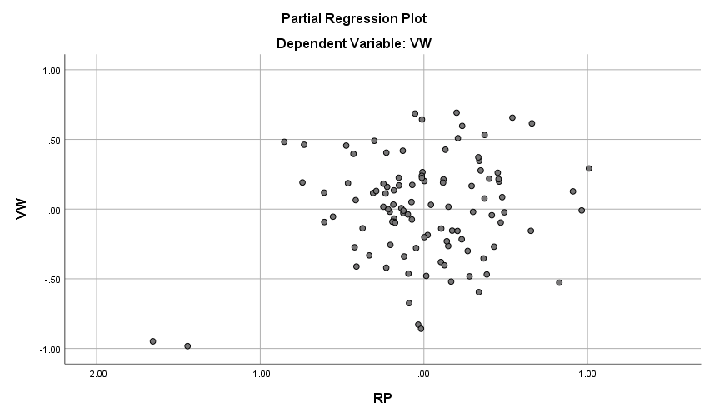
Figure ‎5-44: Scatter plot for residual results from the model for VW and RP
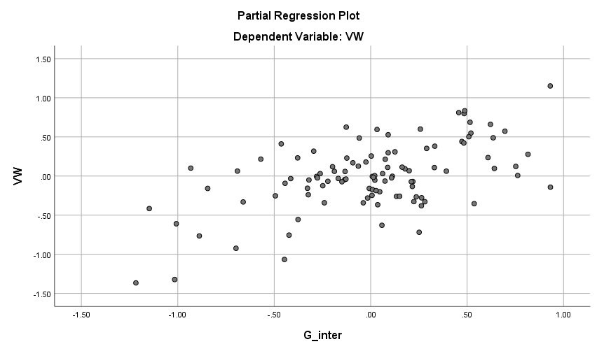
Figure ‎5-45: Scatter plot for residual results from the model for VW and IRF

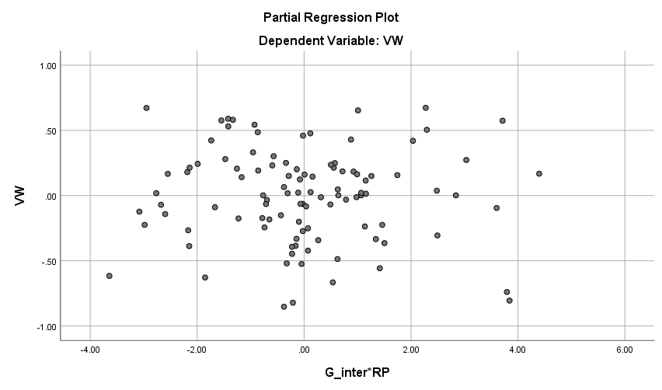
Figure ‎5-46: Scatter plot for residual results from the model for VW and IRF*RP

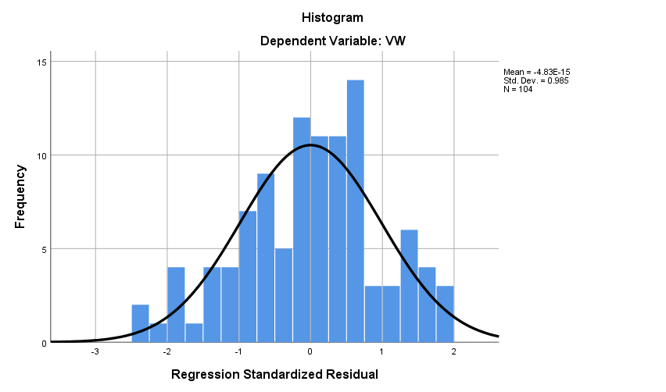
Figure ‎5-47: Histogram of the frequency of the standardised residuals for VW

Finally, the P–P diagram (Figure ‎5-48) shows that there is a normal distribution.
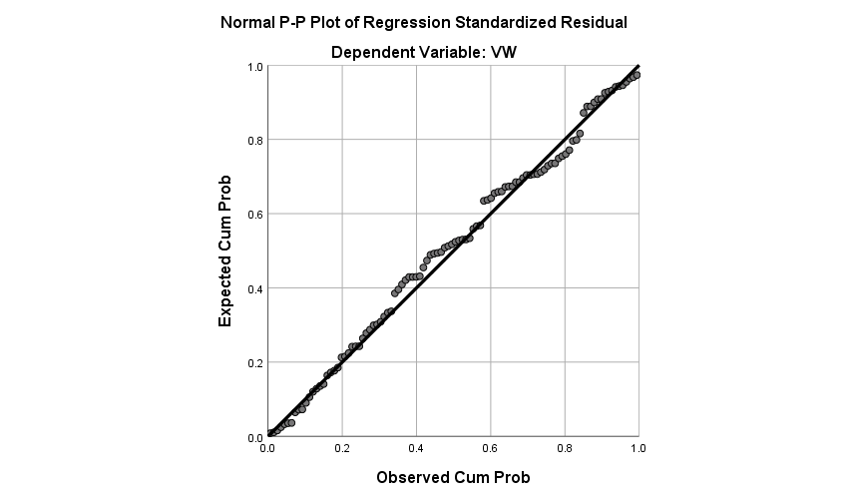
Figure ‎5-48: Normal P–P plot of regression standardised residual for the dependent variable

Regression

11– (External + Proportionate Organisational Resilience) VW = ERF + OR + OR*ERF
Multiple regressions were used to estimate the parameters in model equation VW = ERF + OR + OR*ERF. The purpose of the multi-linear models was to map the variation in OR against the relationship between vulnerabilities and weaknesses and external threats in the UAE public sector organisations. The variation variables were all entered at different stages of the simulation.
The regression results in Table ‎5-105 show that ERF moderated by OR explained 45.0% of the variance in VW. This variance proportion was statistically significant because the F-value was 27.307, with three degrees of freedom and p-value of 0.000 (Table ‎5-106). The results also indicate that all the variation variables in the model were significant and goodness-of-fit of the estimated regression equation for the model was supported by an R-square value of 0.450 (See also Table ‎5-107).

Model Summary ^{b}
Model | R | R Square | Adjusted R Square | Std. Error of the Estimate | Change Statistics
 |  |  |  |  | R Square Change | F Change | df1
1 | .671ª | .450 | .434 | .44680 | .450 | 27.307 | 3
^{a.} Dependent Variable: VW
^{b.} Predictors: (Constant), ERF*OR, OR, ERF
Table ‎5-105: Regression Model Summary for VW
ANOVA ª
Model |  | Sum of Squares | Df | Mean Square | F | Sig.
1 | Regression | 16.354 | 3 | 5.451 | 27.307 | .000^{b}
1 | Residual | 19.963 | 100 | .200
1 | Total | 36.317 | 103
^{a.} Dependent Variable: VW
^{b.} Predictors: (Constant), ERF*OR, OR, ERF
Table ‎5-106: Analysis of variance of the model for VW
Coefficients ª
Model |  | Unstandardised Coefficients |  | Standardised Coefficients | t | Sig.
 |  | B | Std. Error | Beta | t | Sig.
1 | (Constant) | 1.736 | .850 |  | 2.042 | .044
1 | ORe | .020 | .203 | .025 | 4.097 | .000923
1 | ERF | .344 | .269 | .451 | 11.277 | .000204
1 | ERF*ORe | .038 | .064 | .258 | 6.590 | .000557
^{a.} Dependent Variable: VW
Table ‎5-107: Coefficients ª of the regression model for VW

Testing for Collinearity of the Independent Variables
The collinearity results for the independent variables are in Table ‎5-108.
Collinearity Diagnostics ª
Model | Dimension | Eigenvalue | Condition Index | Variance Proportions
 |  |  |  | (Constant) | ORe | ERF | ERF*ORe
1 | 1 | 3.900 | 1.000 | .00 | .00 | .00 | .00
1 | 2 | .063 | 7.874 | .01 | .01 | .01 | .02
1 | 3 | .037 | 10.294 | .01 | .03 | .02 | .01
1 | 4 | .001 | 73.354 | .97 | .96 | .97 | .97
^{a.} Dependent Variable: VW
Table ‎5-108: Testing the collinearity between variables for VW
Table ‎5-108 shows that the condition index for all but two variables was less than 10. One dimension showed a condition index greater than 10 and less than 30, indicating moderate collinearity, and one was greater than 30, indicating high collinearity.

Examining Residuals using Scatter Plots
Table ‎5-109, Figure ‎5-49, Figure ‎5-50, and Figure ‎5-51 show that there is no pattern of behaviour of the residuals with respect to Y. These variables were systematic, and the assumption of error term independence is not violated.
Residual Statistics ª
 | Minimum | Maximum | Mean | Std. Deviation | N
Predicted Value | 2.1699 | 4.1644 | 3.2024 | .39846 | 104
Residual | −1.68042 | 1.09024 | .00000 | .44025 | 104
Std. Predicted Value | −2.591 | 2.414 | .000 | 1.000 | 104
Std. Residual | −3.761 | 2.440 | .000 | .985 | 104
^{a.} Dependent Variable: VW
Table ‎5-109: Residual statistics of the model regression for VW

Figure ‎5-52 shows that the distribution is bell-shaped and has less gap in the centre that may in part be a consequence of the defined intervals.

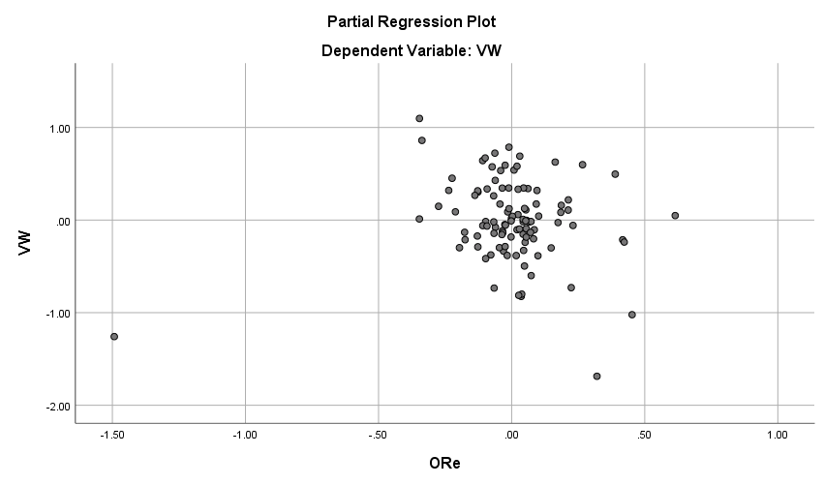
Figure ‎5-49: Scatter plot for residual results from the model for VW

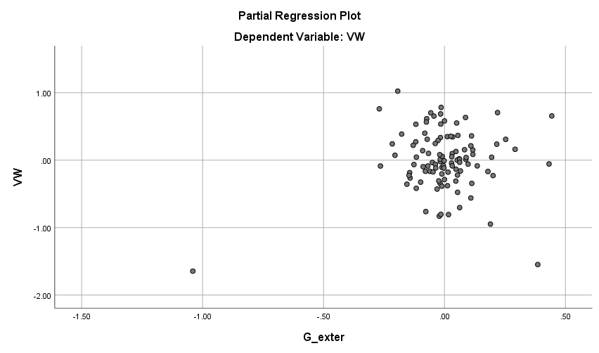
Figure ‎5-50: Scatter plot for residual results from the model for VW

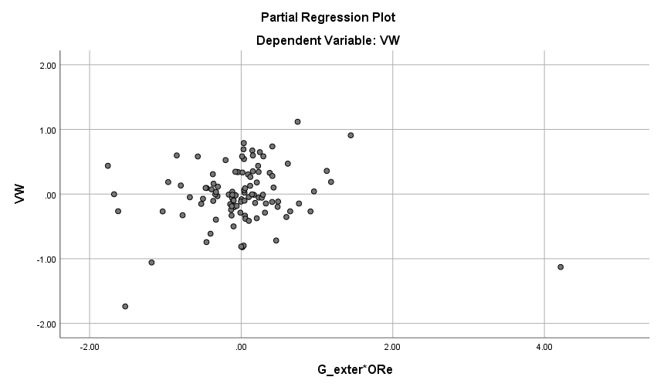
Figure ‎5-51: Scatter plot for residual results from the model for VW

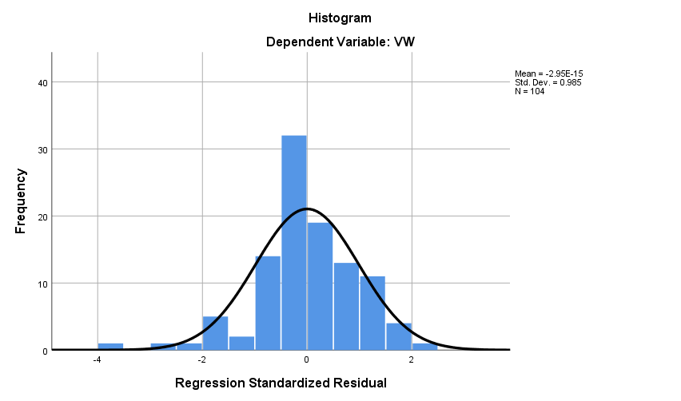
Figure ‎5-52: Histogram of the frequency of the standardised residuals for VW
Finally, the P–P diagram (Figure ‎5-53) shows that there is a normal distribution.
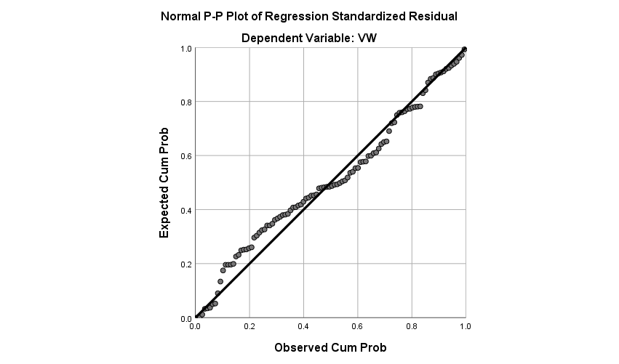
Figure ‎5-53: Normal P–P plot of regression standardised residual for the dependent variable
Regression
12 – (Internal + Proportionate Organisational Resilience) VW = IRF + OR + OR*IRF
This section describes the use of multiple regressions to estimate the parameters in model equation VW = IRF + OR + OR*IRF. The purpose of the multi-linear models was to map variation in OR to the relationship between vulnerabilities and weaknesses and Internal threats in UAE public sector organisations. The variation variables were all entered at different stages of the simulation.
The regression results in Table ‎5-110 show that IRF moderated by OR explained 64.8% of the variance in VW. This variance proportion was statistically significant because the F-value was 61.258 with three degrees of freedom and p-value of 0.000 (Table ‎5-111). The results show that all the variation variables in the model are significant and the goodness-of-fit of the estimated regression equation for the generated model was supported by an R-square value of 0.648 ( See also Table ‎5-112).

Model Summary ^{b}
Model | R | R Square | Adjusted R Square | Std. Error of the Estimate | Change Statistics
 |  |  |  |  | R Square Change | F Change | df1
1 | .805ª | .648 | .637 | .35774 | .648 | 61.258 | 3
^{a.} Dependent Variable: VW
^{b.} Predictors: (Constant), IRF*ORe, ORe, IRF
Table ‎5-110: Regression model summary for VW
ANOVA ª
Model |  | Sum of Squares | df | Mean Square | F | Sig.
1 | Regression | 23.519 | 3 | 7.840 | 61.258 | .000^{b}
1 | Residual | 12.798 | 100 | .128
1 | Total | 36.317 | 103
a. Dependent Variable: VW
b. Predictors: (Constant), IRF*ORe, ORe, IRF
Table ‎5-111: Analysis of variance of the model for VW
Coefficients ª
Model |  | Unstandardised Coefficients |  | Standardised Coefficients | T | Sig. | Correlations
 |  | B | Std. Error | Beta | T | Sig. | Zero-order
1 | (Constant) | .289 | .535 |  | .540 | .590
1 | OR | .304 | .128 | .385 | 7.377 | .000019 | .142
1 | IRF | .898 | .175 | 1.313 | 5.117 | .000 | .792
1 | IRF*OR | .088 | .041 | .654 | 2.113 | .037 | .684
^{a.} Dependent Variable: VW
Table ‎5-112: Coefficients of the regression model for VW

Testing for Collinearity of the Independent Variables
The collinearity results for the independent variables are in Table ‎5-113.
Collinearity Diagnostics ª
Model | Dimension | Eigenvalue | Condition Index | Variance Proportions
 |  |  |  | (Constant) | ORe | IRF | IRF*Ore
1 | 1 | 3.884 | 1.000 | .00 | .00 | .00 | .00
1 | 2 | .080 | 6.977 | .02 | .01 | .01 | .02
1 | 3 | .035 | 10.525 | .02 | .05 | .03 | .02
1 | 4 | .001 | 57.895 | .96 | .93 | .96 | .96
^{a.} Dependent Variable: VW
Table ‎5-113: Testing the collinearity between variables for VW
Table ‎5-113 shows that the condition index for all but three variables was less than 10. Two variables showed a moderate collinearity with a condition index greater than 10 and less than 30; and one variable had high collinearity, with a condition index greater than 30.

Examining Residuals using Scatter Plots
The residual statistics from the regression analysis are shown in Table ‎5-114. The results check the residual mean is zero. Figure ‎5-54, Figure ‎5-55, and Figure ‎5-56 show that there is no pattern of behaviour of the residuals with respect to Y. These variables were systematic, and the assumption of error term independence is not violated.
Residual Statistics ª
 | Minimum | Maximum | Mean | Std. Deviation | N
Predicted Value | 1.4273 | 4.2189 | 3.2024 | .47785 | 104
Residual | −1.00811 | .88287 | .00000 | .35249 | 104
Std. Predicted Value | −3.715 | 2.127 | .000 | 1.000 | 104
Std. Residual | −2.818 | 2.468 | .000 | .985 | 104
^{a.} Dependent Variable: VW
Table ‎5-114: Residual statistics of the model regression for VW
Figure ‎5-57 shows that the distribution is bell-shaped and has less gap in the centre that may in part be a consequence of the defined intervals.
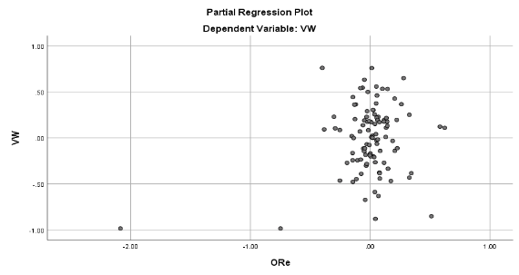
Figure ‎5-54: Scatter plot for residual results from the model for VW
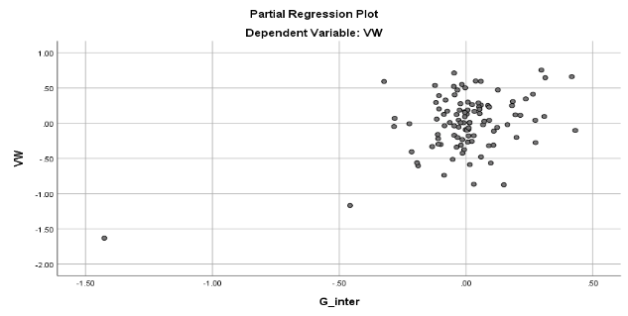
Figure ‎5-55: Scatter plot for residual results from the model for VW

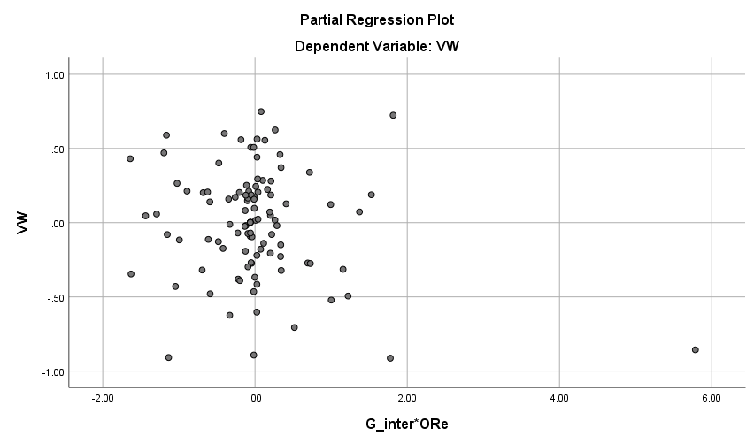
Figure ‎5-56: Scatter plot for residual results from the model for VW

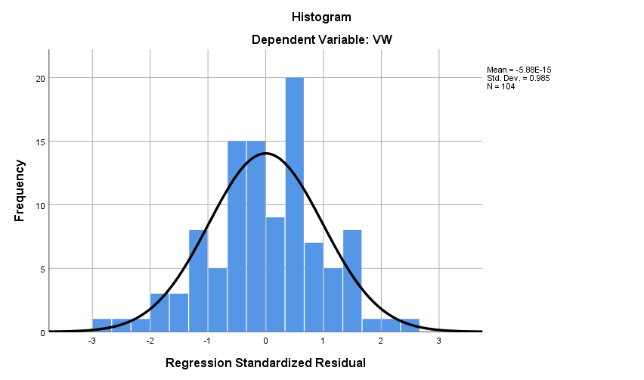
Figure ‎5-57: Histogram of the frequency of the standardised residuals for VW

Finally, the P–P diagram (Figure ‎5-58) shows that there is a normal distribution.
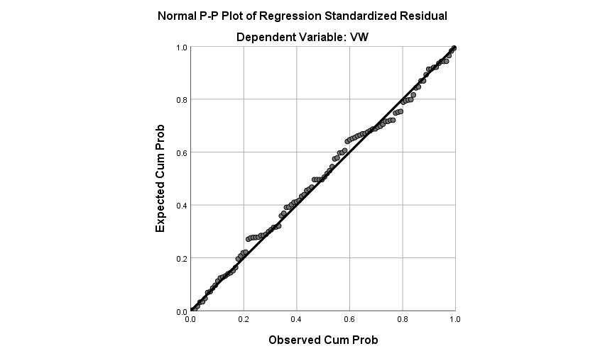
Figure ‎5-58: Normal P–P plot of regression standardised residual for the dependent variable

Summary
This chapter has examined the data and analysed it using EFA and regression analysis, and because the intent is to find the moderating effect of the variables, Hayes’ macro for SPSS (Hayes, 2018) was identified as the most appropriate tool for analysis. Little’s MCAR test (Little, 1988) was used to complete any missing data, and in every case the data was found to have a normal distribution. There were no outlying values or anomalies in any of the data, so there was no need to disregard or remove any entries, improving the overall reliability of the analysis.
In the early part of the chapter, the tests for missing values ‎5.2, outliers ‎5.3, and reliability ‎5.4 are carefully described and explained. There is also a section which explains the statistical meaning of “normality” (Section ‎5.5). Having defined and explained these concepts, the chapter then moves on to discuss and describe the analysis process, beginning with the descriptive statistics (Section ‎5.6), then the EFA (section ‎5.9), and finally the Simple and Multiple Regression analysis (Section ‎5.10), where the moderating effect of the variables is tested using Hayes’ Macro for SPSS (Hayes, 2018). The large number of variables means that the chapter is, necessarily, complex, but every effort has been made to simplify it for the reader.
Essentially, the chapter provides statistical evidence that the data is reliable and fits the definition of “normality”. This, in turn, means that conclusions drawn from the data are repeatable – if the data was analysed by a third party, they would obtain the same results and reach the same conclusions. This adds considerably to the overall reliability and repeatability of the research, despite the relatively small sample size. Additionally, since the demographic of the sample is approximately equal to the demographic of UAE Government federal entities, it can be said to be representative. Thus, it is reasonable to infer that the data collected is also representative and can be generalised for the rest of the UAE public sector.

Discussion

Introduction
This chapter provides a discussion of the research questions, data analysis, and the findings of this research. It has four main sections. The first provides an overview of the research objectives and the proposed cyber-resilience and cyber-threat awareness framework for the public sector in the UAE. The second section discusses the associations between the variables. The third section discusses the findings of the correlation tests used to validate the research hypotheses and compares the results with the literature. The fourth section provides a summary discussion and conclusion.

Research Overview – External and Internal Cyber-Threat Constructs
The study aimed to examine the resilience to external and internal cyber-threats in public sector organisations in the UAE, and the levels of threat awareness among public sector employees. By exploring the resilience practices currently adopted in those organisations, and the opinions and perceptions of employees, the aim was to produce a framework to increase awareness and cyber-resilience. The study also aimed to examine the response mechanisms already in place, and the current levels of resilience and readiness for cyber-attack. It was felt that this would maximise the opportunities to improve awareness and adopt suitable practices. The constructs used in the research were threats (internal and external), vulnerabilities and weaknesses, responses, and resilience. The new framework is displayed graphically in Figure ‎3-5 in ‎Chapter 3.

Threats
The literature divides threats into internal threats (called IRF in the data analysis) and external threats (ERF). The Internet of Things (IoT) spans both categories. Threats are linked to resilience (Ahmed et al., 2015) because some systems can grow stronger when threatened. There is clear evidence that the adoption of cyber-threat resilience practices and increased employee awareness of cyber-risks must be part of the solution for public sector organisations (Podhorec, 2012; Purser, 2011), and in preventing the development of cross-border cyber-crime. However, actual levels of adoption and awareness have not previously been examined in the UAE public sector. This study therefore aimed to examine these factors.
The initial frame of reference for the research was a critical review of the literature to gain an understanding of the current gaps in the knowledge of internal and external threats in the UAE public sector and the levels of compliance with existing policies. Vulnerability is often caused by lack of knowledge about threats (Deloitte, 2011). Awareness was considered the first step towards that knowledge in the development of the new framework. Fransen, Smulders and Kerkdijk (2015) noted that sharing information about threats is essential. Although they are often managed in similar ways, Casey et al. (2016) suggest that it is easier to understand the presence of external threats than internal threats.

Vulnerabilities and Weaknesses
Vulnerabilities and weaknesses (VW in the analysis) were considered next, and the links between them were confirmed to be as shown in Figure ‎3-5. In the past, many public sector cyber-security initiatives have failed because of weak implementation strategies that led to uncoordinated adoption of cyber-security resilience practices, lack of awareness, weak organisation cyber-security culture, and the organisation not having the capacity to cope with the nature of internet and cybercrime (Ciolan, 2014). This emphasises the importance of awareness.
Processes, people, and technology all have vulnerabilities and weaknesses. However, the IoT in particular has caused considerable interactions between them (Hypponen and Nyman, 2017). New connectivity means that people will often complete a process using an inappropriate device. This device may compromise the security of the system (Schatz, Bashroush, and Wall, 2017). Every day, new devices are connected to the IoT and discovered to have new vulnerabilities (Bode, 2015; Corfield, 2017; Hypponen and Nyman, 2017). The system now has connected devices that operate and react in ways that the designers of the legacy systems could not have foreseen. That fact alone increases the vulnerability of the system (Schatz, Bashroush, and Wall, 2017).
Vulnerabilities and weaknesses cannot be entirely removed (2000), and the framework developed in this study does not aim to achieve this. However, an increased awareness of the ways in which technology can bring new threats and how processes can be vulnerable reduces the risks (Hypponen and Nyman, 2017). An understanding of how people can inadvertently introduce risks to the system also helps to reduce this behaviour (Yildirim, 2016). The framework therefore focuses on the importance of increased awareness. Essentially, accidental exposure of the system to risk is less likely to occur where staff are aware of the possibility, and this also avoids exposing the system to risk through poor practice (Dutt, Ahn, and Gonzalez, 2013).

Values at Risk
In the public and private sectors, the values at risk are not the same. In the public sector, the safety of citizens as a whole is at risk in the event of a catastrophic systems failure (Uncapher, 2016). Complete failure may be rare, but if it does occur in, for example, a hospital or health centre, the implications for public safety are severe. It is therefore perhaps even more important to have a cyber-security framework for the public sector than the private sector, and resilience may also be more necessary. The new framework has therefore been designed to minimise vulnerabilities and weaknesses and better protect these values.

Responses
The response to any attack is a vital part of the resilience framework. Without a response in place, every attack would be successful. The response, however, must be appropriate and proportionate (see, for example, Niblett, 2016; Payne and Finlay, 2017; Peng et al., 2006, Sedjelmaci, Senouci and Ansari, 2017, and Shameli-Sendi and Dagenais, 2014). Responses can be divided by type into system, governmental, and transactional, and each of these can also be further sub-divided. The response depends on the type of vulnerability or weakness and the type of threat. However, as Figure ‎3-5 shows, a system is more resilient when a response is triggered earlier.

Capacity (Resilience)
The last of the constructs used in the research is also perhaps the most important. Cyber-resilience is essential in the UAE public sector for the confidence of investors in companies that intend to operate here. Many researchers have stressed the importance of resilience, including Renn (2013) and Sano et al. (2016). This exploration of the relationship between cyber-resilience practices and the levels of compliance with those practices allowed the creation of a tool to measure cyber-resilience. The framework will also allow organisations to visualise some of the cyber-risks and managed the perceived risks efficiently.

Descriptive Analysis Findings
The online survey of public sector staff in the UAE was successful, in that 200 invitations to participate were sent out, and 104 useable surveys were returned. This gave a response rate of 52%, which is regarded as quite high (De Bruijne and Wijnant, 2014). The demographic information was as expected, with a range from senior management to data entry clerks. The most obvious descriptive factor was a lack of trust in the organisation’s ability to cope with a cyber-attack (i.e. resilience was perceived to be low). However, the perception of external risk was high. Lack of awareness of internal risks was seen as important, as were risk culture and laziness. The overall levels of awareness were not as high as the level required for the new framework but high enough to demonstrate that there is a move towards cyber-security in the UAE public sector.
The descriptive statistics were checked for normality using tests suggested by more than one author, to provide cross-checking. The sources used included George and Mallery (2010) and Newson (2005). The tests used included Little’s Missing Completely at Random (MCAR) test (Little, 1988), to examine the randomness of the data. These tests gave confidence that the data were usable and that the answers fitted a normal distribution with few outliers. This is discussed in more detail in the next section.

Validity of the Results
The results can be considered valid because the statistical tests showed them to be in the range expected, and the demographic information of the participants fit perceptions of the UAE public sector workforce. The new framework combines existing frameworks in a new way, but does not detract from any of them, and all assumptions and limitations were stated, increasing the overall validity. Bannigan and Watson (2009) noted that research must be both reliable and valid. The reliability of the data is likely to be high because of the anonymity of the survey, which allowed people to be honest.

Frequencies of the Research Constructs
The frequencies of the research constructs are set out in the data analysis chapter, but a brief discussion of their implications is needed. The answers to the survey questions were on a Likert-type scale ranging from 1–5, where 1 showed strong agreement with the statement or question and 5 strong disagreement. The mean figures for the answers were mainly in the region of 2.75–4 (see Appendix 4, Table ‎0-1 and Table ‎0-2) indicating that there was disagreement with most of the questions. The responses across all areas were broadly in line with expectations from the literature, including from Al-Gahtani, Hubona, and Wang (2007), Almarhabi (2016), Amin (2017), and Bendovschi (2015). This, like the statistical analysis of normality, encourages belief in the data, and increases its validity and reliability.

Association Findings
This part of the discussion considers the concept of external and internal cyber-threats and how they affect public sector organisations. It brings together the findings from the literature review and the analysis of the primary data collected in the survey. The literature review identified the importance of organisational resilience and putting measures in place to reduce or mitigate cyber-threats for public organisations. It also demonstrated an association between these measures and the readiness of organisations to respond to both internal and external threats.
The majority of existing frameworks and standards largely concentrate on mitigation after an attack, although some outline some preventative measures. Mitigation is linked to resilience, but none of the frameworks provided an assessment of organisational resilience before the threat occurs. Additionally, the patterns of cyber-attack, particularly the cyber kill chain® (Hutchins, Cloppert, and Amin, 2011), all emphasise that earlier threat detection gives a better chance of either preventing the cyber-attack or of recovering from it (improved resilience). This indicates that the existing frameworks do not detect cyber-threats or intervene quickly enough. Figure ‎2-15 summarises the existing frameworks and shows that they were developed to mitigate threats after attack, and to prevent threats proceeding past point ‘B’. The new framework is aimed at the ‘gap’ between the current action point (‘B’) and the ideal action point (‘A’). By increasing awareness and allowing a better measurement of resilience, the new framework is intended to move the action point closer to point ‘A’.
To ensure that any proposed framework is directly applicable to the UAE public sector, data were gathered from an online survey of public sector employees. A total of 207 latent variables were identified, and questions were created with answers on a Likert-type scale. In total, 200 electronic questionnaires were distributed, and 127 were returned of which 104 were valid and usable as data. In the data analysis, a principal component analysis of the input data was conducted (Chang et al., 2017), where new code clusters (Pelekis et al., 2017) were identified, using both outlier and space division to forecast the outliers and extract new latent clusters of variables (factor extraction). A multi-linear regression stepwise analysis was used to develop and verity models, to predict and interpret the variables.
As a final step, a multi-linear model was developed to measure the associations among the clustered latent variables. All external and internal threat variables were clustered as external threats (ERF) and internal threats (IRF), then the association with having a response in place (RP) and organisational resilience (ORe) was measured for each group. This permitted the construction of the new proposed framework (Figure ‎3-5).

Discussion of Regression Analysis
The next few sub-sections discuss the relationships between independent and dependent variables in this study, including both direct and moderator effects.

Direct Effect on Vulnerabilities and Weaknesses of External and Internal Threats, Having a Response in Place and Organisational Resilience
The findings obtained from the quantitative analysis indicated that there was a significance relationship between internal and external threats and having a response in place and organisational resilience in public sector organisations. Organisational managers can therefore prevent and mitigate the impacts of both internal and external threats on organisational assets if there are better responses in place and a higher level of organisational resilience.
For the hypothesis testing, a Pearson Correlation test was used to identify the type of association between the independent and dependent variables. The first step was to test the association between the organisations’ vulnerabilities and weaknesses (VW) and the external threats (ERF). ERF was positively correlated with VW at p <0.01, meaning that an increase in external threats was associated with an increase in the level of vulnerabilities and weaknesses in a public sector organisation.
The relationship between VW and IRF also had a positive correlation at p <0.01, meaning that an increase in IRF was also associated with greater vulnerabilities and weaknesses. This is consistent with Thomson and von Solms (2005) who noted that management commitment in public sector organisations was essential to a robust and on-going development of cyber-risk management. In addition to a continuous assessment of organisational vulnerabilities and weaknesses, procedures to raise awareness supported by self-awareness in higher management increase the security culture within the organisation, which reduces the risk of future attacks (Thomson and von Solms, 2005).
The positive and significant correlation of having responses in place (RP) with vulnerabilities and weaknesses indicates that a high level of responses in place was associated with higher levels of vulnerabilities and weaknesses in public sector organisations. Previous studies (e.g. Sano et al., 2016; Schneier, 2012) emphasised the importance of detection and response, to avoid attacks penetrating to the point where the organisation is damaged. However, it is impossible to prevent every attack, and it is therefore essential to be able to respond appropriately to an attack (Vasudevan and Selvakumar, 2016). Having a response in place is therefore a way to assume that a cyber-attack will occur, detect any attacks as early as possible, respond to them appropriately, and prevent any damage from spreading. However, this can be difficult to deliver in practice.
Finally, organisational resilience (OR) was positively correlated with vulnerabilities and weaknesses at p <0.01, indicating that a higher level of resilience was also associated with higher levels of vulnerabilities and weaknesses in public sector organisations.

Direct Effect of External Threats, Having a Response in Place, and Organisational Resilience on Organisational Vulnerabilities and Weaknesses
External threats (ERF) had a positive association with vulnerabilities and weaknesses, meaning that an increase in threats was associated with greater vulnerabilities and weaknesses in public sector organisations.
Response in place (RP) also had a positive association with vulnerabilities and weaknesses, which means that an increase in the level of response in place of the organisation was associated with an increase in the vulnerabilities and weaknesses. This result confirms the findings of Sano et al. (2016), Schneier (2012), and Vasudevan and Selvakumar (2016), who all suggested that early detection and a fast response prevented cyber-attacks from penetrating to the point where damage cannot be mitigated.
Having a response in place does not prevent external threats, but it may reduce the potential impact of those threats (Niblett, 2016). It follows that public sector organisations should develop a response in place strategy that is focused on two pillars: management responses and technical responses. The management response is to ensure that there is a culture of cyber-threat resilience and awareness throughout the organisation. The technical response must focus on continuous assessment of the organisation’s technological infrastructure and the readiness of digital assets to reduce or prevent the potential impact of any attack. Public sector organisations must combine these two pillars to reduce the levels of cyber-threat and to maintain flexible operations and a well-managed response mechanism.
Organisational resilience (OR) had a positive association with vulnerabilities and weaknesses, so an increase in resilience was associated with increased weaknesses and vulnerabilities in public sector organisations. This result confirms the findings of Hollnagel et al. (2006, p. 120), who defined resilience as “the ability of systems to anticipate and adapt to the potential for surprise and failure”. Hollnagel et al. (2006) also stressed that organisations should engineer their technology systems and infrastructure resilience to be able to cope with the growing level and unpredictability of cyber-threats. UAE public sector organisations should move away from their traditional approach to information system security, because reducing vulnerability against identified threats has proven impossible. The revised approach must be to move forward with a cyber-resilience strategy that gives full protection against cyber-threats. This requires a pro-active and flexible approach similar to the human body’s immune system, to avoid interruption of operations caused by cyber-attacks (Brown, Anwar, and Dozier, 2017).

Direct Effect of Internal Threats, Having a Response in Place, and Organisational Resilience on Organisational Vulnerabilities and Weaknesses
The previous sub-section examined the direct effect of external threats, having a response in place, and resilience on vulnerabilities and weaknesses. This sub-section now looks at internal threats (IRF).
IRF had a clear positive association with VW, so an increase in IRF would be association with an increase in the weakness and vulnerability of the organisation. Hong et al. (2010) concluded that organisations are more vulnerable to internal threats than to external threats, since 90% of data leakage incidents were the results of actions by staff. Data leakage could cause massive financial loss as well as damage to brand position.
To reduce internal threats, UAE public sector organisations should develop an internal threat prevention system that focuses on assessing the behaviour patterns or intents of the employees before an incident occurs. Internal threat reduction is concerned with protecting internal assets but should also include careful review of employee access permissions for data. Permissions should be reduced to the lowest level suitable for the employee job function. This involves organising the levels of interdependence of job functions to ensure that no employee has permission levels that could cause future risks. Internal risks can be increased by issues such as dissatisfaction with salary level, long delays in expected promotion or salary increase, and similar issues. UAE public sector organisations should therefore revise their current access permission policies and reassess internal operating processes to ensure that there is functional interdependency and resilience to any potential internal threats.
Thomson and von Solms (2005) suggested that management commitment within the organisation is essential for the ongoing development of risk awareness and cyber-risk management. Management commitment and awareness promotes a culture of risk awareness throughout the organisation and may therefore increase organisational resilience.

Organisational Resilience as a Moderator of the Relationship Between Internal and External Threats and Vulnerabilities and Weaknesses
Organisational resilience seems to have a passive effect on external threats (ERF) and a strong positive association with the dependent variable vulnerabilities and weaknesses. This means that resilience may be a moderator for ERF but had no significate impact in reducing the impact of ERF on VW. However, levels of organisational resilience do seem to be associated with levels of organisational vulnerability and weakness.
Organisational resilience had a negative effect on the independent variable IRF but seemed to have a positive role in reducing the effect of internal threats on vulnerabilities and weaknesses. Organisational resilience therefore acts as a moderator of the relationship between internal threats and vulnerabilities and weaknesses.

Hypotheses
To answer the research questions eight hypotheses were considered, which were related to the threat/response/resilience process shown in Figure ‎3-4. The eight hypotheses in Table ‎6-1 were tested against the data collected in the online survey of public sector staff. Each hypothesis was converted into a formula to test its validity (see p. 147). The next few sub-sections consider each of the hypotheses in detail.
Research Question | Hypothesis | Formula | Accepted / Rejected
RQ1. How can resilience to cyber-risk be measured and developed whilst also maintaining existing responses in place and without increasing vulnerabilities and weaknesses? | H1: Vulnerabilities and weaknesses are associated with external threats. | VW = ERF | Accepted; positive association
 | H2: Vulnerabilities and weaknesses are associated with internal threats. | VW = IRF | Accepted; positive association
 | H3: Vulnerabilities and weaknesses are associated with having responses in place. | VW = RP | Accepted; positive association
 | H6: Vulnerabilities and weaknesses are associated with organisational resilience. | VW = ORe | Accepted; positive association
RQ2. How can a framework for managing cyber-risks that is relevant to the dependent variables in this study, (response in place, organisational resilience, and vulnerabilities and weaknesses) be synthesised from existing standards? | H4: Having responses in place moderates the association between vulnerabilities and weaknesses and internal threats. | VW = IRF +RP | Accepted; positive association
 | H5: Having responses in place moderates the association between vulnerabilities and weaknesses and external threats. | VW = ERF +RP | Accepted; positive association
 | H7: Organisational resilience moderates the association between vulnerabilities and weaknesses and internal threats. | VW = IRF +ORe | Conditionally accepted
 | H8: Organisational resilience moderates the association between vulnerabilities and weaknesses and external threats. | VW = ERF +ORe | Conditionally accepted
Table ‎6-1: The research hypotheses and outcomes

Hypothesis One (H1) Vulnerabilities and weaknesses are associated with external threats
The hypothesis was accepted because external threats had a positive association with VW.

Hypothesis Two (H2) Vulnerabilities and weaknesses are associated with internal threats
The hypothesis was accepted because internal threats had a positive association with vulnerabilities and weaknesses.

Hypothesis Three (H3) Vulnerabilities and weaknesses are associated with responses in place
The hypothesis was accepted because responses in place had a positive association with vulnerabilities and weaknesses.

Hypothesis Four (H4) Having responses in place moderates the association between vulnerabilities and weaknesses and internal threats
Each of these had a positive association, and the hypothesis was accepted. Responses in place as a moderator had a positive association with both internal threats and vulnerabilities and weaknesses.

Hypothesis Five (H5) Having responses in place moderates the association between vulnerabilities and weaknesses and external threats
Each of these had a positive association, so this hypothesis was accepted. Responses in place as a moderator had a positive association with external threats, and a positive association with vulnerabilities and weaknesses.

Hypothesis Six (H6) Vulnerabilities and weaknesses are associated with organisational resilience
This hypothesis was converted into one formula. The hypothesis was accepted because organisational resilience had a positive association with vulnerabilities and weaknesses.

Hypothesis Seven (H7) Organisational resilience moderates the association between vulnerabilities and weaknesses and internal threats
Each of these had a positive association, and this hypothesis was accepted. Organisational resilience as a moderator had significant passive association with internal threats, and positive association with vulnerabilities and weaknesses.

Hypothesis Eight (H8) Organisational resilience moderates the association between vulnerabilities and weaknesses and external threats
Each of these had a positive association, and this hypothesis was accepted. Organisational resilience as a moderator had significant passive association with external threats, and positive association with vulnerabilities and weaknesses.

Discussion of Findings and Results
After the analysis of the data the new framework in Figure ‎3-5 was shown to be appropriate as a scaffolding on which to build the cyber-security awareness, response and resilience of the UAE public sector organisations. The repeated message of both the data and the literature is that early detection and appropriate response are the keys to resilience. It was also clear from the literature and data that awareness of the risks is the biggest step towards early detection. The UAE public sector must therefore adopt the framework envisaged in Figure ‎3-5 but must also emphasise education at all levels from clerks to ministers, and the education must emphasise cyber-risk awareness. The simple fact that when one connects a smart kettle to the system there is a risk of compromise (Bode, 2015; Schneier, 2017) should be made clear to every employee.
Awareness at every level, combined with management commitment, will ensure the smooth operation and development of an organisation-wide response and resilience system. This will then provide a level of assurance to companies wishing to relocate to the UAE that the government takes the issue seriously enough to ensure that there is national critical infrastructure protected in case of attack.

Regression Test Conclusions
The conclusion of the regression tests of the data was that all the hypotheses were accepted, albeit conditionally in two cases. This in turn supports the idea that the new framework is acceptable and will work well. This result and those from the descriptive statistics are all confirmation that the framework may help to improve cyber-security in the UAE public sector.

Validation of the New Framework
To fully validate the framework, it is necessary to first examine the situation before it was designed, and the problems that were either apparent or latent. This provides the justification for the framework and the study. Then it is necessary to clearly demonstrate that these problems are, or would be, eliminated by the application of the framework outlined in the thesis. To that end, the following sections and subsections will provide the necessary detail.

Cyber-Resilience and -Security in the UAE Public Sector Before
In 2020, the TRA launched “The UAE National Cybersecurity Strategy” (TRA, 2020) intended to make the UAE a safe area of cyber-space in which international companies could do business. The reason for the strategy, and for this research, was that, as outlined in the introduction, many elements of society in the UAE feel vulnerable, the country’s own Cyber Security Centre (run by the TRA) say that the UAE is second only to America as a cyber-attack target, and other specialists in cyber security rate the country as vulnerable (Darkmatter, 2020; Kaspersky, 2018).
The public sector and the CI were particularly vulnerable, because the slightest doubt about the resilience of either would negatively impact overseas investment (Kaspersky, 2018). The difficulty that the public sector faced, however, was that they had no means of measuring resilience, and no way of knowing if it was sufficient – ideas borne out by the data collected.

Cyber-Resilience and -Security in the UAE Public Sector After
Applying the new framework within the UAE would be problematic if done in a blanket fashion. However, the framework has been deeply tested. The resilience has been shown to be reasonable but improvable, and the issues have been those that were revealed by the data. Thus, the relevance of the framework has been demonstrated, since the areas which were suspected as being vulnerable were shown to be so, but more importantly, it was shown that the framework mitigated those areas. Additionally, the framework provides for future changes in cyber-risks. Because these risks are perpetually changing, incorporating an cycle of checking and re-checking for new risks ensures that they do not get overlooked.

Testing and Validating the New Framework
The first test of the new framework was to determine whether, from the data collected, it was possible for the researcher to measure or estimate the existing level of ORe (with the assumption, for test purposes only, that the responses all came from a single source in the public sector). The analysis of the data did indicate that an approximation of the existing ORe could be assumed, but it was also clear that it could be improved in order to further reduce the VW that had been found.
It was also possible, from the collected data to approximate the RP (again, assuming a single source for the data). Response in place was just sufficient for existing VW, although some areas were not as strong as others. These two results, if obtained by the Cyber Security Officers “CSO” of a specific establishment in the public sector, would be sufficient for him to establish a policy which would improve ORe and increase RP in the weaker areas.
The next issue for testing the framework was to discover whether it sufficiently emphasised the ongoing nature of cyber-risk and the need for continuing vigilance. Cyber-security is not a “fit and forget” item, it is a process, and its relationship to cyber-resilience requires both to be regularly assessed. In the policies and regulations of the transactional response (see Figure ‎3-5), there is an insistence that all cyber-security and -resilience issues are dealt with in this way. They are always ‘live’, and the value of information sharing has been repeatedly demonstrated. Thus, there is always a link to the latest research and action on cyber-risk, and the -resilience becomes ‘transformational’ as was the original intent of the research.

Acceptance of Validated Framework
To ensure the research finding validity and the cohesiveness of the study variables, a validation of the results conducted by contacting eight managers of study participants from eight public sector organisations of the study population. The selected participants for the study validation were chosen using the following criteria: managerial level, with in the study population sample, and with prior experiences of the cyber security. However, the number who were willing to participate after sending an email invitation for a virtual meeting via video call tool named “Microsoft Teams”, where only 5 out of the 8 targeted public sector organizations. Only 3 out of 8 participants did not reply to the researcher email even though a follow-up emails were sent after 1 week to them. Therefore, the researcher has commenced the study validation with only 5 participants via Microsoft Teams video call. The researcher has started the call by thanking all the participants for their time and contribution of the study, and initiated the meeting by providing a short brief of the study validation concept and the purpose of it. Further, the researcher asked the permission to present them the study results, up one finishing the presentation; he asked the participants their feedback in an open discussion style. Based on those discussions the following interpretation concluded.
It could be argued that the most important part of testing and validation is the acceptance of the new framework by entities in the UAE public sector. It cannot be claimed that the new conceptual framework has been instantly accepted, across the board, by every public sector institution in the UAE. However, the participants in the study validation have been enthusiastic in their reception of it. None of the participants expressed any doubts or raised any queries. This positive attitude suggests that when the completed framework is published and disseminated among UAE public sector entities, the participants will recommend immediate implementation of the framework, and, by doing so will begin to improve the cyber-resilience of the public sector and the nation’s CI. This implies full acceptance of the new framework, and the lack of criticism from the professional cyber-security officers also adds to the perceived validity of the framework. Offering the framework for their opinion was, effectively, the final step in validating the concept. The ‘test’ was passed, so the framework can be considered validated and useable.

Summary
This chapter has discussed the findings and data analysis, starting with an overview of the purpose of the research. It considered the associations between the variables before moving on to discuss the regression analysis, and particularly examining the effect of each variable on vulnerabilities and weakness. It also looked at organisational resilience as a moderator of the effects. There was a clear correlation between the variables and the findings were also consistent with previous literature. This suggests that the proposed framework is workable and can act as the basis of the country’s new resilience and response code. The next chapter will give the conclusions and recommendations of the research.

Conclusion and Recommendations

Introduction
This chapter sets out the study’s main conclusions, revisiting the research questions. It also includes a consolidated list of the key implications of the research, together with a critique of the robustness of the methodology and methods used and the study’s contribution. The chapter also outlines the contributions of the research – to theory, practice, and methodology. These contributions are considered in depth before finally, it considers the research limitations as opportunities for future or further research.

An Overview of the Research
The research considered the fact that the public sector and critical infrastructure in the UAE needed to be cyber-resilient, but that there was no existing framework in place to measure the present state of resilience. In addition to measuring organisational resilience (ORe), the proposed new framework would also permit public sector managers to improve both cyber-resilience and -security. Thus, after a thorough review of the extant literature on the issues, a new conceptual framework was outlined that would make these aims possible.
Data were collected from people working with computers in the UAE public sector. The data analysis identified areas of concern but was broadly in line with the literature. The collected data also confirmed that the new framework would enable an estimate of the existing level of ORe and also incorporate strategies to update cyber-security regularly. Another of the built-in strategies is the sharing of data about cyber-risks and -attacks, as this enables other institutions to take preventative steps and become more resilient. Finally, the new framework was tested and validated, comparing the situation in the UAE before its implementation with the situation after. The cyber-security officers (CSOs) who were consulted expressed no doubts regarding the framework and were happy to apply it.

The Accomplishment of the Research Objectives
The UAE government is actively trying to attract e-commerce companies and expand the cyber-economy of the country (UAE Government, 2020a). There is therefore a perceived need for public sector organisations to set an example in terms of cyber-awareness, -protection, and -resilience. This study set out to provide a framework that would support this aim. The objectives of the research, and the achievement of each, are set out in the next few subsections.

To Identify Emerging Cyber-Risks and Examine the Association Between Cyber-Risk Awareness and Resilience.
There are many emerging cyber-risks, particularly with respect to devices connected via the IoT. These are vulnerable to attack (Hypponen and Nyman, 2017) and many people are unaware of how dangerous they could be for security (Howard, Prince, and Schneier, 2011). This leads to the conclusion that cyber-risk awareness is the main priority for resilience.
The analysis of the data looked for an association between ‘vulnerabilities and weaknesses’ (VW) and ORe. The questionnaire also asked questions which allowed the level of cyber-risk awareness to be estimated, and thus the link was clear. From this, the conclusion from the literature that cyber-risk awareness is a priority is accepted, because the data collected from the UAE public sector employees agreed with this approach.

To Create a Conceptual Framework for Assessing Resilience to Cyber-Risks
Responsibility and awareness both lead to a risk-aware culture throughout the organisation (Ahmed and Zhang, 2010). This, in turn, improves resilience and reduces weaknesses and vulnerabilities. The framework, when fully applied, should encourage both responsibility and awareness, and will therefore contribute to an organisation-wide culture of cyber-risk awareness.

To examine the relationship between Organizational Vulnerability and Weaknesses, and the External/ Internal Cyber-Threats, and the moderating effect of resilience and response of the organization.
This study has worked on the underlying principle that cyber-risk is continually evolving, developing, and changing. The association was achieved through the data analysis. It was also checked in the reverse direction using regression analysis: increasing internal or external risks increases weaknesses and vulnerabilities, having an adverse effect on resilience unless action is taken to reduce one of the factors. Although increasing resilience cannot be expected to reduce external threats, it is possible that it may decrease weaknesses and vulnerabilities or affect the relationship between internal threats and vulnerabilities.
Response in place (RP), cyber-risk, and resilience were next. Each of these was examined with respect to its moderating effect, but an association between them was found in the literature (e.g. Ayyub (2014), Haimes (2009), and Hollnagel et al. (2006)). Cyber-risk awareness is considered a key factor in increasing resilience (Korpela, 2015). Different values have different risk factors (Laube and Böhme, 2017) . Thus, public sector and private sector figures may be different, and the cyber-risks examined are as viewed by the public sector. However, there was a clear correlation between these factors. The level of response in place was positively associated with the level of weaknesses and vulnerabilities.
The UAE is expanding its digital economy rapidly, but this will only be of long-term benefit if the critical infrastructure on which it depends is safe, reliable, and resilient. To attract businesses, it is also necessary to ensure that the critical infrastructure is demonstrably safe, reliable, and resilient. The framework does not, per se, do this, because it is not a mechanism for public proof. However, it does permit managers in the UAE public sector to demonstrate that they have procedures in place to protect critical infrastructure. Once measurably improved resilience is added, the third objective is achieved.

To report the findings and conclusions in an understandable format.
The findings from the literature review and the analysis of the data have been developed into an applicable framework and set out full in this thesis. The data analysis (Chapter Five) and the discussion (Chapter Six) showed that the UAE public sector needs to improve its cyber-resilience as part of the country’s drive to expand the cyber-economy. The proposed framework is considered both practical and helpful for the purpose.
The research questions led to the development of several hypotheses that were tested against the data collected from public sector staff. Each hypothesis was accepted, although two of them only conditionally. The conditional acceptance of these two was on the basis that the variable had a strong, but passive, effect on the outcome. The acceptance of the hypotheses and their placement within the framework (Figure ‎3-4) was a strong validation of the new framework. It is therefore suggested as a suitable tool for public sector managers in the UAE to use to improve cyber-risk awareness and cyber-resilience in their department or organisation. Overall, the reporting of the findings and conclusions has been presented clearly and readably.

Key Findings
The most important finding of the research is that the data suggests that the current levels of ORe in the UAE public sector are satisfactory – although some areas need improvement. Overall, cyber-risk awareness was found to be high among public sector employees, contributing to cyber-resilience as suggested by the literature. Another important finding was that existing frameworks either detect cyber-threats too late or do not provide a fast-enough response to them.
Since it was found that there was a significant relationship between IRF, ERF, RP and ORe in the public sector organisations, the deficiencies of existing frameworks are exacerbated, and a new framework that allows managers to mitigate or prevent the impact of IRF and ERF and protect organisational assets and CI will be welcome. Of course, as noted by Niblett (2016), having a response in place does not prevent threats from existing – it simply helps to reduce the impact of those threats. Thus, public sector organisations must focus their strategies on technical responses and management planning – the latter must aim to increase awareness and cyber-resilience within the organisation.
These findings are related to the contributions and to the implications of the study, which are examined in the sections which follow, but the finding that there is a relatively high level of cyber-risk awareness – albeit with deficiencies regarding the IoT – and of ORe is important, since the current level of awareness makes improvements easier. This is because when the new framework is implemented, rather than resisting it because it is perceived as unnecessary, public sector employees and managers are likely to welcome it as another step towards cyber-safety and -security.

Research Novelty and Contribution
This research aimed to make a significant contribution to the literature on cyber-security and cyber-resilience. It proposed a new conceptual framework for cyber-resilience that can be applied by managers in the UAE public sector. It is hoped that this thesis contributes to work on cyber-resilience both theoretically and in practice. The methodology used should also encourage advances in future research by giving an insight into the way that the UAE public sector has altered its operations.
The novelty of the research is that, although other researchers have examined resilience to cyber-risks, and there are also some existing frameworks, but cyber-risk is continually evolving (GCHQ, 2015). The study was unique, because it was set in a developing country (the UAE) (International Monetary Fund, 2019), and provided insights on the level of cyber-risks and resilience within the public sector. It is therefore essential to reconsider and update frameworks regularly. Failure to do so, or complacency about cyber-risk, are major concerns (Amoroso, 2011). The importance of this study is that it is a necessary update of existing considerations and will indicate the degree to which these are outdated, and whether there are any new risk areas or types. This will increase awareness of cyber-risk. This study also contributes to knowledge about cyber-resilience and cyber-risk awareness in the public sector of the UAE. This was used to develop the new cyber-security and resilience framework for the UAE.

Contributions to Theory
The structure of the proposed framework means that several theories of CRM and resilience were considered and combined in a new way. None of the existing frameworks included resilience as a prime objective. It is also necessary to improve cyber-risk awareness because this has been shown to reduce the risk of human error, particularly for external risk factors (Deloitte, 2011). The study aimed to use empirical analysis of primary data to contribute to bridging the gap in the theoretical literature. Furthermore, the research contributes to our understanding of cyber threats resilience and readiness practices adoption in the public sector, by examining and incorporating literature from several disciplines, such as organisation culture, organisational behaviours, and external/ internal cyber-threats. While exploring the literature, the researcher was able to conclude that there is a wide body of literature discussing the impact of external and internal cyber-threats on organisations business continuity, however, there is a gap in the literature review on the relationship between organizational vulnerability and weaknesses, and the external/ internal cyber-threats in public sector organisations.

The CRM is a rapidly expanding branch of risk management. Probability risk analysis (PRA) is the usual approach for risk management (Ganin et al., 2017), although other models are available (Cherdantseva et al., 2016; Hinde, 2003; Ralston, Graham and Hieb, 2007). This research examined various models of CRM, and used additional theories from Fowler (2015), GCHQ (2015), ISO/IEC (2012), and Shiffman (2012) to gain a full understanding of the position. This research therefore adds to the theoretical understanding of CRM by combining existing theories in a new way.
The main addition to CRM theory is gained by incorporating more elements from the cyber-resilience theories of Renn (2013) and Tran et al. (2016) than are included in the current frameworks. The importance of cyber-resilience, particularly for critical infrastructure and the public sector, has been emphasised by many researchers including Ayyub (2014). The importance of taking a holistic view of cyber-risk was also stressed by Atoum, Otoom, and Abu Ali (2014). This approach was used in this research because the UAE public sector currently uses a narrower view that risks overlooking some threats as only affecting other departments.
This study’s major contribution to cyber-resilience is probably the integration of Renn’s (2013) “adaptive behaviour” into the conceptual framework, whilst still retaining the basic shape of the Lockheed Martin Cyber-Kill Chain™ (Hutchins, Cloppert and Amin, 2011) and the ISO/IEC (2012) framework. This concept of combining theories that examine the problem from different viewpoints is the essence of the proposed framework. The study therefore both underpins understanding of the concepts of CRM and provides greater understanding of cyber-resilience.

Contributions to Practice
This study has created a useable and easily applied framework that supports public sector management because it provides a measure of cyber-resilience that can be used as an assessment tool. It therefore helps to overcome operational threats and risk in public sector organisations. By contributing to changing practices within those organisations, the study improves the safety and security of the UAE’s critical infrastructure. This change in basic practice, combined with a move towards the proactive management of cyber-risk, should also lead to improved awareness levels throughout the organisation.
The proposed conceptual framework emphasises the connection between awareness and resilience. It should therefore alter training practice. it is hoped that UAE public sector managers will become more proactive in risk management. In particular, if they become aware of a new or altered threat from any source, they should pass that awareness on to their staff, encouraging them to become more aware of cyber-risks. This change in behaviour will hopefully be sustained by the improvements that it causes by reducing weaknesses and vulnerabilities, and indirectly improving the response in place. This arises because greater awareness increases the chance of early detection (Dutt, Ahn and Gonzalez, 2013; Korpela, 2015; Yildirim, 2016) and therefore prompt response.

Contributions to Methodology
This research contributes to the literature on cyber-risk in the public sector by identifying new research opportunities that can be pursued in future studies. It provides a clear methodology developed directly from the requirement to produce a new cyber-resilience framework. However, the main methodological contribution of the study is the construction, within the conceptual framework, of a measurement scale for cyber-resilience within public sector organisations in the UAE. The questionnaire can be reused in any organisation in the public sector for this measurement, as the results indicate the current position. The basis of measuring “anything” in cyber-risk (Hubbard and Seiersen, 2016) is used in several ways. Awan, Burnap, and Rana (2015) suggested a means to detect “hotspots” and Karabacak, Yildirim, and Baykal (2016) applied a measurement scale to national critical infrastructure, where the public sector has the biggest influence and stakeholding.

Research Achievement
The main achievement of this thesis with regard to research into cyber-resilience is connected to the methodological processes used to test and verify the results. Taking the stance that the UAE’s public sector organisations form the backbone of the nation’s critical infrastructure, it examined the levels of awareness of cyber-risk, and agreed with Korpela (2015) that there is a clear link between increased awareness and increased resilience. An increase in either was associated with reduced weaknesses and vulnerabilities but increasing both had a greater effect than either alone. The thesis used various statistical methods to verify the accuracy of the data collected, and to ensure that the study results were reliable.
The major achievement of this research is to present models showing the moderating effects of having appropriate responses in place and strong organisational resilience on vulnerabilities and cyber-risks. The key achievements are:
- A new conceptual framework to allow a better estimation of existing levels of cyber-resilience, cyber-risk perception, internal/external risks, and vulnerabilities.
- Using the framework, the study demonstrated that there were clear links between the highest ranked risk factors and the level of preparedness and cyber-resilience.
The regression analysis then demonstrated the relationships between the factors in the framework.

Research Implications
The research aimed to provide the UAE public sector with a framework that can be used to improve cyber-resilience and -risk awareness. The research therefore has implications at all levels of the public sector.

Implications for Research and Theory
The outcomes of this research present a number of important theoretical contributions. Firstly, this study investigated a conceptual model that applies a relationship between Organizational Vulnerability and Weaknesses, and the External/ Internal Cyber-Threats, and the moderating effect of resilience and response in public sector organisations setting in under-developed country. Secondly, the researcher succeeds in combining 207 variables that affect the successful cyber threats resilience’s and readiness practices adoption inside public sector organisations in one model, Thirdly, develop a quantitative data approach that enable the measurement of the current level of resilience in the organisations, or within departments as above mentioned in section 7.5.1.

In addition, researcher follow the guidance on research paradigms (Guba, 1990; Guba and Lincoln 1994) led to the choice of a positivist and deductive approach. The quantitative approach was also supported by McDaniel and Gates (2011), who compared qualitative and quantitative research, and the quantitative approach to data collection was chosen following recommendations in the literature (e.g. Creswell, 2014; Saunders, Lewis and Thornhill, 2012).
Therefore, the results of this research extend a deeper understanding of the cyber-resilience through combining strategies to improve cyber-resilience and to encourage education and awareness of cyber-risks provides an essential starting point for any researcher aiming to examine the resilience level of an organisation whether in the public sector or elsewhere.

Implications for Management and Practice.
The outcomes of this research have many contributions for the different organisational stakeholders in public sector, such as operational teams, middle management, top management, government policy analyist, change management professionals, cyber-attacks consultants and practitioners, as is discussed below.
The research supports every level of employee in the public sector who has access to computers or digital data with a model that shades the light of 207 potential cyber-risks variable. This means that managers must arrange training and awareness courses for everyone (including themselves) at the earliest opportunity. The changing nature of cyber-risk means that managers must also ensure that everyone’s knowledge is kept up to date. This will require regular revision or update courses, probably at least annually. The research has repeatedly shown that cyber-risk awareness is a major contributor to cyber-resilience.
The implications of the research for cyber-security and -resilience improvements are extensive. The new framework designed to give managers a tool to use to improve both cyber-security and cyber-resilience. There is a clear link between these and cyber-risk awareness, as well as management commitment. Applying the new framework will therefore provide the necessary improvements at national level.
Finally, Thompson and von Solms (2005) suggested that without management commitment, cyber-risk awareness, -resilience, and -security programmes would fail. It follows from this, and from the data collected for this research, that manager in UAE public sector organisations must be completely committed to the idea of cyber-resilience, -risk awareness, and -security, or the framework is unlikely to be applied correctly. The implication is that managers in the public sector must be committed to reform and to the implementation of the new framework.

Research Limitations
The main limitation of any research into cyber-risks and attacks, particularly involving the IoT, is that the field is continually evolving, and changes occur very quickly. This unfortunately means that information about new or potential risks is often out of date by the time it has been studied. The IoT has changed the ways that cyber-security specialists have had to look at issues of connectivity, and neural networks will always be, in security terms, among the hardest things to protect. This fact limits, to some extent, the level to which this research can be applied to other organisations. The values at risk are different in the private sector and may also vary in other countries. Therefore, before simply applying the framework to another situation, it is recommended that all factors are considered and compared.

Methodological Limitations and Recommendations
- The methodology used for this research is fundamentally sound, but the study did not involve every employee in the public sector, nor cover every aspect of cyber-risk or cyber-resilience. Future studies may use larger samples, or study other aspects of these constructs. Future studies could also fine-tune the ideas in the framework and make them more compatible with a particular ministry or other public sector organisation.
- The main recommendation for any future or further research, however, is that it adopts a similar methodology to explore resilience levels or measure cyber-risk awareness.
- However, it is also recommended that a different sample of the sector is chosen, because this will both provide a new viewpoint and help to validate the results of this research. The UAE public sector must take the lead for cyber-resilience and -risk awareness, but research in the private sector would also have value in improving the overall level of cyber-resilience and cyber-risk awareness. The basic methodology would be no different, but the sampling would need to be altered to suit specific industry areas. Overall, the private sector would need a wider-ranging survey because of the different uses to which data is put in different industries. However, once the UAE’s critical infrastructure is seen to be resilient and safe, a similar framework for private sector organisations will become increasingly important.

Limitation of Sample Size
The data were quantitative, so the largest possible sample was used. It was not possible to circulate the online survey to every public sector employee or manager in the UAE, but it was also important to find a representative sample, and to ensure that the return rate was acceptable (Barnes, 2017; De Bruijne and Wijnant, 2014). The method used also followed the advice of Bannigan and Watson (2009) to ensure that the results were reliable and valid. The questions in the survey were designed to be non-controversial, and the anonymous nature of the survey meant that there was a lower risk of participants giving a “corporate answer” (i.e. putting the answer that they think their manager wants to see).
These factors all added to the robustness of the research methodology. The main limitation was that it was not possible to include every employee in the public sector. However, to add to the reliability and validity of the research, the data were analysed using correlation and regression analysis (Field, 2017; MacInnes, 2017) and the results were tested statistically for reliability and found to be representative and reliable.
However, it must be noted that, whilst for qualitative data for research at this level as few as five or six participants could be sufficient (Bryman, 1988), for quantitative data the 104 responses obtained is a very small number. To counter-act this apparently small sample it must be considered that effectively the data were collected from 13 federal entities using purposive sampling and targeting the employees who are working in support business departments.

Limitations for the Researcher and Recommendations
- Limited access to existing data. There has been very little research into cyber-security, cyber-resilience, or cyber-threat awareness within the UAE public sector. As a result, it was not possible to make a comparison to other results for validation or cross-checking. The lack of existing data also meant that there was no means of checking the level of computer use and data access within the public sector, so that the sample size was not calculated, but estimated.
- Limited participant access. The lack of information about who has computer access or is responsible for data meant that it was necessary to select names from the e-mail directories of public sector organisations, on the basis that anyone with a work e-mail address must be a computer user. However, there are undoubtedly some computer users within these organisations who do not have a work e-mail address because of their position within the organisation.
- Language limitations. Although English is a lingua franca in the UAE, it is a second language for most workers in the public sector. It was therefore necessary to ensure that basic, clear, and unambiguous English was used throughout the questionnaire.
- Limited publishing opportunities. Unless research into the public sector in the UAE has been commissioned by the government it is unlikely that it will be accepted for publication. However, the research will be placed in the university repository and will be disseminated as widely as possible.

Future Research Agenda
Although this research was thorough, it did not consider the longitudinal effects. This was, necessarily, a cross-sectional study in a field where changes occur very rapidly. To discover whether the framework has:
A. Been applied, and
B. Been successful
Would require at least two further research efforts. Nevertheless, assessing changes over time is very important, because this would demonstrate the efficacy of the framework.
Thus, the future research recommendations are largely practice based, and are as follows:
- The senior management of each public sector organisation should:
  - Apply the new framework
  - Research its effectiveness in their specific case by:
    - Completing a similar survey, but of a higher percentage of employees
    - Analysing the collected data
    - Adjusting their strategies to fit the requirements.
- Government ministers should then request similar actions from other cities in the UAE – the additional data gathered can then:
  - Be consolidated with the data from this research and from other public sector bodies in UAE, allowing a meta-analysis to be completed
  - Shared with other cities, Emirates, and governments
- A similar research programme should be proposed for management in the private sector in UAE. The expansion of this research would follow the steps above, with meta-analyses and data sharing.

Summary of Conclusions
The research set out to investigate how cyber-resilience and cyber-threat awareness could be improved in UAE public sector organisations by the application of a new framework that would allow those organisations to continue to improve in the future. The IoT was seen as an under-estimated threat, and it was expected that there would be a relatively low awareness of cyber-threats from this or other sources. The general consensus when considering cyber-risk is that these may be divided into internal and external risks, although IoT devices potentially fall into both.
After a literature review, an online survey was conducted among public sector staff in the UAE. The data from this survey were analysed in depth and compared to the literature. Eight hypotheses were developed and tested, and all were accepted (although two only in part), confirming that the new framework is correctly constructed. This framework will allow public sector organisations in the UAE to assess their current awareness and resilience to cyber-risks, and therefore improve their performance in both areas. This acceptance of the hypotheses also answers the five research questions, since new risks have been identified, alternative ways of classifying some risks have been found, existing frameworks have been examined and found inadequate, new strategies have been proposed, and managers have been given a way to measure existing levels of cyber-resilience.
The study aimed to start with a framework for public sector organisations in the UAE that would permit them to measure their current awareness and resilience, and then improve that position. The conclusion of the data analysis and the literature review was that there is a limited level of cyber-risk awareness in the UAE public sector, but that the application of the framework would assist managers to increase the levels of cyber-risk awareness and the cyber-resilience of the organisations.
The new framework will, if applied correctly, and with full management commitment, be sufficient to begin the process of making the UAE a safe cyber-space area, with reliable, resilient critical infrastructure that gives users confidence and protects the companies and people living and working in the UAE. This will allow a new, sustainable economy to be built on a platform of technology. Finally, the detailed and complete answers to the research questions and the acceptance of the hypotheses means that the new framework is a good starting point for general improvements in cyber-risk awareness and cyber-resilience across the public sector in the UAE.

References
Abu‐Musa, A. (2010). Information security governance in Saudi organizations: an empirical study. Information Management & Computer Security, 18(4), 226-276. doi:10.1108/09685221011079180
Adams, M., & Makramalla, M. (2015). Cybersecurity Skills Training: An Attacker-Centric Gamified Approach. Technology Innovation Management Review, 5(1), 5-14.
Ahmed, A., & Zhang, N. (2010). Towards the realisation of context-risk-aware access control in pervasive computing. Telecommunication Systems, 45(2-3), 127-137. doi:10.1007/s11235-009-9240-3
Anderson, RE, Hair, JF, Bush, AJ, Almada, MGC and Almada, JC, 1995. Sales management . Mexico City, Mexico: McGraw-Hill.
Ahmed, U., Raza, I., Hussain, S. A., Ali, A., Iqbal, M., & Wang, X. (2015). Modelling cyber security for software-defined networks those grow strong when exposed to threats. Journal of reliable intelligent environments, 1(2), 123-146. doi:10.1007/s40860-015-0008-0
Al Mazari, A., Anjariny, A. H., Habib, S. A., & Nyakwende, E. (2016). Cyber Terrorism Taxonomies: Definition, Targets, Patterns, Risk Factors, and Mitigation Strategies. International Journal of Cyber Warfare and Terrorism (IJCWT), 6(1), 1-12. doi:10.4018/IJCWT.2016010101
Al-Gahtani, S. S., Hubona, G. S., & Wang, J. (2007). Information technology (IT) in Saudi Arabia: Culture and the acceptance and use of IT. Information & Management, 44(8), 681-691. doi:10.1016/j.im.2007.09.002
Allianz. (2015). A Guide to Cyber-Risk. Munich: Allianz Global.
Allianz. (2016). Allianz Risk Barometer 2016. Retrieved March 20, 2016, from http://www.agcs.allianz.com/insights/white-papers-and-case-studies/allianz-risk-barometer-2016/
Almarhabi, K. (2016). Adherence to ICT Security and Privacy Policies in Saudi Arabia. International Journal of Computer Applications, 147(4), 13-18. doi:10.5120/ijca2016910974
Alqahtani, A. (2015). Towards a framework for the potential cyber-terrorist threat to critical national infrastructure: A quantitative study. Information & Computer Security, 23(5), 532-569. doi:10.1108/ICS-09-2014-0060
Aluja, A., Blanch, A., & García, L. F. (2005). Dimensionality of the Maslach Burnout Inventory in School Teachers. European Journal of Psychological Assessment, 21(1), 67 - 76. doi:10.1027/1015-5759.21.1.67
Amin, Z. (2017). A practical road map for assessing cyber risk. Journal of Risk Research, 1-12. doi:10.1080/13669877.2017.1351467
Amoroso, E. G. (2011). Cyber attacks: awareness. Network Security, 10-16.
Andress, J., & Winterfield, S. (2011). Cyber Warfare. (R. Rogers, Ed.) online: Elsevier. Retrieved from https://www.dawsonera.com/readonline/9781597496384
Argaw, S. T., Bempong, N.-E., Eshaya-Chauvin, B., & Flahault, A. (2019). The state of research on cyberattacks against hospitals and available best practice recommendations: a scoping review. BMC medical informatics and decision making, 19(1), 10-11. doi:10.1186/s12911-018-0724-5
Ashrafi, M. Z., & Ng, S. K. (2009). Privacy-preserving e-payments using one-time payment details. Computer Standards & Interfaces, 31(2), 321-328. doi:10.1016/j.csi.2008.04.001
Atoum, I., Otoom, A., & Abu Ali, A. (2014). A holistic cyber security implementation framework. Information Management & Computer Security, 22(3), 251-264. doi:DOI 10.1108/IMCS-02-2013-0014
Awan, M. S., Burnap, P., & Rana, O. (2015). Identifying cyber risk hotspots: A framework for measuring temporal variance in computer network risk. Computers & security, 57(March), 31-46. doi:10.1016/j.cose.2015.11.003
Ayyub, B. M. (2014). Systems Resilience for Multihazard Environments: Definition, Metrics, and Valuation for Decision Making. Risk Analysis: An International Journal., 34(2), 340-355. doi:DOI: 10.1111/risa.12093
Baker, T. L. (1994). Doing Social Research (2nd ed.). New York, NY: McGraw-Hill Inc.
Baldwin, A., Gheyas, I., Ioannidis, C., Pym, D., & Williams, J. (2017). Contagion in cyber security attacks. Journal of the Operational Research Society, 68(7), 780-791. doi:10.1057/jors.2016.37
Bannigan, K., & Watson, R. (2009). Reliability and Validity in a nutshell (Methodological paper). Journal of Clinical Nursing, 18(23), 3237-3242.
Barnes, N. D. (2017). Survey design basics for information professionals. The information management journal, 51(1), 37-39.
Bartolacci, M. R., LeBlanc, L. J., & Podhradsky, A. (2014). personal Denial of Service (PDoS) attacks: A discussion and exploration of a new area of cyber-crime. The Journal of Digital Forensics, Security and Law : JDFSL, 9(1), 19-36.
Baumer, E. P., O'Donnell, I., & Hughes, N. (2009). The Porous Prison. The Prison Journal, 89(1), 119-126. doi:10.1177/0032885508330430
BBC. (2011, April 25). PlayStation outage caused by hacking attack. Retrieved June 09, 2016, from http://www.bbc.co.uk/news/technology-13169518
Bécue, A., Maia, E., Feeken, L., Borchers, P., & Praça, I. (2020). A New Concept of Digital Twin Supporting Optimization and Resilience of Factories of the Future. Applied sciences, 10(13), 4482. doi:10.3390/app10134482
Bendovschi, A. (2015). Cyber-Attacks – Trends, Patterns and Security Countermeasures. 7th International Conference on Financial Criminology 2015 (pp. 24-31). Oxford: Procedia Economics and Finance 28.
Betts, L. R. (2016). Cyberbullying; Approaches, Consequences and Interventions. Nottingham: Palgrave. Retrieved October 14, 2017, from http://reader.vlebooks.com/reader/open?accId=10417&cite=1&isbn=9781137500090&maxCopy=14&maxPrint=14&mmLimit=0&notes=1&pageLimit=0&shareLink=%2F%2FWWW.VLEBOOKS.COM%2FVLEWEB%2FPRODUCT%2FINDEX%2F894538&startPage=0&timestamp=2017-10-14T18%3A42%3A59&userId=270
Bland, J. M., & Altman, D. G. (1997). Cronbach's alpha. British Medical Journal, 314(7080), 572.
Bode, K. (2015). Easily Hacked Tea Kettle Latest To Highlight Pathetic Internet Of Things 'Security'. Retrieved September 26, 2017, from techdirt: https://www.techdirt.com/articles/20151015/13551232547/easily-hacked-tea-kettle-latest-to-highlight-pathetic-internet-things-security.shtml
Boorstin, J. (2015, November 24). The Sony hack: One year later. CNBC, pp. "http://www.cnbc.com/2015/11/24/the-sony-hack-one-year-later.html".
Borum, R., Felker, J., Kern, S., Dennesen, K., & Feyes, T. (2015). Strategic cyber intelligence. Information and Computer Security, 23(3), 317-322. Retrieved from http://ezproxy.uwe.ac.uk/login?url=http://search.proquest.com.ezproxy.uwe.ac.uk/docview/1786145781?accountid=14785
Brinkman, W.-P., Haakma, R., & Bouwhuis, D. G. (2009). The theoretical foundation and validity of a component-based usability questionnaire. Behaviour & Information Technology, 28(2), 121-137. doi:n/a
Brown, J., Anwar, M., & Dozier, G. (2017). An artificial immunity approach to malware detection in a mobile platform. EURASIP Journal on Information Security, 2017(1), 1-10. doi:10.1186/s13635-017-0059-2
Bryman, A. (1988). Quantity and Quality in Social Research (Contemporary Social Research Series ed., Vol. 18). London: Unwin Hyman.
Bryman, A. (2008). Social Research Methods (3rd ed.). Oxford: Oxford University Press.
Bryman, A., & Bell, E. (2015). Business Research Methods (4th ed.). Oxford: Oxford University Press.
BSI. (2005). BS ISO/IEC 27001:2005 BS7799-2:2005: Information technology - Security techniques - Information security management systems - Requirements. London: BSI/ISO.
BSI/ISO. (2016). Standards.UK. Retrieved May 16, 2016, from https://www.standardsuk.com/?gclid=CK7n8tfR3swCFUa4Gwod3fEDiQ
Button, M., & Cross, C. (2017). Cyber frauds, scams and their victims. Abingdon: Routledge. Retrieved October 14, 2017, from http://reader.vlebooks.com/reader/open?accId=10417&bookmark=0&cite=0&isbn=9781317395492&maxCopy=0&maxPrint=0&mmLimit=5&notes=0&pageLimit=50&shareLink=&startPage=1&timestamp=2017-10-14T19%3A09%3A27&userId=270464&watermark=++++++++++++++++++++++++++++++%2F+
Cain, A. A., Chiu, L., Santiago, F., & Still, J. D. (2016). Swipe Authentication: Exploring Over-the-Shoulder Attack Performance. In D. Nicholson (Ed.), Advances in Human Factors in Cybersecurity (pp. 327-336). Basel: Springer. doi:10.1007/978-3-319-41932-9_27
Caldwell, T. (2016). The eagle has landed – what happens next? Computer Fraud & Security, 2016(1), 8-13. doi:10.1016/S1361-3723(16)30007-0
Casey, W., Morales, J. A., Wright, E., Zhu, Q., & Mishra, B. (2016). Compliance signaling games: toward modeling the deterrence of insider threats. Computational and Mathematical Organization Theory, 22(3), 318-349. doi:10.1007/s10588-016-9221-5
Chang, Y.-H., Lai, K.-K., Lin, C.-Y., Su, F.-P., & Yang, M.-C. (2017). A hybrid clustering approach to identify network positions and roles through social network and multivariate analysis. Scientometrics, 113(3), 1733 - 1755. doi:10.1007/s11192-017-2556-y
Chatham House. (2019). Cyber Security. Retrieved December 15, 2019, from Chatham House - Research: https://www.chathamhouse.org/research/topics/cyber-security#
Chen, F., Deng, P., Wan, J., Zhang, D., Vasilakos, A. V., & Rong, X. (2015). Data Mining for the Internet of Things: Literature Review and Challenges. International Journal of Distributed Sensor Networks, 11(8), 431047. doi:10.1155/2015/431047
Chenail, R. J. (2011). Ten Steps for Conceptualizing and Conducting Qualitative Research Studies in a Pragmatically Curious Manner. The Qualitative Report, 16(6), 1715 - 1732.
Cherdantseva, Y., Burnap, P., Blyth, A., Eden, P., Jones, K., Soulsby, H., & Stoddart, K. (2016). A review of cyber security risk assessment methods for SCADA systems. Computers & Security, 56(1), 1-27.
Ciavaglia, L., Chemouil, P., & Maggs, B. (2019). Techniques for smart and secure 5G softwarized networks. Annales des télécommunications(74), 543-544. doi:10.1007/s12243-019-00732-8
Ciolan, I. M. (2014). Defining Cybersecurity as the Security Issue of the Twenty-First Century. A Constructivist Approach. Revista de Administratie Publica si Politici Sociale (The Public Administration and Social Policies Review), 12(1), 120-136.
Clarke, C. P. (2016). Drugs & Thugs: Funding Terrorism through Narcotics Trafficking. Journal of Strategic Security, 9(3 (Fall 2016)), 1-15. doi:10.5038/1944-0472.9.3.1536
Clarke, R. A. (2016). The Risk of Cyber War and Cyber Terrorism. Journal of International Affairs, 70(1), 179-181.
Clinton, L. (2015). Best Practices for Operating Government-Industry Partnerships in Cyber Security. Journal of Strategic Security, 8(4), 53-68. doi:10.5038/1944-0472.8.4.1456
Cohen, D. (2013). Online Fraud Report. N. Y. EMC, 2013(December), 5.
Colin, B. C. (2017). Examples of cyberterrorism. Retrieved May 27, 2017, from Stanford.edu: https://cs.stanford.edu/people/eroberts/cs181/projects/2010-11/Hacktivism/cyberterrorism.html
Contol Risks. (2016). Riskmap Report 2016 (2016 ed.). London: Control Risks Group.
Cooper, D. R., & Schindler, P. S. (2006). Business Research Methods. New York, NY: McGraw-Hill Irwin.
Corfield, G. (2017). More brilliant Internet of Things gadgetry: A £1,300 mousetrap. Retrieved September 26, 2017, from The Register: https://m.theregister.co.uk/2017/02/23/rentokil_1300_pound_iot_mousetrap/
COSO. (2015a). The Committee of Sponsoring Organizations of the Treadway Commission. Retrieved May 16, 2016, from http://www.coso.org/
COSO. (2015b). COSO in the Cyber Age: Report Offers Guidance on Using Frameworks to Assess Cyber Risks. New York: COSO.
Covey, S. R. (1999). The 7 Habits of Highly Effective People: Personal Workbook. London: Simon & Schuster.
Creswell, J. W. (2003). Research design: Qualitative, quantitative, and mixed method approaches (2nd ed.). Thousand Oaks, CA: Sage.
Crosman, P. (2016). Banks Especially Must Beware of Tax Season Surge in Phishing Attacks. The American banker, 1(f358).
Cross, F. B. (1997). The Positivist/Realist Perspective. Journal of Leagal Studies Education, 15(1), 10-13. doi:10.1111/j.1744-1722.1997.tb00057.x.
Crotty, M. (1998). The Foundations of Social Research: Meaning and Perspective in the Research Process. London: Sage.
Cupchick, G. (2001). Constructive Realism: An Ontology That Encompasses Positivist and Constructivist Approaches to the Social Sciences. Forum, Qualitative Social Research, 2(1), art 7. Retrieved from http://nbnresolving.de/urn:nbn:de:0114-fqs01017
D’Amico, A., Buchanan, L., Kirkpatrick, D., & Walczak, P. (2016). Cyber Operator Perspectives on Security Visualization. In D. Nicholson (Ed.), Advances in Human Factors in Cybersecurity (pp. 69-84). Basel: Springer. doi:10.1007/978-3-319-41932-9_7
Dale, S. (2014). Gamification: Making work fun, or Making fun of work? Business Information Review, 31(2), 82-90. doi:10.1177/0266382114538350
Darkmatter. (2020). Smart and Safe Digital. Retrieved April 20, 2020, from DarkMatter: https://www.darkmatter.ae/
de Bernardi, C. (2018). Reflections on the hegemonic exclusion of critical realism from academic settings: alone in a room full of people. Journal of critical realism, 17(4), 374-389. doi:10.1080/14767430.2018.1497316
De Bruijne, M., & Wijnant, A. (2014). Improving Response Rates and Questionnaire Design for Mobile Web Surveys. Public Opinion Quarterly, 78(4), 951-962. doi:10.1093/poq/nfu046
de Laat, P. B. (2015). The use of software tools and autonomous bots against vandalism: eroding Wikipedia’s moral order? Ethics and Information Technology, 17(3), 175-188. doi:10.1007/s10676-015-9366-9
Deloitte. (2011). Risk Intelligent governance in the age of cyber threats: What you don't know could hurt you. London: Deloitte Development LLC.
Deming, W. E. (2000). Out of the Crisis (1 ed.). Boston: SPC Books.
Denscombe, M. (2007). The Good Research Guide (3rd ed.). Milton Keynes: Open University Press.
DeRose, R. A. (2017). IoT Security Risks: 4 Types of Cyber Attacks to be Aware Of. Retrieved September 29, 2017, from L-Tron Corporation: https://www.l-tron.com/iot-security-risks-4-types-of-cyber-attacks/
Dev, P. R. (2015). "Use of Force" and "Armed Attack" Thresholds in Cyber Conflict: The Looming Definitional Gaps and the Growing Need for Formal U.N. Response. Texas International Law Journal, 50(2/3), 381-401.
DeVellis, R. F. (2003). Scale Development: Theory and Applications. London: Sage.
Djaouti, D., Alvarez, J., Jessel, J.-P., & Rampnoux, O. (2012). Origins of Serious Games. Ludoscience [online], http://www.ludoscience.com/files/ressources/origins_of_serious_games.pdf.
Djemame, K., Padgett, J., Gourlay, I., & Armstrong, D. (2011). Brokering of risk-aware service level agreements in grids. Concurrency and Computation - Practice and Experience, 23(13), 1558-1582. doi:10.1002/cpe.1721
Douglas, D. M. (2016). Doxing: a conceptual analysis. Ethics and Information Technology, 18(3), 199-210. doi:10.1007/s10676-016-9406-0
Drmola, J., Bastl, M., & Mares, M. (2015). Modeling Hacktivism Using System Dynamics. Journal of Applied Security Research, 10(2), 238-248. doi:10.1080/19361610.2015.1004514
Dubai Electronic Security Center. (2017). Dubai Cyber Security Strategy ( Version 2.0 ed.). Dubai: Dubai Electronic Security Center.
Dunn Cavelty, M. (2014). Breaking the Cyber-Security Dilemma: Aligning Security Needs and Removing Vulnerabilities. Science and Engineering Ethics, 20(3), 701-715. doi:10.1007/s11948-014-9551-y
Dutt, V., Ahn, Y.-S., & Gonzalez, C. (2013). Cyber Situation Awareness. Human Factors, 55(3), 605-618. doi:10.1177/0018720812464045
Dutt, V., Moisan, F., & Gonzalez, C. (2016). Role of Intrusion-Detection Systems in Cyber-Attack Detection. In D. Nicholson (Ed.), Advances in Human Factors in Cybersecurity (pp. 97-109). Basel: Springer. doi:10.1007/978-3-319-41932-9_9
Efthymiopoulos, M.-P. (2016). Cyber-Security in smart cities: the case of Dubai . Journal of Innovation and Entrepreneurship, 5(1).
Ehsan, E. (2013). Risk management: the next source of competitive advantage. Foresight, 15(2), 117-131. doi:10.1108/14636681311321121
Eich, J., John, L., Smith, K., & Cankaya, E. C. (2016). Extended Password Security via Cloud: CloudPass. In D. Nicholson (Ed.), Advances in Human Factors in Cybersecurity (pp. 33-42). Basel: Springer. doi:10.1007/978-3-319-41932-9_4
Falkner, E. M., & Hiebl, M. R. (2015). Risk management in SMEs: a systematic review of available evidence. The journal of risk finance, 16(2), 122-144. doi:10.1108/JRF-06-2014-0079
Fan, K., Ge, N., Gong, Y., Li, H., Su, R., & Yang, Y. (2017). An ultra-lightweight RFID authentication scheme for mobile commerce. Peer-to-Peer Networking and Applications, 10(2), 368-376. doi:10.1007/s12083-016-0443-6
Farooq, M. U., Waseem, M., Mazhar, S., Khairi, A., & Kamal, T. (2015). A Review on Internet of Things (IoT). International Journal of Computer Applications , 113(1), 1-7.
Fernández-Caramés, T. M., Fraga-Lamas, P., Suárez-Albela, M., & Castedo, L. (2017). Reverse Engineering and Security Evaluation of Commercial Tags for RFID-Based IoT Applications. Sensors (Basel, Switzerland), 17(1), 28-59. doi:10.3390/s17010028
Ferraris, M. (2015). Transcendental Realism. The Monist, 98(2), 215-232. doi:10.1093/monist/onv007
Field, A. (2017). Discovering Statistics Using IBM SPSS Statistics Paperback (5th ed.). London: Sage.
Fielder, A., Panaousis, E., Malacaria, P., Hankin, C., & Smeraldi, F. (2016). Decision support approaches for cyber security investment. Decision Support Systems, 86(1), 13-22. doi:10.1016/j.dss.2016.02.012
Fisk, D. (2012). Cyber security, building automation, and the intelligent building. Intelligent Buildings International, 4(3), 169-181. doi:10.1080/17508975.2012.695277
Fornell, C., & Larcker, D. F. (1981). Evaluating Structural Equation Models with Unobservable Variables and Measurement Error. Journal of Marketing Research, 18(1), 39 - 50. doi:10.2307/3151312
Fowler, K. (2015). Cybersecurity. In P. E. Green, Enterprise Risk Management: A Common Framework for the Entire Organization (pp. 91-108). London: Butterworth-Heinemann.
Fransen, F., Smulders, A., & Kerkdijk, R. (2015). Cyber security information exchange to gain insight into the effects of cyber threats and incidents. Elektrotechnik und Informationstechnik, 132(2), 106-112. doi:10.1007/s00502-015-0289-2
French, R. (2007). Cross-Cultural Management in Work Organisations. London: CIPD.
Gama, A. P., & Geraldes, H. S. (2012). Credit risk assessment and the impact of the New Basel Capital Accord on small and medium-sized enterprises: An empirical analysis. Management Research Review, 35(8), 727-749. doi:10.1108/01409171211247712
Ganin, A. A., Quach, P., Panwar, M., Keisler, J. M., Marchese, D., & Linkov, I. (2017). Multicriteria Decision Framework for Cybersecurity Risk Assessment and Management. Risk Analysis, 1-16. doi:10.1111/risa.12891
GCHQ. (2015). Common Cyber Attacks: Reducing the Impact. Cheltenham: GCHQ/CERT-UK.
George, D., & Mallery, P. (2010). SPSS for Windows Step by Step: A Simple Guide and Reference (10th ed.). Boston: Pearson.
Gorsuch, R.L. and Venable, G.D., 1983. Development of an" age universal" IE scale. Journal for the scientific study of religion, pp.181-187.
Ghadge, A., Weiß, M., Caldwell, N. D., & Wilding, R. (2019). Managing cyber risk in supply chains: a review and research agenda. Supply chain management, 25(2), 223-240. doi:10.1108/scm-10-2018-0357
Gheorghe-Iulian, O. (2011). A BRIEF ANALYSIS OF THE CRIMES FROM THE CATEGORY OF CYBERCRIMES INCRIMINATED BY LAW NO. 161/2003 AND BY THE NEW ROMANIAN CRIMINAL CODE/O SCURTA ANALIZA A INFRACTIUNILOR DIN SFERA CRIMINALITATII INFORMATICE INCRIMINATE ÎN LEGEA NR. 161/2003 SI ÎN NOUL COD. Romanian Journal of Forensic Science, 11(74), 673-681.
Gonzalez, R. D., & Martins, M. F. (2014). Knowledge management: an Analysis From the Organisational Development. Journal of Technology Management & Innovation, 9(1), 653-663.
Goodman, M. (2016). Future Crimes: Inside The Digital Underground and the Battle For Our Connected World. London: Transworld Press.
Greenberg, A. (2015). Hackers Can Disable a Sniper Rifle—Or Change Its Target. Retrieved September 26, 2017, from https://www.wired.com/2015/07/hackers-can-disable-sniper-rifleor-change-target/
Greenberg, A. (2016). The Jeep Hackers Are Back to Prove Car Hacking can get much worse. Retrieved September 26, 2017, from https://www.wired.com/2016/08/jeep-hackers-return-high-speed-steering-acceleration-hacks/
Greitzer, F. L., Moore, A. P., Cappelli, D. M., Andrews, D. H., Carroll, L. A., & Hull, T. D. (2008). Combating the Insider Cyber Threat. IEEE Security and Privacy, 6(1), 61-64. doi:10.1109/MSP.2008.8
Gribaudo, M., Iacono, M., & Levis, A. H. (2017). An IoT-based monitoring approach for cultural heritage sites: The Matera case. Concurrency and Computation: Practice and Experience, 29(11), 1-13. doi:10.1002/cpe.4153
Griffin, P. H. (2016). Biometric-Based Cybersecurity Techniques. In D. Nicholson (Ed.), Advances in Human Factors in Cybersecurity (pp. 43-54). Basel: Springer. doi:10.1007/978-3-319-41932-9_5
Gross, M. L., Canetti, D., & Vashdi, D. R. (2016). The psychological effects of cyber terrorism. Bulletin of the Atomic Scientists, 72(5), 284-291. doi:10.1080/00963402.2016.1216502
Groves, R. M., Fowler, F. J., Couper, M., Lepkowski, J. M., Singer, E., & Tourangeau, R. (2009). Survey Methodology. Hoboken N.J.: Wiley.
Grow, B., Epstien, K., & Tschang, C.-C. (2008). The New E-Spionage Threat; A BusinessWeek probe of rising attacks on America's most sensitive computer networks uncovers startling security gaps. Bloomberg Business Week, April(4080), 033-041.
Guba, E. G. (Ed.). (1990). The Paradigm Dialog. Newbury Park, CA: Sage.
Guba, E. G., & Lincoln, Y. S. (1994). Competing Paradigms in Qualitative Research. (N. K. Denzin, & Y. S. Lincoln, Eds.) Thousand Oaks, CA: Sage.
Habash, R. W., Groza, V., & Burr, K. (2013). Risk Management Framework for the Power Grid Cyber-Physical Security. British journal of applied science & technology, 3(4), 1070-1085. doi:10.9734/BJAST/2013/3682
Hadlington, L., & Chivers, S. (2020). Segmentation Analysis of Susceptibility to Cybercrime: Exploring Individual Differences in Information Security Awareness and Personality Factors. Policing : a journal of policy and practice, 14(2), 479-492. doi:10.1093/police/pay027
Haimes, Y. Y. (2009). On the Definition of Resilience in Systems. Risk Analysis, 29(4), 498-501. doi:DOI: 10.1111/j.1539-6924.2009.01216.x
Hair, J. F., Black, W. C., & Babin, B. J. (2010). Multivariate Data Analysis: A Global Perspective (7th ed.). London: Pearson Education.
Hajian, S., Domingo-Ferrer, J., Monreale, A., Pedreschi, D., & Giannotti, F. (2015). Discrimination- and privacy-aware patterns. Data Mining and Knowledge Discovery, 29(6), 1733-1782. doi:10.1007/s10618-014-0393-7
Halupka, M. (2014). Clicktivism: A Systematic Heuristic. Policy and Internet, 6(2), 115-132. doi:10.1002/1944-2866.POI355
Hamelink, C. J. (2000). The Ethics of Cyberspace (English Language ed.). (C. J. Hamelink, Trans.) London: Sage.
Hammoudeh, M. M. (2012). Islamic Values and Management Practices (Electronic ed.). London: Gower (e-book).
Hancock, M., Calderon, F., Drayton, M., Stapleton, E., Nida, J., Williamson, S., . . . Brown, P. (2016). Multi-cultural Empirical Study of Password Strength Versus Ergonomic Utility. In D. Nicholson (Ed.), Advances in Human Factors in Cybersecurity (pp. 315-326). Basel: Springer. doi:10.1007/978-3-319-41932-9_26
Hashem, I. A., Chang, V., Anuar, N. B., Adewole, K., Yaqoob, I., Gani, A., . . . Chiroma, H. (2016). The role of big data in smart city. International Journal of Information Management, 36(5), 748-758. doi:10.1016/j.ijinfomgt.2016.05.002
Hatch, K. E. (2011). Determining the Effects of Technology on Children. Senior Honors Projects, University of Rhode Island. Rhode Island: University of Rhode Island.
Hathaway, O. A., Crootof, R., Levitz, P., Nix, H., Nowlan, A., Perdue, W., & Spiegel, J. (2012). The Law of Cyber-Attack. California law review, 100(4), 817-885.
Hayes, A. F. (2018). Partial, conditional, and moderated moderated mediation: Quantification, inference, and interpretation. Communication monographs, 85(1), 4-40. doi:10.1080/03637751.2017.1352100
Healey, J. (2013). China Is a Cyber Victim, Too. Retrieved September 27, 2017, from Foreign Policy: http://foreignpolicy.com/2013/04/16/china-is-a-cyber-victim-too/
Heartfield, R., & Loukas, G. (2016). A Taxonomy of Attacks and a Survey of Defence Mechanisms for Semantic Social Engineering Attacks. ACM Computing Surveys (CSUR), 48(3), 37. doi:10.1145/2835375
Heickerö, R. (2014). Cyber Terrorism: Electronic Jihad. Strategic Analysis, 38(4), 554-565. doi:10.1080/09700161.2014.918435
Held, D., & McGrew, A. (2003). The Great Globalisation Debate: An Introduction. In D. Held, & A. McGrew (Eds.), The Global Transformations Reader: An Introduction to the Globalization Debate (2nd ed., pp. 1-50). Malden: Polity.
Herzog, S. (2011). Revisiting the Estonian Cyber Attacks: Digital Threats and Multinational Responses. Journal of Strategic Security, 4(2), 49-60. doi:10.5038/1944-0472.4.2.3
Hessami, A. G., Jahankhani, H., & Nkhoma, N. (2015). Responsive Cyber-Physical Risk Management (RECYPHR). (pp. 263-274). London: 10th International Conference, ICGS3 2015. doi:10.1007/978-3-319-23276-8_24
Hesseldahl, A. (2011). Lockheed Martin confirms it came under attack. Retrieved September 27, 2017, from C|Net: http://www.cnet.com/news/lockheed-martin-confirms-itcame-under-attack/
Hinde, S. (2003). The law, cybercrime, risk assessment and cyber protection. Computers & Security, 22(2), 90-95. doi:10.1016/S0167-4048(03)00203-7
Hinduja, S., & Kooi, B. (2013). Curtailing cyber and information security vulnerabilities through situational crime prevention. Security Journal, suppl. Special Issue: Security in a digital world: Understanding, 26(4), 383-402.
Hoelscher, P. (2017). What Is Phishing? Retrieved May 27, 2017, from Infosec Institute: http://resources.infosecinstitute.com/category/enterprise/phishing/phishing-variations/
Hofmann, D. A., & Freise, M. (Eds.). (2011). Errors in Organizations (1st (Electronic) ed.). London: Routledge. doi:eText ISBN: 9781136731853, 1136731857
Hollnagel, E., Woods, D. D., Fujita, Y., Hale, A., Heijer, T., & Pariès, J. (2006). Resilience engineering: concepts and precepts. (E. Hollnagel, & D. D. Woods, Eds.) Boston: CRC Press.
Hong, J. (2012). The State of Phishing Attacks. Communications of the ACM, 55(1), 74-81. doi:10.1145/2063176.2063197
Hong, Y.-W. P., Huang, W.-J., & K. C.-C. (2010). Cooperative Communications and Networking. Chichester: Springer.
Hopkin, P. (2018). Fundamentals of Risk Management: Understanding, Evaluating and Implementing Effective Risk Management (5th ed.). London: Kogan Page.
Hopkyns, S. (2017). A Conflict of Desires: Global English and its effects on cultural identity in the United Arab Emirates. PhD Thesis. Leicester: University of Leicester. Retrieved August 19, 2020, from https://www.researchgate.net/publication/321747060_A_Conflict_of_Desires_Global_English_and_its_Effects_on_Cultural_Identity_in_the_United_Arab_Emirates
Howard, D., Prince, K., & Schneier, B. (2011). Security 2020: Reduce Security Risks This Decade (Electronic ed.). Indianapolis, IN: Wiley & Sons. doi:9780470639559
Hoyng, R. (2016). From Infrastructural Breakdown to Data Vandalism. Television and New Media, 17(5), 397–415. doi:10.1177/1527476415617032
Huang, Y., Jin, L., Li, N., Zhong, Z., & Xu, X. (2017). Secret key generation based on private pilot under man-in-the-middle attack. Science China Information Sciences, 60(100307), 1-14. doi:10.1007/s11432-017-9195-3
Hubbard, D. W., & Seiersen, R. (2016). How to Measure Anything in Cybersecurity Risk. online: Wiley-Blackwell. Retrieved from https://www.vlebooks.com/vleweb/Product/Index/862478?page=0
Hutchins, E. M., Cloppert, M. J., & Amin, R. M. (2011). Intelligence-Driven Computer Network Defense Informed by Analysis of Adversary Campaigns and Intrusion Kill Chains. Bethesda, MY: Lockheed Martin Corporation.
Hypponen, M., & Nyman, L. (2017). The Internet of (Vulnerable) Things: On Hypponen's Law, Security Engineering, and IoT Legislation. Technology Innovation Management Review, 7(4), 5-11.
IMF. (2019). List of developed and developing economies. Retrieved June 5, 2020, from International Monetary Fund (IMF): https://www.imf.org/~/media/Files/Publications/WEO/2019/October/English/TableA.ashx
Infosec institute. (2016, March 09). The Ferizi Case: The First Man Charged with Cyber Terrorism. Retrieved May 27, 2017, from Infosec Institute: http://resources.infosecinstitute.com/the-ferizi-case-the-first-man-charged-with-cyber-terrorism/#gref
IRM. (2014). IRM Cyber Risk: Executive Summary. London: The Institute of Risk Management.
ISO/IEC. (2012). ISO/IEC 27032:2012 Information technology -- Security techniques -- Guidelines for cybersecurity. Geneva: ISO/IEC.
Ito, A., Zhang, G., Martinho, M., Venne, R., Fajerman, M., Pewitt, J., . . . Odom., C. (2016). Good Practices of Accessible Urban Development. New York, NY, USA: UN Secretariat for the Convention on the Rights of Persons with Disabilities, Division of Social Policy and Development, Department of Economic and Social Affairs of the United Nations (SCRPD/DSPD/DESA).
Jing, Q., Vasilakos, A. V., Wan, J., Lu, J., & Qiu, D. (2014). Security of the Internet of Things: perspectives and challenges. Wireless Networks, 20(8), 2481-2501. doi:10.1007/s11276-014-0761-7
Julisch, K. (2013). Understanding and overcoming cyber security anti-patterns. Computer Networks, 57(2), 2206-2211.
Jung, H., & Chung, K. (2015). Ontology-driven slope modeling for disaster management service. Cluster Computing, 18(2), 677-692. doi: 10.1007/s10586-015-0424-1
Kaiser, H. (1958). The varimax criterion for analytic rotation in factor analysis. Psychometrika, 23(3), 187-200. doi:10.1007/BF02289233
Kandasamy, K., Srinivas, S., Achuthan, K., & Rangan, V. P. (2020). IoT cyber risk: a holistic analysis of cyber risk assessment frameworks, risk vectors, and risk ranking process. EURASIP Journal on Information Security, 2020(1), 1-18. doi:10.1186/s13635-020-00111-0
Kaplan, J. M., Bailey, T., O'Halloran, D., Marcus, A., & Rezek, C. (2015). Beyond cybersecurity: protecting your digital business. online: Wiley-Blackwell. Retrieved from https://www.vlebooks.com/vleweb/Product/Index/491036?page=0
Karabacak, B., Yildirim, S. O., & Baykal, N. (2016). A vulnerability-driven cyber security maturity model for measuring national critical infrastructure protection preparedness. International Journal of Critical Infrastructure Protection, 15(2016), 47-59. doi:10.1016/j.ijcip.2016.10.001
Kaspersky. (2018, December 4). Kaspersky Security Bulletin 2018. Statistics. Retrieved from https://securelist.com/kaspersky-security-bulletin-2018-statistics/89145/
Kaul, A., Chaudhri, V., Cherian, D., Freberg, K., Mishra, S., Kumar, R., . . . Carroll, C. E. (2015). Social Media: The New Mantra for Managing Reputation. Vikalpa: The Journal for Decision Makers, 40(4), 455-491. doi:10.1177/0256090915618029
Keith, J. L. (2014). Enterprise Risk Management: Developing a Strategic ERM Alignment Framework - Financial Sector. A Thesis submitted for the degree of Doctor of Philosophy. London: Brunel University.
Khomami, N. (2017, July 27). More than 70 prisoners released by mistake in 2016-17 amid violence surge. The Guardian, p. online. Retrieved October 18, 2017, from https://www.theguardian.com/society/2017/jul/27/prisoners-released-by-mistake-amid-surge-violence-england-wales-prisons
Kim, J.-H., & Lee, K.-H. (2015). Vulnerabilities of intelligent automobiles using TPEG update based on T-DMB and its countermeasures. Journal of Computer Virology and Hacking Techniques, 11(3), 143-148. doi:10.1007/s11416-015-0243-1
Klein, J. J. (2015). Deterring and Dissuading Cyberterrorism. Journal of Strategic Security, 8(4), 23-38. doi:10.5038/1944-0472.8.4.1460
Korpela, K. (2015). Improving Cyber Security Awareness and Training Programs with Data Analytics. Information Security Journal: A Global Perspective, 24(1-3), 72-77.
Kosub, T. (2015). Components and challenges of integrated cyber risk management. Zeitschrift für die gesamte Versicherungswissenschaft, 104(5), 615-634. doi:10.1007/s12297-015-0316-8
Kuhn, T. (1970). The Structure of Scientific Revolutions (2nd ed.). Chicago, IL: University of Chicago Press.
Kusic, D., & Kandasamy, N. (2007). Risk-aware limited lookahead control for dynamic resource provisioning in enterprise computing systems. Cluster Computing, 10(4), 395-408. doi: 10.1007/s10586-007-0022-y
Larson, S. (2015). The cyber security fair: an effective method for training users to improve their cyber security behaviors? Information Education Security Journal, 2(1), 11-19.
Lathrop, S. D., Trent, S., & Hoffman, R. (2016). Applying Human Factors Research Towards Cyberspace Operations: A Practitioner’s Perspective. In D. Nicholson (Ed.), Advances in Human Factors in Cybersecurity (pp. 281-293). Basel: Springer. doi:10.1007/978-3-319-41932-9_23
Laube, S., & Böhme, R. (2017). Strategic Aspects of Cyber Risk Information Sharing. ACM Computing Surveys (CSUR), 50(5), 1 - 36. doi:10.1145/3124398
Leonard, G. (2015, May 28). IDS, IPS and UTM - What’s the Difference? Retrieved August 22, 2016, from https://www.alienvault.com/blogs/security-essentials/ids-ips-and-utm-whats-the-difference
Lesjak, C., Druml, N., Matischek, R., Ruprechter, T., & Holweg, G. (2016). Security in industrial IoT – quo vadis? e & i Elektrotechnik und Informationstechnik, 133(7), 324-429.
Lewallen, J. (2020). Emerging technologies and problem definition uncertainty: The case of cybersecurity. Regulation & governance, 2020(-), -. doi:10.1111/rego.12341
Li, F., Vögler, M., Sehic, S., Qanbari, S., Nastic, S., Truong, H.-L., & Dustdar, S. (2013). Web-Scale Service Delivery for Smart Cities. IEEE Internet Computing, 17(4), 78-83. doi:10.1109/MIC.2013.79
Li, X., Pak, C., & Bi, K. (2020). Analysis of the development trends and innovation characteristics of Internet of Things technology - based on patentometrics and bibliometrics. Technology Analysis & Strategic Management, 32(1), 104-118. doi:10.1080/09537325.2019.1636960
Li, X., Wang, M., Wang, H., Yu, Y., & Qian, C. (2019). Toward Secure and Efficient Communication for the Internet of Things. IEEE/ACM Transactions on Networking, 27(2), 621-634. doi:10.1109/TNET.2019.2893249
Lincoln, Y. S., & Guba, E. G. (1985). Naturalistic Inquiry. Newbury Park, CA: Sage.
Little, R. J. (1988). A Test of Missing Completely at Random for Multivariate Data with Missing Values. Journal of the American Statistical Association, 83(404), 1198 - 1202.
Liu, J., Xiao, Y., Li, S., Liang, W., & Chen, C. P. (2012). Cyber Security and Privacy Issues in Smart Grids. IEEE Communications Surveys & Tutorials, 14(4).
Lu, Y., Hu, S., Liang, Q., Lin, D., & Peng, C. (2013). Exit, voice and loyalty as firm strategic responses to institutional pressures: A comparative case study of Google and Baidu in mainland China. Chinese Management Studies, 7(3), 419-446. doi:10.1108/CMS-Nov-2011-0095
Lv, K., Chen, Y., & Hu, C. (2019). Dynamic defense strategy against advanced persistent threat under heterogeneous networks. Information Fusion, 49(1), 216-226. doi:10.1016/j.inffus.2019.01.001
MacInnes, J. (2017). An Introduction to Secondary Data Analysis with IBM SPSS Statistics (1st ed.). London: Sage.
Mackalski, R., & Belisle, J.-F. (2015). Measuring the short-term spillover impact of a product recall on a brand ecosystem. Journal of Brand Management, 22(4), 323-339. doi:10.1057%2Fbm.2015.19.pdf
Madni, A. M., Erwin, D., & Sievers, M. (2020). Constructing Models for Systems Resilience: Challenges, Concepts, and Formal Methods. Systems (Basel), 8(1), 3. doi:10.3390/systems8010003
Mantello, P. (2016). The machine that ate bad people: The ontopolitics of the precrime assemblage. Big Data & Society, 2016(3), 1-11. doi:10.1177/2053951716682538
McCumber, J. (2004). Assessing and Managing Security Risk in IT Systems: A Structured Methodology (Electronic ed.). New York: Auerbach Publishers Inc. Retrieved April 25, 2020
McDaniel Jr., C., & Gates, R. (2011). Marketing Research Essentials Paperback (7th ed.). Chichester: John Wiley & Sons.
McEvoy, P., & Still, J. D. (2016). Contextualizing Mnemonic Phrase Passwords. In D. Nicholson (Ed.), Advances in Human Factors in Cybersecurity (pp. 295-304). Basel: Springer. doi:10.1007/978-3-319-41932-9_24
Mckenna, S., Staheli, D., & Meyer, M. (2015). Unlocking user-centered design methods for building cyber security visualizations. 2015 IEEE Symposium on Visualization for Cyber Security (VizSec) (pp. 1 - 8). Chicago, IL: IEEE. doi:10.1109/VIZSEC.2015.7312771
MacCallum, R.C., Widaman, K.F., Preacher, K.J. and Hong, S., 2001. Sample size in factor analysis: The role of model error. Multivariate behavioral research, 36(4), pp.611-637.
MacCallum, R.C., Widaman, K.F., Zhang, S. and Hong, S., 1999. Sample size in factor analysis. Psychological methods, 4(1), p.84.
Microsoft. (2017, June 13). Microsoft Security Advisory 4025685. Retrieved October 19, 2017, from Security Tech Center: https://technet.microsoft.com/en-us/library/security/4025685.aspx
Mierzejewska, L., & Wdowicka, M. (2019, December). City Resilience vs. Resilient City: Terminological Intricacies and Concept Inaccuracies. Quaestiones Geographicae, 37(2), 7-15. doi:10.2478/quageo-2018-0018
Miles, M. B., Huberman, A. M., & Saldaña, J. (2014). Qualitative Data Analysis (3rd ed.). Thousand Oaks, CA: Sage.
Miller, R. L., & Brewer, J. (Eds.). (2003). The A-Z of Social Research. London: Sage. doi:10.4135/9780857020024
MITRE. (2017). CVE Overview. Retrieved June 05, 2017, from The MITRE Corporation: https://www.first.org/resources/papers/raleigh2017/FIRSTPSIRT-CVE_and_CNA_program.pdf
Morency, K. (2015). Cybersecurity finally takes center stage in the U.S. Journal of high technology law, 15(1), 192-229.
Mukhopadhyay, A., Chatterjee, S., Saha, D., Mahanti, A., & Sadhukhan, S. K. (2013). Cyber-risk decision models: To insure IT or not? Decision Support Systems, 56(1), 11-26.
Newsom, J. T., Jones, R. N., & Hofer, S. M. (Eds.). (2005). Longitudinal Data Analysis : A Practical Guide for Researchers in Aging, Health, and Social Sciences. London: Routledge.
Niblett, G. (2016). Cyber Response. ITNow, 58(1), 21. doi:10.1093/itnow/bww008
Niglas, K. (2000, September 20-23). Combining quantitative and qualitative approaches. Retrieved from Leeds University: http://www.leeds.ac.uk/educol/documents/00001544.htm
Nunnally, J., & Bernstein, I. (1994). The Assessment of Reliability. Psychometric Theory, 6(1), 248 - 292.
Obama, B. (2009). Cyberspace Policy Review, Assuring a Trusted and Resikient Information and Communications Infrastructure. Retrieved from Executive Office of the President White House,gov: https://www.whitehouse.gov/assets/documents/Cyberspace_Policy_Review_final.pdf
Oliver, R. M. (2015). The structure of unrevealed Bads in Good/Bad risk scores. Journal of the Operational Research Society, 66(2), 308-315. doi:10.1057%2Fjors.2013.186
O'Neil, C. (2016). Weapons of Math Destruction: How Big Data Increases Inequality and Threatens Democracy. London: Penguin.
ONS. (2017). Overview of fraud statistics: year ending Mar 2016. Retrieved May 15, 2017, from https://www.ons.gov.uk/peoplepopulationandcommunity/crimeandjustice/articles/overviewoffraudstatistics/yearendingmarch2016#what-are-the-long-term-trends-in-fraud
Ortiz, E., Reinerman-Jones, L., & Matthews, G. (2016). Developing an Insider Threat Training Environment. In D. Nicholson (Ed.), Advances in Human Factors in Cybersecurity (pp. 267-277). Basel: Springer. doi:10.1007/978-3-319-41932-9_22
Osborne, J. W. (2015). What is Rotating in Exploratory Factor Analysis? Assessment, 20(2), 1 - 8.
Owens, B. (2020). How hospitals can protect themselves from cyber attack. Canadian Medical Association journal (CMAJ), 192(4), E101-E102. doi:10.1503/cmaj.1095841
Panguluri, S., Phillips, W., & Cusimano, J. (2011). Protecting water and wastewater infrastructure from cyber attacks. Frontiers of Earth Science, 5(4), 406-413. doi: 10.1007/s11707-011-0199-5
Patton, M. Q. (1990). Qualitative evaluation and research methods (2nd ed.). New York, NY: Sage Publications, Inc.
Pawlowski, S. D., & Jung, Y. (2015). Social Representations of Cybersecurity by University Students and Implications for Instructional Design. Journal of Information Systems Education, 26(4), 281-294.
Payne, C., & Finlay, L. (2017). Addressing obstacles to cyber-attribution: a model based on state response to cyber-attacks. The George Washington international law review, 49(3), 535-568.
Pelekis, N., Tampakis, P., Vodas, M., Doulkeridis, C., & Theodoridis, Y. (2017). On temporal-constrained sub-trajectory cluster analysis. Data Mining and Knowledge Discovery, 31(5), 1294 - 1330. doi:10.1007/s10618-017-0503-4
Peng, L., Wijeskera, D., Wingfield, T. C., & Michael, J. B. (2006). An ontology‐based distributed whiteboard to determine legal responses to online cyber attacks. Internet Research, 16(5), 475-490. doi:10.1108/10662240610710969
Peterson, A. (2015, November 14). The Guardian.com - Why tech firms pay hackers to hack them. Retrieved June 09, 2016, from https://www.theguardian.com/technology/2015/nov/14/hackers-technology-bounty-discover-flaws
Philippsohn, S., & Thomas, S. (2003). IP Theft & Corporate Espionage: Remedies. Computer Fraud & Security, 2003(9), 9-12. doi:10.1016/S1361-3723(03)09008-0
Podhorec, M. (2012). Cyber Security Within The Globalisation Process. Journal of Defense Resources Management, 3(1), 19 - 26.
Police 1. (2017). 9 cyberattacks that threatened officer safety and obstructed justice. Retrieved September 29, 2017, from police 1.com: https://www.policeone.com/cyber-attack/articles/371392006--9-cyberattacks-that-threatened-officer-safety-and-obstructed-justice/
Polit, D. F., & Hungler, B. P. (1999). Nursing Research: Principles and Methods (7th ed.). Philadelphia, PA: Lippincott Company.
Polit, D. F., Beck, C., & Hungler, B. P. (2001). Essentials of Nursing Research: Methods, Appraisal, and Utilization (5th ed.). Philadelphia, PA: Lippincott Williams and Wilkins.
Purser, S. (2011). The European cooperative approach to securing critical information infrastructure. Journal of Business Continuity & Emergency Planning, 5(3), 237 - 245.
PWC. (2014). Threats to the Financial Services Sector. London: Price-Waterhouse Cooper.
PytlikZillig, L. M., Wang, S., Soh, L.-K., Tomkins, A. J., Samal, A., Bernadt, T. K., & Hayes, M. J. (2015). Exploring Reactions to Hacktivism Among STEM College Students. Social Science Computer Review, 33(4), 479-497. doi:10.1177/0894439314546815
Radanliev, P., De Roure, D., Page, K., Nurse, J. R., Montalvo, R. M., Santos, O., . . . Burnap, P. (2020). Cyber risk at the edge: current and future trends on cyber risk analytics and artificial intelligence in the industrial internet of things and industry 4.0 supply chains. Cybersecurity, 3(1), 1-21. doi:10.1186/s42400-020-00052-8
Raikov, A. N. (2009). Business reputation potential. Scientific and technical information processing, 36(3), 170-176. doi:10.3103/S0147688209030071
Raiu, C. (2012). Cyber-Threat Evolution: the Past Year. Computer Fraud and Security, 5-8.
Ralston, P. S., Graham, J. H., & Hieb, J. L. (2007). Cyber security risk assessment for SCADA and DCS networks. ISA Transactions, 46(5), 583-594.
Rass, S., König, S., & Schauer, S. (2017). Defending Against Advanced Persistent Threats Using Game-Theory. PloS One, 12(1), e0168675. doi:10.1371/journal.pone.0168675
Raths, D. (2016). Increased Connectivity Brings Cybersecurity Threats to 911 Call Centers. Emergency Management (online), 2016(October), np. Retrieved from Emergency Management: http://www.govtech.com/em/next-gen-911/The-911-Cyber-Challenge.html
Raywood, D. (2012, July 10). The future of IPS, IDS and SIEM. Retrieved August 22, 2016, from http://www.scmagazineuk.com/the-future-of-ips-ids-and-siem/article/249422/
Recorded Future. (2015). Analyzing Attack Vector Trends by Industry, Country, and More. Retrieved December 01, 2016, from https://www.recordedfuture.com/attack-vector-trends/
Rehak, D. (2020). Assessing and strengthening organisational resilience in a critical infrastructure system: Case study of the Slovak Republic. Safety Science, 123(-), 104573. doi:10.1016/j.ssci.2019.104573
Renn, O. (2013, August 30). Towards Increased Resilience. Retrieved December 02, 2016, from http://www.slideshare.net/GRFDavos/ortwinn-renn-towards-increased-resilience-25750367
Richards, K. E., & Norcio, A. F. (2016). Research Directions in Authentication and Personal Data. In D. Nicholson (Ed.), Advances in Human Factors in Cybersecurity (pp. 305-312). Basel: Springer. doi:10.1007/978-3-319-41932-9_25
Risk Nexus. (2014). Global cyber governance: preparing for new business risks. Zurich: ESADE/Zurich Insurance.
Rodionova, Z. (2017, May` 12). Barclays CEO Jes Staley fooled into comic email exchange with prankster posing as bank's chairman. The Idependent, p. online. Retrieved July 20, 2019, from https://www.independent.co.uk/news/business/news/barclays-ceo-jes-staley-email-prank-bank-chairman-john-mcfarlane-scotch-clapton-guitar-courage-a7731871.html
Ross, N. (2000). The decline and fall of high-tech corporate culture. IEEE Software, 17(6), 12-15. doi:10.1109/52.895161
Rossi, B. (2015, June). 6 critical steps for responding to a cyber attack. Retrieved October 03, 2017, from Information age: http://www.information-age.com/was-tv5monde-hacked-russia-123459640/
Roxas, B., Battisti, M., & Deakins, D. (2014). Learning, innovation and firm performance: knowledge management in small firms. Knowledge Management Research & Practice(12), 443-453.
Ruan, K. (2017). Introducing cybernomics: A unifying economic framework for measuring cyber risk. Computers and Security, 65, 77-89. doi:10.1016/j.cose.2016.10.009
Rubio-Hernan, J., De Cicco, L., & Garcia-Alfaro, J. (2017). On the use of watermark-based schemes to detect cyber-physical attacks. EURASIP Journal on Information Security, 2017(1), 1-25. doi:10.1186/s13635-017-0060-9
Saini, H., Rao, Y. S., & Panda, T. C. (2012). Cyber-Crimes and their Impacts: A Review. International Journal of Engineering Research and Applications (IJERA), 2(2), 202-209.
Sano, F., Okamoto, T., Winarno, I., Hata, Y., & Ishida, Y. (2016). A cyber attack-resilient server inspired by biological diversity. Artificial Life and Robotics, 21(3), 345-350. doi:10.1007/s10015-016-0286-5
Saunders, M., Lewis, P., & Thornhill, A. (2012). Research Methods for Business Students (6th ed.). Harlow: Pearson.
Schatz, D., Bashroush, R., & Wall, J. (2017). Towards a More Representative Definition of Cyber Security. The journal of digital forensics, security and law, 12(2), 53-74. doi:10.15394/jdfsl.2017.1476
Schlesinger, J. (2016, June 28). Most people unaware of the risks of using public Wi-Fi. Retrieved September 28, 2017, from CNBC - Cyber Security: https://www.cnbc.com/2016/06/28/most-people-unaware-of-the-risks-of-using-public-wi-fi.html
Schneier, B. (2000). Secrets an Lies: Digital Security in a Networked World. New York, NY: Wiley Computer Publishing.
Schneier, B. (2012). Liars and Outliers - Enabling the Trust That Society Needs to Thrive. Indianapolis, IN: Jihn Wiley & Sons Inc.
Schneier, B. (2015). Data and Goliath. New York, NY: W. W. Norton.
Sedjelmaci, H., Senouci, S. M., & Ansari, N. (2017). A Hierarchical Detection and Response System to Enhance Security Against Lethal Cyber-Attacks in UAV Networks. IEEE Transactions on Systems, Man, and Cybernetics: Systems, PP(99), 1-13. doi:10.1109/TSMC.2017.2681698
Seifert, D., & Reza, H. (2016). A Security Analysis of Cyber-Physical Systems Architecture for Healthcare. Computers, 5(4), 1-24. doi:10.3390/computers5040027
Shackelford, S., & Fort, T. L. (2016). Sustainable Cybersecurity: Applying Lessons from the Green Movement to Managing Cyber Attacks. University of Illinois Law Review, 2016.
Shakarian, P., Shakarian, J., & Ruef, A. (2013). The Dragon and the Computer: Why Intellectual Property Theft is Compatible with Chinese Cyber-Warfare Doctrine. Cryptography and Security (cs.CR), 1309(6450v1), 1-13.
Shameli-Sendi, A., & Dagenais, M. (2014). ARITO: Cyber-attack response system using accurate risk impact tolerance. International Journal of Information Security, 13(4), 367-390. doi:10.1007/s10207-013-0222-9
Sharma, P. S., & Bohra, S. U. (2015). Mobile Cloud Computing: Its Challenges and Solutions. International Journal of Computer Science and Mobile Computing, 4(5), 287-293. Retrieved from Available Online at www.ijcsmc.com
Shields, K. (2015). Cybersecurity: Recognizing the Risk and Protecting against Attacks. North Carolina School Banking Institute Journal, 19, 345-372.
Shiffman, D. (2012). The Nature of Code (1st ed.). New York, NY: Shiffman. Retrieved from http://natureofcode.com/book/chapter-10-neural-networks/
Shin, J., Son, H., ur, R. K., & Heo, G. (2015). Development of a cyber security risk model using Bayesian networks. Reliability Engineering and System Safety, 134(2015), 209-217. doi:10.1016/j.ress.2014.10.006
Shulman, H., & Waidner, M. (2014). DNSSEC for cyber forensics. EURASIP Journal on Information Security, 2014(16). doi:10.1186%2Fs13635-014-0016-2
Silic, M., & Back, A. (2016). The dark side of social networking sites:Understanding phishing risks. Computers in human behavior, 60(July), 35-43. doi:10.1016/j.chb.2016.02.050
Silverman, D. (2000). Doing Qualitative Research. London: Sage Publications Ltd.
Skopik, F., Settanni, G., & Fiedler, R. (2016). A problem shared is a problem halved: A survey on the dimensions of collective cyber defense through security information sharing. Computers & Security, 60(July), 154-176. doi:10.1016/j.cose.2016.04.003
Sky News. (2016, May 27). Bank Heists Linked To Sony Hack And North Korea. Retrieved June 09, 2016, from http://news.sky.com/story/1703191/bank-heists-linked-to-sony-hack-and-north-korea
Smith, A. D., & Rupp, W. T. (2002). Issues in cybersecurity; understanding the potential risks associated with hackers/crackers. Information Management & Computer Security, 10(4), 178-183. doi:10.1108/09685220210436976
Smith, G. S. (2015). Management models for international cybercrime. Journal of Financial Crime, 22(1), 104-125.
Sommestad, T., Ekstedt, M., & Holm, H. (2013). The Cyber Security Modeling Language: A Tool for Assessing the Vulnerability of Enterprise System Architectures. IEEE Systems Journal, 7(3), 363 - 373. doi:10.1109/JSYST.2012.2221853
SOS. (2015). Statistics Online Support (SOS) - Frequency Tables, Pie Charts, and Bar Charts. Retrieved December 05, 2015, from University of Texas at Austin: http://sites.utexas.edu/sos/guided/descriptive/descriptivec/frequency/
Steinke, J., Bolunmez, B., Fletcher, L., Wang, V., Tomassetti, A. J., Repchick, K. M., . . . Tetrick, L. E. (2015). Improving Cybersecurity Incident Response Team Effectiveness Using Teams-Based Research. IEEE Security & Privacy, 13(4), 20-29. doi:10.1109/MSP.2015.71
Sticha, P. J., & Axelrad, E. T. (2016). Using dynamic models to support inferences of insider threat risk. Computational and Mathematical Organization Theory, 22(3), 350-381. doi:10.1007/s10588-016-9209-1
Subashini, S., & Kavitha, V. (2011). A survey on security issues in service delivery models of cloud computing. Journal of Network and Computer Applications, 34, 1-11. doi:10.1016/j.jnca.2010.07.006
Sulaymani, O., Fleer, M., & Chapman, D. (2018). A Reciprocal Digital Relationship Between Home and School: A Case Study from Saudi Arabia Using Cultural–Historical Theory. International Journal of Early Childhood,, 50(2), 227 - 240. doi:10.1007/s13158-018-0217-9
Tabachnick, B. G., & Fidell, L. S. (2007). Using Multivariate Statistics (6th ed.). London: Pearson.
Thomson, K.-L., & von Solms, R. (2005). Information security obedience: a definition. Computers & Security, 24(1), 69 - 75. doi:10.1016/j.cose.2004.10.005
Tomlinson, J. (2003). 23. Globalization and Cultural Identity. In D. Held, & A. McGrew (Eds.), The Global Transformations Reader: An Introduction to the Globalisation Debate (pp. 269-277). Malden: Polity.
TRA. (2020). Home. Retrieved April 25, 2020, from Telecommunication Regulatory Authority: https://www.tra.gov.ae/en/home.aspx
Tran, H., Campos-Nanez, E., Fomin, P., & Wasek, J. (2016). Cyber resilience recovery model to combat zero-day malware attacks. computers & security, 61(August), 19-31. doi:10.1016/j.cose.2016.05.001
Trim, P. R., & Lee, Y.-I. (2017). Cyber Security Management: A Governance, Risk and Compliance Framework (Electronic (PDF) ed.). Chichester: Taylor and Francis (Routledge). doi:ISBN: 9781317155263
Tsigkritis, T., & Spanoudakis, G. (2013). Assessing the genuineness of events in runtime monitoring of cyber systems. Computers & Security, 38(October), 76-96. doi:10.1016/j.cose.2013.03.011
Turkyilmaz, A., Akman, G., Ozcan, C., & Pastuszak, Z. (2011). Empirical study of public sector employee loyalty and satisfaction. Industrial Management & Data Systems, 111(5), 675-696. doi:10.1108/02635571111137250
UAE Government. (2020a). Cyber safety and digital security. Retrieved Jan 04, 2020, from Information and Service: https://u.ae/en/information-and-services/justice-safety-and-the-law/cyber-safety-and-digital-security
UAE Government. (2020b). e-Government Portal. Retrieved August 31, 2020, from UAE Government: https://u.ae/en/information-and-services/home
Uncapher, M. (2016, September 27). Safeguarding Public Safety Communications from Cyber Security Threats. Retrieved June 05, 2017, from TIA - Advancing Global Communications: http://www.tiaonline.org/news-media/blog/safeguarding-public-safety-communications-cyber-security-threats
Valkokari, K., Paasi, J., & Rantala, T. (2012). Managing knowledge within networked innovation. Knowledge Management Research & Practice, 10(1), 27-40.
van Schaik, P., Jeske, D., Onibokun, J., Coventry, L., Jansen, J., & Kusev, P. (2017). Risk perceptions of cyber-security and precautionary behaviour. Computers in Human Behavior, 75, 547-559. doi:10.1016/j.chb.2017.05.038
van Teijlingen, E. R., & Hundley, V. (2001). The Importance of pilot studies. Social Reasearch UPDATE, 35(Winter).
Varella, L. (2016). When it rains, it pours: protecting student data stored in the cloud. When it rains, it pours: protecting student data stored in the cloud, 2016(1), 94-119.
Vashisth, A., & Kumar, A. (2013). Corporate espionage The insider threat. Business Information Review, 30(2), 83-90.
Vasudevan, A. R., & Selvakumar, S. (2016). Local outlier factor and stronger one class classifier based hierarchical model for detection of attacks in network intrusion detection dataset. Frontiers of Computer Science, 10(4), 755-766. doi:10.1007/s11704-015-5116-8
Velte, A. T., Velte, T. J., & Elsenpeter, R. (2010). Cloud Computing: A Practical Approach. New York: McGraw Hill.
Waldron, M. (2008). Developing an information management strategy. Business Information Review, 25(2), 101-104.
Warner, R., & Sloan, R. H. (2016). Defending Our Data: The Need for Information We Do Not Have. Chicago Kent Law Review, Article in Print(Article in Print), Article in Print.
WEF. (2012). Risk and Responsibility in a Hyperconnected World: Pathways to Global Cyber Resilience. Geneva: World Economic Forum.
Weimann, G. (2004). Cyberterrorism - How Real is the Threat. Washington, DC: United States Institute of Peace.
Wong, A. (2014). Corporate sustainability through non-financial risk management. Corporate Governance, 14(4), 575-586. doi:10.1108/CG-02-2013-0026
Wood, M. J. (2015). Some Dare Call It Conspiracy: Labeling Something a Conspiracy Theory Does Not Reduce Belief in It. Political Psychology, 37(5), 695-705. doi:10.1111/pops.12285
Yayla, A. A., & Hu, Q. (2014). The Effect of Board of Directors’ IT Awareness on CIO Compensation and Firm Performance. Decision Sciences, 45(3), 401-436. doi:10.1111/deci.12077
Yildirim, E. (2016). The Importance of Information Security Awareness for the Success of Business Enterprises. In D. Nicholson (Ed.), Advances in Human Factors in Cybersecurity (pp. 211-222). Basel: Springer. doi:10.1007/978-3-319-41932-9_17
Yin, R. K. (2013). Case Study Research: Design and Methods (5th ed.). Thousand Oaks, CA: Sage Publications Inc.
Yoon, J., Dunlap, S., Butts, J., Rice, M., & Ramsey, B. (2016). Evaluating the readiness of cyber first responders responsible for critical infrastructure protection. International Journal of Critical Infrastructure Protection, [article in press].
Zhang, A., Collins, R., & O'Connor-Close, C. (2020). Cyber incident cost estimates and the importance of building resilience. Reserve Bank of New Zealand bulletin, 84(2), iii-12. Retrieved from uwe.summon.serialssolutions.com
Zubrzycki, W. (2016). Similarities and Differences Between Organized Crime and Terrorism. Internal Security, 7(2), 53-70. doi:10.5604/20805268.1212112

Appendices
Appendix 1: The Introduction to ISO/IEC 27032:2012
“Introduction
The Cyberspace is a complex environment resulting from the interaction of people, software and services on the Internet, supported by worldwide distributed physical information and communications technology (ICT) devices and connected networks. However, there are security issues that are not covered by current information security, Internet security, network security and ICT security best practices as there are gaps between these domains, as well as a lack of communication between organisations and providers in the Cyberspace. This is because the devices and connected networks that have supported the Cyberspace have multiple owners, each with their own business, operational and regulatory concerns. The different focus placed by each organisation and provider in the Cyberspace on relevant security domains where little or no input is taken from another organisation or provider has resulted in a fragmented state of security for the Cyberspace.
As such, the first area of focus of this International Standard is to address Cyberspace security or Cybersecurity issues which concentrate on bridging the gaps between the different security domains in the Cyberspace. In particular, this International Standard provides technical guidance for addressing common Cybersecurity risks, including:
— social engineering attacks;
— hacking;
— the proliferation of malicious software (“malware”);
— spyware; and
— other potentially unwanted software.
The technical guidance provides controls for addressing these risks, including controls for:
— preparing for attacks by, for example, malware, individual miscreants, or criminal organisations on the Internet;
— detecting and monitoring attacks; and
— responding to attacks.
The second area of focus of this International Standard is collaboration, as there is a need for efficient and effective information sharing, coordination and incident handling amongst stakeholders in the Cyberspace. This collaboration must be in a secure and reliable manner that also protects the privacy of the individuals concerned. Many of these stakeholders can reside in different geographical locations and time zones and are likely to be governed by different regulatory requirements. Stakeholders include:
— consumers, which can be various types of organisations or individuals; and
— providers, which include service providers.
Thus, this International Standard also provides a framework for
— information sharing,
— coordination, and
— incident handling.
The framework includes
— key elements of considerations for establishing trust,
— necessary processes for collaboration and information exchange and sharing, as well as
— technical requirements for systems integration and interoperability between different stakeholders.
Given the scope of this International Standard, the controls provided are necessarily at a high level. Detailed technical specification standards and guidelines applicable to each area are referenced within this International Standard for further guidance.” (ISO/IEC, 2012, p. 1)

Appendix 2: The relevant ISO/IEC 27k standards
ISO/IEC Standard Number | Year/Area | Sub Area | Title
27031: | 2011/Information technology | Security Techniques | Guidelines for information and communications technology readiness for business continuity
27032: | 2012/Information technology | Security Techniques | Guidelines for cybersecurity
27033: | 2010+/Information technology | Security Techniques | Network security
27034: | 2011+/Information technology | Security Techniques | Application security
27035: | 2016/Information technology | Security Techniques | Information security incident management
27036: | 2013+/IT Security | Security Techniques | Information security for supplier relationships
27037: | 2012/Information technology | Security Techniques | Guidelines for identification, collection, acquisition, and preservation of digital evidence
27038: | 2014/Information technology | Security Techniques | Specification for digital redaction
27039: | 2015/Information technology | Security Techniques | Selection, deployment and operation of intrusion detection and prevention systems (IDPS)
27040: | 2015/Information technology | Security Techniques | Storage security
27041: | 2015/Information technology | Security Techniques | Guidance on assuring suitability and adequacy of incident investigative methods
27042: | 2015/Information technology | Security Techniques | Guidelines for the analysis and interpretation of digital evidence
27043: | 2015/Information technology | Security Techniques | Incident investigation principles and processes
27050: | 2016+/Information technology | Security Techniques | Electronic discovery

Appendix 3: Sample of Questionnaire
Dear Participant,
I am a PhD Candidate at the British University of Dubai, UAE and this survey is part of my research for my PhD dissertation. My study aims at exploring and examining the level of cyber-risk resilience among UAE government employees.
Today, most government executives express high levels of confidence that their cybersecurity strategies are achieving the desired outcomes. However, confidence levels begin to drop when people are asked about their organisation’s resilience against internal cyber-risks, and particularly their ability to monitor, identify and measure breaches internally.
The primary aim of this study is to critically examine the level of cyber-risk resilience in United Arab Emirates government organisations. It is hoped to support government executives by providing an assessment tool to identify the maturity level of cyber-resilience practices, and culture inside their organisations. An examination of cyber-risk resilience will provide insights for government organisations into their current cyber-risk policies, helping them to mitigate risks, and identify possible future breaches.
Your input will help us to understand cybersecurity practices inside government organisations. This in turn will help to ensure the safe and secure provision of online services, with procedures in place to protect both organisations and customers.
We estimate that it will take you approximately 20–25 minutes to complete the survey.
All individual responses will remain confidential and study data will be integrated and analysed as a whole. The research outcome will be reported in a summary form to protect confidentiality.
If you have any concerns or questions about the questionnaire or about participating in this research, you can reach me via e-mail at --------------
Alternatively, you may communicate with the Director of Studies, Professor ----------- by phone at ------------- or e-mail at ------------------
Thank you for your time and support and I look forward to sharing the results of this survey with all of those who participated.
Yours sincerely,
Saeed Alshehhi

CONSENT SHEET
Please complete this form after you have read the Information Sheet above
Title of Study: Resilience to cybersecurity risks in the public sector

Thank you for considering taking part in this research. The first page of this survey is designed to explain the research to you before you agree to take part. If you have any questions as a result, please feel free to get in touch with the researcher (-------------------) before you decide whether to join in.

Please tick or initial
I understand that if I decide at any time before the research data collection that I no longer wish to participate in this project, I can notify the researcher and withdraw from it immediately without giving any reason. I understand that the nature of the online survey data collection means that it may not be possible to withdraw my data after taking part.
I consent to the processing of my personal information for the purposes explained in the information sheet above. I understand that such information will be handled in accordance with the UAE laws and regulations on privacy and data protection.
I understand that the outcomes of this study will be published as part of a dissertation, and if I would like to receive a copy, I will email the researcher. I consent to my information being anonymously stored for use in future research.

Participant’s statement:
I _____________________________________________________________________
agree to take part in the study. I have read both the notes written above and the Information Sheet about the project, and understand what the research study involves

Signed Date

Note: You can print a copy of this Consent Form to keep and refer to at any time.

Ethical considerations
Ethical treatment of participant confidentiality
The researcher will ensure that all the participants’ data and personal information is kept anonymous through use of pseudonyms to protect their personal and organisational identities.
Information sheet and informed consent
The researcher has made sure that all the participants have signed the consent form , which informed the following:
The purpose of this survey,
Estimated time commitment to finish the survey,
Participant’s right to withdraw participation at any point and to not respond to any question,
Their right to confidentiality and anonymity, and the voluntary nature of their participation.
All the signed consent sheets will be handed over to the research ethics committee to be maintained securely at The British University in Dubai premises for any future ethical examination of the research work.
Data anonymity and safety
The researcher will restrict access to participant data and not reveal the participants’ identification without written consent. All the data collected and transcribed during this study will be saved on two external hard disks with encrypted passwords known only to the researcher. The data will be stored securely at different locations, and the softcopy data will be deleted upon completion of the doctoral degree. A hard copy of the research data and participants’ identification will be stored in the researcher’s personal file cupboard, which is locked at all times. To ensure the anonymity of the participants, the researcher will not collect the following data during the survey: names, titles, and details of current or previous employer. Any information that could be used to identify the participants will be removed, changed or anonymised so that it will not hinder the presentation of the research results.

Participants’ Information

Please provide the answer by clicking the checkbox
Job level
Employee Middle management Top management

Years of work experience
0–2 3–5 6–10 11–19 >20
Education level
Below high school High school Diploma/Bachelor’s degree Master’s degree Doctorate or above
Age
Less than 24 years old 25–30 years old 31–40 years old 41–50 years old 51 years old or above
Gender
Male Female
Nationality
UAE Non-UAE

Please use the scale to rate how likely you think it is that your organisation will be influenced by the following external cyber-risks Very likely Likely Neutral Unlikely Very unlikely
Part 1 Key External Threats 5 4 3 2 1
Part 1a. Key External Threats - Cyber Attack
Breaches making computers and internet unusable.
Security systems disconnected from each other
Power blackouts, accidents and compromised signals and controls.
Disrupted services
Control taken of vital systems
Rogue and feral mobile apps
File sharing/peer-to-peer
Social networking
Personal email/webmail
Online games
Calls over internet (VoIP)
Unfriendly user interface(s) of device(s)
Insufficient design of systems
Inadequate credential management
Over-dependency on biometrics (face recognitions, iris scanners, fingerprints)
Part 1b. Key External Threats - Hacktivism Very likely
5 Likely
4 Neutral
3 Unlikely 2 Very unlikely
1
Hacktivism which targets only personal computers
Traffic: overloading system with traffic is harmful
Online blackmail leading to employee vulnerabilities
In proper software integration can be used as a cyber-attacking backdoor
A lack of smart access point controls
Spam attacks
Organisation network hacking
Denial of service/distributed denial of service (DoS/DDoS) attacks
Targeted organisation/brand attacks
Lack of or inadequate access points (identification, authentication and authorisation) and smart access controls
Dependency on a single power system
Lack of data back-up
Excessive dependency on external IT infrastructure
Lack of sufficiently skilled IT staff and security tools
Insufficient protection against reverse engineering
Part 1c. Key External Threats - Phishing 5 4 3 2 1
Phishing emails at any staff level
Stolen business data
Stolen personal identities
Loss of confidential information for fraudulent purposes (whaling scams)
Phishing attacks
Copying credentials and smart access cards
Intentional interference in networks (jamming)
Malicious code and malware
Part 1d. Key External Threats - Financial Fraud 5 4 3 2 1
Manipulated unsecured organisational financial transactions
Asset misappropriation (stealing information)
Human errors and trust issues
Behaviour of customers or suppliers
Financial fraud (e.g. brand theft)
Damage to organisation’s financial reputation
Lack of mechanism for detecting fraudulent transactions
Fraudulent invoice payments
Inadequate legitimacy of transaction processing, e.g. consent
Insufficient protection of wireless networks and communication (weak or no encryption etc.)
Failure of biometric access points
Inadequate transaction encryption measures
Problems with third party integration
Part 1e. Key External Threats - Criminal Acts 5 4 3 2 1
Use of pornography and/or unethical material
Illegal access to IT assets
Lack of non-disclosure agreements
Using third party contacts for data theft
Using third party contacts to review and validate security controls
Using third party contractors to set your security requirements
Faking signature and identity
Theft of hardware from premises
Corporate espionage
Criminal damage (including fire/arson)
Theft of hardware off-site
Use of removable media (e.g. USB sticks)
Loss or misuse (of cards, devices etc.)
Use of erroneous and/or unreliable data
Procedures/instructions not followed
Spoofing of credentials/bypass authentication
Large-scale and/or inappropriate data mining and/or surveillance
Traffic analysis/scan/probe
Social engineering attack
Theft (of cards, devices etc.)
Unauthorised access to/deletion/modification of devices/data etc.
Part 2 Key Internal Threats Very likely
5 Likely
4 Neutral
3 Unlikely 2 Very unlikely
1
Please rate how likely you think it is that your organisation will be influenced by the following internal cyber-risks?
Part 2a. Key Internal Threats - Lack of Awareness
Employees lack vigilance
Connecting personal devices to organisational systems
Laissez faire attitude
Lack of situational awareness materials
Security threats are not gathered and shared
Regulations are not maintained or updated
Internal controls are not reviewed or tested
A failure to use testing scenarios to improve incident detection and response
Accidental leaks of information because of lack of awareness
Lack of reporting policy
Lack of information security training
Unrestricted access for employees
Unrestricted access for contractors and suppliers
Unauthenticated networks
Weak administrative passwords
Weak security administration
Unrestricted remote access
Ignoring security errors
Lack of cybersecurity training
Lack of cybersecurity training update cycles
Lack of incident training
Lack of adequate controls at data entry
Lack of adequate controls at biometric access point
Non-compliance with data protection standards
Function creep (data used for other purposes than the ones for which they were originally collected)
Part 2b. Key Internal Threats - Risk Culture and Laziness Very likely
5 Likely
4 Neutral
3 Unlikely 2 Very unlikely
1
A low organisation-wide risk culture
Cybersecurity training is not based on risk culture
No risk management policies are implemented
Lack of risk culture causes deficiency of appropriate access control
Lack of threats and vulnerability reporting
Lack of regular audit of internal information, system logs and usage
Lack of employee accountability and responsiveness to potential risks
No regular software upgrades and update patching

No test of upgrades and update patches before deployment in the organisation
No regular security patch deployment and control
Lack of protection measures
Use of commonly used passwords
Use of unauthorised applications
Unattended “logged in” computers
No staff induction process covering cyber-risks
No formal assessment of users’ IT skills
Improperly classified information
Lack of clearly defined system users authority
Part 2c. Key Internal Threats - Financial Fraud Very likely
5 Likely
4 Neutral
3 Unlikely 2 Very unlikely
1
Lack of financial and cyber-knowledge
Inadequate audit and accounting measures
Access rights of ex-employees are not immediately terminated
Financial data is handled by non-authorised employees
Espionage, shoulder-surfing
Mistakes by employees
Fraud, misuse of assets or information
Part 2d. Key Internal Threats - Criminal Acts Very likely
5 Likely
4 Neutral
3 Unlikely 2 Very unlikely
1
Revenge attacks by employees or ex-employees
Revenge attacks by outsiders
Enforcing usage policies
Malicious attacks
Theft of hardware
Theft of assets and intellectual property
Social engineering
Part 3 Vulnerabilities and Weaknesses Very Close
5 Close
4 Neutral
3 Not Very Close
2 Far Away
1
Please rate how close you think the following statements are to the situation in your organisation and its views about vulnerabilities and weaknesses
Larger systems cause greater cyber-risks
Systems will never cause risk
Easy access to confidential data can be a problem
We do not report system crashes or failures
We lack a system for independent testing
Anti-virus and anti-malware tools are used to detect attacks
Firewall rules are audited or verified regularly
E-mail protection mechanisms are present
Staff use personal tablets and smartphones in work
Utility programs and applications are restricted
Sharing device/system credentials is common
We sometimes have hardware failures because of malfunctions
We sometimes have power supply (UPS) failure
Part 4 Please rate how likely you think the organisation vulnerabilities and weaknesses impact the physical and digital assets) Very likely
5 Likely
4 Neutral
3 Unlikely 2 Very unlikely
1
Computers
Servers
Hard disks
Personal information
Networks
Business information
Intellectual property
Certificates
Programmes and apps
Malicious attack on power systems
Mobile ‘smart’ devices
RFID and barcode readers
Credit cards/debit card/payment cards/‘e-wallet’
Scanners and detectors
Part 5 Responses in Place Very likely
5 Likely
4 Neutral
3 Unlikely 2 Very unlikely
1
Please rate how likely you think it is that your organisation would make the following responses to external cyber-attackers
Take systems off-line
Change passwords
Investigate incidents
Check firewalls and security procedures
Identify information-sharing risks and publish these to all departments
Identify external dependency risks and publish to all departments
Monitor user access logs
Remove or change all default passwords and unnecessary accounts
Encrypt data transactions across public or untrusted networks
Use encrypted connections and multifactor authentication
Uninstall unauthorised software
Activate procedures for authentication
Audit the deployment of data disposal procedures
Check external access by firewalls regularly
Check network connections regularly
Classify, log, and track incidents to prevent further unauthorised access
Provide network with strong encryption for authentication and transmission
Use real-time day-to-day monitoring
Part 6 Resilience Very likely
5 Likely
4 Neutral
3 Unlikely 2 Very unlikely
1
Please rate how well you think the following statements apply to your organisation
Cyber-attacks are detected and contained immediately
A business continuity risk plan is implemented
Anomalous activities are detected by our monitoring procedures
Logs of physical and/or logical access are reviewed daily
Access to critical systems is monitored to detect any unauthorised or unusual activity
Elevated privileges are regularly monitored
A normal network activity baseline is established
Unauthorised users, devices, connections, and software are monitored
Monitoring and reporting suspicious systems activity is assigned to experts
The physical environment is monitored to detect potential unauthorised access
There are documented response procedures for cyber-incidents
Response team members’ roles and responsibilities are clearly defined
Our response team includes representatives from different departments. e.g., management, legal, public relations, and information technology
Security breaches are reported in a timely manner in line with best practice
A formal backup and recovery plan exists for all critical business communications in our organisation
All internal or external audits and testing are formally tracked and resolved to mitigate risk
The people responsible for analysing and responding to an incident are easily reachable
Issues identified in assessments are prioritised and resolved based on risk levels
Systems, applications, and data recovery are each tested at least yearly
Controls are in place to restrict the use of removable media to authorised personnel only
Event logging practices are independently reviewed to ensure correct management (e.g., access controls, retention, and maintenance).

Appendix 4: Tables of descriptive statistics from the dataset
Code | N | Minimum | Maximum | Mean | Std. Deviation | Skewness | Kurtosis | Std. Error | Std. Error
KECA1 | 104 | 1 | 5 | 3.00 | 1.16 | 0.11 | 0.24 | -0.99 | 0.47
KECA2 | 104 | 1 | 5 | 3.17 | 1.04 | -0.36 | 0.24 | -0.73 | 0.47
KECA3 | 104 | 1 | 5 | 3.22 | 0.99 | -0.34 | 0.24 | -0.71 | 0.47
KECA4 | 104 | 1 | 5 | 3.32 | 1.05 | -0.20 | 0.24 | -0.82 | 0.47
KECA5 | 104 | 1 | 5 | 2.98 | 1.13 | 0.00 | 0.24 | -0.98 | 0.47
KECA6 | 104 | 1 | 5 | 3.14 | 1.19 | -0.21 | 0.24 | -0.98 | 0.47
KECA7 | 104 | 1 | 5 | 3.28 | 1.16 | -0.34 | 0.24 | -0.66 | 0.47
KECA8 | 104 | 1 | 5 | 3.34 | 1.30 | -0.38 | 0.24 | -0.99 | 0.47
KECA9 | 104 | 1 | 5 | 3.38 | 1.30 | -0.48 | 0.24 | -0.92 | 0.47
KECA10 | 104 | 1 | 5 | 2.82 | 1.38 | 0.06 | 0.24 | -1.30 | 0.47
KECA11 | 104 | 1 | 5 | 2.90 | 1.16 | -0.26 | 0.24 | -1.08 | 0.47
KECA12 | 104 | 1 | 5 | 3.02 | 1.17 | -0.11 | 0.24 | -0.83 | 0.47
KECA13 | 104 | 1 | 5 | 3.15 | 1.08 | 0.02 | 0.24 | -0.74 | 0.47
KECA14 | 104 | 1 | 5 | 3.08 | 1.17 | -0.19 | 0.24 | -0.91 | 0.47
KECA | 104 | 1 | 4 | 3.13 | 0.80 | -0.57 | 0.24 | -0.43 | 0.47
KEH1 | 104 | 1 | 5 | 2.94 | 1.27 | 0.05 | 0.24 | -1.10 | 0.47
KEH2 | 104 | 1 | 5 | 3.32 | 1.05 | -0.21 | 0.24 | -0.87 | 0.47
KEH3 | 104 | 1 | 5 | 3.10 | 1.15 | -0.15 | 0.24 | -0.76 | 0.47
KEH4 | 104 | 1 | 5 | 3.24 | 1.08 | -0.36 | 0.24 | -0.61 | 0.47
KEH5 | 104 | 1 | 5 | 3.05 | 1.05 | -0.10 | 0.24 | -0.47 | 0.47
KEH6 | 104 | 1 | 5 | 3.24 | 1.20 | -0.27 | 0.24 | -1.06 | 0.47
KEH7 | 104 | 1 | 5 | 3.09 | 1.17 | 0.02 | 0.24 | -1.08 | 0.47
KEH8 | 104 | 1 | 5 | 3.12 | 1.08 | 0.19 | 0.24 | -0.98 | 0.47
KEH9 | 104 | 1 | 5 | 3.30 | 1.11 | -0.32 | 0.24 | -0.76 | 0.47
KEH10 | 104 | 1 | 5 | 3.17 | 1.08 | -0.07 | 0.24 | -0.84 | 0.47
KEH11 | 104 | 1 | 5 | 3.20 | 1.24 | -0.24 | 0.24 | -1.09 | 0.47
KEH12 | 104 | 1 | 5 | 3.15 | 1.20 | -0.34 | 0.24 | -0.81 | 0.47
KEH13 | 104 | 1 | 5 | 3.26 | 1.30 | -0.28 | 0.24 | -1.07 | 0.47
KEH14 | 104 | 1 | 5 | 3.13 | 1.12 | -0.21 | 0.24 | -0.89 | 0.47
KEH15 | 104 | 1 | 5 | 3.43 | 1.14 | -0.55 | 0.24 | -0.67 | 0.47
KEH | 104 | 1 | 5 | 3.18 | 0.85 | -0.27 | 0.24 | -0.60 | 0.47
KEP1 | 104 | 1 | 5 | 3.40 | 1.14 | -0.57 | 0.24 | -0.30 | 0.47
KEP2 | 104 | 1 | 5 | 3.36 | 1.17 | -0.44 | 0.24 | -0.60 | 0.47
KEP3 | 104 | 1 | 5 | 3.31 | 1.08 | -0.13 | 0.24 | -0.76 | 0.47
KEP4 | 104 | 1 | 5 | 3.46 | 1.09 | -0.41 | 0.24 | -0.82 | 0.47
KEP5 | 104 | 1 | 5 | 3.16 | 1.24 | -0.19 | 0.24 | -1.03 | 0.47
KEP6 | 104 | 1 | 5 | 3.19 | 1.10 | -0.26 | 0.24 | -0.75 | 0.47
KEP7 | 104 | 1 | 5 | 3.28 | 1.10 | -0.13 | 0.24 | -0.92 | 0.47
KEP8 | 104 | 1 | 5 | 2.97 | 1.17 | 0.02 | 0.24 | -0.93 | 0.47
KEP | 104 | 1 | 5 | 3.27 | 0.96 | -0.23 | 0.24 | -0.47 | 0.47
KEFF1 | 104 | 1 | 5 | 3.28 | 1.14 | -0.41 | 0.24 | -0.71 | 0.47
KEFF2 | 104 | 1 | 5 | 3.67 | 1.02 | -0.88 | 0.24 | 0.33 | 0.47
KEFF3 | 104 | 1 | 5 | 3.19 | 0.94 | -0.03 | 0.24 | -0.62 | 0.47
KEFF4 | 104 | 1 | 5 | 3.06 | 1.16 | 0.11 | 0.24 | -1.00 | 0.47
KEFF5 | 104 | 1 | 5 | 3.12 | 1.17 | -0.12 | 0.24 | -0.93 | 0.47
KEFF6 | 104 | 1 | 5 | 3.13 | 1.14 | -0.05 | 0.24 | -0.77 | 0.47
KEFF7 | 104 | 1 | 5 | 2.94 | 1.09 | 0.16 | 0.24 | -0.67 | 0.47
KEFF8 | 104 | 1 | 5 | 2.93 | 1.05 | 0.19 | 0.24 | -0.61 | 0.47
KEFF9 | 104 | 1 | 5 | 3.16 | 1.25 | -0.14 | 0.24 | -1.05 | 0.47
KEFF10 | 104 | 1 | 5 | 3.07 | 1.13 | -0.13 | 0.24 | -1.06 | 0.47
KEFF11 | 104 | 1 | 5 | 2.96 | 1.21 | 0.11 | 0.24 | -1.05 | 0.47
KEFF12 | 104 | 1 | 5 | 3.20 | 1.01 | -0.07 | 0.24 | -0.29 | 0.47
KEFF13 | 104 | 1 | 5 | 2.67 | 1.37 | 0.20 | 0.24 | -1.32 | 0.47
KEFF | 104 | 1 | 5 | 3.11 | 0.87 | 0.02 | 0.24 | -0.28 | 0.47
ETCA1 | 104 | 1 | 5 | 2.93 | 1.29 | 0.07 | 0.24 | -1.22 | 0.47
ETCA2 | 104 | 1 | 5 | 2.79 | 1.40 | 0.21 | 0.24 | -1.25 | 0.47
ETCA3 | 104 | 1 | 5 | 2.96 | 1.25 | 0.04 | 0.24 | -1.12 | 0.47
ETCA4 | 104 | 1 | 5 | 3.05 | 1.13 | -0.10 | 0.24 | -0.71 | 0.47
ETCA5 | 104 | 1 | 5 | 3.11 | 1.14 | -0.25 | 0.24 | -0.69 | 0.47
ETCA6 | 104 | 1 | 5 | 2.82 | 1.23 | 0.42 | 0.24 | -0.84 | 0.47
ETCA7 | 104 | 1 | 5 | 2.92 | 1.24 | 0.24 | 0.24 | -0.93 | 0.47
ETCA8 | 104 | 1 | 5 | 3.32 | 1.13 | -0.21 | 0.24 | -0.75 | 0.47
ETCA9 | 104 | 1 | 5 | 2.78 | 1.11 | 0.14 | 0.24 | -0.75 | 0.47
ETCA10 | 104 | 1 | 5 | 2.97 | 1.17 | -0.02 | 0.24 | -0.87 | 0.47
ETCA11 | 104 | 1 | 5 | 3.18 | 1.33 | -0.24 | 0.24 | -1.11 | 0.47
ETCA12 | 104 | 1 | 5 | 3.34 | 1.12 | -0.40 | 0.24 | -0.75 | 0.47
ETCA13 | 104 | 1 | 5 | 3.11 | 1.12 | -0.25 | 0.24 | -0.88 | 0.47
ETCA14 | 104 | 1 | 5 | 3.49 | 1.08 | -0.42 | 0.24 | -0.73 | 0.47
ETCA15 | 104 | 1 | 5 | 3.03 | 1.19 | 0.01 | 0.24 | -1.09 | 0.47
ETCA16 | 104 | 1 | 5 | 3.05 | 1.14 | -0.10 | 0.24 | -0.92 | 0.47
ETCA17 | 104 | 1 | 5 | 3.19 | 0.94 | -0.03 | 0.24 | -0.62 | 0.47
ETCA18 | 104 | 1 | 5 | 3.25 | 1.06 | -0.17 | 0.24 | -0.61 | 0.47
ETCA19 | 104 | 1 | 5 | 3.35 | 1.02 | -0.19 | 0.24 | -0.85 | 0.47
ETCA20 | 104 | 1 | 5 | 3.22 | 1.21 | -0.34 | 0.24 | -0.95 | 0.47
ETCA21 | 104 | 1 | 5 | 2.88 | 1.10 | 0.05 | 0.24 | -0.73 | 0.47
ETCA | 104 | 1 | 5 | 3.08 | 0.87 | 0.05 | 0.24 | -0.23 | 0.47
KILA1 | 100 | 1 | 5 | 3.31 | 1.13 | -0.29 | 0.24 | -0.90 | 0.48
KILA2 | 100 | 1 | 5 | 2.95 | 1.31 | -0.18 | 0.24 | -1.22 | 0.48
KILA3 | 100 | 1 | 5 | 3.05 | 0.95 | -0.32 | 0.24 | -0.41 | 0.48
KILA4 | 100 | 1 | 5 | 3.25 | 1.01 | -0.28 | 0.24 | -0.84 | 0.48
KILA5 | 100 | 1 | 5 | 3.32 | 1.01 | -0.27 | 0.24 | -0.67 | 0.48
KILA6 | 100 | 1 | 5 | 3.23 | 1.19 | -0.46 | 0.24 | -0.76 | 0.48
KILA7 | 100 | 1 | 5 | 3.19 | 1.13 | -0.34 | 0.24 | -0.71 | 0.48
KILA8 | 100 | 1 | 5 | 3.15 | 1.16 | -0.30 | 0.24 | -0.94 | 0.48
KILA9 | 100 | 1 | 5 | 3.22 | 1.00 | -0.40 | 0.24 | -0.52 | 0.48
KILA10 | 100 | 1 | 5 | 3.60 | 1.01 | -0.89 | 0.24 | 0.29 | 0.48
KILA11 | 100 | 1 | 5 | 3.31 | 1.15 | -0.43 | 0.24 | -0.68 | 0.48
KILA12 | 100 | 1 | 5 | 3.20 | 1.22 | -0.29 | 0.24 | -1.01 | 0.48
KILA13 | 100 | 1 | 5 | 2.89 | 1.29 | 0.12 | 0.24 | -1.18 | 0.48
KILA14 | 100 | 1 | 5 | 2.91 | 1.41 | 0.12 | 0.24 | -1.33 | 0.48
KILA15 | 100 | 1 | 5 | 2.85 | 1.28 | 0.20 | 0.24 | -1.24 | 0.48
KILA16 | 100 | 1 | 5 | 2.93 | 1.30 | -0.01 | 0.24 | -1.20 | 0.48
KILA17 | 100 | 1 | 5 | 3.00 | 1.35 | -0.10 | 0.24 | -1.26 | 0.48
KILA18 | 100 | 1 | 5 | 2.80 | 1.32 | 0.08 | 0.24 | -1.24 | 0.48
KILA19 | 100 | 1 | 5 | 3.07 | 1.28 | -0.10 | 0.24 | -1.15 | 0.48
KILA20 | 100 | 1 | 5 | 3.31 | 1.24 | -0.42 | 0.24 | -0.83 | 0.48
KILA21 | 100 | 1 | 5 | 3.28 | 1.13 | -0.36 | 0.24 | -0.73 | 0.48
KILA22 | 100 | 1 | 5 | 3.42 | 1.06 | -0.55 | 0.24 | -0.15 | 0.48
KILA23 | 100 | 1 | 5 | 3.05 | 1.10 | -0.01 | 0.24 | -0.85 | 0.48
KILA24 | 100 | 1 | 5 | 2.86 | 1.21 | 0.10 | 0.24 | -1.04 | 0.48
KILA25 | 100 | 1 | 5 | 3.11 | 1.19 | -0.22 | 0.24 | -0.88 | 0.48
KILA | 100 | 1 | 5 | 3.13 | 0.94 | -0.28 | 0.24 | -0.41 | 0.48
KIRC1 | 100 | 1 | 5 | 3.05 | 1.17 | -0.14 | 0.24 | -0.84 | 0.48
KIRC2 | 100 | 1 | 5 | 3.01 | 1.13 | -0.19 | 0.24 | -0.85 | 0.48
KIRC3 | 100 | 1 | 5 | 3.06 | 1.15 | 0.08 | 0.24 | -0.94 | 0.48
KIRC4 | 100 | 1 | 5 | 3.16 | 1.21 | -0.38 | 0.24 | -0.83 | 0.48
KIRC5 | 100 | 1 | 5 | 3.06 | 1.14 | -0.24 | 0.24 | -0.82 | 0.48
KIRC6 | 100 | 1 | 5 | 3.25 | 1.27 | -0.24 | 0.24 | -1.05 | 0.48
KIRC7 | 100 | 1 | 5 | 3.07 | 1.27 | 0.05 | 0.24 | -1.09 | 0.48
KIRC8 | 100 | 1 | 5 | 3.19 | 1.17 | -0.34 | 0.24 | -0.79 | 0.48
KIRC9 | 100 | 1 | 5 | 3.12 | 1.23 | -0.27 | 0.24 | -0.84 | 0.48
KIRC10 | 100 | 1 | 5 | 3.08 | 1.24 | -0.25 | 0.24 | -1.02 | 0.48
KIRC11 | 100 | 1 | 5 | 2.90 | 1.26 | 0.13 | 0.24 | -1.08 | 0.48
KIRC12 | 100 | 1 | 5 | 2.92 | 1.22 | 0.05 | 0.24 | -0.82 | 0.48
KIRC13 | 100 | 1 | 5 | 2.93 | 1.18 | -0.05 | 0.24 | -0.85 | 0.48
KIRC14 | 100 | 1 | 5 | 3.06 | 1.24 | -0.08 | 0.24 | -1.02 | 0.48
KIRC15 | 100 | 1 | 5 | 3.02 | 1.31 | -0.12 | 0.24 | -1.20 | 0.48
KIRC16 | 100 | 1 | 5 | 3.24 | 1.21 | -0.19 | 0.24 | -0.97 | 0.48
KIRC17 | 100 | 1 | 5 | 2.91 | 1.31 | 0.09 | 0.24 | -1.13 | 0.48
KIRC18 | 100 | 1 | 5 | 3.26 | 1.18 | -0.11 | 0.24 | -0.96 | 0.48
KIRC | 100 | 1 | 5 | 3.07 | 1.02 | -0.16 | 0.24 | -0.60 | 0.48
KIFF1 | 100 | 1 | 5 | 3.03 | 1.27 | -0.09 | 0.24 | -1.08 | 0.48
KIFF2 | 100 | 1 | 5 | 3.27 | 1.06 | -0.36 | 0.24 | -0.51 | 0.48
KIFF3 | 100 | 1 | 5 | 3.15 | 1.19 | -0.08 | 0.24 | -0.99 | 0.48
KIFF4 | 100 | 1 | 5 | 3.09 | 1.17 | -0.10 | 0.24 | -0.96 | 0.48
KIFF5 | 100 | 1 | 5 | 3.19 | 1.08 | -0.34 | 0.24 | -0.68 | 0.48
KIFF6 | 100 | 1 | 5 | 3.06 | 1.06 | -0.22 | 0.24 | -0.90 | 0.48
KIFF7 | 100 | 1 | 5 | 2.94 | 1.31 | 0.09 | 0.24 | -1.11 | 0.48
KIFF | 100 | 1 | 5 | 3.10 | 0.94 | -0.12 | 0.24 | -0.52 | 0.48
ITCA1 | 100 | 1 | 5 | 3.12 | 1.17 | -0.04 | 0.24 | -1.03 | 0.48
ITCA2 | 100 | 1 | 5 | 3.42 | 0.93 | -0.33 | 0.24 | -0.31 | 0.48
ITCA3 | 100 | 1 | 5 | 3.15 | 1.10 | 0.17 | 0.24 | -0.97 | 0.48
ITCA4 | 100 | 1 | 5 | 2.90 | 1.28 | 0.10 | 0.24 | -1.13 | 0.48
ITCA5 | 100 | 1 | 5 | 3.27 | 1.15 | -0.02 | 0.24 | -0.91 | 0.48
ITCA6 | 100 | 1 | 5 | 3.41 | 1.18 | -0.29 | 0.24 | -0.82 | 0.48
ITCA7 | 100 | 1 | 5 | 3.25 | 1.01 | -0.04 | 0.24 | -0.60 | 0.48
ITCA | 100 | 1 | 5 | 3.22 | 0.88 | 0.04 | 0.24 | -0.26 | 0.48
VW1 | 100 | 1 | 5 | 3.28 | 1.05 | -0.16 | 0.24 | -0.68 | 0.48
VW2 | 100 | 1 | 5 | 3.05 | 1.17 | 0.10 | 0.24 | -1.02 | 0.48
VW3 | 100 | 1 | 5 | 3.24 | 1.09 | -0.21 | 0.24 | -0.65 | 0.48
VW4 | 100 | 1 | 5 | 3.19 | 1.04 | -0.23 | 0.24 | -0.26 | 0.48
VW5 | 99 | 1 | 5 | 3.34 | 1.10 | -0.63 | 0.24 | -0.34 | 0.48
VW6 | 99 | 1 | 5 | 2.52 | 1.11 | 0.37 | 0.24 | -0.67 | 0.48
VW7 | 99 | 1 | 5 | 3.43 | 1.29 | -0.54 | 0.24 | -0.74 | 0.48
VW8 | 99 | 1 | 5 | 2.62 | 1.14 | 0.00 | 0.24 | -0.99 | 0.48
VW9 | 99 | 1 | 5 | 2.95 | 1.07 | -0.10 | 0.24 | -0.43 | 0.48
VW10 | 99 | 1 | 5 | 3.81 | 0.94 | -0.79 | 0.24 | 0.82 | 0.48
VW11 | 99 | 1 | 5 | 3.46 | 0.99 | -0.67 | 0.24 | 0.48 | 0.48
VW12 | 99 | 1 | 5 | 3.80 | 1.13 | -0.96 | 0.24 | 0.47 | 0.48
VW13 | 99 | 1 | 5 | 2.94 | 1.43 | -0.15 | 0.24 | -1.32 | 0.48
VW | 100 | 1 | 5 | 3.21 | 0.61 | -0.51 | 0.24 | 1.99 | 0.48
VWP1 | 99 | 1 | 5 | 3.40 | 1.14 | -0.68 | 0.24 | 0.00 | 0.48
VWP2 | 99 | 1 | 5 | 2.49 | 1.27 | 0.27 | 0.24 | -1.18 | 0.48
VWP3 | 99 | 1 | 5 | 2.78 | 1.09 | 0.07 | 0.24 | -0.55 | 0.48
VWP4 | 99 | 1 | 5 | 2.57 | 1.17 | 0.17 | 0.24 | -0.84 | 0.48
VWP5 | 99 | 1 | 5 | 3.06 | 1.18 | 0.00 | 0.24 | -0.91 | 0.48
VWP6 | 99 | 1 | 5 | 3.02 | 1.25 | -0.04 | 0.24 | -1.00 | 0.48
VWP7 | 99 | 1 | 5 | 2.91 | 1.16 | -0.02 | 0.24 | -0.99 | 0.48
VWP8 | 99 | 1 | 5 | 3.01 | 1.18 | -0.10 | 0.24 | -1.00 | 0.48
VWP9 | 99 | 1 | 5 | 3.16 | 1.23 | -0.18 | 0.24 | -1.05 | 0.48
VWP10 | 99 | 1 | 5 | 3.23 | 1.16 | -0.31 | 0.24 | -0.83 | 0.48
VWP11 | 99 | 1 | 5 | 3.18 | 1.11 | -0.32 | 0.24 | -0.70 | 0.48
VWP12 | 99 | 1 | 5 | 2.99 | 1.13 | 0.11 | 0.24 | -0.82 | 0.48
VWP13 | 99 | 1 | 5 | 3.00 | 1.22 | 0.03 | 0.24 | -1.03 | 0.48
VWP14 | 99 | 1 | 5 | 3.02 | 1.17 | -0.08 | 0.24 | -0.85 | 0.48
VWP | 99 | 1 | 5 | 2.99 | 0.87 | -0.24 | 0.24 | -0.37 | 0.48
RP1 | 99 | 1 | 5 | 3.27 | 1.17 | -0.28 | 0.24 | -0.74 | 0.48
RP2 | 99 | 1 | 5 | 2.91 | 1.17 | -0.13 | 0.24 | -0.87 | 0.48
RP3 | 99 | 1 | 5 | 2.99 | 1.17 | -0.06 | 0.24 | -0.82 | 0.48
RP4 | 99 | 1 | 5 | 2.98 | 1.10 | -0.01 | 0.24 | -0.69 | 0.48
RP5 | 98 | 1 | 5 | 3.73 | 1.05 | -0.92 | 0.24 | 0.55 | 0.48
RP6 | 98 | 1 | 5 | 4.12 | 1.01 | -1.42 | 0.24 | 1.78 | 0.48
RP7 | 98 | 1 | 5 | 4.22 | 1.01 | -1.63 | 0.24 | 2.60 | 0.48
RP8 | 98 | 1 | 5 | 4.10 | 0.99 | -1.25 | 0.24 | 1.49 | 0.48
RP9 | 98 | 1 | 5 | 3.73 | 1.20 | -0.72 | 0.24 | -0.35 | 0.48
RP10 | 98 | 1 | 5 | 3.65 | 1.09 | -0.50 | 0.24 | -0.49 | 0.48
RP11 | 98 | 1 | 5 | 3.97 | 1.08 | -1.20 | 0.24 | 1.07 | 0.48
RP12 | 98 | 1 | 5 | 3.92 | 1.00 | -0.84 | 0.24 | 0.52 | 0.48
RP13 | 98 | 1 | 5 | 3.98 | 0.99 | -0.99 | 0.24 | 0.85 | 0.48
RP14 | 98 | 1 | 5 | 4.03 | 0.96 | -1.07 | 0.24 | 1.34 | 0.48
RP15 | 98 | 1 | 5 | 3.91 | 1.06 | -0.89 | 0.24 | 0.25 | 0.48
RP16 | 98 | 1 | 5 | 3.86 | 0.98 | -0.70 | 0.24 | 0.13 | 0.48
RP17 | 98 | 1 | 5 | 3.80 | 0.99 | -0.73 | 0.24 | 0.36 | 0.48
RP18 | 98 | 1 | 5 | 3.77 | 1.03 | -0.37 | 0.24 | -0.77 | 0.48
RP | 99 | 1 | 5 | 3.71 | 0.69 | -0.96 | 0.24 | 2.21 | 0.48
OR1 | 98 | 1 | 5 | 3.92 | 0.98 | -0.77 | 0.24 | 0.26 | 0.48
OR2 | 98 | 1 | 5 | 3.90 | 1.00 | -0.74 | 0.24 | 0.10 | 0.48
OR3 | 98 | 1 | 5 | 4.07 | 0.92 | -1.11 | 0.24 | 1.39 | 0.48
OR4 | 98 | 1 | 5 | 3.74 | 0.97 | -0.58 | 0.24 | 0.05 | 0.48
OR5 | 98 | 1 | 5 | 3.66 | 1.07 | -0.56 | 0.24 | -0.39 | 0.48
OR6 | 98 | 1 | 5 | 3.58 | 1.07 | -0.52 | 0.24 | -0.31 | 0.48
OR7 | 98 | 1 | 5 | 4.07 | 0.93 | -0.84 | 0.24 | 0.27 | 0.48
OR8 | 98 | 1 | 5 | 3.59 | 1.09 | -0.39 | 0.24 | -0.63 | 0.48
OR9 | 98 | 1 | 5 | 3.46 | 1.10 | -0.25 | 0.24 | -0.66 | 0.48
OR10 | 98 | 1 | 5 | 3.82 | 1.05 | -0.77 | 0.24 | 0.08 | 0.48
OR11 | 98 | 1 | 5 | 3.66 | 0.98 | -0.60 | 0.24 | -0.11 | 0.48
OR12 | 98 | 1 | 5 | 3.65 | 0.90 | -0.47 | 0.24 | -0.08 | 0.48
OR13 | 98 | 1 | 5 | 3.81 | 1.05 | -0.74 | 0.24 | 0.02 | 0.48
OR14 | 98 | 1 | 5 | 3.91 | 1.07 | -0.96 | 0.24 | 0.31 | 0.48
OR15 | 98 | 1 | 5 | 3.80 | 0.97 | -0.67 | 0.24 | -0.15 | 0.48
OR16 | 98 | 1 | 5 | 3.74 | 0.98 | -0.48 | 0.24 | -0.41 | 0.48
OR17 | 98 | 1 | 5 | 3.58 | 0.95 | -0.24 | 0.24 | -0.51 | 0.48
OR18 | 98 | 1 | 5 | 3.47 | 0.99 | -0.08 | 0.24 | -0.46 | 0.48
OR19 | 98 | 1 | 5 | 3.70 | 1.02 | -0.45 | 0.24 | -0.37 | 0.48
OR20 | 98 | 1 | 5 | 3.58 | 1.07 | -0.47 | 0.24 | -0.33 | 0.48
OR21 | 98 | 1 | 5 | 3.62 | 0.96 | -0.54 | 0.24 | 0.25 | 0.48
ORe | 98 | 1 | 5 | 3.73 | 0.77 | -0.56 | 0.24 | 0.58 | 0.48
Valid N | 98
Table ‎0-1: Descriptive statistics of the original dataset. See Table 0-3 for explanation of codes
Code | Mean | 5% trimmed mean | M-TM | Minimum | Maximum | Skewness | Kurtosis
KECA1 | 3.00 | 3.00 | 0.00 | 1 | 5 | 0.12 | -0.99
KECA2 | 3.17 | 3.19 | -0.02 | 1 | 5 | -0.36 | -0.73
KECA3 | 3.22 | 3.23 | -0.01 | 1 | 5 | -0.34 | -0.71
KECA4 | 3.32 | 3.33 | -0.01 | 1 | 5 | -0.20 | -0.82
KECA5 | 2.98 | 2.98 | 0.00 | 1 | 5 | 0.00 | -0.99
KECA6 | 3.14 | 3.16 | -0.02 | 1 | 5 | -0.21 | -0.98
KECA7 | 3.28 | 3.31 | -0.03 | 1 | 5 | -0.34 | -0.66
KECA8 | 3.34 | 3.37 | -0.04 | 1 | 5 | -0.38 | -0.99
KECA9 | 3.38 | 3.43 | -0.04 | 1 | 5 | -0.48 | -0.92
KECA10 | 2.82 | 2.80 | 0.02 | 1 | 5 | 0.06 | -1.30
KECA11 | 2.90 | 2.91 | 0.00 | 1 | 5 | -0.26 | -1.08
KECA12 | 3.02 | 3.02 | 0.00 | 1 | 5 | -0.11 | -0.83
KECA13 | 3.15 | 3.17 | -0.02 | 1 | 5 | 0.02 | -0.74
KECA14 | 3.08 | 3.09 | -0.01 | 1 | 5 | -0.19 | -0.91
KEKA | 3.13 | 3.17 | -0.04 | 1 | 4.43 | -0.57 | -0.43
KEH1 | 2.94 | 2.94 | 0.01 | 1 | 5 | 0.05 | -1.10
KEH2 | 3.32 | 3.33 | -0.01 | 1 | 5 | -0.21 | -0.87
KEH3 | 3.10 | 3.11 | -0.01 | 1 | 5 | -0.15 | -0.76
KEH4 | 3.24 | 3.27 | -0.03 | 1 | 5 | -0.36 | -0.61
KEH5 | 3.05 | 3.05 | -0.01 | 1 | 5 | -0.10 | -0.47
KEH6 | 3.24 | 3.27 | -0.03 | 1 | 5 | -0.27 | -1.06
KEH7 | 3.09 | 3.10 | -0.01 | 1 | 5 | 0.02 | -1.08
KEH8 | 3.12 | 3.10 | 0.01 | 1 | 5 | 0.19 | -0.98
KEH9 | 3.30 | 3.33 | -0.03 | 1 | 5 | -0.32 | -0.76
KEH10 | 3.17 | 3.19 | -0.02 | 1 | 5 | -0.07 | -0.84
KEH11 | 3.20 | 3.22 | -0.02 | 1 | 5 | -0.24 | -1.09
KEH12 | 3.15 | 3.17 | -0.02 | 1 | 5 | -0.34 | -0.81
KEH13 | 3.26 | 3.29 | -0.03 | 1 | 5 | -0.28 | -1.07
KEH14 | 3.13 | 3.14 | -0.01 | 1 | 5 | -0.21 | -0.89
KEH15 | 3.43 | 3.48 | -0.05 | 1 | 5 | -0.56 | -0.67
KEH | 3.18 | 3.20 | -0.01 | 1 | 4.93 | -0.27 | -0.60
KEP1 | 3.40 | 3.45 | -0.04 | 1 | 5 | -0.57 | -0.30
KEP2 | 3.36 | 3.40 | -0.04 | 1 | 5 | -0.44 | -0.60
KEP3 | 3.31 | 3.33 | -0.02 | 1 | 5 | -0.13 | -0.76
KEP4 | 3.46 | 3.49 | -0.03 | 1 | 5 | -0.41 | -0.82
KEP5 | 3.16 | 3.18 | -0.02 | 1 | 5 | -0.19 | -1.03
KEP6 | 3.19 | 3.21 | -0.02 | 1 | 5 | -0.26 | -0.75
KEP7 | 3.28 | 3.30 | -0.02 | 1 | 5 | -0.13 | -0.92
KEP8 | 2.97 | 2.97 | 0.00 | 1 | 5 | 0.02 | -0.93
KEP | 3.27 | 3.28 | -0.02 | 1 | 5 | -0.23 | -0.47
KEFF1 | 3.28 | 3.31 | -0.03 | 1 | 5 | -0.41 | -0.71
KEFF2 | 3.67 | 3.74 | -0.06 | 1 | 5 | -0.88 | 0.33
KEFF3 | 3.19 | 3.18 | 0.01 | 1 | 5 | -0.03 | -0.62
KEFF4 | 3.06 | 3.06 | -0.01 | 1 | 5 | 0.11 | -1.00
KEFF5 | 3.12 | 3.13 | -0.01 | 1 | 5 | -0.12 | -0.93
KEFF6 | 3.13 | 3.14 | -0.01 | 1 | 5 | -0.05 | -0.77
KEFF7 | 2.94 | 2.94 | 0.01 | 1 | 5 | 0.16 | -0.67
KEFF8 | 2.93 | 2.93 | 0.01 | 1 | 5 | 0.19 | -0.61
KEFF9 | 3.16 | 3.18 | -0.02 | 1 | 5 | -0.14 | -1.05
KEFF10 | 3.07 | 3.07 | -0.01 | 1 | 5 | -0.13 | -1.06
KEFF11 | 2.96 | 2.96 | 0.00 | 1 | 5 | 0.11 | -1.06
KEFF12 | 3.20 | 3.22 | -0.02 | 1 | 5 | -0.07 | -0.29
KEFF13 | 2.67 | 2.64 | 0.04 | 1 | 5 | 0.20 | -1.32
KEFF | 3.11 | 3.11 | 0.00 | 1 | 5 | 0.02 | -0.28
ETCA1 | 2.93 | 2.93 | 0.01 | 1 | 5 | 0.07 | -1.22
ETCA2 | 2.79 | 2.77 | 0.02 | 1 | 5 | 0.21 | -1.25
ETCA3 | 2.96 | 2.96 | 0.00 | 1 | 5 | 0.04 | -1.12
ETCA4 | 3.05 | 3.05 | -0.01 | 1 | 5 | -0.10 | -0.72
ETCA5 | 3.11 | 3.12 | -0.01 | 1 | 5 | -0.25 | -0.69
ETCA6 | 2.82 | 2.80 | 0.02 | 1 | 5 | 0.42 | -0.84
ETCA7 | 2.92 | 2.91 | 0.01 | 1 | 5 | 0.24 | -0.93
ETCA8 | 3.32 | 3.35 | -0.04 | 1 | 5 | -0.21 | -0.75
ETCA9 | 2.78 | 2.75 | 0.02 | 1 | 5 | 0.14 | -0.75
ETCA10 | 2.97 | 2.97 | 0.00 | 1 | 5 | -0.02 | -0.87
ETCA11 | 3.18 | 3.20 | -0.02 | 1 | 5 | -0.24 | -1.11
ETCA12 | 3.34 | 3.37 | -0.04 | 1 | 5 | -0.41 | -0.75
ETCA13 | 3.11 | 3.12 | -0.01 | 1 | 5 | -0.25 | -0.88
ETCA14 | 3.49 | 3.52 | -0.03 | 1 | 5 | -0.42 | -0.73
ETCA15 | 3.03 | 3.03 | 0.00 | 1 | 5 | 0.02 | -1.09
ETCA16 | 3.05 | 3.05 | -0.01 | 1 | 5 | -0.10 | -0.92
ETCA17 | 3.19 | 3.18 | 0.01 | 1 | 5 | -0.03 | -0.62
ETCA18 | 3.25 | 3.28 | -0.03 | 1 | 5 | -0.17 | -0.61
ETCA19 | 3.35 | 3.35 | 0.00 | 1 | 5 | -0.19 | -0.85
ETCA20 | 3.22 | 3.25 | -0.02 | 1 | 5 | -0.34 | -0.95
ETCA21 | 2.88 | 2.87 | 0.01 | 1 | 5 | 0.05 | -0.73
ETCA | 3.08 | 3.09 | 0.00 | 1 | 5 | 0.05 | -0.23
KILA1 | 3.31 | 3.34 | -0.03 | 1 | 5 | -0.30 | -0.81
KILA2 | 2.95 | 2.94 | 0.01 | 1 | 5 | -0.18 | -1.14
KILA3 | 3.05 | 3.08 | -0.03 | 1 | 5 | -0.33 | -0.30
KILA4 | 3.25 | 3.25 | 0.00 | 1 | 5 | -0.29 | -0.76
KILA5 | 3.32 | 3.33 | -0.01 | 1 | 5 | -0.27 | -0.57
KILA6 | 3.23 | 3.26 | -0.03 | 1 | 5 | -0.47 | -0.67
KILA7 | 3.19 | 3.21 | -0.02 | 1 | 5 | -0.35 | -0.61
KILA8 | 3.15 | 3.17 | -0.02 | 1 | 5 | -0.31 | -0.86
KILA9 | 3.22 | 3.24 | -0.02 | 1 | 5 | -0.40 | -0.42
KILA10 | 3.60 | 3.65 | -0.05 | 1 | 5 | -0.91 | 0.42
KILA11 | 3.31 | 3.34 | -0.03 | 1 | 5 | -0.44 | -0.59
KILA12 | 3.20 | 3.22 | -0.02 | 1 | 5 | -0.30 | -0.93
KILA13 | 2.89 | 2.88 | 0.01 | 1 | 5 | 0.12 | -1.10
KILA14 | 2.91 | 2.90 | 0.01 | 1 | 5 | 0.12 | -1.26
KILA15 | 2.85 | 2.83 | 0.02 | 1 | 5 | 0.20 | -1.16
KILA16 | 2.93 | 2.92 | 0.01 | 1 | 5 | -0.01 | -1.12
KILA17 | 3.00 | 3.00 | 0.00 | 1 | 5 | -0.10 | -1.19
KILA18 | 2.80 | 2.78 | 0.02 | 1 | 5 | 0.08 | -1.17
KILA19 | 3.07 | 3.08 | -0.01 | 1 | 5 | -0.11 | -1.07
KILA20 | 3.31 | 3.34 | -0.03 | 1 | 5 | -0.43 | -0.74
KILA21 | 3.28 | 3.31 | -0.03 | 1 | 5 | -0.37 | -0.63
KILA22 | 3.42 | 3.47 | -0.05 | 1 | 5 | -0.56 | -0.03
KILA23 | 3.05 | 3.06 | -0.01 | 1 | 5 | -0.01 | -0.76
KILA24 | 2.86 | 2.84 | 0.02 | 1 | 5 | 0.10 | -0.96
KILA25 | 3.11 | 3.12 | -0.01 | 1 | 5 | -0.22 | -0.80
KILA | 3.13 | 3.14 | -0.01 | 1 | 5 | -0.28 | -0.31
KIRC1 | 3.05 | 3.06 | -0.01 | 1 | 5 | -0.14 | -0.75
KIRC2 | 3.01 | 3.01 | 0.00 | 1 | 5 | -0.19 | -0.76
KIRC3 | 3.06 | 3.07 | -0.01 | 1 | 5 | 0.08 | -0.86
KIRC4 | 3.16 | 3.18 | -0.02 | 1 | 5 | -0.39 | -0.74
KIRC5 | 3.06 | 3.07 | -0.01 | 1 | 5 | -0.25 | -0.73
KIRC6 | 3.25 | 3.28 | -0.03 | 1 | 5 | -0.25 | -0.97
KIRC7 | 3.07 | 3.08 | -0.01 | 1 | 5 | 0.05 | -1.01
KIRC8 | 3.19 | 3.21 | -0.02 | 1 | 5 | -0.35 | -0.70
KIRC9 | 3.12 | 3.13 | -0.01 | 1 | 5 | -0.27 | -0.75
KIRC10 | 3.08 | 3.09 | -0.01 | 1 | 5 | -0.26 | -0.94
KIRC11 | 2.90 | 2.89 | 0.01 | 1 | 5 | 0.13 | -1.01
KIRC12 | 2.92 | 2.91 | 0.01 | 1 | 5 | 0.05 | -0.73
KIRC13 | 2.93 | 2.92 | 0.01 | 1 | 5 | -0.05 | -0.76
KIRC14 | 3.06 | 3.07 | -0.01 | 1 | 5 | -0.09 | -0.94
KIRC15 | 3.02 | 3.02 | 0.00 | 1 | 5 | -0.12 | -1.13
KIRC16 | 3.24 | 3.27 | -0.03 | 1 | 5 | -0.20 | -0.89
KIRC17 | 2.91 | 2.90 | 0.01 | 1 | 5 | 0.09 | -1.05
KIRC18 | 3.26 | 3.29 | -0.03 | 1 | 5 | -0.11 | -0.88
KIRC | 3.07 | 3.08 | -0.01 | 1 | 5 | -0.16 | -0.50
KIFF1 | 3.03 | 3.03 | 0.00 | 1 | 5 | -0.09 | -1.00
KIFF2 | 3.27 | 3.30 | -0.03 | 1 | 5 | -0.36 | -0.41
KIFF3 | 3.15 | 3.17 | -0.02 | 1 | 5 | -0.08 | -0.91
KIFF4 | 3.09 | 3.10 | -0.01 | 1 | 5 | -0.10 | -0.88
KIFF5 | 3.19 | 3.21 | -0.02 | 1 | 5 | -0.35 | -0.59
KIFF6 | 3.06 | 3.07 | -0.01 | 1 | 5 | -0.23 | -0.81
KIFF7 | 2.94 | 2.93 | 0.01 | 1 | 5 | 0.09 | -1.03
KIFF | 3.10 | 3.12 | -0.01 | 1 | 5 | -0.13 | -0.42
ITCA1 | 3.12 | 3.13 | -0.01 | 1 | 5 | -0.04 | -0.95
ITCA2 | 3.42 | 3.43 | -0.01 | 1 | 5 | -0.34 | -0.20
ITCA3 | 3.15 | 3.14 | 0.01 | 1 | 5 | 0.17 | -0.89
ITCA4 | 2.90 | 2.89 | 0.01 | 1 | 5 | 0.10 | -1.05
ITCA5 | 3.27 | 3.30 | -0.03 | 1 | 5 | -0.03 | -0.82
ITCA6 | 3.41 | 3.46 | -0.05 | 1 | 5 | -0.29 | -0.73
ITCA7 | 3.25 | 3.25 | 0.00 | 1 | 5 | -0.04 | -0.50
ITCA | 3.22 | 3.22 | 0.00 | 1 | 5 | 0.04 | -0.15
VW1 | 3.28 | 3.30 | -0.02 | 1 | 5 | -0.17 | -0.58
VW2 | 3.05 | 3.06 | -0.01 | 1 | 5 | 0.10 | -0.94
VW3 | 3.24 | 3.27 | -0.03 | 1 | 5 | -0.21 | -0.56
VW4 | 3.19 | 3.21 | -0.02 | 1 | 5 | -0.23 | -0.15
VW5 | 3.34 | 3.38 | -0.04 | 1 | 5 | -0.65 | -0.20
VW6 | 2.51 | 2.47 | 0.04 | 1 | 5 | 0.39 | -0.55
VW7 | 3.44 | 3.49 | -0.05 | 1 | 5 | -0.57 | -0.62
VW8 | 2.61 | 2.59 | 0.02 | 1 | 5 | 0.02 | -0.90
VW9 | 2.97 | 2.97 | 0.00 | 1 | 5 | -0.09 | -0.35
VW10 | 3.81 | 3.87 | -0.07 | 1 | 5 | -0.80 | 1.00
VW11 | 3.46 | 3.51 | -0.05 | 1 | 5 | -0.66 | 0.61
VW12 | 3.78 | 3.87 | -0.09 | 1 | 5 | -0.95 | 0.52
VW13 | 2.95 | 2.94 | 0.01 | 1 | 5 | -0.17 | -1.24
VW | 3.20 | 3.22 | -0.02 | 1 | 5 | -0.53 | 2.30
VWP1 | 3.40 | 3.44 | -0.04 | 1 | 5 | -0.67 | 0.11
VWP2 | 2.48 | 2.43 | 0.06 | 1 | 5 | 0.29 | -1.10
VWP3 | 2.79 | 2.76 | 0.02 | 1 | 5 | 0.05 | -0.46
VWP4 | 2.57 | 2.53 | 0.05 | 1 | 5 | 0.16 | -0.75
VWP5 | 3.08 | 3.09 | -0.01 | 1 | 5 | -0.02 | -0.85
VWP6 | 3.02 | 3.02 | 0.00 | 1 | 5 | -0.03 | -0.90
VWP7 | 2.92 | 2.91 | 0.01 | 1 | 5 | -0.04 | -0.89
VWP8 | 3.01 | 3.02 | 0.00 | 1 | 5 | -0.11 | -0.90
VWP9 | 3.16 | 3.18 | -0.02 | 1 | 5 | -0.19 | -0.95
VWP10 | 3.24 | 3.26 | -0.03 | 1 | 5 | -0.33 | -0.72
VWP11 | 3.19 | 3.22 | -0.02 | 1 | 5 | -0.35 | -0.61
VWP12 | 2.98 | 2.98 | 0.00 | 1 | 5 | 0.13 | -0.72
VWP13 | 2.99 | 2.99 | 0.00 | 1 | 5 | 0.05 | -0.95
VWP14 | 3.01 | 3.01 | 0.00 | 1 | 5 | -0.06 | -0.78
VWP | 2.99 | 3.00 | -0.01 | 1 | 5 | -0.25 | -0.24
RP1 | 3.28 | 3.31 | -0.03 | 1 | 5 | -0.30 | -0.63
RP2 | 2.90 | 2.89 | 0.01 | 1 | 5 | -0.12 | -0.77
RP3 | 3.00 | 3.00 | 0.00 | 1 | 5 | -0.08 | -0.72
RP4 | 2.97 | 2.96 | 0.00 | 1 | 5 | 0.01 | -0.61
RP5 | 3.73 | 3.81 | -0.08 | 1 | 5 | -0.91 | 0.61
RP6 | 4.12 | 4.22 | -0.10 | 1 | 5 | -1.42 | 1.85
RP7 | 4.20 | 4.33 | -0.12 | 1 | 5 | -1.59 | 2.56
RP8 | 4.09 | 4.19 | -0.10 | 1 | 5 | -1.24 | 1.63
RP9 | 3.72 | 3.80 | -0.08 | 1 | 5 | -0.70 | -0.28
RP10 | 3.65 | 3.70 | -0.05 | 1 | 5 | -0.50 | -0.35
RP11 | 3.94 | 4.05 | -0.10 | 1 | 5 | -1.14 | 0.99
RP12 | 3.90 | 3.98 | -0.08 | 1 | 5 | -0.81 | 0.56
RP13 | 3.95 | 4.03 | -0.08 | 1 | 5 | -0.92 | 0.70
RP14 | 4.00 | 4.10 | -0.10 | 1 | 5 | -1.12 | 1.43
RP15 | 3.88 | 3.96 | -0.08 | 1 | 5 | -0.87 | 0.24
RP16 | 3.83 | 3.89 | -0.06 | 1 | 5 | -0.66 | 0.10
RP17 | 3.77 | 3.83 | -0.06 | 1 | 5 | -0.68 | 0.28
RP18 | 3.73 | 3.77 | -0.04 | 1 | 5 | -0.33 | -0.77
RP | 3.70 | 3.74 | -0.03 | 1 | 5 | -0.93 | 2.42
OR1 | 3.89 | 3.96 | -0.06 | 1 | 5 | -0.72 | 0.20
OR2 | 3.87 | 3.93 | -0.06 | 1 | 5 | -0.69 | 0.06
OR3 | 4.05 | 4.13 | -0.08 | 1 | 5 | -1.06 | 1.37
OR4 | 3.73 | 3.78 | -0.05 | 1 | 5 | -0.56 | 0.14
OR5 | 3.66 | 3.71 | -0.05 | 1 | 5 | -0.56 | -0.33
OR6 | 3.55 | 3.61 | -0.05 | 1 | 5 | -0.49 | -0.31
OR7 | 4.06 | 4.14 | -0.07 | 1 | 5 | -0.84 | 0.41
OR8 | 3.58 | 3.63 | -0.04 | 1 | 5 | -0.38 | -0.54
OR9 | 3.46 | 3.49 | -0.04 | 1 | 5 | -0.25 | -0.60
OR10 | 3.81 | 3.87 | -0.07 | 1 | 5 | -0.77 | 0.13
OR11 | 3.66 | 3.69 | -0.04 | 1 | 5 | -0.59 | 0.02
OR12 | 3.66 | 3.69 | -0.03 | 1 | 5 | -0.49 | 0.06
OR13 | 3.80 | 3.86 | -0.07 | 1 | 5 | -0.74 | 0.05
OR14 | 3.89 | 3.96 | -0.08 | 1 | 5 | -0.92 | 0.30
OR15 | 3.78 | 3.82 | -0.04 | 1 | 5 | -0.65 | -0.09
OR16 | 3.74 | 3.78 | -0.04 | 1 | 5 | -0.48 | -0.26
OR17 | 3.57 | 3.59 | -0.02 | 1 | 5 | -0.21 | -0.43
OR18 | 3.45 | 3.47 | -0.02 | 1 | 5 | -0.07 | -0.37
OR19 | 3.68 | 3.73 | -0.05 | 1 | 5 | -0.49 | -0.24
OR20 | 3.57 | 3.62 | -0.05 | 1 | 5 | -0.48 | -0.27
OR21 | 3.60 | 3.65 | -0.05 | 1 | 5 | -0.54 | 0.31
ORe | 3.72 | 3.74 | -0.03 | 1 | 5 | -0.52 | 0.65
Table ‎0-2: The original mean and 5% trimmed mean values, difference between them, minimum, maximum, skewness and kurtosis for the study variables
See Table 0-3 onwards for Code explanation

Factor code | Item | Alpha if deleted | Cronbach Alpha (α)
Key Internal Threats - Lack of Awareness
KILA1 | Employees lack vigilance | 0.974 | 0.975
KILA2 | Connecting personal devices to organisational systems | 0.974
KILA3 | Laissez faire attitude | 0.975
KILA4 | Lack of situational awareness materials | 0.974
KILA5 | Security threats are not gathered and shared | 0.974
KILA6 | Regulations are not maintained or updated | 0.974
KILA7 | Internal controls are not reviewed or tested | 0.974
KILA8 | A failure to use testing scenarios to improve incident detection and response | 0.974
KILA9 | Accidental leaks of information because of lack of awareness | 0.974
KILA10 | Lack of reporting policy | 0.974
KILA11 | Lack of information security training | 0.974
KILA12 | Unrestricted access for employees | 0.974
KILA13 | Unrestricted access for contractors and suppliers | 0.974
KILA14 | Unauthenticated networks | 0.975
KILA15 | Weak administrative passwords | 0.973
KILA16 | Weak security administration | 0.973
KILA17 | Unrestricted remote access | 0.973
KILA18 | Ignoring security errors | 0.974
KILA19 | Lack of cybersecurity training | 0.974
KILA20 | Lack of cybersecurity training update cycles | 0.973
KILA21 | Lack of incident training | 0.974
KILA22 | Lack of adequate controls at data entry | 0.974
KILA23 | Lack of adequate controls at biometric access point | 0.974
KILA24 | Non-compliance with data protection standards | 0.974 | 0.974
KILA25 | Function creep (data used for other purposes than the ones for which they were originally collected) | 0.974
Key Internal Threats - Risk Culture and Laziness
KIRC1 | A low organisation-wide risk culture | 0.974 | 0.975
KIRC2 | Cybersecurity training is not based on risk culture | 0.974
KIRC2 | No risk management policies are implemented | 0.974
KIRC4 | Lack of risk culture causes deficiency of appropriate access control | 0.973
KIRC5 | Lack of threats and vulnerability reporting | 0.973
KIRC6 | Lack of regular audit of internal information, system logs and usage | 0.973
KIRC7 | Lack of employee accountability and responsiveness to potential risks | 0.974
KIRC8 | No regular software upgrades and update patching | 0.973
KIRC9 | No test of upgrades and update patches before deployment in the organisation | 0.973
KIRC10 | No regular security patch deployment and control | 0.973
KIRC11 | Lack of protection measures | 0.973
KIRC12 | Use of commonly used passwords | 0.973
KIRC13 | Use of unauthorised applications | 0.973
KIRC14 | Unattended “logged in” computers | 0.973
KIRC15 | No staff induction process covering cyber-risks | 0.972
KIRC16 | No formal assessment of users’ IT skills | 0.974
KIRC17 | Improperly classified information | 0.973
KIRC18 | Lack of clearly defined system user’s authority | 0.974
Key Internal Threats - Financial Fraud
KIFF1 | Lack of financial and cyber-knowledge | 0.891 | 0.911
KIFF2 | Inadequate audit and accounting measures | 0.911
KIFF3 | Access rights of ex-employees are not immediately terminated | 0.892
KIFF4 | Financial data is handled by non-authorised employees | 0.894
KIFF5 | Espionage, shoulder-surfing | 0.895
KIFF6 | Mistakes by employees | 0.895
KIFF7 | Fraud, misuse of assets or information | 0.906
Key Internal Threats - Criminal Acts
ITCA1 | Revenge attacks by employees or ex-employees | 0.869 | 0.894
ITCA2 | Revenge attacks by outsiders | 0.881
ITCA3 | Enforcing usage policies | 0.862
ITCA4 | Malicious attacks | 0.889
ITCA5 | Theft of hardware | 0.873
ITCA6 | Theft of assets and intellectual property | 0.875
ITCA7 | Social engineering | 0.898
Table ‎0-3: Codes for Internal Threats and Cronbach’s Alpha for the study measures using the primary data
Factor code | Item |  | Alpha if deleted | Cronbach Alpha (α)
Vulnerabilities and Weaknesses
VW1 | Larger systems cause greater cyber-risks |  | 0.765 | 0.795
VW2 | Systems will never cause risk |  | 0.761
VW3 | Easy access to confidential data can be a problem |  | 0.758
VW4 | We do not report system crashes or failures |  | 0.766
VW5 | We lack a system for independent testing |  | 0.769
VW6 | Anti-virus and anti-malware tools are used to detect attacks |  | 0.820
VW7 | Firewall rules are audited or verified regularly |  | 0.776
VW8 | E-mail protection mechanisms are present |  | 0.789
VW9 | Staff use personal tablets and smartphones in work |  | 0.776
VW10 | Utility programs and applications are restricted |  | 0.782
VW11 | Sharing device/system credentials is common |  | 0.787
VW12 | We sometimes have hardware failures because of malfunctions |  | 0.799
VW13 | We sometimes have power supply (UPS) failure |  | 0.800
Organisation vulnerabilities and weaknesses physical and digital assets
VWP1 |  | Computers | 0.946 | 0.934
VWP2 |  | Servers | 0.935
VWP3 |  | Hard disks | 0.931
VWP4 |  | Personal information | 0.936
VWP5 |  | Networks | 0.925
VWP6 |  | Business information | 0.924
VWP7 |  | Intellectual property | 0.926
VWP8 |  | Certificates | 0.926
VWP9 |  | Programs and apps | 0.923
VWP10 |  | Malicious attack on power systems | 0.925
VWP11 |  | Mobile ‘smart’ devices | 0.926
VWP12 |  | RFID and barcode readers | 0.926
VWP13 |  | Credit cards/debit card/payment cards/‘e-wallet’ | 0.926
VWP14 |  | Scanners and detectors | 0.926
Table ‎0-4: Codes for Vulnerabilities and Weaknesses and Cronbach’s Alpha for the study measures using the primary data
Factor code | Item | Alpha if deleted | Cronbach Alpha (α)
Responses in Place
RP1 | Take systems off-line | 0.921 | 0.914
RP2 | Change passwords | 0.916
RP3 | Investigate incidents | 0.919
RP4 | Check firewalls and security procedures | 0.916
RP5 | Identify information-sharing risks and publish these to all departments | 0.908
RP6 | Identify external dependency risks and publish to all departments | 0.910
RP7 | Monitor user access logs | 0.907
RP8 | Remove or change all default passwords and unnecessary accounts | 0.905
RP9 | Encrypt data transactions across public or untrusted networks | 0.908
RP10 | Use encrypted connections and multifactor authentication | 0.907
RP11 | Uninstall unauthorised software | 0.907
RP12 | Activate procedures for authentication | 0.905
RP13 | Audit the deployment of data disposal procedures | 0.905
RP14 | Check external access by firewalls regularly | 0.908
RP15 | Check network connections regularly | 0.910
RP16 | Classify, log, and track incidents to prevent further unauthorised access | 0.906
RP17 | Provide network with strong encryption for authentication and transmission | 0.907
RP18 | Use real-time day-to-day monitoring | 0.908
Table ‎0-5: Codes for Responses in Place and Cronbach’s Alpha for the study measures using the primary data
Factor code | Item | Alpha if deleted | Cronbach Alpha (α)
Organisation Resilience
OR1 | Cyber-attacks are detected and contained immediately | 0.962 | 0.963
OR2 | A business continuity risk plan is implemented | 0.962
OR3 | Anomalous activities are detected by our monitoring procedures | 0.962
OR4 | Logs of physical and/or logical access are reviewed daily | 0.962
OR5 | Access to critical systems is monitored to detect any unauthorised or unusual activity | 0.962
OR6 | Elevated privileges are regularly monitored | 0.962
OR7 | A normal network activity baseline is established | 0.962
OR8 | Unauthorised users, devices, connections, and software are monitored | 0.961
OR9 | Monitoring and reporting suspicious systems activity is assigned to experts | 0.961
OR10 | The physical environment is monitored to detect potential unauthorised access | 0.960
OR11 | There are documented response procedures for cyber-incidents | 0.961
OR12 | Response team members’ roles and responsibilities are clearly defined | 0.961
OR13 | Our response team includes representatives from different departments. e.g., management, legal, public relations, and information technology | 0.960
OR14 | Security breaches are reported in a timely manner in line with best practice | 0.960
OR15 | A formal backup and recovery plan exists for all critical business communications in our organisation | 0.961
OR16 | All internal or external audits and testing are formally tracked and resolved to mitigate risk | 0.961
OR17 | The people responsible for analysing and responding to an incident are easily reachable | 0.962
OR18 | Issues identified in assessments are prioritised and resolved based on risk levels | 0.963
OR19 | Systems, applications, and data recovery are each tested at least yearly | 0.961
OR20 | Controls are in place to restrict the use of removable media to authorised personnel only | 0.962
OR21 | Event logging practices are independently reviewed to ensure correct management (e.g., access controls, retention, and maintenance). | 0.961
Table ‎0-6: Codes for Organisational Resilience and Cronbach’s Alpha for the study measures using the primary data

Factor code | Item | Alpha if deleted | Cronbach Alpha (α)
Key External Threats - Cyber Attack
KECA1 | Breaches making computers and internet unusable. | 0.907 | 0.914
KECA2 | Security systems disconnected from each other | 0.912
KECA3 | Power blackouts, accidents and compromised signals and controls. | 0.909
KECA4 | Disrupted services | 0.906
KECA5 | Control taken of vital systems | 0.906
KECA6 | Rogue and feral mobile apps | 0.905
KECA7 | File sharing/peer-to-peer | 0.907
KECA8 | Social networking | 0.909
KECA9 | Personal email/webmail | 0.905
KECA10 | Online games | 0.911
KECA11 | Calls over internet (VoIP) | 0.910
KECA12 | Unfriendly user interface(s) of device(s) | 0.905
KECA13 | Insufficient design of systems | 0.907
KECA14 | Inadequate credential management | 0.910
Key External Threats - Hacktivism
KEH1 | Hacktivism which targets only personal computers | 0.941 | 0.940
KEH2 | Traffic: overloading system with traffic is harmful | 0.936
KEH3 | Online blackmail leading to employee vulnerabilities | 0.934
KEH4 | Improper software integration can be used as a cyber-attacking backdoor | 0.935
KEH5 | A lack of smart access point controls | 0.935
KEH6 | Spam attacks | 0.936
KEH7 | Organisation network hacking | 0.934
KEH8 | Denial of service/distributed denial of service (DoS/DDoS) attacks | 0.934
KEH9 | Targeted organisation/brand attacks | 0.938
KEH10 | Lack of or inadequate access points (identification, authentication, and authorisation) and smart access controls | 0.936
KEH11 | Dependency on a single power system | 0.939
KEH12 | Lack of data back-up | 0.938
KEH13 | Excessive dependency on external IT infrastructure | 0.935
KEH14 | Lack of sufficiently skilled IT staff and security tools | 0.935
KEH15 | Insufficient protection against reverse engineering | 0.937
Key External Threats - Phishing
KEP1 | Phishing emails at any staff level | 0.934 | 0.941
KEP2 | Stolen business data | 0.931
KEP3 | Stolen personal identities | 0.930
KEP4 | Loss of confidential information for fraudulent purposes (whaling scams) | 0.935
KEP5 | Phishing attacks | 0.932
KEP6 | Copying credentials and smart access cards | 0.936
KEP7 | Intentional interference in networks (jamming) | 0.933
KEP8 | Malicious code and malware | 0.938
Key External Threats - Financial Fraud
KEFF1 | Manipulated unsecured organisational financial transactions | 0.939 | 0.943
KEFF2 | Asset misappropriation (stealing information) | 0.944
KEFF3 | Human errors and trust issues | 0.942
KEFF4 | Behaviour of customers or suppliers | 0.936
KEFF5 | Financial fraud (e.g. brand theft) | 0.936
KEFF6 | Damage to organisation’s financial reputation | 0.937
KEFF7 | Lack of mechanism for detecting fraudulent transactions | 0.935
KEFF8 | Fraudulent invoice payments | 0.937
KEFF9 | Inadequate legitimacy of transaction processing, e.g. consent | 0.936
KEFF10 | Insufficient protection of wireless networks and communication (weak or no encryption etc.) | 0.938
KEFF11 | Failure of biometric access points | 0.935
KEFF12 | Inadequate transaction encryption measures | 0.939
KEFF13 | Problems with third party integration | 0.940
Key External Threats - Criminal Acts
ETCA1 | Use of pornography and/or unethical material | 0.957 | 0.960
ETCA2 | Illegal access to IT assets | 0.957
ETCA3 | Lack of non-disclosure agreements | 0.958
ETCA4 | Using third party contacts for data theft | 0.957
ETCA5 | Using third party contacts to review and validate security controls | 0.959
ETCA6 | Using third party contractors to set your security requirements | 0.958
ETCA7 | Faking signature and identity | 0.958
ETCA8 | Theft of hardware from premises | 0.959
ETCA9 | Corporate espionage | 0.960
ETCA10 | Criminal damage (including fire/arson) | 0.958
ETCA11 | Theft of hardware off-site | 0.958
ETCA12 | Use of removable media (e.g. USB sticks) | 0.959
ETCA13 | Loss or misuse (of cards, devices etc.) | 0.959
ETCA14 | Use of erroneous and/or unreliable data | 0.960
ETCA15 | Procedures/instructions not followed | 0.958
ETCA16 | Spoofing of credentials/bypass authentication | 0.958
ETCA17 | Large-scale and/or inappropriate data mining and/or surveillance | 0.960
ETCA18 | Traffic analysis/scan/probe | 0.959
ETCA19 | Social engineering attack | 0.959
ETCA20 | Theft (of cards, devices etc.) | 0.958
ETCA21 | Unauthorised access to/deletion/modification of devices/data etc. | 0.958
Table ‎0-7: Codes for Key External Threats and Cronbach’s Alpha for the study measures using the primary data


Figure 2-4: GCHQ's Simplified Process. Source: Adapted from (GCHQ, 2015)
    - The GCHQ Simplified Process
      - Survey
According to GCHQ (2015) this phase always precedes a cyber-attack. Although it is the perfect time to find out about a future attack, it is also the hardest time to detect unusual behaviour. The initial enquiries made during the survey phase will seem perfectly innocuous – company office hours, staff numbers, means of contacting the company electronically – items which would not usually be concealed or considered secret. Unfortunately, sometimes the electronic response to the request may unintentionally reveal system weaknesses;
“Any information which is published for open consumption should be systematically filtered before it is released to ensure that anything of value to an attacker (such as software and configuration details, the names/roles/titles of individuals and any hidden data) is removed” (GCHQ, 2015, p. 11)
      - Delivery
Prevention of delivery is one area where the IT department can and does have a bearing on cyber-security. The enforcement of password protocols, and control over configuration and access all reduce the opportunity for an attacker to find a way to exploit their knowledge of the system. The GCHQ (2015) document suggests several ways of mitigation of the delivery, but in addition this is an area where an active watch must be kept on the behaviour of external websites, even when these are trusted. If unusual behaviour is detected in this phase, an attack can probably be prevented.
      - Breach
This is the ‘normal’ detection point of a cyber-attack. Existing frameworks tend to accept that this is where action must be taken, and their aim is to prevent it getting any worse. Again, this concentration on mitigation (GCHQ, 2015) is good, and has been well tried and tested, but the aim of a new framework must be to shift this detection point to an earlier phase, either delivery or survey.
      - Affect
If the attack is not detected before this phase, then it is only the resilience of the company that will make recovery possible. Although
“If all the measures for the survey, delivery and breach stages are consistently in place, the majority of attacks using commodity capability are likely to be unsuccessful” (GCHQ, 2015, p. 12)
The possibility still remains that this will be the detection or intervention point. The recommendation of existing frameworks is that, if this point is reached, “a full defence-in-depth strategy” (GCHQ, 2015, p. 12) should be employed – the point of the resilience framework is that this point must simply never be reached.
  - Trends
As the IoT grows it is increasingly subject to attacks, and cloud computing faces similar challenges, as Figure 2 -5 demonstrates. Meanwhile, the attacks by sector in Figure 2 -6 show the importance of the issue to companies and government departments within the UAE.

Figure 2-5: Frequency of successful cyber-attacks. Source: adapted from (Imperva, 2019)

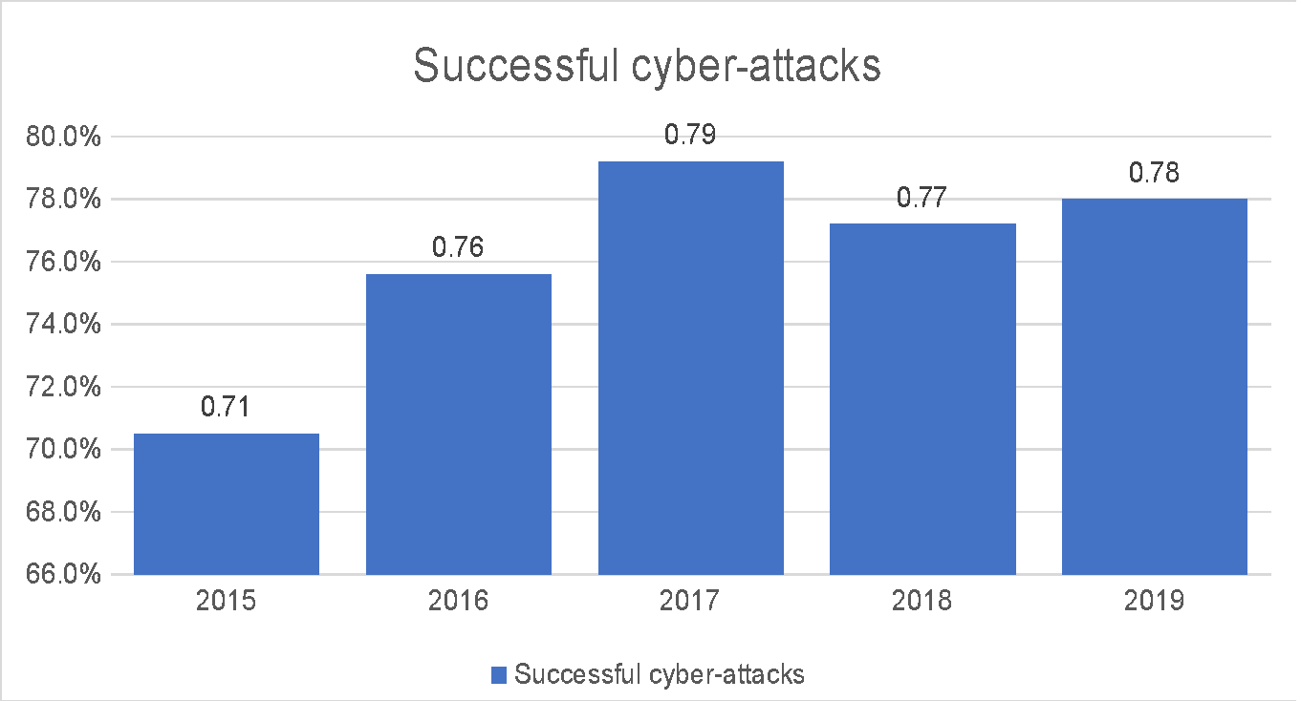
Figure 2-6: Cyber-attacks by sector, 2016. Source: (Control Risks, 2016)
This growth of attacks against the government infrastructure is also borne out by the increase in cyber-terrorism, discussed below. The difficulty that also may arise here is one of ‘gullibility’ – a hacker or cyber-attacker may have been convinced by his/her backers that (s)he is actually ‘doing the right thing’ by sabotaging government infrastructure. This combined with the popular growth of ‘conspiracy theory’ (Wood, 2015) may be the reason for this trend, but the fact that it is a trend is more important than discovering the reason that it has occurred. There is not room, here, to discuss the moral aspects of activism and terrorism in any context, but acceptance of the idea that they are growing can influence the way in which individual companies or governments deal with cyber-security.
  - Terrorism and cyber-attacks
This is another growth area for the future; governments around the world are increasingly online, and causing disruption to a government to which you are opposed is one of the aims of terrorism (Weimann, 2004). Cyber-terrorism is the same as any other form of terrorism except for its delivery (Zubrzycki, 2016), and like most other forms of terrorism needs funding which often comes from other criminal sources (Clarke, 2016a; Clarke, 2016b). However, from the point of view of cyber-attacks;
“Whether or not a cyber-attack against vital information infrastructure is viewed as an act of terrorism depends on the intent” (Heickerö, 2014, p. 555)
Although this is an emerging threat, it is more likely to be aimed at ‘establishment’ websites and information hubs than ordinary commercial companies. This does not mean that ordinary companies can be complacent about the risk, however. An awareness that it may occur should be built-in to any framework that is created.
  - The Development of Cyber Risk Management Frameworks
When cyber-risks began to be seen as something that applied to ‘ordinary’ companies as well as ‘high tech’ companies, the idea of the Critical Infrastructure (CI) became common;
“physical and cyber-based systems that are essential for day-to-day operation of the economy and government. [E.G. Banking,] Electric power production and distribution, water treatment and supply, gas and oil production and distribution, and telecommunications” (Ralston, Graham, and Hieb, 2007, p. 583)
In addition to the CI, it must also be remembered that these are also suppliers and clients of other companies, and the greater the connectedness, the greater the risk. Additionally, in a globalised business world (Held and McGrew, 2003), cyber-security is no longer a matter simply of national importance; cyber-crime is truly international, as proved by the recent banking attacks (Sky News, 2016).
Another emerging risk which has a major effect on connectivity and therefore on security is the concept of Platform as a Service (PaaS) (Li, Wang, Wang, Yu, and Qian, 2019). This approach, suggested for ‘smart cities’ increases the level of access to company data as can be seen in Figure 2 -7, below. This also brings into the balance the Internet of Things (IoT) Infrastructure as a Service (IaaS), which is a far less secure system (currently) than can be offered by the internet itself and could severely impact systems that have not considered attack from that direction.

