

Investigating the Influential Factors of Grade 4 Mathematics and Science TIMSS 2015 Results of the Content and Cognitive Domains in the UAE

استقصاء العوامل المؤثرة على نتائج طلبة الصف الرابع في اختبار التمز TIMSS 2015 لمادتي الرياضيات والعلوم في مجالات المحتوى والتفكير لدولة الإمارات العربية المتحدة

by
ASMA GHAZI BALFAQEEH

A thesis submitted in fulfilment
of the requirements for the degree of
DOCTOR OF PHILOSOPHY IN EDUCATION
at
The British University in Dubai

November 2020

Investigating the Influential Factors of Grade 4 Mathematics and Science TIMSS 2015 Results of the Content and Cognitive Domains in the UAE

استقصاء العوامل المؤثرة على نتائج طلبة الصف الرابع في اختبار التمز TIMSS 2015 لمادتي الرياضيات والعلوم في مجالات المحتوى والتفكير لدولة الإمارات العربية المتحدة

by

ASMA GHAZI BALFAQEEH
A thesis submitted to the Faculty of Education
in fulfilment of the requirements for the degree of
DOCTOR OF PHILOSOPHY IN EDUCATION
At
The British University in Dubai
November 2020

Thesis Supervisor
Professor Sufian A. Forawi

Approved for award:

________________________ ________________________
Name Name
Designation Designation

_________________________ ________________________
Name Name
Designation Designation

Date: ____________

DECLARATION

I warrant that the content of this research is the direct result of my own work and that any use made in it of published or unpublished copyright material falls within the limits permitted by international copyright conventions.
I understand that a copy of my research will be deposited in the University Library for permanent retention.
I hereby agree that the material mentioned above for which I am author and copyright holder may be copied and distributed by The British University in Dubai for the purposes of research, private study or education and that The British University in Dubai may recover from purchasers the costs incurred in such copying and distribution, where appropriate.
I understand that The British University in Dubai may make a digital copy available in the institutional repository.
I understand that I may apply to the University to retain the right to withhold or to restrict access to my thesis for a period which shall not normally exceed four calendar years from the congregation at which the degree is conferred, the length of the period to be specified in the application, together with the precise reasons for making that application.

_______________________
ASMA BALFAQEEH

COPYRIGHT AND INFORMATION TO USER
The author whose copyright is declared on the title page of the work has granted to the British University in Dubai the right to lend his/her research work to users of its library and to make partial or single copies for educational and research use.

The author has also granted permission to the University to keep or make a digital copy for similar use and for the purpose of preservation of the work digitally.

Multiple copying of this work for scholarly purposes may be granted by either the author, the Registrar or the Dean of Education only.

Copying for financial gain shall only be allowed with the author’s express permission.

Any use of this work in whole or in part shall respect the moral rights of the author to be acknowledged and to reflect in good faith and without detriment the meaning of the content, and the original authorship.

ABSTRACT
The educational sector in the UAE considers Trends in International Mathematics and Science Study (TIMSS) as a valuable indicator to trace educational improvements and to fulfil the country’s National Agenda 2021. By then, the nation aspires to become among the top rated educational systems in the world, simultaneously with the country’s National Day Golden Jubilee celebration. However, grades four students scored below the international norm in TIMSS 2015 in both subjects of mathematics and science. Viewing the benchmark results of TIMSS 2015 and 2011, the challenges in content and cognitive domains for the UAE students look similar.

The purpose of the study was to examine the factors that were associated with the students’ performance in the above mentioned domains. The study adopted the quantitative research approach through the data analysis of TIMSS UAE 2015 results for mathematics and science. Additionally, contextual questionnaires for schools, classrooms and student are put under scrutiny. The data analysis included independent sample T-Test, the analysis of variance ANOVA, multiple linear regression and Structural Equation Modelling (SEM).

The findings of the study showed that the association between the content and cognitive domains of mathematics and science for grade 4 TIMSS 2015 were very strong and positive. The analysis indicated that school, classroom and student factors had an association with mathematics and science achievement as well as the content and cognitive domains. The school factors that had a positive effect on students’ achievement were school location, resources, and economic background while principal experience had insignificant effect. The classroom factors that had a positive association with students’ achievement were discipline, mathematics instructional time and science investigation while science instructional time, mathematics homework and mathematics teachers’ degree had negative association. The results of the student factors showed that girls performed better than boys in mathematics and science. The student factor that had a positive association with students achievement were having breakfast on school days, engaging teaching in mathematics lessons, like learning science and confidence in mathematics and science. The student factors that had negative association were bullying and like learning mathematics. It was suggested that policy makers, school leaders and teachers need to focus on the factors that were associated with students’ performance in order to reduce the achievement gap of grade 4 UAE TIMSS results.

الخلاصة
يعتبر دراسة الاتجاهات الدولية في الرياضيات والعلوم (التمز) أداة قيمة تساعد في رصد الأهداف التعليمية في الأجندة الوطنية لدولة الإمارات العربية المتحدة 2021، تطمح دولة الإمارات من خلال هذه الرؤية إلى أن تكون من ضمن أفضل دول العالم على كافة المستويات عند الاحتفال باليوبيل الذهبي للإتحاد، ولكن كان معدل الصف الرابع في اختبار التيمز 2015 أدنى من المعدل الدولي في مادتي العلوم والرياضيات، وعند مراجعة نتائج الدولة في الدورتين 2011 و2015 كانت التحديات مماثلة في مجالات المحتوى والتفكير.
الهدف من الدراسة هو استقصاء العوامل المؤثرة على نتائج الطلاب في المحتوين، ولقد اتبعت الدراسة عملية البحث الكمية عن طريق تحليل بيانات اختبار (التمز) 2015 في دولة الإمارات العربية المتحدة لمادتي الرياضيات والعلوم بالاضافة إلى بيانات الاستبيانات المتعلقة بالمدرسة والصفوف الدراسية والطلبة، لقد استخدمت الدراسة العمليات التحليلية التالية: تحليل العينة المستقلة وتحليل التباين وتحليل الانحدار ونمذجة المعادلات الهيكلية.
وضحت نتائج الدراسة أن العلاقة بين مجالات المحتوى والتفكير لطلبة الصف الرابع في مادتي العلوم والرياضيات إيجابية وقوية، وأن العوامل المؤثرة المتعلقة بالمدرسة والصفوف الدراسية والطلبة لها تأثير على نتائج الطلبة وعلى مجالات المحتوى والتفكير، فالعوامل المدرسية ذات التأثير الإيجابي على نتائج الطلبة هي موقع المدرسة والمصادر والحالة الإقتصادية بينما خبرة مدير المدرسة لم يكن لها تأثير، والعوامل الصفية ذات التأثير الإيجابي على نتائج الطلبة هي الانضباط والوقت التعليمي لمادة الرياضيات وعملية الاستقصاء في مادة العلوم، بينما الوقت التعليمي لمادة العلوم والواجب المدرسي لمادة الرياضيات والدرجة العلمية لمعلمي الرياضيات كان لها تأثير سلبي، لقد كان أداء الإناث أفضل من الذكور في مادتي العلوم والرياضيات، أما بالنسبة للعوامل المتعلقة بالطلبة فقد كان الالتزام بوجبة الفطور في الأيام الدراسية والتدريس الجذّاب في الرياضيات وحب تعلم العلوم والثقة بالنفس ذات تأثير إيجابي بينما التنمر وحب تعلم الرياضيات كان لها تأثير سلبي على نتائج الطلبة، لقد اقترحت الدراسة أن يقوم صنّاع القرار وقادة المدرسة والمعلمين بالتركيز على العوامل المؤثرة على نتائج طلبة الصف الرابع للحصول على النتائج المرغوب فيها في اختبار التمز لدولة الإمارات.

ACKNOWLEDGMENTS
I would like to express my deepest gratitude to my Director of Studies, Prof. Sufian Forawi for his continues support through the process and generously has given his time, encouragement, feedback and support from the beginning to the completion of this study.
I was blessed with the support of my family who has been wonderfully encouraging throughout my studies. My sincere gratitude to my parents, for always have faith and confidence on me. Thanks for all your unconditional love and continuous prayers. I would like to thank my husband who always have been there for me, who have supported me in all kinds of situations, and encouraged me to complete the study. Also, I would like to acknowledge the constant support and encouragements I received from my brother and sisters. Thank you all for being a part of my life during this endeavour.

TABLE OF CONTENTS
LIST OF FIGURES V
LIST OF TABLES VI
LIST OF ABBREVIATIONS: IX
CHAPTER 1: INTRODUCTION 1
1.1 Background 1
1.2 Statement of the Problem 7
1.3 Purpose and Research Questions 9
1.4 Significance of the Study 11
1.5 Organization of the Study 13
CHAPTER 2: THEORETICAL FRAMEWORK AND LITERATURE REVIEW 15
2.1 Theoretical Framework 16
2.1.1 TIMSS Curriculum Model 17
2.1.2 Piaget’s Theory of Cognitive Development 19
2.1.3 Slavin Model 22
2.2 Literature Review 30
2.2.1 Standardized Assessments 30
2.2.2 TIMSS Assessment 36
2.2.3 Factors Associated with TIMSS Performance 40
2.2.5 Content Domain 91
2.2.6 Cognitive Domain 95
CHAPTER 3: METHODOLOGY 100
3.1 Research Approach 101
3.2 Site and Population 104
3.3 TIMSS 2015 Sample Design 107
3.4 TIMSS 2015 Data Collection Instruments 111
3.4.1 TIMSS 2015 Assessment Items 111
3.4.2 TIMSS 2015 Context Questionnaires 114
3.5 TIMSS 2015 Field Test 116
3.6 Validity and Reliability 117
3.7 Data Analysis 120
3.8 Selection of Variables 123
3.9 Ethical Considerations 131
CHAPTER 4: DATA ANALYSIS and RESULTS 133
4.1 Preparing Data for Analysis 134
4.2 Missing Data 137
4.3 Factor Analysis 137
4.4 Results of Research Questions 139
4.5 Results of Research Question 1 141
4.5.1 Descriptive Statistics for the content and cognitive domains 142
4.5.2 Correlation Analysis between the Content and Cognitive Domains 143
4.5.3 Summary of Results of Research Question 1 148
4.6 Results of Research Question 2 – School Factors 149
4.6.1 Descriptive Analysis of School Factors 149
4.6.2 ANOVA Analysis for School Factors and Mathematics Achievement 151
4.6.3 ANOVA Analysis for School Factors and Science Achievement 154
4.6.4 Correlation Analysis for School Factors 158
4.6.5 Multiple Linear Regression for School Factors 159
4.6.6 Structural Equation Modelling (SEM) for School Factors 162
4.6.7 Summary of Results of Research Question 2 – School Factors 173
4.7 Results of Research Question 3 – Classroom Factors 177
4.7.1 Descriptive Analysis for Classroom Factors 177
4.7.2 ANOVA Analysis for Classroom Factors with Mathematics Achievement 180
4.7.3 ANOVA and T-Test Analysis for Classroom Factors with Science Achievement 186
4.7.4 Correlation Analysis for Classroom Factors 193
4.7.5 Multiple Linear Regression for Classroom Factors 195
4.7.6 Structural Equation Modelling (SEM) for Classroom Factors 199
4.7.7 Summary of Results of Research Question 3 – Classroom Factors 211
4.8 Results of Research Question 4 – Student Factors 218
4.8.1 Descriptive Statistics for Student Factors 218
4.8.2 ANOVA and T-Test Analysis for Student Factors with Mathematics Achievement 220
4.8.3 ANOVA and T-Test Analysis for Student Factors with Science Achievement 225
4.8.4 Correlation Analysis for Student Factors 229
4.8.5 Multiple Linear Regression for Student Factors 231
4.8.6 Structural Equation Modeling (SEM) for Student Factors 235
4.8.7 Summary of Results of Research Question 4 – Students Factors 246
4.9 Summary of All Results in Chapter 4 251
CHAPTER 5: DISCUSSION, CONCLUSION, RECOMMENDATIONS and LIMITATIONS 253
5.1 Discussion of Research Question 1 255
5.2 Discussion of Research Question 2 260
5.2.1 School Location 262
5.2.2 School Resources 264
5.2.3 Economic Background 267
5.2.4 Principal Experience 270
5.3 Discussion of Research Question 3 272
5.3.1 discipline 273
5.3.2 Technology 276
5.3.3 Instructional Time 278
5.3.4 Homework 280
5.3.5 Ongoing Assessment 283
5.3.6 Professional Development 285
5.3.7 Teacher Degree 287
5.3.8 Science Investigation 288
5.4 Discussion of Research Question 4 290
5.4.1 Gender 292
5.4.2 Breakfast on School Days 294
5.4.3 Bullying 296
5.4.4 Like Learning Mathematics and Science 297
5.4.5 Engagements in Lessons 299
5.4.6 Confidence in Learning 302
5.5 Conclusion 303
5.6 Recommendations and Implications 305
5.6.1 Research Recommendation 305
5.6.2 Research Implications 306
5.7 Limitation of the Study 311

LIST OF ILLUSTRATIONS
Figure 1: Theoretical Framework of the Current Study 17
Figure 2: TIMSS Curriculum Model 18
Figure 3: Elements of the QAIT Model 23
Figure 4: Elements of Slavin Model 28
Figure 5: Factors Effect Students’ TIMSS Achievement 29
Figure 6: Development of Standardized Assessment 34
Figure 7: Sampled Schools by Emirate for Grade 4 110
Figure 8: Student sample by the curriculum at Grade 4 111
Figure 9: SEM Model for School Factors with the Mathematics Content Domains 164
Figure 10: SEM Model for School Factors with the Cognitive Domain of Mathematics 167
Figure 11: SEM model for School Factors with the Content Domain of Science 170
Figure 12: SEM Model School Factors with the Cognitive Domain of Science 172
Figure 13: SEM Model for Classroom Factors with the Content Domain of Mathematics 201
Figure 14: SEM Model for the Classroom Factors with the Cognitive Domains of Mathematics 203
Figure 15: SEM Model for the Classroom Factors with the Content Domains of Science 207
Figure 16: SEM Model for the Classroom Factors with the Cognitive Domains of Science 210
Figure 17:SEM Model for Student Factors with the Content Domain of Mathematics 237
Figure 18: SEM Model for Student Factors with the Cognitive Domain of Mathematics 239
Figure 19: SEM Model for Student Factors with the Content Domains of Science 242
Figure 20: SEM Model for Student Factors with the Cognitive Domains of Science 245

LIST OF TABLES
Table 1: Percentages of TIMSS 2015 assessment items for the content and cognitive domains. 112
Table 2: Data Analysis Plan to Answer Research Questions 123
Table 3: Selected Variables of School Factors 125
Table 4: Selected Variables of Classroom Factors 128
Table 5: Selected Variables of Student Factors 131
Table 6: Factor Analysis for TIMSS variables 138
Table 7: Descriptive Statistics for the content and cognitive domains: 143
Table 8: Correlation Analysis between the Content and Cognitive Domains for Mathematics TIMSS 2015 145
Table 9: Correlation Analysis between the Content and Cognitive Domains for Science TIMSS 2015 147
Table 10: Descriptive Statistics of School Factors 150
Table 11: One-way ANOVA Results of School Location and Mathematics Achievement 151
Table 12: One-way ANOVA Results of Principal Experience and Mathematics Results 152
Table 13: One-way ANOVA Results of Shortage of Math Resources and Mathematics Results 153
Table 14: One-way ANOVA Results of Economic Background and Mathematics Results 154
Table 15: One-way ANOVA Results of School Location and Science Results 155
Table 16: One-way ANOVA Results of Principal Experience and Science Results 156
Table 17: One-way ANOVA Results of Shortage of Science Resources and Science Results 157
Table 18: One-way ANOVA Results of Economic Background and Science Results 157
Table 19: Correlation between School Factors and Mathematics and Science Achievement 158
Table 20: Regression Analysis of School Factors with Mathematics Results 160
Table 21: Regression Analysis of School Factors with Science Results 162
Table 22: SEM Analysis for School Factors with Mathematics Content Domains 163
Table 23: SEM Analysis for School Factors with the Mathematics Cognitive Domain 166
Table 24: SEM Analysis for School Factors with Science Content Domain 169
Table 25: SEM Analysis for School Factors with Science Cognitive Domain 171
Table 26: Descriptive Statistics for Classroom Factors 179
Table 27: One-way ANOVA Results of Disciple and Mathematics Achievement 181
Table 28: One-Way ANOVA Results of Math Instructional Time and Mathematics Achievement 181
Table 29: One-Way ANOVA Results of Mathematics Homework and Mathematics Achievement 182
Table 30: One-Way ANOVA Results of Assessment of Ongoing Work and Mathematics Achievement 183
Table 31: One-Way ANOVA Results of Mathematics PD and Mathematics Achievement 184
Table 32: One-way ANOVA Results of Teacher Degree and Mathematics Achievement 185
Table 33: One-way ANOVA Results of Mathematics Technology and Mathematics Achievement 186
Table 34: One-way ANOVA Results of Discipline and Science Achievement 187
Table 35: One-way ANOVA Results of Science Instructional Time and Science Achievement 187
Table 36: One-way ANOVA Results of Science Technology and Science Achievement 188
Table 37: One-way ANOVA Results of Science Homework and Science Achievement 189
Table 38: One-way ANOVA Results of Assessment of Ongoing Science Work and Science Achievement 190
Table 39: One-Way ANOVA Results of Science PD and Science Achievement 191
Table 40: One-way ANOVA Results of Teacher Degree and Science Achievement 192
Table 41: Independent sample T-Test between Science Investigation and Science Achievement 192
Table 42: Correlation Analysis between Classroom Factors and Math Achievement 193
Table 43: Correlation Analysis between Classroom Factors and Science Achievement 194
Table 44: Regression Analysis of Classroom Factors with Math Achievement 196
Table 45: Regression Analysis of Grade 4 classroom factors with science TIMSS results 198
Table 46: SEM Analysis for Classroom Factors with Math Content Domain 199
Table 47: SEM Analysis for Classroom Factors with the Cognitive Domain of Mathematics 202
Table 48: SEM Analysis for the Classroom Factors with Content Domains of Science 205
Table 49: SEM Analysis for the Classroom Factors with the Cognitive Domain of Science 208
Table 50: Descriptive Statistics of Student Factors 219
Table 51: Independent Sample T-Test for Gender and Mathematics Achievement 220
Table 52: One-way ANOVA Analysis of Breakfast on School Days and Mathematics Achievement 221
Table 53: One-way ANOVA Results of Bullying and Mathematics Achievement 222
Table 54: One -way ANOVA Analysis Results of Like Learning Mathematics and Mathematics Achievement 223
Table 55: One-way ANOVA Analysis Results of Engagement in Math Lessons and Mathematics Achievement 223
Table 56: One-way ANOVA Analysis Results of Confidence in Mathematics and Mathematics Achievement 224
Table 57: T-Test between Gender and Science Achievement 225
Table 58: One-way ANOVA Analysis Results of Breakfast on School Days and Science Achievement 226
Table 59: One-way ANOVA Analysis Results of Bullying and Science Achievement 227
Table 60: One-way ANOVA Analysis Results of Like Learning Science and Science Achievement 227
Table 61: One-way ANOVA Analysis Results of Engagement in Science Lessons and Science Achievement 228
Table 62: One-way ANOVA Analysis Results of Confidence in Science and Science Achievement 229
Table 63: Correlation Analysis of Student Factors with Math and Science Achievement 230
Table 64: Regression Analysis Results of Student Factors with Mathematics Achievement 232
Table 65: Regression Analysis Results of Student Factors with Science Achievement 234
Table 66: SEM Analysis of Student Factors Model with the Mathematics Content Domain 235
Table 67: SEM Analysis of Student Factors with the Cognitive domains of Mathematics 238
Table 68: SEM Analysis for Student Factors with Content Domains of Science 241
Table 69: SEM Analysis for Student factors with Science Cognitive Domains 244

LIST OF ABBREVIATIONS:
TIMSS Trends in International Mathematics and Science Study
NRC National Research Coordinator
PPS probabilities proportional to size (PPS)
QIRC International Study Centre Questionnaire Item Review Committee
SEM Structural Equation Modeling
ADEK Abu Dhabi Department of Education and Knowledge
MOE Ministry of Education
PEARL Progress in International Reading Literacy Study
PISA Programme for International Student Assessment
STEM Science, Technology, Engineering and Mathematics

CHAPTER 1: INTRODUCTION
To skill and equip our students for the needs of 21st century international economies, educators should strive to develop their collaborative, creative, critical thinking, global awareness, technological and problem-solving skills (Applied Educational Systems 2019). These skills can be attained through a high-quality education system where these skills are intertwined with the best practices of good classroom instruction (Metz 2011). The UAE government has committed a huge section of the country’s budget on developing its education system. In 2018, the education system received 10.4 billion dirhams from the federal budget to develop its education programs and make them compatible with the needs of the future (UAE Ministry of Education 2019).
The UAE Ministry of Education (MOE) launched its Ministry of Education Strategic Plan 2017-2021 which is a five-year plan to provide significant improvements to the UAE’s education system especially in teaching and learning (MOE 2020). The plan includes: “Develop an innovative Education System for a knowledge and global competitive society, that includes all age groups to meet future labor market demand, by ensuring quality of the ministry of education outputs, and provision of best services for internal and external customers” (MOE 2020, p. 1 of 4). For the implementation of this Education strategy, it is important to evaluate the quality and the efficiency of the educational programs through international baseline assessments (Slavin 2006).

1.1 Background
The international baseline assessments or standardized assessments help to measure the outcomes of education systems throughout the world and determine the effectiveness of the different educational systems across the globe (Tymms, Merrell & Jones 2004). These assessments provide countries with an opportunity to compare the knowledge, abilities and skills of their students with those of other countries, as well as with the international norm. Standardized exams are a valuable instrument during educational research as they help in assigning a numerical score to students' performance in a specific area (Ary, Jacobs & Sorensen 2010). Madaus, Russell and Higgins (2009) show how people in society trust specific numbers and believe that standardised test scores are a fair and precise way to make objective judgments about schools, students, teachers and educational programs. On the other hand, when an assessment system uses tests that are not standardized, society believes that the system is more likely to be unfair to some students (Sireci 2005).
Standardized exams are a fundamental part of the school reform process which aims at helping the students acquire the necessary knowledge and understand of the content area by using these results to improve their education (Shermis & Di Vesta 2011). The regular data from standardized tests helps to examine the school programs, analyze and make meaning of the collected data, and uses this to design action plans to address concerns from the collected information (Tankersley 2007). Madaus, Russell and Higgins (2009) explained that policymakers consider standardized tests to develop solutions for problems because they cannot directly regulate classroom teaching practices. However, they can indirectly influence teaching instruction by establishing rewards and sanctions for mandated tests. The rewards will be provided for schools that have high achievement while the sanctions for school that had low achievement.
The UAE values its participation in many international standardized assessments to assess and examine the performance of its education system (UAE government, 2019). The tests include the PISA (Programme for International Student Assessment), TIMSS (Trends in International Mathematics and Science Study) and PIRLS (Progress in International Reading Literacy Study). The UAE National agenda aims at making the country one of the top performers in these assessments by 2021.
International baseline assessments help the UAE to deliver high-quality educational programs according to international levels. The Abu Dhabi Department of Education and Knowledge (ADEK) stated that "ADEK believes that these assessments are a central component of delivering high-quality education that continually improves upon itself" (ADEK, 2019, p. 2 of 4). ADEK believes that standardized assessments provide essential data to develop curriculum, help teachers to adapt their teaching and provide students with the chance for self-evaluation (ADEK 2019).
One of the essential comparative international assessment studies is the Trends in International Mathematics and Science Study (TIMSS). TIMSS is a comparative international assessment study that is conducted by the International Association for the Evaluation of Educational Achievement (IEA). This assessment concentrates on students in grades four and eight and is carried out every four years (IEA 2019). TIMSS aims at studying how educational opportunities are provided for students and what factors are associated with these opportunities (Mullis 2016). The learning opportunities include the organization of the education system, learning in classrooms, teacher characteristics, teaching approaches, and student perspectives about learning Mathematics and Science (Mullis 2016).
TIMSS provides more than merely a ranking of the countries, according to student achievement. The results of the questionnaires give an in-depth analysis of the characteristics of the educational system, school context, classroom practices and student characteristics (Drent, Meelissen & Van Der Kleij 2013). Additionally, TIMSS collects data about the factors related to student learning such as teaching practices, resources, parental involvement and student attitudes (IEA 2016). One of the most critical strengths of the IEA studies, and TIMSS in particular, is the fact that they are classroom-based. Therefore, the contexts that are provided on teaching and learning can be related to student achievement (Drent, Meelissen & Van Der Kleij 2013).
Studies in the literature highlighted many factors that were associated with student performance. These factors could be categorized into school, classroom and student factors. For school factors, different studies investigated the association of the students' economic background, school location, resources and school principal on student attainment. Studies in the literature indicated that there is an association between the students' economic background and their academic achievement, as students with a low socioeconomic status performed lower in schools (Breger 2017; Stumm 2017; Takashiro 2017). For the location of schools, being located in a rural area has been identified as a significant factor that decreases student attainment (Ramos, Duque & Nieto 2016; Zhijun, Zeyun & Baicai 2016; Murphy 2018; Lu et al. 2019). For school resources, studies revealed a positive relationship between the school resources and student learning (Sabah & Hammouri 2010; Adelodun & Babatunde 2015; Lumpkin 2016; Lay & Chandrasegaran 2016; Kweon et al. 2017; Gigliotti & Sorensen 2018). For principal practices, studies indicated a positive relationship between principals' instructional leadership practices and student outcomes (Dhuey & Smith 2018; Park, Lee, & Cooc 2018; Tan 2018a; Aburizaizah, Kim & Fuller 2019; Wu, Gao & Shen 2019).
Classroom factors that were highlighted in the literature were instructional time, technology, teacher degrees, professional development, classroom practices, classroom assessments and discipline. There were inconsistent findings on the association of instructional time, and student attainment. Some studies indicated that an increase in the academic instructional time was associated with better student performance (Fisher et al. 2015; Cattaneo, Oggenfuss &Wolter 2017) while other studies concluded that learning time has no influence on student performance (Gorman 2014; Catur & Usman 2019). Studies on the integration of technology in the literature reveal differences in the impact of this, according to the year of implementation, teaching practices and specific grade levels (Meggiolaro 2018; Aburizaizah, Kim & Fuller 2019). For teacher degrees, Obonyo, Bin and Maina (2018) stated that there is no significant association between teacher degrees and student achievement while Coenen et al. (2018) concluded that subject-specific certification contributes to better learning.
Regarding classroom practices, Aktamiş, Hiğde, and Özden (2016) argued that inquiry-based learning methods used in science classrooms had a more significant effect on student achievement compared to traditional teaching methods. The use of formative assessment has been highlighted in several studies because of its positive impact on student achievement (Andersson & Palm 2017; Faber, Luyten & Visscher 2017; Ozan & Kıncal 2017). Finally, several studies in the literature indicated a positive association between discipline systems and student attainment (Milam, Furr-Holden and Leaf 2010; Gietz & McIntosh 2014; Sulak 2016; Al-Raqqad et al. 2017; Lacey, Cornell & Konold 2017; Anderson, Ritter and Zamarro 2019)
While analyzing student factors, different studies have focused on the relationship between gender, student needs, self-concept and motivation with academic performance. Gender has been an interesting topic in educational research to analyze the differences in academic performance between boys and girls (Meinck & Brese 2019). However, studies in the literature have inconsistent findings regarding the differences in educational achievement between male and female students. For student needs, Anderson, Gallagher and Ritchie (2018) concluded that a healthy diet improves students cognitive functions. While motivation and self-concept have been identified in many studies as factors that have a positive association with student performance (Wang & Liou 2017; Şahin and Öztürk 2018).
There are two different dimensions of learning a subject; the content of the task and the cognitive skills required to solve the task (Männamaa et al. 2012). The cognitive domain refers to the thinking process and skills that are needed to respond to the assessment items (IEA 2019). TIMSS questions assess the student abilities in expressing their knowledge, applying this knowledge in different contexts, problem-solving, and reasoning during the thinking process (Mullis 2016). On the other hand, the content domain focuses on the subject or topics that need to be assessed (IEA 2019). It refers to the knowledge, abilities or skills that need to be measured (Gonzalez 2019). The content domain needs to cover all the aspects of the subject by well-defined learning objectives (Gonzalez 2019). The study focused on investigating the content and the cognitive domains for students in the TIMSS 2015 results.

1.2 Statement of the Problem
TIMSS results have been highly valued by international policymakers and also by the government of the United Arab Emirates (UAE), as they are considered a key indicator for the quality of science and mathematics teaching and learning (UAE Ministry of Education 2017). In 2010, H.H. Sheikh Mohammed bin Rashid Al Maktoum, Vice-President and Prime Minister of the UAE and Ruler of Dubai launched the UAE vision 2021 which aims at making the country one of the top countries in the world when celebrating the 50 years of its union (Vision 2021 2018). To translate this vision into reality, the plan has six national pillars, and one of these pillars is to provide its students with a first-rate education system to prepare them for the 21st-century challenges (Vision 2021 2018). One of the performance indicators of this pillar is for the students of the UAE to be amongst the top fifteen performers in the TIMSS results. However, when looking at the UAE results in TIMSS 2015, it can be noted that grade 4 students need to improve by 20 ranks in both Mathematics and Science (UAE Ministry of Education 2017). Therefore, the factors that were associated with the UAE's student results in the TIMSS 2015 research need to be investigated to meet this national vision.
Even though the UAE vision 2021 might appear to be outdated in regards to the date that the study was conducted, it has been highlighted in the study because it had clear indicators about standardized assessments in general and the TIMSS research in particular. It valued education as an indicator for making the country one of the top nations in the world, according to international standards such as international baseline assessments. Another important factor is to make sure that the UAE reaches its Vision 2021 targets and maintains the progress of student achievement. This means that we need to ensure that the UAE students continue to grow and improve their TIMSS results cycle after cycle.
The Slavin model represents factors that were associated with student results (Slavin 1995) and is the primary model adopted for this study. In this model, factors were divided into three categories that were aligned with the TIMSS 2015 framework, which were schools, classrooms and students. Different studies in the literature investigated the impact of these factors on student attainment. However, most of the previous studies focused on a specific factor or used the data from one or two contextual questionnaires. This study used the factors from three types of contextual questionnaires which were principal, teacher and student. The factors were selected carefully based on the literature and factor analysis, then combined in multiple linear regression models.
Most of the TIMSS analysis studies in the literature were conducted on European, American, or East Asian students. No published studies focused on the students from the United Arab Emirates in-depth. This study focused on the TIMSS 2015 results in the UAE and investigated the factors that were associated with student results according to the school, classroom and student context.
Although several research studies have been conducted on student achievement based on TIMSS, most of these studies investigated the connections between student results as one variable, without taking into consideration the content and the cognitive domains of the subjects of Mathematics and Science. Camilli and Dossey (2019) showed that investigating the content domain in TIMSS helps countries to develop a more strategic use of these test results. Studying the content domain help countries to obtain diagnostic information that helps to differentiate aspects of education on a national level and provides more supplementary information as each country emphasizes different elements in the content domain (Camilli & Dossey 2019). Looking back at the results of the TIMSS 2015 and 2011 research in the UAE, the challenges in the content and cognitive domains are similar (UAE Ministry of Education 2017). The major challenges for Grade 4 students were in Geometry, Earth Science, Life Science and Reasoning (UAE Ministry of Education 2017). Thus, the content and cognitive domain in TIMSS needs to be investigated further as the results have remained the same over two test cycles. The current study investigated the factors that were associated with TIMSS attainment of the content and cognitive domains of mathematics and science.

1.3 Purpose and Research Questions
The purpose of this study was to examine the factors that have an association with the grade four students’ mathematics and science TIMSS 2015 results in the content and cognitive domains in the United Arab Emirates. The content domains in Mathematics are Numbers, Geometry, and Data Display while for science these were Life Science, Physics and Earth Science (IEA 2019). The cognitive domains of Knowing, Applying and Reasoning are the same across these subjects (IEA 2019). The study used the recently published data of TIMSS assessment which was TIMSS 2015 as TIMSS 2019 data was not published when conducting the current study.
Grade 4 was selected for this study because it is a transition stage to middle school in which the students are in the “Concrete Operational Stage” referring to Piaget’s “cognitive development theory” (McLeod 2010). In this stage, students can think more logically and understand the transformation of objects (Long et al. 2011). TIMSS assessment was selected because it focused on mathematics and science which are two important subjects that the UAE national policies emphasize and valued their applications (Government.ae 2018). The study focused on the UAE because it is the nationality of the researcher.
The items in the contextual questionnaire have been referred to as factors that were associated with student results following previous research studies in the literature that focused on TIMSS data analysis. The study followed Drent, Meelissen & Van Der Kleij (2013), Patnam (2013), Bruner (2014); House & Telese (2015) and Mohammadpour, Kalantarrashidi & Shekarchizadeh (2015) studies that refer to TIMSS questionnaire items as school, classroom and student factors.
The main aim of the study was to investigate the relationships between grade 4 UAE students’ science and mathematics TIMSS 2015 results in the content and the cognitive domains with the factors of the TIMSS 2015 questionnaires on schools, classrooms and students in accordance with the Slavin model. This helped to investigate the factors that affect students’ results in TIMSS assessment and identify the factors that have the most significant impact. The research addressed the following questions:
- What are the relationships among grade 4 UAE students’ science and mathematics TIMSS 2015 results in the content and the cognitive domains?
- What are the factors of the school questionnaire that are associated with grade 4 mathematics and science TIMSS 2015 results in the content and cognitive domains of the UAE?
- What are the factors of the teacher questionnaires that are associated with grade 4 mathematics and science TIMSS 2015 results in the content and cognitive domains of the UAE?
- What are the factors of the student questionnaires that are associated with grade 4 mathematics and science TIMSS 2015 results in the content and cognitive domains of the UAE?

1.4 Significance of the Study
Referring to the UAE Ministry of Education report on the TIMSS 2015 results, there was an improvement in the UAE results from the last cycle of 2011 (UAE Ministry of Education 2017). However, grade 4 student scores were still below the international norm in both Mathematics and Science (below 500 points). Grade 4 students were ranked 35th internationally in Mathematics and Science, while the national target is to be one of the top 15 countries in the world (Vision 2021 2018). Results of TIMSS 2015 indicated that there was a gap in the teaching and learning process, as the students performed below the expectations. This gap needs to be investigated in order to identify whether it was related to school, classroom or student factors. Analysing these factors and how they affect student performance will help to reduce this gap.
TIMSS assessment provides a tremendous amount of data and information that might be overwhelming to policymakers. This data includes assessment item results in Mathematics and Science as well as the contextual questionnaire items for principals, teachers and students (IEA 2019). TIMSS assessment item questions were categorized into content and cognitive domains in each subject. This study specified the factors that were associated with students’ performance according to the content and cognitive domains and classified them according to schools, classrooms and students factors. Thus, the results help policymakers to understand the factors that are associated with each context, determine the factors that have the greatest impact on students’ performance, and plan the modifications needed in the curriculum, resources, and the teaching and learning process.
By explaining the factors associated with student performance, researchers and policymakers can identify the ways that will help to raise these scores. There has been a large body in the literature that has highlighted different factors that could impact student performance. These factors are related to the school, classroom and students. However, there have been limited studies conducted in the UAE that investigate the impact of these factors on TIMSS performance. This study selected the factors that have been highlighted in the literature as being associated with student performance, and it studied their association with the UAE TIMSS 2015 results. Addressing these factors is critical to raise the overall TIMSS performance of the country and meet the vision of 2021.
The data analysis techniques that were used in the current study utilized all the plausible values of students’ achievement. As TIMSS assessment does not provide individual scores for students, it estimated the population parameters such as average and variance. Therefore, there were five plausible values for mathematics and science achievement as well as plausible values for the content and cognitive domains. The use of plausible values in these large scale assessments has been advocated since the National Assessment of Educational Progress (NAEP) used this reporting technique (Davier, Gonzalez & Mislevy 2009). Rutkowski et al. (2010) stated that some researchers choose to use one of the plausible values for the analysis which leads to underestimating the standard errors and ignoring the uncertainty associated with the measurement of students’ achievement. The study utilized all the five plausible values of student achievement in conducting the data analysis to make sure that biased estimation was avoided.
The study used Structural Equation Modelling (SEM), which is a widely used statistical analysis approach in social sciences. It is a combination of factor analysis, regression or path analysis. It is a powerful technique that can be used to test and evaluate the multivariate relationship of a specific model (Fan et al. 2016). The advantage of SEM is that it can test direct and indirect relationship effects in one particular model (Fan et al. 2016). The study created SEM analysis models for the factors that were associated with the students TIMSS 2015 results in the content and cognitive domains. This model helped in having a visual representation of the theoretical model of the study with the numerical analysis of factor analysis and regression. Also, SEM analysis provides a numerical estimation of the strength of the model to determine how the association between different factors of school, classroom and students were related to the mathematics and science content and cognitive domains.

1.5 Organization of the Study
The current study consists of five chapters. The first chapter represents the introduction of the study. It includes the background and context of the study, statement of the problem, the aim of the research, research questions and significance of the study. Chapter 2 consists of the theoretical framework and a review of the previous studies in the literature. The theoretical framework of the study consists of two models and one theory which were the Slavin model, TIMSS curriculum model and Piaget cognitive development theory. The primary model of the study was the Slavin model as it identified the factors that could influence student performance. The literature review section consists of five major parts: an overview of standardized assessment, TIMSS, factors associated with student performance, content domain and cognitive domain. This chapter was followed by the methodology section that provides an overview of the research approach, which was a purely quantitative study. Chapter 3 also provides information about the participants, sampling, instruments and data analysis approaches. The results of the study were represented in chapter 4, which includes the data analysis techniques such as descriptive analysis, a one-way ANOVA analysis, independent sample T-Test, correlation, multiple regression and SEM. The final chapter includes the discussion, conclusion, recommendations and limitations. It provides an interpretation and the significance of the findings as well as comparing them to previous studies in the literature. It also has the implications of the study, limitations of the research and recommendation for future studies.

CHAPTER 2: THEORETICAL FRAMEWORK AND LITERATURE REVIEW
The educational sector in the UAE considers the Trends in International Mathematics and Science Study (TIMSS) as a valuable indicator to trace educational improvements and to fulfil the country’s National Agenda 2021 aims. By then, the nation aspires to become among the top-rated educational systems in the world, coinciding with the country’s National Day Golden Jubilee celebration. However, grade four students scored below the international norm in TIMSS 2015 in both subjects of mathematics and science. The purpose of this study is to examine the factors that have an association with grade four students’ mathematics and science TIMSS 2015 results in the content and cognitive domains in the United Arab Emirates. Looking back at the results of the TIMSS 2015 and 2011 studies in the UAE, the challenges in the content and cognitive domains are similar (UAE Ministry of Education 2017). The significant challenges for the fourth-grade students were in Geometry, Earth Science, Life Science and Reasoning (UAE Ministry of Education 2017). Thus, the content and cognitive domains of the UAE TIMSS need to be investigated further as they have remained the same over two test cycles. This study investigated factors that were associated with the TIMSS 2015 attainment of the content and cognitive domains in the UAE.
The current chapter begins by laying out the theoretical dimensions of the research. The theoretical framework of the study consists of two models and one theory which were the Slavin model, TIMSS curriculum model and the Piaget cognitive development theory. Then, it presents an overview about the standardized assessments in general and TIMSS study in particular. After that, it outlines the key studies that identified that factors associated with students’ performance according to school, classroom and student. Finally, it provides an overview about the content and cognitive domains.

2.1 Theoretical Framework
The theoretical framework of the study consisted of two models and one theory which were the TIMSS curriculum model, Slavin model and the Piaget cognitive development theory. As demonstrated in figure 1, the models and the theory were associated with each other and connected students’ TIMSS 2015 results in the content and cognitive domains. The Slavin model, which was the main model of the study consisted of the (QAIT) model and student input. The (QAIT) model was associated with school and classroom factors that were part of the TIMSS 2015 implemented curriculum. Student input was associated with student factors that were part of the TIMSS attained curriculum. TIMSS 2015 attained curriculum also included student results in Mathematics and Science in the content and cognitive domains. TIMSS attained curriculum was influenced by TIMSS 2015 implemented curriculum and the Piaget cognitive development theory. The models and the theory are discussed in detail below.

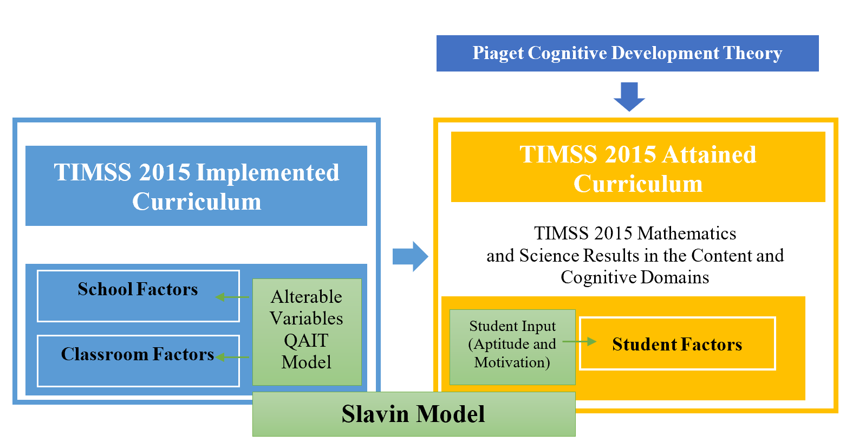
Figure 1: Theoretical Framework of the Current Study

2.1.1 TIMSS Curriculum Model
The TIMSS curriculum model aims at investigating how learning opportunities are provided to students and what factors impact those opportunities (Mullis 2016). Figure 2 shows the TIMSS curriculum model that consists of three parts (Mullis 2016): (1) The intended curriculum refers to the mathematics and science learning expectations for students in the country’s curriculum, and those which the education system attempts to facilitate learning; (2) The implemented curriculum refers to classroom teaching practices and what is actually implemented in the classroom; and (3) The attained curriculum refers to what the students learned and their perceptions about learning mathematics and science.
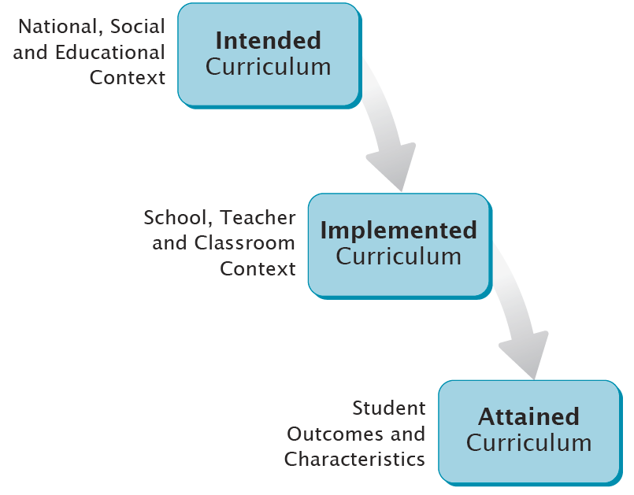
Figure 2: TIMSS Curriculum Model
(from Mullis 2016, p. 5)
For the intended curriculum, TIMSS documents all the educational policies of the mathematics and science curriculum for the participating countries and updates them on each assessment cycle (IEA 2019). All participant countries are requested to prepare a chapter that details the structure of their education system, school curriculum, classroom instruction for primary and secondary schools, teacher qualification requirements, and assessments (Mullis 2016). Along with this requested information, countries are also requested to fill a questionnaire about their curriculum in mathematics and science, instructional practices and the structure of the education system (Mullis 2016).
The implemented curriculum data is collected through principals, teachers and student questionnaires about their school and classroom contexts. Data from the questionnaires provide information about the actual implementation of the educational policies as well as the effective procedures inside schools and classrooms (Mullis 2016). The attained curriculum refers to what the students have learned through the learning process. It is not measured only by student grades since it also involves student attitudes and characteristics that have been developed throughout the learning process (Dindyal 2006).
The study focused on the implemented and attained curriculum because the implemented curriculum refers to the school, classroom and student factors that were associated with student performance, while the attainment curriculum relates to the student results of TIMSS assessment items for mathematics and science for grade 4 students in the content and cognitive domains. The content domain specifies the subject matter that includes topic area and where each topic included subtopics (Mullis & Martin 2013). The cognitive domain refers to the thinking process and skills that are required to respond to the assessment items. An important theory that explains the development of children cognitive skills is Piaget's Theory.

2.1.2 Piaget’s Theory of Cognitive Development
Piaget's (1936) Theory of Cognitive Development focuses on the way humans construct and use knowledge based on their biological development and interaction with the environment. He proposed that children's mental abilities go through a series of stages due to the change in the fundamental logical process (Long et al. 2011). Piaget cognitive development theory showed that human development is gradual and step by step structure of change as each new mental skill is based on the skills of the previous stage (Flavell 1996). During the cognitive stages, children do not passively copy whatever is present in their environment as the cognitive strategies available at the point of their development allows them to distinguish what is meaningful to them (Flavell 1996). The four stages in Piaget's theory are (Long et al. 2011): (1) The Sensori-Motor Stage which spans between zero to two years of age; (2) The Pre- Operational Stage: from two to seven years of age; (3) The Concrete Operational Stage: which lasts roughly from seven to twelve years of age; and (4) The Formal Operational Stage: which the last stage of cognitive development that starts from 12 years.
The focus of the study was for grade 4 students who were in the Concrete Operational Stage. Grade 4 students are approximately 9.5 years old, which sets them in the Concrete Operational Stage. This stage is considered the turning point of a child's cognitive development, language and fundamental skills as it is the start of logical and operational thinking (Ojose 2008; McLeod 2010). During this stage, students can distinguish the different features of objects by using physical manipulatives (Long et al. 2011). Children can also use their senses to recognize two or three dimensions of objects simultaneously (Ojose 2008). An example in science is the liquid experiment when the child recognizes two dimensions at the same time, which are the level of the liquid and the wideness of the dish or the cup (Ojose 2008). In mathematics, children develop two logical operational skills: seriation and classification. Seriation is ordering the objects in ascending or descending order based on their volume, length, or weight, while classification is the grouping of objects based on common features (Ojose 2008).
In the concrete operational stage, the students gain the ability to understand the property of conservation and reversibility, develop rational thinking, solve problems in logical ways but are not able to think abstractly yet (McLeod 2010). According to Piaget, the main challenges that children encounter during their development are logical ones (Smith, Dockrell & Tomlinson 2014). Reversibility skill is needed to understand that any set of given objects will have the same quantity of objects as any other set with the same number (Smith, Dockrell & Tomlinson 2014). The child who acquires reversible skills can understand that length is not a measure of the object number as the spreading out of objects in a row does not change the amount of the items by making them more (Smith, Dockrell & Tomlinson 2014). It is recommended to use hands-on activities to make abstract ideas concrete in mathematics (Ojose 2008). However, a significant challenge encountered by teachers is to make connections between the mathematics concept and the activity, as students may not automatically make the connection of the manipulative materials and the abstract mathematical concept (Ojose 2008).
Some authors have criticized Piaget stages of cognitive development. Goulding (2002) argued that Piaget's theory described learning as a process of maturation, where teachers have a limited role in enhancing it. However, many educational programs for pre-school and primary years are based on Piaget’s theory as it focuses on discovery learning and meeting student interests (Huitt & Hummel 2003). Also, the theory helped in enhancing the learning experience for students as it recommends using a variety of concrete learning experiences for students such as manipulatives, field trips and group work to gain experience from other perspectives (Huitt & Hummel 2003).
Another criticism was pointed out by Marcine (2018) who claimed that Piaget's theory expected children in a particular stage to master all the tasks that are presented to them according to the cognitive skills of the stage. However, cognitive tasks have a different range of abilities that some students might excel or struggle on an area of a task over the other (Marcine 2018). Piaget’s theory explained that teaching students advanced concepts will be unsuccessful, but some students might be able to understand these advanced ideas with brief instruction (Marcine 2018). TIMSS assessment helped in assessing whether the students master these advance concepts or not. Having three cognitive domains in the assessments help in identifying the cognitive skills that grade 4 UAE students master and the skills that they had challenges with. For example, having high performance in the Reasoning cognitive domain questions showed that students were able to use their critical thinking and higher order thinking skills to respond correctly to those question items.
In the TIMSS assessment, students need to be familiar with the content of mathematics and science as well as to acquire the cognitive skills to respond correctly to the questions (Mullis 2016). The cognitive domains that are assessed in the assessment are Knowing, Applying, and Reasoning (Mullis 2016). Referring to the skills that grade 4 students acquired in the concrete operational stage, students can used their Knowing skills in recalling and recognizing the information, Applying skills in applying these knowledge in different contexts by the property of conservation and reversibility, and Reasoning skills in solving problems in logical and rational ways.
Referring to the theoretical framework of the study, Piaget’s Theory of Cognitive Development is linked with TIMSS curriculum model and Slavin model. When the students gained the cognitive skills to respond correctly to TIMSS assessment items, it would have a positive impact on the Attained Curriculum. Also, mastering the cognitive skills in the concrete operation stage will help in developing student aptitude which is an element of Slavin model. Student aptitude is based on their abilities to understand the concept which is connected to their cognitive skills.

2.1.3 Slavin Model
Slavin (1994) proposed the Quality, Appropriateness, Incentive, Time (QAIT) model of instruction in 1987 based on the elements of Carroll's model of school learning in 1963. Carroll (1989) presented a model that consisted of five elements that can affect student achievement: (1) Aptitude: the amount of time the students need to learn a specific task or unit under certain conditions; (2) Opportunity to learn: This is the amount of time allocated to learn according to the school schedule or program; (3) Perseverance: This is the time that learner is willing to allocate to learn a specific task; (4) Quality of instruction: This is the effectiveness of the learning materials and the planned lessons that are delivered to students; and (5) Ability to understand instruction: This is the student abilities to understand the instruction.
From the elements of Carroll model of school learning, Slavin created the (QAIT) model that focuses on the factors that teachers and schools are able to change directly. Figure 3 shows that the elements of the (QAIT) model are like a chain where each one is connected to the other (Slavin 1987). Therefore, all of them must be present to achieve a high level of instruction. It is crucial to understand that effective instruction are not just good teaching, as students will not learn if they do not receive the needed prior knowledge, are not motivated to learn, or they do not have the time needed (Slavin 1987). The compounds of the alterable elements of effective instruction are described in figure 3, which are:
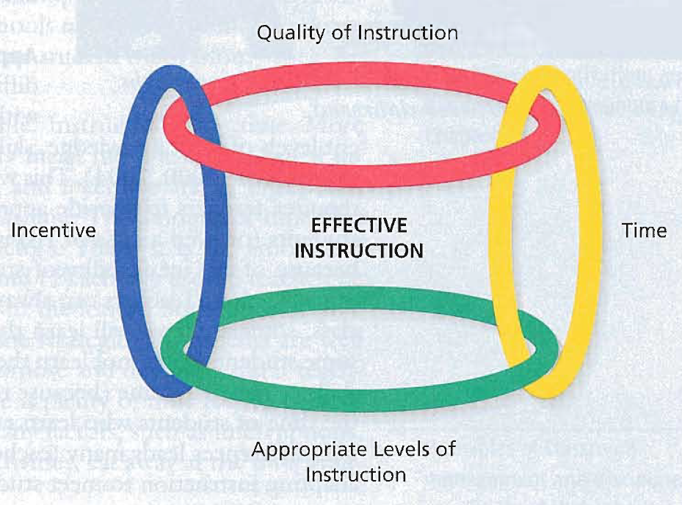
Figure 3: Elements of the QAIT Model
(Slavin 2006, p.277)
(1) Quality of Instruction: This refers to the way information and skills are presented based on the quality of the curriculum and the lesson presentation so that students can understand easily (Slavin 1994). It describes the teaching activities such as lecturing, discussions, calling on students as well as the curriculum, books, and materials (Slavin 1995). For example, teachers can use reflections to encourage students to reflect on what they have learnt (Persaud 2018). They can organize the classroom to implement activities that require movements such as learning stations and the use of computers and technologies (Huitt 1996). Teachers can motivate students to learn and gain students' attention (Orlinch et al. 2010). They can provide meaningful assignments that are related to students' daily lives, create activities and organize the information for students to make it easier to understand (Huitt 1996). Also, it is recommended to have frequent assessments to examine the students' knowledge to make sure that the students are ready to learn a new concept (Slavin 1987).
(2) Appropriate Levels of Instruction: This element is achieved when the teacher ensures that the learners are ready to learn by providing them with the prerequisite skills and meets the needs of the diverse student levels (Slavin 1994). Providing students with the appropriate level of instruction is not a straightforward process as it requires thinking about the different needs of the students, planning appropriate instruction, providing suitable resources and managing the students' group work (Dudley 2016). Teachers can meet the diverse needs of the students through the use of visuals in teaching, peer tutoring students from different abilities, and facilitating cooperative learning activities in problem-solving tasks (Allison & Rehm 2007).
Slavin (1994) stated that the most effective strategy to meet students' different needs is that of individualized instruction, where students work on their learning level. Individualized instruction helps to adapt the instruction to meet students' individual needs as one size no longer fits all (Wang & Latham 2013). There are different methods to be used to individualize instruction such as presenting the lesson in different levels for learners, tailoring the lesson materials and targets for particular students and modifying the presentation style based on student preferences (Wang & Latham 2013). Although individualized instruction can help the teachers to provide an appropriate level of instruction, it might create a problem with classroom discipline (Slavin 1994).
Another way to provide an appropriate level of instruction is through differentiation which means teaching the same materials to students using different learning strategies and difficulties based on student abilities (Weselby 2014). Differentiation practices include designing the lesson based on student learning styles, grouping students based on their interest or the given assignment. They can also include formative assessments, creating a supportive learning environment by managing the classroom and using continues assessment to adjust the teaching materials based on the results (Weselby 2014).
Slavin (1994) indicated that ability grouping help to provide an appropriate level of instruction to students. There are two ways to group students: heterogeneous and homogenous. Some teachers prefer heterogeneous groups which include students from different ages, interests, and abilities. In heterogeneous groups, students are usually in the same age but have different academic, social and emotional levels (Davies 2019). It allows students to learn and interact with diverse abilities (Davies 2019), might challenge the lower abilities students to perform well and provide the advanced students with the opportunity to mentor their peers (Lewis 2019).
Homogenous grouping refers to the distributing of students according to their academic and social levels in the same group (Davies 2019). There are different forms of ability groups to reduce the variation of student levels in instructional groups (Slavin 1994). For example, special education programs are a form of ability grouping that provide specific materials to enhance the achievement for students (Slavin 1994). Furthermore, gifted and talented students could be placed in the same group to work on the materials the suit their strengths (Davies 2019). Homogenous groups allow the teachers to plan a lesson that is tailored to student abilities and save time that the students will spend on task (Lewis 2019). Also, students will feel comfortable when working with students who have the same levels (Lewis 2019).
(3) Incentive: this element is achieved when teachers motivate students to learn and work on the instructional tasks (Slavin 1994). Long et al. (2011) claimed that the educational definition of motivation is focused on academic attainment and involvement in a specific school activity. Teachers can motivate the students by engaging them in the activities through the use of collaborative learning, relating the lesson to the students' life experiences and the use of technology (Orlich et al. 2010). Also, students can be motivated to work harder by reinforcements by using rewards such as praise and points, or punishment such as detentions (Long et al. 2011).
Incentives could be provided to students through feedback. For example, teachers can provide clear feedback to students that motivates them to succeed more in their study (Orlich et al. 2010). Also, routine portfolio nights allow students to share their success with their parents and establish a positive channel of communication between teacher and parents (Orlich et al. 2010). Teachers can motivate students by making the lessons relevant and connecting them to the students' daily lives and reality. Therefore, students will be able to apply their personal input to the lesson and become engaged (Criss 2011). Another important way to motivate students is by supporting them to have high expectations by believing that they can do well and succeed (Criss 2011). More details about motivation are provided in the literature review section.
(4) Time: This is the degree in which the time provided to students is sufficient to learn the assigned material (Slavin 1994). There are two factors associated with the time available for learning: allocated time and engaged time (Slavin 1994). The allocated time is the time scheduled by the school and the teacher for the lessons, and it is used for learning activities (Slavin 1994). It is under the control of the school and the teacher (Slavin 1994). On the other hand, engaged time is the time that students are actually engaged in the learning activities, which is a result of the high quality of instruction and motivation (Slavin 1994).
Dağlı (2018) argued that the effect of instructional time on academic achievement is a variant as some studies showed no benefits, while a minority of studies reflected a negative relationship. This means that the more time spent on teaching does not necessarily lead to additional learning. However, when the other three elements of the (QAIT) model are high, then more time is likely to result in more learning (Slavin 1995).
In addition to the elements of the (QAIT) model, Slavin (1995) adapted the model and based it on two variables: student input and alterable variables of the (QAIT) model which is illustrated in figure 4. Student input is the factor that the school has little control over while the alterable variables of the (QAIT) model are the elements that the school and teacher have direct power to adjust (Slavin 1995).

Figure 4: Elements of Slavin Model
(Adapted from Slavin 1995, p. 7)

Student Inputs include student aptitude and motivation. Student aptitude includes prior knowledge of the content and their abilities to understand the lesson (Slavin 1995). Student motivation to learn refers to the desire that students bring from home, which is different from the one that is influenced by the instructional practices (Slavin 1995). Slavin (1995) highlighted that student inputs are not unchangeable as they can be affected by instructional practices. As student aptitude is strongly influenced by background information which is results from earlier instruction; motivation could be influenced by previous experience in school (Slavin 1995).

Figure 5: Factors Effect Students’ TIMSS Achievement
(Adapted from Slavin 1987, p.99)

As shown in figure 5, the TIMSS assessment questionnaire items for students, teachers and principals were categorized according to three groups: school, classroom and students. School and classroom factors were related to the (QAIT) model, while student factors were related to student input. As the Slavin model was the primary model of the study, the connections among its elements and the content and cognitive domain in TIMSS 2015 were investigated. Thus; the elements of the Slavin model can be looked as the factors that could contribute to better student learning and achievement through the effective implementation of teachers and schools. This helped in identifying the factors that could contribute to better performance for grade 4 UAE students in standardized assessments in general and TIMSS in particular.

2.2 Literature Review
The literature review section consists of five major parts: an overview of standardized assessment, TIMSS, factors associated with student performance, content domain and cognitive domain. Firstly, it identifies the standardized assessments, states its history and how it has been developed. Secondly, it provides an overview about Trends in International Mathematics and Science Study (TIMSS). Thirdly, it outlines the key studies that identified that factors associated with TIMSS performance according to school, classroom and student. Finally, it provides an overview about the content and cognitive domains.

2.2.1 Standardized Assessments
The term standard refers to the thousands of students who experienced the same standard conditions when performing the assessment (Slavin 2006). The logic behind standardization is from the scientific method, which means that the test content and conditions are equivalent across all test takers (Sireci 2005). It also defines the minimum standards about basic skills and competencies that need to be achieved (Huber & Skedsmo 2017).
Standardized assessments are the forms of tests that require all students to answer the same questions or choose from a common bank of questions. The exams are scored in a standard and consistent way to make it possible to compare the performance between different students, groups and countries. The tests consisted of the same sections for everyone, students are given the same amount of time, the examination procedures are the same, and the scores are uniformed regardless of the country or the region that the student took the exam in (Diamond 2019).
Large scale standardized tests have different purposes than regular classroom tests as they are used by countries and regions to answer broad policy questions (Shermis & Di Vesta 2011). They are used to accept or select students for specific programs, diagnose student abilities and levels, evaluate student progress and the effectiveness of the school and teachers, improve the learning process, hold teachers and administrators accountable for student learning, and as a benchmark to measure the performance of individuals, groups, and countries (Slavin 2006). Nichols (2008) noted that standardized tests held teacher accountable by motivating them to teach better, making students work harder to score well in the assessments.
Questions have been raised about the appropriateness of standardized assessments in evaluating student performance. As standardized test results provide teachers with an opportunity for getting bonuses and recognition when their students perform well, they reduce the opportunity for other students in gaining a broader knowledge and skills from all of a school’s faculty because of the fear of raising the scores of the competing teachers (Morgan 2016). Also, some teachers may be treated unfairly when they teach students who do not improve compared to others (Morgan 2016). Standardized tests encourage teaching to the test as the amount of time that is used to cover the test material increases, and teachers might change their teaching practices to accommodate the needs of the assessments (Lynch 2019). They encourage teachers to drill the information to students through memorization and recall, which might improve student attainment but will often fail to develop their higher-order thinking skills (Morgan 2016). In assessing reading comprehension skills, Serravallo (2014) stated that as standardized tests are taken silently, they do not measure how a child handles the text word by word which is an important skill for primary school students. There is a strong relationship between fluency and comprehension. However, a standardized test does not assess fluency (Serravallo 2014). Also, the texts that are mostly used in standardized assessments are short passages which are only one type of reading (Serravallo 2014).

2.2.1.1 History of Standardized Assessments:
The early roots for the standardized assessments were in the 1st century in China. They were used to measure bureaucratic abilities to determine the skills of the participants that would best serve the government (Diamond 2019). These early tests were only restricted to wealthy people and relied on the memorization of Confucian texts and Chinese mythology (Diamond 2019). By the 10th century, low social standing Chinese citizens could take the tests, and the results were valued by all the members of the society, including the emperor (Diamond 2019).
During the middle ages and the Renaissance, the academic education was based on oral practices, and the University of Paris and the University of Bologna were the first to introduce “examinations” (Madaus, Russell & Higgins 2009). During that time, the Western education systems were based on the Socratic method of debates, essays and lectures that focused on philosophy and open-ended discussions rather than factual recitation (Diamond 2019). One of the significant events in the middle of the eighteenth century was the introduction of mathematics into the curriculum at Cambridge University, which made it evident that the oral mode of examination was inappropriate; therefore, the written exams were introduced (Madaus, Russell & Higgins 2009). In the 19th century, standardized tests were used in Europe from Chinese colonies (Diamond 2019). These tests were introduced to ensure that the students acquired the expected skills and knowledge, and to establish the standards of student performance (Madaus, Russell & Higgins 2009).

2.2.1.2 Development of Standardized Assessment:
Standardized tests are prepared by careful and skillful experts to ensure the coverage of broad academic objectives for the majority of the schools and countries, and to provide valid and reliable results (Ary, Jacobs & Sorensen 2010). Figure 6 shows the test development process that consists of four stages (Arbuthnot 2011): (1) Design: This includes specifying the purpose of the assessment, developing the construct, and developing the test specifications such as time, content, format and scoring; (2) Development: This refers to the development of the assessment items to meet the requirement of the test design; (3) Administration: This refers to the administration of exams to the students by using the guidelines in the test specification. It can be seen in figure 1 that there is an arrow from the development to administration and another arrow back from administration to development. If there is an issue with a test such as reliability, it goes back to the development stage; and (4) Use: This is the process that defines how the test should be used. It is not the last stage, as the results are used in the design stage as well.

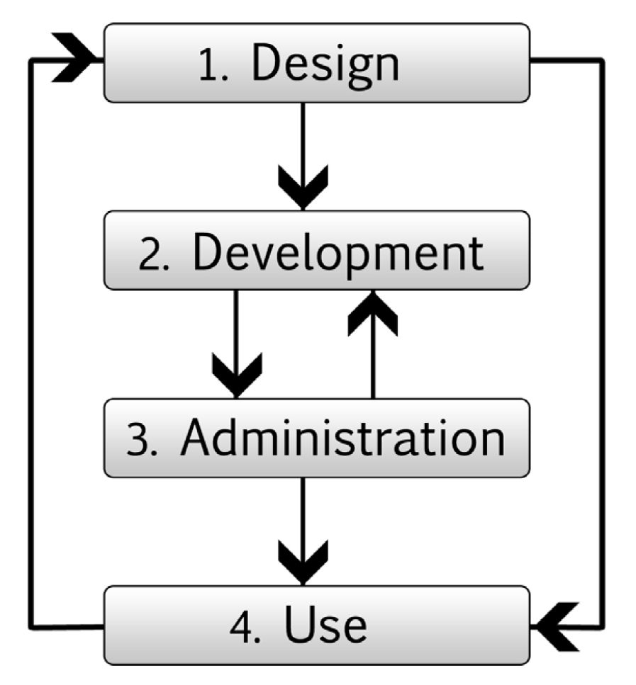
Figure 6: Development of Standardized Assessment
(from: Arbuthnot 2011, p. 4)
Standardized tests consist of test items that contribute to one or more points of student test scores. There are many types of question items in standardized tests, and the most common ones are multiple-choice and construct response questions. Multiple choice questions are easy to score manually or electronically, can test a wide range of higher-order thinking skills and can cover any aspect of the content, however, they provide the students with an opportunity to guess the answer, often assess literacy skills, and good questions need time and skills to construct (Weimer 2018).
Constructed response questions or open response are question items that ask the students to apply skills and knowledge to real-life situations (Tankersley 2007). They ask the students to construct their personal responses to the question without asking them to choose from suggestions, therefore, often, there are more than one technique to answer the questions correctly (Tankersley 2007). They provide the students with an opportunity to express their knowledge and skills, and develops students’ writing skills, however, they require time to grade, and encourage the use of the subjective criteria in evaluation (Weimer 2018). Construct response items vary in their difficulty; some of them simple that can be answered by only one or two sentences while others complex, requiring students to read a specific article, reflect on its main idea and analyze its information (Tankersley 2007).
As the study focused on the United Arab Emirates, it was important to identify the types of the standardized assessments that were implemented in the country. There were two types of standardized assessments in the UAE; National and International. The National assessments were developed by external sources and administered regularly (ADEK 2019). Results were communicated to both parents and students and used by administrators and curriculum developers to determine whether the students met the learning expectations (ADEK 2019). One of the most important National assessments is the Emirates Standardized Test (EmSAT) that was established in 2017 to measure students’ knowledge in Arabic, English, Mathematics and Science (UAE Government 2019). The aim of EmSAT was to make sure that students acquired the necessary skills and knowledge to contribute to the needs of the modern global society (UAE Ministry of Education 2019).
The International assessments are the external tests by different international development agencies and research institutions (ADEK 2019). These tests are considered to be at the center of the development of the education system in the UAE although they were administrated to target age or grade level (ADEK 2019). The UAE participated in many international tests to study the performance of its students and the level of the education system for the country (UAE Government 2019). These assessments included the PISA (Programme for International Student Assessment), TIMSS (Trends in International Mathematics and Science Study) and PIRLS (Progress in International Reading Literacy Study) (UAE Government 2019). PISA, TIMSS and PIRLS are considered important international assessments, so the UAE policymakers valued its results and implication. PISA is the OECD's Programme for International Student Assessment while TIMSS and PIRLS are conducted by the International Association for the Evaluation of Educational Achievement (IEA). PISA assessment measures the 15 years old students’ abilities to use their skills and knowledge in mathematics, science and reading in real life situations (OECD 2021). PISA assessment is conducted every four years (OECD 2021). PIRLS is an international comparison study for grade 4 reading skills that is conducted every 5 years while TIMSS is an international comparison study for grade 4 and 8 mathematics and science skills that is conducted every four years (IEA 2019). The focus of the study is on TIMSS assessment because it focused on mathematics and science which are two important subjects that the UAE national policies emphasize and valued their applications (Government.ae 2018).

2.2.2 TIMSS Assessment
Trends in International Mathematics and Science Study (TIMSS) is a comparative international assessment study for more than 60 countries that is conducted by the International Association for the Evaluation of Educational Achievement (IEA) (IEA 2016). It is part of IEA studies that are directed by TIMSS & PIRLS International Study Center that is located in Boston College (IEA 2019). The IEA is “an international cooperative of national research institutions, government research agencies, scholars, and analysts working to evaluate, understand, and improve education worldwide” (IEA 2019. p. 1 of 5). It is a non-profit organization that was established in 1958 to measure the student proficiency in the areas of Mathematics, Reading and Science, perform assessments for education systems, study students’ computer literacy skills, and study early childhood and teaching development (IEA 2019). The IEA network includes more than 60 countries and 100 education systems that regularly participate in its studies (IEA 2019). The main strengths of IEA comparative studies are that it enables participating countries to understand the policy and the educational practices that improve their education systems and helps them to build their own knowledge and research capacity (IEA 2019). In spite of the high costs of the participation in IEA studies and complex logistics that are associated in performing the assessments, many developing countries participated in one or more of its surveys especially the ones for Mathematics and Science (Johnson 2010). The main reason for participation by developing countries is to determine where their education system stands compared to developed nations and to transfer the knowledge and skills through the survey planning and implementation (Johnson 2010).
TIMSS assessment began in 1995, and it entered its third decade and seventh cycle in 2019 (Mullis 2017). The TIMSS framework is built in collaboration with the participating countries to describe the expectations of grade 4 and 8 students (IEA 2019). Each participating country assigned a National Research Coordinator (NRC) who has an important role in designing the assessment items and questionnaires, running the assessment, reporting the results and interpreting the findings based on the country’s context (IEA 2019).
As it focuses on Mathematics and Science assessment, TIMSS is a valuable tool to monitor the effectiveness of the educational programs in their implementation of STEM (Science, Technology, Engineering and Mathematics) which is the key curriculum area for the future occupations (Mullis 2017). The assessment has a quasi-longitudinal design as grade 4 student cohorts will be assessed later after four years when they are in grade 8 (IEA 2019). The countries that participated in multiple cycles of the assessment can track their progress as well as evaluate any changes that has been made in the education system (IEA 2019). This design provides an early warning system for required curriculum reforms for grade 4 and to measure the effectiveness of these reforms during grade 8 (IEA 2019).
TIMSS also collects data of influential factors for student learning such as school resources, teaching practices, home support and student attitudes through students’, teachers’, schools’, and parents’ TIMSS questionnaires (IEA 2016). TIMSS questionnaires have undergone a process of evaluation since first being administrated by TIMSS in 1995 to improve the quality of the relevant data (Hooper et al. 2017). One of the most important strengths of IEA studies, and TIMSS in particular, is the fact that they are classroom-based, so the contexts that are provided on teaching and learning can be related to student achievement (Drent, Meelissen & Van Der Kleij 2013). The data from the assessment items and contextual questionnaires provide an overview of how students are performing in mathematics and science, how the performance has changed over the last 20 years, the modifications that have occurred in the curriculum, and teaching instruction that influenced the learning process (Mullis, Martin & Loveless 2016).
From TIMSS 2019, a computerized version of the assessment (eTIMSS) was available to enable the participating countries to study complex applications of mathematics and science that were difficult to measure by traditional paper and pen versions (IEA 2019). eTIMSS is an interactive, engaging version of the assessment that incorporates the content of the paper and pen version with the integration of inquiry tasks and problem-solving (IEA 2019). It motivated students through real-world applications and scientific laboratory situations (IEA 2019).
The UAE participated in TIMSS in 2011 for the first time with 459 schools, both private and public (IEA 2016). The results of TIMSS 2015 improved compared to the previous cycle as the promotion was seven ranks in Mathematics and eight ones in Science for grade 4, and four ranks in Mathematics and three in Science for grade 8 (UAE Ministry of Education 2017). The progress of grade 4 Mathematics results placed the UAE among the most improved countries in 2015. Also, the UAE was considered the best performing Arabic-speaking country in TIMSS 2015 for grade 8 Mathematics and Science and grade 4 Mathematics (UAE Ministry of Education 2017). However, the country still performed below the international norm in TIMSS 2015.
The UAE considers TIMSS as a valuable indicator for the achievement of the country’s national agenda 2021 in which the UAE aims to be one of the top countries in the world on the year of the celebration of the golden jubilee (Vision 2021 2018). The goal of the agenda is to ensure that the students get an education system that equips them for the 21st century. An indicator of this goal is to be one of the top performers in international exams such as TIMSS and PISA.
The UAE have had many initiatives to improve the performance of its students and to prepare them for TIMSS 2019. One of these initiatives was Question-a-Day program (QaD); an educational program students can access by phones, tablet and other devices (ADEK 2017). It supported the students who performed in TIMSS 2019 to acquire skills and strategies to respond to higher-order thinking situations and problem solving (ADEK 2017). The program provided teachers with weekly reports about student performance and material to support student strengths and weaknesses (ADEK 2017). Every school day, the students were required to answer one science question and one mathematics question. Students had the option of answering all the five questions during the weekend if they could not access the program during the weekdays.
In addition to the QAD program, students had the further experience of online international style questions in the trimester test (ADEK 2017). The trimester test took place at the end of each school trimester to measure the progress the students made in their mathematics and science skills (ADEK 2017). The online test also provided an indicator of the effect of the students’ participation in QaD and compared the results between the participant and non-participant students (ADEK 2017).
As the UAE had many initiatives to improve student achievement in TIMSS, it was important to investigate the factors that influenced student performance. Studies in the literature that focused on analysing TIMSS results referred to the items in the contextual questionnaires as factors that were associated with student performance. The study will follow Drent, Meelissen & Van Der Kleij (2013), Patnam (2013), Bruner (2014); House & Telese (2015) and Mohammadpour, Kalantarrashidi & Shekarchizadeh (2015) studies that refer to TIMSS questionnaire items as school, classroom and student factors.

2.2.3 Factors Associated with TIMSS Performance
The main purpose of this study was to investigate the factors that were associated with students TIMSS 2015 results in the content and cognitive domain. Referring to the TIMSS 2015 framework, the factors were divided into three groups: school, classroom and student. Each one of these factors was divided into subfactors. The below section provides an overview on the influence of these factors with student attainment based on different studies in the literature.

2.2.4.1 School Factors
The school environment is an important indicator for the effectiveness for the delivery of the school curriculum as well as student achievement (Hooper et al. 2017). School environment includes many aspects that could influence students’ academic performance such as socioeconomic status, school location, resources and principal leadership. All these aspects were related to the TIMSS 2015 framework as they were all part of the contextual questionnaire.

2.2.4.1.1 Socioeconomic Status
The term socioeconomic refers to a combination of social and economic factors (Merriam-Webster 2019). Previous studies investigated the effects of school demographics and socioeconomic factors on student achievement. In their two-level hierarchical linear analysis study, Tavsancil and Yalcin (2015) concluded that the economic affluence of homes was associated with student achievement. Breger (2017) found that student achievement is highly correlated with poverty, while attainment in impoverished schools is lower because their students struggle to meet the expected learning standards compared to higher-income students. In the same vein, Stumm (2017) claimed that children from lower socioeconomic families performed lower in elementary school than the higher socioeconomic children at the same intelligence level, and they experienced less academic progress and growth in later school years. Socioeconomic status is not only reflected in academic achievement, but it also interferes with creativity abilities as students with higher socioeconomic level, have higher creativity abilities (Castillo-Vergara 2018).
Several studies in different countries examined the relationship between socioeconomic status and student attainment. In Middle Eastern and North African countries (MENA) countries, Bouhlila (2012) stated that family background has a strong association with student achievement since educated parents with well paid jobs can offer a variety of resources for their children at home. In Turkey, Sulku and Abdioglu (2015) conducted a study of mathematics student achievement in TIMSS 2011 based on an econometric analysis technique. Results revealed that higher mathematics attainment was associated with students who lived in urban areas and have better socioeconomic families background. Lower student performance was associated with a low level of fathers’ education, disadvantaged socioeconomic groups and living in poor areas. Also, the results of private school pupils were higher than public school ones. A study about Malaysian and Singaporean TIMSS 2011 concluded that higher student achievement were associated with affluent students rather than the disadvantage ones (Lay & Chandrasegaran 2016).
A study in Japan of the TIMSS mathematics achievement and students’ socioeconomic status reported that students who have more home educational resources and well-educated parents, especially fathers perform better in mathematics (Takashiro 2017). Disadvantaged Japanese students who attended schools in rural areas performed lower (Takashiro 2017). In a study of the Swedish TIMSS 2015 results, Wiberg (2019) reported that both the mothers’ educational background and when students have many books at home influence student attainment. Also, as Sweden is a high-income nation, the quality of school building has no association with student outcomes. From the above findings, it is obvious that parent’s education and involvement are considered an indicator for the socioeconomic status of students which is reflected in their academic achievement (Kusaeri et al. 2018).
An analysis study of the South African TIMSS 2015 results indicated that students who attended higher socioeconomic schools or private schools were less likely to experience bullying (Winnaar, Arends & Beku 2018). A study of Indonesian high school students indicated that there is a significant relationship between parental involvement and education level with mathematics achievement while the difference in achievement based on mothers’ education level is higher than the fathers (Kusaeri et al. 2018). Mothers with a high educational background valued learning and established strong home structure and self-discipline skills for their kids.
Other studies attempt to explain how to reduce the achievement gap between different socioeconomic background students. Gustafsson, Nilsen and Hansen (2018) conducted a study of the school characteristics that can reduce the association between socioeconomic status and student achievement. The study used the data of 50 countries who participated in TIMSS 2011. The findings of the study revealed that educational systems that function in a compensatory manner against the variance of student socioeconomic status have a higher level of achievement compared to other non-compensatory systems. The reason for these findings is that highly developed nations are better able to reduce the socioeconomic gap between students through healthy and safe learning environments, prioritizing academic success, high instructional quality, and focusing on the achievement of low socioeconomic students. In a study of the socioeconomic achievement gaps during the school years, Kuhfeld, Gershoff and Paschall (2018) indicated that there is a significant growth in math and reading skills in early primary school while patterns of growth rate decrease in later primary and middle school years which leads to widening the achievement gap between the socioeconomic groups.
Many students from low socioeconomic areas maintain high levels of academic motivation despite the difficulties they encounter (Browman et al. 2017). The reason for this persistence is that those students believe they can be financially successful in the future when they have higher academic achievement (Browman et al. 2017). This persistence is also reflected in their parents as parents of low socioeconomic status confront challenges to seek social mobility for their children while higher socioeconomic parents use their social advantage to benefit their children academic achievement (Tan 2015b).
Conversely to the findings of previous studies in the literature that were mentioned above regarding the socioeconomic status, Tan (2018b) stated that there is no association between socioeconomic status and parental involvement and between parental involvement and students’ science academic achievement. Furthermore, Armor, Marks & Malatinszky (2018) reported that peer socioeconomic has no or small effect on students’ academic outcomes. A study of TIMSS 2011 grade 4 mathematics achievement stated that the gap between low and high socioeconomic families is smaller in many low-income countries because the average score of the country is low (Nonoyama-Tarumi, Hughes & Willms 2015)
In this study, the economic background of grade 4 UAE students was investigated to identify its relationship with students TIMSS 2015 mathematics and science achievement. From the above literature, there were inconsistent findings of the association between the socioeconomic status of students and their academic achievement. Also, there were limited studies in the UAE that investigate the relationship between the socioeconomic background of students and their academic performance. This study investigated whether a more affluent or disadvantaged background had an association with grade 4 UAE TIMSS 2015 results in mathematics and science as well as in the content and cognitive domains.

2.2.4.1.2 School Location:
The school location could influence student attainment as it might be located in rural or urban areas. Rural areas have low population density, and the houses are spread very far apart (National Geographic 2021). People in rural areas usually have properties and farms (Jacobs 2020). Some example of rural areas in the UAE are Bida Zayed, Gayathi and Liwa Oasis (Phanikumar et al. 2020). The urban areas are densely populated cities with well-developed modern landscapes (Sen Nag 2017). The five biggest cities in the UAE are Dubai, Abu Dhabi, Sharjah, Al Ain and Ajman (Nag 2017). The percentage of people living in rural areas in the UAE in 2019 was 19.32% while the percentage of people living in urban areas was 86.79% (Global Economy 2020).
Several studies investigated the relationship between school location and academic achievement (Milam, Furr-Holden and Leaf 2010; Lin, Huang & Ho 2014; Luschei & Fagioli 2016; Ramos, Duque & Nieto 2016; Zhijun, Zeyun & Baicai 2016; Murphy 2018; Lu et al. 2019). In general, a school being located in a rural area has been identified as a major factor in decreasing student attainment (Ramos, Duque & Nieto 2016; Zhijun, Zeyun & Baicai 2016; Murphy 2018; Lu et al. 2019).
In a study that examines the influence of school and neighbourhood climate on student achievement in elementary schools, Milam, Furr-Holden and Leaf (2010) concluded that neighbourhood environment and safety were strongly associated with academic performance as increasing neighbourhood violence decreased mathematics and reading achievement and increasing perceived safety was significantly associated with high achievement. As a justification for their findings, the authors added that when students are worried and fearful about their safety, their focus on learning could be affected negatively. In line with Milam, Furr-Holden and Leaf (2010) study, Sulak (2016) stated that the surrounding crime could be a factor in student achievement.
Other studies in the literature, focusing on school location attempted to investigate the differences between urban and rural schools. Murphy (2018) argues that school location influences academic achievement and participation in mathematics courses as rural schools performed poorly in mathematics compared to schools in the urban areas. In a study of TIMSS 2011 science achievement in Malaysia and Singapore, academic achievement were the highest in schools that were located in big cities, followed by medium-size cities and the lowest in schools that were located in rural areas (Lay & Chandrasegaran 2016). In an analysis study on the differences in academic achievement in mathematics, science and reading based on PISA survey in Colombia, results showed that rural students perform lower than urban students and the differences were related to family characteristics and not to the schools (Ramos, Duque & Nieto 2016). A study in Australia was conducted to explore the differences in self-concept, parental involvement, and teacher relationship between rural and urban students (Gavidia-Payne et al. 2015). The findings of the study showed that the level of parental involvement differs between disadvantaged rural students and advantaged urban students. However, there were no significant differences between the two groups in self-concept and student-teacher relationship (Gavidia-Payne et al. 2015).
In contrast to the above studies, Luschei and Fagioli (2016) conducted a study of the differences in academic performance between urban and rural schools in Latin America and the Caribbean. The study concluded that the mathematics performance of students in rural schools in Colombia was higher than urban schools when controlling relevant background factors. The reason for these differences might be related to the strong performance of rural schools or the difficulties that urban areas schools encounter. Similar to Colombia, several countries had rural schools outperform urban ones which were Argentina, Chile and Peru in mathematics and reading as well as the Dominican Republic, and Uruguay in reading. Luschei and Fagioli (2016) added that student backgrounds and their peers have a major impact on the academic performance which means that rural schools are not worse than urban schools but the conditions the rural students live, and their peers are the major indicators. Furthermore, Rahim (2018) stated that there is no positive association between academic achievement and urban schools.
Some authors have been interested in investigating the reasons behind the achievement gap between rural and urban schools. Zhijun, Zeyun and Baicai (2016) conducted a study of the relationship between family background and schools located in rural areas. Findings indicated that parents’ education, family income and school quality have a significant positive relationship with academic outcomes. Also, increasing the investment in schools will reduce the gap in achievement that are caused by family background. Since students in rural areas have limited access to independent school transportation, Lin, Huang and Ho (2014) conducted an analysis study of the influence of schools’ accessibility on student achievement in rural areas in Taiwan. Results showed that travel obstacles have a negative association with student achievement in primary and high school while it affects adolescent students more significantly (Lin, Huang & Ho 2014). Finally, in a study of the digital divide in India, results revealed that most of the rural students depend mainly on the school computers because they do not have computers facilities at home while urban students use computers at school, home and coaching centres (Kumar & Kumara 2018).
There have been attempts to reduce the academic achievement gap between urban and rural students. In China, professional development programs have been implemented to improve teaching practices in rural areas (Lu et al. 2019). However, there is no significant evidence on the impact of these programs on student achievement, although it had a positive effect on teaching knowledge for teachers. The reasons for these findings is that teachers might not apply what they have learnt to improve their classroom teaching practices (Lu et al. 2019). Furthermore, Zhijun, Zeyun & Baicai (2016) suggested that the investment in schools in rural disadvantaged areas need to be made to shrink the achievement gap.
From the above, the school location could have an influence on student academic performance. In this study, the locations of schools in the UAE had been investigated to explore their association with the TIMSS 2015 results in the content and cognitive domains. The study investigated whether the school locations in urban or rural areas had an association with grade 4 mathematics and science results as well as with the content and cognitive domains.

2.2.4.1.3 Resources:
Several studies that investigated the influence of instructional resources on academic performance highlighted the challenges in finding a clear relationship between them as many other factors interfere in the process. Hedges et al. (2016) reviewed the literature to answer the question whether financial resources could be translated into academic achievement and concluded that it might be impossible to find the answer as school contexts are complicated. However, Hedges et al. (2016) stated that the researcher should ask the question could school resources impact student performance across a different range of schools and different student needs. Chudgar et al. (2015) argued that exploring basic and simple school resources such as clean water, proper toilets, and a clean learning environment may not be enough to understand its impact on student performance. It is not to underestimate their importance as they are crucial preconditions for well-functioned schools, but their presence alone does not explain the variation of academic performance. Chudgar et al. (2015) concluded that schools with more learning facilities such as libraries and laboratories that provide students with cross curricular activities have students with better mathematics performance.
When studying the influence of educational resources on academic achievement, it is important to study the mediation and moderating variables as the traditional economic framework that present "inputs and outputs" may limit the unique effect of these resources (Della Sala, Knoeppel & Marion 2017). The moderating variables include: (1) Student characteristics such as financial status, disabilities, gifted, talented and students who are older than the usual grade; (2) Instructional conditions such as student-teacher ratio, teacher professional development, and the expense on classroom resources; and (3) Personal factors such as teacher salary, teacher degrees, returning teachers, and principals’ years in the school (Della Sala, Knoeppel & Marion 2017).
Another factor that needs to be taken into consideration when studying the impact of school resources is that of resource allocation as Bouhlila (2012) claimed that the inefficiency of allocating resources is considered a constraint for the learning environment. Also, the inequalities of the geographical distribution of school resources among schools may result in an imbalance of student academic performance (Leo´n and Valdivia 2015).
Nonoyama-Tarumi, Hughes and Willms (2015) conducted a quantitative study to investigate the influence of family background and instructional resources on student academic performance. This data was obtained from 45 countries that participated in TIMSS 2011 for fourth-grade mathematics. The findings highlighted that there are some challenges in studying the effect of instructional resources in cross-national studies, as many of the questions had been answered by school administrators who might have different expectations. The cultural factors play a role in the variance of the expectations. Findings highlighted that the effect of family background on student performance is stronger than academic resources. This effect is stronger in low-income countries that had a variation in the quality of school resources.
Other studies revealed a positive relationship between the school resources and students learning (Sabah & Hammouri 2010; Adelodun & Babatunde 2015; Lumpkin 2016; Lay & Chandrasegaran 2016; Kweon et al. 2017; Gigliotti & Sorensen 2018). Lay and Chandrasegaran (2016) conducted a study in Malaysia and Singapore that investigated the influence of school resources based on TIMSS 2011 science achievement. The findings showed that students in schools that were affected by a shortage of science resources had a lower performance than schools that were not. Science achievement was lower in schools that had difficulties in filling their vacancies, and teacher working conditions were not associated with academic achievement. Lay and Chandrasegaran (2016) highlighted that there were inconsistent findings in the results of Malaysia and Singapore compared to the TIMSS 2011 international data. In Malaysia and Singapore, having teacher assistants in science classes did not affect student academic performance while in the global data, the average of students who were attending schools that had teacher assistant was higher.
A study of Jordanian TIMSS results indicated that there is a significant relationship between the shortage of instructional resources and student achievement. This shortage affected mathematics achievement negatively but had no significant effect on science performance (Sabah & Hammouri 2010). Lumpkin (2016) argued that school facilities play an important role in improving student academic achievement because the results in standardized mathematics and reading tests indicated that student performance increased when they attended a new and better school facility. A study about TIMSS 2003 results in Arabic countries concluded that more mathematics instructional resources is associated with higher mathematics achievement (Jurdak 2006).
In a study on the role of instructional resources to enhance the learning experience for high achieving students, results revealed that classroom instructional resources play a significant role to raise student performance (Adelodun & Babatunde 2015). To make sure that these resources have been used appropriately, teachers should be aware that these materials catch students' interest, transfer knowledge, and save time (Adelodun & Babatunde 2015). However, students need to be actively involved and pay attention to the teacher while using these materials (Adelodun & Babatunde 2015). On the other hand, a study about Saudi Arabia TIMSS 2003, 2011 and 2015 results concluded that there is little evidence of the association between instructional resources and academic achievement (Aburizaizah, Kim & Fuller 2019).
Students need a healthy learning environment to learn, play and grow. Kweon et al. (2017) conducted a study on the relationship between green space in schools and academic performance in standardized assessments. Results revealed that schools that had more trees had a higher percentage of students who were proficient or advanced in Mathematics and Reading standardized tests. Kweon et al. (2017) highlighted that not all types of landscapes had the same influence on student achievement as large areas of lands such as lawns and athletic fields had a negative impact on student attainment.
As the UAE government invested a huge part of the country's budget on developing the education and equipping its schools with updated resources (UAE Ministry of Education 2019), it is important to explore the relationship between the school resources and student attainment. These resources include classroom materials, school facilities, equipment, and stationary. The study investigated the association between a shortage of school resources with grade 4 TIMSS 2015 science and mathematics results in the content and cognitive domains. It measured the association between student performance when the school was affected by a shortage of resources.

2.2.4.1.4 Principal Leadership:
Principals are critical factors in improving the learning environment for students (Liebowitz & Porter 2019) as there is a positive relationship between principals' instructional leadership practices and student outcomes (Dhuey & Smith 2018; Park, Lee, & Cooc 2018; Tan 2018a; Aburizaizah, Kim & Fuller 2019; Wu, Gao & Shen 2019) and they have an effect on teachers' learning (Hallinger & Liu 2016). The significant role of the principal in schools is highlighted by the relationship between leadership and academic achievement (Pan & Nyeu 2017). Other than academic outcomes, learning in classrooms depends on the quality of leadership practices that the principal adapts to improve teaching, such as educational background and experience (Masci, De Witte & Agasisti 2018). Therefore, the choice of the school principal is crucial as it could contribute to students' academic attainment and the learning process (Masci, De Witte & Agasisti 2018).
Several studies in the literature focused on the principals' instructional practices that influence academic attainments. Aburizaizah, Kim and Fuller (2019) conducted a longitudinal study on the relationship between principal leadership and students' mathematics performance using TIMSS 2003, 2011 and 2015 data. Results revealed that high student achievement were significantly associated when principals had high expectations for students, involving parents, focusing on reaching school instructional goals, and fostering a positive school climate. The association was stronger and more significant in 2011 and 2015. Furthermore, when principals had the privileges and resources to provide strong mathematics teachers with incentives to attract and retain them, student performance was higher in 2015.
Instructional leadership practices are positively associated with student outcomes (Wu, Gao & Shen 2019). These practices include encouraging updated teaching strategies, recognizing teachers whose students perform well, and focusing on student progress academically and socially (Wu, Gao & Shen 2019). In a meta-analysis study on leadership strategies that promote student outcomes, there were positive associations between principal practices and student attainment, teachers' teaching practices, teachers' well-being and school organization (Liebowitz & Porter 2019). Cobb-Clark and Jha (2016) suggested that principals should be provided with the flexibility of resource allocation, as spending on teaching staff would promote growth in academic achievement in elementary and middle school.
Principals have a significant influence on students' academic achievement, and the effect is more likely related to the match between the principal and the school, while the principals’ educational background had a small impact on improving student attainment (Dhuey & Smith 2018). Therefore, policymakers can use test scores to identify effective principals to allocate them in schools that need to reduce the academic gap or increase students' achievement (Dhuey & Smith 2018). This view is supported by Wu, Gao and Shen (2019) who argued that school leaders could become more effective when they match the characteristics of their leadership skills with the needs of the school.
Shapira-Lishchinsky (2019) conducted a study to investigate the principals' perception based on TIMSS 2015 data. The main aim of the study was to explore the ethical practices from the TIMSS principal questionnaire items. Results revealed that principals perceived three main dimensions of ethical practices which were: caring for students' learning, respecting the rules amongst students and teachers and parents' and students' involvement in schooling. These dimensions had a positive association with student performance.
Other researchers have looked to the role of school principals as influencing teachers to enhance student learning experiences. Park, Lee, and Cooc (2018) stated that school principals' support and professional learning communities have a positive influence on academic achievement through teachers' educational practices rather than having a direct effect. Leadership practices indirectly influence teachers' social–psychological attitudes that are associated with a positive learning environment, students' learning and academic attainments (Park, Lee, & Cooc 2018). Similarly, Tan (2018) indicated that principals' effect on student attainment is mediated through teachers' morale and autonomy by empowering teachers to do the best instructional practices that improve student achievement. This view is supported by Torres (2019), who claimed that school principals, who provide teachers with leadership opportunities, will create a positive school environment that promotes student achievement.
A number of studies have examined the challenges that encounter school principals. In a study of the TIMSS results in the United States that focused on principals’ time use, results revealed that principals face challenges in developing a school environment that motivates and develops teachers' instructional practices (Huang, Hochbein & Simons 2018). Many principals faced challenges to focus on their role as instructional leaders when pulled between different managerial tasks (Huang, Hochbein & Simons 2018). When principals were relieved from the management responsibilities by sharing and delegating responsibilities, they will have more time to engage in instructional leadership practices (Huang, Hochbein & Simons 2018).
In an analysis study of the factors that impact student performance in reading and mathematics based on the principals' perspectives in the United States and Korea, results showed that there was a negative relationship between perceived organizational hindrance and student performance in the United States while there was a positive association between teacher attitude and student attainment (Shin, Slater & Ortiz 2017). Organizational hindrance included poor teacher-student relationships, not meeting student needs, low student expectations, overly strict implementation of rules, lateness in attendance, lack of planning, and resistance to change and improvement (Shin, Slater & Ortiz 2017). Depending on the school context, the role of the principals will vary, but it is needed to overcome negative school environmental factors to improve student performance (Shin, Slater & Ortiz 2017).
Saarivirta and Kumpulainen (2016) indicated that there are limited studies in Finland that connect school leadership to academic achievement as most of them link the role of pedagogical leadership with teachers and staff. The reason for the shortage of studies might be related to inaccessible information on schools and the perception of an equal level of educational standards among schools.
Other scholars looked at the evaluation systems of school principals. Grissom, Blissett and Mitani (2018) conducted a study on the evaluation system of school principals, which indicated that there was a positive association between principal experience and performance. Low rated principals lead schools that have a large number of low-income students, and highly rated principals tend to work in schools with positive outcomes. The authors added that it is not possible to conclude that highly rated principals will lead to positive school outcomes as high performing schools will attract more high performing principals. Therefore, the principal will have high performance even if the principal effectiveness has little influence on the outcomes.
As there is limited research on the effect of principals' preparation programs and principals' performance, Grissom, Mitani and Woo (2019) conducted an analysis study on the effectiveness of these programs and their impact on principals' performance and school outcomes. Results indicated that principals preparation programs were associated with high and low principal performance. However, the program could not identify the differences among the school outcomes as characteristics of the schools need to be taken into consideration.
This study investigated the relationship between principal experience and students TIMSS 2015 results. It studied the relationship between the principal's overall experience and the experience in their current schools with student attainments. Also, it measured whether the principal's experience had a significant association and the direction of this relationship with grade 4 UAE TIMSS 2015 in the content and cognitive domains.

2.2.4.2 Classroom Factors:
As most of the learning process occurs in the classroom, it was important to investigate the classroom factors that could impact student attainment. These classroom factors included teacher preparation and experience as it is the teacher who is responsible for delivering the information to students, and they are the most important element in the learning process. Other factors included instructional time, classroom engagement, technology, classroom assessment and discipline.

2.2.4.2.1Teacher Preparation and Degree
Some studies focused on teacher factors and their effects on student attainment. These factors are teacher experience, teacher degrees, professional development and teacher characters. Studies in the literature had inconsistent findings regarding the influence of teaching experience on students and the learning environment. Lay and Chandrasegaran (2018) conducted a study using TIMSS 2011 results of Malaysian and Singaporean science achievement. Results revealed that higher scores with Singaporean students were associated with teachers having more teaching experience, confidence in teaching science and were satisfied with their careers while these findings were not evident with Malaysian students. Similar to the Singaporean results, Gonzalez and Maxwell (2018) stated that there was a significant relationship between mathematics content knowledge, teacher efficiency and experience with students' mathematics outcomes. The reason for the different impact between experienced and less experienced teachers is related to the differences of the beliefs about teaching, learning and instructional practices between novice and experienced teachers (Caleon, Tan & Cho 2018). As experienced teachers are familiar with the curriculum, teaching approaches, students and assessments, they could help to improve the performance of less experienced teachers who struggle to meet the school expectations (Caleon, Tan & Cho 2018).
Other studies highlighted that it is not only the number of years experience that affected students as the type and quality of this experience could affect teacher performance (Coenen et al. 2018; Obonyo, Bin and Maina 2018). Obonyo, Bin and Maina (2018) argued that high school teachers' degree and years of experience had no significant relationship on student results in developing nations, but the type of teachers' experience could affect student achievement. For example, teachers having more than two years of grade-level experience has a significant effect on students' scores (Obonyo, Bin & Maina 2018). Furthermore, teachers' experience has an association with student performance only for the first few years while after 3 to 5 years additional experience years did not lead to better learning (Coenen et al. 2018).
Coenen et al. (2018) conducted a study to examine the impact of teachers' degree on student performance. The findings indicated that teacher certification has no impact on students' results while subject-specific certification and master degrees contribute to better student attainment (Coenen et al. 2018).
Professional development courses improve teachers' knowledge (Guay et al. 2016; Clary et al. 2017), and teachers' pedagogical content knowledge has an impact on student achievement (Cueto et al. 2017). Professional development courses are essential because they update teachers' knowledge and skills on the requirements of educational standards (Gonzalez & Maxwell 2018). In a study on TIMSS 2007 data, results showed that a high quality of professional development is associated with more job satisfaction, positive attitude and high expectations for students (Song, Hur, & Kwon 2017). Teachers' job satisfaction can be improved through active professional development courses that allow the instructor to interact with the audience, provide teachers with feedback, and have a high participation rate (Song, Hur, & Kwon 2017).
Some authors studied the impact of specific professional development courses. In a study on the impact of technology professional development programs on student attainment, Lee, Longhurst and Campbell (2017) claimed that changing teachers' pedagogical beliefs take more time than what is actually involved in learning during the programs. Student attainment was associated with teacher beliefs and not with the skills they learnt during the technological courses (Lee, Longhurst & Campbell 2017). Another study focused on the influence of internet-based mathematics formative assessment professional development courses. Results revealed that professional development courses are associated with student achievement, and teachers who used formative assessment tools more frequently have better student scores (Polly et al. 2018). Rivard and Gueye (2017) conducted a mixed-method study on the impact of science literacy professional development courses. Results indicated a statistically significant correlation between attending the programs with teacher beliefs and practices on literacy. These practices had a positive impact on the use of language in reading and writing, which resulted in better students' science performance (Rivard & Gueye 2017).
Some elements need to be taken into consideration to ensure effective professional development programs. The content of the programs needs to be adjusted to fit the needs of the teachers as teachers have different educational backgrounds and teach different grade levels (Lindvall 2017). Valiandes & Neophytou (2018) concluded that the characteristics of effective programs are: focused on teacher needs, had initial and follow up training, provided the opportunity to communicate and collaborate with colleagues and experts, and had on-site support during their implementation. In Indonesia, Ashadi and Rice (2016) conducted a case study to examine the impact of high stakes testing on teachers' professional development. They claimed that more qualified teachers were allocated in the classes that would perform standardized assessments and have more access to professional learning courses compared to other teachers who taught non-examined classes which lead to a negative impact on the staff morale.
Grosemans et al. (2015) stated that teachers' learning does not only occur during professional development programs, but it also happens during daily practice. The teacher can learn through experimenting, collaboration with other teachers, and reflection (Grosemans et al. 2015). Working in a more supportive professional environment school improves the effectiveness of teachers (Kraft & Papay 2014). The degree of the effectiveness of progress for teachers varies between schools as the improvement of teachers' effectiveness was associated with the opportunities and support of the schools' environment (Kraft & Papay 2014). Other factors could enhance teaching and learning, such as; instructional coaching, and online professional communities as they empower collaboration and conversation among teachers (Bryc, Wilmes & Bellino 2016). In a study of teachers professional learning goals, Louws et al. (2017) divided teacher goals into two areas; learning goals connected to teaching practices and school as a workplace. Teacher's learning goals are not restricted only to improve teaching practices, but also at the development as a professional to improve their roles in the school (Louws et al. 2017).
Some studies focused on teacher character and how it has an impact on the classroom environment. Popular teachers are motivated to teach, able to create a supportive learning environment in the classroom, treat students respectfully, and care about students' learning and problems (Fauth et al. 2018). Positive teachers' expectations of students are associated with student achievement (Park, Lee, & Cooc 2018). Fauth et al. (2019) stated that teacher competency includes teaching enthusiasm, pedagogical content knowledge, and self-efficacy, which is positively associated with student interests. Considering their relationship with student attainment, teachers' self-efficacy has a positive relationship, as competent teachers implement high-quality instructional practices which will be reflected in students' progress (Fauth et al. 2019). Regarding teacher attendance, reducing teacher absenteeism will lead to better student achievement (Zakharov, Tsheko & Carnoy 2016) and there is a strong positive association between teacher attendance and student academic performance as schools with high teacher absenteeism have low abilities in their reading skills (Rahim 2018).
In an analysis study of TIMSS 2015 Serbian results, Mirkov and Lalić-Vučetić (2018) stated that primary school teachers had a high level of job satisfaction. However, lack of time to support some students and administrative duties were the major concerns in the teaching process although teachers who were more satisfied with their career were mainly more burdened with administrative tasks (Mirkov & Lalić-Vučetić 2018). Serbian primary school teachers tend to use traditional learning strategies, while group work and experimental methods were rarely used in classrooms. The authors added that using a variety of learning strategies in classrooms is linked to the teachers' level of self-confidence.
From the above literature, there were some inconsistent findings of the impacts of teacher preparation, degree and experience on student performance. Therefore, the study investigated the association between teacher degrees and professional development with the UAE TIMSS 2015 student performance in mathematics and science, as well as the content and cognitive domains. For teacher degree, the study investigated whether education or subject-specific degree had an association with student attainment. Also, it examined the relationship with the number of professional development hours that teachers received with the students' TIMSS performance.

2.2.4.2.2Technology:
The integration of technology has become an important factor that enhances teaching, learning and student performance (Lay & Chandrasegaran 2016; Huang & Lin 2017; Herraiz-Martínez 2018; Khlaif 2018; Chen, Gu & Wong 2019). In a study of TIMSS 2011 science results, results indicated that students who have access to computers perform better than the ones who do not have access during classroom instruction (Lay & Chandrasegaran 2016). Also, students who use technology, learn better in the classroom and enjoy classroom activities (Huang & Lin 2017). Khlaif (2018) stated that teachers use technology because it facilitates teaching and provides access to a wide range of resources.
Studies in the literature revealed differences in the influence of technology integration according to the year of implementation, teaching practices and grade levels. A study of TIMSS results in Saudi Arabia revealed that the availability of computer technology in classrooms was associated with higher performance in 2003 while there was no association in the 2011 results (Aburizaizah, Kim & Fuller 2019). In a study about the association of technology use in mathematics classrooms based on the PISA 2012 results, Meggiolaro (2018) concluded that the positive association of technology and mathematics achievement occurred with some but not all the activities. There was a positive association with gaming activities, technical operation and information management while there was a negative association with communication and collaboration activities. Meggiolaro (2018) added that it is not the computer use itself that mattered, but how the computers are used to have a positive impact on students' learning. Skryabin et al. (2015) conducted a study to investigate the influence on technology usage in classrooms based on TIMSS, PIRLS and PISA data in reading, mathematics and science. For grade 4 students, there was a positive association for technology usage at school and home with the three subjects. However, for grade 8 students, the usage at school was negatively associated with students' performance.
A number of researchers identified technology integration practices that would lead to a better learning environment. Moraa, Escardíbulb and Pietro (2018) highlighted that in implementing technology programs in schools, it is important to determine the type of the programs that will be used, whether the students need their own computer, or they will share. Dalby and Swan (2019) indicated that using technology in assessments provides the teachers with the opportunity to summarize student results which helps teachers to identify common misconceptions among students. Farrell and Hamed (2017) stated that technology could be used in classrooms by teachers and students as the following: (1) Teachers use technology for tasks to free time for instructional use; (2) Teachers use technology to improve student instruction; (3) Students use technology to improve learning; and (4) Using technology to assess students' learning.
In an analysis study of TIMSS data, Kadijevich (2015) concluded that computers should not be used frequently and should be used as a learning tool rather than as an informational one. Technology integration practices can be enhanced through online communities that share technological teaching methods between teachers (Abidin et al. 2017).
Falck, Mang and Woessmann (2018) conducted a study on the use of technology in classrooms based on the TIMSS 2011 data. The authors argued that using computers in classrooms are a combination of productive and unproductive practices that depend on the time that is used for the instruction and whether it can replace more, or less teaching time compared to a traditional learning setting. Results revealed a positive influence of using computers in searching for information while it had a negative effect on practicing new skills. Falck, Mang and Woessmann (2018) highlighted that using computers for the activities that do not support student learning took away time from more productive activities. Also, it is costly to equip the classrooms with the updated technology, provide schools with maintenance support and train teachers to use these devices productively.
Some studies focused on one-to-one technological programs which aim to provide students with one laptop or tablet to be used at school or home (Hull & Duch 2019). Johnson (2016) argued that one-to-one laptop programs improved the online test scores compared to the schools that did not implement the program. However, another analysis study about one-to-one laptop programs in Spain concluded that there was a negative impact on student performance, as students who implemented the program scored less than the ones who did not (Moraa, Escardíbulb & Pietro 2018). The reason for the inconsistent finding might be related to the importance of determining the age group of using one-to-one laptops programs as lower grades students may need the basic skills that cannot be easily taught through computers (Hull & Duch 2019).
Other scholars focused on studying the impact of using mobile devices on students’ attainment. Using tablets in classrooms is positively associated with student achievement (Chen, Gu & Wong 2019) and classroom instruction could be improved through mobile technology (Abidin et al. 2017). In a study on the usage of mobile devices in classrooms, results revealed that the frequency of using mobile technology had a positive influence on student learning, performance and interest (Zhai, Zhang & Li 2018). Also, mobile technology was mainly used as a supplementary practice that could improve learning by saving time, using interactive visuals, providing easy to access resources, and giving students immediate feedback (Zhai, Zhang & Li 2018). On the other hand, students using their mobile devices in classrooms might distract them from the learning process (Kay, Benzimra & Li 2017).
There are some challenges to the integration of technology in schools. The greatest challenge for this integration is not the technology itself. It is the understanding of the process of how to utilize technology to improve students' learning (Dalby & Swan 2019). Other factors that need to be taken into consideration are the availability of the network, teacher training, and a system of evaluating these programs (Moraa, Escardíbulb & Pietro 2018). Khlaif (2018) pointed out that the obstacles to implementing technology are technical support and the availability of resources. Abidin et al. (2017) stated that insufficient facilities and access to devices made teachers reluctant to use technology in teaching.
One of the indicators of the UAE vision 2021 is to equip schools with the latest technology and smart devices (Vision 2021 2018). Therefore, it is important to investigate the association between technology and student performance. This study examined that relationship between the frequency of using technology in mathematics and science classes with grade 4 TIMSS 2015 results in the content and cognitive domains.

2.2.4.2.3 Instructional Time:
Studies in the literature had inconsistent findings regarding the impact of increasing instructional time on student attainments. Some studies indicated that increasing academic instructional time is associated with student performance (Fisher et al. 2015; Cattaneo, Oggenfuss &Wolter 2017) while other studies concluded that instructional time had no influence on student performance (Gorman 2014; Catur & Usman 2019).
A study based on the PISA results in Switzerland concluded that there was a positive effect of additional instructional time on student performance (Cattaneo, Oggenfuss &Wolter 2017). The extra instructional time is needed to reduce the gap between individual student achievement as low achievers might need extra time to meet the required educational standards (Cattaneo, Oggenfuss &Wolter 2017). In a review study of the effect of instructional time on student attainment, Dağlı (2018) concluded that increasing instructional time might influence student performance. However, there were inconsistent findings as some studies showed no benefits and a minority showed a negative impact. Dağlı (2018) added that the relationship depends on the baseline length of time that the extra time is added, socioeconomic status, nature of the child population and the quality of the educational programs. Gorman (2014) indicated that increasing the instructional school day or year might not result in the desired progress of student attainment, but the policies that improve student attendance might help.
Motegi and Oikawa (2019) conducted a study based on the TIMSS data to determine the most effective factors in which increasing instructional time will lead to better student performance. Results revealed that the effect of increasing instructional time was higher with high-quality teachers who had more teaching experience and had a postgraduate degree. Also, the influence was greater with low socioeconomic students. Another TIMSS study concluded that there is an inconsistent relationship between instructional time and students' mathematics performance as the association was significant and positive only in a limited number of participant countries (Burroughs at al. 2019).
As there were inconsistent findings in the literature on the impact of instructional time on student attainment, this study investigated that association of instructional time with the TIMSS 2015 UAE mathematics and science results in the content and cognitive domains. The study focused on the number of hours, teaching minutes per week that grade 4 students receive in mathematics and science classes, and their association with student performance.

2.2.4.2.4 Homework:
Homework is considered a strategy that teachers can use to extend the instructional time and evaluate student learning (Hooper, Mullis, & Martin 2013). Homework is considered a common instructional practice that is used to enhance student skills, inform parents about the learning process, improve student performance and motivate students (Güven & Akçay 2019). Some studies indicated that there is a positive impact of homework on student learning (Fan et al. 2017; Rosário et al. 2018; Güven & Akçay 2019) while others revealed that homework has a negative influence on student performance (Fernández-Alonso et al. 2017; Abdelfattah & Lam 2018; Rodríguez et al. 2019).
Güven and Akçay (2019) conducted an analysis study to examine the relationship between homework frequency and student results based on the TIMSS data in 2003, 2007, 2011 and 2015 for Singapore, United States, Slovenia, and Turkey. Results revealed that homework frequency is significantly associated with student performance in grade 8 but not grade 4. Although the frequency of homework has no significant impact in all grade levels and countries, it is important to assign homework because it teaches the students time management, and responsibility (Güven & Akçay 2019). Fan et al. (2017) indicated that there is a positive impact of homework on student performance in mathematics and science. The impact of homework on student achievement has greater influence with elementary students compared to middle school and high school (Fan et al. 2017). Regarding the differences between countries, homework has a stronger impact on attainment with US students and a weaker impact on Asian students (Fan et al. 2017).
Abdelfattah and Lam (2018) conducted a study on the influence of homework on student achievement based on the TIMSS 2015 results in ten Arab countries. Results revealed that everyday homework would lead to lower achievement in mathematics, and students performed better when they were assigned less homework. The authors concluded that when the teacher attempts to make learning easier in the classroom and promotes active learning strategies, it will help the students to do their homework in less time and in a more efficient way. Therefore, the role of the homework will be to apply the skills that the students learned in the classroom rather than learning the concept they supposed to understand in the classroom.
Rodríguez et al. (2019) stated that although some studies have revealed that homework could negatively be associated with students' mental health. There are other variables that need to be taken into consideration other than the time spent on homework, such as parent involvement, teacher instruction, student motivation, and students' self-regulating skills. To promote student involvement in homework, students need to understand the purpose of the task and teachers need to explain how the homework will meet their needs (Rosário et al. 2018).
As there are inconsistent findings of the impact of homework on student performance, this study examined the association between the frequency of assigning homework to mathematics and science classes with the TIMSS 2015 results in mathematics and science as well as the content and cognitive domains. Teachers had been asked to indicate the frequency of assigning homework weekly in mathematics and science. Then, the results were analyzed to determine the association between the frequency of homework and student attainment.

2.2.4.2.5 Classroom Engagement:
Classroom engagement refers to the practices where the students are actively involved in the learning process (Lei, Cui & Zhou 2018). It is known that the higher level of behavioral, emotional, and cognitive engagements can influence academic performance (Konold et al. 2018; Lei, Cui & Zhou 2018). Also, the higher achieving students show higher cognitive engagement while lower-achieving students are at risk of disengagement in school activities (Moreira et al. 2018). House & Telese (2015) examined the relationships between student engagement in classrooms and academic achievement in the TIMSS 2011 in Korea. Results indicated that there is a significant positive relationship between student engagement and academic achievement. Also, high achievement were associated with clear and easy to understand teacher instruction.
Effective classroom management techniques have an influence on students' behavioral and academic performance (George, Sakirudeen & Sunday 2017; Gaias et al. 2019) and promote student engagement in the classroom (Hooper, Mullis, & Martin 2013). A teacher should have strong classroom management skills in order to affect students' academic performance positively (George, Sakirudeen & Sunday 2017). In order to develop teachers' classroom management skills, they need to attend classroom management programs as teachers who participated in these programs improved their interaction with their students and created a more responsive and emotional supportive class for their students (Murray et al. 2018).

Teacher classroom management programs help in reducing behavioral problems and improve students' social competencies (Aasheim et al. 2019). Schiefele (2017) conducted a study on classroom management and its effect on teachers' and student motivation. Results revealed that teachers’ educational interests are strongly associated with classroom management and student motivation. To ensure sustainable implementation of these programs, continuous monitoring and continued partnerships with educational authorities are needed (Aasheim et al. 2019).
Bellens et al. (2019) conducted a study based on the TIMSS 2015 on a Dutch-speaking part of Belgium (Flanders), Germany, and Norway. Results revealed that there was a positive relationship between classroom management and students' mathematics outcomes which means that good classroom management systems will help in maintaining high student performance. The positive relationship with a supportive climate and student achievement was only found in Flanders and not with the other two countries while there was a negative relationship between cognitive activation and student achievement.
Students engagement could be promoted through student-centered learning which occurs when the teachers' role is minimized, and the students have the opportunity to be at the center of the learning with materials that are easy to use (Eronen & Kärnä 2018). The selection of the task in learning-centered activities is important. The task is not supposed to be easy, so the students won't feel bored and not too difficult to be overly challenging (Eronen & Kärnä 2018). Therefore, teachers could provide the students with a wide range of choices of levels and difficulties (Eronen & Kärnä 2018). As the process of the student-centered activities could be strange for students, teachers should encourage them to ask for help when needed (Eronen & Kärnä 2018).
An important teaching strategy that enhances student engagement, knowledge and skills is that of inquiry-based learning (Khalaf & Zin 2018). Aktamiş, Hiğde, and Özden (2016) argued that inquiry-based learning methods in science classrooms had a more significant effect on student achievement compared to traditional teaching methods. Inquiry-based learning in the science classroom had a significant effect on student outcomes compared to a traditional learning setting (Aktamiş, Hiğde, & Özden 2016). However, Cordero and Izquierdo (2018) reported that the traditional teaching method has a positive effect on student outcomes and the implementation of innovative active modern learning strategies has a negative impact on student achievement. Khalaf and Zin (2018) conducted a critical review study of traditional and inquiry-based learning. Results revealed that traditional learning is supposed to increase student attainment and make them active through the process, while inquiry-based learning enhances student knowledge and skills. The authors pointed out that tradition and inquiry-based learning were both effective in certain conditions, but the changes in the curriculum, technology revolution and investigation required a new reform in the learning process.
Collaborative learning has become an important strategy in classroom instructional design, as it has a positive impact on student learning behaviors and academic achievement (Northey et al. 2018). A collaborative learning experience could develop students' critical and creative problem-solving skills and promote cognitive understanding (Gillies 2019). Teamwork engagement has a positive influence on students' personal success, learning and work satisfaction (Zhang et al. 2019). The strategies that help students develop their collaborative and social skills are: seating them in groups, apply group building exercises, promoting the interaction and discussion between the members, and regrouping them regularly (Dukuzumuremyi & Siklander 2018). Furthermore, Zhang et al. (2019) stated that the mutual trust between group members and rewards could promote students' teamwork engagement.
In a meta-analysis study about the teacher-student relationship and academic achievement concluded that an effective relationship is associated with classroom engagement and student outcomes while the association was stronger in secondary schools compared to primary school students (Roorda et al. 2017). The authors highlighted that teachers need to be aware of the importance of developing a positive relationship with the students and investing as much time and effort in establishing it (Roorda et al. 2017).
Studies in the literature pointed out strategies that could enhance student engagement. Classroom intervention programs help to increase the academic engagement levels and decreases the off-task time during the lessons (Clair et al. 2017). Collie and Martin (2017) stated that adaptability refers to the ability to adjust to a new environment which is associated with mathematics engagements and achievement. Moreover, a study based on the Swedish TIMSS data reported that mathematics achievement are associated with practices such as memorizing formulas, often listening to the teacher and connecting mathematics to daily life practices (Eriksson, Helenius & Ryve 2019).
As studies in the literature indicated that there was a positive association between student attainment and classroom engagement, this study investigated this relationship with grade 4 UAE TIMSS results. Students had been asked to indicate their level of engagement in mathematics and science classrooms. Then, the study analyzed the association between the level of student engagement with mathematics and science results as well as the content and cognitive domains.

2.2.4.2.6 Classroom Assessments:
Teachers have different methods to monitor student progress and assessment in the classrooms (Hooper, Mullis, & Martin 2013). Formative and summative assessments are considered common practices in classrooms. Formative assessments provide teachers with more flexibility as they occur in the classrooms, have sufficient time, and teachers could utilize different resources according to the needs of the assessments (Phelps 2019). On the other side, large summative tests have constraints for test security, the arrangement of test sites and expenses (Phelps 2019). Although high stakes summative assessment has a negative impact on student achievement, it is needed to select students for specific programs and judge whether the student has the minimum requirements for a degree or diploma (Phelps 2019).
Studies in the literature indicated a positive impact of formative assessment on student achievement (Andersson & Palm 2017; Faber, Luyten & Visscher 2017; Ozan & Kıncal 2017) and motivation as it builds their confidence when completing challenging tasks (Faber, Luyten & Visscher 2017; Beesley et al. 2018). In a study based on TIMSS 2015 data from Turkey, Şahin and Öztürk (2018) stated that teachers’ emphasizing national achievement test has a positive impact on student performance in mathematics and science. The authors pointed out that there was no significant relationship between students' TIMSS achievement and classroom tests or ongoing work. Similar to Şahin and Öztürk (2018) study, Beesley et al. (2018) stated that there was no statistically significant impact of using formative assessment on student achievement.
The characteristics of effective formative assessment practices: assessing students according to their development level, emphasizing learning rather than grades, and prioritizing sharing and cooperation skills in group work rather than individual efforts (Ozan & Kıncal 2017). Formative assessments that are designed on a specific task can provide qualitative data about the students' performance, thinking skills and experience (Shepard & Penuel 2018). A productive formative assessment needs to provide feedback that is not based on grading points, but it should provide the opportunity for students to use feedback to improve their work (Shepard & Penuel 2018).
The way the assessment feedback is provided to students plays an important role as unclear feedback might be ignored by students (Kleij 2019). Pinger et al. (2018) conducted a study between the effective practices of feedback and mathematics achievement. Results revealed a positive influence of students' mathematics achievement and interest when the feedback was embedded with classroom instruction and emphasized the utilization of it according to the lesson. However, there was a negative effect on the number of feedback comments and student performance. The negative association could occur because lower-achieving students might receive more feedback comments, and those students might not benefit from it and increasing the number of feedback comments might lead to more complexity.
The study investigated the association between ongoing classroom assessment and the students' TIMSS 2015 mathematics results in the content and cognitive domains. Teachers had been asked whether they emphasize giving students ongoing assessments in classrooms. Ongoing assessments are considered formative ones that had been highlighted in the literature as a factor that had a positive association with student performance.

2.2.4.2.7 Discipline:
A positive and safe school environment will promote academic achievement while a negative one with disciplinary issues may lower student performance (Suluk 2016). Several studies have indicated a positive impact of a disciplined safe school environment on student attainment (Milam, Furr-Holden & Leaf 2010; Gietz & McIntosh 2014; Sulak 2016; Al-Raqqad et al. 2017; Lacey, Cornell & Konold 2017; Anderson, Ritter & Zamarro 2019).
An analysis study of mathematics and science TIMSS results for both grade 4 and 8 students in Slovenia indicated that there was a significant relationship between school aggressive behavior and academic achievement, as students who were exposed to aggressive behavior performed lower in mathematics and Science (Perše, Kozina & Leban 2011). The authors pointed out that it is not possible to be certain that experiencing aggressive behavior leads to low academic achievement; however; the association between them is strong which could help in predicting the achievement by taking into consideration students' perception about school safety.
Anderson, Ritter and Zamarro (2019) conducted a study of the relationship between school discipline and academic attainment. Results revealed that the choice of behavioral consequences had an influence on academic performance. The study recommended to limit school suspension and focus on alternative consequences such as detention, parent conferences and Saturday school as they are associated with better academic outcomes. The authors pointed out that the first behavioral consequences are associated with large academic decline, which means that schools should develop prevention approaches rather than waiting for students to be involved in discipline issues.
Implementing positive behavior intervention programs will lead to positive academic and behavior outcomes, increase students' perception of safety in the school environment, help in the understanding of the school code of conduct and decrease bullying (Kelm, McIntosh & Cooley 2014). Behavior intervention programs will lead to a decline in office discipline referrals and out of school suspension (Kim et al. 2018). Positive behavior intervention programs increase student performance in standardized assessments for grade 4 reading, writing and mathematics (Kelm, McIntosh & Cooley 2014). These programs will save instructional time for students and parents because they raise the students' level in academic subjects (Kelm, McIntosh & Cooley 2014). Conversely, Kim et al. (2018) argued that there is no significant association between behavioral intervention programs and academic outcomes.
Foncha et al. (2017) suggested that following the school code of conduct will lead to better academic performance, and the sustainability of discipline in schools is based on the rules that are set and owned by the community. Furthermore, high-quality teaching and learning in schools will lead to discipline, and academic achievement as students need to realize that the main reason of being at school is to develop their academic, social, and cultural skills (Foncha et al. 2017). On the other hand, teachers need to act professionally in applying school rules and foster academic performance by not consider themselves just as a worker (Foncha et al. 2017) as teacher support will lead to better academic attainment (Strom et al. 2013).
The study examined the association between discipline and students TIMSS 2015 results in mathematics and science. It asked the teachers to indicate their agreement whether the students behaved in an orderly manner, the students were respectful of the teachers, the school had clear rules about students' conduct, and the school enforces the rules. Then, the data was analyzed to examine the relationship between discipline and students results in the content and cognitive domains.

2.2.4.3 Student Factors:
Other than school and classroom factors, there were factors related to individual students that could influence their academic performance. These factors included students' readiness to learn, gender, motivation, self-concept and bullying. Students need to be ready to learn by meeting their physiological needs, such as a healthy diet and good quality of sleep. As for students' gender, it could be a factor that influences student attainment as studies in the literature indicated differences in the achievement between male and female students. Students motivation is their inner desire to learn, which can be intrinsically or extrinsically. Students self-concept was related to how they perceive their academic abilities and skills (Seaton et al. 2014). Finally, bullying is considered a phenomenon that might hinder students' academic results. All these factors were investigated to explore their relationship with grade 4 TIMSS 2015 mathematics and science results in the content and cognitive domains.

2.2.4.3.1 Students' Readiness to Learn:
Students have physiological needs that make them ready for the learning process, and these could affect their academic performance. A number of researchers reported that there was a positive impact of a healthy lifestyle and academic attainment (Correa-Burrows et al. 2015; Burrows et al. 2017; Dumuid et al. 2017; Haapala et al. 2017; Anderson, Gallagher & Ritchie 2018).
Studies from the literature investigated the effect of a healthy diet on children skills as a healthy diet improves students’ cognitive functions with primary school students (Anderson, Gallagher & Ritchie 2018). Burrows et al. (2017) stated that balanced dietary behaviors are associated with better academic performance as children who consume a greater amount of fruits and vegetables are significantly less likely to fail in standardized assessments. The association between diet and academic achievement is due to the fact that fruits, vegetables and fortified cereals are a rich source of antioxidants which supports cellular mitochondria DNA (Burrows et al. 2017). Similarly, a healthy lifestyle and meeting a recommended diet, sleep and screen time for primary students are associated with student academic expectations (Faught et al. 2017). There is a stronger effect in meeting combined multiple healthy lifestyles, including diet, sleeping hours and screen time with children academic performance than single lifestyle behavior (Faught et al. 2017). Unhealthy lifestyle for elementary students will lead to poor academic performance for English language and mathematics (McIsaac, Kirk & Kuhle 2015). The support of a healthy behavior will help in improving students' academic achievement (McIsaac, Kirk & Kuhle 2015).
Studies in the literature have inconsistent findings regarding the impact of obesity on students' academic performance. Hjorth et al. (2016) stated that normal-weight students have higher cognitive test scores comparing to overweight and underweight ones. However, Flores et al. (2017) concluded that obesity and over nourished are not associated with lower student achievement in elementary school.
A healthy balanced dietary lifestyle is characterized by the quality of the meals. Balanced dietary lifestyle for children that is associated with better cognitive skills and academic achievement is characterized by high consumptions of vegetable, fruits, fish, nuts, and berries (Haapala et al. 2017). It is important for students to eat breakfast daily as children who did not eat breakfast, have more serious reported sleep problems and lower scores in cognitive assessments (Hjorth et al. 2016). Furthermore, students who eat school breakfast and lunch get higher diet quality than the ones who are obtaining their meals from home because school meals have higher dairy-rich food with a limited number of calories and added sugar compared to home meals (Lauren et al. 2016). In contrast, Anderson, Gallagher and Ritchie (2018) argued that there is no evidence that healthier school meals decrease the schools' obesity rates.
The study investigated the relationship between students having breakfast on school days and their academic achievement. Students had been asked to state the frequency of having breakfast during school days. Then, the study analyzed the relationship between the frequency of having breakfast on school days and the grade 4 UAE TIMSS mathematics and science results in the content and cognitive domains.

2.2.4.3.2 Student Gender:
It has been an interesting topic in educational research to study the differences in academic performance between boys and girls (Meinck & Brese 2019). Studies in the literature have inconsistent findings regarding the differences in academic achievement between male and female students. Some studies revealed that girls have higher academic achievement. A study of the Saudi Arabia TIMSS results concluded that mathematics achievement of girls is stronger than boys and this was indicated in three cycles on TIMSS and became wider in the 2015 cycle (Aburizaizah, Kim & Fuller 2019). The authors pointed out that girls in Saudi Arabia are getting more opportunities to become productive members in society and that influences their academic performance (Aburizaizah, Kim & Fuller 2019).
In Jordan, Ababneh and Samad (2018) conducted a study of the gender gap in science achievement in four cycles of PISA assessment which were in 2006, 2009, 2012, and 2015. Results revealed that girls outperformed boys in science in the four cycles. Another study of Jordan's TIMSS 2015 results concluded that girls performed higher than boys (Innabi & Dodeen 2018). Guroo (2018) stated that there was a significant association between study habits and academic performance among girls while there was no significant association among boys.
A study of gender differences in the TIMSS assessment of Singapore concluded that girls performed as well or higher than boys in mathematics (Yoo 2018). The study found that there are no significant differences between male and female in the areas of parental involvement, student attitude in liking to learn mathematics and teacher efficacy (Yoo 2018). The author illustrated that teacher efficiency and parental involvement have a greater influence on female confidence in mathematics skills compared to male students (Yoo 2018).
Other authors concluded that there were no significant differences between boys and girls. Boz, Yerdelen-Damar and Belge-Can (2018) stated that there was no direct relationship between student gender and science achievement. Al-Shabibi and Alkharusi (2018) noted that there were no significant differences between male and female according to their metacognitive skills. Stewart et al. (2017) conducted a study to investigate gender differences in mathematics skills. Results revealed that there were no significant differences between male and female in the areas of math calculation, geometric concepts, basic math concepts, and addition error factors. However, boys outperformed girls in complex real-life problems situations. The authors pointed out that teachers and parents perceived that male mathematics skills were better than female while girls were also less interested in joining higher-level mathematics courses.
Some studies concluded that boys were able to solve more complex higher-level questions in assessment (Stewart et al. 2017; Innabi & Dodeen 2018; Han 2019; Meinck & Brese 2019). Boys get higher scores in mathematics achievement tests compared to girls (Han 2019). Meinck and Brese (2019) conducted an analysis study of the gender gap in mathematics and science over the last 20 years based on the TIMSS results in different countries. Results indicated that more male students were high achievers in mathematics and science in many education systems. These two subjects had always been favored by boys, and there was an underrepresentation of girls in scientific subjects.
In Jordan, boys were more likely than girls to correctly answer complex, unfamiliar, real-life situation mathematics questions while girls were more likely to get the correct answer of familiar and less difficult questions (Innabi & Dodeen 2018). The authors justified their findings by stating that Jordan is a male-dominated society where boys are encouraged to take risks and try new things while girls are not (Innabi & Dodeen 2018). Therefore, boys tend to solve more challenging mathematics problems while girls are more likely to follow the steps and procedures of systematic problems (Innabi & Dodeen 2018).
Pavešić and Cankar (2018) conducted a comparison study between the TIMSS results and the national assessment in Slovenia based on gender differences. Girls in the national assessments tend to perform better than boys while boys outperformed girls in TIMSS. National assessment in Slovenia has an oral part that allows the girls to get higher grades than boys. The author reported that girls did not make an effort on the TIMSS tests compared to the national assessments as grade 8 girls mathematics motivation is linked to marks rather than international assessments.
Studies in the literature indicated inconsistent findings regarding the relationship between gender and mathematics and science achievement. Therefore, this study investigated the differences between the male and female performance in the UAE TIMSS 2015 results. It analyzed the differences between these in the subjects of mathematics and science as well as in the content and cognitive domains.

2.2.4.3.3 Motivation:
Motivation can be defined as an abstract concept where the inner self desires to do something (Orlinch et al. 2010). A number of studies have found that there is a strong relationship between student motivational beliefs and student academic achievement (Eklöf 2007a; Seaton et al. 2014; Lay 2016; Liou 2017; Wang & Liou 2017; Şahin & Öztürk 2018). In a study of middle school science motivational beliefs based on the TIMSS data, Liou (2017) stated that there is a positive correlation between student motivational beliefs and academic performance. The researcher added that in East Asian countries who performed the best in these exams, there was a stronger association between the motivational beliefs and student achievement. Another TIMSS analysis study concluded that when students are motivated to learn, it will have a positive effect on their academic results (Lay 2016).
A students' motivation is influenced by their beliefs, interests, and attitudes which can have either a positive or negative impact (Lay, Ng & Chong 2015). Some studies highlighted the factors that enhance student motivation. Using activity-based teaching methods will make students more motivated to learn and improve their academic achievement (Anwar 2019). Prast et al. (2018) conducted a study on the effect of previous academic achievement on student motivation. Results indicated that the effect of the previous achievement is similar, regardless of whether it was high or low. Anwar (2019) stated that the interaction between teachers and students during classroom activities is considered an important factor to motivate students, improve student performance and help in monitoring students' disruptive behaviors.
Motivation can be intrinsically where the students are engaged in a given task for its own sake or extrinsically when students complete the task because of an external reward (Long et al. 2011). In a study that explored intrinsic and extrinsic motivational factors, Wilkie and Sullivan (2018) indicated that intrinsic motivational aspects were derived from the students' character while extrinsic factors were related to the learning environment which included collaboration activities and interesting, challenging work. Regarding the association between certain classroom practices and student motivation, Bear et al. (2017) stated that discipline consequences are associated with extrinsic motivation while praising and rewards foster recommended behavior but do not harm intrinsic motivation. Both intrinsic and extrinsic motivation enhances student performance (Bear et al. 2017). A study of the PISA results concluded that intrinsic motivation to learn mathematics was not associated with academic achievement while extrinsic incentives such as grades and job were associated with better student performance (Pitsia, Biggart & Karakolidis 2017). Furthermore, the joint effect of extrinsic and intrinsic motivation with learning behaviors affect student achievement (Tokan & Imakulata 2019).
Intrinsic motivation influences learning behaviors as well as academic achievement (Tokan & Imakulata 2019). There are many factors that could influence students' intrinsic motivation. Classroom engagement helps in maintaining students' intrinsic motivation (Oga-Baldwin & Nakata 2017). Using gamified educational programs in classrooms that provide students with the opportunity to interact, compete and having fun improve students' intrinsic motivation (Sun & Hsieh 2018). Furthermore, the role of immediate feedback in the interactive programs helps in enhancing student’s intrinsic motivation to learn (Sun & Hsieh 2018). Negative performance feedback or grades do not have a negative influence on intrinsic motivation which mean that intrinsic motivation is not a result of academic grades, but it is a combination of different factors (Weidinger, Steinmayr & Spinath 2017). In a study on the influence of parenting style on academic achievement, Tang et al. (2018) stated the mothers' authoritative parenting styles improve students' intrinsic motivation.
As students' motivation is considered an important factor that influences students' learning, it is important to investigate its association with student achievement. This study investigates the association between student motivation in the subjects of science and mathematics in the UAE TIMSS 2015 results in the content and cognitive domains. The aspects of motivation that are investigated are whether the students like learning, enjoy their classes, like solving mathematics and science problems and look forward to the lessons.

2.2.4.3.4 Self-Concept:
Students' self-concept is related to different aspects of their lives and how they perceive their abilities in different dimensions (Seaton et al. 2014). For example, an expert athlete may have a very high physical self-concept but a low academic self-concept (Seaton et al. 2014). Academic self-concept and self-confidence are important concepts in motivation as they have an impact in the students' academic achievement (Long et al. 2011; Hardy 2014; Sewasew & Schroeders 2018; Zhao et al. 2018). Self-concept is related to self-esteem, and it is the difference between the ideal self and the actual one (Long et al. 2011).
Studies in the literature examined the importance of high academic self-concept as it is connected to student interests, productivity and academic attainment (Hardy 2014; Sewasew & Schroeders 2018; Zhao et al. 2018; Denner et al. 2019). Students' science achievement depended greatly on student factors such as self-confidence (Mohammadpour, Kalantarrashidi & Shekarchizadeh 2015). A student’s low level of math self-concept will lead to a decline in their interest in the subject (Denner et al. 2019), mathematics and students' verbal achievement are associated with self-concept (Zhao et al. 2018), and there is a positive relationship between academic self-concept and standardized assessment results (Sewasew & Schroeders 2018).
Liou (2014) conducted a study to investigate the relationship between grade four and eight students’ self-concept with mathematics and science achievement based on the TIMSS 2011 results in Taiwan. The findings indicated that self-concept is positively associated with students' individual achievement in mathematics and science while there was a negative correlation between students' self-concept and the school's average achievement.
In a study of TIMSS and PISA assessments, results revealed that students' personal judgment about their abilities and futures were important for their academic performance (Lee & Stankov 2018). Hardy (2014) conducted a study of science self-concept and concluded that some students might have lower levels of self-concept in science compared to their understanding and performance, which might be reflected in lower academic achievement.
Other studies investigated the factors that are associated with students' self-concept. Guay et al. (2019) concluded that teachers' relationship with students improves academic achievement, academic self-concept, and intrinsic motivation. Elementary school students who are more intrinsically motivated to learn will develop more academic self-concept and improve their schools' performance (Guay et al. 2019). The authors pointed out that primary school self-concept has a greater impact on academic achievement compared to intrinsic motivation (Guay et al. 2019). In the same vein, Zhao et al. (2018) indicated that teacher support influences students' self-concept, which has an impact on classroom engagements. As the increase of self-concept will improve student interests in the subject, teachers need to encourage high academic self-concept to promote students' interest and engagement (Zhao et al. 2018).
To maintain their high level of academic motivation, Kurdi et al. (2018) studied the relationship between teaching practices and student self-perceptions in low socioeconomic primary schools. Results revealed that there is a positive relationship between teacher structure and student perception of competence because having a well-structured learning environment will help students feel confident of achieving teachers' expectations (Kurdi et al. 2018). Furthermore, having a close positive relationship with the teacher will promote positive self-perceptions of those disadvantaged students (Kurdi et al. 2018).
An analysis study that examined students' mathematics self-concept with peer victimization and mathematics achievement concluded that peer victimization is associated with low academic self-concept and lower student attainment (Lohbeck & Petermann 2017). The authors added that self-concept is formed from student experiences and that there is a difference between its impact according to students' gender as lower math self-concept was associated with social exclusion and humiliation for male students while it was associated with social exclusion with female students (Lohbeck & Petermann 2017).
This study investigated the relationship between student’s self-confidence and their achievement in the TIMSS 2015 mathematics and science results in the content and cognitive domains. Students had been asked to rate their confidence, and whether they usually did well in the subjects, the subject was harder for them than other ones, they could learn quickly, the subject made them nervous, they were good at the subject, and the subject made them confused. The data was analyzed to investigate the association between student confidence in mathematics and science with student results as well as the content and cognitive domains.

2.2.4.3.5 Bullying:
A common phenomenon in schools that threatens student safety is bullying (Strom et al. 2013; Al-Raqqad et al. 2017; Lacey, Cornell & Konold 2017; Evans et al. 2018; Kisfalusi 2018; Sikhakhane, Muthukrishna & Martin 2018). Al-Raqqad et al. (2017) define bullying as a complex problem in all communities that influences all students, including both bullies and victims. It involved many forms such as verbal, jokes, threats, physical and criticizing (Al-Raqqad et al. 2017). It is a serious issue for schools that has a negative influence on student wellbeing and usually occurs in complex and invisible places for school management and teachers (Sikhakhane, Muthukrishna & Martin 2018).
A study aimed at investigating the schools' bullying relationship with academic achievement in Jordan based on teacher perspectives concluded that bullying has existed in every school and it affects academic performance for both victims who suffer or bullies themselves (Al-Raqqad et al. 2017). Gietz and McIntosh (2014) stated that student perception about their school's environment such as safety, bullying experience and clear behavior expectations are associated with their academic achievement. Similarly, Strom et al. (2013) added that schools with a high percentage of bullying show lower academic performance and Sulak (2016) claimed that low frequency of school discipline issues is often associated with high academic performance and high perception of order and a safe school environment.
Evans et al. (2018) argued that although bullying is often an ongoing phenomenon, there are limited studies of how its cumulative experience has an impact on behavioral and mental health as well as academic performance. Therefore, the authors created a model that examined the cumulative effect and exposure to bullying victimization over time rather than a cross-sectional study. The findings indicated that cumulative bullying victimization had a significant positive relationship with aggressive behavior and internalizing symptoms. Also, it had a significant negative relationship with future aspiration and self-esteem. Evans et al. (2018) suggested that it is curial to pay attention to the consistent experience of victimization from year to year to break this cycle. However, Evans et al. (2018) argued that cumulative bullying victimization had no influence on academic attainment even though it affects students' mental health.
In a study about TIMSS 2003 results in Arab countries, Jurdak (2006) stated that bullying is a common phenomenon in Arab countries that negatively affects mathematics and science achievement. The author heighted that it is important to increase student’ perception of being safe at schools by reducing bullying.
A study of the association between teasing and bullying with academic achievement indicated that a high number of students and teachers perceive this to be significantly associated with low academic achievement and classroom engagements (Lacey, Cornell & Konold 2017). The association between teasing, bullying and academic achievement may partly be attributed to the level of student engagement as teasing and bullying will lead to lower student engagement in the school which might decrease students' desire to learn and perform well academically (Lacey, Cornell & Konold 2017).
Some studies identified the differences in frequencies of being exposed to bullying in schools according to social status, grade level, and student achievement. Referring to students' social status in schools, students with more friends are less likely to experience bullying victimization except for mocking and gossip (Kisfalusi 2018). For grade levels, Gietz and McIntosh (2014) stated that there were differences in the association of bullying victimization and student achievement as it has a stronger relationship with grade 4 achievement compared to grade 7. Higher achieving students are less likely to be the victims of bullying except for mocking and negative gossip (Kisfalusi 2018).
Other researchers focused on the factors that improve school discipline and reduce bullying. Winnaar, Arends and Beku (2018) conducted a study based on TIMSS 2015 mathematics and science results in South Africa. Results showed that students were less likely to experience bullying when they feel a sense of belonging to the school, show confidence and are engaged in school. Winnaar, Arends and Beku (2018) recommended that schools need to create a welcoming environment for parents and students and ensure policies that focus on safety and discipline are followed. To address the issue of bullying, Sikhakhane, Muthukrishna and Martin (2018) noted that there is a need for reporting systems, addressing the aspects of invisibility in bullying and involving the students, parents, management and community while Gietz and McIntosh (2014) pointed out that teaching students the school behavior expectations is the key element to promote positive discipline in schools.
Aldridge, McChesney and Afari (2017) identified the factors that could improve school climate by reducing bullying and delinquent behaviors. There were three major findings of the study. Firstly, teacher support, clear school rules and school connectedness had a negative association with bullying, while school diversity and reporting for help had a positive association with school bullying. Secondly, clarity of school rules and school sense of belonging were negatively associated with delinquent behaviors. Thirdly, bully victimization had a positive relationship with delinquent behaviors which means that when students were bullied, they experienced delinquent behaviors.
This study investigated the association between bullying and students' TIMSS attainment. Students had been asked to state the frequency of experiencing bullying in the school. Then, the results were analyzed to identify the relationship between the frequency of being bullied in school and grade 4 TIMSS 2015 results in the content and cognitive domains.

2.2.5 Content Domain
The content domain focuses on the subject or topics that need to be assessed (IEA 2019). It refers to the knowledge, abilities or skills that need to be measured (Gonzalez 2019). The content domain needs to cover all the aspects of the subject by well-defined learning objectives (Gonzalez 2019). Camilli and Dossey (2019) showed that investigating the content domain in TIMSS helps the countries to gain more strategic use of the test results, obtain diagnostic information that helps to differentiate aspects of education on a national level, and to provide more supplementary information, as each country emphasizes different aspect in the content domain.
In the TIMSS assessment, the content domains for grade four in Mathematics were Number, Geometry, and Data Display while for science, these were Life Science, Physics and Earth Science (IEA 2019). Each content topic that was mentioned will be divided into subtopics (Mullis & Martin 2013).
Daus and Braeken (2018) conducted a study on curriculum implementation of grade 8 TIMSS 2015, of which the most implemented science domain was Chemistry followed by Physics, then Earth Science and Biology. The varieties in the implementation of the content domains were because of some school’s investment in teaching biology while others aimed for a balance between the four domains. The countries that have federal structures might also provide different science curriculum in each region. For the UAE, Daus and Braeken (2018) concluded that the implementation of the science curriculum in the four domains was similar between schools.
Cogan, Schmidt and Wiley (2001) stated that the differences in student learning opportunities in the content domains in mathematics were related to the number of different mathematics courses that are available for students in each school, the percentage of the students who attend these courses, the different types of textbooks that are used to teach the same mathematics courses and teachers' emphasize on the teaching of specific mathematics topics. Cogan, Schmidt and Wiley (2001) concluded that the variation in the delivery of mathematics content domains hinders any attempt to provide a focused opportunity for students to learn important mathematics and led to a poorer TIMSS performance in the United States.
Studies in the literature showed differences in the achievement of genders in the content domain. A study on the differences between genders in the content domain for grade 4 TIMSS mathematics assessment revealed that the highest differences in favor of boys were in number, followed by Geometry and then Data Display (George & Robitzsch 2018). Another study on the content domain of Data Display in the United States concluded that boys outperformed girls (Mills & Simon 2015).
There are differences in the student achievement between the countries in the content domain of mathematics and science that could be related to culture, textbooks or curriculum. In a study of the TIMSS 2011 mathematics results, Hole, Grønmo and Onstad (2018) stated that there was a difference between mathematical culture among the participated countries in using formal language and formulas in teaching mathematics. Eastern European countries focused more on teaching mathematical formula in schools than Western countries (Hole, Grønmo & Onstad 2018). In a study on the structure of mathematics and science curriculums for the top-performing countries in TIMSS, results revealed that the curriculum of those countries represented the topics in a sequence hierarchical logical structure, not as interchangeable topics in random order for grade levels (Schmidt, Wang & McKnight 2005). The high achievement of East Asian countries in TIMSS assessment is related to the high quality of content the students have been exposed to in classrooms as the quality of learning will not occur without the quality of the content (Leung 2005).
In comparison, a study between the Level Determination Examination (SBS) assessment and TIMSS in Turkey, Incikabi (2012) stated that there were differences in the distribution of the topics covered between the two assessments. For example, the content domain of Algebra and Geometry were overrepresented in SBS, while Numbers and Data Display were underrepresented. This might cause a poor performance by Turkish students in TIMSS. (Incikabi 2012). Therefore, it is important to take into account the differences of TIMSS content domain coverage topics of participating countries when making the interpretation of its scores (Incikabi 2012).
Studies in the literature provided a different approach to enhance the content domain for students. Science content domain for students can be improved through after school intervention programs, as these programs enhance student attitudes and influence their decisions about pursuing science-related careers (Newell et al. 2015). For mathematics, greater exposure to mathematics content will improve student achievement even though the instructional quality was low (Ottmar et al. 2014). Furthermore, a study of elementary science teachers concluded that teachers believe that their students will learn better through interaction with scientific materials to motivate students while giving little priority to learn the scientific content (Furtak & Alonzo 2010). Those teachers prioritize the activities over learning which results in those not meeting the content and cognitive learning targets for students (Furtak & Alonzo 2010).
Some studies focused on investigating the student attainment of specific content domains. In a study of grade 4 Indonesian TIMSS 2015 mathematics results, Wijaya (2017) stated that Indonesian students have a low understanding of the concept of fractions compared to other countries. The reason behind this low achievement might be because the grade 3 Indonesian curriculum has little emphasis on the concept of fractions, and the Indonesian textbooks were restricted to only one definition of a fraction (Wijaya 2017). The content domain of Geometry in mathematics is correlated highly with proportional reasoning, application of knowledge, and logic (Tatsuoka, Corter, & Tatsuoka 2004). Therefore, it is important to integrate Geometry into the curriculum as it promotes high order mathematical skills that are needed in physical science and engineering (Tatsuoka, Corter, & Tatsuoka 2004).
In this study, the content domain of mathematics and science for grade 4 UAE TIMSS 2015 results were investigated to analyze their association with the school, classroom and student factors. From TIMSS 2011 and 2015 results, the challenges in the content domains were similar, and the major challenges for fourth graders were Geometry, Earth Science, and Life Science (UAE Ministry of Education 2017). Therefore, it was important to investigate the content domain as it will help to determine which content domain for UAE students’ needs to be improved and what factors will lead to these improvements.

2.2.6 Cognitive Domain
There are two different dimensions in learning a subject which are the content of the task and the cognitive skills required to solve the task (Männamaa et al. 2012). The cognitive domain refers to the thinking process and skills that are required to respond to the assessment items (IEA 2019). In TIMSS assessment, question items cover students thinking skills in three cognitive domains: Knowing, Applying and Reasoning (Mullis 2016). TIMSS questions assess student abilities in expressing their knowledge, applying this knowledge in different contexts, problem-solving, and reasoning during the thinking process (Mullis 2016). Knowing refers to the remembering process of topics or the materials that have been learned previously, which involved recalling the information (Herr 2019). Applying focuses on student abilities to use the learned information in new situations such as rules, theories and concepts (Herr 2019). Reasoning skills involve critical thinking skills, analysis, problem-solving, creative thinking and information process (ORC 2011). The cognitive process in different domains requires organizing the sequential information into an integrated structure (Van De Cavey & Hartsuiker 2016). A study of gender differences in TIMSS assessment according to the cognitive domain concluded that there is little difference in the three areas which are knowing, applying and reasoning with boys outperforming girls in all of them (George & Robitzsch 2018).
The factors that influence the cognitive domain for students have been explored in several studies. In a study of the relationship between students' cognitive process and teachers' experience concluded that the highest achievement of the cognitive process were associated with students in schools that were taught by experienced teachers as teaching experience provides teachers with the ability to facilitate the learning process, targeting the learning objectives and providing students with various classroom activities (Heny, Mercuriani & Paidi 2018). Cargneluttia, Tomasetto and Passolunghi (2017) conducted a study of the relationship between the affective domain and the cognitive domain for grade 4 students. Results revealed that there was a negative relationship between mathematics anxiety and academic performance because anxiety disrupts the students' cognitive process. In an analysis study of TIMSS 2011 grade 4 science results for Serbia and Slovenia, Miscevic-Kadijevic (2015) discussed that cognitive achievement in the areas of knowing, applying and reasoning were linked to self-confidence. The positive relationship between the cognitive domain and self-confidence was stronger in the areas of Knowing and Applying for Slovenia (Miscevic-Kadijevic 2015).
A number of studies have investigated the reasons behind the poor performance of students in specific cognitive domains. Utomo et al. (2018) conducted a study that aimed to identify student errors in answering the TIMSS cognitive domain of reasoning questions in Jember in Indonesia. The most common error that was made by students was misreading due to carelessness while reading the questions while the rarest error was not using the available data to solve the problems (Utomo et al. 2018). Peduk and Ates (2019) claimed that one of the most important reasons for nations not performing well in the TIMSS assessment was that the assessment and examinations that are implemented in these schools do not measure higher-order thinking skills. For example, using knowledge-based questions that rely on memorization may not allow students to practice problem-solving and critical thinking skills (Peduk & Ates 2019). The curriculum that relies on a low level of cognitive skills does not support students to develop their higher-order skills to improve their results in the TIMSS assessment (Peduk & Ates 2019). Männamaa et al. (2012) examined the relationship between students' cognitive abilities and three domains of mathematics competency which were knowing, applying and problem-solving. Results indicated that verbal reasoning and verbal concept had a positive association with the mathematics knowing and problem-solving (Männamaa et al. 2012).
Studies highlighted different strategies to improve student performance according to the cognitive domain. Learning mathematics improves student cognitive abilities, and there is a reciprocal relationship between learning mathematics and general cognitive abilities between the age of 7 and 9 years (Cowan, Hurry & Midouhas 2018). The online individualized tutor program helps in improving student cognitive skills (Wu 2019). In Turkey, the grade 8 entrance assessment had been modified to align with the TIMSS assessment items of cognitive levels (Peduk & Ates 2019). Therefore, Peduk and Ates (2019) claim that these modifications will be reflected positively on future TIMSS results.
There are different analysis studies in the literature on countries performance in TIMSS according to the cognitive domain. In a study of the differences in the cognitive domain between TIMSS and Turkish national assessment, Incikabi (2012) stated that there are differences in the balance of the cognitive skills as the Turkish assessment focused more on applying the domain while there is a slight emphasize on applying the skill in TIMSS. A study of Taiwanese TIMSS results concluded that reasoning cognitive domain questions were more difficult than applying and knowing because reasoning is considered a higher-order thinking skill that requires analysis of information and judgment of its purpose (Liou & Bulut 2017). Liou and Bulut (2017) added that the difficulty of applying and knowing cognitive domain questions are the same, although it is required first to know the fact before applying it to the problem context.
The cognitive domain plays an important role in student learning. Higher cognitive mathematics tasks are positively associated with the affective domain of students (Ni et al. 2018). As students might have a negative attitude toward learning science, it is important to link it to their experiences through the integration of the cognitive and affective domains (Littledyke 2008). Integrating high cognitive domain tasks in the classroom improves student desire to learn mathematics and builds a positive relationship with the mathematics classroom (Ni et al. 2018).
The analysis by cognitive domain provides the governments and policymakers with a clear image of how the students are performing in a specific cognitive task. This will help them to determine which areas need to be improved (Nixon & Barth 2014). For instance, if a county outperformed all nations in the cognitive reasoning domain, it is important to study the curriculum and teaching practices that support the students to be successful in that domain (Nixon & Barth 2014). On the other hand, if the results showed that students are struggling in answering the reasoning cognitive domain questions, teachers need to adjust their teaching practices to enhance higher-order thinking skills (Nixon & Barth 2014).
From the literature, the analysis of student performance by cognitive domain helps to identify the strengths and areas of improvement for students. This study investigated students TIMSS 2015 results and the cognitive domain in the UAE. As the challenges for UAE students in the cognitive domain are similar in TIMSS 2015 and 2011, it is important to identify the factors that were associated with this performance. The greatest challenge for grade 4 UAE students was in the Reasoning domain (UAE Ministry of Education 2017). Identifying the factors that were associated with their performance will help to improve student performance in the cognitive domain.

CHAPTER 3: METHODOLOGY
The purpose of this study was to examine the factors that have relationships with the grade four students’ mathematics and science TIMSS 2015 results in their content and cognitive domains in the United Arab Emirates. It investigated the relationship between the content domain and the cognitive domain with the factors of the TIMSS 2015 questionnaire of schools, classrooms and students following the Slavin model. This helped to investigate the factors that affected the student results in their TIMSS assessments and to identify the factors that had the most significant impact. The research addressed the following questions:
- What are the relationships among grade 4 UAE students’ science and mathematics TIMSS 2015 results in the content and the cognitive domains?
- What are the factors of the school questionnaire that are associated with grade 4 mathematics and science UAE TIMSS 2015 results in the content and cognitive domains?
- What are the factors of the teacher questionnaires that are associated with grade 4 mathematics and science TIMSS 2015 results in the content and cognitive domains in the UAE?
- What are the factors of the student questionnaire that are associated with grade 4 mathematics and science TIMSS 2015 results in the content and cognitive domains of the UAE?
This section provided an overview of the research approach, which was a purely quantitative study. It presents the information regarding the participants, sampling, instruments and data analysis approach.

3.1 Research Approach
The approach of this study was purely quantitative. Quantitative research aims to examine a research problem by establishing an overall tendency of responses from participants (Creswell 2012). It also explains “phenomena by collecting numerical data that are analyzed using mathematically based methods” (Muijs 2004, p. 1). The critical elements of research and quantitative studies are to explain something and find out the reasons behind these phenomena. The phenomena examined in this study were the factors behind the UAE TIMSS 2015 student results in the content and cognitive domains for the subjects of mathematics and science. These factors were related to schools, classrooms and students.
The measurement method in quantitative research is objective as it gathers numerical data to answer the research questions (Ary, Jacobs & Sorensen 2010). In a quantitative approach, numerical data from a large number of people is collected by using specific types of instruments (Creswell 2012). As the analysis of the quantitative study needed to be based on the mathematical method, all the data needed to be in numerical forms (Muijs 2004). The numerical data is analyzed to examine the relationship among variables and then interpret the results by comparing them with previous studies in the literature (Creswell 2012). The numerical data of this study is extracted from: (1) Grade 4 UAE TIMSS 2015 mathematics and science results; (2) School principal questionnaires for the schools who participated in the study; (3) Grade 4 teacher questionnaires; and (4) Grade 4 students’ questionnaires.
These numerical data were analyzed to examine the relationships among them and to identify the factors that were associated with the UAE TIMSS 2015 student performance. The study was quantitative correlational research that examined the relationships between two or more variables by describing the degree of the relationship among the quantitative variables using correlation coefficient (Fraenkel, Wallen & Hyun 2019). The purpose of the correlational study is to clarify our understanding of a specific phenomenon by identifying and analyzing the relationships among its variables (Fraenkel, Wallen & Hyun 2019). The correlational study does not establish the cause and effect among variables; it only investigates their relationships. The study examined the relationships among grade 4 students’ mathematics and science TIMSS 2015 results in the content and cognitive domains in the UAE. Also, it investigated the relationships between the variables of schools’, classrooms’ and student questionnaires and the content and cognitive domains. As the variables of the study were all quantitative, the correlational approach described the strength of the relationships by using the correlation coefficient. The analysis of the relationships between the content and cognitive domains and the factors in the schools’, classrooms’ and students helped to clarify the understating of the factors that were associated with the TIMSS 2015 UAE results in both mathematics and science.
While the quantitative approach is based on the analysis of numerical data, the qualitative one uses non-numerical data (Muijs 2004). The qualitative method aims at understanding the phenomenon by focusing on the holistic picture and depth of understanding rather than breaking it down into different variables (Ary, Jacobs & Sorensen 2010). The data collection of a qualitative study is based on words from a small number of participants, and the data is analyzed into themes by using text analysis and interpretations (Creswell 2012). Therefore, the qualitative method did not suit the purpose of the study, as the study aimed to examine the relationship between the factors which are associated with student performance, used numerical data, and had a large number of participants.
The approach of a mixed-method data collection did not suit the purpose of the study either. The mixed-method design study included the procedures of mixing both quantitative and qualitative data in a single study (Creswell 2012). It is used when one type of method (either qualitative or quantitative) is not enough to answer the research questions (Creswell 2012). Therefore, the combination of both approaches helped in explaining phenomena that cannot be investigated by using one method by itself. The mixed-method data collection study did not suit the study as the qualitative approach answered the research question and examined the relationship between the factors that were associated with the UAE students TIMSS 2015 performance.
The philosophy of the study is post-positivist that accepts not being totally objective in understanding reality, as the nature of sciences does not provide a model for all social research. Therefore, the intention is to approximate the reality as much as possible (Muijs 2004). The researcher could not be totally objective in investigating the truth, as the nature of the study described the factors that are associated with student performance. These factors depended on school, classroom and student context. As the nature of science does not provide a model for all social research, the reality was approximated by identifying the factors of the Slavin model that were associated with student performance in school, classroom and the student’s level.
The post-positivist approach in social science highlights the confidence on how to relay on generalizing the findings of the study (Muijs 2004). The study examined the relationship between the content and cognitive domains for the UAE TIMSS results and the influential factors that were associated with these. The generalization of the findings helped in approximating the reality and identifying the variables that had a relationship with student performance in the content and cognitive domains.
A Post-positivist approach does not focus on a certain and absolute truth. It focuses on how much we can rely on our findings and predict a certain outcome (Muijs 2004). The study relied on the quantitative data analysis operations that measured the relationships among the variables of the TIMSS 2015 questionnaire and students’ attainment in the content and cognitive domains. The quantitative results approximated the truth and reality of the factors that were associated with the UAE student results in the content and cognitive domains.

3.2 Site and Population
The site of the study was the public and private schools in the United Arab Emirates. The public schools in the UAE are government-funded and follow a curriculum that was designed by the Ministry of Education that matched the country’s goals and values. The instructional language in public schools is Arabic and English for second language learners (Cultural Division 2011). Private schools were divided into three types: schools that follow the UAE Ministry of Education curriculum, foreign private schools and foreign community schools that follow their own curriculum which is approved by the Ministry (Mullis, Martin, & Cotter 2016). Public schools are free for UAE citizens while the fees vary in private schools.
The UAE government commits a considerable part of the country’s budget on developing its education system. In 2018, the education system received 10.4 billion dirhams from the federal budget to advance the education programs and make it compatible with the needs of the future (UAE Ministry of Education 2019). The UAE valued participation in many international standardized assessments to assess and examine the performance of its education system (UAE government, 2019). The tests include PISA (Programme for International Student Assessment), TIMSS (Trends in International Mathematics and Science Study) and PIRLS (Progress in International Reading Literacy Study). The UAE National agenda aimed at making the country one of the top performers in these assessments by 2021 (UAE government, 2019).
The study used secondary data analysis of TIMSS 2015 for grade 4 students in the subjects of mathematics and science in the UAE. Referring to the TIMSS framework, the target population had been described according to the number of years of formal schooling among participating countries. Therefore, the TIMSS target population are all students in their fourth year of formal education. Regardless of the age of the students, all of the students enrolled in grade 4 were considered part of the population and could participate in TIMSS (LaRoche, Joncas & Foy 2016).
The population of the study were all grade 4 students in the UAE. Grade 4 represents four years of schooling with an average age of 9.5 (LaRoche, Joncas & Foy 2016). Referring to the theoretical framework in chapter 2, grade 4 students are in the concrete operational stage of Piaget cognitive development theory. The Methods and Procedures booklet of TIMSS 2015 stated that the UAE population of grade 4 students was 74,930, while the target public and private school population was 696 schools (LaRoche & Foy 2016).

As TIMSS aimed to describe the whole population in a country, it is important to have an eligible sample of students. In some cases, schools and students were excluded from the study based on the guidelines of the TIMSS 2015 framework. For the school level, there were some schools that were excluded because of their inaccessible geographic location, having an extremely small size, providing a curriculum that was different from the mainstream of the country and offering instruction for a specific group of students such as special needs (LaRoche, Joncas & Foy 2016). For the student level, some students were excluded because of functional disabilities, intellectual disabilities and non-native language speakers (LaRoche, Joncas & Foy 2016). For the UAE TIMSS 2015 population, the percentage of grade 4 school level exclusion was 2%, and the sample exclusion was 2.7% (LaRoche & Foy 2016).

3.3 TIMSS 2015 Sample Design
Referring to the sample design chapter in the Methods and Procedures guide of TIMSS 2015, LaRoche, Joncas and Foy (2016) indicated that the sample design for TIMSS was a stratified two-stage cluster. For its implementation, each participating country needed to provide a plan to define the national target population and how to apply the TIMSS sampling methods. The plan was developed with the cooperation of the country’s National Research Coordinator (NRC) and TIMSS sampling experts.
For the first sampling stage, the schools were stratified into groups or strata that shared common demographic variables such as the region of the country, school type, the language of instruction, socio-economic status, level of urbanization, and the schools’ performance in standardized national assessments (LaRoche, Joncas & Foy 2016). The stratification of the schools improved the efficiency of the sample and ensured the representation of each group (LaRoche, Joncas & Foy 2016).
The process of school sampling started by constructing the school sampling frame, which was the list that the school sample was drawn from. This consisted of all schools in the country that had grade 4 students (LaRoche, Joncas & Foy 2016). The characteristics of an accurate sampling frame were to provide all the information about the country’s target population without including inaccurate or duplicate data consisting of elements that were not part of the target population (LaRoche, Joncas & Foy 2016). The stratified sample of the schools was selected from the sampling frame within each stratum by using systematic sampling with the probabilities proportional to size (PPS) in which larger schools had a higher probability for being selected than smaller ones (LaRoche, Joncas & Foy 2016). To avoid the sample size losses, two pre-assigned replacement schools were identified that belong to the same stratum as the original one (LaRoche, Joncas & Foy 2016).
There were two forms of school stratification in the TIMSS 2015 assessment, which were explicit and implicit. The explicit stratification was constructed using a specific sample list for each stratum, and a then a sample was drawn from this. For example, explicit stratification by location or region would help in ensuring equal numbers of representative schools from each region. The implicit stratification included categorizing the schools according to certain variables in each explicit stratum (LaRoche, Joncas & Foy 2016). An important implicit stratification variable was that of school size as it always been used regardless of any other explicit and implicit ones (LaRoche, Joncas & Foy 2016). For the UAE TIMSS 2015 study, the explicit stratification for grade 4 was by the seven Emirates, national assessment scores, school curriculum such as Ministry, British, or American, and School type whether public or private (LaRoche & Foy 2016). The implicit stratification for the UAE was by the educational zone such as Ajman, Fujairah, Ras Al Khaimah, Umm Al Quwain, and the language of the test (LaRoche & Foy 2016).
The second sampling stage of the TIMSS 2015 study was the selection of one or more classes of grade 4 students from selected schools (LaRoche, Joncas & Foy 2016). Each class had an equal probability of being selected by using systematic random sampling, using the WinW3S sampling software (LaRoche, Joncas & Foy 2016). The TIMSS 2015 framework stated that the reason behind selecting a sample of classes rather than individual students was to evaluate the curriculum and instructional practice which were organized on a classroom basis. Also, sampling classes created less disruption for the schools’ administration, compared to an individual student sampling. If any school in the sample contained multi-grades classes, the students from the target grade level would only be part of the sampling process (LaRoche, Joncas & Foy 2016). It was important to avoid sampling many small classes because they might increase the risk of unreliable data and reduce the total number of the sample size. Therefore, there was a minimum class size for each participating country, and if any class was smaller than the minimum, it was combined with another class (LaRoche, Joncas & Foy 2016). For the UAE TIMSS 2015 study, the grade 4 sample of schools included 372 private schools and 186 public schools (UAE Ministry of Education 2017). The total number of sample schools was 558 schools. The sample of grade 4 included 21,177 students (UAE Ministry of Education 2017).
The sample ensured that all the sub-groups of the UAE population were presented in the assessment. Figure 7 shows the breakdown of the sample according to each emirate. All the seven emirates were represented in the sample of the study as they were an implicit stratification. For grade 4, the largest number of schools was in Dubai while the lowest number was in Umm Al Quwain. According to school type, Abu Dhabi had the largest number of public schools, which was 64 while Dubai had the largest number of private schools, which was 140.
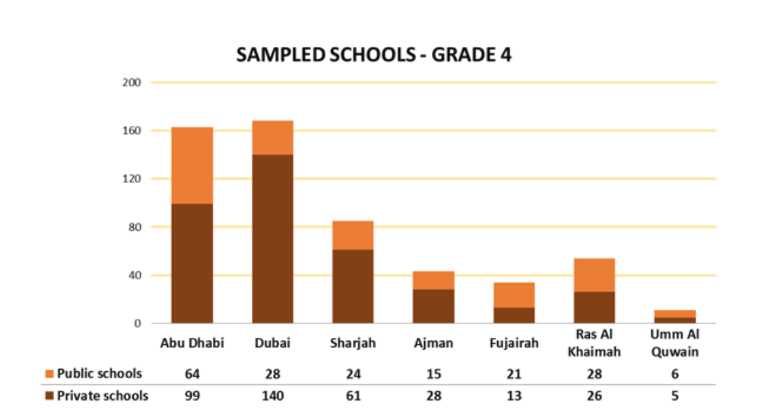
Figure 7: Sampled Schools by Emirate for Grade 4
(UAE Ministry of Education 2017, p. 29)

Figure 8 illustrated the breakdown of the sample in the UAE by the curriculum. For grade 4, around 33% of the sample was from public MOE curriculum weighted, followed by the private UK curriculum, which was 17% and then the private Indian schools, which were 16.2%.
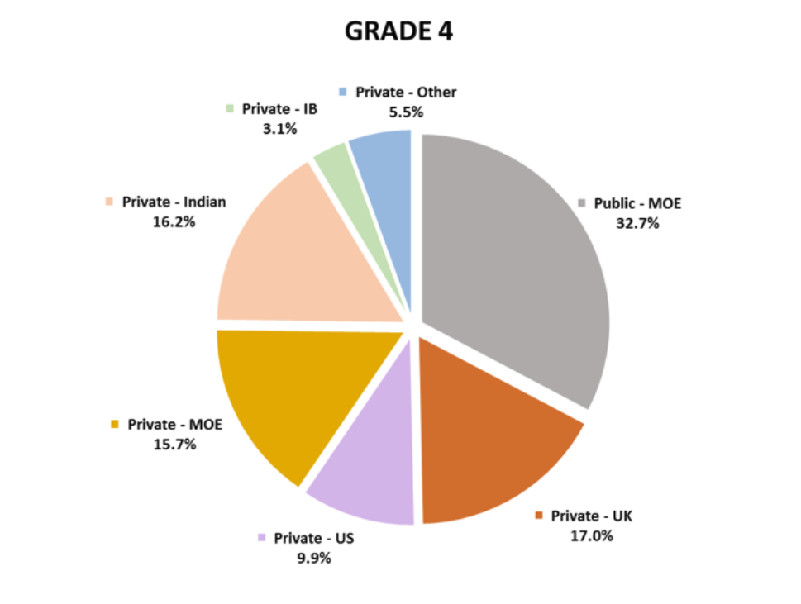
Figure 8: Student sample by the curriculum at Grade 4
(UAE Ministry of Education 2017, p. 30)

3.4 TIMSS 2015 Data Collection Instruments
The data collection instruments were divided into two parts: assessment items and context questionnaires. The assessment items consisted of grade 4 mathematics and science TIMSS 2015 questions. These questions were presented in two formats: multiple choice and constructed response questions. The context questionnaires were the questionnaire that was completed by students, teachers and school principals.

3.4.1 TIMSS 2015 Assessment Items
The structure of the TIMSS mathematics and science framework was based on two dimensions, the content and the cognitive domains. The content domains of mathematics for grade 4 were Number, Geometry and Data Display while for science, these were Life Science, Physics, and Earth Science (Mullis et al. 2016). For each content domain of Mathematics and Science in the TIMSS 2015 framework, there were different topic areas. TIMSS 2015 frameworks were updated based on the standards and curriculum for the participated countries (Mullis et al. 2016). The cognitive domains in the two subjects were: Knowing, Applying, and Reasoning (Mullis et al. 2016). Table 1 shows the Percentages of TIMSS 2015 assessment items for the content and cognitive domains.
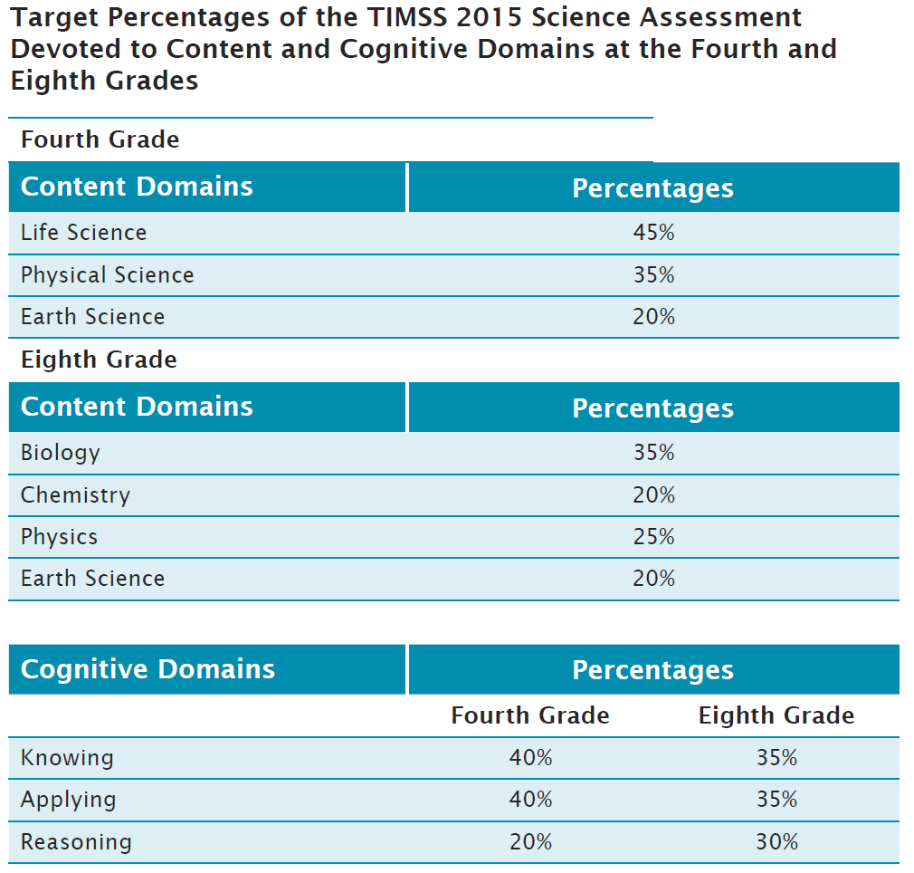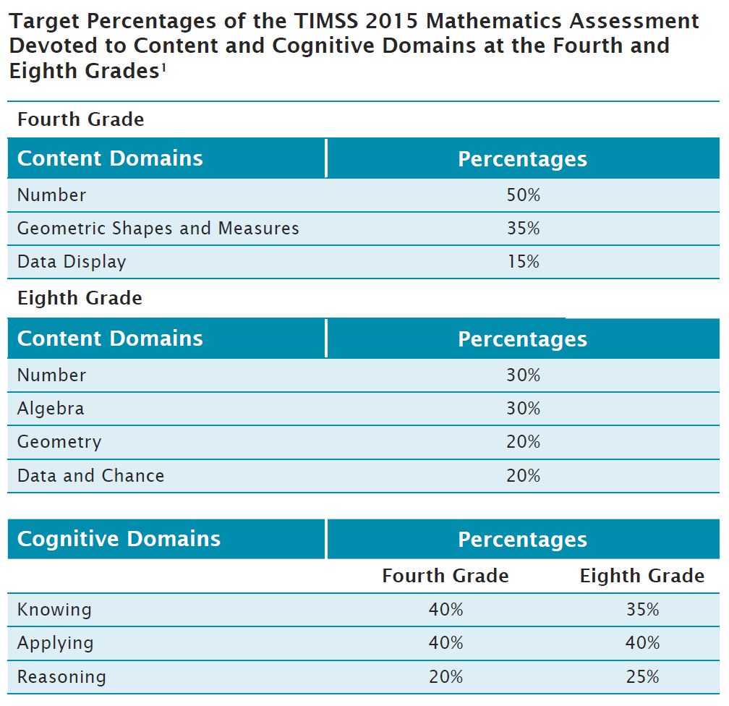
Table 1: Percentages of TIMSS 2015 assessment items for the content and cognitive domains.
(Mullis & Martin 2013, p.12 & 30)

Hooper, Mullis, and Martin (2013) stated that as the TIMSS 2015 assessment framework aimed to track the trends of students' performance from one assessment cycle to another, it required an assessment that had a broad content coverage of mathematics and science, as well as an innovative assessment approach. Consequently, there were many more questions required in the assessment that could be answered by one student during testing time. Therefore, TIMSS 2015 used a matrix-sampling approach that involved grouping the assessment of mathematics and science question items for each grade level into a set of fourteen student booklets (Hooper, Mullis, & Martin 2013). Each question item appeared in two booklets, which provided a mechanism for linking the students’ answers from these different booklets (Hooper, Mullis, & Martin 2013). Assessment booklists consisted of item blocks, whereas each block consisted of between 10-14 question items for the grade 4 students (Martin, Mullis & Foy 2013). Similar to the TIMSS 2011 study, the TIMSS 2015 booklets had 28 blocks; 14 blocks for mathematics questions and 14 for the science questions. There were 16 blocks from TIMSS 2011 assessment that were secured to be used for the TIMSS 2015 (Martin, Mullis & Foy 2013). The remaining 12 blocks of the TIMSS 2011 study were published for the purposes of research and teaching. The twelve blocks were replaced by newly developed question items for the TIMSS 2015 research. To maximize the coverage of the assessment framework, each block appeared in two booklets. Each student booklet consisted of 4 blocks: two blocks of mathematics and two blocks of science. The mathematics blocks came first for half of the booklets while for the other half, the science blocks came first (Martin, Mullis & Foy 2013).
The assessment time for each booklet was 72 minutes, followed by 30 minutes to fill in the student questionnaire (Hooper, Mullis, & Martin 2013). The student booklets consisted of a large range of mathematics and science questions. The fourth-grade assessment consisted of 350 items, half of them in mathematics and the other half in science (Hooper, Mullis, & Martin 2013).
There were two question formats in the TIMSS 2015 study: multiple-choice and constructed responses (Hooper, Mullis, & Martin 2013). Multiple choice question points were weighted as at least half of the score of the TIMSS study's entire assessment. Most of these multiple-choice questions were weighted as one point while there were some compound multiple-choice questions worth 2 points (Mullis et al. 2016). The compound multiple-choice questions were marked as fully correct answers (two points) or partially correct answers (one point). The constructed response questions were weighted as one or two points depending on the difficulty of the question (Mullis et al. 2016). The fully correct answers indicated a deep understanding of the context, while the partially correct answer showed a partial understanding (Mullis et al. 2016). The languages used for grade 4 UAE TIMSS 2015 assessment items were Arabic, English, and Arabic with some English text (Hooper, Mullis, & Martin 2016). Schools were given the option to choose the language of the assessment depending on the language used in teaching the students. Appendix 1 shows samples of the TIMSS question items.

3.4.2 TIMSS 2015 Context Questionnaires
The purpose of the TIMSS context questionnaire was to collect data from educational systems around the world to gain insight on how to teach and learn mathematics and science. This data was about the practices and the procedures in the home, community, schools, and classrooms that were effective in improving student performance in mathematics and science (Hooper, Mullis, & Martin 2016). TIMSS 2015 administered context questionnaire to students, teachers, school principals, grade 4 parents, curriculum questionnaires to specialists, and national context questionnaires (Hooper, Mullis, & Martin 2016). The Languages used for the UAE grade 4 TIMSS 2015 context questionnaires were Arabic, English, and Arabic with some English text (Hooper, Mullis, & Martin 2016). Schools have been given the option to select the language of the questionnaires depending on the language of instruction in the school.
When comparing this data in relation to student attainment, this provided information about the effective educational practices to develop and enhance education systems (Hooper, Mullis, & Martin 2016). After the field test, the result of the contextual questionnaire was reviewed multiple times and then delivered to the National Research Coordinators (NRCs) in each participating country for translation. For this study, the focus was on principal, teacher and student questionnaires.
The grade 4 student questionnaire consisted of 17 pages. The first two pages provided directions on how to fill the questionnaire with three examples. Then, the questionnaire was divided into the following sections: about me, your school, mathematics in the school, and science in the school. These types of questions varied between yes/no questions and multiple-choice questions. Most of the questions had four-point Likert scale questions to measure students' agreement about the statements. The scale was if students would agree a lot, agree a little, disagree a little and disagree a lot. There were no neutral options on the Likert scale to determine whether the students agree or not. These student questionnaires required approximately 15 to 30 minutes to complete (Martin, Mullis, & Foy 2016). A Grade 4 student questionnaire is included in Appendix 2
The Grade 4 teacher questionnaire consisted of 22 pages. The first page had an overview and an introduction about the purpose of the questionnaire. The questionnaire was divided into three sections: general questions, mathematics classes, and science classes. The general section consisted of the following: about you, school emphasis on academic success, school environment, about being a teacher, and about teaching the TIMSS class. Then, the teacher questionnaire had the following questions about mathematics classes: teaching mathematics to the TIMSS class, using calculators and computers for the teaching of mathematics to the TIMSS class, mathematics topics taught to the TIMSS classes, mathematics homework for the TIMSS class, mathematics assessment of the TIMSS class, and preparation to teach mathematics. After that, it had the following sections about science: teaching science to the TIMSS class, using computers for the teaching of science to the TIMSS class, science topics taught to the TIMSS class, science homework for the TIMSS class, the science assessment of the TIMSS class, and preparation to teach science. All the question items in the teachers' survey were multiple choice. The teachers' survey required 30 minutes to complete (Martin, Mullis, & Foy 2016). Appendix 3 shows the TIMSS 2015 grade 4 teacher questionnaire.
The grade 4 school questionnaire consisted of 9 pages. The first page included an overview of the assessment and expectations of the questionnaire. After that, the school principals were asked to fill the following sections: school enrolment and characteristics, instructional time, resources and technology, school emphasis on academic success, school discipline and safety, school readiness, and principals' experience and education. The school principal needed 30 minutes to fill the survey (Martin, Mullis, & Foy 2016). Appendix 4 shows the grade 4 school questionnaire.

3.5 TIMSS 2015 Field Test
In implementing the TIMSS 2015 field test, the same expectations and procedures were applied as planned in the actual assessment, such as data collection and scoring (Mullis et al. 2016). The TIMSS 2015 field test was designed to be delivered to 30 schools in each participating country and for at least 200 students to answer each mathematics and science question item (Mullis et al. 2016).
To ensure the reliability of marking the field test constructed response questions, a training on grading of the responses was delivered to the National Research Coordinators (NRCs) and scoring supervisors in March 2014 (Mullis et al. 2016). During this training, the purpose of each question item was explained, along with a description of the grading guide, as well as the rationale behind providing the score (Mullis et al. 2016).
The TIMSS 2015 field test was delivered between March and April 2014, which was one full year before the actual assessment (Mullis et al. 2016). During the piloting or the field test phase, TIMSS 2015 countries administrated this test for 111,194 students, 2,775 principals, and 10,165 teachers (Hooper 2016). The modifications applied after the field test focused on increasing the number of questionnaire items to improve the reliability and content coverage (Hooper 2016).

3.6 Validity and Reliability
As TIMSS aimed to study the trends of student achievement from cycle to cycle, the assessment items in mathematics and science could not change dramatically, but the achievement question items need to be updated to avoid being dated and irrelevant to the current learning targets (Mullis et al. 2016). This ensured more reliable and consistent results in each cycle and helped countries to track their progress. The development of the new items for each TIMSS cycle included: (1) Updating the TIMSS framework for 2015; (2) Creating the achievement items and their scoring guides based on TIMSS 2015 framework; (3) Organizing a field test; (4) Selecting the new achievement items following the 2015 structure; and (5) Conducting training about reliability scoring of construct response items (Mullis et al. 2016). The TIMSS field test followed the same procedures as the actual TIMSS study. Therefore, it provided the opportunity to practice the data collection and scoring procedures (Mullis et al. 2016).
Content validity refers to the content and the format of the instrument and how it is appropriate to the participants (Fraenkel, Wallen & Hyun 2019). The language of the TIMSS achievement items and the questionnaires were translated into different languages based on the needs of the students in different countries. The international version of the TIMSS assessment items was created in English. The translation of the questions was conducted by the participating countries into their language of instruction. (Mullis et al. 2016).
Content validity was also obtained by making cultural adaptations for the assessment items based on the needs of the participating countries (Mullis et al. 2016). Several cultural adaptation changes were made in the TIMSS 2015 UAE assessment to maintain international comparability. These changes were in the student questionnaire and teacher questionnaire. For grade 4 student questionnaire, there was a question about the luxury things that students had at home. The adapted choices for the UAE for this question were smartphones, swimming pool, luxury car and luxury watch. This helped to measure the luxury resources that the UAE students had which were different from other countries in the world. Also, the choices in the degree questions for teachers and principals were adapted to start from high school degree up to having a doctorate. This question was adapted to reflect the national level of education in the UAE as there were no teachers with less than high school degree.
Also, there are two question formats in the TIMSS 2015 study: multiple-choice and constructed response (Hooper, Mullis, & Martin 2016). Multiple-choice questions provided a valid and reliable assessment of a wide coverage of the content in a short time, but they might be less suitable to measure student abilities in a complex evaluation as they did not allow students to explain their answers (Hooper, Mullis, & Martin 2016). To improve the content validity of the assessment, constructed-response items were created to assess students' knowledge and skills that required explanation and interpretation of data based on their experience as students were required to write written responses, support the answers with reasons, or draw a diagram (Hooper, Mullis, & Martin 2016). Content validity was also included the clarity of the directions (Fraenkel, Wallen & Hyun 2019). Both the assessment items and student questionnaires provided examples on the first page to show students how to respond to these items.
Content validity could be maintained through development and judgment of the instruments by experts in the field. The development of the TIMSS 2015 context questionnaires was a collaborative process that included several cycles of revision by the experts of TIMSS & PIRLS International Study Centre, Questionnaire Item Review Committee (QIRC), and National Research Coordinators (NRCs) of the participating countries (Hooper 2016). The process included five steps: (1) Updating the framework for 2015; (2) Development of new questionnaire items by the TIMSS & PIRLS staff; (3) Revision of the questionnaires by QIRC and NRCs; (4) The administration of a field test; and (5) Using the field test results to modify the questions (Hooper 2016).
To ensure reliability in the marking of constructed response questions, a grading training was delivered based on the results of the field test. To deliver the relevant training for all the participating countries in the TIMSS 2015 study, TIMSS & PIRLS International Study Center delivered two training sessions: one for the southern hemisphere in November 2014 in New Zealand and the other for the northern hemisphere in March 2015 in the Czech Republic (Mullis et al. 2016).
An internal consistency reliability test is used when the instruments have more than one item, and this was conducted to determine the homogenous of these items and whether they were considered as a single construct (Mujis 2004). A widely used measure for the homogeneity of data is coefficient alpha, also called Cronbach alpha after Lee Cronbach (Ary, Jacobs & Sorensen 2010). To measure the internal consistency reliability of the TIMSS 2015 assessment booklets, Cronbach's Alpha reliability test was conducted for the UAE results. The reliability coefficient for the grade 4 results was 0.87 in mathematics and 0.85 in science (Foy et al. 2016). The Cronbach reliability test was also calculated for the variables of the composite scores to measure their homogeneity using the Stata software.

3.7 Data Analysis
The aim of this study was to examine the factors that were associated with the UAE TIMSS 2015 student results through a quantitative data analysis approach. Table 2 shows the breakdown for each research question, approach, instruments, participants and the data analysis techniques used. As the study was purely quantitative, the approach for the four research questions was quantitative. The instruments were the UAE TIMSS 2015 student results in the content and cognitive domains, and this was used for all of the research questions. Along with the students' attainment, the principal questionnaire results were used for RQ2, teachers' questionnaire results were used for RQ3, and the student questionnaire results were used for RQ4.
The data analysis technique for the first research question was the descriptive statistics and the Pearson product moment coefficient of correlation. This analysis was completed by using the IEA IDP Analyzer, which is a free piece of software that was used for analysis in the IEA studies. Descriptive statistics were calculated to describe the data that was involved in answering the research question. The correlation coefficient determined whether the high score of the content domain was associated with the high score of the cognitive domain (Muijs 2004). The correlation coefficient measured the association by determining its direction, strength and significance. The direction of the relationship was presented by the sign of the Pearson product moment coefficient. If this was positive, this would mean that when the content domain increased, the cognitive domain would increase. However, if this was negative, this would mean that the content domain would decrease when the cognitive domain increased. For the strength of the relationship, when the correlation coefficient was closer to 1 or -1, it would be stronger. The statistical significance of the relationship means that the relationship was a possibility to occur in the sample if it was reflected in the population as well (Muijs 2004).
The second, third and fourth research questions used similar data analysis techniques which were descriptive statistics, an Independent Sample T-Test, a One-way ANOVA analysis, correlations, multiple linear regression, and Structural Equation Modeling (SEM). The statistical software that was used to conduct these data analysis techniques was Stata. The IEA IDB analyzer can merge or do simple analysis technique and then produce the data in SPSS format. However, the SPSS program could not perform the required analysis using the plausible values for the mathematics and science results. Therefore, Stata/IC 16.1 was used to perform these analyses. Stata had specific commands for survey analysis that used plausible values (PV), Jackknife Repeated Replication (JRR), sampling weights and specific controls for TIMSS data.
After conducting the descriptive statistics, T-Test and ANOVA analysis were conducted. T-Test helped to compare the average score of mathematics and science achievement between two groups while the ANOVA analysis measured the differences of achievement among three or more groups. The multiple linear regression was used to investigate the relationship between one dependent variable and multiple independent variables. As there were many independent variables that could influence the students TIMSS performance, the multiple linear regression helped to measure them simultaneously. The dependent variables were the students TIMSS 2015 mathematics and science results.
Structural Equation Modelling (SEM) is a widely used statistical analysis approach in social sciences. It is a combination of factor analysis, regression or path analysis. Looking back to RQ2, RQ3 and RQ4, the dependent variables of these questions were the content and the cognitive domains, which were three variables for each. Instead of running a single linear regression for each dependent variable, the SEM analysis helped in estimating the multiple regression for them simultaneously.
Research Question | Approach | Instrument | Participants | Data Analysis Technique
RQ1: What are the relationships among grade 4 UAE students’ science and mathematics TIMSS 2015 results in the content and the cognitive domains? | Quantitative | TIMSS 2015 results of mathematics and science | Grade 4: 21,177 students | Descriptive Statistics and Pearson’s correlation using IEA IDP Analyzer
RQ2: What are the factors of the school questionnaire that are associated with grade 4 mathematics and science TIMSS 2015 results in the content and cognitive domains of the UAE? | Quantitative | TIMSS 2015 Principal questionnaire | Grade 4: 21,177 students | Descriptive Statistics, ANOVA, Correlation, multiple linear regression, and SEM by Stata
RQ3: What are the factors of the teacher questionnaires that are associated with grade 4 mathematics and science TIMSS 2015 results in the content and cognitive domains of the UAE? | Quantitative | TIMSS 2015 Teacher questionnaires | Grade 4: 21,177 students | Descriptive Statistics, T-Test, ANOVA, Correlation, multiple linear regression, and SEM by Stata
RQ4: What are the factors of the student questionnaires that are associated with grade 4 mathematics and science TIMSS 2015 results in the content and cognitive domains of the UAE? | Quantitative | TIMSS 2015 Student questionnaire | Grade 4: 21,177 students | Descriptive Statistics, T-Test, ANOVA, Correlation, multiple linear regression, and SEM by Stata
Table 2: Data Analysis Plan to Answer Research Questions

3.8 Selection of Variables
The variables were selected from schools, teachers and students TIMSS 2015 questionnaires based on studies in the literature that identified them as the most critical variables that affected student performance. As there were many variables in the TIMSS questionnaires, these were reduced by combining them into composite variables. The study used two ways of calculating composite variables. The first one and the most efficient way used the TIMSS 2015 background indices. The background index is a composite variable that assigns the participants’ responses into one of three levels, based on the data of the component variables (IEA 2019). The second method was a factor analysis, and it was used when there were variables that were necessary to study but did not have any background indices.
Table 3 shows that there were five school factors selected in the study. Three of them were the TIMSS background indices which were economic background, a shortage of mathematics resources and a shortage of science resources. The fourth factor was principal experience which was calculated based on factor analysis. Each composite variable consisted of individual variables from the TIMSS questionnaire. The economic background factor consisted of two variables. Studies in the literature indicated that the economic background of students was highly correlated with their academic achievement (Tavsancil & Yalcin 2015) and students from a low socio-economic level performed lower (Breger 2017; Stumm 2017). The second factor was a shortage of math’s resources consisting of thirteen variables, while the third factor, a shortage of science resources consisted of twelve variables. The shortage of resources included instructional materials, supplies, school building, instructional space, as well as the basic resource such as heating systems. Lay and Chandrasegaran (2016) stated that students in schools affected by the shortage of resources performed poorer than in schools that were not affected. The fourth factor was principal experience which included the general years of experience for the school principal as well as the number of years in the school. Finally, there was an ungrouped variable that was essential to be studied based on the literature, which was the school location. Several studies indicated that there were differences between the performance of students in urban and rural areas. Schools who were located in rural areas were identified as having a lower level of student attainment (Ramos, Duque & Nieto 2016; Zhijun, Zeyun & Baicai 2016; Murphy 2018; Lu et al. 2019).
Variable | Description
ACDG03 | TIMSS Index: Economic Background
ACBG03A | Approximately the percentage of students from economically disadvantaged homes
ACBG03B | Approximately the percentage of students from economically affluent homes
ACDGMRS | TIMSS Index: Instruction Affected by Mathematics Resource Shortages
ACBG14AA | Affected by a shortage of Instructional materials
ACBG14AB | Affected by a shortage of supplies
ACBG14AC | Affected by a shortage of school building
ACBG14AD | Affected by a shortage of heating system
ACBG14AE | Affected by a shortage of Instructional space
ACBG14AF | Affected by a shortage of technical staff
ACBG14AG | Affected by a shortage of audio-visual resources
ACBG14AH | Affected by a shortage of computer technology
ACBG14BA | Affected by a shortage of teachers with specialization of mathematics
ACBG14BB | Affected by a shortage of mathematics computer software
ACBG14BC | Affected by a shortage of mathematics library resources
ACBG14BD | Affected by a shortage of mathematics calculators
ACBG14BE | Affected by a shortage of mathematics concrete objects
ACDGSRS | TIMSS Index: Shortage of Science Resources
ACBG14AA | Affected by a shortage of Instructional materials
ACBG14AB | Affected by a shortage of supplies
ACBG14AC | Affected by a shortage of school building
ACBG14AD | Affected by a shortage of heating system
ACBG14AE | Affected by a shortage of Instructional space
ACBG14AF | Affected by a shortage of technical staff
ACBG14AG | Affected by a shortage of audio-visual resources
ACBG14AH | Affected by a shortage of computer technology
ACBG14CA | Affected by a shortage of teachers with specialization of science
ACBG14CB | Affected by a shortage of scientific computer software
ACBG14CC | Affected by a shortage of science library resources
ACBG14CD | Affected by a shortage of science equipment
Principal Experience
ACBG19 | Principal Experience in general
ACBG20 | Principal Experience in the school
$α$: 0.83
Other Variables of Interest With No Group
ACBG05B | Location of the school
Table 3: Selected Variables of School Factors

Similar to school factors, table 4 shows classroom factors that were selected from the teacher questionnaire, based on the studies in the literature that were highlighted in the TIMSS 2015 framework. There are four composite scores from the teacher questionnaires. These factors were discipline, using technology in a mathematics lesson, using technology in science lessons and the emphasis on science investigation. Only one of these was in the TIMSS index, which was the emphasis on science investigation while the other three were calculated by using factor analysis.
The first composite variable discipline had four variables. Discipline has been identified in the literature as a factor that leads to better learning (Foncha et al. 2017), and the implementation of positive behavior programs will leads to positive academic and behavior outcomes (Kelm, McIntosh & Cooley 2014)
The second and third composite scores involved the integration of technology in mathematics and science lessons. Studies in the literature revealed differences in the influence of technological integration according to the year of implementation, teaching practices and grade levels (Meggiolaro 2018; Aburizaizah, Kim & Fuller 2019). The fourth composite score was in the area of science investigation, and it consisted of nine variables. Regarding the emphasis on science investigation, Aktamiş, Hiğde, and Özden (2016) argued that inquiry-based learning methods in science classrooms had a more significant effect on students’ achievement compared to traditional teaching methods.
There were other ungrouped variables that were selected from the teacher questionnaire were based on the studies of the literature as they were considered factors that were associated with student performance. These factors were teacher degree, professional development, instructional time, homework and assessment of ongoing work. For the teachers’ degree, Coenen et al. (2018) stated that subject-specific certification contributes to better student attainment. Professional development has been highlighted in the literature as it improves teachers’ knowledge (Guay et al. 2016; Clary et al. 2017) and teachers pedagogical content knowledge has an impact on students’ achievement (Cueto et al. 2017). Regarding instructional time, there were inconsistent findings of the association of instruction time, and student attainment as some studies indicated that increasing academic instructional time is associated with student performance (Fisher et al. 2015; Cattaneo, Oggenfuss &Wolter 2017) while other studies concluded that learning time has no influence on student performance (Gorman 2014; Catur & Usman 2019). For ongoing assessments, studies highlighted that providing students with formative assessments have a positive impact on student achievement (Andersson & Palm 2017; Faber, Luyten & Visscher 2017; Ozan & Kıncal 2017). Similar to instructional time, there were inconsistent findings on the impact of homework on student performance. Some studies indicated that there was a positive impact of homework on student learning (Fan et al. 2017; Rosário et al. 2018; Güven & Akçay 2019) while others claimed that homework had a negative influence on student performance (Fernández-Alonso et al. 2017; Abdelfattah & Lam 2018; Rodríguez et al. 2019). The selected classroom variables are listed in table 4.
Variable | Description
Discipline
ATBG07D | The students behave in an orderly manner
ATBG07E | The students are respectful of the teachers
ATBG07G | The school has clear rules about students’ conduct
ATBG07H | The enforcement of the school rules
$α$= 0.87
Using Technology with Mathematics
ATBM05CA | Using technology to explore mathematics principles and concepts
ATBM05CB | Using technology to practice skills and procedures
ATBM05CC | Using technology to look up ideas and information
$α$ = 0.86
Using Technology with Science
ATBS04CA | Using technology to practice science skills and procedures
ATBS04CB | Using technology to look up scientific ideas
ATBS04CC | Using technology to do scientific procedures
ATBS04CD | Using technology to study scientific phenomena
$α=$ 0.85
ATDSESI | TIMSS Index Science Investigation
ATBS03B | How often students observe phenomena?
ATBS03C | How often students conduct experiments?
ATBS03D | How often students plan experiments?
ATBS03E | How often the students conduct experiments?
ATBS03F | How often students present data from experiments?
ATBS03G | How often students interpret data?
ATBS03H | How often students use evidence to support?
ATBS03G | How often students interpret data?
ATBS03K | How often students do fieldwork?
Other variables of interest with no group
Mathematics
ATDM05 | Teachers Majored in Ed and Math
ATBM10 | Mathematics Teacher professional development
ATBM01 | Mathematics instructional time
ATBM07A | Assigning mathematics homework
ATBM08A | Emphasizing assessment of student’s mathematics ongoing work
Science
ATDS05 | Teachers Majored in Ed and Science
ATBS01B | Science instructional time
ATBS06A | Assigning Science Homework
ATBS07A | Emphasizing assessment of student’s science ongoing work
ATBS09 | Science professional development
Table 4: Selected Variables of Classroom Factors
The same method of selecting variables from the school and teacher questionnaires was applied to the student questionnaire. The variables were selected based on previous studies in the literature that were aligned to the TIMSS 2015 framework and factor analysis. There were seven composite factors in the student questionnaire, and all of them were in the TIMSS indices. The variables were student bullying, engagement in math lessons, like learning mathematics, student confidence in learning mathematics, engagement in science lessons, like learning science, and student confidence in learning science. There were also two ungrouped essential variables, selected which were gender and breakfast during school days.
The composite scores of student factors were mentioned in the literature and said to have an impact on student attainment. In the literature, bullying has been associated with low academic achievement and classroom engagement (Lacey, Cornell & Konold 2017). Motivation and self-concept have been identified in many studies as factors that have a positive association with students’ performance (Wang & Liou 2017; Şahin and Öztürk 2018). For classroom engagement, it is known that the higher level of behavioural, emotional, and cognitive engagements will influence academic performance (Konold et al. 2018; Lei, Cui & Zhou 2018).
For the ungrouped variables, gender has been an interesting topic in educational research to figure out the differences in academic performance between boys and girls (Meinck & Brese 2019). However, studies in the literature have inconsistent findings regarding the differences in academic achievement between male and female students. For students’ needs, Anderson, Gallagher and Ritchie (2018) concluded that a healthy diet improves students’ cognitive functions. All the student factors that are involved in the study are presented in table 5.

Variable | Description
ASDGSB | TIMSS Index: Student Bullying
ASBG12A | Someone made fun of me
ASBG12B | I was left out of games
ASBG12C | Someone spread lies about me
ASBG12D | Someone stole from me
ASBG12E | I was hurt by others
ASBG12F | Someone forced me to do something
ASBG12G | Someone shared embarrassing information
ASBG12H | Someone Threatened me
ASDGEML | TIMSS index: Engaging Teaching in Mathematics Lessons
ASBM02A | I know what my teacher expects me to do
ASBM02B | My teacher is easy to understand
ASBM02C | I am interested in what my teacher says
ASBM02D | My teachers give me interesting things to do
ASBM02E | My teacher has clear answers
ASBM02F | My teacher gives good explanation
ASBM02G | My teacher let me show what I had learned
ASBM02H | My teacher does a variety of things to help us learn
ASBM02I | My teachers show me how to do better
ASBM02J | My teachers listen to me
ASDGSLM | TIMSS Index: Like learning mathematics
ASBM01A | I enjoy learning mathematics
ASBM01B | I wish not to study math*
ASBM01C | Math is boring*
ASBM01D | I learn interesting things in mathematics
ASBM01E | I like mathematics
ASBM01F | I like schoolwork involving numbers
ASBM01G | I like solve math problems
ASBM01H | I look forward to math lessons
ASBM01I | Math is my favorite subject
ASDGSCM | TIMSS Index: Student confidence in mathematics
ASBM03A | I usually do well in math
ASBM03B | Mathematics is harder for me than for others
ASBM03C | I am just not good in math
ASBM03D | I learn quickly in mathematics
ASBM03E | Math makes me nervous
ASBM03F | I am good at working out problems
ASBM03G | I am good at mathematics
ASBM03H | Mathematics is harder for me than any other subject
ASBM03I | Math makes me confused
ASDGESL | TIMSS index: Engaging Teaching in Science Lessons
ASBS05A | I know what my teacher expects me to do
ASBS05Bl | My teacher is easy to understand
ASBS05C | I am interested in what my teacher says
ASBS05D | My teachers give me interesting things to do
ASBS05E | My teacher has clear answers
ASBS05F | My teacher gives me clear explanation
ASBS05G | My teacher lets me show what I have learned
ASBS05H | My teacher does a variety of things to help us learn
ASBS05I | My teachers show me how to do better
ASBS05J | My teachers listen to me
ASDGSLS | TIMSS Index: Like learning Science
ASBS04A | Enjoy learning science
ASBS04B | I wish not to study science*
ASBS04C | Science is boring*
ASBS04D | I learn interesting things in science
ASBS04E | I like science
ASBS04F | I look forward to learning science
ASBS04G | Science teaches me how things in the world work
ASBS04H | I like to do science experiments
ASBS04I | Science is my favorite subject
ASDGSCS | TIMSS Index: Students Confident in Science
ASBS06A | I usually do well in science
ASBS06B | Science is harder for me than for others
ASBS06C | I am just not good at science
ASBS06D | I learn quickly in science
ASBS06E | I am good at science
ASBS06F | Science is harder for me
ASBS06G | Science makes me confused
Other variables of interest with no group
ASBG01 | Gender
ASBG09 | Breakfast on School Days
*Reversed coded
Table 5: Selected Variables of Student Factors

3.9 Ethical Considerations
It is the responsibility of the researcher to ensure that all the participants in the study are protected from any psychological harm, discomfort or danger during the research procedures (Fraenkel, Wallen & Hyun 2019). Whenever it is possible, the names of the participants should be removed in the study by assigning a number or a letter for each form (Fraenkel, Wallen & Hyun 2019). The data from the TIMSS questionnaires for schools, students and teachers was anonymous, and there was no indication of their identities to ensure confidentiality. They were referred to as numbers on the SPSS data file.
All the TIMSS 2015 data is available on the IEA international databases for any individuals who are interested in analyzing the data. It is free of charge and available in SPSS format. For sensitive data that was not made available for public viewing, this can be obtained by contacting the IEA. However, that was not necessary for this study, as all the required data was available on the website.
There were some students who were excluded from the target population as they were non-native language speakers, or had disabilities (LaRoche, Joncas & Foy 2016). Non-native speakers were excluded because of the language barrier as they did not have equal access and the opportunity to perform in the assessment in comparison to the native-speaking students. For students with disabilities, there were clear rules and a description of students who should be excluded from the study.
One important aspect of ethical consideration during the study was to respect the site by disturbing it as little as possible during the data collection process (Creswell 2012). It was less disruptive on the school day selecting full classes to perform in the TIMSS 2015 research process, rather than to choose specific students. Therefore, the school day was disrupted only for the participating classes instead of disrupting any other classes.
The study was considered as low-risk research. The research was considered low risk when the only expected risk was the discomfort of the participants (UNSW 2020). The secondary use of data, survey research and interviews were considered to be low risk studies (UNSW 2020). As the current study used secondary use of data, it was low-risk study. The British University in Dubai (BUiD) research low risk ethical from is illustrated in appendix 5.

CHAPTER 4: DATA ANALYSIS and RESULTS
The purpose of this study was to examine the factors that have relationships to grade four students’ mathematics and science TIMSS 2015 results in the content and cognitive domains, in the United Arab Emirates. It investigated the relationship between the content domain and the cognitive domain of the subjects of mathematics and science with the factors of TIMSS 2015 questionnaire of schools, classrooms and students following the Slavin model. This chapter presents the results of the data analysis techniques, conducted to answer the study’s research questions. The research questions were:
- What are the relationships among grade 4 UAE students’ science and mathematics TIMSS 2015 results in the content and the cognitive domains?
- What are the factors of the school questionnaire that are associated with grade 4 mathematics and science UAE TIMSS 2015 results in the content and cognitive domains?
- What are the factors of the teacher questionnaires that are associated with grade 4 mathematics and science TIMSS 2015 results in the content and cognitive domains of the UAE?
- What are the factors of the student questionnaire that are associated with grade 4 mathematics and science TIMSS 2015 results in the content and cognitive domains of the UAE?
The analysis techniques included an independent sample T-Test, analysis of variance ANOVA, correlations, multiple linear regression and structural equation modelling (SEM) with the use of Stata/IC 16.1 software. The software helped in conducting the required data analysis techniques taking into consideration the complex data and sampling design of TIMSS 2015. Also, it included the feature of the SEM model building and estimation. Before conducting the analysis, specific steps were implemented to prepare the data for analysis such as cleaning the data, performing composite scores, dealing with missing data, and descriptive analysis. All of these steps are described in detail in this chapter.

4.1 Preparing Data for Analysis
As TIMSS assessment has extensive coverage of the content of mathematics and science, many more questions were required in the evaluation session that cannot be answered by one student during testing time. Therefore, TIMSS 2015 used a matrix-sampling approach that involved grouping the mathematics and science question items for each grade level into a set of fourteen student booklets. Each question item appeared in two booklets which provided a mechanism of linking students’ answers (Hooper, Mullis, & Martin 2013). Each question covered a specific content and cognitive domain. Therefore, when calculating the average score of the content and cognitive domain, it is essential to take into consideration that not all the students answered the same questions. Thus, to achieve consistent results, plausible values were calculated for each content and cognitive domains in the subjects of mathematics and science, along with the student’s overall achievement in these two subjects. The Plausible values (PV) are a computational approximation of the population characteristics in assessments, used when there are few items to provide a precise estimation of students’ abilities (Institute for Objective Measurement 2020). The PVs were used in TIMSS assessment because they did not provide individual scores for students, but they estimated the population parameters such as average and variance. When analyzing TIMSS data, each PV variable needs to be considered during the analysis. These variables help the researcher to achieve an accurate estimation of the average achievement for each domain.
TIMSS 2015 used Jackknife Repeated Replication (JRR) Techniques that provide an accurate estimation of sampling errors. This sampling method was used in schools as the first selection and then this replicated the choices of schools based on the requirement of the assessments. After the selection of the schools, students and teachers were chosen from within the school sample. Sampling weight is used to make sure that all schools, teachers and students were selected with the same probability (Rutkowski et al. 2010). There are different types of weights, depending on the analyses of the study. The study followed recommendations from Rutkowski et al. (2010) when calculating the sampling weight of TIMSS analysis that included schools, classrooms and student factors. The study generated final school weight, and final school student weight for analysis, including students and schools factors.

Final School weight = School weight factor × School weight adjustment
Final Student weight = (Student weight factor × Student weight adjustment) × (Class weight factor × Class weight adjustment)

For teachers’ questionnaire data, a math weight was used for math data analysis, while a science weight was used for science data analysis.
TIMSS data is available for the public on the IEA website for all assessment cycles (IEA 2019). This data includes the results of the assessment items of mathematics and science for grades 4 and 8 students. The data of the contextual questionnaires for students, teachers and principals were also included. Besides the data, the IEA website has user guides, an assessment framework, questionnaires and technical reports. The raw data can be merged by using the free IDB data analyzer from the IEA, which also had a user manual. The IEA IDB analyzer can merge or do simple analysis techniques by using IEA data. The study used the IEA IDB analyzer to combine the data to ensure that the data was merged with the correct variables, plausible values and weights. The merged data was then produced using the SPSS format. However, the SPSS program could not perform the required analysis using the plausible values for the mathematics and science results. Therefore, Stata/IC 16.1 was used to perform these analyses. Stata had specific commands for survey analysis that used plausible values (PV), Jackknife Repeated Replication (JRR), sampling weights and specific controls for TIMSS data. This helped in making sure that the data was analyzed while taking into consideration all of the required restrictions to achieve accurate results and minimize errors.
An essential step to prepare the data for analysis was data cleaning as it assisted in handling potential errors before analysis (Chai 2020). Also, it is a crucial step to represent the data on graphs as the study used Structure Equation Modelling analysis (SEM). The cleaning process in the study included making gender 0,1 (Female 1, male = 0) variable instead of 1,2, as was indicated in TIMSS original data set. Also, it included rescaling questions to recode “Never” as 1 instead of 4 and “Strongly Disagree” as 1 instead of 4 for positive variables. The cleaning process was achieved after merging the data with the IDB analyzer through Stata software.

4.2 Missing Data
Because of the large sample size of the TIMSS assessment, some of the data was missing. The missing data of study were the TIMSS 2015 questionnaire items that had not been answered by principals, teachers or students. Sawlin (2018) stated that there is no ideal way to handle missing data as the researcher has the choice whether to impute or remove the data depending on the analysis type and the context of the study. There are two ways of dealing with missing data: deleting and imputing. For multivariate analysis, it is recommended to drop the cases of the missing data rather than to replace them (Statistics Solutions 2020). Therefore, as the study used a multivariate analysis, such as factor analysis and multiple linear regression, the study used the deleting method.
Allison (2001) stated that data could be deleted by listwise or pairwise. Listwise deleting refers to deleting all the records from the participant that had missing data while pairwise deletion refers to analyzing all the available data (Sawlin, 2018). Allison (2001) stated that listwise deletion leads to an unbiased estimation of regression coefficients and leads to an accurate estimate of stand errors. As the study used regression and SEM analysis, it is essential to take into consideration the analysis method when selecting the deleting method of data analysis. Therefore, the study used listwise deleting.

4.3 Factor Analysis
The variables were selected from schools, teachers and students TIMSS 2015 questionnaires based on studies in the literature that identified them as the most critical variables that affected the students’ performance. As there were many variables in the TIMSS questionnaires, these variables were minimized by combining them into composite variables. The study used two ways of calculating composite variables. The first one and the most efficient method was by using the TIMSS 2015 background indices. The background index is a composite variable that assigns the participants’ responses into one of three levels based on the data of the component variables (IEA 2019). The second method was factor analysis, used when there were variables that are necessary to study but which did not have background indices. The factor analysis reduced the number of variables into a fewer number of composite factors. This process was conducted through extracting the common variance between all variables and combine them into one common composite score (Statistics Solutions 2020). Table 6 shows the results of the principal factor analysis for the variables that were selected through factor analysis. Four composite variables were selected, using factor analysis. The variables were principal experience, discipline, math technology and science technology. The Cronbach reliability test was then applied to the composite factors that were calculated based on factor analysis to ensure the consistency of the data in the variables. From table 6, all the composite scores had an alpha value above 0.8 which showed a high consistency and reliability among the variables in those composite scores.
Table 6: Principal Factor Analysis for TIMSS variables
Factors |  | Eigenvalue | Factor Loadings | Cronbach’s Alpha
Principal Experience
ACBG19 | Principal Experience in general | 1.42 | -0.66 | $α$: 0.83
ACBG20 | Principal Experience in the school |  | -0.72 | $α$: 0.83
Discipline
ATBG07D | The students behave in an orderly manner | 2.49 | 0.73 | $α$= 0.87
ATBG07E | The students are respectful of the teachers |  | 0.66 | $α$= 0.87
ATBG07G | The school has clear rules about students’ conduct |  | 0.52 | $α$= 0.87
ATBG07H | The enforcement of the school rules |  | 0.59 | $α$= 0.87
Math Technology
ATBM05CA | Using technology to explore mathematics principles and concepts |  | 0.71 | $α$ = 0.86
ATBM05CB | Using technology to Practice skills and procedures | 4.52 | 0.69 | $α$ = 0.86
ATBM05CC | Using technology to Look up ideas and information |  | 0.73 | $α$ = 0.86
Science Technology
ATBS04CA | Using technology to practice science skills and procedures |  | 0.73 | $α=$ 0.85
ATBS04CB | Using technology to look up scientific ideas |  | 0.65 | $α=$ 0.85
ATBS04CC | Using technology to do scientific procedures | 4.51 | 0.68 | $α=$ 0.85
ATBS04CD | Using technology to study scientific phenomena |  | 0.67 | $α=$ 0.85

4.4 Results of Research Questions
While answering the four research questions, five data analysis techniques were conducted. These analyses were the independent sample T-Test, analysis of variance ANOVA, Pearson correlation, multiple linear regression and Structural Equation Modelling (SEM). Before conducting the analysis, descriptive statistics for the variables of the questions were calculated in order to describe the data involved and answer the research questions.
For RQ1, only the Pearson correlation analysis was conducted while the five analysis techniques were conducted for the other three research questions. The Pearson’s coefficient r describes the relationship between two variables by specifying the direction and the strength of the relationship. The positive direction indicates a positive relationship, while the negative directions indicate a negative relationship. The relationship was considered stronger when it was closer to 1, either positive or negative.
For RQ2, RQ3 and RQ4, after conducting the descriptive statistics for the factors of the questions, T-Test and ANOVA analysis were conducted. The descriptive statistics had the advantage of describing the information that included many scores and numbers with categories such as mean, standard deviation, frequency, maximum and minimum (Fraenkel, Wallen & Helen Hyun 2019). The T-Test helped to compare the average score of mathematics and science achievement between two groups while the ANOVA analysis measures the difference of achievement among three or more groups. After that, the Pearson correlation analysis was conducted between the factors of the questions and student achievement in mathematics and science. This analysis was followed by a multiple linear regression. The multiple linear regression analysis looked at the relationship between the dependent variables and the independent variables. The independent variables were the variables of the school, teacher and student questionnaires while the dependent variables were math and science TIMSS results. The analysis was conducted separately for each questionnaire item and each subject. Also, the five plausible values for mathematics and science were included in the regression module.
Structural Equation Modelling (SEM) is a widely used statistical analysis approach in social sciences. It is a combination of factor analysis, regression or path analysis. Looking back to RQ2, RQ3 and RQ4, the dependent variables of these questions were the content and the cognitive domains, which were three variables for each. Instead of running a single linear regression for each dependent variables, SEM analysis helped in estimating the multiple regression for them simultaneously. Also, the SEM analysis had the advantage of excluding the measurement errors in the model, and it investigated the relationship between latent and observed variables in the model. The latent variables are not observed variables, but they can be inferred through mathematical operations while the observed variables are the ones that can be measured. The latent variables in the SEM diagram were presented in ovals while the observed ones were presented in rectangles. The latent variables in the study were the content and cognitive domain of the subjects mathematics and science for the TIMSS 2015 assessments. The latent variables for mathematics content domain were Data Display, Geometry and Number while for science they were Earth Science, Life Science and Physics. The latent variables for the cognitive domain were the same for the two subjects, which were Knowing, Applying and Reasoning. Each content and cognitive domain were represented by five plausible values. The observed variables were the factors that were associated with student performance which are the school, classroom and student factors. Below are the four research questions of the study with the data analysis technique to answer them.

4.5 Results of Research Question 1
This section presents the answer for the first research question “What are the relationships among grade 4 UAE students’ science and mathematics TIMSS 2015 results in the content and the cognitive domains?”. The analysis technique that was used to answer this question was the Pearson correlation analysis. Before the correlation analysis, the descriptive statistics were conducted for the content and cognitive domains for mathematics and science as well as the students overall achievement in the two subjects. The analysis for this question was achieved through the IEA IDB analyzer, and each operation was run five times; one for each PV value.

4.5.1 Descriptive Statistics for the content and cognitive domains
The descriptive statistics for the content and cognitive domains were calculated through the IEA IDP Analyzer, and the results are illustrated in table 7. The total number of observation (N=21177) refers to the grade 4 students who participated in the study. The overall mathematics achievement (M=451.58, SD=105.34) was slightly higher than the science achievement (M= 451.24, SD=120.92). The standard deviation of science achievement was higher, which indicated that the science scores varied between students and they were not close to the mean score. For the content domain of mathematics, the highest achievement was for Number (M=455.06, SD= 105.55) while the lowest was Geometry (M=441, SD=11.50). This means that the students performed higher in Number questions and lower in Geometry questions. For the cognitive domain of mathematics, the highest average was for Knowing (M=453.02, SD= 108.89), and the lowest average was for Reasoning (M=445.1, SD=106.14). This means that the students got higher scores with the questions that focus on students’ knowledge more than the questions that required reasoning skills.
For the science content domain, the highest performance was associated with Physics (M=453.27, SD=123.25) while the lowest mean score was for Earth Science (M=447.86, SD=122.73). This means that the students performed better in the Physics questions than the Earth Science ones. Similar to the results of the cognitive domain of mathematics, students performed higher with the Knowing cognitive domain (M=453.27, SD=132.53) while the lowest average was for Reasoning (M=444.32, SD=117.16). This means that students performed higher with the science questions that assessed the students’ knowledge than the questions that required the reasoning skills.
Table 7: Descriptive Statistics for the content and cognitive domains:
Content and Cognitive Domains | N | M | SD
Math Achievement | 21177 | 451.58 | 105.34
Content Domain of Mathematics
Data Display | 21177 | 453.44 | 113.10
Geometry | 21177 | 441.62 | 111.50
Number | 21177 | 455.06 | 105.55
Cognitive Domain of Mathematics
Knowing | 21177 | 453.02 | 108.89
Applying | 21177 | 452.29 | 105.75
Reasoning | 21177 | 445.10 | 106.14
Science Achievement | 21177 | 451.24 | 120.92
Content Domain of Science
Life Science | 21177 | 449.06 | 125.68
Physics | 21177 | 453.27 | 123.25
Earth Science | 21177 | 447.86 | 122.73
Cognitive Domain of Mathematics
Knowing | 21177 | 453.27 | 132.53
Applying | 21177 | 451.91 | 120.39
Reasoning | 21177 | 444.32 | 117.16

4.5.2 Correlation Analysis between the Content and Cognitive Domains
After the descriptive statistics, Pearson Correlation analysis was conducted through the IDP analyzer. Tables 8 shows the results of the analysis between the content and the cognitive domains in mathematics and science. The analysis was conducted by using the five plausible values (PV) for each content and cognitive domain. From table 8, all the correlation relationships between the content and cognitive domains of mathematics were statistically significant. The strength of the relationships was very strong (positive), as all of them were above 0.8. For the Reasoning cognitive domain relationship with the three content domains of mathematics, the strongest correlation was with the Number r=0.84, p< 0.01, followed by Data Display r=0.83, p<0.01 and Geometry r=0.83, p <0.05. This means that students’ reasoning skills are highly associated with the three content domains of mathematics.
The correlations between the Knowing cognitive domain with the three content domains of mathematics were stronger than the relationships with Reasoning. The strongest correlation of Knowing was with Number r= 0.88, p<0.01, followed by Data Display r=.85, p<0.01 and Geometry=.85, p<0.05. This means that students mathematics knowledge are highly associated with the content domains of Number, Geometry, and Data Display. Similar to the cognitive domains of Reasoning and Knowing, Applying had a statistically significantly strong correlation with the three content domains of mathematics. The strongest correlation was with Number content domain r=.88, p<0.01, followed by the Geometry r=.85, p<0.01 and then Data Display r=.85, p<0.01. This means that students’ abilities to apply their mathematics skills are highly correlated with the three content domains of mathematics.
For the relationship between the three cognitive domains, the largest correlation was between Knowing and Applying r=.97, p<0.01 followed by Reasoning and Applying r=.95, p<0.01 and then Reasoning and Knowing r=.94, p<0.01. This means that the students mathematics knowledge is highly associated with their reasoning and application skills. The relationship between the three content domains was also statistically significant and strong. The strongest correlation was between Number and Geometry r=.93, p<0.01 as well as between Number and Data Display r=.93, p<0.01. This correlation, followed by the one between Geometry and Data Display r=.90, p<0.01. This means that the students content skills of each content domain were highly associated with each other.

Table 8: Correlation Analysis between the Content and Cognitive Domains for Mathematics TIMSS 2015
Dependent variable | Correlated variable | r
Reasoning | Reasoning | 1.00
Reasoning | Knowing | .94**
Reasoning | Applying | .95**
Reasoning | Number | .85**
Reasoning | Geometry | .83*
Reasoning | Data Display | .83**
Knowing | Reasoning | .94**
Knowing | Knowing | 1.00
Knowing | Applying | .97**
Knowing | Number | .88**
Knowing | Geometry | .85*
Knowing | Data Display | .85**
Applying | Reasoning | .95**
Applying | Knowing | .97**
Applying | Applying | 1.00
Applying | Number | .87**
Applying | Geometry | .85**
Applying | Data Display | .85**
Number | Reasoning | .85**
Number | Knowing | .88**
Number | Applying | .87**
Number | Number | 1.00
Number | Geometry | .93**
Number | Data Display | .93**
Geometry | Reasoning | .83*
Geometry | Knowing | .85*
Geometry | Applying | .85**
Geometry | Number | .93**
Geometry | Geometry | 1.00
Geometry | Data Display | .90**
Data Display | Reasoning | .83**
Data Display | Knowing | .85**
Data Display | Applying | .85**
Data Display | Number | .93**
Data Display | Geometry | .90**
Data Display | Data Display | 1.00
Note * significant at 0.05 level. ** significant at 0.01 level

Similar to mathematics, all the correlation analysis between the content and cognitive domains for science were statistically significantly positive and very strong. The analysis was conducted through the IDP analyzer by using the five PV values for the content and cognitive domains of science. The results of the correlation analysis are indicated below in table 9. For the relationship between the cognitive domain of Knowing and the science content domain, all correlation was strong and equal r=.86, p<0.01. This means that students’ knowledge was highly correlated with Life Science, Physics and Earth Science. For the relationship between the cognitive domain of Applying and content domains, the strongest correlation was between Life Science r=.87, p<0.01 and Physics r=.87, p<0.01. This correlation was followed by the relationship between Applying and Earth Science r=.86, p<0.01. These three correlations indicated that students’ application skills are highly associated with the three content domains of science. For the relationship between Reasoning cognitive domain and the content domains of science, the strongest relationship was with Life Science r=.86, p<0.01 followed by Physics r=.85, p<0.01 and then Earth Science r=.84, p<0.05. This means that students’ reasoning skills are highly associated with the three content domains of science.
There were also strong correlations between the three cognitive domains. The strongest correlations were between Knowing and Applying r=.97, p<0.01, followed by Applying and Reasoning r=.95, p<0.01, and then Knowing and Reasoning r-.93, p<0.01. This means that the three cognitive domains had a strong association with each other. The three content domains also had a strong correlation. The strongest correlation was between Physics and Earth Science r=.95, p>0.01 follow by the two correlations between Life Science and Physics r=.94, p>0.01 and Life and Earth Sciences r=.94, p>0.01. This means that the three content domains of science are highly associated with each other.

Table 9: Correlation Analysis between the Content and Cognitive Domains for Science TIMSS 2015
Dependent variable | Correlated variable | r
Knowing | Knowing | 1.00
Knowing | Applying | .97**
Knowing | Reasoning | .93**
Knowing | Life Science | .86**
Knowing | Physics | .86**
Knowing | Earth Science | .86**
Applying | Knowing | .97**
Applying | Applying | 1.00
Applying | Reasoning | .95**
Applying | Life Science | .87**
Applying | Physics | .87**
Applying | Earth Science | .86**
Reasoning | Knowing | .93**
Reasoning | Applying | .95**
Reasoning | Reasoning | 1.00
Reasoning | Life Science | .86 **
Reasoning | Physics | .85 **
Reasoning | Earth Science | .84*
Life Science | Knowing | .86**
Life Science | Applying | .87**
Life Science | Reasoning | .86**
Life Science | Life Science | 1.00
Life Science | Physics | .94**
Life Science | Earth Science | .94**
Physics | Knowing | .86**
Physics | Applying | .87**
Physics | Reasoning | .85**
Physics | Life Science | .94**
Physics | Physics | 1.00
Physics | Earth Science | .95**
Earth Science | Knowing | .86**
Earth Science | Applying | .86**
Earth Science | Reasoning | .84*
Earth Science | Life Science | .94**
Earth Science | Physics | .95**
Earth Science | Earth Science | 1.00
Note * significant at 0.05 level. ** significant at 0.01 level

4.5.3 Summary of Results of Research Question 1
In general, there were statistically significant strong positive relationships between the content and cognitive domains for grade 4 mathematics and science in the UAE TIMSS 2015 results. For the mathematics, the Number content domain had the strongest relationships with three cognitive domains, while Data Display and Geometry had equal correlations with the three cognitive domains. This means that the grade 4 UAE students’ knowledge of mathematics concepts, their abilities to apply their knowledge in different mathematical contexts, and the usage of their critical thinking skills were highly associated with their skills of the content domains of Number, Data Display and Geometry.
For the subject of science, all the relationships between the content and cognitive domains were statistically significant, positive and strong. The strongest two correlations were between Applying and Life Science and Applying and Physics. This means that grade 4 UAE students scientific knowledge, their abilities to apply their scientific skills in different contexts and their problem-solving skills were highly associated with their skills in the content domains of Life Science, Physics and Earth Science.

4.6 Results of Research Question 2 – School Factors
The following section presents the results of the second research question: “What are the factors of the school questionnaire that are associated with grade 4 mathematics and science UAE TIMSS 2015 results in the content and cognitive domains?”. There were four statistical analyses techniques conducted in order to answer this question. These analyses included the analysis of variance (ANOVA), Pearson correlation, multiple linear regression and structural equation modelling (SEM). Before conducting the analysis, the descriptive statistics were calculated for the school factors.

4.6.1 Descriptive Analysis of School Factors
The descriptive statistics of the school factors are illustrated in table 10. The total number of observation (N) refers to the number of responses for each variable. This number is high because it is the result of merging the data of school, teacher and student questionnaire variables.
There were five variables in table 10. The first three were the TIMSS indices which were economic background, shortage of math resources and shortage of science resources. These measurements were recorded using a scale of these indices, including three-point Likert scales. For example, the scale for economic background variable was (1: More Disadvantaged; 2: Neither More Affluent nor More Disadvantaged; 3: More Affluent). This means that the larger the average score of this variable, the more affluent the students were. From table 10, the average of economic background (M=2.15, SD 0.88) showed that most of the students came from affluent backgrounds while the small standard deviation showed a high consistency of the responses from principals that were close to the average score.
The second and third variables were regarding the shortage of mathematics and science resources and how they could affect instructional practices. As these two variables were the TIMSS indices, they also had a three-point Likert scale measurement (1: Affected A Lot; 2: Affected; 3 Not Affected). This means that the higher the mean score, the more the school would not be affected by the shortage of resources. The results of these two variables showed that the schools were not affected by the shortages of resources, as the shortage of math resources (M= 2.13, SD = 0.64) and the shortage of science resources (M=2.12, SD= 0.67). For the principal experience variable, the average score was 9.2 years (SD=7.54). For this variable, the principal had been asked to state their number of years’ experience. The high standard deviation indicated that principal responses were spread and not close to the average score. The location of the school variable had a five-point Likert scale (1:Remote rural; 2: Small town or village; 3: Medium size city; 4: Suburban; 5: Urban, Densely populated). The urban areas are the densely populated cities, suburban are areas that are less densely populated than urban areas, while rural areas have low population density (National Geographic 2021). The average location of the school variable was M=3.65, SD 1.12. This showed that most of the participants were from suburban to urban cities. A more detailed analysis of the school location is presented in the next section.

Table 10: Descriptive Statistics of School Factors
Variable | N | M | SD | Min | Max
Economic Background | 30,754 | 2.15 | 0.88 | 1 | 3
Shortage of Mathematics Resources | 34,649 | 2.13 | 0.64 | 1 | 3
Shortages of Science Resource | 34,551 | 2.12 | 0.67 | 1 | 3
Principal Experience | 32,691 | 9.20 | 7.54 | 1 | 41
Location of the school | 34,624 | 3.65 | 1.12 | 1 | 5

4.6.2 ANOVA Analysis for School Factors and Mathematics Achievement
The analysis of variance (ANOVA) was conducted with the school factors and mathematics TIMSS 2015 results. Table 11 shows the results of ANOVA analysis between school location and mathematics achievement. Results revealed a statistically significant variance between the five groups of location (F=347.3, p<0.001). The largest mean was with students who lived in suburban areas (M=469.68, SD= 107.74) followed by urban areas (M= 461.23, SD= 104.72) while the lowest average in mathematics was for students who lived in small towns (M=410.64, SD=91.41). This means students who live in urban or suburban areas performed higher in mathematics, while the students who lived in small towns performed lower in mathematics.

Table 11: One-way ANOVA Results of School Location and Mathematics Achievement
School Location | M | SD | Freq. | F | p
Remote rural | 423.68 | 92.22 | 1,201 | 347.3 | <0.001
Small town or village | 410.64 | 91.41 | 3,489 |  | <0.001
Medium size city or large town | 431.03 | 97.55 | 11,995 |  | <0.001
Suburban | 469.68 | 107.74 | 7,403 |  | <0.001
Urban, Densely populated | 461.23 | 104.72 | 10,536 |  | <0.001
Total | 446.18 | 103.26 | 34,624 |  | <0.001

A one-way analysis of variance ANOVA was conducted to examine the differences between the mathematics achievement according to the principal’s years of experience. As the principal experience variable asked the school principals to state the number of years of their experience, the years of experience had been divided into five groups as the below table (F=161.75, p<0.001). The results in table 12 show statistically significant differences between the five groups. The largest mean was with students who attended schools that had principal experience of between 41-50 years (M=685.73, SD=37.53) followed by principal experience between 21-30 years (M=466.57, SD=96.95) and then principal experience between 0-10 years (M=448.64, SD=105.33). The high standard deviation (SD=105.33) for the principal experience between 0-10 years indicated the high differences in achievement, and these were not close to the mean score. From the analysis, the students who attended schools that had experienced principals performed higher while the students who attended schools by principals who had fewer years of experience did not perform lower. However, these data must be interpreted with caution because there were differences of the frequencies in each category as the lowest frequency was for principal experience between 41-50 (Freq.= 66) years and the highest frequency was for 0-10 year (Freq. = 22,887). When the number of frequencies was low, the average can easily be higher or lower.

Table 12: One-way ANOVA Results of Principal Experience and Mathematics Results
Principal Experience | Mean | SD | Freq. | F | p
0-10 years | 448.64 | 105.33 | 22,887 | 161.75 | <0.001
11-20 years | 436.54 | 99.4 | 6,619
21-30 years | 466.57 | 96.95 | 2,407
31-40 years | 402.62 | 85.35 | 712
41-50 years | 685.73 | 37.53 | 66
Total | 446.99 | 104.07 | 32,691

An ANOVA analysis was conducted to measure the differences in the effect of the shortage of mathematics resources on mathematics achievement. Results in table 13 showed statistically significant differences (F=1775.64, p<0.001) between the three groups. The largest mean was for the schools who were not affected by the shortage of math resources (M= 496.46, SD=101.13) while the lowest average was for the schools who were affected a lot with the shortages of the resources (M=442.37, SD=101.87). This means that the students in the schools who were not affected by the shortage of math resources performed higher in mathematics

Table 13: One-way ANOVA Results of Shortage of Math Resources and Mathematics Results
Shortage of Math Resources | M | SD | Freq. | F | p
Affected A lot | 442.37 | 101.87 | 5,147 | 1775.64 | <0.001
Affected | 423.38 | 96.43 | 19,999
Not Affected | 496.46 | 101.13 | 9,503
Total | 446.24 | 103.48 | 34,649

A one-way ANOVA analysis was conducted to examine the differences between the students’ economic background and mathematics achievement. The results of the analysis in table 14 shows statistically significant differences between the three economic background groups (F= 1418.74, p<0.001). The highest average was for the students who came from a more affluent background (M=467.4, SD=105.44) while the lowest average was for the students from a disadvantage background (M=401.85, SD=88.29). This means that students who come from an affluent background performed higher in mathematics.

Table 14: One-way ANOVA Results of Economic Background and Mathematics Results
Economic Background | M | SD | Freq. | F | p
More Disadvantaged | 401.85 | 88.29 | 9,855 | 1418.74 | <0.001
Neither More Affluent nor More Disadvantaged | 463.54 | 99.58 | 6,348
More Affluent | 467.4 | 105.44 | 14,551
Total | 445.6 | 103.49 | 30,754

4.6.3 ANOVA Analysis for School Factors and Science Achievement
The analysis of the variance ANOVA was conducted with school factors and science achievement. Table 15 shows the results of the ANOVA analysis between school location and science achievement. Results revealed statistically significant differences between the five groups of location (F=347.3, p<0.001). The largest mean was for the students who lived in suburban areas (M=471.2, SD= 121.99) followed by urban areas (M= 461.27, SD= 116.95) while the lowest average of science achievement was for the students who lived in small towns (M=404.32, SD=107.64). This means students who lived in urban or suburban areas perform better in science.

Table 15: One-way ANOVA Results of School Location and Science Results
School Location | M | SD | Freq. | F | p
Remote rural | 414.85 | 105.73 | 1,201 | 347.3 | <0.001
Small town or village | 404.32 | 107.64 | 3,489
Medium size city or large town | 427.86 | 113.69 | 11,995
Suburban | 471.2 | 121.99 | 7,403
Urban, Densely populated | 461.27 | 116.95 | 10,536
Total | 444.47 | 117.91 | 34,624

A one-way analysis between groups (ANOVA) was conducted to measure the differences between the science achievement according to the principals’ years of experience. As the principal experience variable asked the school principals to state the number of years of their experience, the years of experience had been divided into five groups as the below table. The results in table 16 show statistically significant differences between the five groups (F=106.55, p<0.001). The highest mean was for the students who attended schools that had principal experience was between 41-50 years (M=662.65, SD=55.41) followed by principal experience between 21-30 years (M=464.13, SD=104.89), then principal experience between 0-10 years (M=447.25, SD=120.51). The high standard deviation (SD=120.51) for the principal experience between 0-10 years indicated the high differences between the achievement for the students in this category, and those achievement were not close to the average score. Although the highest average was associated with the highest number of years for principal experience, this result therefore need to be interpreted with caution because this category had the lowest frequency (freq.=66).

Table 16: One-way ANOVA Results of Principal Experience and Science Results
Principal Experience | M | SD | Freq. | F | p
0-10 years | 447.25 | 120.51 | 22,887 | 106.55 | <0.001
11-20 years | 434.08 | 114.86 | 6,619
21-30 years | 464.13 | 104.89 | 2,407
31-40 years | 407.23 | 105.85 | 712
41-50 years | 662.65 | 55.41 | 66
Total | 445.39 | 118.65 | 32,691

An ANOVA analysis was conducted to measure the differences in the effect of the shortage of science resources on science achievement. Results in table 17 show statistically significant differences (F=1324.97, p<0.001) between the three groups. The largest mean was for the students who attended schools that were not affected by the shortage of science resources (M= 491.93, SD=112.8) while the lowest average was for the students who attended schools that were affected by the shortages of resources (M=440.27, SD=113.91). This means the students in the schools who were not affected by a shortage of science resources perform higher in science.

Table 17: One-way ANOVA Results of Shortage of Science Resources and Science Results
Shortage Science Resources | M | SD | Freq. | F | p
Affected A lot | 440.27 | 113.91 | 6,021 | 1324.97 | <0.001
Affected | 419.46 | 114.65 | 18,401
Not Affected | 491.93 | 112.8 | 10,129
Total | 444.33 | 118.27 | 34,551

A One-way ANOVA analysis was conducted to examine the differences between the students’ economic background and science achievement. The results of the analysis in table 18 showed statistically significant differences between the three economic background groups (F=1372.74, p<0.001). The highest average was for the students who came from a more affluent background (M=468.19, SD=118.35) while the lowest average was for the students from a disadvantage background (M=395.18, SD=105.83). This means that students who came from affluent backgrounds perform higher while the students who came from a disadvantaged background performed lower.

Table 18: One-way ANOVA Results of Economic Background and Science Results
Economic Background | M | SD | Freq. | F | p
More Disadvantaged | 395.18 | 105.83 | 9,855 | 1372.74 | <0.001
Neither More Affluent nor More Disadvantaged | 466.65 | 112.76 | 6,348
More Affluent | 468.19 | 118.35 | 14,551
Total | 444.48 | 118.27 | 30,754

4.6.4 Correlation Analysis for School Factors
A Correlation analysis was conducted between mathematics and science achievement and school factors. From table 19, all the correlation results were statistically significant, weak and positive, except the principal experience that had a statistically significant, weak, negative association. Although the values of the correlation coefficients were small, the relationship were significant because of the large sample size that lead to more reliable correlation.
For math achievement, the variables that had a positive weak correlation were economic background r=.27, p<0.01, math resources r=.22, p<0.01, and school location r=.17, p<0.01. The principal experience r=-.03, p<0.01 had a negative weak association with math achievement. This means that the school factors had a significant weak correlation with the TIMSS 2015 mathematics results.
Similar to mathematics achievement, table 19 shows a statistically significant weak correlation between school factors and science achievement. The positive weak association were with economic background r=.26, p<0.01, science resources r=.17, p<0.01 and school location r=.17, p<0.01. The negative weak correlation was with principal experience r=-0.03,p<0.01. This means that the school factors had a significant weak correlation with the TIMSS 2015 science results.
Table 19: Correlation between School Factors and Mathematics and Science Achievement
 | School Location | Math Resources | Economic Background | Principal Experience
Math Achievement | 0.17** | 0.22** | 0.27** | -0.03 **
 | School Location | Science Resources | Economic Background | Principal Experience
Science Achievement | 0.17** | 0.17** | 0.26** | -0.03**
Note * significant at 0.05 level. ** significant at 0.01 level

4.6.5 Multiple Linear Regression for School Factors
After the correlation analysis, multiple linear regression was conducted with school factors and mathematics achievement. This model had four variables which were economic background, shortage of math resources, principal experience and school location. The regression equation was the following:
$$Y_{i}\left(Math Achievement\right)=∝_{i}+b_{1}{\left(Economic Background\right)}_{i}+b_{2}{\left(Shortage Math Resources\right)}_{i}+b_{3}{\left(Principal Experience\right)}_{i}+b_{4}{\left(School Location\right)}_{i}+ ε$$

From the equation, the math achievement is the TIMSS attainment of a student i, alpha $∝$ is the y intercept and $ε$ is the error term of student’s math achievement. $b_{1}$ was the change of math achievement based on one unit change of their economic background. $b_{2}$ was the predicted variation of math achievement based on one-unit change in the degree of the effect of instruction by a shortage of math resources. $b_{3}$ represented the change in the math achievement based on a one-unit change of the years’ experience of principals. $b_{4}$ was the change of math achievement if the school was located in urban areas.
The regression analysis was conducted on Stata. The estimation model was conducted by using the five plausible values of mathematics achievement. Table 20 shows the regression model of school factors that were associated with the grade 4 mathematics results.
From table 20, the R² of mathematics achievement based on school factors was 0.12 which means that approximately 12% of the variability of mathematics achievement was accounted for in the variables of the model. The predictors that demonstrated significant effect on mathematics achievement were school location (b=13.77, p<.001), shortage of math resources (b=26.68, p<.001) and economic background (b =25.55, p<.001) while principal experience demonstrated an insignificant effect. Therefore, the predictor of principal experience was not included in the equation. The significant regression equation that predicted the mathematics achievement based on school factors was the following:
$$Y_{i}\left(Grade 4 math Achievement\right)=285.80+25.55{\left(Economic Background\right)}_{i}+26.68{\left(Shortage Math Resources\right)}_{i}+13.77{\left(School Location\right)}_{i}$$

Table 20: Regression Analysis of School Factors with Mathematics Results
Predictor | b | SE | t | p
School Location | 13.77*** | 1.99 | 6.93 | <.001
Shortage of Math Resources | 26.68*** | 3.029 | 8.82 | <.001
Economic Background | 25.55*** | 2.54 | 10.05 | <.001
Principal Experience | -0.28 | 0.23 | -1.19 | 0.2362
Intercept | 285.80*** | 10.49 | 27.24 | <.001
R² | 0.12
* significant at 0.05 level, ** significant at 0.01 level, *** significant at 0.001 level

Then, a similar regression equation was repeated with science achievement with almost the same variables except the shortage of math resources was replaced by the shortage of science resources. The regression equation for the science achievement based on school factors was:
$$Y_{i}\left( Science Achievement\right)=∝_{i}+b_{1}{\left(Economic Background\right)}_{i}+b_{2}{\left(Shortage Science Resources\right)}_{i}+b_{3}{\left(Principal Experience\right)}_{i}+b_{4}{\left(School Location\right)}_{i}+ε$$
The regression analysis was conducted on Stata software. The estimation model was conducted by using the five plausible values of science achievement. Table 21 shows the regression model of school factors that were associated with the science results.
As for the science model, the R² of science achievement based on school factors was 0.10 which means that approximately 10% of the variability of science achievement was accounted for in the variables of the model. The predictors that demonstrated significant effects on science achievement were school location (b=16.31, p<.001), shortage of science resources (b=22.58, p<.001) and economic background (b=28.53, p<.001) while principal experience demonstrated an insignificant effect. Therefore, the predictor of principal experience was not included in the equation. The significant regression equation that predicted science achievement based on school factors is the following:
$$Y_{i}\left(Grade 4 Science Achievement\right)=276.4+28.53{\left(Economic Background\right)}_{i}+22.58{\left(Shortage Science Resources\right)}_{i}+16.31{\left(School Location\right)}_{i}+ε$$

Table 21: Regression Analysis of School Factors with Science Results
Predictor | b | SE | t | p
School Location | 16.31*** | 2.12 | 7.71 | <.001
Shortage of Science Resources | 22.58*** | 3.44 | 6.56 | <.001
Economic Background | 28.53*** | 2.97 | 9.60 | <.001
Principal Experience | -0.32 | 0.26 | -1.24 | 0.2198
Intercept | 276.4*** | 11.43 | 24.19 | <.001
R² | 0.10
* significant at 0.05 level, ** significant at 0.01 level, *** significant at 0.001 level

4.6.6 Structural Equation Modelling (SEM) for School Factors
A SEM Analysis was conducted with school factors and content domain mathematics. From table 22, all school factors had significant relationships with mathematics content domains. The model fit was only measured through Standardized Root Mean Square Residual (SRMR) and Coefficient of Determination (CD). A value of less than 0.08 of SRMR is considered a good fit while the closer the value of CD is to one, the better the fit of the model. For the school factor model with the content domain of mathematics, the SRMR value was 0.46 and CD was 0.32, which was not a good fit for the model. The model with Data Display had three positive statistically significant factors and one negative statistically significant. The positive factors with the model were school location (b=14.99, p<.001), shortage of math resources (b=29.33, p<.001), economic background (b=28.37, p<.001) while principal experience (b=-.29, p<.001) had a negative effect. Similar to Data Display model, Geometry content domain model had a positive effect with the factors of school location (b=13.98, p<.001), shortage of math resources (b=25.55, p<.001), economic background (b=24.46, p<.001) while principal experience (b=-.39, p<.001) had a negative effect. In the same vein, the model with the Number content domain had a positive effect with school location (b=14.06, p<.001), shortage of math resources (b=27.16, p<.001), economic background (b=24.97, p<.001) while principal experience (b=-.21, p=.005) had a negative effect. Figure 9 shows the SEM model for school factors with the content domain of mathematics.

Table 22: SEM Analysis for School Factors with Mathematics Content Domains
Model | Coefficient | p
Model with Data Display
School Location | 14.99*** | <.001
Shortage of Math Resources | 29.33*** | <.001
Economic Background | 28.37*** | <.001
Principal Experience | -0.29*** | <.001
Model with Geometry
School Location | 13.98*** | <.001
Shortage of Math Resources | 25.55*** | <.001
Economic Background | 24.46*** | <.001
Principal Experience | -0.39*** | <.001
Model with Number
School Location | 14.06*** | <.001
Shortage of Math Resources | 27.16*** | <.001
Economic Background | 24.97*** | <.001
Principal Experience | -0.21** | 0.005
Model Fit
SRMR | 0.46
CD | 0.32
* significant at 0.05 level, ** significant at 0.01 level, *** significant at 0.001 level
From figure 9, the latent variables in the model were Data Display, Geometry and Number while the observed variables were principal experience, school location (ACBG05B), shortage of math resources (ACDGMRS) and economic background (ACDG03). All the factors had a statistically significant positive effect with the three content domains except principal experience which had statistically a significant negative effect with the three of them.

Figure 9: SEM Model for School Factors with the Mathematics Content Domains

A SEM analysis was conducted with school factors, and the content domain of mathematics by Stata software, and results are indicated in table 23. Similar to the model of the content domain of mathematics, the model fit was only with (SRMR= 0.48) and (CD= 0.31), which also indicates that it is not a good fit. The model with Knowing had three positive significant factors and one negative significant one. The positive factors with the model were school location (b=13.94, p<.001), shortage of math resources (b=28.31, p<.001), economic background (b=26.00, p<.001) while principal experience (b=-.17, p=.033) had a negative effect. Similar to the Knowing model, Applying the cognitive domain model had a positive effect with the factors of school location (b=13.56, p<.001), shortage of math resources (b=26.23, p<.001), economic background (b=24.78, p<.001) while principal experience (b=-.23, p=.003) had a negative effect. In the same vein, the model with Reasoning cognitive domain had a positive effect with the factors of school location (b=14.29, p<.001), shortage of math resources (b=26.77, p<.001), economic background (b=23.68, p<.001) while principal experience (b=-.35, p<.001 had a negative effect. Figure 10 shows the SEM model for school factors with the cognitive domain of mathematics.

Table 23: SEM Analysis for School Factors with the Mathematics Cognitive Domain
Model | Coefficient | p
Model with Knowing
School Location | 13.94*** | <.001
Shortage of Math Resources | 28.31*** | <.001
Economic Background | 26.00*** | <.001
Principal Experience | -0.17* | 0.033
Model with Applying
School Location | 13.56*** | <.001
Shortage of Math Resources | 26.23*** | <.001
Economic Background | 24.78*** | <.001
Principal Experience | -0.23** | 0.003
Model with Reasoning
School Location | 14.29*** | <.001
Shortage of Math Resources | 26.77*** | <.001
Economic Background | 23.68*** | <.001
Principal Experience | -0.35*** | <.001
Model Fit
SRMR | 0.48
CD | 0.31
* significant at 0.05 level, ** significant at 0.01 level, *** significant at 0.001 level

From figure 10, the latent variables in the model were Knowing, Applying and Reasoning while the observed variables were principal experience, school location (ACBG05B), shortage of math resources (ACDGMRS) and economic background (ACDG03). All the factors had a positive effect on the three cognitive domains except principal experience that had a negative effect on the three latent variables.

Figure 10: SEM Model for School Factors with the Cognitive Domain of Mathematics

Similar to the previous analysis, SEM analysis was conducted with school factors and science content domains. From table 24, all the factors had a statistically significant relationship with the latent variables of the science content domain. The model has a poor fit as (SRMR = 0.48, CD = 0.28). The model with Earth Science had three positive statistically significant factors and one negative significant one. The positive factors with the model were school location (b=15.00, p<.001), shortage of science resources (b=21.2, p<.001), economic background (b=26.57, p<.001) while principal experience (b=-.42, p<.001) had a negative effect. Similar to the Earth Science model, the Life Science content domain model had a positive effect with the factors of school location (b=16.98, p<.001), shortage of science resources (b=25.44, p<.001), economic background (b=30.8, p<.001) while principal experience (b=-.37, p<.001) had a negative effect. In the same vein, the model with the Physics content domain had a positive effect with the factors of school location (b=16.24, p<.001), shortage of science resources (b=20.42, p<.001), economic background (b=26.40, p<.001) while principal experience (b=-.38, p<.001) had a negative effect. Figure 11 shows the SEM model for school factors with the content domain of science.
Table 24: SEM Analysis for School Factors with Science Content Domain
Model | Coefficient | p
Model with Earth Science
School Location | 15.00*** | <.001
Shortage of Science Resources | 21.20*** | <.001
Economic Background | 26.57*** | <.001
Principal Experience | -0.42*** | <.001
Model with Life Science
School Location | 16.98*** | <.001
Shortage of Science Resources | 25.44*** | <.001
Economic Background | 30.80*** | <.001
Principal Experience | -0.37*** | <.001
Model with Physics
School Location | 16.24*** | <.001
Shortage of Science Resources | 20.42*** | <.001
Economic Background | 26.40*** | <.001
Principal Experience | -0.38*** | <.001
Model Fit
SRMR | 0.481
CD | 0.279
* significant at 0.05 level, ** significant at 0.01 level, *** significant at 0.001 level
From figure 11, the latent variables in the model were Earth Science, Life Science and Physics while the observed variables were principal experience, school location (ACBG05B), shortage of science resources (ACDGSRS) and economic background (ACDG03). All the factors had a positive effect on the three content domains of science except principal experience which had a negative effect on the three latent variables.
Figure 11: SEM model for School Factors with the Content Domain of Science

Similar to the content domain of science, SEM analysis was conducted through Stata software between school factors and the cognitive domain of science. The results are illustrated in table 25. The SEM model had a poor fit as (SRMR = 0.48, CD= 0.29). The model with the Knowing cognitive domain had three positive significant factors which were school location (b=16.49, p<.001), shortage of science resources (b=21.39, p<.001), economic background (b=27.85, p<.001) while principal experience (b=-.03, p=.003) had a negative effect. Like the Knowing model, Applying the cognitive domain model had a positive effect with the factors of school location (b=15.62, p<.001), shortage of science resources (b=21.6, p<.001), economic background (b=28.11, p<.001) while principal experience (b=-.37, p<.001) had a negative effect. In the same vein of the previous two models, the model with the Reasoning content domain had a positive effect with the factors of school location (b=16.54, p<.001), shortage of science resources (b=26.28, p<.001), economic background (b=31.17, p<.001) while principal experience (b=-.35, p<.001) had a negative effect. Figure 12 shows the SEM model for school factors with the cognitive domain of science.
Table 25: SEM Analysis for School Factors with Science Cognitive Domain
Model | Coefficient | p
Model with Knowing
School Location | 16.49*** | <.001
Shortage of Science Resources | 21.39*** | <.001
Economic Background | 27.85*** | <.001
Principal Experience | -0.03** | 0.003
Model with Applying
School Location | 15.62 *** | <.001
Shortage of Science Resources | 21.60*** | <.001
Economic Background | 28.11*** | <.001
Principal Experience | -0.37*** | <.001
Model with Reasoning
School Location | 16.54*** | <.001
Shortage of Science Resources | 26.28*** | <.001
Economic Background | 31.17*** | <.001
Principal Experience | -0.35*** | <.001
Model Fit
SRMR | 0.481
CD | 0.293
* significant at 0.05 level, ** significant at 0.01 level, *** significant at 0.001 level

Figure 12 shows the SEM diagram for school factors with the cognitive domain of science. The latent variables in the model were Knowing, Applying and Reasoning while the observed variables were principal experience, school location (ACBG05B), shortage of science resources (ACDGSRS) and economic background (ACDG03). All the school factors had a positive effect on the three cognitive domains of science except principal experience, which had a negative effect on the three of them.
Figure 12: SEM Model School Factors with the Cognitive Domain of Science

4.6.7 Summary of Results of Research Question 2 – School Factors
The school factors that were involved in the analysis for the second research question were school location, shortage of resources, economic background and principal experience. The regression model for school factors with mathematics achievement showed that approximately 12% of the variability of mathematics achievement was accounted for the variables of the model while the regression model with science achievement showed that approximately 10% of the variability of science achievement was accounted for in the variables of the model. SEM analysis for school factors with the content and cognitive domains of mathematics and science showed a poor fit and all the four factors had a statistically significant effect on the three content and cognitive domains.
The first factor was the school location. Descriptive statistics showed that most of the students attended schools in suburban and urban cities. To examine the differences between the performance of the students based on the location of the school, the analysis of variance ANOVA was conducted, and the results indicated statistically significant differences in the performance of mathematics and science based on the location of the school. Students who attended schools in urban and suburban cities performed higher in mathematics and science, compared to students who attended schools in other locations. Correlation analysis showed a statistically significant positive weak relationship between school location and mathematics and science achievement. A Multiple linear regression model showed a statistically significant positive effect of the predictor schools location on mathematics and science achievement. SEM analysis indicated that the observed variable of school location had a statistically significant positive effect on the latent variables of the content and cognitive domains of mathematics and science. In general, the factor school location had a statistically significant association with mathematics and science achievement as students who attended schools in urban and suburban cities performed higher. However, the strength of this relationship was weak as it had a weak correlation, poor fit in the multiple linear regression model and SEM model.
The second factor was the shortage of mathematics and science resources. This factor measured whether school instruction were affected by the shortage of resources. Descriptive statistics showed that most of the schools were not affected by the shortages of resources in the subjects of mathematics and science. One-way ANOVA analysis was conducted to measure the differences in students' performance based on the degree of the shortage of resources. Results revealed that students in the schools that were not affected by the shortage of science and mathematics resources performed higher compared to other schools. A Correlation analysis indicated a statistically significant positive weak relationship between a shortage of resources and mathematics and science achievement. A Multiple linear regression model showed a statistically significant positive effect of the predictor shortage of resources on mathematics and science achievement. SEM analysis indicated that the observed variable shortage of resources had a statistically significant positive effect on the latent variables of the content and cognitive domains of mathematics and science. From the analysis, there was a statistically significant association between a shortage of resources to mathematics and science achievement. This means that students who attended schools that were not affected by the shortage of mathematics and science resources performed better. However, the strength of this relationship was weak as it had a weak correlation, and poor fit in the multiple linear regression model and SEM model.
For the third factor economic background, descriptive statistics showed that most of the UAE students came from an affluent background. To measure the differences between the performance of mathematics and science, based on economic background, an ANOVA analysis was conducted, and results revealed statistically significant differences among the three groups of economic backgrounds. Students who came from a more affluent background performed higher in mathematics and science compared to students who came from other economic backgrounds. Correlation analysis showed a statistically significant positive weak relationship between economic background and mathematics and science achievement. The Multiple linear regression model showed a statistically significant positive effect of the predictor economic background on mathematics and science achievement. SEM analysis indicated that the observed variable economic background had a statistically significant positive effect on the latent variables of the content and cognitive domains of mathematics and science. From the analysis, there was a statistically significant association of economic background with grade 4 mathematics and science achievement, which showed that students who came from a more affluent background performed higher. However, the strength of this relationship was weak as it had a weak correlation, poor fit in the multiple linear regression model and SEM model.
The last school factor was the principal experience. Descriptive statistics showed that the average years of experience of this factor was approximately nine years. To compare the performance between students according to the years of experience for principals, the analysis of variance ANOVA was conducted. Results showed statistically significant differences between the five groups as students who attended schools with a principal who had the highest years of experience performed better, while students who attended schools with principals with the lowest number of years of experience did not perform lower. Correlation analysis showed a statistically significant negative weak relationship between principal's experience and mathematics and science achievement. The Multiple linear regression model showed an insignificant effect of the predictor principal experience on mathematics and science achievement. Therefore, the factor was not included in the regression equation model. SEM analysis indicated that the observed variable principal experience had a statistically significant negative effect on the latent variables of the content and cognitive domains of mathematics and science. From the analysis, students who attended schools that had principals with a high number of years’ experience performed lower in the content and cognitive domains of these two subjects. However, the strength of this relationship was weak as it had a weak correlation and was a poor fit in the SEM model.

4.7 Results of Research Question 3 – Classroom Factors
This section presents the results for the third research question: “What are the factors of the teacher questionnaires that are associated with grade 4 mathematics and science TIMSS 2015 results in the content and cognitive domains of the UAE?”. The section focuses on the classroom factors from the TIMSS 2015 teacher questionnaire. The section includes descriptive statistics, one-way ANOVA analysis, an independent sample T-Test, Pearson correlation analysis, multiple linear regression, and structural equation modelling (SEM).

4.7.1 Descriptive Analysis for Classroom Factors
Table 26 shows the descriptive statistics for the variables of teacher questionnaire. The total number of observation (N) refers to the number of responses for each variable. This number is high because it is the result of merging the data of school, teacher and student questionnaire variables.
There are fifteen variables in table 26. The variables vary in their measurement as some of them had 3, 4 or 5 Likert scale points while others had scale measurement. The discipline variable had a four-point Likert scale which were (1:Disagree a lot; 2: Disagree a little; 3: Agree a little; 4: Agree a lot). The average of (M = 3.34, SD = 0.61) showed that teachers agreed that the students behave well in the classroom and follow the schools’ rules. The low standard deviation showed that the teachers had similar responses that were close to the mean score.
Teacher degree variable had five points Likert scale which was (1: No Formal Ed Beyond Upper Secondary; 2: All Other Majors; 3: Major in Math but not in Primary Ed; 4: Major in Primary Ed but not in Math; 5: Major in Primary Ed and Math). The average of teachers majored (M=3.32, SD=1.06) showed that most of the teachers either had a mathematics or education major or both of them. The teacher degree in science variable had a similar scale to the math one. The average of science major degree (M=3.39, SD = 1.05) showed that most of the teachers either had a science or education major or both of them.
The frequency of using technology in math and science variables had similar Likert scale points which were (1: Never or almost never; 2: Once or twice a month; 3: Once or twice a week; 4: Every or almost every day). The average of math technology (M=2.67, SD= 0.75) showed that teachers used technology once or twice monthly or weekly. Similar to the frequency of using technology in mathematics classes, the average with the science classes was 2.54, which indicated that technology was used weekly or monthly.
The teacher emphasizes of science investigation variable had a two-point Likert scale (0: Less than Half the Lessons; 1: About Half the Lessons or More). The average of 0.54 showed that most of the teachers used science investigation about half or more of their science lessons. For the professional development variables, these had a five-point Likert scale which were (1: None; 2: Less than 6 hours; 3: 6–15 hours; 4: 16–35 hours; 5: More than 35 hours). The average of math professional development hours (M= 3.29, SD = 1.32) and science professional development hours (M=3.1, SD = 1.37) showed that teachers received between 6 to 15 hours in the past two years for each subject.
The instructional time variable asked teachers to state the number of teaching minutes per week for the subjects mathematics and science. The average number of mathematics instructional time was 242.41 minutes while the average for science 171.7 minutes. However, the standard deviation was high for mathematics (SD=70.15) and science (SD=66.59) which means that teacher responses were different and not close to the average score.
Assigning homework for math and science variables had a five-point Likert scale (1: No homework; 2: Less than once a week; 3: 1 or 2 times a week; 4: 3 or 4 times a week; 5: Every day). The average in mathematics (M= 3.87, SD= 0.94) showed that teachers provided the students with math homework 3 or 4 times a week while the average in science (M=2.92, SD= 0.95) showed that teachers provided students with science homework 1 or 2 times a week.
The assessment of ongoing work focuses on whether the teacher emphasizes assessing students’ ongoing work or not. The variables of mathematics and science had a three-point Likert scale (1: Little or no emphasis; 2: Some emphasis; 3: Major emphasis). The average of emphasizing ongoing mathematics assessment was (M=2.9, SD= 0.3) and for science (M=2.87, SD= 0.35) which showed that teachers had a major emphasize on assessing ongoing work for students mathematics and science work and the low standard deviation indicated that responses of teachers were similar and close to the average score.

Table 26: Descriptive Statistics for Classroom Factors
Variable | N | M | SD | Min | Max
Discipline | 34,812 | 3.34 | 0.61 | 1 | 4
Teachers Degree in Math | 29,727 | 3.32 | 1.06 | 1 | 5
Teachers Degree in Science | 30,276 | 3.39 | 1.05 | 1 | 5
Math Technology | 5,595 | 2.67 | 0.75 | 1 | 4
Science Technology | 6,439 | 2.54 | 0.73 | 1 | 4
Science Investigation | 18,990 | 0.54 | 0.50 | 0 | 1
Math Professional Development | 20,183 | 3.29 | 1.32 | 1 | 5
Science Professional Development | 19,690 | 3.101 | 1.37 | 1 | 5
Math Instructional Time | 15,245 | 262.41 | 70.15 | 3 | 600
Science Instructional Time | 16,500 | 171.70 | 66.59 | 4 | 540
Mathematics homework | 19,281 | 3.87 | 0.94 | 1 | 5
Science Homework | 18,685 | 2.92 | 0.95 | 1 | 5
Assessment of Mathematics Ongoing Work | 16,702 | 2.90 | 0.30 | 2 | 3
Assessment of Science Ongoing Work | 17,209 | 2.87 | 0.35 | 1 | 3

4.7.2 ANOVA Analysis for Classroom Factors with Mathematics Achievement
The Analysis of variance ANOVA was conducted to compare the mean between the groups of the variables in the teacher questionnaire. Table 27 shows the ANOVA analysis between discipline and mathematics achievement. The results revealed statistically significant differences (F=846.51. p<0.001) between the four groups. The highest mean was for the teachers who agreed a lot, that their schools had well-managed discipline systems and rules that students follow regularly (M=488.52, SD=101.05). This average was followed by teachers who agreed a little (M=437.46, SD=98.36) after that, teachers who disagreed a little (M=426.25, SD=100.09) while the least average was for the teachers who disagreed a lot (M=372.22, SD=97.9). This means that when teachers indicated that their classrooms had strong discipline procedures, TIMSS 2015, mathematics achievement became higher.

Table 27: One-way ANOVA Results of Disciple and Mathematics Achievement
Discipline | M | SD | Freq. | F | p
Disagree a lot | 372.22 | 97.79 | 797 | 846.51 | <0.001
Disagree a little | 426.25 | 100.09 | 5,546
Agree a little | 437.46 | 98.36 | 18,851
Agree a lot | 488.52 | 101.05 | 9,618
Total | 448.29 | 102.93 | 34,812

The analysis of variance ANOVA was conducted between the mathematics instructional time and math achievement. As this variable was a scale that asked teachers to state the number of minutes instructional time per week, it has been divided into six categories as shown in table 28. Results revealed statistically significant differences (F= 33.21, p<0.001) between the six groups of the number of teaching minutes for mathematics. The highest average was for the number of minutes between 301-400 (M=480.71, SD=104.59) followed by 101-200 minutes (M=450.05, SD=115.26) while the lowest mean was for the least number of instructional time 1-100 (M=419.83, SD=90.49). From table 28, the highest mathematics achievement were not associated with the high number of mathematics instructional time.

Table 28: One-Way ANOVA Results of Math Instructional Time and Mathematics Achievement
Math Instructional Time | M | SD | Freq. | F | p
1-100 minutes | 419.83 | 90.49 | 449 | 33.21 | <0.001
101-200 minutes | 450.05 | 115.26 | 1,384
201-300 minutes | 457.31 | 110.34 | 11,096
301-400 minutes | 480.71 | 104.59 | 1,694
401-500 minutes | 432.52 | 106.6 | 490
501-600 minutes | 436.33 | 104.89 | 132
Total | 457.17 | 110.06 | 15,245

Table 29 shows ANOVA analysis between the frequency of mathematics homework and mathematics achievement. Results indicated statistically significant differences (F=91.71, p<0.001) between the five groups. The highest average was for the students who received homework less than once a week (M=482.55, SD=116.13) followed by 1 or 2 times a week (M=468.55, SD=112.91) and the lowest average was for the students who received math’s homework 3 or 4 times a week (M=438.68, SD= 99.17). From table 29, the students who received math homework everyday did not perform higher while the students who did not receive homework did not perform lower.

Table 29: One-Way ANOVA Results of Mathematics Homework and Mathematics Achievement
Math Homework | M | SD | Freq. | F | p
No mathematics homework | 465.76 | 118.9 | 316 | 91.71 | <0.001
Less than once a week | 482.55 | 116.13 | 522
1 or 2 times a week | 468.55 | 112.91 | 6,455
3 or 4 times a week | 438.68 | 99.17 | 6,039
Every day | 440.94 | 102.15 | 5,949
Total | 451.01 | 106.65 | 19,281

Table 30 shows the analysis of variance ANOVA between the assessment of ongoing mathematics work and mathematics achievement. Results show statistically significant differences (F=205.18, p<0.001) between the groups. The highest achievement were for the teachers who had a major emphasis on assessing students ongoing mathematics work (M=458.99; SD=108.2) followed by the teachers who have some emphasize (M=419.43, SD=104.82). The TIMSS 2015 mathematics results were higher when the teachers had a major emphasize on assessing students’ ongoing mathematics work.

Table 30: One-Way ANOVA Results of Assessment of Ongoing Work and Mathematics Achievement
Assessment of Ongoing Work | M | SD | Freq. | F | p
Some emphasis | 419.43 | 104.82 | 1,698 | 205.18 | <0.001
Major emphasis | 458.99 | 108.2 | 15,004
Total | 454.97 | 108.51 | 16,702

The analysis of variance ANOVA was conducted between the number of professional development hours and mathematics achievement. Results in table 31 indicate statistically significant differences between the five groups (F=89.63, p<0.001). The highest mean was for the teachers who attended 6-15 PD hours (M=460.09, SD=107.58) followed by teachers who attended less than 6 hours (M=460.09, SD=110.56) and the lowest average was for the teachers who attended more than 35 hours of PD (M=428.87, SD=96.63). From table 31, having a high number of professional development mathematics courses did not reflect on high students’ achievement in mathematics.

Table 31: One-Way ANOVA Results of Mathematics PD and Mathematics Achievement
Math PD | M | SD | Freq. | F | p
None | 451.45 | 109.59 | 2,074 | 89.63 | <0.001
Less than 6 hours | 460.09 | 110.56 | 3,944
6–15 hours | 463.71 | 107.58 | 5,624
16–35 hours | 446.21 | 101.3 | 3,126
More than 35 hours | 428.87 | 96.63 | 5,415
Total | 449.69 | 105.52 | 20,183

The analysis of variance ANOVA was conducted to measure the differences between mathematics achievement according to teachers’ degree. Results in table 32 indicate statistically significant differences among the five types of degrees (F=53.86, p<0.001). The highest mathematics students’ achievement were for the teachers who had a primary school degree but not in math (M=459.15, SD=111.9) followed by teachers who have other majors (M=456.88, SD=106.34) while the lowest average was for the teachers who did not have any formal education beyond secondary school (M=418.91, SD=85.6). From the results in table 32, the highest mathematics achievement was for the students who had teachers with a primary school education degree while the lowest achievement was associated with the teachers who did not have an undergraduate degree.

Table 32: One-way ANOVA Results of Teacher Degree and Mathematics Achievement
Teacher Degree | M | SD | Freq. | F | p
No Formal Ed Beyond Upper Secondary | 418.91 | 85.6 | 178 | 53.86 | <0.001
All Other Majors | 456.88 | 106.34 | 7,473
Major in Math but not in Primary Ed | 439.63 | 95.83 | 10,077
Major in Primary Ed but not in Math | 459.15 | 111.9 | 6,572
Major in Primary Ed and Math | 444.57 | 101.62 | 5,427
Total | 449.06 | 103.58 | 29,727

ANOVA analysis was conducted between the frequency of using technology in mathematics classes and mathematics achievement. Results in table 33 show statistically significant differences (F=5.65, p<0.001) between the four groups. The highest score was for the teachers who never or almost never used technology in mathematics lessons (M=523.08, SD=91.59) followed by once or twice a month (M=494.06, SD=113.66) then once or twice a week (M=492.74, SD=112.09) and the lowest average was for technology usage of every or almost every day (M=485.26, SD=107.02). The results of ANOVA analysis indicated that high frequency of using technology in mathematics classrooms did not reflect on higher achievement in TIMSS 2015 mathematics results. However, these data must be interpreted with caution because the number of teachers who responded to this composite variable (Frequency=5,595) questions was low as it was only directed to the teachers who had technology in their schools, so other teachers had the option to not respond to the question.

Table 33: One-way ANOVA Results of Mathematics Technology and Mathematics Achievement
Mathematics Technology | M | SD | Freq. | F | p
Never or almost never | 523.08 | 91.59 | 149 | 5.65 | <0.001
Once or twice a month | 494.06 | 113.66 | 1,442
Once or twice a week | 492.74 | 112.09 | 2,749
Every or almost every day | 485.26 | 107.02 | 1,255
Total | 492.21 | 111.03 | 5,595

4.7.3 ANOVA and T-Test Analysis for Classroom Factors with Science Achievement
Similar to mathematics achievement, the analysis of variance ANOVA was conducted to measure the differences in performance among three or more groups in science. The variable science investigation had a two-point Likert scale. Therefore, an independent sample T-Test was conducted for this variable to compare the results between the two groups.
Table 34 shows the ANOVA analysis between Discipline and science achievement. The results revealed statistically significant differences (F=988.97, p<0.001) between the four groups. The highest mean was where the teachers 'agreed a lot' that their classroom and school had a clear discipline system (M=495.92, SD=110.59) followed by teachers who agreed a little (M=434.38, SD=113.19) after that disagreed a little (M=417.99, SD=115.33) while the lowest average was for the teachers who disagreed a lot (M=352.93, SD=110.38). From the results of the analysis, students science TIMSS 2015 results were higher when teachers agreed a lot that the classroom and school had a strong discipline system.

Table 34: One-way ANOVA Results of Discipline and Science Achievement
Discipline | M | SD | Freq. | F | p
Disagree a lot | 352.93 | 110.38 | 797 | 988.97 | <0.001
Disagree a little | 417.99 | 115.33 | 5,546
Agree a little | 434.38 | 113.19 | 18,851
Agree a lot | 495.90 | 110.59 | 9,618
Total | 446.90 | 117.46 | 34,812

To examine the differences in students’ science achievement according to science instructional time, the analysis of variance ANOVA was conducted, and the results are shown in table 35. As this variable was a scale that asked teachers to state the number of minutes per week of instructional time, it was divided into six categories, as shown in table 35. Results indicated statistically significant differences (F=18.23, p<0.001) among the six groups of instructional time. The highest science achievement were for students who studied science for 301-400 minutes (M=461.05, SD=129.34) followed by 1-100 minutes (M=450.05, SD=115.26) while the lowest average was for the science instructional time of 401-500 minutes (M=356.82, SD=92.67). From table 35, the highest number of science instructional time did not result in the highest science achievement.

Table 35: One-way ANOVA Results of Science Instructional Time and Science Achievement
Science Instructional Time | M | SD | Freq. | F | p
1-100 minutes | 455.45 | 121.18 | 2,367 | 18.23 | <0.001
101-200 minutes | 453.23 | 119.81 | 10,986
201-300 minutes | 442.69 | 124.19 | 2,646
301-400 minutes | 461.05 | 129.34 | 369
401-500 minutes | 356.82 | 92.67 | 87
501-600 minutes | 378.38 | 86.55 | 45
Total | 451.32 | 121.06 | 16,500

One-way analysis of variance ANOVA was conducted to measure the differences in science achievement based on the frequency of using technology in science classes. Results in table 36 show statistically significant differences (F=72.44, p<0.001) between the four groups. The highest average was for the teachers who used technology once or twice a month during science lessons (M=498.13, SD=118.73) followed by once or twice a week (M=485.99, SD=117.12) then every or almost every day (M=482.22, SD=114.31) and the lowest average was for technology usage of never, or almost never (M=309.07, SD=102.03). From table 36, the results of ANOVA analysis indicated that high frequency of using technology in science classrooms did not reflect on higher achievement in TIMSS 2015 science results. However, These data must be interpreted with caution because the number of teachers who responded to this composite variable questions (Frequency=6,439) was low as it was only directed to the teachers who had technology in their schools, so other teachers had the option to not respond to the question.

Table 36: One-way ANOVA Results of Science Technology and Science Achievement
Science Technology | M | SD | Freq. | F | p
Never or almost never | 309.07 | 102.03 | 84 | 72.44 | <0.001
Once or twice a month | 498.13 | 118.73 | 2,236
Once or twice a week | 485.99 | 117.12 | 2,752
Every or almost every day | 482.22 | 114.31 | 1,367
Total | 487.1 | 118.84 | 6,439

Table 37 shows ANOVA analysis results of the frequency of science homework and science achievement. Results indicated statistically significant differences between the five groups (F=43.88, p<0.001). The highest average was for the students who received no science homework (M=476.45, SD=125.72) followed by every day (M=460.01, SD=113.49) and the lowest average was for the students who received 3 or 4 times a week of science homework (M=429.27, SD= 113.49). From table 37, the students who did not receive science homework, got higher scores on science TIMSS 2015 results.

Table 37: One-way ANOVA Results of Science Homework and Science Achievement
Science Homework | M | SD | Freq. | F | p
No science homework | 476.45 | 125.72 | 1,466 | 43.88 | <0.001
Less than once a week | 456.5 | 127.46 | 3,760
1 or 2 times a week | 449.98 | 119.26 | 9,418
3 or 4 times a week | 429.27 | 111.47 | 2,880
Every day | 460.01 | 113.49 | 1,161
Total | 450.8 | 120.52 | 18,685

Table 38 shows a one-way analysis of variance ANOVA results on the assessment of ongoing science work and science achievement. Results indicated statistically significant differences among the three groups (F=43.88, p<0.001). The highest achievement were for the teachers who have a major emphasis on assessing students ongoing science work (M=454.73, SD=120.38) followed by the teachers who have some emphasize (M=440.89, SD=118.78). The lowest average was when the teachers had little or no emphasize (M=359.85, SD=114.34). The TIMSS 2015 science results were higher when the teachers had a major emphasize on assessing students’ ongoing science work.

Table 38: One-way ANOVA Results of Assessment of Ongoing Science Work and Science Achievement
Assessment of ongoing Science work | M | SD | Freq. | F | p
Little or no emphasis | 359.85 | 114.34 | 111 | 43.88 | <0.001
Some emphasis | 440.89 | 118.78 | 2,008
Major emphasis | 454.73 | 120.38 | 15,090
Total | 452.51 | 120.46 | 17,209

A One-way analysis of variance ANOVA was conducted between the number of professional development hours and science achievement. Results in table 39 indicated statistically significant differences between the five groups (F=118.24, p<0.001). The highest mean was for the teachers who attended less than 6 PD hours (M=468.84, SD=125.23) followed by the teachers who attended 6-15 hours (M=461.351, SD=117.01) and the lowest average for science was for the teachers who attended more than 35 hours of PD (M=422, SD=114.39). From table 39, having a high number of professional development science courses did not reflect in higher student achievement in science.

Table 39: One-Way ANOVA Results of Science PD and Science Achievement
Science PD | M | SD | Freq. | F | p
None | 431.86 | 120.25 | 2,967 | 118.24 | <0.001
Less than 6 hours | 468.84 | 125.23 | 4,139
6–15 hours | 461.35 | 117.01 | 4,990
16–35 hours | 453.33 | 112.22 | 3,107
More than 35 hours | 422 | 114.39 | 4,487
Total | 448.25 | 119.36 | 19,690

Table 40 shows the ANOVA analysis of teachers’ degree and science achievement. Results indicated statistically significant differences (F=9.49, p<0.001) among the five types of degrees. The highest science achievement were achieved when the teachers who had a primary school degree but not in science (M=449.4, SD=126.71) and the teachers who had primary school degree and science (M=449.01, SD=116.63). These two averages were followed by other equal ones for teachers who have different majors (M=448.57, SD=117.28) and the teachers who majored in science but not in primary education (M=448.22, SD=114.6). The lowest average was for the teachers who did not have any formal education beyond secondary school (M=394.44, SD=92.41). From the results in table 40, the highest science achievement was for the students who had teachers with a primary school education degree while the lowest achievement was associated with the teachers who did not have an undergraduate degree

Table 40: One-way ANOVA Results of Teacher Degree and Science Achievement
Teacher Degree | M | SD | Freq. | F | p
No Formal Ed Beyond Upper Secondary | 394.44 | 92.41 | 178 | 9.49 | <0.001
All Other Majors | 448.57 | 117.28 | 6,202
Major in Science but not in Primary Ed | 448.22 | 114.6 | 11,964
Major in Primary Ed but not in Science | 449.4 | 126.71 | 5,592
Major in Primary Ed and Science | 449.01 | 116.63 | 6,340
Total | 448.36 | 117.84 | 30,276

An independent sample T-Test was conducted to compare the science achievement between the teachers who used science investigation less than half the lessons and about half the lesson or more. Results in table 41 revealed statistically significant differences between the two groups (t=-5.17, p<0.001). The higher science achievement was achieved by the teachers who used science investigations about half the lessons or more (M=454.74, SD=1.15) while the lower score was for the teachers who used science investigation less than half the lessons (M=445.7, SD=1.33). When teachers used science investigation more, students got higher achievement in science.

Table 41: Independent sample T-Test between Science Investigation and Science Achievement
Science Investigation | M | SD | Freq | t | p
Less than Half the Lessons | 445.7 | 1.33 | 8,828 | -5.17 | <0.001
About Half the Lessons or More | 454.74 | 1.15 | 10,162
combined | 450.54 | 0.87 | 18,990

4.7.4 Correlation Analysis for Classroom Factors
Table 42 shows the correlation analysis between classroom factors with mathematics and science achievement. For mathematics achievement, all the variables had a statistically significant correlation except teachers’ degree (p=0.11) and math technology (p=0.86). All these significant correlations were weak. The variables that had a significant positive weak correlation with math achievement were discipline r=.25, p<0.01, instructional time r=.1, p<0.01, and assessment of ongoing math work r=.11, p<0.01. There were two variables that had a negative significant weak correlation with math achievement, which were mathematics homework r=-.11, p<0.01 and mathematics professional development r=-.1, p<0.01. This means that classroom factors have either weak positive or negative correlation with the mathematics TIMSS 2015 results. Although the values of some correlation coefficients were small, the relationships were significant because of the large sample size that lead to more reliable correlation.

Table 42: Correlation Analysis between Classroom Factors and Math Achievement
Classroom Factors | Math Achievement | p
Instructional Time | 0.10** | <0.01
Mathematics Homework | -0.11** | <0.01
Assessment of Ongoing Work | 0.11** | <0.01
Mathematics PD | -0.10** | <0.01
Teacher Degree | -0.01 | 0.11
Math Technology | 0.002 | 0.86
Discipline | 0.25** | <0.01
Note * significant at 0.05 level. ** significant at 0.01 level

Table 43 shows the Pearson correlation analysis between classroom factors and science achievement. From the results, all the variables had a statistically significant correlation except teachers’ degree (p=0.14) and science technology (p=0.40). The variables that had a positive weak significant correlation were discipline r=.26, p<0.01, assessment ongoing science work r=0.06, p<0.01, and emphasizing science investigations r=0.04, p<0.01. The factors that had a statistically significant weak correlation with science achievement were instructional time r=-0.06, p<0.01, science homework r=-0.06, p<0.01, and science professional development r=-0.06, p<0.01. The significance of the values of those weak correlations could be related to the large sample size of TIMSS assessment.

Table 43: Correlation Analysis between Classroom Factors and Science Achievement
Classroom Factors | Science Achievement | p
Instructional Time | -0.06** | <0.01
Science Homework | -0.06** | <0.01
Assessment of Ongoing Work | 0.06** | <0.01
Science PD | -0.06** | <0.01
Teacher Degree | 0.01 | 0.14
Science Technology | 0.01 | 0.40
Discipline | 0.26** | <0.01
Science Investigation | 0.04** | <0.01
Note * significant at 0.05 level. ** significant at 0.01 level

4.7.5 Multiple Linear Regression for Classroom Factors
After the correlation analysis, a multiple linear regression analysis was conducted through Stata software. For classroom factors, the variables of the teacher questionnaire were used in creating the regression equation for classroom factors with mathematics and science achievement as dependent variables. For math and science TIMSS achievement, the five plausible values were utilized in performing the analysis. For mathematics, the classroom factors model included the variables of math instructional time, math homework, ongoing math assessment, mathematics PD, teacher degree, math technology and discipline. The regression equation of mathematics classroom factors was the following:
$$Y_{i}\left( Math Achievement\right)=∝_{i}+b_{1}{\left(Instructional Time\right)}_{i}+b_{2}{\left(Math HW\right)}_{i}+b_{3}{\left(Ongoing Assessment\right)}_{i}+b_{4}{\left(Math PD\right)}_{i}+b_{5}{\left(Teacher Degree\right)}_{i}+ b_{6}{\left(Math Technology\right)}_{i}+b_{7}{\left(Discipline\right)}_{i}+ε$$
From this equation, math achievement is the TIMSS attainment of a student i, alpha $∝$ is the y intercept and $ε$ is the error term of the students math achievement. $b_{1}$represented the change of mathematics achievement based on the unit change of the math instructional time. $b_{2}$ represented the variation of math achievement when one unit of math homework was changed. $b_{3}$ was the change of math achievement when one degree of teachers’ emphasize of math ongoing assessment changed by one unit. $b_{4}$ was the change in math achievement based on one unit of change in mathematics professional development hours. $b_{5}$ represented the change of student achievement based on one unit of change in the degree of math and education for the teacher. $b_{6}$ represented the variation of math achievement based on one unit of change in the degree of technology integration in math classes. $b_{7}$ represented the change of math achievement based on one unit of variation in the level of discipline.
From table 44, the R² of mathematics achievement based on classroom factors was 0.15, which means that approximately 15% of the variability of mathematics achievement was accounted for in the variables of the model. The predictors that demonstrated a significant effect on math achievement were math instructional time (b =0.32, p=0.02), math homework (b=-25.28, p<.001), teacher degree (b=-20.32, p<.001) and discipline (b =50.27, p<.001) while the predictors of ongoing math assessment, math PD and math technology demonstrated an insignificant effect. Therefore, these three predictors were not included in the regression equation. The regression equation that predicted math achievement based on classroom factors was the following:
$$Y_{i}\left( Math Achievement\right)=351.72+0.32{\left(Instructional Time\right)}_{i}-25.28{\left(Math HW\right)}_{i}-20.32{\left(Teacher Degree\right)}_{i}+50.27{\left(Discipline\right)}_{i}+ε$$

Table 44: Regression Analysis of Classroom Factors with Math Achievement
Predictor | b | SE | t | p
Math Instructional Time | 0.32* | 0.13 | 2.41 | 0.02
Math HW | -25.28*** | 6.90 | -3.66 | <.001
Ongoing Math Assessment | 13.60 | 24.92 | 0.55 | 0.59
Math PD | -4.53 | 6.90 | -0.66 | 0.52
Teacher Degree | -20.32*** | 5.70 | -3.56 | 0.001
Math Technology | 6.78 | 12.94 | 0.52 | 0.60
Discipline | 50.27** | 15.21 | 3.30 | 0.001
Intercept | 351.72*** | 86.09 | 4.09 | <.001
R² | 0.15
* significant at 0.05 level, ** significant at 0.01 level, *** significant at 0.001 level

Similar to math achievement, the regression equation of classroom factors that were associated with the TIMSS science results was the following:
$$Y_{i}\left(Science Achievement\right)=∝_{i}+b_{1}{\left(Instructional Time\right)}_{i}+b_{2}{\left(Science HW\right)}_{i}+b_{3}{\left(Ongoing Assessment\right)}_{i}+b_{4}{\left(Science PD\right)}_{i}+b_{5}{\left(Teacer Degree\right)}_{i}+ b_{6}{\left(Science Technology\right)}_{i}+b_{7}{\left(Discipline\right)}_{i }+b_{8}{\left(Science Investigations\right)}_{i}+ε$$
In comparison to the math achievement equation, all the variables were almost the same for the above equation with the focus of the science subject instead of mathematics. Furthermore, there was one extra variable which was science investigation. $b_{8}$ represented the change of science achievement based on one unit of variation in the implementation frequency of science investigations. Table 45 indicated the regression model for science results based on the variables of classroom factors. The five plausible values of science achievement were used in the calculation of the regression model.
From table 45, the R² of science achievement based on classroom factors was 0.17 which means that approximately 17% of the variability of science achievement was accounted for in the variables of classroom factors. The predictors that demonstrated significant effect on science achievement were science instructional time (b=-0.32, p<.001), discipline (b=64.64, p<.001), and science investigation (b=28.60, p=0.04), while the predictors of science homework, ongoing science assessment, science PD and science technology demonstrated an insignificant effect. Therefore, these four predictors were not included in the equation. The regression equation the predicted science achievement based on classroom factors was the following:

$$Y_{i}\left(Grade 4 Science Achievement\right)=323.13- 0.32{\left(Instructional Time\right)}_{i}+64.64{\left(Discipline\right)}_{i }+28.60{\left(Science Investigations\right)}_{i}+ε$$

Table 45: Regression Analysis of Grade 4 classroom factors with science TIMSS results
Predictor | b | SE | t | p
Science instructional time | -0.32*** | 0.07 | -4.42 | <.001
Science HW | -3.30 | 6.43 | -0.51 | 0.61
Ongoing Science Assessment | 1.64 | 24.09 | 0.07 | 0.95
Science PD | -6.79 | 7.43 | -0.91 | 0.36
Teacher Degree | -6.07 | 7.00 | -0.87 | 0.39
Science Technology | 8.54 | 10.67 | 0.80 | 0.43
Discipline | 64.64*** | 11.83 | 5.47 | <.001
Science Investigation | 28.60* | 13.84 | 2.07 | 0.04
Intercept | 323.13*** | 88.60 | 3.65 | <.001
R² | 0.17
* significant at 0.05 level, ** significant at 0.01 level, *** significant at 0.001 level

4.7.6 Structural Equation Modelling (SEM) for Classroom Factors
A SEM analysis was conducted to estimate the relationship between classroom factors and mathematics and science results in the content and cognitive domains. From table 46, all classroom factors had statistically significant relationships with all the content domain of mathematics except math technology. The model with the content domains of mathematics had a weak fit as SRMR = 0.41 and CD= 0.35. The model with Data Display content domain had six statistically significant factors which were discipline (b=50.03, p<.001), math instructional time (b=.32, p<.001), math homework, (b=-28.23, p<.001), ongoing math assessment (b=16.9, p=.033), math PD (b=-5.32, p=.003), teacher degree (b=-21.23, p<.001) while math technology had insignificant effect (p=.06). Like Data Display model, the Geometry model had a statistically significant effect on discipline (b=47.70, p<.001), math instructional time (b=.31, p<.001), math homework, (b=-27.38, p<.001), ongoing math assessment (b=20.41, p=0.012), math PD (b=-5.06, p=.005), teacher degree (b=-20.75, p<.001) while math technology had an insignificant effect (p=.092). Similar to the previous two models, the Number content domain model with classroom factors had a statistically significant effect with discipline (b=49.23, p<.001), math instructional time (b=0.30, p<.001), math homework, (b=-25.46, p<.001), ongoing math assessment (b=16.36, p=0.027), math PD (b=-4.86, p=.005), teachers degree (b=-20.46, p<.001) while math technology had an insignificant effect (p=.11). Figure 13 shows the SEM model for classroom factors with the content domain of mathematics.

Table 46: SEM Analysis for Classroom Factors with Math Content Domain
Model | Coefficient | p
Model with Data Display
Discipline | 50.03*** | <.001
Math Technology | 6.05 | 0.06
Math Instructional Time | .32*** | <.001
Math HW | -28.23*** | <.001
Ongoing Math Assessment | 16.90* | 0.033
Math PD | -5.32* | 0.003
Teacher Degree | -21.23*** | <.001
Model with Geometry
Discipline | 47.70*** | <.001
Math Technology | 5.45 | 0.092
Math Instructional Time | 0.31*** | <.001
Math HW | -27.38*** | <.001
Ongoing Math Assessment | 20.41* | 0.012
Math PD | -5.06** | 0.005
Teacher Degree | -20.75*** | <.001
Model with Number
Discipline | 49.23*** | <.001
Math Technology | 4.94 | 0.11
Math Instructional Time | 0.30*** | <.001
Math HW | -25.46*** | <.001
Ongoing Math Assessment | 16.36* | 0.027
Math PD | -4.86** | 0.005
Teacher Degree | -20.46*** | <.001
Model Fit
SRMR | 0.41
CD | 0.35
* significant at 0.05 level, ** significant at 0.01 level, *** significant at 0.001 level

Figure 13 shows the SEM diagram for classroom factors with the content domains of math. The latent variables in the model were Data Display, Geometry and Number. The observed variables that had a positive effect with the three latent variables were discipline, math technology, math instructional time (ATBM01), and ongoing math assessment (ATBM08A), while math PD (ATBM10), teacher degree (ATDM05), and math HW (ATBM07A) had a negative effect with three latent variables of the content domains in mathematics. All the effects were significant except math technology which did not demonstrate a statistically significant effect with the three content domains.
Figure 13: SEM Model for Classroom Factors with the Content Domain of Mathematics

A SEM analysis for classroom factors with the cognitive domains of mathematics was conducted, and the results were indicated in table 47. The analysis of the estimated model was fit only with SRMR = 0.42 and CD=0.34, which indicates a poor fit for the model. All the cognitive domains of mathematics had a statistically significant effect on the model except math technology. The model with Knowing cognitive domain had six statistically significant factors which were discipline (b=50.66, p<.001), math instructional time (b=.33, p<.001), math homework, (b=-26.36, p<.001), ongoing math assessment (b=18.89, p=.011), math PD (b=-5.35, p=.003), teacher degree (b=-21.71, p<.001) while math technology had an insignificant effect (p=.082). Like Knowing model, the Applying model had a statistically significant effect on discipline (b=47.58, p<.001), math instructional time (b=.30, p<.001), math homework, (b=-25.01, p<.001), ongoing math assessment (b=18.54, p=0.011), math PD (b=-4.57, p=.008), teachers degree (b=-20.01, p<.001) while math technology had an insignificant effect (p=.081). Similar to the previous two models, the Reasoning cognitive domain model with classroom factors had a statistically significant effect with discipline (b=44.61, p<.001), math instructional time (b=0.26, p<.001), math homework, (b=-26.77, p<.001), ongoing math assessment (b=17.42, p=0.026), math PD (b=-4.24, p=.015), and teacher degree (b=-19.27, p<.001) while math technology had an insignificant effect (p=.055). Figure 14 shows the SEM model for classroom factors with the cognitive domains of mathematics.

Table 47: SEM Analysis for Classroom Factors with the Cognitive Domain of Mathematics
Model | Coefficient | p
Model with Knowing
Discipline | 50.66*** | <.001
Math Technology | 5.57 | 0.082
Math Instructional Time | 0.33*** | <.001
Math HW | -26.36*** | <.001
Ongoing Math Assessment | 18.89* | 0.011
Math PD | -5.35* | 0.003
Teacher Degree | -21.71*** | <.001
Model with Applying
Discipline | 47.58*** | <.001
Math Technology | 5.30 | 0.081
Math Instructional Time | 0.30*** | <.001
Math HW | -25.01*** | <.001
Ongoing Math Assessment | 18.54* | 0.011
Math PD | -4.57** | 0.008
Teacher Degree | -20.01*** | <.001
Model with Reasoning
Discipline | 44.61*** | <.001
Math Technology | 5.99 | 0.055
Math Instructional Time | 0.26*** | <.001
Math HW | -26.77*** | <.001
Ongoing Math Assessment | 17.42* | 0.026
Math PD | -4.24* | 0.015
Teacher Degree | -19.27*** | <.001
Model Fit
SRMR | 0.42
CD | 0.34
* significant at 0.05 level, ** significant at 0.01 level, *** significant at 0.001 level

The SEM diagram for classroom factors with the cognitive domains of math is represented in figure 14. The latent variables in the model were Knowing, Applying and Reasoning. The observed variables that had a positive effect with the three latent variables were discipline, math technology, math instructional time (ATBM01), and ongoing math assessment (ATBM08A), while math PD (ATBM10), teacher degree (ATDM05), and math HW (ATBM07A) had a negative effect with three latent variables of the cognitive domains. All the variables had a statistically significant effect on the latent variables except using technology in mathematics lessons that had an insignificant effect.
Figure 14: SEM Model for the Classroom Factors with the Cognitive Domains of Mathematics

A SEM analysis was conducted through Stata software for classroom factors with the content domains of science, and results are illustrated in table 48. The model with the content domains of science had a weak fit as SRMR = 0.37 and CD= 0.41. The model with Earth Science content domain had six statistically significant factors which were discipline (b=61.97, p<.001), science technology (b=8.3, p=.006), science instructional time (b=-.33, p<.001), science PD (b=-6.31, p=.001), science investigations (b=31.20, p<.001) and teacher degree (b=-8.15, p<.001). While science homework (p=.06), and ongoing science assessment (p=.972) had an insignificant effect. For Life Science model, the factors that had a statistically significant effect were discipline (b=66.56, p<.001), science technology (b=8.01, p=0.013), science instructional time (b=-.29, p<.001), science homework, (b=-5.53, p=.013), science PD (b=-8.35, p<.001), teacher degree (b=-6.65, p=.002), science investigations (b=30.08, p<.001) while ongoing science assessment had an insignificant effect (p=.571). Similar to the Earth Science model, the Physics content domain model with classroom factors had a statistically significant effect with discipline (b=61.60, p<.001), science technology (b=6.84, p=.027), science instructional time (b=-0.33, p<.001), science PD (b=-7.02, p<.001), teacher degree (b=-8.05, p<.001) and science investigations (b=35.66, p<.001). While science homework, (p=.394) and ongoing science assessment ( p=0.956) had an insignificant effect. Figure 15 shows the SEM model for classroom factors with the content domains of science.

Table 48: SEM Analysis for the Classroom Factors with Content Domains of Science
Model | Coefficient | p
Model with Earth Science
Discipline | 61.97*** | <.001
Science Technology | 8.30** | 0.006
Science Instructional time | -0.33*** | <.001
Science HW | -4.12 | 0.06
Ongoing science assessment | -0.24 | 0.972
Science PD | -6.31** | 0.001
Teacher Degree | -8.15*** | <.001
Science Investigation | 31.20*** | <.001
Model with Life Science
Discipline | 66.56*** | <.001
Science Technology | 8.01* | 0.013
Science Instructional time | -0.29*** | <.001
Science HW | -5.53* | 0.013
Ongoing science assessment | 3.82 | 0.571
Science PD | -8.35*** | <.001
Teacher Degree | -6.56** | 0.002
Science Investigation | 30.08*** | <.001
Model with Physics
Discipline | 61.60*** | <.001
Science Technology | 6.84* | 0.027
Science Instructional time | -0.33*** | <.001
Science HW | -1.88 | 0.394
Ongoing science assessment | 0.38 | 0.956
Science PD | -7.02*** | <.001
Teacher Degree | -8.05*** | <.001
Science Investigation | 35.66*** | <.001
Model Fit
SRMR | 0.37
CD | 0.41
* significant at 0.05 level, ** significant at 0.01 level, *** significant at 0.001 level

Figure 15 shows the SEM diagram for classroom factors with the content domain of science. The latent variables in the model were Earth Science, Life Science and Physics. The observed variables were discipline, science technology, science instructional time (ATBS01), ongoing science assessment (ATBS07A), science PD (ATBS09), teacher degree (ATDS05), science HW (ATBS07A) and science investigation (ATDSESI). The observed variables had a direct effect on the latent variables of the model. From figure 15, the factors that had a statistically significant positive effect with the Earth Science model were discipline, science technology, and science investigation while the factors science instructional time, science PD and teacher degree had a statistically significant negative effect. For the Life Science model, the factors that had a statistically significant positive effect were discipline, science technology, and science investigation while the factors science instructional time, science homework, science PD and teacher degree had a statistically significant negative effect. The third model was for the Physics content domain model. The factors that had a statistically significant positive effect were discipline, science technology, and science investigation while the factors science instructional time, science PD and teacher degree had a statistically significant negative effect.
Figure 15: SEM Model for the Classroom Factors with the Content Domains of Science

A SEM analysis was conducted to estimate the model of the classroom factors with the cognitive domains of science. The results are illustrated in table 49. The model with the cognitive domains of science had a weak fit as SRMR = 0.38 and CD= 0.41. The model with the Knowing content domain had six statistically significant factors which were discipline (b=67.96, p<.001), science technology (b=10.03, p=.002), science instructional time (b=-.31, p<.001), science PD (b=-6.07, p=.003), science investigations (b=36.45, p<.001) and teacher degree (b=-8.40, p<.001). While science homework, (p=.273), and ongoing science assessment (p=.938) had an insignificant effect. For the Applying content domain model, the factors that had a statistically significant effect were discipline (b=62.48, p<.001), science technology (b=6.42, p=0.033), science instructional time (b=-.30, p<.001), science homework, (b=-4.33, p=0.046), science PD (b=-6.96, p<.001), teacher degree (b=-6.82, p=.001), science investigations (b=29.72, p<.001) while ongoing science assessment had an insignificant effect (p=0.819). Similar to the Applying model, the Reasoning content domain model with classroom factors had a statistically significant effect with discipline (b=64.52, p<.001), science technology (b=7.44, p=.014), science instructional time (b=-0.26, p<.001), science homework (b=-6.69, p=0.001) science PD (b=-7.64, p<.001), teacher degree (b=-6.38, p=.001) and science investigations (b=23.40, p<.001) while ongoing science assessment ( p=0.904) had an insignificant effect. Figure 16 shows the SEM model for classroom factors with the cognitive domains of science.

Table 49: SEM Analysis for the Classroom Factors with the Cognitive Domain of Science
Model | Coefficient | p
Model with Knowing
Discipline | 67.96*** | <.001
Science Technology | 10.03** | 0.002
Science Instructional time | -0.31*** | <.001
Science HW | -2.61 | 0.273
Ongoing science assessment | -0.55 | 0.938
Science PD | -6.07** | 0.003
Teacher Degree | -8.40*** | <.001
Science Investigation | 36.45*** | <.001
Model with Applying
Discipline | 62.48*** | <.001
Science Technology | 6.42* | 0.033
Science Instructional time | -.30*** | <.001
Science HW | -4.33* | 0.046
Ongoing science assessment | 1.52 | 0.819
Science PD | -6.96*** | <.001
Teacher Degree | -6.82** | 0.001
Science Investigation | 29.72*** | <.001
Model with Reasoning
Discipline | 64.52*** | <.001
Science Technology | 7.44* | 0.014
Science Instructional time | -0.26*** | <.001
Science HW | -6.69** | 0.001
Ongoing science assessment | 0.75 | 0.904
Science PD | -7.64*** | <.001
Teacher Degree | -6.38** | 0.001
Science Investigation | 23.40*** | <.001
Model Fit
SRMR | 0.38
CD | 0.41
* significant at 0.05 level, ** significant at 0.01 level, *** significant at 0.001 level

Figure 16 shows the SEM diagram for classroom factors with the cognitive domains of science. The latent variables in the model were Knowing, Applying and Reasoning and the observed variables were similar to the previous model. For the Knowing cognitive domain model, the factors that had a statistically significant positive effect on the model were discipline, science technology and science investigations. While in science instructional time, science PD and teacher degree had a statistically significant negative effect. For the Applying model, the factors that had a statistically significant positive effect on the model were discipline, science technology and science investigations. While in science instructional time, science HW, science PD and teacher degree had a statistically significant negative effect. The Reasoning cognitive domain model had a statistically significant positive effect with discipline, science technology and science investigations. While it had a statistically significant negative effect with science instructional time, science HW, science PD and teacher degree.

Figure 16: SEM Model for the Classroom Factors with the Cognitive Domains of Science

4.7.7 Summary of Results of Research Question 3 – Classroom Factors
The classroom factors that were involved in the analysis for the third research question were discipline, technology, instructional time, homework, ongoing assessment, professional development, teacher degree, and science investigation. The regression model for classroom factors with mathematics achievement showed that approximately 15% of the variability of mathematics achievement was accounted for in the variables of the model. The regression model of science achievement showed that approximately 17% of the variability of science achievement were accounted for in the variables of the model. SEM analysis for classroom factors with the content and cognitive domains of mathematics and science showed a poor fit.
The first classroom factor was discipline. Descriptive statistics showed that teachers agreed that the students behave well in the classrooms and follow the schools' rules. The analysis of the variance ANOVA was conducted to examine the differences in students' achievement based on teachers' perception of discipline in the school. Results revealed statistically significant differences among the four-point Likert scale responses. When teachers indicated that their classrooms had strong discipline procedures, TIMSS 2015 mathematics and science achievement was higher. Furthermore, mathematics and science achievement were the lowest for the teachers who indicated that their classroom and school had poor discipline system. The Correlation analysis showed a statistically significant positive weak relationship between discipline and mathematics and science achievement. Multiple linear regression analysis showed that the predictor discipline had a statistically significant positive effect on the regression model of classroom factors for mathematics and science subjects. The SEM analysis indicated that the observed variable discipline had a statistically significant positive effect on the latent variables of the content and cognitive domains of mathematics and science. In general, the factor discipline had a statistically significant positive association with mathematics and science achievement. Therefore, the students who learnt in the classroom where students behave in an orderly manner, respect the school rules and follow them, got higher results in TIMSS mathematics and science as well as for content and cognitive domains of the two subjects. However, the strength of this relationship was weak as it had a weak correlation, and was a poor fit in the multiple linear regression model and the SEM model.
The second classroom factor was technology in mathematics and science which focused on the frequency of using technology in classrooms. Descriptive statistics showed that teachers used technology once or twice monthly or weekly in mathematics and science classrooms. One-way ANOVA analysis was conducted to measure the differences in students' achievement based on the frequency of using technology. Results showed that the students who had the highest frequency of using technology in the classroom did not perform higher in mathematics and science. The correlation analysis showed an insignificant relationship between the frequency of using technology in the classrooms and mathematics and science achievement. Multiple linear regression analysis showed that the predictors' math and science technology had an insignificant effect on the classroom factors model. Therefore, the two variables were not included in the regression equation. SEM analysis for the content and the cognitive domains of mathematics showed that the observed variable math technology had an insignificant effect on three latent variables of the content and cognitive domains. However, the observed variable science technology had a positive effect on the latent variables of the content and cognitive domains of science. In general, the factor technology in the classroom had an insignificant association with mathematics and science achievement. However, the frequency of using technology in science classrooms had a statistically significant positive effect on the SEM model for the content and cognitive domains of science. Still, these relationships were weak as the SEM model had a poor fit.
For the third classroom factor instructional time, descriptive statistics indicated that the average number of mathematics instructional time was 242.41 hours while the average for science 171.7 hours. In order to examine the differences in the students’ performance, based on the school instructional time, the analysis of variance ANOVA was conducted. The results revealed the highest mathematics and science achievement were not associated with the high number of instructional hours. The Pearson correlation analysis showed that math instructional time had a statistically significant positive weak relationship with mathematics achievement, while science instructional time had a statistically significant weak relationship with science achievement. The Multiple linear regression model for classroom factors indicated that the predictor math instructional time had a statistically significant positive effect on the regression model. For science, the predictor science instructional time had a statistically significant negative effect on the multiple linear regression model for classroom factors on science achievement. SEM analysis for the mathematics subject showed a statistically significant positive effect of the observed variable math instructional time on the three latent variables of the content and cognitive domains of mathematics. The SEM analysis of science showed a statistically significant negative effect of the observed variable science instructional time on the three latent variables of the content and cognitive domains of science. In general, mathematics instructional time had a statistically significant positive association with mathematics achievement as well as the content and cognitive domains, while science instructional time had a statistically significant negative association with science achievement and the content and cognitive domains. However, the strengths of these associations were weak as they had a weak correlation and a poor fit in the multiple linear regression models and SEM models.
The fourth classroom factor was homework for the mathematics and science subjects. Descriptive statistics showed that teachers provided the students with math homework 3 or 4 times a week and science homework 1 or 2 times a week. To compare the performance of students based on the frequency of receiving homework, an ANOVA analysis was conducted. Results revealed statistically significant differences among the groups. For mathematics, the students who received math homework every day did not perform higher while the students who did not receive homework did not perform lower. For science, the students who did not receive science homework got higher scores on science. Correlation analysis revealed that homework had a statistically significant weak negative relationship with mathematics and science achievement. The Multiple linear regression model showed that the predictor math homework had a statistically significant negative effect on math achievement while science homework demonstrated insignificant effect. The SEM analysis showed that the observed variable math homework had a statistically significant negative effect on the three latent variables of the content and cognitive domain. The observed variable science homework had a statistically significant negative effect with Life Science, Applying and Reasoning. In general, the factor math homework had a negative association with mathematics achievement as the students who received high frequency of math homework did not perform better in the mathematics TIMSS 2015 results. The factor science homework did not show a statistically significant effect on science achievement, but it had a negative effect on the Life Science content domain as well as Applying and Reasoning cognitive domains. However, the strengths of these associations were weak as they had a weak correlation and a poor fit in the multiple linear regression model and SEM models.
The fifth classroom factor was the assessment of ongoing work. The descriptive statistics showed that teachers had a major emphasis on assessing ongoing work for mathematics and science. The analysis of variance ANOVA showed that mathematics and science results were higher when the teachers had major emphasize on assessing students' ongoing mathematics and science work. The Pearson correlation analysis indicated that assessing ongoing student work had a statistically significant positive relationship with mathematics and science achievement. Multiple linear regression models showed that the ongoing predictor's math and science assessment demonstrated an insignificant effect on the regression models of classroom factors. SEM analysis showed that the observed variable assessment of ongoing mathematics work had a statistically significant positive effect on the latent variable of the content and cognitive domains of mathematics. For science, the observed variable assessment of ongoing science work did not demonstrate a significant effect on the latent variables of the content and cognitive domains of science. In general, teacher emphasizes in the assessment of ongoing math work did not have a significant effect on math achievement, but it had a positive effect on the content and cognitive domains of mathematics. The effects on the content and cognitive domains of mathematics were weak because the SEM model had a weak fit. For science subject, emphasizing assessing students ongoing science work did not have an association with students' achievement, content and cognitive domains.
The sixth classroom factor was the number of professional development hours for teachers in mathematics and science. Descriptive statistics indicated that teachers received between 6 to 15 hours of PD in the past two years for each subject. ANOVA analysis indicated that the students who had been taught by teachers who received a high number of PD hours did not perform higher in mathematics and science comparing to the other groups. Pearson correlation analysis showed a statistically significant negative weak relationship between teacher PD and mathematics and science achievement. Multiple linear regression models showed that the predictor's teacher PD demonstrated an insignificant effect on the regression models for classroom factors of mathematics and science. SEM analysis showed that the observed variable teacher PD had a statistically significant negative effect on the content and cognitive domains of mathematics and science. In general, teachers PD demonstrated an insignificant effect on students' performance in mathematics and science. However, it had a statistically significant negative effect on specific content and cognitive domains in mathematics and science. Nevertheless, these associations were weak as they had a weak fit in SEM models.
The seventh factor was teacher degree. Descriptive statistics of the mathematics subject showed that most of the teachers either had a mathematics or education major or both of them. For the science subject, the average score showed that most of the teachers either had a science or education major or both of them. ANOVA analysis indicated statistically significant differences between mathematics and science achievement based on the teaching degree. The highest mathematics and science achievement were for the students who had teachers with a primary school education degree. The lowest achievement was associated with the teachers who did not have an undergraduate degree. Pearson correlation analysis showed an insignificant association between teacher degree and mathematics and science achievement. The mathematics multiple linear regression model showed that the predictor teacher degree demonstrated a significant negative effect on the regression model. For science multiple linear regression model, the predictor teacher degree demonstrated an insignificant effect. SEM analysis showed that teacher degree had a statistically significant negative effect on the content and cognitive domains of mathematics and science. In general, having the degree of mathematics and primary education had a significant negative association with mathematics achievement as well as the content and cognitive domains. Having the degree of science and primary education had an insignificant effect on science achievement, but it had a statistically significant negative effect on specific content and cognitive domains of science. These associations were weak as they had a weak fit in the SEM model.
The last classroom factor was only for science, which was the frequency of using science investigations in classrooms. Descriptive statistics showed that most of the teachers used science investigation during half or more of their science lessons. An independent sample T-Test indicated that science achievement for the teachers who used science investigation more was higher. The correlation analysis showed a statistically significant weak positive relationship between science investigation and science achievement. Multiple linear regression analysis showed that the predictor science investigation had a statistically significant positive effect on the regression model for science. SEM analysis indicated that the observed variable science investigations had a statistically significant positive effect on the latent variables of the content and cognitive domains of science. In general, when the teacher used science investigation more in the science classroom, science achievement, as well as the content and cognitive domains, were higher. However, the strength of this relationship was weak as it had a weak correlation, and poor fit in the multiple linear regression model and SEM model.

Results of Research Question 4 – Student Factors
The following section presents the results of the fourth research question: “What are the factors of the student questionnaire that are associated with grade 4 mathematics and science TIMSS 2015 results in the content and cognitive domains of the UAE?”. The section focuses on the student factors from the TIMSS 2015 student questionnaire. The section includes descriptive statistics, one-way ANOVA analysis, an independent sample T-Test, Pearson correlation analysis, multiple linear regression, and structural equation modelling (SEM).

Descriptive Statistics for Student Factors
The descriptive statistics for student factors are presented in table 50. The total number of observation (N) refers to the number of responses for each variable. This number is high because it is the result of merging the data of school, teacher and student questionnaire variables.
There are nine variables in table 50, and most of them were TIMSS indices except gender and breakfast on school days. The bullying variable had a three-point Likert scale (1: Almost Never; 2: About Monthly; 3: About Weekly). The average of 1.84 showed that most of the students experienced bullying in school every month. The two variables of like learning mathematics and science had a similar three-point Likert scale (1: Do Not Like Learning; 2: Like Learning; 3: Very Much Like Learning). The average of like learning mathematics was (M=2.44, SD=0.68) showed that most of the students either like or very much like learning mathematics. For like learning science, the mean score was 2.56, which showed that most of the students very much like learning science.
The confidence in learning mathematics and science had a three-point Likert scale (1: Not Confident; 2: Confident; 3: Very Confident). The average of confident with mathematics was 2.11 which showed that most of the students were confident about learning mathematics, while the average for science was higher (M=2.24, SD = 0.73) which also indicated that students were confident about their skills in science. The engagement of learning in mathematics and science variables had a three-point Likert scale (1: Less than Engaging Teaching; 2: Engaging Teaching; 3: Very Engaging Teaching). The average for engagement teaching mathematics (M=2.63, SD= 0.59) and science (M= 2.68, SD = 0.57) showed very engaging mathematics and science teaching practices.
The breakfast on school days variable had a four-point Likert scale (1: Never or almost never; 2: Sometimes; 3: Most days; 4: Every day). The largest average and standard deviation in the table was for this variable (M= 3.27. SD= 1.03) which means that the majority of the students had breakfast most of the school days. The variable gender had two values (Female=1, Male =0 ) the mean of 0.49 showed that the number of male and female students were almost equal.

Table 50: Descriptive Statistics of Student Factors
Variable | N | M | SD | Min | Max
Bullying | 37,024 | 1.84 | 0.82 | 1 | 3
Like learning Mathematics | 37,012 | 2.44 | 0.68 | 1 | 3
Like learning Science | 36,620 | 2.56 | 0.62 | 1 | 3
Student confident in Mathematics | 36,990 | 2.11 | 0.71 | 1 | 3
Student confident in science | 36,459 | 2.24 | 0.73 | 1 | 3
Engagement in Mathematics Lessons | 36,901 | 2.63 | 0.59 | 1 | 3
Engagement in Science Lessons | 36,665 | 2.68 | 0.57 | 1 | 3
Breakfast on School Days | 36,773 | 3.27 | 1.03 | 1 | 4
Gender | 37,397 | 0.49 | 0.50 | 0 | 1

4.8.2 ANOVA and T-Test Analysis for Student Factors with Mathematics Achievement
To examine the differences between the mathematics achievement among different groups, the analysis of variance ANOVA and T-Test were conducted for student factors. An independent sample T-Test was conducted to compare the mathematics achievement between the boys and the girls. Results in table 51 indicated a statistically significant differences between the two groups (t= -7.11, p<0.001). The higher average for girls was (M=451.59, SD= 98.21) while the boys scored (M=444.01, SD=107.43). Therefore, girls performed higher than the boys in mathematics TIMSS 2015.

Table 51: Independent Sample T-Test for Gender and Mathematics Achievement
Gender | Freq. | M | SD | t | p
Boy | 19,167 | 444.01 | 107.43 | -7.11 | <0.001
Girl | 18,230 | 451.59 | 98.21
Total | 37,397 | 447.70 | 103.10

One-way ANOVA analysis was conducted was to measure the differences in mathematics achievement based on the frequency of having breakfast on school days. The results in table 52 show statistically significant differences (F=77.04, p<0.001) among the four groups. The highest mean was for the students who had breakfast every day during the school day (M=453.65, SD=103.82), followed by most of the days (M=449.52, SD= 103.43) then never or almost never (M=440.32, SD=107.02) and the lowest average was for the students who had breakfast sometimes (M= 433.25. SD=95.89). From table 52, the highest students’ mathematics achievement was for the students who had breakfast every day on school days while the lowest achievement were not associated with the students who never had breakfast.

Table 52: One-way ANOVA Analysis of Breakfast on School Days and Mathematics Achievement
Breakfast on School Days | M | SD | Freq. | F | p
Never or almost never | 440.32 | 107.02 | 2,927 | 77.04 | <0.001
Sometimes | 433.25 | 95.89 | 7,015
Most days | 449.52 | 103.43 | 4,180
Every day | 453.65 | 103.82 | 22,651
Total | 448.23 | 102.89 | 36,773

Table 53 shows the ANOVA analysis between bullying and mathematics achievement to measure the differences in mathematics achievement based on the frequency of being bullied in school. Results indicated statistically significant differences (F=698.24, p<0.001) among the three categories. The highest mathematics achievement was for the students who almost never experienced bullying in school (M=466.58, SD=99.33) followed by the students who experienced bullying monthly (M=450.51, SD=102.05) and the lowest average was for the students who have been bullied in the school weekly (M=448.7, SD=102.75). From the result of the analysis, the high frequency of bullying was associated with low math achievement while the low frequency of bullying was associated with a high achievement.

Table 53: One-way ANOVA Results of Bullying and Mathematics Achievement
Bullying | M | SD | Freq. | F | p
Almost Never | 466.58 | 99.33 | 15,649 | 698.24 | <0.001
About Monthly | 450.51 | 102.05 | 11,519
About Weekly | 418.2 | 101.92 | 9,856
Total | 448.7 | 102.75 | 37,024

The results in table 54 show the ANOVA analysis between the variables students like leaning mathematics and mathematics achievement. The results showed statistically significant differences between the three groups (F=754.47, p<0.001). The highest mathematics achievement was for the students who very much like learning mathematics (M=467.15, SD=96.48) followed by students who do not like learning mathematics (M=429.99, SD=105.1) and the lowest average was for the students who like learning mathematics (M=425.22, SD=96.48). From the analysis, the highest score was for the students who very much like learning mathematics, while the lowest average was not for the students who do not like learning mathematics.

Table 54: One -way ANOVA Analysis Results of Like Learning Mathematics and Mathematics Achievement
Like Learning Mathematics | M | SD | Freq. | F | p
Do Not Like Learning Mathematics | 429.99 | 105.1 | 4,039 | 754.47 | <0.001
Like Learning Mathematics | 425.22 | 105.83 | 12,687
Very Much Like Learning Mathematics | 467.15 | 96.48 | 20,286
Total | 448.72 | 102.76 | 37,012

The analysis of the variance ANOVA was conducted to measure the differences between the averages of the three levels of engagement in mathematics lessons. Results in table 55 show statistically significant differences among the three levels of engagement (F=608.83, p<0.001). The highest mean was for the very engaging teaching (M=460.56. SD=99.44) followed by engaging teaching (M=428.28, SD=103.84) and then less than engaging teaching (M=399.61, SD=107.59). From the analysis, the high level of engagement was associated with high math achievement, while the low level of engagement was associated with low math achievement.

Table 55: One-way ANOVA Analysis Results of Engagement in Math Lessons and Mathematics Achievement
Engagement in Math Lessons | M | SD | Freq. | F | p
Less than Engaging Teaching | 399.61 | 107.59 | 2,052 | 608.83 | <0.001
Engaging Teaching | 428.28 | 103.84 | 9,367
Very Engaging Teaching | 460.56 | 99.44 | 25,482
Total | 448.97 | 102.69 | 36,901

To examine the differences in students mathematics achievement based on their level of confidence in mathematics, the analysis of the variance ANOVA was conducted. Results indicated statistically significant differences among the three levels of confidence (F=2132.52, p<0.001). From table 56, the highest mathematics achievement was for the students who were very confident (M=492.89, SD=94.06) followed by confident students (M=440.03, SD=99.59) while the lowest average was for the students who were not confident (M=401.2, SD=96.65). When the students were very confident, their mathematics achievement were higher. Also, students who were not confident about their mathematics skills got lower scores.

Table 56: One-way ANOVA Analysis Results of Confidence in Mathematics and Mathematics Achievement
Confidence in Mathematics | M | SD | Freq. | F | p
Not Confident in Mathematics | 401.2 | 96.65 | 7,371 | 2132.52 | <0.001
Confident in Mathematics | 440.03 | 99.59 | 18,148
Very Confident in Mathematics | 492.89 | 94.06 | 11,471
Total | 448.69 | 102.78 | 36,990

4.8.3 ANOVA and T-Test Analysis for Student Factors with Science Achievement
To measure the differences in science achievement between different groups of student factors, the analysis of the variance ANOVA and a T-Test were conducted. An independent sample T-Test was conducted to compare the science achievement between the boys and the girls. Results in table 57 show statistically significant differences between gender (t=-15.7, p<0.001). The higher average was for girls (M=455.71, SD= 111.15) while the boys scored (M=436.66, SD=122.92). Therefore, girls scored higher than boys in science TIMSS 2015

Table 57: T-Test between Gender and Science Achievement
Gender | M | SD | Freq. | t | p
Boy | 436.66 | 122.92 | 19,167 | -15.7 | <0.001
Girl | 455.71 | 111.15 | 18,230
Total | 445.95 | 117.71 | 37,397

The analysis of the variance ANOVA was conducted to measure the differences between the frequency of having breakfast on school days and science achievement. From table 58, the results show statistically significant differences among the four groups (F=78.86, p<0.001). The highest mean was for the students who had breakfast every day during the school day (M=453.35, SD=117.6), followed by never or almost never (M=444, SD= 124.11) then most days (M=441.29, SD=118.66) and the lowest average was for the students who had breakfast sometimes (M= 429.43, SD=110.58). From table 58, the highest students achievement were for the students who had breakfast every day while the lowest achievement were not associated with the students who never had breakfast.

Table 58: One-way ANOVA Analysis Results of Breakfast on School Days and Science Achievement
Breakfast on School Days | M | SD | Freq. | F | p
Never or almost never | 444 | 124.11 | 2,927 | 78.86 | <0.001
Sometimes | 429.43 | 110.58 | 7,015
Most days | 441.29 | 118.66 | 4,180
Every day | 453.35 | 117.6 | 22,651
Total | 446.67 | 117.32 | 36,773

To measure the differences in students’ science achievement based on the frequency of being bullied in school, the analysis of the variance ANOVA was conducted between bullying and science achievement. Results in table 59 indicate statistically significant differences (F=991.13, p<0.001) between the three categories. The highest science achievement was for the students who almost never experience bullying in school (M=470.61, SD=109.84) followed by the students who experienced bullying monthly (M=450.95, SD=115.47) and the lowest average was for the students who have been bullied in the school weekly (M=405.55, SD=119.24). From the result of the analysis, high frequency of bullying was associated with low science achievement while low frequency of bullying was associated with high achievement.

Table 59: One-way ANOVA Analysis Results of Bullying and Science Achievement
Bullying | M | SD | Freq. | F | p
Almost Never | 470.61 | 109.84 | 15,649 | 991.13 | <0.001
About Monthly | 450.95 | 115.47 | 11,519
About Weekly | 405.55 | 119.24 | 9,856
Total | 447.17 | 117.17 | 37,024

The analysis of variance ANOVA was conducted between the variable Like Learning Science and science achievement. The results in table 60 show statistically significant differences between the three groups (F=1974.1, p<0.001). The highest science achievement was achieved by the students who very much like learning science (M=476.16, SD=105.15) followed by students who like learning science (M=401.79, SD=120.37) and the lowest average was achieved by the students who do not like learning science (M=396.16, SD=118.78). From the analysis, the highest score was achieved by the students who very much like learning science while the lowest average was achieved by the students who do not like learning science.

Table 60: One-way ANOVA Analysis Results of Like Learning Science and Science Achievement
Like Learning Science | M | SD | Freq. | F | p
Do Not Like Learning Science | 396.16 | 118.78 | 2,603 | 1974.1 | <0.001
Like Learning Science | 401.79 | 120.37 | 10,853
Very Much Like Learning Science | 476.16 | 105.15 | 23,164
Total | 448.43 | 116.68 | 36,620

Table 61 shows the analysis of the variance ANOVA to measure the differences between the averages of the three levels of engagement in science lessons. Results show statistically significant differences among the three levels of engagement (F=799.6, p<0.001). The highest mean was for very engaging teaching (M=462.21. SD=111.98) followed by engaging teaching (M=416.25, SD=120.64) and then less than engaging teaching (M=385.87, SD=119.81). From the analysis, the high level of engagement was associated with high science achievement, while the low level of engagement was associated with low science achievement.

Table 61: One-way ANOVA Analysis Results of Engagement in Science Lessons and Science Achievement
Engagement in Science Lessons | M | SD | Freq. | F | p
Less than Engaging Teaching | 385.87 | 119.81 | 1,923 | 799.6 | <0.001
Engaging Teaching | 416.25 | 120.64 | 8,027
Very Engaging Teaching | 462.21 | 111.98 | 26,715
Total | 448.15 | 116.81 | 36,665

To measure the differences in students science achievement based on their level of confidence in science, the analysis of the variance ANOVA was conducted. Results indicated statistically significant differences among the three levels of confidence (F=2709.45, p<0.001). From table 62, the highest science achievement was for the students who were very confident (M=493.44, SD=101.04) followed by confident students (M=432.02, SD=114.74) while the lowest average was for the students who were not confident (M=381.24, SD=112.9). When the students were very confident, their science achievement were higher. Also, students who were not confident about their science skills got lower scores.

Table 62: One-way ANOVA Analysis Results of Confidence in Science and Science Achievement
Confidence in Science | M | SD | Freq. | F | p
Not Confident in Science | 381.24 | 112.9 | 6,515 | 2709.45 | <0.001
Confident in Science | 432.02 | 114.74 | 14,710
Very Confident in Science | 493.44 | 101.04 | 15,234
Total | 448.61 | 116.69 | 36,459

4.8.4 Correlation Analysis for Student Factors
Table 63 shows the correlation analysis between mathematics and science achievement and the student factors. All the factors had significant positive relationships except bullying that had a negative correlation between math and science achievement. The values of some correlation coefficient are small, but significant because of the large sample size of TIMSS 2015 assessment.
For mathematics achievement, confidence in mathematics r=0.32, p<0.01 had a statistically significant modest correlation. The factors that had a statistically significant positive weak correlation with mathematics achievement were engagement in math lesson r=0.18, p<0.01, like learning mathematics r=0.17, p<0.01, and having breakfast during school day r=0.07, p<0.01. The negative correlation was between bullying and math achievement r=-0.19, p<0.01. The variable gender had a positive weak correlation r=0.04, p<0.01which means that female students had a positive weak correlation with math achievement. In general, all student factors had a weak correlation with math achievement except confidence in mathematics that had a modest correlation.
For science achievement, confidence in science r=0.36, p<0.01 had a statistically significant positive modest correlation. The student factors that had a statistically significant positive weak correlation like learning science r=0.29, p<0.01, engaging in science lessons r=0.20, p<0.01, and having breakfast during school days r=0.07, p<0.01. The variable that had a significant weak negative correlation was bullying r=-0.22, p<0.01. The variable gender had a positive weak correlation r=0.08, p<0.01which means that female students had a positive weak correlation with science achievement. In general, all student factors had a weak correlation with science achievement except confidence in science that had a modest correlation.

Table 63: Correlation Analysis of Student Factors with Math and Science Achievement
 | Gender | Breakfast | Bullying | Like Math | Engaged Math | Confidence Math
Math Achievement | 0.04** | 0.07** | -0.19** | 0.17** | 0.18** | 0.32**
 | Gender | Breakfast | Bullying | Like Science | Engaged Science | Confidence Science
Science Achievement | 0.08** | 0.07** | -0.22** | 0.29** | 0.20** | 0.36**
Note * significant at 0.05 level. ** significant at 0.01 level

4.8.5 Multiple Linear Regression for Student Factors
In the same vein of the school and classroom factors, the variables of student questionnaire were utilized to form the linear regression model of student factors. The analysis was conducted for the five plausible values for the two subjects. The model had six variables which were gender, breakfast during school days, bullying, like mathematics, engagement in mathematics lessons, and confidence in mathematics. These variables were represented in the below equation:
$$Y_{i}\left(Math Achievement\right)=∝_{i}+b_{1}{\left(Gendar\right)}_{i}+b_{2}{\left(Breakfast\right)}_{i}+b_{3}{\left(Bullying\right)}_{i}+ b_{4}{\left(Like Math\right)}_{i}+b_{5}{\left(Engaging teaching in Math Lessons\right)}_{i}+b_{6}{\left(Math Confidence\right)}_{i}+ ε$$

From the above equation, the math achievement is the TIMSS attainment of a student i, alpha $∝$ is the y intercept and $ε$ is the error term of student’s math achievement. $b_{1}$represented the change of the achievement when the student was female (male = 0, female = 1). $b_{2}$ represented the variation of math achievement based on one unit of change of the frequency of a student having breakfast during school days. $b_{3}$ represented the change in student achievement based on one unit of change in the frequency of experiencing bullying in the school. $b_{4}$ was the variation of the change in math achievement based on a one unit of change of interest and desire of learning mathematics. $b_{5}$ represented the change of math achievement based on a one unit of change of the degree of engagement in math lessons. Finally, $b_{6}$ represented the change of student achievement based on a one unit change of the degree of confidence of students in learning math.
Table 64 shows the regression analysis for student factors based on math achievement. The R² of mathematics achievement model based on student factors was 0.12 which means that approximately 12% of the variability of mathematics achievement was accounted for in the variables of the model. The predictors that demonstrated a statistically significant effect on math achievement were breakfast (b=2.52, p=.01), bullying (b=-13.1, p<.001), like learning math (b =-5.13, p=0.033), engaging teaching in math lessons (b=11.5, p<.001), and math confidence (b=41.07, p<.001) while the predictor gender demonstrated insignificant effect. Therefore, gender predictor was not included in the equation. The significant regression equation the predicted math achievement based on student factors was the following:

$$Y_{i}\left(Grade 4 Math Achievement\right)=369.75++2.52{\left(Breakfast\right)}_{i}-13.10{\left(Bullying\right)}_{i} - 5.13{\left(Like Math\right)}_{i}+11.5 {\left(Engaging Teaching in Math Lessons\right)}_{i}+41.07{\left(Math Confidence\right)}_{i}+ ε$$

Table 64: Regression Analysis Results of Student Factors with Mathematics Achievement
Predictor | b | SE | t | p
Gender | -1.41 | 3.82 | -0.37 | 0.71
Breakfast on School Days | 2.52* | 0.91 | 2.75 | 0.01
Bullying | -13.10*** | 1.60 | -8.20 | <.001
Like Learning Math | -5.13* | 2.36 | -2.18 | 0.033
Engaging Teaching in Mathematics Lessons | 11.5*** | 2.64 | 4.35 | <.001
Student Confident in Mathematics | 41.07*** | 1.81 | 22.66 | <.001
Intercept | 369.75*** | 8.12 | 45.52 | <.001
R² | 0.12
* significant at 0.05 level, ** significant at 0.01 level, *** significant at 0.001 level

Like mathematics achievement equation, the regression model for the student factors that were associated with science achievement was formed as below:
$$Y_{i}\left(Grade 4 science Achievement\right)=∝_{i}+b_{1}{\left(Gendar\right)}_{i}+b_{2}{\left(Breakfast\right)}_{i}+b_{3}{\left(Bullying\right)}_{i}+ b_{4}{\left(Like science \right)}_{i}+b_{5}{\left(Engaged in science Lessons\right)}_{i}+b_{6}{\left(science Confidence\right)}_{i}+ ε$$

The above regression equation had similar variables as the math achievement ones with the focus of science subject in those variables. Regression analysis was conducted for student factors as predictors for science achievement. The five PV of science achievement were included in the analysis of the model. Table 65 shows the results of the regression analysis.
From table 65, the R² of science achievement based on classroom factors was 0.16, which means that approximately 16% of the variability of science achievement was accounted for the variables of student factors model. The predictors that demonstrated a statistically significant effect on science achievement were breakfast (b=2.20, p=.032), bullying (b=-16.69, p<.001), like learning science (b =21.57, p<.001), and science confidence (b =43.40, p<.001) while the predictors, gender and engaging teaching in science lessons demonstrated an insignificant effect. Therefore, these predictors were not included in the equation. The significant regression equation that predicted science achievement based on student factors was the following:
$$Y_{i}\left(Science Achievement\right)=327.37+2.20{\left(Breakfast\right)}_{i}-16.69{\left(Bullying\right)}_{i}+ 21.57{\left(Like science \right)}_{i}+43.40{\left(science Confidence\right)}_{i}+ ε$$

Table 65: Regression Analysis Results of Student Factors with Science Achievement
Predictor | b | SE | t | p
Gender | 2.83 | 4.16 | 0.68 | 0.50
Breakfast on School Days | 2.20* | 1.01 | 2.19 | 0.032
Bullying | -16.69*** | 1.80 | -9.26 | <.001
Like Learning Science | 21.57*** | 2.33 | 9.26 | <.001
Engaging Teaching in Science Lessons | 0.32 | 2.78 | 0.12 | 0.91
Student Confidence in Science | 43.40*** | 1.97 | 22.01 | <.001
Intercept | 327.37*** | 10.01 | 32.72 | <.001
R² | 0.16
* significant at 0.05 level, ** significant at 0.01 level, *** significant at 0.001 level

4.8.6 Structural Equation Modeling (SEM) for Student Factors
A SEM analysis through Stata software was conducted with the variables of student factors and the content and cognitive domains of mathematics and science. Table 66 shows the SEM analysis of student factors with the content domains of mathematics. From table 66, all student factors had statistically significant relationships with all the content domains of mathematics. The model had a weak fit as SRMR = 0.42 and CD= 0.30. The model with the Data Display content domain had six statistically significant factors which were gender (b=2.54, p.047), breakfast on school days (b=2.06, p=.001), bullying (b=-15.09, p<.001), like learning mathematics (b=-4.05, p=.001), engaging teaching in mathematics lessons (b=16.10, p<.001), and student confidence in mathematics (b=41.62, p<.001). Like the Data Display model, all the factors of the Geometry content domain model had statistically significant effects. The factors were gender (b=3.58, p=0.005), breakfast on school days (b=3.15, p<.001), bullying (b=-12.11, p<.001), like learning mathematics (b=-7.27, p<.001), engaging teaching in mathematics lessons (b=9.72, p<.001), and student confidence in mathematics (b=40.05, p<.001). Similar to the previous two models, all the student factors had a statistically significant effect on the Number content domain. The factors were gender (b=-4.48, p<.001), breakfast on school days (b=2.23, p<.001), bullying (b=-11.97, p<.001), like learning mathematics (b=-4.29, p<.001), engaging teaching in mathematics lessons (b=9.33, p<.001), and student confidence in mathematics (b=42.54, p<.001). Figure 17 shows the SEM model for student factors with the content domain for mathematics.

Table 66: SEM Analysis of Student Factors Model with the Mathematics Content Domain
Model | Coefficient | p
Model with Data Display
Gender | 2.54* | 0.047
Breakfast on School Days | 2.06** | 0.001
Bullying | -15.09*** | <.001
Like learning mathematics | -4.05** | 0.001
Engaging Teaching in Mathematics Lessons | 16.10*** | <.001
Student confident in mathematics | 41.62*** | <.001
Model with Geometry
Gender | 3.58** | 0.005
Breakfast on School Days | 3.15*** | <.001
Bullying | -12.11*** | <.001
Like learning mathematics | -7.27*** | <.001
Engaging Teaching in Mathematics Lessons | 9.72*** | <.001
Student confident in mathematics | 40.05*** | <.001
Model with Number
Gender | -4.48*** | <.001
Breakfast on School Days | 2.23*** | <.001
Bullying | -11.97*** | <.001
Like learning mathematics | -4.29*** | <.001
Engaging Teaching in Mathematics Lessons | 9.33*** | <.001
Student confident in mathematics | 42.54*** | <.001
Model Fit
SRMR | 0.42
CD | 0.30
* significant at 0.05 level, ** significant at 0.01 level, *** significant at 0.001 level

From figure 17, the latent variables of the model were Data Display, Geometry and Number. The observed variables were gender (ASBG01), breakfast on school days (ASBG09), bullying (ASDGSB), like learning mathematics (ASDGSLM), being engaged in math lessons (ASDGEML) and confidence in mathematics (ASDGSCM). The factors that had a positive effect on the three latent variables were breakfast on school days, being engaged in math lessons and students’ confidence in mathematics while bullying and like learning mathematics had a negative effect on the model. The gender variable had a positive effect on Data Display and Geometry while having a negative effect on the Number variable. This means that being a female student had a positive impact on Data Display and Geometry while it had a negative effect on the Number content domain.

Figure 17:SEM Model for Student Factors with the Content Domain of Mathematics
A SEM analysis through Stata software was conducted with student factors, and the cognitive domain of mathematics and results are shown in table 67. From the table, the model had a weak fit as SRMR= 0.43 and CD= 0. 32. The model with the Knowing cognitive domain had five statistically significant factors which were breakfast on school days (b=3.38, p=.001), bullying (b=-13.82, p<.001), like learning mathematics (b=-7.60, p=.001), engaging teaching in mathematics lessons (b=16.49, p<.001), and student confidence in mathematics (b=45.59, p<.001) while gender ( p=0.075) had an insignificant effect on the model. For Applying cognitive domain model, all the factors had a statistically significant effect on the model. The factors were gender (b=-3.78, p=0.025), breakfast on school days (b=3.64, p<.001), bullying (b=-13.67, p<.001), like learning mathematics (b=-7.89, p<.001), engaging teaching during mathematics lessons (b=13.22, p<.001), and student confidence in mathematics (b=43.34, p<.001). Similar to the Knowing cognitive domain, all the student factors had a statistically significant effect on the Reasoning cognitive domain except gender. The factors were breakfast on school days (b=3.2, p<.001), bullying (b=-13.68, p<.001), like learning mathematics (b=-7.99, p<.001), engaging teaching during mathematics lessons (b=12.72, p<.001), and student confidence in mathematics (b=43.85, p<.001). Gender factor had an insignificant effect on the model (p=.959). Figure 18 shows the SEM model for student factors with the cognitive domain of mathematics.

Table 67: SEM Analysis of Student Factors with the Cognitive domains of Mathematics
Model | Coefficient | p
Model with Knowing
Gender | -3.09 | 0.075
Breakfast on School Days | 3.38*** | <.001
Bullying | -13.82*** | <.001
Like learning mathematics | -7.60*** | <.001
Engaging Teaching in Mathematics Lessons | 16.49*** | <.001
Student confident in mathematics | 45.59*** | <.001
Model with Applying
Gender | -3.78* | 0.025
Breakfast on School Days | 3.64*** | <.001
Bullying | -13.67** | <.001
Like learning mathematics | -7.89*** | <.001
Engaging Teaching in Mathematics Lessons | 13.22*** | <.001
Student confident in mathematics | 43.34*** | <.001
Model with Reasoning
Gender | .085 | 0.959
Breakfast on School Days | 3.20*** | <.001
Bullying | -13.68*** | <.001
Like learning mathematics | -7.99*** | <.001
Engaging Teaching in Mathematics Lessons | 12.72*** | <.001
Student confident in mathematics | 43.85*** | <.001
Model Fit
SRMR | 0.43
CD | 0.34
* significant at 0.05 level, ** significant at 0.01 level, *** significant at 0.001 level

Figure 18 shows the SEM model for student factors with the cognitive domain of mathematics. The latent variables in the model were Knowing, Applying and Reasoning and the observed variables were similar to the previous model. The observed variables that had a statistically significant positive effect with the three latent variables were breakfast, being engaged in math lessons, and students confidence in mathematics. The factors bullying and like learning mathematics had a negative effect on the three models of the cognitive domains. Gender had an insignificant effect on the cognitive domains of Knowing and Reasoning, while it had a statistically significant negative effect on the Applying model.
Figure 18: SEM Model for Student Factors with the Cognitive Domain of Mathematics

In the same vein as mathematics, a SEM analysis was conducted between the student factors and the content and cognitive domain of science. From table 68, the SEM analysis model for the student factors with the content domain of science had a poor fit shown in the value of SRMR = 0.40 and CD= 0.39. The model with the Earth Science content domain had five statistically significant factors which were gender ( b= -3.24, p=0.015), breakfast on school days (b=2.05, p<.001), bullying (b=-15.03, p=.002), like learning science (b=19.2, p<.001), and student confidence in science (b=44.22, p<.001) while engaging teaching in science lessons (p=.806) had an insignificant effect on the model. Similar to the Earth Science model, the Life Science model had five statistically significant factors which were gender ( b=6.63, p=0.015), breakfast on school days (b=2.04, p=.003), bullying (b=-16.74, p<.001), like learning science (b=22.61, p<.001), and student confident in science (b=45.13, p<.001) while engaging teaching in science lessons (p=.382) had an insignificant effect on the model. Similar to the previous two models, for the Physics content domain model, the factors gender ( b=-2.74, p=0.041), breakfast on school days (b=2.02, p=.002), bullying (b=-16.70, p<.001), like learning science (b=20.01, p<.001), and student confidence in science (b=43.68, p<.001) while engaging teaching in science lessons (p=.396) had an insignificant effect on the model. Figure 19 shows the SEM model diagram for student factors with the content domains of science

Table 68: SEM Analysis for Student Factors with Content Domains of Science
Model | Coefficient | p
Model with Earth Science
Gender | -3.24* | 0.015
Breakfast on School Days | 2.05*** | <.001
Bullying | -15.03** | 0.002
Like Learning Science | 19.20*** | <.001
Engaging Teaching in Science Lessons | 0.39 | 0.806
Student Confident in Science | 44.22*** | <.001
Model with Life Science
Gender | 6.63*** | <.001
Breakfast on School Days | 2.04** | 0.003
Bullying | -16.74*** | <.001
Like Learning Science | 22.614*** | <.001
Engaging Teaching in Science Lessons | -1.41 | 0.382
Student Confident in Science | 45.13*** | <.001
Model with Physics
Gender | -2.74* | 0.041
Breakfast on School Days | 2.02** | 0.002
Bullying | -16.70*** | <.001
Like Learning Science | 20.01*** | <.001
Engaging Teaching in Science Lessons | 1.32 | 0.396
Student Confident in Science | 43.68*** | <.001
Model Fit
SRMR | 0.40
CD | 0.39
* significant at 0.05 level, ** significant at 0.01 level, *** significant at 0.001 level

From figure 19, the latent variables in the model were Earth Science, Life Science and Physics. The observed variables were gender (ASBG01), breakfast on school days (ASBG09), bullying (ASDGSB), like learning science (ASDGSLS), being engaged during science lessons (ASDGESL) and confidence in science (ASDGSCS). The factors that had a positive effect on the three latent variables were breakfast on school days, like learning science, and student confidence in science while bullying had a negative effect on the three models. Gender had a positive effect on Life Science and negative effect on Earth Science and Physics. Student confidence in science had the largest effect with the three latent variables (b = 44.22) with Earth Science, (b = 45.13) with life science and (b = 43.68) with Physics.

Figure 19: SEM Model for Student Factors with the Content Domains of Science

A SEM analysis was conducted between student factors and the cognitive domains of science. From table 69, the SEM analysis model for student factors with cognitive domains of science had a poor fit as the value of SRMR = 0.41 and CD= 0.39. The model with the Knowing cognitive domain had four statistically significant factors which were breakfast on school days (b=2.48, p<.001), bullying (b=-18.23, p<.001), like learning science (b=25.98, p<.001), and student confidence in science (b=46.29, p<.001) while gender (p=0.535), and engaging teaching during science lessons (p=.292) had an insignificant effect on the model. The Applying cognitive domain of science had five statistically significant factors which were gender ( b=3.09, p=0.02), breakfast on school days (b=1.45, p=.025), bullying (b=-16.07, p<.001), like learning science (b=21.50, p<.001), and student confidence in science (b=42.66, p<.001) while engaging teaching in science lessons (p=.433) had an insignificant effect on the model. The Reasoning cognitive domain model had a statistically significant relationship with all students factors. The factors were gender ( b=6.07, p<0.001), breakfast on school days (b=3.32, p<.001), bullying (b=-14.29, p<.001), like learning science (b=17.94, p<.001), engaging teaching in science lessons (b=-3.58, p=.019), and student confidence in science (b=41.88, p<.001). Figure 20 showed the SEM model diagram for student factors with the cognitive domains of science

Table 69: SEM Analysis for Student factors with Science Cognitive Domains
Model | Coefficient | p
Model with Knowing
Gender | -.90 | 0.535
Breakfast on School Days | 2.48*** | <.001
Bullying | -18.23*** | <.001
Like Learning Science | 25.98*** | <.001
Engaging Teaching in Science Lessons | 1.78 | 0.292
Student Confident in Science | 46.29*** | <.001
Model with Applying
Gender | 3.09* | 0.02
Breakfast on School Days | 1.45* | 0.025
Bullying | -16.07*** | <.001
Like Learning Science | 21.50*** | <.001
Engaging Teaching in Science Lessons | -1.23 | 0.433
Student Confident in Science | 42.66*** | <.001
Model with Reasoning
Gender | 6.068*** | <.001
Breakfast on School Days | 3.32*** | <.001
Bullying | -14.29*** | <.001
Like Learning Science | 17.94*** | <.001
Engaging Teaching in Science Lessons | -3.58* | 0.019
Student Confident in Science | 41.88*** | <.001
Model Fit
SRMR | 0.41
CD | 0.39
* significant at 0.05 level, ** significant at 0.01 level, *** significant at 0.001 level

The model of SEM analysis between the student factors and the cognitive domains of science is illustrated in figure 20. The latent variables were the cognitive domains of Knowing, Applying and Reasoning while the observed variables were similar to the previous model. The factors that had a statistically significant positive effect on the three cognitive domains of science were breakfast on school days, like learning science and student confidence in science while bullying had a statistically significant negative effect on the three models. Gender had a positive effect on Applying and Reasoning. Similar to the model of the content domain, student confidence in science had the largest coefficient with the three latent variables.
Figure 20: SEM Model for Student Factors with the Cognitive Domains of Science

4.8.7 Summary of Results of Research Question 4 – Students Factors
The student factors that were involved in the analysis of the results of the fourth research questions were gender, breakfast on school days, bullying, like learning mathematics and science, engaging teaching in lessons and student confidence in mathematics and science. The regression model for student factors with mathematics achievement showed that approximately 12% of the variability of mathematics achievement was accounted for in the variables of the model while the regression model for science achievement showed that approximately 16% of the variability of science achievement was accounted for in the variables of the model. SEM analysis for student factors with the content and cognitive domains of mathematics and science showed a poor fit.
The first factor was gender. Descriptive statistics showed that the number of boys and girls were almost equal. An Independent sample T-Test was conducted to compare the performance between boys and girls. Results revealed statistically significant differences between genders and girls outperformed boys in mathematics and science. The Pearson correlation analysis showed a statistically significant positive relationship with girls and student achievement in mathematics and science. The Multiple linear regression analysis showed that the predictor gender had an insignificant effect on the regression model of student factors for mathematics and science subjects. Therefore, gender was not included in the regression equation for mathematics and science achievement. SEM analysis for mathematics indicated that girls had a statistically significant positive effect with the latent variables Data Display and Geometry while it had a negative effect on Number and Applying. For science, girls had a positive effect on Life Science, Applying and Reasoning while it had a negative effect on Earth Science and Physics. However, these associations were weak as they had a poor fit in the SEM model.
The second factor was having breakfast on school days. Descriptive statistics showed that most of the students had breakfast on most of the school days. To compare students achievement based on the frequency of having breakfast during school days, the analysis of the variance ANOVA was conducted. Results revealed that the highest students’ mathematics and science achievement were for the students who had breakfast every day while the lowest achievement were not associated with the students who never had breakfast. Correlation analysis showed that breakfast had a statistically significant positive weak association with mathematics and science achievement. Multiple linear regression analysis showed that the predictor breakfast on school days had a statistically significant positive effect on the regression model of student factors for mathematics and science subjects. The SEM analysis indicated that the observed variable breakfast had a statistically significant positive effect on the latent variables of the content and cognitive domains of mathematics and science. In general, having breakfast on school days was associated with mathematics and science achievement as well as the content and the cognitive domains of the two subjects. However, the strength of these relationships was weak as they had a weak correlation, and a poor fit in the multiple linear regression model and SEM models.
The descriptive statistics of the third factor, bullying showed that most of the students experienced bullying in school monthly. The ANOVA analysis indicated the students who experienced bullying more frequently performed lower while the low frequency of bullying was associated with high achievement. Correlation analysis showed a statistically significant negative weak relationship between bullying and mathematics and science achievement. Multiple linear regression analysis showed that the predictor bullying had a statistically significant negative effect on the regression model of student factors for mathematics and science subjects. SEM analysis indicated that the observed variable bullying had a statistically significant negative effect on the latent variables of the content and cognitive domains of mathematics and science. When students were bullied in school, their mathematics and science achievement became lower. Also, besides mathematics and science achievement, bullying had a negative association with the content and cognitive domains. Nevertheless, the strength of these relationships was weak as it had a weak correlation, and a poor fit in the multiple linear regression model and SEM models.
The fourth factor was like learning mathematics and science. The descriptive statistics showed that most of the students either like or very much like learning mathematics, while they very much like learning science. The results of the ANOVA analysis showed that students who very much like learning mathematics scored the highest while the lowest average was not for the students who do not like learning mathematics. For science, the results of the ANOVA analysis indicated that the highest score was for the students who very much like learning science while the lowest average was for the students who did not like learning science. The Correlation analysis showed a statistically significant positive weak relationship between like learning and student achievement. The strength of correlation was higher with science achievement. The Multiple linear regression analysis showed that the predictor like learning mathematics had a statistically significant negative effect on the regression model of student factors of mathematics achievement while like learning science had a statistically significant positive effect on the science achievement model. SEM analysis indicated that the observed variable like learning mathematics had a statistically significant negative effect on the latent variables of the content and cognitive domains of mathematics while like learning science had a statistically significant positive effect on the science content and cognitive domains. From the analysis, like learning mathematics had a negative association with mathematics achievement, content and cognitive domains while like learning, science had a positive association with science achievement, content and cognitive domains of science. Nevertheless, the strength of these relationships was weak as they had a poor fit in the multiple linear regression model and SEM models.
The descriptive statistics of the fifth variable students engagement showed that the students perceived that their mathematics and science teaching practices were very engaging. An ANOVA analysis was conducted to measure the differences in students’ achievement based on the levels of engagement in their science and math classes. Results revealed that high level of engagement was associated with high math and science achievement, while the low level of engagement was associated with the low achievement. The Correlation analysis showed a statistically significant positive weak relationship between engaging teaching in lessons with mathematics and science achievement. The Multiple linear regression analysis showed that the predictor engaging teaching in mathematics lessons had a statistically significant positive effect on the regression model of student factors of mathematics achievement while the predictor engaging teaching in science lessons had an insignificant effect on science achievement model. The SEM analysis showed that the observed variable engaging teaching in mathematics lessons demonstrated a statistically significant positive effect on the latent variables of the content and cognitive domains of mathematics. The observed variable engaging teaching in science lessons had only one statistically significant negative effect with the latent variable Reasoning. However, the strength of these relationships was weak as they had a poor fit in the multiple linear regression models and SEM models.
The last variable was confidence in mathematics and science. Descriptive statistics showed that most of the students were confident about learning mathematics and science. The analysis of the variance ANOVA was conducted to compare the achievement based on the level of engagements. Results showed that very confident students performed higher in mathematics and science while unconfident students performed lower. The Pearson correlation analysis showed a statistically significant positive moderate relationship between confidence in mathematics and science with students’ achievement. The Multiple linear regression analysis showed that the predictor confidence in mathematics and science had a statistically significant positive effect on the regression model of student factors in mathematics and science achievement. The SEM analysis indicated that the observed variables confidence in mathematics and science had a statistically significant positive effect on the latent variables of the content and cognitive domains of mathematics and science. When students were confident about their skills and abilities in mathematics and science, they performed better in the subject as well as in the content and cognitive domains. However, the strength of these relationships was weak as they had a poor fit in the multiple linear regression models and SEM models.

4.9 Summary of All Results in Chapter 4
This chapter presents the results of the four research questions of the study using a quantitative approach. The findings of the study focused on the factors that were associated with grade 4 UAE TIMSS 2015 results in the content and cognitive domains. The results of the first research question showed that the association between the content and cognitive domains of mathematics and science were very strong and positive. The findings of the second research question showed that the school factors that had a positive effect on students’ achievement were school location, resources, and economic background while principal experience had insignificant effect. The third research question focused on classroom factors. The classroom factors that had a positive association with student achievement were discipline, math instructional time and science investigation while science instructional time, math homework and math teachers degree had a negative association. The results of the fourth research question showed that girls performed better than boys in mathematics and science. The student factor that had a positive association with students’ achievement were having breakfast on school days, engaging teaching in mathematics lessons, like learning science and confidence in mathematics and science. The student factors that had negative association were bullying and like learning mathematics. Overall, the findings indicated that school, classroom and student factors had an association with mathematics and science achievement as well as the content and cognitive domains. The next chapter presents the discussion and the conclusion of the findings.

CHAPTER 5: DISCUSSION, CONCLUSION, RECOMMENDATIONS and LIMITATIONS
The purpose of the current study was to examine the factors that have relationships with grade four students' mathematics and science TIMSS 2015 results in the content and cognitive domains in the United Arab Emirates. The study followed a quantitative approach for data analysis. The findings of this study were based on the data analysis of grade 4 mathematics and science results with principal, teacher and student TIMSS 2015 questionnaires. The main results of the current study indicated that there were statistically significant strong positive relationships between the content and cognitive domains for grade 4 mathematics and science UAE TIMSS 2015 results. Although the UAE had many initiatives to improve student achievement in TIMSS assessment, students performed below the international norm. The reason behind these results could be related to school, classroom and student factors.
For school factors, students who attended schools that were located in urban areas were not affected by a shortage of resources and who came from a more affluent background performed higher in mathematics and science as well as in the content and cognitive domains. Contrary to expectations, principals' experience had an insignificant association with student achievement in mathematics and science and a negative association with the content and cognitive domains.
For classroom factors, the factors that demonstrated positive associations with student achievement as well as in the content and cognitive domains were discipline, mathematics instructional time and science investigations. The factors science instructional time, mathematics homework and teacher degrees in mathematics demonstrated negative associations. Furthermore, other factors had an insignificant associations which were technology, science homework, ongoing assessment, professional development and science teachers' degree.
Finally, student factors, the factors that had a positive association with student performance as well as in the content and cognitive domains were breakfast, like learning science, engagements in mathematics lessons and student confidence in mathematics and science. The factors that had a negative association were bullying and like learning mathematics. The factor engagements in science lessons demonstrated an insignificant association with student achievement. It is interesting to note that the factor confidence in learning demonstrated the most substantial effect among other variables as it had the strongest effect on mathematics and science achievement as well as in the content and cognitive domains.
The theoretical framework of the study consisted of the Piaget Cognitive Development Theory, the TIMSS curriculum model and the Slavin model. Piaget Theory was linked to a strong association with the cognitive and content domains for grade 4 students based on the skills they developed in the Concrete Operational Stage. School and classroom factors were related to the Slavin (QAIT) model and the TIMSS implemented curriculum. Student factors were associated with the Slavin (student input) model, and the TIMSS attained curriculum. As the study identified that factors that were associated with better UAE performance in the content and cognitive domains, these factors will ensure a high level of interaction according to the Slavin model and positive impact on the TIMSS attained curriculum. The sections below discuss the findings of each research question and link it to previous studies from the literature and the theoretical framework.

5.1 Discussion of Research Question 1
The following section discusses the first research question: "What are the relationships among grade 4 UAE students' science and mathematics TIMSS 2015 results in the content and the cognitive domains?". It sought to determine the relationship between the content and cognitive domains for the grade 4 UAE TIMSS 2015 results. The results of the correlation analysis indicated that there were statistically significant strong positive relationships between the content and cognitive domains for grade 4 mathematics and science UAE TIMSS 2015 results. The correlations were strong because the Pearson coefficient was above 0.8 for all the analysis. These findings are similar to Patnam (2013), who concluded that the content and the cognitive domains of TIMSS assessment were highly correlated. Therefore, the students who scored high in any content or cognitive domain would probably score high in the other one. Also, when the students scored low in one of the domains, they would score low in the other. It was challenging to find TIMSS studies in the literature that focused on the association between the content and cognitive domains, as most of the published studies analyzed TIMSS data based on students' overall achievement. The analysis of the first research question included three relationships: analysis between the content domains; analysis between cognitive domains; and analysis between the content and cognitive domains.
The analysis of the content domains showed a strong positive association. For mathematics content domains, the study found that students who scored high in Number topics, also scored high in Geometry and Data Display and vice versa. For science content domains, when grade 4 students scored high in Physics, they scored high in Earth and Life Science and vice versa. These results match those observed in earlier studies that there was no variation of the implementation of the content domain of science as the three of them were highly correlated (Daus & Braeken 2018). Referring to the TIMSS intended curriculum, by the end of grade 4, students in public schools had covered all the required topics according to the TIMSS framework in Number, Geometry and Data Display for mathematics as well as Earth Science, Life Science and Physics for science (IEA 2019). The coverage of all the content domain topics was reflected in the high correlations between content domains. However, it is important to note that this coverage was only indicated for the schools that followed the Ministry of Education (MOE) curriculum, which represented around half of the schools in the sample of the study.
The analysis between the cognitive domains showed a strong positive association for mathematics and science. If a student scored high in Knowing cognitive domain questions, he/she also scored high in Applying and Reasoning questions. Students' knowledge of topics and recalling the information they learnt was highly associated with their abilities to apply this knowledge in new situations, rules and theories. This resulted in enhancing students' reasoning, critical thinking skills, analysis, and problem-solving. The findings confirmed the association of the three cognitive domain in TIMSS 2015 framework as all of them were involved in the thinking process when responding to the assessment items in mathematics and science (IEA 2019). The results were similar to Fuchs et al. (2016) claim that mathematical cognitive domains are related to each other as the difficulty of one domain will result in the difficulty of the other. For science, Andersen and Hepburn (2016) stated that the learning of science subjects includes constructing knowledge by observation, conducting experiments, inductive and deductive reasoning. The findings were also in the same vein as Cherry (2020), who indicated that the cognitive process is a combination of thinking, knowing, judging, and problem-solving. Therefore, all of these cognitive domains are highly associated with each other.
Referring to the theoretical framework, Grade 4 students are in the Concrete Operational Stage of Piaget's Cognitive development theory. This stage is considered the turning point of the child's cognitive development, language and fundamental skills as it is the start of logical and operational thinking (Ojose 2008; McLeod 2010). As the students developed their logical operational thinking, this was reflected in the strong correlation between the content and cognitive domains in the study. Students were able to utilize the cognitive skills they acquired to respond to the TIMSS 2015 questions items which were part of TIMSS attained curriculum. For example, students used their knowing cognitive domain skills in mathematics when recognizing the two or three dimensions of shapes (Ojose 2008), and in science when distinguishing the different features of objects (Long et al. 2011). For the Applying cognitive domain, students determined the appropriate mathematics operations to solve mathematics problem, and classify organisms, objects and materials based on common features in a science subject (Ojose 2008). According to Piaget, the important skills that students developed in the Concrete Operational Stage were conservation and reversibility (Smith, Dockrell & Tomlinson 2014). These two skills helped students to enhance their reasoning and critical thinking abilities. For instance, understanding that the quantity of the objects will stay that same even if it had different shapes helped students evaluate alternative methods and provide valid conclusion about their findings.
The analysis between the content and cognitive domains showed a strong positive association. Grade 4 UAE students' knowledge of mathematics concepts, their abilities to apply their knowledge in different mathematical contexts, and the usage of their critical thinking skills were highly associated with their skills of the content domains of Number, Data Display and Geometry. This finding corroborates the ideas of Hill (2020, p. 4 of 6) who stated that
[f]or children to succeed in mathematics, a number of brain functions need to work together. Children must be able to use memory to recall rules and formulas and recognize patterns; use language to understand vocabulary, instruction, and explain their thinking; and use sequential ordering to solve multi-step problems.
The present findings for the Geometry cognitive domain were consistent with another piece of research that found the content domain of Geometry in mathematics was correlated highly with proportional reasoning, application of knowledge, and logic (Tatsuoka, Corter, & Tatsuoka 2004). Therefore, it is important to integrate Geometry into the curriculum as it promotes high order mathematical skills that are needed in physical science and engineering (Tatsuoka, Corter, & Tatsuoka 2004). For the Number content domain, Zhang et al. (2017) indicated that three content domains were associated with students' numerical skills. The association with Knowing was through written computation, Applying through work problems and Reasoning through arithmetic reasoning (Zhang et al. 2017). The findings confirm Campos et al. (2011) indication that responding to mathematics content domains required the cognitive domain functions.
For science, the present study concluded that there was a strong positive correlation between the content and cognitive domains of science. Grade 4 UAE students’ scientific knowledge, their abilities to apply their scientific skills in different contexts and their problem-solving skills were highly associated with their skills in the content domains of Life Science, Physics and Earth Science. It is encouraging to compare this association with Andersen and Hepburn (2016) indication that students in science classrooms construct their knowledge by observation and description of a specific phenomenon, applying their skills when formulating a hypothesis to explain the phenomenon, then conducting an experiment and analyzing the results to figure out the conclusion using their reasoning skills. The scientific phenomenon is related to a specific content in science. Consequently, students will not be able to respond to science questions unless they incorporate their content and cognitive skills, which was reflected by the high correlation between the two domains.
As the content and cognitive domains were highly correlated, the increase of one area will result in an increase of the other and vice versa. Therefore, the plan to improve student performance needs to focus on all these areas as a combination while taking into consideration the areas where grade 4 UAE students had challenges. Identifying the content domains where students scored the lowest in the TIMSS assessment helped in recognizing the gaps in the curriculum, textbooks and instructional practices. Camilli and Dossey (2019) illustrated that investigating the content domain in TIMSS helps the countries to get a more strategic use of test results, obtaining diagnostic information that helps to differentiate aspects of education on a national level, and providing more supplementary information as each country emphasizes different aspects in the content domain. The challenges on the content domains for UAE remained the same in two TIMSS assessment cycles which were Geometry, Earth Science and Life Science. Therefore, grade 4 students need to be exposed to more content topics in these areas. It is very important to close the gap of the content domains for UAE students in order to be one of the top performers in TIMSS assessment as Leung (2005) stated that the high achievement of East Asian countries in TIMSS assessment was related to the high quality of the content the students have been exposed to, in classrooms.
In studying the cognitive domains of mathematics and science, grade 4 UAE students had challenges in the Reasoning cognitive domain. Peduk and Ates (2019) claimed that one of the most important reasons for nations not performing well in TIMSS assessment was that the assessment and examinations that are implemented in schools do not measure higher-order thinking skills. Students did not perform well in the Reasoning cognitive domain because Reasoning questions might be more difficult than Applying and Knowing ones. Liou and Bulut (2017) stated that Reasoning cognitive domain questions were more difficult than Applying and Knowing because Reasoning is considered a higher-order thinking skill that required the analysis of information and judgment of its purpose. Another reason could be misreading the questions as Utomo et al. (2018) claimed that the most common error in answering Reasoning questions was misreading due to carelessness to read the questions while the rarest error was not using the available data to solve the problems.

5.2 Discussion of Research Question 2
The following section discusses the findings of the second research question: "What are the factors of the school questionnaire that are associated with grade 4 mathematics and science UAE TIMSS 2015 results in the content and cognitive domains?" The school factors that were involved in the analysis were school location, shortage of resources, economic background and principals' experience. The findings of the first three factors were expected and consistent with most of the previous studies in the literature. Students who attended schools located in urban areas were not affected by a shortage of resources and came from more affluent background performed higher in mathematics and science as well as in the content and cognitive domains. Contrary to expectations, principals' experience had an insignificant association with student achievement in mathematics and science and a negative association with the content and cognitive domains. The reasons behind achieving below the international norm in UAE TIMSS 2015 could be related to school location, economic background and school resources because these factors demonstrated positive significant association in the multiple linear regression model.
School factors were related to the Slavin (QAIT) model, which is the primary model of this study. The model focuses on the elements that teachers and schools can change directly. These elements included: quality of instruction, appropriate levels of instruction, incentives and time (Slavin 1994). The school factors were related to the quality and appropriate levels of instruction. The results of this study showed that schools that were located in urban areas, attended by more affluent students and were not affected by a shortage of resources had a high quality of instructional materials, provided students with instruction according to their needs, and updated by the latest instructional practices and facilities. Firstly, school location is associated with school quality (Zhijun, Zeyun & Baicai 2016) as schools in urban areas attract highly qualified teachers and are equipped with modern technology and resources. Secondly, more affluent students had educated parents with well-paid jobs (Bouhlila 2012) who can afford a high quality of schools for their children. Thirdly, school resources help teachers to deliver high quality of instruction as they catch students' interest, transfer knowledge, and save time (Adelodun & Babatunde 2015). As principal experience demonstrated an insignificant association with student achievement and a negative association with the content and cognitive domains, it did not help in providing a high quality of instruction for students.
The school factors were part of the TIMSS implemented curriculum as the data from the principal questionnaires provided information about the actual implementation of the educational policies as well as the effective procedures inside schools (Mullis 2016). The implemented curriculum had an influence on the attained curriculum, which is the student outcomes and characteristics. The implementation included how the practices vary in schools according to the different locations, economic background, and instructional resources, and the association of these variations with student achievement. Findings of this current study indicated that a positive impact on the attained curriculum was through schools located in urban areas, not affected by a shortage of resources and attended by more affluent students. A positive association also occurs with the content and cognitive domains. However, principals' experience had no influence on the attained curriculum and a negative impact on the content and cognitive domains. The findings of this current study of school factors and their association with previous studies in the literature are discussed further in the section below.

5.2.1 School Location
The school location refers to the setting of the area that the school is located. Schools could be located in different areas such as remote rural, small towns or villages, a medium-size city, suburban, or urban, densely populated cities. The current study found that students who attended schools in urban areas, performed higher while students who attended schools in rural areas performed lower in mathematics and science. The results of SEM analysis showed that students who attended schools in urban areas could respond correctly to the questions related to the content domain of Number, Geometry, Data Display, Physics, Earth Science and Life Science. Also, they performed higher in the questions related to the cognitive domains of Knowing, Applying and Reasoning. Students who attended schools in urban areas had higher performance in the content and cognitive domains compared to the students who attended schools in rural areas.
The findings of the current study of the negative association between students who live in rural areas and academic achievement were similar to studies in the literature that concluded that schools that are located in rural areas had been identified as a major factor that decreased student attainment (Ramos, Duque & Nieto 2016; Zhijun, Zeyun & Baicai 2016; Murphy 2018; Lu et al. 2019). The findings were also similar to Lay and Chandrasegaran’s (2016) study of TIMSS 2011, where the highest performance was associated with schools that were located in big cities. It was not consistent with Luschei and Fagioli's (2016) claim that mathematics performance of students in rural schools was higher than urban schools and Rahim (2018) who stated that there is no positive association between academic achievement and urban schools. A possible explanation for the findings might be related to family backgrounds as Ramos, Duque and Nieto (2016) stated that differences of the achievement between urban and rural students are related to family characteristics and not to the schools. The family characteristics were related to the parents' involvement, and support they provide to students as Gavidia-Payne et al. (2015) stated that the level of parental involvement differs between disadvantaged rural students and advantages urban students. Other reasons for the association between school location and academic performance could be parents' education, family income and school quality (Zhijun, Zeyun & Baicai 2016). Students in urban areas had highly educated parents who followed up on their academic performance and provided them with the needed support at home. Schools in urban areas attract highly qualified teachers that had effective teaching strategies. Furthermore, schools in urban areas were new, equipped with modern technology and resources and had facilities to enhance students' learning experiences.
School location is linked to the Slavin model, and the TIMSS implemented curriculum. It refers to the quality of education element in the Slavin model, which is the way the information and skills were presented to students based on the quality of the school and curriculum (Slavin 1994). Zhijun, Zeyun and Baicai (2016) indicated that school location is associated with school quality. The higher quality of schools is usually associated with urban areas because they attract highly qualified teachers, and are equipped with modern technology, resources and facilities. Kumar and Kumara (2018) stated that students in urban areas had more access to technology than ones in rural areas while Lin, Huang and Ho (2014) claimed that students in rural areas suffer from traveling obstacles that had a negative association with their achievement. As school location had an impact on the quality of instruction, it would also influence the implemented curriculum. The high quality of practices in the implemented curriculum was associated with schools located in urban areas while the low ones with schools located in rural areas. Thus, a school located in urban areas had a positive association with the attained curriculum.

5.2.2 School Resources
The factor of school resources examined whether the school instruction would be affected by the shortage of resources in the subjects of mathematics and science. The instructional resources included instructional materials, supplies, school buildings, instructional space, technical staff, teachers, libraries, computer software, calculators, concrete objects and science equipment. The finding of this study showed a significant positive association between resources and the TIMSS 2015 results, as well as in the content and cognitive domains. When the students attended schools that were not affected by a shortage of mathematics and science resources, their performance in mathematics and science was found to be higher. Also, the students who attended schools that were affected by a shortage of mathematics and science resources performed lower.
The results of the Structural Equation Modelling (SEM) showed that students who attended schools that were not affected by a shortage of mathematics resources performed higher in the content domains of Number, Geometry and Data Display as well as cognitive domains of Knowing, Applying and Reasoning and vice versa. Furthermore, for science, students who attended schools that were not affected by a shortage of science resources, performed higher in the content domains of Physics, Earth Science and Life Science as well as in the cognitive domains of Knowing, Applying and Reasoning.
The present findings of a positive association between the availability of resources and student performance seem to be consistent with other research which found a positive relationship between the school resources and student learning (Sabah & Hammouri 2010; Adelodun & Babatunde 2015; Lumpkin 2016; Lay & Chandrasegaran 2016; Kweon et al. 2017; Gigliotti & Sorensen 2018). The findings were similar to the results of a study about TIMSS 2011 in Malaysia and Singapore. Lay and Chandrasegaran (2016) stated that students in schools that were affected by a shortage of science resources had a lower performance than schools that were not. In the same vein, Adelodun and Babatunde (2015) stated that classroom instructional resources play a significant role to raise student performance. Furthermore, Lumpkin (2016) argued that school facility plays an important role in improving students' academic achievement because results in standardized mathematics and reading tests indicated that students' performance increased when they attended new and better school facilities.
School resources had a positive influence on student results because this provided students with a high quality of instruction according to the Slavin model. When a school does not have the necessary required equipment such as instructional materials, supplies, teachers, school buildings, and instructional space, this will affect the students' performance negatively as they need these fundamental resources to be able to learn properly, have a high level of interaction in the classroom and perform well in standardized assessments. Adelodun and Babatunde (2015) indicated that teachers could use instructional materials to catch student interest, transfer knowledge, and save time. The usage of instructional resources could develop students' knowledge in the content domain, and enhance their cognitive abilities in recalling information, applying them in daily life contexts and use them in critical thinking situations. Other resources such as libraries, and science equipment help to provide students with high-quality instructional strategies. Chudgar et al. (2015) stated that schools with more learning facilities such as libraries and laboratories could provide students with cross-curricular activities which leads to better students' performance.
Contrary to the findings about the positive association between school resources and students’ attainment, Sabah and Hammouri (2010) stated that a shortage of resources had no significant effect on science performance in Jordan. Also, the findings of the current study were not consistent with a study of Saudi Arabia TIMSS 2003, 2011 and 2015 results that concluded that there was little evidence of the association between instructional resources and academic achievement (Aburizaizah, Kim & Fuller 2019).
The reasons for the inconsistent findings between the current study and other ones in the literature could be related to Nonoyama-Tarumi, Hughes and Willms (2015) conclusion that there are some challenges in studying the effect of instructional resources in cross-national studies. Many of the questions were answered by the school administrators who might have different expectations, and the cultural factor played a role in the variance of the expectations. Another reason could be related to Hedges et al. (2016) indication in an analysis study to answer the question whether the financial resources would be translated into academic achievement and concluded that it might be impossible to find the answer as school contexts are complicated.

5.2.3 Economic Background
Economic background factor described whether the students came from a disadvantaged or affluent background. In general, there was a positive association between students who came from an affluent background and their achievement in TIMSS 2015 in the content and cognitive domains. Students who came from a more affluent background performed higher in mathematics and science, while students who came from a more disadvantaged background performed lower. Furthermore, the result of SEM analysis showed that students who came from a more affluent background performed higher in the content domains of Number, Data Displays, Geometry, Physics, Earth Science and Life Science while the students who came from more disadvantaged backgrounds performed lower. The similar association was with the cognitive domains of mathematics and science as students who came from a more affluent background performed higher in the cognitive domains of Knowing, Applying and Reasoning while the students who came from a disadvantaged background performed lower.
The findings of a positive association between more affluent students and academic performance support previous research that indicated a positive association between high economic backgrounds and student achievement. The findings were similar to Tavsancil and Yalcin (2015) who concluded that the economic affluence of homes was associated with student achievement and Lay and Chandrasegaran (2010) indicated that higher student achievement was associated with affluent students rather than the disadvantaged ones. Also, it was in the same vein as Stumm's (2017) conclusion that children from lower socioeconomic families performed lower in elementary schools than the higher socioeconomic children.
Different authors justify the differences in the attainment between affluent and disadvantaged students by studying the family background of students. Bouhlila (2012) stated that family background has a strong association with student achievement since educated parents with well paid jobs can offer a variety of resources for their children at home. Furthermore, Takashiro (2017) stated that students with well-educated parents, especially fathers, perform better in mathematics and Wiberg (2019) reported that mothers' educational background had an influence on student attainment. Students from more affluent backgrounds might have highly educated parents and more supportive resources at home to achieve higher. Educated parents follow up regularly with their children's schoolwork, make sure that their kids meet the grade-level expectations, and emphasize students' performance in standardized assessments. Also, more affluent students will have more supportive resources at homes such as books, technology, after school activities and educational programs.
A possible explanation of the low performance of disadvantaged students because those students had a low level of fathers' education and lived in poor areas (Sulku & Abdioglu 2015). Disadvantaged students struggled to meet academic expectations because those students usually live in poor areas. Breger (2017) found that student achievement is highly correlated with poverty, while attainment in impoverished schools is lower because their students struggle to meet the expected learning standards compared to higher-income students. Disadvantaged students struggled to meet the grade-level expectations because they usually attend schools that lack instructional resources, qualified teachers and high-quality teaching programs that enhance students abilities in the content and cognitive domains.
Referring to the theoretical framework of the study, the economic background was related to the Slavin model, and the TIMSS implemented curriculum. The Slavin model focused on the elements that provided students with high-quality instruction. More affluent students had educated parents with well-paid jobs (Bouhlila 2012) who can afford a high quality of schools for their children. On the other side, Sulku and Abdioglu (2015) stated that disadvantaged students lived in poor areas and had a low level of father's education. Parent's education and involvement are considered an indicator of the economic background status of students which is reflected in their academic achievement (Kusaeri et al. 2018). Educated parents ensured that their kids attend high-quality schools that deliver high quality of instruction while disadvantaged parents struggle to provide their kids with a high quality of school. Referring to TIMSS implemented curriculum, affluent students attended schools that deliver high quality of instruction that had a positive impact on the attained curriculum. The positive association was not only restricted to student achievement, as affluent students were less likely to experience bullying (Winnaar, Arends & Beku 2018) and had better creativity abilities (Castillo-Vergara 2018).

5.2.4 Principal Experience
Principals' experience described the overall experience of school leaders and experience in their current school. The current study showed that the number of principal years of experience had no association with students TIMSS 2015 mathematics and science results as it demonstrated insignificant effect in the multiple linear regression model. About the association with the content and cognitive domains, the findings of the SEM analysis were unexpected and indicated that the observed variable of principal experience had a statistically significant negative effect on the latent variables of the content and cognitive domains of mathematics and science. When the principals years of experience increases, it had a negative effect on the content domains of Number, Data Displays, Geometry, Physics, Earth Science and Life Science. Also, the increase of the number of years of experience had a negative effect on students' performance in the cognitive domains of Knowing, Applying and Reasoning. However, the results of the SEM analysis then need to be interpreted with caution as the value of the coefficient was very small compared to the values of other factors in the models.
The current study showed that principals experience had an insignificant effect on student attainment in mathematics and science while it had a poor negative association with the content and cognitive domains. This means that an increase in the number of years of experience for principals does not result in highly qualified principals that could impact student learning and academic achievement. The findings were inconsistent with Grissom, Blissett and Mitani's (2018) study that stated that there was a positive association with performance and principal experience. Therefore, what matters was not the principal's experience, it is the instructional leadership practices as studies in the literature indicated a positive relationship between principals' instructional leadership practices and student outcomes (Dhuey & Smith 2018; Park, Lee, & Cooc 2018; Tan 2018a; Aburizaizah, Kim & Fuller 2019; Wu, Gao & Shen 2019).
Instructional leadership practices helped in providing students with a high level of instruction according to the Slavin model. It also ensured a high quality of school practices in the implemented curriculum. These instructional leadership practices involved high expectations for students, involving parents, focusing on reaching school instructional goals, and fostering a positive school climate (Aburizaizah, Kim & Fuller 2019). Other practices included encouraging updated teaching strategies, recognizing teachers whose students perform well, and focusing on students' progress academically and socially (Wu, Gao & Shen 2019).
Beside instructional leadership practices, some authors highlighted the match between the characteristics of the principal and the school. Dhuey and Smith (2018) stated that a significant influence on students' academic performance is more likely related to the match between the principal and the school. This view is supported by Wu, Gao and Shen (2019) who argued that school leaders could become more effective when they match the characteristics of their leadership skills with the needs of the school. Therefore, policymakers can use test scores to identify effective principals and their matches to allocate them to schools that need to reduce the academic gap or increase student achievement (Dhuey & Smith 2018).

5.3 Discussion of Research Question 3
The following section presents the discussion of the third research question: "What are the factors of the teacher questionnaires that are associated with grade 4 mathematics and science TIMSS 2015 results in the content and cognitive domains of the UAE?". The items in the teacher questionnaires considered the classroom factors. The classroom factors that were involved in the analysis for the third research question were discipline, technology, instructional time, homework, ongoing assessment, professional development, teacher's degree, and science investigation. Although the UAE highly invested in education, students performed below the international norm in TIMSS 2015. Student achievement could be related to the classroom factors that had significant association with student performance. The factors that demonstrated a positive association were discipline, mathematics instructional time and science investigations. On the other side, it was unexpected that science instructional time, mathematics homework and mathematics teachers' degrees demonstrated a negative association. Furthermore, there were other factors that had an insignificant association which were technology, science homework, ongoing assessment, professional development and science teachers' degrees.
Classroom factors were related to the Slavin (QAIT) model. The (QAIT) model focuses on the factors that teachers can change directly to achieve a high level of instruction which is associated with student performance. Therefore, the classroom factors that provided a high level of instruction are the ones which had a positive association with student achievement as well as in the content and cognitive domains. The high quality and appropriate level of instruction could be provided by using well-disciplined classrooms and science investigations. Incentives could be provided through science investigations, while time can be provided through instructional time.
The classroom factors were considered part of the TIMSS implemented curriculum, which refers to the teaching practices and what is actually implemented in the classroom (Mullis 2016). The implemented curriculum had an influence on the attainted curriculum, which is student characteristics and results. The findings of this study showed classroom factors that had a positive impact on the attained curriculum were well-disciplined classrooms, the instructional time that was provided to students in mathematics lessons, and science investigations. Classroom discipline had a positive association with student attainment (Cornell & Konold 2017; Anderson, Ritter & Zamarro 2019) because it ensured a safe and productive learning environment. The mathematics instructional time is needed to help students to practice working out mathematical operations to improve their skills in the content and cognitive domains. Science investigation helps the students to practice higher-order thinking skills such as problem-solving and critical thinking with different content domains in science. The higher-order thinking skills were used through observing the phenomena, conducting experiments, reporting results and drawing conclusions. All the classroom factors are discussed in the below section along with the relationship with previous studies in the literature and the theoretical framework.

5.3.1 discipline
The factor discipline asked the teachers to indicate their agreement whether the students behave in an orderly manner, the students were respectful to the teachers, the school has clear rules about student conduct and the schools' enforcement of the rules. The current study found that there was a positive association between classroom discipline and student performance as well as in the content and cognitive domains. When the students behaved properly in the classroom, respected their teachers, and the school had clear rules that had been enforced regularly, the achievement of students' TIMSS 2015 results in mathematics and science became higher. On the other hand, when the students did not behave properly and when they did not have clear rules, student achievement was lower.
Similar to the association with student achievement, Structural Equation Modelling (SEM) analysis indicated that discipline also had a positive association with the content and cognitive domains. When there was a strong discipline system that students follow in the classroom, it had a positive effect on the content domains of Number, Data Displays, Geometry, Physics, Earth Science and Life Science. Also, a strong discipline system had a positive relationship with student performance in the cognitive domains of Knowing, Applying and Reasoning.
In accordance with the present results of the positive association between discipline and students' performance, previous studies have demonstrated similar findings of the positive association between discipline systems and student attainment (Milam, Furr-Holden and Leaf 2010; Gietz & McIntosh 2014; Sulak 2016; Al-Raqqad et al. 2017; Lacey, Cornell & Konold 2017; Anderson, Ritter & Zamarro 2019). The low performance of students who attended schools with a weak discipline system could be related to being exposed to aggressive behavior because students who were exposed to aggressive behavior performed lower in mathematics and science (Perše, Kozina & Leban 2011). More details about aggressive behaviors and bullying in schools are provided later in the current section.
The positive association between discipline and student results could be because well-disciplined classrooms had a strong school system that included clear rules and procedures as well as the expected behavior from students. It also should include the consequences that students will receive when they break the rules. Teachers and school administrators need to be consistent in applying these rules. It is very important to teach these rules to students as Gietz and McIntosh (2014) pointed out that teaching students the school behavior expectations is the key element to promote positive discipline in schools.
Another possible reason for the positive association was related to the Slavin model, as the well-disciplined classroom provided a high quality of instruction (Foncha et al. 2017). Strong discipline procedures helped students to focus on the classroom instruction and not get distracted by discipline issues. An important element to maintain discipline is classroom management. Effective classroom management techniques have an influence on students' behavioural and academic performance (George, Sakirudeen & Sunday 2017; Bellens et al. 2019; Gaias et al. 2019). Therefore, teachers should have strong classroom management skills in order to affect students' academic performance positively (George, Sakirudeen & Sunday 2017). Gómez (2017) stated that the key to classroom management with primary school students is motivation as teachers need to work harder on preventing approaches by creating a positive and friendly learning environment for students. Thus, having strong classroom management techniques and teaching practices help students be on task in classrooms, minimize the waste of time in dealing with discipline issues, and will lead to better learning.
Discipline also had an association with incentives and time elements in the Slavin model. The well-disciplined classroom is related to strong classroom management skills that also had an association with student motivation (Schiefele 2017) because it helps students stay on task and achieve classroom expectations. The well-disciplined classroom will also save the instructional time (Kelm, McIntosh & Cooley 2014) because the teachers will not waste time to reinforce expected behavior in the classroom when students break the rules.

5.3.2 Technology
The factor technology measured the frequency of using technology in mathematics and science classrooms. The usage of technology in mathematics classrooms was to explore mathematics concepts, practice exercises, and search for information. While technology was used in science classrooms to practice science skills, search for scientific concepts, do scientific procedures and study scientific phenomena. The study found that using technology in mathematics and science classrooms had an insignificant association with students TIMSS 2015 results. The findings were similar to the Saudi Arabian results of TIMSS 2011 as Aburizaizah, Kim and Fuller (2019) stated that the availability of computer technology in classrooms had no association with student results. However, the results of the study were different from Lay and Chandrasegaran's (2016) conclusion that access to technology in science classrooms was associated with higher TIMSS 2011 science performance. Similarly, the findings were inconsistent with Skryabin et al.'s (2015) study that concluded that there was a positive association for technology usage at school with grade 4 performance in reading, mathematics and science.
There are several reasons for the insignificant association between frequency of using technology and student performance. Falck, Mang and Woessmann (2018) argued that using computers in classrooms is a combination of productive and unproductive practices. The authors added that these practices depend on the time that is used for the instruction and whether it can replace more or less teaching time compared to the traditional learning setting (Falck, Mang & Woessmann 2018). Falck, Mang and Woessmann (2018) highlighted that using computers for the activities that do not support student learning took away the time for more productive activities. Furthermore, Dalby and Swan (2019) indicated that the most significant challenge for technology integration was not the technology itself; it is the understanding of how to utilize technology to improve student learning. It is important to note that the positive association of technology and student achievement has occurred with some but not all the activities (Meggiolaro 2018). Teachers need to utilize technology and select suitable programs and activities that enhance the learning experience for students. For example, Falck, Mang and Woessmann (2018) stated that there was a positive influence of using computers in searching for information while it had a negative effect on practicing new skills.
Structural Equation Modelling (SEM) analysis showed that there was no association between using technology in mathematics classrooms and student results in the content and cognitive domains. For science, the frequency of using technology in science classrooms had a positive association with student results in the content domains of Physics, Earth Science and Life Science as well as the content domains of Knowing, Applying and Reasoning. However, as the technology question items were optional because it applied only to the classrooms that had the technology, the results must be interpreted with caution due to the low number of responses.
The positive association with technology usage in the current study only occurred with the content and cognitive domains in science. The positive association could be related to the Slavin (QAIT) model as appropriate use of technology could provide students with a high quality of instruction. Students can use technology to search for scientific concepts which expose them to a wider range of the content domains in science. The positive association with the cognitive domains could be related to the quality of activities that students perform in science classrooms. Students enhance the Knowing domain by online classroom practices, the Applying domain in doing scientific procedures such as virtual labs and Reasoning domain when analyzing a scientific phenomenon.

5.3.3 Instructional Time
Teachers had been asked to state how many minutes per week, they teach mathematics and science for grade 4 students. In general, the instructional time had a positive association with mathematics achievement as well as in the content and cognitive domains while it had a negative association with science achievement as well as in the content and cognitive domains.
For mathematics, when the number of instructional time minutes per week increases, mathematics achievement increased, and when it decreased, the students' achievement decreased. Moreover, SEM analysis showed that the increase of the mathematics instructional time had a positive association with the content domains of Number, Geometry and Data Display as well as in the cognitive domains of Knowing, Applying and Reasoning. Also, when the mathematics instructional time decreased, the content and cognitive domains of mathematics decreased as well.
The positive association with mathematics instructional time and student achievement was consistent with Burroughs at al. (2019) conclusion of TIMSS analysis study that there is an inconsistent relationship between instructional time and students' mathematics performance as the association was significant and positive only in a few number of participant countries. The UAE mathematics results were one of the few countries that showed this positive association. Similar to mathematics results, some studies indicated that increasing academic instructional time is associated with primary school students' performance (Fisher et al. 2015; Cattaneo, Oggenfuss &Wolter 2017). On the other side, Dahmann (2017) stated that instructional time has no relationship with students' cognitive skills.
The positive association with mathematics instructional time might be related to Slavin's (1995) argument that more time spent on teaching does not necessarily lead to additional learning, but when the other three elements of the (QAIT) model are high, then more time is likely to result in more learning. These three elements are quality of instruction, an appropriate level of instruction and incentives. To support this claim, Burroughs at al. (2019) indicated that the countries that showed a positive association might be related to the instructional strategies that were implemented in the classrooms and the professional development programs that teachers received. Providing teachers with professional development programs helps in utilizing the instructional time of learning to benefit students. Also, effective instructional strategies help students learn better and increase their academic attainment. Another possible reason for the positive association for mathematics is that students need the extra time in practicing mathematics problems and operations as practicing will help them understand the mathematical concepts. Furthermore, teachers could use the extra time for exposing students to higher-order thinking mathematical problems that enhance their results in the content and cognitive domains.
The association between science instructional time and science achievement was negative. When the science instructional time increased, students' science achievement decreased, and when the science instructional time decreased, students' achievement increased. Furthermore, SEM analysis revealed that when the science instructional time increased, the results of the content domains of Physics, Life Science and Earth Science as well as the cognitive domains of Knowing, Applying and Reasoning decreases and vice versa. Dağlı (2018) indicated that increasing instructional time might influence student performance, but there were inconsistent findings as some studies showed no benefits and a minority showed a negative impact. The results of the association between science instructional time and science achievement were in a minority of studies that showed negative associations. Furthermore, the findings of the study were different from other studies that concluded that learning time has no influence on student performance (Gorman 2014; Catur & Usman 2019).
The negative association with science could be related to the instructional practices that were provided in science classes. The increase of instructional time by itself, will not result in better academic achievement as this time needs to be utilized effectively to improve student achievement. Good instructional practice in the science classrooms that had a positive association with students performance was science investigation that is discussed later in this chapter. The results of the association with science instructional time, therefore, need to be interpreted with caution because they had a low coefficient value in the regression and SEM model.

5.3.4 Homework
The factor homework asked teachers to state the frequency of giving students homework per week in mathematics and science classes. The high frequency of mathematics homework had a negative association with mathematics achievement, while the science homework demonstrated an insignificant effect. Providing students with more frequent mathematics homework was associated with lower mathematics achievement. Also, providing students with less mathematics homework was associated with higher achievement in mathematics. For science, there was not a statistically significant association between the frequency of providing homework and science achievement.
Structural Equation Modelling (SEM) analysis found that the increase of the frequency of mathematics homework had a negative association with the content domains of Number, Geometry and Data Display as well as the cognitive domains of Knowing, Applying and Reasoning. Also, when the frequency of mathematics homework decreased, the content and cognitive domains of mathematics increased. For science, the increase of the frequency in science homework resulted in a lower performance with the content domain of Earth Science and vice versa. For science cognitive domains, the increase of the frequency science homework resulted in lower performance with the cognitive domains of Applying and Reasoning and vice versa.
Several studies in the literature had consistent findings to the current study, while others showed different results. The negative association between mathematics homework and mathematics results in the content and cognitive domains was similar to some studies that revealed that homework had a negative influence on student performance (Fernández-Alonso et al. 2017; Abdelfattah & Lam 2018; Rodríguez et al 2019). It is consistent with Abdelfattah and Lam's (2018) study of the influence of homework on student achievement based on the TIMSS 2015 results in ten Arabic countries. Abdelfattah and Lam (2018) stated that everyday homework leads to lower achievement in mathematics, and students performed better when they were assigned less homework. The findings on mathematics homework were inconsistent with Güven and Akçay's (2019) conclusion that the frequency of assigning homework had no significant association with grade 4 mathematics TIMSS 2015 results. Finally, the study did not confirm the findings of the studies that indicated a positive association between frequency of homework and student attainment (Fan et al. 2017; Rosário et al. 2018).
There were some possible explanations for the negative and insignificant association between homework and student achievement, as well as in the content and cognitive domains. These reasons could be related to the (QAIT) model as the classroom instruction might not be appropriate and do not motivate them to learn. For illustration, Rodríguez et al. (2019) indicated that there were other variables that need to be taken into consideration along with the time spent on homework such as teacher instruction, student motivation, and students' self-regulating skills. For teacher instruction, when the teacher attempts to make learning easier in the classroom and promote active learning strategies, it will help the students to do their homework in less time and in a more efficient way (Abdelfattah & Lam 2018). Clear and active learning strategies will make the role of the homework as applying the skills that the students learnt in the classroom rather than learning (Abdelfattah & Lam 2018). Furthermore, to promote students' involvement in homework, students need to understand the purpose of the task and teachers need to explain how the homework meets their needs (Rosário et al. 2018). Parent involvement is also considered a variable that is associated with homework (Rodríguez et al. 2019) as they are the ones who support the students at home to finish the required task easily and more efficiently. All these factors need to be active in order to make homework more beneficial to student learning.

5.3.5 Ongoing Assessment
The factor of assessment of ongoing work asked teachers to indicate the level of emphasis on the assessment of ongoing mathematics and science students' work. In general, the factor emphasis on the assessment of ongoing work had only a positive association with the content and cognitive domains of mathematics. In contrast, it had an insignificant association with science achievement, mathematics achievement and the science content and cognitive domains.
The assessment of ongoing mathematics and science work had an insignificant association with UAE TIMSS 2015 results of mathematics and science. The findings of the UAE results were similar to Turkey TIMSS 2015 results. Şahin and Öztürk (2018) stated there was no significant relationship between students' TIMSS achievement and assessment of ongoing work. The insignificant association with emphasizing ongoing assessments and student performance could be related to the ineffective design and implementation in the classrooms. Ozan and Kıncal (2017) listed the characteristics of effective ongoing formative assessment practices. These practices included no comparisons between student performance, assessing students according to their development level, emphasizing learning rather than grades, and prioritizing sharing and cooperation skills in group work rather than individual efforts.
Another possible explanation for the insignificant association could be related to the feedback that teachers' provide students after conducting the assessments. Feedback on ongoing assessment is an important factor as Shepard and Penuel (2018) highlighted that a productive ongoing formative assessment needs to provide feedback that is not based on grading points, but it should provide the opportunity for students to use the feedback to improve their work. Feedback is also associated with the Slavin model as it provided students with an appropriate level of instruction and incentives. Effective feedback provided students with an appropriate level of instruction by meeting their diverse needs. Reynolds (2018) stated that as classrooms had diverse learners, some students need to push hard to achieve higher while others need to be handled gently not to damage their self-esteem. Thus, teachers need to have a balance in providing feedback to provide proper encouragements. This links feedback to student motivation as teachers can provide clear feedback to students that motivates them to succeed more in their studies (Orlich et al. 2010). Furthermore, Pinger et al. (2018) indicated that the positive effect of feedback on student achievement occurred when it was embedded with classroom instruction and emphasized the utilization of it according to the lesson.
Regarding the association with the content and cognitive domains, SEM analysis showed that teachers who had a major emphasis on the assessment of students' ongoing work, the mathematics achievement of their students increased in the content domains of Number, Geometry and Data Display as well as in the cognitive domains of Knowing, Applying and Reasoning. Also, when the teachers had no emphasis on assessment of ongoing work, the content and cognitive domains of mathematics decreased. These results, therefore, need to be interpreted with caution as they were in the significance level of (p<0.05). For science, there was no significant association between assessment of ongoing science work and the content and cognitive of science.
A possible explanation for the positive association between ongoing mathematics assessments and the content and cognitive domains is related to ongoing assessment providing students with the opportunity to practice specific mathematical skills. Practice in mathematics helps students to master the skills of the content domains, understanding the mathematical rules and formulas, and applying these rules in different contexts (Chubb 2018). Therefore, more assessment of ongoing work could result in more practice of mathematical skills that enhance students abilities in specific content and cognitive domains.

5.3.6 Professional Development
The teachers had been asked to state how many hours they spent in official school professional development programs for mathematics and science in the last two years. In general professional development had an insignificant association with mathematics and science results, but it showed a negative effect on the content and cognitive domains.
The Structural Equation Modelling (SEM) analysis of the current study showed that an increase in the number of PD hours in mathematics had a negative association with the content domains of Number, Geometry and Data Display as well as the cognitive domains of Knowing, Applying and Reasoning. Also, when the number of professional development hours decreased, the results of the content and cognitive domains of mathematics increased. For science, the increase in the number of teachers’ professional development hours had a negative association with the content domains of Physics, Life Science and Earth Science as well as the cognitive domains of Knowing, Applying and Reasoning and vice versa.
Studies in the literature indicated that the professional development courses improve teachers' knowledge (Guay et al. 2016; Clary et al. 2017) and teachers pedagogical content knowledge has an impact on student achievement (Cueto et al. 2017). However, the findings of the current study showed that PD had an insignificant association with student attainment and a negative influence in the content and cognitive domains which did not support the previous research. The insignificant and negative association might be because these courses were not designed according to the teacher needs (Valiandes & Neophytou 2018). Lindvall (2017) illustrated that the content of the programs needs to be adjusted to fit the needs of the teachers as teachers have different educational backgrounds and teach different grade levels. When teachers attended professional development courses that did not meet their needs, it will waste their time, and make them feel frustrated because they had other responsibilities that they could be doing instead of attending unnecessary PD. This might harm their interest and enthusiasm and could affect their abilities to enhance student skills in the content and cognitive domains.
The positive effect on student attainment by the professional development programs could be related to the proper implementation inside the classrooms. The appropriate implementation ensures a high quality of instruction which is an element of the Slavin (QAIT) model. The implementation of the professional development courses could be done through follow up training, provide the opportunity to communicate and collaborate with colleagues and experts, and onsite support during the implementation (Valiandes & Neophytou 2018). It is important to follow up on the professional development courses to make sure that teachers implement them properly in their classrooms. The communication and collaboration between colleagues and experts help in sharing the best practices between teachers. Professional development courses need to allow the instructor to interact with the audience, provide teachers with feedback, and have a high participation rate (Song, Hur, & Kwon 2017). Furthermore, onsite support help in ensuring efficient implementation and provide coaching services for teachers who need extra support. Finally, an important factor that ensured high quality of implementation of professional development programs is teachers' pedagogical beliefs. Lee, Longhurst and Campbell (2017) claimed that changing teachers' pedagogical beliefs take more time than what is actually involved in learning during the programs. Student attainment was associated with teachers' beliefs and not with the skills they learnt during the courses (Lee, Longhurst & Campbell 2017).

5.3.7 Teacher Degree
The teacher degree factor described the formal education degree that the participating teachers received. It was unexpected that teacher degree would have a negative association with mathematics performance, as well as in the content and cognitive domains in mathematics and science. The factor teacher degree demonstrated an insignificant association with science results. Teachers who had a primary education degree and a mathematics degree had a negative association with mathematics results while teachers who had both an education degree and a science degree demonstrated an insignificant association with science results. The findings for science teachers' degree was similar to Obonyo, Bin and Maina’s (2018) study that concluded that teachers' degree and years of experience had no significant relationship on student results. Also, it is in line with Coenen et al. 's (2018) study that indicated that teacher certification has no impact on student results.
Regarding the association with the content and cognitive domains, SEM analysis showed that having a degree in mathematics and primary education had a significant negative association with mathematics content domains of Number, Geometry and Data Display as well as in the cognitive domains of Knowing, Applying and Reasoning. For science, having a degree in science and primary education had a statistically significant negative effect on the content domains of Earth Science, Life Science and Physics and the cognitive domains of Knowing, Applying and Reasoning.
It is difficult to explain this result, but the negative association might be related to that teachers' degree was not considered a factor by itself that could result in better teaching practices. There were other important factors that enhance teachers' competencies. These factors could be related to the elements of the Slavin (QAIT) model. The model focuses on classroom practices that provide students with a high and appropriate level of instruction that are not necessarily linked to the teachers' degree. These factors included teaching enthusiasm, pedagogical content knowledge, and self-efficacy (Fauth et al. 2019). Lay and Chandrasegaran (2018) stated that higher student attainment was associated with teachers having more teaching experience, confidence in teaching science and being satisfied with their careers. Other factors could enhance teaching and learning, such as instructional coaching, and online professional communities because they empower collaboration and conversation among teachers (Bryc, Wilmes & Bellino 2016).

5.3.8 Science Investigation
The last classroom factor was only for science, which was the frequency of using science investigations in classrooms. This factor asked the teacher to indicate how frequently their students observe phenomena, conduct experiments, present the findings from the experiments, interpreted data and complete fieldwork. The science investigation had a positive association with science results and the content and cognitive domains. When teachers used science investigation more, the students' achievement was higher. Also, SEM analysis results indicated that when teachers used science investigation more, student performance in the content domains of Earth Science, Life Science and Physics and the cognitive domains of Knowing, Applying and Reasoning became higher, and vice versa.
The positive associations between science investigation and student attainment, as well as in the content and cognitive domains were similar to Aktamiş, Hiğde, and Özden's (2016) indication that science investigation or inquiry-based learning methods in science classrooms had a more significant effect on student achievement, compared to the traditional teaching method. It is different from Cordero and Izquierdo's (2018) conclusion that traditional teaching methods have a positive effect on student outcomes and the implementation of innovative active modern learning strategies have a negative impact on student achievement.
The positive association with science investigation might be because it was related to the Slavin model that aimed at providing students' with effective instruction. Science investigation was associated with elements of the (QAIT) model, which is a high and appropriate level of instruction, and incentives. Science investigation enhanced student engagement, knowledge and skills (Khalaf & Zin 2018). The high and appropriate level of instruction is provided as a science investigation is a student-centred activity. In student-centred activities, teachers' role is minimized, and the students have the opportunity to be the center of the learning with the materials that are easy to use (Eronen & Kärnä 2018). Student-centred activities help the students to become independent problem solvers and lifelong learners (Loveless 2020). Another important factor in enhancing students' experience in science investigations activities is the selection of task as it is not supposed to be easy so the students would feel bored and not too difficult to be overly challenging (Eronen & Kärnä 2018). Science investigation is also related to the incentive element in the Slavin model because it motivated students to learn as they would show a high level of engagement.

5.4 Discussion of Research Question 4
The following section presents the findings of the fourth research question: "What are the factors of the student questionnaire that are associated with grade 4 mathematics and science TIMSS 2015 results in the content and cognitive domains of the UAE?". The student factors that were involved in the analysis of the results of the fourth research questions was gender, breakfast on school days, bullying, like learning mathematics and science, engaging teaching in lessons and student confidence in mathematics and science. The findings of the current study showed that girls performed higher in mathematics and science while there were specific content and cognitive domains where the boys outperformed girls.

Referring to TIMSS 2015 results, UAE student performed below the international norm in both mathematics and science. The UAE TIMSS performance could be related to student factor that had significant association. The factors that had a positive association with student performance were breakfast, like learning science, engagements in mathematics lessons and student confidence in mathematics and science. It is very interesting to note that student confidence in learning showed the strongest effect among other factors in both regression and SEM models. On the other hand, the factor that has negative association were bullying and like learning mathematics. Finally, engagements in science lessons demonstrated an insignificant association with student achievement.
Student factors are related to the student input element in the Slavin model. This refers to students' abilities and desire to learn (Slavin 1994). Students abilities are connected to their biological needs, such as having breakfast on school days. Having breakfast on school days ensures that students have a healthy lifestyle and meet their recommended diet (Faught et al. 2017). For student desire to learn, there were many factors that could influence these desires positively or negatively. The factors that had a positive association with students' desire were classroom engagements, like learning science and confidence. High levels of engagement are associated with students' interest to learn (Lay, Ng & Chong 2015), like learning or motivation had an influence on student beliefs, interest, and attitudes (Lay, Ng & Chong 2015), and self-confidence is connected to student interest and productively in the lessons (Hardy 2014; Sewasew & Schroeders 2018; Denner et al. 2019). Findings of the current study showed that these factors had a positive association with student results as well as in the content and cognitive domains.
Student factors, as well as their achievement, were part of the TIMSS attained curriculum. The attained curriculum refers to what the students learned and their perceptions of learning mathematics and science (Mullis 2016). The attained curriculum had been affected by the implemented curriculum, which was the school and classroom factors. The study found that student factors that had a positive impact on student perception were breakfast because it ensured healthy diet for students, like learning as the students were interested in the lesson, engagement because students were able to have a high level of interaction with the teacher, and confidence because the students believe that they can do well in the lessons. The discussion of the student factors and their relationship with the previous studies in the literature and the theoretical framework is provided in the below sections.

5.4.1 Gender
The current study found that girls outperformed boys in both mathematics and science TIMSS 2015 results. The findings of girls performing higher than boys were similar to many TIMSS studies in the literature. It is in the same vein as a study of the Saudi Arabia TIMSS results which concluded that the mathematics achievement of girls is stronger than boys and this was indicated in three cycles on TIMSS (Aburizaizah, Kim & Fuller 2019). Also, it was consistent with the Jordanian TIMSS results as Innabi and Dodeen (2018) indicated that girls performed higher than boys in TIMSS 2015. A study of gender differences in the Singaporean TIMSS assessment concluded that girls performed as well or higher than boys in mathematics (Yoo 2018). Furthermore, Ababneh and Samad (2018) conducted a study of the gender gap in science achievement during four cycles of PISA assessment which were 2006, 2009, 2012, and 2015. Results revealed that girls outperformed boys in science in the four cycles. However, the results of the current study were different from Han (2019), who stated that boys get higher scores in mathematics achievement tests compared to girls.
A possible reason for the higher achievement of girls than boys might be because the UAE government provided women with many rights to be productive members of society. Women in the UAE have the same rights as men, and they have access to education, different careers, social benefits and holding government offices (UAE government 2020). The UAE is ranked as the 1st country in the 'Women Treated with Respect' indicator of the social progress index (UAE government 2020). Also, the country has been recognized as a leading country in gender equality in the World Economic Forum's 2020 (Embassy of the United Arab Emirates 2020).
However, Structural Equation Modelling (SEM) analysis showed that there were differences between gender in the performance in the specific content and cognitive domains. Girls performed higher than boys in the content domains Data Display and Geometry, while boys performed higher in the Number and Applying questions. For science, girls performed higher than boys in Life Science, Applying and Reasoning questions while boys performed higher in Earth Science and Physics.
For the differences between student achievement in the content domain of mathematics, girls performed higher in Geometry and Data Display while boys performed higher in Number. Studies in the literature indicated different findings from the current study in the content domains of mathematics. Stewart et al. (2017) stated that there are no significant differences between male and female achievement in the areas of math calculation, geometric concepts, basic math concepts, and addition error factors. Also, George and Robitzsch (2018) conducted a study of the content domain for grade 4 TIMSS mathematics assessment that concluded that the highest differences in favor of boys was in Number, followed by Geometry and then Data Display. Furthermore, a study of the content domain of Data and Chance in the United States concluded that boys outperformed girls (Mills & Simon 2015).
The current study concluded that there was an insignificant association between gender and the Reasoning cognitive domain questions. However, studies in the literature indicated that boys performed higher in the Reasoning cognitive domains tasks. Stewart et al. (2017) stated that boys outperformed girls in complex real-life problems situations. In Jordan, boys were more likely than girls to correctly answer complex, unfamiliar, real-life situations mathematics questions while girls were more likely to get the correct answer of familiar and less difficult questions (Innabi & Dodeen 2018). A study of gender differences in the TIMSS assessment according to the cognitive domain concluded that there are little differences in the three areas which are Knowing, Applying and Reasoning with boys outperforming girls in all of them (George & Robitzsch 2018). The findings of these studies were different from the current study as boys only performed higher in mathematics Applying questions.
It was difficult to find reasons for the differences in performance between genders in the specific content and cognitive domains. It could be related to the student input element in the Slavin model as gender had an association with student abilities in the content and cognitive domains. An argument provided by George and Robitzsch (2018) about gender differences in specific content and cognitive domains stated that question items should be treated as a combination of both rather than one domain by itself. For example, it might be possible for boys to perform higher in Number/Applying, while performing lower in Number/Knowing and Number/Reasoning. George and Robitzsch (2018) concluded that the interaction effect of the content and cognitive domains could explain the significant differences between genders which were not contemplated in a specific domain TIMSS analysis.

5.4.2 Breakfast on School Days
The factor having breakfast on school days asked students to indicate the frequency of having breakfast meals on the school days. It was expected that having breakfast on school days would have a positive association with mathematics and science results as well as in the content and cognitive domains. When the frequency of having breakfast on school days was greater, student results in mathematics and science became higher. Furthermore, SEM analysis indicated that when the students had their breakfast every school day, it had a positive effect on the content domains of Number, Data Displays, Geometry, Physics, Earth Science and Life Science. Also, having breakfast had a positive effect on student performance in the cognitive domains of Knowing, Applying and Reasoning.
The current study confirms that having breakfast on school days had a positive association with student attainment as well as in the content and cognitive domains. The results matched those observed in earlier studies. Hjorth et al. (2016) concluded that students who do not eat breakfast daily had lower scores in cognitive assessments. Also, Burrows et al. (2017) concluded that balanced dietary behaviors are associated with better academic performance. Similarly, a healthy lifestyle and meeting the recommended diet for primary students are associated with achieving student academic expectations (Faught et al. 2017). McIsaac, Kirk and Kuhle (2015) stated that an unhealthy lifestyle for elementary students would lead to poor academic performance in mathematics.
The possible reasons for the positive association between breakfast and student achievement are that breakfast is considered the most important meal in the day. This important meal has an impact on student abilities which is an important factor of the student input element in the Slavin model. Having breakfast on school days improves student abilities by maintaining a balanced dietary lifestyle for students which is associated with better cognitive skills and academic achievement (Haapala et al. 2017). On the other hand, skipping breakfast will make students feel tired and limit their ability to function well in the school. Students need a high level of energy to respond to different subjects and contents, to do physical and mental activities, and to work out high levels of critical thinking problems. When the students skip their breakfast, they will not be able to perform all these activities well, and that could result in lower student performance. It is very important to support a healthy diet behavior as it helps to improve students' academic achievement (McIsaac, Kirk & Kuhle 2015).

5.4.3 Bullying
The factor bullying describes the frequency of students being bullied in the school. The bullying behaviour included making fun of students, students left out of games, spreading lies, stealing, being hurt, forcing students to do certain things, sharing embarrassing information, and being threatened. It was anticipated that bullying would have a negative association with mathematics and science achievement as well as in the content and cognitive domains. When students experienced bullying more frequently, their mathematics and science achievement decreased. Also, SEM analysis showed that when the students have been bullied in the school, their achievement in the content domains of Number, Data Displays, Geometry, Physics, Earth Science and Life Science became lower. Also, bullying had a negative effect on student performance in the cognitive domains of Knowing, Applying and Reasoning.
The negative association between bullying and student performance was consistent with those of Al-Raqqad et al. (2017), who stated that bullying had negative effects on student academic performance. In the same vein, Strom et al. (2013) concluded that schools with a high incidence of bullying show lowered academic performance and Gietz and McIntosh (2014) indicated that bullying is associated with academic performance. The negative association between bullying and academic achievement could be related to its negative impact on the student input element in the Slavin model. Bullying had a negative effect on the students' ability and desire to learn. Student abilities to learn will decrease as a result of teasing and bullying. This will lead to lower student engagement in the school, which might decrease student desire to learn and perform well academically (Lacey, Cornell & Konold 2017). Bullying had a negative influence on student wellbeing and safety (Sikhakhane, Muthukrishna & Martin 2018), which could affect their desire to learn and perform well in schools. The high frequency of bullying means that the school and classrooms did not have a strong discipline system, and the current study showed that discipline had a positive association with student performance. Also, students who have been bullied were exposed to aggressive behaviour that leads to lower performance in mathematics and science (Perše, Kozina & Leban 2011).

5.4.4 Like Learning Mathematics and Science
The factors like learning mathematics and like learning science asked the students to rate their preference in learning mathematics and science in the areas of whether they enjoy learning, the subject was boring, they learned interesting things, like the subject, they like the school work involved in the subjects, they like solving mathematics problems, they look forward to lessons, the lesson is their favourite and they like doing science experiments. It was somewhat surprising that like learning mathematics had a negative association with student performance as well as in the content and cognitive domains because most of the studies in the literature showed a positive association. On the other hand, as expected, the factor like learning science had a positive association with student performance, in the content and cognitive domains. The findings of SEM analysis indicated that when the students like learning mathematics, their achievement in the content domains of Number, Data Displays, Geometry, became lower. Also, like learning mathematics had a negative effect on student performance in the cognitive domains of Knowing, Applying and Reasoning. For science, liked learning science had a positive association with the content domains of Physics, Earth Science and Life Science and the cognitive domains of Knowing, Applying and Reasoning.
Like learning is referred to as the students desired to learn that could be defined as motivation (Orlinch et al. 2010). Studies in the literature showed similar findings with the current study of the positive association between science motivation and student achievement and in the content and cognitive domain. Liou (2017), in a study of science motivational beliefs based on TIMSS data, concluded that there was a positive association between student motivational beliefs and academic performance. Liou (2017) added that East Asian countries who scored the top in TIMSS had a stronger association between the motivational beliefs and student achievement. In the same vein, another TIMSS analysis study concluded that when students are motivated to learn, it will have a positive effect on their academic results (Lay 2016). Furthermore, Bear et al. (2017) concluded that motivation enhances student performance.
Student motivation is related to the student input element in the Slavin model, which is associated with student achievement. Slavin (1995) stated that student motivation is influenced by previous experience in the school. This experience includes a high level of engagements the students' show when they like learning. More details of student engagement are provided in the below section. Student motivation influences their beliefs, interest, and attitudes (Lay, Ng & Chong 2015) which could result in a positive effect on student attainment. Students will learn better when they believe that subjects will benefit them, be interested in classroom activities, and have a positive attitude to learning in school.
It was difficult to explain the negative association between like learning mathematics and student results as well as the content and cognitive domains. One possible explanation might be related to Ni et al.’s (2018) indication that mathematics desire to learn could be improved through high cognitive domain tasks, and building a positive relationship with the mathematics classroom. High achieving students might not be provided with high cognitive domain tasks that could make them like learning mathematics and have a positive relationship with mathematics classrooms. However, the negative association must be interpreted with caution because it had the lowest coefficient value in the multiple linear regression model that was significant at the p = 0.05 while most of the other factors were at the p = 0.001.

5.4.5 Engagements in Lessons
The factor described the level of student engagement in mathematics and science classes. It asked the students whether they know teacher expectations, the teacher was easy to understand, and students were interested in what the teachers say. Also, the factor focused on whether the teacher gave them interesting things, provided clear answers, had a good explanation, used a variety of teaching methods, explained to them how to do better, and listened to them. Generally, engagements in mathematics lessons demonstrated a positive association with student performance as well as in the content and cognitive domains, while engagement in science lessons showed an insignificant association. When the students were highly engaged in mathematics lessons, their achievement in mathematics TIMSS 2015 became higher. On the other hand, the high engagement in science lessons had no association with science TIMSS 2015 results.
Regarding the content and cognitive domains, results of the Structural Equation Modelling (SEM) analysis indicated that when the students had a high level of engagement in mathematics lessons, their achievement in the content domains of Number, Data Displays, Geometry, became higher. Also, engagement in mathematics lessons had a positive effect on student performance in the cognitive domains of Knowing, Applying and Reasoning. For science, engaging teaching in science lessons had only one statistically significant negative effect with the latent variable Reasoning.
The findings of the current study of the positive association between student engagement and mathematics achievement, content domains and cognitive domains were similar to some studies in the literature. House and Telese (2015) indicated that there is a significant positive relationship between student engagement and their academic achievement in Korean TIMSS 2011 results. Furthermore, Moreira et al. (2018) stated that higher-achieving students show higher cognitive engagement. Student engagement had a positive association with students' mathematics results since it influenced students' abilities and interests, which are parts of the student input element in the Slavin model. Students abilities are influenced by classroom instruction (Slavin 1995), such as the level of engagement. The positive association between classroom engagement and mathematics results might be because students were actively involved in the learning activities of the mathematics lessons (Lei, Cui & Zhou 2018). When the students were actively involved in the learning activities, they will understand the mathematical concepts and will be able to respond to the question items that cover specific content and cognitive domains. Also, a high level of engagement is associated with students' interest to learn (Lay, Ng & Chong 2015), which is another element of the Slavin model. Therefore, when students were interested in learning mathematical concepts, they could perform higher.
For the insignificant association between the engagement in science lessons and student performance and the negative association with the Reasoning domain, the explanations for these findings might be related to ineffective teaching strategies that were implemented in science classes. Littledyke (2008) stated that students might have a negative attitude toward learning science when the concept was not linked to their experiences through the integration of the cognitive and affective domains. Teachers should relate the scientific concepts to students' daily life activities to make these more relevant and enhance the students' interaction with the subject. Another factor could be the language barrier in schools that followed the Ministry of Education curriculum. The science curriculum was taught in the English language in those schools, and almost all of the students in the schools were English second language learners. Therefore, it was challenging for students to be engaged with the content of the science lessons when it had been taught in a language that was not familiar to them. Rivard and Gueye (2017) stated that science literacy skills had a positive association with students performance. Therefore, teachers need to provide literacy activities in science lessons to make the lesson more familiar to students.
It is important to enhance student engagement as they are associated with mathematics achievement as well as in the content and cognitive domains. Roorda et al. (2017) stated that an effective teacher-student relationship was associated with classroom engagement and student outcomes. Roorda et al. (2017) highlighted that teachers need to be aware of the importance of developing a positive relationship with the students and invest as much time and effort in establishing this. Classroom intervention programs help to increase academic engagement and decreases the off-task time during the lessons (Clair et al. 2017).

5.4.6 Confidence in Learning
The last variable was confidence and self-concept in mathematics and science. It asked students to rate their confidence on whether they usually do well in the subjects, the subject was harder for them than others, they were not good, they could learn quickly, the subject made them nervous, they are good at the subject, and the subject made them feel confused. The factor confidence in learning mathematics and science had a positive association with students results as well as in the content and cognitive domains. The most interesting finding was that the factor confidence in learning mathematics and science was the strongest student factor as it had the highest coefficient in both the regression and SEM models.
The findings of the current study indicated that when the students were very confident in their skills in mathematics and science, their achievement were higher. The results of SEM analysis showed that when the students were confident about their skills and abilities in mathematics and science, their performance in the content domains of Number, Data Displays, Geometry, Physics, Earth Science and Life Science became better. Also, confidence in learning mathematics and science had a positive effect on student performance in the cognitive domains of Knowing, Applying and Reasoning.
Students confidence in mathematics and science was related to their self-esteem and self-concept. The positive association with the confidence of learning was similar to a number of studies in the literature. Mohammadpour, Kalantarrashidi and Shekarchizadeh (2015) stated that students' science achievement depended greatly on student factors such as self-confidence, Zhao et al. (2018) concluded that mathematics achievement is associated with self-concept, Guay et al. (2019) stated that primary school self-concept had an impact on academic achievement, and Sewasew and Schroeders (2018) noted that there is a positive relationship between academic self-concept and standardized assessment results. In the same vein, a study on Taiwan's TIMSS 2011, Liou (2014) concluded that self-concept is positively associated with grade 4 students' individual achievement in mathematics and science. The findings of the current study on the association with confidence to learn and the cognitive achievement are consistent with those of Kadijevic (2015) who illustrated in an analysis study of TIMSS 2011 grade 4 results that cognitive achievement in the areas of Knowing, Applying and Reasoning were linked to self-confidence.
A possible reason for the positive association between confidence in learning and academic performance was that it is linked to student motivation which is part of the student input element in the Slavin model. Self-confidence is connected to student interest and productively in the lessons (Hardy 2014; Sewasew & Schroeders 2018; Denner et al. 2019). Furthermore, Guay et al. (2019) stated that academic self-concept was associated with student motivation. When the students are interested to learn mathematics and science, they will be able to follow the classroom activities and understand the teacher expectations. Also, the greater desire the students will develop in the classroom will have a positive association with their level of engagements in the activities, and that will be reflected in their academic performance (Zhao et al. 2018).

5.5 Conclusion
The educational sector in the UAE considers Trends in International Mathematics and Science Study (TIMSS) as a valuable indicator to trace educational improvements and to fulfil the country's National Agenda 2021. The purpose of this study was to examine the factors that have an association with grade four students' mathematics and science TIMSS 2015 results in the content and cognitive domains, in the United Arab Emirates. It investigated the relationship between the content and the cognitive domains of the subjects of mathematics and science with the factors of TIMSS 2015 questionnaire of schools, classrooms and students. These factors were in line with the Slavin model, which was the primary model of the current study. The findings of this study showed that the associations between the content and cognitive domains of mathematics and science for grade 4 TIMSS 2015 were very strong and positive.
The analysis indicated that school, classroom and student factors had an association with mathematics and science achievement as well as in the content and cognitive domains. The reasons behind performing below the international norm in UAE TIMSS 2015 could be related to school, classroom and student factors. For school factors, students who attended schools located in urban areas, were not affected by a shortage of resources and came from more affluent backgrounds performed higher in mathematics and science as well as in the content and cognitive domains. Contrary to expectations, principal experience had an insignificant association with student achievement in mathematics and science and a negative association with the content and cognitive domains. The classroom factors vary in their associations with students TIMSS 2015 results. The factors that demonstrated a positive association were discipline, mathematics instructional time and science investigations. On the other side, it was unexpected that science instructional time, mathematics homework and mathematics teachers' degree demonstrated a negative association. For student factors, girls performed higher in mathematics and science while there were specific content and cognitive domains that the boys outperformed girls. The factors that had a positive association with student performance were breakfast, like learning science, engagements in mathematics lessons and student confidence in mathematics and science. The factors that had negative associations were bullying and like learning mathematics. It is very interesting to note that student confidence in learning showed the strongest effect among other factors in both regression and SEM models.

5.6 Recommendations and Implications
The following section consists of two parts. Firstly, it provides recommendations for future research based on the findings of the current study. Secondly, it states the implications of the findings in the areas of policy, schools and classrooms.

5.6.1 Research Recommendation
For future research, it is recommended to conduct a cross-sectional study to discover the patterns of student achievement in the UAE. The grade 4 cohort who participated in TIMSS 2015, participated as grade 8 students in TIMSS 2019. In the cross-sectional study, patterns of the factors that were associated with the students' performance in the UAE can be explored over time to measure their progress. Also, further research should be done to study grade 8 TIMSS 2015 results and measure how school, classroom and student factors are associated with grade 8 UAE student performance in the content and cognitive domains. Then, it is recommended to compare the students' achievement and the association with factors between grade 4 and 8.
In addition to the TIMSS study, a comparison study of the factors that were associated with Progress in International Reading Literacy Study (PIRLS) could be conducted. As both TIMSS and PIRLS are studies that conducted by IEA for grade 4 students, they had similar sample design and framework as both of them collects data from questionnaire items of school, classroom and student contexts. It is recommended to study students’ performance in the areas of reading, mathematics and science and investigate the factors that are associated with students’ results in each discipline.
A comparison study between different participating countries in TIMSS assessment could be conducted to compare students’ performance in the content and cognitive domains. The countries that could be involved are Gulf countries as they share similar characteristics with the UAE, and East Asian countries as they are the top performers in TIMSS assessment. Studying the factors that are associated with the students’ performance in different countries will help in identifying the factors that could lead to higher performance in the content and cognitive domains. For example, if a country had a high performance in a specific content and cognitive domain comparing to other countries, it is important to study the factors the help its students to be successful on that domain.

5.6.2 Research Implications
Based on the findings of the study, there were some implications that need to be addressed to improve student performance. As the content and cognitive domains were highly correlated, the increase of one area will result in an increase of the other and vice versa. Therefore, the plan to improve student performance needs to focus on all these areas in combination while taking into consideration the areas where grade 4 UAE students had challenges. The challenges with the content domain were in Geometry, Life Science and Earth science, while the challenge in the cognitive domain was in Reasoning. Therefore, the grade 4 curriculum needs to be adjusted to focus more on the students' geometrical skills as well as Life and Earth science. Besides modifying the curriculum, teachers need to provide students with extra support in these content topics. For example, teachers can use interactive platforms that help students to practice different skills, differentiate instruction according to the needs of the students and focus more on teaching Geometry, Earth and Life science lessons.
In order to improve student performance in the cognitive domain of Reasoning, students need to develop their critical thinking skills, problem solving and analysis. An important classroom factor that developed students reasoning skills and had a positive association with students performance was science investigation. Teaching students by using discovery and inquiry learning helps in developing their reasoning and problem-solving skills as the students will observe phenomena, solve an issue in a daily life situation, present their findings and provide a conclusion of the activity. Teaching students by investigation needs to be used more frequently in classrooms as it will develop students higher-order thinking skills, especially with Reasoning cognitive domain areas.
Highlighting school factors that are associated with student performance helps to reduce the gaps between different schools. Results showed that students who attended schools in rural areas, came from disadvantaged backgrounds and where their schools were affected by a shortage of resources performed lower in mathematics and science. Zhijun, Zeyun & Baicai (2016) suggested that investment in schools in rural disadvantaged areas needs to be done to shrink the achievement gap. The investment should focus on a healthy and safe learning environment, prioritizing academic success, a high instructional quality, and focusing on the achievement of low socioeconomic students (Gustafsson, Nilsen & Hansen 2018). Jurdak (2006) recommended that government and policymakers should implement policies that provide schools with instructional mathematics and science resources. Also, policymakers need to make sure that there is equity in the distribution of resources for schools as Leo´n and Valdivia (2015) stated that the inequalities of the geographical distribution of school resources among schools might result in inequalities of students' academic performance. As most of the challenging issues that faced those schools were related to the school budgets, it is recommended to have funding programs to support these schools.
The government could establish a school funding program that targets schools that are located in rural areas, are affected by a shortage of resources and have disadvantaged students. The role of the funding programs will not be restricted to provide schools with resources. It will also develop teachers' instructional practices through professional development courses on how to utilize school resources for student learning. Also, the funding programs would provide low achieving students with intervention courses to shrink the achievement gap between students. The program would include an evaluation of the school performance based on the extra budget that they received from the government. For example, the schools who receive the extra budget will need to prepare an action plan that includes goals, the progress of student results and strategies that they will use along with a time frame.
The current study concluded that discipline had a positive association with student performance while bullying had a negative association. Therefore, schools need to establish a strong discipline system that includes proper consequences for student behaviour. The role of policymakers is to establish clear rules and procedures for all schools in the country and make sure that these rules have been implemented in schools. Also, the school rules or code of conduct needs to be communicated to all parents and students. Besides the school code of conduct, it is important to develop prevention programs for discipline issues and bullying. Anderson, Ritter and Zamarro (2019) stated that schools should develop prevention approaches rather than waiting for students to be involved in discipline issues. The prevention program could include lectures, assembly programmes, workshops and competitions to raise awareness. For example, a school could participate in the anti-bullying week activities which aim to raise awareness about bullying. The anti-bullying week occurs in the third week of November, and the school could participate by designing activities that focus on reducing bullying in schools.
To ensure sustainability in the implementation of the schools' rules, these rules need to be set and owned by the community (Foncha et al. 2017). To include the community in setting up the rules, schools need to create a welcoming environment for parents and students and ensure that policies that focus on safety and discipline are followed (Winnaar, Arends & Beku 2018). When all the members of the community were included in setting up the rules, they will feel that they belong to the school community, and the reinforcement of the rules becomes higher. Parents could be involved in the process through having parents advisory committees who are considered a connection between the school and community. Students voice can be included by setting up the students' council of leaders who communicate the student views to the school administration.
There was an insignificant association between the frequency of using technology and student achievement. Using technology in classrooms does not result directly in influencing student learning. Falck, Mang and Woessmann (2018) argued that using technology is a combination of productive and unproductive practices that depend on the time that is used and whether it can replace more or less teaching time compared to the traditional learning setting. Schools leaders need always to monitor the process of using technology. This could be done by providing teachers with professional development courses and establishing systems for the evaluations of these programs (Moraa, Escardíbulb & Pietro 2018).
The study found that the number of hours for professional development had an insignificant association with mathematics and science achievement. The number of PD hours will not result in better teaching practices as the programs need to be designed according to teacher needs. It is recommended to survey teachers and ask them about their interest in upcoming professional development courses to make them more relevant. Also, school leaders need to decide on the topics that suit the needs of the school. For example, if a school principal noticed that there were many teachers not using differentiation in their instruction according to the needs of students, the teachers would need to attend training on differentiation. After conducting the training, it is very important to follow up on the implementation of these programs by establishing systems for evaluations (Moraa, Escardíbulb & Pietro 2018). The evaluation systems will include the expected outcomes of the professional development courses and time frame to meet these outcomes.
As the study concluded that having breakfast on a school day had a positive association with grade 4 performance, it is important to ensure that students do not miss this important meal during school days. It is recommended to provide this meal to students at school to make sure that the students eat healthy food regularly. Lauren et al. (2016) stated that students who eat school breakfast and lunch get a higher quality of diet than the ones who are obtaining their meals from home. This was because school meals are a dairy-rich food with a limited amount of calories and added sugar compared to home meals. Furthermore, school leaders need to ensure the consistency of providing healthy food and follow the regulations of the county's food authority.
As the strongest student factor that was associated with academic achievement was students self-confidence, it is important to maintain high self-confidence for students. The school leaders should ensure that their students maintain high levels of self-confidence by following up with the classroom strategies that enhance this. These classroom practices include having a well-structured learning environment that helps the students to feel confident enough to achieve teacher expectations (Kurdi et al. 2018). From the teachers' side, teachers need to provide students with the support needed (Zhao et al. 2018) and have a close and positive relationship with students because it will promote positive self-perceptions (Kurdi et al. 2018). Furthermore, schools should implement professional development programs that focus on enhancing student self-concept (Jurdak 2006). All these strategies need to be implemented in order to get higher achievement in TIMSS assessments.

5.7 Limitation of the Study
A number of important limitations of the current study need to be considered. Firstly, as it was purely quantitative research, it did not provide an in-depth understanding of the reasons behind student achievement in TIMSS 2015 in the content and cognitive domains. However, the fact that the instrument of the study was developed by experts in the assessment field and piloted in different countries provided more reliable and valid data that could be generalized to the whole cohort of grade 4 students in the UAE. Secondly, the study used secondary sources of data that were not collected by the researcher, so the purpose of collecting the data might be different from the purpose of the analysis, and the variables might be identified differently from the study (Crossman 2018). Also, the researcher had no control of the sampling and instrument of the design.
Thirdly, TIMSS assessment is considered as an observational study and not experimental. Students who participated in the study were already enrolled in their schools and not randomly assigned to schools by TIMSS. The effect of the factors that were associated with grade 4 UAE results should not be interpreted as cause-effect relationships because the assessment and contextual questionnaires data collection occur at the same time. Finally, TIMSS data had a tremendous number of variables in the background questionnaires that could be associated with student results but not included in the study. However, there was great care taken in the selection of the variables of the study based on the factors that have been highlighted by the literature that had an association with student performance as well as in the factor analysis.

References
Aasheim, M., Reedtz, C., Handegård, B., Martinussen, M. & Mørch, W. (2018). Evaluation of the incredible years teacher classroom management program in a regular Norwegian school setting. Scandinavian Journal of Educational Research, vol. 63 (6), pp. 899-912.
Ababneh, E. & Abdel Samad, M. (2018). Gender gap in science achievement for Jordanian students in PISA 2015. European Journal of Educational Research, vol. 7 (4), pp. 963-972.
Abdelfattah, F. & Lam, J. (2018). Linking homework to achievement in mathematics: an examination of 8th grade Arab participation in TIMSS 2015. International Journal of Instruction, vol. 11 (4), pp. 607-624.
Abdollahi, A. & Noltemeyer, A. (2016). Academic hardiness: mediator between sense of belonging to school and academic achievement?. The Journal of Educational Research, vol. 111 (3), pp. 345-351.
Abidin, Z., Mathrani, A., Hunter, R. & Parsons, D. (2017). Challenges of integrating mobile technology into mathematics instruction in secondary schools: an Indonesian context. Computers in the Schools, vol. 34 (3), pp. 207-222.
Aburizaizah, S., Kim, Y. & Fuller, B. (2019). Principal leadership and student achievement: decentralising school management in Saudi Arabia. Compare: A Journal of Comparative and International Education, vol. 49 (5), pp. 795-816.
ADEK. (2017). Preparing our grade 3 and grade 7 students for international assessments trimester online test. Abu Dhabi: ADEK.
ADEK. (2019). Standardized assessment [online]. [Accessed 22 July 2019]. Available at: https://www.adek.abudhabi.ae/en/Students/PS/Assessments/StandardizedAssessment/Pages/default.aspx
Adelantado‐Renau, M., Diez‐Fernandez, A., Beltran‐Valls, M., Soriano‐Maldonado, A. & Moliner‐Urdiales, D. (2019). The effect of sleep quality on academic performance is mediated by Internet use time: DADOS study. Jornal de Pediatria (Versão em Português), vol. 95 (4), pp. 410-418.
Adelodun, G. & Asiru, A. (2015). Instructional resources as determinants of English language performance of secondary school high-achieving students in Ibadan, Oyo State. Journal of Education and Practice, vol. 6 (21), pp. 195-201.
Aktamis H, Higde E & Ozden B (2016). Effects of the inquiry-based learning method on students' achievement, science process skills and attitudes towards science: a meta-analysis science. Journal of Turkish Science Education, vol. 13(4), pp. 248–261.
Aldridge, J., McChesney, K. & Afari, E. (2017). Relationships between school climate, bullying and delinquent behaviours. Learning Environments Research, vol. 21 (2), pp. 153-172.
Alghadir, A., Gabr, S., Iqbal, Z. & Al-Eisa, E. (2019). Association of physical activity, vitamin E levels, and total antioxidant capacity with academic performance and executive functions of adolescents. BMC Pediatrics, vol. 19 (1) pp. 1-8.
Allison, B. & Rehm, M. (2007). Effective teaching strategies for middle school learners in multicultural, multilingual classrooms. Middle School Journal, vol. 39 (2), pp. 12-18.
Allison, P. (2001). Missing data: design and inference. Thousand Oaks: SAGE.
Al-Raqqad, H., Al-Bourini, E., Al Talahin, F. & Aranki, R. (2017). The impact of school bullying on students’ academic achievement from teachers point of view. International Education Studies, vol. 10 (6), pp. 44-50.
Al-Shabibi, A. & Alkharusi, H. (2018). Mathematical problem-solving and metacognitive skills of 5th grade students as a function of gender and level of academic achievement. Cypriot Journal of Educational Sciences, vol. 13 (2), pp. 385-395.
Anderson, K., Ritter, G. & Zamarro, G. (2019). Understanding a vicious cycle: the relationship between student discipline and student academic outcomes. Educational Researcher, vol. 48 (5), pp. 251-262.
Anderson, M., Gallagher, J. & Ramirez Ritchie, E. (2018). School meal quality and academic performance. Journal of Public Economics, vol. 168 (1), pp. 81-93.
Andersson, C. & Palm, T. (2017). The impact of formative assessment on student achievement: A study of the effects of changes to classroom practice after a comprehensive professional development programme. Learning and Instruction, vol. 49 (1) , pp. 92-102.
Anwar, F. (2019). Activity-based teaching, student motivation and academic achievement. Journal of Education and Educational Development, vol. 6 (1), pp. 154-170.
Applied Educational Systems. (2019). What are 21st century skills? [online]. [Accessed 10 May 2019]. Available at: https://www.aeseducation.com/career-readiness/what-are-21st-century-skills
Arbuthnot, K. (2011). Filling in the blanks. Charlotte, N.C.:Information Age Pub.
Armor, D., Marks, G. & Malatinszky, A. (2018). The impact of school ses on student achievement: evidence from U.S. statewide achievement data. Educational Evaluation and Policy Analysis, vol. 40 (4), pp. 613-630.
Ary, D., Jacobs, L., Sorensen, C. & Walker, D. (2010). Introduction to research in education. 8th edn. Belmont:Wadsworth.
Ashadi, A. & Rice, S. (2016). High stakes testing and teacher access to professional opportunities: lessons from Indonesia. Journal of Education Policy, vol. 31 (6), pp. 727-741.
Au, L., Rosen, N., Fenton, K., Hecht, K. & Ritchie, L. (2016). Eating school lunch is associated with higher diet quality among elementary school students. Journal of the Academy of Nutrition and Dietetics, vol. 116 (11), pp. 1817-1824.
Bear, G., Slaughter, J., Mantz, L. & Farley-Ripple, E. (2017). Rewards, praise, and punitive consequences: relations with intrinsic and extrinsic motivation. Teaching and Teacher Education, vol. 65, pp. 10-20.
Beesley, A., Clark, T., Dempsey, K. & Tweed, A. (2018). Enhancing formative assessment practice and encouraging middle school mathematics engagement and persistence. School Science and Mathematics, vol. 118 (1-2), pp. 4-16.
Bellens, K., Van Damme, J., Van Den Noortgate, W., Wendt, H. & Nilsen, T. (2019). Instructional quality: catalyst or pitfall in educational systems’ aim for high achievement and equity? an answer based on multilevel SEM analyses of TIMSS 2015 data in Flanders (Belgium), Germany, and Norway. Large-scale Assessments in Education, vol. 7 (1), pp. 1-27.
Bouhlila, D. (2015). The Heyneman–Loxley effect revisited in the Middle East and North Africa: analysis using TIMSS 2007 database. International Journal of Educational Development, vol. 42, pp. 85-95.
Boz, Y., Yerdelen-Damar, S. & Belge-Can, H. (2018). Investigation of relations among middle school (junior high school) students’ gender, learning approaches, perceptions of learning environment and science achievement. İlköğretim Online, vol. 17(3), pp. 1268-1282.
Breger, L. (2017). Poverty and student achievement in Chicago public schools. The American Economist, vol. 62 (2), pp. 206-216.
Breton, T. (2014). Evidence that class size matters in 4th grade mathematics: an analysis of TIMSS 2007 data for Colombia. International Journal of Educational Development, vol. 34, pp. 51-57.
Browman, A., Destin, M., Carswell, K. & Svoboda, R. (2017). Perceptions of socioeconomic mobility influence academic persistence among low socioeconomic status students. Journal of Experimental Social Psychology, vol. 72, pp. 45-52.
Bruner, J. (2014). What factors help or hinder the achievement of low ses students? An international comparison using TIMSS 2011 8th grade science data. Ph.D. Michigan State University.
Bryce, N., Wilmes, S. & Bellino, M. (2016). Inquiry identity and science teacher professional development. Cultural Studies of Science Education, vol. 11 (2), pp. 235-251.
Burroughs, N., Gardner, J., Lee, Y., Guo, S., Touitou, I., Jansen, K. & Schmidt, W. (2019). ‘Relationships between instructional alignment, time, instructional quality, teacher quality, and student mathematics achievement’, in Burroughs, N., Gardner, J., Lee, Y., Guo, S., Touitou, I., Jansen, K. and Schmidt, W. (eds). Teaching for excellence and equity. Springer: Cham, pp. 63-100.
Burrows, T., Goldman, S., Olson, R., Byrne, B. & Coventry, W. (2017). Associations between selected dietary behaviours and academic achievement: a study of Australian school aged children. Appetite, 116, pp. 372-380.
Caleon, I., Tan, Y. & Cho, Y. (2018). Does teaching experience matter? the beliefs and practices of beginning and experienced physics teachers. Research in Science Education, vol. 48 (1), pp. 117-149.
Camilli, G. & Dossey, J. (2019). Multidimensional national profiles for TIMSS 2007 and 2011 mathematics. The Journal of Mathematical Behavior, 55, pp. 1-7.
Campos, I., Almeida, L., Ferreira, A., Martinez, L. & Ramalho, G. (2011). Cognitive processes and math performance: a study with children at third grade of basic education. European Journal of Psychology of Education, vol. 28 (2), pp. 421-436.
Capraro, R., Capraro, M. & Morgan, J. (2013). STEM project-based learning. Rotterdam:SensePublishers.
Cargnelutti, E., Tomasetto, C. & Passolunghi, M. (2017). The interplay between affective and cognitive factors in shaping early proficiency in mathematics. Trends in Neuroscience and Education, vol. 8-9, pp. 28-36.
Castillo-Vergara, M., Barrios Galleguillos, N., Jofré Cuello, L., Alvarez-Marin, A. & Acuña-Opazo, C. (2018). Does socioeconomic status influence student creativity?. Thinking Skills and Creativity, vol. 29, pp. 142-152.
Cattaneo, M., Oggenfuss, C. & Wolter, S. (2017). The more, the better? The impact of instructional time on student performance. Education Economics, vol. 25 (5), pp. 433-445.
Catur, O. & Usman, O. (2019). The influence of learning time, learning style and the activation of students in learning achievement. SSRN Electronic Journal [Online]. [Accessed 8 October 2019]. Available at: https://dx.doi.org/10.2139/ssrn.3415592
Chai, C. (2020). The importance of data cleaning: three visualization examples. Chance, vol. 33 (1), pp. 4-9.
Chen, W., Gu, X. & Wong, L. (2019). To click or not to click: effectiveness of rating classroom behaviors on academic achievement with tablets. British Journal of Educational Technology, vol. 50 (1), pp. 440-455.
Cherry, K. (2019). Formal Operational Stage of Cognitive Development [online]. [Accessed 7 January 2020]. Available at: https://www.verywellmind.com/formal-operational-stage-of-cognitive-development-2795459
Cherry, K. (2020). The Importance of Cognition in Determining Who We Are [online]. [Accessed 8 July 2020]. Available at: https://www.verywellmind.com/what-is-cognition-2794982
Chubb, M. (2018). The role of “practice” in mathematics class [online]. [Accessed 3 July 2020]. Available at: https://buildingmathematicians.wordpress.com/2018/09/05/the-role-of-practice-in-mathematics-class/#:~:text=When%20practice%20allows%20students%20to,are%20engaging%20in%20thinking%20mathematically!
Chudgar, A., Chandra, M., Iyengar, R. & Shanker, R. (2015). School resources and student achievement: data from rural India. PROSPECTS, vol. 45 (4), pp. 515-531.
Ciascai, L. (2009). Comparative study on Romanian school science curricula and the curriculum of TIMSS 2007 Testing. Acta Didactica Napocensia, vol. 2 (2), pp. 25-34.
Clair, E., Bahr, M., Quach, H. & LeDuc, J. (2018). The positive plus program: affirmative classroom management to improve student behavior. Behavioral Interventions, vol. 33 (3), pp. 221-236.
Clary, R., Elder, A., Dunne, J., Saebo, S., Beard, D., Wax, C. & Tucker, D. (2018). Beyond the professional development academy: teachers' retention of discipline-specific science content knowledge throughout a 3-year mathematics and science partnership. School Science and Mathematics, vol. 118 (3-4), pp. 75-83.
Cobb-Clark, D. & Jha, N. (2016). Educational achievement and the allocation of school resources. Australian Economic Review, vol. 49 (3), pp. 251-271.
Cogan, L., Schmidt, W. & Wiley, D. (2001). Who takes what math and in which track? Using TIMSS to characterize U.S. students’ eighth-grade mathematics learning opportunities. Educational Evaluation and Policy Analysis, vol. 23 (4), pp. 323-341.
Collie, R. & Martin, A. (2017). Students’ adaptability in mathematics: examining self-reports and teachers’ reports and links with engagement and achievement outcomes. Contemporary Educational Psychology, vol. 49, pp. 355-366.
Cordero, J. & Gil-Izquierdo, M. (2018). The effect of teaching strategies on student achievement: an analysis using TALIS-PISA-link. Journal of Policy Modeling, vol. 40 (6), pp. 1313-1331.
Correa-Burrows, P., Burrows, R., Blanco, E., Reyes, M. & Gahagan, S. (2016). Nutritional quality of diet and academic performance in Chilean students. Bulletin of the World Health Organization, vol. 94 (3), pp. 185-192.
Cowan, R., Hurry, J. & Midouhas, E. (2017). The relationship between learning mathematics and general cognitive ability in primary school. British Journal of Developmental Psychology, vol. 36 (2), pp. 277-284.
Creswell, J. (2012). Educational research: planning, conducting, and evaluating quantitative and qualitative research. 4th edn. Boston:Pearson.
Crispin, L. (2016). School size and student achievement: does one size fit all? Eastern Economic Journal, vol. 42 (4), pp. 630-662.
Criss, E. (2011). Dance all night: motivation in education. Music Educators Journal, vol. 97 (3), pp. 61-66.
Crossman, A. (2018). Is secondary data right for your research project? [online]. [Accessed 13 February 2019]. Available at: https://www.thoughtco.com/secondary-data-analysis-3026536
Cueto, S., León, J., Sorto, M. & Miranda, A. (2016). Teachers’ pedagogical content knowledge and mathematics achievement of students in Peru. Educational Studies in Mathematics, vol. 94 (3), pp. 329-345.
Cultural Division. (2011). United Arab Emirates cultural division | introduction [online]. [Accessed 25 January 2020]. Available at: http://www.uaecd.org/education-introduction
D’Agostino, J., Karpinski, A. & Welsh, M. (2011). A method to examine content domain structures. International Journal of Testing, vol. 11 (4), pp. 295-307.
Dahmann, S. (2017). How does education improve cognitive skills? Instructional time versus timing of instruction. Labour Economics, vol. 47, pp. 35-47.
Dalby, D. & Swan, M. (2019). Using digital technology to enhance formative assessment in mathematics classrooms. British Journal of Educational Technology, vol. 50 (2), pp. 832-845.
Daus, S. & Braeken, J. (2018). The sensitivity of TIMSS country rankings in science achievement to differences in opportunity to learn at classroom level. Large-scale Assessments in Education, vol. 6 (1), pp. 1-31.
Davier, M., Gonzalez, E. & Mislevy, R. (2009). ‘What are plausible values and why are they useful?’ in Davier, M., Gonzalez, E. & Mislevy, R. (eds). Issues and methodologies in large-scale assessments. Hamburg: IERI, pp. 9-36.
Davies, C. (2019). What is the difference between heterogeneous and homogeneous grouping? [online]. [Accessed 12 January 2020]. Available at: https://resumes-for-teachers.com/blog/interview-questions/difference-between-heterogeneous-and-homogeneous-grouping/
Della Sala, M., Knoeppel, R. & Marion, R. (2017). Modeling the effects of educational resources on student achievement. Education and Urban Society, vol. 49 (2), pp. 180-202.
Denner, J., Valdes, O., Dickson, D. & Laursen, B. (2019). Math interest and self-concept among latino/a students: reciprocal influences across the transition to middle school. Journal of Adolescence, vol. 75, pp. 22-36.
Dhuey, E. & Smith, J. (2017). How school principals influence student learning. Empirical Economics, vol. 54 (2), pp. 851-882.
Diamond, A. (2019). The history of standardized testing [online]. [Accessed 22 July 2019]. Available at: https://study.com/academy/lesson/the-history-of-standardized-testing.html
Dindya, J. (2006). The Singaporean mathematics curriculum: connections to TIMSS. Identities, cultures and learning spaces: 29th Annual Conference of the Mathematics Education Research Group of Australasia Incorporated. Canberra. 1– 5 July.
Drent, M., Meelissen, M. & van der Kleij, F. (2013). The contribution of TIMSS to the link between school and classroom factors and student achievement. Journal of Curriculum Studies, vol. 45 (2), pp. 198-224.
Dudley, E. (2016). Working with mixed-ability groups. Teaching Teenagers, vol. 25 (1), pp. 59-61.
Dukuzumuremyi, S. & Siklander, P. (2018). Interactions between pupils and their teacher in collaborative and technology-enhanced learning settings in the inclusive classroom. Teaching and Teacher Education, vol. 76 (1), pp. 165-174.
Dumuid, D., Olds, T., Martín-Fernández, J., Lewis, L., Cassidy, L. & Maher, C. (2017). Academic performance and lifestyle behaviors in Australian school children: A cluster analysis. Health Education & Behavior, vol. 44 (6), pp. 918-927.
Eklöf, H. (2007). Test-taking motivation and mathematics performance in TIMSS 2003. International Journal of Testing, vol. 7 (3), pp. 311-326.
Eriksson, K., Helenius, O. & Ryve, A. (2018). Using TIMSS items to evaluate the effectiveness of different instructional practices. Instructional Science, vol. 47 (1), pp. 1-18.
Eronen, L. & Kärnä, E. (2017). Students acquiring expertise through student-centered learning in mathematics lessons. Scandinavian Journal of Educational Research, vol. 62 (5), pp. 682-700.
Evans, C., Smokowski, P., Rose, R., Mercado, M. & Marshall, K. (2018). Cumulative bullying experiences, adolescent behavioral and mental health, and academic achievement: an integrative model of perpetration, victimization, and bystander behavior. Journal of Child and Family Studies, vol. 28 (9), pp. 2415-2428.
Faber, J., Luyten, H. & Visscher, A. (2017). The effects of a digital formative assessment tool on mathematics achievement and student motivation: results of a randomized experiment. Computers & Education, vol. 106, pp. 83-96.
Falck, O., Mang, C. & Woessmann, L. (2018). Virtually no effect? different uses of classroom computers and their effect on student achievement. Oxford Bulletin of Economics and Statistics, vol. 80 (1), pp. 1-38.
Fan, Y., Chen, J., Shirkey, G., John, R., Wu, S., Park, H. & Shao, C. (2016). Applications of structural equation modeling (SEM) in ecological studies: an updated review. Ecological Processes, vol. 5 (1), pp. 1-12.
Farrell, I. & Hamed, K. (2017). Examining the relationship between technological pedagogical content knowledge (TPACK) and student achievement utilizing the Florida value-added model. Journal of Research on Technology in Education, vol. 49 (3-4), pp. 161-181.
Faught, E., Ekwaru, J., Gleddie, D., Storey, K., Asbridge, M. & Veugelers, P. (2017). The combined impact of diet, physical activity, sleep and screen time on academic achievement: a prospective study of elementary school students in Nova Scotia, Canada. International Journal of Behavioral Nutrition and Physical Activity, vol. 14 (1), pp. 1-13.
Faught, E., Qian, W., Carson, V., Storey, K., Faulkner, G., Veugelers, P. & Leatherdale, S. (2019). The longitudinal impact of diet, physical activity, sleep, and screen time on Canadian adolescents' academic achievement: an analysis from the compass study. Preventive Medicine, vol. 125, pp. 24-31.
Fauth, B., Decristan, J., Decker, A., Büttner, G., Hardy, I., Klieme, E. & Kunter, M. (2019). The effects of teacher competence on student outcomes in elementary science education: The mediating role of teaching quality. Teaching and Teacher Education, vol. 86, p. 102882.
Fauth, B., Decristan, J., Rieser, S., Klieme, E. & Büttner, G. (2018). Exploring teacher popularity: associations with teacher characteristics and student outcomes in primary school. Social Psychology of Education, vol. 21 (5), pp. 1225-1249.
Fisher, C., Berliner, D., Filby, N., Marliave, R., Cahen, L. & Dishaw, M. (2015). Teaching behaviors, academic learning time, and student achievement: an overview. Journal of Classroom Interaction, vol. 50 (1), pp. 6-24.
Flavell, J. (1996). Piaget's legacy. American Psychological Society, vol. 7 (4), pp. 200-203. [Accessed 13 January 2020].
Flores, O., Orellana, Y., Leyton, B., Valenzuela, R., Barrera, C., Almagià, A., Martínez, V. & Ivanovic, D. (2018). Overnutrition and scholastic achievement: is there a relationship? an 8-year follow-up study. Obesity Facts, vol. 11 (5), pp. 344-359.
Foncha, J. W., Ngoqo, V. M., Mafumo, T. N. and Maruma, M. W. (2017). The relationship between discipline and academic performance: towards building sustainable teaching and learning behaviours in schools, Gender & Behaviour, vol. 15 (2), pp. 9046-9053.
Foy, P., Martin, M. O, Mullis, I. V. S., Yin, L., Centurino V. & Reynolds, K. (2016). ‘Reviewing the TIMSS 2015 Achievement Item Statistics’, in M. O. Martin, I. V. S. Mullis, and M. Hooper (eds.), Methods and Procedures in TIMSS 2015. Boston College, TIMSS & PIRLS International Study Center, Ch.11.
Fraenkel, J., Wallen, N. & Hyun, H. (2019). How to design and evaluate research in education. 10th edn. New York:McGraw-Hill Education.
Fuchs, L., Gilbert, J., Powell, S., Cirino, P., Fuchs, D., Hamlett, C., Seethaler, P. & Tolar, T. (2016). The role of cognitive processes, foundational math skill, and calculation accuracy and fluency in word-problem solving versus prealgebraic knowledge. Developmental Psychology, vol. 52 (12), pp. 2085-2098.
Furtak, E. & Alonzo, A. (2010). The role of content in inquiry-based elementary science lessons: an analysis of teacher beliefs and enactment. Research in Science Education, vol. 40 (3), pp. 425-449.
Gaias, L., Lindstrom Johnson, S., Bottiani, J., Debnam, K. & Bradshaw, C. (2019). Examining teachers' classroom management profiles: incorporating a focus on culturally responsive practice. Journal of School Psychology, vol. 76, pp. 124-139.
García Torres, D. (2019). Distributed leadership, professional collaboration, and teachers’ job satisfaction in U.S. schools. Teaching and Teacher Education, vol. 79, pp. 111-123.
Gavidia-Payne, S., Denny, B., Davis, K., Francis, A. & Jackson, M. (2015). Children’s self-concept: parental school engagement and student–teacher relationships in rural and urban Australia. Social Psychology of Education, vol. 18 (1), pp. 121-136.
George, A. & Robitzsch, A. (2017). Focusing on interactions between content and cognition: a new perspective on gender differences in mathematical sub-competencies. Applied Measurement in Education, vol. 31 (1), pp. 79-97.
George, I., Oladeni Sakirudeen, A. & Happiness Sunday, A. (2017). Effective classroom management and students’ academic performance in secondary schools in Uyo local government area of Akwa Ibom state. Research in Pedagogy, vol. 7 (1), pp. 43-56.
Gietz, C. & McIntosh, K. (2014). Relations between student perceptions of their school environment and academic achievement. Canadian Journal of School Psychology, vol. 29 (3), pp. 161-176.
Gigliotti, P. & Sorensen, L. (2018). Educational resources and student achievement: evidence from the save harmless provision in New York state. Economics of Education Review, vol. 66, pp. 167-182.
Gillies, R. (2019). Promoting academically productive student dialogue during collaborative learning. International Journal of Educational Research, vol. 97, pp. 200-209.
Global Economy. (2020). United Arab Emirates Percent urban population [online]. [Accessed 20 January 2021]. Available at: https://www.theglobaleconomy.com/United-Arab-Emirates/Percent_urban_population/
Goldhaber, D., Gratz, T. & Theobald, R. (2017). What's in a teacher test? assessing the relationship between teacher licensure test scores and student STEM achievement and course-taking. Economics of Education Review, vol. 61, pp. 112-129.
Gómez, A. (2017). Primary student motivation and achievement: Developing classroom management and managing positive behaviour. Educación y Futuro, vol. 37, pp. 183-199.
Gonzalez, K. & Maxwell, G. (2018). Mathematics teachers’ efficacy, experience, certification and their impact on student achievement. Journal of Instructional Pedagogies, vol. 21. [Accessed 25 September 2019].
Gonzalez, K. (2019). Content domain: definition & explanation [online]. [Accessed 26 March 2019]. Available at: https://study.com/academy/lesson/content-domain-definition-lesson-quiz.html
Gorman, L. (2014). Long-term damage from the Great Recession in OECD countries. European Journal of Economics and Economic Policies: Intervention, vol. 11 (2), pp. 149-160.
Goulding, M. (2002). Cognitive acceleration in mathematics education: teachers' views. Evaluation & Research in Education, vol. 16 (2), pp. 104-119.
Government.ae. (2018). Key sectors in science and technology [online]. [Accessed 2 November 2018]. Available at: https://www.government.ae/en/about-the-uae/science-and-technology/key-sectors-in-science-and-technology
Grissom, J., Blissett, R. & Mitani, H. (2018). Evaluating school principals: supervisor ratings of principal practice and principal job performance. Educational Evaluation and Policy Analysis, vol. 40 (3), pp. 446-472.
Grissom, J., Mitani, H. & Woo, D. (2019). Principal preparation programs and principal outcomes. Educational Administration Quarterly, vol. 55 (1), pp. 73-115.
Grosemans, I., Boon, A., Verclairen, C., Dochy, F. & Kyndt, E. (2015). Informal learning of primary school teachers: considering the role of teaching experience and school culture. Teaching and Teacher Education, vol. 47, pp. 151-161.
Guay, F., Stupnisky, R., Boivin, M., Japel, C. & Dionne, G. (2019). Teachers’ relatedness with students as a predictor of students’ intrinsic motivation, self-concept, and reading achievement. Early Childhood Research Quarterly, vol. 48, pp. 215-225.
Guay, F., Valois, P., Falardeau, É. & Lessard, V. (2016). Examining the effects of a professional development program on teachers' pedagogical practices and students' motivational resources and achievement in written French. Learning and Individual Differences, vol. 45, pp. 291-298.
Guroo, T. (2018). Gender analysis of academic achievement among the high school students of urban Srinagar and rural Bandipore districts. Scholedge International Journal of Multidisciplinary & Allied Studies ISSN 2394-336X, vol. 5 (1), p. 1.
Gustafsson, J., Nilsen, T. & Hansen, K. (2018). School characteristics moderating the relation between student socio-economic status and mathematics achievement in grade 8. Evidence from 50 countries in TIMSS 2011. Studies in Educational Evaluation, vol. 57, pp. 16-30.
Güven, U. & Akçay, A. (2019). Trends of homework in mathematics: comparative research based on TIMSS study. International Journal of Instruction, vol. 12 (1), pp. 1367-1382.
Haapala, E., Eloranta, A., Venäläinen, T., Jalkanen, H., Poikkeus, A., Ahonen, T., Lindi, V. & Lakka, T. (2016). Diet quality and academic achievement: a prospective study among primary school children. European Journal of Nutrition, vol. 56 (7), pp. 2299-2308.
Hallinger, P. & Liu, S. (2016). Leadership and teacher learning in urban and rural schools in China: meeting the dual challenges of equity and effectiveness. International Journal of Educational Development, vol. 51, pp. 163-173.
Han, F. (2019). Self-Concept and achievement in math among Australian primary students: gender and culture issues. Frontiers in Psychology, vol. 10, pp. 1-9.
Hanne, A. & Brian, H. (2016). Scientific method (Stanford encyclopedia of philosophy) [online]. [Accessed 8 July 2020]. Available at: https://plato.stanford.edu/entries/scientific-method/
Hardy, G. (2014). Academic self-concept: modeling and measuring for science. Research in Science Education, vol. 44 (4), pp. 549-579.
Hedges, L., Pigott, T., Polanin, J., Ryan, A., Tocci, C. & Williams, R. (2016). The question of school resources and student achievement. Review of Research in Education, vol. 40 (1), pp. 143-168.
Heny, A., Mercuriani, I. & Paidi. (2018). An analysis on the achievement of biology cognitive process and product of grade eleven students in Kulon Progo based on the teacher’s teaching experience. International Journal of Social Sciences & Educational Studies, vol. 4 (5), pp. 1-8.
Herr, N. (2019). Bloom's taxonomy [online]. [Accessed 27 March 2019]. Available at: https://www.csun.edu/~vceed002/ref/reasoning/questions_blooms/blooms.html#Knowledge
Herraiz-Martínez, A. (2018). Technology and task-based language teaching (TBLT): Exploring pragmatics. International Journal of Education and Development using Information and Communication Technology, vol. 14 (2), pp. 38-61.
Hill, B. (2020). Cognitive skills and math | edCircuit [online]. [Accessed 2 July 2020]. Available at: https://www.edcircuit.com/cognitive-skills-math/
Hjorth, M., Sørensen, L., Andersen, R., Dyssegaard, C., Ritz, C., Tetens, I., Michaelsen, K., Astrup, A., Egelund, N. & Sjödin, A. (2016). Normal weight children have higher cognitive performance – independent of physical activity, sleep, and diet. Physiology & Behavior, vol. 165, pp. 398-404.
Hole, A., Grønmo, L. & Onstad, T. (2018). The dependence on mathematical theory in TIMSS, PISA and TIMSS Advanced test items and its relation to student achievement. Large-scale Assessments in Education, vol. 6 (1), pp. 1-17.
Hooper, M. (2016). Developing the TIMSS 2015 context questionnaires. In M. O. Martin, I. V. S. Mullis, & M. Hooper (eds.), Methods and Procedures in TIMSS 2015. Boston College, TIMSS & PIRLS International Study Center, Ch. 2.
Hooper, M., Mullis, I. V. S., & Martin, M. O. (2013). TIMSS 2015 context questionnaire framework. In I. V. S. Mullis, & M. O. Martin, (eds.), TIMSS 2015 Frameworks. Boston College, TIMSS & PIRLS International Study Center, Ch. 3.
Hooper, M., Mullis, I., Martin, M. & Fishbein, B. (2017). TIMSS 2019 context questionnaire framework, in I. Mullis and M. Martin (ed.). TIMSS 2019 assessment frameworks. Chestnut Hill: TIMSS & PIRLS International Study Center. Ch. 3.
House, D. & Telese, J. (2018). Engagement in science lessons and achievement test scores of eighth-grade students in Korea: findings from the TIMSS 2011 assessment. Education is the property of Project Innovation, vol. 135 (4), pp. 435-438.
Huang, T., Hochbein, C. & Simons, J. (2018). The relationship among school contexts, principal time use, school climate, and student achievement. Educational Management Administration & Leadership, pp. 602-614.
Huang, Y. & Lin, P. (2017). Evaluating students’ learning achievement and flow experience with tablet PCs based on AR and tangible technology in u-learning. Library Hi Tech, vol. 35 (4), pp. 602-614.
Huber, S. & Skedsmo, G. (2017). Standardization and assessment practices. Educational Assessment, Evaluation and Accountability, vol. 29 (1), pp. 1-3.
Huitt, W. (1996). Summary of principles of direct instruction [online]. [Accessed 10 January 2020]. Available at: http://www.edpsycinteractive.org/topics/instruct/dirprn.html
Hull, M. & Duch, K. (2019). One-to-one technology and student outcomes: evidence from mooresville’s digital conversion initiative. Educational Evaluation and Policy Analysis, vol. 41 (1), pp. 79-97.
IEA. (2016). Abu Dhabi, UAE – TIMSS 2015 encyclopedia [online]. [Accessed 9 March 2018]. Available at: http://timssandpirls.bc.edu/timss2015/encyclopedia/benchmarking-participants/abu-dhabi-uae/
IEA. (2017). TIMSS 2015 User Guide for the International Database: Supplement 1. Boston College: International Association for the Evaluation of Educational Achievement. Viewed 19 March 2019. http://timss.bc.edu
IEA. (2018). About - TIMSS & PIRLS international study center [online]. [Accessed 9 March 2018]. Available at: https://timssandpirls.bc.edu/about.html
IEA. (2019). TIMSS. Trends in International Mathematics and Science Study [online]. [Accessed 16 March 2019]. Available at: https://www.iea.nl/timss
Incikabi, L. (2012). After the reform in Turkey: A content analysis of SBS and TIMSS assessment in terms of mathematics content, cognitive domains, and item types. Education as Change, vol. 16 (2), pp. 301-312.
Innabi, H. & Dodeen, H. (2018). Gender differences in mathematics achievement in Jordan: a differential item functioning analysis of the 2015 TIMSS. School Science and Mathematics, vol. 118 (3-4), pp. 127-137.
Institute for Objective Measurement. (2020). Plausible values [online]. [Accessed 9 May 2020]. Available at: https://www.rasch.org/rmt/rmt182c.htm
Jacobs, J. (2021). 3 types of communities (rural, urban, suburban) explained [online]. [Accessed 22 January 2021]. Available at: https://www.thecoldwire.com/3-types-of-communities/
Japelj Pavešić, B. & Cankar, G. (2019). Linking mathematics TIMSS achievement with national examination scores and school marks: unexpected gender differences in Slovenia. Orbis Scholae, vol. 12 (2), pp. 77-100.
Johnson, M. (2016). 1:1 Laptop experience and high-stakes testing: effects on eighth grade student achievement. Doctor of Philosophy in the Department of Leadership and Counselor Education. The University of Mississippi.
Johnson, S. (2010). International association for the evaluation of educational achievement science assessment in developing countries. Assessment in Education: Principles, Policy & Practice, vol. 6 (1), pp. 57-73.
Jurdak, M. (2006). Impact of student, teacher, school factors on achievement in mathematics and science based on TIMSS 2003 Arab Countries Data. Beirut: UNESCO Regional Office in Beirut.
Kadijevic, G. (2015). TIMSS 2011: Relationship between self-confidence and cognitive achievement for Serbia and Slovenia. Revista Electrónica de Investigación Educativa, vol. 17 (3), pp. 109-115.
Kadijevich, D. (2015). A dataset from TIMSS to examine the relationship between computer use and mathematics achievement. British Journal of Educational Technology, vol. 46 (5), pp. 984-987.
Kareshki, H. & Hajinezhad, Z. (2014). A multilevel analysis of the role of school quality and family background on students’ mathematics achievement in the middle east. Universal Journal of Educational Research, vol. 2 (9), pp. 593-602.
Kay, R., Benzimra, D. & Li, J. (2017). Exploring factors that influence technology-based distractions in bring your own device classrooms. Journal of Educational Computing Research, vol. 55 (7), pp. 974-995.
Kelm, J., McIntosh, K. & Cooley, S. (2014). Effects of implementing school-wide positive behavioural interventions and supports on problem behaviour and academic achievement in a Canadian elementary school. Canadian Journal of School Psychology, vol. 29 (3), pp. 195-212.
Khalaf, B. & Zin, Z. (2018). Traditional and inquiry-based learning pedagogy: a systematic critical review. International Journal of Instruction, vol. 11 (4), pp. 545-564.
Khlaif, Z. (2018). Factors influencing teachers’ attitudes toward mobile technology integration in K-12. Technology, Knowledge and Learning, vol. 23 (1), pp. 161-175.
Kim, J., McIntosh, K., Mercer, S. & Nese, R. (2018). Longitudinal associations between SWPBIS fidelity of implementation and behavior and academic outcomes. Behavioral Disorders, vol. 43 (3), pp. 357-369.
Kisfalusi, D. (2018). Bullies and victims in primary schools. Intersections, vol. 4 (1), pp. 133-158.
Konold, T., Cornell, D., Jia, Y. & Malone, M. (2018). School climate, student engagement, and academic achievement: A latent variable, multilevel multi-informant examination. AERA Open, vol. 4 (4), pp. 1-17.
Konstantopoulos, S. & Shen, T. (2016). Class size effects on mathematics achievement in Cyprus: evidence from TIMSS. Educational Research and Evaluation, vol. 22 (1-2), pp. 86-109.
Kraft, M. & Papay, J. (2014). Can professional environments in schools promote teacher development? explaining heterogeneity in returns to teaching experience. Educational Evaluation and Policy Analysis, vol. 36 (4), pp. 476-500.
Kuhfeld, M., Gershoff, E. & Paschall, K. (2018). The development of racial/ethnic and socioeconomic achievement gaps during the school years. Journal of Applied Developmental Psychology, vol. 57, pp. 62-73.
Kurdi, V., Archambault, I., Brière, F. & Turgeon, L. (2018). Need-supportive teaching practices and student-perceived need fulfillment in low socioeconomic status elementary schools: the moderating effect of anxiety and academic achievement. Learning and Individual Differences, vol. 65, pp. 218-229.
Kusaeri, K., Aditomo, A., Ridho, A. & Fuad, A. (2018). Socioeconomic status, parental involvement in learning and student’ mathematics achievement in Indonesian senior high school. Jurnal Cakrawala Pendidikan, vol. 37 (3).
Kweon, B., Ellis, C., Lee, J. & Jacobs, K. (2017). The link between school environments and student academic performance. Urban Forestry & Urban Greening, vol. 23, pp. 35-43.
Lacey, A., Cornell, D. & Konold, T. (2016). The relations between teasing and bullying and middle school standardized exam performance. The Journal of Early Adolescence, vol. 37 (2), pp. 192-221.
LaRoche, S., Joncas, M., & Foy, P. (2016). ‘Sample design in TIMSS 2015’, in M. O. Martin, I. V. S. Mullis, and M. Hooper (eds.), Methods and Procedures in TIMSS 2015. Boston College, TIMSS & PIRLS International Study Center, Ch.3.
Larson, J. E. (2009). Educational psychology : cognition and learning, individual differences and motivation. New York: Nova Science Publishers, Inc.
Lay Y.F and Chandrasegaran A.L (2018). The contribution of teacher preparation on grade 8 students’ science achievement in TIMSS: a comparative study between Malaysia and Singapore. Journal of Baltic Science Education, vol. 17(4), pp. 576–589.
Lay, Y. & Chandrasegaran, A. (2016). Availability of school resources and TIMSS grade 8 students’ science achievement: a comparative study between Malaysia and Singapore. International Journal of Environmental & Science, vol. 11(9), pp. 3065-3080.
Lay, Y. (2016). The predictive effects of motivation toward learning science on TIMSS grade 8 students’ science achievement: A comparative study between Malaysia and Singapore. EURASIA Journal of Mathematics, Science and Technology Education, vol. 12 (12), pp. 2949-2959.
Lay, Y., Ng, K. & Chong, P. (2015). Analyzing affective factors related to eighth grade learners’ science and mathematics achievement in TIMSS 2007. The Asia-Pacific Education Researcher, vol. 24 (1), pp. 103-110.
Lee, H., Longhurst, M. & Campbell, T. (2017). Teacher learning in technology professional development and its impact on student achievement in science. International Journal of Science Education, vol. 39 (10), pp. 1282-1303.
Lee, J. & Stankov, L. (2018). Non-cognitive predictors of academic achievement: evidence from TIMSS and PISA. Learning and Individual Differences, vol. 65, pp. 50-64.
Lei, H., Cui, Y. & Zhou, W. (2018). Relationships between student engagement and academic achievement: a meta-analysis. Social Behavior and Personality: an international journal, vol. 46 (3), pp. 517-528.
León, G. & Valdivia, M. (2015). Inequality in school resources and academic achievement: evidence from Peru. International Journal of Educational Development, vol. 40, pp. 71-84.
Leung, F. (2005). Some characteristics of East Asian mathematics classrooms based on data from the TIMSS 1999 Video Study. Educational Studies in Mathematics, vol. 60 (2), pp. 199-215.
Lewis, B. (2019). What happens when schools mix low-, average- and high-level students? [online]. [Accessed 12 January 2020]. Available at: https://www.thoughtco.com/heterogeneous-groups-in-educational-settings-2081645
Liebowitz, D. & Porter, L. (2019). The effect of principal behaviors on student, teacher, and school outcomes: a systematic review and meta-analysis of the empirical literature. Review of Educational Research, vol. 89 (5), pp. 785-827.
Lin, J., Huang, Y. & Ho, C. (2014). School accessibility and academic achievement in a rural area of Taiwan. Children's Geographies, vol. 12 (2), pp. 232-248.
Lin, M. (2018). Examining the influences of Yutori education in japan on opportunity to learn (OTL) and student achievement on the TIMSS: a multiple cohort analysis. Ph.D. Columbia University.
Lindvall, J. (2017). Two large-scale professional development programs for mathematics teachers and their impact on student achievement. International Journal of Science and Mathematics Education, vol. 15 (7), pp. 1281-1301.
Liou, P. & Bulut, O. (2017). The effects of item format and cognitive domain on students’ science performance in TIMSS 2011. Research in Science Education, vol. 50 (1), pp. 99-121.
Liou, P. (2014). Investigation of the big-fish-little-pond effect on students’ self-concept of learning mathematics and science in Taiwan: results from TIMSS 2011. The Asia-Pacific Education Researcher, vol. 23 (3), pp. 769-778.
Liou, P. (2017). Profiles of adolescents’ motivational beliefs in science learning and science achievement in 26 countries: results from TIMSS 2011 data. International Journal of Educational Research, vol. 81, pp. 83-96.
Littledyke, M. (2008). Science education for environmental awareness: approaches to integrating cognitive and affective domains. Environmental Education Research, vol. 14 (1), pp. 1-17.
Liu, J., Liu, X., Ji, X., Wang, Y., Zhou, G. & Chen, X. (2016). Sleep disordered breathing symptoms and daytime sleepiness are associated with emotional problems and poor school performance in children. Psychiatry Research, vol. 242, pp. 218-225.
Lohbeck, A. & Petermann, F. (2017). Peer victimization, self-concept, and grades: the mediating role of self-concept. Deviant Behavior, vol. 38 (6), pp. 709-723.
Long, M., Wood, C., Littleton, K., Passenger, T. & Sheehy, K. (2011). The Psychology of Education. 2nd edn. Oxon:Taylor & Francis.
Louws, M., van Veen, K., Meirink, J. & van Driel, J. (2017). Teachers’ professional learning goals in relation to teaching experience. European Journal of Teacher Education, vol. 40 (4), pp. 487-504.
Loveless, B. (2020). Developing a student-centered classroom [online]. [Accessed 10 July 2020]. Available at: https://www.educationcorner.com/developing-a-student-centered-classroom.html
Lu, M., Loyalka, P., Shi, Y., Chang, F., Liu, C. & Rozelle, S. (2019). The impact of teacher professional development programs on student achievement in rural China: evidence from Shaanxi Province. Journal of Development Effectiveness, vol. 11 (2), pp. 105-131.
Lumpkin, R. B. (2016). School buildings, socioeconomic status, race, and student achievement. Journal of Intercultural Disciplines, pp.170-185
Luschei, T. & Fagioli, L. (2016). A vanishing rural school advantage? changing urban/rural student achievement differences in Latin America and the Caribbean. Comparative Education Review, vol. 60 (4), pp. 703-745.
Lynch, M. (2019). Three important critiques of standardized assessments [online]. [Accessed 22 July 2019]. Available at: https://blogs.edweek.org/edweek/education_futures/2016/06/three_important_critiques_of_standardized_assessments.html
Madaus, G., Russell, M. & Higgins, J. (2009). The paradoxes of high stakes testing. Charlotte, N.C.:Information Age Pub.
Männamaa, M., Kikas, E., Peets, K. & Palu, A. (2012). Cognitive correlates of math skills in third-grade students. Educational Psychology, vol. 32 (1), pp. 21-44.
Marcin, A. (2018). Piaget stages of development: what are they and how are they used? [online]. [Accessed 7 January 2020]. Available at: https://www.healthline.com/health/piaget-stages-of-development
Martin, M. O., Mullis, I. V. S., & Foy, P. . (2013). ‘TIMSS 2015 assessment’, in I. V. S. Mullis, and M. O. Martin, (eds.), TIMSS 2015 Frameworks. Boston College, TIMSS & PIRLS International Study Center, Ch 4.
Martin, M., Mullis, I. & Foy, P. (2013). ‘TIMSS 2015 assessment design’, in I. Mullis and M. Martin (ed.). TIMSS 2015 Assessment Frameworks. Boston:TIMSS & PIRLS International Study Center, Ch 3.
Maryellen Weimer, P. (2018). Advantages, disadvantages of different types of test questions [online]. [Accessed 22 July 2019]. Available at: https://www.facultyfocus.com/articles/educational-assessment/advantages-and-disadvantages-of-different-types-of-test-questions/
Masci, C., De Witte, K. & Agasisti, T. (2018). The influence of school size, principal characteristics and school management practices on educational performance: an efficiency analysis of Italian students attending middle schools. Socio-Economic Planning Sciences, vol. 61, pp. 52-69.
McIsaac, J., Kirk, S. & Kuhle, S. (2015). The association between health behaviours and academic performance in Canadian elementary school students: a cross-sectional study. International Journal of Environmental Research and Public Health, vol. 12 (11), pp. 14857-14871.
Mcleod, S. (2010). Concrete operational stage simply psychology [online]. [Accessed 22 March 2019]. Available at: http://www.simplypsychology.org/concrete-operational.html
Meggiolaro, S. (2018). Information and communication technologies use, gender and mathematics achievement: evidence from Italy. Social Psychology of Education, vol. 21 (2), pp. 497-516.
Meinck, S. & Brese, F. (2019). Trends in gender gaps: using 20 years of evidence from TIMSS. Large-scale Assessments in Education, vol. 7 (1), pp. 1-23.
Merriam-Webster. (2019). Dictionary by Merriam-Webster: America's most-trusted online dictionary [online]. [Accessed 9 August 2019]. Available at: https://www.merriam-webster.com/
Metz, S. (2011). 21st-century skills. The Science Teacher, p. 6. [Accessed 14 December 2018].
Milam, A., Furr-Holden, C. & Leaf, P. (2010). Perceived school and neighborhood safety, neighborhood violence and academic achievement in urban school children. The Urban Review, vol. 42 (5), pp. 458-467.
Mills, J. & Holloway, C. (2013). The development of statistical literacy skills in the eighth grade: exploring the TIMSS data to evaluate student achievement and teacher characteristics in the United States. Educational Research and Evaluation, vol. 19 (4), pp. 323-345.
Ministry of Education. (2020). TLS [online]. [Accessed 28 June 2020]. Available at: https://tls.moe.gov.ae/#!/about
Mirkov, S. & Lalić-Vučetić, N. (2018). Teaching challenges: TIMSS 2015 as a source of information about primary school teachers' attitudes towards their work. Inovacije u nastavi, vol. 31 (3), pp. 1-19.
Miscevic-Kadijevic, G. (2015). TIMSS 2011: Relationship between Self-Confidence and Cognitive Achievement for Serbia and Slovenia. Revista Electrónica de Investigación Educativa, vol. 17 (3), pp. 109-115.
Mohammadpour, E., Shekarchizadeh, A. & Kalantarrashidi, S. (2015). Multilevel modeling of science achievement in the TIMSS participating countries. The Journal of Educational Research, vol. 108 (6), pp. 449-464.
Mora, T., Escardíbul, J. & Di Pietro, G. (2018). Computers and students’ achievement: an analysis of the one laptop per child program in Catalonia. International Journal of Educational Research, vol. 92, pp. 145-157.
Moreira, P., Dias, A., Matias, C., Castro, J., Gaspar, T. & Oliveira, J. (2018). School effects on students' engagement with school: academic performance moderates the effect of school support for learning on students' engagement. Learning and Individual Differences, vol. 67, pp. 67-77.
Morgan, H. (2016). Relying on high-stakes standardized tests to evaluate schools and teachers: a bad idea. The Clearing House: A Journal of Educational Strategies, Issues and Ideas, vol. 89 (2), pp. 67-72.
Motegi, H. & Oikawa, M. (2019). The effect of instructional quality on student achievement: evidence from Japan. SSRN Electronic Journal,.
Muijs, R. (2011). Doing quantitative research in education with SPSS. Los Angeles:SAGE.
Mullis, I. (2017). ‘Introductio’", in I. Mullis and M. Martin (ed.). TIMSS 2019 assessment frameworks. Chestnut Hill: TIMSS 2019 assessment frameworks. Chestnut Hill: TIMSS & PIRLS International Study Center. Ch.1.
Mullis, I. V. S., Cotter, K. E., Fishbein, B. G., & Centurino, V. A. S. (2016). ‘Developing the TIMSS 2015 achievement items’, in M. O. Martin, I. V. S. Mullis, & M. Hooper (eds.), Methods and Procedures in TIMSS 2015. Boston College, TIMSS & PIRLS International Study Center, Ch.1.
Mullis, I. V. S., Martin, M. O., Goh, S., & Cotter, K. (2016). TIMSS 2015 encyclopedia: education policy and curriculum in mathematics and science. Boston College: TIMSS & PIRLS International Study Center
Mullis, I., Martin, M. & Loveless, T. (2016). 20 years of TIMSS: international trends in mathematics and science. Boston College: TIMSS & PIRLS International Study Center.
Murphy, S. (2018). School location and socioeconomic status and patterns of participation and achievement in senior secondary mathematics. Mathematics Education Research Journal, vol. 31 (3), pp. 219-235.
Murray, D., Rabiner, D., Kuhn, L., Pan, Y. & Sabet, R. (2018). Investigating teacher and student effects of the incredible years classroom management program in early elementary school. Journal of School Psychology, vol. 67, pp. 119-133.
Nag, O. (2017). Biggest Cities In The United Arab Emirates (UAE) [online]. [Accessed 22 January 2021]. Available at: https://www.worldatlas.com/articles/the-biggest-cities-in-the-united-arab-emirates-uae.html
National Geographic, 2021. Urban Area. [online]. [Accessed 19 January 2021]. Available at: <https://www.nationalgeographic.org/encyclopedia/urban-area
Newell, A., Zientek, L., Tharp, B., Vogt, G. & Moreno, N. (2015). Students' attitudes toward science as predictors of gains on student content knowledge: benefits of an after-school program. School Science and Mathematics, vol. 115 (5), pp. 216-225.
Ni, Y., Zhou, D., Cai, J., Li, X., Li, Q. & Sun, I. (2018). Improving cognitive and affective learning outcomes of students through mathematics instructional tasks of high cognitive demand. The Journal of Educational Research, vol. 111 (6), pp. 704-719.
Nichols, S. (2008). High-stakes testing. Journal of Applied School Psychology, vol. 23 (2), pp. 47-64.
Nixon, R. & Barth, K. (2014). A comparison of TIMSS items using cognitive domains. School Science and Mathematics, vol. 114 (2), pp. 65-75.
Nonoyama-Tarumi, Y., Hughes, K. & Willms, J. (2015). The role of family background and school resources on elementary school students’ mathematics achievement. Prospects, vol. 45 (3), pp. 305-324.
Northey, G., Govind, R., Bucic, T., Chylinski, M., Dolan, R. & van Esch, P. (2017). The effect of “here and now” learning on student engagement and academic achievement. British Journal of Educational Technology, vol. 49 (2), pp. 321-333.
Obonyo, D., Bin, C. & Maina, G. (2018). Is teacher education level and experience impetus for student achievement? evidence from public secondary schools in Kenya. American Journal of Educational Research and Reviews, pp. 1-16.
OCR. (2011). Level 2 award thinking and reasoning skills. England: Oxford Cambridge and RSA Examinations.
OECD. (2021). What is PISA? [online]. [Accessed 22 January 2021]. Available at: https://www.oecd.org/pisa/
Oga-Baldwin, W. & Nakata, Y. (2017). Engagement, gender, and motivation: a predictive model for Japanese young language learners. System, vol. 65, pp. 151-163.
Orlich, D., Harder, R., Brown, A., Trevisan, M. & Miller, D. (2010). Teaching strategies. 9th edn. Boston:Wadsworth.
Ottmar, E., Decker, L., Cameron, C., Curby, T. & Rimm-Kaufman, S. (2013). Classroom instructional quality, exposure to mathematics instruction and mathematics achievement in fifth grade. Learning Environments Research, vol. 17 (2), pp. 243-262.
Ozan, C. & Kıncal, R. (2018). The effects of formative assessment on academic achievement, attitudes toward the lesson, and self-regulation skills. Educational Sciences: Theory & Practice, vol. 18 (1), pp. 85-118.
Park, J., Lee, I. & Cooc, N. (2018). The role of school-level mechanisms: how principal support, professional learning communities, collective responsibility, and group-level teacher expectations affect student achievement. Educational Administration Quarterly, pp. 1-39.
Patnam, V.S. (2013), Factors related to student achievement in mathematics and comparison of the U.S. with other countries: a study based on TIMSS 2007 report. Ph.D. Thesis. George Mason University
Pecor, K., Kang, L., Henderson, M., Yin, S., Radhakrishnan, V. & Ming, X. (2016). Sleep health, messaging, headaches, and academic performance in high school students. Brain and Development, vol. 38 (6), pp. 548-553.
Peduk, B. & Ates, O. (2019). Analysis of the science course curriculum objectives and high school entrance examination questions according to TIMSS framework. International Journal of Educational Methodology, vol. 5 (3), pp. 434-449.
Persaud, C. (2018). Instructional strategies: the ultimate guide [online]. [Accessed 10 January 2020]. Available at: https://tophat.com/blog/instructional-strategies/
Perše, T., Kozina, A. & Leban, T. (2010). Negative school factors and their influence on math and science achievement in TIMSS 2003. Educational Studies, vol. 37 (3), pp. 265-276.
Phanikumar, D., Basha, G., Ratnam, M., Kondapalli, N., Ouarda, T. & Pangaluru, K. (2020). Assessment of particulate matter concentration and gaseous pollutants in urban and rural regions over the Emirate of Abu Dhabi, UAE. Journal of Atmospheric and Solar-Terrestrial Physics, vol. 199 (1), pp. 1-10.
Phelps, R. (2019). Test frequency, stakes, and feedback in student achievement: A meta-analysis. Evaluation Review, pp. 1-41.
Piaget, J. & Cook, M. (1965). The origins of intelligence in children. 3rd edn. New York:International Universities Press.
Pinger, P., Rakoczy, K., Besser, M. & Klieme, E. (2018). Implementation of formative assessment – effects of quality of programme delivery on students’ mathematics achievement and interest. Assessment in Education: Principles, Policy & Practice, vol. 25 (2), pp. 160-182.
Pitsia, V., Biggart, A. & Karakolidis, A. (2017). The role of students' self-beliefs, motivation and attitudes in predicting mathematics achievement: a multilevel analysis of the programme for international student assessment data. Learning and Individual Differences, vol. 55, pp. 163-173.
Polly, D., Wang, C., Martin, C., Lambert, R., Pugalee, D. & Middleton, C. (2017). The influence of mathematics professional development, school-level, and teacher-level variables on primary students’ mathematics achievement. Early Childhood Education Journal, vol. 46 (1), pp. 31-45.
Prast, E., Van de Weijer-Bergsma, E., Miočević, M., Kroesbergen, E. & Van Luit, J. (2018). Relations between mathematics achievement and motivation in students of diverse achievement levels. Contemporary Educational Psychology, vol. 55, pp. 84-96.
Rahim, B. (2018). School resources and learning outcomes: an empirical study of rural public schools. The Excellence in Education Journal, vol. 7 (2). [Accessed 15 August 2019].
Ramos, R., Duque, J. & Nieto, S. (2016). Decomposing the rural-urban differential in student achievement in Colombia using PISA microdata. Estudios de Economía Aplicada, vol. 34 (2), pp. 379 – 412.
Reynolds, L. (2018). 20 ways to provide effective feedback for learning [online]. [Accessed 10 July 2020]. Available at: https://www.teachthought.com/pedagogy/20-ways-to-provide-effective-feedback-for-learning/
Rivard, L. & Gueye, N. (2017). Enhancing literacy practices in science classrooms through a professional development program for Canadian minority-language teachers. International Journal of Science Education, vol. 38 (7), pp. 1150-1173.
Rodríguez, S., Núñez, J., Valle, A., Freire, C., Ferradás, M. & Rodríguez-Llorente, C. (2019). Relationship between students’ prior academic achievement and homework behavioral engagement: the mediating/moderating role of learning motivation. Frontiers in Psychology, vol. 10.
Roorda, D., Jak, S., Zee, M., Oort, F. & Koomen, H. (2017). Affective teacher–student relationships and students' engagement and achievement: a meta-analytic update and test of the mediating role of engagement. School Psychology Review, vol. 46 (3), pp. 239-261.
Rosário, P., Carlos Núñez, J., Vallejo, G., Nunes, T., Cunha, J., Fuentes, S. & Valle, A. (2018). Homework purposes, homework behaviors, and academic achievement: examining the mediating role of students’ perceived homework quality. Contemporary Educational Psychology, vol. 53, pp. 168-180.
Rutkowski, L., Gonzalez, E., Joncas, M. & von Davier, M. (2010). International large-scale assessment data. Educational Researcher, vol. 39 (2), pp. 142-151.
Saarivirta, T. & Kumpulainen, K. (2016). School autonomy, leadership and student achievement: reflections from Finland. International Journal of Educational Management, vol. 30 (7), pp. 1268-1278.
Sabah, S. & Hammouri, H. (2010). Does subject matter matter? estimating the impact of instructional practices and resources on student achievement in science and mathematics: findings from TIMSS 2007. Evaluation & Research in Education, vol. 23 (4), pp. 287-299.
Sahin, M. & Ozturk, N. (2018). How classroom assessment affects science and mathematics achievement : findings from TIMSS 2015. lnternational Electronic Journal of Elementary Education, vol. 10 (5), pp. 559-569.
Sampath Kumar, B. & Shiva Kumara, S. (2018). The digital divide in India: use and non-use of ICT by rural and urban students. World Journal of Science, Technology and Sustainable Development, vol. 15 (2), pp. 156-168.
Schiefele, U. (2017). Classroom management and mastery-oriented instruction as mediators of the effects of teacher motivation on student motivation. Teaching and Teacher Education, vol. 64, pp. 115-126.
Schmidt, W., Wang, H. & McKnight, C. (2005). Curriculum coherence: an examination of US mathematics and science content standards from an international perspective. Journal of Curriculum Studies, vol. 37 (5), pp. 525-559.
Seaton, M., Parker, P., Marsh, H., Craven, R. & Yeung, A. (2014). The reciprocal relations between self-concept, motivation and achievement: juxtaposing academic self-concept and achievement goal orientations for mathematics success. Educational Psychology, vol. 34 (1), pp. 49-72.
Serravallo, J. (2014). What standardized test don't tell you. Reading Today, November, pp. 12-14.
Sewasew, D. & Schroeders, U. (2019). The developmental interplay of academic self-concept and achievement within and across domains among primary school students. Contemporary Educational Psychology, vol. 58, pp. 204-212.
Shepard, L., Penuel, W. & Pellegrino, J. (2018). Using learning and motivation theories to coherently link formative assessment, grading practices, and large-scale assessment. Educational Measurement: Issues and Practice, vol. 37 (1), pp. 21-34.
Shermis, M. & Di Vesta, F. (2011). Classroom assessment in action. Lanham, Md.:Rowman & Littlefield Publishers.
Shin, S., Slater, C. & Ortiz, S. (2017). Leader perceptions and student achievement. International Journal of Educational Management, vol. 31 (7), pp. 1103-1118.
Sikhakhane, H., Muthukrishna, N. & Martin, M. (2018). The geographies of bullying in a secondary school context. South African Journal of Education, vol. 38 (1), pp.1-11.
Sireci, S. (2005). ‘the most frequently unasked questions about testing’, in R. Phelps (ed.). Defending Standardized Testing. New Jersey:Lawrence Erlbaum Associates. Ch. 5.
Sivertsen, B., Glozier, N., Harvey, A. & Hysing, M. (2015). Academic performance in adolescents with delayed sleep phase. Sleep Medicine, vol. 16 (9), pp. 1084-1090.
Skryabin, M., Zhang, J., Liu, L. & Zhang, D. (2015). How the ICT development level and usage influence student achievement in reading, mathematics, and science. Computers & Education, vol. 85, pp. 49-58.
Slavin, R. E, (2006). Educational psychology: Theory and Practice. 8th edn. Bosten:Pearson.
Slavin, R. E. (1994). Quality, appropriateness, incentive, and time: a model of instructional effectiveness. International Journal of Educational Research, vol. 21 (2), pp. 141–157.
Slavin, R. E. (1995) A model of effective instruction. The Educational Forum, 59:2, 166-176,
Slavin, R. (1987). A theory of school and classroom organization. Educational Psychologist, vol. 22 (2), pp. 89-108.
Smith, L., Dockrell, J. & Tomlinson, P. (2014). Piaget, Vygotsky and beyond. London:Routledge Taylor & Group.
Song, K., Hur, E. & Kwon, B. (2017). Does high-quality professional development make a difference? evidence from TIMSS. Compare: A Journal of Comparative and International Education, pp. 1-19.
Statista, S. (2020). United Arab Emirates - urbanization 2008-2018 | Statista [online]. [Accessed 28 June 2020]. Available at: https://www.statista.com/statistics/455950/urbanization-in-united-arab-emirates/#:~:text=Urbanization%20means%20the%20share%20of,in%20urban%20areas%20and%20cities.
Statistics Solution. (2020). Missing values in data - statistics solutions [online]. [Accessed 9 May 2020]. Available at: https://www.statisticssolutions.com/missing-values-in-data/
Stewart, C., Root, M., Koriakin, T., Choi, D., Luria, S., Bray, M., Sassu, K., Maykel, C., O’Rourke, P. & Courville, T. (2017). Biological gender differences in students’ errors on mathematics achievement tests. Journal of Psychoeducational Assessment, vol. 35 (1-2), pp. 47-56.
Strøm, I., Thoresen, S., Wentzel-Larsen, T. & Dyb, G. (2013). Violence, bullying and academic achievement: a study of 15-year-old adolescents and their school environment. Child Abuse & Neglect, vol. 37 (4), pp. 243-251.
Sulak, T. (2016). School climate and academic achievement in suburban schools. Education and Urban Society, vol. 48 (7), pp. 672-684.
Sulku, S. & Abdioglu, Z. (2015). Public and private school distinction, regional development differences, and other factors influencing the success of primary school students in Turkey. Educational Sciences: Theory & Practice,.
Sun, J. & Hsieh, P. (2019). Application of a gamified interactive response system to enhance the intrinsic and extrinsic motivation, student engagement, and attention of English learners. Educational Technology & Society, vol. 21 (3), pp. 104–116. [Accessed 7 November 2019].
Swalin, A. (2018). How to handle missing data [online]. [Accessed 9 May 2020]. Available at: https://towardsdatascience.com/how-to-handle-missing-data-8646b18db0d4
Takashiro, N. (2017). A multilevel analysis of Japanese middle school student and school socioeconomic status influence on mathematics achievement. Educational Assessment, Evaluation and Accountability, vol. 29 (3), pp. 247-267.
Tan, C. (2015). The contribution of cultural capital to students’ mathematics achievement in medium and high socioeconomic gradient economies. British Educational Research Journal, vol. 41 (6), pp. 1050-1067.
Tan, C. (2018a). Examining school leadership effects on student achievement: the role of contextual challenges and constraints. Cambridge Journal of Education, vol. 48 (1), pp. 21-45.
Tan, C. (2018b). Involvement practices, socioeconomic status, and student science achievement: insights from a typology of home and school involvement patterns. American Educational Research Journal, pp. 1-26
Tang, J., Li, N., Sandoval, J. & Liu, Y. (2018). Parenting styles and academic motivation: a sample from Chinese high schools. Journal of Child and Family Studies, vol. 27 (10), pp. 3395-3401.
Tankersley, K. (2007). Tests that teach. Alexandria, Va.:Association for Supervision and Curriculum Development.
Tatsuoka, K., Corter, J. & Tatsuoka, C. (2004). Patterns of diagnosed mathematical content and process skills in TIMSS-R across a sample of 20 countries. American Educational Research Journal, vol. 41 (4), pp. 901-926.
Tavsancil, E. & Yalcin, S. (2015). A determination of Turkish student’s achievement using hierarchical linear models in trends in international mathematics-science study (TIMSS) 2011. The Anthropologist, vol. 22 (2), pp. 390-396.
Tokan, M. & Imakulata, M. (2019). The effect of motivation and learning behaviour on student achievement. South African Journal of Education, vol. 39 (1), pp. 1-8.
Tymms , P., Merrell, C. & Jones, P. (2004). Using baseline assessment data to make international comparisons. British Educational Research Journal, vol. 30 (5), pp. 673-689.
UAE Government. (2019). Raising the standard of education [online]. [Accessed 22 July 2019]. Available at: https://government.ae/en/about-the-uae/leaving-no-one-behind/4qualityeducation/raising-the-standard-of-education
UAE government. (2020). Women in the UAE | UAE embassy in Washington, DC [online]. [Accessed 28 June 2020]. Available at: https://www.uae-embassy.org/about-uae/women-uae
UAE Ministry Education. (2019). EmSAT-the emirates standardized test [online]. [Accessed 22 July 2019]. Available at: http://emsat.moe.gov.ae/emsat/Default.aspx
UNSW. (2020). Low risk research | UNSW research [online]. [Accessed 13 March 2020]. Available at: https://research.unsw.edu.au/low-risk-research
Utomo, A., Yuana, K., Narulita, E., Fikri, K. & Wahono, B. (2018). Students’ errors in solving science reasoning-domain of trends in international mathematics and science study (TIMSS). Jurnal Pendidikan IPA Indonesia, vol. 7 (1), pp. 48-53.
Valiandes, S. & Neophytou, L. (2017). Teachers’ professional development for differentiated instruction in mixed-ability classrooms: investigating the impact of a development program on teachers’ professional learning and on students’ achievement. Teacher Development, vol. 22 (1), pp. 123-138.
Valiandes, S. & Neophytou, L. (2018). Teachers’ professional development for differentiated instruction in mixed-ability classrooms: investigating the impact of a development program on teachers’ professional learning and on students’ achievement. Teacher Development, vol. 22 (1), pp. 123-138.
Van de Cavey, J. & Hartsuiker, R. (2016). Is there a domain-general cognitive structuring system? evidence from structural priming across music, math, action descriptions, and language. Cognition, vol. 146, pp. 172-184.
Van Der Kleij, F. (2019). Comparison of teacher and student perceptions of formative assessment feedback practices and association with individual student characteristics. Teaching and Teacher Education, vol. 85, pp. 175-189.
Vision2021. (2018). First-rate education system [online]. [Accessed 5 March 2018]. Available at: https://www.vision2021.ae/en/national-priority-areas/first-rate-education-system
Von Stumm, S. (2017). Socioeconomic status amplifies the achievement gap throughout compulsory education independent of intelligence. Intelligence, vol. 60, pp. 57-62.
Wang, C. & Liou, P. (2017). Patterns of motivational beliefs in the science learning of total, high-, and low-achieving students: evidence of Taiwanese TIMSS 2011 data. International Journal of Science and Mathematics Education, vol. 16 (4), pp. 603-618.
Wang, H. & Latham, B. (2013). Academic libraries in the US and China. Oxford, UK:Chandos Pub.
Webster, B. & Fisher, D. (2000). Accounting for variation in science and mathematics achievement: a multilevel analysis of Australian data third international mathematics and science study (TIMSS). School Effectiveness and School Improvement, vol. 11 (3), pp. 339-360.
Weidinger, A., Steinmayr, R. & Spinath, B. (2017). Math grades and intrinsic motivation in elementary school: a longitudinal investigation of their association. British Journal of Educational Psychology, vol. 87 (2), pp. 187-204.
Weselby, C. (2014). What is differentiated instruction? examples of strategies [online]. [Accessed 12 January 2020]. Available at: https://education.cu-portland.edu/blog/classroom-resources/examples-of-differentiated-instruction/
Wiberg, M. (2019). The relationship between TIMSS mathematics achievement, grades, and national test scores. Education Inquiry, pp. 1-16.
Wigfield, A. & Eccles, J. (2007). Development of achievement motivation. Amsterdam:Elsevier.
Wijaya, A. (2017). The relationships between Indonesian fourth graders’ difficulties in fractions and the opportunity to learn fractions: A snapshot of TIMSS results. International Journal of Instruction, vol. 10 (4), pp. 221-236.
Wilkie, K. & Sullivan, P. (2017). Exploring intrinsic and extrinsic motivational aspects of middle school students’ aspirations for their mathematics learning. Educational Studies in Mathematics, vol. 97 (3), pp. 235-254.
Winnaar, L., Arends, F. & Beku, U. (2018). Reducing bullying in schools by focusing on school climate and school socio-economic status. South African Journal of Education, vol. 38 (1), pp. 1-10.
Woltman, H., Feldstain, A., MacKay, J. & Rocchi, M. (2012). An introduction to hierarchical linear modeling. Tutorials in Quantitative Methods for Psychology, vol. 8 (1), pp. 52-69.
Wu, H., Gao, X. & Shen, J. (2019). Principal leadership effects on student achievement: a multilevel analysis using programme for international student assessment 2015 data. Educational Studies, vol. 39 (10), pp. 1-21.
Yeşil Dağlı, Ü. (2018). Effect of increased instructional time on student achievement. Educational Review, vol. 71 (4), pp. 1-17.
Yoo, Y. (2018). Modelling of factors influencing gender difference in mathematics achievement using TIMSS 2011 data for Singaporean eighth grade students. Asia Pacific Journal of Education, vol. 38 (1), pp. 1-14.
Younes, R. (2013). The relationship of student dispositions and teacher characteristics with the mathematics achievement of students in Lebanon and six Arab countries in TIMSS 2007. Ph.D. Texas A&M University.
Yu, C. (2012). Examining the relationships among academic self-concept, instrumental motivation, and TIMSS 2007 science scores: a cross-cultural comparison of five East Asian countries/regions and the United States. Educational Research and Evaluation, vol. 18 (8), pp. 713-731.
Zhai, X., Zhang, M. & Li, M. (2018). One-to-one mobile technology in high school physics classrooms: Understanding its use and outcome. British Journal of Educational Technology, vol. 49 (3), pp. 516-532.
Zhang, L. & Rao, N. (2017). Effortful control and academic achievement in rural China. Early Education and Development, vol. 28 (5), pp. 541-558.
Zhang, X., Meng, Y., Ordóñez de Pablos, P. & Sun, Y. (2019). Learning analytics in collaborative learning supported by Slack: from the perspective of engagement. Computers in Human Behavior, vol. 92, pp. 625-633.
Zhang, X., Räsänen, P., Koponen, T., Aunola, K., Lerkkanen, M. & Nurmi, J. (2017). Knowing, applying, and reasoning about arithmetic: roles of domain-general and numerical skills in multiple domains of arithmetic learning. Developmental Psychology, vol. 53 (12), pp. 2304-2318.
Zhao, W., Song, Y., Zhao, Q. & Zhang, R. (2018). The effect of teacher support on primary school students’ reading engagement: the mediating role of reading interest and Chinese academic self-concept. Educational Psychology, vol. 39 (2), pp. 236-253.
Zhijun, S., Zeyun, L. & Baicai, S. (2016). Families, schools, and children’s school achievement: a study based on rural regions in China Gansu province. Chinese Education & Society, vol. 48 (6), pp. 464-482.

Appendix 1: Samples of TIMSS Assessment Items
(Mullis & Martin 2013, p.126-127)
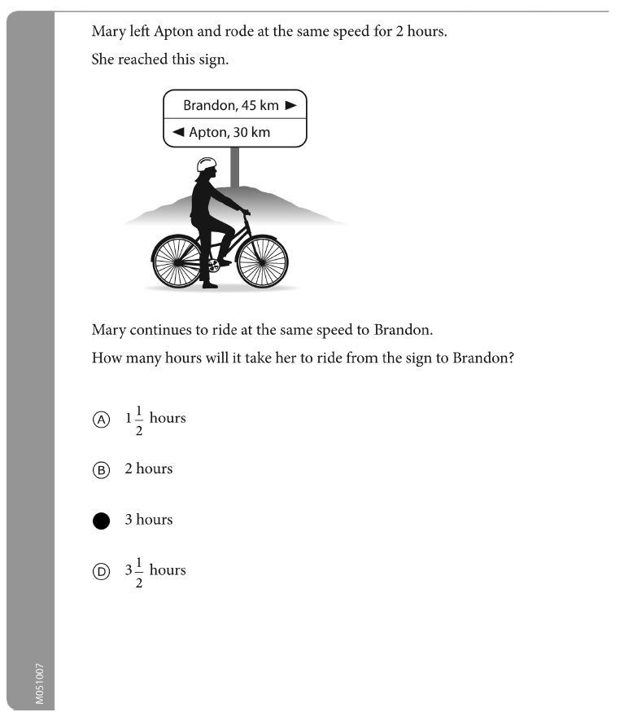
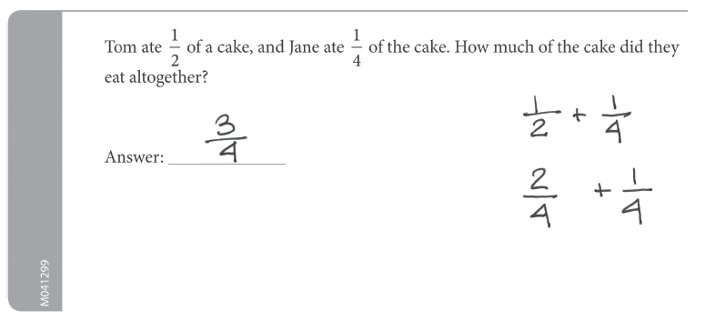

Appendix 2: TIMSS 2015 Grade 4 Student questionnaire
(IEA 2017, pp.8-24) 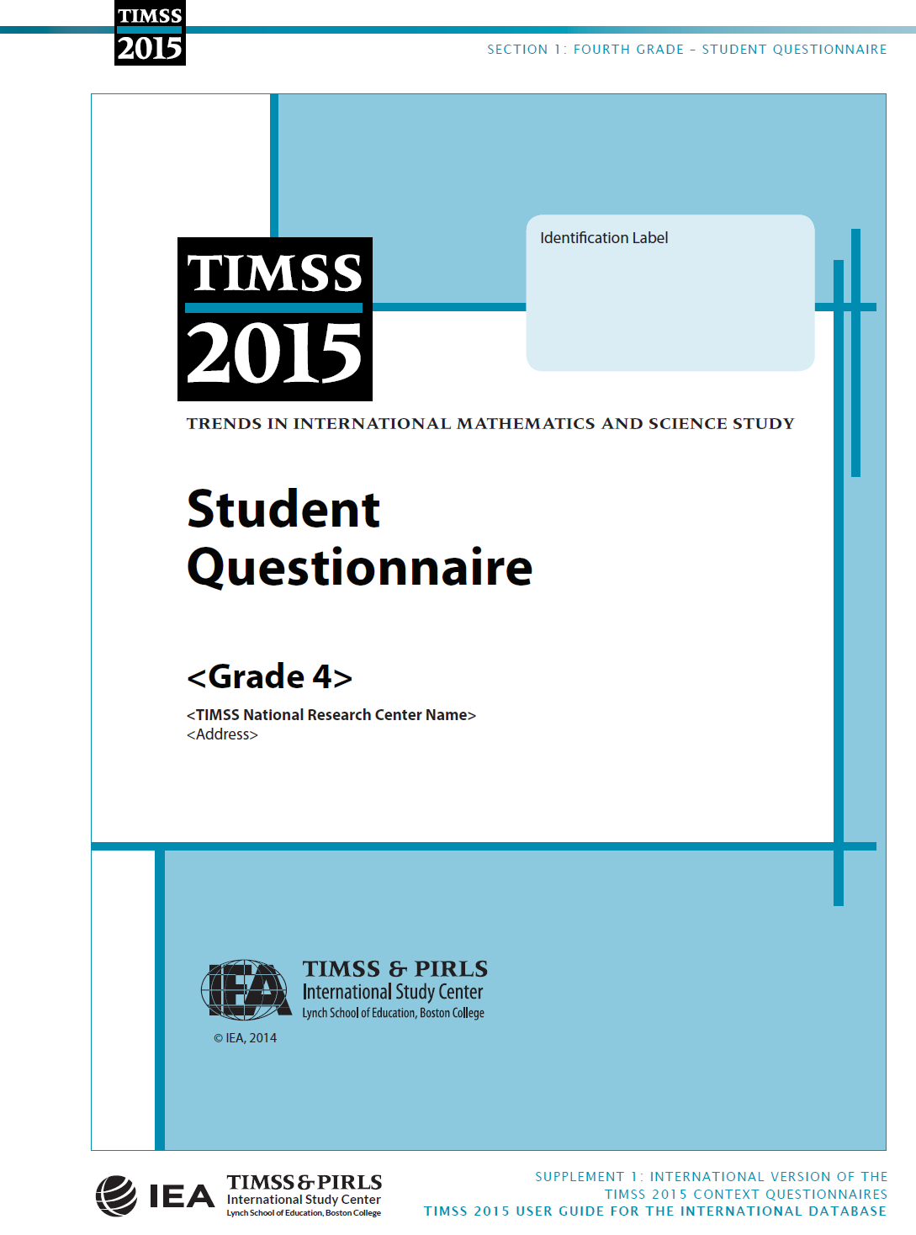
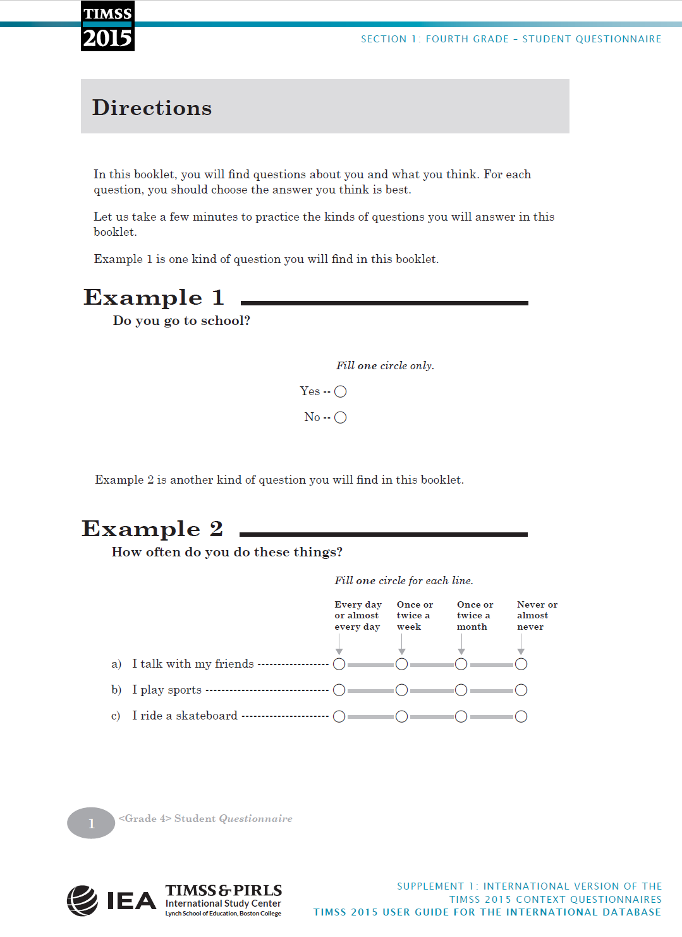 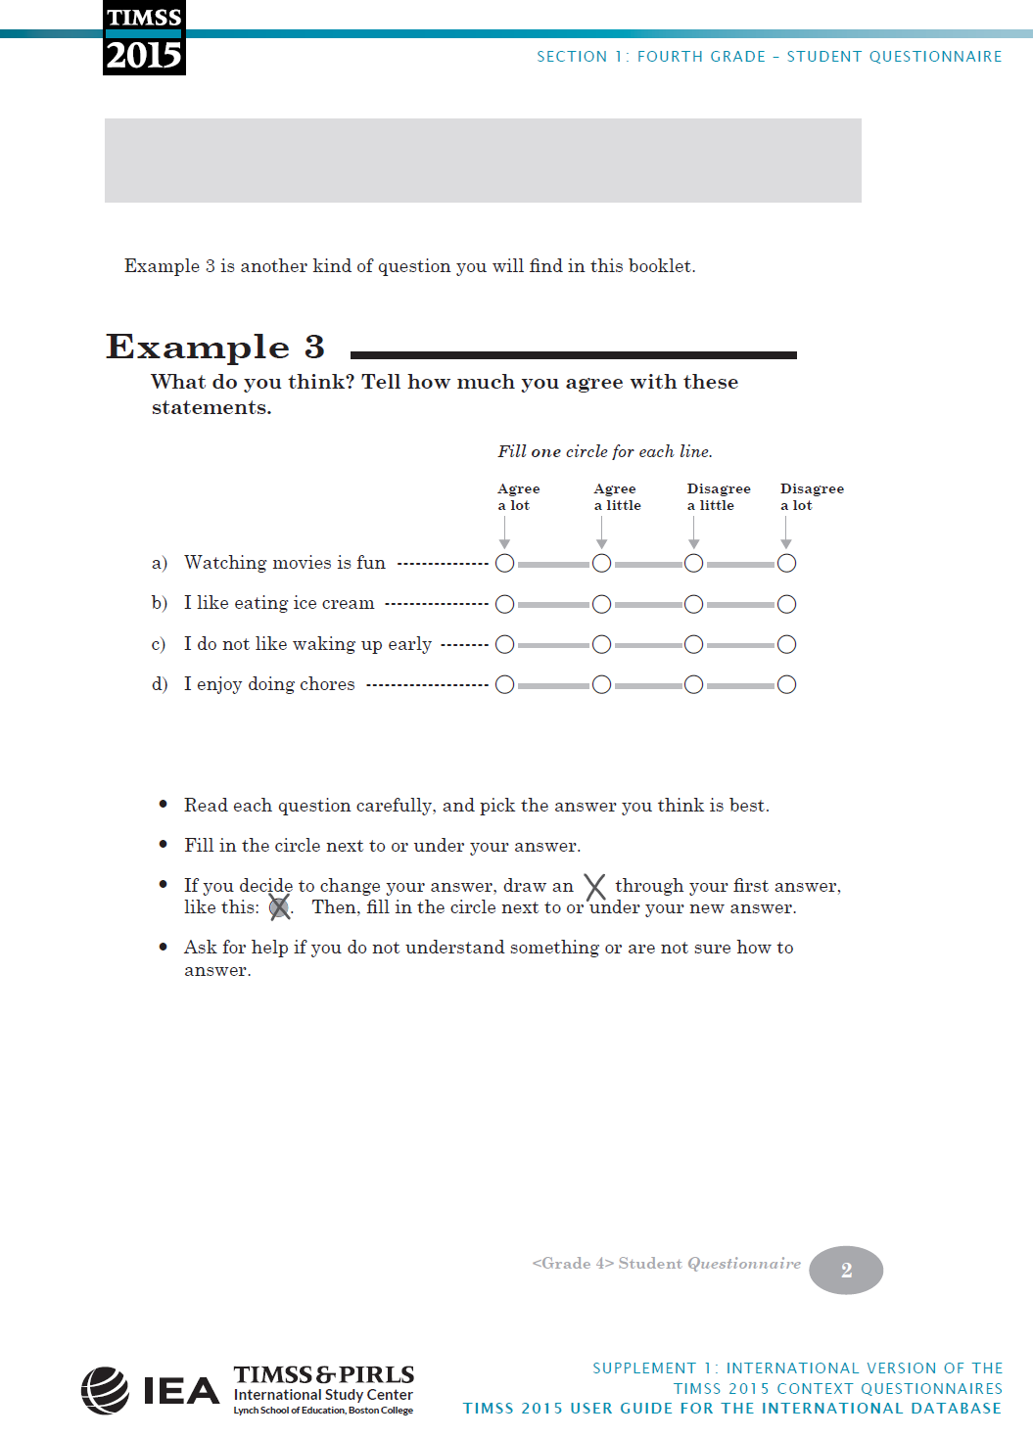 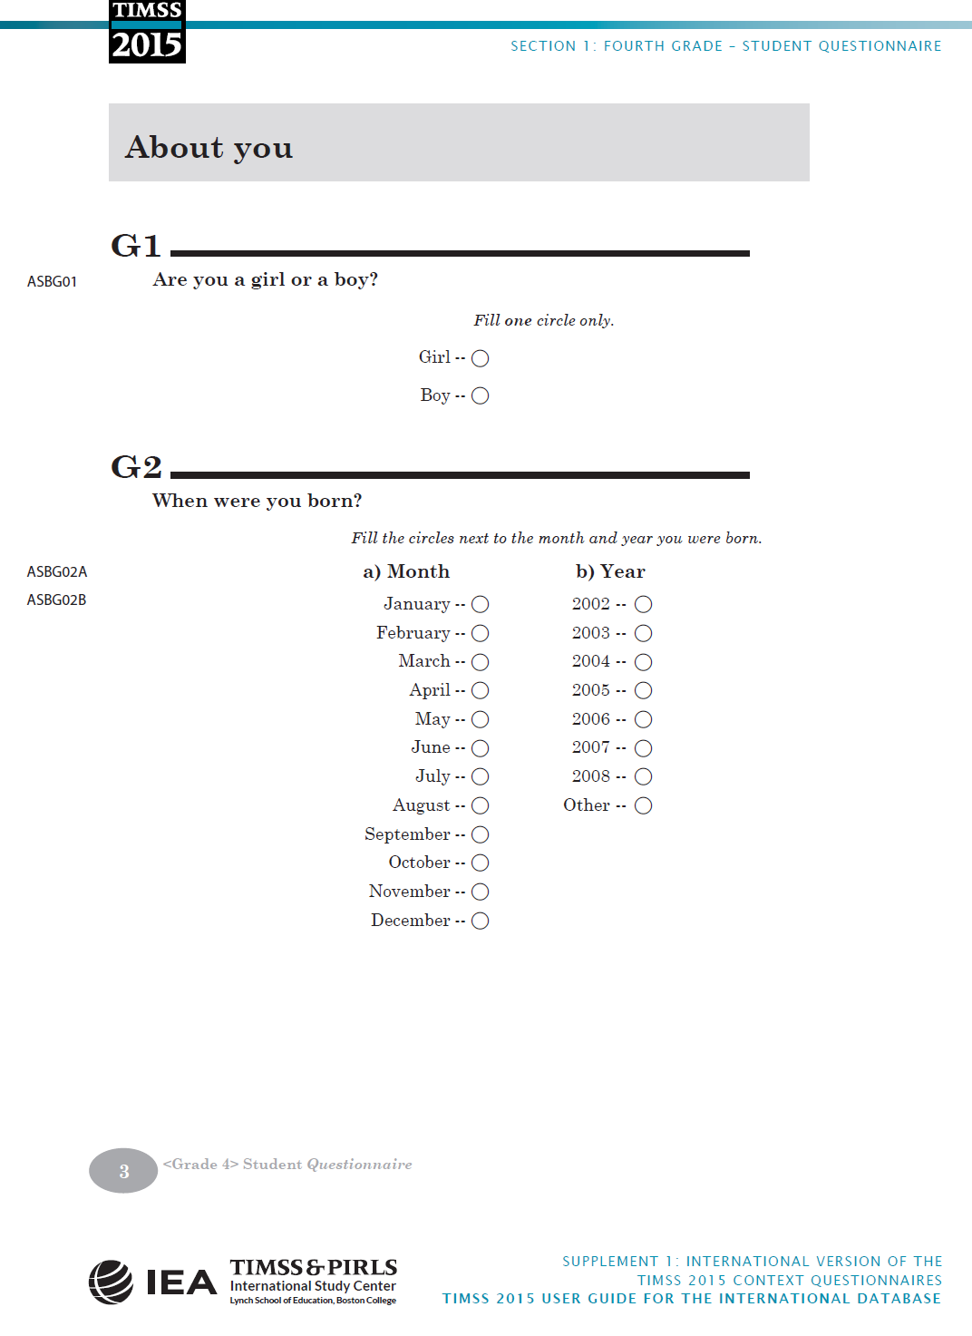 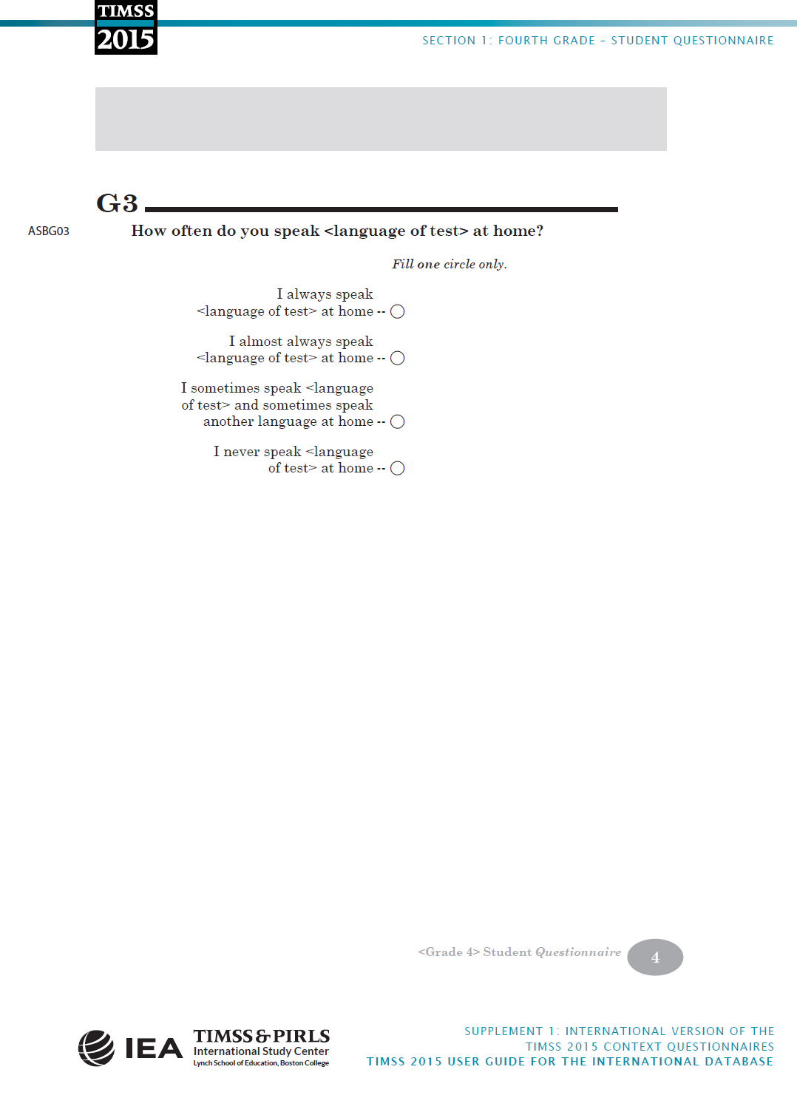 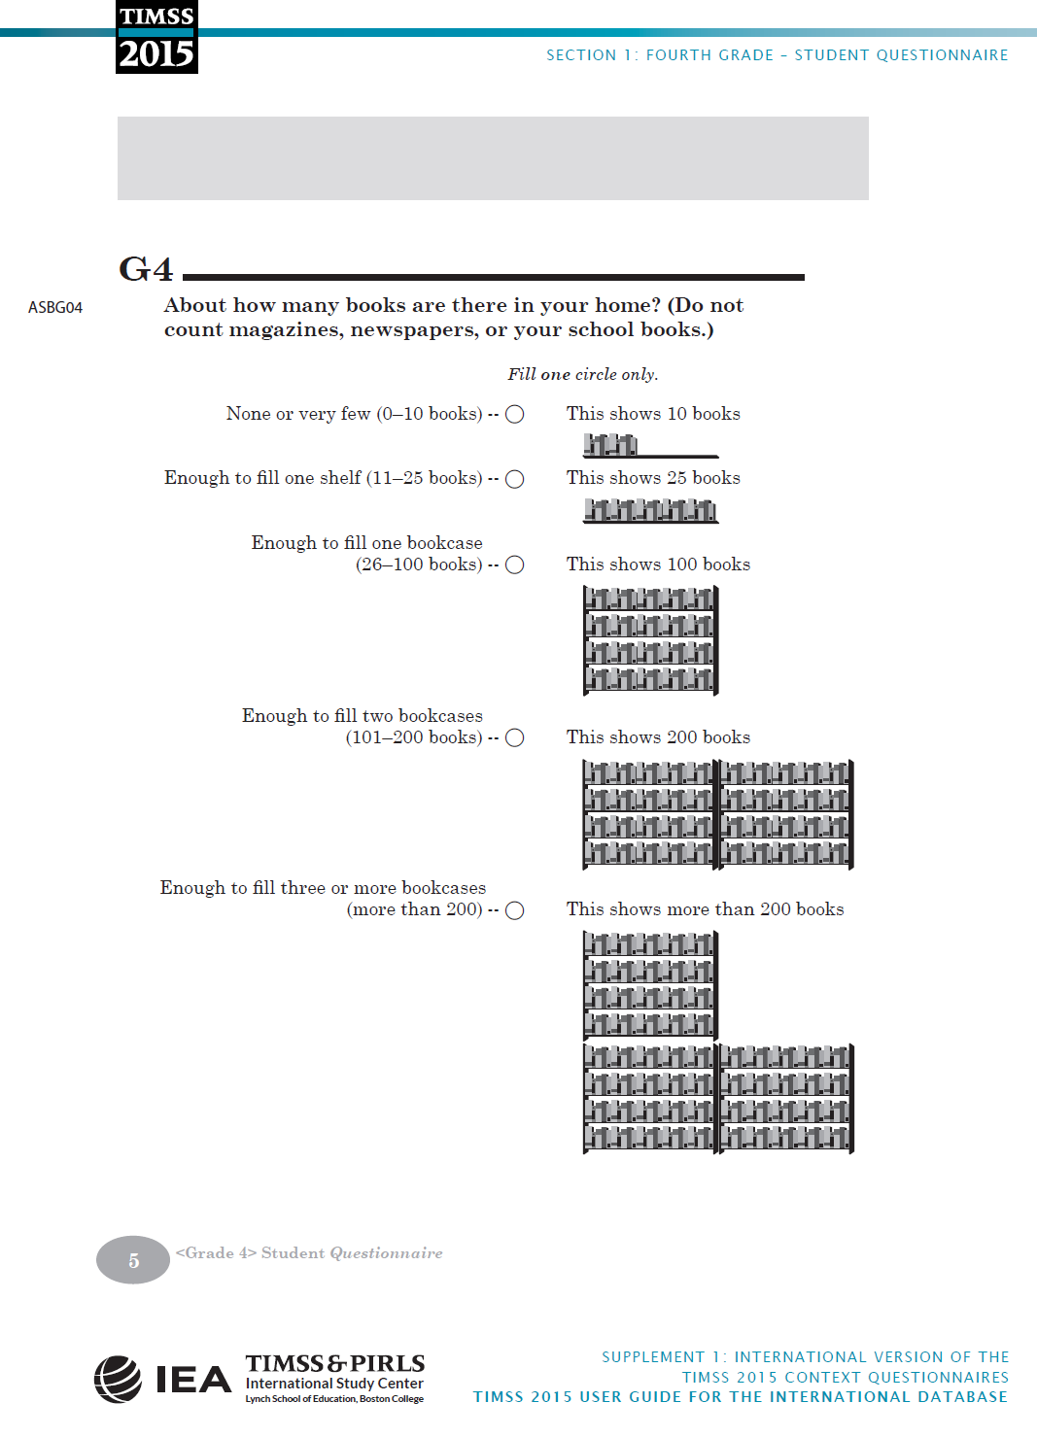 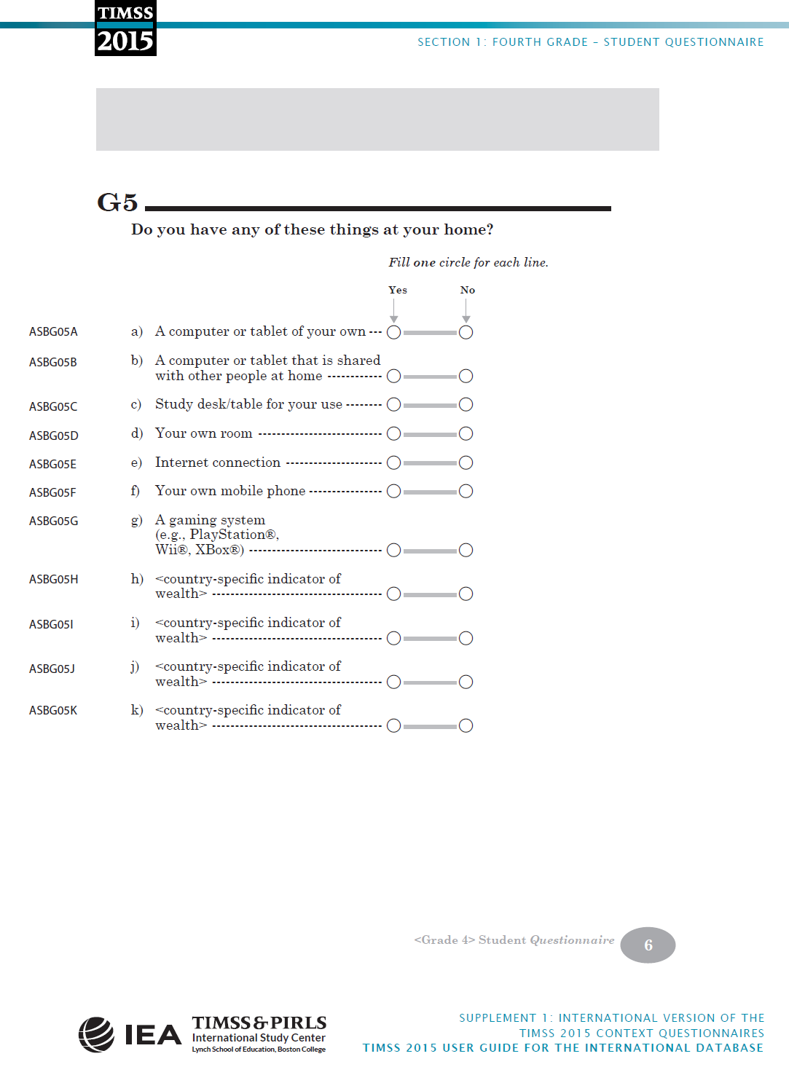 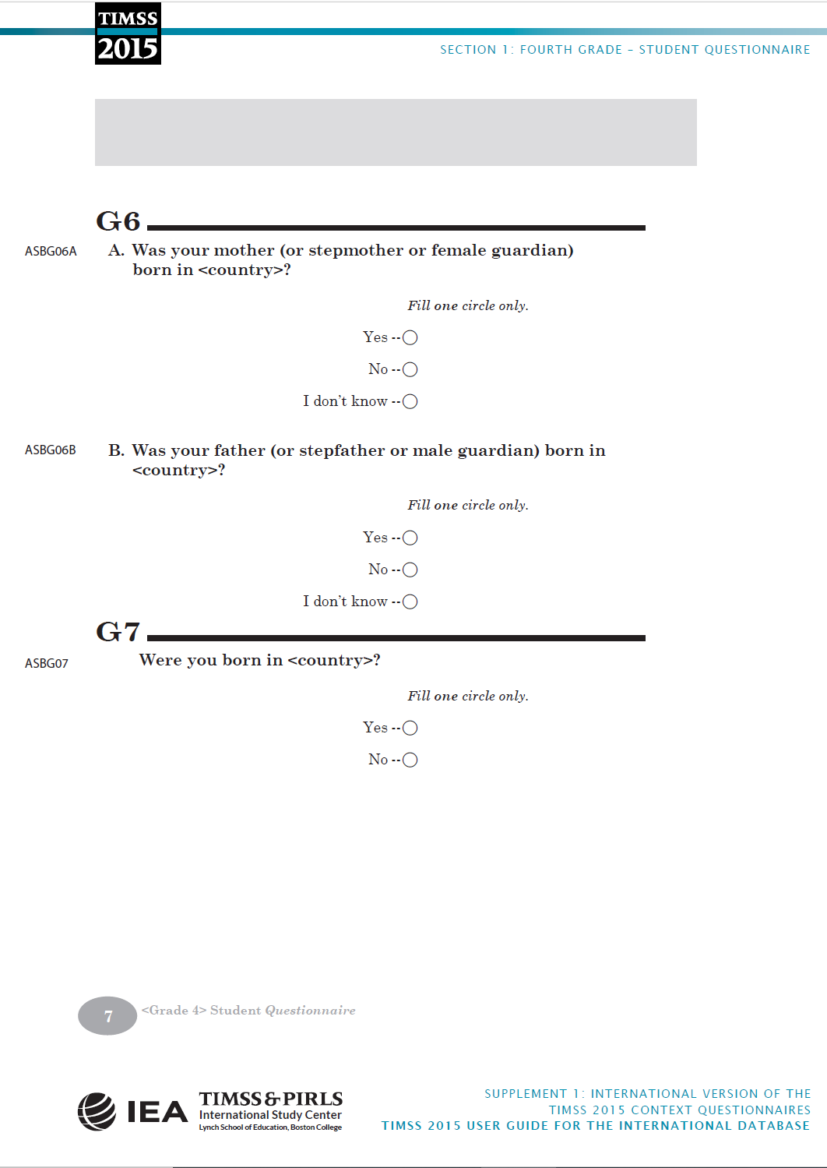 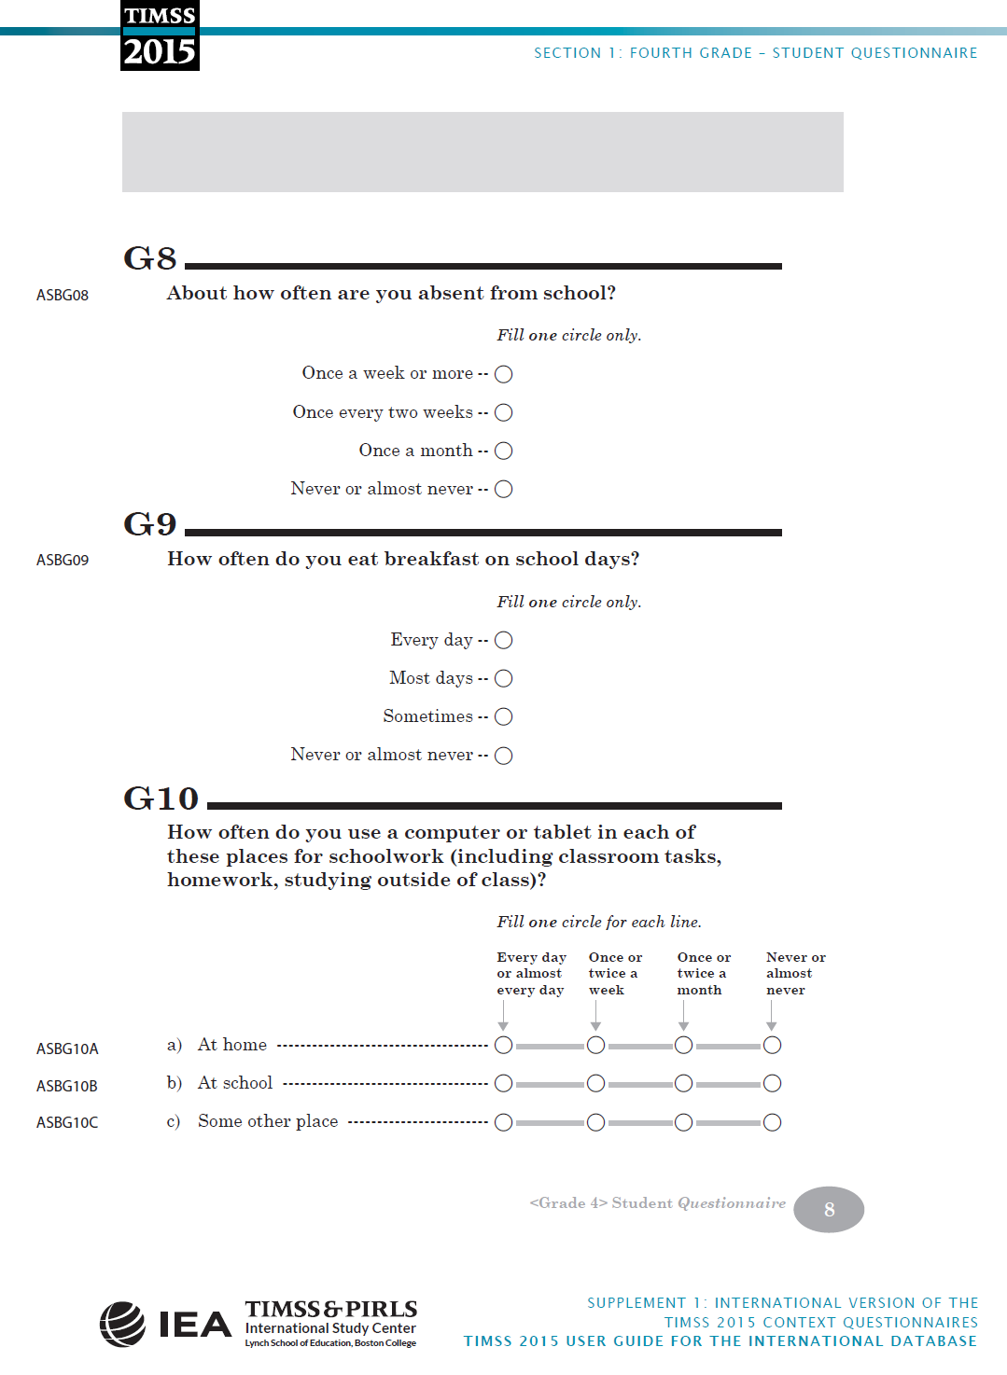 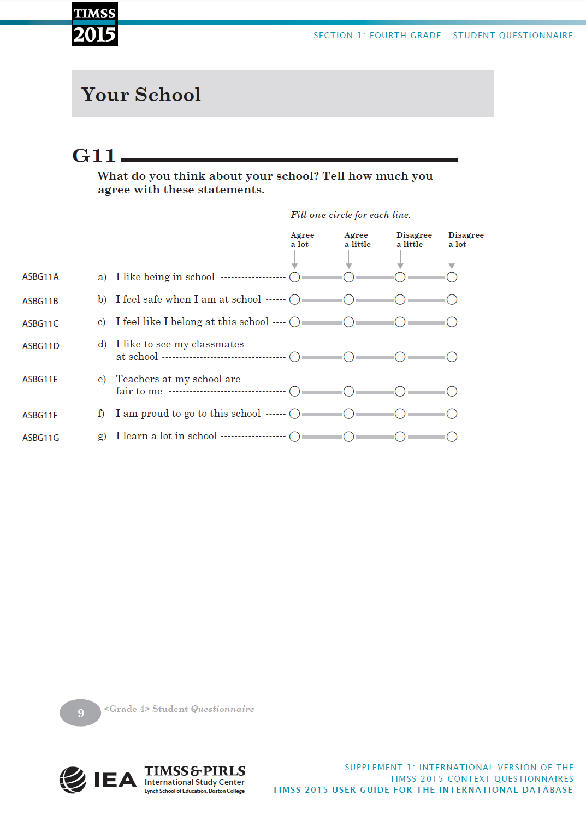 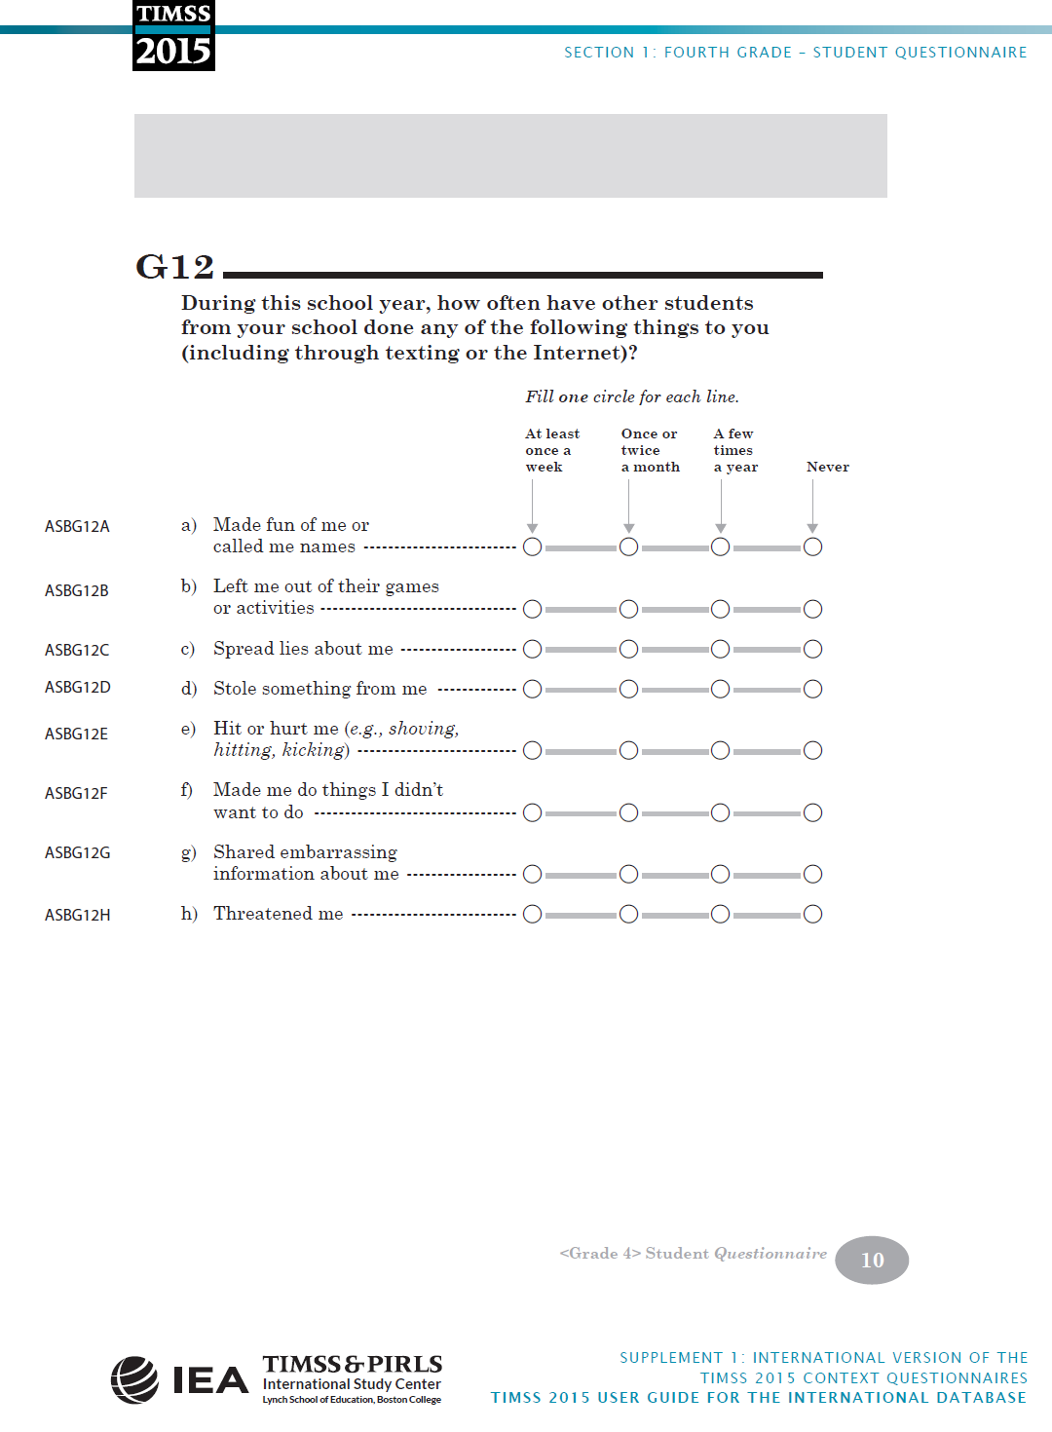 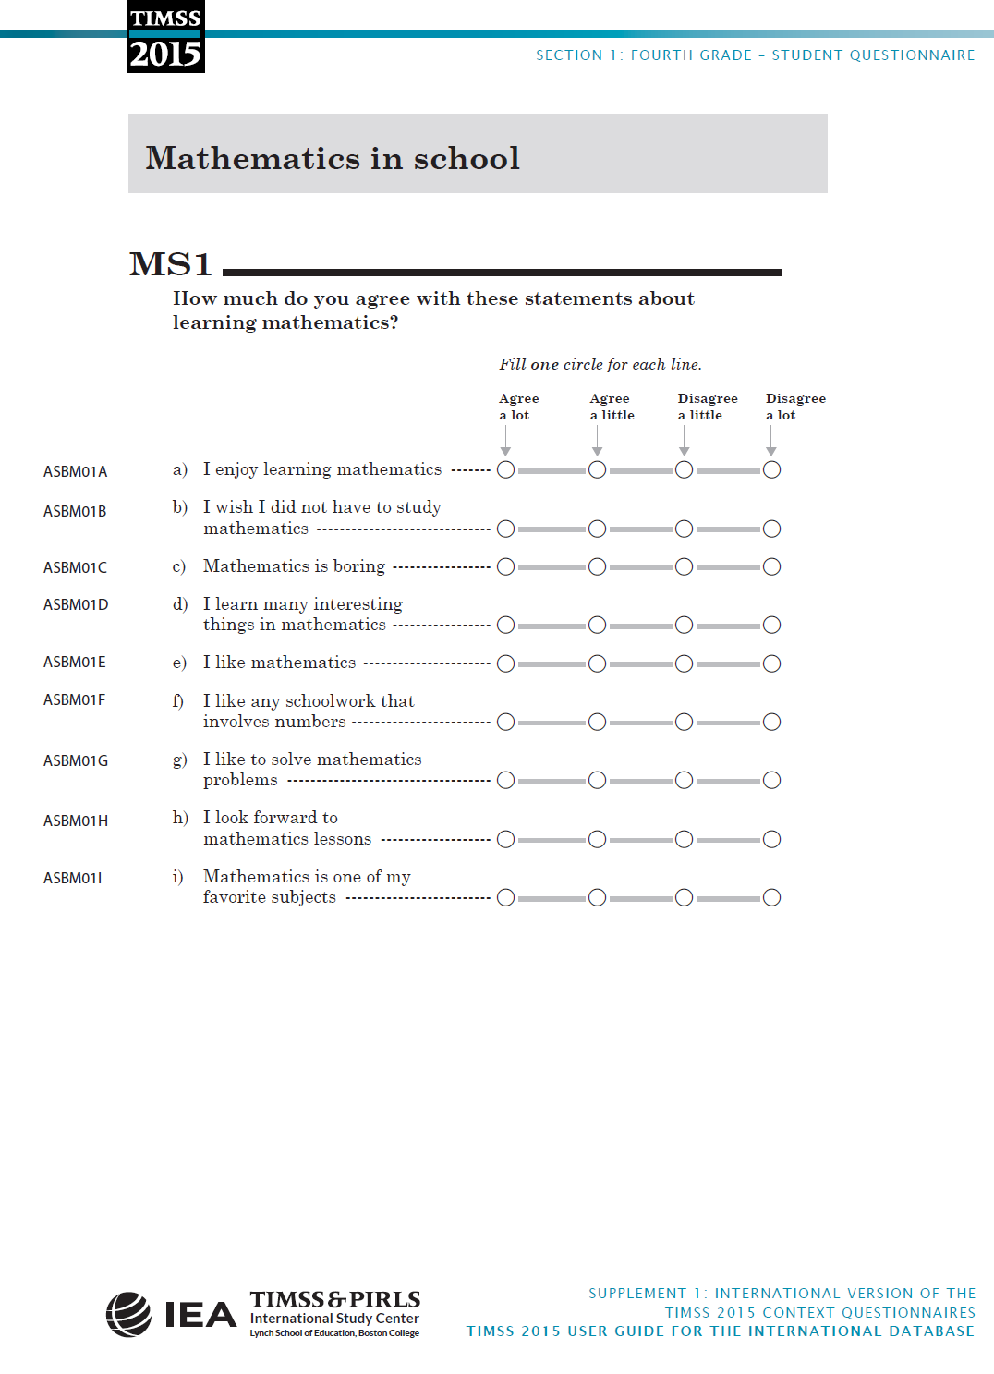 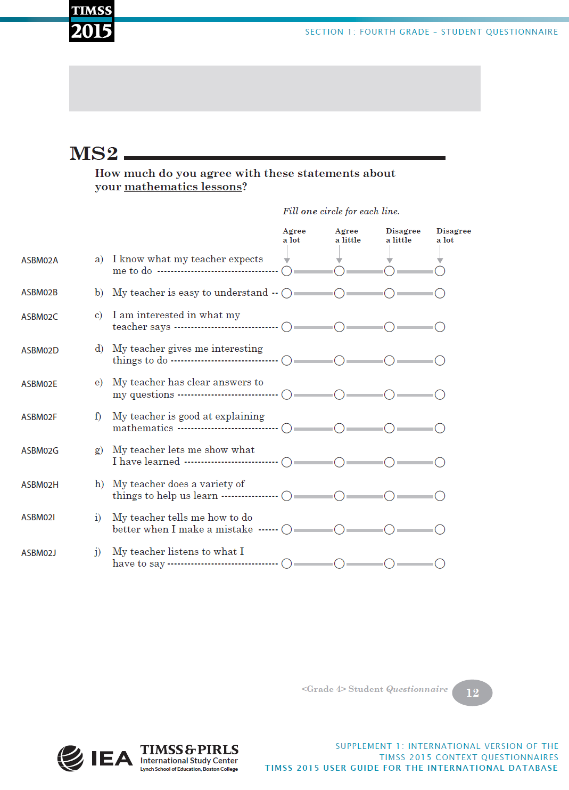 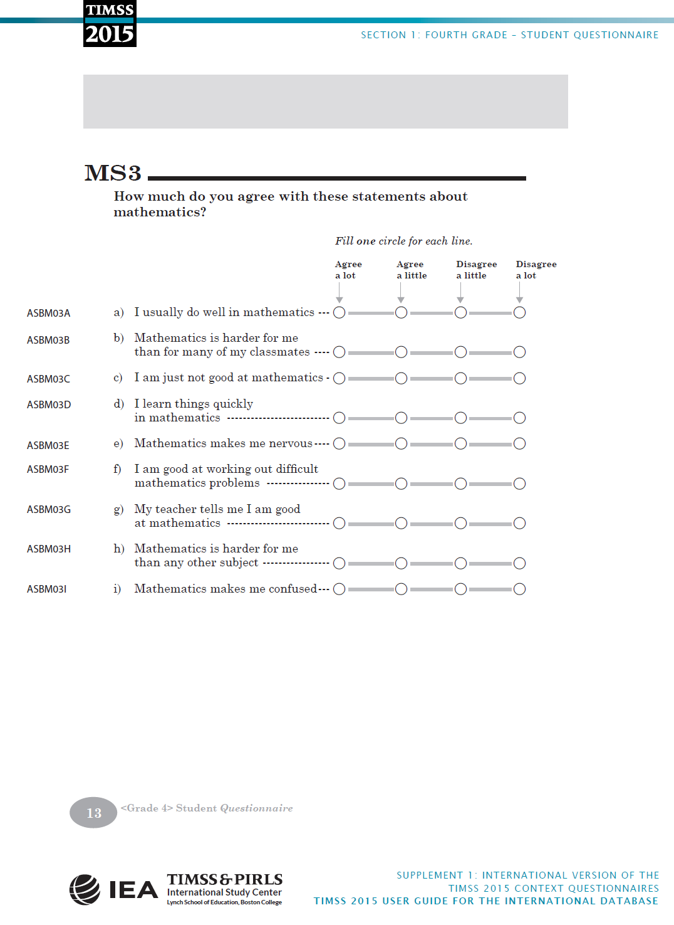 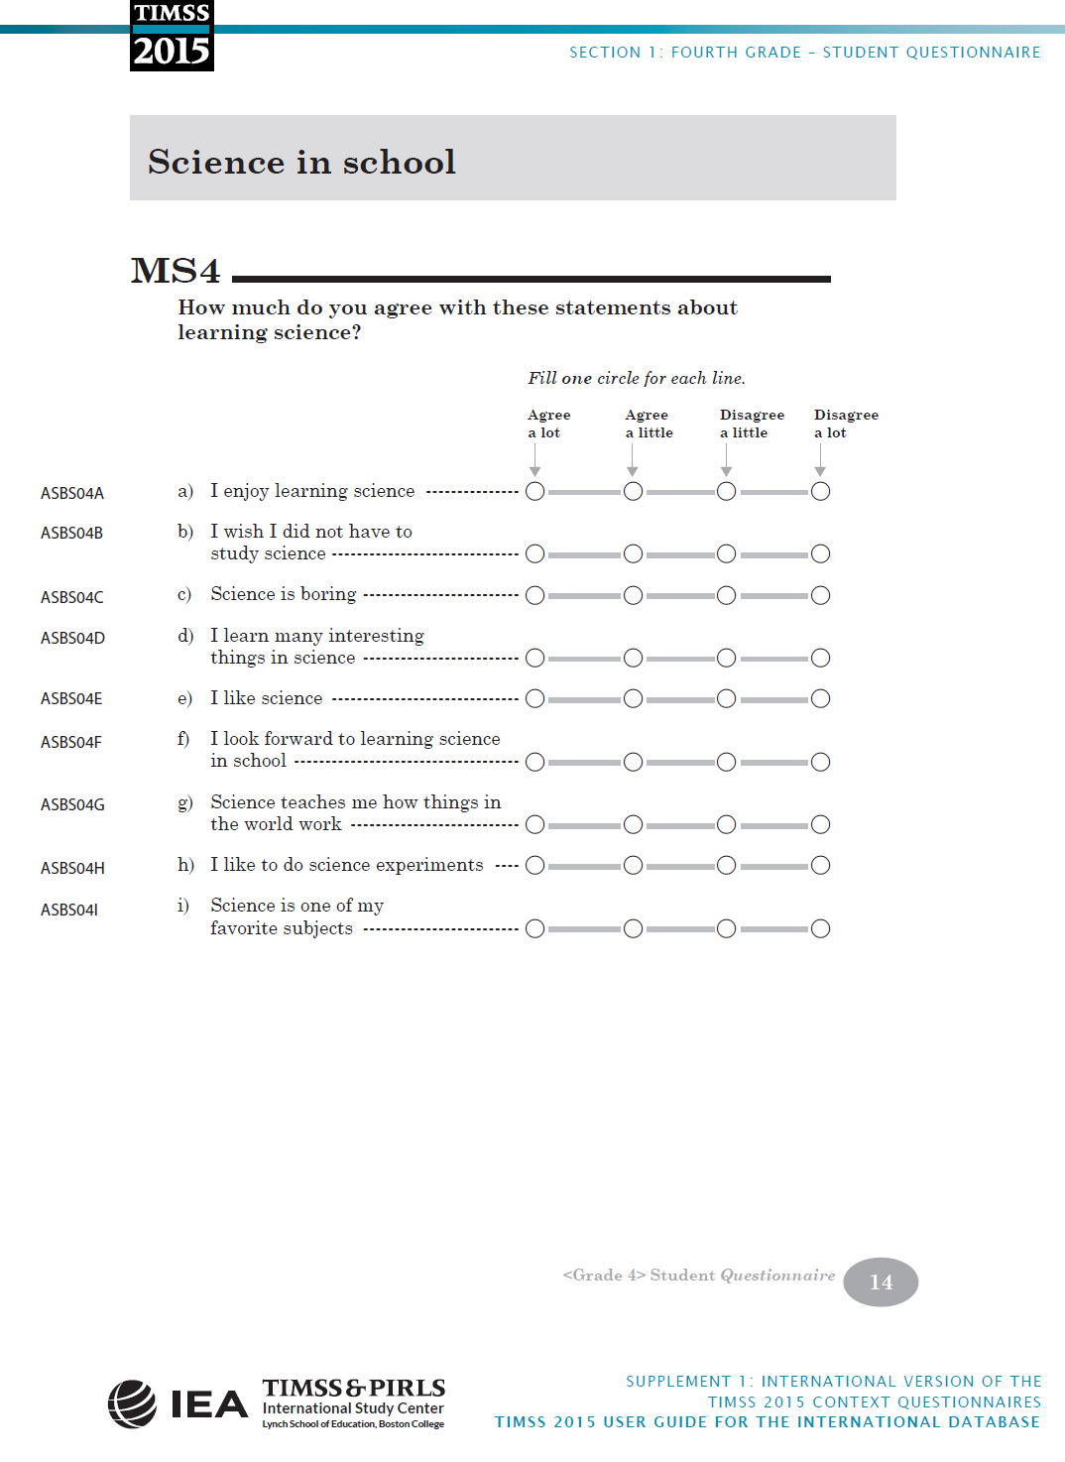 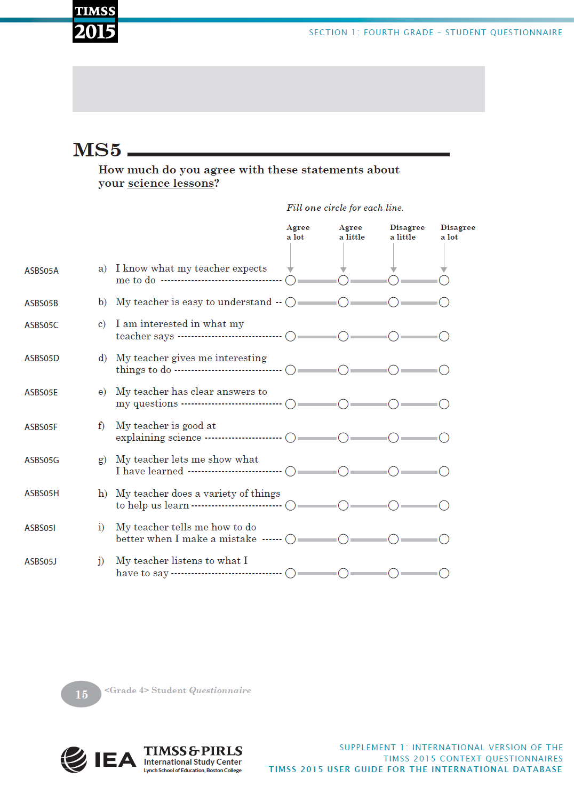 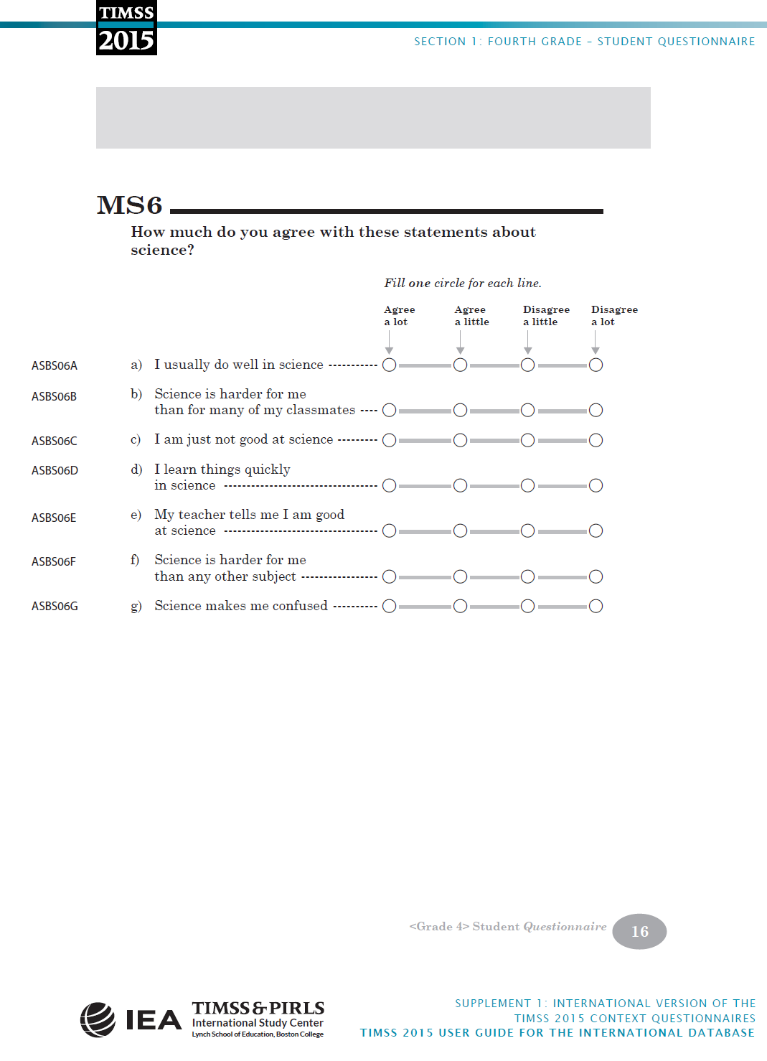Appendix 3: TIMSS 2015 Grade 4 Teacher Questionnaire
(IEA 2017, pp. 66-87)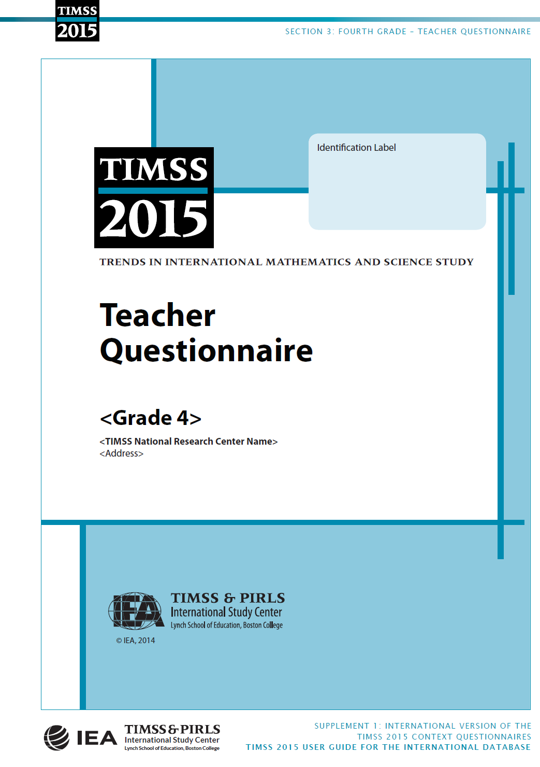 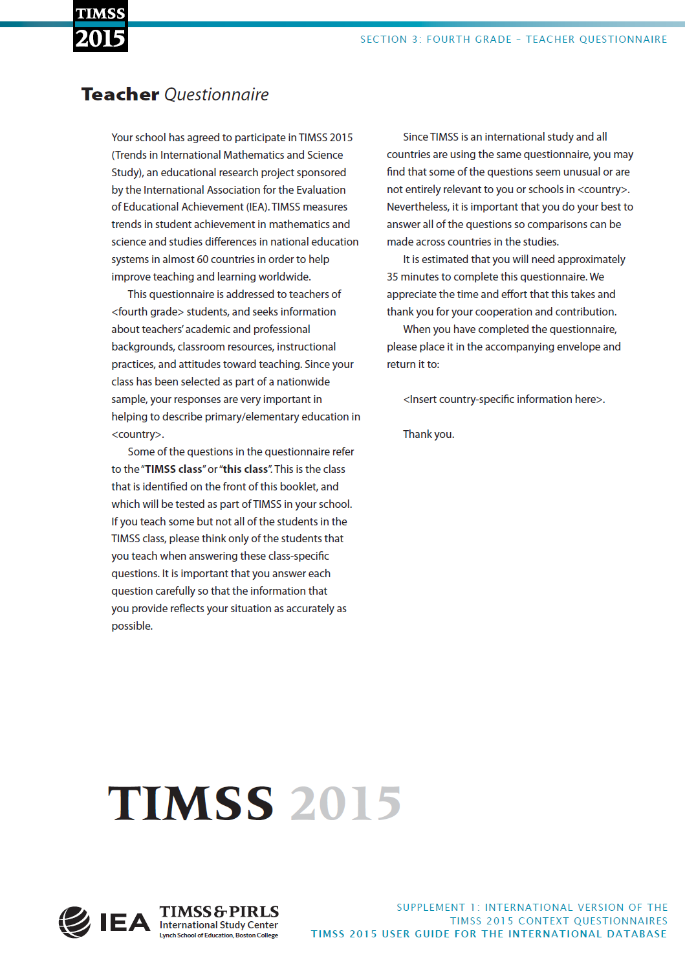 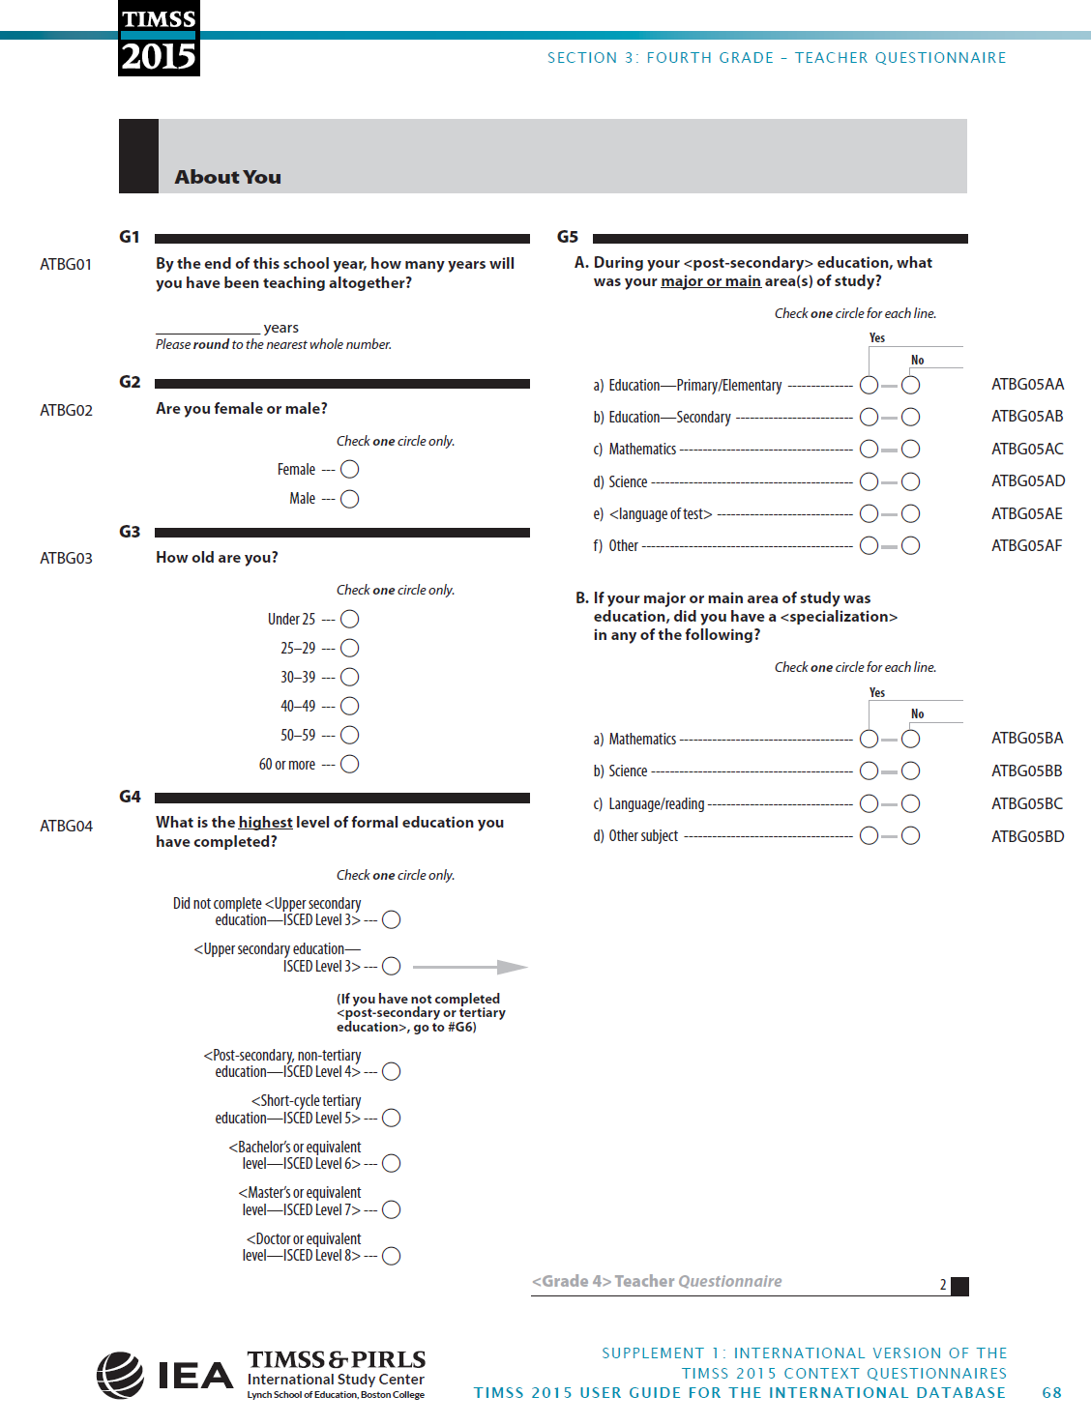 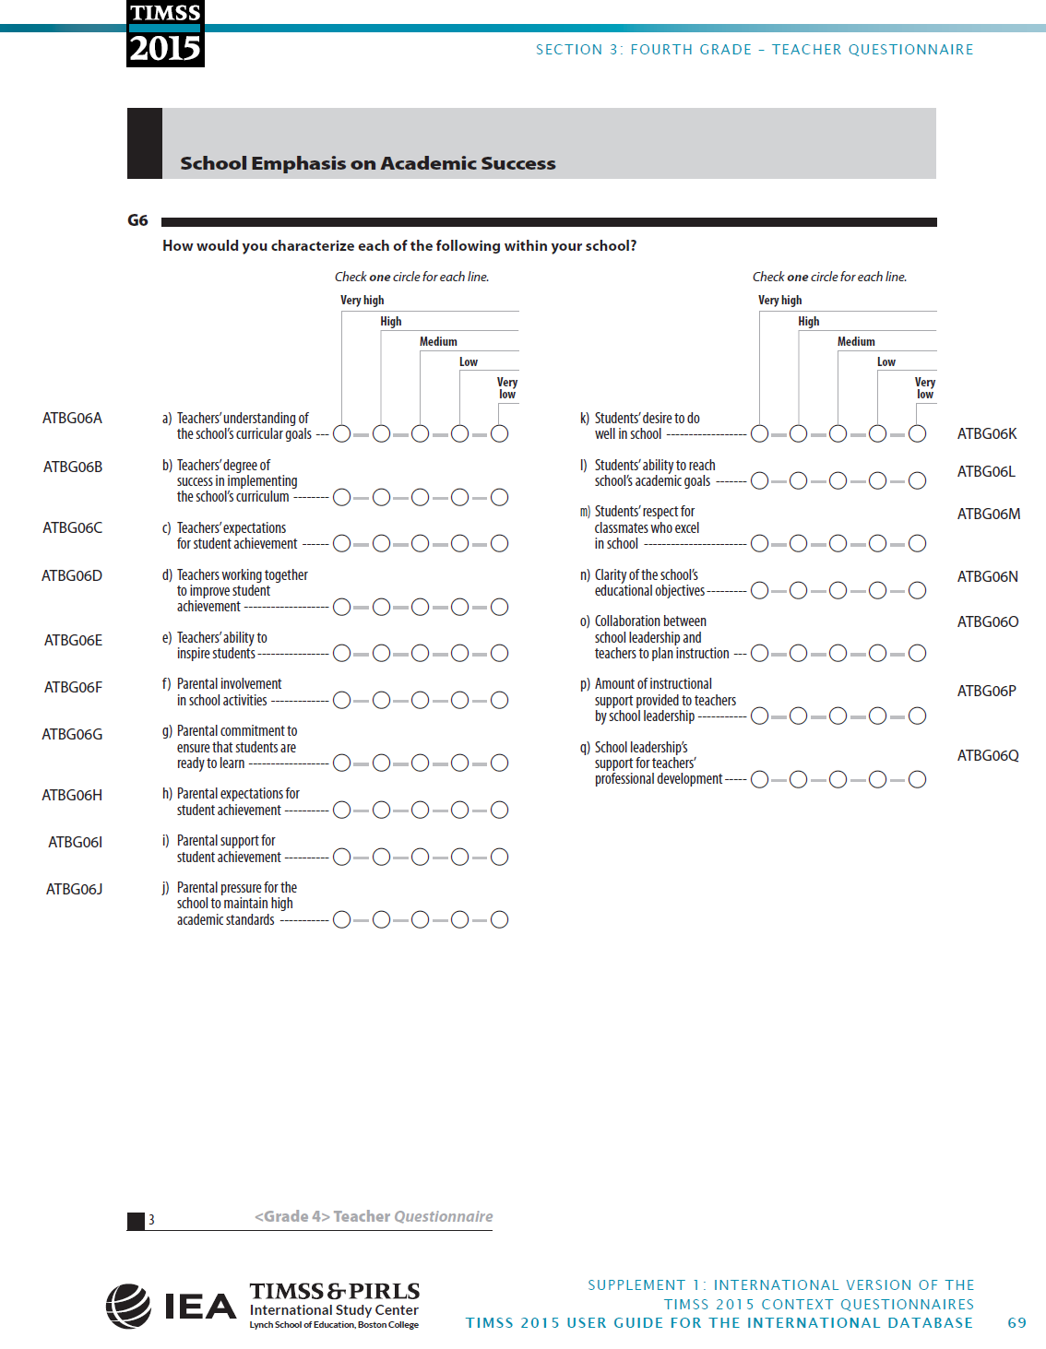 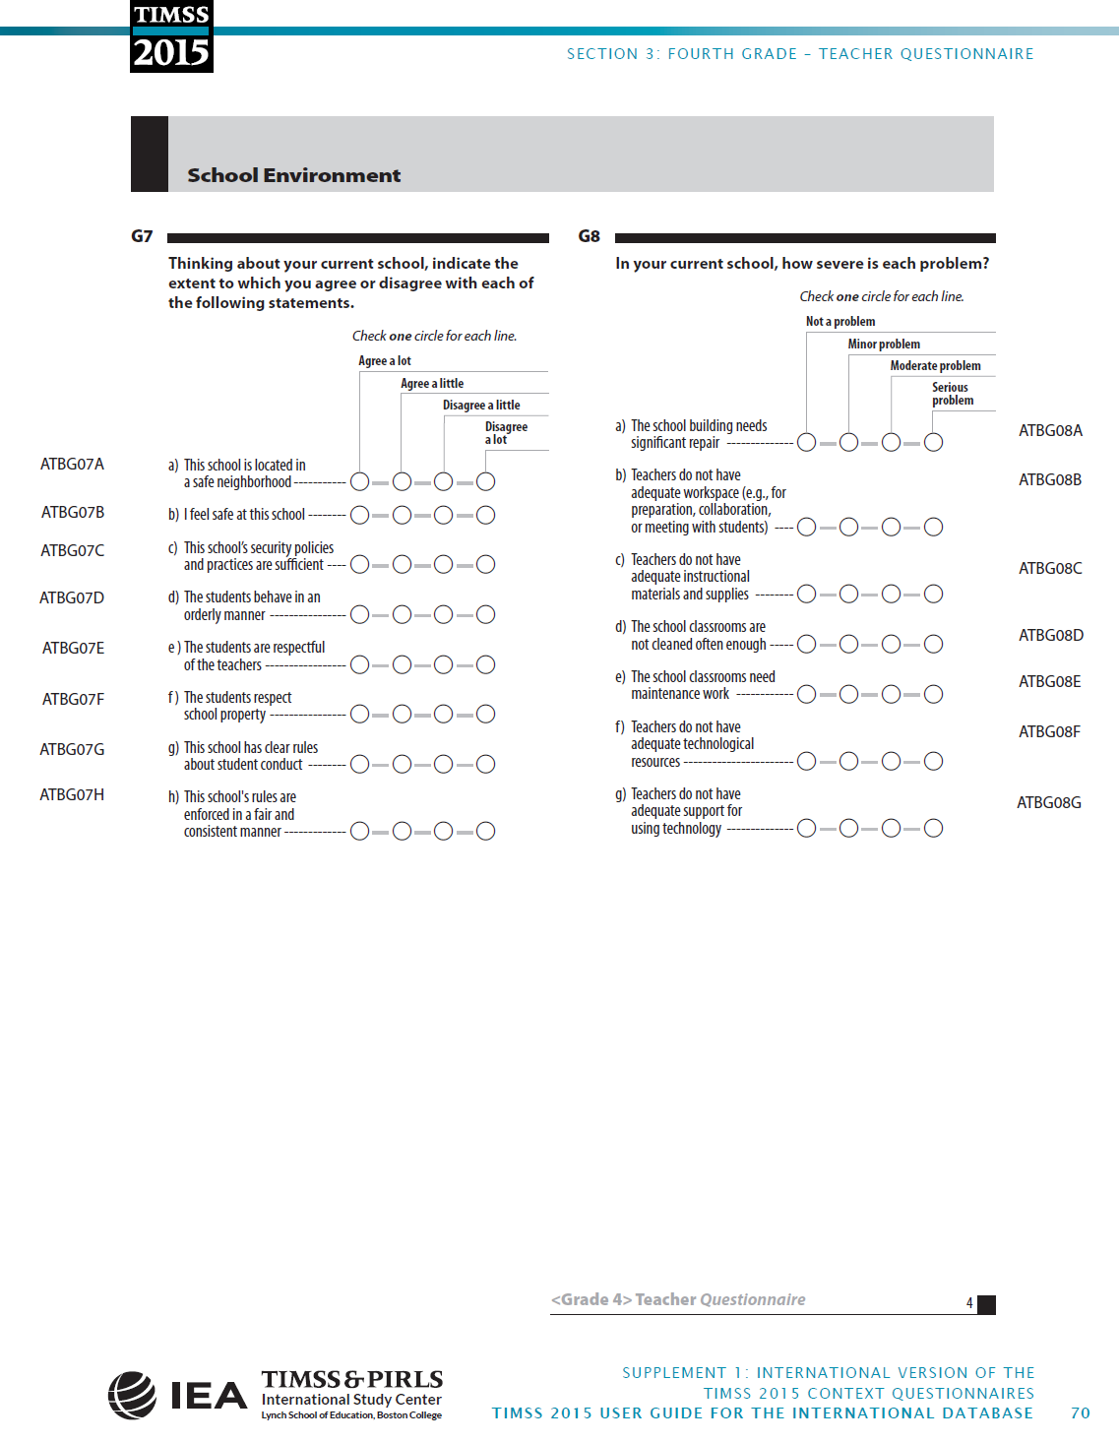 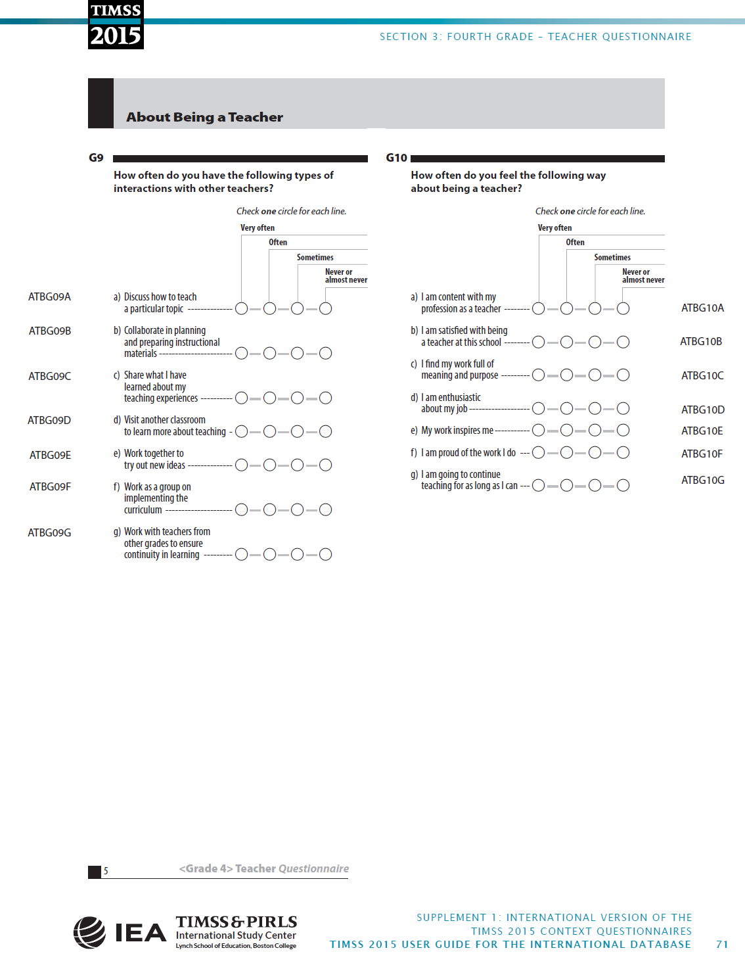 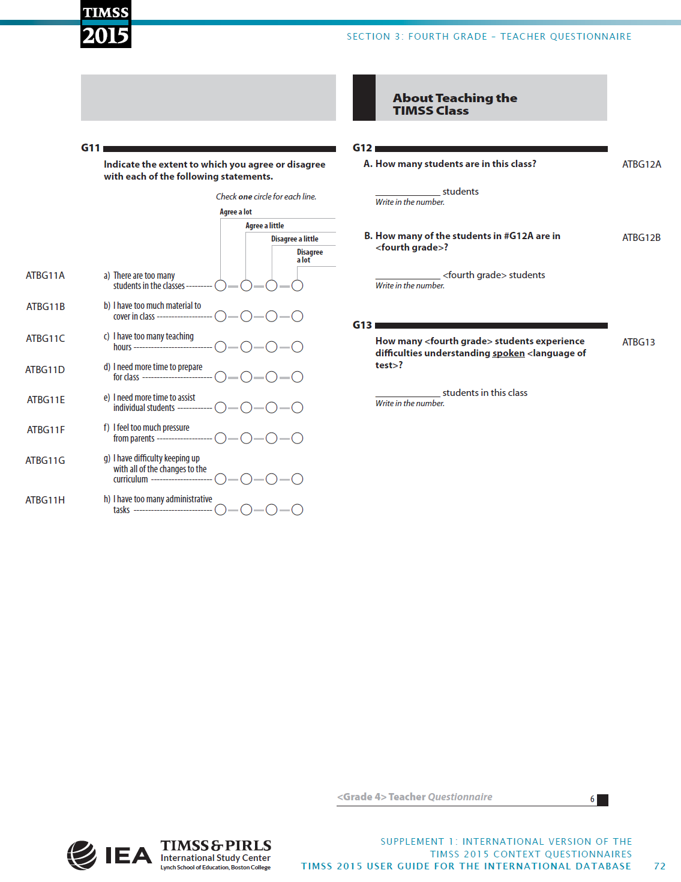 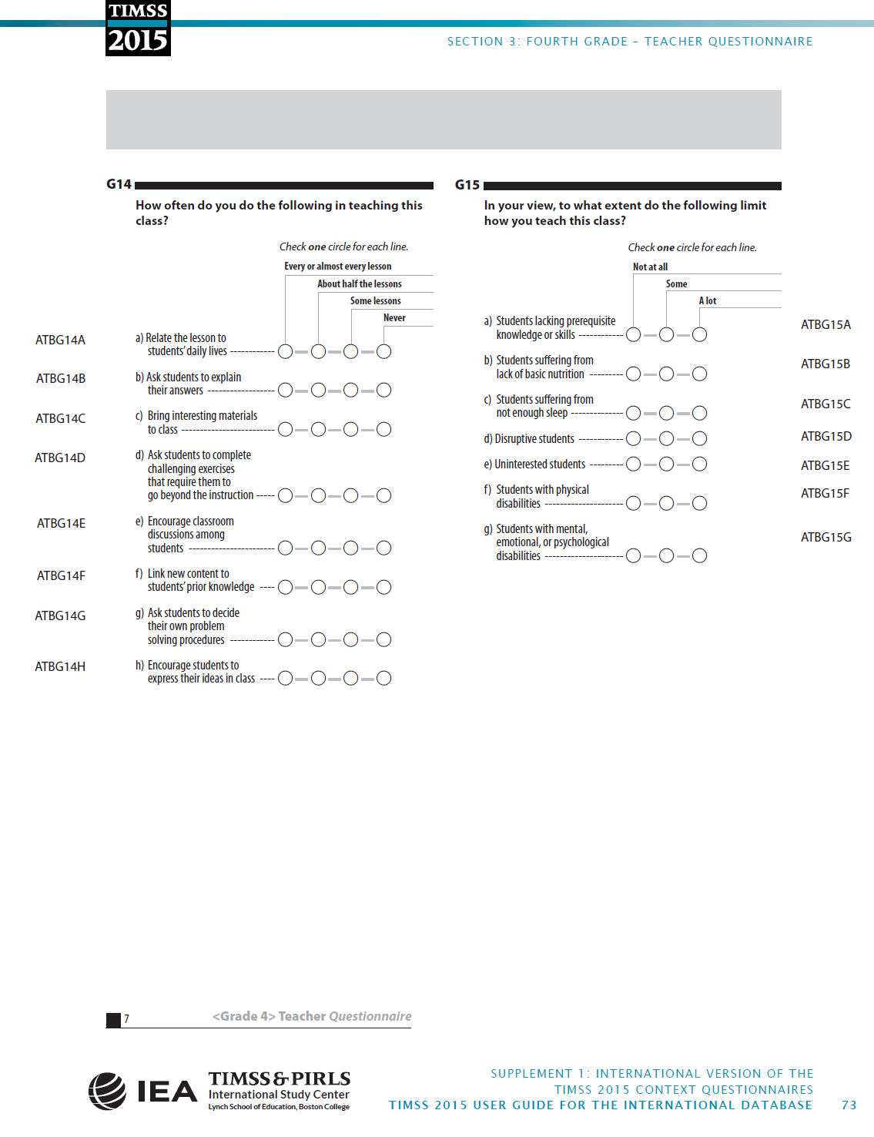 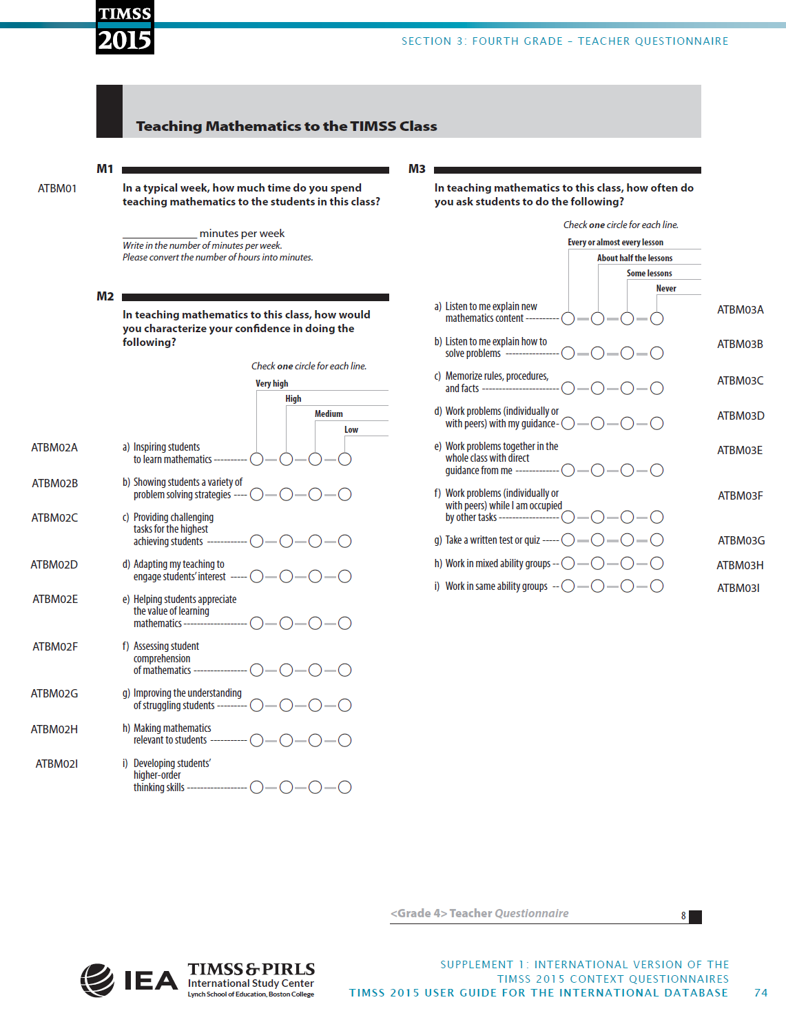 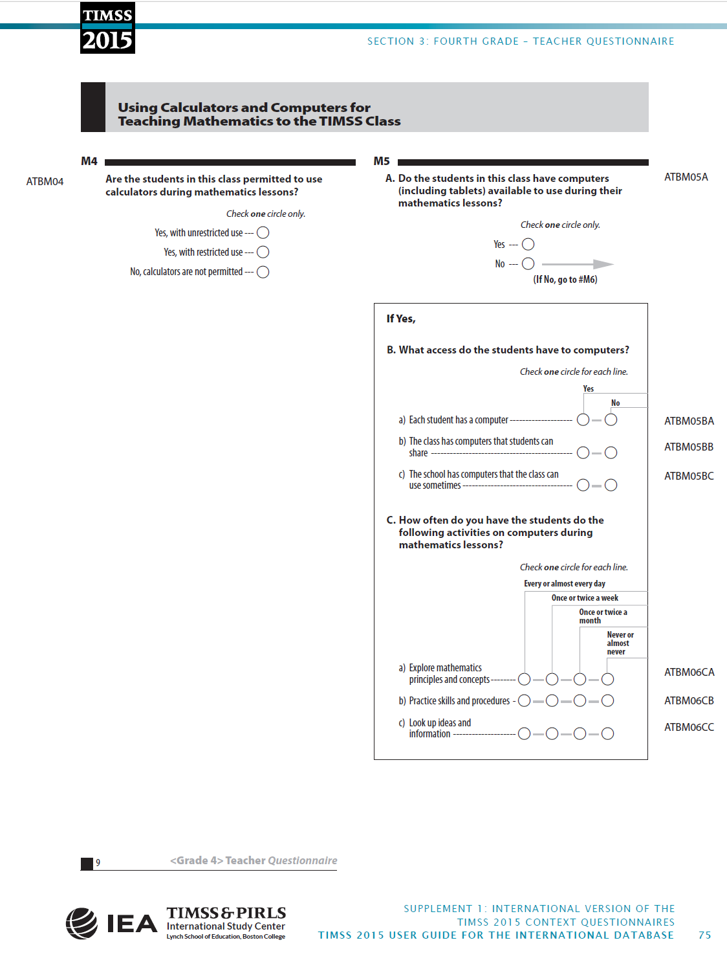 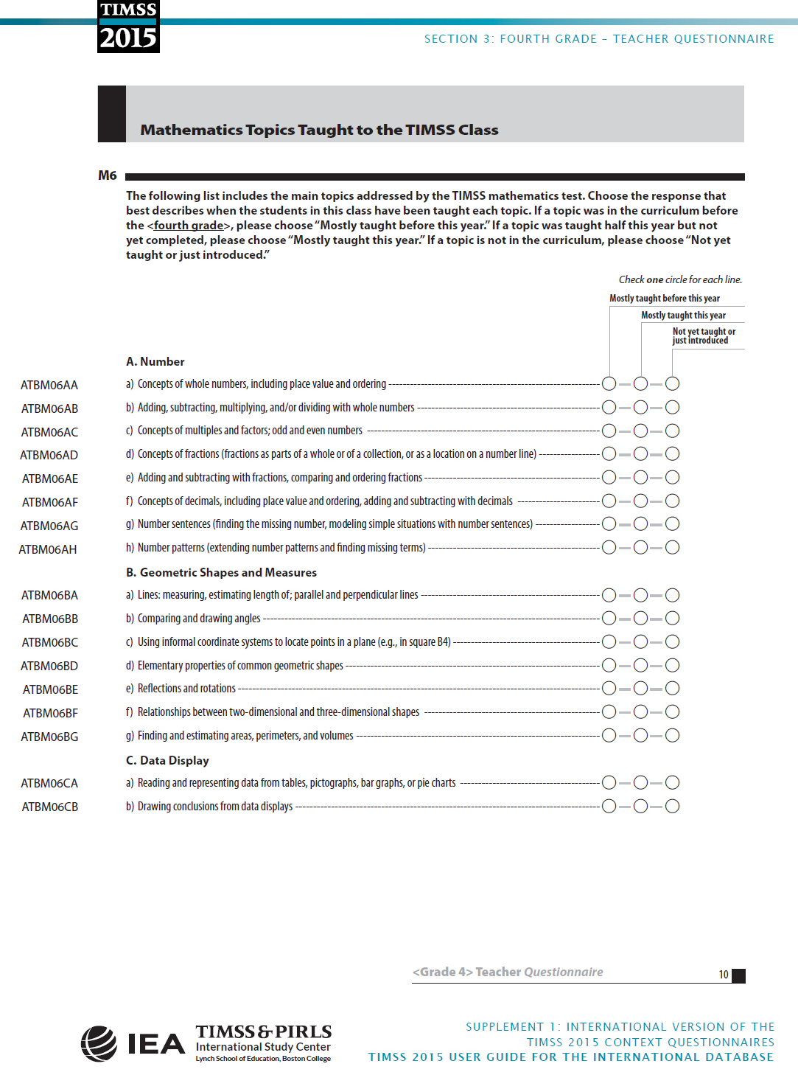 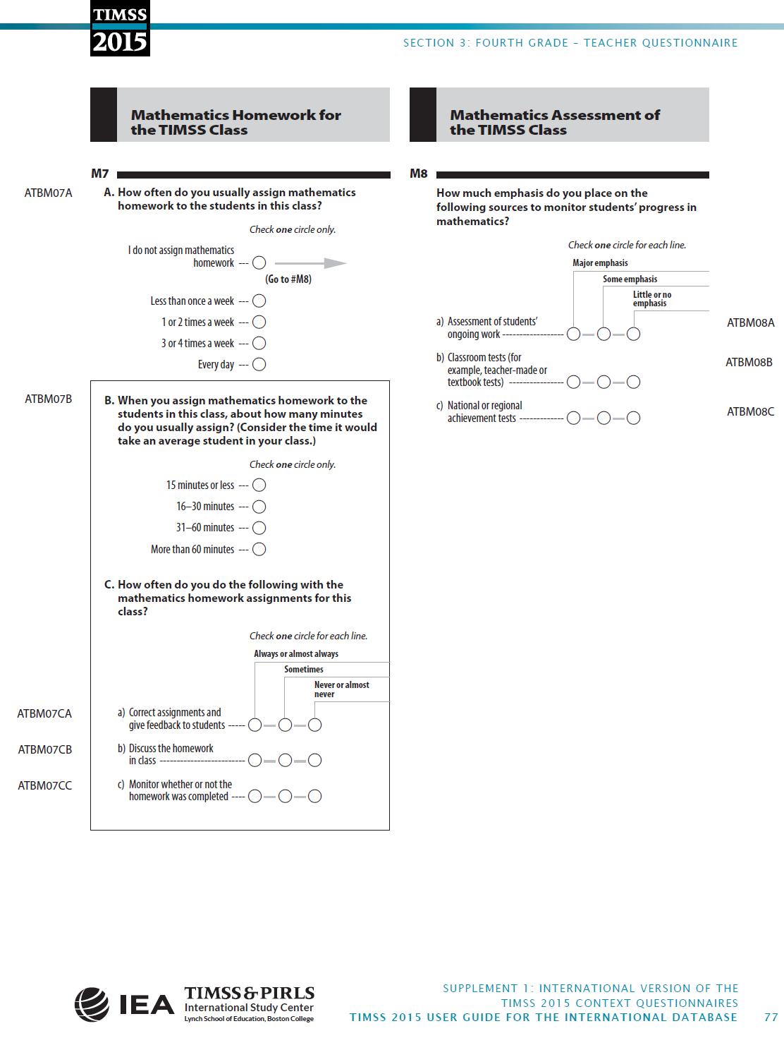 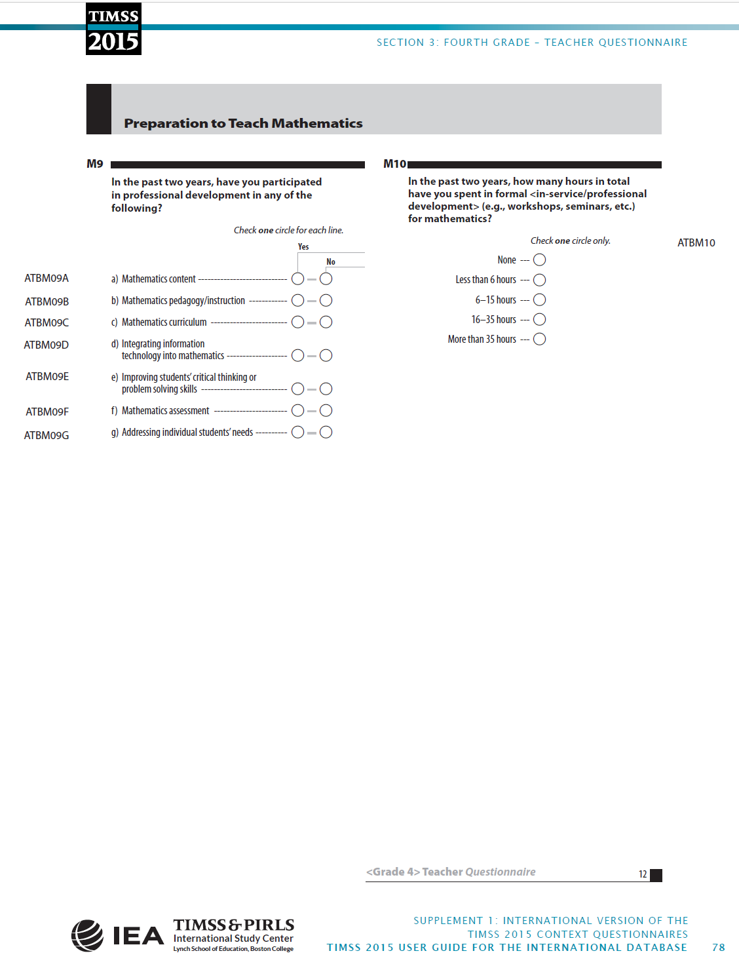 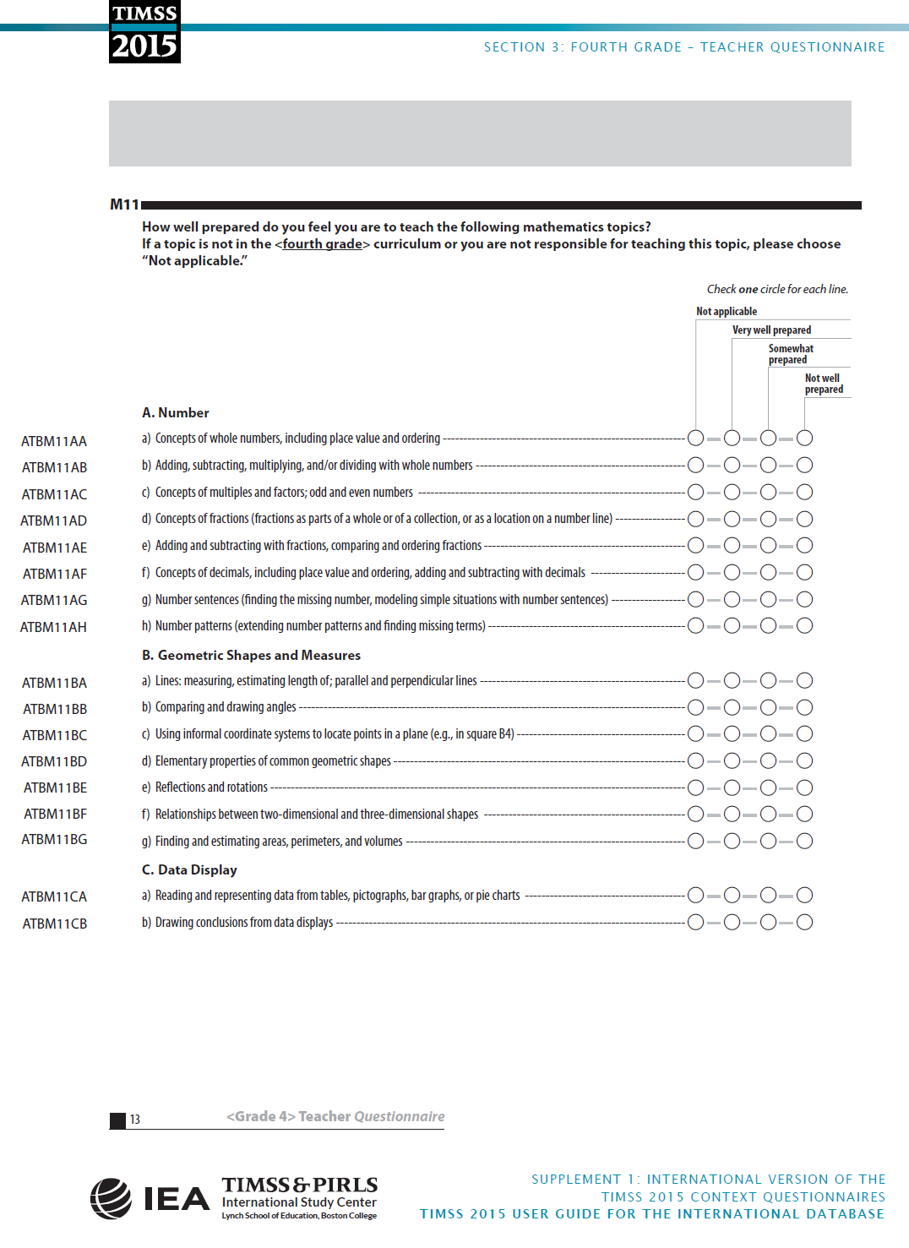 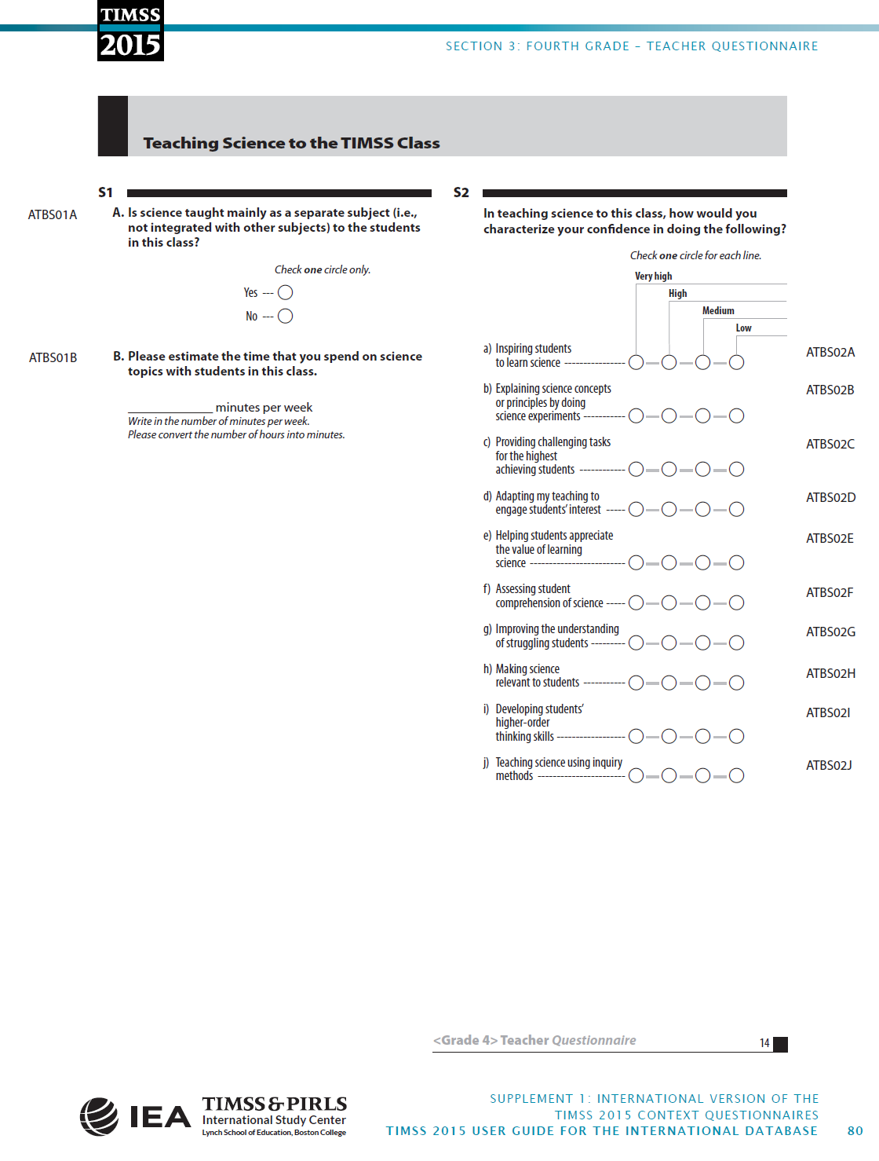 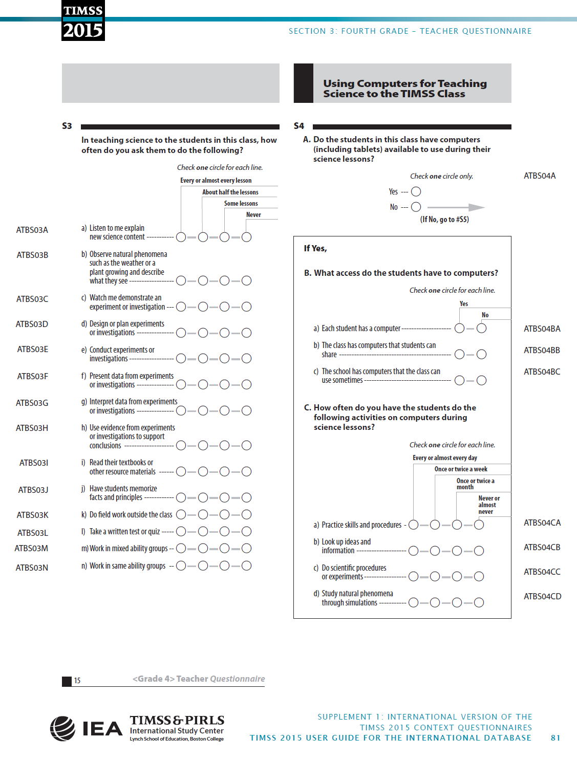 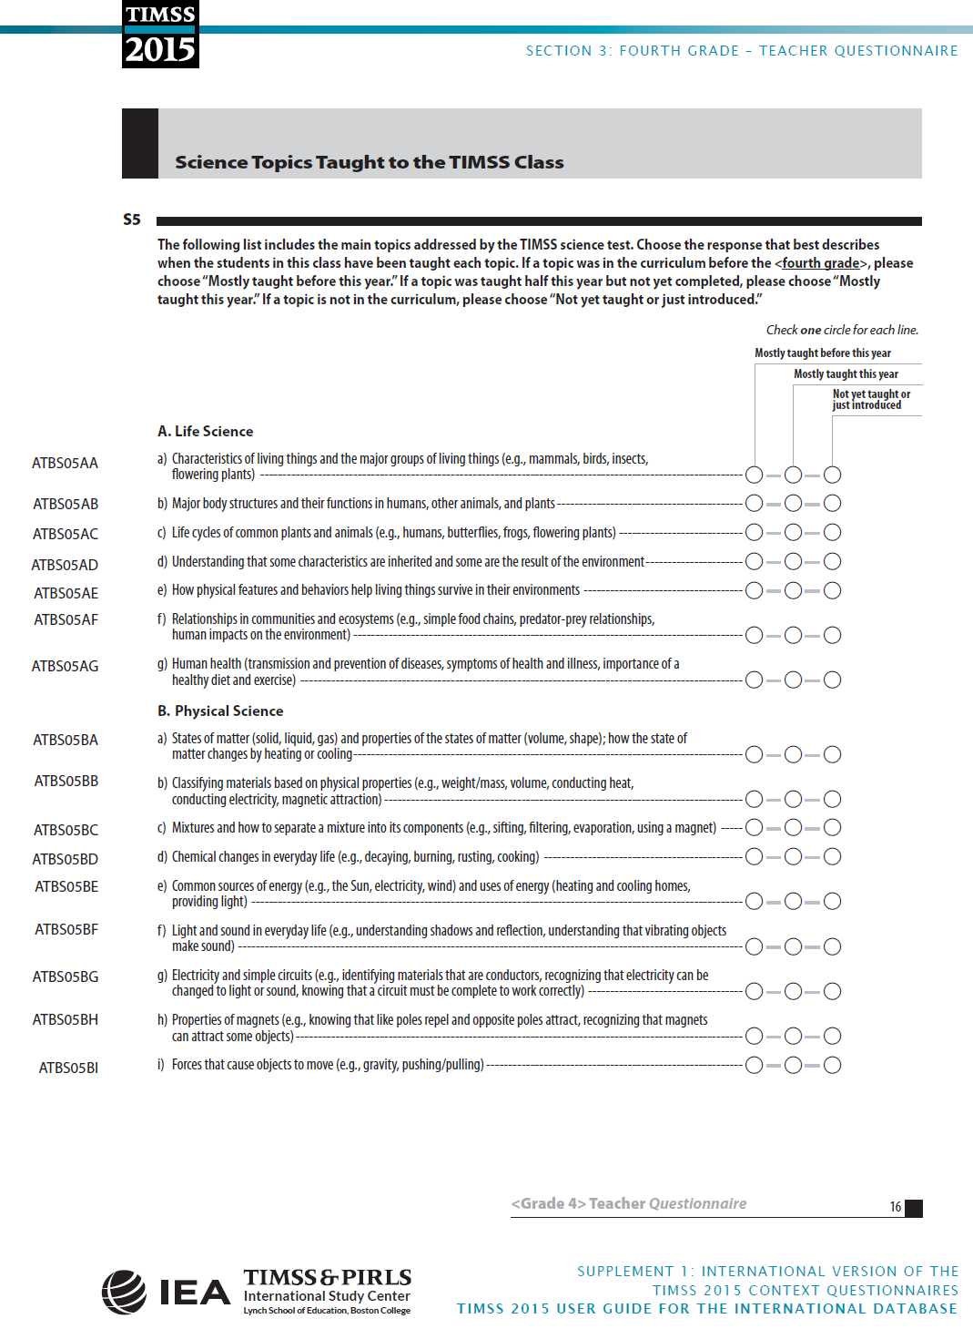 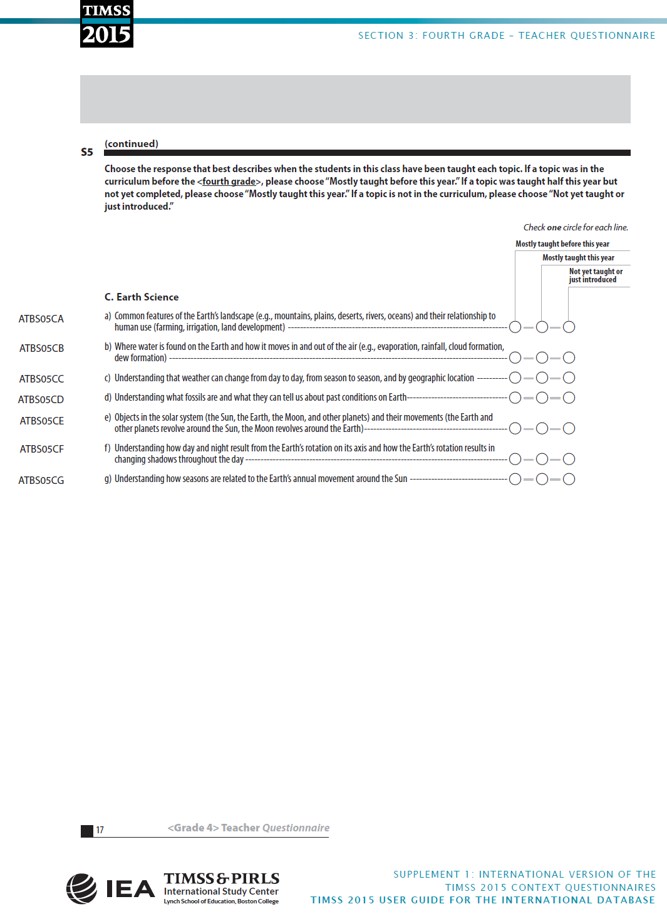 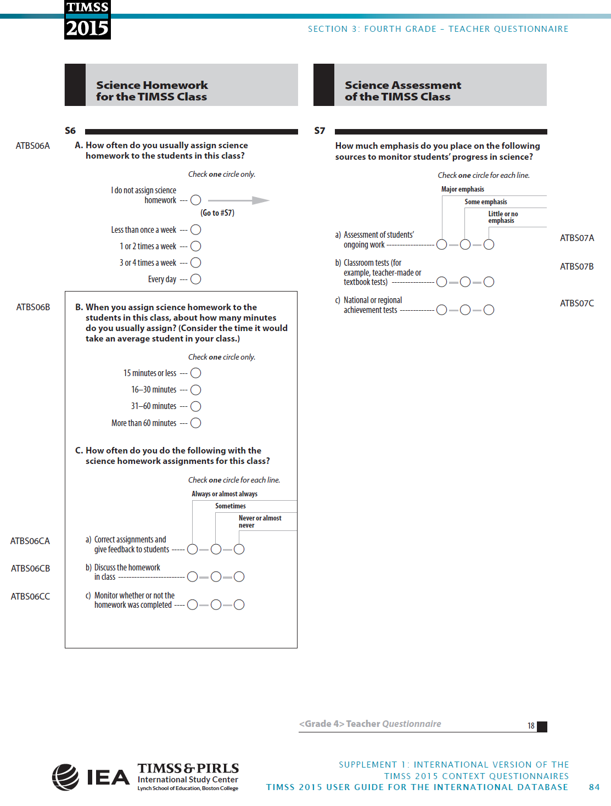 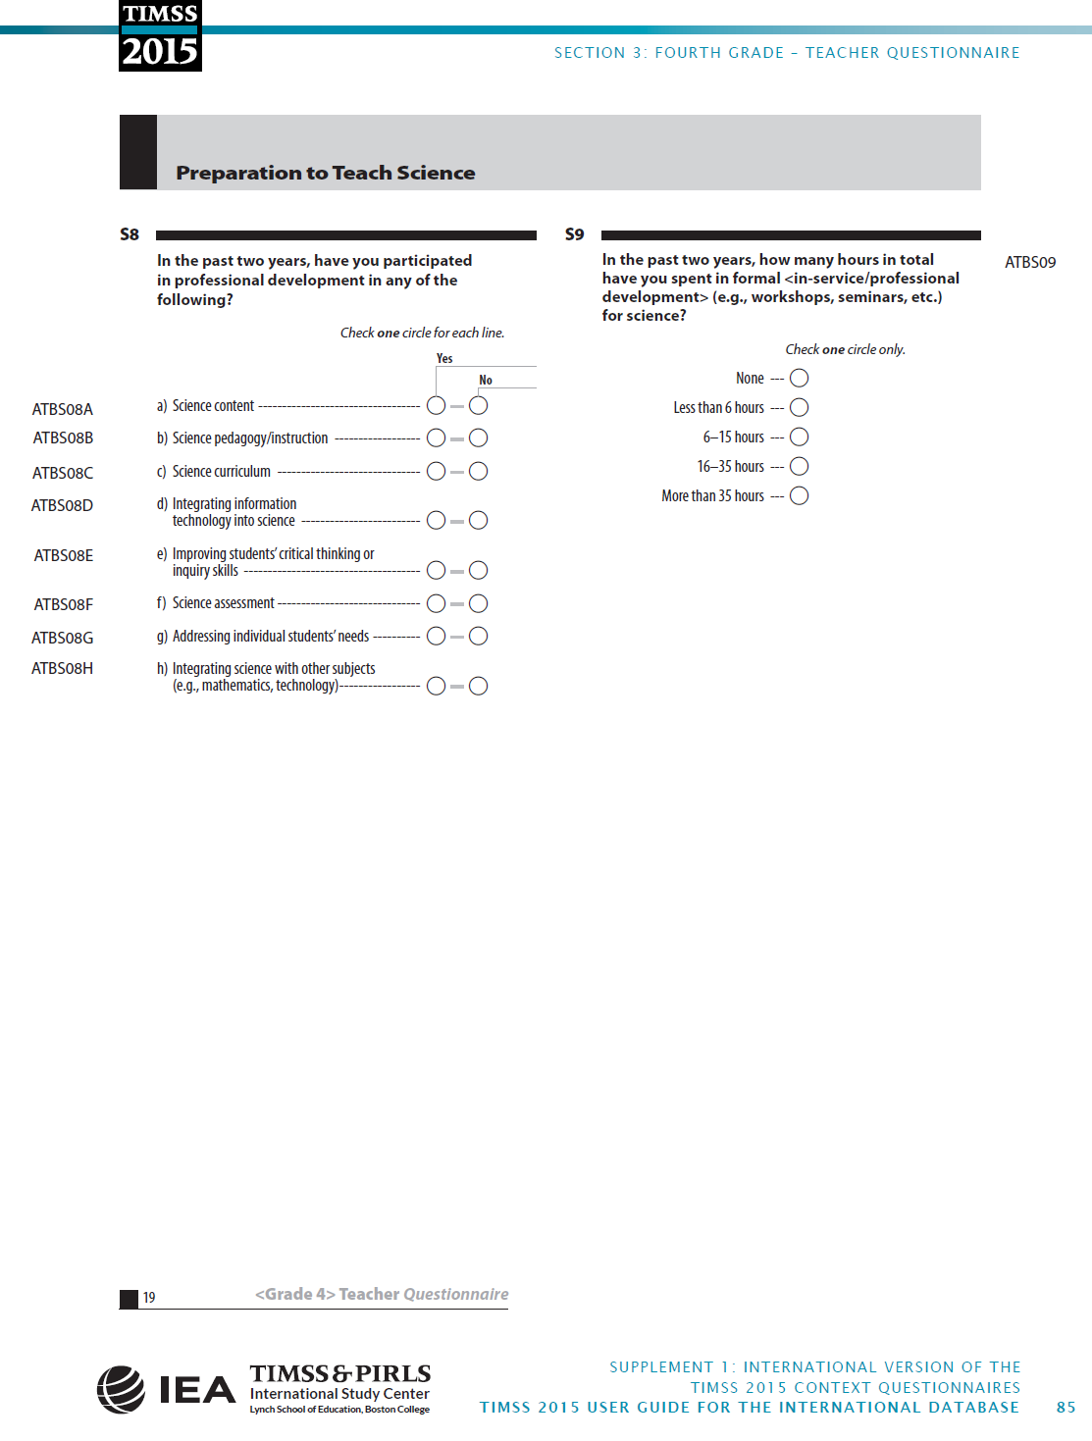 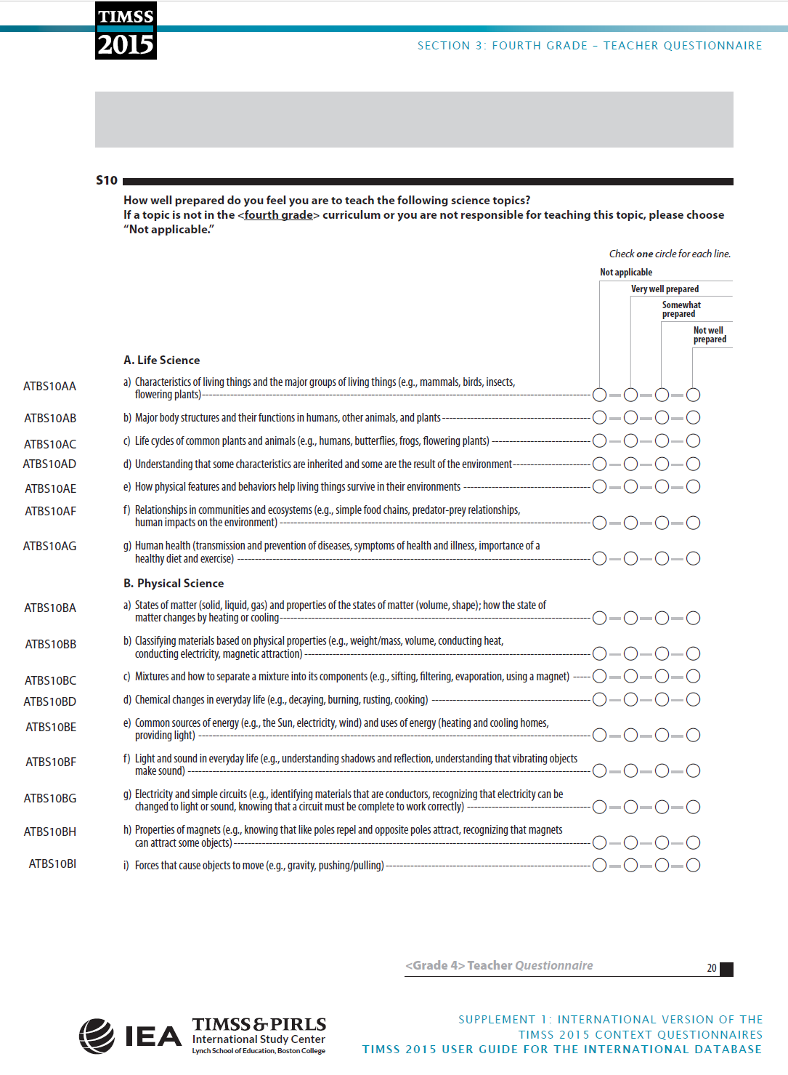 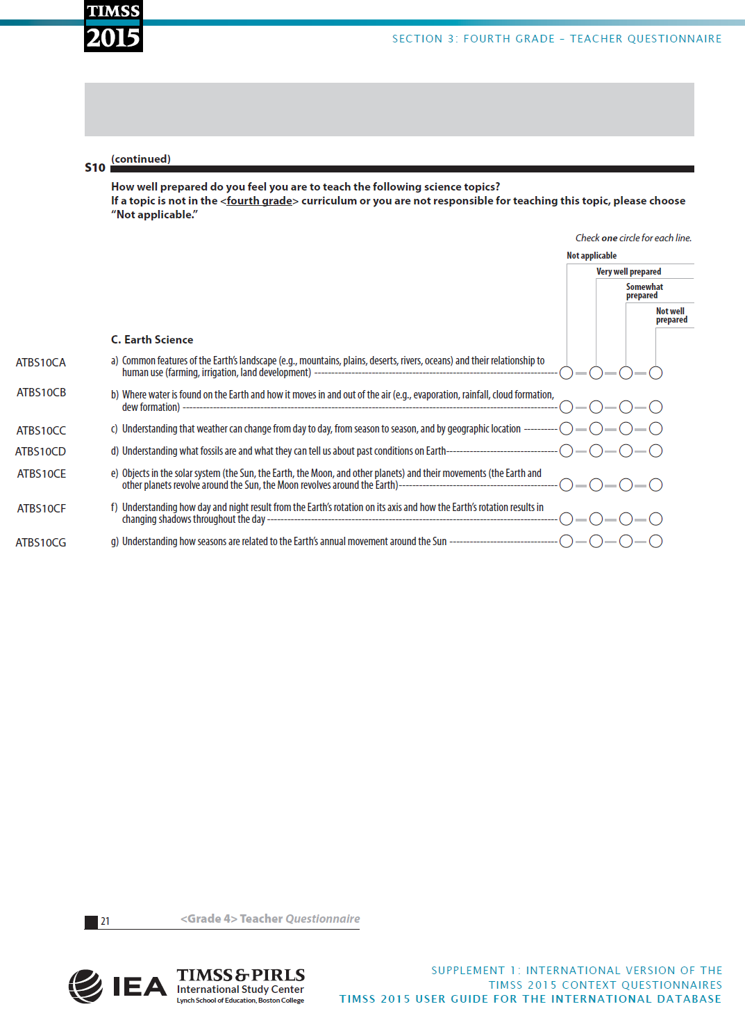
Appendix 4: Grade 4 TIMSS 2015 School Questionnaire
(IEA 2019, pp. 95-103)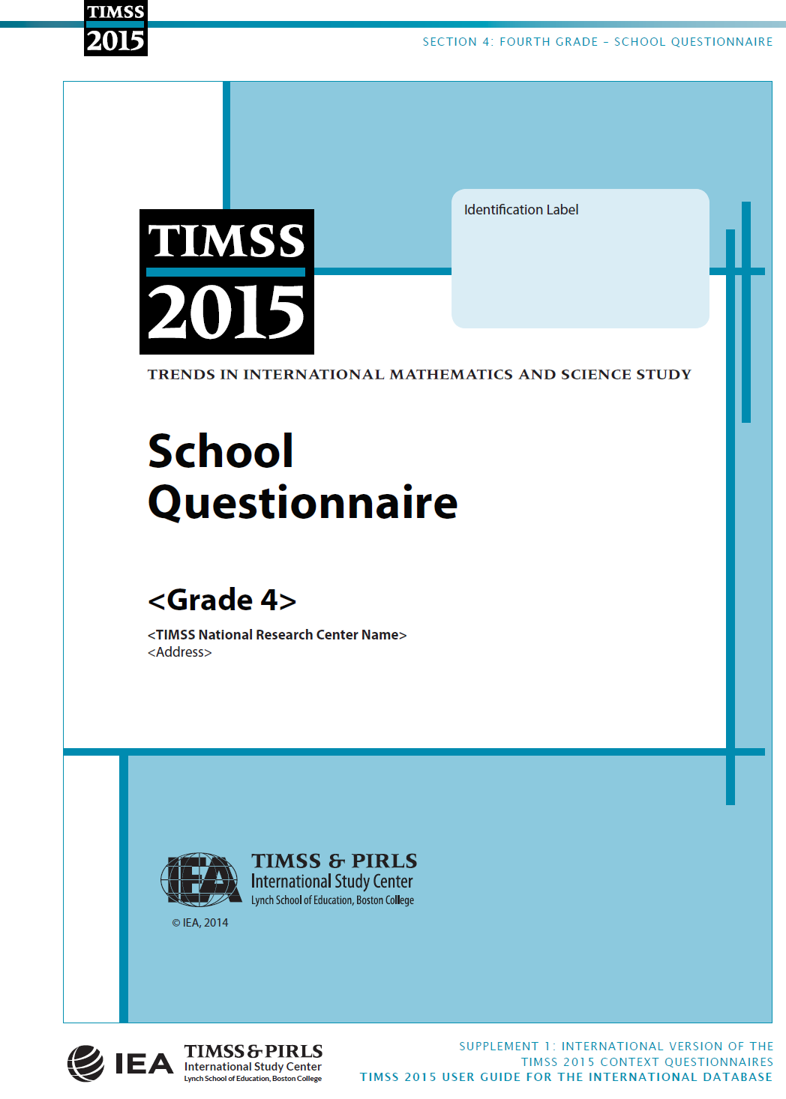 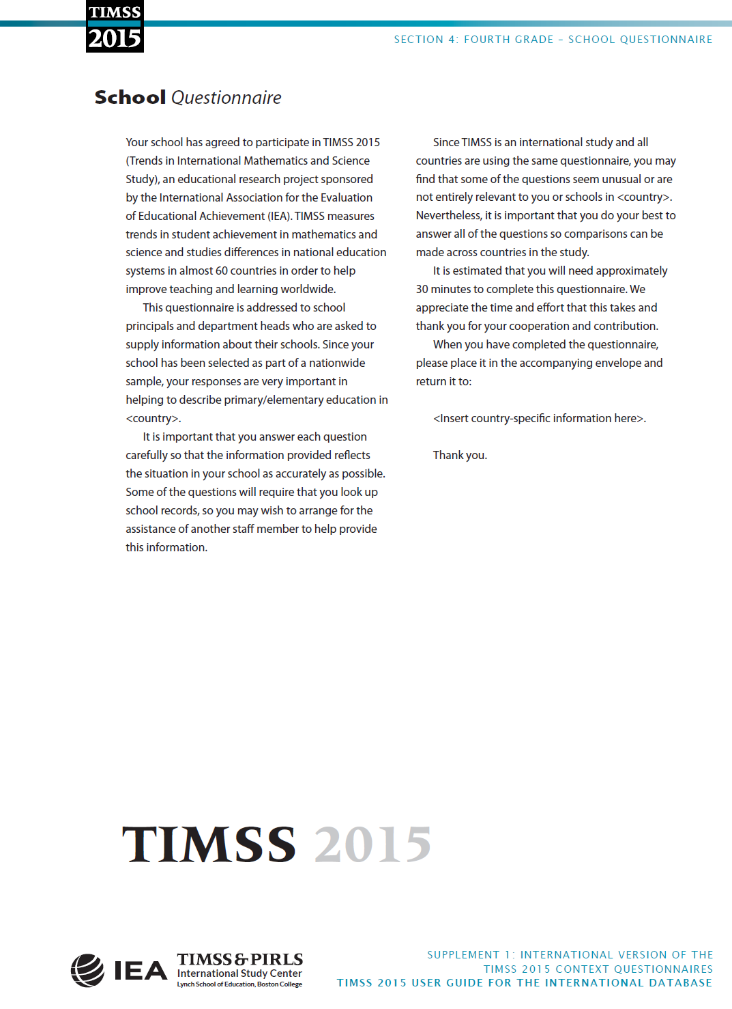 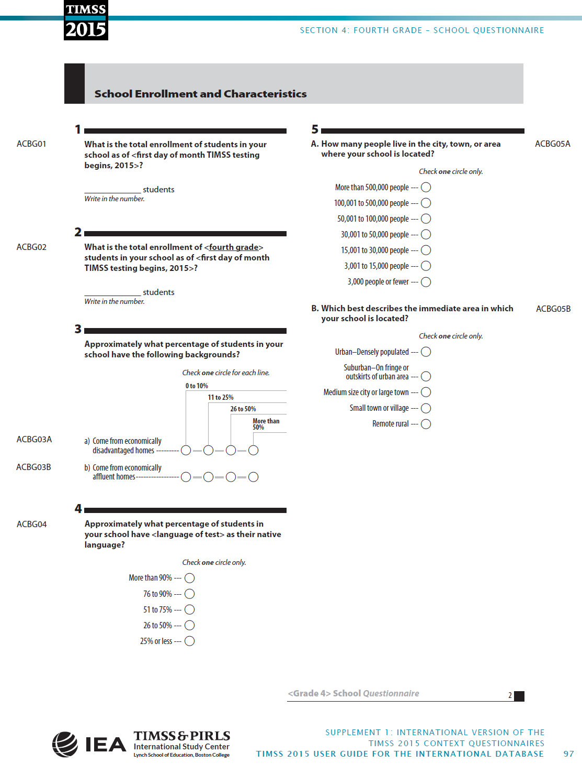 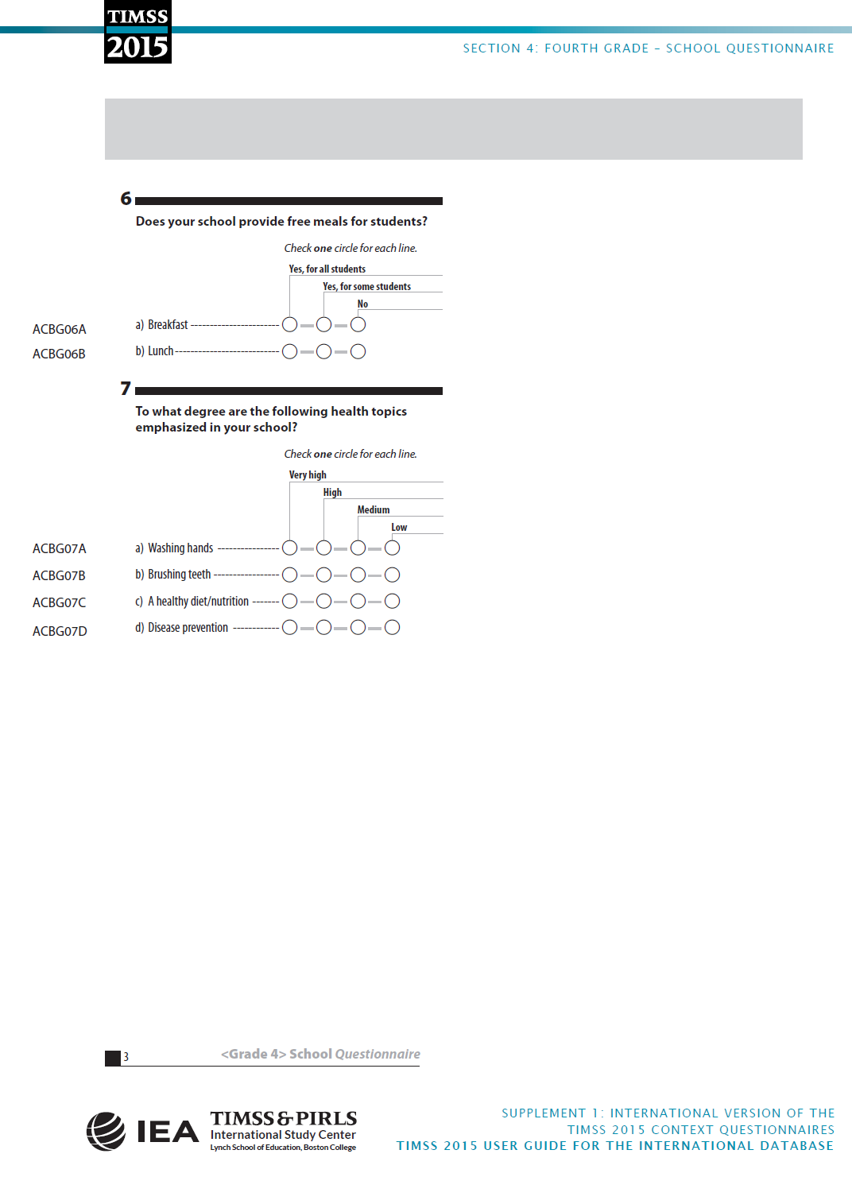 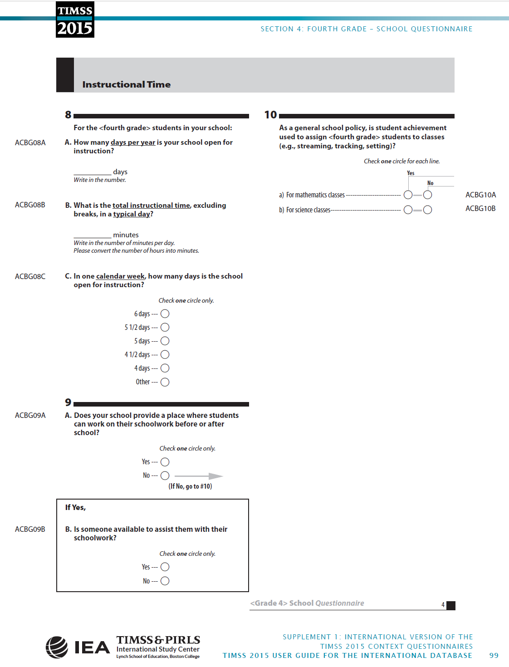 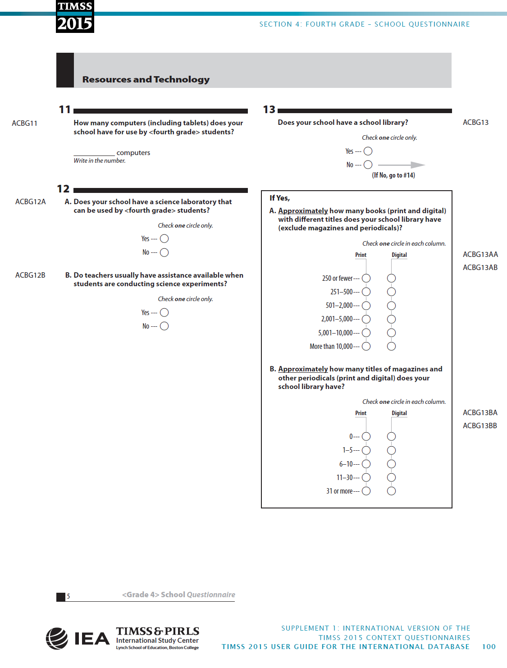 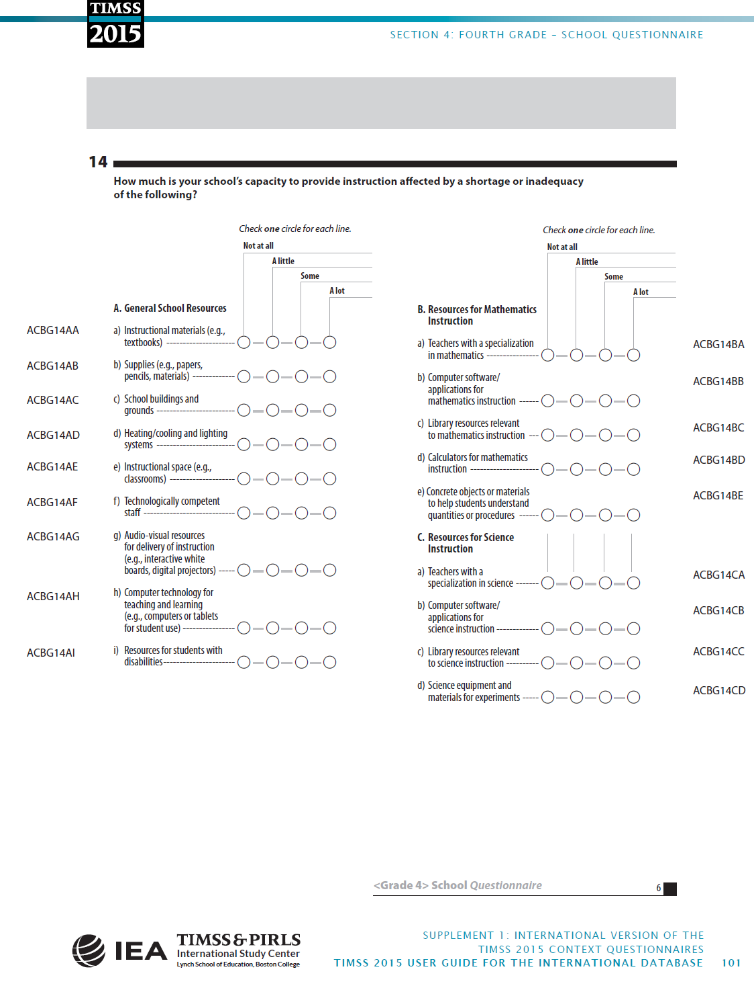 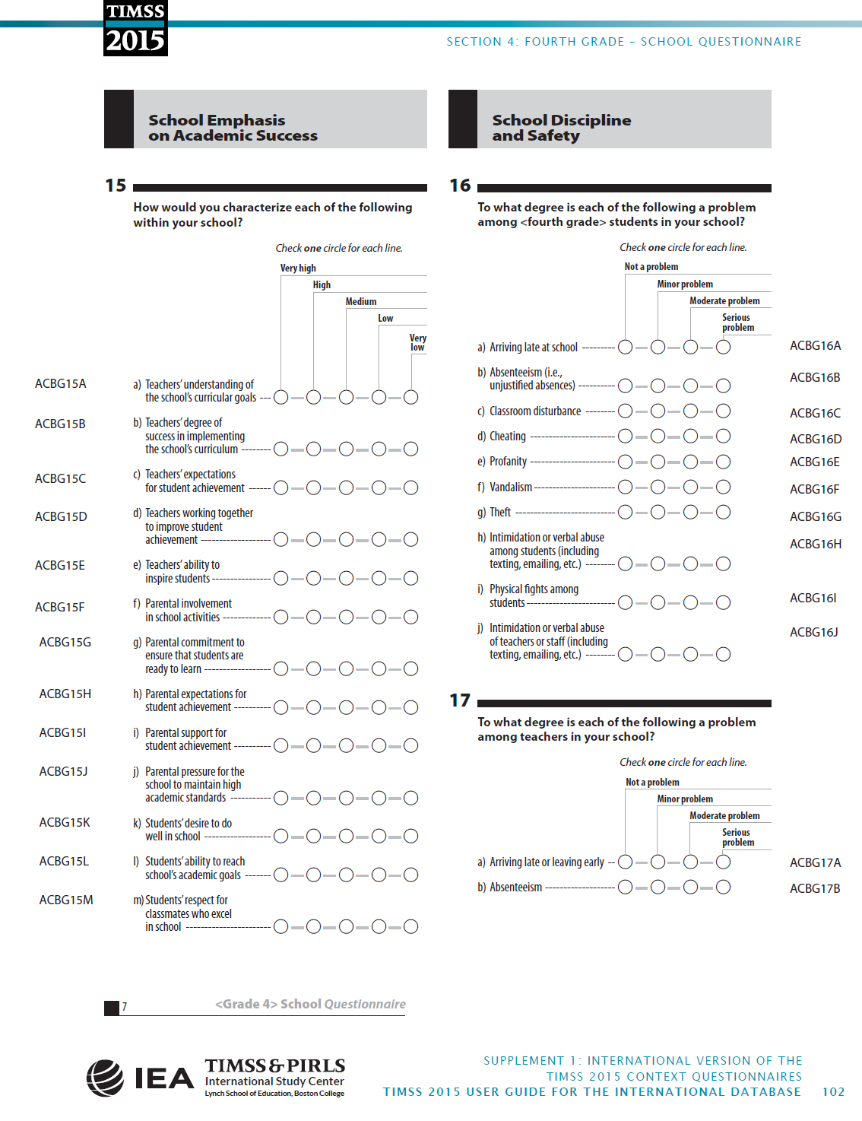 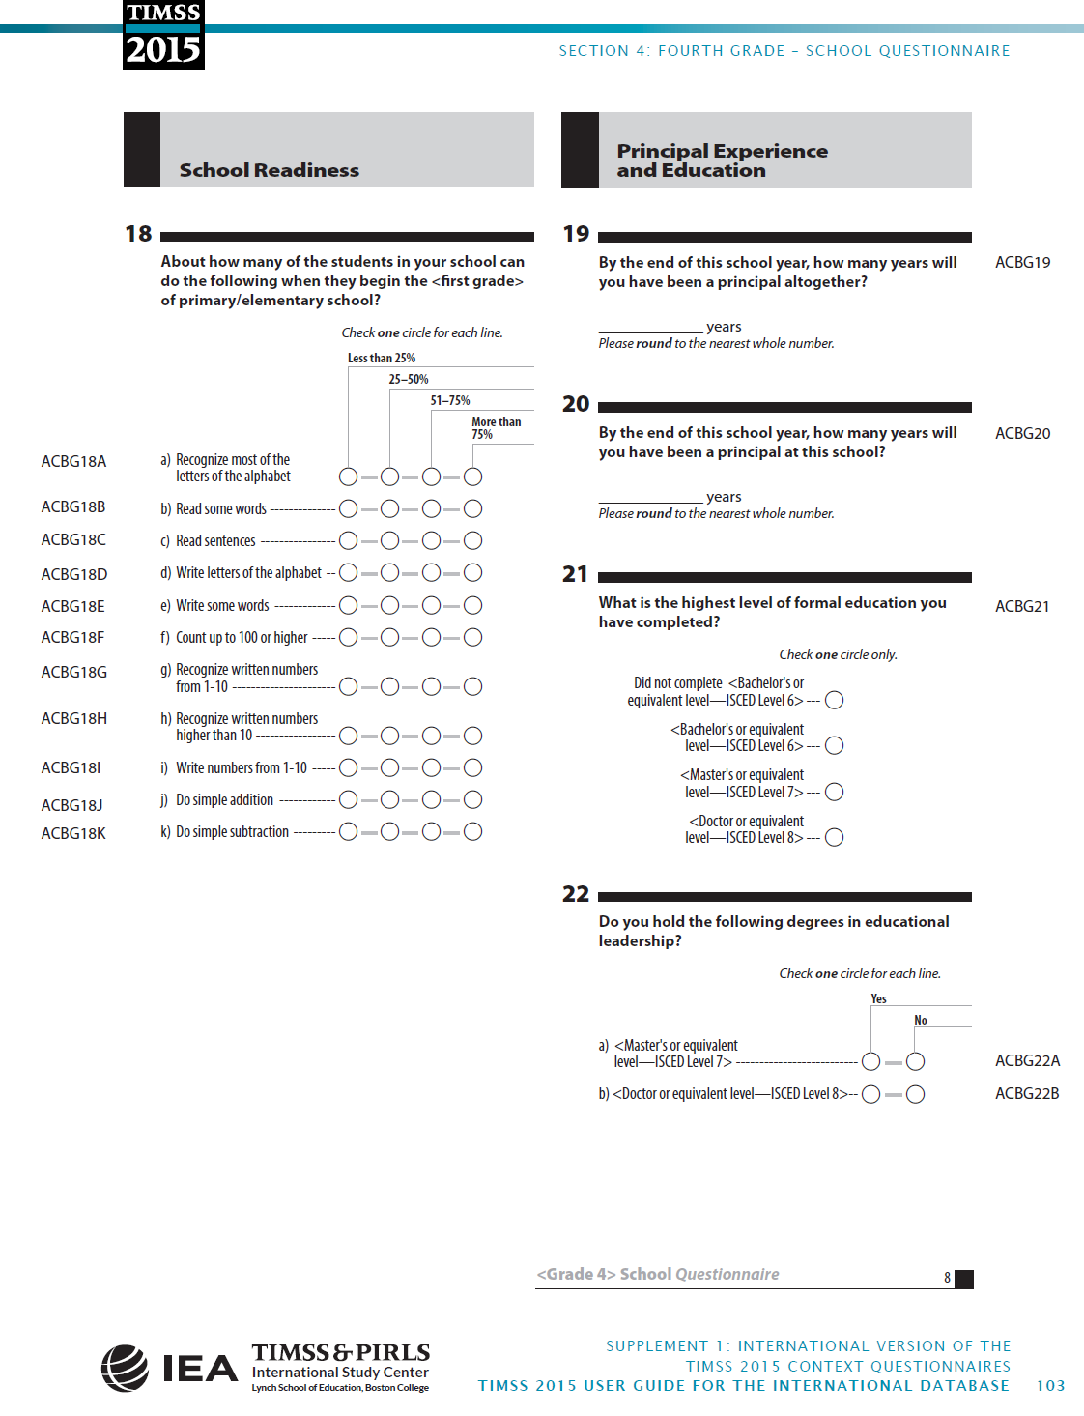
Appendix 5: BUID Research Ethics Form