

The Impact of Corporate Social Responsibility (CSR) on the firms’ Financial Performance and Value Creation: the case of Publicly Listed firms in the United Arab Emirates

تأثير المسؤولية الاجتماعية على الأداء المالي وعلى خلق القيمة للمؤسسات المدرجة في سوق الإمارات المالي
by

SAHAR MANSOUR ABDULLAH

A Thesis submitted in fulfilment
of the requirements for the degree of
PhD PROJECT MANAGEMENT
at
The British University in Dubai

Prof. Halim Buossabaine
May 2017

بسم الله الرحمن الرحيم

In the name of Allah, Most Gracious, Most Merciful

{وقل ربي زدني علما}

Candidate Declaration

I warrant that the content of the research is the direct result of my own work and that any use made in it of published or unpublished copyright material falls within the limits permitted by international copyright conventions.
I understand that a copy of my research will be deposited in the university library for permanent retention.
I hereby agree that the material mentioned above for which I am an author and copyright holder may be copied and distributed by The British University in Dubai for the purpose of research, private study or education and that the British University in Dubai may recover from purchasers the costs incurred in such copying distribution, where appropriate.
I understand that The British University in Dubai (BUiD) may make a digital copy available in the institutional repository.
I understand that I may apply to the University to retain the right to withhold or to restrict access to my thesis for a period which shall not normally exceed four calendar years from the congregation at which the degree is conferred, the length of the period to be specified in the application, together with the precise reasons for making that application.

___________________________
Signature of the students

COPYRIGHT AND INFORMATION TO USERS
The author whose copyright is declared on the title page of the work has granted to the British University in Dubai the right to lend his/her research work to users of its library and to make partial or single copies for educational and research use.

The author has also granted permission to the University to keep or make a digital copy for similar use and for the purpose of preservation of the work digitally.

Multiple copying of this work for scholarly purposes may be granted by either the author, the Registrar or the Dean of Education only.

Copying for financial gain shall only be allowed with the author’s express permission.

Any use of this work in whole or in part shall respect the moral rights of the author to be acknowledged and to reflect in good faith and without detriment the meaning of the content, and the original authorship.

Acknowledgement

First of all, I would like to thank Allah for the countless blessings and bounties that I was given to be able to complete this work successfully.
Secondly, I would like to express my deepest gratitude to my director of studies (DOS), Prof. Halim Boussabaine for his excellent guidance, caring, patience, continuous support and encouragement, which I have benefited greatly from. His supervision has equipped me with the necessary academic skills to complete this research study.
I am also extremely thankful to the Vice Chancellor of British University in Dubai (BUiD) for his continuous support, patience, caring and encouragement, to complete this study successfully, as he was the supporter from the beginning of this journey.
I am most grateful to my three kids, who have shown lots of understanding, patience, endless love, and moral support throughout the research study; actually their eyes were always in front of me to give me this huge power to reach to the top just because of them.
I am indebted to my Father, Mother, and my Sisters, for their endless love, support and prayers and for their persistent and continuous moral encouragement to me to achieve this degree of knowledge.
Finally, I am grateful to my colleagues and my friends on my workplace, whom I have worked with them and shared my problems, concerns and also happiness and laughing throughout the research journey.

Abstract
CSR is the Corporate Social Responsibility of a business which includes the economic, legal, ethical, and discretionary expectations that society has of corporate at a given point in time. Several studies have sprung out to develop investment criteria in relation to a spectrum of CSR practices, such as corporate governance, environmental and societal ethical issues. Empirical analyses of the relationship among corporate social responsibility (CSR) and financial performance (FP) initiated before about thirty years ago, and the findings of these analyses still in contention. These studies suffer from several limitations in the sense they were unable to view CRS as a vehicle for a high financial performance (FP) and also value creation. Thus, the aim of this thesis is to extend our understanding of the CSR determinants those contribute to financial performance and value creation of the firms publicly listed in United Arab Emirates (UAE).
This research carried out an exhaustive literature research with a focus on contemporary academic research in the field of CSR practices and financial performance and value creation in order to examine the main theories and seminal authors from the following aspects: origins of CSR notion, classification and development of its definition, determinants of CSR, evolution of studies examining the relationship among CSR and financial performance.
This research was able to advance the existing literature by classifying the CSR practices into 4 groups and identify 97 CSR determinants/questions; these groups are including: Corporate Governance (CG) CSR practices; Economic (EC) CSR practices; Environment (ENV) CSR practices; and Social (S) CSR practices. The study also put forward an integrated framework for assessing the financial performance and the value creation of the firms through CSR practices. The most important CSR practices were evaluated for their potential to value creation through questionnaires in the firms studied. Several statistical methods were used to analyze the data.
The results demonstrated that only “Economic Value - ECN1” is associated with “Stakeholder Relationships - VC2”, while “Wealth Distribution - ECN2” is associated with “Reputation of the firm - VC1”. On the other hand, “Environmental Practices - ENV1” is associated with “Price to Book Ratio -PB”, while “Environmental Policies - ENV2” is associated with both “Price to Book Ratio - PB” and with “Reputation of the firm - VC1”. Also, “Reputation of the firm - VC1” is associated with “Share Price - SP”.
The study observed that the CSR practices of the UAE firms in their current structure are not the significant predictor of their profits with comparing to other important variables such as debt ratio, origin of the firm, firm growth and firm size.
However, involvement in CSR activities should be happened in simultaneous with other variables that have a major influence on firms’ Financial Performance. This study found a positive association between UAE firms’ CSR practices and their Financial Performance “Share Price (SP)”.
The results of this research have important practical and theoretical implications. In practical, the research results revealed that decision makers should put more resources and efforts on their CSR practices as their firms will be rewarded by their stakeholders and the long-term profitability. In theoretical, further research should aim to develop further CSR determinants and confirm the association proposed this study framework.

المسؤولية الاجتماعية للشركات (CSR)هي شكل من أشكال تنظيم الشركات والتي يتم إدماجها في التقارير التجارية للشركات. وتعتبر سياسة المسؤولية الاجتماعية للشركات بمثابة آلية التنظيم الذاتي التي تضمن التزام الشركة بالقوانين والمعايير الأخلاقية والدولية، حيث تشمل هذه المعايير حوكمة الشركات والقضايا الأخلاقية و البيئية والمجتمعية والاقتصادية والقانونية.
وتعد ممارسة المسؤولية الاجتماعية للشركات موضوع نقاش وانتقاد واسع من قبل العديد. إذ يرى المؤيدون أن هناك طلباً قوياً على قضية المسؤولية الاجتماعية للشركات ، إذ أن الشركات سوف تستفيد من المسؤولية الاجتماعية للشركات بطرق عديدة من خلال العمل مع منظور أوسع وأطول من مجرد النظر إلى الأرباح قصيرة الأجل. في حين يجادل المنتقدون على أن المسؤولية الاجتماعية للشركات ليس لها أي دور اقتصادي على الشركات بل على العكس هي تخفض من قيمة الأرباح، الرأي الثالث يرى أن المسؤولية الاجتماعية للشركات ليست أكثر من نافذه سطحية لاستباق دور الحكومات كرقيب على الشركات القوية متعددة الجنسيات.
لقد بدأت دراسة العلاقة بين المسؤولية الاجتماعية للشركات والأداء المالي قبل نحو ثلاثين عاما، وما زالت نتائج هذه التحليلات موضوع خلاف. وتعاني هذه الدراسات والنتائج من العديد من القيود بمعنى أنها لم تستطيع التوصل إلى علاقة محدده ومباشره بين المسؤولية الاجتماعية للشركات وبين الأداء المالي للشركات وخلق القيمة. وبالتالي، فإن الهدف من هذا البحث هو توسيع المفهوم حول العوامل التي تتحكم في المسؤولية الاجتماعية للشركات وبالتالي تؤثر على الأداء المالي للشركات و تسهم في خلق القيمة للشركات المدرجة في السوق المالي لدولة الإمارات العربية المتحدة. ولتحقيق هذه النتيجه تم إجراء بحث علمي شامل مع التركيز على البحوث الأكاديمية المعاصرة، ولذلك تمت دراسة النظريات الرئيسية والمؤلفين الأساسيين من الجوانب التالية: أصول نشأة المسؤولية الاجتماعية للشركات وتصنيف وتطوير تعريفه، ومحددات وعوامل المسؤولية الاجتماعية للشركات، وتطور الدراسات التي تدرس العلاقة بين المسؤولية الاجتماعية للشركات وبين الأداء المالي للشركات وخلق القيمة. وقد تمكن هذا البحث من تحليل الأدبيات والدراسات المعاصرة وبالتالي تصنيف عوامل المسؤولية الاجتماعية للشركات إلى 4 مجموعات وتحديد 97 نقطه من محددات المسؤولية الاجتماعية للشركات، حيث شملت العوامل: حوكمة الشركات (Corporate Governance - CG)، العوامل الاقتصادية (Economic - EC)، العوامل البيئية (Environment - ENV)، العوامل الاجتماعية (Social)، وذلك من خلال استخدام استبيان يتكون من 97 سؤال.
واستخدمت عدة طرق إحصائية لتحليل البيانات. ثم تم تقليل عدد الاسئله لتصبح 13 سؤال بدلا من 97 سؤال ومن ضمن هذه العوامل ال 13 ظهرت النتائج التالية:
"القيمة الاقتصادية - ECN1" لها علاقة قوية مع "علاقات أصحاب المصلحة - VC2" في حين أن "توزيع الثروة - ECN2" لها علاقة قوية مع "سمعة الشركة “VC1 -
ومن ناحية أخرى، فإن "الممارسات البيئية -ENV1" لها علاقة قوية مع "Price to Book Ratio "، في حين أن "السياسة الشركة البيئية - ENV2 "لها علاقة مع " Price to Book Ratio" وأيضاً مع "سمعة الشركة “VC1 – .
أيضا، "سمعة الشركة “VC1 - لها علاقة قوية مع " سعر السهم (SP) ".
لاحظت نتائج هذا البحث أن ممارسات الشركات الإماراتية في مجال المسؤولية الاجتماعية للشركات في هيكلها الحالي ليست مؤشراً هاماً لأرباحها مقارنة بعوامل أخرى مهمة مثل نسبة الديون وأصل الشركة وحجمها والنمو الثابت لها. ولكن تعتبر خطوة المشاركة في أنشطة المسؤولية الاجتماعية خطوة مهمة جداً ويجب أن تطبق بالتزامن مع العوامل الأخرى التي لها تأثير كبير على الأداء المالي للشركات. نتائج هذا البحث وجدت ارتباط إيجابي بين ممارسات الشركات في مجال المسؤولية الاجتماعية للشركات وبين أداءها المالي من حيث "سعر السهم (SP)".
نتائج البحث الحالي لها آثار عملية ونظرية هامة. فمن الناحية العملية، كشفت نتائج البحث على أن صانعي القرار يجب أن يضعوا المزيد من الموارد والجهود في ممارساتهم المتعلقة بالمسؤولية االجتماعية للشركات حيث ستكافأ شركاتهم من أصحاب المصلحة مثل الزبائن ولكن على المدى الزمني الطويل. أما من الناحية النظرية فيجب أن تعقد المزيد من البحوث لإستحداث المزيد من العوامل الخاصة بالمسؤولية الاجتماعية للشركات والأداء المالي للشركات وكذلك خلق القيمة.

Table of Contents
Title |  |  |  |  |  |  | Page no
Candidate’s Declaration |  |  |  |  |  |  | i
Acknowledgement |  |  |  |  |  |  | ii
Abstract |  |  |  |  |  |  | iii
Table of Contents |  |  |  |  |  |  | v
List of Tables |  |  |  |  |  |  | x
List of Figures |  |  |  |  |  |  | xiii
List of Appendices |  |  |  |  |  |  | xiv
Abbreviations |  |  |  |  |  |  | xv
Chapter 1: Introduction |  |  |  |  |  |  | 1
Introduction |  |  |  |  |  |  | 1
1.1 Theoretical Background of CSR |  |  |  |  |  |  | 1
1.2 Publicly listed firms in UAE |  |  |  |  |  |  | 5
1.3 Research Need |  |  |  |  |  |  | 8
1.4 Research Aims and Objectives |  |  |  |  |  |  | 13
1.5 Research Questions |  |  |  |  |  |  | 14
1.6 Contribution to the current studies |  |  |  |  |  |  | 15
 |  |  |  | 1.6.1 Theoretical Contribution |  |  | 15
1.7 Research Structure |  |  |  |  |  |  | 16
Summary |  |  |  |  |  |  | 17
Chapter 2: Theoretical Background of CSR |  |  |  |  |  |  | 18
Introduction |  |  |  |  |  |  | 18
2.1 CSR Definition |  |  |  |  |  |  | 18
2.2 CSR Theories |  |  |  |  |  |  | 24
2.3 Western Studies of CSR |  |  |  |  |  |  | 29
2.4 African Studies of CSR |  |  |  |  |  |  | 33
2.5 Asian Studies of CSR |  |  |  |  |  |  | 35
2.6 Middle East Studies of CSR |  |  |  |  |  |  | 38
2.7 CSR Practices in UAE |  |  |  |  |  |  | 40
2.8 CSR Conceptual Framework |  |  |  |  |  |  | 45
Summary |  |  |  |  |  |  | 46
Chapter 3: CSR Determinants |  |  |  |  |  |  | 47
Introduction |  |  |  |  |  |  | 47
3.1 Extraction of CSR Determinants |  |  |  |  |  |  | 48
 |  |  |  | 3.1.1 Corporate Governance (CG) |  |  | 50
 |  |  |  |  |  | 3.1.1a Employee | 53
 |  |  |  | 3.1.2 Economic |  |  | 59
 |  |  |  |  |  | 3.1.2a Product Characteristics | 60
 |  |  |  |  |  | 3.1.2b Supplier | 60
 |  |  |  |  |  | 3.1.2c Customer | 61
 |  |  |  |  |  | 3.1.2d Location of the Head Office | 62
 |  |  |  | 3.1.3 Environment (ENV) |  |  | 67
 |  |  |  |  |  | 3.1.3a Environmental practices in UAE | 73
 |  |  |  | 3.1.4 Social (S) |  |  | 78
 |  |  |  |  |  | 3.1.4a Community | 80
 |  |  |  |  |  | 3.1.4b Ownership Structure | 82
 |  |  |  |  |  | 3.1.4c Philanthropy | 84
 |  |  |  |  |  | 3.1.4d Ethics | 86
3.2 Financial Performance Ratios (FP) |  |  |  |  |  |  | 92
 |  |  |  | 3.2.1 Price to Book Ratio (PB) |  |  | 97
 |  |  |  | 3.2.2 Return on Assets (ROA) |  |  | 97
 |  |  |  | 3.2.3 Return on Equity (ROE) |  |  | 99
 |  |  |  | 3.2.4 Share Price (SP) |  |  | 99
3.3 Impact of CSR on Financial Performance (FP) |  |  |  |  |  |  | 100
3.4 Moderating Variables |  |  |  |  |  |  | 106
 |  |  |  | 3.4.1 Firm Size |  |  | 107
 |  |  |  | 3.4.2 Firm Age |  |  | 111
 |  |  |  | 3.4.3 Industry Type |  |  | 112
3.5 Value Creation Variable |  |  |  |  |  |  | 113
Summary |  |  |  |  |  |  | 114
Chapter 4: Conceptual Framework |  |  |  |  |  |  | 115
Introduction |  |  |  |  |  |  | 115
4.1 Conceptual Framework |  |  |  |  |  |  | 116
4.2 Linking CSR Determinants to Financial Performance & Value Creation |  |  |  |  |  |  | 116
 |  |  |  | 4.2.1 Corporate Governance (CG) SCR value driver |  |  | 118
 |  |  |  | 4.2.2 Economic (EC) SCR value driver |  |  | 118
 |  |  |  | 4.2.3 Environmental (ENV) SCR value driver |  |  | 118
 |  |  |  | 4.2.4 Social (S) SCR value driver |  |  | 119
4.3 Research Hypothesis |  |  |  |  |  |  | 120
 |  |  |  | 4.3.1 Corporate Governance (CG) CSR Practices |  |  | 121
 |  |  |  | 4.3.2 Economic (EC) CSR Practices |  |  | 126
 |  |  |  | 4.3.3 Environment (ENV) CSR practices |  |  | 130
 |  |  |  | 4.3.4 Social (S) CSR practices |  |  | 134
4.4 Updated Conceptual Framework |  |  |  |  |  |  | 142
Summary |  |  |  |  |  |  | 143
Chapter 5: Methodology |  |  |  |  |  |  | 144
Introduction |  |  |  |  |  |  | 144
5.1 Research Philosophy |  |  |  |  |  |  | 145
5.2 Research Conceptual Framework |  |  |  |  |  |  | 147
5.3 Research Approach/ Design |  |  |  |  |  |  | 148
5.4 Development of Questionnaire |  |  |  |  |  |  | 150
 |  |  | 5.4.1 Structure of the Questionnaire |  |  |  | 151
 |  |  | 5.4.2 Administration of the Questionnaire |  |  |  | 152
 |  |  | 5.4.3 Validation of Research Constructs and Questions |  |  |  | 153
 |  |  | 5.4.4 Selection of Respondents |  |  |  | 153
5.5 Data Collection |  |  |  |  |  |  | 154
5.6 Research Questions |  |  |  |  |  |  | 155
5.7 Sample Size |  |  |  |  |  |  | 156
 |  | 5.7.1 Sample Size for Primary Data |  |  |  |  | 157
 |  | 5.7.2 Sample Size for Secondary Data |  |  |  |  | 157
5.8 Data Sources |  |  |  |  |  |  | 158
 |  |  | 5.8.1 Primary Data Source |  |  |  | 158
 |  |  | 5.8.2 Secondary Data Sources |  |  |  | 158
5.9 Data analysis |  |  |  |  |  |  | 159
Summary |  |  |  |  |  |  | 160
Chapter 6: Reliability, Descriptive Analysis, Ranking & Factor Analysis |  |  |  |  |  |  | 161
Introduction |  |  |  |  |  |  | 161
6.1 Reliability Analysis |  |  |  |  |  |  | 162
6.2 Descriptive Analysis |  |  |  |  |  |  | 164
6.3 Ranking Analysis |  |  |  |  |  |  | 165
 | 6.3.1 Ranking Analysis of Corporate Governance (CG) CSR practices |  |  |  |  |  | 165
 | 6.3.2 Ranking Analysis of Economic (EC) CSR practices |  |  |  |  |  | 166
 | 6.3.3 Ranking Analysis of Environment (ENV) CSR practices |  |  |  |  |  | 167
 | 6.3.4 Ranking Analysis of Social (S) CSR practices |  |  |  |  |  | 168
6.4 Factor Analysis |  |  |  |  |  |  | 169
 |  | 6.4.1 Factor Analysis of Corporate Governance (CG) CSR practices |  |  |  |  | 170
 |  | 6.4.2 Factor Analysis of Economic (EC) CSR practices |  |  |  |  | 178
 |  | 6.4.3 Factor Analysis of Environment (ENV) CSR practices |  |  |  |  | 184
 |  | 6.4.4 Factor Analysis of Social (S) CSR practices |  |  |  |  | 189
 |  | 6.4.5 Factor Analysis of Value Creation (VC) CSR practices |  |  |  |  | 194
Summary |  |  |  |  |  |  | 200
Chapter 7: Correlation & Regression |  |  |  |  |  |  | 201
Introduction |  |  |  |  |  |  | 201
7.1 Testing for Hypotheses |  |  |  |  |  |  | 2002
7.2 Association Analysis between CSR practices and Financial Performance (FP) |  |  |  |  |  |  | 203
 |  | 7.2.1 Association between Corporate Governance (CG) and Financial Performance (FP) ratios |  |  |  |  | 203
 |  |  | 7.2.2 Association between Economic (EC) and Financial Performance (FP) ratios |  |  |  | 204
 |  |  | 7.2.3 Association between Environment (ENV) and Financial Performance (FP) ratios |  |  |  | 205
 |  |  | 7.2.4 Association between Social (S) and Financial Performance (FP) ratios |  |  |  | 206
7.3 Association between” Important Area of CSR” and other Variables |  |  |  |  |  |  | 207
 |  |  | 7.3.1 Association between “Important Area of CSR” and Corporate Governance (CG) |  |  |  | 207
 |  |  | 7.3.2 Association between “Important Area of CSR” and Economic (EC) |  |  |  | 209
 |  |  | 7.3.3 Association between “Important Area of CSR” and Environment (ENV) |  |  |  | 210
 |  |  | 7.3.4 Association between “Important Area of CSR” and Social (S) |  |  |  | 211
 |  |  | 7.3.5 Association between “Important Area of CSR” and Financial Performance (FP) |  |  |  | 213
7.4 Association between “Role of Stakeholders” and other Variables |  |  |  |  |  |  | 214
 |  |  | 7.4.1 Association between “Role of Stakeholders” and Corporate Governance (CG) |  |  |  | 214
 |  |  | 7.4.2 Association between “Role of Stakeholders” and Economic (EC) |  |  |  | 216
 |  |  | 7.4.3 Association between “Role of Stakeholders” and Environment (ENV) |  |  |  | 218
 |  |  | 7.4.4 Association between “Role of Stakeholders” and Social (S) |  |  |  | 220
 |  |  | 7.4.5 Association between “Role of Stakeholders” and Financial Performance (FP) |  |  |  | 222
7.5 Association between Value Creation (VC) variables and other Variables |  |  |  |  |  |  | 223
 |  |  | 7.5.1 Association between Value Creation and Corporate Governance (CG) |  |  |  | 223
 |  |  | 7.5.2 Association between Value Creation and Economic (EC) |  |  |  | 226
 |  |  | 7.5.3 Association between Value Creation and Environment (ENV) |  |  |  | 229
 |  |  | 7.5.4 Association between Value Creation and Social (S) |  |  |  | 232
 |  |  | 7.5.5 Association between Value Creation and Financial Performance (FP) |  |  |  | 234
7.6 Association between New Latent Clusters and other variables |  |  |  |  |  |  | 236
 |  |  | 7.6.1 Association between New Latent Clusters and Financial Performance (FP) |  |  |  | 236
 |  |  | 7.6.2 Association between New Latent Clusters and Value Creation (VC) |  |  |  | 237
7.7 Association between Value Creation (VC) and Financial Performance Ratios (FP) |  |  |  |  |  |  | 239
7.8 Regression Analysis |  |  |  |  |  |  | 239
 |  |  | 7.8.1 Prediction of Financial Performance (FP) using CSR practices |  |  |  | 240
 |  |  | 7.8.2 Prediction of Value Creation (VC) using CSR New Latent Clusters & FP |  |  |  | 247
Summary |  |  |  |  |  |  | 251
Chapter 8: Summary, Conclusion and Suggestions |  |  |  |  |  |  | 252
Introduction |  |  |  |  |  |  | 252
8.1 Determinants of CSR Value Creation practices |  |  |  |  |  |  | 253
 |  |  | 8.1.1 Corporate Governance (CG) CSR Value Creation practices |  |  |  | 257
 |  |  | 8.1.2 Economic (EC) CSR Value Creation practices |  |  |  | 258
 |  |  | 8.1.3 Environment (ENV) CSR Value Creation practices |  |  |  | 259
 |  |  | 8.1.4 Social (S) CSR Value Creation practices |  |  |  | 260
8.2 New Latent Clusters of CSR practices |  |  |  |  |  |  | 261
 |  |  | 8.2.1 New Latent Clusters of Corporate Governance (CGN) determinants |  |  |  | 262
 |  |  | 8.2.2 New Latent Clusters of Economic (ECN) determinants |  |  |  | 265
 |  |  | 8.2.3 New Latent Clusters of Environment (ENV) determinants |  |  |  | 267
 |  |  | 8.2.4 New Latent Clusters of Social (S) determinants |  |  |  | 268
 |  |  | 8.2.5 New Latent Clusters of Value Creation Metrics |  |  |  | 270
8.3 Testing for Hypotheses |  |  |  |  |  |  | 272
8.4 Association between CSR Determinants and “Important area of CSR” |  |  |  |  |  |  | 274
 |  |  | 8.4.1 Association between Corporate Governance (CG) and “Important area of CSR” |  |  |  | 274
 |  |  | 8.4.2 Association between Economic (EC) and “Important area of CSR” |  |  |  | 274
 |  |  | 8.4.3 Association between Environment (ENV) and “Important area of CSR” |  |  |  | 275
 |  |  | 8.4.4 Association between Social (S) and “Important area of CSR” |  |  |  | 275
 |  |  | 8.4.5 Association between Financial Performance (FP) and “Important area of CSR” |  |  |  | 276
8.5 Association between CSR Determinants and Value Creation Metrics |  |  |  |  |  |  | 278
 |  |  | 8.5.1 Association between Corporate Governance (CG) and Value Creation Metrics |  |  |  | 278
 |  |  | 8.5.2 Association between Economic (EC) and Value Creation Metrics |  |  |  | 279
 |  |  | 8.5.3 Association between Environment (ENV) and Value Creation Metrics |  |  |  | 280
 |  |  | 8.5.4 Association between Social (S) and Value Creation Metrics |  |  |  | 280
 |  |  | 8.5.5 Association between Financial Performance (FP) and Value Creation Metrics |  |  |  | 281
8.6 Association between New Latent Clusters and CSR Value Creation Metrics |  |  |  |  |  |  | 284
8.7 CSR determinants as Predictors for Financial Performance (FP) |  |  |  |  |  |  | 285
8.8 Emerged CSR Value Creation Conceptual Framework |  |  |  |  |  |  | 292
8.9 New Instruments for the Assessment |  |  |  |  |  |  | 294
8.10 Recommendations and Contribution |  |  |  |  |  |  | 269
8.11 Conclusion |  |  |  |  |  |  | 298
8.12 Research Limitations |  |  |  |  |  |  | 299
8.13 Suggestions for Future Research |  |  |  |  |  |  | 300
References |  |  |  |  |  |  | 302
Appendices |  |  |  |  |  |  | 324

List of Tables
Table No. | Description | Page no.
Table 1.3-A | Listed firms in the GCC | 5
Table 1.3-B | Arab Market Capitalization in 2012 | 6
Table 1.3-C | Nominal GDP of the UAE from 2006 to 2016 | 6
Table 5.1 | Quantitative Analysis | 146
Table 5.4.1a | Numerical Code for Questionnaire | 152
Table 5.4.1b | Questionnaire Structure | 152
Table 6.1 | Reliability (Cronbach alpha test) for the four groups (CG, EC, ENV, S, G) | 164
Table 6.3.1 | Ranking Analysis of Corporate Governance (CG) CSR practices | 165
Table 6.3.2 | Ranking Analysis of Economic (EC) CSR practices | 166
Table 6.3.3 | Ranking Analysis of Environment (ENV) CSR practices | 167
Table 6.3.4 | Ranking Analysis of Social (S) CSR practices | 168
Table 6.4 | Tests for Factor Analysis applicability | 169
Table 6.4.1a | Total Variance Explained for Corporate Governance (CG) group | 170
Table 6.4.1b | Rotated Component Matrix for Corporate Governance (CG) group | 172
Table 6.4.1c | Rotated components Matrix for (CG) after Factor Analysis Codes | 173
Table 6.4.2a | Extracted components for Economic (EC) group | 178
Table 6.4.2b | Rotated Component Matrix for Economic (EC) group | 180
Table 6.4.2c | Rotated components Matrix for (EC) after Factor Analysis Codes | 181
Table 6.4.2d | Wealth Distribution of GCC countries in 2013 | 183
Table 6.4.3a | Extracted components for Environment (ENV) group | 184
Table 6.4.3b | Rotated Component Matrix for Environment (ENV) group | 186
Table 6.4.3c | Rotated components Matrix for (ENV) after Factor Analysis Codes | 187
Table 6.4.4a | Extracted components for Social (S) group | 189
Table 6.4.4b | Rotated Component Matrix for Social (S) group | 191
Table 6.4.4c | Rotated components Matrix for (S) after Factor Analysis Codes | 192
Table 6.4.5 | Value Creation Questions | 194
Table 6.4.5a | Extracted components for Social group | 195
Table 6.4.5b | Rotated Component Matrix for Value Creation group. | 196
Table 6.4.5c | Rotated components Matrix for Value Creation group after New Code | 197
Table 7.2.1 | Association between Corporate Governance (CG) and Financial Performance (FP) ratios | 203
Table 7.2.2 | Association between Economic (EC) and Financial Performance (FP) Ratios | 204
Table 7.2.3 | Association between Environment (ENV) and Financial Performance (FP) ratios | 205
Table 7.2.4 | Association between Social (S) and Financial Performance (FP) ratios | 206
Table 7.3 | “Important Area of CSR” Variables | 207
Table 7.3.1 | Association between “Important Area of CSR” and Corporate Governance (CG) | 208
Table 7.3.2 | Association between “Important Area of CSR” and Economic (EC) | 209
Table 7.3.3 | Association between “Important Area of CSR” and Environment (ENV) | 210
Table 7.3.4 | Association between “Important Area of CSR” and Social (S) | 211
Table 7.3.5 | Association between “Important Area of CSR” and Financial Performance (FP) | 213
Table 7.4 | “Role of Stakeholders” Variables | 214
Table 7.4.1 | Association between “Role of stakeholders” and Corporate Governance (CG) | 214
Table 7.4.2 | Association between “Role of Stakeholders” and Economic (EC) | 216
Table 7.4.3 | Association between “Role of Stakeholders” and Environment (ENV) | 218
Table 7.4.4 | Association between “Role of Stakeholders” and Social (S) | 220
Table 7.4.5 | Association between “Role of Stakeholders” and Financial Performance (FP) | 222
Table 7.5 | "Value Creation" CSR Variables | 223
Table 7.5.1 | Association between Value Creation and Corporate Governance (CG) | 223
Table 7.5.2 | Association between Value Creation and Economic (EC) | 226
Table 7.5.3 | Association between Value Creation and Environment (ENV) | 229
Table 7.5.4 | Association between Value Creation and Social (S) | 232
Table 7.5.5 | Association between Value Creation and Financial Performance (FP) | 234
Table 7.6.1 | Association between New Environment Cluster (ENVN) and Financial Performance | 236
Table 7.6.2 | Association between New Economic Clusters and Value Creation (VC) | 238
Table 7.7 | Association between Value Creation (VC) and Financial Performance (FP) | 238
Table 7.8.1a | Regression of New Latent Clusters as a separate groups vs. FP (Model Summary) | 240
Table 7.8.1b | Regression of New Latent Clusters as a separate groups vs. FP (Coefficients) | 240
Table 7.8.1c | Regression of New Latent Clusters Altogether vs. FP (Model Summary) | 244
Table 7.8.1d | Regression of New Latent Clusters Altogether vs. FP (Coefficients) | 245
Table 7.8.2a | Regression of Value Creation (VC) vs. New Latent Clusters (Model Summary) | 247
Table 7.8.2b | Regression of Value Creation (VC) vs. New Latent Clusters (Coefficients) | 248
Table 8.3 | Association between original CSR groups and FP | 273
Table 8.4a | Association between CSR Determinants “Important area of CSR” (at p = 0.05) | 277
Table 8.4b | Association between CSR Determinants “Important area of CSR” (at p = 0.01) | 278
Table 8.4c | Association between CSR Determinants and Value Creation Metrics (at p = 0.05) | 282
Table 8.4d | Association between CSR Determinants and Value Creation Metrics (at p = 0.01) | 283
Table 8.6 | Association between New Latent Clusters and CSR Value Creation Metrics | 284
Table 8.7a | New Latent Clusters (separate groups) as a predictor for FP (Model Summary) | 288
Table 8.7b | New Latent Clusters (separate groups) as a predictor for FP (Coefficients) | 288
Table 8.7c | New Latent Clusters (Altogether) as a predictor for FP (Model Summary) | 289
Table 8.7d | New Latent Clusters (Altogether) as a predictor for FP (Coefficients) | 289
Table 8.7e | New Latent Clusters and FP as a predictor for VC (Model Summary) | 290
Table 8.7f | New Latent Clusters and FP as a predictor for VC (Coefficients) | 290
Table 8.7g | New Latent Clusters as a predictor for VC (Model Summary) | 291
Table 8.7h | New Latent Clusters as a predictor for VC (Coefficients) | 291

List of Figures
Figure No. | Description | Page no.
Figure 2.1 | Carroll Pyramid | 22
Figure 2.8 | CSR Conceptual Framework | 45
Figure 3.1.1 | Grant Thornton Corporate Governance associations | 51
Figure 3.1.3 | Stages of conducting Cradle-to-grave analysis | 70
Figure 4.2 | Conceptual Framework of this research that is linking CSR to FP and VC | 117
Figure 4.3 | Delphi techniques identified the CSR indicators | 122
Figure 4.3.1 | Relationship between Corporate Governance (CG) CSR practices and FP | 124
Figure 4.3.2 | Relationship between Economic (EC) CSR practices and FP | 129
Figure 4.3.3 | Relationship between Environment (ENV) CSR practices and FP | 133
Figure 4.3.4a | Investment in different type of CSR practices | 136
Figure 4.3.4 | Relationship between Social (S) CSR practices and FP | 140
Figure 4.4 | Updated Conceptual Framework of this research that is linking CSR to FP and VC | 142
Figure 5.3 | Research Approach/ Design | 149
Figure 6.1 | Reliability (Cronbach alpha test) for the four groups (CG, EC, ENV, S, G) | 164
Figure 6.4.1 | Screen plot of Eigen Values of Corporate Governance (CG) group | 171
Figure 6.4.2 | Screen plot of Eigen Values of Economic g (EC) group | 179
Figure 6.4.3 | Screen plot of Eigen Values of Environment (ENV) group | 185
Figure 6.4.4 | Screen plot of Eigen Values of Social (S) group | 190
Figure 6.4.5 | Screen plot of Value Creation (VC) group | 195
Figure 7.8.1 | Regression Test Processes | 240
Figure 8.1.1 | Ranking of Corporate Governance (CG) group | 257
Figure 8.1.2 | Ranking of Economic (EC) group | 258
Figure 8.1.3 | Ranking of Environment (ENV) group | 259
Figure 8.1.4 | Ranking of Social (S) group | 260
Figure 8.2.1 | Typical stages in the audit process | 264
Figure 8.8 | Emerged CSR Value Creation Conceptual Framework | 293

List of Appendices
Appendix No. | Description | Page no.
Appendix 5.4 | Questionnaire used in this Study | 324
Appendix 5.5 | UAE market sectors | 330
Appendix 5.7.1 | The surveyed sample of UAE Listed firms | 331
Appendix 6.2 | Descriptive Analysis | 332
Appendix 6.2.1 | Descriptive Analysis for Corporate Governance (CG) | 329
Appendix 6.2.2 | Descriptive Analysis for Economic (EC) | 357
Appendix 6.2.3 | Descriptive Analysis for Environment (ENV) | 369
Appendix 6.2.4 | Descriptive Analysis for Social (S) | 389
Appendix 6.2.5 | Descriptive Analysis for General Questions (G) | 407
Appendix 6.2.6 | Descriptive Analysis for Demographic Information (D) | 450
Appendix 6.2.7 | Descriptive Analysis for Financial Performance Ratios (FP) | 458
Appendix 6.2.7.1 | Descriptive Analysis for Price to Book Ratio (PB) | 459
Appendix 6.2.7.2 | Descriptive Analysis for Return on Asset (ROA) | 460
Appendix 6.2.7.3 | Descriptive Analysis for Return on Equity (ROE) | 461
Appendix 6.2.7.4 | Descriptive Analysis for Share Price (SP) | 462

Abbreviations
CSR: Corporate Social Responsibility
FP: Financial Performance
KLD: Kinder Lydenberg Domini
UAE: United Arab Emirates
CG: Corporate Governance
EC: Economic
ENV: Environment
S: Social
EU: European
NGO: Non-Governmental Organization
EU: European Union
UN: United Nation
SME: Small Medium enterprises
DFM: Dubai Financial Market
ADX: Abu Dhabi Securities Exchange
S&P: Standard and Poor's of the top 500 publicly listed firms by market cap in US.
COMPUSTAT: financial database of global firms throughout the world founded in 1962.
KLD: Kinder, Lydenberg, Domini is firm for analyzing the environmental and social data.
BP: Price to Book financial Ratio
ROA: Return on Asset financial Ratio
ROE: Return on Equity financial Ratio
SP: Share Price financial Ratio
Tobin Q: the ratio of the market value of a firm’s assets divided by the book value
CGN1: Provision of Policies
CGN2: Ethical Practices
CGN3: Audit & Legal Issues
CGN4: Equal Opportunities
ECN1: Economic Value
ECN2: Wealth Distribution
ECN3: Financial Transparency
ENVN1: Environmental Practices
ENVN2: Environmental Policies
SN1: Internal Social CSR Practices
SN2: External Social CSR Practices
VC1: Value Creation Variable #1, named “Reputation of the firm”
VC2: Value Creation Variable #2, named Stakeholder Relationships
G1CSRs: Firms spending on CSR practices
G2Ind: Number of CSR indicators the firms discloses
G3Size: Firm Size

Chapter 1: Introduction

Introduction
This chapter presents the theoretical context of the research and provides theoretical basis of the study. The second part of the chapter addresses the research need, the research questions, research hypothesis, research aims and objectives, research contribution to existing knowledge and thesis layout.

1.1 Theoretical Background of CSR
Firms are engaged in many activities relate to the CSR. Such activities involves non-financial yearly reports, governance and environment initiatives of the firms, rules and strategies, business codes and the process of dealing with or controlling things or people (Baker & Anderson, 2010). However, there are diverse considerations with regards to CSR by firms; some consider CSR as a virtuous obligation that generate abundant benefits, so CSR plays a positive role in generating profits, For example, (Heinkel et al., 2001; Hong & Kacperczyk, 2009; Hong & Kostovetsky, 2012; Dimson et al., 2013; Fatemi & Fooladi, 2013; Servaes & Tamayo, 2013), while others believe that CSR plays a negative role in generating profits to businesses, For example, (Friedman, 1970; Smith, 2005; Lopez et al., 2007; El Ghoul et al., 2011; Goss & Roberts, 2011). Friedman (1970) claimed that CSR and FP have a negative association. He concluded that a “firm is an artificial thing” and so not be able to have a real responsibilities. Studies carried out by Aupperle et al. (1985) suggested that there is no association between CSR and FP. They used return on assets measurement in both short-run and long-run on a sample of 241 managers. Another study also made by Ullman (1985) to prove that there is no relationship between CSR and FP. He estimated that there are so many intervening factors between CSR and FP, and he also claimed that there are still various problems in measuring the intangible implications of CSR. Carroll (1991) claimed that CSR is the social responsibility of a business which includes the economic, legal, ethical, and discretionary expectations that society has of organizations at a given point in time. In my opinion Carroll (1991) definition for the CSR consider as the best concept for CSR as it identifies the corporations’ commitments toward society, and as it systematically differentiates the corporations’ responsibility from the social responsibilities of governments and from mere profit making. Jones (1995) claimed that by adopting the Instrumental Stakeholder Theory, then the stakeholder satisfaction will impact the FP of the company. However, the Instrumental Stakeholder Theory is combining two theories. First, the instrumental theory is a financial theory that expected the findings that will be revealed as a result of shareholders management. The next theory, the Stakeholder Theory, is a moral theory that suggests decision makers have an obligation to put stakeholders’ requirements first for the purpose of increasing the value of the company, so that there is a positive relationship between the CSR and FP. Orlitzky (2000) claimed that the perception of CSR has progressed through time in three directions. The first direction is identified as the CSR direction, which considers that the responsibility of the corporations merely focuses on the firm’s business motivation and on obligation. The second direction is known as the Social Responsiveness direction, which stresses on actions and activities conducted by firms in order to meet specific social obligations. It emphasizes actions that have expected and distinct outcomes that provide developments of policies relevant to the firm. The third direction, which is the CSR practiced today and is well known as Corporate Social Performance. It translates the effectives of corporate policies that are used to achieve social goals. It focuses on satisfying a variety of stakeholders like workers and the overall community. In other words, it holds the company responsibly towards the community as a whole besides its normal objective in maximizing profits. Abbey (2002) argues that CSR is not considered as what companies provide or can provide; it is simply how these companies operate. Some perceive CSR as a corporate philanthropy, while others view it as definition for interests, admiration and watchfulness that can brought-up to the physical environment. Zsolnai (2006) defines CSR as a tool that supports the integration between the operations of a business with the interests of the society and the environment taking into account the interaction between the firm and its stakeholders on deliberate basis. Lopez et al. (2007) were one of the most famous advocates about the negative relationship between CSR and FP; they made a study for two years in 2002 to evaluate the FP of the firms by measuring the profit or loss by using the Dow Jones Index and the sample of 110 European companies, however, the study has a limitation as it analysed the short-term relationship between CSR and FP. Poddi & Vergalli (2009) reported the definition of Corporate Social Responsibility that was offered by the Council of Business for Sustainable Development. The definition of CSR according to them is “The task of a business to contribute to sustainable economic development, working together with workers, their families, the society and local community to improve quality of life”. According to Iwu-Egwuonwu (2010), Corporate Social Responsibility can be defined as a tool that aligns the interest of societies with those of corporations. Furthermore, CSR supports in mitigating the chaos that may potentially be brought by societies against corporations. On the other hand, corporations that care less about communities and societies will experience unavoidable chaos since their focus is merely on profitability whilst ignoring the entire social benefits. Yet, and as far as employees are concerned, CSR is defined as how firms unquestioningly and sincerely show concerns to issues that affect the employees in terms of wellbeing and the overall enhancement of his/her disposable income whilst maintain a proper work and life balance along with a friendly environment at the workplace (Iwu-Egwuonwu, 2010).
In conclusion, for a company to be considered as a socially responsible firm, it must respect and obey laws, operate ethically and always be a good corporate inhabitant or a philanthropist besides its objective in maximizing the shareholder’s wealth through profit generation. In other words, any firm must concurrently fulfil these roles, whereby each is considered as a separate component of CSR when combined the sum depicts the meaning of CSR (Iwu-Egwuonwu, 2010). The substantial increase in consumptions to encourage the CSR in the earlier periods of time encourage shareholders to find out a financial advantages from CSR initiatives, mainly taking into the accounts the financial goal of the firm as maximising the owner’s wealth. However, empirical analyses of CSR and FP initiated before about thirty years ago and the findings of these analyses have been confused. Palmer (2012) claimed that there are triple findings for the association among corporate social responsibility and financial performance: positive relationship, no relationship, and negative relationship. Most of the theoretical and empirical analyses proposed the first association: that there is a positive relationship between CSR and FP. This research included an exhaustive literature research with a focus on contemporary academic research in the field of CSR and FP of the firms in order to examine the main theories and seminal authors from the following aspects: origins of CSR notion, classification and development of the definition, evolution of studies examining the CSR and FP relationship. Important and well-cited authors within the field will be included. A big part of literature research attempted to determine the CSR determinants. The significant determinants are Community, Corporate Governance, Customers, Suppliers, Employees, Environment, Business Ethic, and Controversies. Earlier studies reveal that there are a relationship between the CSR determinants and FP of the firm (Venazi & Fidanza, 2006).

1.2 Publicly listed firms in UAE
The stock markets of the UAE consist of two exchanges: Abu Dhabi Securities Exchange (ADX) and Dubai Financial Market (DFM). The regulatory authority for Abu Dhabi Securities Exchange is the Securities and Commodities Authority of UAE which was established 2000. As of January 2016, the total number of listed firms in the UAE equity market was 130; 69 in ADX and 61 in DFM (DFM, 2017; ADX 2017). The firms listed on the DFM are mostly Emirati companies in addition to some secondary listings from the neighbouring Gulf countries, in particular Kuwait. The original name of Abu Dhabi Securities Exchange (ADX) was the Abu Dhabi Securities Market (ADSM) but it was renamed in May 2008. The main trading floor is in Abu Dhabi but it has secondary listings for many firms in different places such as North African and Middle East. Table 1.3-A shows the number of listed companies in each of the member countries of the GCC.
As evidenced by Table 1.3-A, the UAE ranked as the third in between the GCC in terms of the number of publicly listed firms; hence, the relative importance of the stock markets in the UAE. Market capitalization is referred to share price multiplied by the number of shares outstanding (Eiteman et al., 2010). Most of studies advocate that the macro-economic environment has a significant impact on the market cap through indices, including: GDP, money supply, current account, interest rates and exchange rates (Kurihara, 2006; Ologunde et al., 2006). The comparison between the market capitalization of the UAE stock markets and the total Arab Market Capitalization in 2012 is shown in Table 1.3-B (IMF, 2012):
As evidenced by Table 1.3-B, the UAE accounts for the second largest marketplace in the Middle East in terms of capitalization. As per the International Monetary Fund (IMF) Country Report No. 12/116 May 2012, Nominal Gross Domestic Product (GDP) of the UAE is estimated as $360 billion USD in 2011 (IMF, 2012). The Nominal GDP of the UAE is projected to reach a level of $448 billion USD in 2017, a 24.44% increase from the GDP level of 2011 (IMF, 2012).
Figure 1.3-C shows the evolution of the Nominal GDP of the UAE from 2006 to 2016.
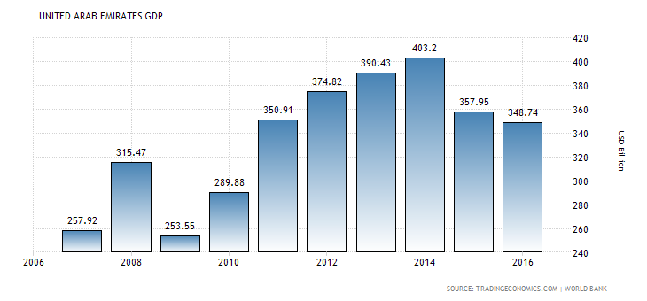
Table 1.3-C - Nominal GDP of the UAE from 2006 to 2016
Source: World Bank - 2017

As claimed by the UAE Minister of Higher Education, the United Arab Emirates studies focus are devoted to develop sustainable and innovative solutions to the UAE concerns. The UAE has prioritized many fundamental areas of strategic necessity, including education, water resources, renewable energy, technological advancement, space exploration, transportation, and health. This study focus adds to the understanding of the United Arab Emirates 2020 vision where studies, technology, science, and innovation buildup the basics of a competitive and productive knowledge entity. It is a new entity that will be supported by genius ideas and minds where both private and public firms and other organizations can buildup efficient and friendly business collaborations.
Choosing UAE as a site was based in so many variables as following:
1. The available studies about the CSR in GCC countries are not developed very well.
2. The available studies were unable to view CSR as a vehicle of Value creation.
3. Majority of the available studies suffer from lack of establishing a coherent conceptual framework for selecting determinants that contribute to firms’ Value Creation.
4. The available studies are based on value judgment rather than financial information.
5. The CSR practices in UAE lagged behind developed nations.
6. UAE Market Capitalization consider as the 2nd largest marketplace in the Middle East.

1.3 Research Need
Empirical evidences of the relationship between CSR and firm FP with respect to the earlier literature are mixed (Baker & Anderson, 2010). According to Friedman (1970) the most important target of the firms is to create profits for its owners, but it also has to work within the policies of the society by obeying the laws and policies of the surrounding community and paying taxation. When Friedman (1970) claimed that the “sole and first target of a firm is to profit” he made a huge mistake only in claiming that the sole target is the profit, as it is still being the first. In the work activities, CSR should have a high outcome otherwise it cannot be considered as sustainable practice. Owners and decision makers need to see these outcome; they want to ensure that their firm will be lucrative, and that was the main purpose for many scholars 60 years ago to examine the association among CSR and FP. Friedman (1970) is considered as the most famous opponent to CSR, as he claimed that the firm is inappropriate and inefficient mediators of any variation in community, and any philanthropy practices to community are considered as wasting the owner’s capital. Manne & Wallich (1972) claimed that CSR is considered as a cost to the organization instead of being a source of income. On the other hand, Davis (1973) claimed that firms implementing CSR can attract in the long-term a reputable public image that will help to catch more consumers and better workers, and this will serve the interests of the firms. Webster (1975) claimed that consumers take into consideration the social aspects of the firms’ practices while buying the product. On the other hand, Freeman (1984) was the leading proponent to CSR as he claimed that CSR improve the relationship with the firm’s stakeholders. McGuire et al. (1988) examined both the accounting and market yields, and claimed that earlier FP is more closely related to CSR than later FP. Jones (1995) claimed that CSR minimized the operational cost. Matzler & Hinterhuber (1998) claimed that one of the most important sources of sustainable competitive advantage for organizations is the firm reputation that is gained from a long period of high consumer satisfaction. They opined that in order to know whether advancement in specific commodity characteristics lead to competitive advantage, it is important to differentiate the consumers' perceived commodity quality with that of rivals' commodity. If consumers are satisfied with the quality of the commodity, the reputation of the organization will be improved. Fombrun et al. (2000) confirmed that CSR leads to competitive advantages as it maximize the pricing premiums and market opportunities. Epstein & Roy (2001) confirmed that implementing CSR practices will minimize the costs and enhances the efficiency in allocating the resources. Friedman & Miles (2001) claimed that CSR minimize the waste and its related costs, while it also improves the productivity by adopting eco-friendly programs and conserving energy. McWilliams & Siegal (2001) claimed that CSR minimizes environmental and social costs which will lead to profit maximization. Chambers et al. (2003) claimed that CSR is considered as a slave to the financial interests of the organization because it is really complex for management to measure the financial effects of CSR in most cases; they added, the ‘ideal’ extent of CSR can be identified by management through cost-benefit method. They also confirmed that, the contemporary framework views owner well-being and CSR as complementary to each other. Davies et al. (2003) confirmed that organization’s reputation attracts consumers. More satisfied consumers mean higher competitive advantage, higher growth of sales, and improved reputation which ends up with higher FP. Margolis & Walsh (2003) claimed that between the 70’s of the last millennium and the earlier of the current millennium, about 130 studies empirically analyzed this association. Recently, the focus on this subject has increased; actually, out of the 130 studies, approximately 70 were published in the nineties. Orlitzky et al. (2003) made a study that analyzed 52 earlier questionnaires on the association between CSR and FP revealed that the firm with better CSR scores better FP than the firm with poor CSR scores. Roberts (2003) claimed that if the firms did not implement CSR practices this will lead to bad public image which will underestimate the firms’ commodities. So that, public image is an important factor of organization’s success and profitability. To maximize profitability, a firm can either reduce its costs or increase its revenue. Some studies have proposed that implementing CSR practices leads to improve the firm’s image which will lead to higher sales. Tsoutsoura (2004) pointed out that worker wellbeing, demands of stakeholder, customer income, history of CSR practices, culture kind, advertisement, Research and Development, industry type, firm size, diversification level, etc., are examples of some drivers that really affect the relationships among CSR and FP. Barnett (2005) claimed that, from a normative context, the most important investment of the firm is to focus on increasing the well-being of the shareholders of the firm; as CSR contains practices to enhance community well-being. On the other hand, based on a report issued from the organization for Economic Cooperation and Development, there are some issues about shifting the balance of power; as among the largest hundred international countries as measured by Gross Domestic Product indicator, only 49 firms from the whole countries and 51 firms from United States. Werther & Chandler (2005) claimed that although the profits are the main target of the firm. However, increasing the pressure from government, non-governmental firms, media and fast spread of news require firms to focus beyond just increasing the profit and satisfy all parties of stakeholders in an ethical and sustainable way; like developing the workers, reducing pollution, maintaining natural resources or adopting any CSR activities. Adopting any CSR practices is becoming urgent for firms, in particular if they want to maintain a well-appreciated brand and looking for a good reputation. From a practical viewpoint, Qu (2007) claimed that the CSR practices will minimize FP if it is seen as a strategic marketing technique that aids to enlarge the organization’s market share in the short-term. However, the FP will surpass CSR if it is regarded as a long-run business that supports the sustainability of the firm. According to Margolis et al. (2008), by 2008 the number of research raised about CSR is approximately 170 studies. Galbreath (2008) analyzed Australian organizations and he found a strong positive correlation. Scholtens (2008) claimed that FP is more important than social performance. Van Beurden & Gössling (2008), assessed 34 studies of the relationship among CSR and FP; and the findings indicate that about 70% of research showed positive correlation. Lin et al. (2009) also analyzed the association among CSR and FP but in one thousand Taiwanese respondents and a positive correlation was found. Rettab et al. (2009) used a questionnaire on 280 firms in the United Arab Emirates also to analyse the association among CSR and FP; the results revealed that CSR has a positive correlation with all the tripartite factors of FP: firm integrity, personnel obligation and monetary performance. According to Blue Book (2009), about 97% of consumers in China seek to buy their commodities from socially responsible firms. Moreover, other research has claimed that CSR practices support firms by minimizing costs. Arendt & Brettel (2010) also support the previous studies as they claimed that socially responsible firms have a better reputation and this will improve the competitive advantages, so that the FP of the organisation will be increased. Chen & Wang (2011) examined 141 organizations in China over the period of 2007-2008. They claimed that the changes in CSR and FP affect each other extensively, and that CSR practices can both enhance the FP in the current year and have an important effect with the FP of the coming year. The strong and positive correlation among CSR and FP was evidently given by Alafi & Hasoneh (2012) results which had been adopted among the Jordanian Housing Banks. After that Cabral (2012) came to support the earlier research by adding the factor of sustainable competitive advantage to evaluate the firm’s reputation and consumer satisfaction and in addition to measure the final outcome. The bottom line is that since CSR is an environment-oriented method to measure the quality of process and product that supports design groups in creating new processes or products in an organized manner based on more environment protection and satisfying of consumers' expectations and needs, it could be debated that CSR does not have a direct impact on the FP of the firm, but it is totally mediated by competitive advantage, consumer satisfaction and reputation. Cheung et al. (2012) examined 100 listed organizations in China to assess the quality of the firms by using certain CSR indicators. Their findings revealed that the Chinese organizations enhanced their CSR activities in the period of 2004-2007, and the consumers rewarded these enhancements. Galbreath & Shum (2012) claimed that most of the recent literature reviews use United States and developed European countries as samples. In spite of (1) the lack of research on the relationship among CSR and firm FP in developing countries, especially in Arab countries; (2) Arab countries being little used as a selected chosen sample in global research; and (3) the presence of a negative gap among the expected and actual range of CSR for Arabic firms. The existing research which had investigated the determinants of CSR concentrates on either CSR activities or their relationship with some financial indicators. These studies suffer from several limitations in the sense they were unable to view CSR as a vehicle for value creation. Also the majority of studies suffer from a lack of presenting a coherent theoretical framework for selecting the determinants that contribute to value creation. Also the existing studies do not provide a meaningful way of integrating both quantitative and qualitative measurement of CSR determinants. Furthermore, recently, ethical investment has been associated CSR activities. Several studies have sprung out to develop investment criteria in relation to a spectrum of CSR practices, such as corporate governance, environment, and societal ethical issues. The emergence of ethical investment portfolios was based on the assumption that enterprises which adhere to ethical practices attract more long term investors leading to stability and continuity of the enterprises. Moreover, most of the existing investment criteria (in relation to CSR) are based on value judgment rather than financial information. Additionally, it was pointed out that the practices of CSR in UAE lag behind the developed world. The National (2016) quoted Nasser AlIssa, Chief Sustainable Officer at Saudi Generations stating that “Government and semi-government authorities in the region can work on a strategy to develop on a local CSR guide and a reporting system” (The National, 2016). The article went to say that “But there is a clear gap between what is happening in the GCC compared to advanced countries, particularly in Europe and in North America. These gaps are in knowledge, innovation, research, training and education, and web applications, among others”. Furthermore, Investvine (2013) quoted the director of Dubai chamber of commerce “our research shows that while the intention is there, implementing and integrating CSR and sustainability amongst businesses is still a huge challenge”. The reporter went on to elaborate “but that there is still a long way to go before CSR and sustainability are fully incorporated by the entire business community”. This study proposes an integrated framework for assessing value creation through CSR activities. Within this theoretical framework, this research contributes to the existing literature by investigating the CSR determinants which contribute to value creation within the UAE context.

1.4 Research Aims and Objectives

The aim of this research is to extend the understanding of the CSR determinants that contribute to Value Creation and Financial Performance of UAE firms. This aim will be achieved by pursuing different research objectives.

Examine the existing literature on CSR with a view to extract the most relevant CSR determinants.

Develop a value creation based CSR conceptual framework.

Evaluate the relevance of SCR determinants in value creation in UAE enterprises.

- Figure out the type and the nature of the association among the CSR practices and the firms’ financial performance of UAE firms.

1.5 Research Questions
The study of the literature led to raising many relevant questions; these questions concern many techniques that link Corporate Social Responsibility to a Company’s Financial Performance and Value Creation.
Thus, the main drawback of the existing studies is the lack of a coherent framework that explains the CSR determinants in the context of Financial Performance and Value Creation. The main research questions are:
RQ1: Examine the current studies on CSR to extract the most relevant CSR determinants that might contribute to UAE firms’ financial Performance and value Creation.

To derive a robust answer to the main question, the research needs to answer the following sub-questions:
- What are the determinants of CSR Value Creation in UAE firms?

- What are the CSR determinants that have significant effect on firm financial performance in UAE?

- What is the Association between CSR and firms’ financial performance in terms of value creation?

- What are the significant CSR predictors of FP and value creation?

- What are the characteristics of a new Conceptual Model that assists in explaining the relationships between Corporate Social Responsibility and firms’ Financial Performance for publicly-listed firms in the United Arab Emirates stock exchanges?

Based on the above mentioned questions, the following main research hypothesis is formulated:
General hypothesis: CSR practices/ determinants are associated with the Financial Performance (FP) and Value Creation (VC) of UAE publicly listed firms.

In order to test the above hypothesis, different other hypotheses are examined (these are explained in details in Chapter 4).

1.6 Contribution to the Current Studies
As the quality study employs a research design to handle the hot topics; the original study must add to the existing literature body by contributing to theory, knowledge, methodology, and/or practice (Wellington, 2009). The objective of the research should be directly linked to the physical and theoretical approach of the research and to its intended contribution (Wellington, 2009). This section aims at the background and context of the research and to which extent the current study builds on what is known. The focus on Corporate Social Responsibility (CSR) has witnessed further attention not only within academia but laterally in the outside world as well. In other words, CSR and its importance is an interdisciplinary field. Authors from different areas of interest such as Economics, Finance, Accounting, Management and Law have been conducting various studies aiming to explore its relevance and importance. The nature of this research is to contribute specifically to the understanding of the practices of CSR and the correlation with firms’ FP from theoretical and practical perspectives. On the other hands, evaluation and analysis of CSR accountability needs an action of who is assumed to be accountable to whom and this is the fundamental component of principal-agent models. In principal-agent theory, an actor called an agent carries out some activities on behalf of another actor called a principal. However, the principal can make actions that affect the agent’s incentive to take any of its various actions. This procedure of structuring the agent’s incentives is the main point of principal-agent theory. The decisions carried out by the principle that structures the incentive of the agent to take various actions constitutes the principal-agent theory (Bolton, 2004).

1.6.1 Theoretical Contribution
To the knowledge of the author gained through a preliminary investigation of the literature it is believed that detailed research focused on examining the interactive effects of CSR practices on Firms’ FP of the publicly listed firms in the United Arab Emirates has yet to be completed. Moreover, the primary aim of the research is to build up a new conceptual framework that will address the underlying relationships between CSR and firms’ Financial Performance and also value creation. In spite of (1) the lack of research on the relationship among CSR and firm financial performance in developing countries, especially in an Arabic countries; and (2) Arabic countries being little used as a selected chosen sample in global research (Chapardar & Khanlari, 2011; Nejati & Ghasemi, 2012); and (3) the presence of a negative gap among the expected and actual range of CSR between the Arabic organizations (Salehi & Azary, 2009). The author of this research expected the similar findings to that found in US & Europe to be found in UAE.

1.7 Research Structure
The thesis is structured into eight interlinked chapters.

Chapter 2: reviews the literature dealing with the Theoretical Background of CSR such as CSR Definition, CSR Theories, the Studies about the CSR (Western, African, Asian, and Middle East), CSR Practices in UAE, and CSR Conceptual Framework.

Chapter 3: examines the literature with a view to extract the most relevant CSR determinants/practices and explain the four groups of the CSR practices including (Corporate Governance (CG), Economic (EC), Environment (ENV), and Social (S)), it also discuss the impact of CSR on FP and the Financial Performance Ratios used in this research including (Price to Book Ratio (PB), Return on Assets (ROA), Return on Equity (ROE), Share Price (SP)). Finally it examined the Value Creation Variables extracted in this research.

Chapter 4: summaries the literature and presents a conceptual model upon which the subsequent research design and deployment is focused. It discussed the Research Hypotheses including the previous four group mentioned and also examines the CSR Value Creation Conceptual Framework.

Chapter 5: presents the methods adopted and deployed to answer the research questions regarding the Research Methodology including the Research Philosophy; Research Framework; Research Approach; Development, structure and Administration of Questionnaire; Data Collection; Sample Size; and the Research Question.

Chapter 6: Covers Reliability; Descriptive Analysis; Ranking; and Factor Analysis.

Chapter 7: Covers Correlation Test and Regression Analysis for the data.

Chapter 8: Covers conclusion and summarization of all the findings and results of the research. It includes Recommendations; Contribution and Limitations of the Study.

Summary
Thus far, the preliminary literature review suggests that harmony on the definition of CSR proved to be illusive and that the industry can be qualified as pre-paradigmatic. Moreover, there is still a confused perception among many scholars regarding the effect of CSR on a firm’s FP. The direction and magnitude in which CSR can affect the firm’s FP depends on many variables. Thus, the importance of this research is to clarify the relationship among CSR and FP in a certain framework and to try to bridge the gap in knowledge that appears to be available.
Chapter 2: Theoretical Background of CSR
Introduction
In spite of the fact that the notion of corporate social responsibility (CSR) is becoming more and more familiar, there is still considerable ambiguity all around it: In this chapter, the Author will define the concept of CSR. The techniques used to measure the CSR will be examined to identify to the best technique used to measure the CSR practices. The targeted people for the CSR to be held will be determined. The forces behind the firms to be responsible will be discussed. Different authors attempt through the past years to find answers to these issues giving attention to hundreds of theories and scripts that, without a strong analysis of all the research, made all the issues more complicated to be understood. Out of the issues related to the CSR notion. It is worth examining the reason why the CSR notion is a key issue now. This chapter will identify important studies conducted during the past years that led to the current case, and will identify also how the CSR notion was developed over time.

2.1 CSR Definition
The concept of CSR had a rapid evolution in the last five decades; however, it has been discovered long before. The review of literature indicates there are many researchers like (Carroll, 1999; McWilliams & Siegel, 2001; Orlitzky, et al., 2011; Palmer, 2012) who tried to analyze the development of this theme, addressing, the main theories and interpretations related to the CSR concept. It was believed that Chester Barnard (1938) was the first researcher who initiated the concept of CSR in firms; in the form the Functions of the Executives, Barnard (1938) indicated the influence and the importance of the external environment on the decision maker and those decisions. He precisely mentioned that the leaders have to consider how the success of the firm can be based on the ethical values they can bring to it. Then, many researchers claimed that the first remarkable contribution on the CSR was made by Howard Bowen (1953), who linked the CSR to the managers’ responsibility and not to the firm’s responsibility. Even if this idea still revolves around the businessmen and not the entire firm in its complex, this thought is pertinent since it treats the company as a strong structure that is able to effect the whole community. Bowen (1953) defines the CSR as the “Obligations of the company to follow those lines of actions or to pursue those policies, to make those decisions which are desirable in terms of the values and objectives of society”. After that many researchers attributed the development of the CSR theme to Peter Drucker (1954) who was the first one to use the word “social responsibilities”. Drucker (1954) in his book “The Practice of Management” identified the “public responsibility” as one of the most important ten goals a firm must have. Unlike Barnard (1938) who put more interest in the moral and ethical factors of human’s behavior inside firms, Drucker (1954) focused more on CSR as he stated: “it has to consider whether the action is likely to promote the public good, to advance the basic beliefs of our society, to contribute to its stability, strength, and harmony”. As previously mentioned, the early thoughts revolved around the managers’ responsibilities rather than the whole firm responsibilities; businessmen were considered as the one having the power to affect the external field, with obligations that go beyond the classical approaches (manufacturing, profits, logistics). In the sixties and seventies of the previous century the term “Corporate Social Responsibility” that consider the whole responsibilities of a company was founded. Moreover, Davis (1960) introduced the general rule for corporations referred to as “Iron Law of Responsibility” and sometimes also referred to as "The Law of Long-Run Self-Interest." in which the firm power must be checked by social responsibility in order for it to be maintained: “social responsibilities of manager should be proportionate with their social power”. They claimed that if a businessperson did not make decisions in a socially responsible manner this will lead to a reduction to his power. On the other hand, Frederick (1960) confirmed the role of a firm toward the environment. He claimed that: “social responsibility in the final analysis implies a public posture toward society’s economic and human resources and a willingness to see that those resources are utilized for broad social end and not simply for the narrowly circumscribed interest of private persons and firms”. Through this period, there was a change in the argument of social responsibility probably due to the effort of Milton Friedman (1962) who perceived the maximization of the profit as the only responsibility of the firms and managers. Friedman (1962) was very tough once he stated that: “few trends would so thoroughly undermine the very foundations of our free society as the acceptance by corporate officials of a social responsibility other than to make as much money for their shareholders as they possibly can”. Based on Friedman’s (1962) opinion, the priority was given to the profits as it was considered the core objective of the firm, he noted that: “there is one and only one social responsibility of business – to use its resources and engage in activities designed to increase its profits so long as it stays within the rules of the game, which is to say, engages in open and free competition without deception or fraud”. Friedman (1970) did not ignore the importance of social side but he argued that the social side supposed to be adopted by the governments; he claimed that if businessman would like to adopt some social interest, he should do it personally and not because of policies, meaning that he should not utilize owners’ capital for his own goals. Friedman’s (1970) tough opinion was surpassed by many other researchers including Davis (1973) and McGuire et al. (1988). Davis (1973) proposed that the social responsible initiatives could positively affect the whole economic situation of the company in the long term. Davis (1973) was the pioneer in this field for his novel idea but at that time his idea sounded to be nothing. Davis (1973) examined the advantages and disadvantages of the carried out CSR, and advocated that social responsibility starts after the rules end. Therefore, he focused on the optional attribute of a company that cannot have better CSR scores if it just follows the rules. Through seventies, attention to CSR was increased and became a primary factor to identify firms’ duties. Thereafter, Simon (1997) claimed that all the firms have to feel responsibility toward their community, regardless of the restrictions imposed by the Government. He also presumed that many companies can be perceived as having a high importance and as a public interest for owners and investors; that is why firms have to maintain a robust relationship with their customers. On the other hand, Freeman (1984) considered as the leader of the “Corporate Social Responsibility” concept which was the prop for the Neo-Classical perspective that was later considered by a lot of authors including (Carroll, 1991; Preston & O’Bannon, 1994; van Beurden & Gossling, 2008). On the other hand, McGuire (1988) supported Frederick’s point of view as he asked firms to consider social responsibilities in addition to legislative and economic responsibility. The ambiguity in the notion of CSR is still essential; the studies that aimed at formalizing the notion of CSR started to increase enormously, as the explanatory models that examine from different points of view the CSR topic. There are many researchers who tried to define the behavior that a firm should act to improve corporate social performance. Carroll (1979) proposed a CSR conceptual framework that is characterized by many priority levels that a firm should focus on when identifying its behavior and objectives. Carroll conceptual framework was originally published on (1979) but he recast it as a pyramid in (1991). Carroll’s (1979) research dubbed “A Three-Dimensional Conceptual Model of Corporate Performance” proposed four CSR determinants that identified the whole responsibilities a company has. The conceptual framework of Carroll (1979) is considered as the base for the most of CSR frameworks and still used up-to-date as a standard for most studies. Carroll (1979) concluded that: “For a definition of social responsibility to fully address the entire range of obligations business has to society, it must embody the economic, legal, ethical, and discretionary categories of business performance. These four basic expectations reflect a view of social responsibility that is related to some of the definitions offered but that categorizes the social responsibilities of businesses in a more exhaustive manner”. To have a clear understanding and comprehensive definition of the CSR topic; the four determinants of Carroll (1991) are explained in the following Figure. Figure 2.1 represents a pyramid consisting of 4 levels, and each level reflects one of the 4 CSR enablers, where the levels are: discretionary, ethical, legal and economic (from up to down). Carroll (1991) proposed in his article that “all of these kinds of responsibilities have always existed to some extent, but it has only been in recent years that ethical and philanthropic functions have taken a significant place”.
Figure 2.1: Carroll Pyramid, Source: (Carroll, 1991)
Carroll (1991) above mentioned Pyramid is ordered from most pressing to the least pressing, so that the firm must attends the CSR determinants in exactly the same order. The base of Carroll’s pyramid consists of the first layer, which is the economic determinant as it is still the main goal of the company, which is increasing the profitability of the shareholders, the economic determinant placed in the base of the pyramid as it detects all the other determinants, to assure the superiority of this determinants over the other determinants. Then the next layer is the legal determinant as it supposes to be very close to the economic determinant; Carroll (1991) claimed, “Firms are expected to pursue their economic missions within the framework of the law”. In the firm’s operation, the first two determinants are concomitant and supposed to be close to each other since a firm must play by the policies and follow the laws. The next layer that is the third which reflects the ethical determinant; Carroll (1991) explained this determinant as “those standards, norms, or expectations that reflect a concern for what consumers, employees, shareholders, and the community regard as fair, just, or in keeping with the respect or protection of stakeholders' moral rights”. This means that this layer integrates practices and activities that society prohibited from the company, even if these policies are not mentioned in the formal policies of the company. This layer is considered as an expansion of the second layer: it exaggerates the legal determinant, however it places more effort on decision-makers to cope with the requirements of the law. The fourth and the last layer is the philanthropic determinant; Carroll (1991) explained this determinant as “those corporate actions that are in response to society’s expectation that businesses be good corporate citizens. This includes actively engaging in acts or programs to promote human welfare or goodwill”. Carroll (1991) argued that these four CSR determinants are supposed to be fulfilled together and not mutually exclusive, so that the firm is considered socially responsible. Indeed, Carroll’s (1991) paper contributes to the development and promotion of CSR concept as it was considered as the first endeavors of designing the model of the CSR (Ghelli, 2013).
Review of the current literature shows that the majority of research cited used the well-known definition of CSR presented by Carroll (1991), as it is the clearest conceptualization of CSR as in addition to evaluating the organization’s obligations toward community, it consistently differentiates the organizations’ responsibilities from the social responsibility of governments and from just making a profit (Chen et al., 2012). Carroll’s framework is considered as the base for most of CSR frameworks and is still used up to date as a standard for most studies (Ghelli, 2013). Evidence for the power of this argument is the variety of researchers who have employed this definition in their research (e.g. Ahamed et al., 2014; Ioannou & Serafeim, 2014; Karaye et al., 2014; Ofori, 2014; Saveanu et al., 2014; Tronsgaard & Berger, 2014; Arshad et al., 2015; Chen et al., 2015). Consequently, this study will adopt the Carroll (1991) CSR definition mentioned above. On the other hand, Carroll (1999) considered that the 50’s of the previous century as the Quantum leap of CSR concept; in the 50s the CSR strongly entered the managerial and academic studies. Fazio (2006) confirmed that there is always a confusion between the CSR and the philanthropic practices; as the philanthropic practices are a part of CSR but there are so many other practices defining the CSR.

2.2 CSR Theories
There are different theories and assumptions that are intended to explain the logic behind firm eagerness to get involved in CSR disclosures. The prevailing theory is Milton Friedman (1970) Trade-Off Theory and Slack Resource Theory, which are opposed to CSR disclosures, while proponents to CSR activities like Edward Freeman (1984) Stakeholder Theory and Good Management Theory both of which justify the conflicting opinion of why firms behave in a socially responsible way. Stakeholder Theory is a theory of firms’ ethics, businesses and management which addresses values and morals in managing the firm.
However, there are also other unfamiliar theories which are against CSR activities like Legitimacy Theory, Ethical Theory, Integrative Theory, Political Theory, Contingency Theory, and Social Contracts Theory. Friedman (1970) is considered as the main opponent in criticizing the CSR practices. According to him, "there is one and only one social responsibility of business – to use its resources and engage in activities designed to increase its profits so long as it stays within the rules of the game, which is to say, engages in open and free competition without deception or fraud". He presumed that the managers of firms are representatives and should behave toward the benefit of their shareholders, i.e. increasing the earnings of the company. Those managers could involve in CSR initiatives individually, whereas most CSR activities should come from government side. Preston & O’Bannon (1994) claimed that the viewpoint of Friedman is very close to the concept of the trade-off theory, which presumed that CSR firms dedicate many resources to CSR disclosures and, as a result, this will make them lose in comparison to less CSR active firms, which focus on revenue base. On the other hand, Freeman (1984) with his publication “Strategic Management – A Stakeholder Theory” has an opposed opinion to Friedman’s Theory which is Trade-Off Theory; as he assumed that the surrounding of the firm keeps changing quickly and so the social connection among the competing firms will also keep increasing. For this purpose, the managers should create value for its stakeholders so as to lead a successful operation. Freeman et al. (2006) opined that, if the firm involved all the stakeholders in their operation it will be considered a socially responsible firm and the expression “firm stakeholder responsibility” should be used as an alternative. A Good Management Theory is very close to Freeman’s Stakeholder Theory mentioned above. It is usually utilized by the supporters of positive relationship between CSR and Financial Performance. According to Waddock & Graves (1997), the notion of Good Management Theory is depending on good management initiatives that will lead to an incredible impact on firm FP. An example of this initiatives comprise looking after the core stakeholders by providing training and motivational packages to staff, who will later on respond by increasing the productivity; or socially supporting the society, which leads to prefer its products more and so appreciate the firm over the lower CSR disclosures rivals. On the other hand, Stakeholder Theory opposes Slack Resource Theory regarding the relationship between the CSR and financial performance of the firm. Bird et al. (2006) highlighted that the firms can adopt non- compulsory CSR initiatives when they have better financial profits; meaning that the managers’ priorities do not support stakeholders’ interest, and they are not that much motivated when it comes to CSR practices. The managers are not stimulated by the possible profits that come from extra investment in CSR, but they use the classical techniques of consuming extra money. The contradiction between the good management theories and slack resource raises the core question of causation between CSR disclosures and firm FP. Bird et al. (2006) raised a question in the case of positive CSR-FP relationship that is whether maximizing the CSR initiatives will also maximize the profits of the firm, or the business achievement is not related to CSR initiatives. Arshad (2015) builds his hypotheses based on two theories namely Legitimacy Theory and Stakeholder Theory. Garriga & Mele (2004) build their study on four different theories of why organisations take CSR, namely Ethical Theory, Integrative Theory, Political Theory and Stakeholder Theory.
The Ethical Theory is introduced as a contrast to a continuum, which indicated that an organization will implement CSR as “it is the right thing to do” – regardless of the financial profits. The Stakeholder Theory indicated that CSR is considered as a part of an organization’s branding strategy, and aims to incorporate CSR to the contributions of the organization’s financial objective, and thus increasing its competitive advantage. However, Integrative Theory and Political Theory are pointed in between (Ethical Theory and Stakeholder Theory). They revolve around the firm’s responsibilities and power in a community and what is the firm’s necessity to incorporate CSR in community based on their acceptance and expectations. Barnet (2007) claimed that the CSR initiatives have been implemented by firms to enhance their relationship with their stakeholders. According to Freeman (1984) the stakeholders of the company include all the followings: financial institutions, educational institutions, management, unions labour, sales force, government regulation, consumers, suppliers, stockholders, competitors, industry association and holding company. He also opined that the more a firm arranges its relationship with the stakeholders in the company or with different people that have specific interest the more flourishing it will be over time. Similarly, Karaye et al. (2014) adopted Stakeholder Theory in his research. Likewise, according to Jones (1995), the Stakeholder Theory looks at the company as a series of contracts that identifies the capacity of the company to reduce its cost of contracting and so to increase its competitive advantage. Jung & Pompper (2014) used both Contingency Theory and Stakeholder Theory to form a new framework to examine the relationship between CSR disclosures and firm FP. They claimed that by adopting the Instrumental Part of the Stakeholder Theory along with the Advocacy and Accommodation Continuum part of the Contingency Theory, this will guide the researcher to enlarge the firm mission statement literature in a considerable direction. Jones & Wicks (1999) have used the same mix of both theories and so Jung & Pompper (2014) got inspired by him. The authors claimed that the instrumental part of stakeholder theory is contingency-based. Notwithstanding, some public relations investigator appear to be against the theme of authors because it reflect persuasion, self-interest motives and manipulation. Moreover, Cancel (1997) postulates that the company and their public relations investigator should accommodate the stakeholders by building mutually distinguished relationship with them. On the other hand, Jones (1995) claimed that when corporate relationship with stakeholders is based on mutual benefit, then the corporation will have a competitive advantage over other corporations that do not. Krukowska (2014) who made his research on Japanese companies in Poland for the period has also used the Stakeholder Theory. He claimed that, in spite of the fact that the power of the staff would not be confirmed compared to other stakeholders’ power, it would be a general agreement by the main stakeholders as to the scope of their mutual responsibility. Especially that this power of the staff appears to be activated only in the group, which also has impact on CSR disclosure. Where the preferences are handed over to a group, it takes responsibility for the mistake of one of its members. Naser & Hassan (2013) used four types of theories which are legitimacy, stakeholder, political & economy, and agency theories. Legitimacy theory confirmed that firms are supposed to involve more social data regarding safety, health and environment concerns than firms belonging to other industries for the purpose of avoiding additional obstacles and public pressure (Tagesson et al., 2009). Mwangi & Jerotich (2013) adopted two theories in their study; the Stakeholder Theory and the Social Contracts Theory. Stakeholder Theory proposed a positive relationship between CSR and firm FP. Likewise; this theory has some opponents from different areas like management, industries and classical economics (Mwangi & Jerotich, 2013). For instance, Sternberg (1997) confirmed that the Stakeholder Theory basics include the rights of the property of the owners of the firm, can upset the stability of the governments operations, free market technique, and thus destroys the capitalism nature. On the other hand, Social Contracts Theory opined that the management processes should not just deal in a responsible way as it is in their financial benefit, but because it is how community believes the management processes to pursue. Community is a chain of social agreements among community itself and its members (Gray et al, 1996). Therefore, decision makers are required to make ethical resolutions, and for this purpose, Donaldson & Dunfee (1999) established the Social Contracts Theory as a technique for decision makers to use their rationality to take solutions in a way that do not have unfavorable impact on others. Decision makers are believed therefore, to show a strong commitment to the society, as the agreement is not written, and management processes only get to know its outcome when they are unsuccessful to do what is required. Mallin (2014) tested two theories in his study; the Slack Resources Theory and the Good Management Theory. He confirmed that corporations that have preeminent financial performance will then have slack resources provided to engage in CSR initiatives like improving society and employee relations. Adopting these social disclosures will create better CSR responsiveness.
In summary, there are many theories that are aimed to explain the relationship between CSR and Financial Performance of the firm, this study has classified these theories into two main groups each one is totally opposite the other group. The first group is the group which is the opponent of CSR activities, and they believe on just increasing the profit of the firm so that that CSR has a negative relationship with FP. These advocates are Milton Friedman (1970) Trade-Off Theory and also Slack Resource Theory. The second group is the group which is the proponents to CSR activities, and they believe in good management initiatives will lead eventually to high FP; so that CSR has a positive relationship with FP. These theories are Stakeholder Theory, Good Management Theory, Legitimacy Theory, Ethical Theory, Integrative Theory, Political Theory, Contingency Theory, and Social Contracts Theory.

2.3 Western Studies of CSR
Studies in the area of CSR initiatives started during the seventies of the previous century. The earliest study was carried out in developed countries by Ernst & Ernst (1978) who carried out a chain of questionnaires to measure the level of CSR initiatives in the annual reports of US Fortune 500 firms. Porter & Kramer (2006) claimed that many firms used the reputation-building context to justify social areas, and as claimed by Surroca et al. (2009) it may mediate the association between CSR and FP, this is why Moura-Leite (2010) made his research on the influence of CSR on firm’s reputation, in addition to that there are scant studies about the CSR and firm’s reputation, without conclusive findings. The data were gathered from two main databases. The CSR data were gathered from KLD database which is considering the best tool available to measure the CSR of U.S. companies, while the FP data were gathered from the Thomson Database. The author made his research by using 40 peer-reviewed other studies, covering different academic areas (including sociology, management, economics and finance). The sample consisted of 809 companies, and the study implemented seven independent variables including (product quality, employee relations, human rights, natural environment, diversity, corporate governance, and community), while the dependent variable was the FP approximated by (ROA). The author concluded that CSR should be a distinctive strategy for companies. Therefore, if there is a stable difference between industries with regard to CSR, there is big chance to implement CSR disclosure. In other words, for those interested in implementing CSR they should remember the amount of differences represented by industry effects. Chen (2010) shed light on the current aggregation approaches and explored a new methodology based on Data Envelopment Analysis (DEA) to measure the CSR disclosure. The researcher claimed that DEA provides an efficient indicator to measure the CSR disclosure and is independent of subjective weight specifications. The data were obtained in a sample of 2,190 companies in 3 main sectors (Service, Finance, and Manufacturing) which is extracted from Kinder, Lydenberg, and Domini (KLD) database in 2007. Rabti (2010) claimed that the literature of CSR studies related to the aviation industry is very little, so he investigated the relationship between CSR and FP but in aviation industry, which is UK Manchester Airport. The researcher considers that the problematic measurement of CSR is the lack of a common framework in which society-business relation will be involved. The author examined the relationship between CSR and FP through peer multiples (or valuation multiples) a methodology extensively used in financial study. The FP of a company was measured via its annual account reports, where data about costs, earnings, investments and growth are gathered. Vollono (2010) also investigated the relationship between CSR and FP by asking this question: “All else equal, do more socially responsible firms have better corporate financial performance than less socially responsible firms”. The study revealed that there is a moderate statistically significant positive association between CSR and FP by using many control variables like industry, firm size, and year. The study used the CSR rankings of US firms in Fortune 500 Magazine for 3 years in 2005 as an independent variable. However, for dependent variables the study used accounting and market measures from firm SEC Form 10-K’s as reported by Standard and Poor's Global Rating. Galbreath & Shum (2012) claimed that reading the available literature review shows that most of studies cited use US or developed European samples. Palmer (2012) tried to analyze the relationship between CSR and FP that the decision makers can implement to form a unique strategy that can maximize profits. If decision makers are interested in employing CSR activities, the research predicts how the FP of the firms will be influenced by CSR and suggested some strategies decision makers can use to meet their goals. The research sample includes 333 corporations included in the S&P 500 for four years starting from 2001. Tang (2012) suggested that corporation profits are controlled by how corporations are involved in CSR. He claimed that recent studies on the relationship between CSR and FP suggested many organizational and contextual variables to generate a more robust association, but few of these studies examine the role of the CSR spending. Tang (2012) included many theories and perspectives in his study including path dependence theory, asset mass efficiencies, time compression diseconomies and absorptive capacity theory, and based on these theories he concluded that when a corporation engaged slowly in CSR then the FP will be improved. Tang (2012) used longitudinal data gathered from 130 corporations for twelve years starting from 1995, and he used the triple bottom line from database provided by Morgan Stanley Capital International which covers American companies. Triple bottom line concept asserted that the firm is considered as a member of the society, this is why it has a certain social responsibilities toward the society to be achieved including environment, social and economic practices. Tang (2012) claimed that regardless of CSR variables used, a company can choose the proper strategy to enhance its FP. Zhang (2012) also examined the relationship between CSR and firm FP. The CSR variables used were (environment, community, creditors, suppliers, customers, employees and shareholders). The author used stakeholder theory and triple bottom line principle to extract the mentioned CSR variables, and he also adopted a quantitative method to carry out the empirical study which was based on samples of 95 US listed corporations. SPSS statistical software application was utilised to investigate the correlation between the CSR variables and FP. The regression analysis was adopted to determine the relationship between CSR and FP. The research proved that there is a considerable positive short-run relationship among CSR and FP for employees variable, however, there is a considerable negative short-run relationship among CSR and FP for community variable. Aile (2013) analyzed the relationship between CSR variables and corporate financial performance in the Baltic States of Estonia, Lithuania, and Latvia. The CSR variables were included (community, environment, market place and workplace). The research used content analysis to gather the data and regression method to analyze the relationship between CSR and FP. Aile (2013) confirmed that the CSR initiatives do not have any effect on FP in Baltic, however the reason behind that as he said is that the concept of CSR has not yet become familiar in the Baltic States, therefore, firms are not yet ready to pay more for products or services delivered by CSR firms. Ducassy (2013) chose to examine the relationship between CSR and FP from a different angle for the purpose of providing an alternate viewpoint on this theme: his main question was “does CSR play a role during periods of uncertainty”, The data were obtained from a sample of 44 firms of French listed firms over the period of the financial crises which is 2007-2009. The findings indicate a remarkable positive relationship among CSR and FP for the period of 2008 financial crises. Ghelli (2013) conduct a very valuable and interesting study about the relationship between CSR and FP, his purposes was to generate the most comprehensive sample, for the purpose of having the best representation of the most companies. Malhotra (2007) stressed the importance of having a considerable sample “if it is not of an acceptable size, the risk is to end up with an insignificant sample that can negatively affect the whole study”. Ghelli (2013) obtained the data from a sample of 322 American firms which belong to the Fortune 500 magazine and classified by their gross revenues. The logic behind Ghelli (2013) sample choices is that, he was a student and so he has limited access to the data; and by choosing a population consisting of the most popular U.S. firms it will be much easier to gather both financial and social information. However, the number of firms in the sample was reduced from 500 firms to 322 firms, as some important information was missing. In addition to that, gathering the social data was not as easy as gathering the financial data: and for the purpose of avoiding complications in the process of data collection, Ghelli (2013) decided that selecting an economic important and well-known companies like the firms in the Fortune 500, will help him to get the required information without any problems. Krukowska (2014) made a series of studies about the relationship between CSR and FP specially in Poland and generally in EU countries and he opined that the CSR level depends on the compliance of CSR factors by most of firm’s stakeholders, “The higher the degree of conformity of the CSR factors indicated by key stakeholders, the higher level of the firm's social responsibility”. He found out that if Polish partners want to build mutual, long-run, effective and responsible relations, they also have to put into consideration the mutual understanding of the factors of CSR.

2.4 African Studies of CSR
Mwangi & Jerotich (2013) carried out a study over all listed public firms of the Nairobi Securities Exchange, and due to the small size of population as it was only 10 firms to be studied, he used a census survey. He claimed that he selected the Nairobi Securities Exchange as it provides a comprehensive and accessible listing of firms in Kenya. Farouk (2013) examined the (financial and non-financial) variables of CSR of Nigerian listed Deposit Money Banks for six years from 2005. The sample consisted of thirteen banks and the examined variables included: (organisation leverage and growth, organisational ownership, dividend, organisation size, Economic profit). The research used content analysis and analysed the data by using multiple regression method. The results revealed that the CSR variables are significantly strong and positively influencing the financial performance of Nigerian listed Deposit Money banks. Hussainy (2011) made a distinguished research of the relationship between CSR and FP by providing the first research of its type carried out in Egypt as an example of a developing country by using a sample of 111 Egyptian listed firms covering 13 sectors for a period of five years starting from 2005. The results of the analysis imply that 66% of the Egyptian listed firms involved on average 10–50 CSR disclosures. Moreover, the research found out that product of Egyptian listed firms use customer data widely when it is compared to the other types of CSR data. The other finding was that profitability is the main disclosure for the CSR data in Egypt. Regressions analyses were run to determine the relationship between CSR and FP measured by (ROI). Bayoud (2012) made a significant contribution to the CSR initiatives literature by offering the first study of its type undertaken in Libya. The CSR initiatives were measured through the annual reports of Libyan firms, while the FP was measured by firm size, industry type and firm age. In his research he used a mixed method of both qualitative and quantitative factors. The data were obtained in a sample of 40 Libyan firms for the period of two years in 2007 and the hypotheses was tested by using regression analysis. The qualitative results revealed a positive relationship between all factors influencing CSR used in Libyan firms. However, the quantitative results revealed that there is a positive relationship between CSR initiatives and firm’s age and industry type as independent variables. On the other hand, Iwu-Egwuonwu (2010) claimed that implementing CSR is a feeder to firm’s reputation. In other words, it encourages ethical behaviour of decision makers, and this has a positive influence on corporate reputation. The author tried to refute the opponents of CSR who claimed that it is costly and incompatible with the outstanding financial objective of maximizing shareholder profits. For this purpose the author presented the case for the relationship between CSR and FP in Nigeria’s Niger Delta region. The author adopted many theories in his study like stakeholder theory, shareholder value theory and corporate social performance theory, and he claimed that implementing CSR in the company will lead to maximise shareholder return.

2.5 Asian Studies of CSR
Singh & Ahuja (1983) were the first to carry out a research on CSR in an emerging country like India. Mittal et al. (2008) examined the relationship between CSR and FP of Indian corporations by using Market Value Added and Economic Value Added; however, the data were obtained in a sample of 50 Indian corporations. Banerjee et al. (2009) examined the relationship between CSR and corporate governance factor of Indian corporations. Bedi (2009) examined the impact of CSR spending on the FP of Indian corporations but he used a very small sample size. Vasal (2009) examined the relationship between CSR and shareholder returns by comparing its Governance, Social and Environment portfolio with Market portfolio of Indian corporations. On the other hand, Ioannou (2010) investigated the relationship between CSR and FP but from so many different countries from different continents including 42 countries such as Singapore, Hong Kong, Japan, Australia, European countries, UK, and USA. The study covers 7 years starting in 2002 and includes about 13 thousands observations. The independent CSR variables used were corporate governance, environment and social. The findings of the study shed light on the supply and demand forces that identify CSR globally. Mishra & Suar (2010) also attempted to explore the impact of CSR towards the core stakeholders and its implications in nonfinancial and financial performance of Indian corporations using perceptual data. Inoue (2011) investigated the relationship between CSR and FP but in tourism-related industries. The Author tried to disaggregate CSR into five components based on firm voluntary initiatives for five main stakeholder concerns: diversity concerns, Environment concerns, community relations, product quality, and employee relations, and analyzed how each component would influence the FP of the company within four industries of tourism-related including restaurant, hotel, casino, and airline. Although all CSR components proved that it has a positive financial impact, the findings reflected that each CSR component has a different impact on both future and short-run profitability and that such financial effect diversified across the four tourism-related industries. The author gathered the data from two main sources: COMPUSTAT, and KLD databases, for the period from 1991 to 2007. However, the total number of companies involved in the study was 183 restaurants, 51 hotels, 59 casinos, and 74 airlines. The research implemented a multiple regression method to analyze the impacts of 5 CSR components on both the market’s evaluation measured by Tobin Q, and profits measured by (ROA). Montoya (2011) analyzed the relationship between CSR and FP as well as innovation on a sample size of 241 firms for two years in 2007. The data were obtained in a sample of 25 different countries including: Asia, Mediterranean, Scandinavian, Western Europe, North America and Anglo Sax. About 50% of the firms of the sample were from North America (Canada and USA); the second region by number of firms was Western Europe. The data was analyzed by regression analysis and the findings indicated that there is no role of innovation in the relationship of CSR and FP, and revealed that there is no ambiguity or statistical significance in the relationship between CSR and FP. Oikonomou (2011) analyzed the relationship between CSR and FP in different ways. First, he examined the wealth-protective impact of CSR by analyzing its relationship with equity risk for a sample. The findings from S&P 500 firms revealed that CSR is negatively associated with corporation risk; however, CSR is positively associated with financial risk. Second, he analyzed the firm’s bond market and figured out that there was a negative association between CSR and firm spreads as well as credit risk. Singhania (2011) examined the relationship between CSR and corporate governance factor of Indian corporations. Yao (2011) also studied the relationship between CSR and FP in China; he used a content analysis methodology applied over 800 listed corporations in the Shanghai Stock Exchange for two years starting from 2008. The results of the analysis implied that CSR is positively affected by corporation shareholding, share ownership concentration, media exposure and firm size. Moreover, firms in environment based industry tend to involve more environment responsibility data than other firms. The study findings supported the legitimacy theory in an emerging market with a strong focus on firm’s decision makers who implemented content analysis as a technique to legitimize their corporate social behavior. Al-Shubiri (2012) made a very interesting study on the financial and non-financial of CSR determinants in Jordan. He used a content analysis of a sample of 60 industrial firms listed on the Amman Stock Exchange of Jordan for a period 4 years in 2006. The study results revealed that firms that are highly leveraged, maintaining growth and are expected to be large in age and size are more likely to involve CSR data. Tyagi (2012) claimed that the influence of social and Environment performance on FP has not been examined in any of Indian studies, for this purpose he made a research about the CSR initiatives towards its stakeholders and explaining its triple bottom line advantages and he tried to fill the existing gap by extending previous findings on Standard and Poor's 500 listed Indian firms from different sectors. Triple bottom line concept asserted that a firm is considered as a member of the society, so this is why it has a certain social responsibilities toward the society to be achieved including environment, social and economic practices. The research addressed fundamental Indian CSR initiatives and outlined their significance in shaping the relationship between CSR and FP. The research also examined the stakeholder relationship, financial strength and competitiveness variables of socially responsible corporations using perceptual data. However the limitation of the study is that it does not fully examine all the fundamental conceptual hubs of CSR as corporate governance and other issues, but only explains its significance in formulating the CSR scope. Qiu (2012) analyzed the promotion of CSR and he adopted content analysis as the method basis and the stakeholder theory as the theoretical basis. The data were obtained in a sample of 839 Chinese listed firms in 2010; then use regression analysis to identify the relationship among Chinese firms’ CSR and the FP. The findings revealed that the CSR practice in China still needs a lot of work to be successful. According to the study findings out, adopting CSR to employees has also remarkable positive influence, and adopting CSR to shareholders will result in remarkable positive influence on Chinese firms’ FP; however adopting of CSR to other stakeholders has no remarkable influence on Chinese firms’ FP. Yin (2012) carried out a research on the relationship between CSR and FP in China for the period 2008-2009. The research proved that the FP is positively liked to CSR variables and the CSR variables have a positive and fundamental effect on the corporate FP. Krukowska (2014) studied the basic factors influencing CSR of the Japanese firms operated in Poland country to facilitating any future research in the Polish – Japanese relations. He defined four kinds of determinants of CSR in Japan including Legal determinants, Economic & Historical determinants, social & cultural determinants and finally religious and philosophical determinants.

2.6 Middle East Studies of CSR
In spite of the fact that the study regarding CSR disclosure covered both emerging and developed countries who have obviously maximized over the last 30 years, only very few of this kind of study has been carried out in the Middle East and Arab nations (Abu-Baker & Naser, 2000; Ahmad & Gao, 2005; Hanafi & Gray, 2005; Mikdashi & Leal, 2005; Naser et al., 2006; Pratten & Mashat, 2009). Kamla (2007) carried out a research in nine of the Middle East countries, including Syria, Jordan, Egypt, Saudi Arabia, Kuwait, Bahrain, UAE, Oman, and Qatar. The research analysed the data using content analysis. The sample of population was 68 firms and the research was focused on 3 CSR determinants including social, economic and environment. The research indicated that, the initiatives on customer, community, and employee issues were the common between the Middle East countries while the initiatives on environmental issues got the lowest score initiatives compared to social and economic. Katsioloudes & Brodtkorb (2007) examined 403 firms in the UAE using a survey of 12 items about the consciousness of these firms on the disclosure of CSR. The researchers developed four determinants about on CSR namely community issues, consumer protection and Environment issues. The examined firms were multinational firms which came from all over the world like Intel, DHL and Shell. The research pointed out that, the UAE firms are cognizant about the CSR disclosures and the level of its importance. Hossain & Hammami (2009) carried out his research only over one of the GCC countries Qatar, and the researchers made a list of 44 points on CSR. The research analysed the data using multiple regression method. The research sample was 42 annual reports of the firms listed on Qatar Security Market. The research indicated that the complexity of the firm, assets, age and size have been the most important factors that encourage firms to disclose about CSR initiatives. Rettab et al. (2009) examined the relationship among CSR and FP between 280 firms from different sectors which operated in UAE by using the survey approach. The research measured the company’s FP by analysing 3 determinants dubbed; firm reputation, employee commitment and financial performance. The research revealed that, there is a positive relationship among the CSR and company’s FP. Khanifar (2012) made his study in Iran on the relationship between CSR and FP of restaurants, airlines and hotels, and he examined whether these firms CSR have positive or negative influence on FP of the firms. However, his results showed different results among different fields and will participate to firms’ proper decision-making for CSR initiatives. Mallin (2014) made a deep research on the relationship between CSR & FP of on 90 financial institutions from 13 countries by using the cross-sectional analysis, but he did not use certain countries close to each other from the same area or even the same continent. Some of the sample countries was from Europe like UK, some other countries was from the middle east like UAE, Saudi Arabia, Qatar, Kuwait, Bahrain, Syria and Jordan, and some other countries was from east Asia like Pakistan, Malaysia, Indonesia and Bangladesh, and one country was from Africa which was Sudan. It was a strange collection of countries but there were some common factors like they all were Islamic banks. Saeidi (2014) choose a developing Asian country which is Iran to conduct his study. He choose Iran for the following reasons (1) the big gap among expected and actual level of CSR between Iranian companies; (2) As Iranian firms are underused sample among global studies; and (3) the lack of research on relationship among CSR and FP in Iran.

2.7 CSR Practices in UAE
The UAE’s financial disclosures are controlled by many entities like government through the Corporate Discipline Standards (policies), Governance Rules, Emirates Securities and Commodities Market Authority, central bank and the firm’s law. UAE firm policies that determined the accounting practices and principles are supposed to be in accordance with the Generally Accepted Accounting Principles (GAAP). However, the Ministry of Economy has introduced a rule in 2009 named rule no. 518 asking the decision makers of all firms to implement the corporate governance laws which include adopting the CSR initiatives toward the domestic environment. On the other hand, more rules and policies about the financial statements in the UAE have been introduced in a resolution in 2000 including Federal resolution no. 4 regarding the Emirates Securities and Commodities Authority (ESCA). But the resolution is not clear about whether or not to adopt IFRS particularly for Abu Dhabi Securities Exchange companies. Finally, the Central Bank in the UAE introduced a resolution in 1999 named resolution no. 20 asking all the investment companies, financial institutions and the banks working in the UAE to make their financial reports in compliance with International Financial Reporting Standards (IFRS). The implementation of the IFRS resolution was very important to the financial companies in order to improve their situation and to make their financial statements more acceptable and understandable internationally, taking into account that many nations implement the IFRS resolution (UAECB, 1999). Haswell & McKinnon (2003) opined that the UAE government is eager to adopt the western model on the international trade and the financial situation especially after the fast development that the country has witnessed in the current decade. Jahamani (2003) carried out research in the developing countries on the green accounting and he asserted that the decision makers of the UAE's organisations are conscious of the green accounting issues and focus on three Environmental issues namely; Environment awareness, reporting and involvement. Kaufmann et al. (2003) confirmed that the UAE market does not expanded into wider stakeholder involvement and it is distinguished by legal charity, legal compliance and lower attention to economic effectiveness. The UAE firms’ perception about the corporation responsibilities is confined to worker safety, worker health, regulatory compliance and business growth. The process of redirection and transformation of the CSR in some Arabic nations is considered very confused and complex; however, some other nations suffer from macro-economic and political problems. For instance at the beginning of this century only the UAE has no political instability with the World Bank in the time where all the other nations have political problems. “World Education Research Association” made a prolonged study in 2003 of the CSR initiatives in the UAE. The findings on the CSR initiatives in UAE were as follows: “the UAE firms are still in their infancy period”. Decision makers start to adopt CSR in business, but most of the firms show a traditional understanding of the theme of CSR. Aljifri & Khasharmeh (2006) confirmed that although the UAE’s government does not officially force the firms to apply the IFRSs, most of the firms working in UAE implement it without force. Irvine & Lucas (2006) opined that the UAE’s obligations toward globalization, and the diversified culture, have made the procedures of adopting IFRS very easy, bearing in mind the unique infrastructure and culture of UAE. Likewise, there will be many hurdles in adopting IFRS in the UAE because of the uniqueness of the infrastructure and culture. Furthermore, the researchers also highlighted the importance of adopting IFRS in the UAE to measure the firms' workflow using similar financial criterion and to attract foreigner investments. Kamla (2007) conducted research on nine Arab Middle East nations which are Jordan, Syria, Egypt, Saudi Arabia, Qatar, Bahrain, Kuwait, Oman and UAE to analyse the social accounting and reporting issues. She analysed the results using the content analysis. The analysis data were about 70 annual reports of organisations which operated in previous listed nations. Kamla (2007) research also focused on 3 enablers of social accounting called; Environment enablers, economic enablers and social enablers. The research asserted that, the concerns about customer, employee and community issues are common in all the Arab Middle East nations; however the concerns about the environment issues has a lower importance level comparing to social and economic issues. Katsioloudes & Brodtkorb (2007) preferred to choose an Islamic country with multinational organisations and for this purpose, he chooses the UAE. The authors made research on 403 organisations like Intel, DHL and Shell companies using a questionnaire method of 12 items about the consciousness of these organisations on the issues of CSR. The researchers focused over four CSR factors, named community affairs, consumer protection and Environment issues. The research asserted that, the UAE firms are conscious of the CSR initiatives and the significance of integrating it in all aspects. Understandings of the CSR in the United Arab Emirates became more significant especially with regard to its significance and relevance for the UAE's sectors. Organization’s beliefs from works vary frequently among nations. Each nation’s culture has a huge impact on choosing techniques to create a CSR standard (Noeiaghaei, 2009). Rettab et al. (2009) used the survey method to analyse the relationship between the CSR and the financial performance of 280 firms working in Dubai in different sectors. The research measured the firm’s financial performance by analysing three factors: corporate reputation, financial performance and employee commitment. The research confirmed that there is a positive relationship between the financial performance and the CSR of the organisation. Rettab et al. (2009) findings strengthened and increased the number of empirical studies for the positive relationship between CSR and financial performance and defined the influential hypotheses that, taking into account the weak firms’ framework in emerging countries, CSR practices are weakening the ability of companies to compete and lead to resource depletion. Rettab et al. (2009) claimed that firms may maximise their CSR practices but the main problem is how to engage the stakeholders within the CSR practices; as to a bounded social media and the weakness of communication. He also added that most of the UAE firms were established to realise and be cognizant about CSR practices more than any time but the obstacles are that they are still following the classic approaches, philanthropy and charity. On the other hand, this notion is changing recently as claimed by many respondents that CSR practices are supposed to be considered regardless of charitable issues. Moreover, Multi-national firms are supposed to adhere to their home country office and their practices are supposed to be similar to them. Rettab & Brik (2010) also found that CSR practices differ from industry to industry. Accordingly, their CSR practices and initiatives are differing based on the domain of their industry and businesses. For example, firms that are engaged in legal practices offer free consultation related to legal and law practices. Another example is that, firms that are engaged in pharmaceutical works, offer free consultation for medicine and increasing consciousness between people. Indeed, Rettab et al. (2009) and Rettab & Brik (2010) studies are very important to this research as long as both of them are examining the CSR-FP relationship in UAE in the last years, however, the current study differ from Rettab et al. (2009) study as to so many points discussed down in the following parts.
This research is different from any other UAE research for the following reasons:
- This research is about the value creation through the CSR practices.
- This research has a number of Independent (CSR) variables more than any other study as it includes about 136 Independent (CSR) variables, as it will be discussed in the following chapters.
- This research independent (CSR) variables are more than any other study, as it includes 5 main groups, then another 5 main clusters performed after factor analysis.
- This research Mediating Variables used in this study are more than any other study; as the study has focused on the Value Creation Aspects through the activities. The study has two main Value Creation variables (VC) in the Factor Analyses chapter, which consist mainly from 15 sub-variables.
- This research Financial Performance Ratios, which are used as dependent variables are more than any other study, as it used four main Financial Performance Ratios including Price to Book Ratio (PB), Return on Asset (ROA), Return on Equity (ROE), and Share Price (SP).

2.8 CSR Conceptual Framework
Figure 2.2 below explains this research Conceptual Framework. The first step of this research conceptual framework is starting with the CSR Value Drivers which consists of so many drivers like Corporate Governance, Business Ethics, Employee, Supplier, Customer, Environment and Community. The second step is the CSR Determinants itself including classifying the previous mentioned CSR Value Drivers under four groups: (1) Corporate Governance (CG) practices, (2) Economic (EC) practices, (3) Environment (ENV) practices, and (4) Social (S) practices. The third step is the Benchmarking which is the type of modeling used like Regression, Correlation, Factor Analysis, Reliability and Ranking. Then the fourth step is the values gained from implementation of the CSR practices within the UAE publicly listed firms; whether it is tangible or intangible value. Tangible values include: profit margin, loss, level of sale, etc., however, Intangible values include: the firms’ image, trade-name, trade-mark, goodwill, franchises, copyrights, and patents. The last step is the Firm’s Value Creation including the Capital Cost, Operational cost, Investment and Risk Governance.

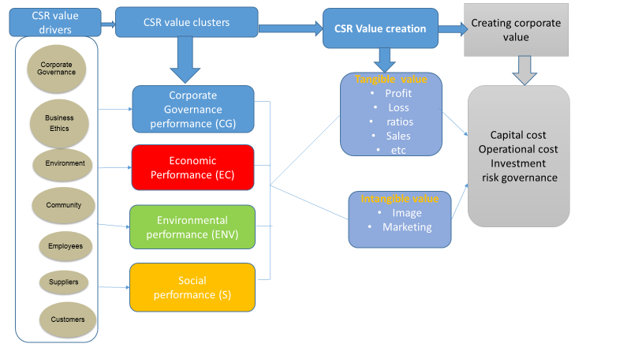
Figure 2.8 - CSR Conceptual Framework, Source: Author

Summary
The above chapter has taken the researcher to land into the knowledge, evolution, evaluation and perceptions of Corporate Social Responsibility definitions with their four groups of determinants. All the Corporate Social Responsibility definitions, in the last seven decades, more or less covered one or more of the above four groups’ determinants. This enabled the literature reviews of CSR to get all the CSR dimensions at a glimpse. However, it was not possible in this bounded part to involve all the definitions of CSR introduced in the last seven decades, but most of the main definitions have been included in this research.
The different studies also examined developed and developing countries including Western, Asian, Middle East and African Studies. This chapter focuses also on the difference kinds of the theories utilized to explain the behavior of the CSR.

Chapter 3: CSR Determinants

Introduction
Corporate social responsibility (CSR) is a subject matter that has gained more attention recently. This attention however, is essentially focused on the outcomes and values that are linked with CSR determinants. This chapter adds to the extensive academic literature by examining the CSR determinants. This chapter seeks to add to the argument on the corporate social responsibility (CSR) determinants and their influence on the firms’ financial performance in developed and developing countries in general and also in the United Arab Emirates specifically. It devoted to analyze the association among what motivate the organizations to implement the CSR practices and the importance given to voluntary CSR determinants. Based on a questionnaire and financial reports of 40 UAE publicly listed firms, this chapter focused on the determinants driving the CSR practices. The findings proved that the firms’ characteristics like corporate governance, Economic factors, Environment issues, Social tools, profitability, CSR Spending, financial indicators and firm size probably affecting the CSR determinants. In addition to the CSR determinants, this chapter explains the financial performance indicators used in this research such as: Price to Book Ratio (P/B), Return on Asset Ratio (ROA), Return to Equity Ratio (ROE), and Share Price Ratio (SP). The following chapter finally is examining the mediating variables used in this research such as CSR spending and firm size.

3.1 Extraction of CSR Determinants
CSR determinants will be considered as the Independent Variables of this research. However, CSR determinants has been discussed in so many studies examining the relationship among CSR and FP of the firms like (Cavaco & Crifo, 2010; Echave & Bhati, 2010; Hameed, 2010; Hussainey, et al., 2011; Youssef, 2011; Palmer, 2012; Tyagi, 2012; Zhang & GU, 2012; Aile & Bausys, 2013; Ghelli, 2013; Naser & Hassan, 2013; SajadiFar, 2013; Tronsgaard, 2014; Arshad, 2015; Chen, et al., 2015; Manchiraju & Rajgopal, 2015; Boztosun & Aksoylu, 2016; Lee, et al., 2016). While the CSR determinants used by them were differ from scholar to scholar but most of them have tackled the following determinants: Corporate Governance, Economic, Environment, Social, Legal, Philanthropic and Ethical. However, this research will consider only 4 determinants of CSR Independent Variables, i.e. Corporate Governance, Economic, Environment, Social. Inside each determinant of the previous one there are sub-categories including so many variables related to the group determinant itself. As pointed out in earlier chapters, weak operationalisation consider as the most important limit of CSR. How to measure CSR remains a challenge both due to the absence of consensus regarding the proposed initiatives for firms, and to its high level of desirability. The issue is not the agreement upon a specific intensity or level of such activity, but the real alternative of the viewpoints to be believed is that: if we care about the economic extent of CSR, how we are going to reflect it in the CSR measurement? Marquez & Fombru (2005) and McWilliams et al. (2005) claimed that the rapid increase of firms which standardise CSR practices of firms particularly in developed nations is usually disputed by academics. The basic problem with how to measure CSR is that they employ prestige as proxy for CSR initiatives. The truth competitions such method – Elron is a traditional viewpoint for the technique a firm highly used in the United States ranking about the social activities proved to be a cheating in recording such practices (through theft and misappropriation the managers of this firm in the energy field made one of the biggest losses to the US). These kinds of failures raise significant question marks about the best technique of how to measure the CSR practices. Very broadly speaking, global standardisations are disputed by firms themselves as decision makers’ know that these infrequently fit all the types of all the firms (Knox & Maklan, 2004). In spite of that, for the firm to be standardised or not (self-reporting) it will consider a biased as it involve either just a small part of the real state of issues (Zaharia & Grundey, 2011) or just positive perspectives (Moir, 2001). Some critics against CSR is that the CSR includes many practices which consider as a pure public relations techniques (Banerjee, 2007). How to measure impact of the society involvement is also a disputed side. Firstly, the long-run impact, about the participation of firms to CSR practices goals is very difficult to be measured because of the time frame (Barth et. al. 2007). Secondly, without a good arrangement between these endeavours towards obvious goals it is unlikely that these practices affect congruently and efficiently a society (Knox & Maklan, 2004). Thirdly, statistically there are literatures which measure perceptions, actions and attitudes of decision makers regarding CSR practices of firms. These analyses organize stocks of firms’ practices based on decision makers’ agreement with different practices of CSR (Maigan & Ferrel, 2000) or as reaction offered to all groups of stakeholder (Turker, 2009) and so proved theoretical differences. From one side, Maigan & Ferrel (2000) claimed that the practices established by American and French firms, regardless of the difference in the culture, are quantitatively mentioned in the Carroll’s pyramid model in 1991. Most of these practices are located at the bottom of the Carroll’s pyramid, the economic responsibilities. It is worth noting that the practices are associated at the four layers, to prove that the whole Carroll’s pyramid model reflects practices at all layers. Accordingly, Lindgreen et al. (2009) and Turker (2009) practically confirm the significance of differentiation of different groups of stakeholder: secondary and primary, (i.e. society, investors, consumers, clients, suppliers, partners, employees, etc.). One more important point is that the great variability in the CSR culture in between the nations. In this concern, Maigan (2001) revealed that customers from America, France and Germany enormously confirm other layers of Carroll’s pyramid model of CSR.

3.1.1 Corporate Governance (CG)
Lee et al. (2016) has claimed that authors widely opined that organizations are responsible extensively about the stakeholders that include more than just shareholders; it also includes the governmental units and Corporate Governance. Boztosun & Aksoylu (2016) has opined that big scandals of firm and economic crises have given rise to the notion of CG. Particularly, with the detaching of ownership from CG in firms, a conflict of “principle administrator” has come out. According to him, solving this conflict will be by targeting the CG. According to Eccles & Youmans (2015), Corporate Governance (CG) in general denotes the mechanisms, relations and processes by which firms are directed and controlled. CG rules and policies allocating the responsibilities and rights between numerous groups in the firms including (shareholders, stakeholders, managers, creditors, regulators, auditors and board of directors) and include the principles of taking resolutions in firm affairs. CG comprises the procedures through which firms' goals are established and adopted in the field of the market environment regulatory and social. CG processes involve controlling the decisions, practices, policies and actions of firms, influenced stakeholders, and their agents. CG initiatives are influenced by the desire of aligning the interests of stakeholders. Interests in the CG initiatives of emerged firms, especially which linked to responsibility, raised later on the big collapses of many big firms on 2002, most of which included bankruptcies; and then once more after the 2008 global financial crisis. Boztosun & Aksoylu (2016) claimed that the various forms of CG bankruptcies keep the political and public interest in the policies of CG. Like for example in the United States the First National Bank of Crestview, Highland Community Bank, Capitol City Bank and Trust, Doral Bank, Edge brook Bank, The Bank of Georgia and the Hometown National Bank who went bust in 2014 following financial scandals. Their disappearance was linked to the Sarbox in 2002, which was an American federal law that extended requirements for all American management and public boards of the company; for the purpose of get back the public confidence to the CG.
According to Cavaco & Crifo (2010), the CG initiatives include transparent compensation system of directors, respecting all the shareholders’ rights and finally encouraging the competent and independent auditors and administrators. Grant Thornton, the global 7th biggest professional services network company in the world confirmed that the CG includes a group of associations among the firm’s board, shareholders, management, and stakeholders. They have defined these associations as the following Figure 3.1.
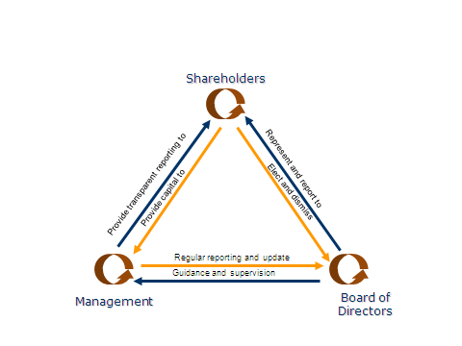
Figure 3.1.1 - Grant Thornton Corporate Governance associations

The previous figure illustrates how Grant Thornton Company perceives the CG. They claimed that CG consists of three steps as following: (1) the firm’s management has to provide transparent report to shareholders, in the same time the shareholders have to provide a capital to the management. (2) The shareholders have to elect and dismiss the board of directors, in the same time the board of directors have to represent and report to shareholders. (3) The board of directors have to guide and supervise the management, in the same time the management has to send an updated report to the board of directors. Cavaco & Crifo (2010) defined the CG determinant as the transparent compensation policy of directors, promotion of competent and independent auditors and administrators, and respect for stakeholders’ rights. On the other hand, Cavaco & Crifo (2010) mentioned a new term called “business behaviour” which is refers to organisations’ initiatives toward society, consumers and suppliers like incorporating CSR in the supply chain, providing information to customers, goods safety, corruption disclosures, prevent conflicts of interest, etc. In this research, the Corporate Governance independent variable tackled some sub-categories including Supplier, Customers, Employee and Product Characteristics as explained in the following part. Youssef (2011) confirmed that the study conducted and empirical results in last few years support the assumption of “it deserves to have good corporate governance.” It was noticed that about 85 percent of the universal investors are willing incur costs to purchase a well-governed firm over a firm considered weak -governed even it is with a high financial performance. The implementation of corporate governance initiatives - as a useful concern can increase the corporate value of the firms. Arthur Levitt, chairman of the United States Securities and Exchange Commission from 1993 to 2001, mentioned that “If a nation does not have a reputation for robust CG disclosures, assets will escape elsewhere. If investors are not completely certain about the level of CG practices, assets will escape elsewhere. If a nation opts for lax accounting and reporting standards, assets will escape elsewhere and then all projects will suffer from bad consequences”. Palmer (2012) defined the CG as the “framework of practices and rules by which a board of directors ensures transparency, fairness, and accountability in a firm's relationship with its stakeholders (community, government, employees, management, customers, and the financiers.)” CG applies to CSR because it is important that firms produce high-quality and comprehensive CSR reports. A firm’s CSR disclosures cannot affect FP if there is no advertisement of the CSR disclosures or CSR report in some form because people are not aware about CSR disclosures being adopted. For this purpose, completeness and transparency in CSR system or proper CG, is an integral part of a successful CSR system. Ghelli (2013) claimed that the strengths of CG activities are only two forms: public strengths and transparency strengths. Public strengths indicate the corporation’s support to those activities that have a distinguished effect on the customers, staff, communities or environment. Transparency strengths indicate the consumption of a corporation on its sustainability or CSR disclosures. According to Ghelli (2013) the CG practices are classified into four groups. The first group is transparency issue which is reflecting the transparency strengths; the second group is public policy issue which is evaluating whether there is any shortage in the public policies like regulations, mandates, or laws created by the government through a political system. The third group is CG structure disputes, which is assessing the seriousness of disputes taking into accounts the directors compensation system and CG system within the corporation. The fourth group is other disclosures which include all the other CG’s disputes. Lee et al. (2016) has made his empirical study about the governance structures and he analysed how stakeholders who have contractual agreements with organisations affect the financial performance of the organisation and how CG techniques can be enhanced by increasing the profit for the shareholders. Chatterjee (2016) claimed that, the best way to be involved in “Sustainability‟ is to push the firms to the CSR practices.

3.1.1a Employee
According to Delery & Doty, et al. (1996), the employees as the worker of a company play a fundamental role in the management and operation of the whole work. A group of theories and experimental studies claimed that the technique that the company use it to manage its worker have an impact on its financial output. It is known that the worker’s job satisfaction has a positive impact on job performance (Ruf, et al., 2001). Worker own behavior have the strength to affect the firm performance. According to Rupp, et al. (2006) the workers’ understanding to CSR will trigger behavioral, emotional and attitudinal reactions, for instance, Frooman (1999) claimed that workers may prevent other labor by striking. Better CSR responsibility on workers needs more spending on labor cost, which may negatively affect the corporate financial performance, however, workers will be motivated to spend more power into their works, which have a positive impact on corporate FP. Ghelli (2013) classified the employee relations into six determinants, for both issues and strengths. For the strengths: (1) Union relations: examine the firm’s evolutions in its relations with its unionized labor. (2) Cash profit sharing: measure whether the firm has a distinguished sharing program in terms of revenues so that it allows distributions to the most of its labor. (3) Employee involvement: which is measured by many techniques, like sharing in decision making, participating financial information, sharing profits and shares issues? (4) Safety and health strength: measure if the firm has an accredited safety and health programs. (5) Supply chain policies, programs and activities: measure a company’s rules and administration system used to control the labor and human rights of all consultants, contractors and suppliers. (6) Other strengths: examine all the labor relations’ concerns that are not included in the other strengths. According to Tyagi (2012), the firms’ operation depends on high quality employee relationships, which measured by loyalty and motivation of employees, maximize productivity and minimizing attrition rate. Globescan (2005) confirmed that the CSR is an important driver in retaining and attracting diverse and talented labor. Moon (2007) claimed that strong labor relationships can increase productivity with higher efforts and commitments attitude and can minimize absenteeism and attrition. According to Waddock & Graves (1997) and Berman et al. (1999), maximizing diversity between the labors indicates that the company is not restricted by gender or race in choosing the suitable employee for its jobs, that way, guiding it to hire the best employee. The international Oxfam organization that is devoted to create a fair humanity without poorness stated that “if works created by firms are distributed on fair terms with decent working situations, they can obtain advantages more than nominal financial increasing in revenues and wages”. Hussainey, et al. (2011) claimed that the human resource dimension involves social data for the purpose of the welfares of human resources. CSR initiatives involve retirement fund, job enrichment plans, working conditions, training programs and improvement practices. On the other hand, Cavaco & Crifo (2010) claimed that the human resource dimension involves respect for employee’s rights and responsible employee’s management like management of safety, removal of child labor, non-discrimination and respect for human rights standard. Lee et al. (2016) has claimed that authors widely opined that organizations are responsible extensively about the stakeholders that include more than just shareholders; it also includes the staff. According to BelalUddin et al. (2008), the firms are the primary source to generate employment opportunities for the society. Hence, the meaning of CSR to employees encroach just conditions and terms of the official agreement between the employee and the firm. Firms supposed to satisfy the employees’ expectations for their working condition quality. These expectations involve supporting their motivation and skills for the job, looking after of the employee’s safety and wellbeing at work. More than these advantages, CSR ensure an equal opportunities and medication for all its human resources, regardless of religion, race, age and gender. However, these variables including religion, race, age and gender will not be considered on this research for reasons that the questionnaire used is handling the firm’s services; it is not handling the stakeholders or employees demographic information; so that they are not related to this study. A summary of some the important studies is portrayed in the following table.
3.1.2 Economic
BelalUddin et al. (2008) claimed that the economic practices of CSR included the financial concerns and the profitability aspects of the firms. It composed of realising the economic effects of the firm’s operations. The economic practices have long been ignored in the research of the CSR. Quite the contrary, in fact it is underrepresented in the firm’s CSR agenda, and the least understood by those who is forming the CSR policies and regulations. The economic practices of CSR are usually wrongly thought to be equivalent with financial practices, in the sense that why it has been believed that it is easier to be adopted than both environment and social practices. None the less, the economic practices are not merely an issue of following up debts, employment situations and firms being financially responsible. The economic practices should rather focus in the indirect and direct economic effects of the firms on its stakeholders and on the surrounding society. That is what exactly formed economic practices of CSR. The economic practices of a firm has indirect and direct effects on all of its stakeholders like its suppliers, consumers, competitors, domestic governments, staff and the societies in which the firms operates. For instance: a successful economic practice leads to develop the workers and to improve the long-run operations. The workers of the firm get good wages, from which they pay taxation and buy products. These practices fuel the society’s initiatives, government agenda and the domestic industry. Firms consider the main contributors to the welfare of the society in all around area, like the domestic taxation. So that, the question posed: is it responsible for a firm to deal with the taxation as to be an avoided cost, instead of being a part of the economic contract with the community? Taxation has a fundamental effect on the formation and allocation of wealth: taxation evasion, although completely legal, prevents the society in the surrounding area from the welfare. A firm’s authorization to work relies on the support and trust of the domestic societies where it works. The transfer in capacity from being a private firm to be a public one asserts the significance of this trust, and its responsibilities and obligations that accompany with it. Some firm’s practices are most likely very harmful to the trust gained from the society or at least considered as economically irresponsible. These behaviors supposed to be cautiously considered or even avoided. An example of these destructive behaviors is taxation evasion, corruption, bribery and distribution of incentives and rewards of the firm’s performance to some employees only rather than equal allocation between the employees. The firm should also stop focusing on the economic impact of changes in operations and locations to the society.

3.1.2a Product Characteristics
According to Ghelli (2013) there are three determinants for the Product Characteristics; named (1) access to capital: which examines the positive effect of the products of the firm; (2) benefits for economic shortage: which measure the provision of products for the economic shortage; and (3) Quality: which examines the extent of the quality programs of firms. Ghelli (2013) also defined three issues in related to Product Characteristics; named (1) contracting/ marketing issue: which examines the extent of controversy that the firm afford in which related to their advertisement and marketing initiatives. Then it measures the extent of controversies linked to the firm’s anti-rival activities; (2) product safety: that examines the extent of the quality of the products; and (3) other issues.

3.1.2b Supplier
Zhang & GU (2012) defined the suppliers as some stakeholders who have a work agreement with the company and with specific financial risks. For example, a firm can change their suppliers regularly, but the long run agreement makes suppliers believe that they are safer. Another important concern for the suppliers is the receivable accounting time. Freeman (1994) revealed that if a firm deals with its supplier as a beneficial partner instead of being just a raw materials source, suppliers will try to reply respectfully when something bad happens to the firm. Suppliers also assist in the shaping of the price in the discount times and offers, and they can accept a late installments from the firm as well. Accordingly, socially responsible firms with suppliers will make the situation more flexible when the raw materials required, and it is expected that the CSR responsibility on suppliers to have a positive correlation with financial performance when the company operates in short run poor condition. Lee et al. (2016) has claimed that authors widely opined that organizations are responsible extensively about the stakeholders that include more than just shareholders; it also includes the suppliers.

3.1.2c Customer
According to Zhang & GU (2012) Consumers spend their money, effort and time to purchase any goods and services, and they are looking for an affordable price and high quality for the goods. Consumers maybe also consider the firm reputation, which is determined primarily by the CSR disclosures. Consumers are indirectly paying for development and innovation of goods, so they will be satisfied if the firm spends more money on goods warranty and R&D. Product quality and R&D program are a part in making considered decisions of CSR on consumers. The firm’s reputation has a strong impact on the consumers’ feelings for and perceptions of a company and a brand. Customer’s behaviors are very difficult; and many researchers like (Davis, (1975); Soloman & Hansen, (1985), McGuire, et al. (1988)) claimed that enhancing consumer’s behaviors considered as a fundamental result of CSR practices. It is expected that CSR on consumer will increase the profit and enhance the firm reputation. In return, it is very complex to measure how the CSR on consumer will affect the entire performance of the firm, as there are balances among the spending and the profits. On the other hand, Hussainey, et al. (2011) claimed that the CSR on consumer include product quality, consumer safety and health, consumer feedback, consumer satisfaction, etc. BelalUddin et al. (2008) confirmed that the point of dealing with consumers with attention and respect is not a new technique to management: Usually being responsible about the consumers has a positive direct impact on the firm’s revenues. There are wide social determinants like giving a high value for funds. These determinants involve some aspect like complete and clear data about potential consumers; high standards of trading and advertising; sufficient supply of commodities; courteous and quick attention to complaints and enquiries; after-sales or standard services and durability and safety of commodities.

3.1.2d Location of the Head Office
Also location of the listed firm’s head office consider as a very important determinant of the CSR. Many studies focused on the relationship between economic system and accounting system including (Cooke & Wallace, 1990; Doupnik & Salter, 1995; Salter, 1998; Williams, 1999). Previous studies revealed that the highly developed nations probably have a well advanced economic system than the less developed nations. This will be appeared on the level extent of reporting system. Firms listed on Abu Dhabi Financial Market and Dubai Financial Market are located in seven Emirates, and the level of economic advancement differ from Emirate to Emirate. Loughran & Schultz (2005) claimed that firms located in rural cities would be typically more invisible than firms located in urban cities; since urban cities more likely have many lobby groups, financial consultant, economic analysts, developed banking system, brokers and institutional investors. In the UAE, the most advanced cities are Dubai and Abu Dhabi, they also regarded as urban cities as about 70% of the total citizen of the UAE are working there with the highest standard of living as compared with the remaining five cities. In the other word, it is believed that the firms located in Dhabi and Abu Dhabi tend to provide more economic information to be less invisible to the community than the firms located in the other five cities. However this variable will not be used in this study as long as all the targeted firms are the publically listed firms in UAE and all of them are located in Dubai and Abu-Dhabi cities; so location itself will not be an effective variable to be tackled. In conclude, the location of the firm is important determinant, but this variable is not used in this research as long as all the firms’ sample are a publically listed firms and all of them are located in the most important cities in UAE, which is Abu-Dhabi and Dubai; so it was seen that there are no benefits of using such a variable. A summary of some the important studies is portrayed in the following table.

3.1.3 Environment
According to Lee et al. (2016), organizations with high productivity through CSR initiatives may be controlled and evaluated based on the environment practices.
According to Ghelli (2013) the environment is the enabler with the biggest number of indices. Some of these indices are strengths and some of them are weaknesses. For the strength, Ghelli (2013) explained three strengths; the first strength is beneficial products/services which measure a part of returns that is resulting from products and services that have any benefits to environment. Under this strength there are two sub-strengths which are recycling prevention and pollution prevention, where the firm is examined whether it has any effect on the air pollution and climate change, for instance, throughout the usage of renewable energy. The second strength is the system of management which examine the corporation’s management and monitoring of its environment disclosures. The third strength is called other concerns like regulatory problems which examines if a firm has ever trespass any policies of the environment. Ghelli (2013) also explained three weaknesses; the first weakness is the substantial emissions which examine the amountof emissions of toxic chemical. Under this weakness there is single sub-weakness under this point which is climate change that examines the level of disputes in the rules and regulations of the company. The second weakness is the negative impact of products and services, which examine the bad influence of the firm’s products and services on the environment like the non-carbon emissions levels and also the biodiversity & land use that is considering the usage of the natural resources. The third weakness is the other concerns. Booz Allen Hamilton Incorporation which is one of the biggest American management consulting incorporation in the field of security, technology and management carried out a questionnaire and found that about 70% of the directors of big firms deal with the environment concern as “extremely important” to their operation (Zhang & GU, 2012). It is very easy to grasp the significance of environment disclosure from an ethical concern; however some researchers propose an economic cause. According to Hart (1995), the increasing consciousness about the sustainability, product management, pollution protection and natural environment became an essential factor of competitive advantage. The power of a firm to manage its environment concern is regarded as a part of firms’ capability. Fineman & Clarke (1996) claimed that the firms should regard the environment concern in their entire action plan. Judge & Douglus (1998) confirmed that there are a couple of causes for companies to regard the environment concern as a key issue. The first cause is that the environment enablers consider as a threat to the cost reduction procedure for the most of the companies. Sometimes the governmental policies toward the environment issues push the companies to increase their awareness toward environment issue. For instance, some forms of vehicles getting foreclosed or when the exhaust emissions standard improved, so vehicles companies have to minimise their emission to adapt to the governmental policies. The second cause is that the environment enablers will lead to new fruitful opportunities. A research proves that the customers are capable to spend about 7% for Eco-friendly commodities. Another studies claimed that appropriate formed environment policies may urge companies to generate and innovate new businesses (Zhang & GU, 2012). The mentioned debate alludes to a positive correlation among environment CSR enablers and FP. On the other hand, the positive correlation results will appear in a long-run period of time, so far in short-run surpassed spending on environment disclosures may lead to a negative relationship on FP. Palmer (2012) claimed that the environment enablers include something called a sustainability programs which include clean energy, recycling, pollution prevention and sustainable commodities. He presumed that the sustainability enablers are depending on a one rule which is maximizing sustainability and minimizing the environment footprint of the operations of the firms. He asked at the end of his research named “CSR and FP: Does it Pay to Be Good?”, that the term “Corporate Social Responsibility” supposed to be replaced by the term “corporate shared value” for the purpose of strengthen the sustainability program and to remove any negative feature. Hussainey, et al. (2011) defined the environment as those enablers explain the firms’ practices related to the environment. These practices including adopting the environment tools, complying with the environment act and endeavours to minimise emissions of chemicals into the water or air. Hussainey, et al. (2011) handle in his research an example about the Egyptian Ministry of Environment that acquired an approval from the main stakeholders to implement the EU Emission Standards for new cars starting from 2002. Consequently, Ministry of Environment recently established new policies regarding the limits of emission for cars and motors. Cavaco & Crifo (2010) defined the environment enablers as integrating the environment disclosures into the design, production and distribution of commodities: management of transportation impacts on environment, management of domestic pollution, management of waste, management of Biological diversity, minimising of water consumption, controlling and preventing pollution, etc. BelalUddin et al. (2008) claimed that the environment enablers are the main hub of the CSR. Environment concerns have been a fundamental area of the debate for the past 30 years in the management field which is the greatest time of all the enablers of CSR. The issues and knowledge of the enablers have evolved throughout the variation of businesses facts. Environment enablers started to be considered in the seventies of the last century with the first actual understanding of the environment enablers of CSR. However, in the current century, the company is facing new challenges. According to BelalUddin et al. (2008) the company’s initiatives have many tools of influences on the environment. Commonly the impact of environment indicates the negative impact happened in the natural environment of surrounds due to operations of business. Such effects involve: clearing, climate change, biological diversity, pollution, non-renewable resources of energy, overuse of natural etc. To comply with the direction of environment CSR disclosure, firms can adopt the next procedures: identifying the impact of environment: which can be measured by so many techniques like cradle-to-grave analysis & ecological footprint, product input per unit calculations, and environment input-output Models etc. Cradle-to-grave analysis is used to examine the environment influence of the products life stages from cradle to grave, in the sense that, starting from extraction the raw material through processing like manufacturing, distributing, consuming, maintenance and repair, then recycling or disposal. ISO standards confirmed that, a cradle to grave analysis is conducted in 4 different stages as shown in the following Figure 3.2. The stages are often connected in that the findings of any stage will guide how other stages will behave.
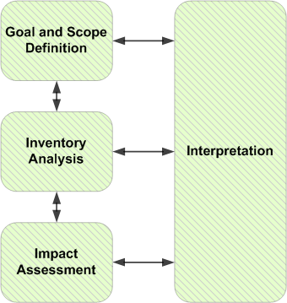
Figure 3.1.3 – Stages of conducting Cradle-to-grave analysis

Ecological footprint is an assessing of human effect on the ecosystem of the Earth. It's usually calculated in the quantity of natural capital used annually or by the wilderness area. The widespread technique to calculate footprint is to measure the wilderness area of both sea and land that needed to provide resources to a human beings; including the places of wilderness of assimilating the human being waste. Globally, it is aimed to measure how fast the human beings are consuming natural capital. The international ecological footprint is measured by the International Footprint Network from United Nations information. The initial estimation in 2007 proved that the human beings have been consuming natural capital 2 times as rapid as planet can renew it. On the other hand, the product input per unit calculations is measured by taking the ratio between the quantity of material the product causes to shift to the amount of value its brings. An input–output tool is a quantitative financial table that shows the linkage among different regional economies or different branches of a national economy (BelalUddin et al., 2008). If the firms seriously would like to be bounded to the environment disclosures, it should modify its classical way of business to the direction of environmentally more responsible one. An environmentally oriented business should regard some concerns like active discussion with the firm’s stakeholders, pollution-free manufacturing and increasing resource productivity. A lot of firms came to know that implementing environment CSR disclosures is the best choice for distinguished environment output. Many firms came to know that promoting environment disclosures will lead to increase the benefit of the firm. Streamlining procedures and reducing the materials used to reduce the waste will reduce the costs of business extensively. Furthermore, the close evaluation to the business that is required to enhance the environment management system may lead to another improvement like material management and risk reduction. According to BelalUddin et al., (2008), the general image of CSR can attract more consumers; these types of investments and improvements are usually considered as win to win relationships for both the FP of the firm and for the environment. The win to win relationship between the environment and FP of the firm has been founded many years ago, and lately in 2012 the European environment policy has been recognized in the Sixth Environment Action Program. The program elucidates, how the EU countries can achieve their role in helping firms to determine the emerging alternatives and achieve win to win operations, the Environment Action Program also put some other measurements including: set out of global, but harmonized, firm environment reward program that promote voluntary contracts and commitments, determine the best performance and establishing a compliance support program to guide the firms to realize the environment needs of the EU countries (Mansour, 2017). Lee, et al. (2016) opined that if an organization is involved in CSR activities, the organization may have easier access to the data external environment. This data will be valuable for the managers to acquire self-interested behavior of managers. According to Curran (2005), if the firms would like to minimize their effect on the environment, they can develop certain system about the management of the environment to help them in stocktaking their manufacturing operation and trying the best towards minimizing pollution. He has provided two systems where firms can adopted and for which they can got accreditation: The ISO 14000 and the Eco-Management. The Institution of the European Union implemented Eco-Management system in the beginning of the nineties, to allow voluntary involvement in the management of the environment, depend on harmonized standard of the EU. It was basically formed to firms in manufacturing fields working in the EU. The overall goal of the environment Management system is to enhance continuous environment performance developments of economic initiatives by obligating firms to offer related data to the citizens and to estimate the performance of the environment. The environment Management system did not eliminate the firm's CSR to fulfill all of its legal commitments nor did not change current technical standards or country environment legislation. A flower and Eco-label from the European Union (EU) is awarded to goods that minimized environment pollution. Criteria are placed for single goods like detergents, textiles, paper products and electronics and electrical like dishwashers and refrigerators. European Union Council (2003) articulated that when the customer found goods with the eco-label, he will know that these goods have been cautiously examined and have been produced to reduce the environment pollution than the similar goods from the rivals, or from the goods that misleading environment impacts on them. On the other hand, another award launched in 1991 in United Kingdom called the Investors in People offers the best initiative for the public management standard, providing accreditation to firms that stick to the Investors in People criteria which is high standard of human resource management (Mansour, 2015). Lee et al. (2016) has claimed that authors widely opined that organizations are responsible extensively about the stakeholders that include more than just shareholders; it also includes governmental issues.

3.1.3a Environmental practices in UAE
According to SajadiFar (2013), the World Wildlife Fund organization for Nature (2008) stated that the United Arab Emirates has the greatest amount of greenhouse gas emissions per person globally, and this is essentially due to the massive demands for aluminum smelting plants, purifying water from salts, using air conditioning and so the massive demands for the fossil fuels. The environment management of the United Arab Emirates is not advanced enough in CSR concerns. United Arab Emirates (2008) year book claimed that the UAE has the largest amount globally of the following: (1) carbon footprint, Brik (2009) presumed that the hotels in UAE consume double amount more likely carbon footprint than the same hotels in EU, which is about 14 tons per year per capita. (2) Solid waste: Dubai consume double amount more likely solid waste per person in UK, which is about 300 kg per person. (3) Industrial and commercial power consumption: this reaches to 55 percent of total energy consumed in Dubai. (4) Other Power consumption: Hotels consume double amount as much power as in EU. (5) Water consumption. However, there are a lot of firms in United Arab Emirates trying to minimize their negative influence on the environment, like DLA Piper, ENOC, TNT, etc. Emirates Environment Group is a non-governmental professional working group founded in early nineties in Dubai devotes to protect the environment through the techniques of society participation, action programs and education. It is a firm that is inspiring respect and admiration and having high status in the Middle East and distinguished itself on its environment contributions. It is also a member of the International Union for Conservation of Nature and Natural Resources. It is a party that has signed an agreement with the United Nations Global Compact and considered as a key point of the Global Compact in the Gulf Cooperation Council countries. It is the first environment non-governmental organizations given ISO 14001 globally and the only firm in the United Arab Emirates with accredited certificate to the UN Environment Program and the UN Convention to Combat Desertification. Interestingly, the UAE Ministry of Environment and Water has classified the Emirati’s firms to the most environment friendly firms. Similarly, the Environment Performance Card is a certificate given by the Ministry of Environment and Water to enterprises that are wholeheartedly dedicated to environment policies of UAE, the ministry has embarked on the execute of environment performance card on 2009 as one of the actions of its strategic goal (Mansour, 2016). Dr. Rashid Ahmed bin Fahd, the Emirati’s Minister of Environment and Water, has declared a 100-mark Environment Performance Card certificate yearly to choose the firms’ dedication to environment, safety and health regulations. In Khaleej Times (a local newspaper) dated 18 June 2009, Dr. Fahd announced that, “The chance is now exist for about 4,500 firms under different sectors to voluntarily look for local accreditation for their environment performance” (Khaleej Times, 2009). According to SajadiFar (2013), this initiative aim to promote the notion of saving raw materials and energy, minimize the carbon footprint and maximize sustainability. The Ministry of Climate Change and Environment mentioned that the sustainability has many pros both environmentally and economically, like it enhances the environment quality, minimizes the level of risks of manufacturing accidents and minimize the level of pollution. Likewise, it minimizes the costs of providing raw materials and energy and the costs of the waste disposal. Under the orders of the President of the United Arab Emirates, His Highness Sheikh Khalifa Bin Zayed Al Nahyan, issued certain policies and regulations in 2005 about the management of the waste. SajadiFar (2013) claimed that there are many public and private firms in the United Arab Emirates who adopt environment practices and check its own environment impact. Nevertheless, more initiatives should be implemented to ensure that all entities in the UAE implement the environment CSR disclosures. Lyon & Maxwell (2008) listed the enablers that urge firms to include the environment disclosures. They mentioned that “Maybe pollution is a result of inefficiency production but with reduction of the cost and reduction of pollution they will reach the win to win relationship”. However, with the universal’s consciousness now about global warming, consumers in the United Arab Emirates, like other nations prefer to “go green” and incur costs to use green commodities and companies are aware about this and comply accordingly. Other reasons that push companies to show interest about the environment concern is reduction of the cost. A successful execution and establishment of corporate social responsibility will create a positive perception between stakeholders and the market. SajadiFar (2013) claimed that to get better CSR scores is not only because morality, it is also joined with a long-run financial profit. Similarly, it has a clear impact in developing, motivating, and keeping talent in current’s challenges of the resources, like the human resources “war for talent”.
Finally, the information presented in this section will be highly considerable in this research questionnaire that will be used to gather the primary data; as the pollution in the UAE is one of the most important issues regarded by the government and by the awareness of the population themselves. A summary of some the important studies is portrayed in the following table.
3.1.4 Social
Social determinants are getting additional attention than it has earlier had and it is the most recent of the all determinants of CSR. Many firms are being more energetic in handling social practices. Social determinants means becoming responsible for the directly and indirectly social impacts the firms has on citizens. Social determinants involves the whole of stakeholder, the employee inside the firm, consumers of the firm, the society the firm is in and the supply chain of the firm. Social determinants mean the decision makers’ commitment make decisions and take choices that will add to the interests and welfare of community in addition to those of the firm (BelalUddin, 2008). According to Palmer (2012), the successful social determinants include product safety activities, employee relations, diversity, human rights and community. Social determinants can be achieved through firm philanthropy and cause-related marketing. Firm philanthropy is when a firm pays a direct donation to a cause or a charity. An example of a very successful firm philanthropy is Kroger Company which is the biggest grocery chain in United States, as it donates with 10% of its total revenues which is about 64,000,000 US dollar to charity’s projects. Kroger Company donates with millions of dollars yearly to support nonprofit firms, religious firms, hospitals, medical research and education. Cause-related marketing is defined as a firm’s obligations to make a donation as proportion of profits for a certain reason based on commodities sales and typically includes a firm partnering with nonprofit firms. It is believed that these activities can build a mutual successful relationship between the firm and the nonprofit firms as it creates a financial support and additional sales of commodities for the nonprofit firms. An example of a very successful cause-related marketing program is a campaign established in 2015 by an American Food Manufacturer Company called General Mills in United States to increase the awareness to enhance the battle against breast cancer disease. In this campaign which called “Yoplait”, the consumers must buy Yoplait yogurt and then gather the pink covers of the yogurt bottle then send these covers to General Mills Company which will donate 10 cents per cover to Susan Komen organization of the breast cancer disease. Other social activities include product safety practices, diversity, workers relations and human rights. Product safety practices used to ensure whether the commodities are safe to use. Diversity practices include activities to maximize the minority and women existence in the firm, including maximizing their existence on the executive board. Workers relations practices include having robust benefit programs, robust health programs and strong union relations. Firms with robust human rights practices make certain of a double-way communication among managers, consumers and workers. Moreover, the firms do not break such rights as fairness, equality, privacy and young labor (Palmer, 2012).

3.1.4a Community
Community development and involvement is one of the fundamental determinants of CSR. Lee (2008) defined the community as a group of citizen who share a common and similar principle, who are not depending on another and seek to achieve specific demands. CSR definition also indicates the importance for the firm to participate in the society and community in which they are operate, and so the CSR consider as a precious opportunity for the firms to contribute positively to the community and to become socially responsible. Many firms in United Arab Emirates have joined the wave of CSR for the purpose of building community relations, fulfill their interests, involve them, engage them and develop them. SajadiFar (2013) mentioned examples for community practices such as show interest toward suppliers and consumers and also develop a network around all the stakeholders and show concerns toward employees.
Zhang & GU (2012) defined the community as a group of stakeholder little bit complex to be exactly determined. In this research, when ones say the theme “community”, it refers to the entire society including even the government. Firms have a commitment to act as a good entity, participate in community’s initiatives, pays taxation to government and to comply with regulations and laws. Freeman (1994) claimed that community and firm depend on each other, and when the firm misunderstand this relationship, the firm will make itself as an entity which commits a crime. On the other hand, handling duties for the government consider as an elective choice for firms. For example, the Unite states law of taxation states that a firm may choose to pay out more on charity for the purpose of avoiding taxation officially. Firms who consume more money on charity or other types of community initiatives probably improve their reputation. Consequently, many studies like (Zhang & GU, 2012) confirmed that better CSR practices on community may lead to improve the firm’s financial performance.
Hussainey, et al. (2011) mentioned some community determinants like safety, cultural initiatives, health, sponsoring sport, education and human rights, charitable donations, stop the kids labour and non-discrimination in genders or in colours. On the other hand Ghelli (2013) mentioned four determinants including: (1) Community involvement which measures the level of engagement of a firm with its society. (2) Innovative involvement: which measure the donation to non-governmental organizations; particularly at least 25% of firm’s profit should be donated to have a high rating in this determinant. (3) Charitable giving: which measure the level of how much a firm donated to charity. (4) Other determinants: measure the outstandingly donation in distinguished programs or carry out remarkably positive community initiatives. Conversely, Ghelli (2013) also commented on the negative impact of economic determinants, which is every operation from the firm affecting the social in a negative way. On the other hand, BelalUddin (2008) mentioned the community as one of the main social determinants of CSR for a firm. According to him, Firms rely on the prosperity, stability, and health of the communities where they operate. Usually most of the firm’s workers and consumers come from the nearby community – especially for small to medium-sized firms. The image of a firm as an actor in the domestic area, its image as a producer and an employer, its reputation at its location, definitely affects its competitiveness. Several firms become involved in society activities like donations to charitable initiatives, partnerships with charitable entities, sponsoring cultural activities and domestic sports, hiring socially excluded citizen, and providing extra professional training areas.
Lee et al. (2016) has claimed that authors widely opined that organizations are responsible extensively about the stakeholders that include more than just shareholders; it also includes the communities and social entities.

3.1.4b Ownership Structure
Ownership type is not predominantly examined in earlier CSR studies. For instance, Secci (2005) claimed that firms managed by the Italian government are disclosing fewer amounts of CSR disclosures than others. Adams & McNicholas (2007) also examined the relationship among ownership structure and CSR practices; and they claimed that the integrity, honesty and personal perspective of the decision makers are undoubtedly influencing the desired level of accountability and the reporting nature. Thus, in their research, where shareholders’ wealth maximization was not a driver, the issues affecting CSR is actually differ from those issues mentioned in Adams (2002). Tuominen et al. (2008) also have reached the same findings in their study about the forest industry in Finland; they claimed that public limited firms disclosed more detailed information than other firms. Kotonen (2009) confirmed that firms deal with CSR as behavior to deal responsibly towards CSR reporting and their stakeholders as a response toward stakeholders' demands and expectations. The insight gained from the research is that the, it is expected that the private firms which is not owned by government to disclose more CSR information than the public firms which is owned by government. Elsayed & Hoque (2010) claimed that the private firms do not affect the voluntary information disclosure, while only public firms negatively affect the voluntary information disclosure. On the other hand, Naser & Hassan (2013) has made a robust study about the UAE’s industry; and he claimed that many of the publically listed firms in Abu-Dhabi financial market were at the beginning initiated as governmental firms and then privatized to stimulate the private sector role in forming the UAE’s economy. Decision makers of these firms may choose to share more CSR information for the purpose of attracting investments and to prove that they are working in line with environment’s preference, and so, promoting transparency and legitimizing their initiatives and existence. Government ownership has an impact over the relationship among shareholders (principals) and (managers) agents. Eng & Mak (2003) claimed that due to the dispute among customer’s expectations and firm’s objectives, shareholders’ communication with firms has been increased under the government ownership. According to Naser et al. (2006), in a nation like the United Arab Emirates where labour unions are not available, firms with big amount of stocks owned by the government are more likely to provide welfare, retirement programs and training programs to improve the employees’ working conditions. In addition to that, such firms are mostly documenting CSR information in its financial statements to present its role in community and to show itself as a role model for the other organizations. Empirical evidence about the association among the ownership type and the disclosure of CSR information is still misleading. Ghazali & Weetman (2006) have made a study over a sample of Malaysian firms and they claimed that there are a very weak association among ownership type and voluntary information disclosure. Naser et al. (2006) also has reached the same findings of a weak association among ownership type and voluntary information disclosure but in a sample of Qatari firms. On the other hand Eng & Mak (2003) claimed that there are a positive and a strong association among ownership type and voluntary information disclosure in a sample of Singaporean firms. Also Ghazali (2007) has reached the same findings of a positive and strong association among ownership type and voluntary information disclosure but in a sample of Malaysian firms.
In conclude, the ownership structure will not be used in this research as long as the targeted firms are the publically listed firms in the Emirati stock exchange market. As the topic of this research is regarding the Corporate Social Responsibility that means the CSR is always private there is no Governmental firms. However, there are one question in the questionnaire of this research asking about the firm structure whether it is public, private or charity; such a question has been put because some of the firms deemed to be private however, it is owned by the government or some of them are semi-governmental firms; this is one difference between the stock exchange in this area and elsewhere in the world.

3.1.4c Philanthropy
Firms’ philanthropy practices are defined as the financial assistance that the firms give to social activities and charities. However, philanthropy does not mean only a financial support. Firms can aid the community by contributing their expertise and time. Many firms have some programs to promote philanthropy like providing financial support to the projects for the needy citizens, participating in job fairs, also providing training and workshops to fresh graduates and pupils, and to also develop a youth profession. For instance in constructing a charitable hospital for deprived people, many firms can support the project by providing their expertise and time. Many firms like interior designs, contractors, constructors, architectures and so on can participate in these social charity initiatives by giving their services. Some examples of the philanthropy support from firms are (1) asking workers on the project and pay them normal wages, (2) launching “Employee Volunteering Program”. Studies proved that the community volunteerism is very beneficial to the society. Forming a group of people came from different perspectives, backgrounds and ethnicity to minimise the stereotypes. Volunteers have also proved that they enhance the academic success of the students. Eyler & Giles (1999) confirmed that involving person into serving others and into service learning has a good effect in both personal and academic fields. According to them there are many reasons help the person to improve relational skills and teamwork like for example support the youth to find people that they relate to, also to maximize appreciation of other cultures, and to teach the person how to work together as a group which will minimize stereotypes. Eyler & Giles (1999) also confirmed that at the end and beginning of each semester in the university, the pupils participated in service-learning programs and so they said that the most important issues that they had learned from the university is to appreciate all the types of people, and to not judge others as everybody has his own different characteristics. Volunteers of the society proved that they are a powerful predictor in university experience and pupils' academic life in general. According to Astin (1992), the pupils who participate in society volunteer in their university have more desire to complete their degree. Example of the philanthropic initiatives is Shell Company. It launched a program for a fuel efficiency challenge to satisfy the deficit in energy for pupils to acquire knowledge in the new innovation and in technology and to grasp the experimental experience. The program target is to have and to make studies on energy efficient machines. The company assigned 4 pupils to participate environment friendly marathon in Germany in 2009, where the international competition aimed to design a car that crossed longer distance with lowest fuel consumption (shell.com, 2010). According to ibid (2010), the Shell company has launched a scholarship programs in collaboration with Higher education for talented pupils who have no sufficient money for higher educations.
Another example for philanthropic initiatives is the community welfare program that was launched by Tetra Pak Company for the purpose of donating the charity for technical and educational workshops. Yawar (2009) claimed that the Tetra Pak Company launched a society development program by offering Vocational Education and Technical Training to create a new opportunities of job for the purpose of economic development of the country, and to improve the skills of the workers. In 2007, the Pakistani branch of Tetra Pak Company has donated by 5 million euro to Lahore University of Management and Science for the purposes of improving the Pakistani educational infrastructure.

3.1.4d Ethics
Curran (2005) claimed that as firm becomes globalized, industry relationship, educational institutions, governments and interest groups are urging firms to invest in behaviors basics to show their codes of conduct. LPA (2003) defined the codes of conduct as an official behavior of the business practices and values of a firm; which can be a short-run documents or long-run statement that needs complying with international terms. According to (SA8000 Standard, 2014), a new auditable standard named “Social Accountability standard - SA 8000” has been introduced to urge the firms to apply, maintain, and develop socially responsible activities in the place where the employee work. It was incorporated in the end of nineties by Social Accountability International in the USA, where the board members made up of civil society firms, non-governmental organizations and trade unions. SA8000 facilitate the complications of following up codes of conducts and industry to build up a widespread standard and language to measure the ethical commitment. As it can be implemented widely to any firm in any field, it is a very valuable mechanism in verifying, measuring and comparing ethical commitment in the workplace. Firms adopt a SA 8000 to acquire an accreditation. According to Curran (2005), SA8000 was founded based on two quality management systems standards these are ISO9000 and ISO14000. It was formed to be the first auditable international standard for firms looking for warranty for the fundamental rights of employees. It was depend on the UN conference on the Rights of the kid, twelve International Worker Institution conferences and UN Universal Declaration of Human Rights. SA 8000 handles 9 fundamental fields where firms should respond to its own perspectives and to pertinent local legislation; like management disclosures, compensation, working time, disciplinary disclosures, safety and health, freedom of participation, forced labor and child worker and freedom from discrimination. It also needs a huge transparency, in the sense that, workers reports about the firms. The second auditable standard designed by the Social and Ethical Accountability Institution in the United Kingdom named AA1000 which devoted to enhance auditing by a procedures of stakeholder involvement.
It offers a model for a firm to respond, identify and prioritize to its social responsibility disclosures and help them to become more sustainable, accountable and responsible. AA1000 provide a functional advice on stakeholder involvement and sustainability disclosures, in addition to handle fields regarding firm’s strategy, governance, and business frameworks. The standard was basically formed to reduce the amount of carbon and to acquire a green economy, as well as supporting integrated assurance and reporting. It was build up from a prolonged consultation with many stakeholders to make sure that it was designed for those they have influence, not just those who get benefits from them. AA1000 are adopted by many civil and governmental entities, SME, multinational firms and a wide series of firms (aa1000, 2016).
Valuable auditable system is very tough to be achieved as firms faced many challenges; moreover, stakeholders’ requirements are very high, and usually contradict with each other (Curran, 2005). The third standard is the United Nations Global Compact which was designed sixteen years ago. It is practices used to hearten the firms internationally to implement socially responsible and sustainable standards and to document their achievement. It is a principle-based approach for firms, based on 10 rules in the fields of anti-corruption, environment issues, worker Standards and human rights. By implementing this standard the firms are brought together with civil community, United Nation institutions and labors (UN Global compact, 2014). The fourth and the last standard called the Sullivan standards which are consisting of two codes of conduct; it was designed by an African scholars called Reverend Leon Sullivan and Kofi Annan the United Nations Secretary General, to enhance the CSR. The Sullivan principle originally was designed in mid-seventies of the last century to put financial pressure on South Africa to protest against the racism. Shortly thereafter, the standard acquired a high reputation in between American firms. Then the new International Sullivan standards were launched in nineties of the last century. The new design of Sullivan principle was formed to activate the participation of firms in the fields of social justice and human rights at the global level (Global Sullivan Principles, 2016).
A summary of some the important studies is portrayed in the following table.
3.2 Financial Performance Ratios
Pour et al. (2014) presumed that the contemporary notion of CSR has progressed in the last century in the fifties, formalized in the sixties and proliferated in the seventies. Depending on many research about the CSR and FP literature like (Hart, 1995; Carroll, 1999; Holme & Watts, 2000; McWilliams & Siegel, 2001; Tsoutsoura, 2004; Engardio et al., 2007; Nicolau, 2008), CSR generally refers to the initiatives making firms’ good employees who add to community’s well-being in addition to their own welfare. Tyagi (2012) confirmed that the effect of CSR on the FP of a firm has been defined as the ‘enlightened owner method’ which proposed that the decision-makers of the firm must consider some environment and social initiatives in order to enlarge long-run financial performance. According to Smith (1996), there are an inadequate data about the practical research in which it is really implemented, However, Foohey (2004); Brammer et al. (2006); Porter & Kramer (2006); Campbell & Slack (2008) confirmed that these practices are still very poor. On the other hand, a study of Bakker-de et al. (2005) proved that specialized study fields like firm philanthropy, firm citizenship and issue management have progressed over the time from being vague concepts to be theory-testing and to be more clarified. So far, Griffin & Mahon (1997) and Ullmann (1985); claimed that the CSR studies have been criticized of having loose and fast notions. According to Bourguignon (1995) the financial performance (FP) is referred to the achievement of the firm’s goals, or as Niculescu (2003) define it as being both efficient and productive. Lorino (2004) also defined the FP as everything can improve both the cost and the value and not only things contribute to increase the value or decrease the cost. Likewise, Dorina et al. (2012) claimed that the firms should always show their financial and economic performance to their society. According to Tatiana & Marioara (2012) the FP measurement is very important to ensure the firm’s progress. Boaventura et al. (2012) claimed that the parameter of financial performance is measured usually by many tools like return on assets, Tobin Q, contribution margin, return on sales, sales growth, return on equity, etc., which will be discussed later in more details in the current chapter. On the other hand, the CSR has been defined by many institutions, firms and scholars differently due to the wider nature of dimension. Consequently, the Parliamentary Joint Committee on corporations and financial services has defined CSR as “the firm balancing, managing and considering the environment, social and economic influence of its practices”. Brine et al. (2007) recommend many issues to urge the firms to be involved in CSR like: minimizing the cost, retaining the talented workers, risk management, government support and consumers’ patronage. This section discusses the relationship among CSR and FP, it also will identify how the financial performance ratios have been selected and performed.
Several studies have attempted to investigate the relationship between CSR activities and financial performance of businesses. It is well known the fact that the financial performance is measured using a variety of quantitative and qualitative metrics. Quantitative measure are normally based on the firm increases in sales, market shares and assets, turnover returns, equity returns, liquidity conditions, decrease in debts and market value. Qualitative metrics are based on how sociality the firms’ executives perceive their performance. Several studies have attempted to investigate the relationship between CSR activities and financial performance of businesses. The idea of linking CSR to economic performance of firms is not new. The discussion in the literatures focuses mainly on the aspect of CSR cost and revenue implications from CSR activities. However, recently the focus has shifted to investment returns carried out under the ethos of environment. This is mainly due to the fact investors are demanding ethical investment products. This support the view that firms that value CSR will increase demand for their services or products (Margolis et al., 2007). For example, it is well argued in the literature that investment in human resources results in better performance as a consequence of employee empowerment and motivation (Becchetti et al., 2008). Giving back to the community (through charitable initiatives) is associated mainly with cost but in reality the intangible benefits, e.g., reputational benefits, that may be generated from such activities occurs through increased demand for the firm services/product and attraction of talented human capital. The impact of governance practices of firms is well documented in literature. There is no doubt that the profitability of a firm is directly associated with the ethical governance practices of a firm. The majority of studies in this area have tested the linear relationship between CSR activities and a firm financial performance. For example, Orlitzky et al. (2003) used accounting indicators to study the relationship between CSR and a firm financial performance. The authors reported that the CSR activities are likely to lead a better financial performance of the enterprise. This finding is confirmed by the Margolis et al. (2007) who articulated the positive relationship between financial performance and CSR activities. Hart & Ahuja (1996) investigated the relationship between CSR environment measures and return on assets. The authors found a positive relationship. This positive relationship is also reported by Russo & Fouts (1997). The authors suggested that this type of relationship is more prominent in high growth industries. However, a study by Wagner et al. (2002) reported a negative relationship between CSR environment initiatives and the firm financial performance. Van der Laan et al. (2008) conducted an investigation to measure the impact of CSR activities on earnings per share and return on assets. The study concluded that with the exception of CSR environment activities, CSR practices of the studied firms have no impact on the two financial measures. The argument posed in this study is that incorporating CSR activities in the firm core business operational activities might be associated with higher/lower financial performance. This study tentatively selects earnings per share and return on assets as profitability measure. These two will be used as dependent variables. The study also recognises that there are other factors that contribute to the variability of a firm financial performance. Several factors have reported in the literature. For example, sector of industry, firm size, firm growth, retained earnings, R&D, dividend, etc. as control variables. This study will use some of this control variable to moderate the relationship between CSR activities and financial performance.
This study will use quantitative measures, based on the questionnaire on the publically listed firms in UAE. Many studies used profitability to identify changes in the level of CSR practices like (Singhvi, 1968; Singhvi & Desai, 1971; McNally et al., 1982; Malone et al., 1993; Wallace et al., 1994; Meek et al., 1995; Raffournier, 1995; Wallace & Naser, 1995; Inchausti, 1997; Owusu-Ansah, 1998; Tower et al., 1999; Camfferman & Cooke, 2002; Naser et al., 2002; Glaum & Street, 2003; Prencipe, 2004; Akhtaruddin, 2005; Barako, 2006, Al Shammari, 2008; Hossain & Hammami, 2009; Othman et al., 2009; Aly et al., 2010; Ali, 2011; Galani et al., 2011; Javed, 2012; Rehman, 2012).
Juhmani (2014) has used legitimacy theory to determine five factors links the CSR to the FP, one of these factors is the profitability. He claimed that the logical basis for the effect of profitability on philanthropic CSR is very clear. Firm with high profits has motivation to differentiate itself from firms with low profits so as to increase capital on the best obtainable conditions. According to legitimacy theory, firms are bounded to a tacit contract with the community where they work. Failure to respond to their legality will threaten firms’ survival and performances. Accordingly, firms with high profits supposed to reveal more information than firms with low profits (Deegan et al. 2002). The relationship among profitability and CSR practices has been tackled in many empirical studies like (Janggu et al., 2007; Smith et al., 2007; Akrout & Othman, 2013). On the other hand, Cormier & Magnan (2004) mentioned a poor relationship among profitability and CSR practices, however (Connelly & Limpaphayon, 2004; Smith et al., 2007; Rahman et al., 2010) claimed that there is no significance at all among profitability and CSR practices.
Naser & Hassan (2013) claimed that profitability is one of the most important drivers that have been usually used in the literature to identify the level of CSR practices. Profitability of the firm gives signal about the professionality of decision makers. It is very favorable to see firms with high profits disclosing much information for the purpose of attracting more consumers to their products in order to focus on the effectiveness of management. Firms with high profits have positive impact on the consumers. It is, consequently, known to firms of high profits to declare more information than the firms of low profits. Even though, there are many firms suffering from a loss while they are declaring much information in order to identify how they are going to correct it and what went wrong.
Many studies examined the relationship among profitability and CSR practices and they came up with mixed findings. Bowman & Haire (1976) and Preston (1978) claimed that there is a positive correlation among the profitability and CSR practices. Their findings drawn from the premise that CSR practices encourage an adaptive resource management method in firms and aid them improve their capability to work in a multidimensional and dynamic society. Roberts (1992) also claimed that there is a positive association among profits and CSR practices. However, (Cowen et al., 1987; Davey, 1982; Ng, 1985; Patten, 1991; Gil-Estallo et al., 2009) documented no association among profitability and CSR practices.
Finally, Naser & Hassan (2013) confirmed that different indicators were used to measure profitability such as: return on capital; return on assets, operating profit to total asset; profit margin; net income to sales; earnings to sales; return on equity.
In this research, four dependent variables of the financial performance indicators will be used to “examine the association among CSR as independent variable and firms’ financial performance as dependent variable” as following:

3.2.1 Price to Book Ratio (PB)
According to Rotblut (2015) the price-to-book indicator (P/B) is a financial indicator used to measure a current firm's market price to its book value. The computation can be achieved by two techniques, but the results supposed to be the same in both techniques.
The first way, is to divide the firm's current stock price over the book value per stock. In the second way, the balance sheet of the firm is used to divide the market capitalization of the firm over its total book value. The P/B is almost similar to the other ratios as it varies based on the industry type. The industry type that needs less infrastructure capital will probably have at higher P/B indicators. P/B ratios are usually used to differentiate between financial institutions, because usually the asset and the liability of financial institutions are valued at market values. A higher P/B indicator reflects that investors expect banks to generate more value from the asset; so that the market value of the financial institutions' assets is extensively greater than its accounting value. However, P/B indicators do not reveal any disclosures on the capability of the company to create profits for owners. On the other hand, this indicator also provides information whether the investors are putting too much for what will be left in the firm if it bankrupted suddenly.
Drobetz et al. (2003) reported a significant relationship between corporate governance rating and price-to-book ratio in a study conducted over 90 Germany firms.
In this research, the price-to-book ratio (P/B) will be used as the first dependent variable of the financial performance indicators.

3.2.2 Return on Assets (ROA)
According to Rostami et al. (2016) Return on assets (ROA) which is also called (return on investment) is an index to measure how profitable the firm is comparing to its total asset. ROA reflects how effective the decision makers are at employing its assets to generate profits. Return on assets (ROA) can be measured by dividing the firm's annual Net Income by its total asset. This ratio reflects how the profits were created from assets used. ROA for firms can differ extensively and will be greatly depend on the industry’s type. This is why when adopting ROA as a comparative indicator, it is better to compare it versus the ROA value of a convergent firm or to compare it with the firm's previous ROA values. The assets of the firm are consists of equity and debt; where both of them are utilized to fund the functions of the firm. The ROA indicator gives information of how efficiently the firm is shifting the fund into net income. The lower the ROA value, the worse, because the firm is earning less fund on more business.
Cengiz (2016) has made a study to examine the relationship among corporate governance and firm profitability by using Return on Asset indicator in Turkey listed market over 44 firms. Another study for Vo & Nguyen (2014) have made a distinguished study in Vietnam and have used Return on Assets (ROA) as a fundamental financial performance ratio to check the Impact of Corporate Governance on Vietnamese financial performance. Al Haddad et al. (2011) have studied the effect of corporate governance on the financial performance of Jordanian firms also based in Return on Asset indicator as the dependent variable. Da-Silva & Leal (2005) about the relationship among corporate governance and the firms’ financial performance has also used Return on Assets (ROA) as a fundamental financial performance ratio. Klapper & Love (2004) also have made a study about the relationship among corporate governance and the firms’ financial performance across 14 emerging markets has also used Return on Assets (ROA) as a fundamental financial performance ratio.
In this research, the Return on Assets (ROA) will be used as the second dependent variable of the financial performance indicators.

3.2.3 Return on Equity (ROE)
Ichsani & Suhardi (2015) has defined the Return on equity (ROE) as the quantity of net income as a percentage of shareholders equity. It measures the firm's profits by disclosing the profit of the firm generated from the fund invested by the shareholders. Return on equity is valuable in differentiating among the firms’ profitability and the other firms’ profitability in the same industrial type. Kula & Baykut (2014) made a study to establish a link among effectiveness of corporate governance and market performance of 43 Turkeys publicly listed firms has used the Return on Equity (ROE) as the main financial performance indicator. So many scholars has used Return on equity (ROE) as one of the main indicators to examine the relationship among the financial performance of the firms and the independent variables including Bhagat & Black, 2002; Hermalin & Weisbach, 2003; Brown & Caylor, 2004.
In this research, the Return on equity (ROE) will be used as the third dependent variable of the financial performance indicators.

3.2.4 Share Price (SP)
According to Akinyi & Melissa (2017), a share price is defined as the price of a single stock of the saleable shares, financial asset or other derivatives of a firm. As is customary, the share price is the smallest amount that it can be purchased for, or the largest amount anybody is capable to pay for the share.
Asif & Akbar (2016) claimed that many practical studies have been achieved to examine the impact of financial data on the share prices. The financial data is an efficient method to predict the price of the share.
Cengiz (2016) has found a positive relationship among corporate governance and many measurements of the firms’ financial performance like share price. Ergin (2012) also has found a positive strong association among corporate governance and many firms’ financial performance like the share price.
Many other scholars also have used the share price to examine the relationship among the firms’ financial performance and the independent variables like Bhagat & Black (2000), Hermalin & Weisbach (2003), and Brown & Caylor (2004).
In this research, the Share Price (SP) will be used as the fourth dependent variable of the financial performance indicators.

3.3 Impact of CSR on Financial Performance (FP)
Friedman (1970) confirmed that the most important target of the firms is to create profits for its owners, in the same time he also has to work within the policies of the society by obeying the laws and policies of the surrounding community and paying taxation, but he also commented that the CSR consumptions put the corporation in a competitive disadvantage and drain away its resources. On the other hand, Fombrun et al. (2000) confirmed that CSR leads to competitive advantages as it maximize the pricing premiums and market opportunities, it also will minimize operation cost (Jones, 1995), and improve the relationship with the firm’s stakeholders (Freeman,1984). Definitely, this action will lead to high financial performance.
In the financial development history, Garriga & Mele (2004) defined the CSR as the most important factor to attain the wealth generation and financial targets. Accordingly, many authors tried to find an international relationship among CSR and corporate financial performance like: (Orlitzky et al., 2003; Luo & Bhattacharya, 2006; Margolis et al., 2008; Shen & Chang, 2008; Van Beurden & Gössling, 2008; Lin et al., 2009; Rettab et al., 2009; Alafi & Hasoneh, 2012; Galbreath & Shum, 2012). For instance, experimental findings by some authors like (e.g. Luo & Bhattacharya, 2006; Margolis et al., 2008; Shen & Chang, 2008; Alafi & Hasoneh, 2012; Galbreath & Shum, 2012) revealed a positive correlation among CSR and financial performance. Orlitzky et al. (2003) results also confirm the findings proved by Garriga & Mele (2004). His research that contains an analysis of all 52 earlier questionnaires about the association among CSR and financial performance revealed that the firm with better CSR scores has better financial performance than the firm with poor CSR scores. On the other hand, Rettab et al. (2009) distributed a questionnaire on 280 firms in the United Arab Emirates also to analyse the association among CSR and financial performance; the results revealed that CSR has a positive correlation with all the tripartite factors of financial performance: firm integrity, personnel obligation and monetary performance. Lin et al. (2009) also analyzed the association among CSR and financial performance but in one thousand Taiwanese respondents and a positive correlation was found. Galbreath (2008) adopted the same analysis but among an Australian organizations and he also found a strong positive correlation. Consistent with the mentioned research, after assessing 34 previews research about the relationship among CSR and FP done by Van Beurden & Gössling (2008), the findings indicate that about 70 percent of research showed a positive correlation. Finally, the strong and positive correlation among CSR and financial performance was evidently given by Alafi & Hasoneh (2012) results which had been adopted among the Jordanian Housing Banks. Galbreath & Shum (2012) claimed that most of the recent literature reviews use United States and developed European countries as a sample. In spite of (1) the lack of research on the relationship among CSR and firm financial performance in developing countries, especially in an Arabic countries; (2) Arabic countries being little used as a selected chosen sample in global research (Chapardar & Khanlari, 2011; Nejati & Ghasemi, 2012); and (3) the presence of a negative gap among the expected and actual range of CSR between the Arabic organizations (Salehi & Azary, 2009), The author of this research expected the similar findings to that of US & European countries will be found in UAE. It is worth mentioning that Matzler & Hinterhuber (1998) claimed that one of the most important sources of sustainable competitive advantage for organizations is the firm reputation that is gained from a long period of time of high consumer satisfaction. They opined that in order to know whether advancement in specific commodity characteristics lead to competitive advantage, it is important to differentiate the consumers' perceived commodity quality with that of rivals' commodity. If consumers are satisfied with the quality of the commodity, the reputation of the organization will be improved. Davies et al. (2003) also confirmed that organization’s reputation attract consumers. More satisfied consumers mean higher competitive advantage, higher growth of sales, improved reputation which ends up with higher financial performance. All this research prove that there are three associations among firm reputation, consumer satisfaction, and earning competitive advantage so that they confirmed that competitive advantage and firm reputation are affected by consumer satisfaction.
Arendt & Brettel (2010) also support the previous studies as they claimed that socially responsible firms have a better reputation and this will improve the competitive advantages, so that the financial performance of the organization will be increased.
After that Cabral (2012) came to support the earlier research by adding the factor of sustainable competitive advantage to evaluate the firm’s reputation and consumer satisfaction in addition to measure the final outcome. The bottom line is that since CSR is an environment-oriented method to measure the quality of process and product that supports design groups in creating new processes or products in an organized manner based on more environment protection and satisfying of consumers' expectations and needs, it could be debated that CSR do not have a direct impact on the financial performance of the firm, but it is totally mediated by competitive advantage, consumer satisfaction and reputation.
Another important point is that there are some firms decided to involve the CSR activities just because they believe that it is the right way, but this is not the normal thing to do, as this happens just because there are costs to afford, and not anyone can bear it. Many researchers mentioned that CSR increase profits as well, however it is not easy to measure them in economic manner. For decision makers, this is not sufficient. When Friedman (1970) claimed that the “sole and first target of a firm is to profit” he made a big mistake only in claiming that the sole target is the profit, as it is still being the first. In the work activities, CSR should have a high outcome otherwise it cannot be considered as sustainable practice. Owners and decision makers need to see these outcome; they want to ensure that their firm will be lucrative, and that was the main purpose for many scholars 60 years ago to examine the association among CSR and financial performance, For example, Margolis & Walsh (2003) claimed that between 70’s of the last millennium and the new millennium, about 130 research that empirically analyzed this association were conducted. Recently, the concentration over this subject has been increased: actually, out of the 130 research, approximately 70 literatures were published in the nineties. According to Margolis et al. (2008), by 2008 the number of research raised about CSR is approximately 170 studies. Werther & Chandler (2005) claimed that although the profits are the main target of the firm. However, increasing the pressure from government, non-governmental firms, media and fast spread of news require firms to focus beyond just increasing the profit and satisfy all parties of stakeholders in an ethical and sustainable way; like developing the workers, reducing pollution, maintain natural resources or adopting any CSR activities. Adopting any CSR practices is becoming an urgent for firms, in particular if they want to maintain a good-appreciated brand and looking for a good reputation.
Davis (1973) claimed that firms implementing CSR practices can attract in long-term a reputable public image that will help to catch more consumers and better workers, and this will serve the interests of the firms. On the other hand, Roberts (2003) claimed that if the firms did not implement CSR practices this will lead to bad public image which will underestimate the firms’ commodities. So that, public image is an important factor of organization’s success and profitability. To maximize profitability, a firm can either reduce its costs or increase its revenue. Some research have proposed that implementing CSR practices leads to improve the firm’s image which will lead to higher sales. Webster (1975) claimed that the consumers put on them consideration the social matters of firms’ practices throughout buying the product. According to Blue Book (2009), about 97 percent of consumers in China seek to buy their commodities from socially responsible firms. Moreover, other research has claimed that CSR practices support firms by minimizing costs. Epstein & Roy (2001) confirmed that implementing CSR practices will not only minimize different costs, but it will also enhances the efficiency in allocating the resources. Friedman & Miles (2001) claimed that socially responsible firms can minimize the waste and its related costs. Furthermore, productivity can be improved by adopting eco-friendly programs and by conserving energy. McWilliams & Siegal (2001) also claimed that CSR practices may minimize environment and social costs, and this will lead to maximize the firm’s profit. From the financial viewpoint, if the costs linked with CSR practices are lower than the profits incurred, firms are more committed to make CSR obligations.
Hence that Scholtens (2008) confirmed that CSR practices reduce an organization’s resources in the short-run and that organization with higher earlier FP is probably going to adopt the socially responsible practices. McGuire et al. (1988) examine both the accounting and market yields, and claimed that earlier FP is more closely related to CSR than later FP. Scholtens (2008) claimed that FP is more important than social performance. From a practical viewpoint, Qu (2007) claimed that the CSR practices will minimize FP if it is seen as a strategic marketing technique that aids to enlarge the organization’s market share in the short-term. However, the FP will surpass CSR if it is regarded as a long-run business that supports the sustainability of the firm. Cheung et al. (2012) examined 100 listed organizations in China to assess the quality of the firms by using certain CSR indicators. Their findings revealed that the Chinese organizations enhanced their CSR activities in the period of 2004-2007, and the consumers rewarded these enhancements. Chen & Wang (2011) analyzed the relationship among CSR and FP by examining 141 organizations in China over the period of 2007-2008. They claimed that the changes in CSR and FP affect each other extensively, and that CSR practices can both enhance the FP in the current year and have an important effect with the FP of the coming year.
The organizations consume resources from community they operates in, so that they have a moral commitment to return the favor back to community. None the less, the opponents for CSR practices like Friedman (1970) claimed that firms are inappropriate and inefficient mediators of any variation in community, and any philanthropy practices to community are considered as wasting the owner’s capital. By focusing on this ongoing discussion, many scholars have studied the topic of the CSR. Each firm differs from the other firm in its adoption of CSR into planning process and initiatives. Tsoutsoura (2004) pointed out that worker wellbeing, demands of stakeholder, customer income, history of CSR practices, culture kind, advertisement, Research and Development, industry type, firm size, diversification level, etc., are examples of some drivers that really affect the relationships among CSR and FP. Chambers et al. (2003) claimed that CSR considered as slave to the financial interests of the organization because as Walton (1967) claimed that it is really complex for decision makers to measure the financial effects of CSR practices in most cases. Accordingly, the ‘ideal’ extent of CSR can be identified by decision makers through cost-benefit method. With regards to firm’s consumption to be considered as CSR practices, they have to cater lower profits than an alternative business. In general, CSR considered as a cost to the organization instead of being a source of income (Manne & Wallich, 1972). Chambers et al. (2003) claimed that the contemporary framework views owner well-being and CSR as complementary to each other. Barnett (2005) claimed that, from a normative context, the most important investment of the firm is to focus on increasing the well-being of the shareholders of the firm; as CSR contain practices to enhance community well-being. On the other hand, based on a report issued from the Organization for Economic Cooperation and Development, there are some issues about shifting the balance of power; as among the largest hundred international countries as measured by Gross Domestic Product indicator, only 49 firms from the whole countries and 51 firms from United States.

3.4 Moderating Variables
Kraemer et al. (2002) have defined moderating variable as the third variable that affecting the strength or weaknesses of the association among the CSR practices and Financial Performance. Ratios in analyzing the data, like firm size, Firm age and Industry type. Wu & Zumbo (2008) claimed that the impact of a moderating variable is measured statistically as a relationship that affects the strength and the direction of the relationship among CSR practices and Financial Performance Ratios. In another meaning, within a correlation analysis, a moderating variable is the figure of the slope of the Financial Performance Ratios on the CSR practices. In analysis of ANOVA or variance, the fundamental moderating variable impact can be presented as an interaction among a CSR practices and a variable that determines the best relationship for its operation.
Moderating Variables are used by many scholars. For example, Ratri & Dewi (2017) moderating variables are: Islamic Social Reporting Index. Kabara & Danyaro (2016) moderating variables are: Ownership Concentration and Voluntary Disclosure. Lee et al. (2016) moderating variables are: debt ratio, advertising investment, research and development (R&D) and return on assets (ROA). Yulianti et al. (2016) moderating variables are: firm age, firm Secretary, Proportion of Independent Commissioners, firm leverage and Firm Size. Alkababji (2014) moderating variables are: economic sector, firm size and profitability.

3.4.1 Firm Size
According to Jariya (2015) and Echave & Bhati (2010), the relationship among CSR and firm size was first examined by Eilbert & Parket (1973). They asserted that big organizations consider themselves to be the goal of social organizer or activists and so found it important to spend more power to build up their CSR credentials to maintain their strength and survival. This method is harmonized with the Watts & Zimmerman (1978) theory which named “Agency and positive accounting theories” and stated that the political costs to the organizations change with its size, and this cost can be markedly minimised by participating of CSR disclosures. According to Hackston & Milne (1996), the legitimacy theory developed the foundation for the association among the CSR and organization size. Cowen et al. (1987) and Guthrie & Parker (1990) claimed that as compared to smaller firms the big firms are scrutinized more by customers. So that under pressure the bigger firms are disclosing more CSR information as comparable to smaller firms for the purpose of reducing the pressure came from the customers. Big firms try to get accreditation for their existence and actions by making themselves as a CSR firms.
According to Jariya (2015) big organisations see themselves to be the target of CSR practices and so have been found to be it important to spend more power to create their CSR credentials to keep their market share.
Many scholars including Tronsgaard & Berger (2014) and Watts & Zimmerman (1978) confirmed that big companies in critical businesses are considered to be more affected by world exposure, and usually they are facing more legitimate concerns than smaller companies. The studies proposed that bigger organizations are most probably subjected to accurate examination and probably having bigger impact on the environment disclosures of the organizations. Consequently, bigger organizations with higher community existence will probably take more legitimacy and will probably have more involvement and reputation of CSR than smaller organization (Tronsgaard & Berger, 2014). It is worth noting that the studies have mixed findings regarding the correlation among firm size and CSR; as some studies state that it remains unclear whether the firm size has a positive, negative or no effect over the CSR. Some authors like Davey, (1982); Ng, (1985); Roberts, (1992); Barako et al., (2006); Smith et al., (2007) believed that there is no correlation at al. However, other authors like Cormier & Morgan, (2004); Haniffa & Cooke, (2005); Hossain et al., (2006); Naser et al., (2006); Branco & Rodrigues, (2008); Alarussi et al., (2009); Ponnu & Okoth, (2009); Suttipun & Standton, (2011); Macarulla & Talalwe, (2012); Setyorini & Ishak, (2012); Akrout & Othman, (2013) and Alkababji, (2014) believed that there are positive correlation between the firm size and the CSR.
Some other authors like Roberts (1992) have found a negative association among the firm size and the extent of voluntary information. Cooke (1991) presumed that “firm size can be measured in many ways and there is no overriding theoretical reason to select one (measure) rather than another”.
Naser & Hassan (2013) also confirmed that many researchers scrutinized the association among the firm size and the CSR. He noted that big firms are believed to have human and financial resources to disclose, compile and analyze information more than the small firms. As the firms have high resources, they are most likely that they will hire large international audit organizations that are probably to apply better practices than small audit organizations. Big firms are also forced to be scrutinized from the public. To assure the participation of the customer, big firms like to involve more disclosures than smaller firms. Big firms will be hardly controlled by the stock markets more than smaller firms. Archel (2003) and Cormier & Magnan (2003) claimed that big firms also try to minimize the political costs as they are more overtly visible than the small firms. However, Othman et al. (2009) confirmed that a big firm also tries to minimize the costs incurred from conflicts among stakeholders and management by participating more voluntary information.
Waddock & Graves (1997) claimed that small organizations did not show much public socially responsible behaviors as a big organizations do because as organizations getting bigger, they acquire more interest and so, they are required to satisfy the stakeholder’s needs more professionally.
On the other hand, different indicators used to investigate firm size in the literature. So far, many of the mentioned studies employed total assets to measure the firm size like for instance: Singhvi,1968; Singhvi & Desai,1971; McNally et al., 1982; Teoh & Thong, 1984; Belkaoui & Karpik, 1989; Patten, 1991; Cooke, 1992; Roberts, 1992; Cooke, 1993; Malone et al., 1993; Wallace et al., 1994; Wallace & Naser,1995; Deegan & Gordon, 1996; Inchausti, 1997; Owusu-Ansah,1998; Tower et al., 1999; Williams, 1999; Bujaki & McConomy, 2002; Camfferman & Cooke, 2002; Ferguson et al., 2002; Naser et al., 2002; Barako, 2006; Naser, et al., 2006; Fauzi et al., 2007; Othman et al., 2009; Hossain & Hammami, 2009; Aly et al., 2010; Ali, 2011; Galani et al., 2011). Some other researchers measure the firm size by using the total sales like for instance: Cooke, 1993; Wallace et al., 1994; Meek et al., 1995; Raffournier, 1995; Inchausti, 1997; Depoers, 2000; Naser et al., 2002; Prencipe, 2004; Rouf, 2011). According to Naser & Hassan (2013), most of the studies find a positive and significant relationship among the CSR and firm size.
On the other hand, some other scholars used other financial performance ratios to investigate firm size. According to Aile & Bausys (2013) these ratios include revenue, index rank and number of employees. While, some other researchers like Hackston & Milnes (1996) have used market capitalization, and some others like Cochran & Wood (1984) have used asset age. However, Fauzi, et al. (2007) used lagged total assets.
Conversely, some other researchers like Prado-Lorenzo et al. (2009) did not find any relationship among the CSR and the firm size. However, his research did not been supported by any other research. May be it requires more time and effort to examine the relationship among the CSR and the firm size in his case study that was employed in Spain.
On the other hand, Hackston & Milne (1996) claimed that the legitimacy theory offer a basis for the association among firm size and extent of CSR information. According to Cowen et al. (1987) and Guthrie & Parker (1990), the small firms are scrutinized less by customers and government as compared to larger firms. So that the large firms under pressure suppose to increase the level of voluntary disclosure as compared to small firms to minimize the pressure of the customers and government. This is why the firms try to increase their legitimacy by establishing themselves to be more CSR responsible firms.
According to Deegan et al. (2002), the legitimacy theory proposed that the organisations’ social survival relies on the acceptance of the community where they located. Since the organisations have influences to and can be influenced by the community, legitimacy will be considered as a key factor determining their existence.
In conclude, in this research, the firms’ size will be one of the most important moderating variables will be used to analyze the data, as it is recommended by most of the authors mentioned above and it will be effectively affect the other financial performance Ratios like Return on Asset (ROA) and Return on Equity (ROE).

3.4.2 Firm Age
The legitimacy theory stated that the firms’ community presence based on the acceptance of the community where they work. Deegan et al. (2002) claimed that as the firms have influences and can be influenced by the community, legitimacy is considering a fundamental resource addressing their survival. Yang et al. (2009) presumed that the older firms that have lengthy societal presence probably taking more legitimacy and have a higher involvement and reputation of CSR than younger firms. As a firm works longer, the requirement for the communication with the surrounding society increased more and more. This will give the firms a huge social network, influencing their public images. Old researchers like Roberts (1992) and Yang et al. (2009) recommend the strong correlation between the firm’s age and the environment practices. On the other hand, Tronsgaard & Berger (2014) claimed that the longer a firm has been exist on the Stock Exchange Market, the more likely the firm will reveal environment and social disclosure.
According to Galani et al. (2011), the rationale for selecting firm age as moderating variable is that the old organizations might have enhanced their financial performance over time and so the organizations will try to improve their image and reputation. On the other hand, Owusu-Ansah (1998) claimed that the competition issue proposed that the small organizations are not likely to share sensitive data about their financial performance, as this data could be against them if full data is shared with the new arrivals. In conclusion, this research will not consider the firm age as a moderating variable, as the sample of the study is considering only the publically listed firms in UAE which almost a new Market compared to the other markets as it opened on 2000, so that the age of the firm in this case will not strongly affect the findings.

3.4.3 Industry Type
Naser & Hassan (2013) confirmed that many researchers has investigated the relationship among the industry type as a CSR determinant and the FP like (McNally et al, 1982; Cooke, 1992; Meek et al, 1995; Raffournier, 1995; Inchausti, 1997; Owusu-Ansah, 1998; Tower et al, 1999; Camfferman & Cooke, 2002; Ferguson et al., 2002; Naser et al, 2002; Glaum & Steet, 2003; Akhtaruddin, 2005; Al Shammari, 2005; Haniffa & Cooke, 2005; Barako, 2007; Hossain & Hammami, 2009; Othman et al., 2009; Aly et al., 2010; Ali, 2011; Galani et al., 2011). The type of industry is extremely affecting the activities and practices of the firm. According to Naser & Hassan (2013) the services firms involved in fewer activities than manufacturing firms. As manufacturing firms are usually larger in size and involved on many functions. They are also capital intensity and not labor intensity so they need heavy capital investment in buying assets that forced them to search for another sources of funding. They also used to buy different kinds of raw materials that is required to be stored and handled before being employed in production. And then they also have three stages of inventory (raw material, work in progress and final products) to store and to handle before being distributed to customers. Tagesson et al. (2009) stated that based on the legitimacy theory, the manufacturing firms trying to share more CSR information regarding health and safety and environment fields more than firms belongs to other sectors for the purpose of avoiding more regulations and public pressure. Knowing that, the industry type is supposed to affect the volume of firms’ reporting. Experimental studies also supported that the association among the industry type and the volume of firms’ reporting, as many of the previous studies has reported a positive association among manufacturing firms and the volume of firms’ reporting. In conclusion, this research will not consider the Industry Type as a moderating variable as there are more important variables other than this. Normally CSR practices are varies from firm to firm, but this research has handled them all as a whole sample, and this is because the sample of the firms is not large, and so the CSR practices between the firms is not that much different, and so the firms are treated as a homogenous sample.

3.5 Value Creation Variable
A value creation is a promise of value to be acknowledged, communicated, and delivered. It is also a consumer expectation about how benefits or values will be obtained, practiced, and handed over. A value creation can be applied to the whole firm, or a part of it, or services, or commodities, or consumer accounts. Value creation consider as a part of the strategy of the firm. Kaplan & Norton (2004) stated that "Strategy of the firm is based on a differentiated consumer value creation. Satisfying consumers is the source of sustainable value creation." Come up with a value creation is based on an analyzing and examining the value, costs, and benefits that a firm can convey to its consumers, potential consumers, and other stakeholders inside and outside the firm. Value creation can be calculated by subtracting the cost from the benefits. Osterwalder & Pigneur (2003) and Boussabaine (2006) pointed out that the value creation must be analyzed through the whole value life cycle. Value creation enablers can be founded in each stage of the Whole life cycle. These stages are five stages including: creation of value, appropriation of value, consumption of value, renewal of value, and transfer of value.
This research created two Value creation variables named Reputation of the firm (VC1) and Stakeholder Relationships (VC2), more details are explained in chapter 8.

Summary
The interest has increased about the strategy of the CSR and so about its determinants in various countries. Practical analyses have proved that CSR determinants vary among firms, time, and type of industry (Gray et al., 2001). They have also proved that these determinants to be systematically and importantly identified by a variety of certain industry’s attributes and also firms attributes that influence the benefits and costs and of relative data (Cormier et al., 2005). This research has identified so many variables as determinants for Corporate Social Responsibility (CSR) to be used for value creation measurement. All of these variables have been classified under four groups; i.e. Corporate Governance (CG), Economic (EC), Environment (ENV) and Social (S). Each group has many items related to the group itself.
In the literature, so many financial performance measurement techniques have been used by firms. These techniques could be quantitative, qualitative, perceptual (subjective) or even objective. However, sometimes more than one technique is used to measure the financial performance of the firms. According to Boztosun & Aksoylu (2016), to measure the quantitative or the qualitative firms’ financial performance, the decision makers are required to examine the success or failure of the their firm compared to the other firms in the same type of the industry by using the different indicators of perceived financial performance techniques including Price to Book Ratio (PB), Return on Assets (ROA), Return on Equity (ROE), Share Price (SP), profitability, liquidity, level of sales, turnover, etc.). According to Alpkan et al. (2005), the perceived FP techniques has some problems in terms of reliability and validity, as of the complexity in attaining the real information to examine the firms’ FP, like for example unpublished financial reports of the firms, did not reflect the similar factors and the real situation to force the use of real data that is received from the stakeholders.

Chapter 4: Conceptual Framework
Introduction
This chapter aims to introduce the research Conceptual Framework used in this research. This chapter is framing this research and showing how much the author is knowledgeable about the models, theories and key concepts that are related to relationship among CSR and firms’ Financial Performance. The models and definitions that were selected in this chapter gives the direction to this research, as it will continued to build up on these alternatives in the different chapters of this research. The theoretical framework also identifies a logical explanation for this research analysis: it proves that this research is not just coming “out of the blue,” but that it is both based on and grounded in scientific theory. The theoretical framework is one of the most important parts of this research. A strong theoretical framework gives support for the rest parts of this research and grants a robust scientific research base. On the other hand, most firms follow four CSR initiatives to disengage their social obligations. The majority of these initiatives are clustered around corporate governance, environment, social and economic. Each of these initiatives is made up of several specific CSR activities. In this research the CSR initiatives under each of the category are correlated with the financial performance.

4.1 Conceptual Framework
The role of corporation is to create additional value to their stakeholders. Although the endeavor to create value to shareholders is an important enterprises objective, it is also important to the emphasis the importance of determining and linking value creation drivers to the corporate objectives. To do so, decision makers must first identify potential value drivers that will have the potential to unlock additional value. Once these potential value drivers are identified the management must focus their effort on these activities. CSR activities are among potential drivers that will have impact on value. The idea of linking CSR to economic performance of firms is not new. The discussion in the literatures focuses mainly on the aspect of CSR cost and revenue implications from CSR activities. However, recently the focus has shifted to investment returns carried out under the ethos of environment. This is largely due to the fact that the investors are demanding ethical investment products. This supports the view that the firms which value the CSR will increase demand for their services/products (Margolis et al., 2007). For example, it is well argued in the literature that investment in human resources results in better performance as a consequence of employee empowerment and motivation (Becchetti et al., 2008). The impact of governance practices of firms is well documented in literature. There is no doubt that the profitability of a firm is directly associated with the ethical governance practices of a firm.

4.2 Linking CSR Determinants to Financial Performance & Value Creation
Based on the above extensive literature this research frames the existing theories of CSR by linking CSR determinants as potential value drives the corporate strategic objectives to create additional value. This model suggests that firms must first identify where the firm’s value investing in CSR activities lie. Then the management must identify which of the CSR activities influence corporate broad objectives such as growth. This in turn will lead either to value creation, if the CSR activities are targeted and are effectively implemented, or it will lead to value loss if the CSR activities are not well designed and not well implemented. Subsequently, the influence of the value creation chain of events will cascade on the firms’ financial performance of the firm. Consequently, one can assume that the firms’ value can be enhanced through a composite set of macro-value of specific CSR activities. As demonstrated in the literature, the consensus in the literature suggests that the firms’ CSR macro-value creating mechanisms are a set of four CSR value cluster drivers: Corporate Governance, economic, environment, and social. This research suggests that if the firm uses these CSR activities effectively additional value be unlocked. This research will identify CSR activities associated with value creation. To conceptualise this association, this research proposes a structured framework shown in Figure 4.2 below. This research Conceptual Framework consists of the following process:

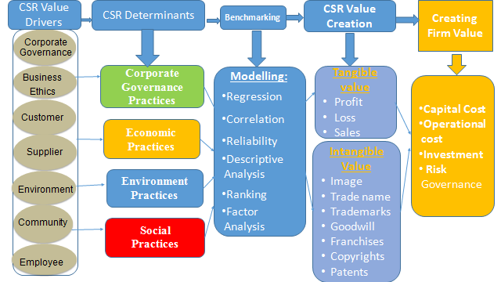
Figure 4.2 – Conceptual Framework of this research that is linking CSR to FP and VC
4.2.1 Corporate Governance (CG) CSR value driver
The relevance of Corporate Governance to CSR value creation stems from the fact that the firm needs to be accountable and transparent in their practices. Firms spend a considerable wealth on devising procedures to deal with environment, ethical, and behaviour governance, to defend their position in the market place. For example, if CSR activities are included in the financial reporting of firms, this create transparency to the shareholders and public leading to firms an increase on the level confidence on the firm which lead to further value creation.

4.2.2 Economic (EC) CSR value driver
Kitzmueller et al. (2012) pointed that CSR is “not necessarily incompatible with profit maximization, at least for a subset of firms within a separating equilibrium”. This signifies that CSR activities enhance shareholders value. Others have the view that CSR is about “sacrificing profits in the social interest”. According to the authors “shareholder value maximization in general, as well as profit maximization in particular, can motivate CSR”. This is consistent with the view that firms economic CSR activities lead to further value creation, i.e. profits. That is to say if the CSR activities can lead to a better return than it is for the best interest for the firm to follow such activities.

4.2.3 Environment (ENV) CSR value driver
Environment has become an increasingly important issue in CSR practices. Previous studies have suggested that environment practices can have an influence over the firms’ tangible value such as financial performance. For example, Purnomo et al. (2012) showed that there was a significant relationship between environment practices by manufacturing companies and their financial performance. The authors correlated return on asset, return on equity and economic value added to the to the firms discourse on CSR In some sectors of the industry environment performance is also related to the policies and objectives cited by firms to control their environment credentials and consequently improving their image.

4.2.4 Social (S) CSR value driver
The majority of CSR activities revolve around the social programs. The literature suggested that the social aspects of CSR might create additional value, in terms of sales, images etc., to the firm. For example, Aksoylu (2013) founded that CSR social policies have a significant correlation with corporate, market, and business policies. CSR social activities lead to “amplifies the intentions of their employees and company mission” (Forman-Ortiz 2016). Bhattacharya & Sen (2004) reported that “CSR is not only an ethical/ideological imperative, but also an economic one”. The author suggested that the CSR activities have a positive impact on how shareholders view investment in firms. In a recent research Shuili et al. (2010) found that firms that engaged CSR activities to their practices tends to build a strong reputation in the market place and attract investors.

4.3 Research Hypotheses
To obtain this research objectives mentioned in Methodology Chapter # 5, a questionnaire tool was performed for gathering primary data. Four groups of CSR practices were performed including: Corporate Governance (CG) practices; Economic (EC) practices; Environment (ENV) practices; and Social (S) practices. Each group of them consists of many questions related to the field itself. On the other hand, the firms’ Financial Performance was examined by using four ratios including: Price to Book Ratio (PB); Return on Asset (ROA); Return on Equity (ROE); and Share Price (SP). The following hypotheses were performed based on the literature review of the conceptual model of this research:-
H1: Corporate Governance CSR practices (CG) are associated with the financial performance of firms in UAE.

H2: Economic CSR practices (EC) are associated with the financial performance of firms in UAE.

H3: Environment CSR practices (ENV) are associated with the financial performance of firms in UAE.

H4: Social CSR practices (S) are associated with the financial performance of firms in UAE.

Reviews of the literature revealed comprehensive linkage among CSR and firms’ FP, and most results indicated a positive correlation like (Saiia et al., 2003; Brammer & Millington, 2005; Carroll & Shabana, 2010; Foote et al., 2010; Schaltegger 2011; Tayagi, 2012; Malik, 2014; von Schnurbein & Stühlinger, 2015) proving that the high CSR costs are compensated by the long-term benefits. According to Tayagi (2012), a company that tries to minimise its implicit costs by following irresponsible social practices (by, for instance, ignoring precaution against environment pollution) will ultimately suffer from high explicit costs. Based on the last mentioned ideas, this research also hypothesizes that CSR practices are consist of the following four groups:
4.3.1 Corporate Governance (CG) CSR Practices
Corporate Governance (CG) practices are the first group of CSR practices used in this research. Governance is defined as “Establishment of policies, and continuous monitoring of their proper implementation, by the members of the governing body of an organization”. It includes the mechanisms required to balance the powers of the members (with the associated accountability), and their primary duty of enhancing the prosperity and viability of the organization” (Business dictionary, 2016). Governance is also related to corporate governance (CG) (a method by which organisations police themselves).The relevance of governance to CSR stems from the fact that firms need to be accountable and transparent for their practices. As a result, organisations have to find consistent methods to deal with environment, and ethical behaviour governance, to defend their position in the market place. One way of disengaging their responsibilities is through producing annual CSR reports. Within this research framework, this investigation casts light on the correlation between corporate governance CSR practices and FP that were not considered in previous research investigations. This will be achieved through the use of various statistical methods. This research has some advantages over previous studies in the sense that investigating large number of variables taking into consideration several mediating variables. CSR initiatives should be included in the financial reporting of firms, this creates transparency to the shareholders and public that CSR initiatives are being undertaken. Several studies have examined the relationship between firm FP and corporate governance CSR practices (e.g. the number of board members, proportion of non-executive directors, etc.). The results from these studies showed a mixture of findings. Some reported positive association between corporate governance and CSR while others reported no association between CSR activities. Some studies have attempted to investigate the relationship between the financial determinants of the organisations and CSR. For example, Naser et al. (2006) investigated the association between corporate growth, market capitalisation, profitability, leverage, ownership factors and CSR practices. The study was based on a limited sample of 21 companies in Qatar. The results showed there were a positive association between the CSR and corporate size, leverage, and corporate growth variables. Study by Giannarakis, et al. (2011) through Delphi techniques identified the CSR indicators that are related to corporate governance shown in the Figure 4.3 below.
Figure 4.3 - Delphi techniques identified the CSR indicators

Within this research framework, this investigation casts light on the correlation between FP and corporate governance CSR practices that were not considered in previous research investigations. This will be achieved through the use of various statistical methods. This research has some advantages over previous research in the sense investigating large number of variables taking into consideration several mediating Variables.
The Source of References used in this research to measure how Corporate Governance (CG) practices contribute to financial performance is listed in the table below.

Figure 4.3.1 below shows the relationship between Corporate Governance CSR practices and Firms’ financial performance (FP) which is explored and tested through the following hypothesis:
H1: Corporate Governance CSR practices (CG) are associated with the financial performance of firms in UAE.

Figure 4.3.1 - Relationship between Corporate Governance (CG) CSR practices and FP
Source: Author

This research hypothesis was tested by using multiple linear regression analysis. The CSR Practices including: 1) Corporate Governance 2) Economic 3) Environment and 4) Social will be tested as the independent variables; however, the Firm’s Financial Performance (FP) including 1) Price to Book Ratio (PB); 2) Return on Asset (ROA); 3) Return on Equity (ROE); and 4) Share Price (SP) is the Dependent Variables of the publicly listed firms in UAE. The testing is carried in three stages. In the first stage univariate test will be used to study the characteristics of each of the CSR independent variables. In the second stage correlation analysis was used to assess the association between the CSR and financial performance. Also an analysis on the descriptive statistics of the financial performance of the selected firms will be conducted. In the third stage the following regression equation will be used to test the hypotheses of this research.
To investigate the influence of the Corporate Governance CSR Practices on the level of financial performance, Correlation Analysis and Regression Analysis techniques were used.
For Correlation, the following formula is used:
x: Independent Variables.
y: Dependent Variables.
n: No. of respondents.
For Multiple Regression Analysis the following expression is used:
$$FP= α+ β\sum_{i=1}^{i=n}{CG}+ε$$
FP: is the firms’ financial performance. Several financial parameters will be identified and experimented with.
α: is the estimated constant
β: is estimated coefficient for each of the corporate governance CSR practices variables
CG: are the independent variables of Corporate Governance CSR Practices.
$ε$ : Errors
In the third stage the research will use moderating variables such as the firms’ CSR spending, Firms’ CSR Indicators, and firms’ size to check if these variables will further contribute to the relationship.

4.3.2 Economic (EC) CSR Practices
Economic (EC) practices are the second group of CSR practices used in this research. From a pure economic of point of view, CSR practices are unlikely to be costless to firms. Kitzmueller & Shimshack (2012) attempted to define CSR from an economic perspective. The authors postulated several questions about the nature of CSR existence. For example, the authors stated why “CSR should exist to why it does exist and how it affects the economy, CSR growing so fast”. More importantly the authors pointed that “CSR is not necessarily incompatible with profit maximization, at least for a subset of firms within a separating equilibrium”. This signifies that CSR practices enhance shareholders value. Others have the view that CSR is about “sacrificing profits in the social interest”. According to the authors “shareholder value maximization in general, as well as profit maximization in particular, can motivate CSR”. The authors portrayed this view in the following figure. This consists with the view that firms use CSR to increase their profits. That is to say if the CSR practices can lead to a better return, then it is for the best interest for the firm to follow such practices. Reinhardt et al. (2008) posed the question “can firms sacrifice profits in the social interest?” the authors articulated “The socially beneficial actions may reduce a firm’s business expenses by an amount greater than the cost of the actions themselves”.
Thus in their view the cost spend on CSR practices may lead to a reduction on the operational costs. The authors concluded that firms can “sacrifice profits in the social interest without suffering serious adverse economic consequence”. The debate here is over financial performance of firms rather than the economic responsibility of the firm towards the sociality. Creating sustainable societies require firms to contribute to the welfare of the societies. Udin et al. (2008) identified three mechanisms through which the firm can contribute to the sustainability of the society. These are:
- The Multiplier Effect: this is related to how the economic performance has direct and indirect impact on the society.
- Contribution through taxes: this is related to the fact that taxation is used as means of wealth distribution.
- Avoiding Actions that Damage Trust: this is concerned with how firm fulfil obligations and responsibilities society to the society through the compliance with the existing laws and ethical practices.
Gallardo-Vázquez et al. (2011) attributed the economic performance of the firm to CSR practices shown as the following:
This study poses the questions “Do CSR economic practices undertaken by firms lead to higher firm performances”. The Source of References used in this research to measure how Economic (EC) practices contribute to financial performance are listed in the table below.
Figure 4.3.2 below shows the relationship between Economic (CSR) practices and Firms’ financial performance (FP) which explored and tested through the following hypothesis:
H2: Economic CSR practices (EC) are associated with the financial performance of firms in UAE.

Figure 4.3.2 - Relationship between Economic (EC) CSR practices and FP
Source: Author

This research hypothesis was tested by using multiple linear regression analysis test. The CSR Practices including: (1) Corporate Governance, (2) Economic, (3) Environment, and (4) Social will be tested as the independent variables; however, the Firm’s Financial Performance (FP) including 1) Price to Book Ratio (PB); 2) Return on Asset (ROA); 3) Return on Equity (ROE); and 4) Share Price (SP) is the Dependent Variables of the publicly listed firms in UAE. The testing is carried in three stages. In the first stage univariate test will be used to study the characteristics of each of the CSR independent variables. Also an analysis on the descriptive statistics of the financial performance of the selected firms will be conducted. In the second stage the following regression equation will be used to test the hypotheses of this research.
To investigate the influence of the Economic CSR Practices on the level of financial performance, Correlation Analysis and Regression Analysis techniques were used.
For Correlation, the following formula is used:
x: Independent Variables.
y: Dependent Variables.
n: No. of respondents.
For Multiple Regression Analysis the following expression is used:
$$FP= α+ β\sum_{i=1}^{i=n}{EC}+ε$$
FP: is the firms’ financial performance. Several financial parameters will be identified and experimented with.
α: is the estimated constant
β: is estimated coefficient for each of the corporate governance CSR practices variables
EC: are the independent variables of Economic CSR Practices.
$ε$ : Errors
In the third stage the research will use moderating variables such as the firms’ CSR spending, Firms’ CSR Indicators, and firms’ size to check if these variables will further contribute to the relationship.

4.3.3 Environment (ENV) CSR practices
Environment (ENV) practices are the third group of CSR practices used in this research. The impact from industrial activities on environment has become an increasingly important issue in CSR practices. According to WAM (2015), “The UAE’s standing on the Environment Performance Index went up from 152 in 2010 to 25 in 2014. Out of the 178 countries, the UAE was the top-ranked country in the Middle East and North Africa regions in terms of the number of marine-protected areas”. This lead in the performance indicates the importance given to the environment in UAE. This could also signify the importance of environment management. Previous studies have investigated the effects of environment practices by firms on their FP. In this research, environment performance is related to the activities that undertaken to protect the environment and the wellbeing of the society. In some sectors of the industry environment performance is also related to the policies and objectives cited by organisations to control their environment credentials. Previous studies like Purnomo & Widianingsih (2012) showed that there was a significant relationship between environment practices by manufacturing firms and their FP. The authors correlated return on asset, return on equity and economic value added to the to the firms’ discourse on CSR.
The Source of References used in this research to measure how Environment (ENV) practices contribute to financial performance is listed in the table below.
Figure 4.3.3 shows the relationship between environment (CSR) practices and Firms’ financial performance (FP) is explored and tested through the following hypothesis:
H3: Environment CSR practices (ENV) are associated with the financial performance of firms in UAE.

Figure 4.3.3 - Relationship between Environment (ENV) CSR practices and FP
Source: Author

This research hypothesis is tested by using multiple linear regression analysis test. The CSR Practices including: 1) Corporate Governance 2) Economic 3) Environment and 4) Social will be tested as the independent variables; however, the Firm’s Financial Performance (FP) including 1) Price to Book Ratio (PB); 2) Return on Asset (ROA); 3) Return on Equity (ROE); and 4) Share Price (SP) is the Dependent Variables of the publicly listed firms in UAE. The testing is carried in three stages. In the first stage univariate test will be used to study the characteristics of each of the CSR independent variables. Also an analysis on the descriptive statistics of the financial performance of the selected firms will be conducted. In the second stage the following regression equation will be used to test the hypotheses of this research.
To investigate the influence of the Environment CSR Practices on the level of financial performance, Correlation Analysis and Regression Analysis techniques were used.
For Correlation, the following formula is used:
x: Independent Variables.
y: Dependent Variables.
n: No. of respondents.
For Multiple Regression Analysis the following expression is used:
$$FP= α+ β\sum_{i=1}^{i=n}{ENV}+ε$$
FP: is the firms’ financial performance. Several financial parameters will be identified and experimented with.
α: is the estimated constant
β: is estimated coefficient for each of the corporate governance CSR practices variables
ENV: are the independent variables of Environment CSR Practices.
$ε$ : Errors
In the third stage the research will use moderating variables such as the firms’ CSR spending, Firms’ CSR Indicators, and firms’ size to check if these variables will further contribute to the relationship.

4.3.4 Social (S) CSR practices
Social (S) practices are the fourth group of CSR practices used in this research. This section addresses the question “what are the social CSR practices firms must address?”. The majority of CSR practices revolved around social performance. These practices take place in several forms, including community projects, diversity initiatives, corporate philanthropy, etc. In most cases firms partner with NGO to deliver the social CSR practices. Based on the Socrates database (a USA database that monitor and rate CSR practices of firms) Bhattacharya (2004) suggested three aspects the social practices of CSR. According to the researcher these are:
Employee Support: (e.g. employee involvement, union issue, profit-sharing, job security, safety.
Diversity: (e.g., disability, sexual orientation, family, race and gender).
Community Support: (e.g., innovative/ generous giving, housing and educational practices for the economic disadvantaged, and support of health and arts programs)”
Other social CSR practices that were reported in the literatures include:
Several researchers carried empirical study to extract the importance of CSR social activities. For example, Hanzaee & Rahpeima (2013) classified CSR activities into five categories, these are:
Each of the above mentioned categories is made up of several factors. The research found that the “Obligation to employees” CSR activities were the most important whereas the “Obligation to society” CSR factors were the least important. The social CSR practices considered by Hanzaee & Rahpeima (2013) are:
The results of the research are shown in the following Figure 4.3.4a. The results demonstrated that sponsorships and donations topped the list of practices. The results showed that the surveyed firms did not consider training people outside the firm is an important CSR practice. However, most western firms offer work placement for students.

Figure 4.3.4a - Investment in different type of CSR practices. (Source: Saveanu et al., 2014).

A research by Gallardo-Vázquez et al. (2011) investigated whether the firms that practiced CSR are more innovative and have a better competitive advantage. The researchers classified the social CSR practices into four categories, the social practices were one of them, and then the social practices included eight sub-categories as shown below.
Giannarakis et al. (2011) carried a research to identify CSR practices in the telecommunication sector in Greece. The researcher used Delphi techniques to identify forty-three CSR practices. The practices that are relevant to the social aspects of CSR are:
Sponsorships, Philanthropy, commitment to research program, voluntary overtime, dialogue with stakeholders, Health and safety, equal opportunities, employees’ satisfaction, benefits bonuses, training, personnel entertainment, assessment and flexible working programs.
Aksoylu (2013) investigated the relationships between CSR and accounting information systems in the Turkish industry based on information gathered from accounting managers. He considered the following CSR practices:
The effect of the above CSR practices was tested on accounting information systems. The researchers found social CSR practices have a significant correlation with firm, market and business policies. There is a suggestion in the literature to suggest that the social CSR practices might generate additional benefits, in terms of sales, images … etc., to the firm. Social CSR practices lead to “amplifies the intentions of their employees and company mission” (Forman-Ortiz 2013). The researcher went to report on the top ten social practices by the major international firms. These are: donation of goods to children causes, provision of solar panels, staff time donation, provision of education … etc. Other researchers have reported on the relationship between the social CSR practices and consumer behaviour. For example, Bhattacharya (2004) studied the relationship between financial gain from social CSR practices and market. The researcher reported that “CSR is not only an ethical/ideological imperative, but also an economic one”. The researcher went to suggest that the CSR practices have a positive impact on how shareholders view investment in firms. In a recent research Shuili et al. (2010) found that firms that engage in CSR practices tend to build a strong reputation in the market place and attract investors. It is claimed by Carroll & Buchholtz (2008) that the firm commitment to CSR leads to social performance standing resulting in a better corporate citizenship. The idea here is that the engaging in social CSR practices leads to firm to be an ethical corporate citizen. That is to say socially responsible firms lead to respectable citizen in corporate world. A research by Gallardo-Vázquez et al. (2011) investigated the relation between CSR practices and firm FP. The researchers attributed firm FP to several key performance indicators related to human and financial elements. The researchers went on to advocate “a firm has competitive success when it is able to get a favourable position in the market obtaining superior results and avoiding an extremely poor retribution of factors of production”. These view concords with the conceptual model advocated by this research. To examine the relationship between social CSR and FP, multiple regression method is proposed. The dependent variables will be chosen as the financial performance indicators. The independent variables will be a set of factors related to the level of CSR practices in UAE. The Source of References used in this research to measure how Social (S) practices contribute to financial performance is listed in the table below.
Figure 4.3.4b shows the relationship between social (CSR) practices and Firms’ financial performance (FP) is explored and tested through the following hypothesis:
H4: Social CSR practices (S) are associated with the financial performance of firms in UAE.

Figure 4.3.4 - Relationship between Social (S) CSR practices and FP
Source: Author

The above hypothesis is tested by using multiple linear regression analysis test. The CSR Practices including: 1) Corporate Governance 2) Economic 3) Environment and 4) Social will be tested as the independent variables; however, the Firm’s Financial Performance (FP) including 1) Price to Book Ratio (PB); 2) Return on Asset (ROA); 3) Return on Equity (ROE); and 4) Share Price (SP) is the Dependent Variables of the publicly listed firms in UAE. The testing is carried in three stages. In the first stage univariate test will be used to study the characteristics of each of the CSR independent variables. Also an analysis on the descriptive statistics of the financial performance of the selected firms will be conducted. In the second stage the following regression equation will be used to test the hypotheses of this research.
To investigate the influence of the Social CSR Practices on the level of financial performance, Correlation Analysis and Regression Analysis techniques were used.
For Correlation, the following formula is used:
x: Independent Variables.
y: Dependent Variables.
n: No. of respondents.
For Multiple Regression Analysis the following expression is used:
$$FP= α+ β\sum_{i=1}^{i=n}{S}+ε$$
FP: is the firms’ financial performance. Several financial parameters will be identified and experimented with.
α: is the estimated constant
β: is estimated coefficient for each of the corporate governance CSR practices variables
S: are the independent variables of Corporate Governance CSR Practices.
$ε$ : Errors
In the third stage the research will use moderating variables such as the firms’ CSR spending, Firms’ CSR Indicators, and firms’ size to check if these variables will further contribute to the relationship.

4.4 Updated Conceptual Framework
Figure 4.4 below explains the updated Conceptual Framework of this research; where it was explained in chapter 2 and in the begenning of this chapter. This research start with the CSR practices Drivers which is consists of so many drivers related to the CSR practices, such as: stakeholders, regulators, auditors, creditors, shareholders, managers, supplier, customer, atmosphere, land, climate, infrastructure, and employee. The second step is CSR Determinants including classifying the previous mentioned CSR practices under four groups including: (1) Corporate Governance (CG) practices, (2) Economic (EC) practices, (3) Environment (ENV) practices, and (4) Social (S) practices. The third step is the values gained from implementation of these CSR practices within the UAE publicly listed firms; whether it is tangible or intangible values. Tangible values included: profit/loss, whereas, Intangible values included: the firms’ image, goodwill, and reputation. The fourth and the last step is the Firm’s Financial Performance (FP) and Value Creation (VC) including the Capital Cost, Operational cost, Investment and Risk Governance.

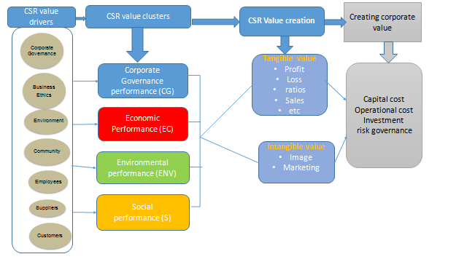
Figure 4.4 – Updated Conceptual Framework of this research that is linking CSR to FP and VC
Source: Author
Summary
This research used two methods to analyse the data in compliance with the objective of this research. Firstly, through the Questionnaire tool, the concern was on determining the drivers which are favourably disposed towards CSR practices and analyse the role of employees and the role of CSR practices in creating competitive and financial value to UAE organisations. Secondly, the concern was on determining the causality and direction of CSR practices in context with firms’ financial performance by using Regression Test. Both approaches have been performed to examine the hypothesis. The current chapter has made the research techniques and design employed in the future less confused and more clearly comprehensible. This is proof of that this topic of study is still in its infancy and is under-exploration in UAE. However, this research proposed that the findings and results of the research will significantly contribute to the literature of CSR field in the UAE’s perspective.

Chapter 5: Methodology
Introduction
This chapter aims to introduce the methodological tools and research methods used in this research. The research methodology is performed to examine and disclose a support and an analysis to the main objectives and the arguments of this research. This chapter will explain and introduce the study approach, methodology, study sample and limitations.
The underlying principle of this chapter is to explain the study and methods have been chosen to examine the association among the CSR practices through four groups and the firms’ CSR and the UAE firms’ financial performance. In the preceding chapters; the concept of CSR has been explained so that it makes a comprehensive review about the development of the notion of CSR and the CSR theoretical background and its implications. Then, the CSR determinants and the research conceptual framework have been illustrated. Now in the current chapter will discuss the model used in this research to empirically examine all the notions mentioned above, in the effort to answer this research question. This chapter will explain the research philosophy.
This chapter puts forth this research design of the secondary and primary data. It studies this research goal, hypothesis, sample size and data sources for both secondary and primary data. This chapter examines this research structure; the observations grabbed when forming the questionnaire along with participants’ demographic information. It also presents the data collection method in addition to key areas in the examining of governmental, environment, social and economic data of sample organisations. Lastly, this chapter presents the main problems, research methodology for secondary and primary data, research dependent and independent variables, techniques and tools with model specifications also are examined.

5.1 Research Philosophy
The main goal of the current research is to empirically examine the association among CSR and FP. Out of three kinds of methods, i.e. quantitative, qualitative and mixed, the quantitative method will be the best technique used to answer this research question. According to Swartz, et al. (1998), “theory cannot be generated without data, and data cannot be collected without a theoretical framework”, so that, a robust theoretical background aids the empirical findings in this study. Swartz, et al. (1998) claimed that, in a reputable study there should be a balance among empirical and theoretical study: both are devoted to reach to convinced findings. As long as the first step is the theoretical framework, from where the conceptual framework and hypotheses are derived, and out of three kinds of reasoning/arguments, i.e. the deductive, inductive, and abductive reasoning; this research reasoning will be the deductive one. In the deductive reasoning the logic will start from top to down where premises lead to the conclusions. Then, to empirically analyse the association among CSR practices and firms’ financial performance the multiple linear regression analysis will be used. The words of method and methodology in academic context are interrelated. For example methodology is seen as (Saunders et al. 2009) “theory of how research should be undertaken, including the theoretical and philosophical assumptions upon which research is based and the implications of these for the method or methods adopted”. The underline view in this definition is that research process, techniques, methods and tools are brought together (although each of terms has different meaning in the research context) to provide an overall view of the problem being investigated. The methodological aspects of the research deal with the strategy of how research is conduct. Research methods, for example data collection, are subordinates activities or processes within the research methodology. It is widely accepted in the literatures that the research methodologies are classified into three types; quantitative, qualitative, and hybrid. This research will focus only on the quantitative analysis as it is the method type that will be used. Quantitative research: as the name suggests quantitative research is concerned with the measurement of the causal relationship between the constructs of the problem been investigated. The meaning of the process is not used part of the research process. Quantitative research is driven by data, in the form of numbers. It is claimed that the results that are generated from quantitative studies can be generalised to other problems. It is also indicated this method associated with objectivism. The bottom line is that quantitative research is about testing and validating results and it is not about creating theories. The data for quantitative research is generated from survey and hard data. Quantitative methods might include: Statistical analysis or Simulation. Table 5.1 below shows the characteristics of the quantitative.
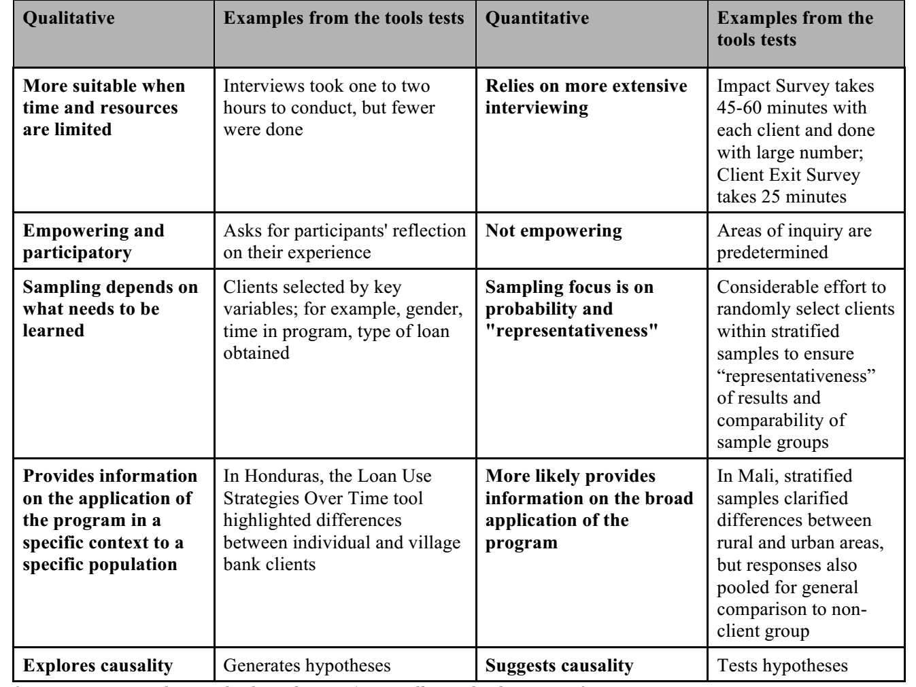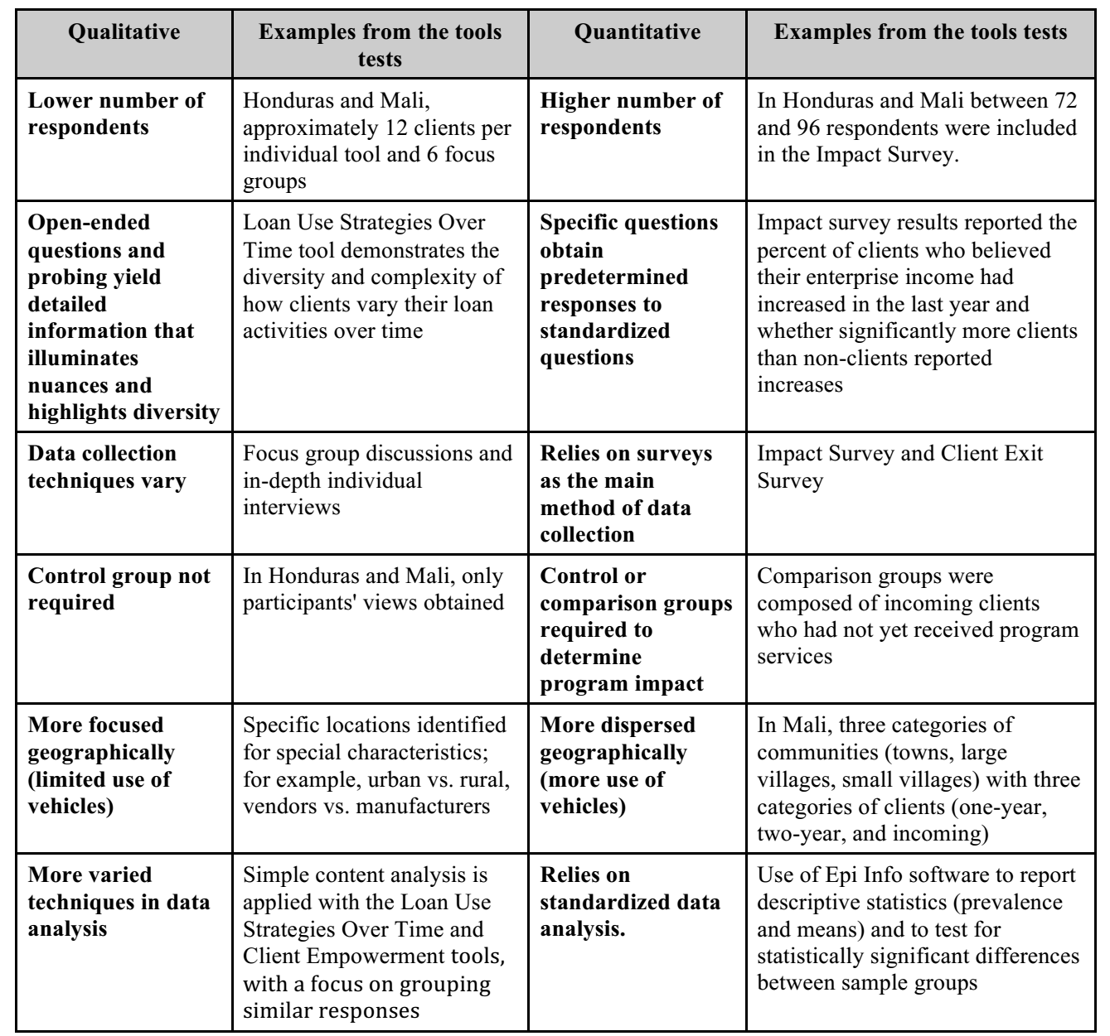
Table 5.1: Quantitative Analysis (www.ugcascru.org accessed 2017).

The primary focus of this research in the first stage is the secondary data with a view to extract the research main constructs and sub-construct variables. In the second stage the focus is on identifying the causal relationship. In the third stage the focus is on exploring and understanding the generated causal relationship.
5.2 Research Conceptual Framework
With the progress in the notion of CSR, association among CSR and firms’ financial performance are increasingly concerned by researchers, thus many pertinent research had been done. Though, according to Qiu (2012), only after the stakeholder theory initiated into the literature, the research of the association among CSR and firms’ financial performance had a breakthrough. Up to date, there have been many approaches to measure the association among corporate social responsibility and firms’ FP. Exactly like what was explained in chapter 2 in related to CSR Theories, each of these approaches has its pros and cons in research perspectives or operation process, so no approach occupies the total advantage points. Considering the small number of firms in this research are not appropriate for all approaches, and the most of measurable data for UAE listed firms are financial data, this is why the Linear Regression Test have been chosen as the analysis method in this study. The Regression Test here utilized the financial data from UAE listed firms’ annual report to compute the values or ratios that can reveal the CSR value to all stakeholders, can reach to more objective findings. Whereas may also have other approaches can be utilized in the same research. On the other hand, the choice of questions in Regression Test depends on scholar’s subjective opinions. For the purpose of minimizing the subjective influence, this research will linked with the stakeholder theory, choosing the questions which are directly related to firm’s stakeholders, to examine the association among UAE firms’ CSR and their financial performance. According to Qiu (2012) for the options of financial ratios, the accounting ratios have been showed a robust result than any other accounting ratios in exploring CSR in preceding studies. Consequently, in the current study, financial performance ratios are chosen to take part in the study. So that, in order to get more veritable and objective ending, a reasonable number of UAE listed firms as samples have been chosen and utilized in regression test.
5.3 Research Approach/ Design
This research tackled the CSR concepts and its initiatives that firms are undertake it as a part of their CSR practices in the publicly listed UAE firms. The aim of this research is to examine how the UAE firms perceive CSR and to which level they are motivated to adopt it and whether the CSR positively or negatively affecting the Financial Performance (FP) of the UAE firms. The objective of this research is to gain a deeper understanding of the association among Corporate Social Responsibility (CSR) and the Financial Performance (FP) of the publicly listed firms
Of the UAE exchange market. Based on Figure 5.3 below, the research design consists of five parts (1) Aims and Objectives, (2) literature review, (3) Questionnaire Design and Development, (4) Data Collection and Analysis, and (5) Data analysis and findings.
Environment
Social
Task 1
Task 2
Task 3
Task 4
Task 5
Introduction, aim, objectives, problem statement
CSR literature review

Definition
CSR Determinants
Fin. Performance
CSR Groups
CSR Research Framework
CSR Constructs selection
Questionnaire Design and Development
Questionnaire Validation
By Academic Experts
Questionnaire Development
Selection analysis tools
Sample size and delivering the questionnaire to potential respondents
Data Collection and Analysis
Descriptive Statistics & Data ranking
Discussion
Conclusion and Future Research
Initial
Research
Literature
Review
Design

Questionnaire
Finding

Corporate Governance
Economic

Regression results
Results analysis
Discussion and conclusion
Figure 5.3 - Research Approach/ Design

5.4 Development of Questionnaire
The designing of any questionnaire requires detailed analysis of questionnaire manner, question framing and construction in which the questionnaire was to be performed. According to Hafekost et al. (2017), the main enquiry for designing a questionnaire is to avoid uncertainty in the questions and to raise the participants’ cooperation. For this purpose, the questionnaire was originally designed and pre-examined by considering useful information from worthy literatures and asking skilled experts from the same domain. Intel acquired is as follow:
- The language applied is to be simple, without any descriptors signifiers or acronyms.
- Using closed – ended points, especially with the Likert scale of five grades, it will help in gathering relevant answers.
- Questionnaire must utilise diverse pattern to prevent odd influences while keeping unbiased opinion.
In accordance to the mentioned points, the questionnaire was revamped with updated presentation. In compliance with this research objective, the questionnaire was segregated into six sections with clear guidelines as to how to attain each point. Statements were generated after precise evaluation to achieve the short, neutral positively and simple to reframe biased approach.

5.4.1 Structure of the Questionnaire
The questionnaire was designed on the basis of reviewing the literature and a total of 149 questions were performed along with six different groups as following:
Group 1 - Corporate Governance (CG) practices which consists of 32 questions.
Group 2- Economic (EC) practices which consists of 16 questions.
Group 3- Environment (ENV) practices which consists of 27 questions.
Group 4- Social (S) practices which consists of 22 questions.
Group 5- General Questions (G) which consists of 39 questions.
Group 6- Demographic Questions (D) which consists of 13 questions.
Groups 1 to 4 pertain on getting information about the CSR practices adopted on publicly listed UAE firms. These groups consist of 97 questions. A five point Likert scale was used - comprising of Very unlikely, unlikely, neutral, likely up to Very likely – through a multiple choice questions along with giving open ended spaces for their opinion. Group 5 consists of 6 main questions asking about the CSR spending, number of financial indicators used, firm size/ number of employees, the most significant CSR areas, stakeholders’ importance level and CSR value creation. A five point Likert scale was used - comprising of Very unlikely, unlikely, neutral, likely up to Very likely – through a multiple choice questions along with giving open ended spaces for their opinion. Group 6 comprised of the Demographic questions of the participants like Name, e-mail, Telephone Number, Gender, Educational Level, Age, Nationality, Employer Industry, Ownership Type, position in the company, Years of experience, Number of Employees in company. It has open-end questions for the Name, e-mail, Telephone Number. However, the closed-end questions were used for Gender, Educational Level, Age, Nationality, Employer Industry, Ownership Type, position in the company, Years of experience, Number of Employees in the company.
Table 5.4.1a - Numerical Code for Questionnaire

The questionnaire is given in Appendix 5.4. Overall, the questionnaire can be seen in the following structural manner:

Table 5.4.1b - Questionnaire Structure

5.4.2 Administration of the Questionnaire
Effective monitoring of the questionnaire plays a pivotal rule in obtaining accurate research and data survey, ensuring reliable authentic and unquestionable information. The participating individuals were chosen from a pool of functionally active professionals and employees whose very core revolved around the objectives of this questionnaire, so as to achieve practical and vivid information. Seminal studies were adopted on the literatures handling the same topic of the relationship among CSR and FP, then choosing the best papers and the best variables adopted in these papers. The questionnaire was targeting the top level of the firms’ management, most of these firms’ top level people was a local people from UAE and most of them were not perfect in English language, especially that there were some terminologies and acronyms in the questionnaire that needs only experts people to understand it. This is why it was translated from English to Arabic language. Next step was to make the questionnaire easy for the respondents to be filled and attained, this is why instead of pushing a hard copies for them to be answered; it was performed in a specialized software application called Survey Monkey. Survey Monkey is defined as an online questionnaire cloud-based software performed to offer paid services for firms and individuals, established in 1999. It provides customizable, free questionnaires, in addition to payable back-end software that include instruments like representation of data, selection of sample, elimination of bias, and analysis of data. The softcopy (Survey Monkey) of this research questionnaire was also submitted to the respondents in two different versions; the English and the Arabic one; and then attained based on them preferences. Then the Questionnaires were sent through all modern communication channels like e-mails etc.

5.4.3 Validation of Research Constructs and Questions
Next step was to classify and arrange these variables under the most important four groups as previously mentioned in the last chapters, then reviewing and editing these variables by the Director of study (DOS) of this research and by the Vice Chancellor of this University (The British University in Dubai - BUiD). It was also reviewed by some expertise in the same field, some of them from practical and empirical field and some bodies else from Academician field. Then, two more groups were added; the fifth group was a General Questions about the financial and operational situation of the firm; and then the sixth group which was the Demographic questions of the respondents. After that, a grammar correction was adopted and then the whole questionnaire was translated from the English to Arabic language.

5.4.4 Selection of Respondents
The questionnaire was targeting the top level positions of the firms’ management, the firms was the publically listed one in UAE. The respondents supposed to be ranked in certain positions like: President or Chief Executive Officer (CEO), Treasurer or Chief Financial Officer (CFO), Chief Operating Officer (COO) or any business titles that have high level of responsibilities and duties. Respondents were not limited to certain nationality, however, most of these high level of positions were given to UAE people as it is a kind of formal policy of Emiratisation. Emiratisation is a UAE governmental initiative to employ its citizens in an efficient and meaningful manner in the private and public sectors. For this purpose most of the questionnaires were filled by UAE respondents, however, there were some respondents from other countries like GCC countries, some of them from Egypt, Jordan and Palestine, some others from east Asia like India, and Philippine. The purpose of ranking of the position has affected the ages of the respondents, as long as they were highly ranked people that means most of them were above 40 years old, however very little were in thirties and fifties. With regard to the Gender of respondents, what was observed that, 90% of them were a male. Respondents’ level of Education was mostly Bachelor level and Master degree. The respondents’ Work Experience was about 10 to 25 years of working, 5 of this experience were on the higher positions.

5.5 Data Collection
Data used in this research is obtained from United Arab Emirates Exchange Market. The UAE financial market is consisting of two stock exchanges; Dubai Financial Market (DFM), and Abu Dhabi Securities Exchange (ADX). According to an official sites like (DFM, 2017) and (ADX, 2017); Dubai Financial Market (DFM) was founded in March 26, 2000 and consisting of 67 listed firms. Abu Dhabi Securities Exchange (ADX) was founded in November 15, 2000 and consisting of also 71 listed firms. The ADX has more firms listed than DFM but trading capacity is much less. As of beginning of 2016 the Market Capitalization of DFM is equal to 90 billion US$, while Market Capitalization of ADX is equal to 122 billion US$.
Due to the quite small number of firms listed on the UAE Stock market all firms were considered for inclusion in the questionnaire. As of January 2017, there were 130 firms listed on UAE Stock Exchange. The sample of this research consists of initially 40 firms form UAE and non-UAE firms. However, 18 firms are eliminated from the list of firms because of suspension as they have a suspicious data and outlier results after Factor Analysis. Therefore, the final sample consists of 22 firms listed on UAE Stock market. As per (DFM, 2017) the market sectors within the UAE consist of 9 types as following: Banks; Consumer Stables; Investment & Financial Services; Insurance; Industrials; Real Estate; Telecommunications; Transportations; Services and Energy. The data used for this research were gathered from the firms them self by getting the help and support of Dubai Financial Market (DFM) in the Dubai Trading Centre. An official email was send from the Public Relation and Department of Dubai Financial Market (DFM) to all listed firms in UAE Exchange Market and only 40 firms responded out of the total of 130 firms (Further information is provided in Appendix 5.5)

5.6 Research Questions
Titled “The Impact of Corporate Social Responsibility on the Firm’s Financial Performance and Value Creation: the case of Publicly Listed firms in the United Arab Emirates”. The primary objective of this research is to examine whether the Corporate Social Responsibility (CSR) influence the Financial Performance (FP) of the UAE firms or not and also identify the key drivers of CSR in the UAE business landscape. Hence, it needs comparing CSR with FP by creating a link between various Financial Performance Indicators with CSR performance scores of sample firms. Further, on the basis of additional information and relative data as well as the Financial Statements of different CSR performance measurement, whether financial or social, the probability of this association can be achieved. This research also investigates in the UAE firms’ context on different CSR determinants through practical study. Consequently, clear points of the objectives of this research become important and necessary. This is mainly essential for confirming that the concentration of the main purpose is not lost at any level.

The aim of this research is to extend our understanding of the CSR determinants that contributes to financial performance of firms in UAE leading to value creation. This aim will be achieved by pursuing several distinct research objectives and questions.

Examine the existing literature on CSR with a view to extract the most relevant CSR determinants.

Develop a value creation based CSR conceptual framework.

Evaluate the relevance of SCR determinants in value creation in UAE enterprises.

- Figure out the type and the nature of the association among the CSR practices and the firms’ financial performance of the UAE firms.

5.7 Sample Size
The following conditions were performed to identify the sample population for secondary data and for questionnaire gathering:
- Must be listed on Dubai Financial Market (DFM) and/or Abu Dhabi Securities Exchange (ADX).
- Must have been ranked through for at least 5 consecutive financial years from 2011 to 2016.
- Additional financial data of these 5 financial years 2011 to 2016 must be available for these recorded organisations.
- Following the simple linear regression Test, one problem was appeared that is the financial data of some firms was not reasonable; this is why the author of this research minimised the number of investigated firms from being 40 firms to be only 22 firms.

5.7.1 Sample Size for Primary Data
For undertaken the questionnaire, the target population was very small, excluding the thought of comprising the whole firms as the sample. In addition to that, it was not easy to perform a pilot study because of the small sample. However, the questionnaire was performed using pre-testing with this research supervisor and modified later for significant modifications. The main questionnaire received 40 total responses out of 110 emails sent, a response rate of (40÷110) = 36% which is comparable to other studies. Appendix 5.7.1 identified the surveyed sample UAE companies.

5.7.2 Sample Size for Secondary Data
As previously mentioned, 40 companies made up the sample of this research which have a complete financial reports in compliance with this research requirements. For secondary data analysis, the firms’ databases were arranged and organized based on an unbalanced panel data. Further details about the list of sample of UAE firms used in panel data analysis refer to Appendix 5.7.1.

5.8 Data Sources
Both kinds of data gathered (primary and secondary) have been used in this research in compliance with its objectives.

5.8.1 Primary Data Source
A questionnaire tool was designated for gathering the primary data for the purpose of measuring the level to which an organisations’ system adopting CSR practices in the UAE perspective, representing the previous mentioned this research objectives. A questionnaire studies usually have a questionnaire about administration and its development on a sample of participants to derive conclusions regarding the population from which the sample was derived. Therefore, a questionnaire was designated to highlight the CSR practices and the financial performance results of the firms. The questionnaire was performed on the basis of certain criteria and was professionally modified and examined using appropriate techniques (for more details refer to Section 4.7).

5.8.2 Secondary Data Sources
Dual kind of data sources were used for the analysis of this research objective; the data of CSR practices and the data of financial performance indicators of UAE organisations. The biggest challenge in the data collection was the acquiring the real information about the CSR practices of UAE organisations. In contradict to the European and United State countries, the UAE organisations had no such ratings or index to measure their CSR practices. This research uses the respondents’ data along with the financial performance indicators collected from the annual reports and the financial statements of their official websites for the year of 2016.

5.9 Data analysis
Data analysis from the self-administrated questionnaire is analysed by using the Statistical Package for the social Science application “SPSS”. Six types of statistical analysis performed on data as the following:
- Reliability Test and Validity Test: Reliability is measuring to which extent the assessment tool used in this research revealed consistent and stable findings. It consists mainly from four types including: (Internal consistency, Inter-rater, Parallel forms, Test-retest).
On the other hand, Validity Test measures how well a test measures what it is supposed to be measured. It consists mainly from five types including: (Sampling, Formative, Criterion-Related, Construct, Face types).
- Descriptive Analysis: This is brief descriptive coefficients that summarises the data set of the study for the sample or for the entire population. It consists mainly from two types including: the spread/ variability and the central tendency. Spread includes (skewness and kurtosis, maximum & minimum variables, variance/ standard deviation). However, Central Tendency includes: (mode, median, mean). Hint that the details of Descriptive Analysis are available on Appendix 5.9a.
- Ranking Analysis: shows the importance of the variables, to highlight the level of CSR importance over the FP of the firms.
- Factor analysis: is a statistical process used to analyse the variability between the variables among factors represents the potentially minimum number of unobserved variables.
- Association based on Correlation Analysis: is measuring any statistical association, whether causal or not, among two variables. It is the measurement to which degree are two variables have a linear relationship with each other.
- Multiple Regressions: is a statistical method for estimating the associations between variables throughout analysing and modelling many variables; i.e. it helps to realize how the dependent variable varies when any one of the independent variables is changes, Ceteris paribus.

Summary
This research used two methods of analysing the data in compliance with this research objective of the current research. In the second approach, through the Questionnaire tool, the concern was on determining the drivers which are favourably disposed towards CSR practices and analyse the role of employees and the role of CSR practices in creating competitive and financial value to UAE organisations. Second, the concern was on determining the causality and direction of CSR practices in context with firms’ financial performance by using Regression Test. Both approaches have been performed to examine the hypothesis. The current chapter has made the research techniques and design employed in the future less confused and more clearly comprehensible. This is proof of that this topic of study is still in its infancy and is under-exploration in UAE. However, this research proposed that the findings and results of the research will significantly contribute to the literature on this field in the UAE’s perspective.

Chapter 6: Reliability, Descriptive Analysis, Ranking and Factor Analysis

Introduction
This chapter measures four issues – (1) Reliability of the scale measurement, (2) Descriptive Analysis for the given data, (3) Ranking Analysis and (4) Factor Analysis.
In the first section, the reliability of the scale measurement used to measure the overall consistency of a measure used to gather the data is performed. In the second section, a brief descriptive statistics that summarizes the enclosed data is performed, which measure the spread/ variability and the central tendency. Measuring variability will include the kurtosis and skewness, the minimum and maximum variables, and variance/ standard deviation. While measuring of central tendency will include the mode, median and mean. In the third section, the ranking for the four CSR groups is measured. In the fourth section, the Factor Analysis to reduce number of repeated or similar variables used in the questionnaire of this research is measured.

6.1 Reliability Analysis
The fundamental areas under credibility aspect are reliability, validity and Generalisability. So as to minimise the possibility of obtaining any mistakes, it concludes considering two important issues, validity and reliability (Saunders et al., 2003). Hussey & Hussey (1997) and Saunders et al. (2003) claimed that the reliability is linked with the results of the study, which is considered to be reliable if they are occurring again several times in the same study circumstances. Easterby-Smith et al. 1991 confirmed that the next 4 enquiries can be asked to evaluate the reliability of the study:
- Is there lucidity once the raw data was made?
- Is there any similarity in results be reached by other researcher?
- Is there any similarity in findings on other cases?
- Is there consistency in the findings?
On the other hand, Morris (2012) claimed that Reliability Test is the examining consistent between the findings. This differs from Validity test which is the power of the questionnaire to quantify exactly what it is designed to quantify. Both Reliability test and Validity test are important in the questionnaire. One technique to adopt the Reliability is to perform a series of corresponding statements about the subject under examination, so that some participants react with, others against – and to examine how consistent the responses are. There are different techniques to achieve Reliability – like Cronbach’s Alpha technique which is the most popular one. Reliability is calculated on a rate of 0-1 with 0 refers to no reliability and 1 refers to perfect reliability. A value greater than 0.9 is considered perfect, while a value in between 0.75 and 0.9 is considered good however lower than 0.75 is a very poor Reliability. Akgül & Çevik, (2005) also claimed that a value of 0.7 and more defines a good reliability of the scale. Firstly, the reliability test (Cronbach alpha test) was adopted to examine the correlations and the internal consistency between the questions of the questionnaire; as long as the questions have been classified to 6 groups, this is why the reliability (Cronbach alpha test) has been calculated for six groups as well. The scale which was used to measure the reliability test of the first group (Corporate Governance) that is consisting of 32 questions is very consistent (r=0.93). The scale which was used to measure the reliability test of the second group (Economic) that is consisting of 16 questions is very consistent (r=0.92). The scale which was used to measure the reliability test of the third group (Environment) that is consisting of 27 questions is very consistent (r=0.98). The scale which was used to measure the reliability test of the fourth group (Social) that is consisting of 22 questions is very consistent (r=0.95).The scale which was used to measure the reliability test of the fifth group (General Questions) that is consisting of 39 questions is very consistent (r=0.91). Thus, it was decided that the first, second, third, fourth and fifth groups of the questionnaire were highly reliable and statistical tests could be performed.
By testing the reliability (Cronbach alpha) for the five groups (i.e. CG, EC, ENV, S, G), which is consisting of 149 questions, the reliability result was calculated as (r=0.93), thus, it was decided that the whole questionnaire questions were highly reliable and statistical tests could be performed. Based on the following Table 6.1 and Figure 6.1, one can observe that the first highest reliability results belong to group #3 the Environment (ENV), where (r= 0.98) which was consisting of 27 questions and this is a very good indicator that the Environment criteria were strongly adopted. The second high reliability belongs to group #4 the Social (S), where (r= 0.95) which was consisting of 22 questions and this is a very good indicator that the economic criteria was strongly adopted. The third high reliability belongs to group #1 the Corporate Governance (CG), where (r= 0.93) which was consisting of 32 questions and this is a very good indicator that the economic criteria was strongly adopted. Then the fourth high reliability belongs to group #2 the Economic (EC), where (r= 0.92) which was consisting of 16 questions and this is a very good indicator that the economic criteria was strongly adopted. Then the last and fifth high reliability belongs to group #5 the General Questions (G), where (r= 0.91) which was consisting of 39 questions and this is probably because of wide variety difference in the answers ; for example one of the questions was asking about the amount of the firm capital and based to widely different size of firms the answers was ranging from 1million to about 10 billion, however, the reliability result was still high and this is a very good indicator that the economic criteria was strongly adopted.
Table 6.1: Reliability (Cronbach alpha test) for the four groups (CG, EC, ENV, S, G)
Source: SPSS Output processed
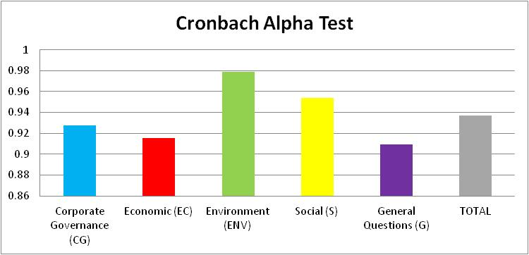
Figure 6.1: Reliability (Cronbach alpha test) for the four groups (CG, EC, ENV, S, G)
Source: SPSS Output processed

6.2 Descriptive Analysis
The following section is Descriptive Analysis which is a brief descriptive coefficient that summarise the enclosed data. Descriptive Analysis measures the Spread/ Variability of the data and also the Central Tendency. Measuring Variability will include the Kurtosis and Skewness, the Minimum and Maximum variables, and Variance/ Standard Deviation. While measuring of central tendency will include the mode, median and mean. More details about the Descriptive Analysis are available in Appendix 6.2.
6.3 Ranking Analysis
The Ranking Test was made to each of the CSR four Groups to highlight the level of impact of attributes in each of the CSR variables on Financial Performance (FP) of the firms.

6.3.1 Ranking Analysis of Corporate Governance (CG) CSR practices
The following Table 6.3.1 shows the highest level of impacts of Corporate Governance (CG) variables on the Financial Performance (FP) of the firms.

Table 6.3.1 - Ranking Analysis of Corporate Governance (CG)
Source: SPSS Output processed

The above Table 6.3.1 shows that the highest level of impact for Corporate Governance (CG) variables is as following:
Where all the results of ranking were greater than 3.5, however only the ranking of CG3, CG32, CG2, CG14 and CG4 was greater than 4.5 as shown in Table 6.3.1

6.3.2 Ranking Analysis of Economic (EC) CSR practices
The following Table 6.3.2 shows the highest level of impacts of Economic (EC) variables on the Financial Performance (FP) of the firms.

Table 6.3.2 - Ranking Analysis of Economic (EC)
Source: SPSS Output processed

The above Table 6.3.2 shows that the highest level of impact for Economic (EC) variables is as following:
Where all the results of ranking were greater than 3.5, however only the ranking of EC1 and EC11 was greater than 4.3 as shown in Table 6.3.2

6.3.3 Ranking Analysis of Environment (ENV) CSR practices
The following Table 6.3.3 shows the highest level of impacts of Environment (ENV) variables on the Financial Performance (FP) of the firms.

Table 6.3.3 - Ranking Analysis of Environment (ENV) CSR practices
Source: SPSS Output processed

The above Table 6.3.3 shows that the highest level of impact for Environment (ENV) variables is as following:
Where all the results of ranking were greater than 3.1, however only the ranking of ENV6 and ENV5 was greater than 3.7 as shown in Table 6.3.3

6.3.4 Ranking Analysis of Social (S) CSR practices
The following Table 6.3.4 shows the highest level of impacts of Social (S) variables on the Financial Performance (FP) of the firms.

Table 6.3.4 - Ranking Analysis of Social (S) CSR practices
Source: SPSS Output processed

The above Table 6.3.4 shows that the highest level of impact for Social (S) variables is as following:
Where all the results of ranking were greater than 2.9, however only the ranking of S11, S13 and S2 was greater than 3.8 as shown in Table 6.3.4

6.4 Factor Analysis
Statistical test of factor analysis is performed to examine the primary and secondary data. As to small sample size, the factor analysis was performed in two steps. In the first step, factor analysis was achieved over the four groups (CG, EC, ENV, S) and factors were outlined for each group individually. These factors outlined from each individual group were then embedded and factor analysis was performed over the embedded factors back again and final factors were performed. The following part presents a summary for the factor analysis to assist in explanation of the findings. The main goal of factor analysis is to reduce number of repeated or similar questions used in the questionnaire of this research. The questionnaire consists of 32 questions in the 1st group “Corporate Governance (CG)”; 16 questions in the 2nd group “Economic (EC)”; 27 questions in the 3rd group “Environment (ENV)”, and 22 questions in the 4th group “Social (S)”, and 16 questions in the Value Creation (VC) of the 5th group “General Questions (G)”. So that the total number of the questions used in this questionnaire is 113 questions regardless some questions in the General questions part of the 5th group and also regardless the questions of the 6th groups which is the Demographic Questions. There are several tests that can be used to confirm that correlation matrices are not identity matrices. These tests are Kaiser-Meyer-Olkin (KMO) and Bartlett Test, and Reliability Test (Cronbach Alpha).
Table 6.4 - Tests for Factor Analysis applicability
Source: SPSS Output processed
Table 6.4 above shows results for the carried out test to check whether the factor analysis can be executed. For KMO, values above 0.5 pointed out that the variance of variables is coming from common variables. Almost all of KMO results are greater than 0.5 which is a very good indicator that common factors between the variable are available. However, Bartlett’s Test has values of zero for all new clusters which lower than the threshold of 0.05. However, if the Bartlett’s Test values are bigger than 0.05 then the correlation matrices will be similar to the identity matrices, which is not the results of this research. Moreover, Reliability Test by using Cronbach Alpha was performed also to examine if variables are measuring the same issues especially within groups them self. As result approaches 1 then the reliability is increased. It is obvious from Table 6.4 above that the performed questionnaire can be considered very reliable. The next part will carry out the factor analysis for each one of the 5 groups examined in this research.

6.4.1 Factor Analysis for Corporate Governance (CG) CSR practices
Table 6.4.1a: Total Variance Explained for Corporate Governance (CG) group
Source: SPSS Output processed
The first step in factor analysis is to perform principle component analysis. Table 6.4.1a shows the results of the extracted components for Corporate Governance (CG) group. There are 32 questions in the Corporate Governance group. The second column from the left represents Eigen values for each one of the extracted questions. These values are used to select a subset of these questions. Selected questions are the ones which have Eigen values greater than one. The largest Eigen value is 10.739; while the smallest is 0.005. Mainly there are 7 questions with Eigen values greater than one, however, one can delete the repeated questions and get the higher value of Rotated Component Matrix and reach to 4 questions only instead of 7 questions; so that the 32 questions of Corporate Governance (CG) group will be minimised to be 4 questions only since there are almost 4 questions with Eigen values greater than one. Figure 6.4.1 provides further illustration of Eigen values for the extracted questions through screen plot.
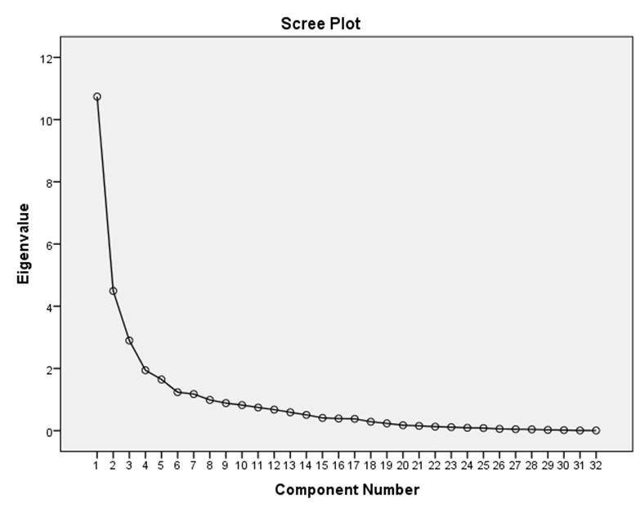
Figure 6.4.1 - Screen plot of Eigen Values of Corporate Governance (CG) group
Source: SPSS Output processed

Based on Extraction Sum of Squared Loadings part of factor analysis (third column of Table 6.4.1a), one can see how each one of the selected questions account for variance. The first Component accounts for 33.559% of variance. The last selected component accounts for the least Variance at 3.680%. All of the selected components account for 75.407% of cumulative variance; that means using the whole 32 variables of (CG) group is explaining 100% while using the latent 7 variables (revealed from Factor Analysis) are explaining 75.407% which is very good result. After performing rotation, variance is distributed among selected questions to improve representation as seen in Rotation Sums of Squared Loadings (fourth column of Table 6.4.1a). After rotation, the first question accounts for 17.964% of variance and the last selected question accounts for 4.613%.
Table 6.4.1b - Rotated Component Matrix for Corporate Governance (CG) group
Source: SPSS Output processed

The relationship between each variables of Corporate Governance (CG) group and selected components can be seen in Table 6.4.1b. The strongest relationship is between CG25 and component # 1. The strength of this relationship is represented by loading value of 0.932. Assigning each variable to the component which has the largest loading will lead to Table 6.4.1c.
Table 6.4.1c: Rotated components Matrix for (CG) after Factor Analysis Codes
Source: SPSS Output processed
This research discovered four New Latent Clusters of Corporate Governance (CG). The determinants that make up each cluster are shown in Table 6.4.1c. As illustrated in Table 6.4.1c, there are 8 variables assigned to the first New Latent Cluster coded (CGN1), 8 variables assigned to the second New Latent Cluster coded (CGN2), 8 variables assigned to the third New Latent Cluster coded (CGN3) and 7 variables assigned to the fourth New Latent Cluster coded (CGN4), the interpretation of these New Latent Clusters is provided in the following sub sections:

CGN1 - Provision of Policies
This cluster is formed from 8 CSR practices i.e. CG10, CG22, CG23, CG24, CG25, CG26, CG27, CG28. This emerged cluster is consistent with the literature on CSR, for example Provision Policies includes: Conflict of Interest, Procedures for conducting internal reviews, Minority Language Policy and Guidance, Progress Reports, Environment Information Regulations, Disability Action Plan and Complaints Policy. Provision of Policies is a very fundamental point in CSR practices. A provision of Policies are a legal conditions or clauses that are involved in a n agreement that needs all the parties to achieve certain requirements in an identified time, or prohibits the parties from achieving certain requirements in an identified time.
The findings of this research supported the studies conducted by Sander, et al., 2001; Orloff, 2003; Ghelli, 2013; Burrell, 2011; Mallin et al., 2014; Tronsgaard & Berger, 2014; European Commission, 2015. Sander, et al. (2001) in an article entitled “End-to-End Provision of Policy Information for Network QoS” defined a number of technical issues complicate the co-reservation process including: Scalability; Inter-domain policy dependencies; heterogeneity of Trust; and heterogeneity of Policy. Orloff (2003) claimed that Social provision and regulation have performed in different private/public and public shapes, from publicly-subsidized charity and poor relief, to “l’etat providence,” “the social state,” “welfare capitalism,” “the welfare state,” “social security,” or pensions and “workingman insurance”. Burrell (2011) classified the consequences of the policy intervention to the following:
European Commission (2015) made a study about the Provision of Policies of Adult learning and the findings revealed that:

CGN2 - Ethical Practices
This cluster is formed from 8 CSR practices i.e. CG1, CG2, CG3, CG4, CG5, CG13, CG20, CG21. It is very well understood in the academic literature the Ethical Practices are an essential element to CSR practices. The findings of this research supported the studies conducted by Tyagi, 2012; Tomba & Sanjoy, 2013; Ghelli, 2013; Ferrell et al., 2015.
Tomba & Sanjoy (2013) claimed that Ethical Responsibilities consists of practices and initiatives that are prohibited or expected by social relations people even though they are not committed with the policies and regulations. Ethical practices embrace different components of expectations, standards, policies, and norms, that reflect an issue for what shareholders, customers, staff, and the society considered as fair, to protect the rights of moral. On one hand, improving values and ethics come before the laws establishment as they become the forces of driving behind the creation of regulations and laws. For instance, the customer & environmental movements and civil rights revealed preliminary modifications in values of community so that it could may be shown as moral foreshadowing bellwethers that lead to later legislation. On the other hand, ethical practices show latent emerging norms and values that community believed firms to satisfy, even though they show a high level of performance than that actually needed by law. Ghelli (2013) claimed that Business ethics is a kind of professional or applied ethics that investigated the ethical moral and principles that happened in the firms. It is adopted in all areas of the conduct of the firm and is related to the conduct of workers and whole company. These ethics established originally from legal system of the country or from the company policies.
Ethical Practices conceptualized as contemporary norms, principles, values, and standards that control the behaviour and action of staff in the firms. Ethical Practices has two methods including descriptive and normative. The descriptive methods are including Academics efforts to conceptualize behaviour of the businesses. While the normative method is the careers’ specialization and the firms’ practices. The quantity, quality and range of the Ethical Practices are directly affecting the association among non-economic issues and profit maximization of the firms. Ferrell et al. (2015) claimed that, there are a good business reasons for a strong commitment to ethical values as the following:

CGN3 - Audit and Legal Issues
This cluster is formed from 8 CSR practices i.e. CG9, CG12, CG14, CG16, CG17, CG29, CG31, CG32. Audit and Legal Issues is extensive procedures that many firms normally conduct to find out whether the firms’ Human Resource policies are updated and whether it satisfy the legal suggestions. The findings of this research supported the studies conducted by Center for Ethical Business Cultures, 2005; Tang, 2012; Tronsgaard & Berger, 2014.
Centre for Ethical Business Cultures (2005) claimed that the management of social issues and social auditing are other notion that established in the seventies and eighties of the last momentum. The eighties saw attempts to link the principles of CSR, responsiveness (as (processes of CSR), and social concerns (as policies) or to connect CSR, responsiveness and ethics. Tronsgaard & Berger (2014) claimed that in the Audit and Legal Issues, the managers of the firms meet with the counsel to identify and analyse projected and current legal requirements, analyse the fundamental records and documents, and to negotiate strategic objectives and plans of the firm. The Audit and Legal Issues also sets the preliminary work for the establishing of a continuing prevention programs and legal compliances for the purpose of ensuring that the firms’ operations, structures, and objectives are harmonised with the recent achievements in corporate law and business. Lastly, the Audit and Legal Issues help the managements to determine the legal concerns results from the modifications in objectives, goals, and strategies and leads to plan the legal responsibilities that must be achieved as a consequence to the identified goals.

CGN4 - Equal Opportunities
This cluster is formed from 7 CSR practices i.e. CG6, CG7, CG11, CG15, CG18, CG19, CG30. Equal opportunity came from the like manner behaviour with all worker, without obstacles by preferences or prejudices unless there are a clear justification for certain differences. The findings of this research supported the studies conducted by Hussainey et al., 2011; Oikonomou, 2011. The purpose of Equal opportunities is usually complicated and disputed issue is that the remarkable jobs supposed to go to the "most qualified" – worker performs professionality in their jobs – and not goes to workers for irrelevant issues or for arbitrary, like race, gender, ethnicity, religion, birth circumstances, caste, having friends/ relatives, upbringing, it also includes not voluntary personal factors like age, gender orientation, disability, or gender identity. Advancement chances supposed to be opened for everyone interests like whether they have equal opportunities to compete within the established rules and the goals framework. The goal is to eliminate abuse from the processes and make it depend on "pre-accepted basics of fairness, with the performance evaluation that is belonging to the type and the level of position, and emphases on legal and procedural ways. Candidates supposed to fail or pass based on their skills and achievements and not on any external factors like nepotism. The Equal Opportunities notion is basically adopted in general life where the interests are received and earned like education and employment, while it also can be adopted to so many fields also.
Thus, these are an evident that the Corporate Governance has a significant relationship with the Financial Performance and value creation of the firms.

6.4.2 Factor Analysis for Economic (EC) CSR practices
Table 6.4.2a - Extracted components for Economic (EC) group
Source: SPSS Output processed

Table 6.4.2a shows the results of the reliability Test for Economic (EC) group. There are 16 questions in the Economic (EC) group. The second column from the left represents Eigen values for each one of the extracted questions. These values are used to select a subset of these questions. Selected questions are the ones which have Eigen values greater than one. The largest Eigen value is 7.503; while the smallest is 0.045. The 16 questions of Economic group will be minimised to be 3 questions only since there are 3 questions with Eigen values greater than one. Figure 6.4.2 provides further illustration of Eigen values for the extracted questions through screen plot.
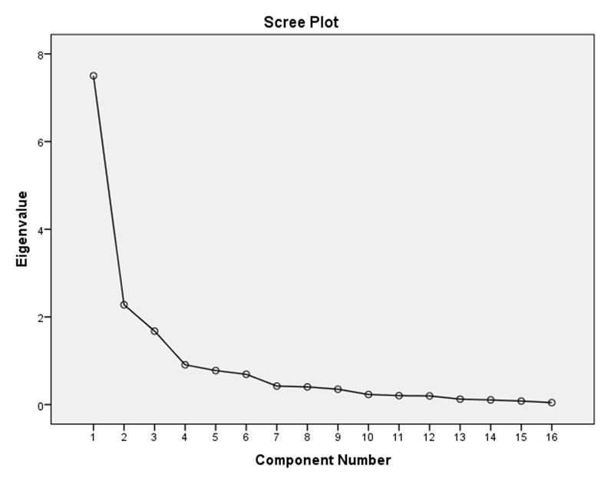
Figure 6.4.2 - Screen plot of Eigen Values of Economic (EC) group
Source: SPSS Output processed

Based on Extraction Sum of Squared Loadings (third column of Table 6.4.2a), one can see how each one of the selected questions account for variance. The first Component accounts for 46.893% of variance. The last selected component accounts for the least variance at 10.478%. All of the selected components account for 71.606% of cumulative variance, that means using the whole 16 variables of (EC) group is explaining 100% while using the latent 3 variables (revealed from Factor Analysis) are explaining 71.606% which is very good result. After performing rotation, variance is distributed among selected questions to improve representation as seen in Rotation Sums of Squared Loadings (fourth column of Table 6.4.2a). After rotation, the first question accounts for 33.101% of variance and the last selected question accounts for 12.569%.
Table 6.4.2b - Rotated Component Matrix for Economic (EC) group
Source: SPSS Output processed

The relationship between each variables of Economic (EC) group and selected components will be seen in Table 6.4.2b. The strongest relationship is between EC13 and component # 1. The strength of this relationship is represented by loading value of 0.932. Assigning each variable to the component which has the largest loading will lead to Table 6.4.2c
Table 6.4.2c - Rotated components Matrix for (EC) after Factor Analysis Codes
Source: SPSS Output processed

This research discovered three New Latent Clusters of Economic (EC). The determinants that make up each cluster are shown in Table 6.4.2c above. As illustrated in Table 6.4.2c, there are 8 variables assigned to the first New Latent Cluster coded (ECN1), 4 variables assigned to the second New Latent Cluster coded (ECN2), and 3 variables assigned to the third New Latent Cluster coded (ECN3), the interpretation of these New Latent Clusters is provided in the following sub sections:

ECN1: Economic Value
This cluster is formed from 8 Economic CSR practices i.e. EC2, EC9, EC10, EC12, EC13, EC14, EC15, EC16. Economic value is the measurement of the value introduced by the services or the good to any business entity. It is normally calculated by currency units, i.e. what is the highest rate of money a certain factor is able and willing to give for any service or good. The findings of this research supported the studies conducted by Krukowska, 2014; Arshad et al., 2015; Hanemann, 2017. The economic value of the product has perplexed economists. Economists attempted to determine the value of the product to an individual alone, and expand that definition to products that can be interchanged. Economic value is depending on the price of the product through of interchange. When economists observed an interchange, couple of fundamental functions is expressed: they are the seller and buyer. As the sellers express what is the cost to give up the product the buyers express what he is able to pay for a specific amount of money.
Hanemann (2017) claimed that the official definition of ‘economic value’ has a slightly tortuous and long and history; as it was not well established until the seventies of the previous momentum. But, the question is “Does price measure economic value?”. This is what most public believe: if any product has a price of $10, then this is its economic value, the answer is NO, because this reflects that only advertised products can have economic value. There can be no such products as non- advertised value. This issue has been clarified in economics only on seventies of the last momentum.

ECN2: Wealth Distribution
This cluster is formed from 4 Economic CSR practices i.e. EC3, EC4, EC5, EC7. The Wealth Distribution is a comparing between the wealth of worker in a certain community. However, it is totally different from the distribution of the income so that it focuses at the distribution of the economics of the assets’ ownership in a community, and not the present income of worker of that community. The findings of this research supported the studies conducted by Mallin et al., 2014; Arshad et al., 2015. In different cultures, efforts were applied, through tax collection, policies, and property redistribution to wealth redistribution, sometimes to eliminate inequality of the economic, and sometimes to assist the higher level. Wealth distribution of shows differences among the economics of the countries by using an Index called Gini Ratio; it is used to evaluate the inequality in certain country. Table 6.4.2d below revealed the Wealth Distribution of GCC countries in 2013 that was performed from reports given by the “Research Institute of Global Wealth Data book of Credit Suisse Co.". Wealth Distribution is identified as the one's net worth, represented as the difference between the Asset and the liability.
Table 6.4.2d below showed that UAE ranked as the 4th GCC country in terms of the Gini percentage Index.
Table 6.4.2d - Wealth Distribution of GCC countries in 2013
Source: Research Institute of Global Wealth Data book of Credit Suisse Co

ECN3: Financial Transparency
This cluster is formed from 3 Economic CSR practices i.e. EC1, EC6, EC11. Financial Transparency is a set of policies that aggregate the governments and civil community globally to stop illegal money cash-flows that are incurred cost of about a trillion Euros yearly in a developing nations. The findings of this research supported the studies conducted by Noeiaghaei, 2009; Bauhr & Grimes, 2012. Transparency includes accountability, communication, openness, and collaboration. It is easy in such a way that it is practical for the people to notice what operations are executed. Transparency is applied in administrations, firms, institutions, and societies. It helps the firms’ regulations and decisions on the contents of full data to its staff and also to the clients. Transparency is defined by Bauhr & Grimes (2012) as "the perceived quality of intentionally shared information from a sender". Financial Transparency of the market is defined in economics if many are known much about: What is the exact price, what is the quantity available which reflects the market depth, what capital assets or goods and services are available. Transparency consider as a fundamental issue for the economy, as it is the theoretical terms needed for the market to be an efficient free economy.

6.4.3 Factor Analysis for Environment (ENV) CSR practices
Table 6.4.3a - Extracted components for Environment (ENV) group
Source: SPSS Output processed

The first step in factor analysis is to perform principle component analysis. Table 6.4.3a shows the results of the reliability Test for Environment (ENV) group. There are 27 questions in the Environment (ENV) group. The second column from the left represents Eigen values for each one of the extracted questions. These values are used to select a subset of these questions. Selected questions are the ones which have Eigen values greater than one. The largest Eigen value is 17.772; while the smallest is 0.001. The 27 questions of Environment group will be minimised to be 2 questions only since there are 2 questions with Eigen values greater than one. Figure 6.4.3 provides further illustration of Eigen values for the extracted questions through screen plot.
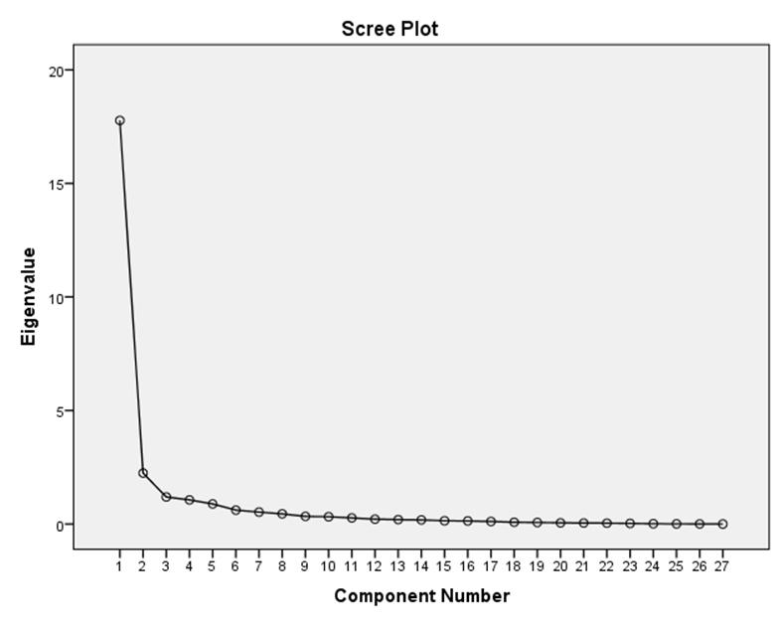
Figure 6.4.3 - Screen plot of Eigen Values of Environment (ENV) group
Source: SPSS Output processed

Based on Extraction Sum of Squared Loadings (third column of Table 6.4.3a), one can see how each one of the selected questions account for variance. The first Component accounts for 65.823% of variance. The last selected component accounts for the least variance at 3.936%. All of the selected components account for 82.486% of cumulative variance, that means using the whole 27 variables of (ENV) group is explaining 100% while using the latent 2 variables (revealed from Factor Analysis) are explaining 82.486% which is very good result. After performing rotation, variance is distributed among selected questions to improve representation as seen in Rotation Sums of Squared Loadings (fourth column of Table 6.4.3a). After rotation, the first question accounts for 64.734% of variance and the last selected question accounts for 4.326%.

Table 6.4.3b - Rotated Component Matrix for Environment (ENV) group
Source: SPSS Output processed

The relationship between each variables of Environment (ENV) group and selected components can be seen in Table 6.4.3b. The strongest relationship is between ENV27 and component # 1. The strength of this relationship is represented by loading value of 0.928. Assigning each variable to the component which has the largest loading will lead to Table 6.4.3c.

Table 6.4.3c - Rotated components Matrix for (ENV) after Factor Analysis Codes
Source: SPSS Output processed

This research discovered two New Latent Clusters of Environment (ENV). The determinants that make up each cluster are shown in Table 6.4.3c above. As illustrated in Table 6.4.3c, there are 23 variables assigned to the first New Latent Cluster coded (ENVN1), and 4 variables assigned to the second New Latent Cluster coded (ENVN2), the interpretation of these New Latent Clusters is provided in the following sub sections:

ENVN1: Environmental Practices
This cluster is formed from 8 Environment CSR practices i.e. ENV1, ENV2, ENV3, ENV4, ENV8, ENV9, ENV10, ENV11, ENV13, ENV14, ENV15, ENV16, ENV17, ENV18, ENV19, ENV20, ENV21, ENV22, ENV23, ENV24, ENV25, ENV26, ENV27. Environment Practices are those which minimise resources wastage and minimise Environment harm, including practices of work, general guidelines and Procedures. The findings of this research supported the studies conducted by Krukowska, 2014; Tronsgaard & Berger, 2014.

ENVN2: Environmental Policies
This cluster is formed from 4 Environment CSR practices i.e. ENV5, ENV6, ENV7, ENV12. Environment policies defined as the compliance of the firm to the regulations, laws and any tools used for Environment aspects. It also includes policies of toxic and inhuman substances or energy consumption like industrial waste and pesticide. The findings of this research supported the studies conducted by Vargas-Hernandez et al., 2011; Qiu, 2012; Ghelli, 2013; Mallin et al., 2014.
It is important to mention that the term “environmental policy” is consisting of couple of parts: the environment and the policy. Environment is mainly consisting of the physical eco-systems, however, it also comprises the economic factors including (biodiversity, resource allocation), it also comprise the social factors including (wellbeing of worker, health situation). With regard to the second part of the “environmental policy”, Vargas-Hernandez et al. (2011) has defined the “Policy” as a "set of principles or actions proposed or adopted by an individual, party, government, or business". So that the Environmental Policy identifies a problem arises from the humans’ influence over the environment, in the sense that it has a returned reaction over the community by affecting negatively over the human-beings values including green and clean environment, or like good health. Environmental concerns usually handled by environmental policy such as: endangered species and wildlife, protection of biodiversity, waste disposal, natural resources protection, eco-system issues, water and air pollution, and sustainability issues.

6.4.4 Factor Analysis for Social (S) CSR practices
Table 6.4.4a - Extracted components for Social (S) group
Source: SPSS Output processed
The first step in factor analysis is to perform principle component analysis. Table 6.4.4a shows the results of the reliability Test for Social (S) group. There are 22 questions in the Social group. The second column from the left represents Eigen values for each one of the extracted questions. These values are used to select a subset of these questions. Selected questions are the ones which have Eigen values greater than one. The largest Eigen value is 11.488; while the smallest is 0.022. The 22 questions of Social (S) group will be minimised to be 2 questions only since there are 2 questions with Eigen values greater than one. Figure 6.4.4 provides further illustration of Eigen values for the extracted questions through screen plot.
Figure 6.4.4 - Screen plot of Eigen Values of Social (S) group
Source: SPSS Output processed

Based on Extraction Sum of Squared Loadings (third column of Table 6.4.4a), one can see how each one of the selected questions account for variance. The first Component accounts for 52.220% of variance. The last selected component accounts for the least variance at 5.005%. All of the selected components account for 78.217% of cumulative variance, that means using the whole 22 variables of (S) group is explaining 100% while using the latent 2 variables (revealed from Factor Analysis) are explaining 78.217% which is very good result. After performing rotation, variance is distributed among selected questions to improve representation as seen in Rotation Sums of Squared Loadings (fourth column of Table 6.4.4a). After rotation, the first question accounts for 50.541% of variance and the last selected question accounts for 5.683%.

Table 6.4.4b - Rotated Component Matrix for Social (S) group
Source: SPSS Output processed

The relationship between each variables of Social (S) group and selected components can be seen in Table 6.4.4b. The strongest relationship is between S6 and component # 1. The strength of this relationship is represented by loading value of 0.883. Assigning each variable to the component which has the largest loading will lead to Table 6.4.4c
Table 6.4.4c - Rotated components Matrix for (S) after Factor Analysis Codes
Source: SPSS Output processed
This research discovered two New Latent Clusters of Social (S). The determinants that make up each cluster are shown in Table 6.4.4c above. As illustrated in Table 6.4.4c, there are 18 variables assigned to the first New Latent Cluster coded (SN1), and 4 variables assigned to the second New Latent Cluster coded (SN2), the interpretation of these New Latent Clusters is provided in the following sub sections:

SN1: Internal Social CSR Practices
This cluster is formed from 18 Environment CSR practices i.e. S4, S5, S6, S7, S8, S9, S10, S12, S13, S14, S15, S16, S17, S18, S19, S20, S21, S22. Internal social CSR Practices became more dominant in the business area. How to build a culture that is engaged in life style or based on the recent technology needs more efforts, time and power. Internal Social CSR Practices needs an outstanding responsibility which is a challenge for those employees who are not digitally intelligence. Some major issues to maintain and implement a successful internal social CSR practices are: Engaging with workers, sharing workers stories, listening to workers, and commitment to the firms’ rules and policies. The findings of this research supported the studies conducted by Oikonomou, 2011; Calveras, 2013; Saeidi, et al., 2015.
Internal Social CSR Practices comprises from those business activities that have a social effect over the internal stakeholders, especially, workers. This is why a high obligation HR department should be considered like high wages of workers, workers participation, workers stability, workers training, and so on. According to Calveras (2013), Internal Social CSR Practices should not be observed by customers; especially that it does not have a direct effect over the customers’ utility function. Calveras (2013) also claimed that the Internal Social CSR Practices has a positive effect over productivity of the workers which will lead to reduce the firms’ cost of the investment.

SN2: External Social CSR Practices
This cluster is formed from 4 Environment CSR practices i.e. S1, S2, S3, S11. External Social CSR Practices is the system of sharing information about the CSR social effects of firms' economic situations to certain groups of people or to community. The findings of this research supported the studies conducted by Calveras, 2013; Jung & Pompper, 2014.
External Social CSR Practices comprises from those business activities that have a social effect over the external stakeholders, especially, customers. However, it could be used as an index for unobservable goods quality by these customers. Calveras (2013) claimed that the ranges of External Social CSR Practices are starting from no pollution business activities reaching to no child worker regulations. External Social CSR Practices also believed as an additional factor of goods quality and so it will positively affect the customer utility function.

6.4.5 Factor Analysis of Value Creation (VC) CSR practices
For the purpose of creating Value Creation (VC) variables, the author of this research chosen a part of the General Questions (G) of the 6th group of the questionnaire used in this research which to be the Value Creation (VC) variables as showed in Table 6.4.5. The main question was “Do you think CSR create value to the following”; and the options available were 16 options as explained in Table 6.4.5 below.
Table 6.4.5 - Value Creation (VC) Questions

By performing the Reliability Test by using Cronbach Alpha for the variables (G24, G25, G26, G27, G28, G29, G30, G31, G32, G33, G34, G35, G36, G37, G38, G39) mentioned above in Table 6.4.5, one can see the result in the following Table 6.4.5a.
Table 6.4.5a - Extracted components for Value Creation (VC) group
Source: SPSS Output processed

The first step in factor analysis is to perform principle component analysis. Table 6.4.5a shows the results of the Reliability Test for Value Creation (VC) group. There are 16 questions in the Value Creation (VC) group. The second column from the left represents Eigen values for each one of the extracted questions. These values are used to select a subset of these questions. Selected questions are the ones which have Eigen values greater than one. The largest Eigen value is 9.770; while the smallest is 0.006. The 16 questions of Value Creation (VC) group will be minimised to be 2 questions only since there are 2 questions with Eigen values greater than one. Figure 6.4.5 provides further illustration of Eigen values for the extracted questions through screen plot.
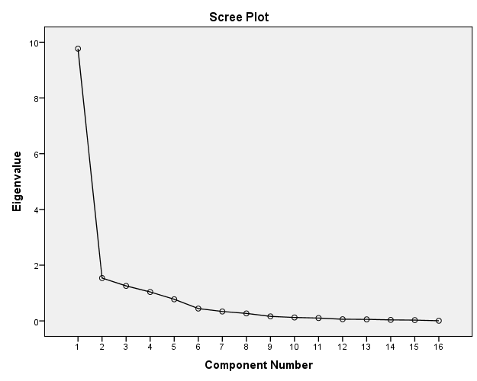
Figure 6.4.5 - Screen plot of Value Creation (VC) group
Source: SPSS Output processed
Based on Extraction Sum of Squared Loadings, one can see how each one of the selected questions account for variance. The first Component accounts for 61.060% of variance. The last selected component accounts for the least variance at 6.488%. All of the selected components account for 85.010% of cumulative variance, that means using the whole 16 variables of (VC) group is explaining 100% while using the latent 2 variables (revealed from Factor Analysis) are explaining 85.010% which is very good result. After performing rotation, variance is distributed among selected questions to improve representation as seen in Rotation Sums of Squared Loadings. After rotation, the first question accounts for 60.154% of variance and the last selected question accounts for 6.732%.
Table 6.4.5b - Rotated Component Matrix for Value Creation (VC) group
Source: SPSS Output processed

The relationship between each variables of Value Creation (VC) group and selected components can be seen in Table 6.4.5b. The strongest relationship is between G24 and component # 2. The strength of this relationship is represented by loading value of 0.906. Assigning each variable to the component which has the largest loading will lead to Table 6.4.5c.
Table 6.4.5c - Rotated components Matrix for Value Creation (VC) group after New Code
Source: SPSS Output processed
Value Creation is a consumers’ belief about how the benefit or the value will be acquired, experienced, and delivered. It is also a value promise to be acknowledged, communicated, and delivered. A Value Creation can be implemented to the whole firm, or a part of it, or services or products, or consumer account. Kaplan & Norton (2004) claimed that Value Creation is a part of strategy of the firm. According to them "Strategy is based on a differentiated consumers’ value creation. Consumers’ satisfaction is the source of value creation sustainability." Building up a Value Creation is depend on an analysis and review of the value, costs, and benefits that a firm can handed over to its loyal consumers, prospective consumers, in addition to the other Stakeholders. However the Value Creation formula equal the Cost subtracted from the Benefits.
This research discovered two New Latent Clusters of Value Creation (VC). The determinants that make up each cluster are shown in Table 6.4.5c above. As illustrated in Table 6.4.5c, there is one variables assigned to the first New Latent Cluster coded (VC1), and 14 variables assigned to the second New Latent Cluster coded (VC2). Hint that, variable G25 has no reliability with any of the selected components this is why G25 will be excluded from the variables. The interpretation of these New Latent Clusters is provided in the following sub sections:

VC1: Reputation of the firm
This cluster is formed from only one general CSR practice i.e. “Enhancing corporate reputation (G24)”. The findings of this research supported the studies conducted by Boussabaine, 2006; Ingram, 2012; Lawal, 2012; Feldman, et al., 2014.
Feldman, et al. (2014) has defined the corporate reputation as the collective judgments of the observers’ about the firm based on evaluations of environmental, social, financial effects results from the firm over a period of time. On the other hand, Ingram (2012) claimed that there are three factors of reputation, named (reputational radar); these factors are: Reputation of stakeholder, reputation of the firm, and reputation of the brand.

VC2: Stakeholder Relationships
This cluster is formed from 14 general CSR practices i.e. G26, G27, G28, G29, G30, G31, G32, G33, G34, G35, G36, G37, G38, G39. The findings of this research supported the studies conducted by Venazi & Fidanza, 2006; Schnurbein & Stühlinger, 2015; Minciullo, 2016.
These 14 general CSR practices regarding the Value Creation are consisting of:
Value Creation consider as the primary target for any firm. Creating value for consumers helps to sell the goods and services of the firm, however creating value for shareholders increases the profits and expands the market share of the firm. Creating value will also ensure availability of the capital for any future investment (Mansour, 2017).

Summary
The above mentioned chapter discussed the Reliability, Descriptive Analysis, Ranking Analysis and Factor Analysis of the data used in this research. The findings of the Reliability Test were very high (greater than 0.9) for all the groups. The Environment (ENV) came in the first, then Social (S), then Corporate Governance (CG), then Economic (EC) and finally the General questions (G). The Ranking Analysis for Corporate Governance (CG) was the highest then Economic (EC) then Environment (ENV) and finally Social (S). Factor Analysis which is a statistical process used to explain variance between correlated variables used in the questionnaire used in this research, for the purpose of minimizing the number of uncorrelated variables. The Factor Analysis for the 1st group - Corporate Governance (CG) has minimised the number of variables from being 32 variables to be only 4 variables. However, The Factor Analysis for the 2nd group – Economic (EC) has minimised the number of variables from being 16 variables to be only 3 variables. On the other hand, The Factor Analysis for the 3rd group – Environment (ENV) has minimised the number of variables from being 27 variables to be only 2 variables. Also, The Factor Analysis for the 4th group – Social (S) has minimised the number of variables from being 22 variables to be only 2 variables. Lastly, The Factor Analysis for the mediating variables the Value Creation (VC) variables has minimised the number of variables in the same group itself from being 16 variables to be only 2 variables. In conclude the total number of the variables which was used in the Factor Analysis and equal to 113 variables will be minimised to be only 13 variables.

Chapter 7: Correlation and Regression
Introduction
This chapter explains the interpretation and results of primary and secondary data through the Correlation and Regression Tests. The first part of this chapter explains the Correlation which is defined as the type and degree of association among two variables in which they fluctuate together over a period of time. The negative correlation reflects to which extent one variable decreases as the other increases and vice versa, where, the positive correlation reflects to which extent two variables or more are decrease or increase together. Correlation can have an amount fluctuated among (-1 and +1). Results close to -1 mean a high level of negative correlation, while results close to +1 mean a high level of positive correlation.
The second part of this chapter is measuring the Regression Analysis which measures the Prediction and Modelling. Regression Analysis is the instrument used to determine the statistical association among two quantities where the variation in one dependent quantity is linked with the variation in the other independent quantity. Basically the linear regression has two major types which are Simple and Multiple linear regressions, while there are many non-linear regression instruments for more complex analysis and data. The Simple linear regression predicts the outcome of the dependent quantity by using one independent quantity only; however the Multiple Linear Regression predicts the outcome of the dependent quantity by using two or more independent quantities.

7.1 Testing for Hypotheses
As explained in Factor Analysis section in Chapter 7:
- 4 new latent clusters were emerged from the 1st group - Corporate Governance (CG); i.e. CGN1, CGN2, CGN3, CGN4
- 3 new latent clusters were emerged from the 2nd group - Economic (EC); i.e. ECN1, ECN2, ECN3
- 2 new latent clusters were emerged from the 3rd group - Environment (ENV); i.e. ENVN1, ENVN2
- 2 new latent clusters were emerged from the 4th group - Social (S); i.e. SN1, SN2
- 2 new latent clusters were emerged from the 5th group – Value Creation (VC); i.e. VC1, VC2
Notice that the Author has added the letter “N” to differentiate the New Clusters emerged from the Original CSR variables.
Based on these results the researcher proposed to test the following hypotheses using multiple regressions:
H1: Corporate Governance CSR practices (CG) are associated with the financial performance of firms in UAE.

H2: Economic CSR practices (EC) are associated with the financial performance of firms in UAE.

H3: Environment CSR practices (ENV) are associated with the financial performance of firms in UAE.

H4: Social CSR practices (S) are associated with the financial performance of firms in UAE.

7.2 Association Analysis between CSR practices and Financial Performance (FP) ratios
The level of association for all variables was achieved. The individual correlation was examined so as to address, essentially, the correlation between the Corporate Social Responsibility (CSR) practices as the (Independent Variables) and the firms’ Financial Performance (FP) as the (Dependent Variables). The correlation analysis using the Pearson coefficient assumes normality of the variables. Normality Determine if the data is well modelled by normal distribution and to measure how likely it is for random variables underlying the data to be normal distribution. Normality is required when the sample size is smaller than 200 respondents.
As discussed in the previous section 6.2.7, some variables are not normally distributed and some authors like Hair et al. (2003) claimed that the correlation analysis considers the normality of the CSR variables for granted. On the other hand, there are two types of correlation coefficients; the Pearson’s Coefficient and Spearman’s Coefficient. Pearson’s Coefficient uses continuous variables as they do in this research. The correlations represent the significant correlation coefficients at 1% and 5%.

7.2.1 Association between Corporate Governance (CG) and Financial Performance (FP)
Table 7.2.1 below represents the correlation between the first group Corporate Governance (CG) as independent variables and the Financial Performance Ratios as dependent variables.
Table 7.2.1 -Association between Corporate Governance (CG) and Financial Performance (FP)
Source: SPSS Output processed
Table 7.2.1 above shows that out of 32 Corporate Governance independent variables, there is only one independent variable (CG2) has significant correlation at the p=0.05 level with the dependent variable (Price to Book Ratio (PB)), and the correlation is positive. Also, there are two of Corporate Governance independent variables (CG9, CG26) have significant correlations at the p=0.005 level with the dependent variable (Return on Asset Ratio (ROA)), and one correlation is positive while the other one is negative respectively. However, there are three of Corporate Governance independent variables (CG8, CG9, CG17) have significant correlations at the p=0.005 level for (CG8, CG17) and at the p=0.001 level for (CG9) with the dependent variable (Return on Equity Ratio (ROE)), and all the correlations are positive. Finally, for the last financial ratio, only two of Corporate Governance independent variables (CG26, CG31) have significant correlations at the p=0.005 level and at the p=0.001 level respectively with the dependent variable (Share Price Ratio (SP)), and both correlations are negative. In summary, the highest correlation was with the Share Price (SP) dependent variable where Spearman= -.693 at the p=0.001 level. All the 10 Spearman correlations are greater than 0.3 and some of them are greater than 0.6, indicating a strong association between the Corporate Governance variables and the Financial Performance Ratios.

7.2.2 Association between Economic (EC) and Financial Performance (FP) ratios
Table 7.2.2 below represents the correlation between the second group Economic (EC) as independent variables and the Financial Performance Ratios as dependent variables.
Table 7.2.2 - Association between Economic (EC) and Financial Performance (FP) Ratios
Source: SPSS Output processed
Table 7.2.2 above shows that, out of 16 Economic independent variables, none of the Economic independent variables has any significant correlation with the dependent variable (Price to Book Ratio (PB)). However, only one of Economic independent variables (EC5) has significant correlation at the p=0.005 level with the dependent variable (Return on Asset Ratio (ROA)) and the correlation is negative. Similarly, there are three of Economic independent variables (EC13, EC14, EC15) have significant correlations at the p=0.005 level with the dependent variable (Return on Equity Ratio (ROE)), and the correlations are positive. Finally, for the last financial ratio, there is only one of Economic independent variables (EC14) has significant correlation at the p=0.005 level with the dependent variable ((Share Price Ratio (SP)), and the correlation is negative. In summary, the highest correlation is with the ratio Share Price (SP) where Spearman is greater than 0.5 at the p=0.001 level. All the 8 Spearman correlations are greater than 0.3 and some of them are greater than 0.5, indicating a strong association between the Economic variables and the Financial Performance Ratios.

7.2.3 Association between Environment (ENV) and Financial Performance (FP) ratios
Table 7.2.3 below represents the correlation between the third group Environment (ENV) as independent variables and the Financial Performance Ratios as dependent variables.
Table 7.2.3 - Association between Environment (ENV) and Financial Performance (FP) ratios
Source: SPSS Output processed

Table 7.2.3 above shows that, out of 27 Environment independent variables, none of the Environment independent variables has any significant correlation with the dependent variable (Price to Book Ratio (PB)). However, there are two of Environment independent variables (ENV5, ENV19) have significant correlation at the p=0.005 level with the dependent variable (Return on Asset Ratio (ROA)) and the correlations are positive. Similarly, there are only one of Environment independent variables (ENV5) has significant correlation at the p=0.005 level with the dependent variable (Return on Equity Ratio (ROE)), and the correlation is positive. Finally, for the last financial ratio, none of the Environment independent variables has any significant correlation with the dependent variable ((Share Price Ratio (SP)). In summary, all the 4 Spearman correlations are greater than 0.3, indicating a strong association between the Environment independent variables and the Financial Performance Ratios.

7.2.4 Association between Social (S) and Financial Performance (FP) ratios
Table 7.2.4 below represents the correlation between the fourth group Social (S) as independent variables and the Financial Performance Ratios as dependent variables.
Table 7.2.4 - Association between Social (S) and Financial Performance (FP) ratios
Source: SPSS Output processed

Table 7.2.4 above shows that, out of 22 Social independent variables, none of the Social independent variables has any significant correlation with the dependent variables (Price to Book Ratio (PB)), (Return on Asset Ratio (ROA)) and (Return on Equity Ratio (ROE)). Finally, for the last financial ratio, only one of the Social independent variables (S15) has significant correlation at the p=0.005 level with the dependent variable ((Share Price Ratio (SP)) and the correlation is negative. In summary, the two Spearman correlations are greater than 0.3, indicating a strong association between the Social independent variables and the Financial Performance Ratios.

Association between General Questions and other Variables
The General Questions part is the fifth part of the questionnaire. It consists mainly of six questions; the first three questions are general questions about the firm itself. However, the Correlation Tests have been conducted over the other three questions named:
7.3 “Important Area of CSR” Variables
7.4 “Role of Stakeholders” Variables
7.5 “Value Creation” Variables

7.3 Association between” Important Area of CSR” and other Variables
Table 7.3 below shows “Important Area of CSR” variables.
Table 7.3 – “Important Area of CSR” Variables
Source: Author

7.3.1 Association between “Important Area of CSR” and Corporate Governance (CG)
Table 7.3.1 below shows the Spearman Correlations between the variables of Important Area of CSR which was mentioned above in Table 7.3 and the variables of the first group: Corporate governance (CG)).
Table 7.3.1 - Association between “Important Area of CSR” and Corporate Governance (CG)
Source: SPSS Output processed

Table 7.3.1 above shows that there are only 3 independent variables (CG1, CG2, CG13) have a Spearman correlation with the (Governance (G4)) at the p=0.005 level; the coefficients correlation are positive and greater than 0.3 indicating a strong association between variables. Similarly, only 3 independent variables (CG2, CG3, CG12) have a Spearman correlation with the (Dialogue with the stakeholders (G5)) at the p=0.005 level for (CG1, CG2) and at the p=0.001 level for (CG13); the coefficients correlation are positive and greater than 0.3 indicating a strong association between variables. Also, there are only two independent variables (CG15, CG28) have a Spearman correlation with the (Policy towards employees (G6)); one coefficient correlation (CG15) is negative at the p=0.001 level, and the other coefficient correlation (CG28) is positive at the p=0.005 level, both coefficients are greater than 0.3 indicating a strong association between both variables. On the other hand, there are no independent variables have any Spearman correlation with the (Relationship with clients and suppliers (G7)). However, there are 4 independent variables (CG2, CG3, CG10, CG12) have a Spearman correlation with the (Relationship with the community (G8)) at the p=0.005 level; all the coefficients correlation are positive and greater than 0.3 indicating a strong association between both variables. While only one independent variable (CG28) has a Spearman correlation with the (Environment protection (G9)) at the p=0.005 level; the coefficient correlation is positive and greater than 0.3 indicating a strong association between both variables. Also there are 5 independent variables (CG2, CG5, CG9, CG10, CG21) have a Spearman correlation with the (Relationship with professional bodies (G10)) at the p=0.005 level for (CG2, CG5) and at p=0.001 level for (CG9, CG10, CG21); all the coefficients correlation are positive and greater than 0.3 indicating a strong association between both variables. Finally, there are no independent variable has any Spearman correlation with the (Relationship with regulators (G11)) or with the (Relationship with governmental entities (G12)).

7.3.2 Association between “Important Area of CSR” and Economic (EC)
Table 7.3.2 below shows the Spearman Correlations between the variables of Important Area of CSR which was mentioned above in Table 7.3 and the variables of the second group: (Economic (EC)).
Table 7.3.2 - Association between “Important Area of CSR” and Economic (EC)
Source: SPSS Output processed

Table 7.3.2 above shows that there are only one independent variables (EC12) has a Spearman correlation with the (Governance (G4)) at the p=0.005 level; the coefficient correlation is negative and greater than 0.3 indicating a strong association between variables. However there are no independent variables have any Spearman correlation with the (Dialogue with the stakeholders (G5)), (Policy towards employees (G6)) and (Relationship with clients and suppliers (G7)). On the other hand, there are only one independent variables (EC11) has a Spearman correlation with the (Relationship with the community (G8)) at the p=0.005 level; the coefficient correlation is positive and greater than 0.3 indicating a strong association between variables. Conversely, there are no independent variables have any Spearman correlation with the (Environment protection (G9)) and (Relationship with professional bodies (G10)). However, there are only one independent variables (EC11) has a Spearman correlation with the (Relationship with regulators (G11)) at the p=0.005 level; the coefficient correlation is positive and greater than 0.3 indicating a strong association between variables. Similarly, there are only one independent variables (EC12) has a Spearman correlation with (Relationship with governmental entities (G12)) at the p=0.005 level; the coefficient correlation is negative and greater than 0.3 indicating a strong association between variables.

7.3.3 Association between “Important Area of CSR” and Environment (ENV)
Table 7.3.3 below shows the Spearman Correlations between the variables of Important Area of CSR which was mentioned above in Table 7.3 and the variables of the third group: (Environment (ENV)).
Table 7.3.3 - Association between “Important Area of CSR” and Environment (ENV)
Source: SPSS Output processed

Table 7.3.3 above shows that there are 8 independent variables (ENV1, ENV2, ENV4, ENV8, ENV11, ENV16, ENV21, ENV27) have a Spearman correlation with the (Governance (G4)) at the p=0.005 level for all of the except for (ENV4) it is at the p=0.001 level; all the coefficients correlation are negative and greater than 0.3 indicating a strong association between variables. However there is no independent variable has any Spearman correlation with the (Dialogue with the stakeholders (G5)). On the other hand, there are 3 independent variables (ENV3, ENV9, ENV19) has a Spearman correlation with the (Policy towards employees (G6)) at the p=0.005 level, all coefficients are negative and greater than 0.3 indicating a strong association between both variables. Similarly, there is only one independent variable (ENV1) has a Spearman correlation with the (Relationship with clients and suppliers (G7)) at the p=0.005 level, the coefficient is negative and greater than 0.3 indicating a strong association between both variables. However, there is no independent variable has any Spearman correlation with the (Relationship with the community (G8)), with (Environment protection (G9)), with (Relationship with professional bodies (G10)) and also with the (Relationship with regulators (G11)). Finally, there are 10 independent variables (ENV1, ENV2, ENV4, ENV5, ENV13, ENV16, ENV21, ENV23, ENV24, ENV25) have Spearman correlation with the (Relationship with governmental entities (G12)) at the p=0.005 level for all except at the p=0.001 level for (ENV4), all the coefficients are negative and greater than 0.3 indicating a strong association between both variables.

7.3.4 Association between “Important Area of CSR” and Social (S)
Table 7.3.4 below shows the Spearman Correlations between the variables of Important Area of CSR which was mentioned above in Table 7.3 and the variables of the fourth group: (Social (S)).
Table 7.3.4 - Association between “Important Area of CSR” and Social (S)
Source: SPSS Output processed

Table 7.3.4 above shows that there are only two independent variables (S1, S2) have a Spearman correlation with the (Governance (G4)) at the p=0.005 level for (S2) and at the p=0.001 level for (S1); all the coefficients correlation are negative and greater than 0.3 indicating a strong association between variables. Similarly, there is only one independent variable (S1) has a Spearman correlation with the (Dialogue with the stakeholders (G5)) at the p=0.005 level; the coefficient correlation is negative and greater than 0.3 indicating a strong association between variables. Also, there is only one independent variable (S9) has a Spearman correlation with the (Policy towards employees (G6)) at the p=0.005 level, the coefficient correlation is positive and greater than 0.3 indicating a strong association between both variables. Conversely, there are no independent variables have any Spearman correlation with the (Relationship with clients and suppliers (G7)). While, there are 6 independent variables (S5, S6, S7, S8, S9, S10) have a Spearman correlation with the (Relationship with the community (G8)) at the p=0.005 level for (S5, S6, S7, S9, S10) and at the p=0.001 level for (S8); the coefficients correlation are positive and greater than 0.3 indicating a strong association between variables. Similarly, there are two independent variables (S10, S18) have a Spearman correlation with the (Environment protection (G9)) at the p=0.005 level; the coefficients correlation are positive and greater than 0.3 indicating a strong association between variables. Conversely, there are no independent variable have any Spearman correlation with the (Relationship with professional bodies (G10)). On the other hand, there are two independent variables (S9, S17) have a Spearman correlation with the (Relationship with regulators (G11)) at the p=0.005 level; the coefficients correlation are positive and greater than 0.3 indicating a strong association between variables. Finally, there are two independent variables (S1, S2) have Spearman correlation with the (Relationship with governmental entities (G12)) at the p=0.005 level for (S2) and at the p=0.001 level for (S1); all the coefficients are negative and greater than 0.3 indicating a strong association between both variables.

7.3.5 Association between “Important Area of CSR” and Financial Performance (FP)
This part will measure the Spearman associations between the independent variables of Important Area of CSR which was mentioned above in Table 7.3 and the Financial Performance Ratios: (Price to Book Ratio (PB), Return on Asset (ROA), Return on Equity (ROE), and Share Price (SP)).
Table 7.3.5 - Association between “Important Area of CSR” and Financial Performance (FP)
Source: SPSS Output processed

Table 7.3.5 above shows that the independent variables (Governance (G4)), (Dialogue with the stakeholders (G5)), (Policy towards employees (G6)), (Relationship with clients and suppliers (G7)), and (Relationship with the community (G8)) have no Spearman correlation with any of financial Performance Ratios. Conversely, the independent variable (Environment protection (G9)) has a Spearman correlation with (Price to Book Ratio (PB)) at the p=0.005 level with a negative value, and also with (Return on Asset (ROA)) at the p=0.005 level with a positive value, both coefficients correlation are greater than 0.3 indicating a strong association between variables. Finally, the independent variables (Relationship with professional bodies (G10)), (Relationship with regulators (G11)) and (Relationship with governmental entities (G12)) have no Spearman correlation with any of financial Performance Ratios.
7.4 Association between “Role of Stakeholders” and other Variables
Table 7.4 below shows the “Role of stakeholders” CSR variable.

Table 7.4 – “Role of Stakeholders” Variables
Source: Author

7.4.1 Association between “Role of stakeholders” and Corporate Governance (CG)
Table 7.4.1 below shows the Spearman Correlations between the variables of the Role of stakeholders which was mentioned above in Table 7.4 and the variables of the first group: (Corporate governance (CG)).
Table 7.4.1 - Association between “Role of stakeholders” and Corporate Governance (CG)
Source: SPSS Output processed
Table 7.4.1 above shows that there are 4 independent variables (CG2, CG13, CG20, CG26) have a Spearman correlation with the (Government (G13)) at the p=0.005 level; where the coefficients correlation (CG2, CG13, CG20) are positive but (CG26) is negative, and all of them are greater than 0.3 indicating a strong association between variables. Similarly, there are 5 independent variables (CG2, CG3, CG10, CG19, CG20) have a Spearman correlation with the (Customers (G14)) at the p=0.005 level; all the coefficients correlation are positive and greater than 0.3 indicating a strong association between variables. Also, there is only one independent variables (CG28) has a Spearman correlation with the (Employees (G15)) at the p=0.005 level with positive correlation and it is greater than 0.3 indicating a strong association between variables. Similarly, there are only two independent variables (CG19, CG20) has a Spearman correlation with the (Global community (G16)) at the p=0.005 level with positive correlation and it is greater than 0.3 indicating a strong association between variables. On the other hand, there is no independent variable has any Spearman correlation with the (Local community (G17)). However, there are 6 independent variables (CG6, CG7, CG10, CG20, CG27, CG28) have a Spearman correlation with the (Environmentalist groups (G18)) at the p=0.005 level for (CG10, CG20, CG27, CG28) and at the p=0.001 level for (CG6, CG7); all the coefficients correlation are positive and greater than 0.3 indicating a strong association between variables. Similarly, there are 4 independent variable (CG10, CG12, CG19, CG20) has a Spearman correlation with the (Mass media (G19)); the coefficients correlations are positive and greater than 0.3 indicating a strong association between variables at the p=0.005 level for (CG12) and at the p=0.001 level for (CG10, CG19, CG20). Also there are 3 independent variables (CG9, CG14, CG17) have a Spearman correlation with the (Investors (G20)); all the coefficients correlation are positive and greater than 0.3 indicating a strong association between variables at the p=0.005 level for (CG9, CG14) and at p=0.001 level for (CG17). Similarly, there are 5 independent variable (CG6, CG7, CG22, CG25, CG27) has a Spearman correlation with the (Natural environment (G21)); the coefficients correlations are positive and greater than 0.3 indicating a strong association between variables at the p=0.005 level for (CG6, CG22, CG25, CG27) and at the p=0.001 level for (CG7). Similarly, there are 13 independent variable (CG6, CG7, CG8, CG10, CG20, CG22, CG23, CG24, CG25, CG26, CG27, CG28, CG30) has a Spearman correlation with the (Environment policies of other competitors (G22)); the coefficients correlations are positive and greater than 0.3 indicating a strong association between variables at the p=0.005 level for (CG8, CG10, CG23, CG24, CG26, CG28) and at the p=0.001 level for (CG6, CG7, CG20, CG22, CG23, CG24, CG25, CG27, CG30). Finally, there are 3 independent variable (CG7, CG9, CG17) has a Spearman correlation with the (Natural Gas Company pressure from consumer and media (G23)); the coefficients correlations are positive and greater than 0.3 indicating a strong association between variables at the p=0.005 level for (CG7) and at the p=0.001 level for (CG9, CG17).

7.4.2 Association between “Role of Stakeholders” and Economic (EC)
Table 7.4.2 below shows the Spearman Correlations between the variables of the Role of Stakeholders which was mentioned above in Table 7.4 and the variables of the second group: (Economic (EC)).
Table 7.4.2 - Association between “Role of Stakeholders” and Economic (EC)
Source: SPSS Output processed

Table 7.4.2 above shows that there is no Spearman correlation between the (Government (G13)) variable and the Economic variables. On the other hand, there are 3 independent variables (EC10, EC11 EC14) have a Spearman correlation with the (Customers (G14)) at the p=0.005 level for (EC10, EC14) and at the p=0.001 level for (EC11), all the coefficients correlation are positive and greater than 0.3 indicating a strong association between variables. Also, there is only one independent variables (EC4) has a Spearman correlation with the (Employees (G15)) at the p=0.005 level with positive correlation and it is greater than 0.3 indicating a strong association between variables. Similarly, there are only two independent variables (EC14, EC15) has a Spearman correlation with the (Global community (G16)) at the p=0.005 level with positive correlation and it is greater than 0.3 indicating a strong association between variables. On the other hand, there are no independent variable has any Spearman correlation with the (Local community (G17)), (Environmentalist groups (G18)), (Mass media (G19)) and (Investors (G20)). However, there are 3 independent variable (EC4, EC12, EC16) has a Spearman correlation with the (Natural environment (G21)); the coefficients correlations are positive and greater than 0.3 indicating a strong association between variables at the p=0.005 level. Similarly, there are 8 independent variable (EC4, EC5, EC8, EC10, EC12, EC14, EC15, EC16) has a Spearman correlation with the (Environment policies of other competitors (G22)); the coefficients correlations are positive and greater than 0.3 indicating a strong association between variables at the p=0.005 level for (EC5, EC10, EC12, EC14, EC16) and at the p=0.001 level for (EC4, EC8, EC15). Finally, there is no Spearman correlation between the (Natural Gas Company pressure from consumer and media (G23)) and the Economic variables.

7.4.3 Association between “Role of Stakeholders” and Environment (ENV)
Table 7.4.3 below shows the Spearman Correlations between the variables of the Role of Stakeholders which was mentioned above in Table 7.4 and the variables of the third group: (Environment (ENV)).
Table 7.4.3 - Association between “Role of Stakeholders” and Environment (ENV)
Source: SPSS Output processed
Table 7.4.3 above shows that there are no Spearman correlation between (Government (G13)) and the Environment variables. On the other hand, there are two independent variables (ENV5, ENV6) have a Spearman correlation with the (Customers (G14)) at the p=0.005 level; both coefficients correlation are positive and greater than 0.3 indicating a strong association between variables. Similarly, there is only one independent variables (ENV12) has a Spearman correlation with the (Employees (G15)) at the p=0.005 level with negative correlation and it is greater than 0.3 indicating a strong association between variables. Also, there is only one independent variables (ENV25) has a Spearman correlation with the (Global community (G16)) at the p=0.005 level with negative correlation and it is greater than 0.3 indicating a strong association between variables. Where, there are two independent variable (ENV5, ENV6) have Spearman correlation with the (Local community (G17)) at the p=0.005 level with positive correlation and it is greater than 0.3 indicating a strong association between variables. Also, there are 7 independent variables (ENV4, ENV10, ENV18, ENV20, ENV21, ENV22, ENV27) have a Spearman correlation with the (Environmentalist groups (G18)) at the p=0.005 level for (ENV4, ENV10, ENV18, ENV20, ENV22) and at the p=0.001 level for (ENV21, ENV27) with positive correlations for all and it is greater than 0.3 indicating a strong association between variables. Similarly, there are two independent variable (ENV5, ENV6) has a Spearman correlation with the (Mass media (G19)); the coefficients correlations are positive and greater than 0.3 indicating a strong association between variables at the p=0.005 level for (ENV6) and at the p=0.001 level for (ENV5). On the other hand, there are no Spearman correlation between (Investors (G20)) and the Environment variables. While, there are 4 independent variable (ENV10, ENV18, ENV22, ENV27) have a Spearman correlation with the (Natural environment (G21)); the coefficients correlations are positive and greater than 0.3 indicating a strong association between variables at the p=0.005 level. Similarly, there are 14 independent variable (ENV3, ENV8, ENV9, ENV10, ENV11, ENV15, ENV17, ENV18, ENV20, ENV21, ENV22, ENV24, ENV26, ENV27) has a Spearman correlation with the (Environment policies of other competitors (G22)); the coefficients correlations are positive and greater than 0.3 indicating a strong association between variables at the p=0.005 level for (ENV3, ENV8, ENV9, ENV10, ENV11, ENV20, ENV22, ENV24, ENV26, ENV27) and at the p=0.001 level for (ENV15, ENV17, ENV18, ENV21). Finally, there are 6 independent variable (ENV3, ENV5, ENV6, ENV12, ENV13, ENV19) has a Spearman correlation with the (Natural Gas Company pressure from consumer and media (G23)); the coefficients correlations are positive and greater than 0.3 indicating a strong association between variables at the p=0.005 level for (ENV3, ENV12, ENV13, ENV19) and at the p=0.001 level for (ENV5, ENV6).
7.4.4 Association between “Role of Stakeholders” and Social (S)
Table 7.4.4 below shows the Spearman Correlations between the variables of the Role of Stakeholders which was mentioned above in Table 7.4 and the variables of the fourth group: (Social (S)).
Table 7.4.4 - Association between “Role of Stakeholders” and Social (S)
Source: SPSS Output processed

Table 7.4.4 above shows that there are no independent variables has a Spearman correlation with the (Government (G13)) and also with the (Customers (G14)). On the other hand, there are 7 independent variables (S6, S7, S8, S9, S10, S13, S21) have a Spearman correlation with the (Employees (G15)) at the p=0.005 level for (S7, S8, S9, S10, S13, S21) and at the p=0.001 level for (S6) with positive correlation and it is greater than 0.3 indicating a strong association between all variables. However, there are no independent variables has a Spearman correlation with the (Global community (G16)). While, there are only one independent variable (S10) has a Spearman correlation with the (Local community (G17)) at the p=0.005 level; the coefficient correlation is positive and greater than 0.3 indicating a strong association between variables. Similarly, there are 12 independent variables (S4, S5, S6, S10, S11, 14, S15, S18, S19, S20, S21, S22) have a Spearman correlation with the (Environmentalist groups (G18)) at the p=0.005 level for (S6, S11, S15, S20, S21) and at the p=0.001 level for (S4, S5, S10, S14, S18, S19, S22); all the coefficients correlation are positive and greater than 0.3 indicating a strong association between variables. On the other hand, there are no independent variables has a Spearman correlation with the (Mass media (G19)) and also with (Investors (G20)). In contrast, there are 14 independent variable (S1, S4, S5, S6, S10, S13, S14, S15, S16, S18, S19, S20, S21, S22) has a Spearman correlation with the (Natural environment (G21)); the coefficients correlations are positive and greater than 0.3 indicating a strong association between variables at the p=0.005 level for (S1, S6, S13, S16, S21) and at the p=0.001 level for (S4, S5, S10, S14, S15, S18, S19, S20, S22). Similarly, there are 18 independent variable (S1, S4, S5, S6, S7, S8, S10, S11, S12, S14, S15, S16, S17, S18, S19, S20, S21, S22) have a Spearman correlation with the (Environment policies of other competitors (G22)); the coefficients correlations are positive and greater than 0.3 and some of them are greater than 0.6 like (S22) indicating a strong association between variables at the p=0.005 level for (S1, S7, S8, S11, S12, S17) and at the p=0.001 level for (S4, S5, S6, S10, S14, S15, S16, S18, S19, S20, S21, S22). Finally, there are only two independent variable (S7, S12) has a Spearman correlation with the (Natural Gas Company pressure from consumer and media (G23)); the coefficients correlations are negative and greater than 0.3 indicating a strong association between variables at the p=0.005 level.

7.4.5 Association between “Role of Stakeholders” and Financial Performance (FP)
This part will measure the Spearman Correlations between the independent variables of Role of Stakeholders which was mentioned above in Table 7.4 and the Financial Performance Ratios: (Price to Book Ratio (PB), Return on Asset (ROA), Return on Equity (ROE), Share Price (SP)).
Table 7.4.5 - Association between “Role of Stakeholders” and Financial Performance (FP)
Source: SPSS Output processed

Table 7.4.5 above shows that the independent variables (Government (G13)), (Customers (G14)), (Employees (G15)), (Global community (G16)), (Local community (G17)), (Environmentalist groups (G18)) and (Mass media (G19)) have no Spearman correlation with any of financial Performance Ratios. Conversely, the independent variable (Investors (G20)) has a Spearman correlation with (Return on Equity (ROE)) at the p=0.001 level; the coefficient correlation is positive and greater than 0.4 indicating a strong association between variables. On the other hand, the independent variables (Natural environment (G21)) and (Environment policies of other competitors (G22)) have no Spearman correlation with any of financial Performance Ratios. Finally, the independent variable the (Natural Gas Company pressure from consumer and media (G23)) has a Spearman correlation with the (Price to Book Ratio (PB)) at the p=0.001 level, and with (Return on Asset (ROA)) at the p=0.005 level, and also with (Return on Equity (ROE)) at the p=0.001 level, the coefficients correlation is negative for (Price to Book Ratio (PB)), while it is positive for (Return on Asset (ROA)) and (Return on Equity (ROE)) and also greater than 0.3 indicating a strong association between variables.

7.5 Association between Value Creation (VC) variables and other Variables
Table 7.5 below shows the Value Creation variables.
Table 7.5 – “Value Creation” CSR Variables
Source: Author

7.5.1 Association between Value Creation and Corporate Governance (CG)
Table 7.5.1 below shows the Spearman Correlation between the variables of the Value Creation which was mentioned above in Table 7.5 and the variables of the first group: (Corporate governance (CG)).
Table 7.5.1 - Association between Value Creation and Corporate Governance (CG)
Source: SPSS Output processed
Table 7.5.1 above shows that there are only two independent variables (CG12, CG29) have a Spearman correlations with the (Enhancing corporate reputation (G24)) at the p=0.005 level; where the coefficient correlation (CG12) is positive but (CG29) is negative, and both of them are greater than 0.3 indicating a strong association between variables. Similarly, there are 3 independent variables (CG7, CG17) have a Spearman correlation with the (Improving relations with suppliers (G25)) at the p=0.005 level; all the coefficients correlation are positive and greater than 0.3 indicating a strong association between variables. Also, there are 3 independent variables (CG15, CG18, CG21) have a Spearman correlation with the (Strengthen the sense of employee (G26)) at the p=0.005 level for (CG18, CG21) and at the p=0.001 level for the (CG15) with a negative correlations that are greater than 0.3 indicating a strong association between variables. Similarly, there are 3 independent variables (CG6, CG7, CG26) have a Spearman correlation with the (Increase of the efficiency of the firm operation (G27)) at the p=0.005 level, with positive correlation for (CG6, CG7) and negative correlation for (CG26), where the correlations are greater than 0.3 indicating a strong association between variables. Similarly, there is only one independent variable (CG2) have a Spearman correlation with the (Acquisition of commercial benefits (G28)) at the p=0.005 level with negative correlation where the correlation is greater than 0.3 indicating a strong association between variables. On the other hand, there are no independent variable have any Spearman correlation with the (Identification of reputational risks (G29)). Whereas, there is only one independent variable (CG25) has a Spearman correlation with the (Accessing to credit in good terms (G30)); the coefficient correlations is negative and greater than 0.3 indicating a strong association between variables at the p=0.005 level. On the other hand, there are no independent variable have any Spearman correlation with the (Increasing corporate profitability (G31)) and (Supporting share price (G32)). However, there are two independent variable (CG12, CG28) have a Spearman correlation with the (Increasing business volume (G33)) at the p=0.005 level with a positive correlations that are greater than 0.3 indicating a strong association between variables. Similarly, there is only one independent variable (CG6) has a Spearman correlation with the (Raising company Environment standards (G34)) at the p=0.005 level; the coefficient correlations is positive and greater than 0.3 indicating a strong association between variables. Also, there are 3 independent variable (CG6, CG8, CG28) have a Spearman correlation with the (Increasing Employee retention (G35)) at the p=0.005 level for (CG28) and at the p=0.001 level for (CG6, CG8); the coefficient correlations are positive and greater than 0.3 indicating a strong association between variables. Similarly, there are 3 independent variable (CG6, CG17, CG28) have a Spearman correlation with the (Strengthen business partner relationships (G36)) at the p=0.005 level; the coefficients correlations are positive and greater than 0.3 indicating a strong association between variables. Also, there are two independent variable (CG6, CG28) have a Spearman correlation with the (Protecting consumer privacy (G37)) at the p=0.005 level; the coefficients correlations are positive and greater than 0.3 indicating a strong association between variables. Similarly, there is only one independent variable (CG12) has a Spearman correlation with the (Dealing with stakeholders’ appeal (G38)) at the p=0.005 level; the coefficient correlations is positive and greater than 0.3 indicating a strong association between variables. Finally, there are no independent variables have any Spearman correlation with the (Avoiding unethical behaviour (G39)).

7.5.2 Association between Value Creation and Economic (EC)
Table 7.5.2 below shows the Spearman Correlation between the variables of the Value Creation which was mentioned above in Table 7.5 and the variables of the second group: (Economic (EC)).
Table 7.5.2 - Association between Value Creation and Economic (EC)
Source: SPSS Output processed

Table 7.5.2 above shows that there are only two independent variables (EC4, EC7) have a Spearman correlations with the (Enhancing corporate reputation (G24)) at the p=0.005 level; the coefficients correlation are negative and greater than 0.3 indicating a strong association between variables. On the other hand, there are no independent variables have any Spearman correlations with the (Improving relations with suppliers (G25)). However, there is only one independent variable (EC5) has a Spearman correlation with the (Strengthen the sense of employee (G26)) at the p=0.005 level with a positive correlation that are greater than 0.3 indicating a strong association between variables. Similarly, there are 5 independent variables (EC2, EC12, EC13, EC14, EC15) have a Spearman correlations with the (Increase of the efficiency of the firm operation (G27)) at the p=0.005 level for (EC2, EC12, EC13) and at the p=0.001 level for (EC14, EC15), where the correlations are positive and greater than 0.3 indicating a strong association between variables. Similarly, there are 5 independent variable (EC9, EC10, EC13, EC14, EC15) have a Spearman correlations with the (Acquisition of commercial benefits (G28)) at the p=0.005 level for (EC9, EC10, EC13) and at the p=0.001 level for (EC14, EC15), the coefficients correlation are positive and greater than 0.3 indicating a strong association between variables. Also, there are 8 independent variables (EC2, EC9, EC10, EC12, EC13, EC14, EC15, EC16) have a Spearman correlations with the (Identification of reputational risks (G29)) at the p=0.001 level, the coefficients correlation are positive and greater than 0.3 indicating a strong association between variables. Similarly, there are 4 independent variables (EC9, EC13, EC14, EC15) have a Spearman correlation with the (Accessing to credit in good terms (G30)) at the p=0.005 level for (EC13) and at the p=0.001 level for (EC9, EC14, EC15); the coefficients correlation are positive and greater than 0.3 indicating a strong association between variables. On the other hand, there are 7 independent variables (EC9, EC10, EC12, EC13, EC14, EC15, EC16) have Spearman correlation with the (Increasing corporate profitability (G31)) at the p=0.005 level for (EC9, EC10, EC12, EC16) and at the p=0.001 level for (EC13, EC14, EC15); the coefficients correlation are positive and greater than 0.3 indicating a strong association between variables. Similarly, there are 4 independent variables (EC6, EC13, EC14, EC15) have Spearman correlation with the (Supporting share price (G32)) at the p=0.005 level for (EC6, EC13) and at the p=0.001 level for (EC14, EC15); the coefficients correlation are positive for (EC13, EC14, EC15) except (EC6) is negative, and all coefficients are greater than 0.3 indicating a strong association between variables. Also, there are 5 independent variable (EC12, EC13, EC14, EC15, EC16) have a Spearman correlation with the (Increasing business volume (G33)) at the p=0.005 level for (EC16) and at the p=0.001 level for (EC12, EC13, EC14, EC15) with a positive correlations that is greater than 0.3 indicating a strong association between variables. Similarly, there is 4 independent variable (EC3, EC5, EC10, EC16) have a Spearman correlation with the (Raising company Environment standards (G34)) at the p=0.005 level for (EC3, EC10 EC16) and at the p=0.001 level for (EC5); the coefficients correlation are positive and greater than 0.3 indicating a strong association between variables. However, there is only one independent variable (EC8) has a Spearman correlation with the (Increasing Employee retention (G35)) at the p=0.005 level; the coefficient correlation is positive and greater than 0.3 indicating a strong association between variables. Similarly, there are 4 independent variable (EC12, EC13, EC14, EC15) have a Spearman correlation with the (Strengthen business partner relationships (G36)) at the p=0.005 level for (EC12) and at the p=0.001 level for (EC13, EC14, EC15); the coefficients correlation are positive and greater than 0.3 indicating a strong association between variables. Also, there is only one independent variable (EC6) have a Spearman correlation with the (Protecting consumer privacy (G37)) at the p=0.005 level; the coefficient correlations is negative and greater than 0.3 indicating a strong association between variables. Similarly, there are 3 independent variable (EC6, EC14, EC15) have a Spearman correlation with the (Dealing with stakeholders’ appeal (G38)) at the p=0.005 level; the coefficient correlation is negative for (EC6) and positive for (EC14, EC15) and also greater than 0.3 indicating a strong association between variables. Finally, there are 7 independent variables (EC2, EC9, EC10, EC12, EC13, EC14, EC15) have Spearman correlation with the (Avoiding unethical behaviour (G39)) at the p=0.005 level for (EC2, EC9, EC10) and at the p=0.005 level for (EC12, EC13, EC14, EC15); the coefficients correlation are positive and greater than 0.3 indicating a strong association between variables.

7.5.3 Association between Value Creation and Environment (ENV)
Table 7.5.3 below shows the Spearman Correlation between the variables of the Value Creation which was mentioned above in Table 7.5 and the variables of the third group: (Environment (ENV)).
Table 7.5.3 - Association between Value Creation and Environment (ENV)
Source: SPSS Output processed

Table 7.5.3 above shows that there are 13 independent variables (ENV4, ENV8, ENV9, ENV10, ENV11, ENV14, ENV15, ENV18, ENV19, ENV23, ENV24, ENV25, ENV26) have a Spearman correlation with (Enhancing corporate reputation (G24)) at the p=0.005 level for ENV4, ENV8, ENV9, ENV10, ENV14, ENV15, ENV18, ENV19, ENV23, ENV24, ENV26) and at the p=0.001 level for (ENV11, ENV25); the coefficients correlation are negative and greater than 0.3 indicating a strong association between variables.
Similarly, there are one independent variable (ENV7) has Spearman correlation with (Improving relations with suppliers (G25)) at the p=0.001 level; the coefficient correlation is negative and greater than 0.3 indicating a strong association between variables. Also, there are 5 independent variables (ENV1, ENV3, ENV9, ENV10, ENV19) have a Spearman correlation with (Strengthen the sense of employee (G26)) at the p=0.005 level for (ENV1, ENV3, ENV10, ENV19) and at the p=0.001 level for (ENV9); the coefficients correlation are negative and greater than 0.3 indicating a strong association between variables. Similarly, there are 9 independent variables (ENV1, ENV4, ENV8, ENV9, ENV23, ENV24, ENV25, ENV26, ENV27) have a Spearman correlation with (Increase of the efficiency of the firm operation (G27)) at the p=0.005 level for (ENV1, ENV4, ENV8, ENV9, ENV23, ENV24, ENV25, ENV27) and at the p=0.001 level for (ENV26); where the coefficients correlation are negative and greater than 0.3 indicating a strong association between variables.
Also, there are 8 independent variable (ENV4, ENV8, ENV9, ENV10, ENV23, ENV25, ENV26, ENV27) have a Spearman correlations with the (Acquisition of commercial benefits (G28)) at the p=0.005 level for (ENV8, ENV9, ENV10, ENV23, ENV25, ENV26, ENV27) and at the p=0.005 level for (ENV4); the coefficients correlation are negative and greater than 0.3 indicating a strong association between variables. Also, there is only one independent variables (ENV6) has a Spearman correlations with the (Identification of reputational risks (G29)) at the p=0.001 level, the coefficient correlation is positive and greater than 0.4 indicating a strong association between variables. Similarly, there are 6 independent variables (ENV4, ENV8, ENV10, ENV25, ENV26, ENV27) have a Spearman correlation with the (Accessing to credit in good terms (G30)) at the p=0.005 level; the coefficients correlation are negative and greater than 0.3 indicating a strong association between variables.
On the other hand, there are only two independent variables (ENV5, ENV6) have Spearman correlation with the (Increasing corporate profitability (G31)) at the p=0.005 level for (ENV5) and at the p=0.001 level for (ENV6); the coefficients correlation are positive and greater than 0.3 indicating a strong association between variables. There are also two independent variables (ENV5, ENV6) have Spearman correlation with the (Supporting share price (G32)) at the p=0.005 level; the coefficients correlation are positive and greater than 0.3 indicating a strong association between variables. Similarly, there are two independent variable (ENV5, ENV6) have a Spearman correlation with the (Increasing business volume (G33)) at the p=0.001 level; the coefficients correlation are positive and greater than 0.3 indicating a strong association between variables. On the other hand, there are no independent variable have a Spearman correlation with the (Raising company Environment standards (G34)) and also with (Increasing Employee retention (G35)). In contrast, there are two independent variable (ENV5, ENV6) have a Spearman correlation with the (Strengthen business partner relationships (G36)) at the p=0.001 level; the coefficients correlation are positive and greater than 0.3 indicating a strong association between variables. However, there are no independent variable have a Spearman correlation with the (Protecting consumer privacy (G37)). Wherease, there is only one independent variable (ENV6) has a Spearman correlation with the (Dealing with stakeholders’ appeal (G38)) at the p=0.005 level; the coefficient correlation is positive and greater than 0.3 indicating a strong association between variables. Finally, there are no independent variables have Spearman correlation with the (Avoiding unethical behaviour (G39)).

7.5.4 Association between Value Creation and Social (S)
Table 7.5.4 below shows the Spearman Correlation between the variables of the Value Creation which was mentioned above in Table 7.5 and the variables of the fourth group: (Social (S)).
Table 7.5.4 - Association between Value Creation and Social (S)
Source: SPSS Output processed

Table 7.5.4 above shows that there are only one independent variable (S1) has a Spearman correlation with (Enhancing corporate reputation (G24)) at the p=0.005 level; the coefficient correlation is negative and greater than 0.3 indicating a strong association between variables. On the other hand, there are no independent variables have Spearman correlation with (Improving relations with suppliers (G25)). However, there are two independent variables (S6, S7) have a Spearman correlation with (Strengthen the sense of employee (G26)) at the p=0.005 level for (S7) and at the p=0.001 level for (S6); the coefficients correlation are positive and greater than 0.3 indicating a strong association between variables. Similarly, there are only one independent variables (S10) has a Spearman correlation with (Increase of the efficiency of the firm operation (G27)) at the p=0.005 level; the coefficient correlation is positive and greater than 0.3 indicating a strong association between variables. On the other hand,, there are no independent variables have a Spearman correlations with the (Acquisition of commercial benefits (G28)). However, there is only one independent variables (S10) has a Spearman correlations with the (Identification of reputational risks (G29)) at the p=0.005 level, the coefficient correlation is positive and greater than 0.3 indicating a strong association between variables. Similarly, there are two independent variables (S12, S22) have a Spearman correlation with the (Accessing to credit in good terms (G30)) at the p=0.005 level; the coefficients correlation are negative and greater than 0.3 indicating a strong association between variables. Also, there are only one independent variable (S3) has Spearman correlation with the (Increasing corporate profitability (G31)) at the p=0.005 level; the coefficient correlation is positive and greater than 0.3 indicating a strong association between variables. There are also 3 independent variables (S3, S10, S12) have Spearman correlation with the (Supporting share price (G32)) at the p=0.005 level for (S10, S12) and at the p=0.001 level for (S3); the coefficients correlation are positive for (S3, S10) and negative for (S12); it is also greater than 0.3 indicating a strong association between variables. Similarly, there are 3 independent variable (S3, S4, S10) have a Spearman correlation with the (Increasing business volume (G33)) at the p=0.005 level for (S4) and at the p=0.001 level for (S3, S10); the coefficients correlation are positive and greater than 0.3 indicating a strong association between variables. Also, there are 4 independent variables (S6, S7, S10, S21) have a Spearman correlation with the (Raising company Environment standards (G34)) at the p=0.005 level for (S7, S10) and at the p=0.001 level for (S6, S21); the coefficients correlation are positive and greater than 0.3 indicating a strong association between variables. Similarly, there are only one independent variable (S3) with (Increasing Employee retention (G35)) at the p=0.005 level; the coefficient correlation is positive and greater than 0.3 indicating a strong association between variables. Also, there are two independent variables (S3, S10) have a Spearman correlation with the (Strengthen business partner relationships (G36)) at the p=0.005 level; the coefficients correlation are positive and greater than 0.3 indicating a strong association between variables. Similarly, there are only two independent variables (S1, S16) have a Spearman correlation with the (Protecting consumer privacy (G37)) at the p=0.005 level; the coefficients correlation are positive and greater than 0.3 indicating a strong association between variables. On the other hand, there are no independent variables have a Spearman correlation with the (Dealing with stakeholders’ appeal (G38)). Finally, there are two independent variables (S2, S17) have Spearman correlation with the (Avoiding unethical behaviour (G39)) at the p=0.005 level; the coefficients correlation are negative and greater than 0.3 indicating a strong association between variables.

7.5.5 Association between Value Creation and Financial Performance (FP)
This part will measure the Spearman Correlation between the independent variables of Value Creation which was mentioned above in Table 7.5 and the Financial Performance Ratios: Price to Book Ratio (PB), Return on Asset (ROA), Return on Equity (ROE) and Share Price (SP).
Table 7.5.5 - Association between Value Creation and Financial Performance (FP)
Source: SPSS Output processed

Table 7.5.5 above shows that the independent variable (Enhancing corporate reputation (G24)) has no Spearman correlation with any of financial Performance Ratios. On the other hand, the independent variable (Improving relations with suppliers (G25)) has a Spearman correlation with (Return on Equity (ROE)) at the p=0.001 level; the coefficient correlation is positive and greater than 0.4 indicating a strong association between variables. However, the independent variable (Strengthen the sense of employee (G26)) has no Spearman correlation with any of financial Performance Ratios. Whereas, the independent variable (Increase of the efficiency of the firm operation (G27)) has a Spearman correlation with the (Return on Equity (ROE)) at the p=0.005 level; the coefficient correlation is positive and greater than 0.3 indicating a strong association between variables. Also, the independent variable (Acquisition of commercial benefits (G28)) has a Spearman correlation with the (Return on Equity (ROE)) at the p=0.005 level; the coefficient correlation is positive and greater than 0.3 indicating a strong association between variables. In contrast, the independent variable (Identification of reputational risks (G29)) has no Spearman correlation with any of financial Performance Ratios. On the other hand, the independent variable (Accessing to credit in good terms (G30)) has Spearman correlation with (Share Price (SP)) at the p=0.001 level; the coefficient correlation is negative and greater than 0.6 indicating a strong association between variables. In contrast, there are no Spearman correlation neither between (Increasing corporate profitability (G31)) and Financial performance Ratios nor between (Supporting share price (G32)) and also Financial performance Ratios. Conversely, the independent variable (Increasing business volume (G33)) has a Spearman correlation with (Price to Book Ratio (PB)) at the p=0.001 level; the coefficient correlation is negative and greater than 0.4 indicating a strong association between variables. In contrast, the independent variable (Raising company Environment standards (G34)) has no Spearman correlation with any of financial Performance Ratios. Conversely, the independent variable (Increasing Employee retention (G35)) has a Spearman correlation with (Price to Book Ratio (PB)) at the p=0.005 level; the coefficient correlation is negative and greater than 0.3 indicating a strong association between variables. Similarly, the independent variable (Strengthen business partner relationships (G36)) has a Spearman correlation with (Price to Book Ratio (PB)) at the p=0.005 level; the coefficient correlation is negative and greater than 0.3 indicating a strong association between variables. In contrast, the independent variables (Protecting consumer privacy (G37)), (Dealing with stakeholders’ appeal (G38)) and (Avoiding unethical behavior (G39)) have no Spearman correlations with any of financial Performance Ratios.
7.6 Association between New Latent Clusters and other variables
New clusters as mentioned earlier in Factor Analysis section in Chapter 6 have been created to exempt the outlier and repeated questions in the questionnaire. The current section analyses the correlation between the New Latent Clusters emerged from the Factor Analysis, i.e. (CGN1, CGN2, CGN3, CGN4, ECN1, ECN2, ECN3, ENVN1, ENVN2, SN1, SN2, SN3) and the Financial Performance Ratios (PB, ROA, ROE, SP).

7.6.1 Association between New Latent Clusters and Financial Performance (FP)
1. New Corporate Governance Cluster (CGN) vs. Financial Performance Ratios:
The SPSS shows that there is No independent variable of the new latent Corporate Governance clusters (CGN1, CGN2, CGN3, CGN4) has a Spearman correlation with Financial Performance Indicators (PB, ROA, ROE, SP).

2. New Economic (ECN) Cluster vs. Financial Performance Ratios:
Similarly, the SPSS shows that there is No independent variable of the new latent economic clusters (ECN1, ECN2, ECN3) has a Spearman correlation with Financial Performance Indicators (PB, ROA, ROE, SP).

3. New Environment Cluster (ENVN) vs. Financial Performance Ratios:
Table 7.6.1 – Association between New Environment Cluster (ENVN) and Financial Performance (FP)
Source: SPSS Output processed

Table 7.6.1 above shows that that there is only one independent variable of the new latent Environment clusters (ENVN1) has a Spearman correlation with the Financial Performance Indicators ((Price to Book Ratio (PB)); at the p=0.005 level; the coefficient correlation is negative and greater than 0.3 indicating a strong association between variables. On the other hand, the other independent variable of the new latent Environment cluster (ENVN2) has No Spearman correlation with Financial Performance Indicators (PB, ROA, ROE, SP).

4. New Social Cluster (SN) vs. Financial Performance Ratios:
On the other hand, the SPSS shows that there is No independent variable of the new latent Social clusters (S1, S2, S3) has any Spearman correlation with Financial Performance Indicators (PB, ROA, ROE, SP).

7.6.2 Association between New Latent Clusters and Value Creation (VC)
This section analyse the correlation between the new latent clusters of the four groups (CGN1, CGN2, CGN3, CGN4, ECN1, ECN2, ECN3, ENVN1, ENVN2, SN1, SN2, SN3) and the value creation variables (VC1, VC2).

1. New Corporate Governance Cluster (CGN) vs. Value Creation (VC):
The SPSS shows that there is No independent variable of the new latent Corporate Governance clusters (CGN1, CGN2, CGN3, CGN4) has a Spearman correlation with value creation variables (VC1, VC2).

2. New Economic Cluster (ECN) vs. Value Creation (VC):
Table 7.6.2 - Association between New Economic Clusters and Value Creation (VC)
Source: SPSS Output processed

Table 7.6.2 above shows that there is one independent variable of the new latent Economic clusters (ECN1) has a Spearman correlation with value creation variables (VC2); at the p=0.001 level; the coefficient correlation is positive and greater than 0.5 indicating a strong association between variables. Similarly, there is one independent variable of the new latent Economic clusters (ECN2) has a Spearman correlation with value creation variables (VC1); at the p=0.005 level; the coefficient correlation is negative and greater than 0.4 indicating a strong association between variables. On the other hand, the new latent Economic clusters (ECN3) has No Spearman correlation with either value creation variable (VC1) or value creation variables (VC2).

3. New Environment Cluster (ENVN) vs. Value Creation variables (VC):
The SPSS shows that there is No independent variable of the new latent Environment clusters (ENVN1, ENVN2) has a Spearman correlation with value creation variables (VC1, VC2).

4. New Social Cluster (SN) vs. Value Creation variables (VC):
The SPSS shows that there is No independent variable of the new latent Social clusters (SN1, SN2) has a Spearman correlation with value creation variables (VC1, VC2).

7.7 Association between Value Creation (VC) and Financial Performance Ratios (FP)
Table 7.7 - Association between Value Creation (VC) and Financial Performance (FP)
Source: SPSS Output processed

Table 7.7 above shows that there is only one independent variable of the new latent Value Creation variables (VC2) has a Spearman correlation with one of the Financial Ratios Share Price (SP); at the p=0.005 level; the coefficient correlation is positive and greater than 0.3 indicating a strong association between variables.

7.8 Regression Analysis
In this part, the researcher will report on results from using Linear Regression Analysis to test further hypotheses used in this research that emerged from the Factor Analysis. Regression Analysis is a statistical method for estimating the relationships between questions used in the questionnaire used in this research. Accordingly, regression analysis helps to figure out how the results of the Financial Performance Ratios varies when any one of the CSR factors is changed, while the other CSR factors are held fixed. More specifically, regression analysis evaluates the conditional expectation of the Financial Performance Ratios given the CSR factors – In the sense that, the average result for the Financial Performance Ratios when the CSR factors are fixed. In summary, the objective is the function of the CSR factors which is called the regression function.

7.8.1 Prediction of Financial Performance (FP) using CSR practices
Linear regression analysis was carried out to assess the Regression/ Prediction between CSR practices and FP ratios. The process used in Figure 7.8.1 below, shows that this research followed a robust methodology to determine the Regression/ Prediction. Figure 7.8.1 below shows the experiment that carried out to check if CSR variables can predict the FP ratios. Each FP ratio used individually against an abundant of CSR variables to check the significance of the model. If one starts with for example PB ratio individually against an abundant of CSR variables. P-values then supposed to be checked, so that if P-value is smaller than 0.05 so that the model is significant and one can intervene the mediating variables to check the result. However, if P-value is greater than 0.05 so that the model is not significant and one can start from beginning back again to check the next FP ratio like For example ROA and repeated the same steps back again.

Figure 7.8.1 – Regression Test Processes
Source: Author
- In the first phase, the original CSR groups including (CG), (EC), (ENV), (S), (VC) groups, were regressed individually to predict the FP ratios (BP), (ROA), (EOE), (SP). Although several regression methods were tried, none of them led to extract model that is statistically significant. Then, in the quest of finding a significant model, many mediating variables (G1CSRs, G2Ind, G3Size) were also intervene to predict the FP ratios, but again the experiment failed to produce statistically significant models.
- In the second phase, the original groups including (CG, EC, ENV, S, VC) groups, were regressed Altogether to predict the FP ratios (BP), (ROA), (EOE), (SP). Although several regression methods were tried, none of them led to extract model that is statistically significant. Then, in the quest of finding a significant model, many mediating variables (G1CSRs, G2Ind, G3Size) were also intervene to predict the financial performance (FP) ratios, but again the experiment failed to produce statistically significant models.
- In the third phase, the New Latent Clusters emerged from Factor Analysis i.e. (CGN1), (CGN2), (CGN3), (CGN4), (ECN1), (ECN2), (ECN3), (ENVN1), (ENVN2), (SN1), (SN2), (VC1), (VC2) were regressed individually to predict the FP ratios (BP), (ROA), (EOE), (SP). Although several regression methods were tried, none of them led to extract a statistically significant model. Then, in the quest of finding a significant model, many mediating variables (G1CSRs, G2Ind, G3Size) were intervene to predict the financial performance (FP) ratios, but again the experiment failed to produce statistically significant models.
- In the fourth phase, the New Latent Clusters emerged from Factor Analysis i.e. (CGN1, CGN2, CGN3, CGN4), (ECN1, ECN2, ECN3), (ENVN1, ENVN2), (SN1, SN2), (VC1, VC2) were regressed Altogether as a separate groups to predict the FP ratios (BP, ROA, EOE, SP) with All Mediating variables (G1CSRs, G2Ind, G3Size), the experiment produced few significant models as illustrated in Table 7.8.1a and Table 7.8.1b below.
Table 7.8.1a – Regression of New Latent Clusters as a separate groups vs. FP (Model Summary)
Source: SPSS Output processed
Table 7.8.1b – Regression of New Latent Clusters as a separate groups vs. FP (Coefficients)
Source: SPSS Output processed

1) There is a regression between (CGN1, CGN2, CGN3, CGN4) with (G1CSRs, G2Ind, G3Size) against (SP). Table 7.8.1a above shows that there are 2 variables from the New Latent Clusters of Corporate Governance and from the mediating variables were selected according to the best regression model as a significant predictor to Share Price (SP) Indicator. The selected 2 variables are (CGN2) and (G1CSRs). The best model achieved R² of 0.474. After adjustment, the Adj. R² is 0.424. The standard error (SSE) of the best regression model is 1.964 with R² Change of -0.035. This model has an F-Ratio of 9.464 at 0.001 of significance level. The constant of the model has a value of -6.981. According to the regression model, Table 7.8.1b above shows that G1CSRs has the strongest positive relationship with SP since it has the unique Beta coefficient of 0.606 at 0.001 of significance. Where Beta reflects how much G1CSRs contribute to this model. G1CSRs are handling the "Firms spending on CSR practices". However, there is No negative relationship with SP. In conclude the strong relationship between (CGN2) and (G1CSRs) and Share Price (SP) suggests that "Firms spending on CSR practices (G1CSRs)", "Ethical Practices (CGN2)" are very important practices to the firms which confirm the hypothesis.
2) There is No regression between (ECN1, ECN2, ECN3) and (G1CSRs, G2Ind, G3Size) against any of the Financial Performance Ratios (PB), (ROA), (ROE), (SP).
3) There is regression between (ENVN1, ENVN2) and (G1CSRs, G2Ind, G3Size) against (SP). Table 7.8.1a above shows that there is one variable of the New Latent Clusters of Environment and mediating variables was selected according to the best regression model as a significant predictor to Share Price (SP) Indicator. The selected variable is (G1CSRs). The best model achieved R² of 0.360. After adjustment, the Adj. R² is 0.331. The standard error (SSE) of the best regression model is 2.117 with R² Change of -0.076. This model has an F-Ratio of 12.388 at 0.002 of significance level. The constant of the model has a value of -0.902.
According to the regression model, Table 7.8.1b above shows that (G1CSRs) has the strongest positive relationship with SP since it has the unique Beta coefficient of 0.600 at 0.002 of significance. G1CSRs are handling the "Firms spending on CSR practices". However, there is No negative relationship with SP. Beta reflects how much G1CSRs contribute to this model. In conclude the strong relationship between (G1CSRs) and Share Price (SP) suggests that "Firms spending on CSR practices (G1CSRs)" is very important practice to the firms which confirm the hypothesis.
4) There is regression between (SN1, SN2) and (G1CSRs, G2Ind, G3Size) and (SP). Table 7.8.1a above shows that there is one variable of the New Latent Clusters of Social was selected according to the best regression model as a significant predictor to Share Price (SP) Indicator. The selected variable is (G1CSRs). The best model achieved R² of 0.360. After adjustment, the Adj. R² is 0.331. The standard error (SSE) of the best regression model is 2.117 with R² Change of -0.018. This model has an F-Ratio of 12.388 at 0.002 of significance level. The constant of the model has a value of -0.902.
According to the regression model, Table 7.8.1b above shows that (G1CSRs) has the strongest positive relationship with SP since it has the unique Beta coefficient of 0.600 at 0.002 of significance. Beta reflects how much G1CSRs contribute to this model. (G1CSRs) is handling the "Firms spending on CSR practices". However, there is No negative relationship with SP. In conclude the strong relationship between this variable and Share Price (SP) suggests that "Firms spending on CSR practices (G1CSRs)" is very important practice to the firms which confirm the hypothesis.
- In the fifth phase, the 16 New Latent Clusters of CSR practices in conjunction with the mediating variables including (CGN1, CGN2, CGN3, CGN4, ECN1, ECN2, ECN3, ENVN1, ENVN2, SN1, SN2, VC1, VC2, G1CSRs, G2Ind, G3Size) were regressed Altogether as a Whole group to predict the Financial Performance Ratios including (PB), ROA), (ROE), (SP), the experiment produced few significant models as illustrated in Table 7.8.1c and Table 7.8.1d below.
Table 7.8.1c – Regression of New Latent Clusters Altogether vs. FP (Model Summary)
Source: SPSS Output processed
Table 7.8.1d – Regression of New Latent Clusters Altogether vs. FP (Coefficients)
Source: SPSS Output processed

- Table 7.8.1d above shows that there are 3 variables of the New Latent Clusters (CGN2, ECN3, VC1) were selected according to the best regression model. Table 7.8.1c above shows that, the best model achieved R² of 0.393. After adjustment, the Adj. R² is 0.302. The standard error (SSE) of the best regression model is 0.480 with R² Change of -0.076. This model has an F-Ratio of 4.316 at 0.017 of significance level. The constant of the model has a value of -2.497. On the other hand, according to the regression model, Table 7.8.1d above shows that VC1 has the strongest positive relationship with PB since it has the biggest Beta coefficient of 0.533 at 0.012 of significance. Beta reflects how much G1CSRs contribute to this model. VC1 is handling the "Value Creation 1". At the same time, there is no negative relationship with PB.
In conclude the strong relationship between these 3 variables and Price to Book Ratio (PB) suggests that "Ethical Practices (CGN2)", "Financial transparency (ECN3)" and "Value Creation 1 (VC1)" are very important practices to the firms which confirm the hypothesis.
- Table 7.8.1d above shows that there are 3 variables of the New Latent Clusters (CGN3, CGN4, ECN3) were selected according to the best regression model. Table 7.8.1c above shows that, the best model achieved R² of 0.517. After adjustment, the Adj. R² is 0.445. The standard error (SSE) of the best regression model is 1.132 with R² Change of -0.036. This model has an F-Ratio of 7.141 at 0.002 of significance level. The constant of the model has a value of 7.189. On the other hand, according to the regression model, Table 7.8.1d above shows that CGN4 has the strongest positive relationship with ROA since it has the unique Beta coefficient of 0.998 at 0.001 of significance. CGN4 are handling the "Equal opportunities (CGN4)". At the same time, CGN3 has the strongest negative relationship with ROA since it has the smallest Beta coefficient of -0.982 at 0.001 significance. CGN3 is handling the "Audit & legal issues (CGN3)". Beta reflects how much G1CSRs contribute to this model. In conclude the strong relationship between these 3 variables and Return on Asset Ratio (ROA) suggests that "Audit & legal issues (CGN3)", "Equal opportunities (CGN4)", "Financial transparency (ECN3)" are very important practices to the firms which confirm the hypothesis.
- Table 7.8.1d above shows that there are 2 variables of the New Latent Clusters (CGN4, ENVN1) were selected according to the best regression model. Table 7.8.1c above shows that, the best model achieved R² of 0.266. After adjustment, the Adj. R² is 0.197. The standard error (SSE) of the best regression model is 3.942 with R² Change of -0.082. This model has an F-Ratio of 3.813 at 0.039 of significance level. The constant of the model has a value of -1.208. On the other hand, according to the regression model, Table 7.8.1d above shows that CGN4 has the unique positive relationship with ROE since it has the positive Beta coefficient of 0.541 at 0.081 of significance. CGN4 are handling the "Equal opportunities (CGN4)". At the same time, ENVN1 have the strongest negative relationship with ROE since it has the smallest Beta coefficient of -0.432 at 0.052 of significance. ENVN1 is handling the "Environment practices". Beta reflects how much G1CSRs contribute to this model. In conclude the strong relationship between these 2 variables and Return on Equity Ratio (ROE) suggests that "Equal opportunities (CGN4)" and "Environment practices (ENVN1)" are very important practices to the firms which confirm the hypothesis.
- Table 7.8.1d above shows that there are 2 variables of the New Latent Clusters (CGN2, G1CSRs) were selected according to the best regression model. Table 7.8.1c above shows that, the best model achieved R² of 0.474. After adjustment, the Adj. R² is 0.424. The standard error (SSE) of the best regression model is 1.964 with R² Change of -0.058. This model has an F-Ratio of 9.464 at 0.001 of significance level. The constant of the model has a value of -6.981. On the other hand, according to the regression model, Table 7.8.1d above shows that G1CSRs has the strongest positive relationship with SP since it has the biggest positive Beta coefficient of 0.606 at 0.001 of significance. G1CSRs are handling the "Firms spending on CSR practices". However, there is No negative relationship with SP.
In conclude the strong relationship between these 2 variables and Share Price Ratio (SP) suggests that "Ethical Practices (CGN2)" and " Firms Spending on CSR practices (G1CSRs)" is very important practices to the firms which confirm the hypothesis.

7.8.2 Prediction of Value Creation (VC) using CSR New Latent Clusters & FP
In the sixth phase, the Value Creation variables (VC1), (VC2) were regressed Individually to predict the 16 New Latent Clusters of CSR practices in conjunction with the mediating variables one time with the Financial Performance Ratios including (CGN1, CGN2, CGN3, CGN4, ECN1, ECN2, ECN3, ENVN1, ENVN2, SN1, SN2, G1CSRs, G2Ind, G3Size, PB, ROA, ROE, SP) and the other time without the Financial Performance Ratios including (CGN1, CGN2, CGN3, CGN4, ECN1, ECN2, ECN3, ENVN1, ENVN2, SN1, SN2, G1CSRs, G2Ind, G3Size). The experiment produced few significant models as illustrated in Table 7.8.2a and Table 7.8.2b below.
Table 7.8.2a – Regression of Value Creation (VC) vs. New Latent Clusters (Model Summary)
Source: SPSS Output processed
Table 7.8.2b – Regression of Value Creation (VC) vs. New Latent Clusters (Coefficients)
Source: SPSS Output processed

1) The dependent variable is Value Creation (VC1), while the independent variables are 20 variables belonging to the New Latent Clusters of CSR including (CGN1, CGN2, CGN3, CGN4, ECN1, ECN2, ECN3, ENVN1, ENVN2, SN1, SN2, VC1, VC2, G1CSRs, G2Ind, G3Size) and also the Financial Performance Ratios including (PB, ROA, ROE, SP). Table 7.8.2b above shows that there are 5 of the variables belonging to New Clusters and Financial Performance Ratios were selected according to the best regression model. The selected 5 variables are (ECN3, ENVN1, PB, SP, G1CSRs). However, Table 7.8.2a above shows that, the best model achieved R² of 0.680. After adjustment, the Adj. R² is 0.592. The standard error (SSE) of the best regression model is 0.575 with R² Change of -0.035. This model has an F-Ratio of 7.661 at 0.001 of significance level. The constant of the model has a value of 5.350. On the other hand, according to the regression model, Table 7.8.2b above shows that PB has the strongest positive relationship with VC1 since it has the biggest positive Beta coefficient of 0.524 at 0.001 of significance. PB is handling the "Price to Book Ratio". At the same time, ECN3 has the strongest negative relationship with VC1 since it has the smallest Beta coefficient of -0.562 at 0.001 of significance. ECN3 is handling the "Financial transparency (ECN3)".
In conclude the strong relationship between these 5 variables and Value Creation (VC1) suggests that "Financial transparency (ECN3)", "Environment practices (ENVN1)", "Price to Book Ratio (PB)", "Share Price (SP)" and "Firms Spending on CSR practices (G1CSRs)" are very important practices to the firms which confirm the hypothesis.
2) The dependent variable is Value Creation (VC1), while the independent variables are 16 variables belonging to the New Latent Clusters of CSR including (CGN1, CGN2, CGN3, CGN4, ECN1, ECN2, ECN3, ENVN1, ENVN2, SN1, SN2, VC1, VC2, G1CSRs, G2Ind, G3Size), but with excluding to the Financial Performance Ratios including (PB, ROA, ROE, SP). Table 7.8.2b above shows that there are only 2 of the variables belonging to New Clusters were selected according to the best regression model. The selected 2 variables are (ECN3, ENVN1). However, Table 7.8.2a above shows that, the best model achieved R² of 0.354. After adjustment, the Adj. R² is 0.292. The standard error (SSE) of the best regression model is 0.757 with R² Change of -0.076. This model has an F-Ratio of 5.743 at 0.010 of significance level. The constant of the model has a value of 6.727. On the other hand, according to the regression model, Table 7.8.2b above shows that there is no positive relationship with VC1. At the same time, ENVN1 has the strongest negative relationship with VC1 since it has the smallest Beta coefficient of -0.423 at 0.025 of significance. ENVN1 is handling the "Environment practices".
In conclude the strong relationship between these 2 variables and Value Creation (VC1) suggests that "Financial transparency (ECN3)" and "Environment practices (ENVN1)" are very important practices to the firms which confirm the hypothesis.
3) The dependent variable is Value Creation (VC2), while the independent variables are 20 variables belonging to the new latent clusters of CSR including (CGN1, CGN2, CGN3, CGN4, ECN1, ECN2, ECN3, ENVN1, ENVN2, SN1, SN2, VC1, VC2, G1CSRs, G2Ind, G3Size) and also the Financial Performance Ratios including (PB, ROA, ROE, SP). Table 7.8.2b above shows that there are 8 of the variables belonging to New Clusters and Financial Performance Ratios were selected according to the best regression model. The selected 8 variables are (CGN2, CGN3, ECN1, ECN3, ENVN1, ENVN2, SP, G2Ind). However, Table 7.8.2a above shows that, the best model achieved R² of 0.831. After adjustment, the Adj. R² is 0.741. The standard error (SSE) of the best regression model is 0.442 with R² Change of -0.023. This model has an F-Ratio of 9.218 at 0.000 of significance level. The constant of the model has a value of 0.253. On the other hand, according to the regression model, Table 7.8.2b above shows that ECN1 has the strongest positive relationship with VC2 since it has the biggest positive Beta coefficient of 0.773 at 0.000 of significance. ECN1 is handling the "Economic value". At the same time, ECN3 has the strongest negative relationship with VC2 since it has the smallest Beta coefficient of -1.076 at 0.000 of significance. ECN3 is handling the "Financial transparency (ECN3)".
In conclude the strong relationship between these 8 variables and Value Creation (VC2) suggests that "Ethical Practices (CGN2)", "Audit & legal issues (CGN3)", "Economic value (ECN1)", "Financial transparency (ECN3)", "Environment practices (ENVN1)", "Environment policies (ENVN2)", "Share Price (SP)" and "Number of CSR indicators the firms discloses (G2Ind)" are very important practices to the firms which confirm the hypothesis.
4) The dependent variable is Value Creation (VC2), while the independent variables are 16 variables belonging to the New Latent Clusters of CSR including (CGN1, CGN2, CGN3, CGN4, ECN1, ECN2, ECN3, ENVN1, ENVN2, SN1, SN2, VC1, VC2, G1CSRs, G2Ind, G3Size), but with excluding to the Financial Performance Ratios including (PB, ROA, ROE, SP). Table 7.8.2b above shows that there are 3 of the variables belonging to New Clusters were selected according to the best regression model. The selected 3 variables are (CGN2, ECN1, ECN3). However, Table 7.8.2a above shows that, the best model achieved R² of 0.633. After adjustment, the Adj. R² is 0.578. The standard error (SSE) of the best regression model is 0.563 with R² Change of -0.040. This model has an F-Ratio of 11.496 at 0.000 of significance level. The constant of the model has a value of 1.891. On the other hand, according to the regression model, Table 7.8.2b above shows that ECN1 has the strongest positive relationship with VC2 since it has the biggest positive Beta coefficient of 0.825 at 0.000 of significance. ECN1 is handling the "Economic value". At the same time, ECN3 has the unique negative relationship with VC2 since it has the Beta coefficient of -0.600 at 0.002 of significance. ECN3 is handling the "Financial transparency (ECN3)".
In conclude the strong relationship between these 3 variables and Value Creation (VC2) suggests that "Ethical Practices (CGN2)", "Economic value (ECN1)" and "Financial transparency (ECN3)" are very important practices to the firms which confirm the hypothesis.

Summary
The above chapter discussed the Correlation and Regression Tests carried out for the data used in this research. Overall, the correlation results overall were founded between six variables of (CG) and (FP) ratios, and also between six variables of (EC0 and (FP) ratios, however only between two variables of (ENV) and (FP) ratios, while it was only with one variable of (S) and (FP) ratios. With regards to the Regression Analysis that carried out in this chapter, it was performed in two ways as the following: first, the regression analysis between New Latent Clusters to predict the Financial Performance Ratios including (Price to Book Ratio (PB), Return on Asset Ratio (ROA), Return on Equity Ratio (ROE), Share Price Ratio (SP)). Second, the regression analysis between New Latent Clusters to predict the Value Creation (VC) variables, however, one time with the Financial Performance Ratios and the other time without the Financial Performance Ratios. The regression analysis revealed that the strong relationship between these CSR practices variables and Financial Performance Ratio suggests that the Corporate Governance (CG), Economic (EC), Environment (ENV), and Social (S) are very important practices to the FP and Value Creation of the firm, which confirm the hypothesis.
Chapter 8: Discussion and Conclusion
Introduction
The previous chapters have presented and discussed research results from the investigation between CSR value creation determinants and firms’ financial performance (FP). This chapter summaries the research results and discusses the finding in relation to the existing related literature. The research outcomes are also presented in conjunction with the evidences to support the acceptance (or reject) of the research questions and hypothesizes. First thing in this chapter the Determinants of CSR practices Value Creation are summarized in conjunction with the objectives of this research such as Corporate Governance (CG) CSR Value Creation practices; Economic (EC) CSR Value Creation practices; Environment (ENV) CSR Value Creation practices; and Social (S) CSR Value Creation practices. Then, the New Latent CSR value creation determinants such as: New Latent Corporate Governance (CGN) value creation determinates; New Latent Economic (ECN) value creation determinates; New Latent of Environment (ENVN) value creation determinates; and New Latent of Social (SN) value creation determinates. After that, Hypotheses Testing are summarized including Association between CSR value creation determinants and Firms’ CSR Policy; Association between CSR value creation determinants and Value metrics; and association between the New Latent Clusters and CSR value creation determinants. Then, the CSR Value Creation Predictors of FP is discussed. After that, the Final Verdict - Synergic Effects is summarised. Then the Recommendations and Contribution is explained. After that, Limitations of the Study is summarised. And finally, the Suggestions for Future Research are conducted.

8.1 Determinants of CSR Value Creation practices
This research has set to explore several inter-related questions, the success or otherwise in answering these questions is evaluated.
RQ1: Examine the current studies on CSR to extract the most relevant CSR determinants that might contribute to UAE firms’ financial Performance and value Creation.

The aim of this study was to attain to which extent the CSR has become an important question between academicians: whether or not Corporate Social Responsibility (CSR) activities have an influence on the firms’ Financial Performance (FP), and if the answer is positive, what is the causality for this association. In the effort of attaining this enquiry, this research depends on the theoretical background for the purpose of having a better insight about this concept. Particularly, this research examined the CSR definition, considering its establishment all the way through history, since Friedman (1970) negative perspective in his famous article “The Social Responsibility of Business is to Increase Its Profits” in which he strongly rejected any such responsibilities; till the approval of the notion on the hand of Freeman (1984) and introducing the Stakeholders Theory, so that this research give a clear and univocal CSR definition.
Once the notion of CSR was illustrated and explained, this research explained the association among CSR and firms’ financial performance. By reviewing the corresponding literature, it was simple to observe the interest given to this concept in the last few years. Recently the CSR topic has become an attractive theme, generally due to globalisation and to the shift of roles from Multinational Companies; because of the increasing importance that CSR is attaining in firms’ daily operation, it become yet more critical to examine which association connects CSR to firms’ FP. For this motive scholars attempted to figure out an empirical explanation for this case. Although, the studies are not clear about it: the current empirical literature gave possibility to all available findings (positive, neutral and negative association). In the effort of realizing why such a big difference of findings available, researcher give their consideration on the single variables of this association, indicating a chain of issues and reasons that could be reason for this huge difference. In between these key arguments, the most important point was the technique used to measure both CSR and financial performance. Even the option of the mediating variables causes some arguments, to such an extent that some scholars made certain research aimed at examining if one CSR determinant rather than using another CSR determinant is critical when examining this association. After exploring these issues, it was easy to perform the conceptual model. To measure CSR, the publicly listed firms in the exchange market of UAE were used as the scope of studying; to measure financial performance, the accounting measurement through the financial performance ratios was used for the purpose of having a further clear image of it. When choosing the mediating variables, a literature review has been made and so the most crucial variables have been selected. Then the analysis was split into two sections: the descriptive analysis and the Association and Regression. The literature pointed to the fact that there may be an association between CSR and firms’ FP. This leads to many research endeavours that examined this theme. Despite this, still there are many uncertainties about the impact that Corporate Social Responsibility has over the firm’s financial performance as a clear result from the researchers still is not available. Some firms engaged in CSR practices as of the modification happened to the around society, other firms required more incentives and motivations to start to accepting CSR concept. So many debates have been introduced on this theme but there are still so many things also to be introduced: actually, the inconsistency and variability of the studies must be overcome. It is worth noting that the main objective of this research is to examine the relationship among Corporate Social Responsibility (CSR) and firms’ Financial Performance (FP) of publicly listed firms in United Arab Emirates. Unfortunately, very few studies have been carried out in the UAE context to examine the relationship among CSR and FP. For this reason, it is necessary to examine if it is worth to carry out CSR as a strategic step toward the leading business world, and also to examine the level of CSR of organisations and the extent of influence it could have on the competitive value of an organisations. Competency level exploring and creating new markets, risk minimised and stakeholder relationships are some of the key issues which need to be explored within the UAE contexts.
The research was able to advance the existing literature by classifying CSR practices into four groups and identify 97 CSR variables. The study also extracted 16 variables for Value Creation Metrics. This research analysed the main keystones or variables for UAE organisations.
- Corporate Governance (CG) CSR practices, (32 variables).
- Economic (EC) CSR practices, (16 variables).
- Environment (ENV) CSR practices, (27 variables).
- Social (S) CSR practices, (22 variables).
- Value Creation (VC) Metrics, (16 variables).
The above mentioned groups identified a solid base of 113 variables which are identified as key variables in determining the effect of adopting CSR practices over the Financial Performance of the firm. According to Tayagi (2012), organisations can run out the CSR practices and business operations together while considering the performance of bottom line. The above mentioned CSR variables proposed that CSR practices should not be considered as an extra cost or charitable action, actually Corporate Social Responsibility goes beyond these issues. CSR helps organisations to be creative for the purpose of increasing market share, satisfying their customers and distinguish themselves from others in an ethical manner to get the competitive advantages. Moreover, the high social responsible organisations would face less negative risk and would be less affected by harmful issues as of robust reputation. Socially responsible firms are self-assured that they are improved their capability to increase their capital, increase availability of raw materials, increase operation gearing, reduce the production cost and capital cost, and reduce debt. For this purpose, the most important CSR influences were evaluated for their potential to value creation through questionnaires in the firms studied. Several CSR practices were deemed likely to contribute to value creation.
As discussed earlier, the questionnaire was performed to practically analyse the perception of participants about the different CSR practices performed by their firms to link the gap among the present CSR initiatives of their organisations and their viewpoint on such initiatives. The questionnaire was performed with the assistance of valued contributions from professionals and experts in conjunction with the information gathered from a prolonged and deep literature review. As already explained, the questionnaire was performed on identify the extent of association between the independent variables under the following groups namely: Corporate Governance (G); Economic (EC), Environment (ENV), and Social (S). The scholar believed that the questionnaire would submit a new thoughtful about the association among the CSR practices and firm’s financial performance from the firms perspective, in addition to significantly assist the academicians to determine the core CSR practices. The questionnaire consists of broadly six main sections – Sections 1 to 4 handling the CSR practices while Section 5 handling general questions about the firms. Sections 1 to 5 have designed questions on 5 point Likert scale (1-5, 1 equivalent to Very unlikely and 5 equivalent to Very likely), however, Section 6 handling the demographic questions of the respondents in conjunction with open-end questions to collect qualitative data as explained in Chapter 4.
The following part elicits the most important CSR practices on the firms’ financial performance which might contribute to value creation.

8.1.1 Corporate Governance (CG) CSR Value Creation practices
The following Figure 8.1.1 below shows the most likely Corporate Governance (CG) practices that might lead to value creation.
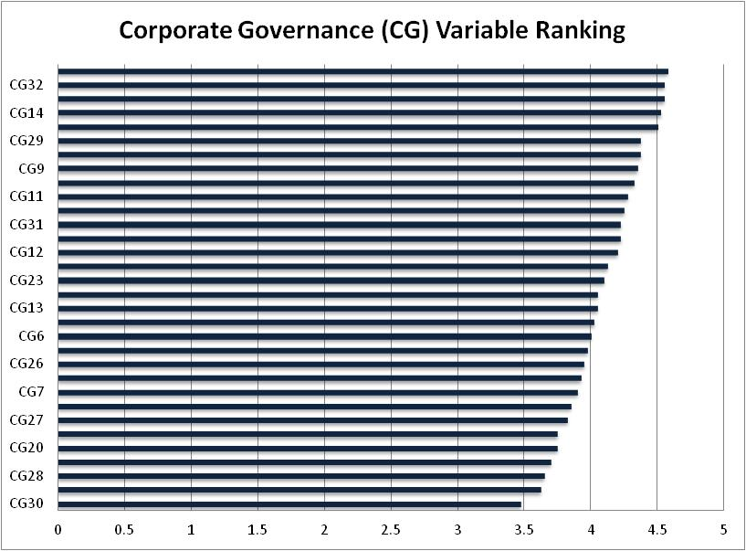
Figure 8.1.1 – Ranking of Corporate Governance (CG) group
Source: SPSS Output processed

It appears that there is a general agreement between the studied companies that “CG3-Comply with legal regulations” is considered one the most important contributors to value creation. This is in agreement with the existing literature in the sense of noncompliance can lead to legal consequences and financial fines resulting in both tangibles and intangible value destruction. Furthermore, the study confirms that the “CG32-internal audits and risk management” are also important value creators. This support the view that the robust audit system adds value and improves firm’s operational performance. “CG2-Comply with international standard” would lead to value creation. Also ‘CG14-information disclosure and audit trails” are cited among the factors that induce confidence in investing in firms. The study also confirms that “CG4-Eliminating corruption and unethical behaviour” would lead to value creation.
These findings were supported by Hussainey et al., 2011; Ahmed et al., 2012; Palmer, 2012; Qiu, 2012; Tang et al., 2012; Tyagi, 2012; Aile & Bausys, 2013; Ghelli, 2013; Jung & Pompper, 2014; Mallin et al., 2014; Tronsgaard & Berger, 2014; Wang & Tuttle, 2014.

8.1.2 Economic (EC) CSR Value Creation practices
The following Figure 8.1.2 shows the most likely Economic (EC) practices that might lead to value creation.
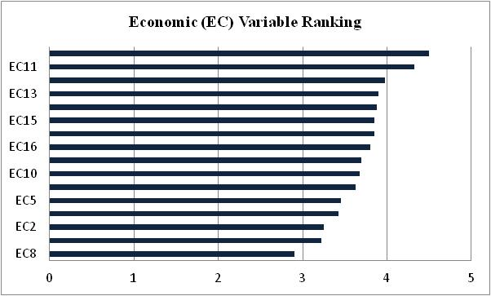
Figure 8.1.2 – Ranking of Economic (EC) group
Source: SPSS Output processed

The most prominent CSR value creation determinants are EC1 and EC11. Indeed, “EC1- Auditing Income/revenue and financial by external bodies” is concerned with the financial credibility, it is well reported in the literature review that is the more transparent and robust the financial reports of the firms the more it is attracting investments. Also, “EC11- Providing information about products/services to customers” is directly related to confidence by the customers on the firm products; the literature review also indicated that the customer satisfaction is a value creator to the firm. Figure 8.1.2 also shows that the majority of respondents’ view the most of Economic CSR determinants as moderately (score above 3) value creators to the firm. The only determinant seems not important is (EC8 - Investing in projects which have serious controversies with the communities). It is well known EC8 leads to destruction of tangible and intangible values of the firm such as corporate image. This result was supported by Aile & Bausys, 2013; Farouk & Hassan, 2013; Flammer, 2013; Cornett et al., 2014; Jung & Pompper, 2014; Krukowska, 2014; Arshad et al., 2015; Saeidi et al., 2015.

8.1.3 Environment (ENV) CSR Value Creation practices
The following Figure 8.1.3 shows the most likely Environment (ENV) practices that might lead to value creation.
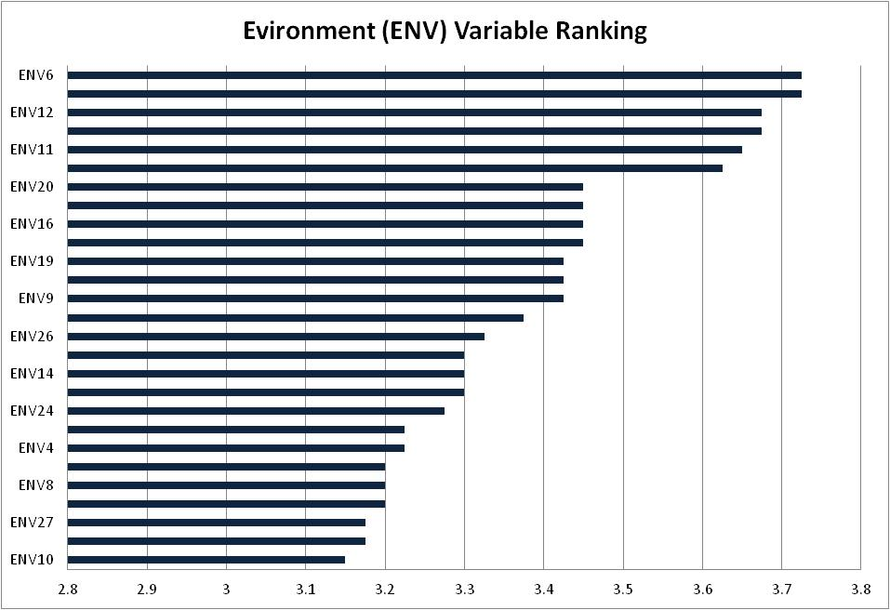
Figure 8.1.3 – Ranking of Environment (ENV) group
Source: SPSS Output processed

In contrast to the previous results it appears that most of the respondents thought that the majority of Environment CSR determinants only contribute moderately to value creation of the firm. It is surprising to see only six have a score above 3.5. Normally in the literatures it is reported that most of Environment CSR determinants add value to firms in one way or another. However, it is comforting to see the respondents thought that (ENV6-Compliance with pollution laws and regulations) is value creator. This finding reinforces the views of expressed in most of CSR literature. Despite the low score of the results, it is interesting that this study confirms (ENV5-Commitment to Environment management systems through ISO certification and other voluntary programs) is also good value creator. This is in keeping with the recent trends of investors seeking investments opportunities in assets which comply with Environment standards. This result was supported by Ahmed et al., 2012; Palmer, 2012; Qiu, 2012; Tang et al., 2012; Tyagi, 2012; Aile & Bausys, 2013; Ghelli, 2013; Krukowska, 2014; Mallin et al., 2014; Tronsgaard & Berger, 2014.

8.1.4 Social (S) CSR Value Creation practices
The following Figure 8.1.4 shows the most likely Social (S) practices that might lead to value creation.
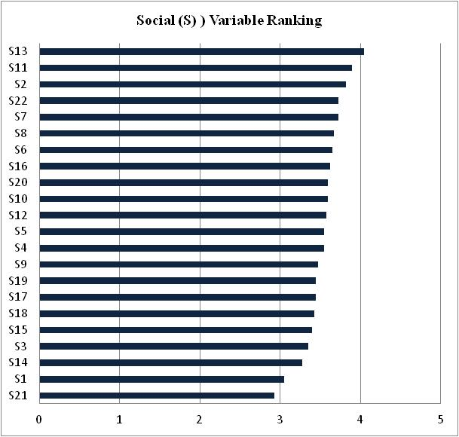
Figure 8.1.4 – Ranking of Social (S) group
Source: SPSS Output processed

The results illustrated in the above Figure 8.1.4 shows that only “S11-Promoting women and minorities in leadership positions”, “S13-Protecting employee health and safety” and “S2-Assisting charity or social vulnerable groups” are likely to contribute to value creation of the firm. Although this Social CSR practices are very important but somehow the results shown in the Figure 8.1.4 above, do not concur with the findings illustrated in the literature. Most of CSR practices are based on Social activities, and it is normally contributing at least to intangible values such as improving firms’ image and reputations. These findings were supported by (Aile & Bausys, 2013; Ghelli, 2013; Jung & Pompper, 2014; Krukowska, 2014; Tronsgaard & Berger, 2014; Wang & Tuttle, 2014; Saeidi et al., 2015).

8.2 New Latent Clusters of CSR practices
The number of extracted CSR determinants from the literature considerably large. In quest to find any underlying patterns among the extract CSR practices factor analysis was performed. Several latent CSR value creation determinants cluster were emerged within each of the initial CSR groups.

8.2.1 New Latent Clusters of Corporate Governance (CGN) determinants
This research created four New Latent Clusters of Corporate Governance (CG) determinates, as following:

CGN1 - Provision of Policies
This cluster is formed from 8 CSR practices i.e. CG10, CG22, CG23, CG24, CG25, CG26, CG27, CG28. This emerged cluster is consistent with the literature on CSR, for example Provision Policies includes: Conflict of Interest, Procedures for conducting internal reviews, Minority Language Policy and Guidance, Progress Reports, Environment Information Regulations, Disability Action Plan and Complaints Policy. The findings of this research supported the studies conducted by Sander, et al., 2001; Orloff, 2003; Rahimi & Noruzi, 2011; Vargas-Hernandez et al., 2011; Ghelli, 2013; Burrell, 2011; Mallin et al., 2014; Tronsgaard & Berger, 2014; European Commission, 2015.
For example Vargas-Hernandez et al. (2011) claimed that the Policy acts a fundamental role within the society. It gives the basics which dictate how the society members supposed to behave. There is a high requirement for a more proud and informed conversation, to make certain that there is fair swap of information and thoughts on some preliminary elucidation of the key issues of provision of policies. Rahimi & Noruzi (2011) claimed that these thoughts are shaped by and derived from: the norms and values the firm included in its strategic planning, society expectations and national standards, and the regulations and law of the country.

CGN2 - Ethical Practices
This cluster is formed from 8 CSR practices i.e. CG1, CG2, CG3, CG4, CG5, CG13, CG20, CG21. It is very well understood in the academic literature the Ethical Practices are an essential element to CSR practices. Ghelli (2013), as they claimed that Business ethics is a kind of professional or applied ethics that investigated the ethical moral and principles that happened in the firms. It is adopted in all areas of the conduct of the firm and is related to the conduct of workers and whole company. These ethics established originally from legal system of the country or from the company policies. The findings of this research supported the studies conducted by Tyagi, 2012; Ghelli, 2013; Tomba & Sanjoy, 2013; Ferrell et al., 2015.
Tomba & Sanjoy (2013) tried to find an answer to question of “How to make CSR work (By institutionalization of ethics), they claimed that a firm should have a sound ethics regulations which needs to be employed effectively. The ethical policy recommended by Tomba & Sanjoy (2013) is as following:

CGN3 - Audit and Legal Issues
This cluster is formed from 8 CSR practices i.e. CG9, CG12, CG14, CG16, CG17, CG29, CG31, CG32. Audit and Legal Issues is extensive procedures that many firms normally conduct to find out whether the firms’ Human Resource policies are updated and whether it satisfies the legal suggestions. The findings of this research supported the studies conducted by Center for Ethical Business Cultures, 2005; Tang, 2012; Tronsgaard & Berger, 2014.
as stated by the “National Association of Legal Fee Analysis”, the Audit and Legal issues is a risk management instrument and a litigation management behaviour , used by the customer of legal services and the insurance people, to identify if inefficiency, abuses, billing mistakes, available by cautiously analysing and determining irrational attorney expenses and obligations. Figure 8.2.1 below shows the typical stages in the audit process.
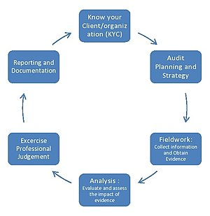
Figure 8.2.1 - Typical stages in the audit process

CGN4 - Equal Opportunities
This cluster is formed from 7 CSR practices i.e. CG6, CG7, CG11, CG15, CG18, CG19, CG30. Equal opportunity came from the like manner behaviour with all worker, without obstacles by preferences or prejudices unless there are a clear justification for certain differences. The findings of this research supported the studies conducted by Global Sullivan Principles, 1999; Hussainey et al., 2011; Oikonomou, 2011.
The new Global Sullivan Principles that was introduced through the UN in 1999 to enlarge the dynamic contribution of firms in the development of social justice and human rights at the global ranking. Based into Global Sullivan Principles, the issues is about to enhance political, social, and economic justice by firms where they operate; to enhance equal opportunity and to promote human rights at the employment levels, including gender and racial diversification on boards and decision-making committees; to develop and promote disadvantaged employees for management Supervisory, and technical, opportunities; and to support with huge ability or willingness among employees; so that, pushing to enhance the life quality for societies, employees and kids with equality and respect. Firms that are obligated to the Global Sullivan Principles believe in providing their performance financial reports of their firms.

8.2.2 New Latent Clusters of Economic (ECN) determinants
This study has created three New Latent Clusters of Economic (EC) determinates, as following:

ECN1: Economic Value
This cluster is formed from 8 Economic CSR practices i.e. EC2, EC9, EC10, EC12, EC13, EC14, EC15, EC16. Economic value is the measurement of the value introduced by the services or the good to any business entity. It is normally calculated by currency units, i.e. what is the highest rate of money a certain factor is able and willing to give for any service or good. The findings of this research supported the studies conducted by Richard, 2006; Cetindamar & Husoy, 2007; Ismail, 2009; Krukowska, 2014; Arshad et al., 2015; Hanemann, 2017.
According to Richard (2006), firms provided broad behaviours of human rights than can be acquired by focusing only on economic values. Cetindamar & Husoy (2007) claimed that by implementing voluntary CSR initiatives that can enhance different stakeholders is to the interest of the company in both short-term and long- term. These interests are not only confined with ethical behaviours like taking care of the environment but also it contains economic values as well like minimising the costs of labours and minimising the waste amount. Ismail (2009) pointed out that the evolution of economic values in a community is one of the measures of CSR.
ECN2: Wealth Distribution
This cluster is formed from 4 Economic CSR practices i.e. EC3, EC4, EC5, EC7. The Wealth Distribution is a comparing between the wealth of worker in a certain community. However, it is totally different from the distribution of the income so that it focuses at the distribution of the economics of the assets’ ownership in a community, and not the present income of worker of that community. The findings of this research supported the studies conducted by Fukukawa, 2009; Mallin et al., 2014; Arshad et al., 2015; Asif & Akbar, 2016.
According to Fukukawa (2009), the Asian firms still have some concerns regarding wealth distribution, supposed to be resolved. On the other hand, Asif & Akbar (2016) argued that the absolute target of most of the organisations is to maximise their profits. Organisation almost have different regulations about the wealth distribution however if they fail to maximise their bottom line they are probably going to face the concerns to enhance their initiatives through raising the capitalization. As a consequence maximise the value of the shareholder is a key issue for both the management and the shareholder of the organisation.

ECN3: Financial Transparency
This cluster is formed from 3 Economic CSR practices i.e. EC1, EC6, EC11. Financial Transparency is a set of policies that aggregate the governments and civil community globally to stop illegal money cash-flows that are incurred cost of about a trillion Euros yearly in a developing nations. The findings of this research supported the studies conducted by Melewar et al., 2005; Noeiaghaei, 2009; Bauhr & Grimes, 2012.
Melewar et al (2005) argued that putting on the consideration what is called “ethical customer” (increasing the stakeholders needs for ethical behaviour practices and financial transparency) and the raising pressure on firms to satisfy the global criteria on CSR has become a major issue for firms reputation. Firms are driven by its reputation, to maintain its financial transparency and keep its promises in all fields.

8.2.3 New Latent Clusters of Environment (ENV) determinants
This study has created two New Latent Clusters of Environment (ENV) determinates, as following:

ENVN1: Environmental Practices
This cluster is formed from 8 Environment CSR practices i.e. ENV1, ENV2, ENV3, ENV4, ENV8, ENV9, ENV10, ENV11, ENV13, ENV14, ENV15, ENV16, ENV17, ENV18, ENV19, ENV20, ENV21, ENV22, ENV23, ENV24, ENV25, ENV26, ENV27. Environment Practices are those which minimise resources wastage and minimise Environment harm, including practices of work, general guidelines and Procedures. The findings of this research supported the studies conducted by Huang, 2008; Iamandi & Filip, 2008; Stern, 2000; Krukowska, 2014; Tronsgaard & Berger, 2014.
Huang (2008) claimed that the legitimacy did not come only from financial issues but it also comes from the Environmental Practices as well. Nowadays, the firm needs more than ever to increase its market share. Iamandi & Filip (2008) claimed that endeavours to report and measure the firm’s effect on community have basically focused on environmental practices. Stern (2000) claimed that the Environmental Practices of people are initiated by adopting CSR in their daily life, such as reducing pollution and reducing materials’ consumption, Moreover; environmental Practices improvement can be attained indirectly by forming the issues in which decisions are made that has an influence over the society the environment.

ENVN2: Environmental Policies
This cluster is formed from 4 Environment CSR practices i.e. ENV5, ENV6, ENV7, ENV12. Environment policies defined as the compliance of the firm to the regulations, laws and any tools used for Environment aspects. It also includes policies of toxic and inhuman substances or energy consumption like industrial waste and pesticide. The findings of this research supported the studies conducted by Brunner & Klein, 1999; Vargas-Hernandez et al., 2011; Qiu, 2012; Ghelli, 2013; Mallin et al., 2014.
Brunner & Klein (1999) claimed that the significance of the customers’ involvement in environmental policy is belonging to the growing resists encountered by authorities with regards to addresses environmental policies. What is it make it more complex for authorities to identify the methods and levels of environmental policy is the scientific uncertainty and multiple stakeholders?

8.2.4 New Latent Clusters of Social (S) determinants
This study has created two New Latent Clusters of Social (S) determinates, as following:

SN1: Internal Social CSR Practices
This cluster is formed from 18 Environment CSR practices i.e. S4, S5, S6, S7, S8, S9, S10, S12, S13, S14, S15, S16, S17, S18, S19, S20, S21, S22. Internal social CSR Practices became more dominant in the business area. How to build a culture that is engaged in life style or based on the recent technology needs more efforts, time and power. Internal Social CSR Practices needs an outstanding responsibility which is a challenge for those employees who are not digitally intelligence. Some major issues to maintain and implement a successful internal social CSR practices are: Engaging with workers, sharing workers stories, listening to workers, and commitment to the firms’ rules and policies. The findings of this research supported the studies conducted by Wood, 2010; Oikonomou, 2011; Calveras, 2013; Saeidi, et al., 2015.
Wood (2010) noted that the reputational consequences of involvement in Internal Social CSR Practices are providing a crucial association among social activities and profits. Calveras (2013) claimed that the Internal Social CSR Practices (for example HR activities, like participation training of worker) can enhance the organisation’s productivity. Moreover, external and internal CSR practices are complements to each other (alternately promote each other), and both of them are associated with improving quality of the product.

SN2: External Social CSR Practices
This cluster is formed from 4 Environment CSR practices i.e. S1, S2, S3, S11. External Social CSR Practices is the system of sharing information about the CSR social effects of firms' economic situations to certain groups of people or to community. The findings of this research supported the studies conducted by Williamson et al., 2006; Gitman et al., 2009; Calveras, 2013; Jung & Pompper, 2014.
Williamson et al. (2006) claimed that the firms’ policies playing a vital role in enhancing the external social practices. Gitman et al. (2009) also asserted that the professional external social practices in the firms will lead to better financial performance in its funds.

8.2.5 New Latent Clusters of Value Creation Metrics
Value Creation is a consumers’ belief about how the benefit or the value will be acquired, experienced, and delivered. It is also a value promise to be acknowledged, communicated, and delivered. A Value Creation can be implemented to the whole firm, or a part of it, or services or products, or consumer account. Kaplan & Norton (2004) claimed that Value Creation is a part of strategy of the firm. According to them "Strategy is based on a differentiated consumers’ value creation. Consumers’ satisfaction is the source of value creation sustainability." Building up a Value Creation is depend on an analysis and review of the value, costs, and benefits that a firm can handed over to its loyal consumers, prospective consumers, in addition to the other Stakeholders. However the Value Creation formula equal the Cost subtracted from the Benefits.
This study created two New Latent Clusters of Value Creation (VC) determinants as following:

VC1: Reputation of the firm
This cluster is formed from only one general CSR practice i.e. “Enhancing corporate reputation (G24)”. Feldman, et al. (2014) has defined the corporate reputation as the collective judgments of the observers’ about the firm based on evaluations of environmental, social, financial effects results from the firm over a period of time. Ingram (2012) claimed that there are three factors of reputation, named (reputational radar); these factors are: Reputation of stakeholder, reputation of the firm, and reputation of the brand. The findings of this research supported the studies conducted by Boussabaine, 2006; Ingram, 2012; Lawal, 2012; Feldman, et al., 2014.
Roberts & Dowling (2002) claimed that organisations with good reputation featured with higher ROA and growth of sales. Sabate & Puente (2003) proved that the benefits of good reputation are exceeding the financial advantages as there are also non-financial advantages. Findings have proved that high degree of consumers’ satisfaction lead to a high level of competitive advantage and reputation (Walsh, et al. 2006). Shamsie (2003) proved that there are a positive association among high level of firms’ performance and good reputation. Current studies proved that that reputation of the firm has a direct correlation with a high level of performance. Helm (2007) proved that a firm with less well-established reputation is considered to be more risky than firms with equivalent financial performance, but with a high reputation. Cabral (2012) proved that level of performance in the firm depends on its reputation, and that reputation based randomly on the organisation’s strategies and efforts to retain it and enhance it. Galbreath & Shum (2012) proved that the best way that helping the organisation to retain and enhance their long-run reputation is to raise the consumer satisfaction.

VC2: Stakeholder Relationships
This cluster is formed from 14 general CSR practices i.e. G26, G27, G28, G29, G30, G31, G32, G33, G34, G35, G36, G37, G38, G39. Value Creation consider as the primary target for any firm. Creating value for consumers helps to sell the goods and services of the firm, however creating value for shareholders increases the profits and expands the market share of the firm. Creating value will also ensure availability of the capital for any future investment. The findings of this research supported the studies conducted by D’Aveni, 1994; Alexander et al., 2002; Venazi & Fidanza, 2006; Schnurbein & Stühlinger, 2015; Minciullo, 2016.
D’Aveni (1994) claimed that distinguished stakeholder relationship is important for successful firms especially in a hyper-competitive community. Evans & Laskin (1994) claimed that by considering the relationships, firms looking for gaining more stakeholder loyalty and satisfaction while stakeholders considering the quality. Alexander et al. (2002) argued that there are many factors about the stakeholders’ interaction that may act as a fundamental role in identifying the relationship importance. They have used two kinds of variables as the key factors of stakeholders’ relationship importance; these variables called (1) inherent risk variables, and (2) situational variables. Inherent risk variables are the risk liked with certain issues due to the type and kind of the exchange relationship such as termination costs performance risk, and financial risk. On the other hand, situational variables is including frequency of contact among the stakeholder and the firm, substitutes availability, services’ amount, of product offering types, and situation favourability.

8.3 Testing for Hypotheses
Studying the hypotheses reproduced below were described and justified in chapter 4. This is linked to the empirical questionnaire and FP data collected through the questionnaire and stock exchange database. The analyses of the hypotheses were presented in chapters 6 and 7. Different experiments were conducted to test this research hypothesis. Summary of the results and evidence relating to the study hypotheses are presented and discussed in the following part.
General hypothesis: CSR practices/ determinants are associated with the Financial Performance (FP) and Value Creation (VC) of UAE publicly listed firms.

Table 8.3 below represents the association between the original CSR groups (i.e. Corporate Governance (CG), Economic (EC), Environment (ENV), Social (S)) as independent variables and the Financial Performance Ratios (FP) as dependent variables.
Table 8.3 - Association between original CSR groups and FP
Source: SPSS Output processed
The summary of the results of the association test based on correlation Test demonstrated that only few CSR value creation practices are associated with Financial Performance (FP). For example, Price to Book Ratio (PB) has association with CG2 only and it is significant at 0.05 level. Return on Asset Ratio (ROA) has association with CG9, CG26, EC5, ENV5, ENV19 and they are significant at 0.05 level. Return on Equity Ratio (ROE) has association with CG8, CG9, CG17, EC13, EC14, EC15, ENV5 and it is significant at 0.05 level, except CG9 and it is significant at 0.01 level. Share Price Ratio (SP) has association with CG26, CG31, EC3, EC14, S15 and they are significant at 0.05 level, except CG31 is significant at 0.01 level. The results here are in concordance with some of the research publication such as Pava & Krausz, 1996; Preston & Bannon, 1997; Hopkins & Cowe, 2003; Curran, 2005; Ian, 2005; Lee, 2010; Malik, 2014; Vo & Nguyen, 2014; Rostami et al., 2016; Akinyi & Melissa, 2017.
8.4 Association between CSR Determinants and “Important area of CSR”
The following parts explain the association between the CSR Determinants as an Independent variables and “Important area of CSR” as dependent Variable.

8.4.1 Association between Corporate Governance (CG) and “Important area of CSR”
With regard the association at P = 0.05 level: the study confirmed that “Important area of CSR” such as: “Governance (G4)”; “Dialogue with the stakeholders (G5)”; “Policy towards employees (G6)”; “Relationship with clients & suppliers (G7)”; “Relationship with the community (G8)”; “Environment protection (G9)”; “Relationship with professional bodies (G10)”; “Relationship with regulators (G11)”, and “Relationship with governmental entities (G12)” are significantly associated with Corporate Governance (CG) CSR determinants CG1, CG2, CG3, CG5, CG9, CG10, CG12, CG13, CG15, CG21, CG28, as shown in Table 8.4a below. On the other hand, as smaller p-value is more significant and much better than bigger value, so that 1% (**) is much better than the results of 5% (*). So that with regard the association at P = 0.01 level: the study demonstrated that “Important area of CSR” such as: “Dialogue with the stakeholders (G5)”; “Policy towards employees (G6)”; “Relationship with professional bodies (G10)” are significantly associated with Corporate Governance (CG) CSR determinants CG2, CG5, CG12, CG15, as shown in Table 8.4b below.

8.4.2 Association between Economic (EC) and “Important area of CSR”
With regard the association at P=0.05 level: the study confirmed that “Important area of CSR” such as: “Governance (G4)”; “Relationship with the community (G8)”; “Relationship with regulators (G11)”, and “Relationship with governmental entities (G12)” are significantly associated with Economic (EC) CSR determinants i.e. EC11 and EC12, as shown in Table 8.4a below. On the other hand, as smaller p-value is more significant and much better than bigger value, so that 1% (**) is much better than the results of 5% (*). So that with regard the association at P=0.01 level: the study demonstrated that there is no significant association with Economic (EC) CSR determinants, as shown in Table 8.4b below.

8.4.3 Association between Environment (ENV) and “Important area of CSR”
With regard the association at P=0.05 level: the study confirmed that “Important area of CSR” such as: “Governance (G4)”; “Policy towards employees (G6)”; “Relationship with clients & suppliers (G7)”; and “Relationship with governmental entities (G12)” are significantly associated with Environment (ENV) CSR determinants ENV1, ENV2, ENV3, ENV5, ENV8, ENV9, ENV11, ENV13, ENV16, ENV19, ENV21, ENV23, ENV24, ENV25, ENV27, as shown in Table 8.4a below. On the other hand, as smaller p-value is more significant and much better than bigger value, so that 1% (**) is much better than the results of 5% (*). So that with regard the association at P=0.01 level: the study demonstrated that “Important area of CSR” such as: “Governance (G4)”; and “Relationship with governmental entities (G12)” are significantly associated with Environment (ENV) CSR determinants ENV4, as shown in Table 8.4b below.

8.4.4 Association between Social (S) and “Important area of CSR”
With regard the association at P=0.05 level: the study confirmed that “Important area of CSR”: such as: “Governance (G4)”; “Dialogue with the stakeholders (G5)”; “Policy towards employees (G6)”; “Relationship with the community (G8)”; “Environment protection (G9)”; “Relationship with regulators (G11)”, and “Relationship with governmental entities (G12)” are significantly associated with Social (S) CSR determinants S1, S2, S5, S6, S7, S9, S10, S17, S18, as shown in Table 8.4a below. On the other hand, as smaller p-value is more significant and much better than bigger value, so that 1% (**) is much better than the results of 5% (*). So that with regard the association at P=0.01 level: the study demonstrated that “Important area of CSR” such as: “Governance (G4)”; “Relationship with the community (G8)”; and “Relationship with governmental entities (G12)” are significantly associated with Social (S) CSR determinants S1, S8, as shown in Table 8.4b below.

8.4.4 Association between Financial Performance (FP) and “Important area of CSR”
With regard the association at P=0.05 level: the Financial Performance was considered here as an Independent variable while the “Important area of CSR” considered as dependent variable. The study confirmed that “Important area of CSR” such as: “Environment protection (G9)” is significantly associated with Financial Performance Ratios: “Price to book Ratio (PB)” and “Return on Asset (ROA)”, as shown in Table 8.4a below. On the other hand, as smaller p-value is more significant and much better than bigger value, so that 1% (**) is much better than the results of 5% (*). So that with regard the association at P=0.01 level: the study demonstrated that there is no significant association with Financial Performance (FP).
Table 8.4a - Association between CSR Determinants “Important area of CSR” (at p = 0.05)
Source: SPSS Output processed
Table 8.4b - Association between CSR Determinants “Important area of CSR” (at p = 0.01)
Source: SPSS Output processed

8.5 Association between CSR Determinants and Value Creation Metrics
The following parts explain the association between CSR Determinants as an Independent variables and Value Creation Metrics as dependent Variable.

8.5.1 Association between Corporate Governance (CG) and Value Creation Metrics
With regard the association at P=0.05 level: The study confirmed that, Value Creation Metrics such as: “Enhancing corporate reputation (G24)”, “Improving relations with suppliers (G25)”, “Strengthen the sense of employee (G26)”, “Increase of the efficiency of the firm operation (G27)”, “Acquisition of commercial benefits (G28)”, “Accessing to credit in good terms (G30)”, “Increasing business volume (G33)”, “Raising company Environment standards (G34)”, “Increasing Employee retention (G35)”, “Strengthen business partner relationships (G36)”, “Protecting consumer privacy (G37)”, and “Dealing with stakeholders’ appeal (G38)” are significantly associated with Corporate Governance (CG) CSR determinants CG6, CG7, CG12, CG17, CG18, CG21, CG24, CG25, CG26, CG28, CG29, CG32, as shown in Table 8.4c below.
On the other hand, with regard the association at P=0.01 level: the study also demonstrated that Value Creation Metrics such as: “Strengthen the sense of employee (G26)”, “Increasing Employee retention (G35)” are significantly associated with Corporate Governance (CG) CSR determinants CG6, CG8, CG15, as shown in Table 8.4d below.

8.5.2 Association between Economic (EC) and Value Creation Metrics
With regard the association at P=0.05 level: the study confirmed that, Value Creation Metrics such as: “Enhancing corporate reputation (G24)”, “Strengthen the sense of employee (G26)”, “Increase of the efficiency of the firm operation (G27)”, “Acquisition of commercial benefits (G28)”, “Accessing to credit in good terms (G30)”, “Increasing corporate profitability (G31)”, “Supporting share price (G32)”, “Raising company Environment standards (G34)”, “Increasing Employee retention (G35)”, “Strengthen business partner relationships (G36)”, “Protecting consumer privacy (G37)”, “Dealing with stakeholders’ appeal (G38)”, “Avoiding unethical behaviour (G39)”, are significantly associated with Economic (EC) CSR determinants EC2, EC3, EC4, EC5, EC6, EC7, EC8, EC9, EC10, EC12, EC13, EC14, EC15, EC16, as shown in Table 8.4c below.
On the other hand, with regard the association at P=0.01 level: the study also demonstrated that Value Creation Metrics such as: “Increase of the efficiency of the firm operation (G27)”, “Acquisition of commercial benefits (G28)”, “Identification of reputational risks (G29)”, “Accessing to credit in good terms (G30)”, “Increasing corporate profitability (G31)”, “Supporting share price (G32)”, “Increasing business volume (G33)”, “Raising company Environment standards (G34)”, “Strengthen business partner relationships (G36)”, “Avoiding unethical behaviour (G39)” are significantly associated with Economic (EC) CSR determinants EC2, EC5, EC9, EC10, EC12, EC13, EC14, EC15, EC16, as shown in Table 8.4d below.

8.5.3 Association between Environment (ENV) and Value Creation Metrics
With regard the association at P=0.05 level: the study confirmed that, Value Creation Metrics such as: “Enhancing corporate reputation (G24)”, “Strengthen the sense of employee (G26)”, “Increase of the efficiency of the firm operation (G27)”, “Acquisition of commercial benefits (G28)”, “Accessing to credit in good terms (G30)”, “Increasing corporate profitability (G31)”, “Supporting share price (G32)”, “Raising company Environment standards (G34)”, “Increasing Employee retention (G35)”, “Dealing with stakeholders’ appeal (G38)”, are significantly associated with Environment (ENV) CSR determinants ENV1, ENV3, ENV4, ENV5, ENV6, ENV8, ENV9, ENV10, ENV14, ENV15, ENV18, ENV19, ENV23, ENV24, ENV25, ENV26, ENV27, as shown in Table 8.4c below.
On the other hand, with regard the association at P=0.01 level: the study also demonstrated that Value Creation Metrics such as: “Enhancing corporate reputation (G24)”, “Improving relations with suppliers (G25)”, “Strengthen the sense of employee (G26)”, “Increase of the efficiency of the firm operation (G27)”, “Acquisition of commercial benefits (G28)”, “Identification of reputational risks (G29)”, “Increasing corporate profitability (G31)”, “Increasing business volume (G33)”, “Strengthen business partner relationships (G36)” are significantly associated with Environment (ENV) CSR determinants ENV4, ENV5, ENV6, ENV7, ENV9, ENV11, ENV25, ENV26, as shown in Table 8.4d below.

8.5.4 Association between Social (S) and Value Creation Metrics
With regard the association at P=0.05 level: the study confirmed that, Value Creation Metrics such as: “Enhancing corporate reputation (G24)”, “Strengthen the sense of employee (G26)”, “Increase of the efficiency of the firm operation (G27)”, “Identification of reputational risks (G29)”, “Accessing to credit in good terms (G30)”, “Increasing corporate profitability (G31)”, “Supporting share price (G32)”, “Increasing business volume (G33)”, “Raising company Environment standards (G34)”, “Increasing Employee retention (G35)”, “Strengthen business partner relationships (G36)”, “Protecting consumer privacy (G37)”, “Avoiding unethical behaviour (G39)”, are significantly associated with Social (S) CSR determinants S1, S2, S3, S4, S7, S10, S12, S16, S17, S22, as shown in Table 8.4c below.
On the other hand, with regard the association at P=0.01 level: the study also demonstrated that Value Creation Metrics such as: “Strengthen the sense of employee (G26)”, “Supporting share price (G32)”, “Increasing business volume (G33)”, “Raising company Environment standards (G34)” are significantly associated with Social (S) CSR determinants S3, S6, S10, S21, as shown in Table 8.4d below.

8.5.5 Association between Financial Performance (FP) and Value Creation Metrics
With regard the association at P=0.05 level: the study confirmed that the Financial Performance Ratios are significantly associated with Value Creation Metrics. Price to Book Ration (PB) is significantly associated with “Increasing Employee retention (G35)”, and “Strengthen business partner relationships (G36)”. Also, Return on Asset (ROA) is significantly associated with “Increase of the efficiency of the firm operation (G27)”, and “Acquisition of commercial benefits (G28)”, as shown in Table 8.4c below.
On the other hand, with regard the association at P=0.01 level: the Financial Performance Ratios are significantly associated with Value Creation Metrics as the following: Price to Book Ration (PB) is significantly associated with “Increasing business volume (G33)”, Also Return on Equity (ROE) is significantly associated with “Improving relations with suppliers (G25)”, Also Share Price (SP) is significantly associated “Accessing to credit in good terms (G30)”, as shown in Table 8.4d below.
Table 8.4c - Association between CSR Determinants and Value Creation Metrics (at p = 0.05)
Source: SPSS Output processed
Table 8.4d - Association between CSR Determinants and Value Creation Metrics (at p = 0.01)
Source: SPSS Output processed

8.6 Association between New Latent Clusters and CSR Value Creation Metrics
Table 8.6 below shows the Pearson Correlation between New Latent Clusters emerged from the Factor Analysis (CGN1, CGN2, CGN3, CGN4, ECN1, ECN2, ECN3, ENVN1, ENVN2, SN1, SN2, VC1, VC2) and the Financial Performance Ratios (PB, ROA, ROE, SP).
Table 8.6 - Association between New Latent Clusters and CSR Value Creation Metrics
Source: SPSS Output processed

As shown in Table 8.6 above, the association test experiments revealed that “Economic Value (ECN1)” has positive association with Value Creation metric (VC2) at P = 0.01. Further, “Wealth Distribution (ECN2)” has negative association with Value Creation metric (VC1) at P = 0.05. Also, “Environmental Practices (ENVN1)” has positive association with Value Creation metric (VC2) at P = 0.01. While, “Environment Policies (ENVN2)” has a negative association with Price to Book Ratio (PB) at P = 0.05, and also has a negative association with Value Creation metric (VC1) at P = 0.05. Finally, Value Creation Metric (VC2) has positive association with Share Price Ratio (SP) at P=0.05.

8.7 CSR determinants as Predictors for Financial Performance (FP)
In the second step: Table 8.7a below shows that after performing the Factor Analysis over the CSR determinants, 11 New Latent Clusters were performed instead of 113 variables. Many Mutliple Regression experimnets were carried out to ingestigate which of the CSR practices are contributers/Predictors to the Finacial Peformance (FP) of the UAE firms. The models which showed significant results are summarised below:
- This study confirmed that the original CSR groups including (CG), (EC), (ENV), (S) groups, were regressed Individually to predict the financial performance indicators (BP), (ROA), (EOE), (SP), but the models were not significant even even by intervening the mediating variables.
- This study confirmed that the original CSR groups including (CG), (EC), (ENV), (S) groups, were regressed Altogether to predict the financial performance indicators (BP), (ROA), (EOE), (SP), but the models were not significant even even by intervening the mediating variables.
- This study confirmed that the New Latent Clusters emerged from Factor Analysis including (CGN1), (CGN2), (CGN3), (CGN4), (ECN1), (ECN2), (ECN3), (ENVN1), (ENVN2), (SN1), (SN2), (VC1), (VC2) groups were regressed Individually to predict the financial performance indicators (BP), (ROA), (EOE), (SP), but the models were not significant even even by intervening the mediating variables.
- This study confirmed that the New Latent Clusters emerged from Factor Analysis including (CGN1, CGN2, CGN3, CGN4), (ECN1, ECN2), (ENVN1, ENVN2), (S1, S2) groups were regressed as a Separate group to predict the financial performance indicators (BP), (ROA), (EOE), (SP) and the results was as the following:
- Corporate Governance New Clusters (CGN1, CGN2, CGN3, CGN4) in conjunction with the mediating variables (G1CSRs, G2Ind, G3Size) Altogether were a good predictor to Share Price (SP) as shown on Table 8.7a below.
- Environment New Latent Clusters (ENVN1, ENVN2) in conjunction with the mediating variables (G1CSRs, G2Ind, G3Size) Altogether were a good predictor to Share Price (SP) as shown on Table 8.7a below.
- Social New Latent Clusters (SN1, SN2) in conjunction with the mediating variables (G1CSRs, G2Ind, G3Size) Altogether were a good predictor to Share Price (SP) as shown on Table 8.7a below.
This view was supported by Hopkins & Cowe, 2003; Ian, 2005; Murray et al., 2006; Hopkins (2007; Banerjee et al., 2009; Richard, 2010; Hoje & Maretno, 2011; Dimson, et al., 2012; Faris et al., 2012; Andreou et al., 2014; Gupta & Sharma, 2014; Koerniadi et al., 2014; Tronsgaard & Berger, 2014; Wang & Tuttle, 2014; Fatemi et al., 2015; Akinyi & Melissa, 2017.
For example, Cormier et al. (2003) finds a positive relationship among CSR practices and Share Price. Also Hopkins (2007) claimed that despite of growing evidences that CSR tend to do better in terms of share price, Wall Street journal and their mirror image in the main financial centre of Tokyo, Frankfurt and London, still confirmed not to understand what CSR is all about as they punch another button flashing money around the world.
Andreou et al. (2014) examined the association among Corporate Governance and firms’ financial management decisions like sub-optimal investment and earnings management in maritime industries. Their findings proved that by using Corporate Governance indicators like the percentage of directors serving on the boards of other organisations and CEO duality, board size, presence of corporate governance committees, insider ownership, are associated with firms’ financial performance and financial management decisions. Gupta & Sharma (2014) have proved that the CSR have imposed effective limitations on the firms’ share prices on a study made on the Indian and South Korean firms to investigate the effect of corporate governance practices on the firms’ financial performance performance. Koerniadi et al. (2014) examined the relationship among Corporate Governance and share price. Their findings proved that, by keeping all the other factors constant, different issues of Corporate Governance like disclosure practices, shareholder rights, and board composition are positively associated with decreasing the risk levels. Tronsgaard & Berger (2014) made a study over the Norwegian listed firms of the Oslo Stock Exchange (OSE) over the time period 2008-2012. They have investigated the effect CSR practices on the firms’ share price. CSR practices includes 1) corporate governance issues such as (Executive compensation, workers relations, Management structure); 2) Environmental issues such as (Sustainability, Hazardous waste, Nuclear energy, Climate change); and 3) Social issues such as (Animal welfare, Consumer protection, Sin stocks, Human rights, Diversity). The findings proved that the organisations focused more on CSR practices have more insurance against volatility in their share price with accordance to negative coverage of the media. Wang & Tuttle (2014) studied the effects of CSR practices on share price, and they found that CSR practices have a positive effect on share price. Fatemi et al. (2015) examined the relationship among community, social, and environmental factors of CSR and firms’ value creation by developing two valuation models. The findings revealed that the CSR practices reduce the firm’s cost of capital and increased its probability of survival. So that, CSR practices may benefit the firm in many issues including governmental entities and customer-advocacy groups empowered to monitor its practices, decrease the costs came from the adverse actions by worker unions, retain and hire a more dedicated worker, firm’s ability to retain a more loyal consumers. On the other hand, Murray et al. (2006) found no relationship among CSR practices and Share Price. However, Hassel et al. (2005) found negative relationship among CSR practices and Share Price.
Table 8.7a – New Latent Clusters (separate groups) as a predictor for FP (Model Summary)
Source: SPSS Output processed
Table 8.7b - New Latent Clusters (separate groups) as a predictor for FP (Coefficients)
Source: SPSS Output processed

- This study confirmed that the New Latent Clusters emerged from Factor Analysis including (CGN1, CGN2, CGN3, CGN4, ECN1, ECN2, ENVN1, ENVN2, SN1, SN2) group in conjunction with the mediating variables (G1CSRs, G2Ind, G3Size) and also in conjunction with Value Creation Variables (VC1, VC2) were regressed Altogether as a Whole group to predict the financial performance indicators (BP), (ROA), (EOE), (SP) and the results and the results shown in Table 8.7c and Table 8.7d below:
- “Ethical Practices (CGN2)”, “Financial transparency (ECN3)” and “Value Creation (VC1)” are significant predictors for Price to Book Ratio (PB).
- “Audit & legal issues (CGN3)”, “Equal opportunities (CGN4)” and “Financial transparency (ECN3)” are significant predictors for Return on Asset Ratio (ROA).
- “Equal opportunities (CGN4)” and “Environment practices (ENVN1)” are significant predictors for Return on Equity Ratio (ROE).
- “Ethical Practices (CGN2)” and “Firms spending on CSR practices (G1CSRs)” are significant predictors for Share Price Ratio (SP).
Table 8.7c - New Latent Clusters (Altogether) as a predictor for FP (Model Summary)
Source: SPSS Output processed
Table 8.7d - New Latent Clusters (Altogether) as a predictor for FP (Coefficients)
Source: SPSS Output processed

- This study confirmed that the New Latent Clusters emerged from Factor Analysis including (CGN1, CGN2, CGN3, CGN4, ECN1, ECN2, ENVN1, ENVN2, SN1, SN2) group in conjunction with the mediating variables (G1CSRs, G2Ind, G3Size) and also in conjunction with financial performance indicators (BP), (ROA), (EOE), (SP) were regressed Altogether as a Whole group to predict the Value Creation Metrics (VC1) and (VC2), and the results shown in Table 8.7e and Table 8.7f below:
- “Wealth Distribution (ECN2)”, “Environment practices (ENVN1)”, “Price to Book Ratio (PB)”, “Share Price (SP)” and “Firms spending on CSR practices (G1CSRs)” are significant predictors for Value Creation (VC1).
- “Ethical Practices (CGN2)”, “Audit & legal issues (CGN3)”, Economic Value (ECN1)”, “Financial transparency (ECN3)”, “Environment Practices (ENVN1)”, Environment Policies (ENVN2)”, “Share Price (SP)” and "Number of CSR indicators the firms discloses (G2Ind)" are significant predictors for Value Creation (VC2).
Table 8.7e - New Latent Clusters and FP as a predictor for VC (Model Summary)
Source: SPSS Output processed
Table 8.7f - New Latent Clusters and FP as a predictor for VC (Coefficients)
Source: SPSS Output processed

- This study confirmed that the New Latent Clusters emerged from Factor Analysis including (CGN1, CGN2, CGN3, CGN4, ECN1, ECN2, ENVN1, ENVN2, SN1, SN2) group in conjunction with the mediating variables (G1CSRs, G2Ind, G3Size) but without financial performance indicators were regressed Altogether as a Whole group to predict the Value Creation Metrics (VC1) and (VC2), and the results shown in Table 8.7g and Table 8.7h below.
- “Wealth Distribution (ECN2)” and “Environment Practices (ENVN1)” are significant predictors for Value Creation (VC1).
- “Ethical Practices (CGN2)”, “Economic Value (ECN1)” and “Financial Transparency (ECN3)” are significant predictors for Value Creation (VC2).
Table 8.7g - New Latent Clusters as a predictor for VC (Model Summary)
Source: SPSS Output processed
Table 8.7h - New Latent Clusters as a predictor for VC (Coefficients)
Source: SPSS Output processed

Thus, it is evident that the CSR practices have a positive and significant relationship with the firms’ financial performance (FP). This supports the general hypothesis of this research which states that CSR practices (CG) are associated with the financial performance and value creation of the UAE firms. These findings supports the research conducted by Rostami et al. (2016), as they investigated whether there is a significant relationship between the corporate governance and two measures of firms’ financial performance (i.e. return on assets (ROA) and Share price (SP)) based on the Tehran Stock Exchange in a 7 years period from 2006 to 2012. The corporate governance covered 6 components including: (CEO tenure, board size, CEO duality, board independence, institutional ownership, concentration of ownership). The Authors used the descriptive analysis, correlation test and multivariate regression test to evaluate the two hypotheses used. The findings revealed that there is a positive and significant relationship between corporate governance and two measures of firms’ financial performance (i.e. return on assets (ROA) and Share price (SP)).

8.8 Emerged CSR Value Creation Conceptual Framework
Figure 8.8 below shows the latent Conceptual Framework of the New Latent Clusters results from the Factor Analysis (more details in Chapter 6). As mentioned in the previous chapters that the CSR independent variables have originally classified to four groups including: 1) Corporate Governance (CG) which consists of 32 variables, 2) Economic (EC) which consists of 16 variables, 3) Environment (ENV) which consists of 27 variables, 4) Social (S) which consists of 22 variables, and 5) General variables (G) group related to the Value Creation variables (VC) which consists of 16 variables. All the previous mentioned 113 variables are factored based on Factor Analysis to be only 13 New Latent Clusters instead of 113 variables as some of these variables are repeated and highly reliable to each other. The 13 variables considered as the New Latent Clusters as the following: Four New Clusters are related to Corporate Governance (CG) named (CGN1, CGN2, CGN3, CGN4). Three New Clusters are related to Economic (EC) named (ECN1, ECN2, ECN3). Two New Clusters are related to Environment (ENV) named (ENVN1, ENVN2). Two New Clusters are related to Social (S) named (SN1, SN2). Finally Two New Clusters are related to Value Creation (VC) named (VC1, VC2).

Figure 8.8 - Emerged CSR Value Creation Conceptual Framework
Source: Author

8.9 New Instruments for the Assessment
According to Boyne (2010), the notion that firms should manage and quantify their (Social and Financial) performance is a crucial concern in management studies and is strenuously recommended by international entities like the World Bank and the OECD. There is a general agreement that firms supposed to examine their (Social and Financial) performance to comply with the raising needs of accountability and transparency towards all the stakeholders and also to enhance the internal decision-making (Meadows & Pike, 2010; Arvidson & Lyon, 2014). For this purpose, scholars and examiners have introduced many instruments and methodologies to measure the performance of the firms (Ebrahim & Rangan, 2014). These instruments and methodologies are showing a great deal of variety and make a comparison between the firms’ performance very tough (Arena et al., 2015). Indeed, Grieco, et al. (2014) opined that “the overall picture remains fragmentary if not confusing”. According to Manetti (2014), there are two antecedents for why instruments and methodologies are below expectations. Firstly, some literatures are “broad” in their approach/ design and do not provide particular measurement instruments or ratios. The advanced instruments and methodologies usually explain frameworks revolved around general suggestions for firms focussing on implementing and designing measurement instruments for the performance. According to Wilson & Post (2013), the current studies examine how the disparities among the expectations of the stakeholder supposed to be considered or they show different procedures that firms can keep implementing the system of the performance measurement. They do not provide any insight into variables that should or can be tested (Manetti, 2014). However, other studies explain relevant variables of the firms’ performance (including Social, Environmental, Governance, Economical, and so on performance), but do not recommend any related performance variables (Nicholls, 2009). In return, other literatures are detailed and are explaining the firms’ performance instrument in particular phenomenon, and make it tough to generalise or repeat with any other firms. For example, Bellucci, et al. (2012), examine the Fair Trade Italian shops performance and the variables examined are directly belonging to the value chain of the fair trade shops and cannot be repeated without adapting to other regulatory approaches. Disparities in methods and approach with regards to measurement of the firms’ performance are belongs to couple of reasons. On one hand, Firms are differing in goals, initiatives, sizes and consequently stakeholders. Therefore, it is very difficult to perform a conceptual model that is appropriate for all kinds of the firms (Arena, et al., 2015). On the other hand, Measurement of the firms’ performance can also aid and support many objectives. In general, Measurement of the firms’ performance has external and internal objectives. An example for the internal instruments used to measure the firms’ performance is that supporting the internal decision-making and enabling firms to internally examine their performance. However, an example for the external instruments used to measure the firms’ performance is that the external reports that is directly affecting the stakeholders’ accountability. There are different criteria used to measure the firms’ performance (Grieco, et al., 2014). As a consequence to this diversification in firms and performance measurement instruments, the one also observe a general agreement on some issues. On one hand, there is a general agreement that the firms’ performance has different dimensions. It is not only what was earlier mentioned, but there is also variation among non-financial and financial performance. Even the non-financial performance has different dimensions as the firms’ performance have an influence on the local society, environmental issues, global community, and employees (Grieco, 2014; Arena, 2015). On the other hand, there is a general agreement that the firms’ performance should not lead to immediate outcomes. A lot of frameworks use a “logic model” or “chain of results” (Ebrahim, 2014) also resources consumed supposed to be considered and also practices followed in the firms (Bagnoli, 2011; Arena, 2015). These models, confirmed the arrangement between the input, productivity, and the output of the firm, can be utilised to assess the outcomes and to guarantee practices alignment of the firm (Van Loon et al., 2013). With regard to the outputs, the variation is made among the short-run outputs and the medium and long-run outputs, usually called impacts or outcomes (Grieco, 2014). In spite of the fact that there is increasing awareness about “impact measurement”, the notions “impact” and “outcomes” are not constantly utilised (Ebrahim & Rangan, 2014). As such, this research examine in details how the performance measurement instruments are developed by following quantitative analysis and building on the points of view and expertise of the different publicly listed UAE firms.

8.10 Recommendations and Contribution
Corporate Social Responsibility (CSR) in UAE is not any more perceived as primitive, it has developed as a main strategic business instrument. Regardless all the mentioned considerations, it should be known that every movement in CSR practices needs a cost except the moral conduct and the ethical behaviour of the firms and its stakeholders. This issue of cost is not trivial so that it cannot be neglected; actually it needs a massive amount of money without any warranty of secure income to the firm in future. Recently, some efforts were adopted through practical research, to figure out the nature and level of CSR practices involvement in UAE firms. Moreover, UAE organizations were examined with regards to CSR-FP association. The Synergistic outcome of the findings can be founded in – “UAE CSR practices and firms’ Financial Performance” (Figure 6.2). This showed valuable image of judging organisations from four perspectives - Corporate Governance (CG), Economic (EC), Environment (ENV), and Social (S), which will be able to modify the business mentality of firms. In spite of the fact that this research did not reach any statistical basis to explain the massive amount of money invested in CSR, it describes the significant role of Corporate Social Responsibility in forming the firms’ Financial Performance (FP). This research did not only contribute to the current research in many directions but it also provides recommendations. This research has limitations encountered in carried out this review was the absence of a trustworthy measurement of Corporate Social Responsibility to assess the UAE firms from a CSR context, although there have been some recent efforts to evaluate CSR practices, such as the Auditing, Facilitating and Consulting. It is worthy to explain that the CSR practices are a source of intangible assets like trade names, trademarks, goodwill, franchises, copyrights and patents. Although the research does not recommend that a CSR is incapable to bring long-term competitive advantages, or is not valuable, CSR seems to be as a superior predictor to FP even if it shows a neutral association. The results of the analysis imply that better CSR practices does not affect the firms’ financial performance, so, it could be more complicated to force the organisations to be more socially responsible. Although, clear information and transparency are needed to be adopted to maintain the welfare of all stakeholders by the shareholders so that firms should be forced to share their financial information in UAE. The questionnaire disclosed that CSR practices of several UAE firms are basically manipulated by human resources or public relations department and not by the CSR department which is harmonised with the of Sagar & Singla (2004) findings. It was also pointed out that the participants were incapable to distinguish among philanthropic and CSR practices. It was also noticed that the rate of responses to the questionnaire was very low as most of organisations are not adopting structured CSR system on a regular manner. It was also believed that rightly intensive projects are not related to the internal activities, it is directly connected to society development like corporate governance, disclosures and transparency. However, it is suggested to come up with a formal CSR strategy focusing at long-run objectives of organisations. Moreover, a devoted CSR department or network or even team supposed to be initiated to address the key CSR practices required.
8.11 Conclusion
The following conclusion will be drawn from this research:
- The other CSR literature neglected value creation through CSR practices. The practice of CSR within a strategic scope is an integral part of the firms' strategies.
- The CSR practices in UAE are considered to inadequate up to now. This research has examined the motives and views of UAE’s publicly listed firms for value creation CSR practices in addition to its contribution and association to financial performance.
- Findings from this research revealed that publicly listed firms in UAE normally view several CSR practices as being a strategic view toward promoting the value creation and overall credential of their businesses.
- This study found a positive association between UAE firms’ CSR practices and their Financial Performance “Share Price (SP)”.
- The results of this research have an important practical and theoretical implication. In practical, the research results revealed that the decision makers should put more resources and efforts on their CSR practices as their firms will be rewarded by their stakeholders and the long-term profitability. Moreover, the admitting, evolution and execution of CSR practices should be structured, and not accidental, for gaining the related favourable benefits. In theory, this research has contributed to the current research in many ways. 1) It empirically proves the validity of the relationship among CSR practices and firms’ Financial Performance. 2) It adds the UAE perception about CSR to the growing Middle East current research on CSR, so that promoting the current understanding of how firms in UAE and Middle East view the impact of CSR practices on Firms’ Financial Performance.

8.12 Research Limitations
Like the other research, this research is also not impacted by some unwanted issues. Indeed, this study is suffering from some level of subjectivity (reality, truth, conscious) and it is not totally free from bias. The questionnaire depends on a single participant from each organisation that has constrained the sample size of the study. Maybe using many participants could lead to high level of reliability to measure the CSR in UAE context. The regression test was performed on a comparatively little number of sample UAE firms – (40 firms which is reduced to be 22 firms after performing the Factor Analysis) and their reporting time compared to the other research was very short – one years. According to Fauzi (2009), the coverage time of the research is significant because the features of CSR and FP are discretionary, in the sense that the CSR and the FP have no direct association. For this purpose, there is a preference toward a time lag to figure out the association. It was also noticed that the cross section of the sample are consisting of 10 sectors of industries. Field covered by each sector consider unique and differ from each other, however, Griffin & Mahon (1997) claimed that the comprehensive analysis among different type of industries could miss industry-certain areas. In addition, this research is constrained by the time period impact.
Another limitation of this research is that it considered only one country of many emerged countries, as UAE considered as emerged country which has some standards from developed countries, but does not yet meet characteristics to be a developed country, so that, the findings of this research may not be generalizable among other emerged nations. So that, future studies supposed to maximise the sample size and to consider the CSR practices and the pertinence of the conceptual framework to other emerged nations in the direction of widening a realizing of CSR practices and its relationship to the firms’ financial performance in the context of the whole emerged nations. Another point of limitations is that being unable to quantify the whole contributions of firms’ donations to Charities including non-cash issues. Old contributions like Campbell et al. (2006) roughly calculated that cash estimated for about 75 percent of the total amount of donations. So that, for the purpose of invalidating the results of this research, the firms should not heavily depending on non-cash contributions by the poor-vision firms (Slack, 2010). These results suggested different directions for further studies. To comply with the visibility, other testable concerns could be investigated. So far as donate to charity is one instrument in which some stakeholder opined that it could be controlled, another such stakeholder-controlling practices could also be examined. These could comprise political issues, social practices, and similar initiatives. One more limitation is that this research is limited to only 20% of the UAE publicly listed firms. Future studies could examine the CSR-FP relationship of all the UAE listed firms. Future studies could also examine the changes in activities between unlisted and listed firms.

8.13 Suggestions for Future Research
A number of potential suggestions have been identified during the course of this research.
- There are many issues needed to be considered in the future studies like market risk profile, multi-nationality and industry sector.
- Examine the causal relationship among CSR practices and firms’ financial performance and whatever the findings are, identify whether or not this association kept consistent over time.
- Investigate about the duration of the effect of CSR practices on firms’ Financial Performance.
- More Financial Performance ratios can be added, like Tobin Q, Economic Value Added (EVA), and Market Value Added (MVA) to examine the financial performance of the organisation.
- If there are no problems toward multicollinearity test, different CSR practices could also be utilised in econometric analysis.
- Increasing the time period of the study and the number of firms of sample size can extensively change the findings.
- Keeping a certain year lag among CSR determinant and ratios of financial performance can be adopted to check if there is a time lag associated with the CSR practices and improving the firms’ financial performance.
- More variables could be considered to examine the attribution among the CSR practices and firms’ financial performance.
- Taken into account that CSR practices involved important administrative and programmatic costs on firms and only financially robust organisations are capable to adopt CSR practices on the long-term and can bear the cost of CSR investments or practices on the long-term and can bear the cost of CSR investments or practices.
CSR practices are not a single action but actually it is a collective action for many different practices (Godfrey & Hatch, 2007). In other words, it should not be believed that the impact of CSR practices exists only in a unique indicator of firms’ financial performance. CSR denote that firms making alternatives, not only relying on profit amount but also the best alternatives for community, as most of private firms are normally motivated by profit margin and not philanthropic goals. Regrettably, if the absolute objective of the firm is a high profit, factors like safety approach, labour and sustainable raw materials could be compromised or ignored for the purpose of increasing profits. From a moral viewpoint, these points are subjective and adopted to change, makes it possible to discuss over the alternatives researcher needs.

References:

aa1000 (2016). Assurance Accountability Principles standard. http://dqs-cfs.com/wp-content/uploads/2016/06/12_AccountAbility_David-Pritchett.pdf

Abu-Baker, N. & Naser, K. (2000). Empirical evidence on corporate social disclosure (CSD) practices in Jordan. International Journal of Commerce and Management, 10(3/4): 18-34

ADX, (2017). Abu Dhabi Securities Exchange, https://www.adx.ae/English/News/Pages/20160918160117137.aspx

Ahmad, N.S. & Gao, S.S. (2005). Corporate environmental reporting in Libya: A study of absence. Social and Environmental Accounting Journal, 25(5): 11-14

Ahmed, S.U., Islam, M.Z., Hasan, I. (2012). Corporate social responsibility and financial performance linkage. Evidence from the banking sector of Bangladesh; 1(1): 14–21.

Aile, S. & Bausys, Z. (2013). Corporate Social Responsibility and Financial Performance: The Example of Estonia, Latvia, Lithuania. Master Thesis. The Stockholm school of Economics. MSc in Business & Economics

Akgül, A. & Çevik, O. (2005). İstatistiksel Analiz Teknikleri: SPSS’te İşletme Yönetimi Uygulamaları. Emek Ofset, Ankara.

Akhtaruddin, M. (2005). Corporate mandatory disclosure practices in Bangladesh. International Journal of Accounting, 40:399-422

Akinyi, O.M. & Melissa, A.G. (2017). Effect of Earnings Announcement on Share Prices of Companies Listed at the Nairobi Securities Exchange. European Business & Management. 3(2): 29-36. 10.11648/j.ebm.20170302.13

Akrout, M.M. & Othman H.B. (2013). A Study of the Determinants of Corporate Environmental Disclosure in MENA Emerging Markets. Journal of Reviews on Global Economics, 2: 46-59

Aksoylu, S. (2013). Relationships of corporate social responsibility (CSR) with accounting information systems: A study. Journal of Modern Accounting and Auditing, 9(12): 1678-1686

Al Shammari, B. (2008). Voluntary Disclosure in Kuwait Corporate Annual Reports. Review of Business Research, 1: 10−30

Al-Shubiri, F.N., Al-Abedallat, A.Z., & Abu Orabi, M.M. (2012). Financial and Non-Financial Determinants of CSR. Journal of Knowledge Management, Economics and Information Technology. Issue 5

Al-Haddad, W.M.Y, Alzurqan, S.T. & Al-Sufy, F.J. (2011). The Effect of Corporate Governance on the Performance of Jordanian Industrial Companies: An empirical study on Amman Stock Exchange. International Journal of Humanities and Social Science, 1(4)

Alafi, K. & Hasoneh, A.B. (2012). Corporate social responsibility associated with customer satisfaction and financial performance a case study with Housing Banks in Jordan. International Journal of Humanities and Social Science, 2(15): 102–115

Alarussi, A.S., Hanefah, M.M. & Selamat, M.H. (2009). Internet financial and environmental disclosures by Malaysian companies. Issues in Social and Environmental Accounting, 3(1): 3-25

Alexander, C.S., Miesing, P., Parsons, A. (2002). How important are Stakeholder Relationships.

Ali, U. (2011). Determinants of corporate reporting on the internet: An analysis of companies listed on the Istanbul Stock Exchange (ISE). Managerial Auditing Journal, 27(1): 87-104

Aljifri, K. & Khasharmeh, H. (2006). An investigation into the suitability of the international accounting standards to the United Arab Emirates environment. International Business Review, 15(5): 505-526.
Alkababji, M.W. (2014). Voluntary disclosure on Corporate Social Responsibility: A study on the Annual reports of Palestinian corporations. European Journal of Accounting Auditing and Finance Research, 2(4): 59-82

Alpkan, L., Ergün, E., Bulut, C., & Yılmaz, C. (2005). Şirket Girişimciliğinin Şirket Performansına Etkileri. Doğuş Üniversitesi Dergisi, 6(2): 175-189.

Aly, D., Simon, J. & Hussainey, K. (2010). Determinants of corporate internet reporting: evidence from Egypt, Managerial Auditing Journal, 25(2): 82–202

Andreou, PC., Louca, C., Panayides, PM. (2014). Corporate governance, financial management decisions and firm performance: Evidence from the maritime industry. Transportation Research Part E, 63: 59–78.

Archel, P. (2003). Social and environmental information reporting of big size Spanish firms in the period 1994-1998. Spanish Journal of Finance and Accounting, 32(117): 571-601

Arena, M.; Azzone, G.; Bengo, I. (2015). Performance measurement for social enterprises. International Journal of Voluntary and Nonprofit Organizations (VOLUNTAS), 26: 649–672.

Arendt, S. & Brettel, M. (2010). Understanding the influence of corporate social responsibility on corporate identity, image, and firm performance. Management Decision, 48(10): 1469-1492

Arif, K. & Akbar, W. (2016). Impact of Accounting Information on Share Price: Empirical Evidence from Pakistan Stock Exchange. International Finance and Banking, 3(1). ISSN 2374-2089

Arora, D. & Rana, G.A. (2010). Corporate and Consumer Social Responsibility: A Way for Value Based System. Proceedings of AIMS International Conference on Value-based Management, 11-13 August.

Arshad, I.S., Muhammad, T., Al-Astal A.Y.M. (2015). Empirical Study on Corporate Social Responsibility in United Arab Emirates. International Journal of Scientific and Research Publications, 5(7), ISSN 2250-3153

Arvidson, M. & Lyon, F. (2014). Social impact measurement and non-profit organisations: Compliance, resistance, and promotion. International Journal of Voluntary and Nonprofit Organizations (VOLUNTAS), 25: 869–886.

Astin, A.W. (1992). What Matters in College: Four Critical Years Revisited. San Francisco: Jossey-Bass

Bakker-de, F.G.A., Groenewegen, P. & den-Hond, F. (2005). A Bibliometric Analysis of 30 years of Research and Theory on Corporate Social Responsibility and Corporate Social Performance. Business and Society, 44(3): 283-317

Barnard, C.I. (1938). The Functions of the Executive. Cambridge: Harvard University Press.

Banerjee, A., Gokarn, S., Pattanayak, M. & Sinha S.K. (2009). Corporate Governance and Market Value: Preliminary Evidence from Indian Companies, Standard & Poor, (7): 166-178.

Barako, D.G., Hancock, P. & Izan, H.Y. (2006). Relationship between corporate governance attributes and voluntary disclosures in annual reports: The Kenyan experience. Financial Reporting, Regulation and Governance. 5(1): 1-25

Barako, D.G. (2007). Determinants of voluntary disclosures in Kenyan companies annual reports. African Journal of Business Management, 1(5): 113-128

Barnett, M.L. (2005). Stakeholder influence capacity and the variability of financial returns to corporate social responsibility. Academy of Management Review in special topic forum on ‘Corporations as social change agents’.

Barnett, M.L. (2007). Stakeholder Influence Capacity and the Variability of Financial Returns to Corporate Social Responsibility. Academy of Management Review, 32(3): 794–816

Bauhr, M. & Grimes, M. (2012). What is government transparency - New Measures and Relevance for Quality of Government? Working paper series 2012:16. The quality of government institute. ISSN 1653-8919

Bayoud, N.S., Kavanagh, M. & Slaughter, G. (2012). Factors Influencing Levels of Corporate Social Responsibility Disclosure by Libyan Firms: A Mixed Study, International Journal of Economics and Finance, 4(4); April 2012.

Becchetti, L., Pelloni, A., & Rossetti, F. (2008). Relational goods, sociability, and happiness. Kyklos, 61(3), 343–363. http://doi.org/10.1111/j.1467-6435.2008.00405.x

Bedi, H.S. (2009). Financial Performance and Social Responsibility: Indian Scenario. Working Paper.

BelalUddin, M., Hassan, M.R. & Tarique, K.M. (2008). Three Dimensional Aspects of Corporate Social Responsibility. Daffodil International University. Journal of Business and Economics, 3(1).

Belkaoui, A. & Karpik, P.G. (1989). Determinants of the corporate decision to disclose social Information. Accounting, Auditing and Accountability, 2(1): 36-49.

Bellucci, M.; Bagnoli, L.; Biggeri, M.; Rinaldi, V. (2012). Performance measurement in solidarity economy organizations: The case of fair trade shops in Italy. Annals of Public and Cooperative Economics Journal, 83: 25–59.

Ben-Zion, U. (1984). The R&D and investment decision and its relationship to the firm’s market value: some preliminary results. In: Griliches Z, editor. R&D, patents, and productivity. Chicago: University of Chicago Press. 134–62.

Berman, S.L., Wicks, A.C., Kotha, S. & Jones, T.M. (1999). Does Stakeholder Orientation Matter? The Relationship between Stakeholder Management Models and Firm Financial Performance. Academy of Management Journal, 42(5): 488–506.

Bhagat, S. & Black, B. (2000). Board independence and long term firm performance. (CLES Working Paper No. 143). http://leeds-faculty.colorado.edu/bhagat/bb-031700.doc

Bhagat, S. & Black, B. (2002). The non-correlation between board independence and long-term firm performance. Journal of Corporation Law, 27(2): 231-274.

Bhattacharya, C.B. & Sen, S. (2004). Doing better at doing good: When, why and how consumers respond to corporate social initiatives. California Management Review, 47(1): 9−24.

Bird, R., Casavecchia, L. & Reggiani, F. (2006). Corporate Social Responsibility and Corporate Performance: Where to Begin. Working Paper, University of Technology, Sydney and Bocconi University, Milan.

Blue Book of Corporate Social Responsibility (2009). Economics Division of China Academy of Social Science. (2009). Research Report on Corporate Social Responsibility of China. China: Social Sciences Academic Press (China).

Boaventura, J.M.G., Silva, R.S.da, & Bandeira-de-Mello, R. (2012). Corporate Financial Performance and Corporate Social Performance: Methodological Development and the Theoretical Contribution of Empirical Studies. Revista Contabilidade and Financas, 23(60): 232–245

Bourguignon, A. (1995). Peut-on Definer La Performance? Revue Francais de Gestion, (August).

Boussabaine, A.H. (2006). Cost Planning of PFI and PPP Building Projects. Taylor & Francis, ISBN10: 0–415–36622–4 (hbk).

Bowen, H.R. (1953). Social responsibilities of businessman. New York: Harper & Row

Bowman, E.H. & Haire, M. (1976). Social impact disclosure and corporate annual reports, Accounting, Organisations and Society, 1(1): 1-21
Boyne, G.A. (2010). Performance management: Does it work. Public Management and Performance; Cambridge University Press: Cambridge, UK; pp. 207–226.

Boztosun, D. & Aksoylu, S. (2016). Relationships of Corporate Social Responsibility with Perceived Financial Performance of Businesses: A Study. Journal of Modern Accounting and Auditing, 12(2): 111-118.

Brammer, S. & Millington, A. (2005). Corporate reputation and philanthropy: An empirical analysis. Journal of Business Ethics, 61: 29-44

Brammer S., Millington, A., & Pavelin, S. (2006). Is Philanthropy Strategic? An Analysis of the Management of Charitable Giving in Large UK Companies. Business Ethics, 15(3).

Branco, M.C. & Rodrigues, L.L. (2008). Factors influencing Social Responsibility Disclosure by Portuguese Companies. Journal of Business Ethics, 83: 685-701

Brik, A. (2009). Toward Green Economy in the United Arab Emirates: Responsible Business and Sustainable Consumption. URI: http://csrarabia.wordpress.com/2009/10/28/toward-green-economy-in-the-united-arab-emiratesresponsible-business-and-sustainable-consumption

Brine, M., Brown, R. & Hackett, G. (2007). Corporate Social Responsibility and Financial Performance in the Australian Context. Autumn, 47–58

Brown, L.D., & Caylor, M.L. (2004). Corporate Governance and Firm Performance, Georgia State University, USA (Working Paper).

Brunner, R.D.; Klein, R. (1999). Harvesting experience: A reappraisal of the U.S. Climate Change Action Plan.
Policy Sci., 32, 133–161.

Bujaki, M., & McConomy, B. J. (2002). Corporate Governance: Factors Influencing Voluntary Disclosure by Publicly Traded Canadian Firms. Canadian Accounting Perspectives, 1 (2):105-139.

Burrell, A. (2011). Evaluating Policies for Delivering Agri-environmental Public Goods. OECD Workshop, 20-22 June. The Johann Heinrich von Thünen Institute, Braunschweig, Germany

Business dictionary, (2016). URI: http://www.businessdictionary.com/definition/governance.html

Cabral, L.M.B. (2012). Living up to expectations: Corporate reputation and sustainable competitive advantage. Working papers. New York University, Leonard N. Stern School of Business, Department of Economics

Calveras, A. (2013). External and internal corporate social responsibility: complements through product quality - Evidence from the hotel industry. Universitat de les Illes Balears, Spain.

Camfferman, K. & Cooke, T. (2002). An Analysis of Disclosure in the Annual Reports of UK and Dutch Companies. Journal of International Accounting Research, 1:3-30.

Campbell, D.J., Moore, G. and Shrives, P.J. (2006). Cross-sectional effects in community disclosure. Accounting, Auditing & Accountability Journal, 19(1): 96-114.

Campbell, D. & Slack, R. (2008). Corporate ‘Philanthropy Strategy’ and ‘Strategic Philanthropy’: Some Insights from Voluntary Disclosures in Annual Reports. Business and Society Journal, 47(2): 187-212

Cancel, A.E., Cameron, G.T., Sallot, L.M. & Mitrook, M.A. (1997). It Depends: A Contingency Theory of Accommodation in Public Relations. Public Relations Research Journal, 9(1): 31–63

Carroll, A.B. (1979). A Three-Dimensional Conceptual Model of Corporate Performance. Academy of Management Review, 4: 497-505

Carroll, A.B. (1991). The Pyramid of Corporate Social Responsibility: Toward the Moral Management of Organizational Stakeholders. Business Horizons, 34: 39-48

Carroll, A.B. (1999). Corporate Social Responsibility: Evolution of a definitional construct. Business and Society 38(3): 268–295

Carroll, A.B. & Buchholtz, A.K. (2008). Business and Society: Ethics and Stakeholder Management. Ohio: South-Western Cengage Learning.

Carroll, A.B. & Shabana, K. M. (2010). The Business Case for Corporate Social Responsibility: A Review of Concepts, Research and Practice. International Journal of Management Reviews, 12(1): 85-105.

Cavaco, S. & Crifo, P. (2010). Complementarity between CSR Practices and Corporate Performance: An Empirical Study

Cengiz, H. (2016). Corporate Governance and Firm Profitability: Evidence from Turkey. International Journal of Trade, Economics and Finance, 7(6).

Centre for Ethical Business Cultures (2005). Corporate Social Responsibility – The shape of a history (1945-2004). Working Paper No. 1

Cetindamar, D. & Husoy, K. (2007). Corporate Social Responsibility Practices and Environmentally Responsible Behavior: The Case of The United Nations Global Compact. Journal of Business Ethics, 76:163–176. DOI 10.1007/s10551-006-9265-4

Chambers, E., Chapple, W., Moon, J. & Sullivan, M. (2003). CSR in Asia: A seven country study of CSR website reporting. International Centre for Corporate Social Responsibility, Research Paper Series- 09-2003.

Chapardar, H., & Khanlari, R. (2011). Iranian corporations and corporate social responsibility: An overview to adoption of CSR themes. SAGE. URI: http://sgo.sagepub.com/content/early/2011/11/18/2158244011430988

Chatterjee, D. (2016). Exploring the scope of CSR for sustainable smart cities in India. International Research. Journal of Human Resources and Social Sciences, 3(3). ISSN (O): (2349-4085) ISSN(P): (2394-4218)

Chen, C. (2010). Measuring Corporate Social Performance: An Efficiency Perspective. Doctoral Thesis, UCLA Institute of the Environment, University of California, Los Angeles.

Chen, H. & Wang, X. (2011). Corporate Social Responsibility and Corporate Financial Performance in China: An Empirical Research from Chinese Firms. Corporate Governance, 11(4): 361-370.

Chen, B.H., Chen, M.H., Tai1 P.N & Hsiung, W.C. (2015). Constructing the Corporate Social Responsibility Indicators of Professional Sport Organization. International Journal of Business Administration, 6(5). URI: http://ijba.sciedupress.com

Cheung, Y., Jiang, K. & Tan, W. (2012). Doing-good’ and ‘Doing-well’ in Chinese Publicly Listed Firms. China Economic Review. Forthcoming.

Chirieleison, C. (2004). L'evoluzione del concetto di corporate social responsibility. Rusconi, G., Dorigatti, M. & La responsabilità sociale d'impresa. Milan: Franco Angeli.

Chow, C.W. & Wong-Boren, A. (1987). Voluntary disclosures by Mexican corporations. The Accounting Review, 62(3): 533-541.

Cochran, P.L. & Wood, R.A. (1984). Corporate Social Responsibility and Financial Performance. Academy of Management Journal, 27: 42-56.

Connelly, J. T., & Limpaphayom, P. (2004). Environmental reporting and firm performance: evidence from Thailand. The Journal of Corporate Citizenship, 13: 137-149.
Cooke, T.E. & Wallace, R.S. (1990). Financial disclosure regulation and its environment: A review and further analysis. Journal of Accounting and Public Policy, 9(2): 79-110.

Cooke, T.E. (1991). An assessment of voluntary disclosure in the annual report of Japanese corporations. The International Journal of Accounting, 26(3): 174-189.

Cooke, T.E. (1992). The Impact of Size, Stock Market Listing and Industry Type on Disclosure in the Annual Reports of Japanese Listed Corporation. Accounting and Business Research, 22(7): 229-237.

Cooke, T.E. (1993). Disclosure in Japanese Corporate Annual Reports, Journal of Business Finance and Accounting, 20(4): 521–535.

Cormier, D. & Magnan, M. (2003). Environmental reporting management: a continental European perspective. Journal of Accounting and Public Policy, 22(1): 43-62.

Cormier, D & Morgan, M (2004). The impact of the Web on information and communication modes: The case of corporate environmental disclosure, International Journal of Technology Management, 27(4): 393-416.

Cormier, D., Magnan, M. & Van-Velthoven, B. (2005). Environmental Disclosure Quality in Large German Companies: Economic Incentives, Public Pressures or Institutional Conditions. European Accounting Review 14(1): 3–39. URI: 10.1080/0963818042000339617.

Cornell, B. & Shapiro, A.C. (1987). Corporate stakeholders and corporate finance, Financial Management, spring, 5-14.

Cowen, S.S., Ferreri, L.B. & Parker, L.D. (1987). The impact of corporate characteristics on social responsibility disclosure: A typology and frequency-based analysis, Accounting, Organisations and Society, 12(2): 111-22.

Creswell, J. W. (2009), Research design- qualitative, quantitative, and mixed methods approaches. California: Sage Publications.

Curran, M.M. (2005). Assessing the Rate of Return of the Adoption of Corporate Social Responsibility Initiatives. Doctoral Thesis submitted to University of Edinburgh.

D’Aveni, R.A. (1994). Hyper competition: Managing the dynamics of strategic maneuvering. New York: The Free Press.

Da-Silva A.L.C. & Leal, R.P.C. (2005). Corporate governance index, firm valuation and performance in Brazil. Brazilian Review of Finance, 3(1): 1-18.

Davey, H.B. (1982). Corporate Social Responsibility Disclosure in New Zealand: An Empirical Investigation. Unpublished Working Paper, Massey University, Palmerston North, New Zealand.

Davis, K. (1960). Can business afford to ignore social responsibilities. California Management Review 2(3): 70–76.

Davis, K. (1973). The case for and against business assumption of social responsibilities. Academy of Management Journal, June, pp. 312–322.

Davies, G., Chun, R., da Silva, R.V. & Roper, S. (2003). Corporate reputation and competitiveness. London: Routledge.

Davis, K. (1975). Five propositions for Social Responsibility. Business Horizons Journal, 18(3): 19-24.

Deegan, C. & Gordon, B. (1996). A study of the environmental disclosure policies of Australian corporations. Accounting & Business Research, 26(3): 187-99.

Deegan, C., Rankin, M. & Tobin, J. (2002). An examination of the corporate social and environmental disclosures of BHP from 1983-1997: A test of legitimacy theory. Accounting, Auditing, & Accountability Journal, 15(3): 312-333.
Delery, J.E. & Doty, D.H. (1996). Modes of Theorizing in Strategic Human Resource Management: Tests of Universalistic, Contingency and Configurational Performance Predictions. Academy of Management Journal, 39: 802-835

Depoers, F. (2000). A Cost Benefit Study of Voluntary Disclosure: Some Empirical Evidence from French Listed Companies. European Accounting Review, 9 (2): 245-263.

DFM, (2017). Dubai Financial Market. http://www.dfm.ae/

Dimson, E., Karakas, O. & Li, X. (2012). Activism in Corporate Social Responsibility. Presented at the Annual Meetings of the Financial Management, Europe in Istanbul.

Donaldson, T. & Dunfee, T.W. (1999). Ties That Bind, Harvard Business school press, Boston, MA.

Doupnik, T.S. & Salter, S.B. (1995). External environment, culture, and accounting practice: a preliminary test of a general model of international accounting development. International Journal of Accounting, 30(3): 189-207.

Dorina, P., Victoria, B., & Diana, B. (2012). Aspects of Company Performance Analysis Based on Relevant Financial Information and non-Financial. Economic Science Series, 1(July), 956–961.

Drobetz, W., Schillhofer, A., & Zimmermann, H. (2003). Corporate governance and firm performance: Evidence from Germany. Basel, Switzerland: University of Basel. Mimeographed document. URI: http://www.cofar.uni-mainz.de/dgf2003/paper/paper146.pdf

Drucker, P.F. (1954). The practice of management. New York: Harper & Row.

Ducassy, I. (2013). Does Corporate Social Responsibility Pay Off in Times of Crisis? An Alternate Perspective on the Relationship between Financial and Corporate Social Performance. Corporate Social Responsibility and Environmental Management, 20: 157–167.

Easterby-Smith, M., Thorpe, R. & Lowe, A. (1991). Management research: an introduction Sage Publications, London.

Ebrahim, A. & Rangan, V.K. (2014). What impact? A framework for measuring the scale and scoop of social performance. California Management Review. 56: 118–141.

Eccles, R.G. & Youmans, T. (2015), Materiality in Corporate Governance: The Statement of Significant Audiences and Materiality, Boston: Harvard Business School, working paper no. 16-023.

Echave, J.O. & Bhati, S.S. (2010). Determinants of social and environmental disclosures by Spanish Companies. GSMI 3rd Annual International Business Conference, pp. 55-68. Michigan, USA: Global Strategic Management Inc.

Eilbert, H., & Parket, I.R. (1973). The current status of corporate social responsibility. Business Horizons, 16: 5-14.

Engardio, P., Capell, K., Carey, J., & Hall, K. (2007). Beyond the green corporation. Business Week, 29, 25–29.

Epstein, M.J., & Roy, M.J. (2001). Sustainability in action: Identifying and measuring the key performance drivers. Long Range Planning, 34(5): 585-604.

Ergin, E. (2012). Corporate governance ratings and market-based financial performance: Evidence from Turkey. International Journal of Economics and Finance, 4(9): 61.

Ernst & Ernst (1978). Social Responsibility Disclosure: 1978 Survey, Ernst and Ernst, Cleveland, OH.

European Union Council (2003). Regulation (EC) No/ 2003 of the European Parliament and of the Council. European Commission. 17-3-2003. http://europa.eu.int/comm/food/fs/gmo/gmo_ongoinit_01_en_pdf

EU Commission (2015). Improving Policy and Provision for Adult Learning in Europe. Education and Training 2020. B-1049 Brussels.

Eyler, J. & Giles, D.E. (1999). Where's the Learning in Service-Learning. San Francisco: Jossey-Bass. ISBN 0787944831, 0787944831.

Faris, N., Abedalfattah, Z. & Marwan, M.A.O. (2012). Financial and non-financial determinants of corporate social responsibility. Asian Economic and Financial Review, 3(1): 16-27.

Farouk, M.A. & Hassan S.U. (2013). Determinants of Corporate Social Responsibilities in the Nigerian listed Deposit Money Banks. International Journal of Economics, Business and Finance, (1)10: 342-351, ISSN: 2327-8188 URI: http://ijebf.com/

Fatemi, A., Fooladi, I. & Tehranian, H. (2015). Valuation effects of Corporate Social Responsibility. Driehaus College of Business, DePaul University

Fauzi, H., Mahoney, L.S. & Rahman, A.A. (2007). Institutional Ownership and Corporate Social Performance: Empirical Evidence from Indonesian Companies. Issues in Social and Environmental Accounting, 1(2): 334-347.

Fauzi, H. (2009). Corporate Social and Financial Performance: Empirical Evidence from American Companies. In possession of Globsyn Management Journal, http://ssrn.com/abstract=1489494

Fazio, V. & Luison, C. (2006). GUIDARSI: La responsabilità Sociale delle Imprese. Edizioni Metakom.

Feldman, P.M., Bahamonde, R.A., Bellido, I.V. (2014). A New approach for measuring corporate reputation. RAE-Revista de Administração de Empresas. ISSN 0034-7590. DOI: http://dx.doi.org/10.1590/S0034-759020140102

Ferguson, M. J., Lam, K.C.K. & Lee, G.M. (2002). Voluntary Disclosure by State Owned Enterprises Listed on the Stock Exchange of Hong Kong, Journal of International Financial Management and Accounting, 13 (2): 125-152.

Ferrell, O.C., Hirt, G.A., Ferrell, L. (2015). Business Ethics and Social Responsibility. www.mcgrawhill.ca/college/ferrell

Fineman, S. & Clarke, K. (1996). Green stakeholders: industry interpretations and responses. Journal of Management Studies, 33: 715-730.

Fombrun, C.J., Gardberg, N.A., & Barnett, M.L. (2000). Opportunity Platforms and Safety Nets: Corporate Citizenship and Reputational Risk. Business and Society Review, 105(1): 85–106.

Foohey, P. (2004). Theory and Evidence-Corporate Philanthropy: Strategic in Nature, Poor in Execution. Bachelor Thesis, Stern School of Business, New York University.

Foote, J., Gaffney, N. & Evans, J. (2010). Corporate social responsibility: Implications for performance excellence. Total Quality Management, 21(8): 799-812.

Forman-Ortiz, L. (2013). Top 10 Corporate Social Responsibility Initiatives. Retrieved from Smart Recruiters, URI: https://www.smartrecruiters.com/blog/top-10-corporate-social-responsibility-initiatives/

Freeman, R. E. (1984). Strategic Management: A Stakeholder Approach. . Boston: Pitman, Marshfield, MA.

Freeman, R.E., Velamuri, S.R., & Moriarty, B. (2006). Company Stakeholder Responsibility: A New Approach to CSR. The Business Roundtable Institute for Corporate Ethics.

Frederick, W.C. (1960). The growing concern over business responsibility. California Management Review,2:54-61.

Friedman, M. (1962). Capitalism and freedom. University of Chicago press.

Friedman, M. (1970). The Social Responsibility of Business Is to Increase Its Profits. The New York Times Magazine, 173-178.

Friedman, A.L. & Miles, S. (2001). SMEs and the Environment: Two Case Studies. Eco-Management and Auditing, 8(4): 200-209.

Friedman, M. (2003). The Intellectual Portrait Series: A Conversation with Milton Friedman. Interviewed by Gary Becker. Indianapolis: Liberty Fund, Online Library of Liberty. http://oll.libertyfund.org/titles/friedman-the-intellectual-portrait-series-a-conversation-withmilton-friedman

Frooman, J. (1999). Stakeholder Influence Strategies. The Academy of Management Review, 24(2): 191-205.

Fukukawa, K. (2009). Corporate Social Responsibility in Asia. New York: Taylor and Francis Group.

Galani, D., Alexandridis, A. & Stavropoulos, A. (2011). The Association between the Firm Characteristics and Corporate Mandatory Disclosure the Case of Greece, World Academy of Science, Engineering and Technology, 77: 101-107.

Galbreath, J. (2008). The benefits of corporate social responsibility: An empirical study. Paper presented at the ANZAM conference proceedings (22nd annual conference), Auckland.

Galbreath, J., & Shum, P. (2012). Do customer satisfaction and reputation mediate the CSR–FP Link? Evidence from Australia. Australian Journal of Management, 37(2): 211–229.

Gallardo-Vázquez, D., Sánchez-Hernández, M.I., & Martínez-Azúa, M.B.C. (2011). Validation of a measurement scale for the relationship between the orientation to corporate social responsibility and other business strategic variables. URI: http://repositorio.ipl.pt//handle/10400.21/1416

Garriga, E. & Mele, D. (2004). Corporate social if survival of a business enterprise is at stake, then responsibility theories: Mapping the territory. J. you must forget about ethics and social Business Ethics, 53: 51-71

Ghelli, C. (2013). CSR and Financial Performance: An Empirical Evidence. MSc Finance & Strategic Management. Doctoral Thesis. Copenhagen Business School. URI: http://hdl.handle.net/10417/3597

Giannarakis, et al. (2011). A Delphi Study to Identify Corporate Social Responsibility Indicators: The Case of Greek Telecommunication Sector, Journal of Sustainable Development, 4(2).

Gil-Estallo, Maria de- los-Angeles, Giner-de-la-Fuente, F. & Griful-Miquela, C. (2009), Benchmarking corporate social responsibility within Spanish companies, Int. Adv. Econ. Res., 15: 207-225.

Gitman, Laura, Chorn, B. & Fargo, B. (2009). ESG in the Mainstream: The Role for Companies and Investors in Environmental, Social, and Governance Integration. BSR.

Glaum, M. & Street, D. (2003). Compliance with the Disclosure Requirement of German’s New Market, IAS versus US GAAP. Journal of International Financial Management and Accounting, 14(1): 64-100.

Global Sullivan Principles, (2016). The Rev. Leon Sullivan Website.

Globescan, Inc (2005). Definition of corporate social responsibility survey. URI: http://www.globescan.com/rf_csr_first_01.htm

Gray, R.H., Dillard, J. & Spence, C. (1996). Social accounting as if the world matters: an essay in postalgia and a new absurdism, Public Management Review, 11(5): 545-73.

Gray, R., Javad, M., Power, D. M. & Sinclair, C.D. (2001). Social and Environmental Disclosure and Corporate Characteristics: A Research Note and Extension. Journal of Business Finance & Accounting, 28(3/4): 327–356.

Grieco, C.; Michelini, L.; Iasevoli, G. (2014). Measuring value creation in social enterprises: A cluster analysis of social impact assessment models. Nonprofit and Voluntary Sector Quarterly journal, 44: 1173–1193.

Griffin, J.J. & Mahon, J.F. (1997). The Corporate Social Performance and Corporate Financial Performance Debate- Twenty-Five Years of Incomparable Research, Business & Society, 36(1): 5-31.

Griliches, Z. (1979). Issues in assessing the contribution of R&D to productivity growth. Bell Journal of Economics, 10(1): 92–116.

Guerard, J.B., Bean, A.S. & Andrews, S. (1987). R&D management and corporate financial policy. Management Science, 33:1419–27.

Guerard J.B., Stone, B.K. & Andrews, S. (1988). Corporate R&D expenditures, innovation, and competition in an international economy. In: Shrieves R, editor. Competition in the international economy. Cambridge: Cambridge University Press. pp. 215–50.

Gupta, P., Sharma, A.M. (2014). A study of the impact of corporate governance practices on firm performance in Indian and South Korean companies. Procedia-Social and Behavioural Sciences, 133: 4-11.

Guthrie, J. & Parker, L.D. (1990). Corporate social disclosure practices: a comparative international analysis. Advances in Public Interest Accounting. 3: 166-200.

Hackston, D. & Milne, M.J. (1996). Some Determinants of Social and Environmental Disclosures in New Zealand Companies. Accounting, Auditing & Accountability Journal, 9(1): 77–108.

Hafekost, K., Boterhoven de Haan, K., Lawrence, D., Sawyer M.G., & Zubrick S.R. (2017). Validation of the Adolescent Self-Esteem Questionnaire: Technical Report: Telethon Kids Institute and the Graduate School of Education, The University of Western Australia, Perth, Australia.

Hair, J., Babin, B., Money, A. & Samouel, P. (2003). Essentials of Business Research Methods, John Wiley and Sons, New York

Hall, B.H. (1999). Innovation and market value. Working Paper. National Bureau of Economic Research, 6984.

Hameed, S.K. (2010). Corporate Social Responsibility (CSR) Theory and Practice in Pakistan. Master Thesis · 30 hec · Advanced level Degree Thesis No 634 · ISSN 1401-4084. Swedish University of Agricultural Sciences, Faculty of Natural Resources and Agricultural Sciences, Department of Economics

Hanafi, R. & Gray, R. (2005). Collecting social accounting data in developing countries: A cautionary tale from Egypt. Social and Environmental Accounting Journal, 25(1): 15–20.

Hanemann, M. (2017).The concept of Value in Economics. University of California, Berkeley

Haniffa, R.M. & Cooke, T.E. (2005). Culture, corporate governance and disclosure in Malaysian corporations. Abacus, 38(3): 317-349.

Hanzaee, K. & Rahpeima, A. (2013). Corporate Social Responsibility (CSR): A Scale Development Study in Iran, Research Journal of Applied Sciences, Engineering and Technology, 6(9): 1513-1522.

Hart, S.L. (1995). A Natural-Resource-Based View of the Firm. Academy of Management Journal, 20(4): 986-1014

Hassel, L., Nilsson, H., & Nyquist, S. (2005). The value relevance of environmental performance. European Accounting Review Journal, 14 (1): 41–61.

Haswell, S., & McKinnon, J. (2003). IASB standards for Australia by 2005: Catapult or Trojan horse? Australian Accounting Review Journal, 13(29): 8-16.

Helm, S. (2007). The role of corporate reputation in determining investor satisfaction and loyalty. Corporate Reputation Review, 10(1): 22–37.

Hermalin, B., & Weisbach, M. (2003). Board of Directors as an Endogenously Determined Institution: A Survey of the Economic Literature. Economic Policy Review 9 (April), pp. 7 – 26.

Hoje, J. & Maretno, A.H. (2011). Corporate governance and firm value: The impact of corporate social responsibility. Journal of Business Ethics, 103: 351–383.

Holme, R. & Watts, P. (2000). Corporate Social Responsibility: Making Good Business Sense. World Business Council for Sustainable Development: Geneva.

Hopkins, M. & Cowe, R. (2003). Corporate social responsibility- is there a business case. UK, London: ACCA

Hopkins, M. (2007). Corporate Social Responsibility and international development. 1st ed. UK and USA. Earthscan: pg.153.

Hossain, M., Islam, K. & Andrew, J. (2006). Corporate Social and Environmental Disclosure in Developing Countries: Evidence from Bangladesh. Conference paper at Asian Pacific Conference on International Accounting Issues, Hawaii, URI: http://ro.uow.edu.au/Commpapers /179

Hossain, M., & Hammami, H. (2009). Voluntary disclosure in the annual reports of an emerging country: The case of Qatar.

Huang, Y-H. (2008). Trust and relational commitment in corporate crises: the effects of crisis communicative strategy and form of crisis response. Journal of Public Relations Research, 20 (3): 297-327.

Hughes, C. (2006). Quantitative and Qualitative approaches. London, Sage

Hull, C.E. & Rothenberg, S. (2008). Firm performance: the interactions of corporate social performance with innovation and industry differentiation. Strategic Management Journal, 29: 781–9.

Hussainey, k., Elsayed, E., & Abdel-Razik, M. (2011). Factors affecting Corporate Social Responsibility Disclosure in Egypt. Corporate Ownership and Control. JEL: G29; G30; M14

Hussey, J. & Hussey, R. (1997). Business Research: A Practical Guide for Undergraduate and Postgraduate Students, Basingstoke: Macmillan.

Iamandi, I. & Filip, R. (2008). Instruments for Evaluating the Performance of Corporate Social Responsibility - The Romanian Case. The Romanian Economic Journal

Ian, M. (2005). A UK retail banking menifesto, addressing the challenges that lie ahead for the industry and its stakeholders. British Bankers Association.

Ichsani, S. & Suhardi, A.R. (2015). The effect of Return on Equity (ROE) and Return on Investment (ROI) on Trading Volume. Procedia - Social and Behavioral Sciences, 211: 896 – 902

Inchausti, B. G. (1997). The Influence of Company Characteristics and Accounting Regulation on Information Disclosed by Spanish Firms. The European Accounting Review, 6 (1): 45 – 68.

Ingram, T. (2012). Corporate Reputation: definitions and representative history of literature.

Inoue Y. & Lee S. (2011). Effects of different dimensions of corporate social responsibility on corporate financial performance in tourism-related industries. Tourism Management, 32: 790-804

Ioannou, I. & Serafeim, G. (2010). What Drives Corporate Social Performance? International Evidence from Social, Environmental and Governance Scores. Harvard Business School, Working Paper no. 11-016.

Irvine, H. J., and Lucas, N. (2006). The globalization of accounting standards: the case of the United Arab Emirates. Paper presented at the 3rd International Conference on Contemporary Business, Charles Sturt University, New South Wales, Australia.

Ismail, M. (2009). Corporate Social Responsibility and its role in community development: an international perspective. The Journal of International Social Research, 2(9).

Iwu-Egwuonwu, R.C. (2010). Does Corporate Scocial Responsibility (CSR) Impact on Firm Perfromace? A Literature Evidence. Social Science Research Network (SSRN). http://ssrn.com/abstract=1659586

Jahamani, Y. F. (2003). Green accounting in developing countries: The case of UAE and Jordan. Managerial Finance, 29(8), 37-45.

Janggu, T., Joseph, C. & Madi, N. (2007). The current state of corporate social responsibility among industrial companies in Malaysia. Social Responsibility Journal, 3(3): 9-18.

Jariya, A.M.I. (2015). Determinants of Environmental Disclosure in annual reports of Sri lankan listed Manufacturing companies. Journal of Management, 12(1).

Javed, M.U. (2012). Impact of Financial Leverage on Dividend Policy: Case of Karachi Stock Exchange 30 Index. Journal of Contemporary Issues in Business Research, 1(1): 28-32.

Jones, T.M. (1995). Instrumental Stakeholder Theory: A Synthesis of Ethics and Economics. Academy of Management Review, 20(2): 404–437.

Jones, T.M. & Wicks, A.C. (1999). Convergent stakeholder theory. Academy of Management Review, 24(2): 206–21.

Joyner, B.E. & Payne, D. (2002). Evolution and Implementation: A Study of Values, Business Ethics and Corporate Social Responsibility. Journal of Business Ethics, 41: 297–311.

Judge, W.Q., & Douglas, T.J. (1998). Performance Implications of Incorporating Natural Environmental Issue into the Strategic Planning Process: An Empirical Assessment. Journal of Management Studies, 35(2): 243-262.

Juhmani, O. (2014). Determinants of Corporate Social and Environmental Disclosure on Websites: the Case of Bahrain. Universal Journal of Accounting and Finance, 2(4): 77-87.

Jung, T. & Pompper, D. (2014). Assessing Instrumentality of Mission Statements and Social-Financial Performance Links: Corporate Social Responsibility as Context. International Journal of Strategic Communication. URI: http://www.tandfonline.com/loi/hstc20

Kabara, A.S. & Danyaro, K.U. (2016). Impact of ownership concentration on accounting voluntary disclosure reporting: Evidence from Listed firms in the Down-Stream sector of the Nigerian Petroleum Industry. Proceedings of ISERD International Conference, Malacca, Malaysia, 1st-2nd September 2016, ISBN: 978-93-86083-34-0

Kamla, R. (2007). Critically appreciating social accounting and reporting in the Arab Middle East: a postcolonial perspective. Advances in International Accounting, 20: 105-177.

Kaplan, R.S. & Norton, D.P. (2004). Strategy maps: converting intangible assets into tangible outcomes. Harvard Business Press. ISBN 978-1-59139-134-0.

Karaosmanoglu, E. & Melewar, T.C. (2006). Corporate communications, identity and image: a research agenda. Journal of Brand Management, 14 (1-2): 196-206.

Karaye, Y.I., Zuaini-Ishak, Z. & Che-Adam, N. (2014). The mediating effect of stakeholder influence capacity on the relationship between corporate social responsibility and corporate financial performance. Social and Behavioral Sciences, 164: 528–534.

Katsioloudes, M. I., & Brodtkorb, T. (2007). Corporate social responsibility: an exploratory study in the United Arab Emirates. SAM Advanced Management Journal, 72(4): 9

Kaufmann, D., Kraay, A. & Mastruzzi, M. (2003), Governance Matters III: Governance Indicators for 1996–2002, World Bank Policy Research Working Paper 3106.

Khaleej Times newspaper (2009). Environmental Performance Card for Companies Launched, Filed on June 18, 2009. URI: http://www.khaleejtimes.com/article/20090617/ARTICLE/306179981/1002

Khanifar, H., Nazari, K., Emami, M. & Soltani, H.A. (2012). Impacts corporate social responsibility activities on company financial performance. Interdisciplinary Journal of contemporary Research in Business, 3(9)

Kitzmueller, M., & Shimshack, J. (2012). Economic Perspectives on Corporate Social Responsibility. Journal of Economic Literature, 50(1): 51-84.

Klapper, L.F. & Love, I. (2004). Corporate governance, investor protection, and performance in emerging markets. Journal of Corporate Finance, 10(5): 703-728.

Koerniadi, H., Krishnamurti, C. & Tourani-Rad, A. (2014). Corporate governance and the variability of stock returns. International Journal of Managerial Finance, 10(4): 494–510.

Kraemer, W.J., Adams, K., Fleck, S.J. (2002). Progression models in resistance training for healthy adults. Medicine & Science in Sports & Exercise, 34: 364- 380.

Krishnan, S. K. & Balachandran, R. (2004). Corporate Social Responsibility as a determinant of market success: An exploratory analysis with special reference to MNCs in emerging markets. Proceedings of the IIM K – NASMEI International Conference on Marketing Strategies for Emerging Markets, 406-419.

Kristandl, G. & Bontis, N. (2007). The impact of voluntary disclosure on cost of equity capital estimates in a temporal setting. Journal of Intellectual Capital; 8(4): 577-594. Emerald Group Publishing Limited 1469-1930. DOI: 10.1108/14691930710830765

Krukowska, M. (2014). Determinants of CSR in Japanese Companies. Management and Business Administration. Central Europe. Vol. 22, No. 4(127): 39-57, ISSN 2084-3356

Kula, V. & Baykut, E. (2015). Does better corporate governance rating lead to higher market value?: An empirical investigation of best Turkey listed companies. Electronic Journal of Vocational Colleges-December/Aralık 2015.

Lawal, B. (2012). Board Dynamics and Corporate Performance: Review of Literature, and Empirical Challenges. International Journal of Economics and Finance; 4(1). www.ccsenet.org/ijef

Lee, M. (2008). Review of the theories of corporate social responsibility: Its evolutionary path and the road ahead. International Journal of Management Reviews.10: 53-73.

Lee, S., Kim, Y.K. & Kim, K. (2016). Corporate Governance, Firm Risk, And Corporate Social Responsibility: Evidence from Korean Firms. The Journal of Applied Business Research, 32(1).

Lee, S. (2010). Corporate Social Responsibility in India - A Case Study for the Oxford-Achilles Working Group on Corporate Social Responsibility, <http://www.sbs.ox.ac.uk/achilles/ downloads/research/India.pdf>

Lichtenberg, F. & Siegel, D. (1991). The impact of R&D investment on productivity: new evidence using linked R&D-LRD data. Economic Inquiry, 29: 203–28.

Lin, C., Yang, H. & Liou D. (2009). The impact of corporate social responsibility on financial Performance: Evidence from business in Taiwan. Technology in Society, 31: 56–63

Loughran, T. & Schultz, P. (2005). Liquidity: Urban versus rural firms. Journal of Financial Economics, 78(2): 341-374
LPA (2003). Codes of Conduct. URI: http://www.codesofconduct.org

Luo, X., & Bhattacharya, C.B. (2006). Corporate social responsibility, customer satisfaction and market value. Journal of Marketing, 70(4): 1–18.

Lyon, T. & Maxwell, J. (2008). Corporate Social Responsibility and the Environment: A Theoretical Perspective. Environmental Economics and Policy, 1 (0): 1-22.

Macarulla, F. & Talalwe,M. (2012). Voluntary Corporate Social Responsibility Disclosure: A Case Study of Saudi Arabia. Jordan Journal of Business Administration, 8(4): 815-830.

Malhotra, N.K. (2007). Marketing Research: An Applied Orientation. Pearson International Edition.

Malik, M. (2014). Value-Enhancing Capabilities of CSR: A Brief Review of Contemporary Literature. Journal of Business Ethics, 2014 (Jan.). http://digitalcommons.sacredheart.edu/wcob_fac

Mallin, C., Farag, H., & Ow-Yong, K. (2014). CSR and financial performance in Islamic banks. Journal of Economic Behavior & Organization, 103: S21-S38

Malone, D., Fries, C., & Jones, T. (1993). An Empirical Investigation of the Extent of Corporate Financial Disclosure in the Oil and Gas Industry. Journal of Accounting, Auditing, and Finance, 8(3), 249−275.

Manchiraju, H & Rajgopal, S. (2015). Does corporate social responsibility (CSR) create shareholder value? Exogenous shock-based evidence from the Indian Companies Act 2013. http://ssrn.com/abstract=2602960

Manetti, G. (2014). The role of blended value accounting in the evaluation of socio-economic impact of social enterprises. International Journal of Voluntary and Nonprofit Organizations (VOLUNTAS), 25: 443–464.

Manne, H.G. & Wallich, H.C. (1972). The Modern Corporation and Social Responsibility. Washington D.C., American Enterprise Institute for Public Policy Research.

Mansour, S., et al. (2015). The Impact of Corporate Social Responsibility on the Firm’s Financial Performance: the case of Publicly Listed Companies in the United Arab Emirates. Springer International Publishing Switzerland 2015 L. Uden et al. (Eds.): KMO 2015, LNBIP 224, pp. 209–220, 2015. DOI: 10.1007/978-3-319-21009-4_16

Mansour, S. (2016). The Impact of Corporate Social Responsibility on the Firm’s Financial Performance: the case of Publicly Listed Companies in the United Arab Emirates. KMO '16, July 25-28, 2016, Hagen, Germany © 2016 ACM. ISBN 978-1-4503-4064-9/16/07…$15.00 URI: http://dx.doi.org/10.1145/2925995.2926045

Mansour, S. (2017). Global studies about the Corporate Social Responsibilities. The 12th KMO 2017, August 21-24, 2017, Beijing, China. © 2017 ACM.

Margolis, J.D. & Walsh, J. P. (2003). Misery loves companies: Rethinking social initiatives by business. Administrative Science Quarterly, 48(2): 268–305.

Margolis, J.D., Elfenbein, H.A. & Walsh, J.P. (2007). Does it pay to be good? A meta-analysis and redirection of research on the relationship between corporate social and financial performance. Ann Arbor, 1001, pp 48109-1234.

Margolis, J.D., Elfenbein, H.A., & Walsh, J. P. (2008). Does it pay to be good? A meta-analysis and redirection of research on the relationship between corporate social and financial performance. Working papers. Harvard University.

Matzler, K. & Hinterhuber, H.H. (1998). How to make product development projects more successful by integrating Kano's model of customer satisfaction into quality function deployment. Technovation, 18(1): 25–38.

McGuire, J.B., Sundgren, A., & Schneeweis, T. (1988). Corporate Social Responsibility and Firm Financial Performance. The Academy of Management Journal, 31: 854-872.

McNally, G.M., Eng, L.H., & Hasseldine, C.R. (1982). Corporate Financial Reporting in New Zealand: An Analysis of User Preferences, Corporate Characteristics and Disclosure Practices for Discretionary Information. Accounting and Business Research, 13: 11-20.

McWilliams, A. & Siegel, D.S. (2000). Corporate Social responsibility and Financial Performance: Correlation or Misspecification?. Strategic Management Journal, 21(5): 603-609.

McWilliams, A. & Siegel, D.S. (2001). Corporate Social Responsibility: A Theory of the Firm. Academy of Management Review, 26: 117-127.

Meadows, M. & Pike, M. (2010). Performance management for social enterprises. Systemic Practice and Action Research (SPAR), 23: 127–141.

Meek, G. K., Roberts, C.B. & Gray, S.J. (1995). Factors Influencing Voluntary Annual Report Disclosures by U.S., U.K. and Continental European Multinational Corporations, Journal of International Business Studies, 26(3): 555–572.

Melewar, T.C., Karaosmanoglu, E. & Paterson, D. (2005). Corporate identity: concept, components and contribution. Journal of General Management, 31(1): 59-81.

Mikdashi, T. & Leal, W. (2005). Experiences on corporate social responsibility (CSR) implementation in Lebanon: a causal recursive system. International Journal of Environment and Sustainable Development, 4(2): 181-192.

Miles, M.P. & Covin, J.G. (2000). Environmental Marketing: A Source of Reputational, Competitive, and Financial Advantage. Journal of Business Ethics, 23: 299–311.

Minciullo, M. (2016). Shared Value and Philanthropy: the Potential Role of Corporate Foundations. Electronic Journal of Business Ethics and Organization Studies, 21(2). http://ejbo.jyu.fi/

Mishra, S. & Suar, D. (2010). Does Corporate Social Responsibility Influence Firm Performance of Indian Companies?. Journal of Business Ethics, 95: 571–601

Mittal R. K., Sinha, N. & Singh, A. (2008). Current Research Development – An Analysis of Linkage between Economic Value Added and Corporate Social Responsibility. Management Decision, 46(9): 1437-1443.

Montoya, M.M. (2011). Innovation, Corporate Social Responsibility and Financial Performance. Master Thesis. M.Sc. in Economics. Faculty of Economics and Business Administration. Tilburg University. ANR: 951467

Moon, J.J. (2007). In Good Companies? A Critical Evaluation of the Corporate Social Performance. Corporate Financial Performance Link.

Morris, A., (2012). Guide to SPSS for Information Science. Department of Information Science, Loughborough University.

Moura-Leite R.C. (2010). The significance of corporate social performance of organizational effectiveness. Doctoral Thesis, Universidad de Salamanca, facultad de economia de la empresa, departmento de administracion y economia de la empresa.

Murray, A., Sinclair, D., Power, D., & Gray, R. (2006). Do Financial Markets Care about Social and Environmental Disclosure? Further Evidence from the UK. Accounting, Auditing & Accountability Journal, 19(2): 228–55.

Muruganantham, G. (2010). Case study on Corporate Social Responsibility of MNC’s in India. Proceedings of the International Trade & Academic Research Conference (ITARC) – London.

Mwangi, C.I. & Jerotich, O.J. (2013). The Relationship between Corporate Social Responsibility Practices and Financial Performance of Firms in the Manufacturing, Construction and Allied Sector of the Nairobi Securities Exchange, International Journal of Business, Humanities and Technology, (3)2: 81.

Naser, K., Al-Khatib, K. & Karbhari, R. (2002). Empirical Evidence on the Depth of Corporate Information Disclosure in Developing Countries: The Case of Jordan. International Journal of Commerce and Management, 12 (3&4): 122-155.

Naser, K., Al-Hussaini, A., Al-Kwari, D. & Nuseibeh, R. (2006). Determinants of corporate social disclosure in developing countries: the case of Qatar. Advances in International Accounting, 19: 1-23.

Naser, K. & Hassan, Y. (2013). Determinants of Corporate Social Responsibility Reporting: Evidence from an emerging economy. Journal of Contemporary Issues in Business Research, ISSN 2305-8277, 2(3): 56-74.

Naser, K., Nuseibeh, R. & Al-Hadeya, A. (2013). Factors Influencing Corporate Working Capital Management: Evidence from an Emerging Economy. Journal of Contemporary Issues in Business Research, 2 (1): 11-30.

Nejati, M. & Ghasemi, S. (2012). Corporate social responsibility in Iran from the perspective of employees. Social Responsibility Journal, 8(4): 578–588.

Ng, L.W. (1985). Social Responsibility Disclosures of Selected New Zealand Companies for 1981, 1982 and 1983. Occasional Paper, 54. Massey University, Palmerston North, New Zealand.

Nicholls, A. (2009). We do good things, don’t we?’: ‘Blended value accounting’ in social entrepreneurship. Accounting, Organizations & Society Journal, 34: 755–769

Nicolau, J.L. (2008). Corporate Social Responsibility, Worth-Creating Activities. Annals of Tourism Research, 35(4): 990-1006.

Niculescu, M. (2003). Dignistic Global Strategy. Editura Economica.

Noeiaghaei, N. (2009). CSR in UAE: A Case Study of Jumeirah Group’s CSR Practices. Master Dissertation of the British University in Dubai

Oikonomou, I. (2011). Empirical Investigations of the Relationship between Corporate Social and Financial Performance. Doctoral Thesis, Henley Business School, University of Reading

Orlitzky, M. (2001). Does Firm Size Confound the Relationship Between Corporate Social Performance and Firm Financial Performance?. Journal of Business Ethics, 33(2): 167-180.

Orlitzky, M., Schmidt, F.L., & Rynes, S.L. (2003). Corporate Social and Financial Performance: A Meta-Analysis. Organization Studies, 24(3): 403–441.

Orlitzky, M., Siegel, D.S., & Waldman, D.A. (2011). Strategic corporate social responsibility and environmental sustainability. Business & Society, 50(1): 6–27.

Orloff, A.S. (2003) Social Provision and Regulation: Theories of States, Social Policies and Modernity. New Challenges for Welfare State Research, Annual Meeting of the International Sociological Association Research Committee on Poverty, Social Welfare and Social Policy (RC19) August 21-24 2003, University of Toronto, Toronto, Canada.

Osterwalder, A. & Pigneur, Y. (2003). Modeling Value Propositions in e-business. ICEC ’03 Proceedings of the 5th international conference on Electronic Commerce, pp: 429-436.

Othman, R., Thani, A. & Ghani, E. (2009). Determinants of Islamic Social Reporting Among Top Shariah-Approved Companies in Bursa Malaysia. Research Journal of International Studies, 12: 4-20.

Owusu-Ansah, S. (1998). The Impact of Corporate Attributes on the Extent of Mandatory Disclosure and Reporting by Listed Companies in Zimbabwe. The International Journal of Accounting, 33(5): 605–631.

Padgett, R.C. & Galan, J.I. (2009). The Effect of R&D Intensity on Corporate Social Responsibility. Journal of Business Ethics, 93: 407-418.

Palmer, H.J. (2012). Corporate Social Responsibility and Financial Performance: Does it Pay to Be Good?. CMC Senior Theses. Paper 529. URI: http://scholarship.claremont.edu/cmc_theses/529

Patten. D.M., (1991). Exposure, Legitimacy and Social Disclosure. Journal of Accounting and Public Policy, 10: 297-308.

Pava, L. & Krausz, J. (1996). The association between corporate social responsibility and financial performance. Journal of Business Ethics, 15: 321-357.

Ponnu, C.H., Okoth, M.O.A. (2009). Corporate social responsibility disclosure in Kenya: The Nairobi stock exchange. African Journal of Business Management, 3(10): 601-608.

Pour, B.S., Nazari, K. & Emami, M. (2014). Corporate Social Responsibility: A literature review. African Journal of Business Management. 8(7): 228-234. URI: 10.5897/AJBM12.106.

Porter, M.E. & Kramer, M.R. (2006). The link between competitive advantage and corporate social responsibility. Harvard Business Review.1-15.

Prado-Lorenzo, J., Gallego-Alvarez, I., Garcia- Sanchez, I. & Rodriguez-Dominguez, L. (2008). Social responsibility in Spain: Practices and motivation in firms. Management Decisions, 46: 1247-1271.

Prado-Lorenzo, J.-M., I. Gallego-Alvarez & I. Garcia-Sanchez, M. (2009). Stakeholder engagement and corporate social responsibility reporting: the ownership structure effect. Corporate Social Responsibility and Environmental Management, 16(2) 94.

Pratten, J.D. & Mashat, A.A. (2009). Corporate social disclosure in Libya. Social Responsibility Journal, 5(3): 311-327.

Prencipe, A. (2004). Proprietary Costs and Determinants of Voluntary Segment Disclosure: Evidence from Italian Listed Companies. European Accounting Review, 13 (2): 319 –340.

Preston, L.E. (1978). Analysing corporate social performance: methods and results. Journal of Contemporary Business, 7(1): 135-50.

Preston, L.E. & O'Bannon, D.P. (1994). The Corporate Social-Financial Performance Relationship. Business & Society, 36: 419-429.

Preston, L. & Bannon, D.O. (1997). The corporate social-financial performance relationship. Business and Society Journal, pg. 5-31.

Purnomo, P. & Widianingsih, L. (2012). The Influence of Environmental Performance on Financial Performance with Corporate Social Responsibility (CSR) Disclosure as a Moderating Variable: Evidence from Listed Companies in Indonesia. Rev. Integration Business Economics Res., 1(1): 57.

Qiu, Y. (2012). Empirical Study between CSR and Financial Performance of Chinese Listed Companies. Master Thesis in Business Administration no.: 2012:MF06 at University of Boras

Qu, R. (2007). Corporate Social Responsibility: Impact of Regulations, Market Orientation and Ownership Structure. Chinese Management Studies, 1(3): 198-207.

Raffournier, B. (1995). The Determinants of Voluntary Financial Disclosure by Swiss Listed Companies. European Accounting Review, 4 (2): 261-280.

Rahimi & Noruzi, M.R. (2011) A Glance on Policy, Social Policy Making Process and Its Related Issues, Res Manageria.
Rahman, S.A., Yusoff, R.B., & Mohamed, W.N. (2010). Environmental disclosures and financial performance: an empirical study of Malaysia, Thailand and Singapore. Social and Environmental Accountability Journal, 29(2): 46-58.

Rapti E. & Medda F. (2010). Corporate Social Responsibility and Financial Performance in the Airport Industry. University College London.

Ratri R.F., & Dewi, M. (2017). The Effect of Financial Performance and Environmental Performance on Firm Value with Islamic Social Reporting (ISR) Disclosure as Intervening Variable in Companies Listed at Jakarta Islamic Index (JII). SHS Web of conferences 34, 12003. DOI: 10.1051/shsconf/20173412003.

Rehman, A. (2012). Determinants of Dividend Payout Ratio: Evidence from Karachi Stock Exchange (KSE). Journal of Contemporary Issues in Business Research, 1(1): 20-27.

Reinhardt, F., Stavins, R. & Vietor, R.H.K. (2008). Corporate Social Responsibility through an Economic Lens. Review of Environmental Economics and Policy, 2 (2): 219–239. doi:10.1093/reep/ren008

Rettab, B., Brik, A. B., & Mellahi, K. (2009). A study of management perceptions of the impact of corporate social responsibility on organisational performance in emerging economies: the case of Dubai. Journal of Business Ethics, 89(3), 371-390.

Richard, L. (2006). Corporate Social Responsibility: The Concept.

Richard, S. (2010). Voluntary disclosure narrative: reporting content, stakeholders, external materiality and usefulness. Doctoral thesis, Northumbria University.

Roberts, R.W. (1992). Determinants of corporate social responsibility disclosure: an application of stakeholder theory. Accounting, Organisations and Society, 17(6): 595-612.

Roberts, P.W., & Dowling, G.R. (2002). Corporate reputation and sustained superior financial performance. Strategic Management Journal, 23(12): 1077–1093.

Roberts, S. (2003). Supply Chain Specific? Understanding the Patchy Success of Ethical Sourcing Initiatives. Journal of Business Ethics, 44(2/3): 149-70.

Rostami, S., Rostami, Z., & Kohansal, S. (2016). The Effect of Corporate Governance Components on Return on Assets and Stock Return of Companies Listed in Tehran Stock Exchange. Procedia Economics and Finance, 36: 137 – 146

Rotblut, C. (2015). Using Book Value to Judge a Stock’s worth. AAII Journal, the American Association of Individual Investors, June 2015 issue.

Rouf, A. (2011). Corporate characteristics, governance attributes and the extent of voluntary disclosure in Bangladesh. African Journal of Business Management, 5(19): 7836-7845.

Ruf, B.M., Muralidhar, K., Brown, R.M., Janney, J.J. & Paul, K. (2001). An Empirical Investigation of the Relationship between Change in Corporate Social Performance and Financial Performance: A Stakeholder Theory Perspective. Journal of Business Ethics, 32(2): 143-156.

Rupp, D.E., Ganapathi, J., Aguilera, R.V. &Williams, C.A. (2006). Employee Reactions to Corporate Social Responsibility: An Organizational Justice Framework. Journal of Organizational Behaviour, 27: 537-543.

Russo, M. V. & P. A. Fouts (1997). A Resource based Perspective on Corporate Environmental Performance and Profitability. Academy of Management Journal, 40: 534–559.

SA8000 (2014). Social Accountability 8000 International Standard by Social Accountability International June 2014 SA8000®: 2014

Sabate, J.M., & Puente, E. (2003). Empirical analysis of the relationship between corporate reputation and financial performance: A survey of the literature. Corporate Reputation Review, 6(2): 161–177.

Saeidi, S.P., Sofian, S., Saeidi, P., Saeidi, S.P. & Saaeidi, S.A. (2015). How does corporate social responsibility contribute to firm financial performance?. The mediating role of Competitive advantage, Reputation, and Customer satisfaction. Journal of Business Research, 68: 341–350

Saiia, D.H., Carroll, A.B. & Buchholtz, A.K. (2003). Philanthropy as strategy: When corporate charity begins at home. Business and Society. 42: 169-201.

SajadiFar, V. (2013). Corporate Social Responsibility (CSR) in the United Arab Emirates. Master’s degree Thesis in HRM at the British University in Dubai.

Salehi, M. & Azary, Z.H. (2009). Stakeholders' perceptions of corporate social responsibility: Empirical evidences from Iran. International Business Research, 2(1): 63–72.

Salter, S.B. (1998). Corporate financial disclosure in emerging markets: Does economic development matter. The International Journal of Accounting, 33(2): 211-234.

Saunders, M., Lewis, P. & Thornhill, A. (2003). Research Methods for Business Students, Pearson Education Limited.

Saunders, M., Lewis, P. & Thornhill, A. (2009). Research methods for business students (5th ed.). Essex: Pearson Education.

Saveanu, et al. (2014). Management challenges for sustainable development. Proceedings of the 8th international management conference, November 6th-7th, 2014, Bucharest, Romania.

Scholtens, B. (2008). A Note on the Interaction between Corporate Social Responsibility and Financial Performance. Ecological Economics, 68(1): 46-55.

Setyorini, C.T. & Ishak, Z. (2012). Corporate Social and Environmental Disclosure: A Positive Accounting Theory View Point. International Journal of Business and Social Science, 3(9): 152-164

Shamsie, J. (2003). The context of dominance: An industry-driven framework for exploiting reputation. Strategic Management Journal, 24(3): 199–215.

Shen, C.H., & Chang, Y. (2008). Does corporate social responsibility improve financial performance? Evidence from FTSE4GOOD UK index. Academic Economic Papers, 36(3): 341–385.

Shuili D., Bhattacharya, C. & Sen, S. (2010). Corporate social responsibility and competitive advantage: Overcoming the trust barrier. ESMT Working Paper No. 10-006. URI: http://ssrn.com/abstract=1690423

Simon, H.A. (1945). Administrative Behavior. New York: Macmillan Company.

Singh, D.R., & Ahuja, J.M. (1983). Corporate social reporting in India. International Journal of Accounting, 18(2): 151–169.

Singhania, M. (2011). Corporate Governance and Financial Performance in India: An Empirical Study. Social Responsibility Review, 4: 44-64.

Singhvi, S.S. (1968). Disclosure to Whom? Annual Financial Reports to Stockholders and to the Securities and Exchange Commission. The Journal of Business, 41: 347-351.

Singhvi, S.S. & Desai, H.B. (1971). An empirical analysis of the quality of corporate financial disclosure. The Accounting Review, 46 (1): 129-138.

Slack, R.E. (2010) Voluntary disclosure narrative: reporting content, stakeholders, external materiality and usefulness. Doctoral Thesis, Northumbria University. http://nrl.northumbria.ac.uk/3367/

Smith, E.R. (1996). What do connectionism and social psychology offer each other?. Journal of Personality and Social Psychology, 70: 893-912.

Smith, M., Yahya, K. & Amiruddin, A.M. (2007). Environmental disclosure and performance reporting in Malaysia. Asian Review of Accounting, 15(2):185-199.

Smith, R.E. (2011). Defining Corporate Social Responsibility: A Systems Approach for Socially Responsible Capitalism. Master of Philosophy Thesis # 9. http://repository.upenn.edu/od_theses_mp/9

Soloman, R.C., & Hansen, K. (1985). It's good business. New York: Atheneum.

Stern, P.C. (2000). Toward a coherent theory of environmentally significant behavior. J. Soc., 56, 407–424.

Sternberg, E. (1997). The defects of Stakeholder Theory. Corporate Governance: An International Review, 5(1): 3-10.

Surroca, J., Tribo J.A. & Waddock S. (2009). Corporate responsibility and financial performance: the role of intangible resource. Strategic Management Journal. URI: DOI: 10.1002/smj.828

Suttipun, M., & Stanton, P. (2011). Determinates of environmental reporting in corporate annual reports of the Stock Exchange of Thailand (SET), International Journal of Accounting and Financial Reporting, 2(1): 99-115.

Swartz, E., Money, A., Remenyi, D., & Williams, B. (1998). Doing Research in Business and Management: An Introduction to Process and Method. SAGE.

Tagesson, T., Blank, V., Broberg, P., & Collin, S.O. (2009). What explains the extent and content of social and environmental disclosures on corporate websites: a study of social and environmental reporting in Swedish listed corporations. Corporate Social Responsibility and Environmental Management, 16(6): 352-364.

Tang, Z., Hull, C.E., & Rothenberg, S. (2012). How Corporate Social Responsibility Engagement Strategy Moderates the CSR–Financial Performance Relationship, Journal of Management Studies, 49(7)

Tatiana, D. & Marioara, B. (2012). Financial Performance Versus non-Financial Performance Case Study at Antibiotic Trading Company IASI. Economic Science Series, 1(7), 901–909.

Teoh, H.Y. & Thong, G. (1984). Another look at corporate social responsibility and reporting: and empirical study in a developing country. Accounting, Organizations and Society, 9(2): 189–206.

Tomba, S.K., Sanjoy, S.M. (2013). Ethics in Corporate Social Responsibility. Journal of Business and Management. 9(2): 16-21. E-ISSN: 2278-487X, p-ISSN: 2319-7668, www.iosrjournals.org

Tower, G., Hancock, P. & Taplin, R.H. (1999). A regional Study of Listed Companies' Compliance with International Accounting Standards. Accounting Forum, 23(3): 293-305.

Trebucq, S. & D'Arcimoles, C. (2002). The Corporate Social Performance- Financial Performance Link: Evidence from France, in possession of University of Bordeaux Department of International Accounting, Working Paper no. 02-01.

Tronsgaard, T., & Berger, K. (2014). The relationship between corporate social performance and corporate financial performance: An event study of firms listed on OSEBX. Master Thesis at BI Norwegian Business School

Tsoutsoura, M. (2004). Corporate Social Responsibility and Financial Performance. In possession of Centre for Responsible Business, Working Paper Series, Paper 7, University of California, Berkeley.

Tyagi, R. (2012). Impact of CSR on Financial performance and competitiveness of business: a study of Indian firms. Doctoral Thesis of Department of Management study of Technology Roorkee. 247-667 (India)

Udin, et al. (2008). Three Dimensional Aspects of Corporate Social Responsibility. Daffodil International University. Journal of Business and Economics, 3(1), January.

Ullmann, A. (1985). Data in Search of a Theory a Critical Examination of the relationship among Social Performance, Social Disclosure, and Economic Performance. Academy of Management Review: 540-577

Unctad, (United Nations Conference on Trade and Development) (2003). Disclosure of the Impact of Corporations on Society: Current Trends and Issues. Report by the UNCTAD Secretariat, United Nation Conference on Trade and Development, 29 Sep to 1 Oct, Geneva.

United Arab Emirates Central Bank (UAECB). (1999). Central Bank of the United Arab Emirates Circular No. 20 of 1999: Adoption of IASs by the UAE banking and investment sector.

UN Global compact (2014). Guide to corporate Sustainability. URI: https://www.unglobalcompact.org/docs/publications/UN_Global_Compact_Guide_to_Corporate_Sustainability.pdf

van Beurden, P. & Gössling, T. (2008). The Worth of Values – A Literature Review on the Relation Between Corporate Social and Financial Performance. Journal of Business Ethics, 82: 407–424.

van der Laan, G., Van Ees, H., & van Witteloostuijn, A. (2008). Corporate social and financial performance: an extended stakeholder theory, and empirical test with accounting measures. Journal of Business Ethics, 79(3):299-310.

Van Loon, J.H.M.; Bonham, G.S.; Peterson, D.D.; Schalock, R.L.; Claes, C.; Decramer, A.E.M. (2013). The use of evidence-based outcomes in systems and organizations providing services and supports to persons with intellectual disability. Evaluation and Program Planning Journal, 36: 80–87.

Vargas-Hernandez, j., Noruzi, M.R., Haj Ali, I.F.N. (2011). What is Policy, Social Policy and Social Policy Changing?. International Journal of Business and Social Science, 2 (10): 287-291.

Vasal, V. (2009). Corporate Social Responsibility & Shareholder Returns – Evidence from the Indian Capital Market. The Indian Journal of Industrial Relations (Special Issue on Corporate Social Responsibility Guest Editor – Mrityunjay Athreya).

Venazi, D. & Fidanza, B. (2006). Corporate Social Responsibility and value creation. Determinants and mutual relationship on a sample of European listed firms.

Venkatraman, N. & Ramanujam, V. (1986). Measurement of business performance in strategy research: a comparison of approaches. Academy of Management Review, 1(4):801 – 814.

Vo, D.H. & Nguyen, T.M. (2014). The Impact of Corporate Governance on Firm Performance: Empirical Study in Vietnam. International Journal of Economics and Finance; 6(6).

Vollono, R. (2010). Doing well by doing good: The empirical relationship between corporate social responsibility and financial performance. Master Thesis, Faculty of School of Arts and Sciences of Georgetown University.

von Schnurbein, G., & Stühlinger, S. (2015). Revisiting the Relationship of CSR and Corporate Philanthropy by Using Alignment Theory. CEPS Working Paper Series No. 6. Basel: CEPS

Waddock, S.A. & Graves, S.B. (1997). The Corporate Social Performance – Financial Performance Link, Strategic Management Journal, 18(4): 303-319.

Wagner, M., Phu, N.V., Azomahou, T. & Wehrmeyer, W. (2002). The relationship between the environmental and economic performance of firms: an empirical analysis of the European paper industry. Corporate Social Responsibility and Environmental Management, 9(3):133-146.

Wallace, R.S.O., Naser, K. & Mora, A. (1994). The Relationship between the Comprehensiveness of Corporate Annual Reports and Firm Characteristics in Spain. Accounting and Business Research, 25(97): 41−53.

Wallace, R.S.O. & Naser, K. (1995). Firm Specific Determinants of the Comprehensiveness of Mandatory Disclosure in the Corporate Annual Reports of Firms Listed on the Stock Exchange of Hong Kong. Journal of Accounting and Public Policy, 14: 311-368.

Walsh, G., Dinnie, K., & Wiedmann, K. P. (2006). How do corporate reputation and customer satisfaction impact customer defection? A study of private energy customers in Germany. Journal of Services Marketing, 20: 412–420.

Walton, C.C. (1967). Corporate Social Responsibilities. Belmont, CA, Wadsworth.

Watts, R.L. & Zimmerman, J.L. (1978). Towards a positive theory of the determination of accounting standards, Accounting Review, 53: 112-134.

Webster, F.E. (1975). Determining the Characteristics of the Socially Conscious Consumer. Journal of Consumer Research, 2(3): 188-196.

Werther, W.B. & Chandler, D. (2005). Strategic Corporate Social Responsibility as Global Brand Insurance. Business Horizons, 48: 317-324.

Williams, C.A. (1999). The Securities and Exchange Commission and corporate social transparency. Harvard Law Review, 112(6): 1197-1311.

Williamson, D., Lynch-Wood, G., & Ramsay, J. (2006). Drivers of environmental behaviour in manufacturing SMEs and the implications for CSR. Journal of Business Ethics, 67: 317–330.

Wilson, F. & Post, J.E. (2013). Business models for people, planet (& profits): Exploring the phenomena of social business, a market-based approach to social value creation. Small Business Economy Journal. 40: 715–737.

Wood, D.J. (2010). Measuring Corporate Social Performance Review. International Journal of Management Reviews. DOI: 10.1111/j.1468-2370.2009.0027

Wu, A.D. & Zumbo, B. D. (2008). Understanding and Using Mediators and Moderators. DOI: 10.1007/s11205-007-9143-1

WWF, (2008). Living Planet Report. URI: www.wwf.panda.org/about_our_earth.

Yang, F., Lin, C. & Chang, Y. (2009). The linkage between corporate social performance and corporate financial performance. African Journal of Business Management, 4(4): 406-413.

Yao, S., Wang, J. & Song, L. (2011). Determinants of CSR disclosure by Chinese firms. Paper no. 72 at University of Nottingham.

Yin, W.H., (2012). CSR and Firm performance: evidence from China. Master Thesis in Philosophy in Business (Accountancy) at Lingnan University.

Youssef, T.M. (2011). Corporate Governance: An Overview – Around the Globe. Grant Thornton - Egypt.

Yulianti, Y., Suzanawaty, L., Putri, Z.E., & Haribowo, I. (2016). Determinant of the Corporate Environmental Disclosure: Study on Jakarta Islamic Index. Al-Iqtishad: Journal of Islamic Economics, 8 (2): 307 – 322.

Zhang X. & Gu, P. (2012). On the Relationship between CSR and Financial Performance: An empirical study of US firms. Master Thesis within Business Administration. Jönköping International Business School, Jönköping University.

Appendices

Appendix 5.4: Questionnaire
Corporate Governance (CG) Group
Appendix 5.4: Questionnaire
Economic (EC) Group

Appendix 5.4: Questionnaire
Environment (ENV) Group

Appendix 5.4: Questionnaire
Social (S) Group

Appendix 5.4: Questionnaire
General Questions Group
Appendix 5.4: Questionnaire
Demographic Information

Appendix 5.5: UAE market sectors
Appendix 5.7.1
The surveyed sample of UAE Listed firms
Appendix 6.2
Descriptive Analysis
The following section is Descriptive Analysis which is a brief descriptive coefficient that summarise the enclosed data. Descriptive Analysis measures the spread/ variability of the data and also the central tendency. Measuring variability will include the kurtosis and skewness, the minimum and maximum variables, and variance/ standard deviation. While measuring of central tendency will include the mode, median and mean.

6.2.1 Descriptive Analysis for Corporate Governance (CG)
The first section of the questionnaire is about the Corporate Governance practices of the firm. It has a general question: ‘”1. How likely the following Corporate Governance CSR practices contribute to value creation in your firm”; and under the previous main question, there are 32 sub-questions as the following:
The likert scale was used to measure the Likelihood of the questions from the participants for the whole questions; as it is the most widely used technique to scaling responses in questionnaire research, when attending the Likert scale, participants determine their level of disagreement or agreement on a symmetric unlikely-likely scale for the questions. So, the range catches the intensity of their agreements for the questions. The Likert Scale used in this questionnaire is five points scale which has the following format:

1.1 Commitment to reporting on financial and non-financial issues (CG1): Most of the participants have chosen “Very likely” answer, however, many other participants have also chosen “Likely” answer, while little of participants have chosen “Neutral” and “Unlikely” answers and no participant has chosen “Very unlikely”. This is indicated in Table 1.1 and Figure 1.1 below. The result shows here it appears that the respondents agree that CG1 contribute to value creation. Probably this contribution will be more likely in tangible due to the fact that CG1 is linked to transparency in reporting which directly linked to the reputation of the firm.
 | 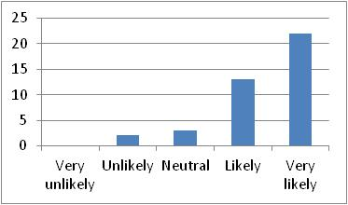
Table 1.1 | Figure 1.1

1.2 Comply with international standards and principles (CG2): Most of the participants have chosen “Very likely” answer; however, many other participants have also chosen “Likely” answer, while little of participants have chosen “Neutral” and no participant has chosen “Unlikely” or “Very unlikely” answers. This is indicated in Table 1.2 and Figure 1.2 below. Overwhelming; majority of respondents in agreement that CG2 is a good contributor to value creation. Adherence to international standards and principles that increase the reputation of the firm as reported in the literature.
 | 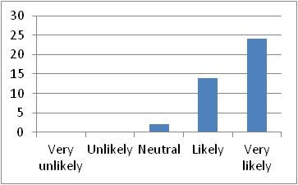
Table 1.2 | Figure 1.2

1.3 Comply with legal regulations (CG3): Most of the participants have chosen “Very likely” answer; however, many other participants have also chosen “Likely” answer, while little of participants have chosen “Neutral” and no participant has chosen “Unlikely” or “Very unlikely” answers. This is indicated in Table 1.3 and Figure 1.3 below.
Overwhelming; majority of respondents in agreement that CG3 is a good contributor to value creation. Compliance with the legal regulation is important for the reputation of the firm image and operational. Therefore, it appears that the respondents also agree it is a good value creator.
 | 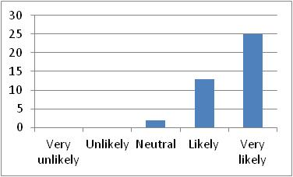
Table 1.3 | Figure 1.3

1.4 Crackdown on corruption and unethical behaviour (CG4): Most of the participants have chosen “Very likely” answer; however, many other participants have also chosen “Likely” answer, while little of participants have chosen “Neutral” and no participant has chosen “Unlikely” or “Very unlikely” answers. This is indicated in Table 1.4 and Figure 1.4 below. Overwhelming; majority of respondents in agreement that CG4 is a good contributor to value creation. Therefore, Crackdown on corruption and unethical behaviour has a huge impact on the firm image and reputation so that if it is not managed well, it will lead to value destruction.
 | 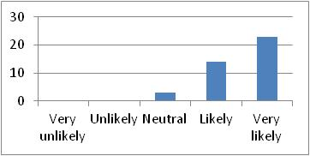
Table 1.4 | Figure 1.4

1.5 Enact policies to ensure ethical procurement at suppliers place (CG5): Most of the participants have chosen “Likely” answer; however, many other participants have also chosen “Very likely” answer, while little of participants have chosen “Neutral” and no participant has chosen “Unlikely” or “Very unlikely” answers. As indicated in Table 1.5 and Figure 1.5 below. Overwhelming; majority of respondents in agreement that CG5 is a good contributor to value creation. Compliance with the ethical procurement is important for the reputation of the firm image and operational. Therefore, it appears by the respondent that it is good value creator.
 | 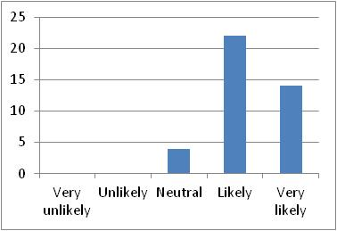
Table 1.5 | Figure 1.5

1.6 Enact policies on violation of human rights at the supplier’s place (CG6): Most of the participants have chosen “Likely” answer; however, many other participants have equally chosen “Very likely” and “Neutral” answers, while no participant has chosen “Unlikely” or “Very unlikely” answers. This is indicated in Table 1.6 and Figure 1.6 below.
Overwhelming; majority of respondents in agreement that CG6 is a good contributor to value creation. Compliance with the human rights is important for the reputation of the firm image and operational. Therefore, it appears by the respondents that it is good value creator.

 | 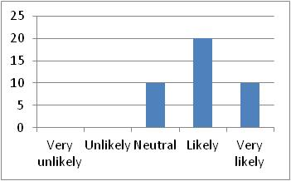
Table 1.6 | Figure 1.6

1.7 Enact policies for social accountability or sustainable reporting by the supplier (CG7): Most of the participants have chosen “Likely” answer; however, many other participants have also chosen “Very likely” and “Neutral” answers, while little of participants have chosen “Unlikely” answer and no participant has chosen “Very unlikely” answer. This is indicated in Table 1.7 and Figure 1.7 below.
In this case there is disagreement and variability between the respondents’ answers in relation to policies for social accountability or sustainable reporting, as some respondents do not think this is a good contributor to value creation of the firm. Actually the literature reviews show that this is a good contributor but maybe this is because of local context.
 | 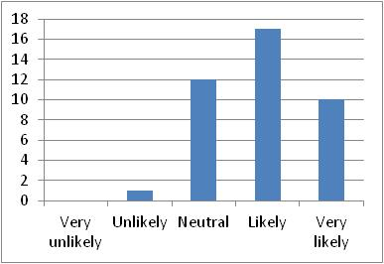
Table 1.7 | Figure 1.7

1.8 Enact management systems for preserving customer health and safety during use of products/services (CG8): Most of the participants have chosen “Likely” answer; however, many other participants have also chosen “Very likely” and “Neutral” answers, while little of participants have chosen “Unlikely” and no participant has chosen “Very unlikely” answers. This is indicated in Table 1.8 and Figure 1.8 below.
In this case there is disagreement and variability between the respondents’ answers in relation to preserving customer health and safety during use of products/services as some respondents do not think this is a good contributor to value creation of the firm. Actually the literature reviews show that this is a good contributor but maybe this is because of local context.
 | 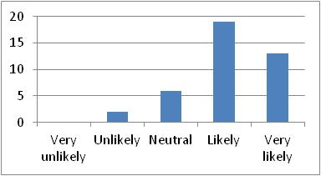
Table 1.8 | Figure 1.8

1.9 Engage in improving regulation within the business sector (CG9): Most of the participants have chosen “Likely” answer; however, many other participants have also chosen “Very likely” answer, while little of participants have chosen “Neutral” and no participant has chosen “unlikely” or “Very unlikely” answers. This is indicated in Table 1.9 and Figure 1.9 below.
Overwhelming; majority of respondents in agreement that CG9 is a good contributor to value creation. Compliance with the improving regulation within the business sector is important for the reputation of the firm image and operational. Therefore, it appears by the respondents that it is good value creator.
 | 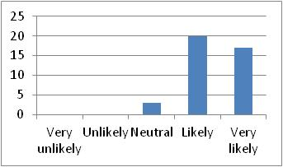
Table 1.9 | Figure 1.9

1.10 Encourage women to be on the board of directors or among its senior line managers (CG10): Most of the participants have chosen “Likely” answer; however, many other participants have also chosen “Very likely” and “Neutral” answers, while little of participants have chosen “unlikely” and no participant has chosen “Very unlikely” answers. This is indicated in Table 1.10 and Figure 1.10 below.
This is very surprising result, in this case there is disagreement and variability between the respondents’ answers in relation to Encourage women to be on the board of directors, as some respondents do not think this is a good contributor to value creation of the firm. Actually the literature reviews show that this is a good contributor but maybe this is because of local context.
 | 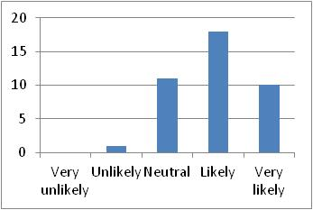
Table 1.10 | Figure 1.10

1.11 Foster a culture of integrity (CG11): Most of the participants have chosen “Likely” answer, however, many other participants have also chosen “Very likely” answer; while little of participants have chosen “Neutral” and no participant has chosen “Unlikely” or “Very unlikely” answers. This is indicated in Table 1.11 and Figure 1.11 below.
Overwhelming; majority of respondents in agreement that CG11 is a good contributor to value creation. Compliance with the culture of integrity is important for the reputation of the firm image and operational. Therefore, it appears by the respondents that it is good value creator.
 | 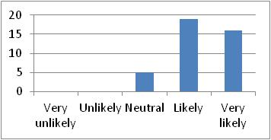
Table 1.11 | Figure 1.11

1.12 Guidelines on corruption and unethical behaviour (CG12): Most of the participants have chosen “Likely” answer; however, many other participants have also chosen “Very likely” answer, while little of participants have chosen “Neutral” and no participant has chosen “Unlikely” or “Very unlikely” answers. This is indicated in Table 1.12 and Figure 1.12 below.
Overwhelming; majority of respondents in agreement that CG12 is a good contributor to value creation. Compliance with the Guidelines on corruption and unethical behaviour is important for the reputation of the firm image and operational. Therefore, it appears by the respondents that it is good value creator.
 | 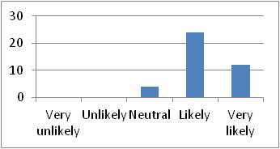
Table 1.12 | Figure 1.12

1.13 Issues policies towards sexual harassment prohibition (CG13): Most of the participants have chosen “Very likely” answer; however, many other participants have also chosen “Likely” answer, while little of participants have chosen “Neutral”, and very little of participants have chosen “Unlikely” and “Very unlikely” answers. This is indicated in Table 1.13 and Figure 1.13 below.
In this case there is disagreement and variability between the respondents’ answers in relation to preserving customer health and safety during use of products/services as some respondents do not think that this as a good contributor to value creation of the firm. Actually the literature reviews show that this is a good contributor but maybe because the respondents thought that this is not important issue with relate to value creation. However, the majority of the respondents agreed with the opinion that it is a good contributor to value creation as supported by the literature review.
 | 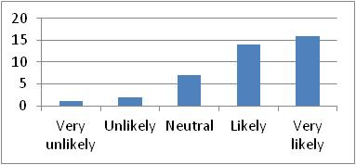
Table 1.13 | Figure 1.13

1.14 Provide regular information on audit trails (CG14): Most of the participants have chosen “Very likely” answer; however, many other participants have also chosen “Likely” answer, while little of participants have chosen “Neutral” and no participant has chosen “Unlikely” or “Very unlikely” answers. This is indicated in Table 1.14 and Figure 1.14 below.
Overwhelming; majority of respondents in agreement that CG14 is a good contributor to value creation. Compliance with the regular information on audit trails is important for the reputation of the firm image and operational. Therefore, it appears by the respondents that it is good value creator.
 | 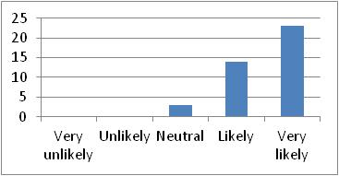
Table 1.14 | Figure 1.14

1.15 Provision of HR policies to facilitate conciliation between professional and personal life (CG15): Most of the participants have chosen “Likely” answer; however, many other participants have also chosen “Very likely” answer, while little of participants have chosen and “Neutral” answer and very little of participants have chosen “Unlikely” answer and no participant has chosen “Very unlikely” answer. This is indicated in Table 1.15 and Figure 1.15 below.
This is very surprising result, in this case there is disagreement and variability between the respondents’ answers in relation to Provision of HR policies, as some respondents do not think this is a good contributor to value creation of the firm. Actually the literature reviews show that this is a good contributor but maybe this is because of local context.
 | 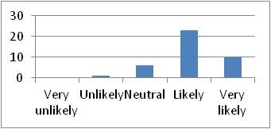
Table 1.15 | Figure 1.15

1.16 Provision of leadership and commitment to set responsible business values and standards (CG16): Most of the participants have chosen “Likely” answer; however, many other participants have also chosen “Very likely” answer, while little of participants have chosen “Neutral” and no participant has chosen “Unlikely” or “Very unlikely” answers. This is indicated in Table 1.16 and Figure 1.16 below.
Overwhelming; majority of respondents in agreement that CG16 is a good contributor to value creation. Compliance with the Provision of leadership is important for the reputation of the firm image and operational. Therefore, it appears by the respondents that it is good value creator.
 | 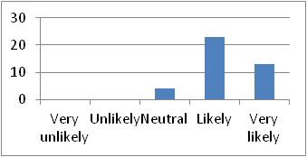
Table 1.16 | Figure 1.16

1.17 Provision of regular information on implementation against targets (CG17): Most of the participants have chosen “Likely” answer; however, many other participants have also chosen “Very likely” answer, while little of participants have chosen “Neutral” and no participant has chosen “Unlikely” or “Very unlikely” answers. This is indicated in Table 1.17 and Figure 1.17 below.
Overwhelming; majority of respondents in agreement that CG17 is a good contributor to value creation. Compliance with the Provision of regular information is important for the reputation of the firm image and operational. Therefore, it appears by the respondents that it is good value creator.
 | 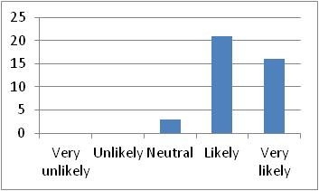
Table 1.17 | Figure 1.17

1.18 Provision of anti-discrimination policies towards issues of gender, pregnancy, marital status (CG18): Most of the participants have chosen “Likely” answer; however, many other participants have chosen “Very likely” and “Neutral answers, while no participant has chosen “Unlikely” or “Very unlikely” answers. This is indicated in Table 1.18 and Figure 1.18 below.
Overwhelming; majority of respondents in agreement that CG18 is a good contributor to value creation. Compliance with the Provision of anti-discrimination policies is important for the reputation of the firm image and operational. Therefore, it appears by the respondents that it is good value creator.
 | 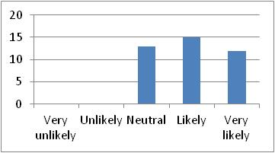
Table 1.18 | Figure 1.18

1.19 Provision of policies towards disability harassment prohibition (CG19): Most of the participants have chosen “Very likely” answer; however, many other participants have equally chosen “Likely” and “Neutral” answers, while no participant has chosen “Unlikely” or “Very unlikely” answers. This is indicated in Table 1.19 and Figure 1.19 below.
Overwhelming; majority of respondents in agreement that CG19 is a good contributor to value creation. Compliance with the Provision of policies towards disability harassment prohibition is important for the reputation of the firm image and operational. Therefore, it appears by the respondents that it is good value creator.
 | 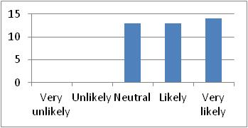
Table 1.19 | Figure 1.19

1.20 Provision of policies to ensure representation of women and minorities in the Board of Directors (CG20): Most of the participants have chosen “Likely” answer, however; many other participants have also chosen “Neutral” answer, while some of participants have chosen “Very likely” and very little of participants have chosen “Unlikely” while no participant has chosen “Very unlikely” answer. This is indicated in Table 1.20 and Figure 1.20 below.
This is very surprising result, in this case there is disagreement and variability between the respondents’ answers in relation to Provision of policies to ensure representation of women and minorities in the Board of Directors, as some respondents do not think this is a good contributor to value creation of the firm. Actually the literature reviews show that this is a good contributor but maybe this is because of local context.
 | 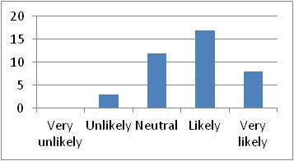
Table 1.20 | Figure 1.20

1.21 Provision of policies towards prohibiting forced overtime (CG21): Most of the participants have chosen “Likely” answer; however, many other participants have also chosen “Very likely” and “Neutral” answers, while no participant has chosen “Unlikely” or “Very unlikely” answers. This is indicated in Table 1.21 and Figure 1.21 below.
Overwhelming; majority of respondents in agreement that CG20 is a good contributor to value creation. Compliance with the Provision of policies towards prohibiting forced overtime is important for the reputation of the firm image and operational. Therefore, it appears by the respondents that it is good value creator.
 | 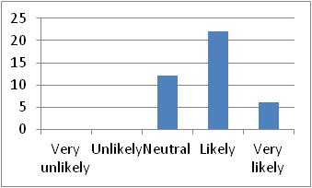
Table 1.21 | Figure 1.21

1.22 Provide the right to freedom of association, collective bargaining and complaint procedure (CG22): Most of the participants have chosen “Likely” answer; however, many other participants have also chosen “Very likely” and “Neutral” answers, while some of participants have chosen “Very unlikely” and very little of participants have chosen “Unlikely” answers. This is indicated in Table 1.22 and Figure 1.22 below.
This is very surprising result, in this case there is disagreement and variability between the respondents’ answers in relation to Provide the right to freedom of association, as some respondents do not think this is a good contributor to value creation of the firm. Actually the literature reviews show that this is a good contributor but maybe this is because of local context.
 | 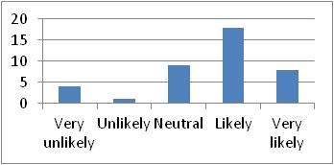
Table 1.22 | Figure 1.22

1.23 Provision of policies covering health and safety at work (CG23): Most of the participants have chosen “Likely” answer; however, many other participants have also chosen “Very likely” answer, while very little of participants have chosen “Neutral”, “Unlikely” and “Very unlikely” answers. This is indicated in Table 1.23 and Figure 1.23 below.
This is very surprising result, in this case there is disagreement and variability between the respondents’ answers in relation to Provision of policies covering health and safety at work, as some respondents do not think this is a good contributor to value creation of the firm. Actually the literature reviews show that this is a good contributor but maybe this is because of local context.
 | 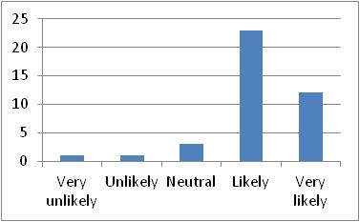
Table 1.23 | Figure 1.23

1.24 Provision for employee’s representation in decision-making (CG24): Most of the participants have chosen “Likely” answer, however; many other participants have also chosen “Very likely” and “Neutral” answers, while very little of participants have chosen “Very unlikely” and “Unlikely” answers. This is indicated in Table 1.24 and Figure 1.24 below.
This is very surprising result, in this case there is disagreement and variability between the respondents’ answers in relation to Provision for employee’s representation in decision-making, as some respondents do not think this is a good contributor to value creation of the firm. Actually the literature reviews show that this is a good contributor but maybe this is because of local context.
 | 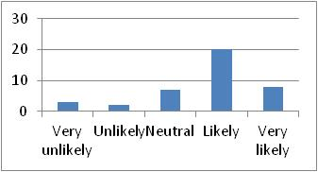
Table 1.24 | Figure 1.24

1.25 Provision of constitutional reference for shareholders’ participation in decision making and access to all relevant information (CG25): Most of the participants have chosen “Likely” answer, however; many other participants have also chosen “Very likely” and “Neutral” answers, while little of participants have chosen “Very unlikely” and “Unlikely” answers. This is indicated in Table 1.25 and Figure 1.25 below.
This is very surprising result, in this case there is disagreement and variability between the respondents’ answers in relation to Provision of constitutional reference for shareholders’ participation in decision making, as some respondents do not think this is a good contributor to value creation of the firm. Actually the literature reviews show that this is a good contributor but maybe this is because of local context.
 | 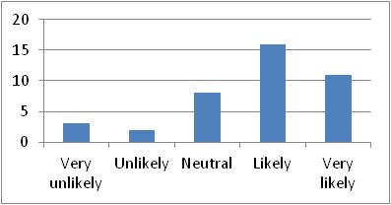
Table 1.25 | Figure 1.25

1.26 Provision of rules to strengthen auditor independence (CG26): Most of the participants have chosen “Very likely” answer; however, many other participants have also chosen “Likely” and “Neutral” answers, while very little of participants have chosen “Unlikely” and “Very unlikely” answers. This is indicated in Table 1.26 and Figure 1.26 below.
This is very surprising result, in this case there is disagreement and variability between the respondents’ answers in relation to Provision of rules to strengthen auditor independence, as some respondents do not think this is a good contributor to value creation of the firm. Actually the literature reviews show that this is a good contributor but maybe this is because of local context.
 | 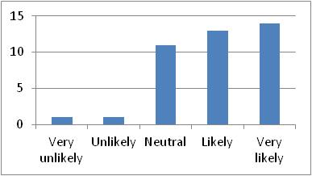
Table 1.26 | Figure 1.26

1.27 Provision of policies for engaging in wide range of stakeholder-dialogs (CG27): Most of the participants have chosen “Likely” answer; however; many other participants have also chosen “Very likely” and “Neutral” answers, while very little of participants have chosen “Unlikely” and “Very unlikely” answers. This is indicated in Table 1.27 and Figure 1.27 below.
This is very surprising result, in this case there is disagreement and variability between the respondents’ answers in relation to Provision of policies for engaging in wide range of stakeholder-dialogs, as some respondents do not think this is a good contributor to value creation of the firm. Actually the literature reviews show that this is a good contributor but maybe this is because of local context.
 | 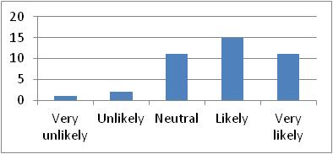
Table 1.27 | Figure 1.27

1.28 Provision of committees dedicated to dealing with environmental risk in credit assessment (CG28): Most of the participants have chosen “Likely” answer, however; many other participants have also chosen “Very likely” and “Neutral” answers, while very little of participants have chosen “Very unlikely” answer and no participant has chosen “Unlikely” answer. This is indicated in Table 1.28 and Figure 1.28 below.
This is very surprising result, in this case there is disagreement and variability between the respondents’ answers in relation to Provision of committees dedicated to dealing with environmental risk in credit assessment, as some respondents do not think this is a good contributor to value creation of the firm. Actually the literature reviews show that this is a good contributor but maybe this is because of local context.
 | 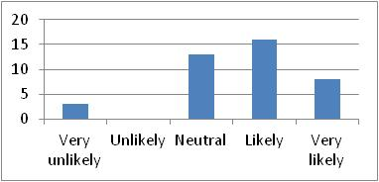
Table 1.28 | Figure 1.28

1.29 Protect the customer rights and respects the stakeholders’ rights (CG29): Most of the participants have chosen “Likely” answer; however, many other participants have also chosen “Very likely” answer, while very little of participants have chosen “Neutral” and no participant has chosen “Unlikely” or “Very unlikely” answers. This is indicated in Table 1.29 and Figure 1.29 below.
Overwhelming; majority of respondents in agreement that CG29 is a good contributor to value creation. Compliance with the Protect the customer rights and respects the stakeholders’ rights is important for the reputation of the firm image and operational. Therefore, it appears by the respondents that it is good value creator.
 | 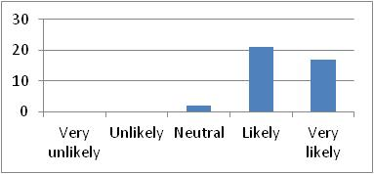
Table 1.29 | Figure 1.29

1.30 Publish legislative offences and fines (CG30): Most of the participants have equally chosen “Likely” and “Neutral” answers, however; many other participants have also chosen “Very likely” and “Unlikely” answers, while very little of participants have chosen “Very unlikely” answer. This is indicated in Table 1.30 and Figure 1.30 below.
This is very surprising result, in this case there is disagreement and variability between the respondents’ answers in relation to Publish legislative offences and fines, as some respondents do not think this is a good contributor to value creation of the firm. Actually the literature reviews show that this is a good contributor but maybe this is because of local context.
 | 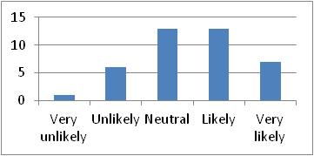
Table 1.30 | Figure 1.30

1.31 Regularly reviews governance arrangements (CG31): Most of the participants have chosen “Very likely” answer, however; many other participants have also chosen “Likely” and “Neutral” answers, while no participant has chosen “Unlikely” or “Very unlikely” answers. This is indicated in Table 1.31 and Figure 1.31 below.
Overwhelming; majority of respondents in agreement that CG31 is a good contributor to value creation. Compliance with the regularly reviews governance arrangements is important for the reputation of the firm image and operational. Therefore, it appears by the respondents that it is good value creator.
 | 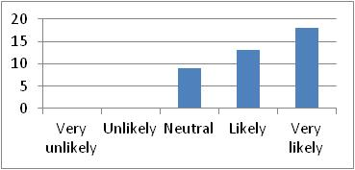
Table 1.31 | Figure 1.31

1.32 Use of internal audits and risk management to manage accountability and responsibility (CG32): Most of the participants have chosen “Very likely” answer; however, many other participants have also chosen “Likely” answer, while very little of participants have chosen “Neutral” and no participant has chosen “Unlikely” or “Very unlikely” answers. This is indicated in Table 1.32 and Figure 1.32 below.
Overwhelming; majority of respondents in agreement that CG32 is a good contributor to value creation. Compliance with the Use of internal audits and risk management to manage accountability is important for the reputation of the firm image and operational. Therefore, it appears by the respondents that it is good value creator.
 | 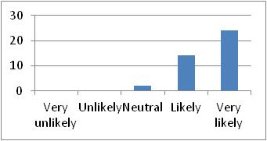
Table 1.32 | Figure 1.32

6.2.2 Descriptive Analysis for Economic (EC)
The second section of the questionnaire is about the Economic initiatives of the firm. It has a general question: “2. How likely the following Economic CSR practices contribute to value creation in your firm”; and under the previous main question, there are 16 sub-questions as the following:

2.1 Auditing Income/revenue and financial by external bodies (EC1): Most of the participants have chosen “Very likely” and “Likely” answers which is about 52.5% and 45%, however, no participants have chosen “Unlikely” or “Very unlikely” answers, while a very little of participants have chosen “Neutral” answers. This is indicated in the Table 2.1 and Figure 2.1 below.
Overwhelming; majority of respondents in agreement that EC1 is a good contributor to value creation. Compliance with the Auditing Income/revenue by external bodies is important for the reputation of the firm image and operational. Therefore, it appears by the respondents that it is good value creator.
 | 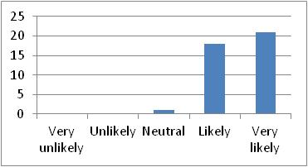
Table 2.1 | Figure 2.1

2.2 Believe wealth distribution through taxation (EC2): Most of the participants have chosen “Neutral” answer which is about 37.5%, however, many other participants have almost equally chosen “Very likely”, “Likely”, “Unlikely” and “Very unlikely” answers. This is indicated in Table 2.2 and Figure 2.2 below.
This is very surprising result, in this case there is disagreement and variability between the respondents’ answers in relation to Believe wealth distribution through taxation, as some respondents do not think this is a good contributor to value creation of the firm. Actually the literature reviews show that this is a good contributor but maybe this is because of local context.
 | 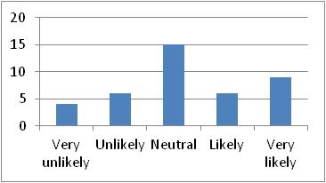
Table 2.2 | Figure 2.2

2.3 Contribute to wealth distribution through Zakat (EC3): Most of the participants have chosen “Neutral” answer which is about 35%, however, many other participants have chosen “Very likely”, “Likely”, “Unlikely” and “Very unlikely” answers. This is indicated in the Table 2.3 and Figure 2.3 below.
This is very surprising result, in this case there is disagreement and variability between the respondents’ answers in relation to Contribute to wealth distribution through Zakat, as some respondents do not think this is a good contributor to value creation of the firm. Actually the literature reviews show that this is a good contributor but maybe this is because of local context.
 | 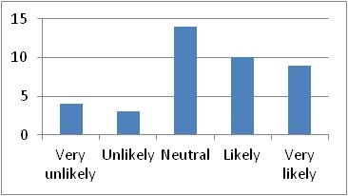
Table 2.3 | Figure 2.3

2.4 Contribute to wealth distribution through Awaqqaf (EC4): Most of the participants have chosen “Neutral” answer which is about 45%, however, many other participants have almost equally chosen “Very likely”, “Likely”, “Unlikely” and “Very unlikely” answers. This is indicated in the Table 2.4 and Figure 2.4 below.
This is very surprising result, in this case there is disagreement and variability between the respondents’ answers in relation to Contribute to wealth distribution through Awaqqaf, as some respondents do not think this is a good contributor to value creation of the firm. Actually the literature reviews show that this is a good contributor but maybe this is because of local context.
 | 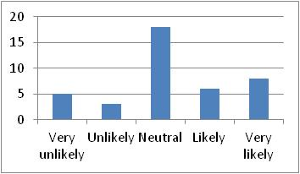
Table 2.4 | Figure 2.4

2.5 CSR initiatives to attract investors (EC5): Most of the participants have chosen “Likely” answer which is about 42.5%, however, many other participants have chosen “Neutral” answer, while the rest of participants have almost equally chosen “Very likely”, “Unlikely” and “Very unlikely” answers. This is indicated in the Table 2.5 and Figure 2.5 below.
This is very surprising result, in this case there is disagreement and variability between the respondents’ answers in relation to CSR initiatives to attract investors, as some respondents do not think this is a good contributor to value creation of the firm. Actually the literature reviews show that this is a good contributor but maybe this is because of local context.
 | 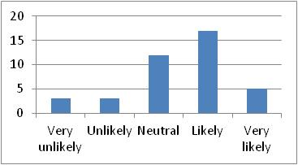
Table 2.5 | Figure 2.5

2.6 Disclosing financial information and government grant/ subsidies (EC6): Most of the participants have chosen “Likely” answer which is about 40%, however, many other participants have almost equally chosen “Very likely” and “Neutral” answers, while almost nobody have chosen “Unlikely” or “Very unlikely” answers. This is indicated in the Table 2.6 and Figure 2.6 below.
This is very surprising result, in this case there is disagreement and variability between the respondents’ answers in relation to Disclosing financial information and government grant/ subsidies, as some respondents do not think this is a good contributor to value creation of the firm. Actually the literature reviews show that this is a good contributor but maybe this is because of local context.
 | 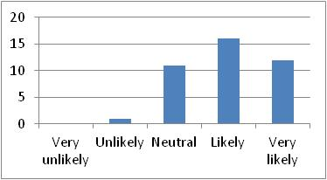
Table 2.6 | Figure 2.6

2.7 Engaged in noteworthy community activities to secure the investment (EC7): Most of the participants have chosen “Likely” and “Neutral” answers which is about 67.5% for both only, however, many other participants have chosen “Very likely” and “Unlikely” answers, while no participants have chosen “Very unlikely” answers. This is indicated in the Table 2.7 and Figure 2.7 below.
This is very surprising result, in this case there is disagreement and variability between the respondents’ answers in relation to Engaged in noteworthy community activities to secure the investment, as some respondents do not think this is a good contributor to value creation of the firm. Actually the literature reviews show that this is a good contributor but maybe this is because of local context.
 | 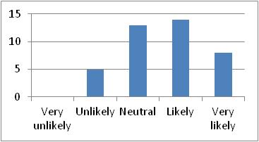
Table 2.7 | Figure 2.7

2.8 Investing in projects which have serious controversies with the communities (EC8): Most of the participants have chosen “Neutral” answer which is about 27.5%, however, many other participants have almost equally chosen “Very likely”, “Likely”, “Unlikely” and “Very unlikely” answers. This is indicated in the Table 2.8 and Figure 2.8 below.
This is very surprising result, in this case there is disagreement and variability between the respondents’ answers in relation to Investing in projects which have serious controversies with the communities, as some respondents do not think this is a good contributor to value creation of the firm. Actually the literature reviews show that this is a good contributor but maybe this is because of local context.

 | 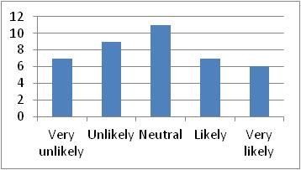
Table 2.8 | Figure 2.8

2.9 Paying share of taxes and other duties regularly on an ethical basis (EC9): Most of the participants have chosen “Very likely” and “Likely” answers which are about 60%, however, many other participants have chosen “Neutral” answer, while some of participants have chosen “Unlikely” and “Very unlikely” answers. This is indicated in the Table 2.9 and Figure 2.9 below.
This is very surprising result, in this case there is disagreement and variability between the respondents’ answers in relation to Paying share of taxes and other duties regularly on an ethical basis, as some respondents do not think this is a good contributor to value creation of the firm. Actually the literature reviews show that this is a good contributor but maybe this is because of local context.
 | 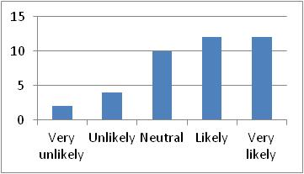
Table 2.9 | Figure 2.9

2.10 Promoting CSR to create long-term profits for the firm (EC10): Most of the participants have chosen “Likely” answer which is about 32.5%, however, many other participants have chosen “Neutral” and “Very likely” answers, while a little of participants have chosen “Unlikely” and “Very Unlikely” answers. This is indicated in the Table 2.10 and Figure 2.10 below.
This is very surprising result, in this case there is disagreement and variability between the respondents’ answers in relation to Promoting CSR to create long-term profits for the firm, as some respondents do not think this is a good contributor to value creation of the firm. Actually the literature reviews show that this is a good contributor but maybe this is because of local context.
 | 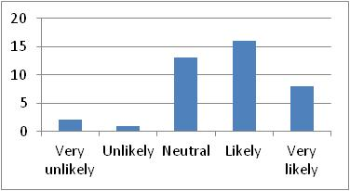
Table 2.10 | Figure 2.10

2.11 Providing information about products/services to customers (EC11): Most of the participants have chosen “Likely” answer which is about 52%, however, many other participants have chosen “Very likely” answer, while a little of participants have chosen “Neutral” answer, while no participant has chosen “Unlikely” or “Very unlikely” answers. This is indicated in the Table 2.11 and Figure 2.11 below.
Overwhelming; majority of respondents in agreement that EC11 is a good contributor to value creation. Compliance with the providing information about products/services to customers is important for the reputation of the firm image and operational. Therefore, it appears by the respondents that it is good value creator.
 | 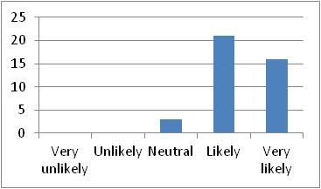
Table 2.11 | Figure 2.11

2.12 Using CSR as strategies for growth/concern or survival (EC12): Most of the participants have chosen “Likely” answer which is about 52.5%, however, many other participants have chosen “Very likely” and “Neutral” answers, while a very little of participants have chosen “Unlikely” and “Very unlikely” answers. This is indicated in the Table 2.12 and Figure 2.12 below.
This is very surprising result, in this case there is disagreement and variability between the respondents’ answers in relation to Using CSR as strategies for growth/concern or survival, as some respondents do not think this is a good contributor to value creation of the firm. Actually the literature reviews show that this is a good contributor but maybe this is because of local context.
 | 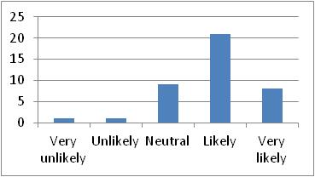
Table 2.12 | Figure 2.12

2.13 Using CSR to enhance the implementation of core business activities (EC13): Most of the participants have chosen “Likely” answer which is about 50%, however, many other participants have chosen “Very likely” and “Neutral” answers, while a little of participants have chosen “Unlikely” and “Very unlikely” answers. This is indicated in the Table 2.13 and Figure 2.13 below.
This is very surprising result, in this case there is disagreement and variability between the respondents’ answers in relation to Using CSR to enhance the implementation of core business activities, as some respondents do not think this is a good contributor to value creation of the firm. Actually the literature reviews show that this is a good contributor but maybe this is because of local context.
 | 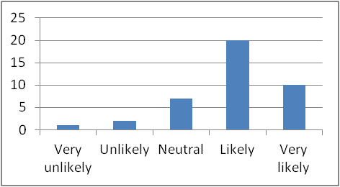
Table 2.13 | Figure 2.13

2.14 Using CSR to in remain competitive (EC14): Most of the participants have chosen the “Likely” answer which is about 40%, however, many other participants have chosen “Very likely” and “Neutral” answers, while a little of participant have chosen “Unlikely” and “Very unlikely” answers. This is indicated in the Table 2.14 and Figure 2.14 below.
This is very surprising result, in this case there is disagreement and variability between the respondents’ answers in relation to Using CSR to in remain competitive, as some respondents do not think this is a good contributor to value creation of the firm. Actually the literature reviews show that this is a good contributor but maybe this is because of local context.
 | 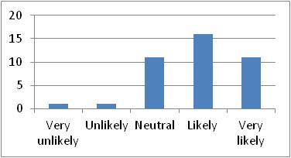
Table 2.14 | Figure 2.14

2.15 Using CSR to create value to shareholder (EC15): Most of the participants have chosen the “Likely” answer which is about 55%, however, some of other participants have chosen “Very likely” and “Neutral” answers, while a little of participants have chosen “Unlikely” and “Very unlikely” answers. This is indicated in the Table 2.15 and Figure 2.15 below.
This is very surprising result, in this case there is disagreement and variability between the respondents’ answers in relation to Using CSR to create value to shareholder, as some respondents do not think this is a good contributor to value creation of the firm. Actually the literature reviews show that this is a good contributor but maybe this is because of local context.
 | 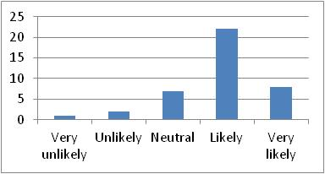
Table 2.15 | Figure 2.15

2.16 Using CSR to strengthen local/ global networks (EC16): Most of the participants have chosen the “Likely” answer which is about 42.5%, however, some of other participants have chosen “Neutral” answer, while a little of participants have chosen “Very likely” answer. This is indicated in the Table 2.16 and Figure 2.16 and Table 2.16a and Figure 2.16a below.
This is very surprising result, in this case there is disagreement and variability between the respondents’ answers in relation to Using CSR to strengthen local/ global networks, as some respondents do not think this is a good contributor to value creation of the firm. Actually the literature reviews show that this is a good contributor but maybe this is because of local context.
 | 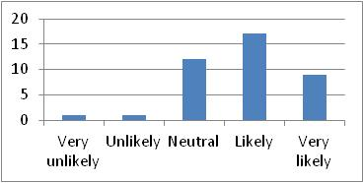
Table 2.16a | Figure 2.16a

6.2.3 Descriptive Analysis for Environment (ENV)
The third section of the questionnaire is about the Environment initiatives of the firm. It has a general question: ‘”3. How likely the following Environmental CSR practices contribute to value creation in your firm”; and under the previous main question, there are 27 sub-questions as the following:

3.1 Adopt policies for preventing direct and indirect pollution of soil, water and air (ENV1): Most of participants have chosen “Likely” answer which is about 45%, however, some other participants have also chosen “Very likely”, “Neutral”, “Unlikely” and “Very unlikely”. This is indicated in Table 3.1 and Figure 3.1 below.
This is very surprising result, in this case there is disagreement and variability between the respondents’ answers in relation to Adopt policies for preventing direct and indirect pollution of soil, water and air, as some respondents do not think this is a good contributor to value creation of the firm. Actually the literature reviews show that this is a good contributor but maybe this is because of local context.
 | 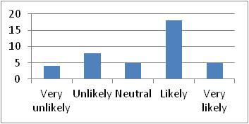
Table 3.1 | Figure 3.1

3.2 Adopt policies in using Ozone Depleting Chemicals (ENV2): Most of participants have chosen “Likely” answer which is about 45%, however, some other participants have also chosen “Very likely”, “Neutral”, “Unlikely” and “Very unlikely”. This is indicated in Table 3.2 and Figure 3.2 below.
This is very surprising result, in this case there is disagreement and variability between the respondents’ answers in relation to Adopt policies in using Ozone Depleting Chemicals, as some respondents do not think this is a good contributor to value creation of the firm. Actually the literature reviews show that this is a good contributor but maybe this is because of local context.
 | 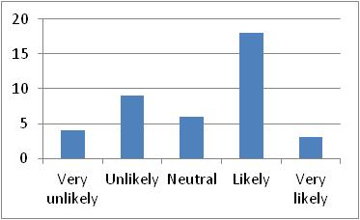
Table 3.2 | Figure 3.2

3.3 Adopt policies on reducing Climate Change impacts (ENV3): Most of participants have chosen “Likely” answer which is about 32.5%, however, some other participants have also chosen “Very likely”, “Neutral”, “Unlikely” and “Very unlikely”. This is indicated in Table 3.3 and Figure 3.3 below.
This is very surprising result, in this case there is disagreement and variability between the respondents’ answers in relation to Adopt policies on reducing Climate Change impacts, as some respondents do not think this is a good contributor to value creation of the firm. Actually the literature reviews show that this is a good contributor but maybe this is because of local context.
 | 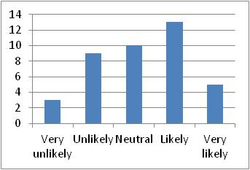
Table 3.3 | Figure 3.3

3.4 Attach very high value to the introduction of alternative sources of energy (ENV4): Most of participants have chosen “Likely” answer which is about 30%, however, some other participants have also chosen “Very likely”, “Neutral”, “Unlikely” and “Very unlikely”. This is indicated in Table 3.4 and Figure 3.4 below.
This is very surprising result, in this case there is disagreement and variability between the respondents’ answers in relation to Attach very high value to the introduction of alternative sources of energy, as some respondents do not think this is a good contributor to value creation of the firm. Actually the literature reviews show that this is a good contributor but maybe this is because of local context.
 | 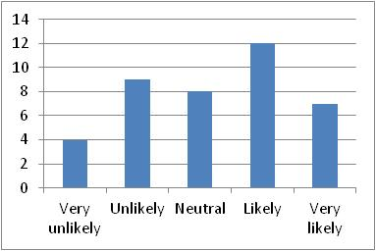
Table 3.4 | Figure 3.4

3.5 Commitment to environmental management systems through ISO certification and other voluntary programs (ENV5): Most of participants have chosen “Very likely” answer which is about 32.5%, however, some other participants have also chosen “Likely” and “Neutral” answers while little participants have chosen “Unlikely” answer and very little participants have chosen “Very unlikely” answer. This is indicated in Table 3.5 and Figure 3.5 below.
This is very surprising result, in this case there is disagreement and variability between the respondents’ answers in relation to Commitment to environmental management systems through ISO certification and other voluntary programs, as some respondents do not think this is a good contributor to value creation of the firm. Actually the literature reviews show that this is a good contributor but maybe this is because of local context.
 | 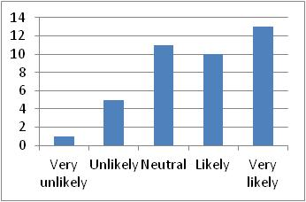
Table 3.5 | Figure 3.5

3.6 Compliance with pollution laws and regulations (ENV6): Most of participants have chosen “Likely” answer which is about 42.5%, however, some other participants have also chosen “Very likely” and “Neutral” answers while little participants have chosen “Unlikely” answer and very little participants have chosen “Very unlikely” answer. This is indicated in Table 3.6 and Figure 3.6 below.
This is very surprising result, in this case there is disagreement and variability between the respondents’ answers in relation to Compliance with pollution laws and regulations, as some respondents do not think this is a good contributor to value creation of the firm. Actually the literature reviews show that this is a good contributor but maybe this is because of local context.
 | 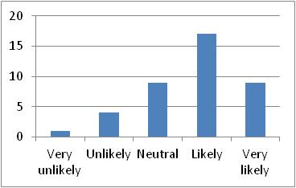
Table 3.6 | Figure 3.6

3.7 Enact policies to minimize energy consumption (ENV7): Most of participants have chosen “Likely” answer which is about 42.5%, however, some other participants have also chosen “Very likely” answer while little participants have chosen “Neutral”, “Unlikely” and “Very unlikely” answers. This is indicated in Table 3.7 and Figure 3.7 below.
This is very surprising result, in this case there is disagreement and variability between the respondents’ answers in relation to Enact policies to minimize energy consumption, as some respondents do not think this is a good contributor to value creation of the firm. Actually the literature reviews show that this is a good contributor but maybe this is because of local context.
 | 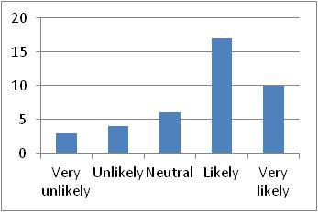
Table 3.7 | Figure 3.7

3.8 Enact policies to minimize the Greenhouse gas emissions (ENV8): Most of participants have chosen “Neutral” answer which is about 35%, however, some other participants have also chosen “Likely” answer while little participants have chosen “Very likely”, “Unlikely” and “Very unlikely” answers. This is indicated in Table 3.8 and Figure 3.8 below.
This is very surprising result, in this case there is disagreement and variability between the respondents’ answers in relation to Enact policies to minimize the Greenhouse gas emissions, as some respondents do not think this is a good contributor to value creation of the firm. Actually the literature reviews show that this is a good contributor but maybe this is because of local context.
 | 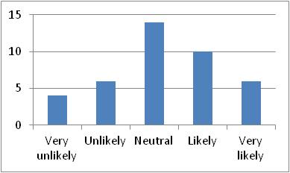
Table 3.8 | Figure 3.8

3.9 Implement special programs to minimize negative impact on the natural environment (ENV9): Most of participants have chosen “Likely” answer which is about 37.5%, however, some other participants have also chosen “Neutral” answer while little participants have chosen “Very likely” and “Unlikely” answers and very little participants have chosen “Very unlikely” answer. This is indicated in Table 3.9 and Figure 3.9 below.
This is very surprising result, in this case there is disagreement and variability between the respondents’ answers in relation to Implement special programs to minimize negative impact on the natural environment, as some respondents do not think this is a good contributor to value creation of the firm. Actually the literature reviews show that this is a good contributor but maybe this is because of local context.
 | 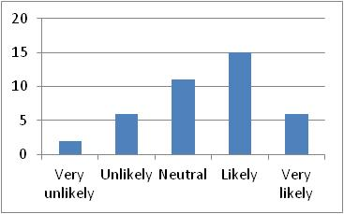
Table 3.9 | Figure 3.9

3.10 Investments to reduce the environmental impact (ENV10): Most of participants have chosen “Neutral” answer which is about 45%, however, some other participants have also chosen “Likely” answer while little participants have chosen “Very likely” and “Unlikely” answers and very little participants have chosen “Very unlikely” answer. This is indicated in Table 3.10 and Figure 3.10 below.
This is very surprising result, in this case there is disagreement and variability between the respondents’ answers in relation to Investments to reduce the environmental impact, as some respondents do not think this is a good contributor to value creation of the firm. Actually the literature reviews show that this is a good contributor but maybe this is because of local context.
 | 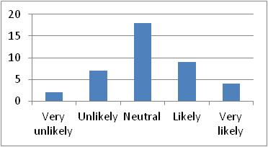
Table 3.10 | Figure 3.10

3.11 Issue dispensable disposal of waste and residues, and recycling systems (ENV11): Most of participants have chosen “Likely” answer which is about 47.5%, however, some other participants have also chosen “Very likely”, while little participants have also chosen “Neutral” and “Unlikely” answers while very little participants have chosen “Very unlikely” answer. This is indicated in Table 3.11 and Figure 3.11 below.
This is very surprising result, in this case there is disagreement and variability between the respondents’ answers in relation to Issue dispensable disposal of waste and residues, and recycling systems, as some respondents do not think this is a good contributor to value creation of the firm. Actually the literature reviews show that this is a good contributor but maybe this is because of local context.
 | 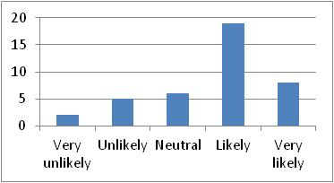
Table 3.11 | Figure 3.11

3.12 Issue discharge, pollution, and waste management policies (ENV12): Most of participants have chosen “Likely” answer which is about 40%, however, some other participants have also chosen “Neutral” answer while little participants have chosen “Very likely” answer and very little participants have chosen “Unlikely” and “Very unlikely” answers. This is indicated in Table 3.12 and Figure 3.12 below.
This is very surprising result, in this case there is disagreement and variability between the respondents’ answers in relation to Issue discharge, pollution, and waste management policies, as some respondents do not think this is a good contributor to value creation of the firm. Actually the literature reviews show that this is a good contributor but maybe this is because of local context.
 | 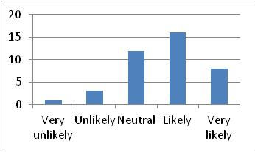
Table 3.12 | Figure 3.12

3.13 Issue Environmental Risk Management and Prevention guidelines (ENV13): Most of participants have chosen “Likely” answer which is about 42.5%, however, some other participants have also chosen “Very likely” and “Neutral” answers while little participants have chosen “Unlikely” answer and very little participants have chosen “Very unlikely” answer. This is indicated in Table 3.13 and Figure 3.13 below.
This is very surprising result, in this case there is disagreement and variability between the respondents’ answers in relation to Issue Environmental Risk Management and Prevention guidelines, as some respondents do not think this is a good contributor to value creation of the firm. Actually the literature reviews show that this is a good contributor but maybe this is because of local context.
 | 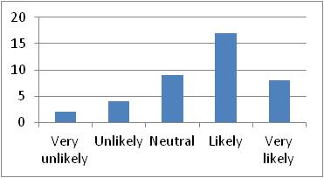
Table 3.13 | Figure 3.13

3.14 Issue programs of saving Natural sources and energy (ENV14): Most of participants have chosen “Likely” and “Neutral” answers which is about 62.5% for both only, however, little participants have chosen “Very likely”, “Unlikely” and “Very unlikely” answers. This is indicated in Table 3.14 and Figure 3.14 below.
This is very surprising result, in this case there is disagreement and variability between the respondents’ answers in relation to Issue programs of saving Natural sources and energy, as some respondents do not think this is a good contributor to value creation of the firm. Actually the literature reviews show that this is a good contributor but maybe this is because of local context.
 | 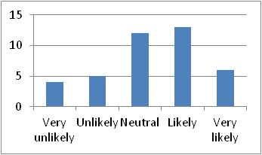
Table 3.14 | Figure 3.14

3.15 Issue recycling and reusing guidelines (ENV15): Most of participants have chosen “Neutral” answer which is about 35%, however, some other participants have also chosen “Likely” and “Very likely” answers while little participants have chosen “Unlikely” answer and very little participants have chosen “Very unlikely” answer. This is indicated in Table 3.15 and Figure 3.15 below.
This is very surprising result, in this case there is disagreement and variability between the respondents’ answers in relation to Issue recycling and reusing guidelines, as some respondents do not think this is a good contributor to value creation of the firm. Actually the literature reviews show that this is a good contributor but maybe this is because of local context.
 | 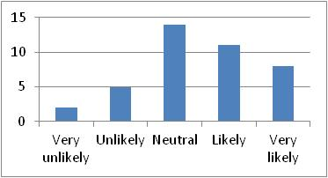
Table 3.15 | Figure 3.15

3.16 Issue solid waste disposal guidelines (ENV16): Most of participants have chosen “Likely” answer which is about 40%, however, some other participants have also chosen “Neutral” answer while little participants have chosen “Very likely” and “Unlikely” answers and very little participants have chosen “Very unlikely” answer. This is indicated in Table 3.16 and Figure 3.16 below.
This is very surprising result, in this case there is disagreement and variability between the respondents’ answers in relation to Issue solid waste disposal guidelines, as some respondents do not think this is a good contributor to value creation of the firm. Actually the literature reviews show that this is a good contributor but maybe this is because of local context.
 | 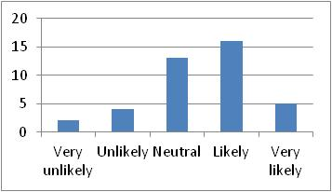
Table 3.16 | Figure 3.16

3.17 Participate in activities aim to protect the quality of the natural environment (ENV17): Most of participants have chosen “Likely” answer which is about 40%, however, some other participants have also chosen “Neutral” answer while little participants have chosen “Very likely” answer and very little participants have chosen “Unlikely” and “Very unlikely” answers. This is indicated in Table 3.17 and Figure 3.17 below.
This is very surprising result, in this case there is disagreement and variability between the respondents’ answers in relation to Participate in activities aim to protect the quality of the natural environment, as some respondents do not think this is a good contributor to value creation of the firm. Actually the literature reviews show that this is a good contributor but maybe this is because of local context.
 | 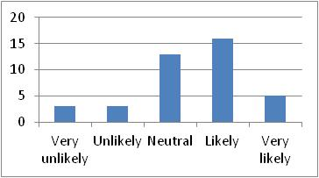
Table 3.17 | Figure 3.17

3.18 Participate in tree Plantation (ENV18): Most of participants have chosen equally “Likely” and “Neutral” answers which is about 65% for both only, however, some other participants have also chosen “Very likely” answer while little participants have chosen “Unlikely” answer and very little participants have chosen “Very unlikely” answer. This is indicated in Table 3.18 and Figure 3.18 below.
This is very surprising result, in this case there is disagreement and variability between the respondents’ answers in relation to Participate in tree Plantation, as some respondents do not think this is a good contributor to value creation of the firm. Actually the literature reviews show that this is a good contributor but maybe this is because of local context.
 | 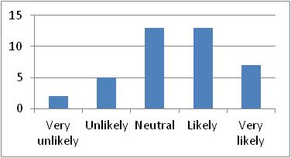
Table 3.18 | Figure 3.18

3.19 Promote cleaner transportation methods (ENV19): Most of participants have chosen “Likely” and “Neutral” answers which is about 67.5% for both only, however, some other participants have also chosen “Very likely” answer while little participants have chosen “Unlikely” answer and very little participants have chosen “Very unlikely” answer. This is indicated in Table 3.19 and Figure 3.19 below.
This is very surprising result, in this case there is disagreement and variability between the respondents’ answers in relation to Promote cleaner transportation methods, as some respondents do not think this is a good contributor to value creation of the firm. Actually the literature reviews show that this is a good contributor but maybe this is because of local context.
 | 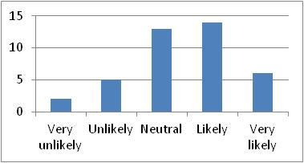
Table 3.19 | Figure 3.19

3.20 Provide Environmental Management and Training (ENV20): Most of participants have chosen “Likely” answer which is about 37.5%, however, some other participants have also chosen “Very likely”, “Neutral” and “Unlikely” answers while very little participants have chosen “Very unlikely” answer. This is indicated in Table 3.20 and Figure 3.20 below.
This is very surprising result, in this case there is disagreement and variability between the respondents’ answers in relation to Provide Environmental Management and Training, as some respondents do not think this is a good contributor to value creation of the firm. Actually the literature reviews show that this is a good contributor but maybe this is because of local context.
 | 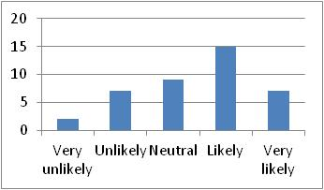
Table 3.20 | Figure 3.20

3.21 Regular voluntary information about environmental management to stakeholders (ENV21): Most of participants have chosen “Neutral” answer with a percentage of 30%, however, some other participants have also chosen “Very likely” and “Neutral” answers while little participants have chosen “Unlikely” and “Very unlikely” answers. This is indicated in Table 3.21 and Figure 3.21 below.
This is very surprising result, in this case there is disagreement and variability between the respondents’ answers in relation to Regular voluntary information about environmental management to stakeholders, as some respondents do not think this is a good contributor to value creation of the firm. Actually the literature reviews show that this is a good contributor but maybe this is because of local context.
 | 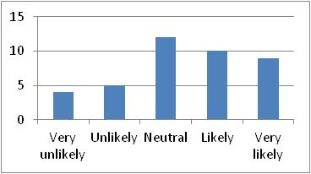
Table 3.21 | Figure 3.21

3.22 Support research aimed at improving energy efficiency (ENV22): Most of participants have chosen “Neutral” answers with a percentage of 37.5%, however, some other participants have also chosen “Likely” answer while little participants have chosen “Very likely”, “Unlikely” and “Very unlikely” answers. This is indicated in Table 3.22 and Figure 3.22 below.
This is very surprising result, in this case there is disagreement and variability between the respondents’ answers in relation to Support research aimed at improving energy efficiency, as some respondents do not think this is a good contributor to value creation of the firm. Actually the literature reviews show that this is a good contributor but maybe this is because of local context.
 | 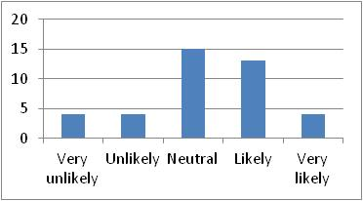
Table 3.22 | Figure 3.22

3.23 Use energy efficient products (ENV23): Most of participants have chosen “Likely” and “Neutral” answers with a percentage of 62.5% for both only, however, some other participants have also chosen “Very likely”, “Neutral” and “Unlikely” answers. This is indicated in Table 3.23 and Figure 3.23 below.
This is very surprising result, in this case there is disagreement and variability between the respondents’ answers in relation to Use energy efficient products, as some respondents do not think this is a good contributor to value creation of the firm. Actually the literature reviews show that this is a good contributor but maybe this is because of local context.
 | 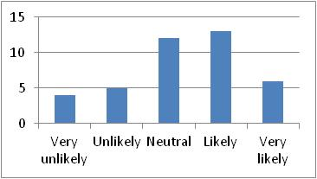
Table 3.23 | Figure 3.23

3.24 Use goods processed with low environmental impact (ENV24): Most of participants have chosen “Likely” and “Neutral” answers which are about 60% for both only, however, some other participants have also chosen “Very likely”, “Unlikely” and “Very Unlikely” answers. This is indicated in Table 3.24 and Figure 3.24 below.
This is very surprising result, in this case there is disagreement and variability between the respondents’ answers in relation to Use goods processed with low environmental impact, as some respondents do not think this is a good contributor to value creation of the firm. Actually the literature reviews show that this is a good contributor but maybe this is because of local context.
 | 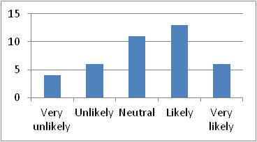
Table 3.24 | Figure 3.24

3.25 Use of pollution control mechanisms (ENV24): Most of participants have chosen “Neutral” answer which is 32.5%, however, some other participants have also chosen “Very likely”, “Likely”, “Unlikely” and “Very unlikely” answers. This is indicated in Table 3.24 and Figure 3.24 below.
This is very surprising result, in this case there is disagreement and variability between the respondents’ answers in relation to Use of pollution control mechanisms, as some respondents do not think this is a good contributor to value creation of the firm. Actually the literature reviews show that this is a good contributor but maybe this is because of local context.
 | 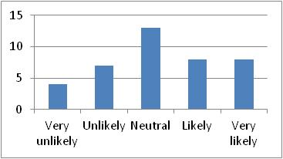
Table 3.24 | Figure 3.24

3.26 Use recyclable packing (ENV26): Most of participants have chosen “Neutral” answer which is 30%, however, some other participants have also chosen “Very likely” and “Likely” and some other participants have chosen “Unlikely” and “Very unlikely” answers. This is indicated in Table 3.26 and Figure 3.26 below.
This is very surprising result, in this case there is disagreement and variability between the respondents’ answers in relation to Use recyclable packing, as some respondents do not think this is a good contributor to value creation of the firm. Actually the literature reviews show that this is a good contributor but maybe this is because of local context.
 | 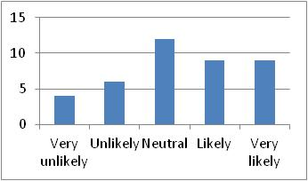
Table 3.26 | Figure 3.26

3.27 Use systems for measuring and assessing environmental performance (ENV27): Most of participants have chosen “Neutral” answer which is about 37.5%, however, some other participants have also chosen “Likely” and little participants have chosen “Very likely”, “Unlikely” and “Very unlikely” answers. This is indicated in Table 3.27 and Figure 3.27 below.
This is very surprising result, in this case there is disagreement and variability between the respondents’ answers in relation to Use systems for measuring and assessing environmental performance, as some respondents do not think this is a good contributor to value creation of the firm. Actually the literature reviews show that this is a good contributor but maybe this is because of local context.
 | 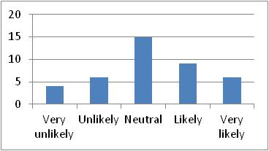
Table 3.27 | Figure 3.27

6.2.4 Descriptive Analysis for Social (S)
The fourth section of the questionnaire is about the Social initiatives of the firm. It has a general question: ‘”4. How likely the following Social CSR practices contribute to value creation in your firm”; and under the previous main question, there are 22 sub-questions as the following:

4.1 Aiding medical research (S1): Most of participants have chosen “Likely” answer which is about 30%, however, some other participants have also chosen “Very likely”, “Neutral”, “Unlikely” and “Very unlikely” answers. This is indicated in Table 4.1 and Figure 4.1 below.
This is very surprising result, in this case there is disagreement and variability between the respondents’ answers in relation to Aiding medical research, as some respondents do not think this is a good contributor to value creation of the firm. Actually the literature reviews show that this is a good contributor but maybe this is because of local context.
 | 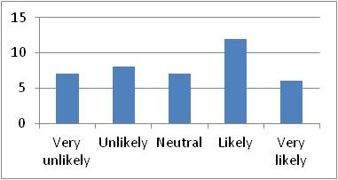
Table 4.1 | Figure 4.1

4.2 Assisting charity or social vulnerable groups like (Donation/ Engage in charitable event/
Form a charity/ Encourage employees to be a volunteer) (S2): Most of participants have chosen “Likely” answer which is about 57.5%, however, some other participants have also chosen “Neutral” answer and little participants have chosen “Very likely” answer while very little participants have chosen “Unlikely” answer while no participants have chosen “Very unlikely” answer. This is indicated in Table 4.2 and Figure 4.2 below.
This is very surprising result, in this case there is disagreement and variability between the respondents’ answers in relation to Assisting charity, as some respondents do not think this is a good contributor to value creation of the firm. Actually the literature reviews show that this is a good contributor but maybe this is because of local context.
 | 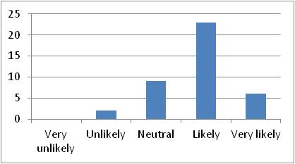
Table 4.2 | Figure 4.2

4.3 Contributing cash donation for disaster by natural calamities programs (S3): Most of participants have chosen “Neutral” answer which is about 40%, however, some other participants have also chosen “Likely” answer and little participants have chosen “Very likely” answer while very little participants have chosen “Unlikely” and “Very unlikely” answers. This is indicated in Table 4.3 and Figure 4.3 below.
This is very surprising result, in this case there is disagreement and variability between the respondents’ answers in relation to Contributing cash donation for disaster by natural calamities programs, as some respondents do not think this is a good contributor to value creation of the firm. Actually the literature reviews show that this is a good contributor but maybe this is because of local context.
 | 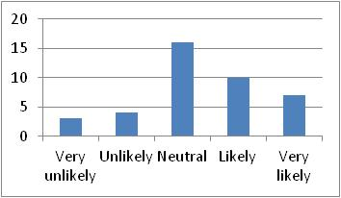
Table 4.3 | Figure 4.3

4.4 Contributing to campaigns and projects that promote the well-being of the society (S4): Most of participants have chosen “Likely” and “Neutral” answers which are about 67.5% for both only, however, some other participants have also chosen “Very likely” answer, while very little participants have chosen “Unlikely” and “Very unlikely” answers. This is indicated in Table 4.4 and Figure 4.4 below.
This is very surprising result, in this case there is disagreement and variability between the respondents’ answers in relation to Contributing to campaigns and projects that promote the well-being of the society, as some respondents do not think this is a good contributor to value creation of the firm. Actually the literature reviews show that this is a good contributor but maybe this is because of local context.
 | 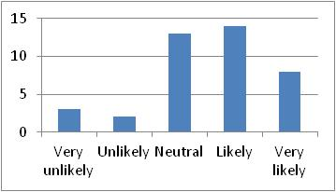
Table 4.4 | Figure 4.4

4.5 Cooperating with other private and public entities in social projects (S5): Most of participants have chosen “Likely” answer which is about 45%, however, some other participants have also chosen “Neutral” answer, while little participants have chosen “Very likely” answer and very little participants have chosen “Unlikely” and “Very unlikely” answers. This is indicated in Table 4.5 and Figure 4.5 below.
This is very surprising result, in this case there is disagreement and variability between the respondents’ answers in relation to Cooperating with other private and public entities in social projects, as some respondents do not think this is a good contributor to value creation of the firm. Actually the literature reviews show that this is a good contributor but maybe this is because of local context.
 | 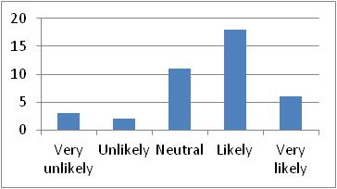
Table 4.5 | Figure 4.5

4.6 Encourage employees to participate in voluntarily activities (S6): Most of participants have chosen “Likely” answer which is about 45%, however, some other participants have also chosen “Very likely” and “Neutral” answers; while little participants have chosen “Very unlikely” answer and very little participants have chosen “Unlikely” answer. This is indicated in Table 4.6 and Figure 4.6 below.
This is very surprising result, in this case there is disagreement and variability between the respondents’ answers in relation to Encourage employees to participate in voluntarily activities, as some respondents do not think this is a good contributor to value creation of the firm. Actually the literature reviews show that this is a good contributor but maybe this is because of local context.
 | 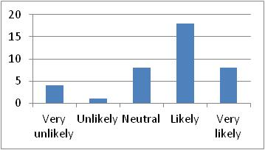
Table 4.6 | Figure 4.6

4.7 Encourage the employees to develop their skills and careers (S7): Most of participants have chosen “Likely” answer which is about 45%; however, some other participants have also chosen “Very likely” answer; while little participants have chosen “Neutral” answer and very little participants have chosen “Unlikely” and “Very unlikely” answers. This is indicated in Table 4.7 and Figure 4.7 below.
This is very surprising result, in this case there is disagreement and variability between the respondents’ answers in relation to Encourage the employees to develop their skills and careers, as some respondents do not think this is a good contributor to value creation of the firm. Actually the literature reviews show that this is a good contributor but maybe this is because of local context.
 | 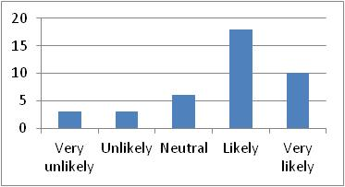
Table 4.7 | Figure 4.7

4.8 Engaging in socio-economic development (S8): Most of participants have chosen “Likely” answer which is about 42.5%, however, some other participants have also chosen “Very likely” and “Neutral” answers, while very participants have chosen “Unlikely” and “Very unlikely” answers. This is indicated in Table 4.8 and Figure 4.8 below.
This is very surprising result, in this case there is disagreement and variability between the respondents’ answers in relation to Engaging in socio-economic development, as some respondents do not think this is a good contributor to value creation of the firm. Actually the literature reviews show that this is a good contributor but maybe this is because of local context.
 | 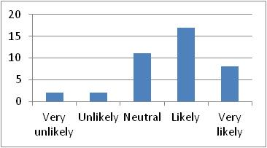
Table 4.8 | Figure 4.8

4.9 Funding scholarship programs or activities (S9): Most of participants have chosen “Likely” and “Neutral” answers which are about 60% for both of them only, however, some other participants have also chosen “Very likely” answer, while little participants have chosen “Unlikely” and “Very unlikely” answers. This is indicated in Table 4.9 and Figure 4.9 below.
This is very surprising result, in this case there is disagreement and variability between the respondents’ answers in relation to Funding scholarship programs or activities, as some respondents do not think this is a good contributor to value creation of the firm. Actually the literature reviews show that this is a good contributor but maybe this is because of local context.
 | 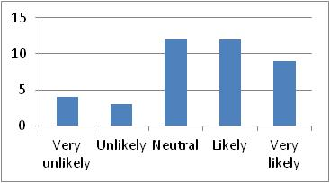
Table 4.9 | Figure 4.9

4.10 Investing in sustainable development to create a better life for future generations (S10): Most of participants have chosen “Likely” answer which is about 37.5%, however, some other participants have also chosen “Very likely” and “Neutral” answers, while little participants have chosen “Unlikely” and “Very unlikely” answers. This is indicated in Table 4.10 and Figure 4.10 below.
This is very surprising result, in this case there is disagreement and variability between the respondents’ answers in relation to Investing in sustainable development to create a better life for future generations, as some respondents do not think this is a good contributor to value creation of the firm. Actually the literature reviews show that this is a good contributor but maybe this is because of local context.
 | 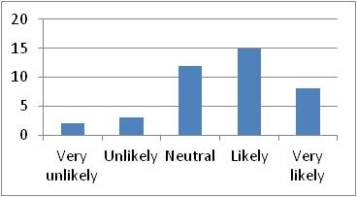
Table 4.10 | Figure 4.10

4.11 Promoting women and minorities in leadership positions (S11): Most of participants have chosen “Likely” answer which is about 40%, however, some other participants have also chosen “Very likely” and “Neutral” answers, while no participant has chosen “Unlikely” or “Very unlikely” answers. This is indicated in Table 4.11 and Figure 4.11 below.
This is very surprising result, in this case there is disagreement and variability between the respondents’ answers in relation to Promoting women and minorities in leadership positions, as some respondents do not think this is a good contributor to value creation of the firm. Actually the literature reviews show that this is a good contributor but maybe this is because of local context.
 | 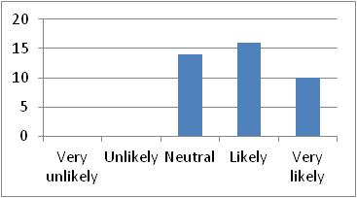
Table 4.11 | Figure 4.11

4.12 Promoting Anti-Discrimination guidelines (S12): Most of participants have chosen “Neutral” answer which is about 40%, however, some other participants have also chosen “likely” and “Very likely” answers, while little participants have chosen “Unlikely” answer and no participant has chosen “Very unlikely” answer. This is indicated in Table 4.12 and Figure 4.12 below.
This is very surprising result, in this case there is disagreement and variability between the respondents’ answers in relation to Promoting Anti-Discrimination guidelines, as some respondents do not think this is a good contributor to value creation of the firm. Actually the literature reviews show that this is a good contributor but maybe this is because of local context.
 | 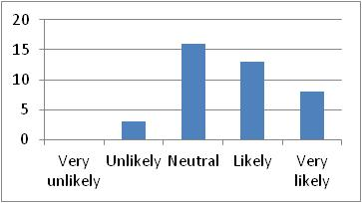
Table 4.12 | Figure 4.12

4.13 Protecting employee health and safety (S13): Most of participants have chosen “Likely” answer which is about 55%, however, some other participants have also chosen “Very likely” answer, while very little participants have chosen “Neutral” and “Unlikely” answers while no participants have chosen “Very unlikely” answer. This is indicated in Table 4.13 and Figure 4.13 below.
This is very surprising result, in this case there is disagreement and variability between the respondents’ answers in relation to Protecting employee health and safety, as some respondents do not think this is a good contributor to value creation of the firm. Actually the literature reviews show that this is a good contributor but maybe this is because of local context.
 | 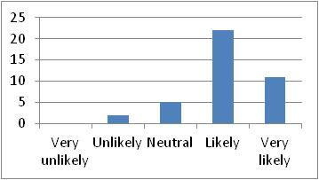
Table 4.13 | Figure 4.13

4.14 Providing support to organization working with autistic and physically challenged children (S14): Most of participants have chosen “Likely” answer which is about 35%, however, some other participants have also chosen “Neutral” answer, while little participants have chosen “Very likely”, “Unlikely” and “Very unlikely” answers. This is indicated in Table 4.14 and Figure 4.14 below.
This is very surprising result, in this case there is disagreement and variability between the respondents’ answers in relation to Providing support to organization working with autistic and physically challenged children, as some respondents do not think this is a good contributor to value creation of the firm. Actually the literature reviews show that this is a good contributor but maybe this is because of local context.
 | 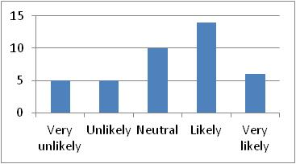
Table 4.14 | Figure 4.14

4.15 Providing sponsorship for Sport, Art & Cultural programs (S15): Most of participants have chosen “Likely” answer which is about 42.5%, however, some other participants have also chosen “Neutral” and “Unlikely” answers, while little participants have chosen “Very likely” answer, and very little participants have chosen “Very unlikely” answer. This is indicated in Table 4.15 and Figure 4.15 below.
This is very surprising result, in this case there is disagreement and variability between the respondents’ answers in relation to Providing sponsorship for Sport, Art & Cultural programs, as some respondents do not think this is a good contributor to value creation of the firm. Actually the literature reviews show that this is a good contributor but maybe this is because of local context.
 | 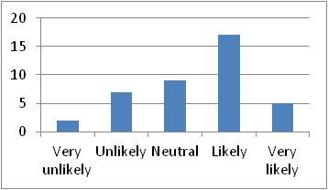
Table 4.15 | Figure 4.15

4.16 Pursuing opportunities to define projects that are beneficial for the firm and society (S16): Most of participants have chosen “Likely” answer which is about 57.5%, however, some other participants have also chosen “Very likely”, “Neutral”, “Unlikely” and “Very unlikely” answers. This is indicated in Table 4.16 and Figure 4.16 below.
This is very surprising result, in this case there is disagreement and variability between the respondents’ answers in relation to Pursuing opportunities to define projects that are beneficial for the firm and society, as some respondents do not think this is a good contributor to value creation of the firm. Actually the literature reviews show that this is a good contributor but maybe this is because of local context.
 | 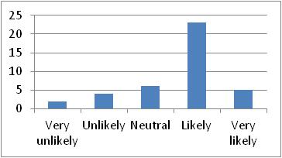
Table 4.16 | Figure 4.16

4.17 Sponsoring summer or part-time employment of students (S17): Most of participants have chosen “Likely” answer which is about 42.5%, however, some other participants have also chosen “Neutral” answer, while little participants have chosen “Very likely”, “Unlikely” and “Very unlikely” answers. This is indicated in Table 4.17 and Figure 4.17 below.
This is very surprising result, in this case there is disagreement and variability between the respondents’ answers in relation to Sponsoring summer or part-time employment of students, as some respondents do not think this is a good contributor to value creation of the firm. Actually the literature reviews show that this is a good contributor but maybe this is because of local context.
 | 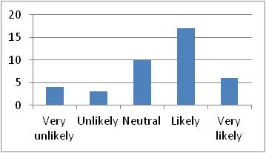
Table 4.17 | Figure 4.17

4.18 Sponsoring public health projects (S18): Most of participants have chosen “Neutral” and “Likely” answers which are about 65% for both; however, some other participants have also chosen “Very likely” answer, while very little participants have chosen “Unlikely” and “Very unlikely” answers. This is indicated in Table 4.18 and Figure 4.18 below.
This is very surprising result, in this case there is disagreement and variability between the respondents’ answers in relation to Sponsoring public health projects, as some respondents do not think this is a good contributor to value creation of the firm. Actually the literature reviews show that this is a good contributor but maybe this is because of local context.
 | 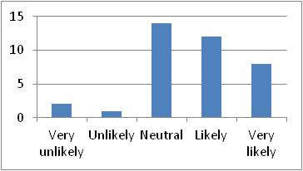
Table 4.18 | Figure 4.18

4.19 Sponsoring educational conferences (S19): Most of participants have chosen “Neutral” and “Likely” answers which is about 67.5% for both, however, some other participants have also chosen “Very likely” and “Unlikely” answers, while very little participants have chosen “Very unlikely” answer. This is indicated in Table 4.19 and Figure 4.19 below.
This is very surprising result, in this case there is disagreement and variability between the respondents’ answers in relation to Sponsoring educational conferences, as some respondents do not think this is a good contributor to value creation of the firm. Actually the literature reviews show that this is a good contributor but maybe this is because of local context.
 | 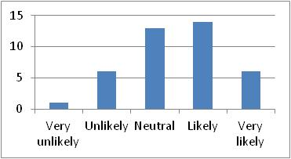
Table 4.19 | Figure 4.19

4.20 Supporting social welfare programs and creation of employment opportunities (S20): Most of participants have chosen “Likely” and “Neutral” answers which are about 67.5% for both, however, some other participants have also chosen “Very likely” answer, while little participants have chosen “Unlikely” and “Very unlikely” answers. This is indicated in Table 4.20 and Figure 4.20 below.
This is very surprising result, in this case there is disagreement and variability between the respondents’ answers in relation to Supporting social welfare programs and creation of employment opportunities, as some respondents do not think this is a good contributor to value creation of the firm. Actually the literature reviews show that this is a good contributor but maybe this is because of local context.
 | 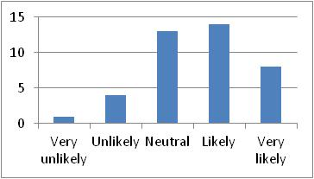
Table 4.20 | Figure 4.20

4.21 Supporting non-governmental organizations working in problematic areas (S21): Most of participants have chosen “Neutral” answer which is about 45%, however, some other participants have also chosen “Likely”, “Unlikely” and “Very unlikely” answers, while very little participants have chosen “Very likely” answer. This is indicated in Table 4.21 and Figure 4.21 below.
This is very surprising result, in this case there is disagreement and variability between the respondents’ answers in relation to Supporting non-governmental organizations working in problematic areas, as some respondents do not think this is a good contributor to value creation of the firm. Actually the literature reviews show that this is a good contributor but maybe this is because of local context.
 | 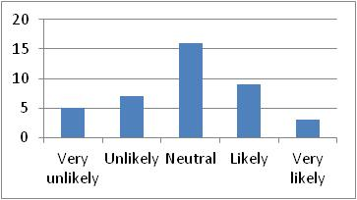
Table 4.21 | Figure 4.21

4.22 Undertaking activities associated with the society’s future (S22): Most of participants have chosen “Likely” and “Neutral” answers which are about 77.5% for both, however, some other participants have also chosen “Very likely” answer, while very little participants have chosen “Unlikely” and “Very unlikely” answers. This is indicated in Table 4.22 and Figure 4.22 below.
This is very surprising result, in this case there is disagreement and variability between the respondents’ answers in relation to Undertaking activities associated with the society’s future, as some respondents do not think this is a good contributor to value creation of the firm. Actually the literature reviews show that this is a good contributor but maybe this is because of local context.
 | 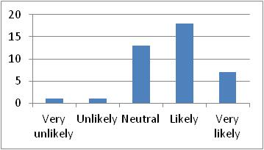
Table 4.22 | Figure 4.22

6.2.5 Descriptive Analysis for General Questions (G)
The fifth section of the questionnaire is a General Questions about the firm. The General questions section has been divided to into six questions.
The first question was “5.1 How much does your firm contribute to CSR practices as a percentage of revenue? (Code: G1)”, where the scale on which it was used for ranking was ‘1’ denoting < 1% of revenue, ‘2’ denoting 1-2% of revenue, ‘3’ denoting 3-4% of revenue, and ‘4’ denoting Other percentage in case that the answer is not close to any answer given.
 | 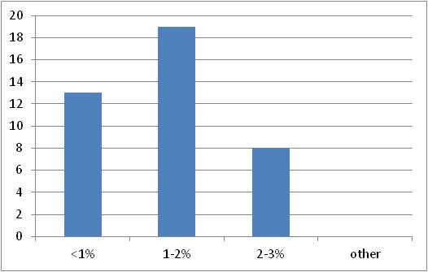
Table 5.1 | Figure 5.1
The above Table 5.1 and Figure 5.1 highlight the responses in each category. 32.5% firms were contributing less than 1% to CSR activities as a percentage of their revenue. 47.5% firms were contributing from 1-2% to CSR activities as a percentage of their revenue. 20% firms were contributing from 2-3% to CSR activities as a percentage of their revenue. And no any firm contribute other percentage.
The second question was “5.2 How many key CSR indicators your firm reports/ discloses? (Code: G2)”, where the scale on which it was used was ‘1’ denoting 5-10 indicators, ‘2’ denoting 10-15 indicators, ‘3’ denoting 15-20 indicators, and ‘4’ denoting 25-30 indicators.
 | 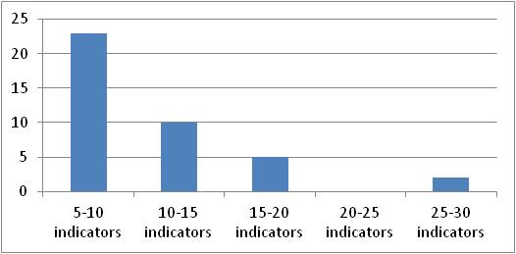
Table 5.2 | Figure 5.2
The above Table 5.2 and Figure 5.2 highlight the responses in each category. 57.5% firms were using 5-10 indicators, 25% firms were using 10-15 indicators, 12.5% firms were using 15-20 indicators, 57.5% no firm was using 20-25 indicators, and only 5% firms were using 25-30 indicators. It concluded that more than 50% were using 5-15 indicators.
The third question was “5.3 How much the total asset of your firm in AED Billions?, (Code: G3)”, where the scale on which it was used for ranking was ‘1’ denoting less than 1 billion out of total asset, ‘2’ denoting 1-5 billion out of total asset, ‘3’ denoting 5-10 billion out of total asset, ‘4’ denoting 10-15 billion out of total asset, ‘5’ denoting 15-20 billion out of total asset, ‘6’ denoting 20-25 billion out of total asset, ‘7’ denoting 25-30 billion out of total asset, ‘8’ denoting 30-50 billion out of total asset, ‘9’ denoting 50-100 billion out of total asset and ‘10’ denoting greater than 100 billion out of total asset.
 | 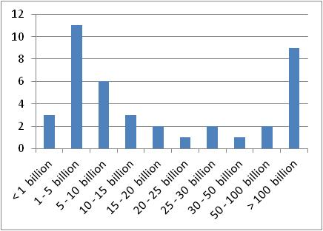
Table 5.3 | Figure 5.3
The above Table 5.3 and Figure 5.3 highlight the responses in each category. the total asset of the firms was as following: less than 1 billion for 7.5% of the firms, 1-5 billion for 27.5% of the firms, 5-10 billion for 15% of the firms, it was 10-15 billion for 7.5% of the firms, 15-20 billion for 5% of the firms, 20-25 billion for 2.5% of the firms, 25-30 billion for 5% of the firms, 30-50 billion for 2.5% of the firms, 50-100 billion for 5% of the firms and greater than 100 billion for 22.5% of the firms, and this is actually the last question of the first part.

The fourth question of general questions section was as following “5.4 Which is the area of CSR more significant for your firm?”, and the question was covering 9 areas as following:
5.4.1 Governance (G4): Most of the participants have chosen “Very likely” and “Likely” answers as n=35 (87.5%) for both answers, while very little participants have chosen “Neutral”, and no participants have chosen “Unlikely” or “Very unlikely” answers. This is indicated in Table 5.4.1 and Figure 5.4.1 below.
Overwhelming; majority of respondents in agreement that G4 is a good contributor to value creation. Compliance with the Governance is important for the reputation of the firm image and operational. Therefore, it appears by the respondents that it is good value creator.
 | 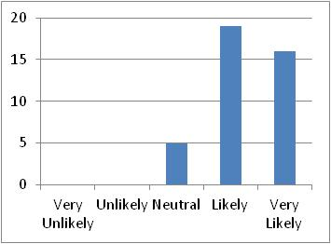
Table 5.4.1 | Figure 5.4.1

5.4.2 Dialogue with the stakeholders (Code: G5): 37.5% of the firms denoting “Very likely”, 42.5% denoting “Likely”, only 17.5% denoting “Neutral” and 0% denoting “Unlikely” or “Very unlikely”, however, one response was missed, this is why The average mean will be considered for the whole responses, so that (n=17) 42.5% denoting “Likely” which is the highest value will be increased by (n=1) 2.5% and so it will be changed to be (n=18) 45% to denote “Likely”. That means most of the participants have chosen “Very likely” and “Likely” answers as n=33 (82.5%) for both answers, and little participants have chosen “Neutral”, while no participant has chosen “Unlikely” or “Very unlikely” answers. This is indicated in Table 5.4.2 and Figure 5.4.2 and Table 5.4.2a and Figure 5.4.2a below.
Overwhelming; majority of respondents in agreement that G5 is a good contributor to value creation. Compliance with the Dialogue with the stakeholders is important for the reputation of the firm image and operational. Therefore, it appears by the respondents that it is good value creator.
 | 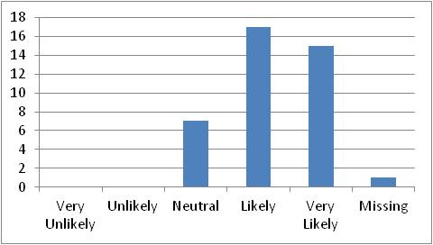
Table 5.4.2 | Figure 5.4.2
 | 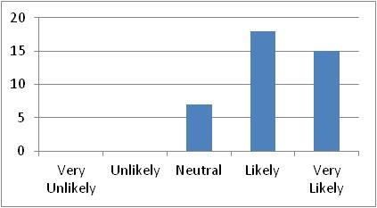
Table 5.4.2a | Figure 5.4.2a

5.4.3 Policy towards employees (Code: G6): only 20% of the firms denoting “Very likely”, but 40% denoting “Likely”, and 37.5% denoting “Neutral” and 0% denoting “Unlikely” or “Very unlikely”, however, one response was missed, this is why the average mean will be considered for the whole responses, so that (n=16) 40% denoting “Likely” which is the highest value will be increased by (n=1) 2.5% and so it will be changed to be (n=17) 42.5% to denote “Likely”. That means most of the participants have chosen “Likely” and “Neutral” answers as n=32 (80%) for both answers, and little participants have chosen “Very likely”, while no participant has chosen “Unlikely” or “Very unlikely” answers. This is indicated in Table 5.4.3 and Figure 5.4.3 and Table 5.4.3a and Figure 5.4.3a below.
Overwhelming; majority of respondents in agreement that G6 is a good contributor to value creation. Compliance with the Policy towards employees is important for the reputation of the firm image and operational. Therefore, it appears by the respondents that it is good value creator.
 | 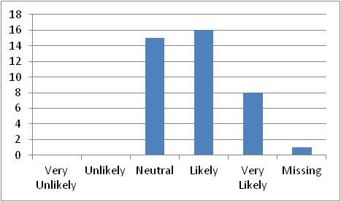
Table 5.4.3 | Figure 5.4.3
 | 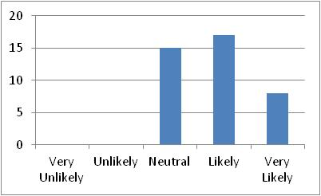
Table 5.4.3a | Figure 5.4.3a

5.4.4 Relationship with clients and suppliers (Code: G7): 45% of the firms denoting “Very likely”, 40% denoting “Likely”, and only 12.5% denoting “Neutral” and 0% denoting “Unlikely” or “Very unlikely”, however, one response was missed, this is why The average mean will be considered for the whole responses, so that (n=18) 45% denoting “Very likely” which is the highest value will be increased by (n=1) 2.5% and so it will be changed to be (n=19) 47.5% to denote “Very likely”. That means most of the participants have chosen “Very likely” and “Likely” answers as n=35 (87.5%) for both answers, and little participants have chosen “Neutral” answer, while no participant has chosen “Unlikely” or “Very unlikely” answers. This is indicated in Table 5.4.4 and Figure 5.4.4 and Table 5.4.4a and Figure 5.4.4a below.
Overwhelming; majority of respondents in agreement that G7 is a good contributor to value creation. Compliance with the Relationship with clients and suppliers is important for the reputation of the firm image and operational. Therefore, it appears by the respondents that it is good value creator.
 | 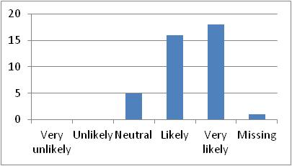
Table 5.4.4 | Figure 5.4.4
 | 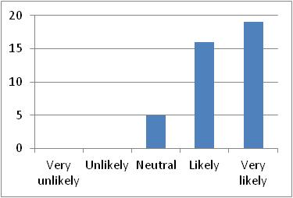
Table 5.4.4 | Figure 5.4.4a

5.4.5 Relationship with the community (Code: G8): 30% of the firms denoting “Very likely”, 50% denoting “Likely”, 15% denoting “Neutral”, only 2.5% denoting ‘Unlikely”, and 0% denoting “Very unlikely”, however, one response was missed, this is why The average mean will be considered for the whole responses, so that (n=20) 50% denoting “Likely” which is the highest value will be increased by (n=1) 2.5% and so it will be changed to be (n=21) 52.5% to denote “Likely”. That means most of the participants have chosen “Very likely” and “Likely” answers as n=33 (82.5%) for both answers and little participants have chosen “Neutral”, and very little participants have chosen “Unlikely” while no participant has chosen “Very unlikely” answers. This is indicated in Table 5.4.5 and Figure 5.4.5 and Table 5.4.5a and Figure 5.4.5a below.
This is very surprising result, in this case there is disagreement and variability between the respondents’ answers in relation to Relationship with the community, as some respondents do not think this is a good contributor to value creation of the firm. Actually the literature reviews show that this is a good contributor but maybe this is because of local context.
 | 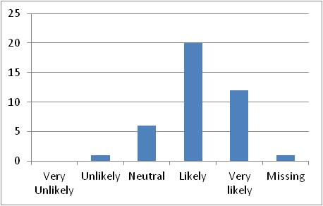
Table 5.4.5 | Figure 5.4.5
 | 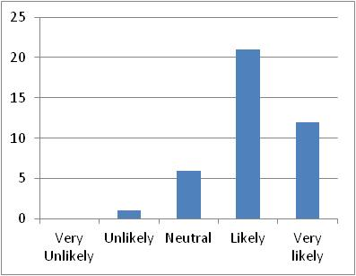
Table 5.4.5a | Figure 5.4.5a

5.4.6 Environment protection (Code: G9): Only 15% of the firms denoting “Very likely”, 35% denoting “Likely”, and also 35% denoting “Neutral”, only 5% denoting ‘Unlikely”, and also 5% denoting “Very unlikely”, however, two responses were missed, this is why The average mean will be considered for the whole responses, so that (n=14) 35% denoting “Likely” which is the highest value will be increased by (n=2) 5% and so it will be changed to be (n=16) 40% to denote “Likely”. That means most of the participants have equally chosen “Likely” and “Neutral” answers as n=30 (75.5%) for both answers, and little participants have chosen “Neutral”, while little participants have chosen “Very likely” answer and no participant has chosen “Unlikely” or “Very unlikely” answers. This is indicated in Table 5.4.6 and Figure 5.4.6 and Table 5.4.6a and Figure 5.4.6a below.
This is very surprising result, in this case there is disagreement and variability between the respondents’ answers in relation to Environment protection, as some respondents do not think this is a good contributor to value creation of the firm. Actually the literature reviews show that this is a good contributor but maybe this is because of local context.
 | 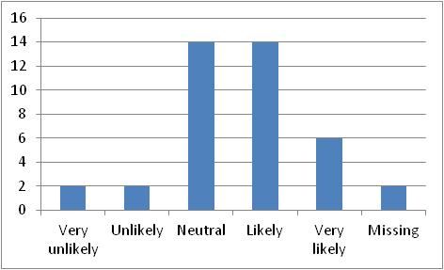
Table 5.4.6 | Figure 5.4.6
 | 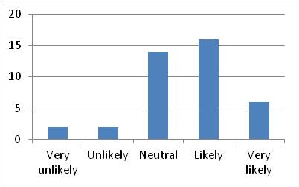
Table 5.4.6a | Figure 5.4.6a

5.4.7 Relationship with professional bodies (Code: G10): 35% of the firms denoting “Very likely”, 35% denoting “Likely”, 22.5% denoting “Neutral”, only 5% denoting ‘Unlikely”, while 0% denoting “Very unlikely”, however, one response was missed, this is why The average mean will be considered for the whole responses, so that (n=14) 35% denoting “Very likely” which is the highest value will be increased by (n=1) 2.5% and so it will be changed to be (n=15) 37.5% to denote “Very likely”. That means most of the participants have chosen “Very likely” and “Likely” answers as n=29 (72.5%) for both answers, and some participants have chosen “Neutral”, while very little participants have chosen “Unlikely” answer and no participant has chosen “Very unlikely” answer. This is indicated in Table 5.4.7 and Figure 5.4.7 and Table 5.4.7a and Figure 5.4.7a below.
This is very surprising result, in this case there is disagreement and variability between the respondents’ answers in relation to Relationship with professional bodies, as some respondents do not think this is a good contributor to value creation of the firm. Actually the literature reviews show that this is a good contributor but maybe this is because of local context.
 | 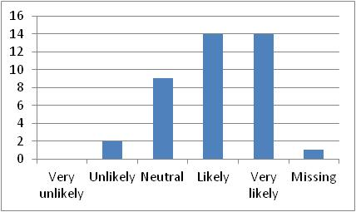
Table 5.4.7 | Figure 5.4.7
 | 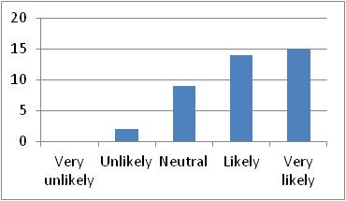
Table 5.4.7a | Figure 5.4.7a

5.4.8 Relationship with regulators (Code: G11): 37.5% of the firms denoting “Very likely”, 40% denoting “Likely”, 17.5% denoting “Neutral”, and only 2.5% denoting ‘Unlikely”, while 0% denoting “Very unlikely”, however, one response was missed, this is why The average mean will be considered for the whole responses, so that (n=16) 40% denoting “Likely” which is the highest value will be increased by (n=1) 2.5% and so it will be changed to be (n=17) 42.5% to denote “Likely”. That means most of the participants have chosen “Very likely” and “Likely” answers as n=29 (72.5%) for both answers, and little participants have chosen “Neutral” answer, while very little participants have chosen “Unlikely” answer and no participant has chosen “Very unlikely” answer. This is indicated in Table 5.4.8 and Figure 5.4.8 and Table 5.4.8a and Figure 5.4.8a below.
This is very surprising result, in this case there is disagreement and variability between the respondents’ answers in relation to Relationship with regulators, as some respondents do not think this is a good contributor to value creation of the firm. Actually the literature reviews show that this is a good contributor but maybe this is because of local context.
 | 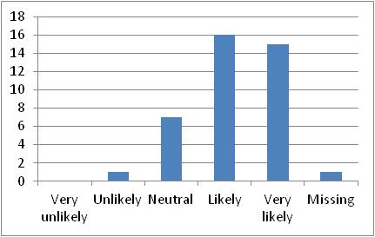
Table 5.4.8 | Figure 5.4.8
 | 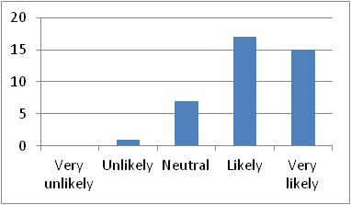
Table 5.4.8a | Figure 5.4.8a

5.4.9 Relationship with governmental entities (Code: G12): 47.5% of the firms denoting “Very likely”, 40% denoting “Likely”, 10% denoting “Neutral”, while 0% denoting ‘Unlikely” and “Very unlikely”, however, one response was missed, this is why The average mean will be considered for the whole responses, so that (n=19) 47.5% denoting “Very likely” which is the highest value will be increased by (n=1) 2.5% and so it will be changed to be (n=20) 50% to denote “Very likely”. That means most of the participants have chosen “Very likely” and “Likely” answers as n=36 (90%) for both answers, and little participants have chosen “Neutral”, while no participant has chosen “Unlikely” or “Very unlikely” answers. This is indicated in Table 5.4.9 and Figure 5.4.9 and Table 5.4.9a and Figure 5.4.9a below, and this is actually the last question of the second part.
Overwhelming; majority of respondents in agreement that G12 is a good contributor to value creation. Compliance with the Relationship with governmental entities is important for the reputation of the firm image and operational. Therefore, it appears by the respondents that it is good value creator.
 | 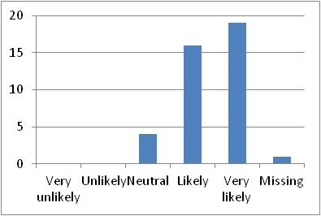
Table 5.4.9 | Figure 5.4.9
 | 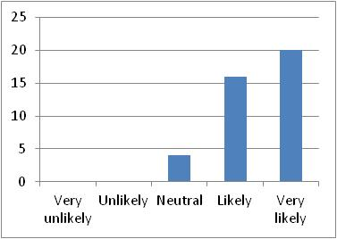
Table 5.4.9a | Figure 5.4.9a

The fifth question of general questions section was as following “5.5 How important are the following stakeholders in shaping your firm CSR policies?”, and it was covering 11 areas as following:
5.5.1 Government (Code: G13): 42.5% of the firms denoting “Very likely”, and also 42.5% denoting “Likely”, 12.5% denoting “Neutral”, while 0% denoting ‘Unlikely” and “Very unlikely”, however, one response was missed, this is why The average mean will be considered for the whole responses, so that (n=17) 42.5% denoting “Very likely” which is the highest value will be increased by (n=1) 2.5% and so it will be changed to be (n=18) 45% to denote “Very likely”. That means most of the participants have chosen “Very likely” and “Likely” answers as n=34 (85%) for both answers, and little participants have chosen “Neutral” answer, while no participant has chosen “Unlikely” or “Very unlikely” answers. This is indicated in Table 5.5.1 and Figure 5.5.1 and Table 5.5.1a and Figure 5.5.1a below.
Overwhelming; majority of respondents in agreement that G13 is a good contributor to value creation. Compliance with the Government is important for the reputation of the firm image and operational. Therefore, it appears by the respondents that it is good value creator.
 | 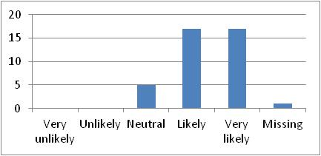
Table 5.5.1 | Figure 5.5.1
 | 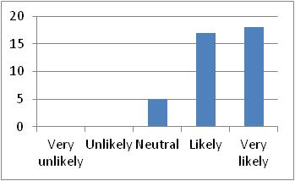
Table 5.5.1a | Figure 5.5.1a

5.5.2 Customers (Code: G14): 42.5% of the firms denoting “Very likely”, 37.5% denoting “Likely”, 17.5% denoting “Neutral”, while 0% denoting ‘Unlikely” and “Very unlikely”, however, one response was missed, this is why The average mean will be considered for the whole responses, so that (n=17) 42.5% denoting “Very likely” which is the highest value will be increased by (n=1) 2.5% and so it will be changed to be (n=18) 45% to denote “Very likely”. That means most of the participants have chosen “Very likely” and “Likely” answers as n=33 (82.5%) for both answers, and little participants have chosen “Neutral” answer, while no participant has chosen “Unlikely” or “Very unlikely” answers. This is indicated in Table 5.5.2 and Figure 5.5.2 and Table 5.5.2a and Figure 5.5.2a below.
Overwhelming; majority of respondents in agreement that G14 is a good contributor to value creation. Compliance with the Customers is important for the reputation of the firm image and operational. Therefore, it appears by the respondents that it is good value creator.

 | 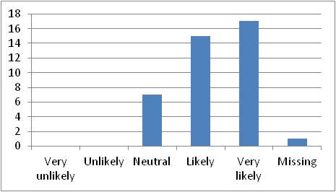
Table 5.5.2 | Figure 5.5.2
 | 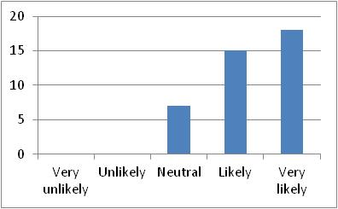
Table 5.5.2a | Figure 5.5.2a

5.5.3 Employees (Code: G15): 32.5% of the firms denoting “Very likely”, 42.5% denoting “Likely”, 22.5% denoting “Neutral”, while 0% denoting ‘Unlikely” and “Very unlikely”, however, one response was missed, this is why The average mean will be considered for the whole responses, so that (n=17) 42.5% denoting “Likely” which is the highest value will be increased by (n=1) 2.5% and so it will be changed to be (n=18) 45% to denote “Likely”. That means most of the participants have chosen “Very likely” and “Likely” answers as n=31 (77.5%) for both answers, and little participants have chosen “Neutral” answer, while no participant has chosen “Unlikely” or “Very unlikely” answers. This is indicated in Table 5.5.3 and Figure 5.5.3 and Table 5.5.3a and Figure 5.5.3a below.
Overwhelming; majority of respondents in agreement that G15 is a good contributor to value creation. Compliance with the Employees is important for the reputation of the firm image and operational. Therefore, it appears by the respondents that it is good value creator.
 | 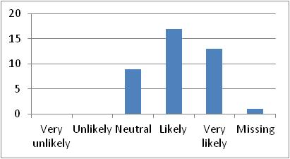
Table 5.5.3 | Figure 5.5.3
 | 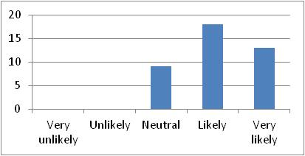
Table 5.5.3a | Figure 5.5.3a

5.5.4 Global community (Code: G16): 22.5% of the firms denoting “Very likely”, 35% denoting “Likely”, 35% denoting “Neutral”, 5% denoting ‘Unlikely” while 0% denoting “Very unlikely”, however, one response was missed, this is why The average mean will be considered for the whole responses, so that (n=14) 35% denoting “Likely” which is the highest value will be increased by (n=1) 2.5% and so it will be changed to be (n=15) 37.5% to denote “Likely”. That means most of the participants have chosen “Likely” and “neutral” answers as n=29 (72.5%) for both answers, and some participants have chosen “Very likely” answer, while very little participants have chosen “Unlikely” answer and no participant has chosen “Very unlikely” answer. This is indicated in Table 5.5.4 and Figure 5.5.4 and Table 5.5.4a and Figure 5.5.4a below.
This is very surprising result, in this case there is disagreement and variability between the respondents’ answers in relation to Global community, as some respondents do not think this is a good contributor to value creation of the firm. Actually the literature reviews show that this is a good contributor but maybe this is because of local context.
 | 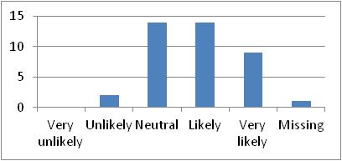
Table 5.3.4 | Figure 5.3.4
 | 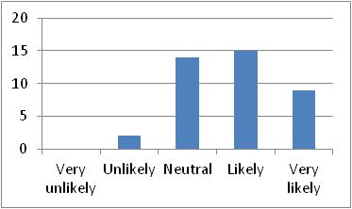
Table 5.5.4a | Figure 5.5.4a

5.5.5 Local community (Code: G17): 42.5% of the firms denoting “Very likely”, 35% denoting “Likely”, 20% denoting “Neutral”, while 0% denoting ‘Unlikely” and “Very unlikely”, however, one response was missed, this is why The average mean will be considered for the whole responses, so that (n=17) 42.5% denoting “Very likely” which is the highest value will be increased by (n=1) 2.5% and so it will be changed to be (n=18) 45% to denote “Very likely”. That means most of the participants have chosen “Very likely” and “Likely” answers as n=32 (80%) for both answers, and little participants have chosen “Neutral” answer, while no participant has chosen “Unlikely” or “Very unlikely” answers. This is indicated in Table 5.5.5 and Figure 5.5.5 and Table 5.5.5a and Figure 5.5.5a below.
Overwhelming; majority of respondents in agreement that G17 is a good contributor to value creation. Compliance with the Local community is important for the reputation of the firm image and operational. Therefore, it appears by the respondents that it is good value creator.
 | 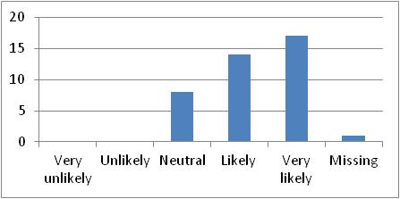
Table 5.5.5 | Figure 5.5.5
 | 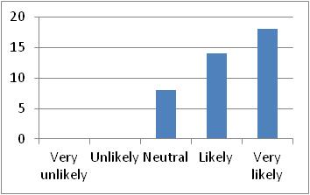
Table 5.5.5a | Figure 5.5.5a

5.5.6 Environmentalist groups (Code: G18): 10% of the firms denoting “Very likely”, 27.5% denoting “Likely”, 32.5% denoting “Neutral”, 17.5% denoting ‘Unlikely” and 7.5% denoting “Very unlikely”, however, two responses were missed, this is why The average mean will be considered for the whole responses, so that (n=13) 32.5% denoting “Neutral” which is the highest value will be increased by (n=2) 5% and so it will be changed to be (n=15) 37.5% to denote “Neutral” answer. That means most of participants have chosen “Likely” and “Neutral” answers as n=26 (65%) for both answers, and some participants have chosen “Unlikely” answer, while little participants have chosen “Very likely” and “Very unlikely” answers. This is indicated in Table 5.5.6 and Figure 5.5.6 and Table 5.5.6a and Figure 5.5.6a below.
This is very surprising result, in this case there is disagreement and variability between the respondents’ answers in relation to Environmentalist groups, as some respondents do not think this is a good contributor to value creation of the firm. Actually the literature reviews show that this is a good contributor but maybe this is because of local context.
 | 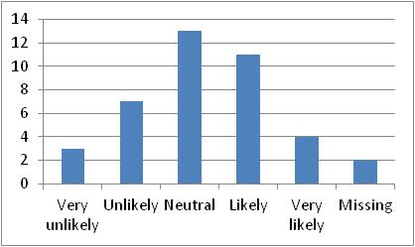
Table 5.5.6 | Figure 5.5.6
 | 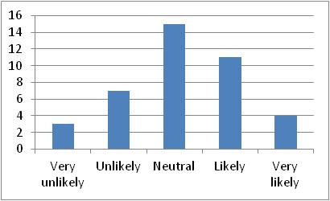
Table 5.5.6a | Figure 5.5.6a

5.5.7 Mass media (Code: G19): 37.5% of the firms denoting “Very likely”, 27.5% denoting “Likely”, 25% denoting “Neutral”, 5% denoting ‘Unlikely” while 0% denoting “Very unlikely”, however, two responses were missed, this is why The average mean will be considered for the whole responses, so that (n=15) 37.5% denoting “Very likely” which is the highest value will be increased by (n=2) 5% and so it will be changed to be (n=17) 42.5% to denote “Very likely”. That means most of the participants have chosen “Very likely” answer as n=17 (42.5%), and some participants have chosen “Likely” and “Neutral” answers, and very little participants have chosen “Unlikely”, while no participant has chosen “Unlikely” or “Very unlikely” answers. This is indicated in Table 5.5.7 and Figure 5.5.7 and Table 5.5.7a and Figure 5.5.7a below.
This is very surprising result, in this case there is disagreement and variability between the respondents’ answers in relation to Mass media, as some respondents do not think this is a good contributor to value creation of the firm. Actually the literature reviews show that this is a good contributor but maybe this is because of local context.
 | 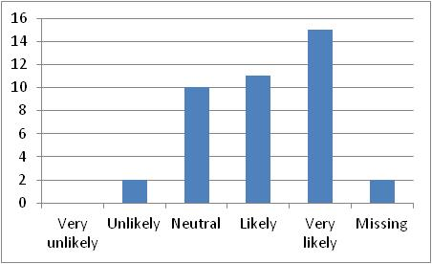
Table 5.5.7 | Figure 5.5.7
 | 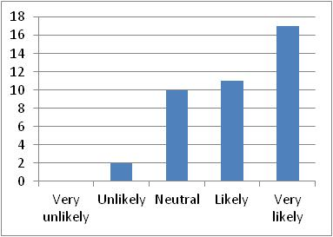
Table 5.5.7a | Figure 5.5.7a

5.5.8 Investors: (Code: G20): 42.5% of the firms denoting “Very likely”, 32.5% denoting “Likely”, 17.5% denoting “Neutral”, 2.5% denoting ‘Unlikely” and 2.5% denoting “Very unlikely”, however, one response was missed, this is why The average mean will be considered for the whole responses, so that (n=17) 42.5% denoting “Very likely” which is the highest value will be increased by (n=1) 2.5% and so it will be changed to be (n=18) 45% to denote “Very likely”. That means most of the participants have chosen “Very likely” and “Likely” answers as n=31 (77.5%) for both answers, while some participants have chosen “Neutral” answer, and very little participant has chosen “Unlikely” and “Very unlikely” answers. This is indicated in Table 5.5.8 and Figure 5.5.8 and Table 5.5.8a and Figure 5.5.8a below.
This is very surprising result, in this case there is disagreement and variability between the respondents’ answers in relation to Investors, as some respondents do not think this is a good contributor to value creation of the firm. Actually the literature reviews show that this is a good contributor but maybe this is because of local context.
 | 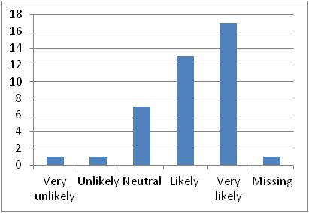
Table 5.5.8 | Figure 5.5.8
 | 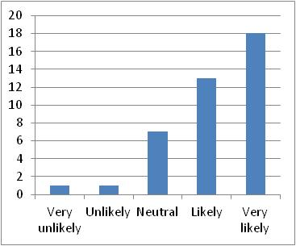
Table 5.5.8a | Figure 5.5.8a

5.5.9 Natural environment (Code: G21): 7.5% of the firms denoting “Very likely”, 30% denoting “Likely”, 40% denoting “Neutral”, 10% denoting ‘Unlikely” and 7.5% denoting “Very unlikely”, however, two responses were missed, this is why The average mean will be considered for the whole responses, so that (n=16) 40% denoting “Neutral” which is the highest value will be increased by (n=2) 5% and so it will be changed to be (n=18) 45% to denote “Neutral”. That means most of the participants have chosen “Likely” and “Neutral” answers as n=30 (75%) for both answers, while some participants have chosen “very likely”, “Unlikely” and “Very unlikely” answers. This is indicated in Table 5.5.9 and Figure 5.5.9 and Table 5.5.9a and Figure 5.5.9a below.
This is very surprising result, in this case there is disagreement and variability between the respondents’ answers in relation to Natural environment, as some respondents do not think this is a good contributor to value creation of the firm. Actually the literature reviews show that this is a good contributor but maybe this is because of local context.
 | 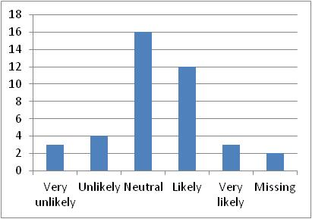
Table 5.5.9 | Figure 5.5.9
 | 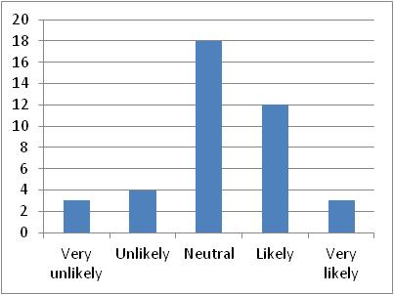
Table 5.5.9a | Figure 5.5.9a

5.5.10 Environmental policies of other competitors (Code: G22): 15% of the firms denoting “Very likely”, 20% denoting “Likely”, 50% denoting “Neutral”, 5% denoting ‘Unlikely” and 5% denoting “Very unlikely”, however, two responses were missed, this is why The average mean will be considered for the whole responses, so that (n=20) 50% denoting “Neutral” which is the highest value will be increased by (n=2) 5% and so it will be changed to be (n=22) 55% to denote “Neutral”. That means most of the participants have chosen “Neutral” answer as n=22 (55%), and little participants have chosen “Likely” and “Very likely” answers, while very little participants have chosen “Unlikely” and “Very unlikely” answers. This is indicated in Table 5.5.10 and Figure 5.5.10 and Table 5.5.10a and Figure 5.5.10a below.
This is very surprising result, in this case there is disagreement and variability between the respondents’ answers in relation to Environmental policies of other competitors, as some respondents do not think this is a good contributor to value creation of the firm. Actually the literature reviews show that this is a good contributor but maybe this is because of local context.
 | 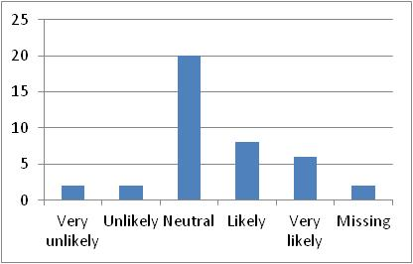
Table 5.5.10 | Figure 5.5.10
 | 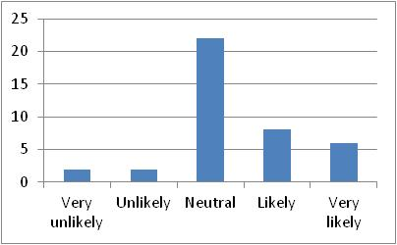
Table 5.5.10a | Figure 5.5.10a

5.5.11 Natural Gas Company pressure from consumer & media (Code: G23): 10% of the firms denoting “Very likely”, 20% denoting “Likely”, 42.5% denoting “Neutral”, 12.5% denoting ‘Unlikely” and 10% denoting “Very unlikely”, however, two responses were missed, this is why The average mean will be considered for the whole responses, so that (n=17) 42.5% denoting “Neutral” which is the highest value will be increased by (n=2) 5% and so it will be changed to be (n=19) 47.5% to denote “Neutral”. That means most of the participants have chosen “Neutral” answer as n=19 (47.5%), and some participants have chosen “Very likely”, “Likely”, “Unlikely” and “Very unlikely” answers. This is indicated in Table 5.5.11 and Figure 5.5.11 and Table 5.5.11a and Figure 5.5.11a below, and this is actually the last question of the third part.
This is very surprising result, in this case there is disagreement and variability between the respondents’ answers in relation to Natural Gas Company pressure from consumer & media, as some respondents do not think this is a good contributor to value creation of the firm. Actually the literature reviews show that this is a good contributor but maybe this is because of local context.
 | 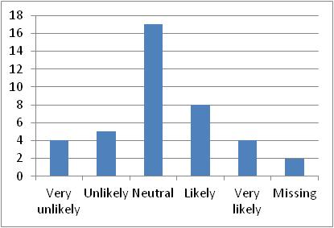
Table 5.5.11 | Figure 5.5.11
 | 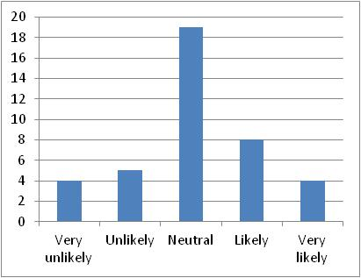
Table 5.5.11a | Figure 5.5.11a

The last and sixth question of general questions section was as following “5.6 Do you think CSR add value to the followings?”, the question was covering 16 areas as following:
5.6.1 Enhancing corporate reputation (Code: G24): 47.5% of the firms denoting “Very likely”, 35% denoting “Likely”, 12.5% denoting “Neutral”, 2.5% denoting ‘Unlikely” and no firm denoting “Very unlikely”, however, one response was missed, this is why The average mean will be considered for the whole responses, so that (n=19) 47.5% denoting “Very likely” which is the highest value will be increased by (n=1) 2.5% and so it will be changed to be (n=20) 50% to denote “Very likely”. That means most of the participants have chosen “Very likely” and “Likely” answers as n=34 (85%) for both answers, while some participants have chosen “Neutral” answer, and very little participants have chosen “Unlikely” answer but no participant has chosen “Very unlikely” answer. This is indicated in Table 5.6.1 and Figure 5.6.1 and Table 5.6.1a and Figure 5.6.1a below.
This is very surprising result, in this case there is disagreement and variability between the respondents’ answers in relation to Enhancing corporate reputation, as some respondents do not think this is a good contributor to value creation of the firm. Actually the literature reviews show that this is a good contributor but maybe this is because of local context.
 | 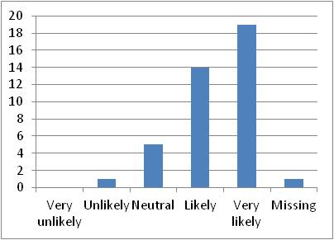
Table 5.6.1 | Figure 5.6.1
 | 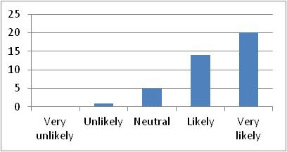
Table 5.6.1a | Figure 5.6.1a

5.6.2 Improving relations with suppliers (Code: G25): 25% of the firms denoting “Very likely”, 47.5% denoting “Likely”, 20% denoting “Neutral”, 5% denoting ‘Unlikely” and no firm denoting “Very unlikely”, however, one response was missed, this is why The average mean will be considered for the whole responses, so that (n=19) 47.5% denoting “Likely” which is the highest value will be increased by (n=1) 2.5% and so it will be changed to be (n=20) 50% to denote “Likely”. That means most of the participants have chosen “Very likely” and “Likely” answers as n=30 (75%) for both answers, while some participants have chosen “Neutral” answer, and very little participants have chosen “Unlikely” answer but no participant has chosen “Very unlikely” answer. This is indicated in Table 5.6.2 and Figure 5.6.2 and Table 5.6.2a and Figure 5.6.2a below.
This is very surprising result, in this case there is disagreement and variability between the respondents’ answers in relation to Improving relations with suppliers, as some respondents do not think this is a good contributor to value creation of the firm. Actually the literature reviews show that this is a good contributor but maybe this is because of local context.
 | 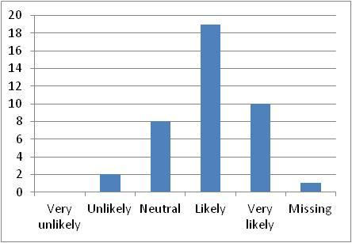
Table 5.6.2 | Figure 5.6.2
 | 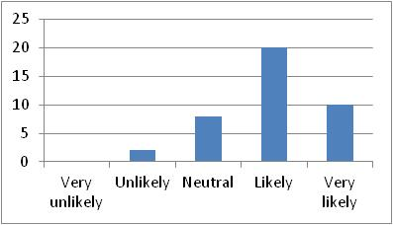
Table 5.6.2a | Figure 5.6.2a

5.6.3 Strengthening the sense of employee (Code: G26): 27.5% of the firms denoting “Very likely”, 47.5% denoting “Likely”, 20% denoting “Neutral”, 0% denoting ‘Unlikely” and 2.5% denoting “Very unlikely”, however, one response was missed, this is why The average mean will be considered for the whole responses, so that (n=19) 47.5% denoting “Likely” which is the highest value will be increased by (n=1) 2.5% and so it will be changed to be (n=20) 50% to denote “Likely”. That means most of the participants have chosen “Very likely” and “Likely” answers as n=31 (77.5%) for both answers, while some participants have chosen “Neutral” answer, and very little participants have chosen “Very unlikely” answer but no participant has chosen “Unlikely” answer. This is indicated in Table 5.6.3 and Figure 5.6.3 and Table 5.6.3a and Figure 5.6.3a below.
This is very surprising result, in this case there is disagreement and variability between the respondents’ answers in relation to Strengthening the sense of employee, as some respondents do not think this is a good contributor to value creation of the firm. Actually the literature reviews show that this is a good contributor but maybe this is because of local context.
 | 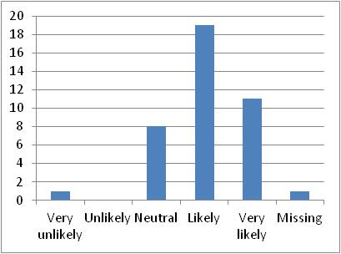
Table 5.6.3 | Figure 5.6.3
 | 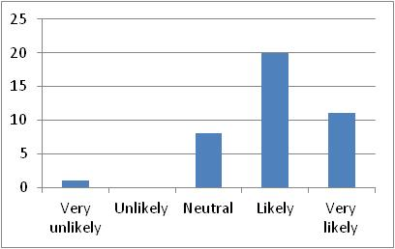
Table 5.6.3a | Figure 5.6.3a

2.6.4 Increasing the efficiency of the firm operation (Code: G27): 32.5% of the firms denoting “Very likely”, 50% denoting “Likely”, 7.5% denoting “Neutral”, 5% denoting ‘Unlikely” and 2.5% denoting “Very unlikely”, however, one response was missed, this is why The average mean will be considered for the whole responses, so that (n=20) 50% denoting “Likely” which is the highest value will be increased by (n=1) 2.5% and so it will be changed to be (n=21) 52.5% to denote “Likely”. That means most of the participants have chosen “Very likely” and “Likely” answers as n=34 (85%) for both answers, while very little participants have chosen “Neutral”, “Unlikely” and “Very unlikely” answers. This is indicated in Table 5.6.4 and Figure 5.6.4 and Table 5.6.4a and Figure 5.6.4a below.
This is very surprising result, in this case there is disagreement and variability between the respondents’ answers in relation to Increasing the efficiency of the firm operation, as some respondents do not think this is a good contributor to value creation of the firm. Actually the literature reviews show that this is a good contributor but maybe this is because of local context.
 | 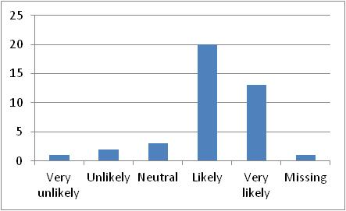
Table 5.6.4 | Figure 5.6.4
 | 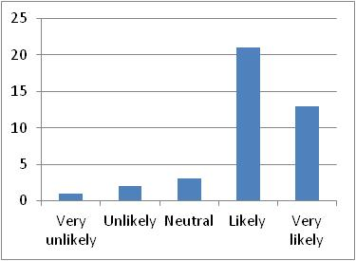
Table 5.6.4a | Figure 5.6.4a

5.6.5 Acquisition of commercial benefits (Code: G28): 27.5% of the firms denoting “Very likely”, 40% denoting “Likely”, 22.5% denoting “Neutral”, 5% denoting ‘Unlikely” and 2.5% denoting “Very unlikely”, however, one response was missed, this is why The average mean will be considered for the whole responses, so that (n=16) 40% denoting “Likely” which is the highest value will be increased by (n=1) 2.5% and so it will be changed to be (n=17) 42.5% to denote “Likely”. That means most of the participants have chosen “Very likely” “Likely” and “Neutral” answers as n=37 (92.5%), while very little participants have chosen “Unlikely” and “Very unlikely” answers. This is indicated in Table 5.6.5 and Figure 5.6.5 and Table 5.6.5a and Figure 5.6.5a below.
This is very surprising result, in this case there is disagreement and variability between the respondents’ answers in relation to Acquisition of commercial benefits, as some respondents do not think this is a good contributor to value creation of the firm. Actually the literature reviews show that this is a good contributor but maybe this is because of local context.

 | 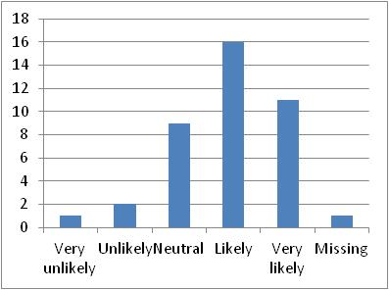
Table 5.6.5 | Figure 5.6.5
 | 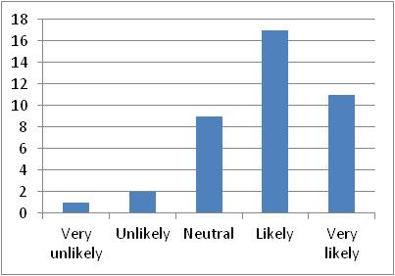
Table 5.6.5a | Figure 5.6.5a

5.6.6 Identification of reputational risks (Code: G29): 25% of the firms denoting “Very likely”, 47.5% denoting “Likely”, 20% denoting “Neutral”, 0% denoting ‘Unlikely” and 2.5% denoting “Very unlikely”, however, two responses were missed, this is why The average mean will be considered for the whole responses, so that (n=19) 47.5% denoting “Likely” which is the highest value will be increased by (n=2) 5% and so it will be changed to be (n=21) 52.5% to denote “Likely”. That means most of the participants have chosen “Very likely” “Likely” and “Neutral” answers as n=39 (97.5%), while very little participants have chosen “Very unlikely” answer and no participant has chosen “Unlikely” answer. This is indicated in Table 5.6.6 and Figure 5.6.6 and Table 5.6.6a and Figure 5.6.6a below.
This is very surprising result, in this case there is disagreement and variability between the respondents’ answers in relation to Identification of reputational risks, as some respondents do not think this is a good contributor to value creation of the firm. Actually the literature reviews show that this is a good contributor but maybe this is because of local context.
 | 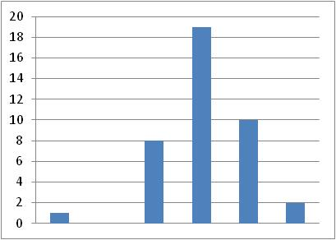
Table 5.6.6 | Figure 5.6.6
 | 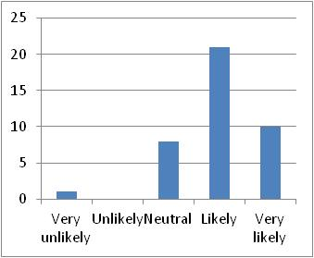
Table 5.6.6a | Figure 5.6.6a

5.6.7 Accessing to credit in good terms (Code: G30): 25% of the firms denoting “Very likely”, 32.5% denoting “Likely”, 25% denoting “Neutral”, 5% denoting ‘Unlikely” and 7.5% denoting “Very unlikely”, however, two responses were missed, this is why The average mean will be considered for the whole responses, so that (n=13) 32.5% denoting “Likely” which is the highest value will be increased by (n=2) 5% and so it will be changed to be (n=15) 37.5% to denote “Likely”. That means most of the participants have chosen “Very likely” “Likely” and “Neutral” answers as n=35 (87.5%), while very little participants have chosen “Unlikely” and “Very unlikely” answers. This is indicated in Table 5.6.7 and Figure 5.6.7 and Table 5.6.7a and Figure 5.6.7a below.
This is very surprising result, in this case there is disagreement and variability between the respondents’ answers in relation to Accessing to credit in good terms, as some respondents do not think this is a good contributor to value creation of the firm. Actually the literature reviews show that this is a good contributor but maybe this is because of local context.
 | 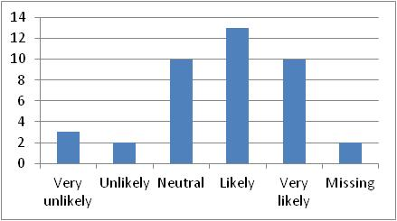
Table 5.6.7 | Figure 5.6.7
 | 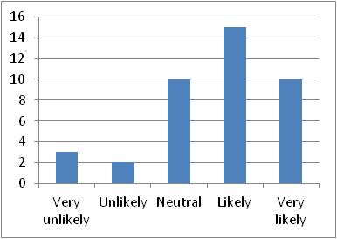
Table 5.6.7a | Figure 5.6.7a

5.6.8 Increasing corporate profitability (Code: G31): 30% of the firms denoting “Very likely”, 35% denoting “Likely”, 25% denoting “Neutral”, 5% denoting ‘Unlikely” and 2.5% denoting “Very unlikely”, however, one response was missed, this is why The average mean will be considered for the whole responses, so that (n=14) 35% denoting “Likely” which is the highest value will be increased by (n=1) 2.5% and so it will be changed to be (n=15) 37.5% to denote “Likely”. That means most of the participants have chosen “Very likely”, “Likely” and “Neutral” answers as n=37 (92.5%), while very little participants have chosen “Unlikely” and “Very unlikely” answers. This is indicated in Table 5.6.8 and Figure 5.6.8 and Table 5.6.8a and Figure 5.6.8a below.
This is very surprising result, in this case there is disagreement and variability between the respondents’ answers in relation to Increasing corporate profitability, as some respondents do not think this is a good contributor to value creation of the firm. Actually the literature reviews show that this is a good contributor but maybe this is because of local context.
 | 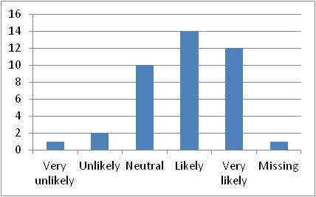
Table 5.6.8 | Figure 5.6.8
 | 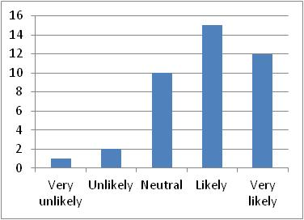
Table 5.6.8a | Figure 5.6.8a

5.6.9 Supporting share price (Code: G32): 17.5% of the firms denoting “Very likely”, 45% denoting “Likely”, 27.5% denoting “Neutral”, 5% denoting ‘Unlikely” and 2.5% denoting “Very unlikely”, however, one response was missed, this is why The average mean will be considered for the whole responses, so that (n=18) 45% denoting “Likely” which is the highest value will be increased by (n=1) 2.5% and so it will be changed to be (n=19) 47.5% to denote “Likely”. That means most of the participants have chosen “Very likely”, “Likely” and “Neutral” answers as n=37 (92.5%), while very little participants have chosen “Unlikely” and “Very unlikely” answers. This is indicated in Table 5.6.9 and Figure 5.6.9 and Table 5.6.9a and Figure 5.6.9a below.
This is very surprising result, in this case there is disagreement and variability between the respondents’ answers in relation to Supporting share price, as some respondents do not think this is a good contributor to value creation of the firm. Actually the literature reviews show that this is a good contributor but maybe this is because of local context.
 | 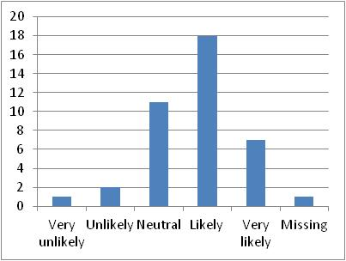
Table 5.6.9 | Figure 5.6.9
 | 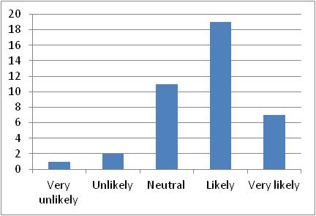
Table 5.6.9a | Figure 5.6.9a

5.6.10 Increasing business volume (Code: G33): 30% of the firms denoting “Very likely”, 40% denoting “Likely”, 12.5% denoting “Neutral”, 7.5% denoting ‘Unlikely” and 5% denoting “Very unlikely”, however, two responses were missed, this is why The average mean will be considered for the whole responses, so that (n=16) 40% denoting “Likely” which is the highest value will be increased by (n=2) 5% and so it will be changed to be (n=18) 45% to denote “Likely”. That means most of the participants have chosen “Very likely” and “Likely” answers as n=30 (75%), while very little participants have chosen “Neutral”, “Unlikely” and “Very unlikely” answers. This is indicated in Table 5.6.10 and Figure 5.6.10 and Table 5.6.10a and Figure 5.6.10a below.
This is very surprising result, in this case there is disagreement and variability between the respondents’ answers in relation to Increasing business volume, as some respondents do not think this is a good contributor to value creation of the firm. Actually the literature reviews show that this is a good contributor but maybe this is because of local context.
 | 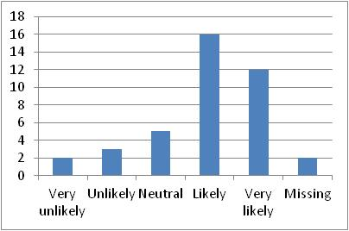
Table 5.6.10 | Figure 5.6.10
 | 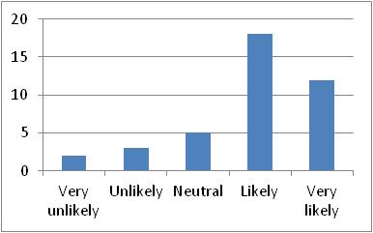
Table 5.6.10a | Figure 5.6.10a

5.6.11 Raising company environmental standards (Code: G34): 20% of the firms denoting “Very likely”, 40% denoting “Likely”, 32.5% denoting “Neutral”, 2.5% denoting ‘Unlikely” and 2.5% denoting “Very unlikely”, however, one response was missed, this is why The average mean will be considered for the whole responses, so that (n=16) 40% denoting “Likely” which is the highest value will be increased by (n=1) 2.5% and so it will be changed to be (n=17) 42.5% to denote “Likely”. That means most of the participants have chosen “Very likely”, “Likely” and “Neutral” answers as n=38 (95%), while very little participants have chosen “Unlikely” and “Very unlikely” answers. This is indicated in Table 5.6.11 and Figure 5.6.11 and Table 5.6.11a and Figure 5.6.11a below.
This is very surprising result, in this case there is disagreement and variability between the respondents’ answers in relation to Raising company environmental standards, as some respondents do not think this is a good contributor to value creation of the firm. Actually the literature reviews show that this is a good contributor but maybe this is because of local context.
 | 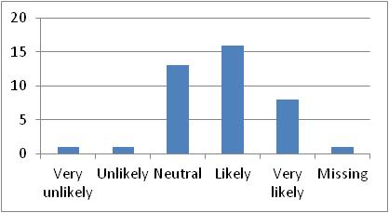
Table 5.6.11 | Figure 5.6.11
 | 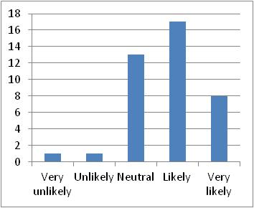
Table 5.6.11a | Figure 5.6.11a

5.6.12 Increasing employee retention (Code: G35): 15% of the firms denoting “Very likely”, 45% denoting “Likely”, 20% denoting “Neutral”, 15% denoting ‘Unlikely” and 2.5% denoting “Very unlikely”, however, one response was missed, this is why The average mean will be considered for the whole responses, so that (n=18) 48% denoting “Likely” which is the highest value will be increased by (n=1) 2.5% and so it will be changed to be (n=19) 47.5% to denote “Likely”. That means most of the participants have chosen “Likely” answer as n=19 (47.5%), while some of participants have also chosen “Very likely”, “Neutral”, and “Unlikely” answers, but very little participants have chosen “Very unlikely” answer. This is indicated in Table 5.6.12 and Figure 5.6.12 and Table 5.6.12a and Figure 5.6.12a below.
This is very surprising result, in this case there is disagreement and variability between the respondents’ answers in relation to Increasing employee retention, as some respondents do not think this is a good contributor to value creation of the firm. Actually the literature reviews show that this is a good contributor but maybe this is because of local context.
 | 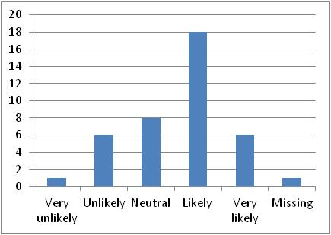
Table 5.6.12 | Figure 5.6.12
 | 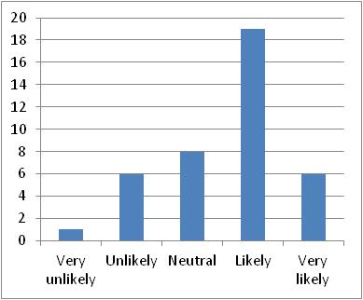
Table 5.6.12a | Figure 5.6.12a

5.6.13 Strengthening business partner relationships (Code: G36): 17.5% of the firms denoting “Very likely”, 40% denoting “Likely”, 27.5% denoting “Neutral”, 10% denoting ‘Unlikely” and 2.5% denoting “Very unlikely”, however, one response was missed, this is why The average mean will be considered for the whole responses, so that (n=16) 40% denoting “Likely” which is the highest value will be increased by (n=1) 2.5% and so it will be changed to be (n=17) 42.5% to denote “Likely”. That means most of the participants have chosen “Likely” and “Neutral” answers as n=28 (70%) for both answers, and some participants have chosen “Very likely” answer, while very little participants have chosen “Unlikely” and “Very unlikely” answers. This is indicated in Table 5.6.13 and Figure 5.6.13 and Table 5.6.13a and Figure 5.6.13a below.
This is very surprising result, in this case there is disagreement and variability between the respondents’ answers in relation to Strengthening business partner relationships, as some respondents do not think this is a good contributor to value creation of the firm. Actually the literature reviews show that this is a good contributor but maybe this is because of local context.
 | 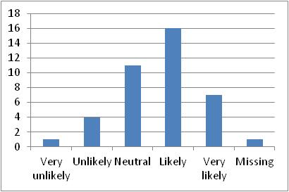
Table 5.6.13 | Figure 5.6.13
 | 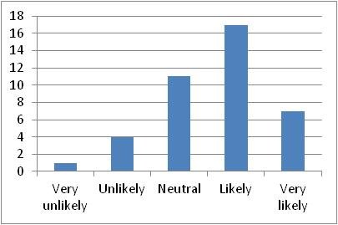
Table 5.6.13a | Figure 5.6.13a

5.6.14 Protecting consumer privacy (Code: G37): 20% of the firms denoting “Very likely”, 40% denoting “Likely”, 22.5% denoting “Neutral”, 12.5% denoting ‘Unlikely” and 2.5% denoting “Very unlikely”, however, one response was missed, this is why The average mean will be considered for the whole responses, so that (n=16) 40% denoting “Likely” which is the highest value will be increased by (n=1) 2.5% and so it will be changed to be (n=17) 42.5% to denote “Likely”. That means most of the participants have chosen “Likely” answer as n=16 (40%), while some of participants have also chosen “Very likely” and “Neutral” answers, and little participants have chosen “Unlikely” answer, while very little participants have chosen “Very unlikely” answer. This is indicated in Table 5.6.14 and Figure 5.6.14 and Table 5.6.14a and Figure 5.6.14a below.
This is very surprising result, in this case there is disagreement and variability between the respondents’ answers in relation to Protecting consumer privacy, as some respondents do not think this is a good contributor to value creation of the firm. Actually the literature reviews show that this is a good contributor but maybe this is because of local context.
 | 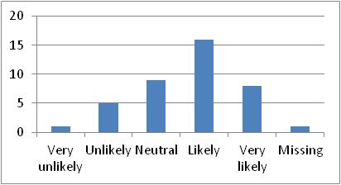
Table 5.6.14 | Figure 5.6.14
 | 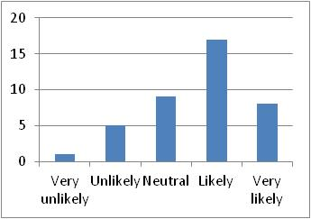
Table 5.6.14a | Figure 5.6.14a

5.6.15 Dealing with stakeholders’ appeal (Code: G38): 17.5% of the firms denoting “Very likely”, 52.5% denoting “Likely”, 17.5% denoting “Neutral”, 7.5% denoting ‘Unlikely” and 2.5% denoting “Very unlikely”, however, one response was missed, this is why The average mean will be considered for the whole responses, so that (n=21) 52.5% denoting “Likely” which is the highest value will be increased by (n=1) 2.5% and so it will be changed to be (n=22) 55% to denote “Likely”. That means most of the participants have chosen “Likely” answer as n=21 (52.5%), while some of participants have also chosen “Very likely” and “Neutral” answers, for about 17.5% for each, however, little participants have chosen “Unlikely” answer and very little participants have chosen “Very unlikely” answer. This is indicated in Table 5.6.15 and Figure 5.6.15 and Table 5.6.15a and Figure 5.6.15a below.
This is very surprising result, in this case there is disagreement and variability between the respondents’ answers in relation to Dealing with stakeholders’ appeal, as some respondents do not think this is a good contributor to value creation of the firm. Actually the literature reviews show that this is a good contributor but maybe this is because of local context.
 | 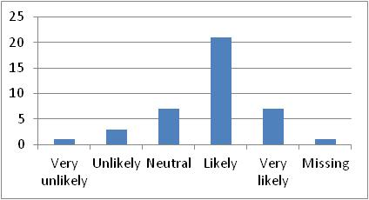
Table 5.6.15 | Figure 5.6.15
 | 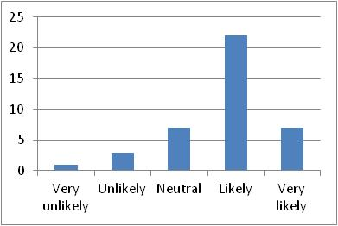
Table 5.6.15a | Figure 5.6.15a

5.6.16 Avoiding unethical behaviour (Code: G39): 35% of the firms denoting “Very likely”, 37.5% denoting “Likely”, 20% denoting “Neutral”, 2.5% denoting ‘Unlikely” and 2.5% denoting “Very unlikely”, however, one response was missed, this is why The average mean will be considered for the whole responses, so that (n=15) 37.5% denoting “Likely” which is the highest value will be increased by (n=1) 2.5% and so it will be changed to be (n=16) 40% to denote “Likely”. That means most of the participants have chosen “Very likely” and “Likely” answers as n=30 (75%) for both answers, and some of participants have chosen “Neutral” while very little participants have chosen “Unlikely” and “Very unlikely” answers. This is indicated in Table 5.6.16 and Figure 5.6.16 and Table 5.6.16a and Figure 5.6.16a below.
This is very surprising result, in this case there is disagreement and variability between the respondents’ answers in relation to Avoiding unethical behavior, as some respondents do not think this is a good contributor to value creation of the firm. Actually the literature reviews show that this is a good contributor but maybe this is because of local context.

 | 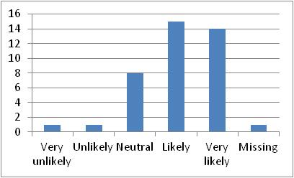
Table 5.6.16 | Figure 5.6.16
 | 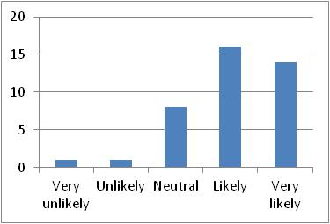
Table 5.6.16a | Figure 5.6.16a

6.2.6 Descriptive Analysis for Demographic Information (D)
The sixth section of the questionnaire is about the Demographic Information of the participants as following:

6.1 Firm Name (Code: D1):
The Firm’s Name was an obligatory field to be filled by the participants/ employees; this is why it was double checked by the interviewer his self as the main purpose of the thesis is to only investigate the publically listed firms within the United Arab Emirates. The responses were collected from 40 firms where the total publically listed firms within the UAE were about 138 firms. As a sample, the responses for this field were 100% achieved. This is shown in the Table 6.1.
Table 6.1

6.2 Participant Name (Code: D2):
This field has barely responded by most of the participants/ employees, as most of them have seen this field is not important and the answer will not affect the result at all, maybe be also some of the employees have felt scared from being responsible of giving private information about the firm. The answers revealed that only 50% of the participants/ employees have answered these questions.

6.3 Participant Email (Code: D3):
This field has barely responded by most of the participants/ employees, as most of them have seen this field is not important and the answer will not affect the result at all, maybe be also some of the employees have felt scared from being responsible of giving private information about the firm. The answers revealed that only 50% of the participants/ employees have answered these questions. This is shown in the Table 6.2 above.

6.4 Participant Phone no. (Code: D4):
This field has barely responded by most of the participants/ employees, as most of them have seen this field is not important and the answer will not affect the result at all, maybe be also some of the employees have felt scared from being responsible of giving private information about the firm. The answers revealed that only 50% of the participants/ employees have answered these questions. This is shown in the Table 6.2 above.

6.5 Participant Gender (Code: D5):
The gender of participants/ employees was mostly male, Table 6.5 and Figure 6.5 revealed that there is n=27 (67.5%) are males and n=13 (32.5%) are females out of a sample of 40 participants. That means the male participants was almost double of female participants
 | 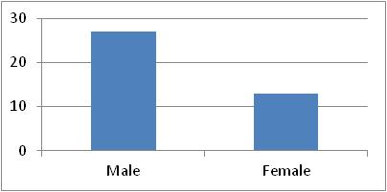
Table 6.5: Gender Distribution | Figure 6.5: Gender Frequency

6.6 Educational Level (Code: D6):
This section focuses on the educational level of the participants for the purpose of assessing whether there is any impact of this characteristic on the perception of relationship among CSR and FP or not. The below Table 6.6 and Figure 6.6 revealed that 52.5% holding a bachelor degree whereas 47.5% holding a master degree, however, there is no participant have Secondary School, PhD, or even Professor level of education. These results are reassuring from the perspective the education level is only clustered in to two groups. Thus it is easy to infer and conclude the influence of education level on perception of CSR practices.
 | 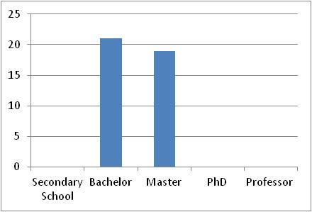
Table 6.6: Educational Level Distribution | Figure 6.6: Educational Level Frequency

6.7 Participant Age (Code: D7):
The age of participants/ employees was mostly in thirties and forties, Table 6.7 and Figure 6.7 revealed that there are only n=2 (5%) greater than 60 years old, n=6 (15%) from 45-50 years old, n=10 (25%) from 40-45 years old, n=12 (30%) from 35-40 years old which is the greatest no of participants, n=7 (17.5%) from 30-35 years old, only n=1 (2.5%) from 25-20 years old so that while making the inferential analysis, this result will be incorporated with the previous or later range to have a significant meaning, and finally n=2 (5%) from 20-25 years old.
 | 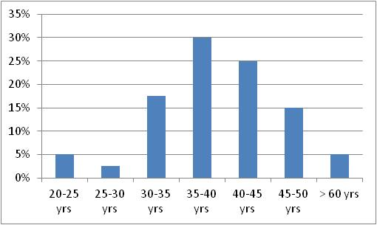
Table 6.7: Age Distribution | Figure 6.7: Age Frequency

6.8 Participant Nationality (Code: D8):
This section focuses on the nationality of the participants/employees for the purpose of assessing whether there is any impact of this characteristic on the perception of relationship among CSR and FP. The study revealed that about 75% of the participants were Emirati and Arabic, i.e. As can be noticed from the below Table 6.8 and Figure 6.8 that most of the participants are Emirati n=18 (45%) and Arabic n=12 (30%), while some of participants were from the Gulf countries n=4 (10%), and only one participant n=1 (2.5) from Africa. On the other hand, there are no participants from the United States, Europe, or Australia.
 | 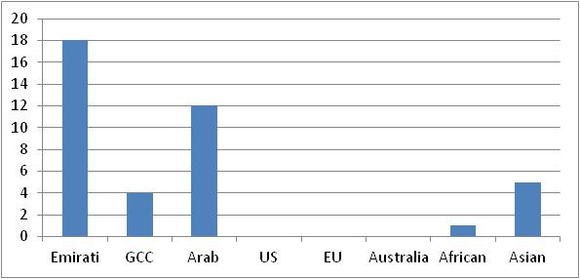
Table 6.8: Nationality Distribution | Figure 6.8: Nationality Frequency

6.9 Firm Industry (Code: D9)
The type of industry the company belongs to has basically classified to 9 main types based to Dubai Financial Market (DFM, 2016). As mentioned below in Table 6.9 and Figure 6.9, the biggest industry the participants belong to was the Banks n=12 (30%), then Insurance n=6 (15%), then Investment & Financial Services n=5 (12.5%), then Consumer Stables n=4 (10%) and also Industrial n=4 (10%), then Real Estates n=3 (7.5%), then Telecommunication n=2 (5%) and also Services n=2 (5%), while only n=1 (2.5%) for Transportation and also n=1 (2.5%) for Energy.
 | 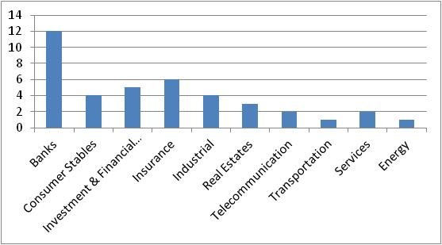
Table 6.9: Industry Distribution | Figure 6.9: Industry Frequency

6.10 Firm Type (Code: D10):
The type of the firms has been classified into 4 types (Public, Private, Charity and other), but only 2 types of them were chosen. Almost half of the firms n=21 (52.5%) were Public firms and the other half n=19 (47.5%) were Private firms, and no one was from a charity firm or any other type of the firms. This is shown in the Table 6.10 and Figure 6.10 below.
 | 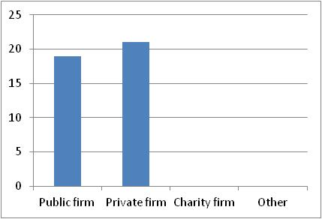
Table 6.10: Firm Type Distribution | Figure 6.10: Firm Type Frequency

6.11 Participant Position (Code: D11):
The participants were asked to describe their work position; only n=2 (5%) of the participants was working as Chief Executive Officer (CEO), n=3 (7.5%) was working as Executive CEO, however most of the participants n=28 (70%) was working as a Manager, while n=3 (7.5%) of the participants was working as Executive Manager, and n=4 (10%) of the participants was working as a normal employee but with a long years of experience. This is shown in the Table 6.11 and Figure 6.11 below.
 | 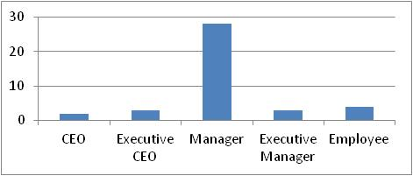
Table 6.11: Employee position Distribution | Figure 6.11: Employee position Frequency

6.12 Participant Work Experience (Code: D12):
For the total number of years of work experience, most of the participants n=12 (30%) have 15-20 years of experience, n=8 (20%) has 20-25 years of experience, n=7 (17.5%) has 5-10 years of experience, n=6 (15%) has 10-15 years of experience, n=4 (10%) has 1-5 years of experience, and only one participant n=1 (2.5%) has 25-30 years of experience, while no participants have greater than 35 years of experience. This is shown in the Table 6.12 and Figure 6.12 below.
 | 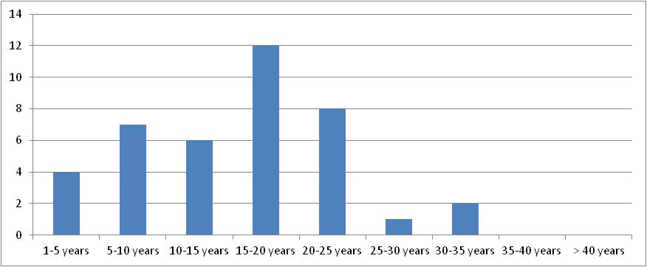
Table 6.12: Work experience Distribution | Figure 6.12: Work experience Frequency

6.13 Firm Size (Code: D13):
For the firm size i.e. (number of the employees) within the firms that the participants belongs to; n=6 (15%) of firms have lower than 100 employees, n=12 (30%) of firms have only 100-500 employees, n=3 (7.5%) of firms have 500-1000 employees, n=4 (10%) of firms have 1000-1500 employees), n=10 (25%) of firms have 1500-2000 employees, n=3 (7.5%) of firms have 2000-3000 employees, and only one firm n=1 (2.5%) has 3000-4000 employees and also only one firm n=1 (2.5%) has 4000-5000 employees, whereas no firm has any other number of the employees. This is shown in the Table 6.13 and Figure 6.13 below.
 | 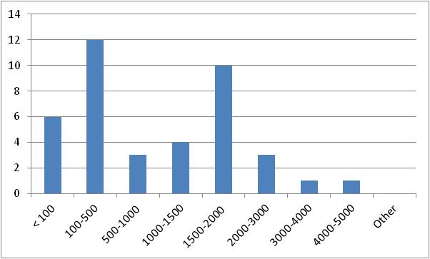
Table 6.13: Firm Size Distribution | Figure 6.13: Firm Size Frequency

6.2.7 Descriptive Analysis for Financial Performance Ratios (FP)
The Data were tested for normality using normal probability plots and tests of skewness and kurtosis. The descriptive statistics of the financial Performance Indicators (FP) used in this study are shown in the following taple 7.
Table 7

6.2.7.1 Descriptive Analysis for Price to Book Ratio (PB)
As can be seen from table 7.1 below, the mean for the Price to Book Ratio indicator (PB) = 28. There is a big range between the minimum = 0.04 and the maximum = 583, this is why the variance = 11391 which is big. However, the following Figure 7.1 shows that there is an outlier by 3 cases, and this might have impacted the curve. This also might have a consequence on the regression results; this is why the author of this thesis will consider removing this outlier firm from the list of the firms once start doing the Regression Analysis in the next part, to create more cohesion between the data. On the other hand, as the kurtosis measure the sharpness of the peak of a frequency-distribution curve, the (PB) indicator has low kurtosis (lower than 15) representing that the variable distributions are flat with central peaks lower and broader than a normal distribution, and tails shorter and thinner. For the skewness, the variables in most cases are normally distributed around mean, what means most of the values are equally distributed to the right and left of the mean. This normal distribution of skewness indicates that the participants entered much closed values when answering the questionnaire. The lower value means a higher agreement with the statements used in the questionnaire.
 | 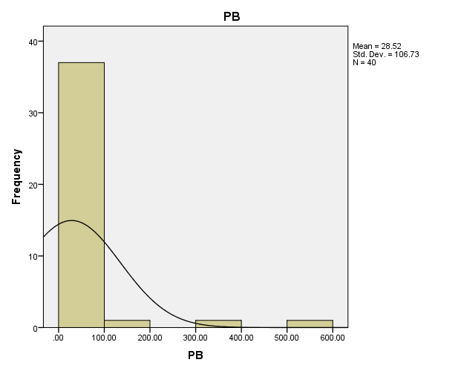
Table 7.1 | Figure 7.1

6.2.7.2 Descriptive Analysis for Return on Asset (ROA)
The Return on Asset (ROA) seems to be normally distributed; most of the data are centered on the mean = 2. There is a small range between the minimum = -8.24 and the maximum = 14.82, this is why the variance = 20, which is small. As shown in the following Figure 7.2 there is no outlier. On the other hand, as the kurtosis measure the sharpness of the peak of a frequency-distribution curve, the (ROA) variables have low kurtosis (lower than 10) representing that the variable distributions are flat with central peaks lower and broader than a normal distribution, and tails shorter and thinner. For the skewness, the variables in most cases are normally distributed around mean, what means most of the values are equally distributed to the right and left of the mean. This normal distribution of skewness indicates that the participants entered much closed values when answering the questionnaire. The lower value means a higher agreement with the statements used in the questionnaire.
 | 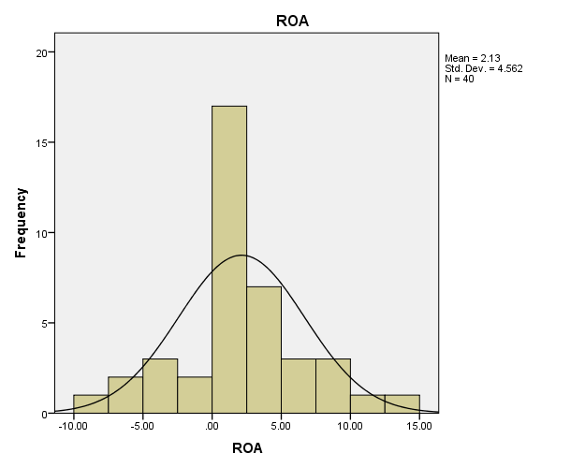
Table 7.2 | Figure 7.2

6.2.7.3 Descriptive Analysis for Return on Equity (ROE)
The Return on Equity (ROE) seems to be normally distributed, most of the data are centered on the mean = 0.46. There are big range between the minimum = -235 and the maximum = 36, this is why the variance = 1651, which is big. However, the following Figure 7.3 shows that there is an outlier by one case, and this might have impacted the following curve. This also might have a consequence on the regression results; this is why the author of this thesis will consider removing this outlier firm from the list of the firms once start doing the Regression Analysis in the next part, to create more cohesion between the data. On the other hand, as the kurtosis measure the sharpness of the peak of a frequency-distribution curve, the (ROE) variables have low kurtosis (lower than 10) representing that the variable distributions are flat with central peaks lower and broader than a normal distribution, and tails shorter and thinner. For the skewness, the variables in most cases are normally distributed around mean, what means most of the values are equally distributed to the right and left of the mean, except the value of the outlier which make the tail very long to the left side of the mean. This normal distribution of skewness indicates that the participants entered much closed values when answering the questionnaire. The lower value means a higher agreement with the statements used in the questionnaire.
 | 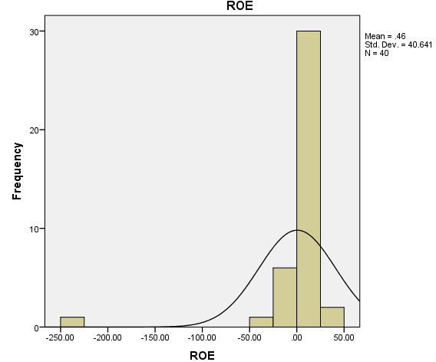
Table 7.3 | Figure 7.3

6.2.7.4 Descriptive Analysis for Share Price (SP)
As can be seen from Table 7.4 that the mean for the Share Price (SP) = 36, where there is a huge range between the minimum = 1 and the maximum = 384, this is why the variance = 11115 which is very huge. However, the following Figure 7.4 shows that there is a huge an outlier case, and this might have impacted the curve. This also might have a consequence on the regression results; this is why the author of this thesis will consider removing this outlier firm from the list of the firms once start doing the Regression Analysis in the next part, to create more cohesion between the data. On the other hand, as the kurtosis measure the sharpness of the peak of a frequency-distribution curve, the (SP) indicator have low kurtosis (lower than 5) representing that the variable distributions are flat with central peaks lower and broader than a normal distribution, and tails shorter and thinner. For the skewness, the variables are in most cases skewed left (negative skewness value), what means most of the values are located to the right of the mean, except very little variables which have positive skewness or less values located to the left of the mean. The negative values of skewness indicate the participants entered, in some cases, higher values when answering the questionnaire. The higher value means a higher approval with the statements used in the questionnaire.
 | 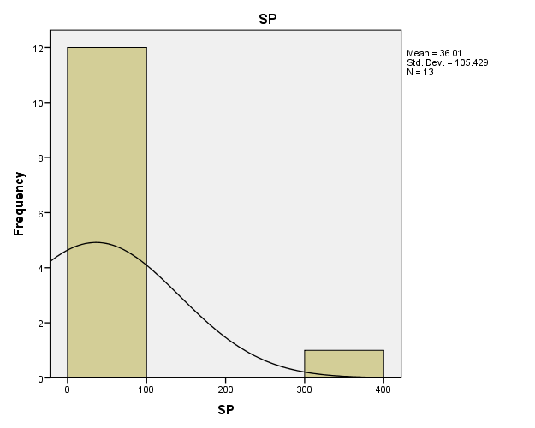
Table 7.4 | Figure 7.4

