

Enhancing the construction innovation practices using exploratory project to overcome construction innovation’s obstacle and improve the project performance

تعزيز الابتكار في مشاريع الإنشاءات عن طريق تطبيق مشاريع الاكتشاف لتجاوز العقبات وتحسين مستوى الأداء.

by
YAZAN WAEL SAYYED

Dissertation submitted in fulfilment
of the requirements for the degree of
MSc ENGINEERING MANAGEMENT
at
The British University in Dubai

November 2019

DECLARATION

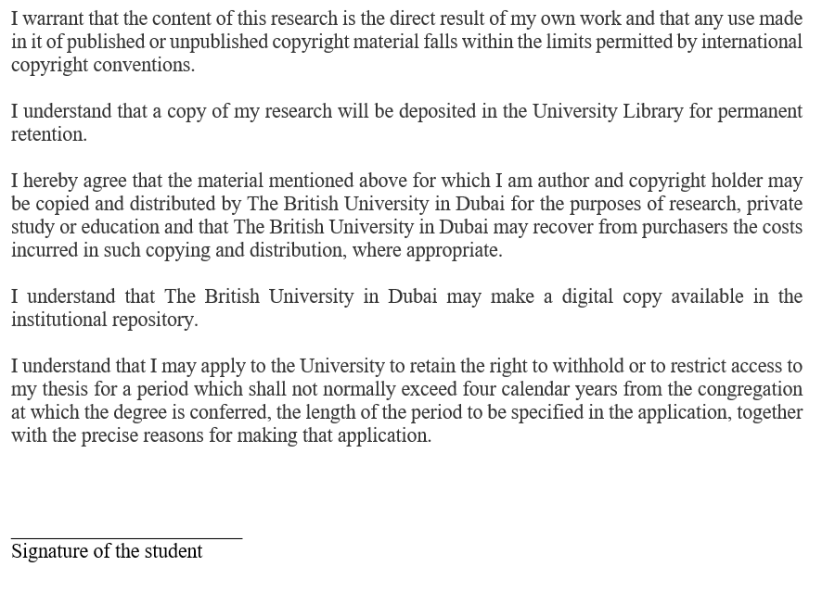

COPYRIGHT AND INFORMATION TO USERS
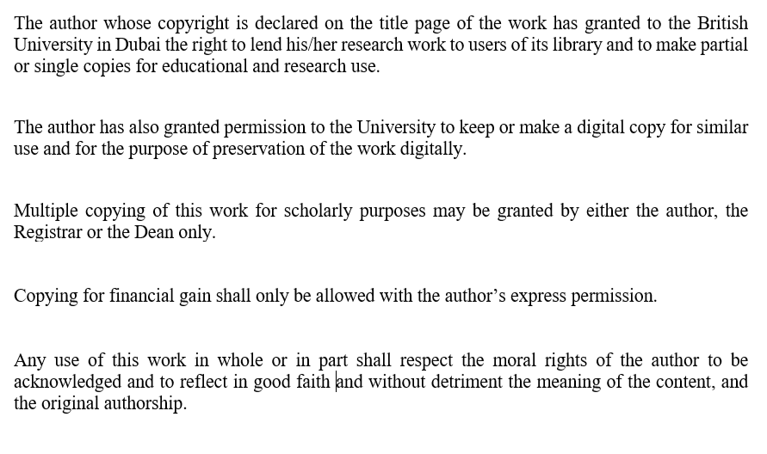

Abstract

Even though the field of construction occupies a privileged place in a country’s economy, the innovation in the construction industry is suffering due to the low quality and slow growth comparing to other industries. Taking into account the role of innovation to succeed in a fast changing and extremely competitive market which highlights the high importance of innovation in the construction market for development and better opportunities. Hence, this research is investigating the reasons behind the backward of innovation in the construction industry and to propose solutions to reduce this gap. After intensive research, a gap has been noticed on the effect of level of innovation and procurement management on the construction project innovation. Accordingly, the role of construction projects’ obstacles and its effect in improving the exploratory project innovation and performance has not been studied before which provides a uniqueness to this research. To achieve this research goals, the impact on the projects’ performance will be studied in relation between the exploratory project’s level of innovation and procurement management type in construction projects (one of construction innovation obstacles) as well as the impact on each other. In order to validate these objectives, a quantitative method is followed based on data collected by a survey filled by professionals in the construction industry. The data collected were valid and reliable as proved by Cronbach and Spearman tests. The process of analyzing the data confirmed that there is a strong positive relation among the exploratory project’s level of innovation, collaborative procurement management, and project performance. Furthermore, the analysis indicated the role of procurement management as a moderator between the level of innovation and the performance.

خلاصة البحث
على الرغم من أن مجال البناء يحتل مكانًا متميزًا في اقتصاد البلدان، ما زال الابتكار في مجال الإنشاءات يعاني من تدني في المستوى والنمو البطيء مقارنة بالصناعات الأخرى. وذلك على الرغم من أهمية ودور الابتكار للنجاح في سوق سريع التغير وذو تنافسية عالية مما يسلط الضوء على الأهمية العالية للابتكار في سوق البناء للتنمية ولفرض فرص أفضل. ومن هنا تأتي أهمية هذه الدراسة للبحث في الأسباب الكامنة وراء تخلف الابتكار في مجال الإنشاءات مع اقتراح لحلول لتقليل من هذه الفجوة والارتقاء بمستوى الابتكار. بناء على دراسة ومراجعة لأبحاث سابقة، تم اكتشافها فجوة حول تأثير مستوى الابتكار وإدارة المشتريات على الابتكار في مجال الإنشاءات، وبالتالي يعتبر هذا البحث فريدًا من نوعه بحيث لا يوجد بحث من قبل درس دور مشاريع الاكتشاف في تجاوز العقبات التي تودي تأخير الابتكار في مجال الإنشاءات وأثر ذلك في تحسين أداء المشروع الاستكشافي. ولتحقيق هذه الأهداف، ستتم دراسة تأثير العلاقة بين مستوى الابتكار في المشروع الاستكشافي ونوع إدارة المشتريات في مشاريع البناء (أحد عقبات الابتكار في البناء) وكذلك تأثير كل منها على حدا على مستوى أداء المشروعات الاستكشافي. من أجل التحقق من صحة هذه الأهداف، تم اتباع طريقة تحليل كمية على البيانات التي تم جمعها من خلال استبيان تم تعبئته بواسطة متخصصين في مجال البناء والتشييد. تم التأكد من صحة وموثوقية البيانات التي تم جمعها بعد اجراء اختباري كرونباخ وسبيرمان لهذه الغاية. كما أكدت عملية تحليل البيانات وجود علاقة إيجابية قوية بين مستوى الابتكار في المشروع الاستكشافي وإدارة المشتريات. علاوة على ذلك أظهرت الدراسات دور إدارة المشتريات كوسيط بين مستوى الابتكار وأداء المشروع.

Acknowledgments

Great thanks to Allah Almighty for his great bounty by giving me the ability and knowledge to complete this work, in addition to that Allah Almighty blessed me with the blessing of my highly educated parents, sisters and nieces who were the first supporter and the greatest motivator throughout the study period.
I would like to give my gratitude and thanks to my supervisor Dr. Amer Alaya for his brilliant management, caring, guidance, and support for providing me with the necessary circumstances to conduct my research while providing me the priority over his engagements. In addition, I would like to extend my appreciation and gratefulness to each member of my thesis board who supervised and monitored my work for the effort and time in reading with a special thanks to Prof. Alaa A-Ameer for his extra efforts and guidelines that it besides providing me with valuable comments.
Finally, the full recognition and appreciation of all my friends for their efforts with me in the entire stages of the dissertation.

Table of Contents
COPYRIGHT AND INFORMATION TO USERS
Abstract
خلاصة البحث
Acknowledgments
Table of Contents I
List of Tables III
List of Figures V
CHAPTER I INTRODUCTION 1
1.1 Background 1
1.2 Research Significances 1
1.3 Research Problem Statement 3
1.4 Research Objectives: 5
1.5 Research Questions, Aims, and Objectives: 5
1.6 Dissertation Structure 6
CHAPTER II LITERATURE REVIEW 8
2.1 Introduction 8
2.2 THEORETICAL BACKGROUND: 8
2.2.1 Exploratory Project 8
2.2.2 Construction Innovation Management 12
2.2.2.1 Models of Innovation: 13
2.2.2.2 Construction’s Procurement Management and Sourcing Decisions: 17
2.2.3 Construction Project Performance. 19
2.2.3.1 Definition and objective 19
2.2.3.2 Time and Cost 22
2.2.3.3 Quality Measurement 28
2.2.3.4 Client Satisfaction 30
2.3 FRAMEWORK BACKGROUND: 31
2.3.1 Exploratory Project and Level of innovation 31
2.3.2 Innovation in Construction 34
2.3.3 Relation between performance and innovation 38
2.3.4 Roles of Procurement Management in Innovation 40
2.4 Chapter Conclusion 45
CHAPTER III 46
RESEARCH METHODOLOGY 46
3.1 Introduction 46
3.2 Research Framework 46
3.2 Research Methodology 49
3.3.1 Research Approach 51
3.3.2 Research Tool 53
3.3.3 Targeted Sample and Data Collection 53
3.3.4 Survey Validation and Reliability 55
3.3.5 Survey Background and Structure 63
3.1 Chapter Conclusion 65
CHAPTER IV RESEARCH RESULTS AND DATA ANALYSIS 66
4.1 Introduction 66
4.2 Demographic Presentation 67
4.3 Descriptive statement for Variable 70
4.4 Framework Analysis 79
4.4.1 Correlation test (Pearson Correlation) 79
4.4.2 Regression (Mediation) 84
4.4.3 Mediation Conclusion 94
4.5 Chapter Conclusion 96
Chapter V Discussion and Conclusion 98
5.1 Introduction 98
5.2 Discussion and Conclusions 98
5.3 Challenges and Recommendations 102
5.4 Chapter Conclusion 104
References 105
Appendixes 119

List of Tables
Chapter 2:
Table 2. 1: the document required for measurement of time, cost and quality (Burke 2003) 30
Table 2. 2: Procurement Approach comparison 42
Chapter 3:
Table 3. 1: Validity test (spearman test) for all variables’ factors 57
Table 3. 2: reliability test for level of innovation factors 59
Table 3. 3 reliability test for procurement management 60
Table 3. 4 reliability test for performance (time, cost and quality) 61
Table 3. 5: research variable, hypothesis and survey questions 65
Chapter4:
Table 4. 1: The rates and frequencies of the categorized professional positions 69
Table 4. 2: The rates and frequencies of the professional years of experiences 70
Table 4. 3: Level of innovation statistical description 74
Table 4. 4: Procurement management statistical description 76
Table 4. 5: Performance statistical description 78
Table 4. 6: Correlation between level on innovation and procurement management 80
Table 4. 7: Correlation between procurement management and performance 82
Table 4. 8: Correlation between level on innovation and performance 83
Table 4. 9: Regression analysis for Path A 88
Table 4. 10: Regression analysis for Path Â and Path C 90
Table 4. 11: Regression analysis for Path B 92
Table 4. 12: Regression results Summery 94

List of Figures
Chapter 2:
Figure 2. 1: innovation level of novelty (Utterback & Abernathy 1978) 11
Figure 2. 2: first Generation of innovation model based “Market Pull”: (Rothwell 1994) 15
Figure 2. 3: Second Generation of innovation model based “Technology Push”: (Rothwell 1994) 15
Figure 2. 4: Third Generation of innovation (Rothwell 1994) 16
Figure 2. 5: example of visual monitoring for construction project (bar chart) 23
Figure 2. 6: example of monthly cash flow for construction project 24
Figure 2. 7: Earned Value Process (Project Management Institute 2011) 26
Figure 2. 8: Earned Value Management Concept (De Marco & Narbaev 2013)) 27
Figure 2. 9: Relation between innovation and performance (Choi, Jang & Hyun 2009) .39
Chapter 3:
Figure 3. 1: conceptual frame work 47
Figure 3. 2 The organization targeted for survey 54

Chapter4:
Figure 4. 1: percentage of the survey’s question “What is your organization type of participation in construction project 67
Figure 4. 2: percentage of the survey’s question “Type of projects” for participants 68
Figure 4. 3:Scatter Plot for the Correlation between Level of Innovation and Procurement Management 81
Figure 4. 4:Scatter Plot for the Correlation between Procurement Management and Performance 83
Figure 4. 5:Scatter Plot for the Correlation between Procurement Management and Performance 84
Figure 4. 6: Regression Parts and Paths 85
Figure 4. 7: Figures generated from Path Â Regression 89
Figure 4. 8: Figures generated from Path Â and Path C Regression 91
Figure 4. 9: Figures generated from Path B Regression 93
Figure 4. 10: Regression Coefficient for The Hypothesis Paths 96

CHAPTER I
INTRODUCTION

1.1 Background
This chapter is considered as the first chapter in this dissertation as it draws the map for the thesis by reviewing the main topics in this research, which will capture the statement of the reasons to study this topic, and illustrates the desired benefits that will give return in the professional and academic field out of this study. Later, the chapter states the research problem and the main hypothesis, in addition to a definition for the objectives and research’s question followed by a brief summery for the structure of this dissertation.

1.2 Research Significances
The management of construction companies is very difficult, as a study conducted by Bizminer, an economic development consulting operation, showed that the rate of a sudden shutdown in construction companies is up to 30%, which is a large percentage. There are many reasons that maybe behind this high rate of construction firm’s shutdown, however a number of researchers agreed that the lack of innovation in construction projects is a main reason for this failure of construction companies, along with other factors such as the fast inflation, the cashflow issues, and lack of investment in researches. Strangely enough, most construction companies are afraid to engage in construction projects for fear of the potential impact on performance or the risks that may be associated with them. They are less aware or ignoring that the inability to adopt changes may lead to large losses which might lead in exiting the market. Hence the innovation is considered as an important strategic factor (Tidd 2000). This fact is supported by figures through a report generated by JBKNOWLEDGE, a corporation for construction’s technology, around 50% of operational construction companies are spending money in development and innovations.
The organization’s procurement management were highlighted by many researchers as one of the main factors that influence the innovation (Van Der Panne, Van Beers & Kleinknecht 2003; Blayse & Manley 2004). Besides, the practices of procurement management in the construction industry was a high area of concern due to its affect, not only on the performance of the project, but on other factors such as organizations’ internal and external relations, investments, and strategies. As the nature of procurement management in construction is generally a project based, it is also accompanied with the lack of trust, collaboration, and durability with the subcontractors. The role of procurement management to improve the innovation and reduce the gap in innovation construction was not investigated in the previous researches and only mentioned as a factor with high importance. The other gap founded in the construction’s innovation was the absence of exploratory project and exploratory learning concepts which are applied and feasible in other industries. Accordingly, the interests of this study were to find a relationship between one of the exploratory project’s factors with one of the most important factors that is considered as an innovation obstacle in construction projects through studying their impact on each other as well on performance, which forms the highest concern of construction institutions.
This research will allow the reader to gain a practical understanding for the gaps in research related to management of innovation in construction. At the same time introducing the first chain in improving the construction innovation practices, while introducing more factors that could be subject of study which might influence on the same purpose of this research. While in professional wise, this research will encourage the construction mangers to revise and modify the procurement management method in a way that facilitate the implementation of innovation application in addition to improve the overall performance.

1.3 Research Problem Statement
The innovation in the field of construction is of a special nature because of the obstacles related to the business conditions of construction. These obstacles come from the practices of construction’s projects and firms’ management, due to the presence of variety of stakeholders and organizations that are involved and interact with the project. Each of which may have different sub-objectives even though they met for a larger goal that is project completion (Aouad, Ozorhon & Abbott 2010).
Egan in 1998 (cited in Rowlinson 2003) highlighted the importance of innovation in the construction industry through his report “Rethinking Construction”, stating that despite the need of continuous innovation for the construction market for development, the adaption of innovation in construction is suffering from the low quality due to the construction culture and practices (Rowlinson 2003). Akintoye, Goulding and Zawdie (2012) confirmed that there is a low rhythm of innovation in construction filed in contrary of the innovation progress in other industrial filed. Other research was carried out with evaluating the reasons of the construction innovation delays such as Aouad, Ozorhon & Abbott (2010) and Rowlinson (2003) who listed the obstacles that face the innovation development in construction.
Most studies attributed the reason behind the delay in construction innovation to two main factors. The first factor is policies and politics of the construction companies in involving the subcontractors and suppliers in the work (procurement management). The supply chain resources should be built in a strategic way rather than pure financial and contractual obligations. Other areas of concern were the organization behavior, client attitude, and management practices of the over sight of the construction team. These cause a less concern on building innovation mentality as innovation required an ongoing support and effort to achieve the innovation. The previously mentioned points are supported by the lack of associated research with the construction’s innovation. The lack of understanding of the positive relationship between innovations improvement and its effect on increasing the projects’ profit and performance (Blayse & Manley 2004). However, this research will consider a solution for the first factor (procurement management), as I believe, based on experience in the construction, the highest effect in innovation belongs to this factor.
This research will introduce the exploratory project concept and its role on improving the construction industry innovation. The analysis will be done on specific element of exploratory project (level of innovation) and the correlation with one innovation’s obstacle in construction industry (Procurement Management) by measuring the improvement in project performance.
The framework of the analysis will be implemented in two phases. First, using the level of innovation in exploratory project as an independent variable with regards to the construction innovation as dependent variable. Second, using the procurement management in construction firm as independent variable in regard to project performance as dependent variable.

1.4 Research Objectives:
The objectives of this research are a reflection part for this thesis. The objectives could be summarized as follows:
- Determine the factor that is related to the success of the exploratory project and highlight the major factors that influence and cause the backward of innovation in construction project
- Define the criteria that frames the successful construction project and enable to assist the impact on the overall project performance to enhance the construction innovation level.
- Correlate the factor that affect the innovation and performance in a way that introduce a framework to overcome the obstacles of innovation in construction and analyze it.
- Discover the exploratory project role in managing and improving the innovation in the construction industry and define exploratory project’s aspects and factors that related to improve the innovation of exploratory project

1.5 Research Questions, Aims, and Objectives:
At the end, this research will be able to answer the question:
Will the procurement management enhance and improve the construction innovation level by improving the overall project performance?
Keywords:
Exploratory Project –Level of Innovation - Construction Innovation –Procurement Management- Construction Management - Project Performance.

1.6 Dissertation Structure
The structure of this research has been designed after intense research and reviewing for studies and books related to research’s design and methodology, the target was to reach the standard structure and format for this research that is easily understood and able to cover and illustrate all technical issues and proofs to support this study.
The dissertation aims to analyze the effect of level of innovation of exploratory project in construction’s procurement management through measuring the affect in project performance, for this purpose the following chapters recognized:
Chapter 1 (Introduction): Here is an overview of the research so that the reader can easily generate an idea about the content of the research. The introduction will include the problem statement from which the research was set up followed by the questions, aims and objective of this research. In addition to definition and overview for the main topics and keywords covered in this research.
Chapter 2 (Literature Review): This chapter will introduce two main sections, the first one will cover the detailed theoretical background for the topics and terminology involved in this study which are generally exploratory project, construction innovation management and project performance denoted by the researched and book that is hired for establishing the background. The second part is summarizing and critique the previous recent study that is related to this research problem and questions, in addition to validation of the conceptual framework of the research through refer to related studies.
Chapter 3 (Framework and Methodology): Here were the detailed conceptual framework will be established on what has been demonstrated in the previous chapter including the hypothesis. Then the methodology for the data collection and the required analysis to support the conceptual framework will be presented, along with justification and validation for the methods chosen for this purpose beside validation for the collected data.
Chapter 4 (Data Analysis and Discussions): After justify the methodology in the previous chapter, here will carry out with the statistical analysis for the collected data. The collected data will be statistically descriptive and visualized to understand the sample view. Then the hypothesis will be tested and validated using statistical test followed by results description explanation and discussions to reach an answer for the research questions.
Chapter 5 (Summary and Conclusion): Finally, the last chapter of this research will be chapter 5, at the end a meaningful summary for the thesis’s works will be presented to draw a conclusion connected to the research question, in addition to discuss the result generated from the research and to highlight the challenges faced to accomplish this work, besides a recommendation to improve the innovation in construction. Besides suggestions for further studies based on this work’s results followed by conclusion drawn out of it.

CHAPTER II
LITERATURE REVIEW

2.1 Introduction
This chapter divided in two main sections. The first one is a theoretical background, definition and introduction for the main three topics of this research in addition to the terms and theories associated with these three topics; which are exploratory project, construction innovation management’s factors and obstacles, and Construction’s project performance. The second section is a review and critique for the previous research that is related to the innovation in construction and the factor that is cause the backward of construction innovation as well the effect of the construction innovation in performance, beside the role of procurement in innovation from one side and in performance in other side.

2.2 THEORETICAL BACKGROUND:

2.2.1 Exploratory Project
What if the new project required to implement a new technology or innovation? Or a novel business model is not implemented as an instance, and the management of the company wishes to start to put it into action? Definitely the risks of execution of these projects will be high as all the activities are affected by the new system. This type of project may lead to significant loss for the executed company and may sometimes affect the company's survival in the market, especially if the cost of projects large.
Exploratory Project can be defined as a project aims to implement or introduce a new technology, innovation or changes in the current system, and this renewal is merely a theoretical principle that has not been implemented or applied before (Gillier, Hooge & Piat 2013). Since any first-time experience is highly uncertain, the exploratory project requires managerial skills and techniques that differ from those used in traditional projects. While the steps and theories used to teach the staff on the new application are called Exploratory Learning. The innovation is modification or adjustment, so the innovation has different types which could be changes in product, process or the models of the organization (Tidd & Bessant 2018).
The successful application of exploratory project is a core element to achieve competitive advantage, as it has been said that the discovery of future opportunities and exploitation it by taking precedence through starting the implementation is the basis of reaching out to the best among the competitors and advancing them (O’Connor 2008). As achieving this requires constant renewal and a look for the future, while taking the necessary action to implement the innovation simultaneously. Taking into consideration that should happen in a manner that ensures continuity of work, at the same time building the advanced competences.
Applying a new innovation usually will be combined with unforeseen condition, where the process of implementation of the project can face things that were not considered during the period of study or cost estimation of the project. The greater the probability of unaccounted-for unforeseen condition or less of experience in a certain field, the less companies desire to execute these projects or it could lead to unjustified rise on the project budget estimation. Accordingly, the exploratory project term as a combination of techniques and precautions should be taken before and during the execution of such type of project in order to decrease the risk of negative affect on performance. (March 1991)
In the pre-execution phase (before starting the exploratory project), an extensive study for the feasibility of the project including a trade-off analysis to compare between the associated risks and the expected damages out of it, with the opportunities and desired outcomes of this project. When the organization decided to get involved or to be a part of an exploratory project that is usually for strategic purposes rather than for achieving goals related to one project. Feasibility study and value engineering to assess the advantages and disadvantages of executing exploratory project, beside the strategic dimension of the new innovation must be analyzed and balanced. Usually feasibility study is done by the top management at early stages of the project, the strategic objectives related to implementation of the project or any doubts or ambitious about the execution or the project targets should be clarified. Such as compare the effort, resources, and cost required for execution compared to the benefits that will come from it (Halil, Nasir, Hassan & Shukur 2016).
Besides, one of the utmost vital points is the exploratory learning. Exploratory learning refer to a strategic plan to build an organization that is able to respond and adopt any changes which associated with market changes or application of new innovation, as new innovation could not comply with the organization structure or protocols prefect, which could require the organization to do a quick decision and to be flexible to changes.
The other factor is the degree of knowledge about the new innovation. Figure -2.1- below which is adapted from Utterback and Abernathy (1978) research “Patterns of Industrial Innovation”, divided innovation management to four zones based on novelty level. In the first area, the invention is linked to a continuous chain of product development using existing knowledge and continuous studies on the product. In this area, the invention is about development of an existing product without major changes in the existing knowledge, for example adding extra feature for the home automation system.
The second area is related to a major change in function or the component of the product while maintaining the architect of it. In this area, the core concept of the product is change in this innovation while building on the existing knowledge without major changes, for example different material to reduce the weight of the exterior structure of the vehicle.
In the third area the innovation architecture is maintained while it’s reinforced with the new innovation. Here the major changes are in the knowledge dimensions to match the client’s requirement such as reduce the economical scale for the product.
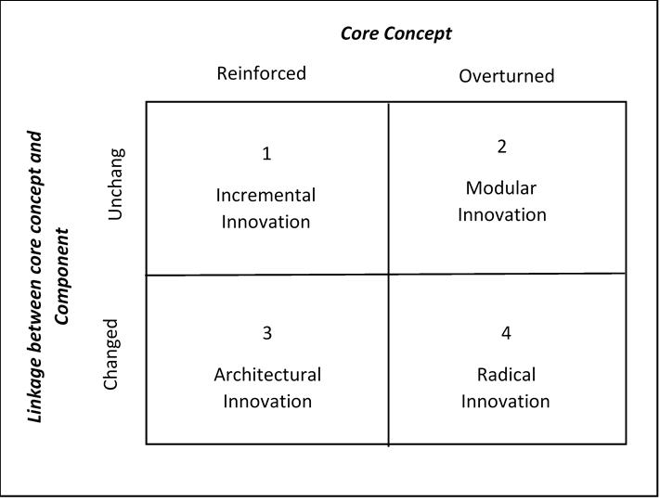
The highest level of novelty is located in the fourth area where the innovation is discontinued innovation as the uncertainty of the final product and the method to achieve it is high. Where these changes are based on radical developments in the market requirements which requires changes in knowledge element and the core elements such as shifting from film cameras to digital cameras. (Tidd & Bessant 2018)
Figure 2. 1: innovation level of novelty
(Utterback & Abernathy 1978)

During the exploratory project execution, Since the nature of innovation and exploratory projects is uncertain, Intensive periodic measurement should be done due to the uncertainty related to exploratory project to confirm the alignment of innovation with the project performance (Brun & Sætre 2009; Gillier, Hooge & Piat 2013).Controlling the project is crucial process to keep the project on track, plus it gives the opportunity to do corrective action and recover the project schedule before incurred a large damage (Lenfle 2014).

2.2.2 Construction Innovation Management
If you want to buy a computer and you are in financial distress and you specify a certain budget for this device. While you were roaming in the market you found that your budget is only met the old device which are incapacitate to fulfill the recent technology requirements. Would you like to buy it based on the available money? Or will you prefer to exceed the specified amount or maybe wait until you can arrange the many to match the market price? Of course, you will not lose the money you have to buy a device that does not meet the requirements of the current technology and you will seek a way to get the new one!
The objective of this example is to clarify the importance of the development of institutions, so that they outweigh the innovation over the differences in cost between the old and the new product. Taking into consideration that the inability to adopt changes may lead to large losses, could reach to exit the market, so the innovation considered as an important strategic factor (Tidd 2000). Seeking an example, Kodak Company when they exit the camera market after the innovation of digital camera as they failed to accommodate the new innovation. Which is true to the statement of Robert Lane, the founder of John Deere company one of the USA large scale companies in production of construction and services heavy machines:
“John Deere’s ability to keep inventing new products that are useful to customers is still the key to the company’s growth”
The innovation is the attempt to change and develop the product or the required processes to produce the product, the innovation will be required for specific goals such as keeping pace with market requirements or maintain the competitive advantage and not exclusively on the development of the technology, the innovation could be in the field of procurement or management process (Panuwatwanich, Stewart & Mohamed 2009).

2.2.2.1 Models of Innovation:
Although there are many different reasons leading to the need for innovation, researchers have recently classified the driver of invention under two views (Trott 2017): the first one is the innovation driven by the market needs (market Pull); In this case the framework of the organisation innovation is defined and driven by market’s opportunities and challenges, for the organisations driven by this view the preferences for an organisation’s innovation on another is to which extent the organisation is connected with the market plus the research and study on the market developments and trends (Trott 1998). The other view is based on the organisation’s capabilities and resources (Technology push); the organisations’ approach under this view aims to achieve a competitive advantage through managing and directing the organisation’s resources to form a sustainable source of innovation, then the innovation is pushed to the market (Grant 1996).
Access to the invention is not coincidental, although access to the invention is not expected, it is closer to a more reasonable and trustworthy. The organization must build a system and direct sources of creativity so that they are ready to seize the right opportunity for innovative. The next is summarise for two main approaches of innovation:

- Linear model
In this approach, the invention is recognized as a set of successive steps working as finish to start relationship till production of the desired output. The first generation of linear approach was simulated in the period after the Second World War to the mid-sixties led by the prosperity and expanded growth of science and technology in that period accompanied with increasing in the demand exceeded the production capacity, which made the attitude tend to use the technology to increase the quantity of production and improve quality supported by government policies to facilitate the innovations and the R& D (Rothwell 1994). Based on these facts the first linear model “Technology Push” was the approach for innovation, as the designers and engineers will develop ideas for the product based on the researches then passed to the manufacturer where they are tasked to find the best way to produce and then comes the job of marketing to deliver the product to those who can benefit from it (Trott 2017). The interaction between these activities are as per the figure -2.2- below (Rothwell 1994)
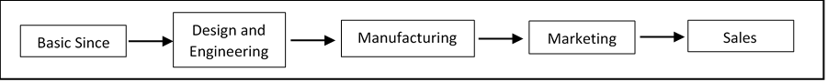
The second type was introduced in the late sixties as a reaction to the continued increase in production and the diversity of fields and studies of technology while the stability of the level of demand, which led to the tendency of organisation to study the need of the market and build upon which the innovation is directed “Market Pull” (Rothwell 1994). The second generation of linear approach of innovation start the line with a study of market requirements and customers’ needs then the designers and engineers will carry out to develop ideas for the product then the manufacture will take the lead to efficiency production (Trott 2017). The figure -2.3- below illustrates the interaction between these activities (Rothwell, 1994):
Figure 2. 3: Second Generation of innovation model based “Technology Push”
(Rothwell 1994)

Figure 2. 2: first Generation of innovation model based “Market Pull”:
(Rothwell 1994)

The linear models of innovation did not reflect all the factors involved in innovation, in additional does not show the role of management besides ignoring the role of the lesson learn and feedback.
- Non-linear Model
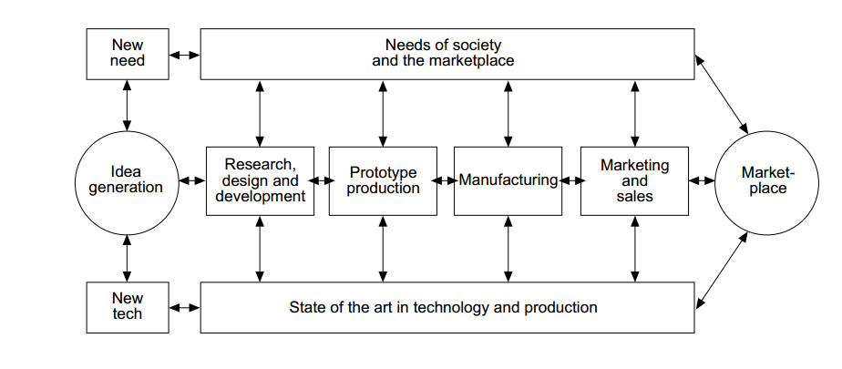
In the early 1970s, the companies had a tendency to build an economic system and raise the concern for control the finance in response to the beginning of deterioration in the global economic scale and associated imbalance between needs and demands in addition to the increase in the unemployment rate (Mowery & Rosenberg 1979). In response to this situation, organisations have found the need to find a new innovation approach that includes economic considerations to reduce the waste of money plus the consideration of stakeholders’ viewpoint while the interaction between “technology push” and “market needs” (Hall 2002) (Galbraith 1982). The interaction among these elements form the third generation of innovation which formulated in the figure -2.4- below:
Figure 2. 4: Third Generation of innovation
(Rothwell 1994)

In this model success is not limited to the completion of one task or component, since the successful innovation is the embodiment of the integration and coordination between elements and objectives at the level of innovation process and organisation alike, while the market requirement and technology are the framework for innovation and enhancing feedback and the lesson learned cycle (Trott 2017).
The third generation of the innovation did not take into consideration the effective role of the interaction of the organisations with each other in the exchange of information and knowledge, which led ten years later to the fourth generation of invention. Where the fourth generation provided an integrated system for innovation process within the organisation and its departments and balance it with the activities carried out by other organisations that work for the same invention in a way to form a network for knowledge exchange (Dodgson, Gann & Salter 2002). The fourth generation also reflected the importance of building a technological strategy that drives the innovation among the organization and its supply chain, such as the strategy of reducing the life of the product to cope with the rapid changes in technology and maintain demand level (Rothwell 1994).
The continuous development and improvement of the exchange information network and knowledge where including the management practices in manage and control of money, time and scope led to the fifth generation of innovation. Where the fifth generation focused on building a flexible innovation model capable of responding to the rapid and continuous changes imposed by the market (Galanakis 2006)

2.2.2.2 Construction’s Procurement Management and Sourcing Decisions:
Due to the multiplicity and diversity of technology and technical matters that may be involved in one project, it is difficult for organizations to rely on themselves only to complete the project without resorting to subcontractors or specialists. It's like our daily life, whatever the extent that we got of experience and knowledge we have in life, our certain abilities that make it difficult to live without dealing with other people. Hence the importance of procurement management as an integral part of the organization’s system and culture. Procurement management are the processes related to the involvement and introduction of service providers or materials to the activities of the organization or project, including the management of contracts and aligning the strategy and objectives of the sub-contractor with the organization (Sears 2015).
The organizations resort to a second party to complete some activities for a diversity of reasons, such as sharing the risk, the cost of a new technology, lack of experience in a particular field, to reduce the cost or time to implement the project or to open up the field of learning a new field by contracting with a specialized company. On the other hand, the organization could avoid the outsourcing due to concerns about information confidentiality, knowledge sharing, project control or conflict of interests. (Tidd & Bessant 2018)
There are many different methods of procurement, the appropriate approach is chosen based on several criteria such as the amount of risk in the project, the number of stakeholders whom involved in the project, the speed required to execute the work or to which extent the project’s cost is accurate or defended (Babatunade, Opawole & Ujaddughe 2010). Different types of Procurement can be classified beneath two main categories:
- Conventional Procurement: This method is a project based and usually driven by contractual obligation signed after the tendering stage, meaning after award the project the contract will be signed with limited allowance for the cost and time. The scope and specification must be defined and any changes lead to variation and claims.
- Collaborative Procurement: Also known as “innovative Method”; it is built on trust and both parties share the goals and both desires to achieve the best values, which reflected positively on both parties and their partnership. This procurement approach is based on establishing a framework aims to increase the collaboration and process to better achieve project objectives. The collaborative procurement could be for reason as increase the capacity, financial, skills, geographical extension, experiences…etc.

2.2.3 Construction Project Performance.

2.2.3.1 Definition and objective
The construction project management is a repeated activity of planning, monitoring, controlling, execution for each phase of the project (from design to key handing over) to achieve client objectives. Usually, the project is governed by client’s specifications that define the time, money and quality framework (Walker 2007). The construction project also includes a high level of coordination to manage the project team, resources, information flow and correspondences. At the project close out, the satisfaction of the client and the profit value is the main measurement of project success for the contractor firm.
Construction is a main pillar on the country's economy, since the cost of construction projects covers a large part of the country's budget. In addition, urban prosperity reflects the progress and development of countries (Maghsoodi & Khalilzadeh 2018). While the construction projects are considered as the most difficult types of projects and complex in management and there is a debate in the best management practice to be followed, however, the way that the construction project are managed were almost steady with minor changes since years. Furthermore, the construction filed itself has many changes in conditions, specifications, resources, organisation structure and technologies used (Sterule, 2016).
In general, the success of the project’s management is measured through three different benchmarks which are cost, time, and quality. The field of construction is one of the areas with high failure to deliver the project within the budget, quality, and time agreed upon (Owen, Koskela, Henrich & Codinhoto 2006). For example, one of the mega projects in UAE, which is one of the leading countries in the field of construction and allocates a large part of its budget to it, the contractual finish date of the project is around 2,000,000,000 AED and assigned duration to complete the work is 900 days. The main contractor of the project claimed for variation on the main scope of the project around 20% of the project contractual cost, plus raising a claim for 300 days as extension of time with associated cost damages.
The project succession is therefore, usually, the responsibility of project management, based on the way of direct and control over the project. To successfully manage the project, it is required to analyse and identify the external and internal factors that is with a possibly to impact positively or negatively on the completion of the project within the specified time, quality, and budget (Lim & Mohamed 1999).
The performance measurement is of great importance and interest on it is increasing in the organisation at the present time as the competition is rising, it has benefits at different levels and stages, and consider as a main way for continuous improvement. At the organisation level, performance measurement allows an organization to maintain its competitive advantage in the market (Simmons, Gardiner & Strauch 2003). At the project level, performance measurement has the advantage of enabling project management to take corrective action before the problem occurs, as well as keeping performance record in company database as lessons learned for future projects (Rose 2013).
In our study, the focus is in measuring performance is at project level as the analysis will be performed in construction projects. Many parties usually involved in construction projects additionally variety of project type leads to many criteria that could be used for measuring construction project performance. As the satisfaction of client could achieve by handing over the final product within the available budget and in the required time, while maintaining the desired quality. On the other hand, the target of consultant is to ensure the quality of work is complying with the client specification and contract condition without consideration of the time or budget. The contractor and subcontractor concern with executing the work within the assigned time and cost while maintaining client satisfaction (Chan, Scott & Lam 2002). In general, the success of construction projects is measured by the performance in cost, time, quality, and customer satisfaction as common criteria between different parties.
Idoro (2012) summarised the project performance criteria into two categories, the first one is related to project circumstances which influence variable factors that measure variances in project performance such as time, cost, and quality. The second set is related to external factors that are subjective and related to the satisfaction of stakeholders, such as the client or organisation owner, about the project performance.
Hatush and Skitmore (1997), Michell, Bowen, Cattell, Edwards & Pearl (2007), and Azar, Militaru and Mattar (2016) in their time-spaced researches referred to the trio of time, cost, and quality as a core criterion for monitoring the project performance and as a benchmark for the success of the projects. They go further to describe the completion of the project within specified time, cost, and quality is achieving the stakeholder’s (specially the client) satisfaction. Considering that the relationship between the client satisfaction and the quality of construction project is on a higher link than others as the satisfaction of the client may be achieved by receiving functional free of defects facilities. In general, satisfaction could be defined as the limit that the expectation of proposed project will meet the actual outcome, so the satisfaction achieved by understanding and applying the client’s pre-defined requirements (Idoro 2012). The next paragraphs will explain the method that used measure these criteria and the aspect that considered as a failure:

2.2.3.2 Time and Cost
To achieve the project objectives, the project manager should apply a good practice of the management process which are initiating, planning, executing, monitoring and controlling and closing. The project manager will coordinate and integrate between these processes for each different project based on the project type and requirements (Sears 2015). Since the project management are the planers and the directors of the project, the construction project management required to have a professional skill in coordination, anticipation and able to reduce the effect of variations by taking corrective action.
The construction projects management is following a traditional project management approach which is known as waterfall methods as it is going in a one-way direction. The plan of the all project life cycle is set out at the beginning of the project and it will be preserved from the beginning to the end of the project, the plan is including the required resources, time, cost, identify activities plus the sequences and relations among them. Critical path method and earned value management are an example of the most common method in planning and controlling the construction project, these processes are applicable for all types of construction project in spite of the differences among projects.
The time and cost measurement are ongoing activity from the beginning of the project to completion. in order to measure the time performance two outlines, prepare, planning documents and measurement method:
- Project Schedule and Critical Path Method:
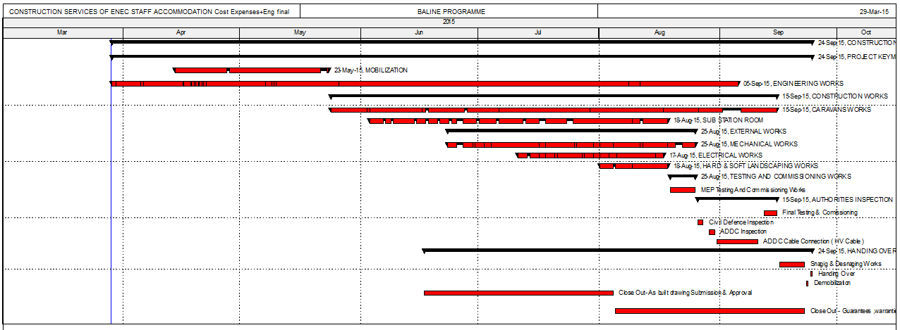
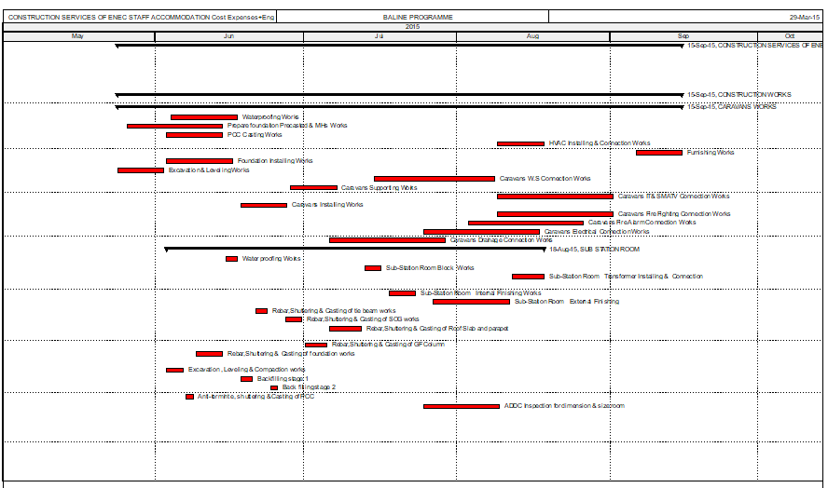
The baseline programme should be submitted directly after the project is awarded; the management are requested to submit the project baseline which is the timeline for the breakdown of the construction activities including high level of details. The resources and the cost of each activity is assigned to each activity, all activities will be connected to successor and processor to make paths from the beginning to the end of the project as a network. The baseline is the plane phase of the project and answer questions such as what and when the activity will start. The baseline could be visualised using different formats, for example bar chart. The figure below shows a high-level detail and break down for one segment of the project baseline:

Figure 2. 5: example of visual monitoring for construction project (bar chart)
The critical path method is a schedule method allow to monitor the time schedule visually. The longest path in the network is called the critical path and the highest attention must give for that path as any delay on it will lead to a delay in the completion date of the project.
Out of this baseline, the project manager will be able to create models to monitor the factor of time and money, which is considered as the tangible factors for monitoring the construction projects, of this project like cash flow for monitoring cost and histograms to monitor the time.
Upon commencement of execution phase, the Project Manager shall collect updates for the progress of the Project with successive in a sequential way within a period of time agreed upon based on the execution acceleration and could be change according to the project phase. These data use to update the baseline which enables the comparison between the plan and the actual, from which the performance is analysed by extracting readings such as the performance Index or variances. Based on this analysis, the project manager can recognize and diagnosed the status of the project and make the necessary decisions to correct the situation, especially if the reason for this delay is located in the critical path.
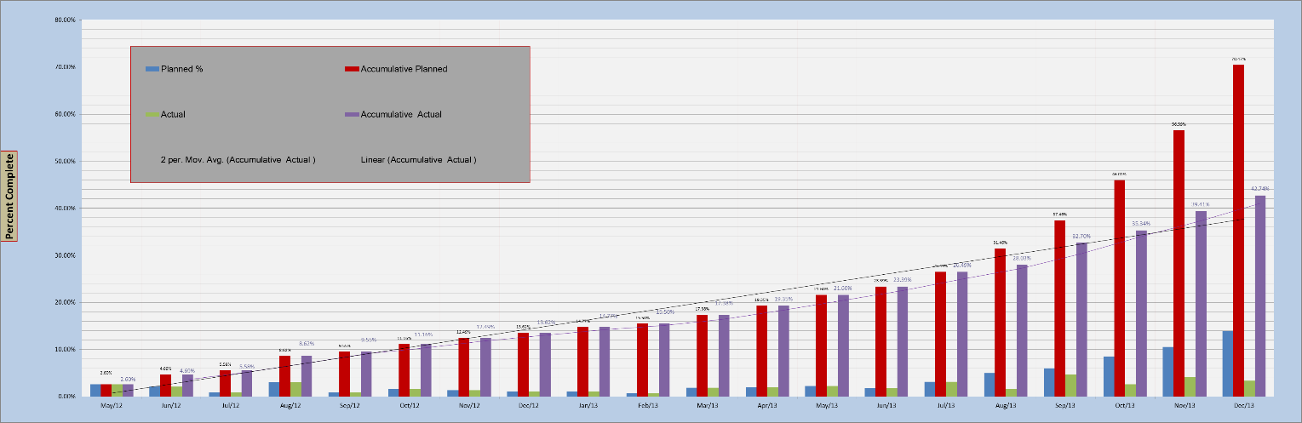
The cost use to monitor the project in the same way. Figure -2.6- below illustrates the cash flow for one of the construction projects, the red bars are the planned while the green are actual, we can see the monthly delays in cash flow plus we can comparison between the cumulative (Sears 2015):
Figure 2. 6: example of monthly cash flow for construction project
The advantage of using the critical method could be summarized as below (Campbell 1982):
- The ability to create more than one path for linking the consequent activities with completion date of the project which allows us to understand which activities are more critical than other and recognised the duration that activities can be late without delay the completion date of the project.
- Milestones for important dates during the project life cycle could be added which allow to understand the performance before the completion of the project.
- Updates for actual statues of each single activity is assigned during the execution of the work and analysis of these data to understand the effect of the progress on the remaining planned activities.
In contrary, the disadvantage of using the critical path method is the great effort that should be done before the starting of the project as a breakdown for all activities with resource, cost and duration assigned for each. In addition, the critical path method could fail and give a fake measurement in case of changes in the sequences of activities in the actual work is not reflected on the planned schedule. Finally, the start and finish dates of the project should be defined in order to apply critical path method analysis.

- Earned Value Management (Actual VS Planned):
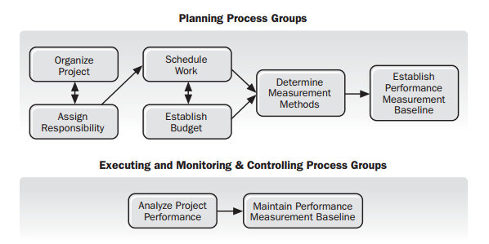
Earned value is an approach that enables to take measurement for the cost and time performance overall the project life cycle, in addition it provides a mechanism to forecast the future performance of time and cost based on current performance. The earned value is a comparison between the baseline and actual data collected periodically from the work progress then applying earned value theory to integrate between time and cost factors. The figure below illustrates the steps for earned value method:
Figure 2. 7: Earned Value Process
(Project Management Institute 2011)

The integration between time and cost is the earned value method uniqueness, as if the cost is measured separately from the time performance will give a fake measurement about the actual performance. To further elaborate, let’s assume that the cost performance of a project was measured after a certain time of the project start date, at the same data date the time performance ratio was calculated. It may be that, the cost performance shows a percentage of the spent money equal to the value of the planned budget at the same date which sounds good, but the percentage of completed work related to that time may be less than planned. These contradictory results may carry many possibilities such as the possibility that the actual money spent on the activities of the project may be than the earned value, and here comes the importance of using the earned value management. Additional advantages of earned value are that, the measurement results of earned value are useful to take corrective action before the problem happened, plus the measurement for the overall performance of the project’s time and cost is archived in the organization's records and database.
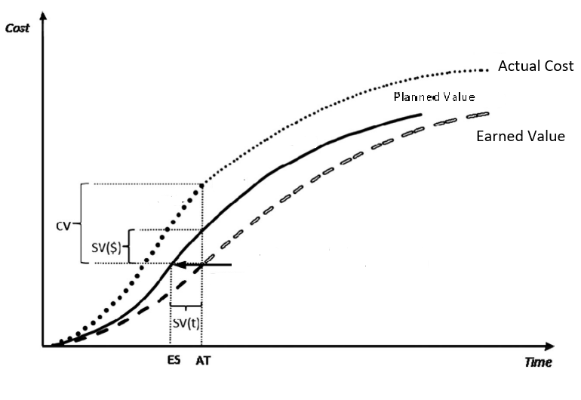
The application of earned value management is not complicated and the measurement result could be embodied in tables or graphs. To understand the earned value method, the curve graph below illustrates the earned value measurement which calculated from the planned baseline schedule and the actual data collected from the progress. The data usually calculated using software like Primavera or manually using earned value formulas:
Figure 2. 8: Earned Value Management Concept
(De Marco & Narbaev 2013)

Where (Project Management Institute 2011),
Planned Value: which is also known as S-curve which represents the cumulative value over time for the amount of money to be disbursed to date (cumulative cash flow). Accordingly, the planned value is the baseline to compare the actual progress with.
Actual Cost: the amount of cost incurred to execute the work up to the date. The variance between the actual cost and earned value on the Y-axis represent the variance in cost between planned budget and actual progress cost.
Earned Value: The percentage of the work done based planned cost (Project budgeted cost). It’s calculated by multiplying the ratio of work progress by budgeted cost. The curve that represent earned value allows to compare the variances between budgeted cost and planned time using actual cost curve and planned value curve consequently.
SV: Schedule Variance
CV: Cost Variance
According to what is mentioned above, the earned value management enable to evaluate the Schedule and cost variance at any time of the project life till completion, in addition to forecasting the budget and time at completion based on the current performance measurement.

2.2.3.3 Quality Measurement
Quality is a term used to express to what extent the specifications and functionality of the product are compatible with the client requirements. Taking into attention the quality is a measure for the product compatibility with client requirement not the grade or rank of the product, for example the client could ask for produce a low grade product with low specification, the quality will measure the compatibility between the product and these specifications rather than compare this product with similar production with higher specification (Burke 2003).
The quality measurement method will vary based on the type of product and required specification, in overall, quality measurement following standard process. First, the quality measurement plans, tools, inspection plans, and format will be initialized and agreed by management. Then, the audit team will inspect the project at agreed time intervals starting at the beginning of the project up to deliver the final product using the planned tools and format. Finally, the data and reports from the audits will be collected and analysis to assess the performance and production quality. (Project Management Institute 2014)
Quality measurement in regular basis could avoid the unnecessary repetition of work which could incur extra cost and time, plus the quality measure will assess the organisation performance for future projects or for continuous improvement.
The table below summarizes the document required for measurement of time, cost and quality (Burke 2003):

Table 2. 1: the document required for measurement of time, cost and quality
(Burke 2003)
Required document | Time | Cost | Quality
Planning Document | -Baseline Programe (Planned Schedule)  -Start and Finish Dates (Project Milestone)  -Resources, Activities Breakdown | -Cost Breakdown  -Baseline Programe  -Cash flow Statement | -Project Quality and Control Plan (Ex. ISO)  -project specification and client requirement  -Auditing formats and checklist.
Measuring Document | -Actual progress report  -updated baseline  -Earned Value management | -Actual cost expenditure  -Actual Cash Flow  -Earned Value management | -Auditing report  -Specification and actual work comparison

2.2.3.4 Client Satisfaction
Project Management Institute (2014, p.229) define the client satisfaction as “Understanding, evaluating, defining, and managing requirements so that customer expectations are met”. Accordingly, the client satisfaction is a subjective criterion related to the degree of end user happiness with the using of the end product. However, satisfaction can be related to time, cost and quality, customer satisfaction is measured by direct contact or end-user survey. However, satisfaction is measured by direct contact or end-user survey.

2.3 FRAMEWORK BACKGROUND:

2.3.1 Exploratory Project and Level of innovation
To succeed in a rapidly changing and highly competitive market, a flexible approach must be built and able to accommodate developments and complexities in its field while containing the uncertainty associated with it (Wirtz, Mathieu & Schilke 2007). Exploratory learning is the organisation tool to cope with these changes, which is a reflection of the extent of the organisation variety. In other words, exploratory learning distinguishes the organization that seeking variance from the other which is built on routine and steady steps. The exploratory learning is a process allowed to growth a new innovation while building on the current routine of the organisation, which is crucial for adopt and create innovation (March 1991).
Exploratory Learning does not conflict with the existing knowledge base of the organisation, but its role in the development and guidance of this knowledge with the changes and the requirements of renewable to enable the institution to adapt any change required by innovation (Fang, Lee & Schilling 2010; McGrath 2001).
Studies and research have proven that the requirements of the ability to build a flexible organisation culture is organisational learning. Where the presence of a strong organisation learning is forming knowledge base of the organisation enables them to respond and adopt any changes (Dobson 2008). Organisation learning is the ability of creating, understanding and translating new knowledge and information in a way that can be understood at the level of individuals, groups or organization which facilitating the acceptance of changes and increasing creativity in the organization (Giesecke & McNeil 2004).
Building an organization learning requires a strategy that makes everyone persevering and committed to change, where learning is connected to the organization's operation, and based on an assessment of the organization's capabilities, while establishing a knowledge sharing base with incentives and support system for learning (Giesecke & McNeil 2004). The research recognised three type of learning based on the cause and the effect of it as per the point below (Argyris 1996; Argyris 2012):
- Single Loop Learning: This type of learning is imposed as a result of taking action to rectify an error, while this situation did not impose any radical changes and done within the framework of the organization.
- Double Loop Learning: It happens for the same reason as single loop learning but rectifying the error led to changes in the goals and / or the procedure of the organisation.
- Triple Loop Learning: Has been found to avoid the difficulties that existed in the double loop learning where it is here to deepen the learning and study the consequences, which may result in deeper changes may reach to change the strategy.

Lant, Milliken and Batra (1992) conducted studies on the effect of management approaches on building effective strategy that fit the requirement of exploratory project. (Benner & Tushman 2003) argued the beneficial of management process in stability of organization to build incremental innovation. McGrath (2001) research in deep the requirement for managing the innovation, as per the study autonomy goals in managerial oversight will result positively on organisational learning and exploratory project consequently. The role of individual, sub-groups and intergroup of organisation and the way of interaction and managed by leaders are influenced in organisation learning (Fang, 2010). Accordingly, the management system that adopts a close monitoring, control and objective directed approach in the management of project’s stuff are low opportunity to success in exploratory project (Lant, Milliken & Batra 1992; Cheng & Van de Ven 1996; McGrath 2001).
According to Drucker (2002), “innovation is the work of knowing rather than doing”.
The innovation is a collection of different types of knowledge from diverse sources, and this knowledge are adapted, developed and integrated to have innovation. This knowledge is not only limited to the technical knowledge of the product to be developed, it is accompanied by stages of knowledge of market requirements and directions, in additional to know how we can integrate our knowledge to reach innovation. These knowledge sets may have been accessed through a research and studies department, or have been exploited for a previously unexplored component or maybe get it for the experience of work in the same field (Tidd & Bessant 2018).
The overview for Henderson & Clark (1990) is that, the innovation may be involved in one high technique, on the other hand plenty of knowledge set could be involved in one innovation, and the success of innovation is yield of a successful integration of these sets. One of the challenges in the integration lies in managing the risks associated with adapting, development and integration of these knowledge due to the uncertainty level. The degree of uncertainty is related to the degree of novelty for the innovation, which measure to which extent that the new innovation is related to the existing knowledge or products. Novelty is measure to categorize the innovation based on the knowledge dimension, so that it depends to what extent this invention contains new ideas like no other, it may range from a new production at the level of the organisation while there is an instance in the market where the level of novelty is low, to a high novelty when there is new product entirely and has no similar before in the market (Kalogerakis, Lüthje Christian & Herstatt 2010).
The challenges in innovation management is in a progressive relationship with the level of novelty, a high degree of novelty product, also known as architectural innovation, is accompanied by high complexity in the knowledge transmission system beside changes in the management structure to suit the requirements of the invention. While a low novelty product is sufficient reallocate the knowledge resources around the product till figure out the innovation (Henderson & Clark 1990).

2.3.2 Innovation in Construction
The innovation in construction industry is of a special nature because of the obstacles related to the business conditions of construction. These obstacles come from the practices of organization and management in construction, in addition to the presence of a variety of stakeholders and organizations involved in the project, each of which may have different sub-objectives even though they met for a large goal, project completion (Aouad, Ozorhon & Abbott 2010).
Egan in 1998 (cited in Rowlinson 2003), through his report “Rethinking Construction”, emphasized the importance of innovation in the field of construction stating that despite the need of continuous innovation for the construction market for development, the adoption of innovation in construction is suffering from low quality due to the construction culture and practices. Marosszeky in 1999 (cited in Akintoye, Goulding & Zawdie 2012) confirm that the low rhythm of innovation in construction filed, in contrast of the innovation progress in other industrial filed. Other research carried out with evaluating the reason of the construction innovation delay such as Egan in 1998 (cited in Rowlinson 2003) and Aouad, Ozorhon and Abbott (2010) listed the obstacles that face the innovation development in the construction industry.
Walker (2016) states that although there has been some progress and increased interest in development, there is still a significant difference between construction and other filed in this area, he claimed that this was caused by poor knowledge management in the construction organization. The same was supported by Anumba (2009) in his research. Also, Procurement management in construction has always been a source of concern and many performance problems (Fairclough 2002).
Leiringer and Cardellino (2008) research the complication related to implementation related to innovation in construction, highlighting some factors lead to that such as the robustness of construction practices. While Nicolini, Holti and Smalley (2001) research the supply chain in construction as a critical reason of backward in construction industry, referring to increase the collaborative in construction supply chain as a solution for that. Furthermore, more research on the delay of construction in this area has been conducted by Winch (1998), Gann (2000) and Woudhuysen and Abley (2004).
Egan in 1998 (cited in Rowlinson 2003) listed the obstacles that face the innovation development in construction. One of concerned area faces the innovation in construction is the policies and politics of the construction companies in involve the subcontractor and supplier in the work, the supply chain resources should be built on strategic way rather than pure financial and contractual obligations. Other area of concern in his list, was the organization behavior, client attitude and management practices of over sighting the construction team is less concern on building innovation mentality, as innovation required directed and ongoing supported efforts to achieve the innovation. What is mentioned is supported by the shortage of research related to the field of construction’s innovation, besides, the lack of understanding of the positive relationship between innovations on the one hand, and increased the chances of award projects and increase profit from another (Blayse & Manley 2004).
(Blayse & Manley 2004, p.144) on his research defines the factors that drive construction’s innovation;
“Clients and manufacturers, the structure of production, relationships between individuals and firms within the industry and between the industry and external parties, procurement systems, regulations / standards, and the nature and quality of organizational resources. These influences are the key factors driving or hindering business innovation”.
It is clear in these factors that the external sources and the nature of its relationship with the organization, in addition to which extend the organizational culture provide systems and innovation’s framework of the organization are the main leader of development. While making a quick comparison between (Egan, 1998, cited in Rowlinson 2003) list for the obstacles that face the innovation development in the construction industry, with Blayse and Manley’s (2004) six factors that drive innovation, you will clearly understand the weakness in construction innovation.
The application of agile management in the field of construction was hampered for the same reasons and obstacles mentioned above, it is an example shows the difficulty in introduce or change the construction projects where it was difficult to apply in construction.
Agile project management is rolling wave technique where a detailed breakdown of required activities for the near-term project’s phase, while the high level of details is given for the next stages in the project. Since the degree of detail in the project is related to the project timeline, all staff will be directed to work together to complete the current phase of the project, achieving the desired targets and goals. With the time when the current phase of the project is finished, the detailed plan for the next phase will be prepared, after that the team will move on to work together in the next phase. To provide a better understanding for the picture, we all may have seen how rugby players in a game of rugby when the whole team is formed around the ball with the opposing team to seize the ball and then began the next stage of attack or defense. Agile project management is a value driven method focusing on client involvement as much as possible in most stages and details of the project.
The Agile Project Management could have been implemented without the following obstacles:
- Supply chain and procurement Management: reassess which type of work should be done internally and the work that is delegated to subcontractors, and align the objective of both (Streule, Miserini, Bartlomé Olin, Klippel & de Soto Borja García 2016; Bonesso, Comacchio, & Pizzi 2011).
- The number of correspondences is enormous due to relying on a large number of unprofessional subcontractors in the same project which is inconsistent with agile project management in addition, the team must work closely to avoid the unnecessary hierarchical corresponds (Owen, Koskela, Henrich & Codinhoto 2006).
- The design and theories of the organization culture which introduce the level of organization contribution and influence in project management process and the organization goals. for example, if the organization type is more into theory Y the application of agile management will be easier than apply it in organization follow theory X, as theory Y give more freedom and healthy environment for the work team to work together (Owen, Koskela, Henrich & Codinhoto 2006).
- The value that the organization seek to meet.
In these points we can see the similarity between the obstacles and causes of the delay in innovation in the construction field and application of construction agile management.

2.3.3 Relation between performance and innovation
Although the application of innovation in construction is fraught with many obstacles and barriers, the successful implementation of the innovation may have a direct or indirect influence the performance of construction projects, which is a high concern in the field of construction projects.
Toole (2001) stated in his research that the successful technological innovation is the one will improve the time, cost the process performance of the construction projects, which giving advances for these projects over other. Toole (2001) in his research did not studied the innovation from managerial view, instead he focused on technological aspect of construction projects and its effect on the performance of special component in construction work. Choi, Jang and Hyun (2009) conducted a research reviewed the effect of the innovation in the firm performance through the project leader and other variable related to organisational environment. Choi, Jang and Hyun (2009) study neglect the effect of innovation in performance at project level, in addition his sample included 118 Korean companies only which will reduce the accuracy and less variety of the samples.
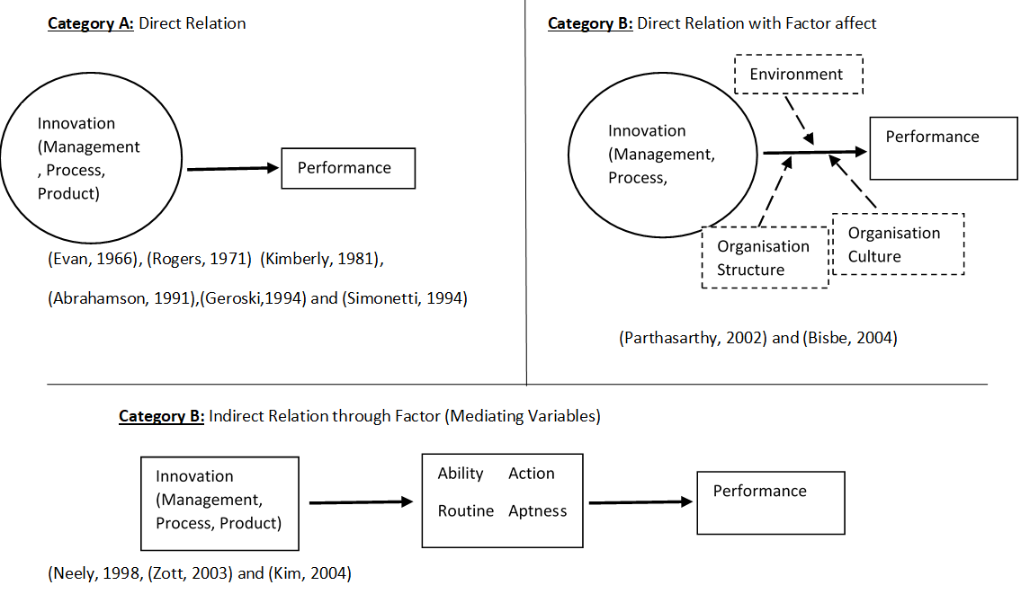
Even though there is a less deep study for relation between construction innovation and the performance of construction projects, several researchers have studied the relationship between innovation and firm performance. Choi, Jang and Hyun (2009) analysed and summarised the research done starting from 1996, some of these researches included the direct relation between innovation and / or some component of it with the performance improvement, the other considered an intermediate between innovation and performance. The figure below illustrates these studies:
Figure 2. 9: Relation between innovation and performance (Choi, Jang & Hyun 2009)

These studies categorized into three groups, two of them for direct relation between innovation and firm performance, one for the research on overall innovation the other done on a specific component of innovation like innovation process or organisation environment. The third group studied the innovation improve in the firm performance with effect of variables like the firm abilities or organisation structure. These studies in general did not consider the effect of innovation in project level which will give more accurate results for performance measurement.

2.3.4 Roles of Procurement Management in Innovation
Sourcing Decision must be based on knowledge and study of the issues and problems of the current project, these studies should be carried out by the management of the current project rather than relying on an archival and historical data from the organization (Macher 2006).
The sourcing decision will be directly affected by evaluate the organization capacity besides assesses the extent of knowledge and understanding of the project. As per (Bonesso, Comacchio, & Pizzi 2011) tow dimension of knowledge based on the reasons of sourcing are recognized; the first one is the novel dimension which in this case the source will be required to produce a new innovation that may be required by a client or a to have a competitive advantage in the market. The second dimension is called breadth, which is related to discover a solution of a technical problem for a product that has been manufactured or is already in the market.
Accordingly, the analysis is made to make a decision whether to give it to an external source, or to do it internally or possible to combine between internal and external:
- Project Level analysis
Most of the studies related to the sourcing decision focus on three main factors. The first factor is the cost to carry out the work within the company and whether the application of the new innovation will be beneficial for future projects The second factor relates to the confidentiality of the information or techniques used in the project and whether the involvement of another company may affect the interest of the monopoly of the company for this information. The third factor depends on the benefit that will be returned to the company from involving out source in the risks resulting from this innovation, in additional to share the cost of errors resulting from the application for the first time) Steensma & Corley 2001).
In fact, making a decision based on detailed study and analysis of each project is not only beneficial to the project, but can reshape the strategy at the organisational level in this regard, while keep the institution’s database up to date and aware of market challenges (Carson, Madhok & Wu 2006). In the case of the inability to conduct a careful study at the project level for a specific project due to special circumstances such as lack of detailed information at the beginning of the project, the sourcing decisions could be based on organisation level, such as the study of the organization's attitude to risk, or the degree of experience or professionalism of the organisation in the proposed project area (Bonesso, Comacchio, & Pizzi 2011). Combining what the company learned and has experience with the innovation challenge to solve a problem can be the embodiment of a new paradigm of knowledge.
The table -2.2- below summarises the two categories of procurement, examples, advantages and disadvantages (Akintoye, Goulding & Zawdie 2012; Ashworth, Hogg & Higgs 2013; Babatunade, Opawole & Ujaddughe 2010; Morledge & Smith 2013):

Table 2. 2: Procurement Approach Comparison
Procurement  Method | Example | Description | Advantage | Disadvantage | Role in the Innovation
Conventional Procurement | - Traditional Procurement  -Management Procurement  - Design and Build System | This method is a project based and usually driven by contractual obligation signed after the tendering stage, meaning after award the project the contract will be signed with limited allowance for the cost and time. The scope and specification must be defined and any changes lead to variation and claims. | - Easy to Change the subcontractor.  - The time and the cost are defined.  - Easy to control.  - Fast decision and corrective action.  - Low prices due to highly competitive.  - Flexibility to award any part of project at any time | -Temporary nature of the relationship.  -Price is the leader of choice.  - Reservation on exchange of information and suggestions are often unwelcome due to the nature of the contractual relationship.  - Conflict of interests between parties (ex. Quality is concern of one party the other concern is cost).  - Transfer most of the risks. | - Due to the temporary project base relation the innovation will be strangling by less security and long-term plans for development.  - The tendering process of conventional will limit the subcontractor involvement and interest in innovation.
Collaborative Procurement | - Joint Ventures  - Strategic Alliances  - Prime Contracting  Framework Agreement  - Partnering  - Public Private Partnership  - Supply Chain Management. | Also known as “innovative Method”; it is built on trust and both parties share the goals and both desired to achieve the best values, which reflected positively on both parties and their partnership. This procurement approach is based on establishing a framework aims to increase the collaboration and process to better achieve project objectives. The collaborative procurement could be for reason as increase the capacity, financial, skills, Geographical extension, experiences…etc. | - Long term relation  - Both parties are more commitment.  - Integration and change of information, knowledge and experience.  - Better understanding for the project as the involvement is at early stages.  - Better communication which improve quality, cost and time performance.  - increase the abilities and chances to innovate and concentrate on competitive advantage.  - Continuous Improvement. | - Hard to apply for short term project  - Required high level of coordination and communication  - the cost uncertain at the beginning  - required extra effort to control the time and cost | - Enhance the opportunity for innovation as the focus in dispute between the parties and increase the collaboration to build long term system to maintain the competitive advantage  - Improve in performance, communication and investment which will reflect in improving the innovation.

The method and the criteria to make decision of sourcing strategies are of great importance and the interest on it continuously increasing from the organisations because of its significant impact on the ability of the company to compete and stay in the market (Huang, Chung & Lin 2009). Although this may have implications for performance, companies must outsource to deliver the product due to the complexities of technology or business that require specialization (Filipescu & Cázares 2012). The outsourcing decision could be a decision based on cost analysis or technical issue for the knowledge out of the organisation’s expertise (Steensma & Corley 2001).
The construction area suffers from problems in procurement relations and management, which adversely affects the achievement of the goals and objectives of the project (de Araújo, Alencar & de Miranda Mota 2017; Jelodar, Yiu & Wilkinson 2016; Meng 2012). Bad practices of construction procurement management, such as long list of subcontractor and supplier plus the project to project relationship, arise negative relationship in construction procurement network (Fairclough 2002). Nicolini, Holti and Smalley (2001) research the relation among procurement network in construction as a critical reason of backward in construction industry, referring to increase the collaborative in construction procurement network as a solution for that.
Collaborative procurement gives the opportunity for the contractor or supplier to involve the project in early stages which reduce the conflict of interest which consider as a solution for the claim culture of construction project (mentioned above) (Mosey 2009; Colledge 2005).
After data collection and project analysis, these data will be reviewed and analysed based on the company's direction and the desired benefit of the project (Birkinshaw, Nobel & Ridderstråle Jonas 2002). Where researchers proved a relationship between the company's knowledge tendencies and the decision of sourcing in case the financial study was exceeded or the subject was taken on the basis of increasing knowledge or add a competitive field for the organisation (Bonesso, Comacchio, & Pizzi 2011).
Based on that, the framework for the sourcing decision is organisation attitude and strategy to deal with the innovation. The new innovation application may require significant changes in the knowledge of the organization, its external relations, and its values (Malerba 2005). Where the decision to source a particular service may be to open a door of information changing with another organization for matters related to the innovation, and could lead to undermine the old relations in the organization (Malerba 2005). This may lead to appearance of a new level of matters and questions that need to be solved which will not be directly related to the invention (Bonesso, Comacchio, & Pizzi 2011).
The involvement of an organisation in a new innovation may be linked to a number of disadvantages, such as the failure of the organization to absorb changes related to development due to the routine performance of employees, which may limit creative ideas, or might suffer due to lack of real understanding about required changes and developments in the managerial or technology filed, due to the uncertainty associated with the innovation which may create unknown unknown risks (Bonesso, Comacchio, & Pizzi 2011).
It must be borne in mind that these misdeeds are more likely in the event that the organization was involved in an invention that has no parallel in the market, while these will be less when this is already made by a competitor while the organisation desired to develop it for the first time. Some studies have shown that this has a direct relationship to sourcing decisions.

2.4 Chapter Conclusion
In summary for the first section, a detailed definition for the exploratory project as a concept for innovation implementation and execution with a highlight for the exploratory projects, knowledge dimensions and level of innovation as a main factor of the exploratory project. Then a background for the innovation management in construction including a model for innovation, the obstacle of innovation in construction beside a brief for construction procurement management. In addition to aspects of measuring the construction project’s time, cost, and quality performance. From the second section, a significant agreement between researchers on relation between the procurement management type and the innovation management and the role of procurement management as obstacle in delay the innovation construction, besides the importance of level of innovation on the sourcing decision. Finally, the way of measuring the effectiveness of innovation by the construction projects performance indicators (time, cost, quality).

CHAPTER III

RESEARCH METHODOLOGY

3.1 Introduction
The aim of the chapter is to create a conceptual framework that links the results and conclusion of the literature review with the objectives of this research. Then general definition for research methods, followed by justification for the methods that fits the created framework and enable to do the proper analysis to answer the thesis question and objective. In summary, the factors of level of innovation, procurement management and performance will be formulated in a way that enable to test the research objectives, then the instrument of data collection will be defined and justified. Finally, some tests will be run over the collected data to validate and measure its reliability.

3.2 Research Framework
The hypothesis of this study will be based on the model below (figure -3.1-) which propose a framework to demonstrate the role of procurement management (as an obstacle for construction innovation) on the relation between the exploratory project’s level of innovation and performance. Also, the framework enables to test if there is a direct effect of exploratory project’s level of innovation on the procurement management (as an obstacle for construction innovation) of an organization. Furthermore, to investigate the impact of the level of innovation and procurement management separately on the overall project performance.

Construction Innovation Obstacle

Procurement Management
Exploratory Project
Project Performance

Level of Innovation

Time
H₁
H₂
Cost
Quality
H₃

Figure 3. 1: Conceptual Frame Work

This framework will be implemented in two phases. First, using the exploratory project’s level of innovation as an independent variable with regards to the procurement management as dependent variable. Second, using the level of innovation and procurement management separately as independent variables with regards to project performance as dependent variable.
Few researchers studied the role of exploratory project’s level of innovation and procurement effect on innovation as a way to improve innovation management. On the other hand, the researchers can detect a gap in the literature about the level of innovation and procurement management effect on the construction innovation. Also, this research shall cover the impact of the innovation on the project performance. Since innovation grow at a slower rate in construction project than any other industries, this study will emphasize one component of exploratory project (level of innovation) and one main reason responsible for innovation setbacks in construction (procurement management). The following are the framework hypothesis:
Hypothesis # 1: Increase the level of innovation will enhance the performance (H₀₁: Factors related to Level of Innovation have significant impact (≤ 0.05) on project Performance.)
Hypothesis # 2: Procurement will improve the relation between level of innovation and the Performance (H₀₂: Factors related to Level of Innovation and procurement management have significant impact (≤ 0.05) on project Performance).
Hypothesis # 3: As the level of innovation in construction increase, the chances of collaborative Procurement will increase (H₀₃: Factors related to Level of Innovation have significant impact (≤ 0.05) on procurement management).

3.2 Research Methodology
The previous section framed the objective and research criteria of this dissertation which demonstrated and built based on the literature review. Here, the conceptual framework will be examined by collecting and analysing data to demonstrate and support the frameworks relations and hypothesis. Research methodology is the approach and techniques that is used in order to reach an answer, solution or drive a knowledge that give a convincing solution, answer questions or supporting the topic of this study (Kothari 2004). The design and the approach of methodology selection varies from research to another based on factors such as sample sources, data type, data collection tools and personal experience, where the purpose at the end to find and adapt a methodology that fit the research’s objectives, aims and answer the research question (Goddard & Melville 2001).
Creswell and Creswell (2018) recognised the research approach into three categories, distinguishing between these varieties is based on the type of collected data. Below is an illustration of these three approaches and their usage: (Creswell & Creswell 2018).

- Qualitative Approach: The tool used to collect data for this approach usually be flexibly formatted to response using participant person’s own words. This approach gives the chance to collect more words and flexible in expression, then the researcher will extract out of these words a conclusion to support or contradict his research. Interview is an example of qualitative approach, this method usually used when its related to social studies.
- Quantitative approach: This method is based on a statistical analysis process on numerical data collected from fields or closed-ended surveys such as yes / no question or ranking. This approach is usually used to validate a relation between two or more variables or predict a relation overtime, beside a description of participants based on demographic data of the participants. The evaluation is done by evaluating the impact of variables over the outcome, the relation could be positive, negative or neglected.
- Mixed Approach: Some research design required a combination between the qualitative and quantitative approaches to overcome the both approaches’ limitations. Choosing mixed approach must be based on high knowledge of the researcher for the reasons of choosing this method and the expected value that will come back out of using it.
The purpose of this chapter is to find and adopt a methodology that fit this thesis objectives that built from the thesis literature review section, where the selected methodology at the end will be able to answer thesis question and validate the objectives:
- Determine the factor that is related to the success of the exploratory project and highlight the major factors that influence and cause the backward of innovation in construction project.
- Define the criteria that frame the successful construction project and enable to assist the effect on the overall project performance to enhance the construction innovation level.
- Correlate the factor that affect the innovation and performance in a way that introduce a framework to overcome the obstacles of innovation in construction and analyses it.
- Discover the exploratory project role in managing and improving the innovation in the construction industry and define the aspect and factor of exploratory project that related to improve the innovation of exploratory project.

3.3.1 Research Approach
The selected approach must be chosen to fit and enable a proper data analysis to reach the correct answer and conclusion for the research questions, otherwise choosing improper approach could generate Unfaithful recap (Kumar 2011). In this research, the objective is to validate the relationships between variables by testing the mentioned hypothesis in the previous section, accordingly the best approach to validate it is to conduct a quantitative approach for the data collected from the survey (Creswell & Creswell 2018; Kothari 2004).
The three hypotheses generated out of the literature review chapter are going to be tested using the numerical data collected from the created survey, the survey questions will collect a three set of data related to the three variables of this research (exploratory project level of innovation, procurement management type and project performance).
- Positivism and Realism
The respondent surveys will be transfer to numerical data that allows to perform a related statistical analysis (correlation, regression, t-Testing) to validate the relation between the three variables through the hypothesis. This supports the selection of quantitative approach as a way to analysis a numerical data.
In addition, this research required a data collection from a big sample size to cover major sectors of engineering organisation that related to this work. More than one participant that could be involved from the same organisation as each organisation has a big number of staff to run various projects under the same organisation. Using the qualitative method will allow to access the largest possible number of targeted samples which will reduce the margin of error and increase the study confidence level (Walpole, Myers, Myers & 2014). Besides, using the survey to collect data for drawing the conclusion and results for the audience will increase the reliability of the study as it allows for a third party, which is the sample fill the survey, to assist and judge the study away from the researcher opinion.
Besides, the aspects and characteristics of this study is extended and complex as it is an engineering study aimed to explore the exploratory project influence on improving construction project innovation and performance. Therefore, using the quantitative method will limit the complexity of this study in variables and hypothesis that can be tested, in contrary the use of qualitative methods will be subjective and will not enable a realistic answer (Mangan, Lalwani & Gardner 2004).
- Theory Definition
The suggested theory in this research is that exploratory project level of innovation will affect the procurement management type (one of construction innovation obstacles) and improve the innovation in the construction industry, consequently improve the innovation will affect the project performance. In order to test this theory, three sets of variables are defined, exploratory project’s level of innovation, procurement management type (one of construction innovation obstacles) and project performance. Each variable will affect the other variable successively, first, using the level of innovation as an independent variable with regard to the procurement management as dependent variable. Second, using the procurement management as independent variable with regard to project performance as dependent variable.

3.3.2 Research Tool
This section is introduced the experimental design to collect the required data for testing the proposed theory previously mentioned in this research. As discussed before, the qualitative method is the most compatible method with this research’s nature. The data is going to be collected through a survey contains parts cover all sets of the proposed theory, the survey will be disturbed to a professional expert related to construction industries. Gathering information through a survey re-assesses the proposed theory by involving the largest number of impartial and fair-minded targeted audiences, away from the influence and perspective of the researcher.

3.3.3 Targeted Sample and Data Collection
As this research is concerned about improving the innovation level in construction by applying exploratory learning techniques, the population of the targeted sample is the total number of engineering employees working in construction organisations involved in exploratory project. The traditional construction project required a client, consultant, contractor and subcontractor to execute the work, all of these organisations have an engineering stuff and many projects. The total population size is large and it’s impossible to identify. The figure below illustrates the parties that will be targeted to participate in the survey:
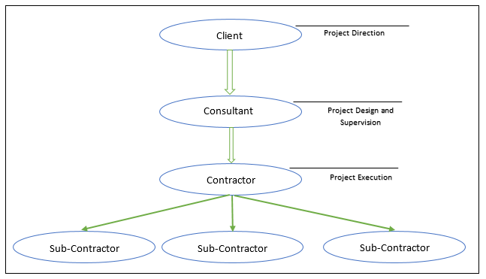
Figure 3. 2: The Targeted Organization for Survey

In order to achieve variety and random sample, the survey is disturbed to qualified professional expertise (engineers and managers) in various qualified organisation which involved in innovation and belongs to the construction industry, the distribution based on relationships and knowledge in this field, then these directly connected (convenience sample) distributed the survey to similar qualified participant in the same organisation or another organisation in the same project. Each convenience participant disturbed the survey request to send the number of disturbed surveys in order to monitor and calculate the response rate.
As the number of populations cannot be determined as it includes a huge number and it is difficult to limit the number of people involved in creative projects. Accordingly, it was hard to determine the sample size as a percentage of the population as it is unknown, in addition it was difficult to limit the collection of data to one geographical area or one country (the data were collected from different countries over the world with higher concentration in Middle East, India, Germany and USA including a high variety in nationalities), since the number of construction projects involving in innovation are few and it was a challenge to find. Referring to the published research for same method type dealing with questions related to level of Innovation, procurement management and/or performance the average sample size will be around 130 participants. In this research we made an effort to increase the sample size for more accuracy, reduce the margin of error and increase the study confidence level (Walpole, Myers, Myers & 2014).
The survey was sent through mail and social media as it is the best way to collect data for wide distance beside the big size of the sample will make it hard to collect data by personal meeting in additional to time limitation (Kumar 2011).

3.3.4 Survey Validation and Reliability
It is very crucial to confirm that the collecting data instrument must be designed to measure the variables of the related research (Sekaran & Bougie 2016). In order to achieve that the validity and reliability of this research collecting data’s instrument, which is survey in this research, should be verified. Creswell and Creswell (2018) defined validation of quantitative approach as the extent that data collection instrument is support and relative to the research hypotheses and the result of instrument chosen could be used to draw a useful conclusion. For this purpose, three types of validity tests are defined; Content, Concurrent and Construct validity.
While reliability is related to the degree of consistency and repeatability of the instrument, as how much the results will be close to each other if we repeated the procedure of collecting data under the same conditions, at the same time it measures the cohesive between each set of questions to serve the same found (Creswell & Creswell 2018).
- Factor Analysis (Validity Test)
The purpose of this analysis is to validate each factor of variables to eliminate the factor that is not measuring the same component and to reduce the factors to the minimum that able to measure and give dimension for the variable.
- Validity
Three types of validity tested (Creswell & Creswell 2018):
- Content Validity:
It aims to correlate the measurement with the filed. The content validity done by contact expertise in construction management, the survey form circulated among 4 senior project managers (more than 20 years’ experience), the content of each question set is correlated with the measured variable. The final thesis survey is formed based on their feedback (example extend the orientation of question to include more construction sectors).
- Concurrent and construct validity
Measure the extent that survey is support and relative to the research hypotheses. The Spearman rank correlation used in concurrent validity is used here to assess the strength of the relation among the variables’ group and variables’ factors. The spearman correlation conducted among the questions in each set separately, and among the three question’s sets.
The purpose of this part is to measure the internal correlation between the questions in each sit from one side, and the external correlation between the sets from another. Accordingly, the cohesion between results and question could be attested. The Spearman rank correlation is a statistical test to evaluate the strength of the relation between pairs of variables. In this research the spearman correlation conducted among the questions in each set separately, and among the five questions’ sets.
From table -3.1- below, the correlation among the questions are confirmed as the data are statistically significant (p-value was less than 0.05) for all variables and factors and spearman coefficient was high for all factors which means each factor is measuring the component it designed for measure:

Table 3. 1: Validity test (spearman test) for all variables’ factors
No. | Variable | Spearman Coefficient | Significance (2-tailed)
1 | Level of Innovation
1.a | Your company can be considered as a pioneer of managing, designing or executing new systems/processes in the market. | .914 | .000221
1.b | Your company can be considered as a pioneer in introducing a new construction or construction management methods | .885 | .000221
1.c | Your company responds intelligently to the new method and process introduced from similar firms in construction. | .908 | .000221
1.d | The newly created product/system is effective in term of Time, Cost and Quality. | .847 | .000221
1.e | The Exploratory Projects in your company have introduced big changes in project management or construction methods. | .878 | .000221
1.f | The Exploratory Projects in your company have introduced a large number of the new design, service, systems (Civil, MEP ...), material or Facilities. | .855 | .000221
2 | Procurement Management
2.a | In your company, the subcontractor is involved at the early stage of the project (tender stage). | .714 | .000221
2.b | The selection of the Subcontractor is NOT mainly based on the lowest price. | .714 | .000221
2.c | The subcontractor is considered compensation including joint profit sharing. | .637 | .000221
2.d | The procurement strategy for construction projects is a part of business strategic vision, mission and long/short term plans. | .812 | .000221
2.e | The procurement strategy for construction projects aims to achieve overall organization objective. | .800 | .000221
2.f | Higher management in the organization is involved in setting procurement strategy. | .780 | .000221
2.g | The procurement strategy of construction projects improves organizational and business relationships. | .851 | .000221
3 | Performance
3.1 | Cost | .856 | .000221
3.1.a | Normally, the cost to complete projects in my company is equal or less than the approved estimated budget. | .860 | .000221
3.1.b | The management is usually satisfied with the final cost of construction project. | .862 | .000221
3.1.c | The wastage of the ordered material to the construction projects in my company is reasonable and within the planned tolerance. | .825 | .000221
3.2 | Time | .837 | .000221
3.2.d | The completion date and milestones of construction projects in my company were achieved as per the contractual date (on time). | .872 | .000221
3.2.e | the subcontractor affects positively in the project completion time. | .855 | .000221
3.2.f | The management is satisfied with construction projects schedule, duration and completion date. | .889 | .000221
3.3 | Quality | .958 | .000221
3.3.g | The quality of construction projects in your company are acceptable comparing to similar projects in other companies. | .882 | .000221
3.3.h | The management of your company is satisfied with the project quality. | .891 | .000221
3.3.j | The planned objectives and aims of construction projects in your company are achieved. | .894 | .000221
3.3.k | Most of the inspection on the completed activities/works of construction projects is usually approved and it meets the project's quality requirement and specification. | .881 | .000221
3.3.l | The number of safety accidents during the construction was less comparing to other similar projects. | .838 | .000221
3.3.m | The management of your company is satisfied with the project documents control and practices. | .868 | .000221
3.3.n | The stakeholders of your company's construction projects are satisfied with the project Quality (outcome). | .888 | .000221

- Reliability
Cronbach and Shavelson (2004) in their research suggested the coefficient alpha as the best method to test the reliability of survey designed to inspect hypothesis. Cronbach’s’ Alpha Coefficient is considered to measure the reliability of the collected data, the range value of alpha will fall in scaled data between 0 to 1. The value of alpha must be higher than .7 to consider as reliable and consistent data, the closer to 1 the higher liability. The Cronbach value was calculated for the three variables beside the breakdown of these variable as follows:
- Level of Innovation:
As illustrated in table (3.2) below, the Cronbach’s alpha for “level of innovation” survey questionnaires overall level was higher than 0.7 which was 0.942. In addition, the scaled criteria questions for “level of innovation” variable was calculated separately and all was lower than 0.942 which point out that all question has a suitable level of inter-item reliability, and nothing required to remove to improve the reliability.

Table 3. 2: reliability test for level of innovation factors
No. | Variable | Cronbach’s Alpha
1 | Level of Innovation | .942
1.a | Your company can be considered as a pioneer of managing, designing or executing new systems/processes in the market. | .926
1.b | Your company can be considered as a pioneer in introducing a new construction or construction management methods | .931
1.c | Your company responds intelligently to the new method and process introduced from similar firms in construction. | .927
1.d | The newly created product/system is effective in term of Time, Cost and Quality. | .937
1.e | The Exploratory Projects in your company have introduced big changes in project management or construction methods. | .932
1.f | The Exploratory Projects in your company have introduced a large number of the new design, service, systems (Civil, MEP ...), material or Facilities. | .936

- Procurement Management
As illustrated in table (3.3) below, the Cronbach’s alpha for “Procurement Management” survey questionnaires overall level was higher than 0.7 which was 0.877. In addition, the scaled criteria questions for “Procurement Management” variable was calculated separately and nothing was higher than 0.877 which highlight that all question has a suitable level of inter-item reliability, and removing any question will not improve the reliability.

Table 3. 3: reliability test for procurement management
No. | Variable | Cronbach’s Alpha
2 | Procurement Management | .877
2.a | In your company, the subcontractor is involved at the early stage of the project (tender stage). | .868
2.b | The selection of the Subcontractor is NOT mainly based on the lowest price. | .868
2.c | The subcontractor is considered compensation including joint profit sharing. | .877
2.d | The procurement strategy for construction projects is a part of business strategic vision, mission and long/short term plans. | .850
2.e | The procurement strategy for construction projects aims to achieve overall organization objective. | .852
2.f | Higher management in the organization is involved in setting procurement strategy. | .856
2.g | The procurement strategy of construction projects improves organizational and business relationships. | .843

- Performance
Finally, table (3.4) below shows Cronbach’s alpha value for the overall performance and the three component of performance (time, cost, quality) survey questionnaires overall level was higher than 0.7 which were0.806 for cost, 0.843 for time and.950 for quality. In addition, the scaled criteria questions for each component of performance was calculated separately and all was lower than0.806, 0.843 and 0.950 for cost time and quality consequently, which highlight that all question has a suitable level of inter-item reliability, and removing any question will not improve the reliability.

Table 3. 4: reliability test for performance (time, cost and quality)
No. | Variable | Cronbach’s Alpha
3 | Performance
3.1 | Cost | .806
3.1.a | Normally, the cost to complete projects in my company is equal or less than the approved estimated budget. | .715
3.1.b | The management is usually satisfied with the final cost of construction project. | .714
3.1.c | The wastage of the ordered material to the construction projects in my company is reasonable and within the planned tolerance. | .773
3.2 | Time | .843
3.2.d | The completion date and milestones of construction projects in my company were achieved as per the contractual date (on time). | .774
3.2.e | the subcontractor affects positively in the project completion time. | .826
3.2.f | The management is satisfied with construction projects schedule, duration and completion date. | .739
3.3 | Quality | .950
3.3.g | The quality of construction projects in your company are acceptable comparing to similar projects in other companies. | .941
3.3.h | The management of your company is satisfied with the project quality. | .940
3.3.j | The planned objectives and aims of construction projects in your company are achieved. | 939
3.3.k | Most of the inspection on the completed activities/works of construction projects is usually approved and it meets the project's quality requirement and specification. | .941
3.3.l | The number of safety accidents during the construction was less comparing to other similar projects. | .947
3.3.m | The management of your company is satisfied with the project documents control and practices. | .942
3.3.n | The stakeholders of your company's construction projects are satisfied with the project Quality (outcome). | .940

The figures from the above table illustrates the calculated alpha value for this research’s survey, all values are fall between 0.7 and 1.0with majority value above 0.9, which show high level of reliability and the same data will be collected if the survey is repeated in the same conditions.
- Pilot Testing:
This test aims to assess the clarity and understanding of the survey’s format and questions in perspective of the target sample along with making any necessary adjustments to achieve this end. First step the survey format discussed with the head of master engineering management programme along with assistant professor of the Faculty of Business and Law beside doctoral training centre to make sure the format of the survey is clear and meet the standard format of survey. Their comments implemented and improved the quality of the survey.
Then the survey disturbed to four project managers (mix of senior level and junior level) to review the questions clarity and structure based on the field experience, the review in general was positive with a minor comment admitted and accepted in the survey.

3.3.5 Survey Background and Structure
The survey was divided into five parts; the first part is an introduction for the purpose of the survey besides a summary for the question of this research. The second part is a demographic question aims to collect data about the survey’s participants, this part enables to evaluate and divide the responses of participants based on general information related to the professionalism and experience of the sample.
The remaining three parts are ranking based question related to the three sets of variables of this research, which are exploratory project’s level of innovation–procurement management as one of construction innovation obstacles - project performance. The participant should answer each question based on rate from one to five, one rank is allowed for each question. The format of these three parts are transformable to a numerical data that enable to proceed with quantitative data analysis for these data.
The standard design format of this survey will generate two types of information related to this research question, the first is a description for the sample involved in this survey which developed from the demographic part. The other information is validation for the hypothesis set out of this research variables, this data is related to the numerical data extracted from the ranking questions. (Creswell & Creswell 2018)
The following is a breakdown of the parts of the survey:
Demographic Section:
This part contains four general questions to collect personal data related to the individual participant to allow for categorization of replied survey. He / she has to define the type of construction organisation they belong, the professional position in the organisation, the type of project that is related to this survey beside the range of overall experience they have.

Variable Section:
The second part of the survey has seven questions related to measure the project level of innovation based on measuring strategic and type of innovation involvement. These questions are adopted from Dulaimi, Nepal and Park (2005), McGrath (2001), Björkdahl and Börjesson (2012), Demirbag and Tatoglu (2008) and Allen and Helms (2006).
The third part contains seven questions devised from Choi, Jang and Hyun (2009), Eriksson and Dickinson (2007), Pal, Wang and Liang (2017) as an indicator for the procurement strategy and management method.
The last part (part number four) divided into three sections related to project performance (time, cost and quality). This part is partly following the standard of PPMS performance measurement tool and built up refer to Olson, Walker, Ruekert and Bonner (2001) and Cheung, Suen and Cheung (2004).
The answer for the variable section is a district scale from 1 to 5 where,
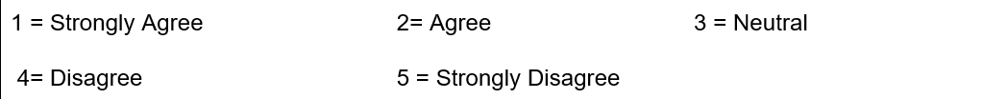
The next table correlate the research variable, hypothesis and survey questions: (Creswell & Creswell 2018):
Table 3. 5: Research Variable, Hypothesis and Survey Questions
Variable | Hypothesis | Survey Question Part (Appendix 1)
Independent variable 1: Exploratory project’s level of innovation | As the level of innovation in construction increase, the chances of collaborative Procurement will increase | Part 2
Dependent \ Independent variable 2: Procurement management | collaborative Procurement will improve the Performance | Part 3
Dependent variable 3: Performance | Increase the level of innovation will enhance the performance | Part 4

3.1 Chapter Conclusion
The framework is established in this section by correlate the level of innovation with performance in direct and indirect relation (with procurement management as mediator and/or moderator). Then, after a brief description for the three research methodologies, a justification for pick the quantitative method as the best approach for this research type and framework. Followed by a breakdown for the instrument used (survey) for the data collection, information about collected data and targeted sample. Finally, validity and reliability test for the survey and collected data is conducted, the result was positive where the data are valid and reliable.

CHAPTER IV
RESEARCH RESULTS AND DATA ANALYSIS

4.1 Introduction

Data collection’s process in the appropriate way and method is the basis of a successful study, but this information collected is raw data and it will be of little value if not studied and analysed in a way that leads to a conclusion related to the hypotheses of the target research (Sekaran & Bougie 2016). In order to analysis this research’s data, SPSS programme version 23 is used. SPSS (Statistical Package for Social Science) statistics 24 is a professional statistical program powered by PMI, SPSS is used extensively over many educational and industrial sectors to perform statistical analysis on raw data (Creswell & Creswell 2018). The analysis will be carried out in this chapter over 221 responded survey, the collected data reliability and validity are verified in the previous chapter (chapter number 3). This chapter has three main sections, the first section of this chapter will describe and analyse the demographic data to categorize and trends analysis of the responses. The second section is statistical analysis related to the dependent and independent variables of this research hypothesis, a correlation test between the level of innovation, procurement management and performance will be conducted reaching to verification (accept or reject) of this research main hypothesis. In the third section, the regression test for determine the role of procurement management in between the level of innovation and the performance. Each statistical and descriptive analysis in this chapter will be followed by summary and discussion about the analysis results.

4.2 Demographic Presentation

The statistical analysis on this section is based on personal and farm information to present and interact with the responder. This will provide more awareness and feel of the collected data by running simple statistical analysis (rates, mean, standard deviation and frequencies) for four categories of demographic data collected in this research’s survey which are the type of construction organisation, the professional position in the organisation, the type of construction project beside the total years of participant experience.
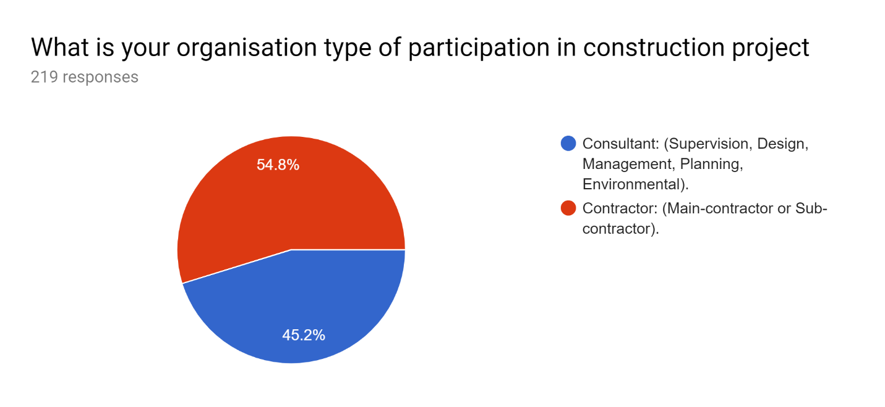
From the pie chart below (figure 4.1) obviously the percentage of contractor responders (%54.8) is higher than the consultants (% 45.2). This due to the fact that the contractor firm required a bigger number of engineering stuff compared to consultant firm as they directly related to the operation work in construction project, in addition the contractor firm are interested more in innovation rather than the consultant as the effects of the innovation is greater and wider in operation than consultancy works.
Figure 4. 1: Percentage Of The Survey’s Question “What is Your Organization Type of Participation in Construction Project

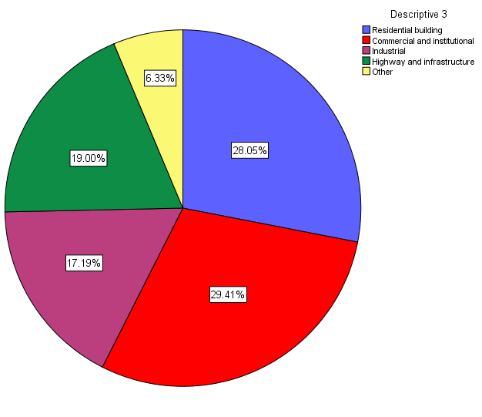
In addition, the survey respondents were belonging to variety types of construction project which enhance the sample and results. The survey respondents were related to commercial and residential building projects were 29.41% and 28.05% consequently which form a major part of the sample. This may indicate that creativity in this type of construction may be wider and more diverse than others, beside these types of projects more widespread and demanded than other types. The pie chart below illustrates the pre-mentioned percentage of different project type plus the other types of survey participants’ projects types; the participant refer to highway and infrastructure projects were (%19), and (%17.19) reported based on industrial type of projects, while the remaining 6.33% are related to other type of projects such as authority, development, metro, hospitality.
Figure 4. 2: Percentage Of The Survey’s Question “Type Of Projects” For Participants

The rates and frequencies of the categorized professional positions beside the total year of experience illustrated in the table (4.1) and table (4.2) subsequently below. The majority of participants are occupying a project manager position which form (35.3%) of overall participant, followed by (16.3%) equally of Assistant Project Managers and Office Engineers, then (11.3%) of Construction Manager or Superintendent, (12.7%) of sample working as site engineers and (11.3%) were occupied a site engineer position. The remaining percentage (8.1%) filled by other professions such as directors, claims consultant, operations managers and account managers.
From these figures drag particular attention that the majority of respondent’s answers were filled by managerial position which is favourable for the accuracy of the collected data as the nature of this study is more related to managerial aspect rather than technical aspects. Besides, the variety of the profession positions of the sample will add value for the accuracy of results.

Table 4. 1: The Rates and Frequencies of The Categorized Professional Positions
Responder’s Position | Frequency | Percentage
Project Manager | 78 | 35.3%
Assistant Project Manager | 36 | 16.3%
Office Engineer | 36 | 16.3%
Site Engineer | 28 | 12.7%
Construction Manager or Superintendent | 25 | 11.3%
Other | 18 | 8.1%
Total | 221 | 100%
The mid-range professional with experience range between 5-10 and 10 - 15 years were 159 participants out of 221 participants, which added extra credit for the collected data as the experience will enhance the ability to assess and consider more aspect of the project involvement in this research area. The largest participation among the proposed age groups were with five to ten years’ experience (52%). The second-high experience range for the one fall between ten to fifteen years with (19.9%) of overall participant, finally the lowest participation rate for the select categories of experience that was less than 5 years with a rate equal to (17.7%) and experience exceed the 20 years (10.4%).

Table 4. 2: The Rates And Frequencies of The Professional Years of Experiences
Responder’s Experience in the construction industry | Frequency | Percentage
Less than 5 Years | 39 | 17.7%
Between 5 to 10 years | 115 | 52%
Between 10 to 15 years | 44 | 19.9%
Above 10 years | 23 | 10.4%
Total | 221 | 100%

4.3 Descriptive statement for Variable
After collecting the data, descriptive analysis considered as first block for conducting statistical analysis. Descriptive analysis is the flat surface to understand and explain the research's variables such as figures distribution, detached data, the variables trends and the correlation among these variables.
In this section four statistical parameter calculated to draw the relevant opinion and orientation of respondents regard the three variables of this research, the following are representation for these four parameters:
- MEAN VALUE (µ):
Mean is a simple mathematical value to calculate the numerical average of number series calculated via the result of the formula:
μ=(∑V) ⁄ N
Where,
μ: The Mean
V: Data value
N: Total values quantities
- THE MODE
The most repeated value (frequency) for the data.
- Variance
Variance is numerical value measure the bias of sample from the mean by the following formula:
S² = (∑(V-μ)²)/(N-1))
Where,
S: Variance
μ: The Mean
V: Data value
N: Total values quantities

- STANDARD DEVIATION VALUE (S):
Standard deviation is the square root for total of how much each value is variance from the mean as per the formula below:
D =√S²
Where,
S: Standard Deviation
S²: Variance
- Coefficient of Variation (CVar)
It is a transaction of the standard deviation in percentage format to facilitate the comparison between different factors or variables as follows:
CVar= S ⁄ μ
Where,
S: Standard Deviation
μ: The Mean
- Classification
The meaning of this is to enable the arrangement of data in groups to enable comparison between data classes. To create class interval, the range of data must be calculated as follows:
Range = Maximum value - Minimum value

Then define the number of required classes and calculate the class interval (CI) as the formula:
CI = Range / Number of required classes

In this survey, the answer for variables questions is district scaled ranks from 1 to 5. To description purpose three classes interval is required (Low scale, Mid scale and High scale), as the highest rank is five and lowest is 1 the class interval will be:
CI = (5-1) / 3
CI= 1.33
So, the data will be classified as:
Range | Class
1 - 2.33 | Low Scale
2.33 - 3.66 | Mid-Scale
3.66 - 5.00 | High Scale

This section will introduce a statistical description for the three variable’s factors (level of innovation, procurement management, time/cost/quality performance) in the research’s survey, followed by analysis for the figures:

- Level of Innovation
The intention of this section is to frame the first hypothesis independent variable “the level of innovation” for the participant’s organisation and project relevant opinion and orientation which collected by answering six scaled questions from 1 to 5. Three questions out of six are related to the organisation learning and attitude towered the innovation and market changes, the other three question are about the specific project that the participants involved in. Descriptive statistics for these six questions are illustrated in the table below (mean, mode, variance, standard deviation and coefficient of variation):

Table 4. 3: Level of innovation statistical description
Variable | Questions | Mean | Mode | Variance | Std. Deviation | Coefficient of Variation (CVar) | Classification
Level of Innovation | Your company can be considered as a pioneer of managing, designing or executing new systems/processes in the market. | 3.009 | 2.00 | 1.873 | 1.368 | 45.48% | Mid Scale
Level of Innovation | Your company can be considered as a pioneer in introducing a new construction or construction management methods | 2.910 | 2.00 | 1.810 | 1.345 | 46.24% | Mid Scale
Level of Innovation | Your company responds intelligently to the new method and process introduced from similar firms in construction. | 3.172 | 3.00 | 1.716 | 1.310 | 41.30% | Mid Scale
Level of Innovation | The newly created product/system is effective in term of Time, Cost and Quality. | 3.181 | 4.00 | 1.658 | 1.288 | 40.48% | Mid Scale
Level of Innovation | The Exploratory Projects in your company have introduced big changes in project management or construction methods. | 3.027 | 3.00 | 1.672 | 1.293 | 42.72% | Mid Scale
Level of Innovation | The Exploratory Projects in your company have introduced a large number of the new design, service, systems, material or Facilities. | 3.100 | 3.00 | 1.690 | 1.300 | 41.94% | Mid Scale

The coefficient of variation range (calculated by divide the standard deviation over the mean) for the level of innovation factor was ranged between 40% to 46%. We can say from this percentage that the sample attitude towered the level of innovation was mid-range. In the same time, it gives a good indicator for high level of agreement as the confident of variation range was very tight. After all, there is a higher rank for the first two factor (questions) which are related to organisation’s innovation profile in addition, around 43% of the participants belong to a high level of innovative organisation as they introduce big changes in construction project.

- Procurement Management
Mean, mode, variance, standard deviation and coefficient of variation are calculated for procurement management’s questions’ responds to draw the relevant opinion and orientation of respondents regard it.
The procurement management is playing a dual role in this research as it is considered dependent variable to the level of innovation in the first hypotheses at the same time it is considered as an independent variable for the performance in the second hypothesis. The assembly of this survey part contains seven questions, the first three questions are related to which extent that the subcontractor is involved in the construction projects, the other four questions are related to the firm strategy toward the procurement.

Table 4. 4: Procurement management statistical description
Variable | Questions | Mean | Mode | Variance | Std. Deviation | Coefficient of Variation (CVar) | Classification
Procurement Management | In your company, the subcontractor is involved at the early stage of the project (tender stage). | 3.054 | 3.00 | 1.579 | 1.257 | 41.14% | Mid Scale
Procurement Management | The selection of the Subcontractor is NOT mainly based on the lowest price. | 3.176 | 3.00 | 1.601 | 1.265 | 39.83% | Mid Scale
Procurement Management | The subcontractor is considered compensation including joint profit sharing. | 2.919 | 3.00 | 1.339 | 1.157 | 39.65% | Mid Scale
Procurement Management | The procurement strategy for construction projects is a part of business strategic vision, mission and long/short term plans. | 3.290 | 4.00 | 1.479 | 1.216 | 36.97% | Mid Scale
Procurement Management | The procurement strategy for construction projects aims to achieve overall organization objective. | 3.330 | 3.00 | 1.449 | 1.204 | 36.15% | Mid Scale
Procurement Management | Higher management in the organization is involved in setting procurement strategy. | 3.371 | 4.00 | 1.598 | 1.264 | 37.50% | Mid Scale
Procurement Management | The procurement strategy of construction projects improves organizational and business relationships. | 3.389 | 4.00 | 1.575 | 1.255 | 37.03% | Mid Scale

The statistical discerption for the procurement management was not much vary from the level of innovation as coefficient of variation stayed in the mid-range. However, there is a slight drop in the range for 5% approximately as the coefficient of variation fall between 36% - 41%, which indicate that the participant sample still introduce a high level of agreement for the role of procurement management. We can notice that the first three factors which related to level of subcontractor involvement in the construction project was of a higher rank which give a hint for the importance of the strategy of involving the subcontractor. We can highlight that around 39% of participants were acknowledge a cooperative procurement management in their projects.
- Performance
The same statistical parameters from the sections above are calculated here to draw a description about the participants’ projects performance in three dimensions (three questions for Time performance, three questions for cost, and seven questions for quality).

Table 4. 5: Performance statistical description
Variable | Questions | Mean | Mode | Variance | Std. Deviation | Coefficient of Variation (CVar) | Classification
Time Performance | Normally, the cost to complete projects in my company is equal or less than the approved estimated budget. | 3.059 | 3.00 | 1.447 | 1.203 | 39.32% | Mid Scale
Time Performance | The management is usually satisfied with the final cost of construction project. | 3.090 | 4.00 | 1.465 | 1.210 | 39.16% | Mid Scale
Time Performance | The wastage of the ordered material to the construction projects in my company is reasonable and within the planned tolerance. | 3.068 | 3.00 | 1.354 | 1.164 | 37.94% | Mid Scale
Cost Performance | The completion date and milestones of construction projects in my company were achieved as per the contractual date (on time). | 2.928 | 3.00 | 1.413 | 1.189 | 40.60% | Mid Scale
Cost Performance | the subcontractor affects positively in the project completion time. | 3.181 | 3.00ª | 1.594 | 1.263 | 39.69% | Mid Scale
Cost Performance | The management is satisfied with construction projects schedule, duration and completion date. | 3.172 | 3.00 | 1.388 | 1.178 | 37.15% | Mid Scale
Quality Performance | The quality of construction projects in your company are acceptable comparing to similar projects in other companies. | 3.430 | 3.00 | 1.537 | 1.240 | 36.15% | Mid Scale
Quality Performance | The management of your company is satisfied with the project quality. | 3.353 | 4.00 | 1.366 | 1.169 | 34.85% | Mid Scale
Quality Performance | The planned objectives and aims of construction projects in your company are achieved. | 3.326 | 4.00 | 1.493 | 1.222 | 36.74% | Mid Scale
Quality Performance | Most of the inspection on the completed activities/works of construction projects is usually approved and it meets the project's quality requirement and specification. | 3.294 | 4.00 | 1.299 | 1.140 | 34.61% | Mid Scale
Quality Performance | The number of safety accidents during the construction was less comparing to other similar projects. | 3.380 | 4.00 | 1.764 | 1.328 | 39.29% | Mid Scale
Quality Performance | The management of your company is satisfied with the project documents control and practices. | 3.385 | 4.00 | 1.356 | 1.164 | 34.40% | Mid Scale
Quality Performance | The stakeholders of your company's construction projects are satisfied with the project quality (outcome). | 3.344 | 4.00 | 1.454 | 1.206 | 36.06% | Mid Scale

Approximately, the coefficient of variation of the performance maintained the same range for the procurement management (between 34% - 41% for performance while 36% - 41% for procurement) and a slight drop from the level of innovation (around 5% drop). Besides what these figures show high level of agreement on the performance of the project, this range indicates an association between the three variables (level of innovation, procurement management and performance.
However, from the figure on table -4.5- above, the participant indicate that the time and cost performance are more affected than the quality performance as the coefficient of variation are higher for both of them. In summary, the participants show a high level of agreement for the three variables and around 40% of the sample had achieved the targeted performance in term of time and cost, while 35% percent in term of quality.

4.4 Framework Analysis

4.4.1 Correlation test (Pearson Correlation)
Correlation is parametric test that is used not only to show if there is linear relation between two variables, it also measures the strength of that relation. It enables to predict the direction of relation (positive or negative) in addition to evaluate rank for this relation (strong, medium, low related). The test will analyse the relation between an independent and dependent variables values that measured as interval, ratio or continuous type of data.
In order to test the correlation between the variables in this analysis, the correlation test will be implemented in three phases. First, using the exploratory project’s level of innovation as an independent variable with regards to the procurement management as dependent variable. Second, the independent variables are the level of innovation with regards to project performance as dependent variable. Third one is considering the independent variables as the procurement management separately with regard to project performance as dependent variable. For this purpose, correlation test using Pearson correlation coefficient was circulated.
Pearson’s coefficient describes the relation between two variables, Pearson’s coefficient value range between -1 to +1 where the negative 1 is a strongest inverse relationship, positive 1 is strongest direct relationship, zero is indication for no relationship and any other figure between 0 to 1 or 0 to -1 is reflection for the strength of the relationship.
Correlation result # 1: As the level of innovation in construction increase, the chances of collaborative Procurement will increase
Table 4. 6: Correlation between level on innovation and procurement management
Correlations
 |  |  | Level of Innovation | Procurement Management
Spearman's rho | Level of Innovation | Correlation Coefficient | 1.000 | .684**
Spearman's rho | Level of Innovation | Sig. (2-tailed) | 221 | .000221
Spearman's rho | Level of Innovation | N | 221 | .000221
Spearman's rho | Procurement Management | Correlation Coefficient | .684** | 1.000
Spearman's rho | Procurement Management | Sig. (2-tailed) | .000221 | 221
Spearman's rho | Procurement Management | N | .000221 | 221
**. Correlation is significant at the 0.01 level (2-tailed).

From table -4.6- generated above, we can conclude a high strength positive relation between the level of innovation and procurement management as Spearman coefficient is very high (equal to 0.684) and it is highly significant as the significance value for the relation almost zero (less than 0.005).
That is mean if the level of innovation in organisation is high, this will lead to increase the strategic procurement management collaborative type. While a lower level of innovation will lead to less chance for strategic or collaborative procurement management.
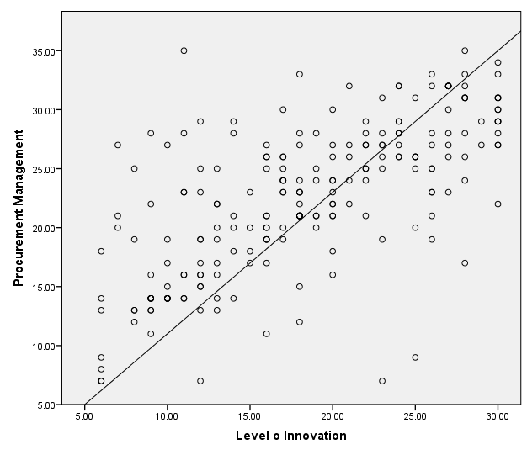
The scatter plot below for visualizing the correlation between the two variables, most of the data located around linear equation line:
Figure 4. 3: Scatter Plot for the Correlation between Level of Innovation and Procurement Management

Correlation result # 2: collaborative Procurement will improve the Performance

Correlations
 |  |  | Procurement Management | Performance
Spearman's rho | Procurement Management | Correlation Coefficient | 1.000 | .768**
Spearman's rho | Procurement Management | Sig. (2-tailed) | 221 | .000221
Spearman's rho | Procurement Management | N | 221 | .000221
Spearman's rho | Performance | Correlation Coefficient | .768** | 1.000
Spearman's rho | Performance | Sig. (2-tailed) | .000221 | 221
Spearman's rho | Performance | N | .000221 | 221
**. Correlation is significant at the 0.01 level (2-tailed).
Table 4. 7: Correlation between procurement management and performance

A higher strength positive relation founded between the procurement management and performance as Spearman’s coefficient is equal to 0.768 which closest to one and it is high significance (less than 0.005) referring to the figure on table -4.7- above.
That is mean following strategic procurement management collaborative type will improve the performance of the project and vice versa. The scatter plot below illustrates the location of data around the linear equation line.
The scatter plot below for visualizing the correlation between the two variables, most of the data located around linear equation line:

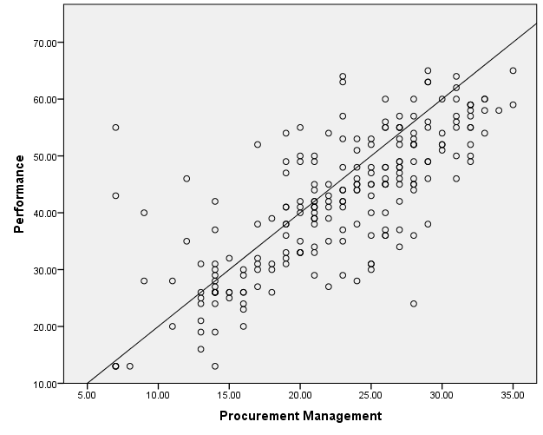
Figure 4. 4:Scatter Plot for the Correlation between Procurement Management and Performance

Correlation result # 3: Increase the level of innovation will enhance the performance

Table 4. 8: Correlation between level on innovation and performance
Correlations
 |  |  | Level of Innovation | Performance
Spearman's rho | Level of Innovation | Correlation Coefficient | 1.000 | .728**
Spearman's rho | Level of Innovation | Sig. (2-tailed) | 221 | .000221
Spearman's rho | Level of Innovation | N | 221 | .000221
Spearman's rho | Performance | Correlation Coefficient | .728** | 1.000
Spearman's rho | Performance | Sig. (2-tailed) | .000221 | 221
Spearman's rho | Performance | N | .000221 | 221
**. Correlation is significant at the 0.01 level (2-tailed).

Approximately the same high positive correlation was found directly between level of innovation and performance with Spearman’s ration equal to 0.728 and highly significance. Accordingly, projects with high level of innovation will expect a better performance than other, the scatter plot below for the equation line and the data around it:
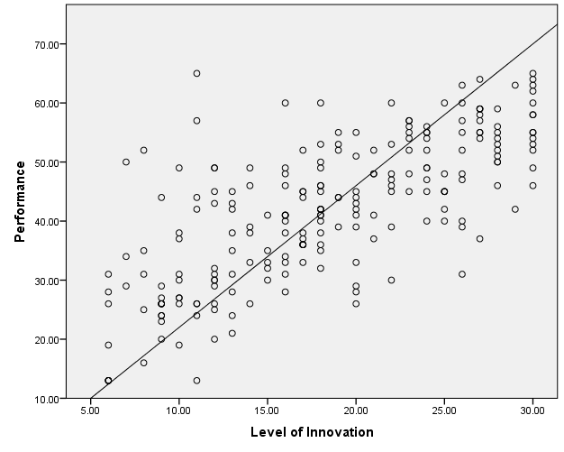

Figure 4. 5: Scatter Plot for the Correlation between Procurement Management and Performance

4.4.2 Regression (Mediation)
In the previous section the analysis proofed and shows a strong relationship between the research variables. In this section, further statistical analysis will process on these proofed relations to explain and predict the existing relation between the variables.
Regression analysis predict the relation between variables, the independent variable is the one to manipulate and the dependent variable is the score. The objective of this section is to understand the role and effect of procurement management in the relation between the level of innovation and performance. For this purpose, mediation and moderation analysis for the three variables was carried out. Moderator does not explain why there is relation between independent variable and dependent variable, it is only changing the direction or strength of the relation without change the fact that there is relationship. In contrarily, the mediator is core reason for the relationship, as in the absent of the mediator factor there is no relation between the variables.
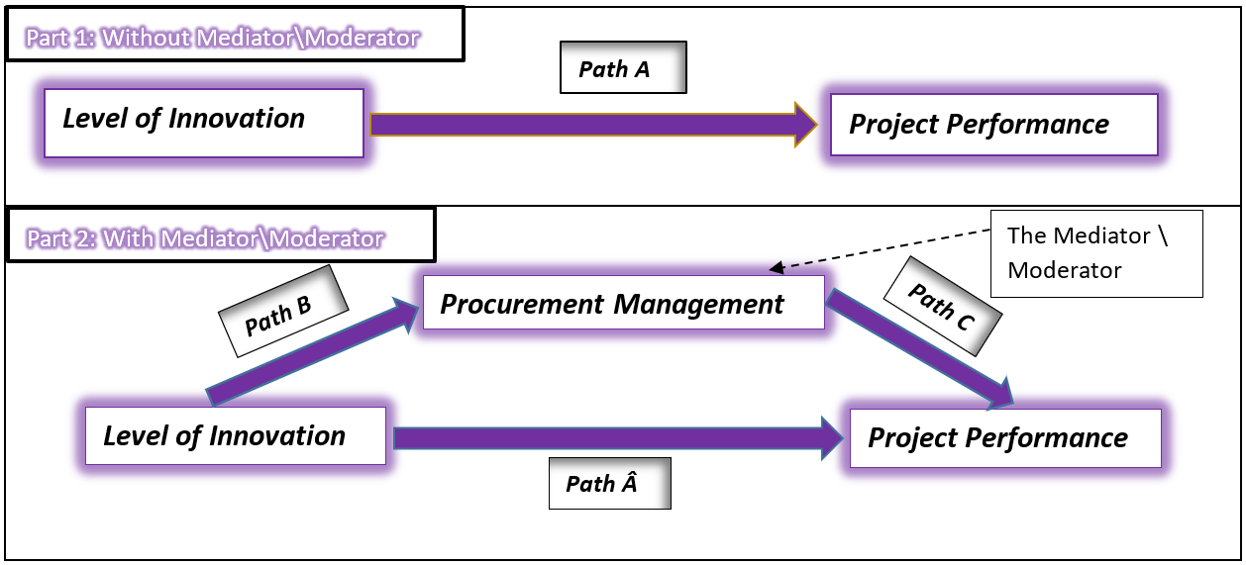
To determine the role of the procurement management as mediator and\or mediator a series of regression process using the all baths between the variables in the frame work, for extended explanation the figure below illustrates the paths of the frame work that will be process the regression tests. The test will process in two phases, the first one, as illustrated in figure -4.6- below, is for the direct relation between the exploratory project level of innovation as independent variable on the performance as dependent variable, in this part the project management variable is ignored. The path in this part is labelled as path (A).
Figure 4. 6: Regression Parts and Paths
The second part (figure 4.6 above) is processing in the three variables by including the project management as a mediator between the level of innovation and performance. The regression analysis in this part will include three paths, the first one is for the indirect relation between the indirect relationship between the exploratory project level of innovation as independent variable on the performance as dependent variable while including the effect of independent variable “procurement management” as mediator in this path. This path is labelled as (Â). The second path as per the figure below, which labelled (B), is for the relation between the exploratory project level of innovation as independent variable and procurement management as dependent variable. The third part is labelled as (C) which is for the direct relation between procurement management as independent variable and the performance as dependent variable. In this part the procurement management has dual part as dependent and independent.
Simple Linear regression for path A and Path B separately and combined regression for path A and C together. The following section will process to generate the formula that enable us to predict the independent variable from the dependent variables value, the linear regression value contains one dependent value to be predicted from one or more input (dependent variables) as the formula:
Ý= α + b₁x₁ ₊ b₂x_{2 ………}
Where,
Ý: the dependent variable α: the intercept of Ý
b₁: slope of line x_{1:} independent value
This formula hypothesis is that, there is a linear relationship between the dependent variable Ý and the independent variables b_{1,} b₂. The regression will test the hypothesis and will be accepted for the significance value less than .05

Part 1, Path A:
H₀₁: Factors related to Level of Innovation have significant impact (≤ 0.05) on project Performance.
The table -4.9- below is generated from linear regression for the hypothesis of path A (H_{01).} Referring to the ANOVA table below, the hypothesis H₀₁is accepted as the F value is high (247.158) and it is statically significance as the P- value is less than .05, so there is a significant positive relation between the level of innovation and performance. In addition, the formula will be generated out of this relation will be able to explain around53% of the input as per the R square on Model Summary table below.
From the coefficients table the Beta standard coefficient for regression is .728 which is high strong and statically significant as the P-value is less than (.05), the formula to predict the performance from the level of innovation dependent variable is as following:
Ý = 18.241 + 1.292*X₁
Where: Ý: Project Performance
x₁: Level of innovation

Table 4. 9: Regression analysis for Path A
Model Summary^{b}
Model | R | R Square | Adjusted R Square | Std. Error of the Estimate | Change Statistics
 |  |  |  |  | R Square Change | F Change | df1 | df2 | Sig. F Change
1 | .728ª | .530 | .528 | 8.49344 | .530 | 247.158 | 1 | 219 | .000
a. Predictors: (Constant), Level of Innovation
b. Dependent Variable: Performance

ANOVAª
Model |  | Sum of Squares | df | Mean Square | F | Sig.
1 | Regression | 17829.631 | 1 | 17829.631 | 247.158 | .000^{b}
1 | Residual | 15798.351 | 219 | 72.139
1 | Total | 33627.982 | 220
a. Dependent Variable: Performance
b. Predictors: (Constant), Level of Innovation
Coefficientsª
Model |  | Unstandardized Coefficients |  | Standardized Coefficients | t | Sig. | 95.0% Confidence Interval for B
 |  | B | Std. Error | Beta | t | Sig. | Lower Bound | Upper Bound
1 | (Constant) | 18.241 | 1.616 |  | 11.286 | .000 | 15.055 | 21.426
1 | Level of Innovation | 1.292 | .082 | .728 | 15.721 | .000 | 1.130 | 1.454
a. Dependent Variable: Performance

The histogram and scatter plots in the figure below illustrated the normal distribution for the regression’s data which support the linear relation. The histogram illustrates the normal distribution bill shape for the data, the scatter plot next to it illustrates the pattern of data around the linear relationship.
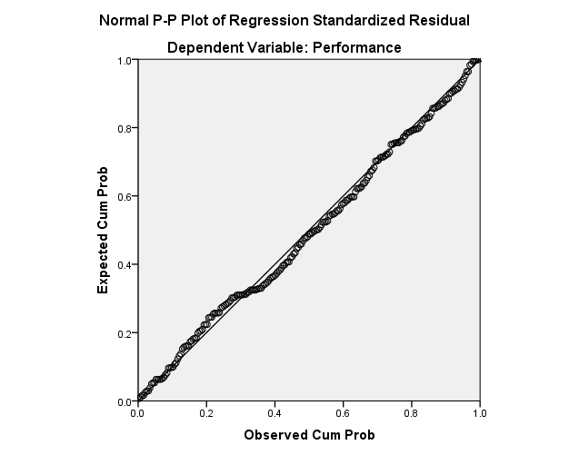
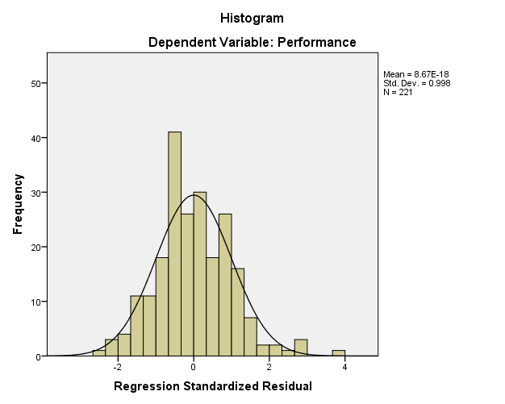
Figure 4. 7: Figures generated from Path Â Regression

Part 2, Path Â and Path C:
H₀₂: Factors related to Level of Innovation and procurement management have significant impact (≤ 0.05) on project Performance.
The table -4.10- below is generated from linear regression for the hypothesis of path Â and Path C (H_{02).} The performance predicted from two independent variables, the level of innovation and procurement management. Referring to the ANOVA table below, the null hypothesis H₀₂ is accepted as the F value is high (218.007) and it is statically significance as the P- value is less than .05, so there is a significant positive relation between the level of innovation and performance. In addition, the formula will be generated out of this relation will be able to explain more than 66% of the input as per the R square on Model Summary table below.
From the coefficients table the Beta standard coefficient for regression is .382 for level of innovation (lower than path A) and (.507) for procurement management and statically significant as the P-value is less than (.05), the formula to predict the performance from the level of innovation dependent variable is as following:
Ý = 7.988 + .677*X₁+.957*X₂
Where: Ý: Project Performance
x₁: Level of innovation
x₂: Procurement Management
Table 4. 10: Regression analysis for Path Â and Path C
Model Summary^{b}
Model | R | R Square | Adjusted R Square | Std. Error of the Estimate | Change Statistics
 |  |  |  |  | R Square Change | F Change | df1 | df2 | Sig. F Change
1 | .817ª | .667 | .664 | 7.17063 | .667 | 218.007 | 2 | 218 | .000
a. Predictors: (Constant), Procurement Management, Level of Innovation
b. Dependent Variable: Performance
ANOVAª
Model |  | Sum of Squares | df | Mean Square | F | Sig.
1 | Regression | 22418.881 | 2 | 11209.441 | 218.007 | .000^{b}
1 | Residual | 11209.101 | 218 | 51.418
1 | Total | 33627.982 | 220
a. Dependent Variable: Performance
b. Predictors: (Constant), Procurement Management, Level of Innovation
Coefficientsª
Model |  | Unstandardized Coefficients |  | Standardized Coefficients | t | Sig. | 95.0% Confidence Interval for B
 |  | B | Std. Error | Beta | t | Sig. | Lower Bound | Upper Bound
1 | (Constant) | 7.988 | 1.743 |  | 4.582 | .000 | 4.552 | 11.424
1 | Level of Innovation | .677 | .095 | .382 | 7.117 | .000 | .490 | .864
1 | Procurement Management | .957 | .101 | .507 | 9.447 | .000 | .758 | 1.157
a. Dependent Variable: Performance

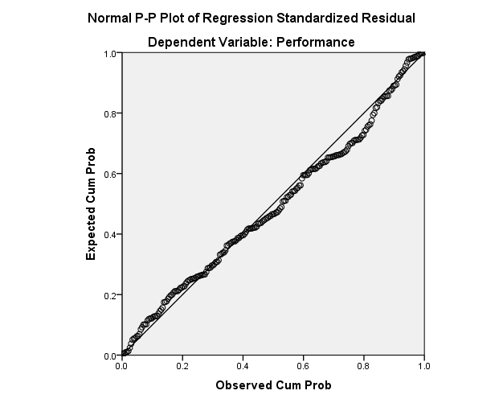
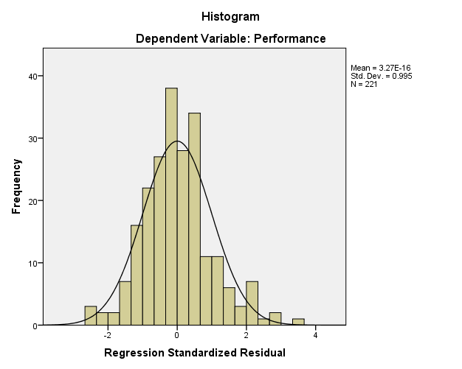
The histogram and scatter plots in the figure below illustrated the normal distribution for the regression’s data which support the linear relation. The histogram illustrates the normal distribution bill shape for the data, the scatter plot next to it illustrates the pattern of data distributed closely around the linear relationship.
Figure 4. 8: Figures generated from Path Â and Path C Regression

Part 2, Path B:
H₀₃: Factors related to Level of Innovation have significant impact (≤ 0.05) on procurement management.
The table -4.11- below is generated from linear regression for the hypothesis of path A (H_{03).} Referring to the ANOVA table below, the hypothesis H₀₃ is accepted as the F value is high (192.738) and it is statically significance as the P- value is less than .05, so there is a significant positive relation between the level of innovation and performance. In addition, the formula will be generated out of this relation will be able to explain around 47% of the input as per the R square on Model Summary table below.
From the coefficients table the Beta standard coefficient for regression is .684 which is high strong and statically significant as the P-value is less than (.05), the formula to predict the performance from the level of innovation dependent variable is as following:
Ý = 10.711 + .642*X₂
Where: Ý: Project Performance
x₂: Procurement Management
Table 4. 11: Regression analysis for Path B
Model Summary^{b}
Model | R | R Square | Adjusted R Square | Std. Error of the Estimate | Change Statistics
 |  |  |  |  | R Square Change | F Change | df1 | df2 | Sig. F Change
1 | .684ª | .468 | .466 | 4.78241 | .468 | 192.738 | 1 | 219 | .000
a. Predictors: (Constant), Level of Innovation
b. Dependent Variable: Procurement Management
ANOVAª
Model |  | Sum of Squares | df | Mean Square | F | Sig.
1 | Regression | 4408.207 | 1 | 4408.207 | 192.738 | .000^{b}
1 | Residual | 5008.852 | 219 | 22.871
1 | Total | 9417.059 | 220
a. Dependent Variable: Procurement Management
b. Predictors: (Constant), Level of Innovation
Coefficientsª
Model |  | Unstandardized Coefficients |  | Standardized Coefficients | t | Sig. | 95.0% Confidence Interval for B
 |  | B | Std. Error | Beta | t | Sig. | Lower Bound | Upper Bound
1 | (Constant) | 10.711 | .910 |  | 11.770 | .000 | 8.917 | 12.505
1 | Level of Innovation | .642 | .046 | .684 | 13.883 | .000 | .551 | .734
a. Dependent Variable: Procurement Management

The histogram and scatter plots in the figure below illustrated the normal distribution for the regression’s data which support the linear relation. The histogram illustrates the normal distribution bill shape for the data, the scatter plot next to it illustrates the pattern of data around the linear relationship.
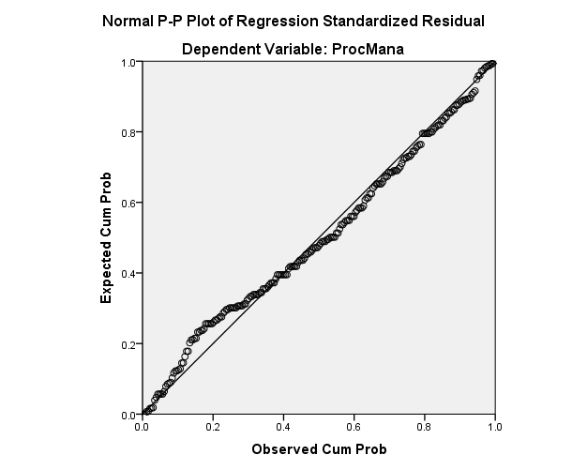
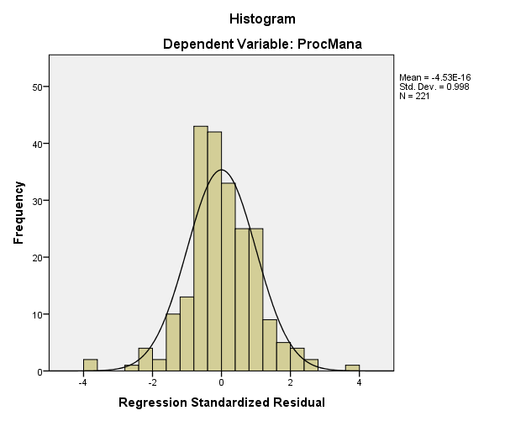
Figure 4. 9: Figures generated from Path B Regression
The histogram and scatter plots in the figure below illustrated the normal distribution for the regression’s data which support the linear relation. The histogram illustrates the normal distribution bill shape for the data, the scatter plot next to it illustrates the pattern of data distributed closely around the linear relationship.

4.4.3 Mediation Conclusion
As mention before, the mediator is core reason for the relationship, as in the absent of the mediator factor there is no relation between the variables. On the other hand, the moderator does not explain why there is relation between independent variable and dependent variable, it is only changing the direction or strength of the relation without change the fact that there is relationship.
The table below summarise the result out of the regression tests:
Table 4. 12: Regression results Summery
Hypothesis | Paths | Beta Stand. Coef. | Beta Unstand. Coef. | R Square | P-Value Sign. | Result | Prediction Formula
H₀₁ | Path A | .728 | 1.292 | .530 | .000 | Accept the Hypothesis | Ý=18.241+1.292* X1
H₀₂ | Path Â and Path C | .382  .507 | .677  .957 | .664 | .000 | Accept the Hypothesis | Ý=7.988+.677* X1 +.957* X2
H₀₃ | Path B | .684 | .642 | .468 | .000 | Accept the Hypothesis | Ý=10.711+.642*X₂
The role of the procurement management is a moderator between the level of innovation and performance is confirmed due to the following:
- The three hypotheses for the linear relation between variables in the defined paths are accepted as the p-value <= 0.05.
- The p-value for Path Â is significant as it was in path A (<0.05 for both). That means the relation between the level of innovation and performance still significance which reject the role of procurement management as a mediator (as in the absent of the mediator factor there is no relation between the variables)
- Regression coefficient (Beta standardized coefficient) was high for path A (equal to .728) before considering the procurement management. After adding the procurement management (H₀₂) the regression coefficient for the relation between level of innovation and project performance reduced to .382 only (was .728), while the regression coefficient for Path C (between procurement management) was high and equal to .507 which emphasise the role of procurement management as mediator (Figure -###- Below illustrates the Beta values), which accept the moderator role for the procurement management as it is changing the strength of the relation without change the fact that there is relationship.
- The regression for the direct relation between level of innovation and performance (Path A, H₀₁) generated a formula that enable to answer 53 % (R square) from independent variable, while adding the procurement management as independent variable for the formula (Path Â and Path C, H₀₂) increased the R square to 0.664 which means that the formula prediction improved to 66.4%, which also support the role of procurement management as a moderator.
- Path B, H₀₂ introduced a strong positive correlation between the level of innovation as independent and procurement management as dependent as the (Beta unstandardized Coefficient) is equal to (.642), and strong positive relation between the procurement management and performance (path C) as the (Beta unstandardized Coefficient) is equal to (.957).
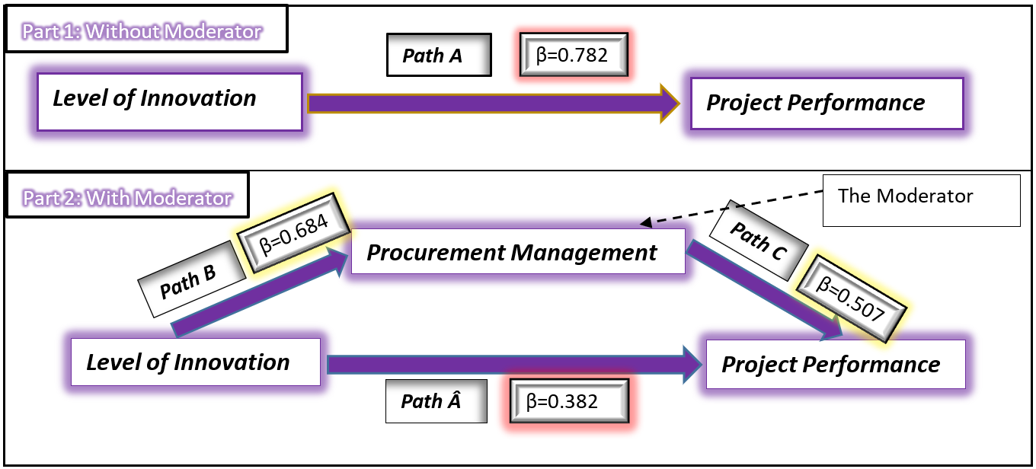
Figure 4. 10: Regression Coefficient for The Hypothesis Paths

4.5 Chapter Conclusion
The first and second sections of this chapter provides a statistical description for the participated sample based on the participants’ profession position, organisation type, projects types and years of experience followed by statement which summarise the sample as a high variety. The purpose of this description is to present and interact with the responder, as will it provide more awareness and feel of the collected data by running a simple statistical analysis (rates, mean, standard deviation and frequencies) which shows a strong source of data. The third section was a statistical test for the conceptual framework illustrated in chapter four. First statistic test was a correlation between the three variables of this research (level of innovation, procurement management and performance), the result of correlation accepted the main hypothesis which means that there is a strong positive relation between the three variables (the tests was for each two individually total three tests), so increasing the level of innovation will improve the chance for collaborative procurement and improve the performance, while applying collaborative procurement will improve the performance. The second statistical test was a regression which accepted the role of procurement management as a moderator between level of innovation and performance.

Chapter V
Discussion and Conclusion

5.1 Introduction

The construction’s projects equipped major part of the country’s economy and considered as an important indicator for development. On the other hand, the innovation in construction industry is suffering from the low quality and is backward when compared to other industries even though the high importance of innovation in the construction market for development and better opportunities. The research concerned with managerial obstacles in construction exploratory project to introduce solutions for construction innovation. This chapter is a close out for this dissertation to discuss the results generated from the research and to highlight the challenges faced to accomplish this work, besides a recommendation to improve the innovation in construction. In addition, suggestions for further studies based on this work’s results followed by conclusion drawn out of it.

5.2 Discussion and Conclusions

This research considers the uniqueness in the type as no research before studied the role of construction projects’ obstacles and its effect in improving the exploratory project innovation and performance. However, considering the partial paths of the research’s framework there is many demonstrative positive impacts of collaborative characteristics of construction procurement management in improving performance (Babatunade, Opawole & Ujaddughe 2010; Khalfan & McDermott 2006; Jelodar, Yiu & Wilkinson 2016; Meng, 2012).
In few conducted studies, research demonstrated the relation between factors related to construction’s innovation in construction projects and performance such as Choi, Jang and Hyun (2009), and other research only identifies factors related to improve the innovation in construction such as Blayse and Manley (2004), while Dulaimi, Nepal and Park (2005) demonstrate the role of the mangers in the level of innovation and the impact of level innovation in performance. The researches that relate to innovation and performance are summarized on literature review. These studies proved the validity of the relationship without addressing its role between the innovation and performance.
Moreover, a gap has been detected in this research, as mentioned before in the literature, on the effect of level of innovation and procurement management on the construction project innovation. Accordingly, this study contribution is exploring the impact and the role of the Procurement management in the exploratory project’s level of innovation; influencing the level of innovation in the role of procurement management and the way that both variables will impact the success aspects of construction project’s performance, in order to introduce a solution for the backward in construction project. This study designed to be comprehensive to the topic of exploratory project innovation management; the way it will be affected by related factors and obstacles in construction and the way it will impact the construction project performance.
Furthermore, all the objectives of this study, which were reviewed in the introduction (chapter one) of this thesis, were examined and met to accomplish the aim of the research. The following is the list of the predefined objectives followed the process and/or analysis related to meet the objective:
- Discover the exploratory project role in managing and improving the innovation in the construction industry. Also, define the aspects and factors of exploratory project that relates to improving the innovation of exploratory project. In the first section of the literature review an intense review and analysis for the importance of exploratory project to apply a new innovation has been conducted. Followed by a highlight for the special factors and conditions that are related to exploratory project which require attention and efforts to achieve the goals of exploratory project such as knowledge management, exploratory learning, knowledge dimensions and level of innovation.

- Further details and reviews for previous studies for the exploratory project’s level of innovation importance and impacts in the construction projects. In addition to determine the factor that is related to the success of the exploratory project and highlight the major factors that influence and cause the backwardness of innovation in construction projects such as organization behavior and procurement management. Then demonstrates the effect of procurement management in improving the performance in some studies and the innovation in other studies and describes the strategic and characteristics of procurement type that is favorable to improve the innovation.

- Based on the literature review, framework for relation between exploratory project’s level of innovation, procurement management, and construction project performance were designed. The design of the framework was subjective to assess the role of the project management in between the level of innovation and project performance besides the direct effect for the exploratory project’s level of innovation on the overall performance. The data related to the framework were collected from profession expertise in construction project.

- Using statistical analysis and hypothesis, the role of procurement management was confirmed as a moderator between the level of innovation and performance. The positive effects of collaborative procurement management are improving the innovation projects innovation. Proving that increasing the level of innovation will improve the performance, while collaborative procurement management will improve the performance for high level of innovation projects.

The results obtained out of this study are global and can be generalized, as the repetition of this study at any time or place will ensure the same result. Since the data collected on this study, which showed a high degree of reliability and validity, were not collected from one country but from different countries all over the world with higher concentration in The Middle East, India, Germany and USA including a high variety in nationalities as it was difficult to limit the collection of data to one geographical area or one country, since the number of construction projects involving in innovation are few and it was a challenge to find. On the other hand, the repetition of this study in the sector other than the construction sector may reach the same result with differences in the strength of the relationship and the role of the mediator because the procurement factor in the field of construction is a large part as companies highly rely on subcontractors to complete the work while in other sectors may be less. In addition, the study of procurement in other sectors may not be feasible because their procurement management’s practices may not be as negative as in contracting.

5.3 Challenges and Recommendations

In conclusion, the completion of this work carried a lot of difficulties and challenges. The first phase required access to the framework of research and intensive reading in sources and references related to this topic directly or indirectly, since there is no study that addressed the subject as a whole it required a separate study of the innovation management factors and eventually the study of construction management’s weaknesses and finding a link between them.
Furthermore, this research results were based on quantitative method from the data collected by survey. The questions of the survey were a summary for the related factor that is related to the topics based on expertise opinion and some research, however the study could be repeated using another indicators and factors, expecting that the same result will be obtained. In addition, collecting survey data was difficult due to the limitation of this study on innovative construction project, accordingly it was hard to limit the data collection in one geographical area due to a small number of construction companies involved in innovative projects. So, it took double the effort and time of other research to reach these companies and follow up with them directly and through connections till get them responds.
In any case, the works were completed finally, based on the analysis of collected data besides the review of previous studies, it is recommended for practitioners in higher management that the construction organization should build a system that is able to manage, design or execute any new systems/processes recent in the market, or even more as introducing a new construction materials, project management or construction methods, for the reason that it has a positive impact in improving the level of performance in projects, which is a major concern in the field of construction. Also, the practitioners should recognize the exploratory project as an intelligent way to implement or introduce a new technology, innovation or changes. As it is required a special condition that enable the organization to respond actively to any changes or corrective action in addition to facilitate the new design, services, systems, materials, or facilities introduction.
Moreover, the construction company should give extra attention to the procurement management strategy and build it under the supervision of the higher management to be a part of business strategic vision, mission, long/short term plans and aims to achieve the overall organization's objective. For example, building a collaborative relation with a subcontractor not based on financial issues besides involve him at the early stage of the project (tender stage) and share profit. Such practices are not only beneficial in terms of time, cost and quality performance, it also improves construction of organizational and business relationships and the ability to build an innovative organization.
On the academic side, for future work and research, this study may be considered as the beginning of a series of studies related to innovation in the field of construction. It is recommended to study the impact of other factors of exploratory projects such as knowledge dimension or knowledge management and its impact of overcoming the obstacles that cause the delay of innovation in the field of construction such as organisation behaviour or roles of management.
The way of conducting the study related to innovation should be done in the same way in this research as the factors that affect the innovation and exploratory projects are not only related to innovation itself, usually these factors are a main element for the success or failure of a project. So, studying these factors without linking it to the project or without define its role in between the innovation and performance could generate misleading results that does not truly reflect the role of these factors in improving the innovation.

5.4 Chapter Conclusion
The last chapter in this paper draw the conclusion that is generated from the previous chapter's analysis which confirmed the role of collaborative procurement management in order to reduce the innovation gap in construction followed by a set of recommendations in academic and practical levels for future works and current situation. In addition to suggestion for future studies following for this research and highlighting the importance of conducting the future study in the same way of this research.

References

Akintoye, A., Goulding, J. & Zawdie, G. (2012). Construction innovation and process improvement. Chichester, West Sussex, U.K.: Wiley-Blackwell.
Allen, R. S. & Helms, M. M. (2006). Linking strategic practices and organizational performance to porter's generic strategies. Business Process Management Journal, vol. 12 (4), pp. 433–433.
Anumba, C. J. (2009). Towards next-generation knowledge management systems for construction sector organisations. Construction Innovation, vol. 9 (3), pp. 245–249.
Aouad, G., Ozorhon, B. & Abbott, C. (2010). Facilitating innovation in construction: directions and implications for research and policy. Construction Innovation, vol. 10 (4), pp. 374–394.
Argyris, C. (1996). Unrecognized defenses of scholars: impact on theory and research. Organization Science, vol. 7 (1), pp. 79–87.
Argyris, C. (2012). On organizational learning. 2nd edn. Malden, Mass:Blackwell.
Ashworth, A., Hogg, K. & Higgs, C. (2013). Willis's practice and procedure for the quantity surveyor. 3rd edn. Chichester, West Sussex, UK:John Wiley & Sons.
Azar, A. D., Militaru, C. & Mattar, C. P. (2016). time, cost and quality management trilogy and its impact on lebanese construction projects success. Applied Mechanics and Materials, vol. 834, pp. 217–222.
Babatunade, S. O., Opawole, A. & Ujaddughe, I. C. (2010). An appraisal of project procurement methods in the nigerian construction industry. Civil Engineering Dimension, vol. 12 (1).
Benner, M. J. & Tushman, M. L. (2003). Exploitation, exploration, and process management: the productivity dilemma revisited. The Academy of Management Review, vol. 28 (2), pp. 238–256.
Birkinshaw, J., Nobel, R. & Ridderstråle Jonas (2002). Knowledge as a contingency variable: do the characteristics of knowledge predict organization structure?. Organization Science, vol. 13 (3), pp. 274–289.
Björkdahl, J. & Börjesson, S. (2012). Assessing firm capabilities for innovation. international journal of knowledge management studies, vol. 5 (1/2), pp. 171–171
Blayse, A. M. & Manley, K. (2004). Key influences on construction innovation. Construction Innovation: Information, Process, Management, vol. 4 (3), pp. 143–154.
Bonesso, S., Comacchio, A. & Pizzi, C. (2011). technology sourcing decisions in exploratory projects. technovation, vo. 31 (10/11), pp. 573–573.
Brun, E. & Sætre, A. S. (2009). Managing ambiguity in new product development projects. Creativity and Innovation Management, vol. 18 (1), pp. 24–34.
Burke, R. (2003). Project management: planning and control techniques. 4th edn. Chichester: Wiley.
Campbell, S. M. (1982). Critical path method. Appraisal Journal, vo. 50 (4).
Carson, S. J., Madhok, A. & Wu, T. (2006). Uncertainty, Opportunism, and Governance: The Effects of Volatility and Ambiguity on Formal and Relational Contracting. The Academy of Management Journal, vol. 49 (5), pp. 1058–1077.
Chan, A. P. C., Scott, D. & Lam, E. W. M. (2002). Framework of success criteria for design/build projects. Journal of Management in Engineering, vol. 18 (3), pp. 120–128.
Cheng, Y.-T. & Van de Ven, A. H. (1996). Learning the innovation journey: order out of chaos?. Organization Science, vol. 7 (6), pp. 593–614.
Cheung, S. O., Suen, H. C. H. & Cheung, K. K. W. (2004). Ppms: a web-based construction project performance monitoring system. Automation in Construction, vol. 13 (3), pp. 361–376.
Choi, S., Jang, H. & Hyun, J. (2009). Correlation between innovation and performance of construction firms. Canadian Journal of Civil Engineering, vol. 36 (11), pp. 1722–1731.
Colledge, B. (2005). Relational contracting – creating value beyond the project. Lean Construction Journal, vol. 2 (1), pp. 30–45.
Creswell, J. W. & Creswell, J. D. (2018). Research design: qualitative, quantitative & mixed methods approaches. 5Th edn. International student edn. Thousand Oaks, CA:SAGE.
Cronbach, L. J. & Shavelson, R. J. (2004). My current thoughts on coefficient alpha and successor procedures. Educational and Psychological Measurement, vol. 64 (3), pp. 391–418.
de Araújo, M. C. B., Alencar, L. H. & de Miranda Mota, C. M. (2017). Project procurement management: a structured literature review. International Journal of Project Management, vol. 35 (3), pp. 353–377.
De Marco, A. & Narbaev, T. (2013). Earned value-based performance monitoring of facility construction projects. Journal of Facilities Management, vol. 11 (1), pp. 69–80.
Demirbag, M. & Tatoglu, E. (2008). Competitive strategy choices of turkish manufacturing firms in european union. The Journal of Management Development, vol. 27 (7), pp. 727–743.
Dobson, C. (2008). Can the key characteristics of a learning organisation be found in our general practice?. Education for Primary Care, vol. 19 (1), pp. 74–79.
Dodgson, M., Gann, D. M. & Salter, A. J. (2002). The intensification of innovation. International Journal of Innovation Management, vol. 6 (1), pp. 53–84.
Drucker, P. F. (2002). The discipline of innovation. Harvard Business Review, vol. 80 (8), pp. 95-102.
Dulaimi, M. F., Nepal, M. P. & Park, M. (2005). A hierarchical structural model of assessing innovation and project performance. Construction Management and Economics, vol. 23 (6), pp. 565–577.
Egan, J. (1998). Rethinking construction: The report of the Construction Task Force to the Deputy Prime Minister, John Prescott, on the scope for improving the quality and efficiency of UK construction. Structural Engineer.
Eriksson, P. E. & Dickinson, M. (2007). The influence of partnering and procurement on subcontractor involvement and innovation. Facilities, vol. 25 (5/6), pp. 203–214.
Fairclough, J. (2002). Rethinking construction innovation and research-a review of the government's R&D policies and practices.
Fang, C., Lee, J. & Schilling, M. A. (2010). Balancing exploration and exploitation through structural design: the isolation of subgroups and organizational learning. Organization Science, vol. 21 (3), pp. 625–642.
Filipescu, D. A. & Cázares, C. C. (2012). Determinants and consequences of R&D strategy selection. Technological, Managerial and Organizational Core Competencies: Dynamic Innovation and Sustainable Development, (January), pp. 428–449.
Galanakis, K. (2006). Innovation process. Make Sense Using Systems Thinking. Technovation, vol. 26 (11), pp. 1222–1232.
Galbraith, J. R. (1982). Designing the innovating organization. Organizational Dynamics, vol. 10 (3), pp. 5–25.
Gann, D. (2000). Building innovation: complex constructs in a changing world. Thomas Telford:London.
Giesecke, J. & McNeil, B. (2004). Transitioning to the learning organization. Library Trends, vol. 53 (1).
Gillier, T., Hooge, S. & Piat, G. (2013). Framing the scope of value in exploratory projects: An expansive value management model. International Product Development Management Conference.
Goddard, W. & Melville, S. (2001). Research methodology : an introduction. 2nd edn. Lansdowne: Juta.
Grant, R. M. (1996). Toward a knowledge-based theory of the firm. Strategic Management Journal, vol. 17 (2), pp. 109–122.
Halil, F. M., Nasir, N. M., Hassan, A. A. & Shukur, A. S. (2016). Feasibility Study and Economic Assessment in Green Building Projects. Procedia - Social and Behavioral Sciences, vol. 222, pp. 56–64.
Hall, A. (2002). Innovation systems and capacity development: an agenda for north-south research collaboration?. The International Journal of Technology Management & Sustainable Development, vol. 1 (3), pp. 146–152.
Hatush, Z. & Skitmore, M. (1997). Evaluating contractor prequalification data: Selection criteria and project success factors. Construction Management and Economics, vol. 15 (2), pp. 129–147.
Henderson, R. M. & Clark, K. B. (1990). Architectural innovation: the reconfiguration of existing product technologies and the failure of established firms. Administrative Science Quarterly, vol. 35 (1), pp. 9–9.
Huang, Y.-A., Chung, H.-J. & Lin, C. (2009). R&d sourcing strategies: determinants and consequences. Technovation, vol. 29 (3), pp. 155–155.
Idoro, G. (2012). Comparing levels of use of project plans and performance of traditional contract and design-build construction projects in Nigeria. Journal of Engineering, Design and Technology, vol. 10 (1), pp. 7–33.
Jelodar, M. B., Yiu, T. W. & Wilkinson, S. (2016). A Conceptualisation of relationship quality in construction procurement. International Journal of Project Management, vol. 34 (6), pp. 997–997.
Kalogerakis, K., Lüthje Christian & Herstatt, C. (2010). Developing innovations based on analogies: experience from design and engineering consultants. The Journal of Product Innovation Management, vol. 27 (3), pp. 418–418.
Khalfan, M. & McDermott, P. (2006). Innovating for Supply Chain Integration Within Construction. Construction Innovation, vol. 6(3), pp. 143–157.
Kothari, C. R. (2004). Research methodology : methods & techniques. 2nd edn. New Delhi: New Age International (P).
Kumar, R. (2011). Research methodology : a step-by-step guide for beginners. Los Angeles, CA: Sage.
Lant, T. K., Milliken, F. J. & Batra, B. (1992). The role of managerial learning and interpretation in strategic persistence and reorientation: an empirical exploration. Strategic Management Journal, vol. 13 (8), pp. 585–585.
Leiringer, R. & Cardellino, P. (2008). Tales of the expected: investigating the rhetorical strategies of innovation champions. Construction Management and Economics, vol. 26 (10), pp. 1043–1054.
Lenfle, S. (2014). Toward a genealogy of project management: sidewinder and the management of exploratory projects. International Journal of Project Management, vol. 32 (6), pp. 921–921.
Lim, C. S. & Mohamed, M. Z. (1999). Criteria of project success: an exploratory re-examination. International Journal of Project Management, vol. 17 (4), pp. 243–2
Macher, J. T. (2006). Technological development and the boundaries of the firm: a knowledge-based examination in semiconductor manufacturing. Management Science, vol. 52 (6), pp. 826–843.
Maghsoodi, A. I. & Khalilzadeh, M. (2018). Identification and evaluation of construction projects’ critical success factors employing fuzzy-topsis approach. KSCE Journal of Civil Engineering, vol. 22 (5), pp. 1593–1605.
Malerba, F. (2005). Sectoral systems of innovation: a framework for linking innovation to the knowledge base, structure and dynamics of sectors. Economics of Innovation and New Technology, vol. 14 (1-2), pp. 63–82.
Mangan, J., Lalwani, C. & Gardner, B. (2004). Combining quantitative and qualitative methodologies in logistics research, International Journal of Physical Distribution & Logistics Management, vol. 34 (7/8), pp. 565–578.
March, J. G. (1991). Exploration and exploitation in organizational learning. Organization Science, vol. 2 (1), pp. 71–87.
Marosszeky, M. (1999) technology and innovation. In: ed. Best, R. & de valence, G., building in value. Arnold, London. 342-355.
McGrath, R.G., 2001. Exploratory learning, innovative capacity, and managerial oversight. Academy of management journal, vol. 44 (1), pp.118-131.
Meng, X. (2012). The effect of relationship management on project performance in construction. International Journal of Project Management, vol. 30 (2), pp. 188–188.
Michell, K., Bowen, P., Cattell, K., Edwards, P. & Pearl, R. (2007). Stakeholder perceptions of contractor time, cost and quality management on building projects. CIB World Building Congress 2007, (1991), pp. 232–239.
Morledge, R. & Smith, A. (2013). Building procurement. 2nd edn. Chichester, West Sussex, UK:Wiley-Blackwell.
Mosey, D. (2009). Early contractor involvement in building procurement : contracts, partnering and project management. Chichester, West Sussex:Ames, Iowa.
Mowery, D. & Rosenberg, N. (1979). The influence of market demand upon innovation: a critical review of some recent empirical studies. Research Policy, vol. 8 (2), pp. 102–153.
Nicolini, D., Holti, R. & Smalley, M. (2001). Integrating project activities: the theory and practice of managing the supply chain through clusters. Construction Management and Economics, vol. 19 (1), pp. 37–47.
O'Connor, G. C. (2008). major innovation as a dynamic capability: a systems approach. The Journal of Product Innovation Management, vol. 25 (4), pp. 313–313.
Olson, E. M., Walker, O. C., Ruekert, R. W. and Bonner, J. M. (2001). Patterns of cooperation during new product development among marketing, operations and r&d: implications for project performance. The Journal of Product Innovation Management, vol. 18(4), pp. 258–271.
Owen, R., Koskela, L.J., Henrich, G. & Codinhoto, R., 2006, July. Is agile project management applicable to construction?. In Proceedings of the 14th Annual Conference of the International Group for Lean Construction (pp. 51-66).
Pal, R., Wang, P. & Liang, X. (2017). The critical factors in managing relationships in international engineering, procurement, and construction (iepc) projects of chinese organizations. International Journal of Project Management, vol. 35 (7), pp. 1225–1237.
Panuwatwanich, K., Stewart, R. A. & Mohamed, S. (2009). Validation of an empirical model for innovation diffusion in australian design firms. Construction Innovation, vol. 9 (4), pp. 449–467.
Project Management Institute (2011). practice standard for earned value management. 2nd edn. Newtown Square, Pa.:Project Management Institute.
Project Management Institute. (2014). A guide to the project management body of knowledge fifth edition. Katalog BPS.
Rose, K.H., 2013. A guide to the project management body of knowledge (pmbok® guide)—fifth edition. Project management journal, vol. 44 (3).
Rothwell, R. (1994). Towards the fifth‐generation innovation process. International Marketing Review, vol. 11 (1), pp. 7–31.
Rowlinson, S. (2003). Construction reports 1944-98. Construction Management and Economics, vol. 21 (7), pp. 789–790.
Sears, S. K. (2015). Construction project management : a practical guide to field construction management. 6th edn. Hoboken, New Jersey:Wiley.
Sekaran, U. & Bougie, R. (2016). Research methods for business : a skill-building approach. 7th edn. Chichester, West Sussex, United Kingdom:John Wiley & Sons.
Simmons, J. E. L., Gardiner, P. D. & Strauch, G. M. (2003). Performance measurement tools: the balanced scorecard and the EFQM excellence model. Measuring Business Excellence, vol. 7 (1), pp. 14–29.
Steensma, H. K. & Corley, K. G. (2001). Organizational context as a moderator of theories on firm boundaries for technology sourcing. Academy of Management Journal, vol. 44 (2), pp. 271–291.
Streule, T., Miserini, N., Bartlomé Olin, Klippel, M. & de Soto Borja García (2016). Implementation of scrum in the construction industry. Procedia Engineering, vol. 164, pp. 269–276.
Tidd, J. & Bessant, J. R. (2018). Managing innovation : integrating technological, market and organizational change. 6th edn. Hoboken, NJ: Wiley.
Tidd, J. (2000). From knowledge management to strategic competence : measuring technological, market and organisational innovation. London: Imperial College Press (Series on technology management, v. 3).
Toole, T. M. (2001). Technological trajectories of construction innovation. Journal of Architectural Engineering, vol. 7 (4), pp. 107–114.
Trott, P. (1998). Growing businesses by generating genuine business opportunities: a review of recent thinking. Journal of Applied Management Studies, vol. 7 (2), pp. 211–222.
Trott, P. (2017). Innovation management and new product development. 6th edn. Harlow:Prentice Hall.
Utterback, J. M. & Abernathy, W. J. (1978). Patterns of Industrial Innovation. Technology Review, vol. 80 (7).
van der Panne, G., van Beers, C. & Kleinknecht, A. (2003). Success and failure of innovation. International Journal of Innovation Management, vol. 07 (03), pp. 309–338.
Walker, A. (2007). Project management in construction. 5th edn. Oxford:Blackwell Pub.
Walker, D. H. T. (2016). Reflecting on 10 Years of Focus on Innovation, Organisational Learning and Knowledge Management Literature in a Construction Project Management Context. Construction Innovation, vol. 16 (2), pp. 114–126.
Walpole, R. E., Myers, R. H., Myers, S. L. & Ye, K. (2014). Essentials of probability and statistics for engineers and scientists. 1st edn. Harlow, Essex:Pearson Education Limited (Pearson custom library).
Winch, G. (1998). Zephyrs of creative destruction : understanding the management of innovation in construction. Building research and information, vol. 26 (5), pp. 268–279.
Wirtz, B. W., Mathieu, A. & Schilke, O. (2007). Strategy in high-velocity environments. Long Range Planning, vol. 40 (3), pp. 295–295.
Woudhuysen, J. and Abley, I. (2004). Why is construction so backward?. Chichester: Wiley-Academy.

Appendixes
Appendix 1: Survey

