

An Artificial Intelligence Approach for Predictive Maintenance in Electronic Toll Collection System

الصيانة التنبؤية لأنظمة التعرفة الالكترونية باستخدام بالذكاء الاصطناعي

by

OSAMA ALKHATIB

Dissertation submitted in fulfilment
of the requirements for the degree of
MSc ENGINEERING MANAGEMENT
at
The British University in Dubai

November 2019





ABSTRACT
Predictive maintenance of Electronic Toll Collection System is a major subject in traffic engineering due to the complexity of the system and the difficulty of predicting the components failures. Two types of machine learning models namely classification and regression model were developed and implemented to predict the failure and abnormal behavior of the system. Nevertheless, the accuracy and performance of these models are questioned since they do not account for other system information. Therefore, for this paper multiple machine learning algorithms are investigated to predict system failure based on vehicle trips information as well as maintenance management historical data including preventive maintenance and corrective maintenance. Historical data of Dubai Toll Collection System is utilized to investigate multiple machine learning algorithms. Experiment is performed using Azure Machine Learning (ML) platform to test and assess the most efficient model that would predict the failure of system elements and predict the abnormality of the operation. Based on the experimental results, the predictions can be made to detect failure and forecast traffic amount. The models presented prove that data analytics can create new value in an ETC environment. The methods and tools used for modeling the prediction model can be generalized to be used in the rest of the ETC system also. As the amount of data grows daily, the model can be trained with more and more data as time passes. Therefore, the model can be re-generated from time to time to gain better results. There are no previous papers or literature reviews on applying artificial intelligence in predictive maintenance for Electronic Toll Collection failure forecast to perform a comparison of the effectiveness of Machine Learning Models. Despite having different performance results on predicting failures, most of the models produced close outcomes. Meaning no “perfect” machine learning algorithm that will produce good

results at particular problem, in fact for each type of problem a specific algorithm is suited and might achieves good outcome, while another algorithm fails heavily. In addition, it relates to a great extent on the nature of dataset and the aim of model development.

خلاصة البحث

الصيانة التنبؤية لنظام التعرفة المرورية الالكتروني هو موضوع رئيسي في هندسة المرور بسبب تعقيد النظام وصعوبة التنبؤ بفشل المكونات. تم تطوير وتنفيذ نوعين من نماذج التعلم الآلي وهما التصنيف ونموذج الانحدار للتنبؤ بالفشل والسلوك غير الطبيعي للنظام. ومع ذلك ، يتم التشكيك في دقة وأداء هذه النماذج لأنها لا تفسر معلومات النظام الأخرى. لذلك ، في هذه الورقة ، يتم فحص خوارزميات تعلم الآلة المتعددة للتنبؤ بعطل النظام استنادًا إلى معلومات رحلات المركبات بالإضافة إلى البيانات التاريخية لإدارة الصيانة بما في ذلك الصيانة الوقائية والصيانة التصحيحية. يتم استخدام البيانات التاريخية لنظام جمع رسوم دبي لدراسة خوارزميات التعلم الآلي المتعددة. يتم إجراء التجربة باستخدام النظام الأساسي Azure Machine Learning (ML) لاختبار وتقييم النموذج الأكثر كفاءة الذي يتوقع فشل عناصر النظام والتنبؤ بخلل العملية. بناءً على النتائج التجريبية ، يمكن إجراء التنبؤات للكشف عن الفشل وتوقع مقدار الحركة. تثبت النماذج المقدمة أن تحليلات البيانات يمكن أن تخلق قيمة جديدة في بيئة ETC. يمكن تعميم الطرق والأدوات المستخدمة لنمذجة نموذج التنبؤ لاستخدامها في بقية نظام ETC أيضًا. مع نمو كمية البيانات يوميًا ، يمكن تدريب النموذج على المزيد والمزيد من البيانات مع مرور الوقت. لذلك ، يمكن إعادة إنشاء النموذج من وقت لآخر للحصول على نتائج أفضل. لا توجد أي مقالات أو مقالات سابقة حول تطبيق الذكاء الاصطناعي في الصيانة التنبؤية لتوقعات فشل Electronic Toll Collection لإجراء مقارنة بين فعالية نماذج التعلم الآلي. على الرغم من اختلاف نتائج الأداء في التنبؤ بالفشل ، إلا أن معظم النماذج حققت نتائج قريبة. بمعنى عدم وجود خوارزمية تعلم الآلة "المثالية" التي ستؤدي إلى نتائج جيدة في مشكلة معينة ، في الواقع لكل مناسبة نوع خوارزمية معينة مناسبة وقد تحقق نتائج جيدة ، في حين فشل خوارزمية أخرى بشكل كبير. بالإضافة إلى ذلك ، يتعلق الأمر إلى حد كبير بطبيعة مجموعة البيانات والهدف من تطوير النموذج.

ACKNOWLEDGEMENTS
All praises are due to Allah, I am truly grateful to Him for His great blessings on myself and every one of my family. I would like to extend my thanks to the instructor and advisor, Professor Alaa A-Ameer who gave much kind help as well as cooperation in every matter to make this research a reality. His great direction and useful discussions made this work completed. I would like to convey my appreciation to everyone at the BUiD University for offering a great environment for students.

DEDICATION
I dedicate this work to my family, friends and Management at Road and Transport Authority in Dubai who supported and encouraged me to complete this paper. Finally yet importantly, I humbly extend my deep gratitude to my parents for their continual inspiration, blessings and prayers. I owe a lot to my wife for her unlimited support and prayers. Her constant and sincere encouragement gave me determination to complete this work and motivated me during hard times.

TABLE OF CONTENTS
TABLE OF CONTENTS i
LIST OF TABLES vi
LIST OF ACRONYMS vii
1. INTRODUCTION 1
1.1. Background 1
1.2. Problem Statement 3
1.3. Research Question 3
1.4. Aims and Objectives 4
1.4.1. Research Aims 4
1.4.2. Research Objective 5
1.5. Conceptual Framework 5
1.6. Research Methodology 6
1.7. Dissertation Overview 6
2. LITERATURE REVIEW 8
2.1. Background 8
2.2. Maintenance Management 9
2.2.1. Types of Maintenances 10
2.2.1.1. Run-To-Failure 12
2.2.1.2. Preventive Maintenance (PM) 12
2.2.1.2.1. Preventive maintenance challenges 14
2.2.1.2.1.1. Financial challenges 15
2.2.1.2.1.2. Technical challenges 16
2.2.1.3. Predictive Maintenance (PdM) 16
2.2.1.3.1. PdM Model Base 17
2.2.1.3.2. PdM Case Based 17
2.2.1.3.3. PdM Data Driven Based 18
2.3. Artificial Intelligence (AI) 18
2.3.1. Machine Learning (ML) 20
2.3.1.1. Introduction 20
2.3.1.2. Machine Learning Methods 21
2.3.1.2.1. Supervised learning 21
2.3.1.2.2. Unsupervised learning 22
2.3.1.2.3. Reinforcement learning 22
2.3.2. Machine Learning (ML) Algorithms 24
2.3.2.1. Neural Network (NN) 24
2.3.2.1.1. Model of Neural Network 25
2.3.2.1.2. Activation Function 26
2.3.2.1.3. Advantages and Disadvantages of NN 27
2.3.2.2. Linear Regression 28
2.3.2.3. Logistic Regression 30
2.3.2.4. Decision Trees 32
2.3.2.5. Support Vector Machines (SVM) 33
2.4. Machine Learning and Predictive Maintenance 35
2.4.1. Predictive maintenance (PdM) Model 36
2.4.1.1. Classification Model 38
2.4.1.2. Regression Model 43
2.5. Summary 46
3. RESEARCH METHODOLOGY 48
3.1. Introduction 48
3.2. Conceptual Framework 48
3.3. Process Model Building Tools 50
3.3.1. SQL Server Reporting Services (SSRS): 51
3.3.2. Jupyter Notebook 52
3.3.3. Python Libraries (Numpy, Pandas, Matplotlib) 52
3.3.4. Machine Learning (ML) Tool 53
3.4. The Data Analytics Methodology 54
3.4.1. Business Problem Understanding 54
3.4.2. Data Acquisition and Preparing 55
3.4.3. Process Modeling 56
3.4.3.1. Process Model Testing and Validation 56
3.4.3.2. Process Model Assessment 57
3.5. Maintenance in Dubai Toll Collection System 57
3.5.1. Introduction 57
3.5.1.1. Roadside system 58
3.5.1.2. Back office Data center: 58
3.5.1.3. The Computerized Maintenance Management System (CMMS) 58
3.5.2. DTCS Maintenance Management Methods and Tools 59
3.5.3. DTCS PM 59
3.5.4. DTCS Predictive Maintenance (PdM) 60
3.5.5. DTCS Failure prediction 60
3.6. Data Acquisition and Preparing 61
3.6.1. Structure of ETC data in DTCS 61
3.6.2. Data Source 62
3.6.2.1. Telemetry records 63
3.6.2.2. Errors records 63
3.6.2.3. Maintenance Events 64
3.6.2.4. Failures Records 64
3.6.3. Data Preprocessing 65
3.6.3.1. Maintenance Data 65
3.6.3.2. Failures and Errors Data 66
3.6.3.3. Vehicle Trips Data 67
3.6.4. Feature Engineering 70
3.6.4.1. Lag Attributes From Trips Data 71
3.6.4.2. Lag Attributes From Errors Data 71
3.6.4.3. Maintenance Attributes 72
3.6.4.4. Lag attributes from Failures data 73
3.6.4.5. Label Construction 73
3.7. Machine Learning Model 74
3.7.1. PdM using Classification Model 74
3.7.1.1. Prediction of Lane failure 74
3.7.1.2. Prediction of Failure using Vehicle Classification 77
3.7.2. Predictive Maintenance using Regression Model 79
3.7.2.1. Prediction of failure using Traffic Counts 79
4. RESULTS AND DISCUSSION 82
4.1. Introduction 82
4.2. Multi-Class Classification Models Performance 82
4.3. Two-Class Classification Models Performance 87
4.4. Prediction of Lane failure using Classification Model 90
4.5. Regression Models Performance 93
4.6. Prediction of Failure using Traffic Counts 94
5. CONCLUSION AND RECOMMENDATION 98
5.1. Introduction 98
5.2. Conclusions 99
5.3. Recommendations 100
REFERENCES 102

LIST OF FIGURES
Figure 1, Bathtub Shape 9
Figure 2, Maintenance types 11
Figure 3, Main subset of artificial intelligence 20
Figure 4, Model of neuron 25
Figure 5, Support Vector Machines technique 34
Figure 6, Classification modeling 39
Figure 7, simple linear regression model. 44
Figure 8, conceptual framework 49
Figure 9, Process Model Building Tools 51
Figure 10, Data analytics process 54
Figure 11, Dubai Toll Collection System Maintenance types. 59
Figure 12, Data Preprocessing 69
Figure 13, Azure ML Classification model workflow (Lane Failure) 76
Figure 14, Azure ML Classification model 78
Figure 15, Azure ML Regression 81
Figure 16, Machine learning Model Performance - Devices 91
Figure 17, Machine learning Model Performance - Vehicle Classification 93
Figure 18, Regression Models Coefficient of Determination 95
Figure 19, Regression Models Mean Absolute Error 96
Figure 20, Regression Models Relative Absolute Error 96

LIST OF TABLES
Table 1, Machine learning algorithms (Nykyri, 2018) 23
Table 2, system error code labeling 63
Table 3, Maintenance sample records. 65
Table 4, Failure and error sample records 67
Table 5, trips sample record 68
Table 6, Trips sample pre-proceed data 70
Table 7, decomposing the categorical features of errors 72
Table 8, summary of Model evaluation and confusion matrix results 83
Table 9, summary of confusion matrix of Multi-Classification models for AVI 85
Table 10, summary of confusion matrix of Multi-Classification models for AVC 86
Table 11, summary of all algorithms model results 86
Table 12, summary of ROC and confusion matrix results 87
Table 13, summary of all algorithms model results 90
Table 14, Regression models evaluation metrics 94

LIST OF ACRONYMS
ETC Electronic Toll Collection System
DTCS Dubai Toll Collection System
DF Decision Forest
DL Deep Learning
PM Predictive Maintenance
CM Corrective Maintenance
PdM Predictive Maintenance
AI Artificial Intelligence
RFID Radio-Frequency Identification
MTTF Main Time To Failure
CBM Condition Based Maintenance
TPM Total Productive Maintenance
TBM Times-Based Maintenances
RCM Reliability Centered Maintenance
SVM Support Vector Machine
ANN Artificial Neural Network
IoT Internet of Things
FL Fuzzy Logic
NLP Natural Language Processing
MTTF Main Time To Failure
RNN Recurrent Neural Network
NN Neural Network
GA Genetic Algorithms
RUL Remaining Useful Life
VIS Video Identification System
AVC Automatic Vehicle Classification
AVI Automatic Vehicle Identification
SSRS SQL Server Reporting Service
ML Machine Learning
MOMS Maintenance Online Management System
CMMS Computerized Maintenance Management System
NTP Network Time Protocol
ROC Receiver Operating Curve
AUC Area Under the Curve
RMAE Root Mean Absolute Error
MAE Mean Absolute Error
SQL Structured Query Language

CHAPTER 1

INTRODUCTION

Background
System failures or malfunction of a critical application would cause significant negative impact to the application and the business in which result in serious losses in production, services, data and financial implications in organization. For example, in Electronic Toll Collection System (ETC), any unforeseen device failures cause loss of revenue and negative implications on customer satisfaction. From previous studies and researches, it has been emphasized that the appropriate maintenance policy is the key to enhance the maintenance cost and optimizing the system performance and device availability.
Today with the enhanced technologies used in various systems, the amount of raw data has increased significantly, which brings the need of using different tools and methods to produce valuable information from existing data. This necessity is emphasized in maintenance management policy and procedures, where the aim is to forecast failures or malfunction of system and process by monitoring the system components and Meta data in real time in order to plan the optimum maintenance action. Inspecting this historical data of system to design and implement a predictive model to extract useful knowledge with less human interaction and manual work is the key challenge for organization. In this context, Artificial Intelligence (AI) has become popular since it establishes a computational process of analyzing data to uncover patterns and extract useful knowledge for further decision-making and use.
Road and Transport Authority (RTA) in Dubai as a system provider for the Dubai Toll Collection System (DTCS). The devices for the ETC system are very precise and sophisticated. Additionally, the vehicle transactions process is required to be fully monitored and functional. Furthermore, the ETC process itself is a highly complex and very accurate process where the room for failure is relatively small. The slightest failure to any device results in revenue lost and negative impact on customer satisfaction. Since the system is very critical, any potential increase in the device availability could be an exciting improvement. Maintenance operations are significant to apply proper maintenance on ETC system and guarantee the devices are fully functional without any interruption to the service. The existing maintenance management method used system is based on preventive maintenance (PM) and corrective maintenance (CM). PM is a regular set of activities such as inspection on the sub-system is performed every fixed number of caps produced, and the service period (regular interval) is around gap from the last inspection. The corrective maintenance is conducted following a breakdown or error of the device occurs a disruption of the machine or detections of unqualified transaction.
ETC system expects to use collected production transaction and maintenance history data to make predictions about failure, process disruptions, and impending maintenance actions. The final common target for this dissertation projects is changing from corrective to predictive maintenance by optimizing or removing the regular inspection cycle, maximizing tool life, minimizing downtime due to changeovers, optimizing the level of device and subsystem, and finally expect to make maintenance plan available to operators.

Problem Statement
Data is collected in multiple processes in ETC System. However, the collected data is not utilized in, for example, preventive and corrective maintenance data, even though failure and maintenance/repair history, devices operating history and devices metadata are recorded but there is no gain from the information collected and recorded. Because of the complexity of traffic systems a wide spectrum of different devices, there are no ready solutions for ETC to be deployed on Dubai Toll Collection System. There is a huge amount of devices, for example cameras, laser scanners, radio-frequency identification (RFID) readers, power supplies, servers and communication systems, in ETC system. Data is gathered in different systems, and there are no intelligence method to analyze these data and it needs to be handled manually, which is a significant job. With data analysis with digitalization, a Machine Learning (ML) model could be deployed to monitor the data, and detect and predict anomalies. However, there is no pre-made model for this application.

Research Question
The maintenance logs record all maintenance types on devices, and the data transaction logs record (from Camera, laser scanner and tag reader) of each lane as time passes. Based on this information, this dissertation is to study how data gathered from multiple components for an ETC can be refined to gain information on process performance and maintenance needs. The goal of this dissertation is to use, test and develop Artificial Intelligence predictive maintenance model for Traffic tolling business. The environment and studied system is one example use case of an intelligence in maintenance management. The most crucial research problems of this dissertation are:
- How can gathered data in an ETC system be refined to produce new information on devices performance and maintenance needs? More precisely, building a classification model, which intend to recognize a known observation status in order to predict whether a lane is operating in normal state, as well as building regression model for real time series attribute to predict specific value of trips for each lane.
- What kind of Artificial intelligence model could be suitable for ETC system needs?
Along with the problems listed above, this dissertation covers an abstract of the existing state of the art of applying predictive maintenance using artificial intelligence and their data analytics capabilities, and emerging machine learning algorithm techniques and common limitation, such as measuring performance of applied preventive maintenance plan through artificial intelligence.

Aims and Objectives

Research Aims
The Master's dissertation is part of the start exploration for the predictive maintenance system using Artificial Intelligence. The aim of this research is to use advanced machine learning algorithms to make predictions on failure of delicate devices and to estimate the normal operation trips value for each lane of whole system. The expectation is to predict device status, especially the need of replacement of devices as soon as possible, to avoid costs on unqualified products made by device failure. The prediction models should have a prediction of fifteen hours to schedule actions before the device is failed.

Research Objective
In this dissertation, different methods and algorithms will be investigated to extract process features engineering. To realize the prediction on device failure actions, classification models will be developed with the random multiple algorithms to distinguish the best model to be utilized; Analyzing Machine Data for Predictive Maintenance of ETC and building a regression model with the algorithm to do the trips estimation on each lane.

Conceptual Framework
A conceptual framework is developed to implement a machine learning modeling within the maintenance management program of ETC. The information used to build the framework is based on gathered data about maintenance history, failure history as well as vehicle trips in similar tollgate from different locations. Using multiple application of distributed databases allow through the machine learning methods to implement a model with prediction of failures, executing timely actions in devices and consequently ensuring system availability and reliability. The conceptual framework consists of three main modules:
1) Independent variables, which is the operation level, this includes data collected from different sources.
2) Modeling which is the effective implementation of Artificial Intelligence.
3) The dependent variable that cover System performance.
The operational datasets are gathered including planned maintenance activities, corrective maintenance actions logged in the maintenance management system and trips historical data collected from different sources. These interventions are reached out following maintenance management program, including all planned preventive maintenance actions conducted by maintenance team, and all corrective maintenance activities performed to rectify system failures. Also trips history data the Artificial Intelligent predictive model process these data, applying machine learning modeling including the classification algorithms and Regression algorithms. In order to produce unforeseen knowledge about system devices and to be used later in order to enhance maintenance productivity and system availability.

Research Methodology
The research methodology for this dissertation is literature review and case study. First a review of various types of approaches and algorithms used in predictive maintenance in various engineering systems and their performance. Then a description on technology stack as well as the functionality of each component. The next step is to acquire and prepare data and describes the data set used in this project, this stage involves dataset cleaning and processing, feature selection and feature engineering. Based on this, an investigation on several modeling approaches using machine-learning algorithms, deploy and identify the sufficient algorithm to be used for modeling. Finally, an explanation the model performance metrics to evaluate the proposed approaches and recommend the best modeling for our case study.

Dissertation Overview
At high level, the dissertation is organized as follows:
Chapter 1 which is an introduction about the research problem, goals and research questions. Chapter 2 , which covers literature review and theoretical background about AI and Maintenance management systems. More specifically, a highlight each algorithm used in the case study and predictive maintenance. In addition, review all research related topic on and reviews related prior work. A detail about methodology of the research and experiments in Chapter 3 and Chapter 4 present the results and discussion. Finally, conclusions and recommendations are discussed in Chapter 5.

CHAPTER 2

LITERATURE REVIEW

Background
This chapter discusses the state-of-the-art on artificial intelligence algorithms and their usage in predictive maintenance programs. At first, the theoretical background of the methods and key concepts required to follow this dissertation. Since the research problem is addressing two main disciplines, namely maintenance management and artificial intelligence and an extensive range of techniques and methods are investigated. Therefore, an introduction about the key concepts used in our case is explained in the following section. The basics about maintenance management methods and techniques are discussed, the conventional methods of maintenance management are discussed and a review for the most maintenance approaches implemented by organizations. Then the challenges of applying preventive maintenance are discussed and how the Artificial Intelligence techniques utilized to address these challenges. In addition, a review on the basic terminology of machine learning methods applied to solve the drawback of enhanced predictive maintenance, and the diversity of these algorithms used to model the failure and abnormally prediction part. Later, the new maintenance approach: predictive maintenance, focusing on the scenarios in which it integrates with artificial intelligence method, is studies. After that, the class of predictive maintenance model are reviewed and discussing the development of data driven based approach. Finally, multiple algorithms and techniques are reviewed in different applications namely classification model and regression model, since they are related to our paper and to discuss the challenges and disadvantages of applying these models in predictive maintenance programs.

Maintenance Management
One of the most critical risks in any organization is the daily operation and production risk, which is the result of abnormal behavior or failures existing processes, procedures. Typically, a device is treated to be in a malfunction state or condition of not function within the specifications or predetermined objectives, and may be viewed as the opposite of normal operation. Usually, the state of being unable to use the system produced by the degradation of components throughout the system usage phase. It is very likely that the form of failure distribution with time gets the structure of Bathtub shape and failure pattern can be obtained by representing the fault change within timeframe of the equipment in the operation phase. Figure 1 shows the most known breakdown form, the bathtub figure demonstrated by an initial phase in device usage generates a higher failure probability. After this cycle, the failure likelihood are become more continuous, which is the normal life of equipment life cycle. The last period is the wear-out in which the likelihood of non-functional state increase over time expected from the long usages of devices (Mobley, 2002, p.4).
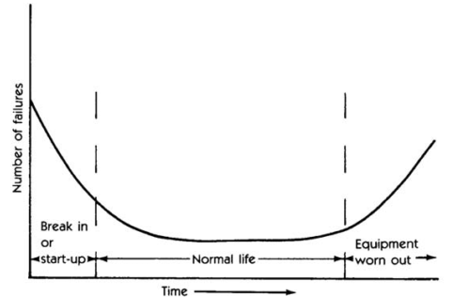
Figure 1, Bathtub Shape
(Mobley, 2002)
However, the unreliability in system failures is controlled by lowering the uncertainty of equipment failures occurrence, which can be accomplished by following the appropriate maintenance programs. For example: Preventive maintenance and predictive maintenance. This justify the need for effective business operations of complex systems demands to invest in necessary maintenance programs to prevent the system from any financial or quality risks. Moreover, the recent evolution and maturity in technology industry growth over the past few decades, with the market trends increment and the competition between companies have led toward cost reduction approach and higher quality. Therefore, many companies start utilize maintenance management programs in their operation and process to maintain effectiveness and efficiency in their production line.
The 1950s is often viewed as a period of arising the Maintenance philosophy and has been evolved worldwide during the industrial revolution (Alsyouf, 2007). With the application of prevention approach, it has begun to be the foundation that establish much mature ground base which take major role in operational function. Peng (2012) defined the maintenance as “combinations of all technical and administrative actions intended to retain an asset or a system in, or restore it to, a state in which it can perform the required functions”. Although, maintenance concept vary from one area to another but it regularly aim to increase the availability of systems and to ensure its operation with highest production line and product quality without impacting daily operations.

Types of Maintenances
There are different approaches for implementing the maintenance program, which companies use to increase the availability of their assets and utility of their facilities, such as Preventive Maintenances (PM), Predictive Maintenances (PdM), Times-Based Maintenances (TBM) and Run-To-Failure maintenance. Figure 2 shows the variety off maintenance methods, which categorize the maintenance type based on failure event. Before detecting the failure, the action taken to maintain the system is called preventive maintenance and subsequently predictive maintenance and time based maintenance are performed. On the other hand, if the failure occurs then an action is required to rectify the fault and bring system back to its normal operation. The maintenance type of this category is Run-To-Failure maintenance but there are more maintenance types, which are utilized to reduce the traditional maintenance method weakness. Some of these schemes include Total Productive Maintenance (TPM) and Reliability Centered Maintenance. (RCM) Typically, most organizations usually follow two approaches of maintenance methods: Run-to-failure and PM (Yu, 2019). To highlight the importance of predictive maintenance approach in complex system environment, conventional maintenance management methods should first be reviewed.
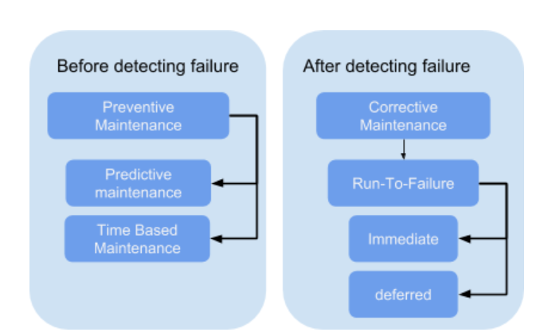
Figure 2, Maintenance types

Run-To-Failure
Since maintenance has its origins in the manufacturing industry, at an earlier period the corrective maintenance, which recognized also as run-to-failure was used in most disciplines especially in small industries for its lower cost. Later method was PM in which maintenance actions are conducted before defects are recorded and it is usually planned with an agreed date and time interval and period. Run-to-failure is the most used method for its simplicity and effortless, keep the asset in operational mode until it fails; or else, no repair is performed (Mobley, 2002). Although this approach is simple but in some cases it might be costly, since asset spares are required to be available always which has a cascading effect of material delays or shortages in manufacturing process. Run-to-failure does not consider any preventive measures, when a manufacturing process interrupted for unplanned incident it accumulates downtime. Obviously, the most direct impact of downtime is a shortage of production line in which can be translated to lost in revenue. Therefore, run-to-failure is the approach that the majority of organization tend to avoid (Mobely, 2002). Nevertheless, this approach is used in some industries for conducting performance test for non-production asset.

Preventive Maintenance (PM)
PM is defined as “an equipment maintenance strategy based on replacing, overhauling or remanufacturing an item at fixed or adaptive intervals, regardless of its condition at the time” (Kahiry & Kobbacy, 2008, p.51). During the PM, parts replacement is completed at a defined portion of time using analytical function built by historical fault dataset of system components. The basic difference between PM and predictive maintenance (PdM) is that first one utilize the measurement system which collects the logs in order to compute the Mean Time To Failure (MTTF) where's PM depends on the overall lifetime analysis. Examples of the PM activities incorporate site inspection, operation test and diagnostic, adaptation, calibration and components replacement. The main aim of PM is to ensure extended lifetime for devices as well as to prohibit some major devices from damage. Kobbacy and Murthy (2008) suggested that PM might be the most difficult of maintenance actions when it comes to mathematical modelling and this is due to the fact that only one value is generally can be calculated on the curve indicate the cost and availability in anticipation of PM interval, and the analysis is usually undertake to define failure rate prediction at a range of preventive maintenance interval.
Preventive maintenance developed to a new approach namely Condition Based Maintenance (CBM). CBM explained by Mobley (2002) as “the activities are defined as all activities involved in the use of modern signal-processing techniques to accurately diagnose the condition of equipment (level of deterioration) during operation. The periodic measurement and trending of process or machine parameters with the aim of predicting failures before they occur.” The condition of assets are continuously monitored and the maintenance activities are conducted based on the information received from monitoring system. Information such as vibration, temperature, acoustic, power voltages and electrical current (Tian et al, 2011). CBM imposes that maintenance action should only be made when definite measurement show signs of degraded performance or forthcoming failure. Predictive Maintenance (PdM) make use of information collected through CBM in order to make a prediction of future asset status and take a decision based on prediction parameters.
Condition Based Maintenance utilize real-time event of device current condition to spot all system devices health and condition, and based on these events the system is maintained at a proper need and conducting the maintenance task only when necessary. By utilizing Condition Based Maintenance, according to Al-Turki (2014) there are advantages of applying Condition Based Maintenance, it assists to decrease the maintenance operation activities, which can be translated to better system reliability and cost effectiveness. However, the achievement of high maintenance reliability by leveraging condition-monitoring maintenance has some disadvantages. The technology and tools used to gather system components historical data are not cost effective, especially in small firms. This is due to the fact that these monitoring tools cost could be much more costly than the real expenses of the devices. Another limitation of Condition Based Maintenance is the number of additional devices, which will, needed to monitor all the components, such as sensors. This will increase the need to perform extra maintenance activities on these monitoring tools that means additional cost and resources.

Preventive maintenance challenges
Despite the fact that preventive maintenance method is currently used in many organization and has shown a lower rate of system components failure and ensuring uninterrupted production (Ab-samat et al, 2012). However, introducing the preventive maintenance program as part of maintenance management somehow is not that simple. It requires resources, financial support, coordination from all organization entities and management support. Challenges of preventive maintenance implementation can be categorized into two domains as follows:

Financial challenges
Maintaining financial stability for maintenance program is very challenging task for organizations, where unnecessary expenses in maintenance occur because of over maintenance program or under maintenance program (Andreson, 2002). The main problem with over maintenance is a significant cost caused by implementation of non-value added maintenance activities. On the other hand, under maintenance usually viewed as activities with extra expenses willing to be reduced in order to increase profits, as a results maintenance management has difficulty to preserve between the maintenance cost and performance needs. Andreson (2002) investigate the impact of maintenance frequency on the over maintenance issue. Conservative perspective to decide the preventive maintenance recurrence has shown expansion in maintenance destruction and has no beneficial value to the failure perception or preventing the fault. Therefore, defining the frequency of applying the PM tasks will influence the overall financial status, and reducing the frequency of maintenance activities required for low critical asset provides an approach to reduce cost and waste.
One type of cost involved in preventive maintenance plan is resources, such as manpower, lack of manpower and planning of the workforce can have a financial impact to the business. Carvalho and lopes (2015) highlighted the importance of having appropriate resources performing the planned maintenance, also there was insignificant planned preventive maintenance activities were performed and insufficient resources to perform the required maintenance. As to ensure the cost-effectiveness and productivity of preventive maintenance program, the author suggests allocating the appropriate resources without significant investment.

Technical challenges
Establishing a preventive maintenance program has some technical challenges; one of them is lacking the data, which is required to provide valuable insight into problems about to occur as well as building the necessary knowledge base to plan an effective preventive maintenance plan. Using information is essential for maintenance management entity to estimate the performance of applying PM program and recognize the strengths and weaknesses at business unit. In addition, failure history is essential to maintenance team in order to build a knowledge base. Yao et al (2004) suggests that effective implementation for preventive maintenance needs a specific data, which is collected from the systems infrastructure in semiconductor manufacturing. In general, the date include holistic overview about maintenance, system components failure history, production and quality. However, in order to collect the data an investment in technology is required such a tool management system, which provides information about the asset and associated maintenance activities. For example current status along with the holistic view of all preventive maintenance activities, inventory records, dispatching resources and a record of all previous maintenance activities.

Predictive Maintenance (PdM)
PdM is the procedure which is responsible to monitor the machinery and production process from time to time by using monitoring tool or by using manual observation and inspection. According to Mobley (2002, p.4), predictive maintenance to some entity, is explained by the action of auditing the condition of a machine with the objective of identifying any malfunction that could have potential problems and to avoid any critical failure. However, to others, it is the process of predicting electrical devices using Infrared thermography instruments. Typically, All definitions of predictive maintenance represented by a periodic time frame monitoring of the machinery status and operation condition to keep the unexpected failures at lowest level.
With predictive maintenance, notifications are automatically generated as a result of failure analysis calculation. Using configurable parameters a notification for the concern team is generated when a part of equipment or process exceed the number of failures within the specified time frame. The time frame is usually defined by maintenance expertise and based on the risk analysis and business needs. To better understand the PdM methods, a review of several types of approaches is introduced. There are different predictive maintenance approaches, Chenq et al (2015) suggests that these methods can be categorized into three main categories: model-based, case based and data-driven base.

PdM Model Base
Model based is one of the methods of applying predictive maintenance program, in which it assumes that faults prediction can be achieved by creating mathematical model. According to Tian et al (2011), this approach is hard to be achieved as to build mathematical model, also Cheng et al (2015) there is a limits of applying the model based methods as it is not an easy task and it is difficult to precisely identify the machine behavior of complex actual world scenarios. This is due to the fact that some system components failure propagation process and response is complex.

PdM Case Based
The second type of predictive maintenance is the case based method, which utilizes the model-based approach. A prediction of system component failure in a new scenario can be achieved by utilizing previous model of any related case chosen from model-based approach, which is created by holistic information. Cheng et al (2015) suggest that implementation of this method is much easier than other methods. However, this approach requires sufficient historical data collected during enough period and this method cannot be implemented for systems that have no enough information and requires significant investment in technology to collect and store all the information required for processing. In addition, this method is time consuming to decide which is the best cases to be selected from the library created from model-based method especially for the system that requires continuous monitoring and critical environments

PdM Data Driven Based
Data driven based approach involves using the data collected from monitored system and its components to perform health check and failure prediction, and the results of the prediction approaches are the predicted fault time and the related uncertainty. The prediction of machine fault time distribution can be acquired for the machine or device being inspected by the sensor or real-time monitoring tools.

Artificial Intelligence (AI)
AI is a subdivision of computer field which studies building code, technology or algorithm to empower the machine and the goal is to mimic, develop or demonstrate the human intelligence, such as decision-making, text processing, and visual perception. According to Kubat (2015), Artificial Intelligence defines as following: “starting from an initial state, find a sequence of steps which, proceeding through a set of interim search states, lead to a predefined final state”. The technology landscape of artificial intelligence cover a wide range of engineering topics worldwide with the applications being implemented in many major disciplines, including intelligence control of electronics devices, cognitive cyber security, computer vision, robotic personal assistants and autonomous vehicles.
Artificial intelligence is a broader field that includes several subfields, i.e. Machine learning, Neural Network, and Deep learning. These terms are used interchangeably and they cater to a particular set of operations to achieve artificial intelligence. Figure 3 shows the main subset of AI. Machine learning (ML) is considered a form of AI where machine does not require any set of rules to be fed rather than learning from data by applying ML algorithms. Similarly, neural network is a branch of machine learning where it attempts by humans to create an artificial brain by applying the same rules of human brain to generate intelligence. In the current stage of development of Artificial Neural Networks (ANN), though, it would be more apt to describe them as a human attempt to mimic the way the brain is supposed to do things. Although Deep Learning (DL) is a particular kind of ML which is originally built based on computing system using Neural Networks (NN), however the contrast between both terms stand in the number of blocks of neural. In other words, Deep learning is a term used for sophisticated neural network. This complexity is attributed by detailed patterns of the data nature can be processed by the model.

Artificial
Intelligence
Machine
Learning
Neural Network
Deep
Learning
Figure 3, Main subset of artificial intelligence

Machine Learning (ML)
In this section, a review of different ML methods is conducted in which could be utilized for PdM at Dubai Toll Collection System. First, it will introduce the basics of machine learning. Then an overview of machine learning methods and functions, after a detailed theoretical background and relevant algorithms used in this dissertation to test the performance of the model are provided. Later this section will describe the regression algorithms and classification algorithms, which is the general form of the problem in this paper.

Introduction
An algorithm consists of a set of commands to resolve a defined issue, according to Corman et al (2002), algorithm defined as any well-defined computational steps that receive value as input and produces some new value as an output. ML algorithm, which is also referred by “Models”, is typically a mathematical articulation that demonstrates dataset in the subject of a defined business problem. According to Bakshi (2018), machine learning is necessary to exploit any opportunities hidden in data. Since data is growing and technology is getting more advanced, extracting valuable information and discovery the necessary knowledge with manual process is extremely challenging. The size of data is huge for performing statistical analysis with traditional methods, leveraging potential correlations and relationships between unstructured data is the key factor for successful business operation. Machine learning was realized by many researches as solid mechanism and it is applied widely in many disciplines, including aerospace, understanding the human genome, self-driving vehicles, stock market and health care.

Machine Learning Methods
Generally, based on the availability of data used by learning algorithm to address the problem, machine Learning includes different types of algorithms to build the models, discover patterns and predict variables, these algorithms can be classified into the below methods:

Supervised learning
In this method, dataset mining process of inferring an output from labeled data and model training process occurs with data that is already defined and known by the user. Using the supervised learning methods, more insight can be extracted from the data with the risk of getting unnecessary information. In this case, the supervised learning algorithms might over fits the data which automatically leads to a loss of prediction functionality. The learning process is controlled by the known labeled output. However, the supervised learning methods need sufficient training data. Some of Supervised learning examples include classification for discrete prediction and regression for the continuous ones.

Unsupervised learning
Unlike supervised learning, the observation features are known and fed to the algorithm and the predictor is not defined. The new insight about the data is to be produced with just the raw data and with this learning method; it might be used to construct a class prediction for totally new inputs. Moreover, these discovered labels then become the basis for classifying any new unseen data

Reinforcement learning
In this category, the model is also built using dataset but unlike supervised and unsupervised learning, it is taking progressively suitable action to maximize cumulative rewards during the learning process.
There are many types of functions that can be achieved using ML. according to Barga et al (2015); these functions can be categorized into four major groups:
- Regression: Regression is used to build a prediction about variables by evaluating the correlation between the dependent and independent variables.
- Classification: Classification is used to predict categorical variables and recognize what class the new observations are reside in. There are two types of this function: Two-Class Classification and Multi-Class Classification.
- Clustering: This model is used to discover a structure which Separate similar data points into intuitive groups.
- Anomaly Detection: Find unusual occurrences in the data, in which spot and foresee abnormal observation values.
For each type of these functions, there are multiple algorithms suited for the desired output. However, according to Nykyri (2018), the best algorithm for each task depends completely on the dataset provided - for example, on some problems neural network might produce better results than random forest algorithms. Nevertheless, it is strongly recommended to test multiple algorithms and evaluate the best model which produces the desired results. Some of machine learning algorithms are listed in table 1.
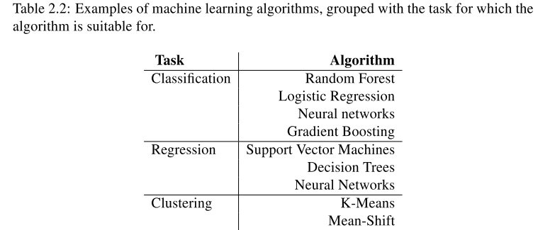
Table 1, Machine learning algorithms (Nykyri, 2018)
In all types of machine learning algorithms, data size is crucial to build a successful model, and the more data used in building the machine learning model, the more it can learn and imply the outcome to insights (Bakshi, 2018). Typically, Machine learning process can be described as follow: first and before the model is created, the data is split into two or three subsets, training and testing datasets and only the trained data is utilized to construct the model and test sample for testing the models performance (Nykyri, 2018). in Bakshi (2018) perceptive, it is necessary to go beyond this approach and use a third validation dataset, this is usually a good practice to keep a clean validation data to enhance the confidence of ML model ability to generalize and in order to be used in new dataset that have never been used before. The next step of machine learning process and once these subsets of data are generated from the original dataset, the model is trained by applying the training data and later model performance is evaluated using test and validation dataset.

Machine Learning (ML) Algorithms
This section will discuss concepts and methods of the most utilized algorithms in ML. This includes algorithms such as Linear Regression, Logistics Regression, Decision Trees, Neural Network (NN) and Support Vector Machines (SVM).

Neural Network (NN)
Neural network (NN) can be described as an attempt by humans to create an artificial brain. In the current stage of development of Artificial Neural Networks, though, it would be more apt to describe them as a human endeavor to mimic the way the brain is supposed to do things. Learning about Artificial Neural networks requires a new vocabulary. An artificial neural network is not programmed, it is taught. An ANN’s speed is measured not in terms of instructions per second but in terms of interconnection between neurons per second. NNs have the capability to obtain knowledge as well as performing complex information processing.
According to Silva et al (2017), NN is a set of processing modules, described with artificial neurons, joined with many interconnections, deployed as vector and matrices of systematic weights. Neural Network is in fact an old concept, but had been one of the most favor learning algorithms for a while. It was applied during the period of the 90s, but nowadays, it is considered as the state of the art approaches for different machine learning algorithms. Some of NN algorithms include back-propagation, Hopfield, Kohonen networks and adaptive resonance theory. The most traditional algorithm is the back--propagation, defined by multilayer perceptron (Barga et al, 2015). Other ML algorithms are exits (i.e. linear and logistic regression). However, for particular machine learning cases in which complex nonlinear function is necessary, for example, classification problems that training set contains different nonlinear features (i.e. image processing), in such cases, many polynomial terms should be model in order to get the right hypothesis to solve the machine learning algorithms.

Model of Neural Network
Generally, the simple form of Artificial Neural Network model consists of three main elements, as shown in figure 4 (Hawkin, 2009):
- Inputs signals each of which is characterized by a weight of its own
- Summing junction which combine all inputs with the respective weights.
- Activation functions for restrict the yield value of the neuron to defined scale.
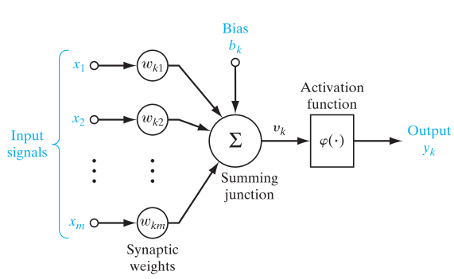
Figure 4, Model of neuron
(Hawkin, 2009)
Mathematically, the computational model for the neuron can be illustrated by the following equation:
$y_{k}=φ(u_{k}+b_{k})$ where $u_{k}=\sum_{j=1}^{m}{w_{kj}x_{j}}$
$x_{j}$ denotes the independent parameters; $w_{kj}$are the relevant weighted associated with each neuron; $u_{k}$denotes the linear operator output caused by independent variable; $b_{k}$ denotes the bias; $ϕ$ denotes the activation function; and $y_{k}$is result of hypothesis function.

Activation Function
In Neural networks, the activation function determines the outturn of a neuron via capturing non-linear relation between the observations and eventually convert into a more useful output. There are multiple activation function can be utilized in the model. Some of these activation functions include: linear function (equation 1), logistic function (also called Sigmoid) which creates an output with values between 0 and 1 (equation 2) and hyperbolic tangent function (equation 3) (Helmiriawan, 2018). In the linear function, the model can be employed to create a linear model, however, in some machine learning problems the correlation between the predictors and output is nonlinear hypothesis function. Therefore, logistic and Hyperbolic Tangent activation functions are implemented when input variable of defined model is nonlinear functions.
$f\left(x\right)=x$ (1)
$f\left(x\right)= \frac{1}{1+e^{-x}}$ (2)
$f\left(x\right)= \frac{e^{x}-e^{-x}}{e^{x}+e^{-x}}$ (3)

Advantages and Disadvantages of NN
The most challenging task in solving Artificial Intelligence problem is whether to use Neural Network or traditional machine learning algorithms. There is no “perfect” machine learning algorithm that will produce good results at particular problem, in fact for each type of problem a specific algorithm is suited and might achieves good outcome, while another algorithm fails heavily. In addition, it relates to a great extent on the nature of dataset and the aim of model development. However, neural networks have some known advantages that make them most satisfactory for particular problems and circumstances. The main advantages of neural networks is the capability to model nonlinear hypothesis function and identify the relationships between input and output, another advantage is the capability to outperform to a certain extent every other machine learning algorithm (Hawkin, 2009). Tu (1996) discussed the advantage of using neural networks compared to logistic regression. The author highlights some of the advantages of using this method such as it requires fewer training, capability to discover viable relationship across predictor features and the ability to apply more than one training algorithms.
Despite the fact that ANN have appeared to be a successful method in many machine learning problems and heavily used for pattern detection, classification and clustering. However, their performance for some problem is not adequate. Kashei and Bijari (2010) has proven with empirical evidence that the results of artificial neural networks in time series forecasting problem is not satisfactory. Another limitation of NN model is the unexplained behavior of used network, it is not possible to understand the results of the model and this reduces trust in this method. Many studies have shown that neural network require a high computational resources power and hardware dependencies Tu (1996). However, over the past few years many technological service providers have made significant investment in Artificial Intelligence and machine learning. Nowadays, Cloud solution makes it easy for organization to conduct experiments with different algorithms without worrying about the hardware dependencies.

Linear Regression
Linear regression is considered as one of the earliest prognostication methods used within statistical analysis. In fact, Carl Friendrisch Gauss originally started it in 1795 (Barga, 2015). Prediction using linear regression means fitting a linear function between input and output values, and exploit the line to forecast the outcome given a value of observation. There are two main classes of linear regression: first, is the simple linear regressions and second is the multimode linear regression. In simple form of linear regression model, it is formulated to discover the relationship between a single input and a corresponding output. However, in multimode linear regression, the model is developed to discover the relationship amongst two or more input features and corresponding output parameter. Generally, the mathematical form of simple linear regression model is described by the following formula (Shea, 2005):
$$Y_{i}=β_{0}+β_{1}X_{i}+ε_{i}$$
Y denotes as the output value, beta zero intercept, beta one is the slope of the line (beta 0 ,1 also known as the model coefficients or parameters that) , Xi is the inputs applied to forecast the dependent variables and εi the error related to the input which cannot be interpreted by the input values.
The random values in dependent variable causes each pair of observed value to produce different results. This is the nature of linear regression model; therefore, a method is necessary to evaluate the linear regression model. Couple of ways which is utilized to evaluate the model effectiveness with the linear regression. The most used one is the least squares estimation procedure. Bender (2016) presented a literature review about several linear regression methods for use cases at modern industrial plants, the paper suggests that ordinary least squares and ridge regression methods can be used to build an accurate model for prediction of failures. However, according to Helmiriawan (2018) some of the predictors in the hypothesis function are not linked with the response. In addition, these inconsequential relationships add complexity to the linear regression algorithm. In the ordinary least square technique, the values of the model are estimated by choosing the smallest possible sum of squared errors within the predictor value and the actual response variables. If considering $\hat{β_{0}}$ and $\hat{β_{1}}$ are the estimation values of the parameters β0 and β1, respectively and Y hat is the prediction value of model, then the mathematical form of lease-squared errors is given by the following formula (Shea, 2005):
$\hat{Y_{i}}$ = $\hat{β_{0}}+ \hat{β_{1}}X_{i}$
The main advantage of linear regression model is linearity, which makes the approximation procedure uncomplicated and easy to be explained beside the interpretability of the resulting model. Helmiriawan (2019) highlights the importance of using linear regression model, it help the engineers at the organization to gain any knowledge about failure by conducting root cause analysis and perceive the intended meaning of the link between dependent and independent variables . However, linear regression model is not good with respect to predictive performance. This is disadvantages is due to the fact that the relationships that can be learned is so restricted and usually oversimplify over real life scenarios. Another disadvantage of linear regression that assumption of the model is considering the relation is linear and expressing the model with a direct line, which is not valid in all ML problems. In addition, linear regression models are very unresponsive to anomalies values within the dataset. Although, the outliers is considered as influential point and can have a dramatic impact on linear regression model, however this depends on the dimensions of the dataset. For example, if the dataset dimension is small, the impact of outliers is minimal but if the data size is not huge then outliers will have a bad prediction or estimation of the linear regression model.

Logistic Regression
Likewise, in the Linear Regression, Logistic Regression is a method for predictive analysis which describes data and expound the connection between dependents and independents variables. The only difference is the response variable can take only one of two values, usually the dependent variables take the form of one and zero or yes or no. According to Elliott and Woodward (2007), logistic regression also used when the requirements is to rank the respective significance of predictor variables in describing the response variables and to compute an odds ratio estimate the importance of a predictor variable on the input value. Some of the types of logistic regressions include binary, multinomial and ordinal logistic regression.
The simplest form of logistic regression algorithm is the binary where the output value should be dichotomous in base. The mathematical design of binary logistic regression is given by the below formula (Elliott & Woodward, 2007):
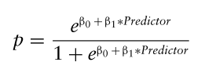
P denotes as the likelihood of the variable when Y = 1, which denoted as p =P(Y=1) β0 is the population intercept parameter and β1 the coefficient for the predictor variable. When the coefficient takes the value of zero, then the logistic formula indicate that logistic regression does not exist and if the coefficient takes a value other than zero, then the independent variable signify the model in predicting the probability of the observation. The above formula shows that once βi are fixed, it can easily compute either the log-odds that Y=1 for a given observation, or the probability that Y=1 for a given observation.
Logistic regression is widely used model in predictive analysis, the popularity of this algorithm is due to the ability to interpret the model performance as well as simplicity in straightforward concept (Dreiseitl and Ohno-Machado , 2002). Another advantage of Logistic Regression is it does not depend on the assumption of normality of data population for the dependent variable or the error and it facilitates the influences determined to different nonlinearly (Janzen and Stern, 1998). From a computational point of view, logistic regression does not require too many resources since independent variables does not require to be scaled and no fine-tuning is required. On the other hand, the drawback of logistic regression it cannot use it for non-linear type of cases since its decision based on linear nature. Another disadvantage of logistic regression is the dependency on a proper presentation of the dataset; this means that the algorithm is not practical unless the significant independent variables are identified.

Decision Trees
Decision Tree is known method for solving classification and regression machine learning prediction, with a hierarchical structure of if/else responses. These questions are called tests and they generate rules for classifying observation. According to Basto et al (2012), the decision tree can be used for different types of data but the most common one is numerical data and it is often preferable to structure nominal attributes before using the model. Generally, the model split the input variables iteratively depend on explicitly conditions. The aim of this algorithm is to make the variance between different internal branches as large as possible and reduce variance within each branch of the tree to the minimum level (Barga, 2015).
Decision trees are considered as a kind of supervised learning method since the targeted attributes are already predefined. Although Decision tree can be used for categorical and continuous values, however in machine learning problems with continuous variables the regression model or neural network are generally more appropriate methods. The main advantages of decision tree is the ease of use due to the nature of model structure which is based on visualization. In addition, the algorithm property is entirely invariant to scale the dataset, since every attribute is handled individually. In addition, the possibility of splitting the dataset does not rely on scaling the inputs. Decision tree does not require any type of preprocessing of the data such as normalize or standardize the input variables (Bakshi, 2018).
Typically, the algorithm perform reasonably, when the parameters of the model are on distinct scales or homogenize by nature of logistic and continuous data set. Decision trees algorithm has two main advantages: Visualize the model is simple, and the methods are completely never changing based on the scale of the dataset. This is due to the fact that for every variable is being processed individually, and the possibility of split of the variables do not rely on scaling. On the other hand, the main disadvantage of decision tree algorithm is that any slight modification of the features can result a great variance in the structure of the model which results in instability and poor generalization performance. Also, in large dataset the decision tree training process is relatively expensive and it requires a lot of computing resources as complexity and time taken is high.

Support Vector Machines (SVM)
According to Rothman (2018), a support vector machine (SVM) classifies input data by transforming variables into higher dimensions and then classify variables into two classes. This is achieved by finding a hyperplane in a multiple dimensional space in order to distinctly classify all attributes. The general concept of the support vector machines is demonstrated in figure 5 (Kubat, 2015).
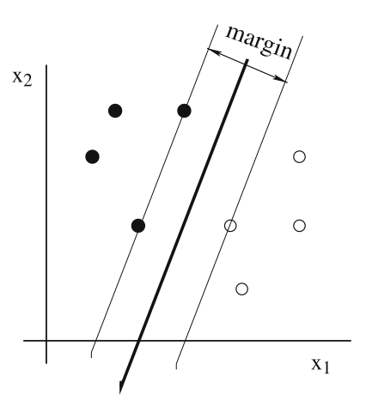
Figure 5, Support Vector Machines technique
(Kubat, 2015)
The line between the two classes is the ideal model fit, which split the variables into two classes in this case which is considered as optimal hyperplane. The data for observations fall on either side of the other two hyperplanes which can be assigned to no identical classes. On the other hand, each Supporting Vector is the observation which is adjacent to the hyperplane and it guides the location and direction of these two lines. Main objective of Support Vector Machine is to make the margin as large as possible for each classifier (Kubat, 2015).
The main leverage of support vector machine, it can be used for nonlinear problems. Cgen et al (2005) argues that when comparing support vector machine with artificial neural network, the overfitting problem can be easily controlled by choosing the right margin which splits the data points into appropriate classes. Another advantage of SVM is the ability to provide a good generalization, which means Support Vector Machine can be robust in case the training features have some bias (Auria and Moro, 2011). On the other hand, when the data is unstructured or semi structured (i.e. text and images) then the Support Vector Machine produce good results. Although this algorithm provide considered superiority method for some machine learning problem, but it requires a high memory usage and computation processing time in order to handle the large amount of data (Zhang et al, 2005). According Auria and Moro (2011) the common disadvantage of support vector machines technique is the lack of transparency when it comes to interpret the outcome of the model. In other words, with this method it cannot construct the results as simple hypothesis function of the original problem. This is due to the high dimension of model classifier.

Machine Learning and Predictive Maintenance
With the arise of technologies and the Internet of Things (IoT), the amount of information that organization generating has been more than ever before and companies are learning how to leverage their data to build a knowledge based about their maintenance and predict future failures. The source of maintenance data can be collected from multiple resources; according to Mobley (2002), a border predictive maintenance scheme should utilize multiple monitoring tools in addition to troubleshooting mechanisms. Some of these approaches incorporate visual check, ultrasonic sensors, vibration sensors, thermography images, tribology and other nondestructive monitoring tools.
There are many artificial intelligence techniques, which utilized in the past three decades to address the maintenance challenges, and the implementation of artificial intelligence approaches for maintenance program has been evolved to extend over a wide area of disciplines by applying different techniques to address different challenges. With artificial intelligence and advanced technologies, industrial companies have the capability to process enormous amounts of data collected by sensors faster than ever before. This allows the business to have the opportunities to enhance maintenance operations and leveraging a real time monitoring which allow stakeholders to make more informed decisions about when a machine will require a repair.
Maintenance programs are a key area that can drive significant cost savings, and add productivity value to the business and the cost of machine faults have negative impact. According to Kobacy and Murthy (2008), roughly 50% of the activities conducted by supporting team was on fixing the machines; around 25% was on implementation of preventive maintenance program and remaining on other type of maintenance. It shows that rectifying the faulty machines have substantial proportion of overall maintenance activities taken by maintenance team and every department in all companies in the research have to carry out a repair.

Predictive maintenance (PdM) Model
In PdM, Data driven based approach involves using the data collected from monitored system and its components to perform health check and failure prediction, and the results of the prediction approaches are the predicted fault time and the related uncertainty. The prediction of machine fault time distribution can be acquired for the machine or device being inspected by the sensors, real-time monitoring tools or inspection checklist. There are many ML approaches to apply data driven based predictive maintenance approach. Among these methods, ANN have been proven effectiveness and flexibility for data driven predictive maintenance approach (Tian et al, 2011).In most industries and complex systems the actual failures are complicated, hard to predict and nonlinear. However, ANN and FL techniques are reasonable for failure predictions due to the fact of their capability in approximating nonlinear functionality and changing dependencies.
Although data driven approaches is sufficient for the systems where the data collected by measurement system required modeling the fault prediction, comparing to the model based approach. However, studies show that the data-driven modeling needs time for learning process, in which might consume a lot of technological resources and a long time to process the data (Cheng et al, 2015). Liue et al (2012) found that there is another limitation of data-driven modeling, which is the fault prediction, is normally non-transparent to the maintenance entity. In some sophisticated applications (e.g. banking fraud detection, earthquake prediction and stock market), there is no place for tolerance and defining the reasoning behind the prediction cannot be compromised and forecasting logic accuracy is necessary.
In spite of the disadvantages of data driven methods during the past years, predictive maintenance has developed gradually and at present, data driven based approaches have become the most desired ones. Thanks to the artificial intelligence and machine learning techniques. According to Yu (2019), currently data driven based methods are applied to systems that are not feasible to use previously and this is due to enhanced machine learning methods which results increase the value and necessity of shifting to the predictive maintenance program. Since the last decade, to so high a degree more studies interests in data driven based methods have been paid attention on the imply of dynamic models such as different types of ANN and FL techniques (Liu et al, 2012).
There are earlier studies of machine learning methods used in predictive maintenance, for example, Alonso et al (2009) suggested a new structure to forecast time until next failure during abnormal behavior of the system. NN has been considered to be sufficient method to track the normal conditions of a generator and could be utilized to be implemented in a predictive maintenance program (Nadai et al, 2017). In this paper, to achieve valuable information from the data collected from the ETC system and its components, it is important to explore these data to produce new information on devices performance and maintenance needs, i.e. to take a decision whether corrective maintenance is required based on the real time system traffic information and devices read and using machine learning algorithms. This falls into the domain of classification and regression modeling. While the relationship between detecting the abnormal behavior of the system and predictive maintenance is closed, there are no studies directly combining those two methods to predict future failure. Therefore, different techniques and their application in predictive maintenance are reviewed.

Classification Model
In classification model is used in case of categorical dependent variable, the objective is to perform a prediction of specific class from a predefined list of labeled variables, and then use the model to identify what category the new dataset or an observed (outcome/response) variable belongs in. In general, the classification function is described as following:
Giving independent variables of $X = (x_{1}, x_{2}, ... , x_{n})$where $x_{n}$denotes the value of sample data with size n, the objective of classification model is to train the representation$X→Y$, in which $y ∈Y$is a set or category (Barga et al, 2015).
Usually, classification problem can be categorized into two types: Two-class classification, in which predict between two possible outcomes such as answering a yes and no question or identify anomalous and normal class as shown in Figure 6.b. The second class is Multi-class classification, which forecast the required value given multiple output, and response to queries with more than one value as can be seen in Figure 6.a. Some of the most often classification algorithms used in the field: Logistic regression, SVM, Bayes point machine, Decision-tree, ANN as well as Averaged perceptron.
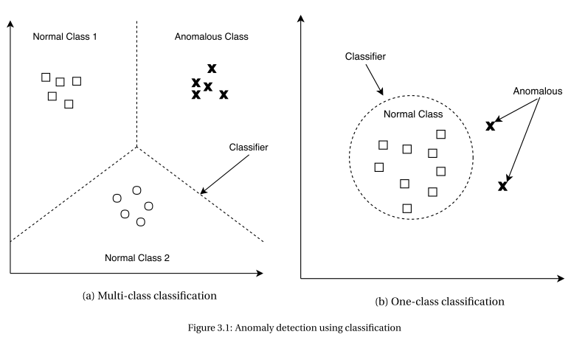
Figure 6, Classification modeling
(Barga et al, 2015)
Classification problems are considered one of the most fundamental and yet challenging for existing problems. The application of classification models are vast, these models are used for Natural Language Processing (NLP), class prediction, image classification, reinforcement training models and many other applications. A classification model is a supervised machine learning techniques used widely in machine learning applications; it attempts to achieve a conclusion from observed data and usually targeting categorical variables. The objective is to make a prediction of class of one or multiple values. Since classification model is supervised learning, then the dataset used for training the models is already labeled with the desired class, and after the model is completed the training phase it utilizes the model to learn the class for a new observation. There are many classification algorithms are available for different applications. However, these algorithms are being used in other machine learning applications and not specific only for classification problems.
This method is particularly satisfying our scenario in predictive maintenance in ETC, since the objective is to recognize a known observation status (in this case normal behavior) in order to predict whether a lane under the gantry for the toll location is operating in an abnormal state ( in this case abnormal behaviors). In addition, the feedback variable is binary in which justify the usage of logistic classification approach and it can utilize one of the classification algorithms. However, The new approaches must be viewed within the context of the failure detection; as the prediction for a failure using one algorithm might be much faster than other algorithms, the investigation of this part can guarantee a short response time by maintenance team, in which considered essential in real-time and critical applications.
Several papers proposed their solutions to mitigate the predicting system failure problem by using classification techniques. These techniques are all attention at improve system performance and device availability. Alonso et al (2009) proposed the classification model to solve the problem of predicting the Main Time To Failure (MTTF) in web service application, when the device is having short time malfunctions, which utilize system resources in random behavior. The authors tested three algorithms: Linear Regression, Decision Tree and Support Vector Machines (SVM). Linear regression algorithm in general is targeting continuous variables and not used in classification problems but it has been used in several studies to predict the next state by computing the correlation between parameters. The authors highlight that Support Vector Machines algorithm are optimistic with term of model precision, however from a technical perspective it requires a high computing processing and it is expensive to apply on real time environment. Although this algorithm was not sufficient at the time of study, but the new approaches must be viewed within the context of computational processing, since the technologies and for applying data mining are evolving rapidly. The paper also suggests that results show “Decision Tree” Algorithm is a successful model to implement the predictive maintenance for forecasting MTTF (Alonso et al, 2009). Historically, decision tree algorithm has been most commonly used algorithm for recording failure diagnosis procedures, a failure tree utilize an indication of fault or testing data as its beginning event, accompanied by a branch Decision Tree which include activities, action required and fixes recommendations( Fenton, McGinnity and Maguire, 2001).
Other research proposed their solutions to integrate intelligence into maintenance program, these approaches are all targeting to improve the performance of the production and reduce the uncertainty of the failure. Classification model proposed by Corazza and Prevete (2018) in order to predict failures in a mobile phone network. Experiment results show that that ridge regression algorithm is utilized as ML models that are capable of forecasting in the near future if a particular unit in the area is going to be in failure mode. The paper also suggests that some time additional features is critical to the ML model performance, for example: geographical information was found as a key factor to preview failures occurring, Nadai et al (2017) used both maintenance team inspection information and sensors data to build a Neural network model to determine whether the system gives any indication of failure. The advantages of applying machine learning algorithms is to successfully interpret information that has never seen before or it is difficult to observe by traditional ways (Corazza and Prevete, 2018).
There are also other approaches to utilize machine learning and predictive maintenance, for example, Recurrent Neural Network (RNN). A system developed by Zhang et al (2016) shows promising results to detect early warning events for IT system failure prediction. RNN is a class of artificial Neural Networks (NN), it adds an interesting twist to basic neural networks because it cannot understand the previous work, and it seems like a major shortcoming of traditional NN. RNN recall the past events and their decisions are influenced by what it has learnt from the previous events. RNN is a very effective method in complex systems i.e. log analysis in IT systems and showed the advantages and potentials to predict failures in system where failures tend to occur very rare.
According to Kobbacy (2012), not all Artificial Intelligence techniques are appropriate for addressing the failure prediction in complex systems and not all machine learning algorithms have been utilized. Industries are implementing increasingly sophisticated IoT solutions in countless scenarios and It is necessary to go beyond the traditional methods to enhance the predictive maintenance program. Recent research shows movement to implement mixed approaches, which utilize more than single machine learning algorithm that one may create a much more reliable and intelligent maintenance programs. Zhang et al (2016) discuss the advantages of applying two AI methods: text mining and deep learning in log-based failure prediction since logs generated by complex systems is generating extremely large number of features required for building the prediction model. Several other papers proposed their solutions by utilizing two or more AI techniques, for example Yu (2019) uses clustering algorithms in the training phase to identify the characteristics of the system, Zhang et al (2016) used clustering methods find pattern and to extract logs with similar format and content before final processing.
Kobbacy (2012) presented a literature review on the application of Artificial Intelligence models in maintenance; the research reveals that many Artificial Intelligence approaches have been implemented in maintenance program. The most common one is Genetic Algorithms (GA), and this is due to the strong and effective optimizing process during the Genetic Algorithm modeling. The algorithm has the ability to perform well to a certain extent with sophisticated maintenance systems. The paper also suggests a few implementations have been adopted on Case Based Reasoning and neural network in maintenance and small number of mixed systems have been utilized in the maintenance management. It is worth noting that there are other classification methods, although might not be suitable for the same objective as in our use case, but it deals with a similar circumstances. Therefore, the research in this can contribute to this research with insights about how to design and implementation of desire algorithm.

Regression Model
In this section, a review of regression based predictive maintenance is reviewed to understand how the regression methods will contribute to our case in the implementation of predictive maintenance program. Regression model is general a set of statistical processes widely used in engineering, for example: oil and gas industry relies on the basic regression method to calibrate dynamic elastic measurement with static variables (Tariq, 2016) and having already been used to forecast the failure by estimating the relationship between variables and it focuses on the relationship between the output and one or more input features. Regression analysis is used for predictive analysis, one of the analytics Spectrum which help to predict an event occurs in the future and the probability of an undetermined outcome. Usually the outcome is numerical variables and with the help of regression techniques, the relation between a dependent and independent variable can be defined. The use of regression model is a well-established approach in engineering, for example; Candanedo et al (2017) uses examples of these various techniques for understanding the correlation between different observations and to measure the effect of energy consumption, as evidence that models for electrical usage in facilities. This approach is used to forecast an outcome, time series analysis and detecting the causative which impact the relationship between both dependent and independent values. Some of the most often regression algorithms used in the field: Poisson Regression, Fast forest, Linear Regression, Bayesian Linear Regression, NN, DF Regression and Decision Tree (Barga, 2005). Generally, the simplest form of regression can be presented by mapping data points on a chart which would look like the theoretical figure 7. The relationship between independent variable and dependent variable can be presented by a line which goes through the middle of all observation. This line is referred to as a regression line that present the best fit of the model.
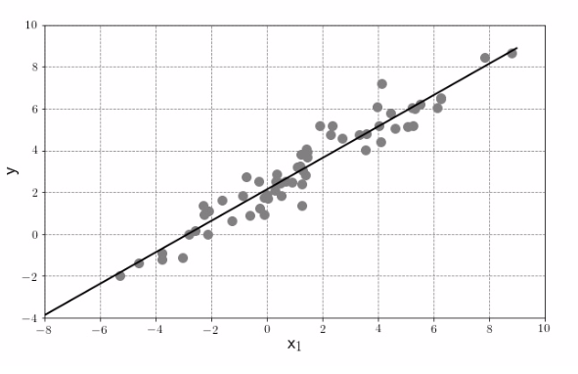
Figure 7, simple linear regression model.
Regression model is usually an implementation of a function which predicts an observation value with quantitative values. The input values can take the form of numeric or categorical, but it is usually commonly with regression model dependent variable or predicted value is quantitative. A large number of regression models have been utilized in machine learning. For example: linear regression, logistic regression, ANN, and decision-trees (Barga et al, 2015). Linear regression is considered the earliest prediction approach for numerical analysis. Prediction using a linear regression is basically fitting an optimum straight line defined by a function between input and output parameters, and then employ the line to forecast a dependent value given the independent observation. Another methods for regression model used in predictive maintenance is random forest algorithm, In Wang (2016), regression method was used to build a function for predicting the Remaining Useful Life (RUL) estimation of electro chemical machinery electrodes. The author use regression model to describe the relationships between the electrodes degradation, operation status and production quality. Generally, a good prediction model anticipate small value of residuals parameters. I.e. Mean Absolute Error and Root Mean Squared Error. However, experiment shows that when the predictor variable is almost linearly increase with time, then it is not possible to apply random forest algorithm. Therefore, other approaches must be viewed within the context of the feature engineering stage to ensure good estimation results.
Another way of doing regression is using SVM algorithm, which is considered as a form of supervised learning. SVM have been widely used in building AI framework for both regression and classification problems. The main purpose of the SVM algorithm is to determine the hyperplane, which divides input variables into two groups with a boundary of high slack. According to Tariq (2016), the SVM algorithm is able to solve complicated and complex highly nonlinear problems. Generally, there are multiple good characteristics of applying SVM algorithm, for example, once the dataset is fixed, running the model multiple times will always generate the same results. Moreover, the algorithm is capable to deal with high number of features by limiting the over fitting and automatically identify the useful feature to be selected for the building the regression model. Recent research has shown the superior performance of SVM algorithm comparing with other algorithms. Dindarloo (2016) discussed the advantages of using SVR in forecasting the time between failures of a Load Haul Dump engines, the author highlighted that SVM result a value of Mean absolute percentage error less than 2.0%. Which explained as good results of machine learning model performance. This successful result of SVM is because the algorithm concept is based on empirical risk minimization which effectively can avoid over-fitting by reducing the upper boundaries on the generalization error and recognize automatically the useful dataset for prediction model.
There is a degree of uncertainty around the usage of regression model and classification model, in general, regression model aim to forecast a continuous input and output observation. Bakshi (2018) suggested an easy approach to differentiate between both models, which investigated for continuity in the output variables, if this is the case, and then a regression model should be used to solve the business challenge.

Summary
To briefly summarize the literature review, it is noteworthy that many research exist in both predictive maintenance and machine learning based failure prediction, somehow research that directly use more than machine learning algorithm is still few, and the focus on specific approach only. Implementing a hybrid predictive model which combines two or more machine learning techniques have shown much better performance. Nevertheless, from the existing research, there is already potential of failure detection methods having good performance in the application of predictive maintenance program. Some of these machine learning algorithms including SVM algorithm, Random Forest algorithm, Genetic Algorithms (GA), Recurrent Neural Network (RNN), Decision Tree and Ridge Regression algorithm.
Although, these algorithms seems to be promising in our case. However, it is hard to qualitatively choose an optimal algorithm. Consequently, most used algorithm will later be implemented and model performance will be compared with each other to find the optimal one. As for failure prediction, the use of classification model and regression model has become popular recently. These two model is satisfying in our case of predictive maintenance in ETC, since the objective is to identify a known observation status and predict whether a particular lane is operating in an abnormal state or not. In general, in this paper, different algorithms will be applied for predictive maintenance to forecast abnormal behavior of toll system and to predict any future devices failure. Further detailed implementations of the machine algorithms are elaborated in Chapter 3. In addition, as founded from literature review, it is important to add additional features beside the sensor measurement to improve the performance of the ML models.
The common challenge is the computing cost and performance to process the huge size of data and the need for real-time failure prediction monitoring. However, over the past few years many technological service provider made significant investment in Artificial Intelligence and machine learning, and cloud provider makes it easy for organization to conduct experiments with different algorithms.

CHAPTER 3

RESEARCH METHODOLOGY

Introduction
This chapter explains the research methodology that is used in this dissertation to address the research problem. The main objective of this study is to build an advanced predictive maintenance using artificial intelligence and their algorithms capabilities. Therefore, the process of building a suitable AI model for failure detection in Electronic Toll systems and detecting abnormal behavior for transaction on each lane under the gantry is explained in detail. More precisely, building a classification model which intend to recognize a known observation status in order to predict whether a lane is operating in normal state, as well as building regression model for real time series attribute to predict specific value of trips for each lane. First, an overview of the conceptual framework is presented, then technology stack used to follow the research methodology are introduced as well as the functionality of each component. Then a presentation of the dataset utilized in this research and elaboration on several modeling approaches that are explored. Finally, evaluating the machine the error metrics to evaluate the proposed approaches.

Conceptual Framework
The aim of this study is to forecast system failures processes by monitoring the system components and meta data in order to plan ahead the optimum maintenance action. The conceptual framework introduced a decentralized platform of advanced predictive maintenance system, based on the application of machine learning techniques over maintenance data and trips history, collected by various machines and systems such as scanner, RFID readers and cameras in the same toll gate. The source of data are collected via a multi-agent system.
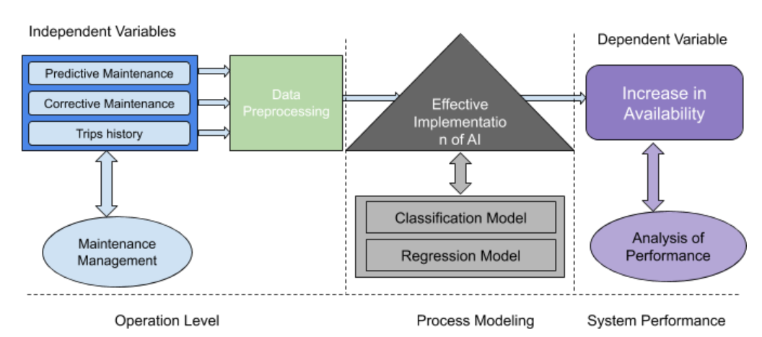
Figure 8, conceptual framework
The aim of this conceptual framework to be developed is to gather data about maintenance history, failure history as well as vehicle trips in similar toll gate from different locations. Using multiple application of distributed databases allow through the data analysis techniques the prediction of failures, executing timely actions in devices and consequently ensuring system availability and reliability. The conceptual framework demonstrated in figure 8 incorporate three main modules:
1) Independent variables, which are the operation level, this includes data collected from different sources.
2) Modeling which is the effective implementation of Artificial Intelligence.
3) The dependent variable which cover System performance.
The operational datasets are gathered including preventive maintenance, corrective maintenance actions and trips history by the different sources. These interventions are reached out following maintenance management program, including all planned preventive maintenance actions conducted by maintenance team, and all corrective maintenance activities performed to rectify system failures. Also trips history data the Artificial Intelligent predictive model process these data, applying machine learning modeling including the classification algorithms and Regression algorithms. In order to produce unforeseen knowledge about toll devices and used later to enhance maintenance productivity and system availability. It is worth to notice that the architecture of the proposed framework must be reflected to be eventually implemented on real time data. However, so far the implementation has been performed on off-line data.

Process Model Building Tools
This section elaborates on the tools and software that are used in this research. There are many different tools for data analysis and applying ML algorithms. In this study, the data for trip transactions as well as maintenance history was generated using SQL Server Reporting Service for a period of six months. The analysis and preprocessing of the toll system data was performed with Python and its additional libraries Pandas and Numpy and Matplotlib. All python libraries were obtained using the Jupyter Notebook and then the final step is processing the data into machine learning algorithm was implemented using the cloud service provided by Microsoft which is Azure Machine Learning Studio. The technology stack that is utilized in this research can be seen in Figure 9, while the role of each building block is discussed in the following subsections:
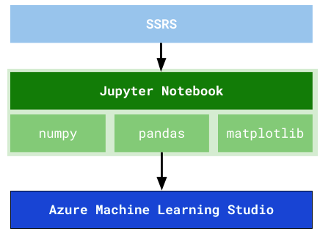
Figure 9, Process Model Building Tools

SQL Server Reporting Services (SSRS):
SQL (Structured Query Language) Server Reporting Service (SSRS) is basically server--based reports generating software from Microsoft. SSRS is one of the Microsoft SQL Server platforms that extend an enterprise and advanced presentation tool which can customize the provide a presentation of the data-driven reporting for the Microsoft Business Intelligence program. SSRS has the capability to generate, building and design reporting function by diversity of powerful data visualization tools, and it has the ability to deploy, manage data and plan the execution of scheduled reporting tasks (Stacia, 2013). The data required for the analysis are generated from SSRS by executing the report parameters which defines the data, the name of the toll location and direction as well as the period of the data. This is applied for both transactions and maintenance history of the toll system.

Jupyter Notebook
Jupyter Notebook is basically offer an open-source platform, which is used to build and execute a different programming languages scripts, as well as related language backend (Kluyver et al, 2016). It has the capability to implement a wide range of python libraries in order to load and process data, deploy statistical tests and analysis as well as execute simulations or plot charts. The Jupyter Notebook is executing scripts via the browser web page. This makes it viable to utilize one interface managed locally via local host machine or by cloud server using web browser. The Jupyter Notebook is used to run the python code for this project which is hosted in the Microsoft Azure cloud. This is including data preprocessing which includes data cleaning, filtering, handling missing and inconsistent data as well as converting data types.

Python Libraries (Numpy, Pandas, Matplotlib)
Python is a powerful programming language which is ranked between as one of the top used coding languages of prime for data science and development. Python provides data analytics capabilities to apply in initial experiments and to maintain reliance on implementation in real life scenarios. Since Python introduced toward the end of the eighties, many advanced Python libraries have been introduced to implement data interpretation and conduct statistical analysis (Barga, 2015). Below are the some of python libraries which have been used to conduct the initial stage of data processing in this research:
- Numpy (Numerical Python): is an open source library for the Python which offers fast and smooth multidimensional operations for container of generic data, it has many set of linear algebra functions as well as random array generator capabilities. Numpy tool is an essential when analysis is required due to the fact that many libraries of data analysis and algorithms rely on them, and many libraries have the ability to handle arrays better than lists automatically as a form of dataset structure in Pythons.
- Matplotlib: Matplotilb is a powerful library used by data analytics that has the capability to generate charts and visual presentation of data. It consists of multiplatform data visualization library based on NumPy arrays. In addition, it helps to streamline the process of working with small and large datasets.
- Pandas: is an open source Python library used for statistical analytics and data manipulation such as reshaping, slicing aggregations and filtering. Pandas offers data structures and data analysis tools, which is built to cover the limitation of Python programming coding (Pandas, 2019). It allows the massive amount of trips and maintenance history-formatted electronic toll collection system data to be loaded into Python and processed.

Machine Learning (ML) Tool
Microsoft provides the ML tool used in this research. Azure ML Studio is a simple browser-based includes modules and statistical tools used by data science and machine learning engineers. It has the capability to perform predictive analysis to make a thorough deep analysis and interpretation for information behind the data and transfer raw data into understandable language to business units. By making it uncomplicated for data scientists to utilize the machine learning algorithms in smooth interface architecture, Azure ML allow sufficient comprehension to extract information from various sources of data. It helps to construct, test, implement and verify predictive models in a simplified way by utilizing state of the art Artificial Intelligence algorithms and pipelines at scale (Barga, 2015).

The Data Analytics Methodology
The data analysis is a process for collecting structured or unstructured raw data and converting it into valuable information which would be convenient for business decision-making process. From the literature review, many different methodologies were followed to implement ML model. However, they are very similar and researchers have adopted the steps in the data analytics methodology depends on the environment and tools used to conduct their research in applying ML model to predictive maintenance. In this research, the following data analysis process is following three main steps demonstrated in the figure 10 as follows:

Business problem understanding
Process Modeling
(Iterative process)
Model testing and validation
Model evaluation
Data Acquisition and Preparing
Feature Engineering
Feature selection

Figure 10, Data analytics process

Business Problem Understanding
This is the main stage as it defines the right steps to take the analysis further. Prior to start building the model, it is important to defining the particular business issue in order to have accurate results and achieve a proper resolution. In this research paper, data is collected in multiple processes in ETC System. However, the collected data is not utilized, data including corrective maintenance and preventive maintenance, even though failure and maintenance/repair history, devices operating history and devices metadata are recorded but there is no gain from the information collected and recorded.

Data Acquisition and Preparing
In this stage, the raw dataset is acquired from different types of sources. This is including database of maintenance history obtained from Maintenance Online Management systems (MOMS) as well as vehicle trips history for particular location. However, the data should be collected in the right format. After the dataset is collected, the next stage is to perform analysis and prepare the data for the model. This stage involves identifying missing values, outliers and feature transformation. Usually, if the data has over 40% of null values, then it would be eliminated from the dataset, except the case where these missing data hold important information. In addition, it is important in this stage to discover if there is any relationship between features by performing statistical technique such as correlation analysis. Finally, defining the key variables for the model is performed at this step.
There are several techniques where the dataset can be prepared for applying machine learning algorithms as well as ensuring good results of the prediction, some of these techniques is dataset clean and preprocess. In this stage validation of all values are clean and accurate, by handling the missing values, validate data type and convert them to the right format (e.g. datetime, integer, strings and Boolean). Also a process of selecting appropriate feature is important at this step, which includes choosing the relevant key features of the raw dataset in order to minimize the dimensionality of the machine learning model. Finally a feature engineering process to create additional appropriate features from current dataset to help increase the accuracy of the model. Typically, in feature engineering process is completed by performing aggregation measures such as running mean and standard deviation. However, after performing the feature engineering, an increase in the data dimensionality is expected since the number of features is increased in which may overabundant and overload the model, hence to overcome this issue a further feature selection is required.

Process Modeling
In his stage, a test to the best machine learning algorithm to be used in the model in alignment with the original research question. In our case, classification model is satisfying our scenario in predictive maintenance in ETC, since the objective is to recognize a known observation status in order to predict whether a lane is operating in an abnormal state. Also a regression model is needed for our case since the objective is forecast the trips for each lane in which will detect the abnormal behavior of the toll operation. Model development is an iterative procedure in which different machine learning algorithms are tested to identify the most efficient model to meet our requirements.

Process Model Testing and Validation
Following modeling stage and since the data flow in toll systems are time-stamped dataset, model testing and validation is an important stage in order to exclude any overestimating results and model performance as well as over-fitting and evaluate how the model will generalize to a new dataset. In predictive maintenance, the independent variables are produced using lagging aggregations. Data in the same time span will likely have same feature label and values, therefore a time dependent register splitting method is the best approach for our research problem. The split is performed by either defining a point in time or based on defined proportions of the trained and tested dataset. Typically, the dataset before a particular time point is utilized for training the ML model and the rest of data are utilized for testing model performance.

Process Model Assessment
in most cases, all ML models are only an approximation of the actual production scenarios. Therefore, it is critical to evaluate the model performance before it is deployed into production environment. In predictive maintenance, device faults are generally infrequent occurrences during the lifetime of the system operation in which result a variance in the data features distribution and this is cause poor performance. Therefore, evaluating the model metrics other than only dependent on the accuracy of the model is important.

Maintenance in Dubai Toll Collection System

Introduction
The Dubai Toll Collection System (DTCS) has been implemented as a distributed system, composed of different devices linked by a communications network. Main system parts are installed at the various locations where trips information are collected and processed. The whole DTCS is built to deliver robust and high available system. The main components of the DTCS include the following:

Roadside system
There are multiple high performance servers and components are installed across all toll locations. The cameras, readers, scanners are all connected to the zone controllers. The Zone Controller is optimized for the collection and storage of data and images in real time. It collects toll information from all subsystems components, organizes it, and makes the information available to other subsystems of the DTS. It furnishes real time status displays of toll collection activity, and supports the analysis of technical data related to system performance and throughput.

Back office Data center:
The Back Office Data Center comprises of a high-speed clustered server installation that interfaces directly with the real time data collector to receive violation and transaction images which are stored in various cabinets on the server. In addition, to provide current and historical traffic reports and event data to support the activities of the DTS operations staff.

The Computerized Maintenance Management System (CMMS)
The tool is located at the central computer center and it is referred as Maintenance Management Online System (MOMS). The MOMS is a server-based software system that provides inventory management for toll system equipment, manages the dispatch of maintenance personnel, and tracks roadside maintenance activity.

DTCS Maintenance Management Methods and Tools
DTCS follow three main classes of applying maintenance management program summarized in Figure 11. DTCS maintenance management includes all necessary personnel, tools, test equipment and diagnostic software as well as administrative management for spare parts and logistics for entire scope of services. Preventive and Predictive maintenance activities are the main of DTCS’s maintenance, since they eliminate the need for unexpected emergency fixes. The Maintenance Management Online System (MOMS) is used to monitor the devices status and failures as well as planned maintenance activities.
DTCS Maintenance
Preventive
Maintenance
Predictive
Maintenance
Corrective
Maintenance

Figure 11, Dubai Toll Collection System Maintenance types.

DTCS PM
DTCS PM activities are scheduled based on field experience and in conjunction with equipment original manufacturers’ manual and guidelines. PM activities are documented on process document and registered into the MOMS application which generate work orders automatically and technicians will update the details of each task as per the plan and close the work order accordingly, in addition to routine check and system status are documented through checklist documents.

DTCS Predictive Maintenance (PdM)
Predictive maintenance focuses on failure detection and troubleshooting of system components degradation devices performance. Predictive Maintenance activities are triggered by estimated Mean Time To Repair (MTTR) and Mean Time Between Failure (MTBF). Data calculated by the MOMS for all components and parts. MOMS provides visibility of equipment status information throughout its production life service and it provides a point of view for problem to enhance the efficiency of each of equipment operations by notifying maintenance personnel of equipment and system components that require attention, this procedure greatly reduces the risk of critical equipment failures.

DTCS Failure prediction
Although predictive maintenance application is already implemented in the existing Toll traffic system, however getting a real time failure prediction is a challenge and there is intelligence in predicting the unforeseen pattern or taking into consideration other factors that may have an impact on the normal operation. In this research, a failure prediction is measured on lane level, since each lane is consistent of multiple devices taking trips record for each transaction. And any of the three main components in each lane (Camera, Tag Reader and Laser Scanner) is having a fail will contribute to the lane failure. Therefore, and to build a PdM model based on ML algorithm, two approaches are followed in this research with the below assumptions:
- Building a Failure prediction model with machine learning algorithm using the trips transaction of all lanes for the period of six months, and adding failures, errors and maintenance history to the trip history to train the model. This will be investigated by conducting an experiment with multiple classification algorithms to predict weather a failure will occur on particular lane. Also investigating if the real time vehicle class information can contribute to the failure prediction.
- Building a failure prediction model with machine learning algorithm using trips count aggregated within defined time interval. This will be investigated by conducting an experiment with regression algorithms with the same data set of trips history for the period of six months of one toll location.

Data Acquisition and Preparing

Structure of ETC data in DTCS
The process data for lane transactions log are collected from SATS application in SQL database application. The number of currently accessed records in the data logs is huge, and each record consists of data for a unique lane. A complete record of transaction contains 9 original features from date and time, transaction type, vehicle speed, vehicle width, vehicle length, vehicle height, vehicle classification, lane ID and tag read. All features are numeric features except the datetime which is the timestamp of each transaction.
The current corrective maintenance strategy focuses on three subsystems of the lane: Camera, reader, and laser scanner. The lane devices are the most delicate parts and is the object that is concerned in this research. Each subsystem can be installed on one lane and lane has unique identifiers (LaneID). All data logs are collected from the lane which runs three ideally same devices and produces one kind of trip information. Preventive maintenance and failure event history and alarm data is stored in MOMS in a consistent form. Every piece of event information contains the event type (usually an alert), start time, end time, time of acknowledgement, priority level, location, location description, event description and amount of triggers. The alerts are prioritized ranging from one to three, one being the most critical failure. Location and event descriptions tell where the alerting piece of equipment is and what caused the alert. The maintenance monitoring system is currently only used for preventive and corrective maintenance, after-the-fact analysis process disruptions and lane transaction data is centrally accessible across different platforms. As a consequence, this case study is only applies machine learning algorithms on summarized data logs, and successful models can be applied to real-time data streams in the future.
The data logs include different kinds of process error codes. Not all errors cause machine disruptions. The error code is simply the error that was given when each device was configured. The code is not used in any kind of feedback loop or tuning. In cases of process/machine errors, the operator will decide on whether or not he will start Technical Out-of-control action plan, which may include maintenance inspection on the devices and system.

Data Source
Typically, the relevant data source used for predictive maintenance include fault historical data, maintenance program records which include any repair or previous maintenance actions or device replacement, the data collected from multiple devices and subsystems during the normal operation. The data for this research combined from multiple sources which are real time telemetry transaction collected from sub-systems, error codes, maintenance history records that includes failures and preventive maintenance register. These data are described as following:

Telemetry records
This data is the telemetry time-based transactions information which includes date and time, transaction type, vehicle speed, vehicle width, vehicle length, vehicle height, vehicle classification, lane ID and tag. These measurements gathered from three sub-system for each lane in one toll location. Since the number of transactions is very high, averaged over every 15 minutes collected during six months period.

Errors records
The errors data logs are the non-breaking event generated while the devices are still in operation mode and do not considered a fault as not all errors cause machine disruptions. Similar to the transactions data, the error data and times are grouped and averaged over every 15 minutes. These errors were collected from MOMS and labeled with specific codes as shown in table 2. These errors include the low traffic scenario where the system is operating normally but there is no vehicle passing under the gantry. In such case, no data will be received from the sub-systems. Also NTP (Network Time Protocol) related errors as well as when any vehicle park under the gantry, the maintenance monitoring system will throw an error. It is important to label these events to get an accurate result during the model training process.
Table 2, system error code labeling
Category | Definition | Description | Error Code
Error | These are non-breaking errors thrown while the devices is still functioning and do not considered as a failure | Low Traffic, No data received | Error 1
Error |  | NTP | Error 4
Error |  | Vehicle park under the gantry | Error 10
Maintenance | These are scheduled and unscheduled maintenance records which correspond to regular inspection of devices | Preventive maintenance | Error 0
Maintenance |  | Accessing cameras using EN | Error 5
Maintenance |  | Road Closure | Error 7
Maintenance |  | Change Request | Error 11
Maintenance |  | Testing | Error 13
Failures | These are the records of devices replacement due to a failure. | Connection failure | Error2
Failures |  | System Error code 16 | Error3
Failures |  | Data Ready Command | Error6
Failures |  | Net Status | Error8
Failures |  | System Error Code 2 | Error12
Failures |  | Failed | Error14

Maintenance Events
The data of maintenance events include the planned maintenance activities or scheduled changes due to enhancement testing or fixes. These maintenance actions are correspondent to devices replacement during the planned inspection or replaced due to asset decommissioning activities such as End Of Life asset management. Also road closure planned activities were labeled as part of maintenance event. The maintenance event data included for the same period of the trips transaction log history which is six months.

Failures Records
Failures event are collected also from Maintenance monitoring systems, each event has a timestamp, lane ID and device impacted. Such failures include the events which as an impact on the toll operation such as communication errors. Generally, the failure occurrence is infrequent in most of system. However, when the predictive maintenance model is built, the algorithm should be fed with the knowledge about system when it is operating in normal condition as well as the failure patterns. Therefore, the machine learning model should contain enough raw data of both groups (normal and abnormal)

Data Preprocessing
Data preprocessing stage is considered as a prerequisite to the feature engineering stage, arranging the dataset from different sources to create a schema from which it is valuable to build the machine learning model. For time-based data, in this case, the vehicle transactions which is recorded every second, and to have distinct knowledge from the dataset the trips data of each lane are rounded down to the data units to specified frequency which is 15 minutes. For this case and using floor function from Pandas library, the operation is performed to data before proceeding to the feature engineering stage. Following data preprocessing for maintenance, failures, errors and vehicle trips data is described as following:

Maintenance Data
Each maintenance record has a lane identifier and timestamp with information about the device that have been subject to the maintenance action. The preprocessing for maintenance data was conducted by Python script and using Pandas and Numpy transformation function. In addition, format feature with the proper type as well as transferring device type feature into categorical where each device type was given a code. I.e. VIS for cameras, AVC for Laser Scanner and AVI for Tag reader. The table 3 is a screenshot from Azure ML studio shows a sample data for maintenance records after completing the preprocessing stage.
Table 3, Maintenance sample records.
comp | datetime | LaneID
VIS | 2019-04-19T02:25:57 | 6
AVI | 2019-04-01T02:58:27 | 99
VIS | 2018-11-15T02:30:34 | 2
VIS | 2018-11-15T03:00:30 | 99
VIS | 2019-03-22T02:15:55 | 1
AVC | 2019-02-22T02:21:27 | 1
VIS | 2019-01-27T02:06:27 | 2
VIS | 2019-04-19T03:02:47 | 1
VIS | 2019-04-19T02:35:34 | 5
AVC | 2019-02-22T02:38:06 | 4
VIS | 2018-12-15T02:16:45 | 3
VIS | 2019-03-22T02:47:57 | 5
AVC | 2019-04-19T02:51:13 | 3

Failures and Errors Data
Similar to maintenance record, each failure and errors record have the lane identifier and timestamp with information about the device. As well as error identification that have been subject to the failure and has an impact on the normal toll operation or errors data which are non-breaking event generated while the devices are still in operation mode and do not considered a fault as not all errors cause machine disruptions. The preprocessing for faults and errors data was conducted by Python script and using Pandas and Numpy transformation function. Also format feature with the proper types such as integer, timedate format as well as labeling for device which were subject to failure. The table 4 shows a sample data for failures and errors records after completing the preprocessing stage.

Table 4, Failure and error sample records
failure | datetime | LaneID
VIS | 2019-05-19T19:31:45 | 1
VIS | 2019-05-10T07:20:33 | 2
VIS | 2019-03-31T21:05:11 | 3
VIS | 2019-03-31T21:05:11 | 4
VIS | 2019-04-08T05:15:37 | 5
VIS | 2019-05-12T05:00:03 | 6
VIS | 2019-04-18T10:27:19 | 7
VIS | 2019-05-23T03:38:18 | 12
VIS | 2019-01-26T10:57:41 | 23
AVC | 2019-04-22T02:03:04 | 34
VIS | 2019-04-07T03:23:31 | 45
VIS | 2019-02-15T11:25:13 | 56
AVC | 2019-04-20T16:32:25 | 67
VIS | 2019-05-15T11:48:09 | 1
VIS | 2019-04-13T18:20:49 | 2
VIS | 2019-02-14T04:40:12 | 3

datetime | LaneID | Error ID
2019-02-16T03:35:55 | 99 | error1
2019-01-07T12:56:12 | 99 | error1
2019-05-10T15:01:24 | 99 | error1
2018-12-31T10:45:20 | 1 | error4
2019-05-22T10:36:42 | 99 | error10
2019-04-10T04:28:12 | 99 | error1
2018-11-22T02:53:08 | 0 | error1
2019-02-22T14:00:32 | 99 | error1
2018-12-31T11:00:58 | 0 | error4
2018-12-31T10:50:05 | 2 | error4
2018-12-31T10:45:30 | 4 | error4
2018-12-31T10:43:08 | 2 | error4
2018-12-31T10:41:22 | 1 | error4
2019-05-11T03:46:10 | 99 | error1

Vehicle Trips Data
The trips records for each month is merged into one data schema using Microsoft Azure machine learning models and Python scripts, along with their respective labels. The structure for each trip information as shown in the table 5, include date and time stamp, lane identification, the classification of the vehicle, vehicle dimensions, speed and weather the record is registered through laser scanner or RFID reader. Other data preprocessing steps include dealing with missing measures. Data cleaning is completed by deleting unnecessary attributes, select features which are relevant to the machine learning problem, format data in fields, feature labeling (Check if the count of class 0 trips is more than 10 within 15 minutes the trip will be labeled as “Error” if not then trip will be labeled as “Normal”). The figure 12, demonstrates the initial stage of the experiment which shows the dataset preparation and merging trips record for each month into one record.
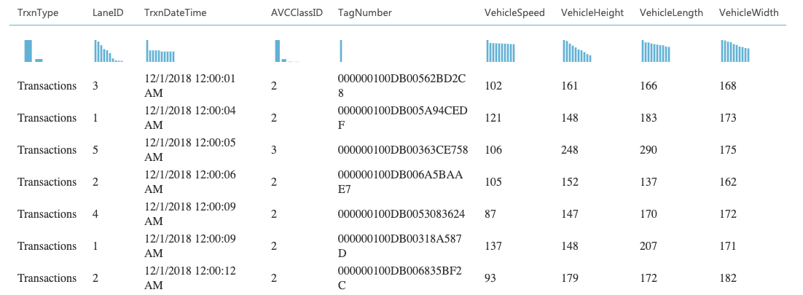
Table 5, trips sample record
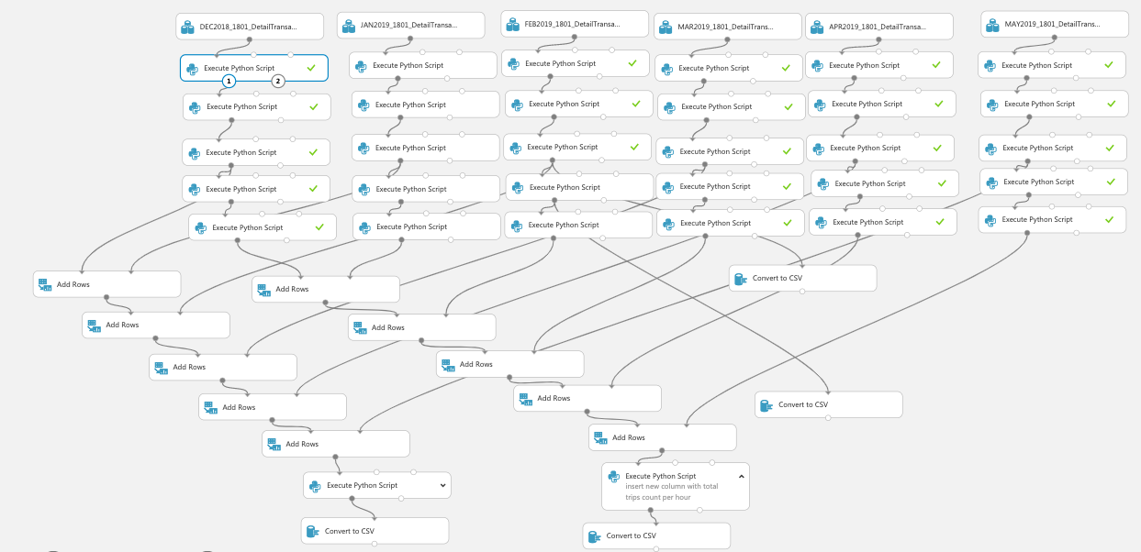
Figure 12, Data Preprocessing
Before the feature engineering stage, and after preprocessing data is completed, the final transformation is to combine all data set records including errors, failures, maintenance records and trips data into one data set based on the rounded timestamp as well as lane identifier. The final result would have null values for the failure record when lane is in operating in normal condition and complete data set ready to be modeled using the appropriate machine learning algorithm. Table 6 shows the sample record of trips after the data preprocessing process.
Table 6, Trips sample pre-proceed data
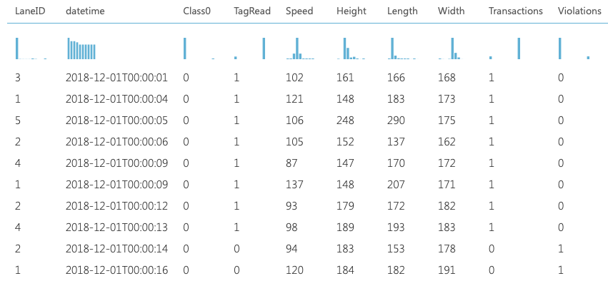

Feature Engineering
Feature engineering process helps to create newly independent features from present dataset, in which the new features are better representation of the underlying problem to machine learning model. Feature engineering helps to enhance the predictive model performance and accuracy, and make adequate preparation of data understanding and key elements that influence the analytic process and decision (Barga, 2015). After data preprocessing stage is completed, the feature engineering for predictive maintenance needs to bring the different features from different sources of data into one combined dataset. Therefore, following feature engineering functions are implemented on the input features to generate valuable new features of each data source.

Lag Attributes From Trips Data
Trips information always recorded with a timestamp, which makes it perfect for aggregation lagging attributes. Therefore, a rolling aggregation function using Python libraries (Pandas and NumPy) is implemented to compute the mean, standard deviation over the defined time window (in our case is 15 minutes). Finally, all feature data were combined into one final data source matrix prior to feed the ML model.

Lag Attributes From Errors Data
Similar to trips data, errors are recorded with a timestamp. However, errors identifications comes as categorical variables and should not be subject to mathematical computing as it is performed in trips dataset. Instead, the errors are aggregated nformation using Pandas sum function in the lagging timeframe. Another approach of feature engineering is decomposing the categorical features, which is creating a new binary variable for each type of error code. For example, a value of 1 is assigned when the error is occurred for particular lane and 0 if there is no any error is recorded. Using Python libraries and function of Pandas, the error data reformatted to create one entry per lane at which a failure has occurred. Table 7 shows the error table after transferring the categorical variables to binary. Finally, all feature data were combined into one final data source matrix prior to feed the machine learning model.
Table 7, decomposing the categorical features of errors
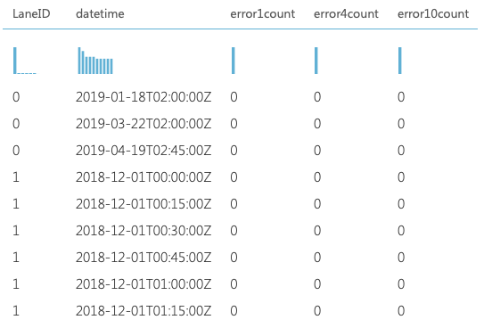

Maintenance Attributes
Maintenance records are important to be included in the machine learning model for predictive maintenance. For the model to distinguish between planned maintenance activities and actual device failure or abnormal behavior, as some planned activities might give wrong impression of system status. Since each maintenance, record has a lane identifier and timestamp with information about the device that have been subject to the maintenance action. The feature engineering for maintenance data was conducted by Python script and using Pandas, and Numpy transformation function. Which combine repairs for a given machine in a given period and decomposing the categorical features, which is creating new binary variables for each type of maintenance code. Finally, all feature data were combined into one final data source matrix prior to feed the machine learning model.

Lag attributes from Failures data
Similar to trips data, failures timestamp is aggregated using Pandas sum function in the lagging timeframe. In addition, the failure data reformatted to create one entry per lane at which a failure has occurred. Table 7 shows the error table after transferring the categorical variables to binary. Additional feature is created which is related to vehicle classification “Class0Status” by counting the number of class 0 trip and label the data with “ERROR” flag if the total number of class 0 is less than 15 for the defined time interval. Creating this feature is not straightforward as trips and maintenance as the new feature is generated in custom way and based on business understanding and domain knowledge. Finally, all feature data were combined into one final data source matrix prior to feed the ML model.

Label Construction
The prediction of a lane failure is defined as a classification problem, therefore labelling is performed by taking a time window of 15 minutes before any device operating in the particular lane is failed. The feature labelling is registered that failure into respective time interval while labelling all other trips as a normal. The time chosen in this case is based on business need and in some failure types, it is sufficient to get failure prediction hour in advance. The prediction problem in this case is to roughly calculate probability in which a device is going to breakdown within short time due to a failure of a particular device. More precisely, the objective is to calculate the probability that a lane will operate abnormally in the next 15 minutes due to device failure such as camera, laser scanner, or RFID reader.

Machine Learning Model
After feature engineering and labelling stage is completed, the next stage is to construct the ML model for both Classification and Regression methods and then test multiple algorithms in order to define which one is giving the best results in terms of accuracy and performance. This step is conducted using the cloud ML platform described in the technology stack section. In this stage, data is partitioning intro training, validation and testing procedure and in the final stage is evaluating the model

PdM using Classification Model

Prediction of Lane failure
Measurements covering six months period were gathered and the data was split into two parts: 75% for the training part and 25% for the testing part. Using the data, a machine learning model was fit to detect lane failure. The data used for the model were including trips history, Preventive Maintenance history and Failure history. In addition to collected data from trips, maintenance and failure database, an additional data column is created for the model. This column is defining the failure flag indicating whether any of the lane devices reader, scanner and camera labeled as AVI, AVC and VIS respectively were on failure mode or not. This column was also used as the target value of the prediction when the model is trained.
The machine learning task for this case is classification, because the desired output is whether the lane is under failure condition or not. The failure feature is having three main values which defining which is the device is causing the failure, the three main values are : AVI, AVC and VIS. also for the trips where there is no any failure is presented, in this case trip is labeled as a new class namely None. The model is generated using different machine learning algorithms including Multi-Class Logistic Regression, Decision Forest algorithm, Decision Jungle algorithm, SVM and ANN algorithm. The model was trained to detect whether the lane has been running on failure mode in the past 15 minutes. Figure 13 shows the experiment for classification model which is built using Azure ML Studio.

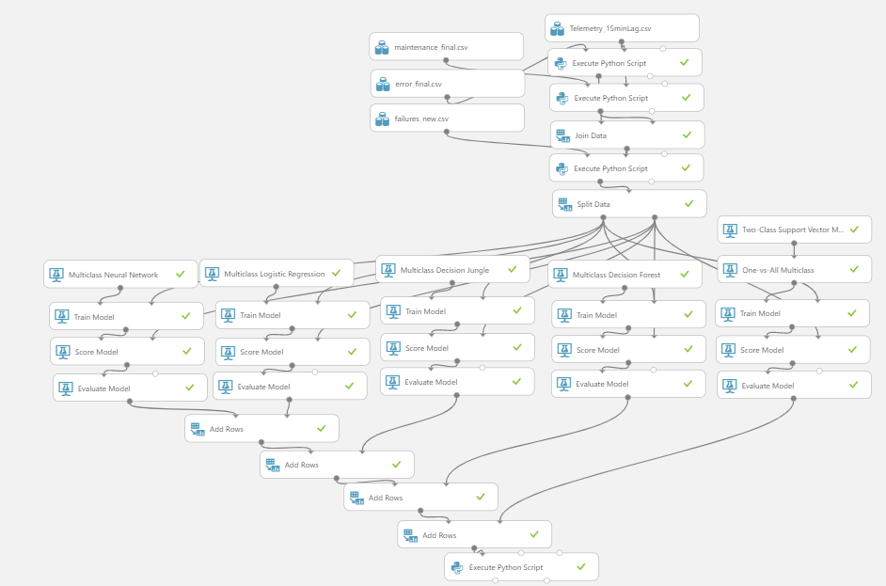
Figure 13, Azure ML Classification model workflow (Lane Failure)

Prediction of Failure using Vehicle Classification
The experiment was performed to cover six months for trips gathered for one toll location and one toll zone from database application. The data was divided into two parts: 70% for the training part and 30% for the testing part. The split is done via rows splitting with randomized selection of rows in each group of data (training and testing data) using “Split Data” Module in Azure ML studio. Using the data, ML model is fitted to detect none classified or trips were unable to be correlated to vehicle. Figure 14 shows the experiment workflow for classification model which is built using Azure machine learning Studio.

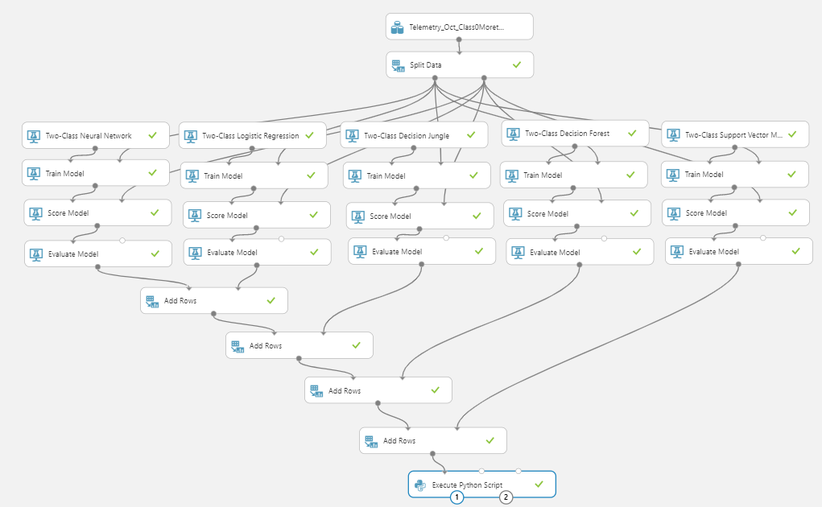
Figure 14, Azure ML Classification model
Following the methodology described in this research and after Data preprocessing and feature engineering is completed, the next step is model training, scoring and evaluation for different machine learning algorithm is performed to validate the most significant algorithm. The model was generated using five different machine learning algorithms which were subject to test classification model and they are as follows: NN, Logistic Regression, Decision Jungle, Decision Forest and SVM. Since the prediction of the failure is using the vehicle classification parameter, an addition data column named Class0Status was created for the model. This column was an abnormal behavior flag indicating whether lane devices (AVI, AVC, and VIS) were able to classify or correlate a vehicle trip which is labeled as “NORMAL” or not “ERROR”. This column was also used as the target value of the prediction. The ML task for this case is classification, because the desired output is whether the trip is classified as Class 0 or not. The model is trained to detect whether the lane has been generating a class 0 trips or not in the past 15 minutes interval by taking the sum of class 0 counts record and label the data with “ERROR” flag if the total number of class 0 is less than 5.

Predictive Maintenance using Regression Model

Prediction of failure using Traffic Counts
Another approach proposed in this paper to predict abnormal behavior of the devices is predicting the traffic count, in case there is a drop in traffic count compared to the historical data this will indicate to an issue in the lane functionality. This is a typical regression problem, where the targeted feature is the continuous numeric values. Therefore, a linear regression model can be fitted. Multiple regression models were investigated, which are used to score the same data obtained from previous models. Once the model is built to predict the trips count, machine learning models is evaluated in terms of performance by investigating at how the predicted values are deviating from the actual trips count on average.
The experiment is performed to cover six months for trips gathered for one toll location and one toll zone from database application. The data was split into two parts: 75% for the training part and 25% for the testing part. The split is done via rows splitting with randomized selection of rows in each group of data (training and testing data) using “Split Data” Module in Azure machine learning studio. Using the dataset, ML model is fitted to make a prediction of number of trips recorded. The regression models were generated using five different machine learning algorithms and they are as follows: NN, Linear Regression, Poisson Regression, Boosted Decision Tree and Decision Forest. Figure 15 shows the experiment workflow for regression model, which is built using Azure ML Studio.

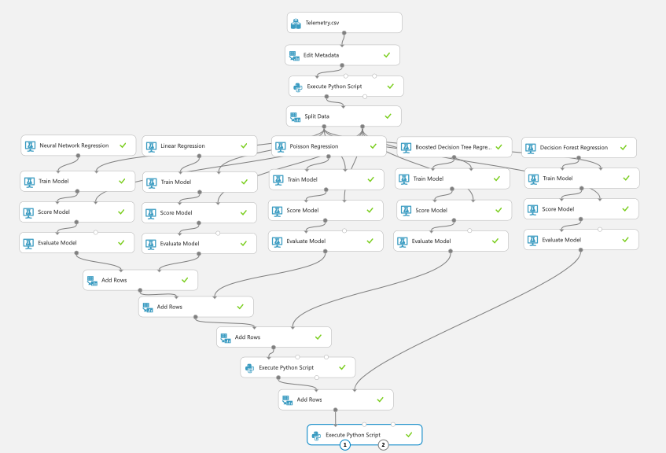
Figure 15, Azure ML Regression
CHAPTER 4

RESULTS AND DISCUSSION

Introduction
In this work, Azure Machine Learning Studio used to build an Artificial Intelligence predictive maintenance model and Python libraries used to write a code to prepare and have an insight about the data. Before the results are discussed, it is important to consider that some of the model configurations that are usually modified to get the optimum accuracy and performance. However, in this experiment, only default parameters were used and have not changed. Also from the literature review, most used algorithms are implemented and model performance is compared with each other to find the optimal one. The results from this research can drive a conclusion that ML models could be created from Electronic Toll Collection system data and these models can utilized in the predictive maintenance, in which it produces new information for the maintenance team.

Multi-Class Classification Models Performance
For all the Classification models, the “Train Model” module was connected to train the data set then fed to another module to compute the Class on the test data created initially. Based on that, an additional module is utilized to evaluate the performance of each model as shown in figure 13. Since there are three main values representing the device failure (AVI, AVC and VIS) and the objective is to predict a failure of any of these devices on particular lane given the other trips information. Therefore, the model used in this case is Multiclass Classification model. To evaluate the multi class classification models, several metrics were used to evaluate the performance, including Accuracy, Precision, Recall, and confusion matrix. Table 8 shows the summary of metrics and confusion matrix results.
Table 8, summary of Model evaluation and confusion matrix results
Algorithm | Metrics | Confusion Matrix
Neural Network | Overall accuracy 0.001062  Average accuracy 0.500531  Micro-averaged precision 0.001062  Macro-averaged precision NaN  Micro-averaged recall 0.001062  Macro-averaged recall 0.241071 | 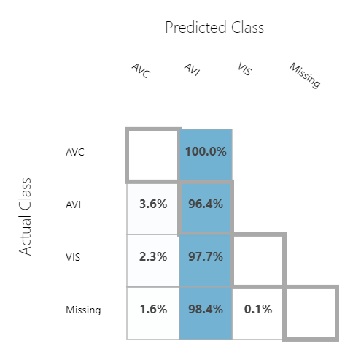
Logistic Regression | Overall accuracy 0.001036  Average accuracy 0.500518  Micro-averaged precision 0.001036  Macro-averaged precision NaN  Micro-averaged recall 0.001036  Macro-averaged recall 0.235119 | 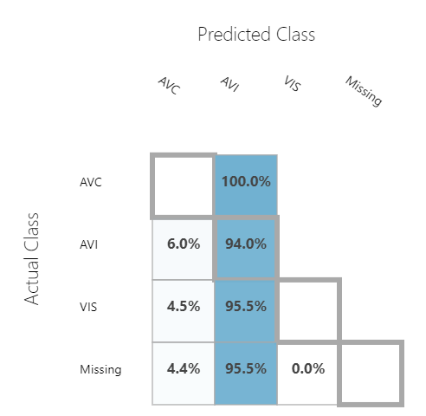
Decision  Jungle | Overall accuracy 0.001206  Average accuracy 0.500603  Micro-averaged precision 0.001206  Macro-averaged precision NaN  Micro-averaged recall 0.001206  Macro-averaged recall 0.272771 | 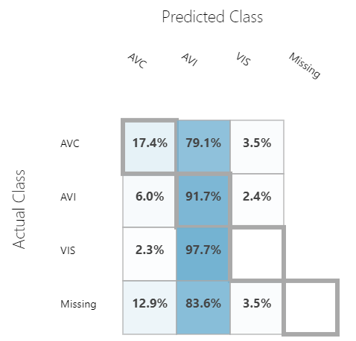
Decision Forest | Overall accuracy 0.001127  Average accuracy 0.500564  Micro-averaged precision 0.001127  Macro-averaged precision NaN  Micro-averaged recall 0.001127  Macro-averaged recall 0.260395 | 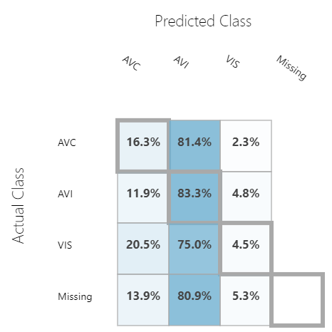
Support Vector Machine( One Vs All) | Overall accuracy 0.001114  Average accuracy 0.500557  Micro-averaged precision 0.001114  Macro-averaged precision NaN  Micro-averaged recall 0.001114  Macro-averaged recall 0.247093 | 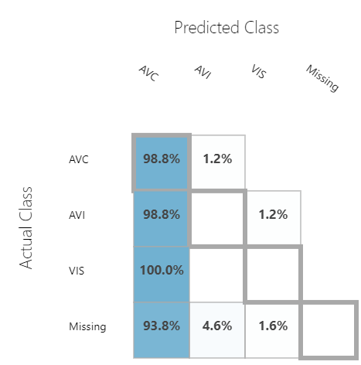

The experiment shows that the model average accuracy for all machine learning algorithms is around 50%, this low accuracy is due to some of the classes were not classify correctly. Although accuracy is representing the proportion of correct classification values. However, since most of the test dataset belongs to normal operational status, in this case accuracy is not good measurement of the effectiveness of the model. The model overall seems to be performed in acceptable level, but in real life scenarios it might fails to identify which device is under failure condition. Therefore, an additional measurement metrics is needed to evaluate the efficiency of the model such as the confusion Matrix. The prediction results are presented as a confusion matrix in Table 9. The rows represent predictions and the columns represent actual values. From the confusion matrix for all models (except Support Vector Machine), it can be seen that the model is very good at detecting the failure of AVI device.
Algorithm | True Positive | False Positive
Neural Network | 96.40% | 3.60%
Logistic Regression | 94.00% | 6.00%
Decision Jungle | 91.70% | 8.30%
Decision Forest | 83.30% | 16.70%
Support Vector Machine | 0.00% | 100.00%
Table 9, summary of confusion matrix of Multi-Classification models for AVI

Table 11, shows the summary of confusion matrix of all models. The model is very good at detecting the True Positive for Neural Network algorithm by predicting 96.40% of AVI failure. Meaning The situations where the lane is having a failure with AVI device, the trip classification was recorded with failure in 84 samples and the model managed to predict 87 of those samples, missing 3 samples only. It can be noticed from the results that most of the algorithms are having good prediction performance, except the Support Vector Machine were unable to predict any of True positive cases For AVI. On the other hand, The model is very good at detecting the True Positive using Support Vector Machine algorithm by predicting 98.80% of AVC failure. Meaning The situations where the lane is having a failure with AVC device, the trip classification was recorded with failure in 86 samples and the model managed to predict 85 of those samples, missing only one sample. It can be noticed from the results that only one algorithm is having good prediction performance, but none of the other algorithms were unable to predict any of True positive cases For AVC.

Table 10, summary of confusion matrix of Multi-Classification models for AVC
Algorithm | True Positive | False Positive
Neural Network | 0.00% | 100.00%
Logistic Regression | 0.00% | 100.00%
Decision Jungle | 17.40% | 79.10%
Decision Forest | 16.30% | 81.4%
Support Vector Machine | 98.8% | 1.20%

Table 11, summary of all algorithms model results
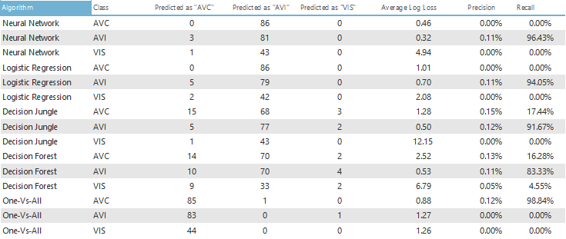
Table 11 summarize of all algorithms model results. Due to the higher value of Precision which represent the accuracy of the ML model during the prediction of positive cases and Recall matrices which tells how complete were failure predictions on positive cases. Recall value tells us the prediction accuracy among only true positives .It explained how accurate our prediction is comparing to other instance. Therefore, Model with NN algorithm, is better than the remaining algorithms in terms of detecting the AVI failure, and SVM is better than other algorithms in detecting the AVC failure. However, none of the Classification model were able to detect the VIS failure.

Two-Class Classification Models Performance
For all the classification models, the “Train Model” module is used to train the data set then fed to “Score model module to compute the prediction on the test data created initially. Based on that, an “Evaluate model” module is used to evaluate the performance of each model. To evaluate the classification models, two metrics were used to measure the performance. The Receiver Operating Curve (ROC) - Area Under the Curve (AUC) which is plotting the true positive with respect to the false positives and the second metric is confusion matrix. Table 12 shows the summary of Receiver Operating Curve (ROC) and confusion matrix results.
Table 12, summary of ROC and confusion matrix results
Algorithm | ROC | Confusion Matrix
Neural Network | 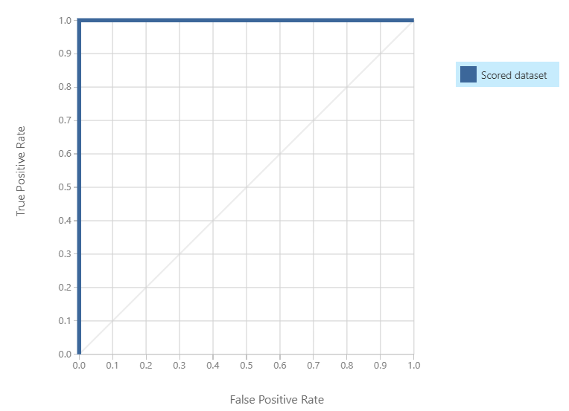 | 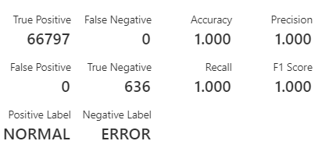
Logistic Regression | 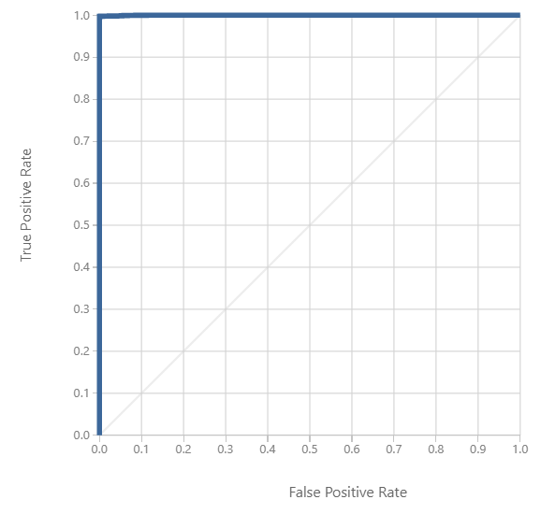 | 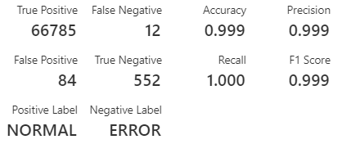
Decision  Jungle | 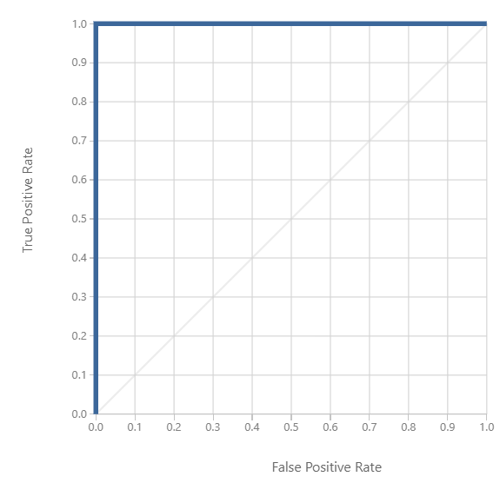 | 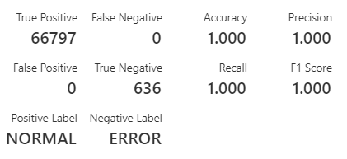
Decision Forest | 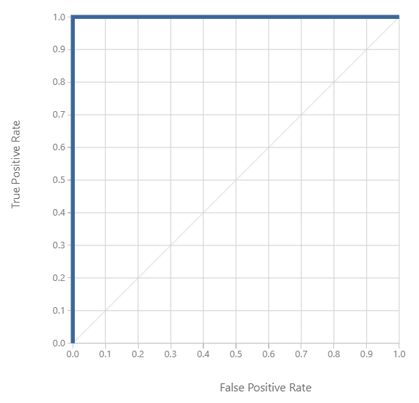 | 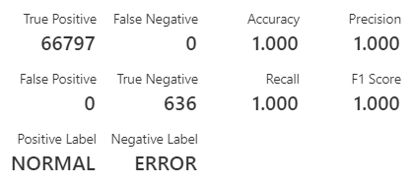
Support Vector Machine | 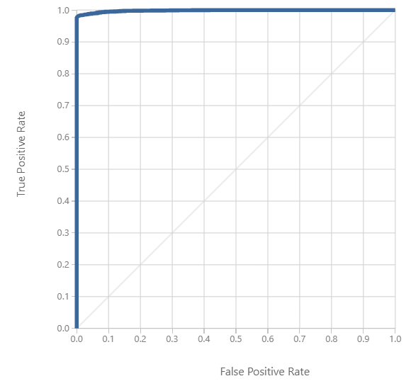 | 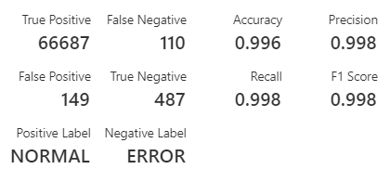

The experiment shows that the model accuracy for all machine learning algorithms are between 99.62% and 100%. Although accuracy is representing the proportion of correct classification values. However, since most of the test dataset belongs to normal operational status, in this case accuracy is not good measurement of the effectiveness of the model. The model seems to be performed well overall, but in real life scenarios, it might fails to identify the “ERROR” correctly. Therefore, an additional measurement metrics is needed to evaluate the efficiency of the model such as the confusion Matrix. The prediction results are presented as a confusion matrix in Table xx. The rows represent predictions and the columns represent actual values. The ideal result when the “False Negative” and “False Positive” would be zero, which is the case in three algorithms namely: Neural Network, Decision Jungle and Decision Forest. From the confusion matrix for all models, it can be seen that the model are very good at detecting true negatives. For example 81.6% in case of Support Vector Machine algorithm: the situations where the Lane is under ERROR, the trip classification was recorded with ERROR in 597 samples and the model managed to predict 487 of those samples, missing 110 samples of them. Also the model is very good at detecting the True Positive (99.8%): The situation where the lane is under NORMAL operation, the trip classification was recorded NORMAL class in 66836 samples and the model managed to predict 66687 of those samples, missing 149 of them.
The performance of models can be measured also with a ROC, which tells how much the model is capable of distinguishing between classes. Typically, the higher AUC or steeper ROC curve, the better the model is detecting true positives. The ideal curve would be shaped like a step function, rising immediately to 1,0. The line connected between the higher and lower values indicate a pure random guess. Therefore, if the curve falls below this line, it indicates that the model gives more false positives than true positives. The area between the curve and the line should be as large as possible which is the case in all algorithms, the AUC for all models fall between 99.83% and 100%. table 13 summarize of all algorithms model results.
Table 13, summary of all algorithms model results
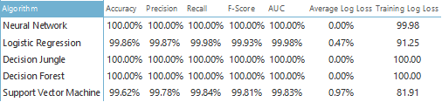
In spite of the fact that all the models results are approximately close for all machine learning algorithms, however the models with NN, Decision Jungle and Decision Forest is better than the remaining algorithms. Due to the higher value of Precision which represent the accuracy of the ML model during the prediction of positive cases and Recall matrices which tells how complete were failure predictions on positive cases. Recall value explains the prediction accuracy between only True Positives values .Meaning, to which certain extent the prediction is valid, compared to other “ERROR” instance. Typically, False Negatives should be minimized by chaining the model parameters or revisit the data preprocessing stage in order to maximize the recall value. In which could result in lower value of accuracy, which is still sufficient as mentioned before.

Prediction of Lane failure using Classification Model
The main objective of this experiment was to build a classification model which intend to recognize a known observation status in order to predict whether a lane is operating in normal state, and investigating the possible Artificial intelligence model which could be suitable for ETC system maintenance program. This method is particularly satisfying our scenario in predictive maintenance in ETC, since the objective is to recognize a known observation status (normal behavior) in order to predict whether a lane is operating in an abnormal state (abnormal behaviors). The results of testing five main ML algorithms are presented with bar chart in figure 16 and figure 17 to illustrate each model performance on predicting the lane failure based on trips transaction data. The failure prediction approach is investigated using classification modeling with two classification model and multi-classification model. Two-classification model was built using the vehicle classification data obtained from the laser scanner and the multi-class classification model is built using trips and maintenance information.
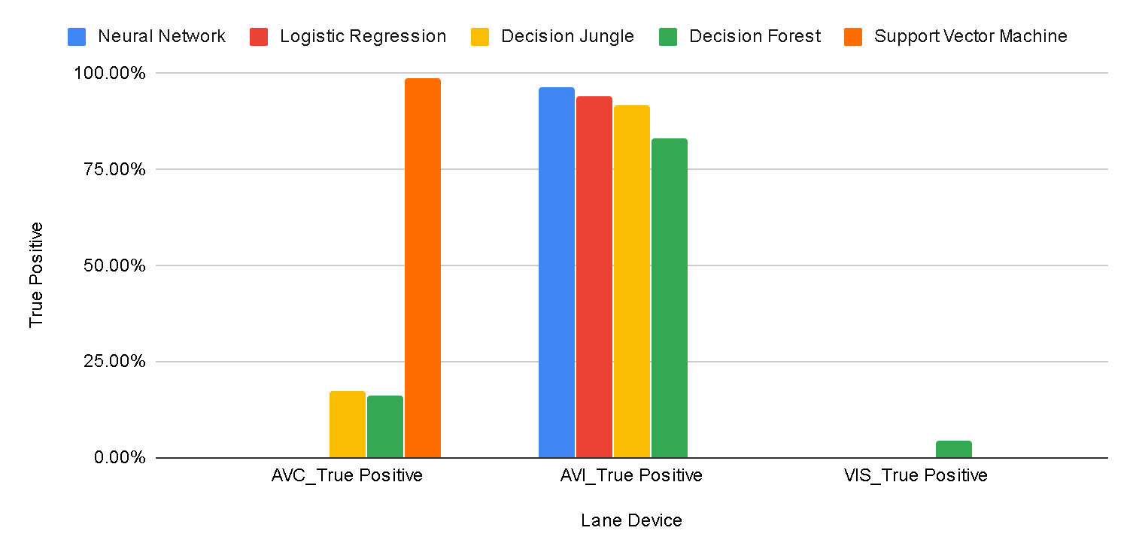
Figure 16, Machine learning Model Performance - Devices
For the multi-class classification model, the best results for each of the three devices are presented in the AVI devices as the entire model showed good prediction. However, the Support Vector Machine was unable to predict any failure. This is due to Support Vector Machine Algorithm is usually used in a two-Class Classifier, however a One--vs---All module is applied to test model performance but the results showed that this algorithm was not suitable for such classification problem. On the other hand, The model is very good at detecting the failure using Support Vector Machine algorithm for the AVC failures. It can be noticed from the results that only one algorithm is having good prediction performance, but none of the other algorithms were unable to predict any of failures For AVC. Moreover, none of machine learning models applied was able to predict VIS failure. This is due to the fact that failure data of some devices are unbalanced, meaning. Some classes have a lot less instances than others do. This discrepancy in the model performance of Support Vector Machine algorithms in different device’s failures cannot be interpreted as no simple function can be constructed from the results and this is due to the high dimension of the model classifier. This finding confirmed the previous knowledge about the disadvantages of the Support Vector Machine algorithm mentioned in the literature review.
On the other hand, and in the two-class classification model. The experiment shows that the model accuracy for all machine learning algorithms are high and the model seems to be performed well overall. However, Decision Tree both Decision Jungle and Decision Forest as well as ANN Algorithms is performed better than the Logistic Regression and SVM algorithm.
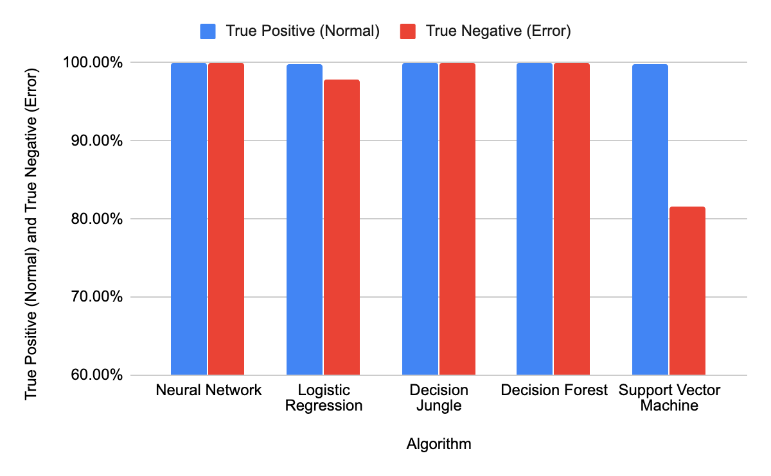
Figure 17, Machine learning Model Performance - Vehicle Classification
Despite having different performance results on predicting the AVI failures, variety of the models appeared to have close outcomes. This finding goes along with the knowledge mentioned in the literature as there is no “perfect” machine learning algorithm that will produce good results at particular problem, in fact for each type of problem a specific algorithm is suited and might achieves good outcome, while another algorithm fails heavily. In addition, it relates to a great extent on the nature of dataset and the aim of model development. Nevertheless, there is a potential

Regression Models Performance
For all the regression models, the “Train Model” module is used to train the data set then fed to “Score model module to compute the prediction on the test data created initially. Based on that, an “Evaluate model” module is used to evaluate the performance of each model. After running the experiment, a Python script is used to combine the results of all algorithms in one table, tables 14 shows the summary results of regression models evaluation metrics. The metrics include the following Mean Absolute Error (MAE), Root Mean Absolute Error (RMAE), Relative Absolute Error, Relative Squared Error, and the Coefficient of Determination. The expression “error” refers to the variation between the predicted variable and the actual variables. Therefore, the lower value of error the higher accuracy of the model in performing the prediction. Also another evaluation metric used is the Coefficient of Determination which is the proportion of variance explained by the model. When the Coefficient of Determination is close to value of one the more regression line is approaching the perfect fit. From the results obtained from all the model, it is concluded that the Linear Regression algorithm achieved the best lower value of absolute and mean errors as well as the value of Coefficient of Determination. Also the decision forest algorithm show a good result compared with the other algorithms.
Table 14, Regression models evaluation metrics
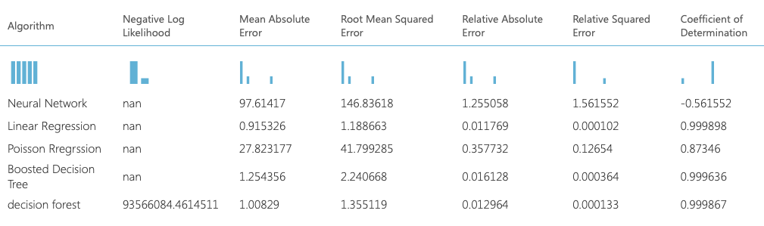
With the ML models, predictions can be made to detect failure and forecast traffic amount. The models presented here prove that data analytics can create new value in an ETC environment. The methods and tools used for modeling the prediction model can be generalized to be used in the rest of the ETC system also. As the amount of data grows daily, the model can be trained with more and more data as time passes. Therefore, the model can be re-generated from time to time to gain better results.

Prediction of Failure using Traffic Counts
With this type of system, a possible relationship between the count of traffic and some machines failure can be identified using regression model. Therefore, the experiment showed that there is potential advantages of using existing data to build a new knowledge about the system status. Since the outcome of the trips are numerical variables and with the help of regression techniques it can define the relationship between an input variable and output variables. Using a regression modeling to predict the value of trips of each lane and later can be compared to the real time data for the purpose of identifying abnormal behavior of toll operation.
From the results obtained from the entire model and as shown in figure 18, when the Coefficient of Determination is compared between machine learning algorithms, all models were able to predict the lane count except the Neural Network Model. The model produced a negative value of Coefficient of Determination that means that the chosen model with its constraints fits the data in the regression model poorly and does not follow the trend of the data. The experiment shows that the model accuracy for all ML algorithms for regression model are high and the model seems to be performed well overall. However, Linear Regression model is performed better than the Decision Tree and Poisson Regression models.
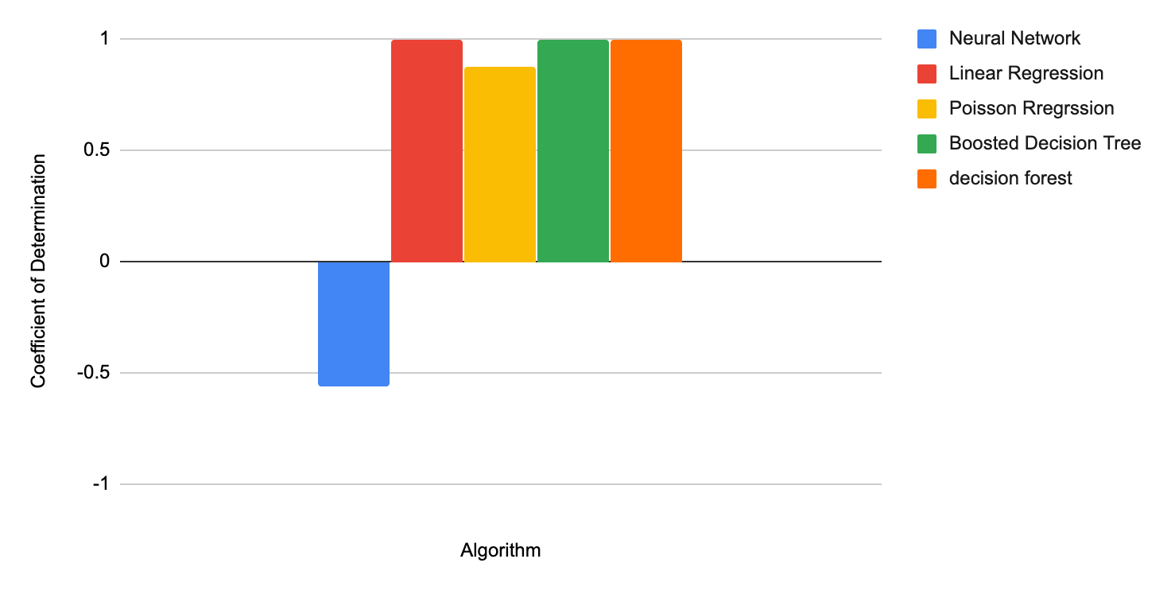
Figure 18, Regression Models Coefficient of Determination
From the results obtained from the entire model, it can be concluded that the Linear Regression algorithm achieved the best lower value of absolute and mean errors as shown in figure 19 and figure 20. Also the decision Tree algorithm show a good result compared with the other algorithms. However, neural network was performed poorly in predicting the vehicle trips.
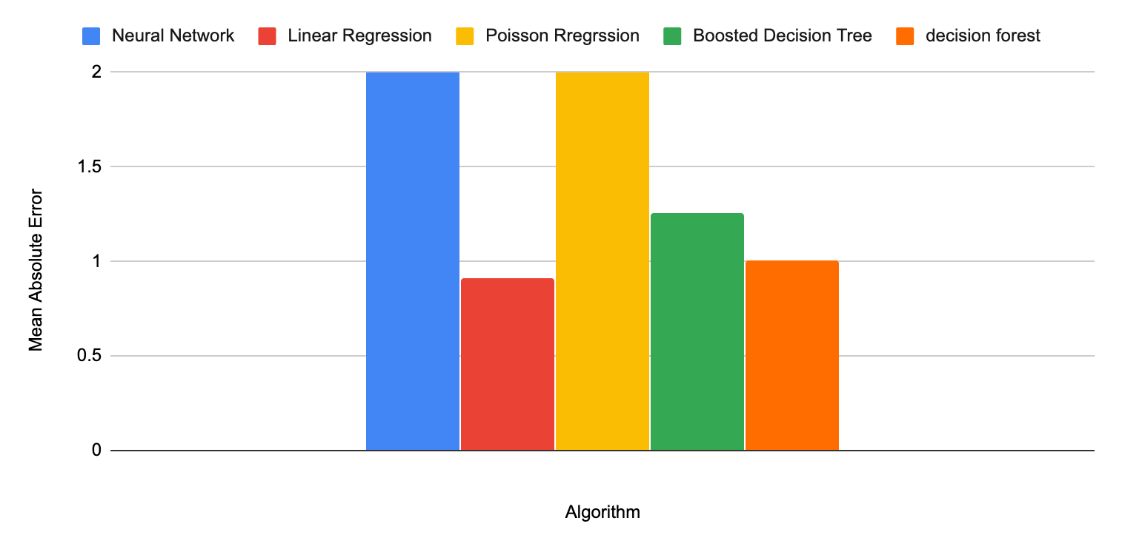
Figure 19, Regression Models Mean Absolute Error
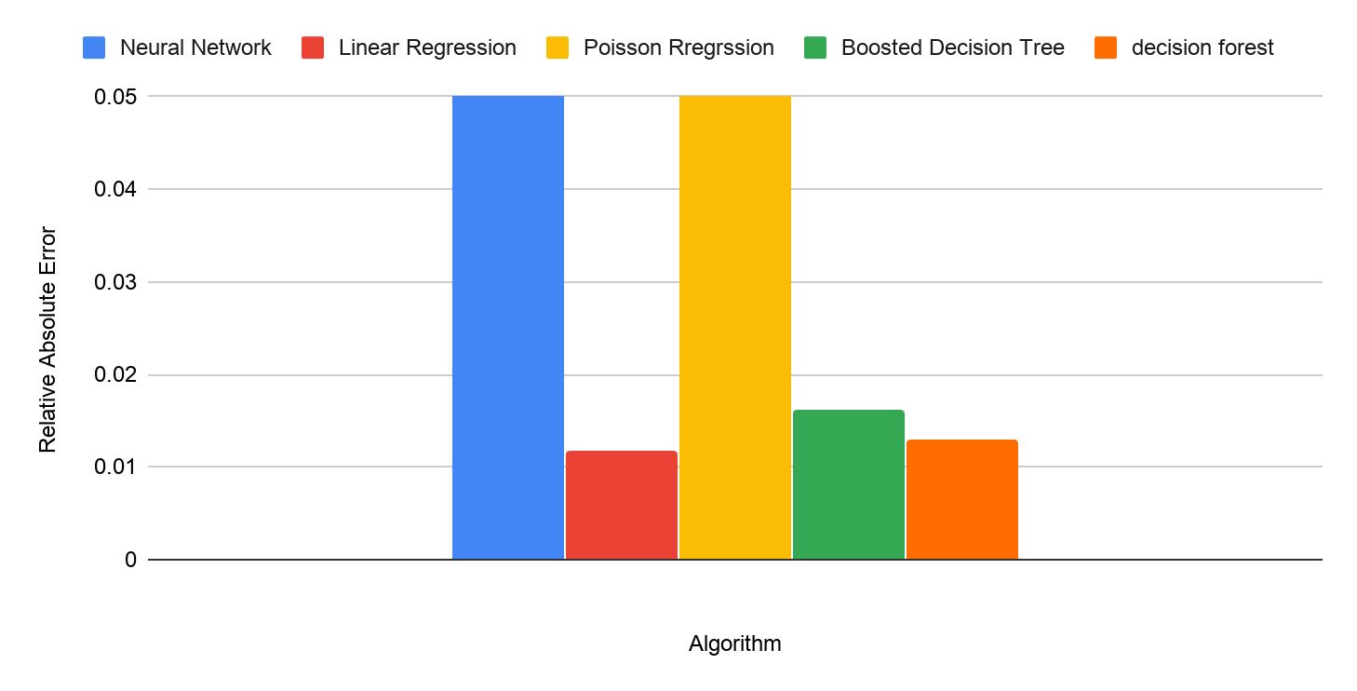
Figure 20, Regression Models Relative Absolute Error
With the machine learning modeling, predictions could be made to detect failure and forecast traffic amount. The models presented here prove that data analytics can create new value in an ETC environment. The methods and tools used for modeling the prediction model can be generalized to be used in the rest of the ETC system also. As the amount of data grows daily, the model can be trained with more and more data as time passes. Therefore, the model can be re-generated from time to time to gain better results. Nevertheless, there are no previous studies or literature reviews on applying artificial intelligence in predictive maintenance for Electronic Toll Collection failure prediction to conduct a comparison between the performances of Machine Learning Models.

CHAPTER 5

CONCLUSION AND RECOMMENDATION

Introduction
This research demonstrates a concept for improving the predictive maintenance program by applying Artificial Intelligence approach to be used by toll systems maintenance team. Corporates are more concerned with enhancing the maintenance program and overcome the system limitations in order to enhance system availability and minimize the failure impact on the operation. Applying ML techniques on the system data and maintenance would contribute new knowledge allowing identifying critical failures that will have considerable impact on system functionality.
Our main contribution is to provide a solution on the current predictive maintenance limitation by using the data gathered from multiple components of an Electronic Toll Collection system, in order to gain new knowledge on the process performance and maintenance needs. This is achieved by developing and testing an Artificial Intelligence model using the combination of trips information and maintenance history. The model is given solutions based on classification model which intend to identify a known observation status in order to predict whether a lane in the toll system is operating in a normal state. Additionally, trips prediction are explored for each lane by building a regression model to have a reference response variable to describe the abnormal status of system components.
This study was focused on the application of advanced AI techniques to implement robust and accurate ML models for failure prediction. The investigated artificial intelligence approaches are classification modeling and regression modeling, and machine learning algorithms used include multiclass logistic regression, decision tree both decision forest and decision jungle algorithms, SVM and ANN algorithm. At the end of each learning algorithm experiment, a comprehensive comparative analysis was performed in both classification and regression modeling to address the accuracy and effectiveness of the best model during training and testing stage.

Conclusions
Following conclusions can be drawn from this research:
- A predictive maintenance program can be developed and implemented in Electronic Toll Collection system by using the framework presented in this paper. All ML models proposed to develop and implement predictive maintenance in three main stages: Business problem understanding, Data Acquisition and preparing which include sub-process such as feature engineering and feature selection modeling which include Model Testing and Validation and Model evaluation.
- Based on the performed systems analysis, and ML model applied to the trips data and maintenance management historical information. It can be concluded that the predictions can be made to detect failure and forecast traffic amount. The models presented here prove that data analytics can create new value in an ETC environment.
- The methods and tools used for modeling the prediction model can be generalized to be used in the rest of the ETC system also.
- As the amount of data grows daily, the model can be trained with more and more data as time passes. Therefore, the model can be re-generated from time to time to gain better results.
- There are no earlier studies or literature review on applying artificial intelligence in predictive maintenance for Electronic Toll Collection failure forecasting to be compared with in terms of the performance of Machine Learning Models.
- Despite having inconsistent performance results on predicting failures, to a certain degree some of models showed proximate outcomes. Meaning no “perfect” ML algorithm that will produce good results at particular problem, in fact for each type of problem a specific algorithm is suited and might achieves good outcome, while another algorithm fails heavily. In addition, it relates to a great extent on the nature of dataset and the aim of model development. Nevertheless, there is a potential

Recommendations
Following recommendations can be drawn from this research:
- The knowledge obtained from the study provided in this paper can be utilized to commence a pilot project as part of the maintenance program for Dubai Toll system.
- More testing needs to be conducted to validate the failure prediction models built by different machine learning algorithms, as the models in this paper are only for proof of concept purposes.
- This research investigated only few system components, the machine learning models can be extended to include more critical system components and maintenance types.
- Once the predictive models are tested and verified to meet the business requirements, they can be integrated with production environment for business use. Machine learning models can be integrated within the production system as a web services which can be invoked from different applications.
- The machine learning models investigated in this paper were implemented without further changes into each algorithm parameters. The parameters of each machine learning algorithm should deeply investigated to achieve the optimum best results out of each model.
- The data used to build the models were limited to trips from each lane and maintenance history obtained from the maintenance management system, including preventive maintenance and corrective maintenance. More relevant information would be included as part of model building need to be investigated such as how long it has been since a device is last replaced as well as information about system components such as memory utilization, Disk I/O and processor utilization. These additional information are expected to contribute to the machine learning model performance, as these would relate to the degradation of the system components and hence enhance the failure prediction.

REFERENCES
Alsyouf, I. (2007). The role of maintenance in improving companies’ productivity and profitability. International Journal of Production Economics, vol. 105(1), pp. 70–78.
Anderson, D. (2002). Reducing the Cost of Preventive Maintenance. Maintenance Journal, vol. 15(4).
Alonso, J., Torres, J. & Gavaldà, R. (2009). Predicting web server crashes: A case study in comparing prediction algorithms. Proceedings of the 5th International Conference on Autonomic and Autonomous Systems, ICAS 2009, pp. 264–269.
Ab-samat, H., Jeikumar, L. N., Basri, E. I. & Harun, N. A. (2012). Effective Preventive Maintenance Scheduling : A Case Study, pp. 1249–1257.
Al-Turki, U. (2014). Integrated maintenance planning in manufacturing systems (SpringerBriefs in applied sciences and technology, manufacturing and surface engineering). Cham: Springer.
Auria, L. & Moro, R. A. (2011). Support Vector Machines (SVM) as a Technique for Solvency Analysis. SSRN Electronic Journal.
Bakshi, K. & Bakshi, K. (2018). Considerations for artificial intelligence and machine learning: Approaches and use cases. IEEE Aerospace Conference Proceedings. IEEE, vol. 2018–March, pp. 1–9.
Barga, R., Fontama, V. & Tok, W. H. (2015). Predictive Analytics with Microsoft Azure Machine Learning. 2nd edn.
Bastos, P., Lopes, I. & Pires, L. (2012). A maintenance prediction system using data mining techniques. Lecture Notes in Engineering and Computer Science, vol. 3, pp. 1448–1453.
Bernard, S., Ulf, S. & Wang, L. (2014). Next Generation Condition Based Predictive Maintenance.
Corazza, A. & Prevete, R. (2018). A machine learning approach for predictive maintenance for mobile phones service providers. F. Xhafa, S. Caballé, and L. Barolli (eds). . Cham: Springer International Publishing (Lecture Notes on Data Engineering and Communications Technologies).
Carvalho, B. A. & Lopes, I. S. (2015). Preventive Maintenance Development: A Case Study in a Furniture Company. Proceeding of the World Congress on Engineering, vol. II.
Cheng, F., Qu, L. & Qiao, W. (2015). A case-based data-driven prediction framework for machine fault prognostics. 2015 IEEE Energy Conversion Congress and Exposition, ECCE 2015, pp. 3957–3963.
Candanedo, L. M., Feldheim, V. & Deramaix, D. (2017). Data driven prediction models of energy use of appliances in a low-energy house. Energy and Buildings. Elsevier B.V., vol. 140, pp. 81–97.
Chen, W. H., Hsu, S. H. & Shen, H. P. (2005). Application of SVM and ANN for intrusion detection. Computers and Operations Research.
Dreiseitl, S. & Ohno-Machado, L. (2002). Logistic regression and artificial neural network classification models: A methodology review. Journal of Biomedical Informatics.
Dindarloo, S. R. (2016). Support vector machine regression analysis of LHD failures. International Journal of Mining, Reclamation and Environment, vol. 30(1), pp. 64–69.
Elliott, A. & Woodward, W. (2007). Statistical Analysis Quick Reference Guidebook. Antimicrobial agents and chemotherapy. Edited by Intergovernmental Panel on Climate Change. 2455 Teller Road, Thousand Oaks California 91320 United States of America: SAGE Publications, Inc.
Fenton, W. G., McGinnity, T. M. & Maguire, L. P. (2001). Fault diagnosis of electronic systems using intelligent techniques: A review. IEEE Transactions on Systems, Man and Cybernetics Part C: Applications and Reviews, vol. 31(3), pp. 269–281.
Hawkin, S. (2009). Neural Networks and Learning Machines. 3nd edn. Pearson Education 3nd edn.
Helmiriawan. (2018). Scalability Analysis of Predictive Maintenance Using Machine Learning in Oil Refineries [online].Available at: http://repository.tudelft.nl/.
Ivan Nunes da Silva, Danilo Hernane Spatti, Rogerio Andrade Flauzino, Liboni, L. H. B. & Alves, S. F. dos R. (2012). Artificial Neural Networks. Radioisotopes.
Janzen, F. J. & Stern, H. S. (1998). Logistic Regression for Empirical Studies of Multivariate Selection. Evolution.
Jupyter Notebook. (2019) [online]. [Accessed 5 October 2019]. Available at: https://jupyter.org/.
Kobbacy, K. A. H. (2012). Application of Artificial Intelligence in maintenance modelling and management. IFAC Proceedings Volumes (IFAC-PapersOnline). IFAC, vol. 45(31), pp. 54–59.
Kobbacy, K. A. H. & Murthy, P. (2008). Complex System Maintenance Handbook.
Khairy A.H. Kobbacy, D. N. P. M. (2008). Complex System Maintenance Handbook. Complex system maintenance handbook. London: Springer London.
Kubat, M. (2015). An Introduction to Machine Learning. Cham: Springer International Publishing.
Khashei, M. & Bijari, M. (2010). An artificial neural network (p, d, q) model for timeseries forecasting. Expert Systems with Applications. Elsevier Ltd, vol. 37(1), pp. 479–489.
Kluyver, T., Ragan-kelley, B., Pérez, F., Granger, B., Bussonnier, M., Frederic, J., Kelley, K., Hamrick, J., Grout, J., Corlay, S., Ivanov, P., Avila, D., Abdalla, S. & Willing, C. (2016). Jupyter Notebooks—a publishing format for reproducible computational workflows. Positioning and Power in Academic Publishing: Players, Agents and Agendas.
Liu, J., Wang, W., Ma, F., Yang, Y. B. & Yang, C. S. (2012). A data-model-fusion prognostic framework for dynamic system state forecasting. Engineering Applications of Artificial Intelligence, vol. 25(4), pp. 814–823.
Mobley, R. K. (2002). An Introduction to Predictive Maintenance. 2nd edn.
Nadai, N., Melani, A. H. A., Souza, G. F. M. & Nabeta, S. I. (2017). Equipment failure prediction based on neural network analysis incorporating maintainers inspection findings. Proceedings - Annual Reliability and Maintainability Symposium.
Nykyri, M. (2018). Data analytics for predictive maintenance in a pulp mill — case electric motors
Peng, K. (2012). Equipment management in the post-maintenance era: A new alternative to total productive maintenance (TPM). Boca Raton, FL: CRC Press.
Pandas. (2019) [online]. [Accessed 6 October 2019]. Available at: https://pandas.pydata.org.
Rothman, D. (2018). Artificial intelligence by example : develop machine intelligence from scratch using real artificial intelligence use cases. Packt. Pp.441-442
Shea, J. J. (2005). Applied regression analysis - a research tool. IEEE Electrical Insulation Magazine.
Stacia, M. (2013). Microsoft SQL Server 2012 Reporting Services.
Tariq, Z. (2016). Estimation of acoustic velocities and rock mechanical parameters using artificial intelligence tools.
Tian, Z., Jin, T., Wu, B. & Ding, F. (2011). Condition based maintenance optimization for wind power generation systems under continuous monitoring. Renewable Energy. Elsevier Ltd, vol. 36(5), pp. 1502–1509.
T.H. Corman, C.E. Leiserson, R.L. Rivest, and C. Stein; Introduction to Algorithms, Second Edition. McGraw-Hill (2002)
Tu, J. V. (1996). Advantages and disadvantages of using artificial neural networks versus logistic regression for predicting medical outcomes. Journal of Clinical Epidemiology, vol. 49(11), pp. 1225–1231.
Wang, F. (2016). Analyzing machine data for predictive maintenance of electro chemical machining electrodes.
Yu, X. (2019). Machine learning based predictive maintenance and regression based control of a servo motor for industrial conveyor belts.
Yao, X., Fern, E., Fu, M. C. & Marcus, S. I. (2004). Optimal Preventive Maintenance Scheduling in Semiconductor Manufacturing, vol. 3(17), pp. 245–356.
Zhang, K., Xu, J., Min, M. R., Jiang, G., Pelechrinis, K. & Zhang, H. (2016). Automated IT system failure prediction: A deep learning approach. Proceedings - 2016 IEEE International Conference on Big Data, Big Data 2016, (December), pp. 1291–1300.
Zhang, J. P., Li, Z. W. & Yang, J. (2005). A parallel SVM training algorithm on large-scale classification problems. 2005 International Conference on Machine Learning and Cybernetics, ICMLC 2005, (August), pp. 1637–1641.

