
Barriers and Opportunities for the Implementation of ESG in the Abu Dhabi Infrastructure Sector
المعوقات والفرص المتاحة لتطبيق معايير الحوكمة البيئية والاجتماعية والمؤسسية في قطاع البنية التحتية في أبوظبي

By

DEEMA RAMI DARWISH

Dissertation submitted in partial fulfilment
of the requirements for the degree of
MSc SUSTAINABLE DESIGN OF THE BUILT ENVIRONMENT
at
The British University in Dubai

July 2026

Declaration
I warrant that the content of this research is the direct result of my own work and that any use made in it of published or unpublished copyright material falls within the limits permitted by international copyright conventions.
I understand that a copy of my research will be deposited in the University Library for permanent retention.
I hereby agree that the contents of this dissertation for which I am author and copyright holder may be copied and distributed by The British University in Dubai for the purposes of research, private study or education and that The British University in Dubai may recover from purchasers the costs incurred in such copying and distribution, where appropriate.
I understand that The British University in Dubai may make a digital copy available in the institutional repository.

I understand that I may apply to the University to retain the right to withhold or to restrict access to my thesis for a period which shall not normally exceed four calendar years from the congregation at which the degree is conferred, the length of the period to be specified in the application, together with the precise reasons for making that application.
_______________________
Signature of the student

Copyright and Information to Users
The author whose copyright is declared on the title page of the work has granted to The British University in Dubai the right to lend his/her research work to users of its library and as an open source, and to make partial or single copies for educational and research use.
The author has also granted permission to the University to keep or make a digital copy for similar use and for the purpose of the preservation of the work digitally.
Multiple copying of this work for scholarly purposes may be granted by either the author, the Registrar or the Dean only.
Copying for financial gain shall only be allowed with the author's express permission.
Any use of this work in whole or in part shall respect the moral rights of the author to be acknowledged and to reflect in good faith and without detriment the meaning of the content, and the original authorship.

Abstract
Environmental, Social, and Governance (ESG) implementation in Abu Dhabi's infrastructure sector remains constrained by a persistent gap between ambitious policy commitments, such as Vision 2030 and the UAE Net Zero 2050 Strategy, and the realities of project-level delivery. This dissertation identifies the structural barriers and opportunities underlying this gap and examines how their priority varies across stakeholder groups. A hybrid Interpretive Structural Modeling (ISM), DEMATEL, and MICMAC design was applied to 27 expert participants across six stakeholder categories, evaluating eleven literature-derived barriers and ten opportunities. Results, externally validated against the independent SmartISM tool, show that Absence of a Unified Framework, Governance Gaps and Lack of Enforcement, and Financial Barriers form a consistent root cause, identified by all three methods and every adequately-sized group; Compliance Fatigue, Inconsistent Reporting, and Over-reliance on Traditional Metrics emerge as downstream symptoms rather than independent obstacles. Correspondingly, Policy Alignment, Standard Refinement, and Targeted Investment form a triad of root-level enablers, with priority differing by role: delivery-side groups favor Targeted Investment, policy-facing groups favor Standard Refinement. These findings suggest ESG implementation here is better advanced through targeted intervention on these upstream root causes than through fragmented management of their symptoms.
Keywords: ESG implementation, infrastructure, Interpretive Structural Modeling, DEMATEL, MICMAC, Abu Dhabi

خلاصة
يظل تطبيق معايير الحوكمة البيئية والاجتماعية والمؤسسية (ESG) في قطاع البنية التحتية بإمارة أبوظبي مقيدًا بفجوة مستمرة بين الالتزامات السياسية الطموحة، مثل رؤية 2030 واستراتيجية دولة الإمارات للوصول إلى صافي انبعاثات صفري بحلول 2050، والواقع العملي لتنفيذ المشاريع على أرض الواقع. تحدد هذه الرسالة المعوقات الهيكلية والفرص الاستراتيجية الكامنة وراء هذه الفجوة، وتبحث في كيفية تفاوت أولوياتها النسبية بين مختلف فئات أصحاب المصلحة في قطاع البنية التحتية. وقد تم تطبيق منهجية هجينة تجمع بين النمذجة الهيكلية التفسيرية (ISM)، وتقنية DEMATEL، وتحليل MICMAC، على بيانات تم جمعها من 27 خبيرًا مشاركًا يمثلون ست فئات من أصحاب المصلحة في قطاع البنية التحتية، لتقييم أحد عشر معوقًا وعشر فرص مستمدة من الأدبيات العلمية. وأظهرت النتائج، التي تم التحقق من صحتها خارجيًا باستخدام أداة SmartISM المستقلة، أن غياب الإطار الموحد، وثغرات الحوكمة وضعف آليات الإنفاذ، والمعوقات المالية، تشكل سببًا جذريًا هيكليًا ثابتًا، حددته الطرق الثلاث بشكل مستقل، وأكدته جميع فئات أصحاب المصلحة ذات الحجم الكافي في العينة؛ بينما برز إجهاد الامتثال، وعدم اتساق التقارير، والاعتماد المفرط على المقاييس التقليدية كأعراض تابعة وليست معوقات مستقلة بذاتها. وعلى صعيد الفرص، تشكل مواءمة السياسات، وتطوير المعايير، والاستثمار الموجه، ثلاثية متكاملة من الممكنات الجذرية الأساسية. وتتفاوت الأولوية النسبية بين هذه الروافع بشكل منهجي تبعًا لدور صاحب المصلحة: فالفئات المرتبطة بالتنفيذ تختار الاستثمار الموجه، بينما تختار الفئات المرتبطة بالسياسات تطوير المعايير. وتشير هذه النتائج إلى أن تطبيق معايير الحوكمة البيئية والاجتماعية والمؤسسية في هذا السياق يتحقق بشكل أفضل من خلال التدخل المستهدف في مجموعة محدودة من المعوقات الجذرية المتعلقة بالحوكمة والإطار التنظيمي والتمويل، بدلًا من الاستمرار في معالجة أعراضها التابعة بشكل متفرق.
الكلمات المفتاحية: تطبيق معايير الإستدام البيئي والاجتماعي والتحوكمي، البنية التحتية، النمذجة الهيكلية التفسيرية، DEMATEL، MICMAC، أبوظبي

Acknowledgements
My deepest gratitude goes first to my family — my mother Ebtihal, my father Rami, and my sisters Dana, Aya, Aseel, and Dalia. You have been my supporters through every stage of this journey, and you are, without exaggeration, my everything. Whatever I have managed to achieve, and whatever I go on to achieve after this, is because of you. You believed in me long before this dissertation existed, and I could not be prouder to be part of this family.
I would like to express my sincere appreciation to my supervisor, Prof. Bassam Abu Hijleh, for his invaluable guidance, support, and encouragement throughout this research. It has been a privilege to learn from his expertise and conduct this dissertation under his supervision.
I would also like to thank Dr. Sa’Ed Salhieh for his guidance and support throughout this project.
My sincere thanks also go to Dr. Wael Sheta and Dr. Fuad Baba for their teaching, mentorship, and support throughout my Master's degree. Their knowledge, encouragement, and dedication have contributed greatly to my academic and professional development.
Finally, I would like to dedicate this dissertation to everyone who has ever had a dream of earning a degree or achieving a goal but faced challenges beyond their control—whether due to personal circumstances, financial hardship, war, displacement, or other difficulties. This achievement is not mine alone; it belongs to all of you as well. To everyone who believed in me and supported me along the way, thank you. I drew my strength from you, and this accomplishment would not have been possible without your encouragement.
I am also grateful to all the experts who participated in this research and to everyone who contributed to this work, directly or indirectly.

Table of Contents
Chapter 1: Introduction 1
1.1. Research Background 1
1.2. Research Problem Statement and Motivation 2
1.3. Research Aim and Objectives 4
1.3.1. Research Aim 4
1.3.2. Research Objectives 4
1.4. Research Scope and Delimitations 5
1.5. Key Operational Definitions 6
1.6. Significance of the Study 7
1.6.1. Academic Significance 7
1.6.2. Practical and Professional Significance 7
Chapter 2: Literature Review 9
2.1. Introduction and Chapter Overview 9
2.2. Conceptual Evolution of ESG 9
2.3. Theoretical Frameworks 13
2.3.1. Stakeholder Theory 13
2.3.2. Legitimacy Theory 14
2.3.3. Resource-Based View (RBV) 15
2.3.4. Institutional Theory and Isomorphism 16
2.4. Global ESG Conceptual Foundations in Infrastructure 17
2.4.1. ESG Maturity and Organizational Ambition 17
2.4.2. ESG Integration Across the Infrastructure Lifecycle 18
2.4.3. Transition Management and Systemic Change 20
2.4.4. Transition Management and Systemic Change 20
2.5. Profiles of ESG Maturity 21
2.6. Future Trends and Policy Innovation in Infrastructure ESG 23
2.6.1. The Shift Towards Impact Investing 23
2.6.2. The Role of Policy Innovation and Regulatory Sandboxes 24
2.6.3. The Integration of Nature-Based Solutions (NbS) 25
2.7. The UAE and Abu Dhabi Context Analysis 25
2.7.1. National Strategic Mandates and Economic Growth 25
2.7.3. The Estidama Pearl Rating System (PRS) and its Limitations 26
2.8 Critical Analysis of Estidama 28
2.8.1. Critical Analysis of Social and Cultural Integration in the GCC 28
2.8.2. The Governance Gap in Local Infrastructure 28
2.9. Critical Analysis of Relevant Publications and the Knowledge Gap 29
2.9.1. A Critical Deconstruction of the Estidama Pearl Rating System (PRS) 30
2.9.2. Aligning Estidama with Global ESG Reporting Frameworks 31
2.9.3. The Impact of the Abu Dhabi Climate Change Strategy 2023-2027 31
2.9.4. Comparative Analysis of ESG Frameworks in the GCC 32
2.9.5. The Role of Sovereign Wealth Funds in Driving ESG 33
2.9.6. Analysis of GCC-Specific Infrastructure Barriers 34
2.10. Systemic Barriers and Opportunities: A Multi-Dimensional Analysis 35
2.10.1. Technical and Data-Related Barriers 35
2.10.2. Regulatory and Policy Barriers 36
2.10.3. Financial and Economic Barriers 37
2.10.4. Synthesis of Barriers and Opportunities by Country and Sector 38
2.11. ESG as a Driver of Risk Mitigation and Value Creation 40
2.12. Sector-Specific ESG Challenges: Transport, Energy, and Water 41
2.12.1. The Role of Professional Skills and Organizational Culture 42
2.12.2. Leveraging Digital Twins for ESG Transparency 43
2.12.3. The Synergy Between BIM and ESG: A Technical Deep Dive 43
2.12.4. IoT and Real-Time ESG Performance Monitoring 44
2.12.5. Bridging the ESG Skills Gap: A Strategic Imperative 45
2.12.6. The Rise of Sustainability-Linked Financing in the GCC 46
2.12.7. ESG and the "Social License to Operate" in Infrastructure 46
2.12.8. The Role of ESG in Enhancing Infrastructure Resilience 47
2.12.9. The Shift Toward Impact Investing and Social Value 48
2.12.10. Nature-Based Solutions and Climate Resilience 49
2.12.11. Synthesis of the Research Gap: A Call for Integrated Lifecycle Analysis 49
2.13. Stakeholder Engagement and the Social License to Operate 50
2.13.1. Models of Stakeholder Engagement 50
2.13.2. Building Trust and Transparency 51
2.14. Digitalization as an Enabler of ESG Integration 52
2.14.1. BIM, GIS, and IoT Integration 52
2.14.2. Challenges to Digital Adoption 52
2.15. Green Finance and Economic Drivers for ESG 53
2.15.1. The Rise of Green Bonds and Sustainable Debt 54
2.15.2. ESG and the "Bankability" of Infrastructure 56
2.15.3. The Business Case for ESG: Beyond Compliance 56
2.16. Contradictions and Tensions in ESG Adoption 57
2.16.1. Upfront Costs vs. Lifecycle Benefits 57
2.16.2. Voluntary vs. Mandatory ESG 59
2.16.3. Reporting vs. Actual Performance 60
2.17. Sector-Specific ESG Challenges in Infrastructure 61
2.17.1. Transportation and Mobility 61
2.17.2. Water and Wastewater Management 61
2.17.3. Energy Infrastructure and Decarbonization 62
2.18. The Role of Professional Skills and Capacity Building 63
2.18.1. The ESG Skills Gap 63
2.18.2. Capacity Building in the Supply Chain 64
2.19. Future of ESG in Infrastructure in UAE/GCC/Abu Dhabi 65
2.19.1. The Future Landscape: ESG Evolution in the UAE and GCC 65
2.19.2. Summary and Synthesis of the Literature 68
Chapter 3: Research Methodology 70
3.1 Introduction 70
3.2 Research Design and Methodological Rationale 70
3.2.1 Alignment with the Research Objectives 71
3.2.2 Broader Review of Methodologies for Complex Systems Analysis 71
3.2.3 Methodology Selection and Justification: A Hybrid ISM-DEMATEL Approach 74
3.3 Context-Dependent Nature of ESG Barriers in Emerging Economies 75
3.4 Identification and Refinement of Barriers and Opportunities 77
3.4.1 Initial Barriers from Literature Review and UAE Applicability 77
3.4.2 Initial Opportunities from Literature Review 80
3.4.3 Final Validated List of Barriers and Opportunities 82
3.5 Stakeholder Identification 84
3.6 Data Collection and Analysis Plan 87
3.7 Data Reliability and Ethical Considerations 91
3.7.1 Data Reliability and Validation 91
3.7.2 Ethical Considerations 91
3.8 Summary 92
Chapter 4: Results 93
4.1 Introduction and Chapter Overview 93
4.2 Realized Composition of the Expert Panel 93
4.3 ISM Hierarchical Structure: Barriers 94
4.4 ISM Hierarchical Structure: Opportunities 96
4.5 ISM Structure Across Stakeholder Groups 97
4.6 MICMAC Classification: Barriers 99
4.7 MICMAC Classification: Opportunities 101
4.8 DEMATEL Cause-Effect Analysis: Barriers 103
4.9 DEMATEL Cause-Effect Analysis: Opportunities 105
4.10 Cross-Stakeholder Comparison 106
4.11 Summary of Key Findings 108
Chapter 5: Discussion 109
5.1 Introduction and Chapter Overview 109
5.2 Triangulated Convergence Across the Three Methods 109
5.3 Discussion Against Existing Literature: Barriers 111
5.4 Discussion Against Existing Literature: Opportunities 112
5.5 Theoretical Implications 114
5.5.1 A Reproducible Methodological Precedent 114
5.5.2 Systemic, Not Isolated, Framing 114
5.5.3 Cross-Stakeholder Structural Validation 115
5.6 Practical Implications 115
5.6.1 For Regulators 115
5.6.2 For Project Teams and Contractors 116
5.6.3 For Investors and Rating Agencies 116
5.6.4 For Academic and Research Institutions 116
5.7 Chapter Summary 117
Chapter 6: Conclusion and Future Work 118
6.1 Introduction and Chapter Overview 118
6.2 Summary of Findings 118
6.3 Limitations of the Study 120
6.4 Recommendations 121
6.4.1 For Government 121
6.4.2 For Engineering Consultancies 122
6.4.3 For Contractors, Suppliers, and Developers 122
6.4.4 For Investors and Rating Agencies 122
6.4.5 For Academic and Research Institutions 123
6.5 Future Work 123

List of Tables
Table 1 Synthesis of Barriers and Opportunities by Country and Sector 39
Table 2 ESG Evolution in the UAE and GCC 66
Table 3 Final Validated List of Barriers (Post-Pilot-Interview) 82
Table 4 Final Validated List of Opportunities (Post-Pilot-Interview) 83
Table 5 Realized Composition of the Expert Panel (N = 27) 94
Table 6 ISM Level Partitioning - Barriers (All Groups, n = 27) 95
Table 6 ISM Level Partitioning - Opportunities (All Groups, n = 27) 96
Table 7 ISM Hierarchy Comparison Across Stakeholder Groups 98
Table 8 MICMAC Classification - Barriers (All Groups, n = 27) 99
Table 9 MICMAC Classification - Opportunities (All Groups, n = 27) 101
Table 10 DEMATEL Cause-Effect Analysis - Barriers (All Groups, n = 27) 103
Table 11 DEMATEL Cause-Effect Analysis - Opportunities (All Groups, n = 27) 105
Table 12 Strongest Barrier(s) and Opportunity(ies) by Stakeholder Group 107
Table 13 Root-Cause Barriers Compared Against Independent Literature 111
Table 14 Root-Level Opportunities Compared Against Independent Literature 113

List of Figures
Figure 1 Study Scope and Explicit Delimitations 5
Figure 2 Triple Bottom Line Framework 11
Figure 3 ESG History: From 1960s Origins to Today's Global Impact 13
Figure 4 Implementing Stakeholder Theory for Business Success 14
Figure 5 Legitimacy Theory 15
Figure 6 Resource Based View Theory 16
Figure 7 ESG Integration Across the Infrastructure Project Lifecycle 19
Figure 8 Integration of Each ESG Principles in Infrastructure Lifecycle 19
Figure 9 Comparison of ESG Dimensions: Estidama vs. International Standards 27
Figure 10 Technical and Data-Related Barrier 36
Figure 11 Regulatory and Policy Barriers 37
Figure 12 Financial and Economic Barriers 38
Figure 13 ESG: Dual of Rish Mitigation & Value Creation 41
Figure 14 Global AUM invested in ESG mandates (in USD tn) 54
Figure 15 Corporate ESG Bond Sales Set to Recover in 2023 55
Figure 16 Relation Between ESG Scores and Cost of Capital Differed Within Developed Regions 59
Figure 17 The Evolution of ESG Reporting: From Voluntary to Mandatory 60
Figure 18 Global Green Skills Gap 64
Figure 19 UAE ESG Investing Market Size & Outlook, (2025-2030) 67
Figure 20 ISM Hierarchical Structure - Barriers (All Groups) 95
Figure 21 ISM Hierarchical Structure - Opportunities (All Groups) 97
Figure 22 MICMAC Classification - Barriers (All Groups) 100
Figure 23 MICMAC Classification - Opportunities (All Groups) 102
Figure 24 DEMATEL Cause-Effect Diagram - Barriers (All Groups) 104
Figure 25 DEMATEL Cause-Effect Diagram - Opportunities (All Groups) 106

List of Abbreviations
BIM Building Information Modeling
CSR Corporate Social Responsibility
DEMATEL Decision-Making Trial and Evaluation Laboratory
DMT Department of Municipalities and Transport
ESG Environmental, Social, and Governance
GCC Gulf Cooperation Council
GIS Geographic Information System
GRI Global Reporting Initiative
IoT Internet of Things
ISM Interpretive Structural Modeling
MICMAC Matrice d'Impacts Croises Multiplication Appliquee a un Classement
SASB Sustainability Accounting Standards Board
SSIM Structural Self-Interaction Matrix
TBL Triple Bottom Line
UAE United Arab Emirates

Chapter 1: Introduction

1.1. Research Background
The global infrastructure sector currently finds itself at a pivotal juncture, undergoing a profound transformation from a singular focus on technical efficiency and cost-minimization towards a more expansive model rooted in Environmental, Social, and Governance (ESG) principles. This evolution signifies a fundamental re-evaluation of how long-term assets are conceived, financed, and delivered, with an imperative to foster resilience and sustainability within an increasingly dynamic global economic landscape (United Nations, 2015). Infrastructure, as the backbone of economic activity, possesses a unique capacity to either lock in carbon-intensive pathways or facilitate the transition to a low-carbon, equitable future. Consequently, the integration of ESG is no longer a peripheral concern but a core strategic necessity for asset owners, investors, and policymakers alike.
Within the United Arab Emirates (UAE), and particularly the Emirate of Abu Dhabi, this transformative journey is intrinsically woven into the fabric of its national strategic vision. As Abu Dhabi actively pursues the ambitious objectives outlined in its Economic Vision 2030 and contributes to the broader UAE Net Zero 2050 Strategic Initiative, the infrastructure sector—encompassing vital domains such as transport networks, public utilities, and essential public works—emerges as the primary conduit for realizing these far-reaching sustainability aspirations ( Abu Dhabi Council for Economic Development, 2008) (UAE Ministry of Climate Change and Environment, 2021). The scale of investment required to meet these goals is unprecedented, necessitating a shift in how projects are evaluated and managed to ensure they deliver long-term value across all three ESG dimensions.
While Abu Dhabi's technical engineering standards are demonstrably robust, the comprehensive integration of broader ESG criteria often appears fragmented. Current practices are heavily influenced by the Estidama Pearl Rating System (PRS), a pioneering framework that has successfully elevated environmental (E) standards for buildings and communities across the Emirate (Department of Municipalities and Transport, 2010). Nevertheless, as infrastructure projects escalate in both complexity and scale, there is an undeniable and pressing need to broaden this singular focus. Academic analyses frequently suggest that the social and cultural components embedded within Estidama are, at times, treated as perfunctory administrative requirements rather than subjects of profound impact assessment (Salim & Abu Dabous, 2018). Furthermore, the Governance (G) pillar stands out as a particularly underdeveloped aspect within the prevailing local framework, necessitating substantial enhancement to achieve congruence with established international best practices (Awadh, 2018).

1.2. Research Problem Statement and Motivation
Despite the unequivocal strategic direction articulated by the Abu Dhabi government, the infrastructure sector continues to grapple with the absence of a unified, technically-grounded methodology for comprehensive ESG integration. This critical void gives rise to several significant challenges that impede the advancement of a truly sustainable built environment. The motivation for this research stems from the urgent need to bridge the gap between high level policy aspiration and the practical, operational of infrastructure delivery. Without a standardized approach, the sector faces inconsistencies in risk identification and reporting, which ultimately hinders the ability to attract the sustainable finance necessary for the Emirate’s long-term goals.
The primary motivation is further underscored by the "E-centric" bias that currently dominates local sustainability efforts. While environmental metrics are relatively well-established through Estidama, the social and governance dimensions often lack the analytical rigor required for true ESG integration. This imbalance creates a strategic risk, as international investors and partners increasingly demand holistic performance data that encompasses labor practices, community impact, and transparent governance structures ( Li, Feng, Liu, & Yang, 2023). Addressing these underdeveloped pillars is not merely a compliance exercise but a fundamental requirement for enhancing the "bankability" and resilience of Abu Dhabi's infrastructure assets.
Furthermore, the transition is complicated by significant implementation barriers that lead to "compliance fatigue" among industry practitioners. The scarcity of localized metrics and a shortage of ESG-skilled professionals within the engineering domain create a bottleneck that slows down project timelines and increases administrative burdens (Shan & Hwang, 2018). By identifying and analyzing these barriers, this research seeks to provide the empirical evidence needed to streamline the integration process. The ultimate motivation is to transform ESG from a perceived administrative hurdle into a value-creating strategic asset that supports Abu Dhabi's transition to a diversified, sustainable economy.

1.3. Research Aim and Objectives

1.3.1. Research Aim
The overarching aim of this research is to meticulously identify and critically analyze the prevailing technical, organizational, and regulatory barriers currently impeding the the full integration of ESG principles within Abu Dhabi's infrastructure sector. By exploring the emerging opportunities and strategic benefits of robust ESG adoption, the study endeavors to propose a set of empirically validated recommendations designed to facilitate comprehensive integration and surmount existing challenges.

1.3.2. Research Objectives
To systematically achieve this overarching aim, the following distinct and sequentially linked objectives have been meticulously established:
- Policy and Literature Synthesis: To undertake a critical analysis of global ESG best practices pertinent to infrastructure, subsequently evaluating their compatibility and points of divergence with Abu Dhabi's existing regulatory landscape, including Estidama and DMT guidelines.
- Barrier and Enabler Identification: To systematically identify, categorize, and characterize the technical, financial, and organizational impediments that currently hinder ESG adoption within the local infrastructure supply chain.
- Opportunity Assessment: To thoroughly investigate the latent opportunities and strategic benefits that robust ESG integration could confer upon project performance and the long-term resilience of infrastructure assets.
- Strategic Recommendations: To meticulously formulate a set of validated recommendations aimed at effectively overcoming the identified barriers and strategically leveraging opportunities to enhance ESG integration across Abu Dhabi's infrastructure.
- Expert Validation: To rigorously validate the identified barriers, opportunities, and proposed recommendations through a series of semi-structured interviews conducted with senior industry experts and key policymakers within Abu Dhabi.

1.4. Research Scope and Delimitations
To ensure clarity and maintain appropriate research boundaries, Figure 1 scope and delimitations are explicitly defined:
Figure 1
Study Scope and Explicit Delimitations
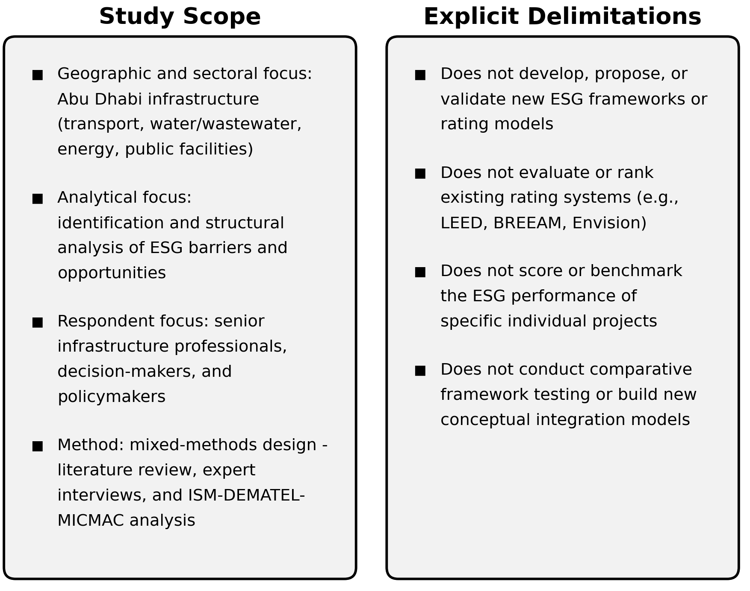
Note. The figure generated by AI tool (FigureLabs)

1.5. Key Operational Definitions
For clarity and consistency throughout this research, the following operational definitions are employed:
- Environmental, Social, and Governance (ESG): A working definition for this study defines ESG as a set of non-financial performance criteria encompassing environmental stewardship (resource efficiency, climate resilience, lifecycle impacts), social responsibility (labor practices, community engagement, stakeholder well-being), and governance integrity (transparency, accountability, ethical conduct) that collectively influence the long-term viability and resilience of infrastructure assets.
- ESG Implementation: The practical integration of ESG principles into infrastructure project planning, design, construction, operation, and decommissioning phases, including the adoption of relevant practices, processes, and accountability mechanisms.
- Infrastructure Sector (Abu Dhabi Context): Large-scale physical assets including transportation networks (roads, railways, metro systems), water and wastewater management facilities, energy systems, public utilities, and essential public buildings. This definition excludes real estate development, commercial buildings, and small-scale projects not classified as critical infrastructure.
- Barriers: Operational obstacles, systemic impediments, or contextual challenges that hinder, delay, or complicate the effective adoption and integration of ESG principles in infrastructure projects. Barriers may be technical, organizational, regulatory, financial, or institutional in nature.
- Opportunities: Enabling factors, leverage points, strategic advantages, or favorable conditions that facilitate, accelerate, or enhance the adoption and integration of ESG principles in infrastructure projects.

1.6. Significance of the Study

1.6.1. Academic Significance
This research addresses a notable lacuna within the extant body of knowledge by undertaking an in-depth investigation into sector-specific ESG implementation barriers and opportunities within a rapidly developing, arid-climate region. By establishing a nuanced understanding of both the impediments and the catalysts for change, the study provides a robust foundation for future strategic interventions and policy refinements (Sica, Tajani, Sáez-Pérez, & Marín-Nicolás,, 2023) . It uniquely synthesizes global ESG standards with local mandates, such as the Abu Dhabi Climate Change Strategy 2023-2027, thereby offering a novel and contextually rich exploration of "Infrastructure ESG" implementation challenges.

1.6.2. Practical and Professional Significance
The practical implications emanating from this research are substantial, offering direct and tangible value to a diverse array of key stakeholders:
- Government Entities (DMT, ITC): The study furnishes a data-driven basis for the refinement of existing infrastructure standards and provides actionable insights for addressing identified implementation barriers, particularly the "Governance" gap (Pambudi, Dayana, & Alfirman, 2023).
- Engineering Consultancies: It offers a strategic roadmap, enabling consultancies to more effectively navigate complex regulatory requirements while simultaneously enhancing project delivery outcomes and ESG integration.
- Contractors & Suppliers: The research identifies specific technical and supply chain barriers, thereby guiding targeted investment in sustainable materials, ethical labor practices, and supply chain resilience.
- Investors & Developers: By clarifying the barriers and opportunities for ESG implementation, the study contributes to enhancing the "bankability" of infrastructure ventures and attracting capital from ESG-focused investors.

Chapter 2: Literature Review

2.1. Introduction and Chapter Overview
This chapter undertakes a comprehensive and critical review of the extant academic and professional literature pertaining to Environmental, Social, and Governance (ESG) principles, with a particular focus on their application within the infrastructure sector, both globally and specifically within the context of Abu Dhabi. The discussion commences by tracing the conceptual evolution of ESG from its foundational antecedents, subsequently delineating its core components and strategic importance. Following this, the chapter explores the global landscape of ESG integration, transitioning to a detailed examination of its manifestation within the United Arab Emirates. A dedicated section then scrutinizes the unique challenges and opportunities presented by ESG within the infrastructure domain. The overarching flow of this chapter progresses from broad global definitions to the nuanced local context, systematically identifying prevailing barriers and emerging opportunities, culminating in a precise articulation of the research gap that this dissertation aims to address.

2.2. Conceptual Evolution of ESG
The conceptual journey towards contemporary ESG frameworks is often traced back to the Triple Bottom Line (TBL), a seminal concept introduced by John Elkington in 1994 (Elkington, 1994). TBL posited that corporate success should not be solely measured by financial profit, but rather by a broader assessment encompassing social and environmental performance, encapsulated by the triumvirate of "People, Planet, and Profit." This framework served as a crucial precursor, broadening the scope of corporate accountability beyond purely economic metrics and laying the groundwork for a more holistic understanding of sustainability (Ehlers & Packer, 2017).
However, the evolution from TBL to ESG represents a significant refinement and a more pragmatic, investor-centric approach to sustainability. While TBL offered a conceptual lens, ESG provides a more structured and quantifiable framework, emphasizing the materiality of non-financial factors—environmental impacts, social responsibilities, and governance structures—and their direct influence on an organization's long-term financial viability and risk profile (Eccles & Serafeim, 2013). Unlike the often broader and more qualitative nature of Corporate Social Responsibility (CSR) initiatives, ESG is distinguished by its reliance on measurable metrics, standardized disclosures, and its increasing integration into the fiduciary duties of investors and corporate boards (Hummel & Schlick, 2016).
Conceptualizing "Infrastructure ESG" extends this understanding beyond the general corporate context to the specific domain of large-scale physical assets. Infrastructure, by its very nature, encompasses a vast array of projects, including transportation networks, energy systems, and public utilities, all of which have profound and lasting impacts on the environment and society. The long-term nature of these assets means that ESG risks and opportunities are particularly salient, as they can manifest over decades. Consequently, a robust "Infrastructure ESG" framework must account for the entire project lifecycle, from initial planning and financing to decommissioning, ensuring that sustainability is embedded at every stage. Figure 2 shows the three pillars of TBL (People, Planet, Profit) and their relationships.

Figure 2
Triple Bottom Line Framework
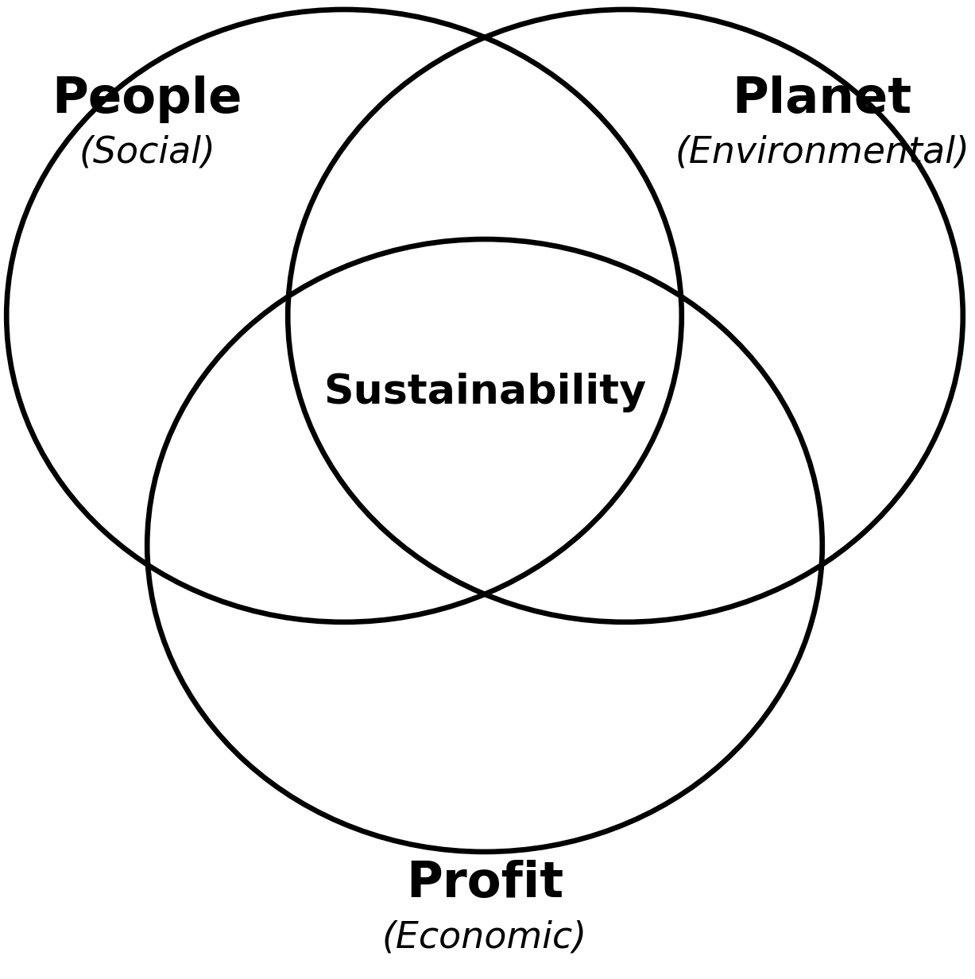
Note. (Elkington, 1994)

Evolution of Global ESG Reporting Standards : The maturation of the ESG paradigm has been inextricably linked to the development and proliferation of global reporting standards, which aim to provide a structured approach for organizations to measure, disclose, and manage their non-financial performance. These standards serve as critical tools for investors, regulators, and the public to assess the sustainability credentials of entities, particularly within the capital-intensive infrastructure sector.
Foremost among these are the Global Reporting Initiative (GRI) Standards, which have emerged as one of the most widely adopted frameworks for sustainability reporting worldwide (Friede, Busch, & Bassen, 2015). GRI provides a comprehensive set of universal and topic-specific standards, enabling organizations to report on their impacts across a broad spectrum of environmental, social, and governance issues. For the infrastructure sector, GRI's relevance lies in its capacity to facilitate transparent disclosure on material topics such as energy consumption, water management, labor practices, and anti-corruption measures, thereby offering a detailed narrative of an entity's sustainability performance (Global Reporting Initiative, n.d.).
Complementing GRI's broad-based approach, the Sustainability Accounting Standards Board (SASB) Standards offer a more industry-specific and financially material perspective. SASB focuses on identifying the subset of ESG issues that are most likely to have a material financial impact on a company in a specific industry. This investor-focused lens is particularly valuable for the infrastructure sector, as it helps to translate sustainability performance into the language of financial risk and opportunity, thereby strengthening the business case for ESG integration ( Sustainability Accounting Standards Board, n.d.). The ongoing convergence and collaboration between these leading standard-setters, as illustrated in joint publications, signal a move towards a more harmonized and less fragmented reporting landscape, reducing the burden on reporting entities and providing more comparable data for stakeholders (GRI & SASB, 2021). Figure 3 represents the evolution of ESG from 1890 up to 2020.

Figure 3
ESG History: From 1960s Origins to Today's Global Impact
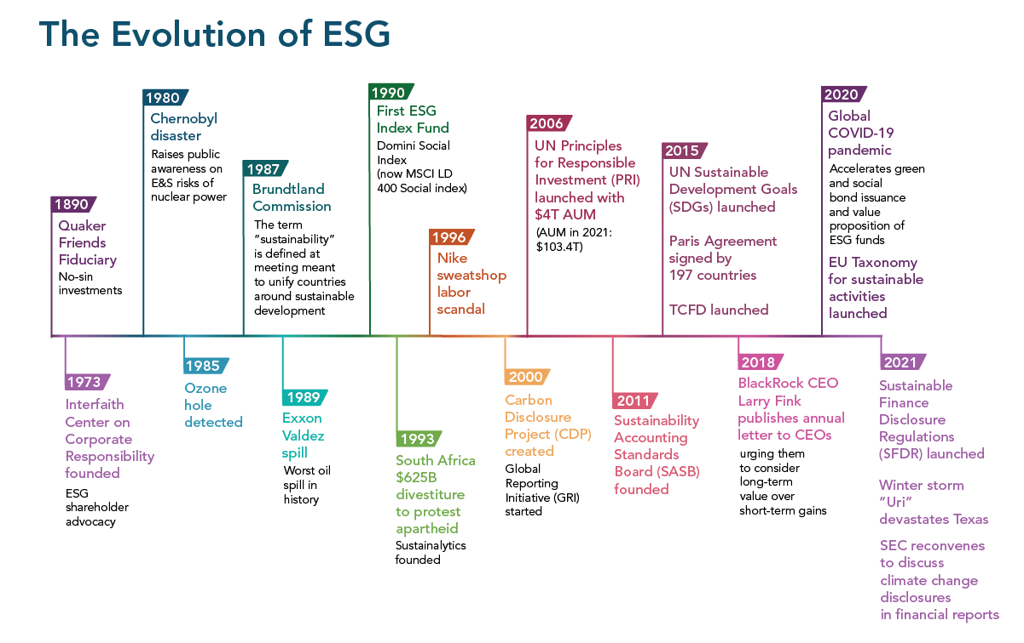
Note. (Carbon Training International, 2024)

2.3. Theoretical Frameworks
The integration of ESG into infrastructure is supported by several key theoretical frameworks that explain why and how organizations adopt these principles. These theories provide a lens through which to understand the motivations, challenges, and outcomes of ESG integration.

2.3.1. Stakeholder Theory
Stakeholder theory, pioneered by R. Edward Freeman, posits that an organization's success depends on its ability to manage relationships with all its stakeholders, not just its shareholders. In the context of infrastructure, stakeholders include government agencies, investors, contractors, local communities, and the environment itself. ESG integration is seen as a way to address the diverse and often competing interests of these stakeholders, ensuring that the project delivers value to all parties involved (Freeman, 2001) figure 4 shows the internal and external stakeholders. By proactively engaging with stakeholders and addressing their concerns, infrastructure projects can build trust, reduce conflict, and enhance their overall legitimacy.
Figure 4
Implementing Stakeholder Theory for Business Success
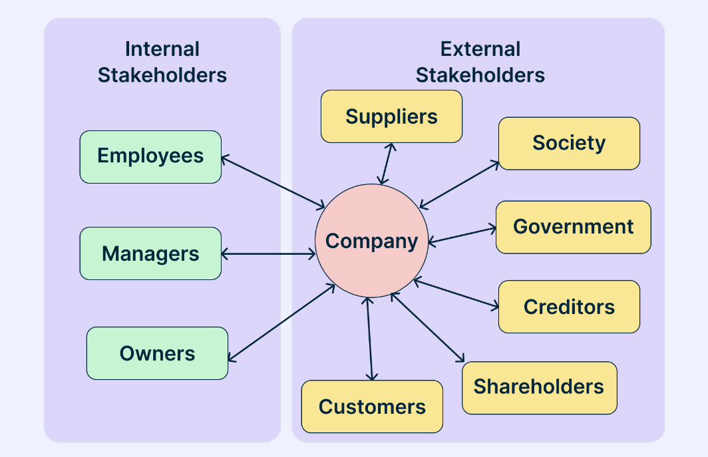
Note. (Al-Amin & Filho, 2015)

2.3.2. Legitimacy Theory
Legitimacy theory suggests that organizations seek to operate within the bounds and norms of their respective societies. In an era of increasing environmental and social awareness, ESG integration has become a key source of organizational legitimacy. Infrastructure projects, which often have significant public visibility and impact, are under intense scrutiny to demonstrate their commitment to sustainability. Adopting ESG principles is a way for these projects to signal their alignment with societal values and secure their "social license to operate" (Suchman, 1995) both of internal and external environment shown in figure 5 represented the Legitimacy Theory. Failure to maintain legitimacy can lead to project delays, increased costs, and reputational damage.
Figure 5
Legitimacy Theory
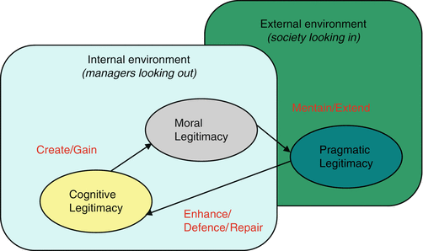
Note. (Schiopoiu Burlea & Popa, 2015)

2.3.3. Resource-Based View (RBV)
The resource-based view of the firm suggests that organizations can achieve a competitive advantage by developing unique, valuable, and non-substitutable resources and capabilities. Figure 6 shows the Resource-Based View Theory. In the context of ESG, the ability to effectively integrate sustainability into project delivery is increasingly seen as a strategic capability. Organizations that excel at ESG integration can differentiate themselves in the market, attract top talent, and secure more favorable financing terms (Barney & Delwyn , 2007). This perspective shifts the view of ESG from a compliance-driven cost to a value-creating strategic asset.
Figure 6
Resource Based View Theory
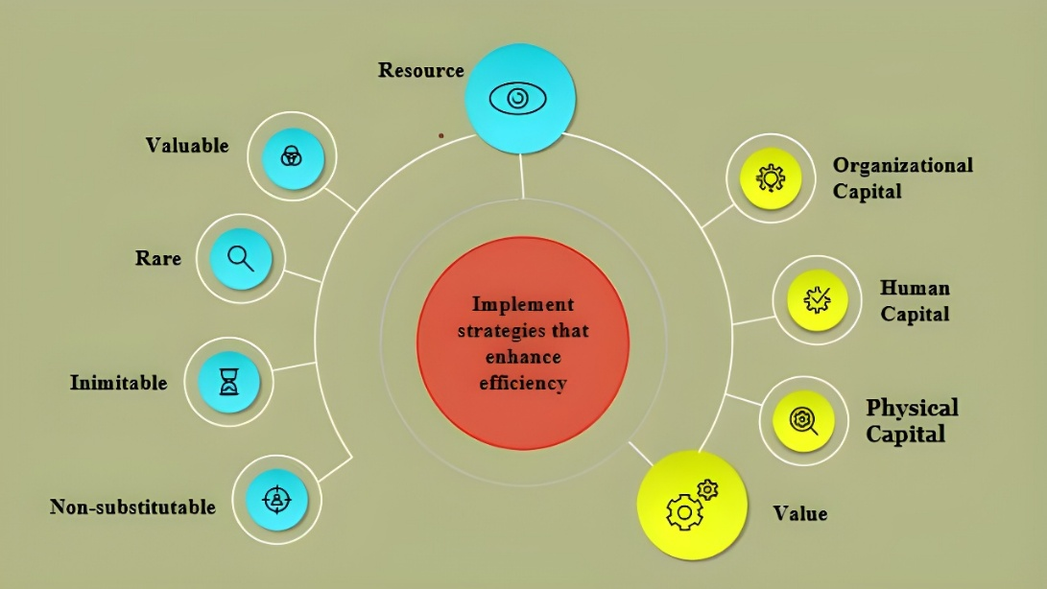
Note. (Rishi, Dwivedi, & Ghosal, 2022)

2.3.4. Institutional Theory and Isomorphism
Institutional theory provides a critical lens for understanding how organizational structures and practices are shaped by the social and regulatory environments in which they operate. In the context of ESG, this theory explains the phenomenon of "isomorphism," where organizations tend to adopt similar practices to gain legitimacy and social acceptance. DiMaggio and Powell (1983) identified three types of isomorphic pressures: coercive, mimetic, and normative. Coercive isomorphism occurs when organizations adopt ESG practices due to formal or informal pressures from regulatory bodies, such as the mandatory requirements of Estidama in Abu Dhabi. Mimetic isomorphism arises when organizations imitate the ESG strategies of successful peers to navigate uncertainty, while normative isomorphism is driven by professional standards and the shared values of the engineering and sustainability communities (Özer, Özalp, Zheng, & Donohue, 2018).
Understanding these pressures is essential for analyzing the "compliance fatigue" often observed in the Abu Dhabi infrastructure sector. When ESG integration is driven primarily by coercive pressures without a corresponding shift in normative values, it can lead to symbolic compliance—where organizations meet the minimum requirements without a genuine commitment to sustainability. This research explores how these institutional pressures interact within the local context and how they can be leveraged to drive more substantive and integrated ESG adoption across the project lifecycle.

2.4. Global ESG Conceptual Foundations in Infrastructure
The integration of Environmental, Social, and Governance (ESG) considerations into the infrastructure sector is not merely a contemporary trend but a reflection of an evolving global theoretical grounding that recognizes the profound, long-term impact of physical assets on both planetary and societal well-being. This framework posits that infrastructure, as the foundational element of economic activity and social development, must transcend purely financial metrics to embrace a more holistic definition of value creation. The theoretical underpinnings of this shift are multifaceted, drawing from concepts of sustainable development, stakeholder theory, and responsible investment, all converging to redefine the parameters of successful infrastructure delivery and management (Barney & Delwyn , 2007).

2.4.1. ESG Maturity and Organizational Ambition
The journey towards full ESG integration is often characterized by varying levels of organizational maturity. Research has identified several distinct profiles, ranging from basic compliance to strategic leadership. Organizations at the lower end of the spectrum often view ESG as a "tick-box" exercise, focusing on meeting minimum regulatory requirements. In contrast, those at the higher end integrate ESG into their core business strategy, viewing it as a source of competitive advantage (Drempetic, S., Christian, & Bernhard, 2020). This transition is heavily influenced by leadership commitment and organizational culture, where "sustainable leadership" is essential for fostering a culture that values long-term sustainability over short-term gains (Strand, 2014).

2.4.2. ESG Integration Across the Infrastructure Lifecycle
Effective ESG integration must be embedded across the entire lifecycle of an infrastructure asset. This begins at the planning and financing stage, where decisions on site selection and resource allocation shape the project's ultimate performance. The burgeoning market for Green Bonds exemplifies this early integration, where capital is raised specifically for projects with clear environmental benefits (Climate Bonds Initiative, 2023). In the design and construction phases, the adoption of Life Cycle Assessment (LCA) methodologies allows for a comprehensive evaluation of environmental impacts, while social aspects focus on fair labor practices and community well-being (ISO, 2006). Finally, the operation phase emphasizes efficiency, resilience to climate impacts, and ongoing stakeholder engagement to ensure the infrastructure continues to serve its purpose sustainably ( Uhl-Bien, Marion, & McKelvey, 2007), The ESG Integration Across the Infrastructure Project Lifecycle in general represented in Figure 7 while Figure 8 shows the Integration of each ESG Principles in Infrastructure Lifecycle.

Figure 7
ESG Integration Across the Infrastructure Project Lifecycle
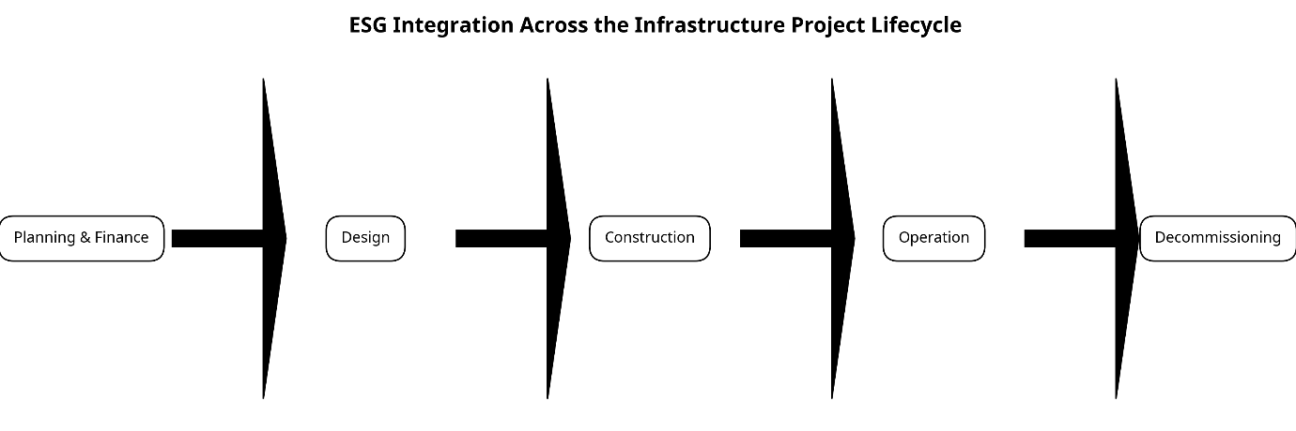
Note. (Shima & Taqi, 2025)

Figure 8
Integration of Each ESG Principles in Infrastructure Lifecycle
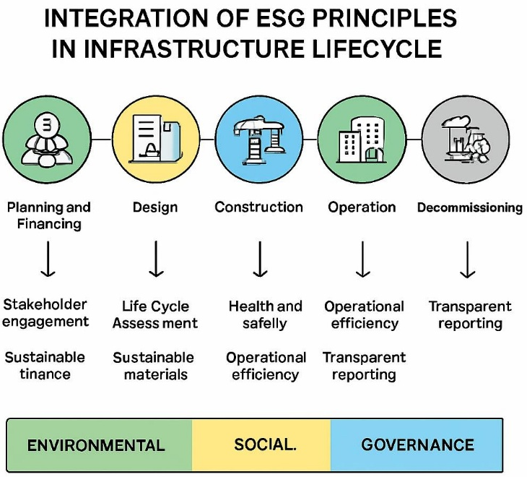
Note. The figure generated by AI tool (FigureLabs)

2.4.3. Transition Management and Systemic Change
The transition towards a sustainable infrastructure sector is not merely a technical challenge but a complex, long-term process of systemic change. Transition management theory, as developed by Loorbach and Rotmans (2010), emphasizes the need for a multi-level and multi-actor approach to managing these transitions. This involves creating "transition arenas" where diverse stakeholders can collaborate on long-term visions and experiment with innovative solutions (Loorbach & Rotmans, 2010). In the context of Abu Dhabi, the government's strategic visions (e.g., Vision 2030) act as the high-level "landscape" pressures that drive the transition, while initiatives like the Net Zero 2050 mandate create the "regime" shifts necessary for systemic change.
However, the literature suggests that these high-level transitions often face resistance at the "niche" level, where individual projects and organizations struggle to implement new practices within existing technical and financial constraints. This research applies transition management principles to identify the specific "leverage points" within the Abu Dhabi infrastructure sector where strategic interventions can accelerate the adoption of ESG principles. By analyzing the barriers at different levels of the system, the study aims to provide a more nuanced understanding of how to manage the complex transition towards a sustainable built environment

2.4.4. Transition Management and Systemic Change
The concept of ESG maturity has evolved from simple compliance-based models to more sophisticated frameworks that emphasize strategic integration and value creation. Early models often viewed sustainability as a peripheral activity, primarily focused on risk mitigation and reputational management. However, contemporary maturity models, such as the PwC ESG Maturity Profile, categorize organizations based on their level of ambition and the extent to which ESG is embedded in their core decision-making processes (Drempetic, S., Christian, & Bernhard, 2020).
In the infrastructure sector, maturity is often measured by the degree to which ESG considerations are integrated into project selection, procurement, and lifecycle management. Organizations at the "nascent" stage may only report on basic environmental metrics, while those at the "leading" stage utilize advanced digital tools for real-time monitoring and engage in deep stakeholder collaboration. This research evaluates the current level of ESG maturity within the Abu Dhabi infrastructure supply chain, identifying the specific organizational and cultural factors that either facilitate or hinder the progression towards higher levels of maturity. By understanding these maturity dynamics, the study can provide more tailored recommendations for enhancing ESG performance across different types of infrastructure entities.

2.5. Profiles of ESG Maturity
Research has identified several distinct profiles of ESG maturity, ranging from basic compliance to strategic leadership. Organizations at the lower end of the spectrum often view ESG as a "tick-box" exercise, focusing on meeting minimum regulatory requirements and avoiding reputational damage. In contrast, organizations at the higher end of the spectrum integrate ESG into their core business strategy, viewing it as a source of competitive advantage and long-term value creation (Drempetic, S., Christian, & Bernhard, 2020).
In the Abu Dhabi infrastructure sector, the level of ESG maturity varies significantly across different entities. While some government-linked organizations have demonstrated leadership in environmental sustainability through the adoption of Estidama, others are still in the early stages of integrating social and governance principles. This unevenness in maturity can create challenges for cross-sector collaboration and the consistent application of ESG standards across complex infrastructure projects (Hummel & Schlick, 2016).
The Role of Leadership and Organizational Culture: The transition towards higher levels of ESG maturity is heavily influenced by leadership commitment and organizational culture. Strategic leadership is essential for setting the vision, allocating resources, and fostering a culture that values sustainability. Research suggests that organizations with "sustainable leadership" are more likely to successfully integrate ESG principles and achieve superior long-term performance (Strand, 2014).
In the context of Abu Dhabi, the strong strategic direction provided by the government through initiatives like Vision 2030 and the Net Zero 2050 mandate provides a powerful impetus for organizational change. However, translating this high-level vision into operational reality requires a shift in organizational culture, moving away from traditional, cost-centric models towards more holistic and value-driven approaches. This cultural shift is often met with resistance, particularly in established engineering and construction firms where traditional practices are deeply ingrained (Senge, 1990).
The disparity in ESG maturity across the Abu Dhabi infrastructure supply chain creates a unique knowledge gap that distinguishes the local context from more mature international markets. While global maturity models emphasize a linear progression from compliance to strategic leadership, the Abu Dhabi landscape is characterized by a "fragmented maturity" where technical environmental excellence often coexists with nascent governance structures (Drempetic, S., Christian, & Bernhard, 2020). This imbalance suggests that the current understanding of ESG in the region is heavily skewed toward measurable environmental outputs, leaving the qualitative complexities of social impact and institutional governance largely unexplored in academic literature (Salim & Abu Dabous, 2018) (Awadh, 2018).
Furthermore, the integration of local mandates, such as the Abu Dhabi Climate Change Strategy 2023-2027, into the broader infrastructure lifecycle remains a significant area of uncertainty. Existing research often overlooks how these specific regional policies interact with global investor demands, creating a disconnect that hinders the "bankability" of local projects (Sica, Tajani, Sáez-Pérez, & Marín-Nicolás,, 2023) (Pambudi, Dayana, & Alfirman, 2023). Addressing this gap requires a more nuanced investigation into how Abu Dhabi-specific regulatory frameworks can be harmonized with international best practices to foster a more consistent and mature ESG ecosystem across all project phases.

2.6. Future Trends and Policy Innovation in Infrastructure ESG
As the global discourse on sustainability continues to evolve, several emerging trends and policy innovations are shaping the future of ESG integration in the infrastructure sector. These trends reflect a move towards more integrated, data-driven, and impact-focused approaches to sustainability.

2.6.1. The Shift Towards Impact Investing
Impact investing, which seeks to generate measurable social and environmental impact alongside a financial return, is increasingly influencing the infrastructure sector. Unlike traditional ESG integration, which focuses on managing risks and minimizing negative impacts, impact investing proactively seeks to create positive outcomes. This shift is driving the development of more sophisticated impact measurement and management (IMM) frameworks that allow investors to track and report on the real-world outcomes of their investments (Sica, Tajani, Sáez-Pérez, & Marín-Nicolás,, 2023).
In the context of Abu Dhabi, the shift towards impact investing offers a powerful opportunity for the infrastructure sector to align with the Emirate's broader social and environmental goals. By attracting impact-focused capital, infrastructure developers can secure the funding required for projects that deliver clear and measurable benefits to society and the environment, such as affordable housing, renewable energy, and sustainable transport (Pambudi, Dayana, & Alfirman, 2023).

2.6.2. The Role of Policy Innovation and Regulatory Sandboxes
Policy innovation is crucial for creating an enabling environment for ESG integration. This includes the development of flexible and adaptive regulatory frameworks that can keep pace with the rapid evolution of ESG standards and technologies. Regulatory sandboxes, which allow for the testing of innovative solutions in a controlled environment, are increasingly being used to facilitate the adoption of new ESG-aligned practices and technologies (Abu Dhabi Global Market, 2023) .
In Abu Dhabi, the government has demonstrated a strong commitment to policy innovation through initiatives like the "Abu Dhabi Global Market (ADGM) Sustainable Finance Regulatory Framework." This framework provides a clear and comprehensive set of rules for sustainable finance, helping to position Abu Dhabi as a leading hub for green investment in the region. Expanding this innovative approach to the broader infrastructure sector could help address the regulatory and policy barriers that currently hinder full ESG integration (Shan & Hwang, 2018).

2.6.3. The Integration of Nature-Based Solutions (NbS)
Nature-based solutions (NbS), which involve the protection, restoration, and sustainable management of ecosystems to address societal challenges, are gaining traction in the infrastructure sector. NbS can provide a cost-effective and sustainable alternative to traditional "grey" infrastructure, offering benefits such as climate resilience, biodiversity conservation, and enhanced community well-being (Tang, S & et al. , 2019).
In the arid environment of Abu Dhabi, NbS can play a critical role in managing water resources, reducing the urban heat island effect, and protecting coastal areas from sea-level rise. Integrating NbS into infrastructure planning and design requires a shift in mindset, moving away from purely engineered solutions towards more holistic and ecosystem-based approaches. This requires the development of new technical standards and the integration of ecological expertise into the infrastructure delivery process (Salim & Abu Dabous, 2018).

2.7. The UAE and Abu Dhabi Context Analysis
The United Arab Emirates, and specifically the Emirate of Abu Dhabi, has positioned itself as a regional leader in sustainable development through a series of ambitious strategic visions and regulatory mandates. These initiatives provide the necessary framework for ESG integration in the infrastructure sector, reflecting a commitment to balancing rapid economic growth with environmental and social responsibility.

2.7.1. National Strategic Mandates and Economic Growth
The Abu Dhabi Economic Vision 2030 serves as the primary roadmap for the Emirate's long-term transformation, emphasizing the development of a sustainable, diversified economy where infrastructure is a key enabler ( Abu Dhabi Council for Economic Development, 2008). This is further reinforced by the UAE Net Zero by 2050 Strategic Initiative, a federal mandate that requires a radical shift towards decarbonization and renewable energy adoption (UAE Ministry of Climate Change and Environment, 2021). Recent academic studies, such as those by Alharbi (2024), highlight that these ESG-aligned reforms are not merely environmental gestures but are intrinsically linked to economic growth in the GCC region. By fostering innovation and enhancing energy efficiency, these reforms attract foreign investment and align the region with global business standards (Sica, Tajani, Sáez-Pérez, & Marín-Nicolás,, 2023)[.2.7.2. UAE Net Zero by 2050 Strategic Initiative
The UAE's commitment to achieving net-zero emissions by 2050 is a landmark initiative that has profound implications for the infrastructure sector. This federal mandate requires a radical shift in how infrastructure is designed, built, and operated, with a focus on decarbonization, energy efficiency, and the adoption of renewable energy sources. For Abu Dhabi, this initiative accelerates the need for robust ESG integration, particularly in the environmental dimension, to ensure that infrastructure assets are aligned with national climate goals (UAE Ministry of Climate Change and Environment, 2021).

2.7.3. The Estidama Pearl Rating System (PRS) and its Limitations
The Estidama Pearl Rating System (PRS) is the cornerstone of Abu Dhabi's sustainable building efforts, evaluating projects across environmental, economic, social, and cultural pillars (Department of Municipalities and Transport, 2010). While Estidama has successfully driven environmental performance, particularly in energy and water efficiency, it has faced significant academic critique. Researchers like Assaf and Nour (2015) have pointed out data gaps for regional materials, while Awadh (2017) identified a notable underdevelopment in the governance pillar compared to international standards (Salim & Abu Dabous, 2018) (Awadh, 2018). This "E-centric" bias suggests that while the technical aspects of environmental sustainability are well-addressed, the broader social and governance dimensions of ESG remain fragmented in their implementation. Both of environmental and cultural standards in Estidama are exceeding the international standards while social and governance still need at least to meet the international standards. Figure 9 represented the Comparison of ESG Dimensions: Estidama vs. International Standards.
Figure 9
Comparison of ESG Dimensions: Estidama vs. International Standards
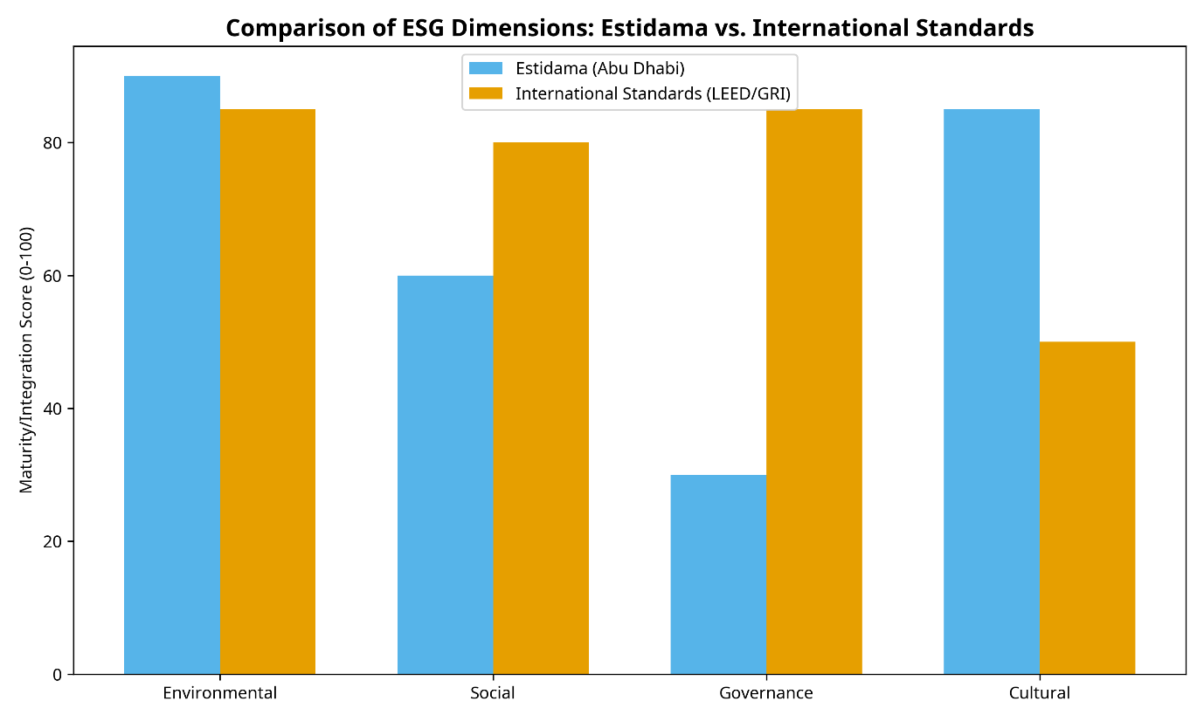
Note. (Wang, Hu, & Du, 2025)

2.8 Critical Analysis of Estidama

2.8.1. Critical Analysis of Social and Cultural Integration in the GCC
The integration of social and cultural dimensions within the GCC infrastructure context presents unique challenges. While Estidama includes a cultural pillar aimed at preserving local heritage, academic scrutiny suggests that these elements often lack the quantifiable metrics found in environmental criteria (Komeily & Srinivasan, 2015). In the broader GCC context, social reforms—including the improvement of expatriate labor conditions and workforce localization—are increasingly recognized as vital for inclusive growth (Sica, Tajani, Sáez-Pérez, & Marín-Nicolás,, 2023). However, the transition from symbolic cultural gestures to deep, participatory social impact assessments remains a significant hurdle. The literature indicates that for ESG to be truly effective in Abu Dhabi, it must move beyond basic provisions to address long-term community resilience and equitable access to resources (Alobaidi & et al., 2015).

2.8.2. The Governance Gap in Local Infrastructure
Perhaps the most critical area of concern identified in recent literature is the "Governance Gap." While international ESG frameworks increasingly recognize governance as the foundational element for achieving environmental and social objectives, the local framework in Abu Dhabi lacks a formal, explicit Governance pillar that aligns with global best practices (Kolk, Sustainability, accountability and corporate governance, 2008). This gap is particularly salient for large-scale infrastructure projects, where transparency, ethical procurement, and robust stakeholder management are paramount. The absence of a dedicated governance framework can lead to fragmented oversight and challenges in enforcing ethical standards across complex supply chains, representing a substantial impediment to holistic ESG performance (Suchman, 1995).

2.9. Critical Analysis of Relevant Publications and the Knowledge Gap
A critical review of recent publications specifically focused on the GCC and UAE reveals a growing body of evidence regarding the state of ESG in the region. Studies such as Zighan et al. (2026) have investigated the barriers to circular economy transitions in the GCC, identifying entrenched consumption patterns and limited technical expertise as foundational constraints (Zyglidopoulos & et al, 2016). Similarly, Al Omairi (2025) explored ESG adoption challenges in family-owned businesses, highlighting the role of organizational inertia and short-term economic priorities (Cabeza & et al., 2014).
Despite these valuable insights, a significant knowledge gap remains regarding the integrated implementation of ESG across the entire infrastructure project lifecycle in Abu Dhabi. Most existing research focuses on specific components—such as sustainable materials or energy efficiency—rather than the systemic interactions between technical, regulatory, and organizational barriers. Furthermore, there is a lack of empirically validated strategic recommendations that specifically address the "Governance Gap" and the "E-centric" bias within the local infrastructure supply chain. This dissertation seeks to address this gap by providing a contextually rich analysis that synthesizes global best practices with the unique socio-economic and regulatory realities of Abu Dhabi. . Appendix 1 (Sustainability Rating Systems Launch Timeline) shows the evolution and launch dates of major sustainability rating systems from 1990-2025, including BREEAM, Energy Star, Green Globes, LEED, Envision, CEEQUAL, Greenroads, GRESB, and others, where Detailed overview of infrastructure-specific rating systems including BREEAM Infrastructure, Envision, FAST-INFRA, Greenroads, and IS Rating Scheme with their key features and assessment methods shown in Appendix 2 (Infrastructure Rating Systems Overview).

2.9.1. A Critical Deconstruction of the Estidama Pearl Rating System (PRS)
The Estidama Pearl Rating System (PRS) represents a landmark achievement in the UAE's journey toward sustainable development, specifically tailored to the unique environmental and cultural context of the region. However, a deep academic deconstruction reveals a complex interplay between its pioneering successes and its inherent limitations. While the PRS has been instrumental in institutionalizing environmental standards—particularly in the realms of energy and water conservation—its application to large-scale infrastructure projects, as opposed to individual buildings, presents significant challenges. The system's "Pearl" hierarchy, while providing a clear benchmark for performance, can sometimes encourage a "point-chasing" mentality, where project teams focus on the most easily attainable credits rather than the most impactful sustainability outcomes (Salim & Abu Dabous, 2018).
Furthermore, the "Cultural" pillar of Estidama, while a noble attempt to preserve local heritage, has been critiqued for its lack of rigorous, quantifiable metrics. Unlike the "Environmental" pillar, which relies on precise engineering data, the cultural credits are often perceived as more subjective and qualitative, leading to inconsistencies in their application and verification. This research critically examines how the cultural and social dimensions of Estidama can be more effectively integrated with the more technically mature environmental criteria. By analyzing the "Social" credits within the PRS, the study identifies the specific areas where the system falls short of international ESG standards, such as the Global Reporting Initiative (GRI) or the Envision framework for sustainable infrastructure.

2.9.2. Aligning Estidama with Global ESG Reporting Frameworks
The challenge for Abu Dhabi's infrastructure sector lies in the "dual reporting" burden created by the need to comply with both local Estidama requirements and international ESG reporting standards. For multi-national firms operating in the Emirate, this can lead to significant administrative complexity and "compliance fatigue." The literature suggests that there is a pressing need for a more harmonized approach that maps Estidama credits directly to global ESG indicators. Such an alignment would not only streamline the reporting process but also enhance the international comparability of Abu Dhabi's infrastructure performance (Pambudi, Dayana, & Alfirman, 2023).
This research explores the potential for a "hybrid" reporting model that leverages the technical strengths of Estidama while incorporating the broader social and governance dimensions of global ESG frameworks. By conducting a detailed mapping exercise between Estidama and international standards like SASB and GRI, the study identifies the specific "Governance" gaps that must be addressed to achieve full alignment. This analysis provides a strategic roadmap for policymakers and industry practitioners to enhance the "bankability" of local projects by ensuring they meet the rigorous transparency and accountability requirements of global sustainable finance markets.

2.9.3. The Impact of the Abu Dhabi Climate Change Strategy 2023-2027
The recently launched Abu Dhabi Climate Change Strategy 2023-2027 adds a new layer of strategic urgency to the ESG discourse. This strategy sets ambitious targets for emissions reduction and climate resilience, specifically identifying the infrastructure sector as a key area for intervention. The strategy emphasizes the need for "climate-proofing" essential assets, such as transport networks and water systems, against the increasing risks of extreme heat and sea-level rise. This research analyzes how the objectives of the Climate Change Strategy can be operationalized through robust ESG integration.
The literature indicates that while the strategy provides a clear high-level mandate, the technical pathways for achieving its targets are still being defined. There is a critical need for more research on the use of low-carbon materials, such as "green concrete," and the adoption of advanced circular economy practices within the local construction supply chain. By synthesizing the goals of the Climate Change Strategy with the identified barriers to ESG adoption, this study provides a contextually rich analysis of the opportunities for Abu Dhabi to lead the region in climate-resilient infrastructure development. This section of the review bridges the gap between high-level policy and operational reality, highlighting the specific technical and regulatory innovations required to meet the Emirate's ambitious climate goals

2.9.4. Comparative Analysis of ESG Frameworks in the GCC
The GCC region presents a diverse landscape of ESG adoption, with each member state developing its own unique approach to sustainability. A comparative analysis of these frameworks reveals both common challenges and distinct regional innovations. For instance, while Abu Dhabi's Estidama system is highly regarded for its technical rigor in environmental performance, Saudi Arabia's Vision 2030 has driven a more rapid integration of ESG into large-scale "Giga-projects" like NEOM and the Red Sea Project. These projects are often used as testing grounds for innovative ESG practices, such as the use of advanced circular economy principles and large-scale renewable energy integration (Zyglidopoulos & et al, 2016).
In contrast, Qatar's approach has been heavily influenced by its hosting of major international events, which necessitated the adoption of global sustainability standards like GSAS (Global Sustainability Assessment System). This cross-regional learning provides a valuable opportunity for Abu Dhabi to benchmark its own practices and identify areas for improvement. Recent studies, such as those by Pillai et al. (2025), suggest that while the UAE leads the region in comprehensive sustainability measures, there is a significant opportunity for greater regional harmonization of ESG reporting standards. Such harmonization would not only reduce the administrative burden on multi-national contractors but also enhance the overall attractiveness of the GCC as a destination for sustainable investment (Sica, Tajani, Sáez-Pérez, & Marín-Nicolás,, 2023).

2.9.5. The Role of Sovereign Wealth Funds in Driving ESG
Sovereign Wealth Funds (SWFs) in the GCC, such as Abu Dhabi's Mubadala and ADIA, play a pivotal role in shaping the ESG landscape. As major investors in both local and international infrastructure, these funds have the power to mandate ESG integration across their portfolios. The literature indicates a growing trend among GCC SWFs to align their investment strategies with global ESG principles, such as the One Planet Sovereign Wealth Funds initiative. This top-down pressure from capital providers is a significant driver for ESG adoption among infrastructure developers and contractors, who must demonstrate robust sustainability performance to secure funding (Pambudi, Dayana, & Alfirman, 2023).
However, the challenge lies in translating these high-level investment principles into operational requirements for individual infrastructure projects. There is often a disconnect between the strategic ESG goals of the SWFs and the technical specifications used by project managers on the ground. This research investigates this "implementation gap" and explores how the influence of SWFs can be more effectively leveraged to drive substantive ESG integration throughout the infrastructure supply chain in Abu Dhabi.

2.9.6. Analysis of GCC-Specific Infrastructure Barriers
A deeper dive into GCC-specific literature reveals a set of unique barriers that are often overlooked in global ESG studies. For example, the "low-cost energy" environment in many GCC countries has historically acted as a disincentive for investing in energy-efficient technologies. While recent subsidy reforms in the UAE have begun to address this, the entrenched mindset of energy abundance remains a cultural barrier to deep ESG integration (Zyglidopoulos & et al, 2016). Furthermore, the extreme climatic conditions of the region necessitate specialized technical solutions for environmental sustainability, which can increase project costs and complexity.
Socially, the unique demographic composition of the UAE, with its high reliance on expatriate labor, presents specific challenges for the "Social" pillar of ESG. While recent labor reforms have significantly improved worker protections, the academic literature suggests that there is still a need for more robust and transparent reporting on social impact and labor practices within the construction sector (Sica, Tajani, Sáez-Pérez, & Marín-Nicolás,, 2023). This research critically analyzes these region-specific barriers, providing a more nuanced understanding of the challenges that must be overcome to achieve truly sustainable infrastructure in Abu Dhabi. By synthesizing these findings, the study identifies the specific "Knowledge Gaps" that it aims to address, particularly the need for a holistic, lifecycle-based approach to ESG that is tailored to the unique socio-economic and climatic context of the Emirate.

2.10. Systemic Barriers and Opportunities: A Multi-Dimensional Analysis
The transition towards comprehensive ESG integration in the infrastructure sector is hindered by a complex array of systemic barriers that vary across different geographic and sectoral contexts. Understanding these impediments, particularly within the GCC and UAE, is essential for developing targeted mitigation strategies. Recent literature emphasizes that these barriers are often interconnected, where technical deficits can exacerbate regulatory confusion, and financial constraints can stifle organizational ambition (Zyglidopoulos & et al, 2016).

2.10.1. Technical and Data-Related Barriers
A primary technical barrier identified in both global and regional studies is the lack of localized, granular data for quantitative ESG metrics. In the UAE, the absence of context-specific Life Cycle Assessment (LCA) databases for construction materials can lead to misleading environmental impact assessments (Drempetic, Klein, & Zwergel, 2020). Furth ermore, the quantification of social impact data remains a significant challenge, as robust metrics for community well-being and cultural preservation are still in the early stages of development (Greenwood, Stakeholder engagement: Beyond the rhetoric, 2007). This is compounded by a critical shortage of ESG-skilled professionals within the engineering and project management domains, which limits the capacity of organizations to effectively leverage available data for strategic decision-making (Al-Sarihi, 2018). Figure 10 shows the Technical and Data-Related Barrier and its impact.

Figure 10
Technical and Data-Related Barrier
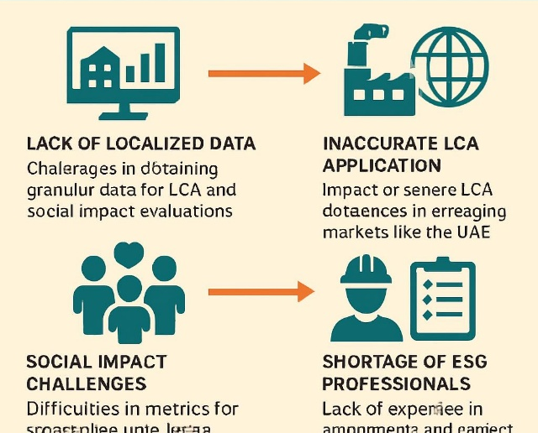
Note. The figure generated by AI tool (FigureLabs)

2.10.2. Regulatory and Policy Barriers
Regulatory fragmentation is a common theme in the literature, where multiple governmental agencies may issue overlapping or contradictory mandates. In the Abu Dhabi context, the challenge lies in aligning local DMT guidelines with broader federal UAE mandates and evolving international standards like GRI or SASB (Abu Dhabi Global Market, 2023). This lack of a unified regulatory voice can create uncertainty for investors and lead to "compliance fatigue" among project developers. However, policy innovations, such as the ADGM Sustainable Finance Regulatory Framework, offer significant opportunities to create a more enabling environment for green investment (Shan & Hwang, 2018). The Regulatory and Policy Barriers are summarized in Figure 11.
Figure 11
Regulatory and Policy Barriers
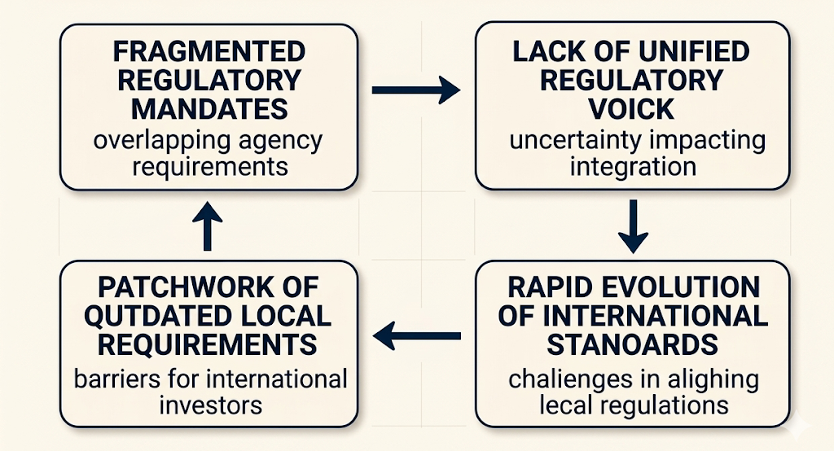
Note. The figure generated by AI tool (FigureLabs)

2.10.3. Financial and Economic Barriers
The perception of high upfront costs remains a formidable barrier to ESG adoption. In a sector characterized by competitive bidding and tight margins, the additional investment required for sustainable materials and advanced monitoring technologies is often viewed as a financial risk (Villabruna, Hluszko, & Rossi, 2024). Moreover, the lack of a clear taxonomy for ESG investments in the region can hinder the flow of capital towards sustainable infrastructure projects. Nevertheless, the rise of green bonds and sustainability-linked loans provides a powerful economic incentive for organizations to enhance their ESG performance, as these instruments can lead to lower financing costs and broader access to capital (Ehlers & Packer, 2017). The summary of financial and economic barriers are shown in Figure 12.

Figure 12
Financial and Economic Barriers
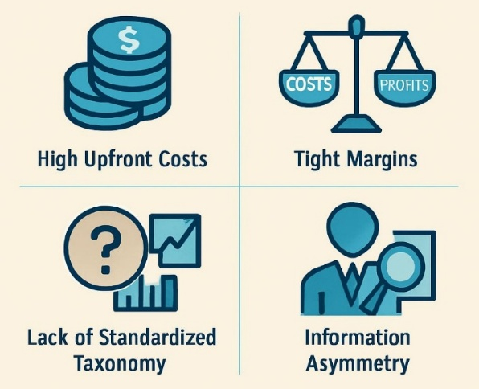
Note. The figure generated by AI tool (FigureLabs)

2.10.4. Synthesis of Barriers and Opportunities by Country and Sector
Table 1 provides a detailed synthesis of the barriers and opportunities identified in recent academic literature, categorized by Country and Sector (C&S). This mapping serves as the foundational evidence base for identifying the specific challenges to be addressed in this research.

Table 1
Synthesis of Barriers and Opportunities by Country and Sector
Study | Country/Region | Sector | Identified Barriers | Identified Opportunities
(Zighan, Alkalha, & Jum'a, 2025) | GCC | Manufacturing/SCM | Technical expertise gaps; low-cost energy disincentives; organizational inertia. | SDG alignment; institutional coordination; public awareness initiatives.
(Alharbi & Csala, 2024) | GCC | Financial/  Economic | Regulatory complexity; data gaps; strategy integration. | Innovation-led growth; energy efficiency gains; increased FDI attraction.
(Al Omairi, 2025) | UAE | Family Businesses | Short-term economic priorities; lack of formal ESG governance. | Long-term resilience; enhanced brand reputation; access to green finance.
(Alzara, Elnasser, Abdelshakor, & Ehab, 2025) | Saudi Arabia | Construction | High initial costs; lack of technical standards; social resistance. | Circular economy transitions; waste reduction; localized material innovation.
(Pillai, Islam, & Aminul , 2024) | Global/MENA | Transport Infra | Weak implementation of ESG ratings; minimal awareness. | Enhanced "bankability"; improved operational efficiency; climate resilience.
(Barham, Matarneh, & Tezel, 2025) | Middle East | Construction | Fragmented regulatory mandates; data gaps for regional materials. | Digital twin integration; BIM-based ESG monitoring; policy alignment.
(Sica, Tajani, Sáez-Pérez, & Marín-Nicolás,, 2023) | Global | Finance/Infra | Lack of clear taxonomy; inconsistent reporting standards. | Green bond market growth; standardized ESG indicators; investor trust.

2.11. ESG as a Driver of Risk Mitigation and Value Creation
While the barriers are significant, the literature also underscores that ESG integration is a powerful driver of both risk mitigation and value creation. Proactive ESG adoption reduces exposure to regulatory penalties and reputational damage, while also enhancing the resilience of infrastructure assets to climate impacts (Busch, Bauer, & Orlitzky, 2016). From a value creation perspective, strong ESG credentials improve access to sustainable finance and can drive innovation in materials and processes, creating a competitive advantage in an increasingly sustainability-conscious market (Beerannavar, 2020). The integration of digital technologies, such as BIM and IoT, further enables real-time monitoring and transparent reporting, which are essential for building stakeholder trust and ensuring long-term project success (Wu, Islam, & Tang, 2025). These Dual of Rish Mitigation & Value Creation are represented in Figure 13.

Figure 13
ESG: Dual of Rish Mitigation & Value Creation
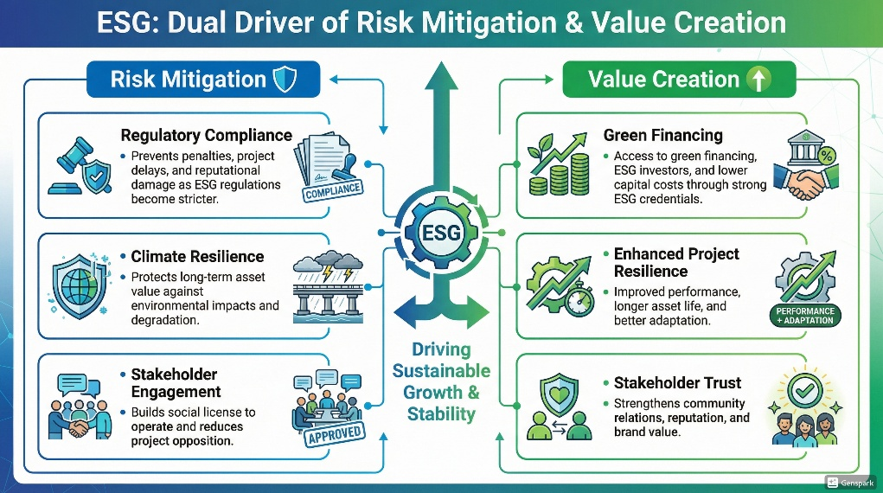
Note. The figure generated by AI tool (FigureLabs)

2.12. Sector-Specific ESG Challenges: Transport, Energy, and Water
The barriers to ESG integration are not uniform across all infrastructure sectors, as each domain faces its own unique set of technical and regulatory challenges. In the transport sector, for instance, the primary focus is often on reducing carbon emissions through the adoption of electric vehicles and the enhancement of public transit networks. However, the "Social" pillar in transport infrastructure is equally critical, encompassing issues of accessibility, safety, and community connectivity (Pambudi, Dayana, & Alfirman, 2023). In Abu Dhabi, the Integrated Transport Centre (ITC) has made significant strides in these areas, yet the integration of broader ESG metrics into project procurement remains a work in progress.
In the energy and water sectors, the challenges are more technically oriented, focusing on resource efficiency and the transition to renewable sources. The UAE's "Water Security Strategy 2036" provides a robust framework for sustainable water management, but the high energy intensity of desalination remains a significant environmental hurdle. Integrating ESG into these sectors requires a deep understanding of the technical trade-offs between different sustainability objectives, such as the balance between water security and carbon reduction. This research explores these sector-specific nuances, providing a more granular analysis of the barriers and opportunities for ESG integration across Abu Dhabi's diverse infrastructure landscape.

2.12.1. The Role of Professional Skills and Organizational Culture
Beyond technical and regulatory barriers, the literature increasingly emphasizes the importance of "soft" factors such as organizational culture and professional skills. The successful adoption of ESG requires a fundamental shift in the mindset of infrastructure professionals, from a focus on short-term technical delivery to a long-term, holistic view of value creation. This cultural shift is often hindered by "organizational inertia," where established practices and hierarchies resist change (Zyglidopoulos & et al, 2016).
Furthermore, the "ESG skills gap" is not just about technical knowledge but also about the ability to integrate diverse perspectives and manage complex stakeholder relationships. Professionals need to be equipped with the skills to navigate the "Governance Gap" and ensure that ethical standards are upheld throughout the supply chain. This research investigates the role of professional development and organizational change management in facilitating the ESG transition in Abu Dhabi. By identifying the specific skills and cultural attributes that drive successful ESG integration, the study provides actionable insights for enhancing the capacity of the local infrastructure sector.

2.12.2. Leveraging Digital Twins for ESG Transparency
One of the most promising opportunities for overcoming data-related barriers is the use of "Digital Twins"—virtual replicas of physical infrastructure assets that are updated in real-time with data from IoT sensors. Digital twins provide a powerful platform for monitoring ESG performance throughout the project lifecycle, from construction to operation. They enable more accurate tracking of resource usage, carbon emissions, and even social impacts, such as worker safety and community engagement (Wu, Islam, & Tang, 2025).
In Abu Dhabi, the adoption of digital twins is aligned with the Emirate's broader digital transformation goals. However, the literature suggests that the full potential of this technology for ESG integration is yet to be realized, as many organizations still struggle with data silos and a lack of standardized protocols for ESG data exchange. This research explores how digital twins can be strategically leveraged to enhance transparency and accountability in the infrastructure sector, providing a more robust evidence base for ESG reporting and decision-making. By analyzing the technical and organizational requirements for digital twin adoption, the study identifies the specific opportunities for Abu Dhabi to lead the way in "Digital ESG."

2.12.3. The Synergy Between BIM and ESG: A Technical Deep Dive
The integration of Building Information Modeling (BIM) with ESG principles represents a paradigm shift in how infrastructure performance is managed. BIM is not merely a 3D modeling tool but a rich information management system that can store and process a vast array of sustainability-related data throughout the project lifecycle. For instance, "6D BIM" specifically focuses on sustainability, allowing for the integration of energy analysis, carbon footprinting, and lifecycle cost data directly into the digital model (Wu, Islam, & Tang, 2025). This enables project teams to conduct "what-if" scenarios during the design phase, optimizing the asset's environmental performance before a single stone is laid.
In the context of Abu Dhabi, the mandatory use of BIM for large-scale projects provides a solid foundation for this integration. However, the literature suggests that the full potential of "BIM-for-ESG" is often hindered by a lack of standardized data protocols and the "siloed" nature of project teams. This research explores the technical requirements for creating an integrated BIM-ESG workflow, identifying the specific data exchanges and collaborative processes needed to ensure that sustainability objectives are met. By analyzing the role of BIM in enhancing the transparency and auditability of ESG data, the study provides a compelling case for the digital transformation of the local infrastructure sector.

2.12.4. IoT and Real-Time ESG Performance Monitoring
The Internet of Things (IoT) complements BIM by providing real-time data on the actual performance of infrastructure assets during their operational phase. Sensors embedded in transport networks, water systems, and energy grids can collect continuous data on resource consumption, emissions, and even structural health. This "live" data feed allows for more proactive and adaptive management of ESG risks, such as identifying energy inefficiencies or detecting water leaks before they become major environmental issues (Tang, S & et al. , 2019). The integration of IoT data with the BIM model creates a "Digital Twin" that provides a comprehensive and dynamic view of the asset's ESG performance.
However, the adoption of IoT for ESG monitoring in Abu Dhabi faces several challenges, including high initial costs, data security concerns, and the need for advanced data analytics capabilities. The literature emphasizes that the value of IoT lies not just in the data collection but in the ability to translate that data into actionable insights for decision-makers. This research investigates the specific opportunities for leveraging IoT to enhance ESG transparency in the Emirate's infrastructure sector. By analyzing the technical and organizational barriers to IoT adoption, the study identifies the strategic interventions needed to build a more data-driven and responsive sustainability framework.

2.12.5. Bridging the ESG Skills Gap: A Strategic Imperative
The "ESG skills gap" is a critical bottleneck that threatens to slow down the transition towards sustainable infrastructure in the UAE. This gap is not limited to technical expertise in areas like carbon accounting or social impact assessment; it also encompasses the "soft skills" needed to manage complex stakeholder relationships and drive organizational change. The literature suggests that the traditional engineering curriculum often lacks a comprehensive focus on ESG, leaving many professionals ill-equipped to navigate the evolving sustainability landscape (Al-Sarihi, 2018).
To bridge this gap, there is a need for a multi-faceted approach that includes professional development programs, university curriculum reforms, and industry-wide capacity building initiatives. In Abu Dhabi, organizations like the DMT and the Abu Dhabi School of Government have a key role to play in fostering a new generation of "ESG-literate" infrastructure professionals. This research explores the specific skills and competencies required for effective ESG integration and identifies the most effective strategies for building this capacity within the local workforce. By analyzing the relationship between professional skills and organizational ESG performance, the study underscores that investing in human capital is just as important as investing in green technology.

2.12.6. The Rise of Sustainability-Linked Financing in the GCC
The financial landscape for infrastructure in the GCC is being reshaped by the rapid emergence of sustainability-linked financing (SLF). Unlike traditional green bonds, which are tied to specific "green" projects, SLF instruments link the cost of capital to the borrower's overall ESG performance, measured against pre-defined Key Performance Indicators (KPIs). This provides a powerful, performance-based incentive for infrastructure developers and contractors to achieve substantive sustainability outcomes across their entire operations (Ehlers & Packer, 2017). In the UAE, major financial institutions are increasingly offering SLF products, reflecting a growing recognition that companies with strong ESG profiles are more resilient and better positioned for long-term success.
However, the effectiveness of SLF depends on the availability of robust, transparent, and verifiable ESG data. The literature highlights that the "data gap" in the local infrastructure sector remains a significant barrier to the widespread adoption of these instruments. Without standardized metrics and third-party assurance, it is difficult for lenders to accurately assess and monitor the ESG performance of their borrowers. This research investigates the specific data requirements for SLF in the Abu Dhabi infrastructure context and explores how digital technologies like BIM and IoT can be leveraged to provide the necessary transparency. By analyzing the relationship between ESG performance and the cost of capital, the study provides a compelling economic case for deep ESG integration.

2.12.7. ESG and the "Social License to Operate" in Infrastructure
The concept of the "Social License to Operate" (SLO) is increasingly relevant to large-scale infrastructure projects, which often have significant impacts on local communities and the environment. SLO refers to the ongoing acceptance and approval of a project by its stakeholders, particularly those directly affected by its development. In the context of ESG, the "Social" pillar is the primary driver of SLO, encompassing community engagement, fair labor practices, and the preservation of cultural heritage (Suchman, 1995). The literature suggests that projects that fail to secure a robust SLO are at higher risk of delays, cost overruns, and reputational damage.
In Abu Dhabi, the unique socio-cultural context necessitates a tailored approach to securing SLO. While the government's top-down planning process provides a strong mandate for infrastructure development, there is a growing recognition of the need for more participatory and transparent stakeholder engagement. This research explores how ESG integration can be used as a strategic tool for building and maintaining SLO in the Emirate. By analyzing the "Social" dimensions of recent infrastructure projects, the study identifies the specific practices that enhance community trust and support. This section of the review highlights that ESG is not just a technical or financial requirement, but a fundamental prerequisite for the long-term social legitimacy of infrastructure development.

2.12.8. The Role of ESG in Enhancing Infrastructure Resilience
Climate change presents a significant and growing risk to infrastructure assets, particularly in the arid and coastal environment of Abu Dhabi. ESG integration provides a framework for enhancing the resilience of these assets to climate-related shocks and stresses. The "Environmental" pillar focuses on climate-proofing designs and adopting sustainable materials, while the "Governance" pillar ensures that climate risks are integrated into long-term strategic planning and risk management (Busch, Bauer, & Orlitzky, 2016). The literature emphasizes that resilient infrastructure is not only more sustainable but also more "bankable," as it is less likely to suffer from climate-related disruptions and asset stranding.
This research analyzes the specific climate risks facing Abu Dhabi's infrastructure—such as extreme heat, water scarcity, and sea-level rise—and explores how ESG principles can be used to mitigate these risks. By synthesizing findings from climate science and infrastructure engineering, the study identifies the technical and organizational innovations required to build a more resilient built environment. This section of the review underscores that ESG is a critical component of disaster risk reduction and long-term asset management, providing a strategic roadmap for ensuring the continued functionality and value of Abu Dhabi's essential infrastructure in a changing climate.

2.12.9. The Shift Toward Impact Investing and Social Value
A significant emerging trend in the global infrastructure sector is the shift from traditional ESG risk management toward "impact investing." While ESG focuses on mitigating negative impacts and managing risks, impact investing proactively seeks to generate positive, measurable social and environmental benefits alongside financial returns. This shift reflects a growing recognition that infrastructure can be a powerful tool for addressing societal challenges, such as inequality, climate change, and resource scarcity (Sica, Tajani, Sáez-Pérez, & Marín-Nicolás,, 2023). In Abu Dhabi, this trend is aligned with the Emirate's broader social development goals, providing an opportunity to leverage infrastructure investment for the greater public good.
However, the literature highlights that measuring and reporting on "social value" remains a significant challenge. Unlike environmental metrics, which are often grounded in physical data, social value is more complex and context-dependent, requiring a deep understanding of community needs and aspirations. This research explores the potential for integrating social value assessments into the Abu Dhabi infrastructure procurement process. By analyzing the "Social" pillar of ESG through the lens of impact investing, the study identifies the specific metrics and methodologies that can be used to quantify the broader societal benefits of infrastructure development.

2.12.10. Nature-Based Solutions and Climate Resilience
Another key trend is the increasing adoption of "Nature-Based Solutions" (NbS) to enhance the climate resilience of infrastructure assets. NbS involve the use of natural systems, such as mangroves, wetlands, and green roofs, to provide essential services like flood protection, carbon sequestration, and urban cooling. These solutions are often more cost-effective and sustainable than traditional "grey" infrastructure, while also providing significant co-benefits for biodiversity and community well-being (Tang, S & et al. , 2019). In the coastal and arid environment of Abu Dhabi, NbS offer a particularly promising approach to climate adaptation.
The literature suggests that while the benefits of NbS are well-documented, their integration into mainstream infrastructure planning remains limited by a lack of technical standards and a perception of higher risk. This research analyzes the opportunities for incorporating NbS into the Abu Dhabi infrastructure landscape, identifying the specific technical and regulatory innovations required to support their adoption. By synthesizing findings from ecology and engineering, the study provides a compelling case for a more "nature-positive" approach to infrastructure development. This section of the review highlights that the future of ESG lies in a more holistic integration of natural and built systems.

2.12.11. Synthesis of the Research Gap: A Call for Integrated Lifecycle Analysis
The comprehensive review of the literature has revealed a significant and multifaceted research gap that this dissertation seeks to address. While there is a growing body of knowledge on individual components of ESG—such as sustainable materials, green finance, and digital monitoring—there is a notable lack of research that provides an integrated, lifecycle-based analysis of ESG implementation specifically within the Abu Dhabi infrastructure sector. Most existing studies are either too broad, focusing on global trends, or too narrow, focusing on specific technical solutions.
Furthermore, the "Governance Gap" and the "E-centric" bias identified in the local framework represent critical areas that have not been sufficiently explored in the academic literature. There is a pressing need for research that investigates the systemic interactions between technical, regulatory, and organizational barriers and develops empirically validated strategic recommendations for their mitigation. This study addresses this gap by providing a contextually rich and multi-dimensional analysis that synthesizes global best practices with the unique socio-economic and regulatory realities of Abu Dhabi. By bridging the gap between high-level policy and operational reality, this research aims to provide a strategic roadmap for the next generation of sustainable and resilient infrastructure in the Emirate.

2.13. Stakeholder Engagement and the Social License to Operate
Effective stakeholder engagement is a cornerstone of robust ESG integration, particularly in the social dimension. Infrastructure projects, by their very nature, have significant impacts on local communities, and managing these impacts is crucial for securing and maintaining a "social license to operate."

2.13.1. Models of Stakeholder Engagement
Various models have been developed to guide organizations in their stakeholder engagement efforts. These models emphasize the importance of moving beyond simple information sharing towards more participatory and collaborative approaches. A "five-stage stakeholder engagement model," for instance, outlines a progression from initial identification and analysis to deep engagement and ongoing partnership (Greenwood, Stakeholder engagement: Beyond the rhetoric, 2007).
In the Abu Dhabi context, stakeholder engagement is often mandated through regulatory processes like Environmental Impact Assessments (EIAs) and Estidama certification. However, academic critiques suggest that these processes can sometimes be perfunctory, focusing on meeting administrative requirements rather than fostering genuine community participation. There is a clear need for more robust and contextually sensitive engagement strategies that consider the diverse and rapidly evolving urban environment of Abu Dhabi (Greenwood, Stakeholder engagement: Beyond the rhetoric, 2007).

2.13.2. Building Trust and Transparency
Transparency and accountability are essential for building stakeholder trust and confidence. Organizations that are transparent about their ESG performance, including both their successes and their challenges, are more likely to secure community support and attract sustainable investment. This requires the adoption of standardized reporting frameworks and the use of third-party assurance to verify ESG claims (Hummel & Schlick, 2016).
In the infrastructure sector, where projects involve multiple entities and complex supply chains, ensuring transparency can be particularly challenging. Fragmented data ownership and inconsistent reporting standards can make it difficult for stakeholders to assess the true ESG performance of a project. Addressing these challenges requires the development of unified reporting platforms and the adoption of digital technologies to enhance data collection and verification (Salim & Abu Dabous, 2018).

2.14. Digitalization as an Enabler of ESG Integration
The rapid advancement of digital technologies offers unprecedented opportunities for enhancing ESG integration in the infrastructure sector. These technologies can provide the data-driven insights and real-time monitoring capabilities required for robust ESG reporting and decision-making.

2.14.1. BIM, GIS, and IoT Integration
The integration of Building Information Modeling (BIM), Geographic Information Systems (GIS), and the Internet of Things (IoT) provides a powerful platform for monitoring and managing ESG performance across the project lifecycle. BIM allows for the creation of detailed digital representations of infrastructure assets, while GIS provides the spatial context required for assessing environmental and social impacts. IoT devices can then be used to collect real-time data on energy consumption, water usage, and other key ESG metrics (Wu, Islam, & Tang, 2025).
This integrated approach enables more accurate and transparent reporting, as well as the ability to proactively identify and mitigate ESG risks. For instance, real-time monitoring of construction sites can help ensure compliance with labor standards and minimize disruption to local communities. In the operation phase, digital twins can be used to optimize energy efficiency and enhance the resilience of infrastructure to climate impacts (Tang, S & et al. , 2019).

2.14.2. Challenges to Digital Adoption
While the potential of digitalization is significant, its adoption in the infrastructure sector faces several challenges. These include the high cost of technology implementation, the need for specialized skills, and concerns over data security and privacy. Furthermore, the fragmented nature of the sector can make it difficult to achieve the level of data sharing and interoperability required for fully integrated digital platforms (Al-Sarihi, 2018).
In Abu Dhabi, the government is actively promoting the adoption of digital technologies through initiatives like the "Smart Cities" strategy. However, translating this policy support into widespread industry adoption requires addressing the technical and organizational barriers that currently hinder the effective use of these technologies for ESG integration.

2.15. Green Finance and Economic Drivers for ESG
The financial landscape for infrastructure is undergoing a fundamental shift, with the rise of green finance and sustainable investment providing a powerful economic impetus for ESG integration. This shift is driven by a growing recognition among investors that ESG factors are materially significant to the long-term financial performance and risk profile of infrastructure assets, ESG investments are expected to further grow and to pass the USD 100 trillion mark by 2030. ESG global investment is expected to be increased by 95% since 2014. Figure 14 shows the Global AUM invested in ESG mandates (in USD tn).

Figure 14
Global AUM Invested in ESG Mandates (in USD tn)
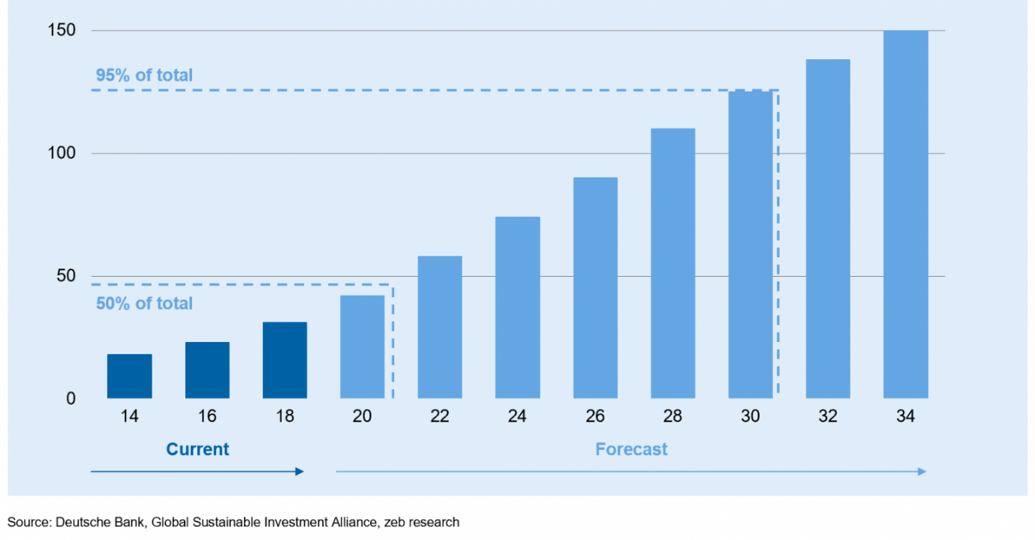
Note. (Wolfgang , Tommaso , & Manuel, 2020)

2.15.1. The Rise of Green Bonds and Sustainable Debt
Green bonds have emerged as a primary instrument for financing environmentally sustainable infrastructure projects. These bonds are specifically designed to raise capital for projects with clear environmental benefits, such as renewable energy, energy efficiency, and sustainable transport. The exponential growth of the green bond market reflects a strong investor appetite for ESG-aligned assets and provides a clear financial incentive for developers to enhance their environmental performance (Ehlers & Packer, 2017).
In addition to green bonds, other forms of sustainable debt, such as sustainability-linked loans, are increasingly being used to finance infrastructure. These instruments link the cost of capital to the achievement of specific ESG performance targets, thereby providing a direct financial reward for organizations that successfully integrate ESG principles into their operations. This "financialization" of ESG is a key driver for change, as it translates sustainability performance into the language of financial risk and return [10]. Shifting the planet's energy system away from fuels that emit greenhouse gases will cost $2 trillion a year by 2030, according to estimates from the International Energy Agency. Even when The corporate ESG bond sales had a drop of around 200 billion USD it started to recover rapidly after one year in 2023 as shown in Figure 15.
Figure 15
Corporate ESG Bond Sales Set to Recover in 2023
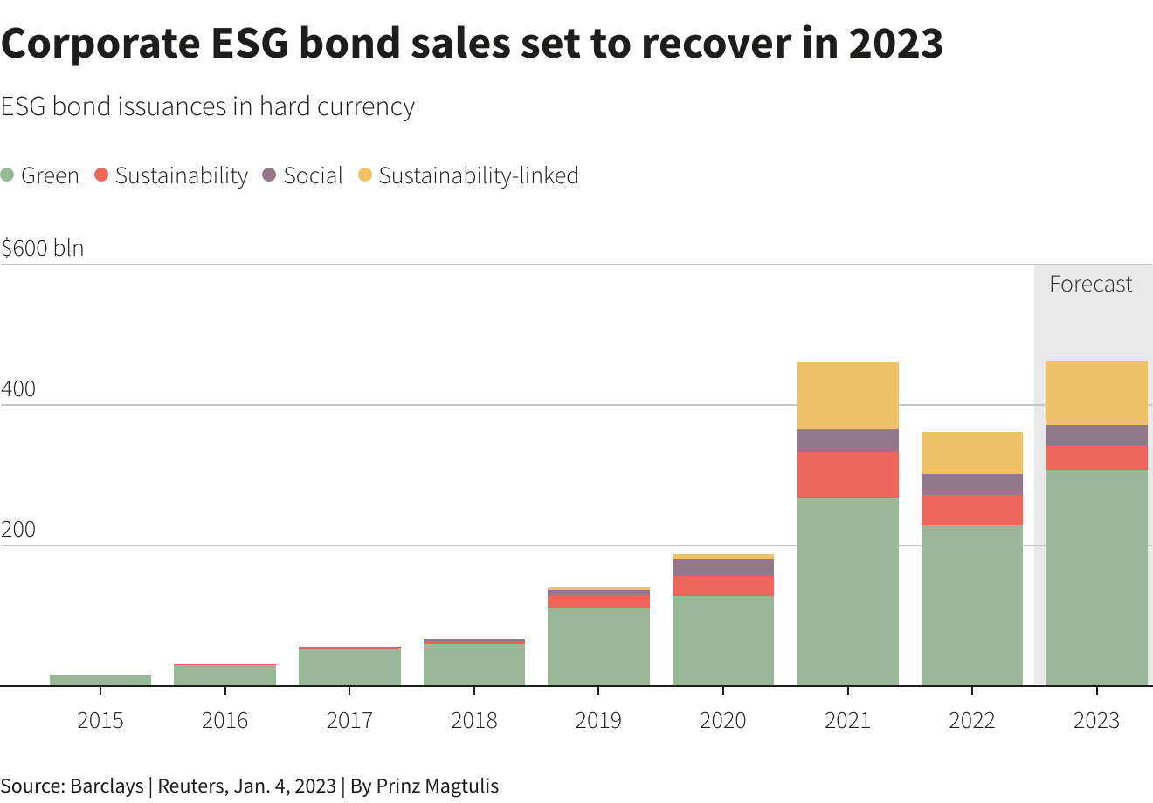
Note. (Gabriele, 2023)

2.15.2. ESG and the "Bankability" of Infrastructure
The "bankability" of an infrastructure project—its ability to attract financing on favorable terms—is increasingly dependent on its ESG credentials. Investors and lenders are now routinely incorporating ESG criteria into their due diligence processes, assessing projects for their exposure to climate risks, social conflict, and governance failures. Projects with strong ESG profiles are seen as more resilient and less risky, leading to lower financing costs and broader access to capital (Villabruna, Hluszko, & Rossi, 2024).
In the Abu Dhabi context, the government's commitment to sustainability and the presence of a robust regulatory framework like Estidama enhance the bankability of local infrastructure projects. However, to fully leverage the potential of green finance, there is a need for more transparent and standardized ESG reporting that aligns with international investor expectations. This includes the adoption of global reporting standards like GRI and SASB, as well as the use of third-party ESG ratings and certifications (Pambudi, Dayana, & Alfirman, 2023).

2.15.3. The Business Case for ESG: Beyond Compliance
While regulatory mandates are a key driver for ESG adoption, the long-term business case for ESG integration extends far beyond mere compliance. Research has consistently shown that organizations that effectively manage their ESG risks and opportunities achieve superior financial performance over the long term. This is driven by several factors, including improved operational efficiency, enhanced brand reputation, and better access to top talent (Friede, Busch, & Bassen, 2015).
In the infrastructure sector, the business case for ESG is particularly strong due to the long-term nature of the assets. ESG-integrated projects are better positioned to adapt to changing environmental and social conditions, reducing the risk of asset stranding and ensuring long-term value creation. Furthermore, the focus on innovation and efficiency that often accompanies ESG integration can lead to significant cost savings over the project lifecycle, offsetting the initial upfront costs of implementation (Cabeza & et al., 2014).

2.16. Contradictions and Tensions in ESG Adoption
Despite the clear benefits of ESG integration, the literature also highlights several contradictions and tensions that can complicate its implementation. These tensions reflect the complex and often competing interests of different stakeholders, as well as the inherent challenges of balancing short-term financial goals with long-term sustainability objectives.

2.16.1. Upfront Costs vs. Lifecycle Benefits
A primary tension in ESG adoption is the perceived conflict between high upfront costs and long-term lifecycle benefits. Implementing ESG-aligned practices often requires significant initial investment in sustainable materials, advanced technologies, and rigorous impact assessments. In a sector where projects are often awarded based on the lowest bid, these additional costs can be a major deterrent (Cabeza & et al., 2014).
However, research demonstrates that these upfront costs are often more than offset by the long-term benefits of improved efficiency, reduced operational expenses, and enhanced asset resilience. This highlights the importance of adopting a long-term financial perspective in ESG evaluation and the need for procurement processes that value lifecycle performance over initial cost (Villabruna, Hluszko, & Rossi, 2024).
Figure 16 gives a clear relationship emerges between ESG performance and financing costs across all three regions. Firms with lower ESG ratings consistently face higher costs, while those with stronger ESG profiles tend to benefit from slightly lower costs. This pattern appears in the cost of capital, cost of equity, and cost of debt, although the strength of the relationship varies by region. In the United States, the differences are more pronounced. Companies with low ESG scores show noticeably higher costs, especially in terms of equity, which suggests that investors demand a higher return to compensate for perceived risks. As ESG performance improves, these costs gradually decline. Europe follows a similar trend, though the variation between ESG categories is less sharp. Japan shows the same overall direction, but the gaps are narrower, indicating that ESG factors may be priced more moderately there.The cost of debt presents the most consistent pattern. Across all regions, firms with higher ESG ratings appear to secure borrowing at lower rates. This could reflect lenders’ preference for companies that are seen as more stable or better managed in terms of environmental and social risks.
Taken together, the figure indicates that ESG performance is not only a reputational factor but also has tangible financial implications. Stronger ESG practices seem to be associated with lower perceived risk, which in turn translates into more favorable financing conditions.

Figure 16
Relation Between ESG Scores and Cost of Capital Differed Within Developed Regions
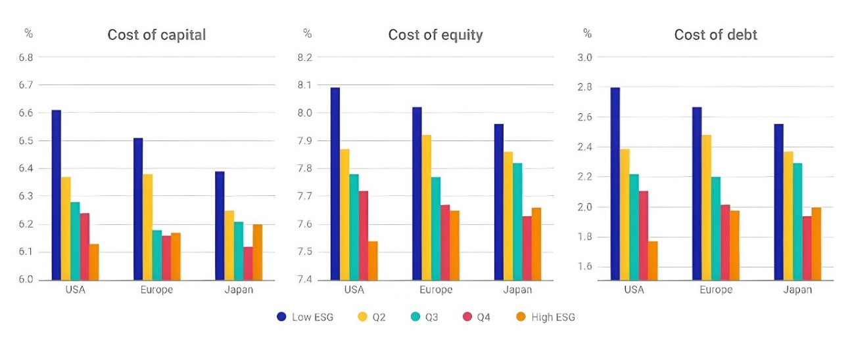
Note. (Ashish, 2020)

2.16.2. Voluntary vs. Mandatory ESG
Another area of debate is the relative effectiveness of voluntary versus mandatory ESG adoption. Some researchers argue that voluntary leadership is more effective, as it allows organizations to develop tailored strategies that align with their specific business goals. Others contend that regulatory mandates are necessary to ensure widespread adoption and to prevent "greenwashing"—the practice of making misleading or unsubstantiated claims about an organization's ESG performance (Carbon Leadership Forum., 2023). In reality, the most effective approach likely involves a combination of both: strong regulatory floors that establish minimum standards, complemented by voluntary leadership that drives innovation and sets new benchmarks for excellence. In Abu Dhabi, the mandatory nature of Estidama has been highly effective in driving environmental performance, but there is still significant room for voluntary leadership in the social and governance dimensions (Shan & Hwang, 2018). Figure 17 shows the road of ESG from Voluntary to Mandatory over the years.

Figure 17
The Evolution of ESG Reporting: From Voluntary to Mandatory
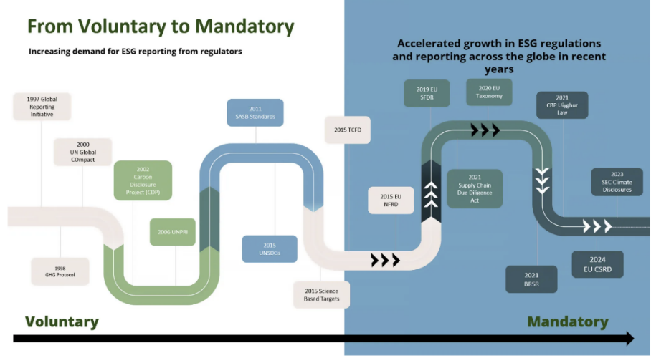
Note. (Cridibl, 2023)

2.16.3. Reporting vs. Actual Performance
A critical challenge in the ESG paradigm is the potential gap between reported performance and actual on-the-ground outcomes. Organizations may report high ESG scores based on their adherence to standardized reporting frameworks, while still generating negative social or environmental impacts that are not captured by these metrics. This "symbolic compliance" can undermine the credibility of the ESG framework and lead to a loss of stakeholder trust (Kolk & Pinkse, The integration of corporate governance with corporate social responsibility: exploring the mechanisms, 2010).
Addressing this challenge requires a shift in focus from reporting as an end in itself to reporting as a tool for operational accountability. This involves the development of more robust and context-specific metrics that capture the true impact of infrastructure projects, as well as the use of independent verification and assurance to ensure the accuracy and reliability of ESG disclosures (Hummel & Schlick, 2016).

2.17. Sector-Specific ESG Challenges in Infrastructure
The infrastructure sector faces a unique set of ESG challenges that distinguish it from other industries. These challenges are rooted in the sector's inherent characteristics, including the large scale of projects, their long lifecycles, and their complex stakeholder landscapes.

2.17.1. Transportation and Mobility
In the transportation sector, ESG integration focuses on reducing carbon emissions, enhancing safety, and improving accessibility. This includes the adoption of low-carbon transport modes, such as electric vehicles and public transit, as well as the design of infrastructure that promotes active mobility, such as walking and cycling. Social considerations in transport include ensuring equitable access to mobility services and minimizing the impact of transport infrastructure on local communities (Wu, Islam, & Tang, 2025).
In Abu Dhabi, the development of the Etihad Rail network and the expansion of the public bus system are key initiatives that align with these ESG objectives. However, achieving full integration requires addressing the technical and financial barriers to decarbonizing the transport sector, as well as the need for more robust social impact assessments of large-scale transport projects (Pambudi, Dayana, & Alfirman, 2023).

2.17.2. Water and Wastewater Management
Water and wastewater management is a critical area for ESG integration in arid regions like Abu Dhabi. Environmental considerations focus on water conservation, the use of non-conventional water sources such as treated sewage effluent (TSE), and the reduction of energy consumption in desalination processes. Social aspects include ensuring the provision of safe and reliable water services to all residents and managing the impact of wastewater treatment on local ecosystems (Salim & Abu Dabous, 2018).
The Estidama framework provides a strong basis for water efficiency in buildings, but there is a need for more comprehensive ESG standards for large-scale water infrastructure. This includes the adoption of lifecycle assessments to evaluate the environmental impact of different water management strategies and the integration of governance principles to ensure transparent and accountable water management (Salim & Abu Dabous, 2018).

2.17.3. Energy Infrastructure and Decarbonization
The energy sector is at the forefront of the ESG transition, with a focus on decarbonization and the shift towards renewable energy sources. This includes the development of solar and nuclear power plants, as well as the modernization of the energy grid to accommodate intermittent renewable energy. Environmental considerations in energy infrastructure focus on reducing greenhouse gas emissions and minimizing the impact of energy production on biodiversity (UAE Ministry of Climate Change and Environment, 2021).
Abu Dhabi's investment in the Barakah Nuclear Energy Plant and the Noor Abu Dhabi solar plant are landmark projects that demonstrate the Emirate's commitment to clean energy. However, the full integration of ESG in the energy sector requires addressing the technical challenges of grid integration and the social implications of the energy transition, such as the impact on local communities and the need for a "just transition" for workers in the fossil fuel industry (Pillai, Islam, & Aminul , 2024).

2.18. The Role of Professional Skills and Capacity Building
The successful integration of ESG principles in the infrastructure sector is heavily dependent on the availability of a skilled workforce that possesses the specialized expertise required for ESG reporting, analysis, and decision-making.

2.18.1. The ESG Skills Gap
Research has identified a significant global shortage of ESG-skilled professionals within the engineering, project management, and supply chain domains. This skills gap is a major barrier to robust ESG integration, as organizations struggle to find individuals who can effectively collect, analyze, and interpret complex ESG data. The specialized nature of ESG metrics, such as lifecycle assessments and social impact evaluations, requires a unique blend of technical, financial, and social science expertise (Al-Sarihi, 2018).
In Abu Dhabi, this skills gap is particularly acute, as the rapid pace of infrastructure development has outstripped the capacity of the local labor market to provide ESG-skilled professionals. Addressing this gap requires a concerted effort from government, academia, and industry to develop targeted training and education programs that equip the next generation of infrastructure professionals with the skills required for the ESG transition (Pambudi, Dayana, & Alfirman, 2023). Figure 18 shows the global green skills gap where it presents a very uneven regional split, with one region clearly taking the lead. Asia Pacific makes up 64.8% of the total, which is far higher than any other region shown. This suggests that the bulk of the activity is concentrated there, rather than being spread evenly across the world.
North America appears next at 9.5%, but the difference between it and Asia Pacific is substantial. After that, the shares become relatively close to one another. The Middle East and North Africa accounts for 7.1%, followed by Latin America at 5.7%. Western Europe and Sub-Saharan Africa are almost at the same level, 4.5% and 4.4%, while Russia and Eastern Europe has the smallest portion at 4.0%.
What stands out is how the remaining regions cluster within a narrow range. None of them individually reach even 10%, which gives the impression of a dispersed contribution outside the leading region. This pattern may reflect where most investments or developments are currently taking place, with Asia Pacific playing a central role while other regions contribute on a smaller scale.
Figure 18
Global Green Skills Gap
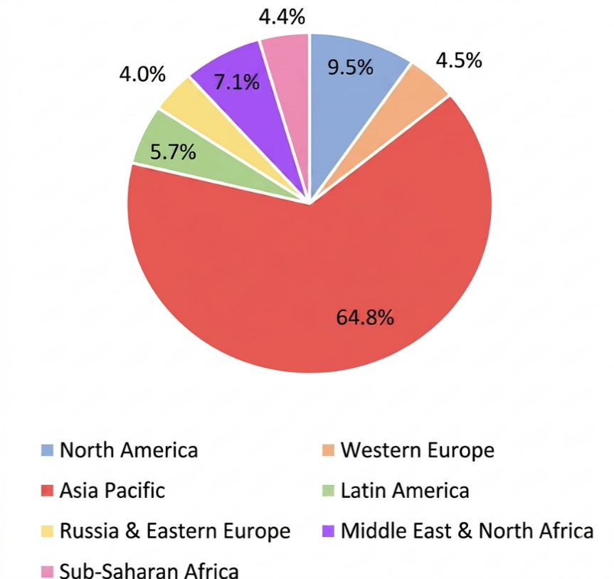
Note. (Globe News Wire, 2025)

2.18.2. Capacity Building in the Supply Chain
In addition to developing internal expertise, organizations must also focus on building ESG capacity within their supply chains. Infrastructure projects involve a vast array of contractors, suppliers, and consultants, many of whom may lack the resources or expertise required to meet rigorous ESG standards. Capacity building in the supply chain involves providing training, resources, and incentives to help suppliers enhance their ESG performance and align with the project's sustainability objectives (Tate, Ellram, & Kirchoff, 2010).
This is particularly important for small and medium-sized enterprises (SMEs), which often face the greatest challenges in meeting ESG requirements. By supporting SMEs in their ESG journey, infrastructure developers can not only enhance the overall sustainability of their projects but also contribute to the broader socio-economic development of the region. This requires the adoption of collaborative procurement models that value supplier development and long-term partnership over short-term cost savings (Villabruna, Hluszko, & Rossi, 2024).

2.19. Future of ESG in Infrastructure in UAE/GCC/Abu Dhabi

2.19.1. The Future Landscape: ESG Evolution in the UAE and GCC
The trajectory of ESG within the UAE and the broader GCC region is moving toward a phase of deep institutionalization, where sustainability is no longer a peripheral reporting requirement but a core driver of economic competitiveness. By 2026, the UAE has transitioned from a period of policy formulation to one of rigorous enforcement and impact-driven investment. This evolution is characterized by several key trends that are redefining the infrastructure sector, most notably the shift toward impact investing and the widespread adoption of nature-based solutions (Sica, Tajani, Sáez-Pérez, & Marín-Nicolás,, 2023) (Tang, S & et al. , 2019). The evolution of ESG in GCC region and in UAE in specific represented in Table 2.

Table 2
ESG Evolution in the UAE and GCC
Future Trend | Description | Strategic Impact on Infrastructure
Impact Investing | Moving beyond risk mitigation to generate measurable positive social and environmental outcomes. | Attracts specialized global capital and aligns projects with national social development goals.
Nature-Based Solutions | Utilizing natural systems like mangroves and green roofs for climate resilience and urban cooling. | Provides cost-effective alternatives to "grey" infrastructure while enhancing biodiversity.
Digital ESG Integration | Leveraging BIM, GIS, and IoT for real-time monitoring and transparent reporting. | Reduces the "data gap" and enhances the accuracy of sustainability-linked financing.
Policy Sandboxes | Creating controlled environments to test innovative ESG technologies and regulatory frameworks. | Accelerates the adoption of cutting-edge solutions while managing implementation risks.

The financial landscape is also undergoing a significant transformation, with the rapid rise of sustainability-linked financing (SLF). Unlike traditional green bonds, these instruments link the cost of capital directly to a borrower’s ESG performance, providing a powerful economic incentive for contractors and developers to achieve substantive outcomes (Ehlers & Packer, 2017). As Abu Dhabi continues to position itself as a global hub for green investment through frameworks like the ADGM Sustainable Finance Regulatory Framework, the integration of these financial innovations will be critical for funding the next generation of resilient infrastructure (BREATH ESG, 2025).
Moreover, the future of ESG in the region will be increasingly defined by its ability to address the unique challenges of an arid climate. The integration of nature-based solutions, such as the restoration of coastal ecosystems to protect against sea-level rise, represents a move toward a more "nature-positive" approach to engineering. This shift requires a fundamental re-evaluation of traditional engineering curricula and the development of a new generation of ESG-literate professionals who can navigate the complex intersections of technology, environment, and society. Figure 19 shows a clear upward trend in ESG investing within the UAE over the period from 2018 to 2030. Growth starts at a moderate pace in the earlier years, with gradual increases from one year to the next. As time progresses, the rise becomes more noticeable, especially after the middle of the timeline.
By the later years, the increase is much stronger, with the market expanding rapidly and reaching around 2000 million USD by 2030. This pattern suggests that ESG investing is gaining traction over time, with stronger momentum building in the later stages as interest and participation continue to grow.
Figure 19
UAE ESG Investing Market Size & Outlook, (2025-2030)
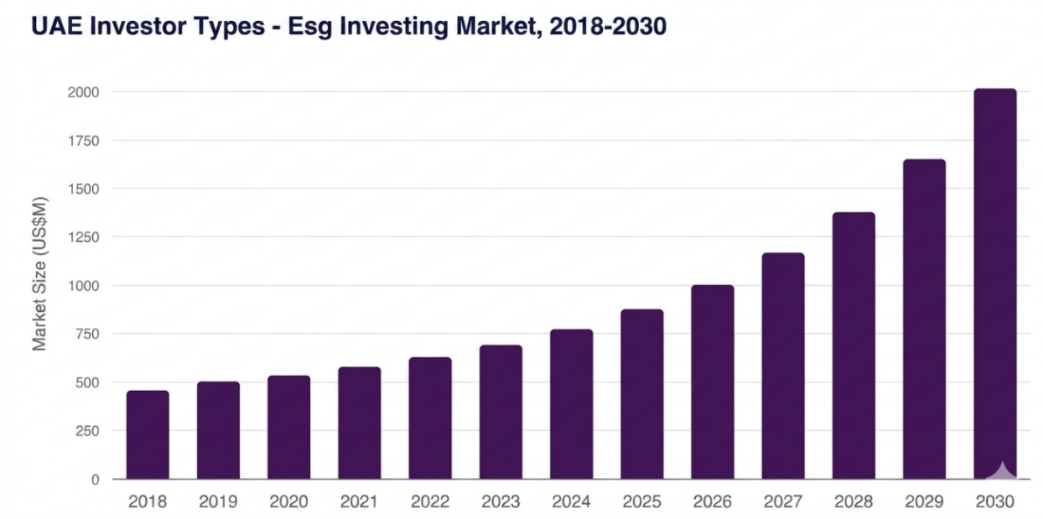
Note. (Grand View Research, 2025)

2.19.2. Summary and Synthesis of the Literature
The comprehensive analysis of existing literature reveals a profound shift in how infrastructure is conceptualized, moving from a narrow focus on technical delivery to a holistic model where Environmental, Social, and Governance (ESG) principles are foundational. This review has traced the evolution of these concepts from the early Triple Bottom Line frameworks to the sophisticated, data-driven ESG systems of today (Elkington, 1994). While global standards like GRI and SASB provide a structured architecture for reporting, their application within the specific socio-economic landscape of Abu Dhabi highlights a significant divergence between high-level strategic aspirations and the practical realities of project implementation (Global Reporting Initiative, n.d.) ( Sustainability Accounting Standards Board, n.d.).
The evidence suggests that Abu Dhabi has established a robust environmental foundation through the Estidama Pearl Rating System, yet a critical "Governance Gap" persists (Department of Municipalities and Transport, 2010) (Awadh, 2018). This gap, characterized by a lack of formal oversight and transparent accountability mechanisms, represents a primary barrier to achieving the Emirate’s Net Zero 2050 goals (UAE Ministry of Climate Change and Environment, 2021) (Müller, Caron, Drouin, & Lereim, 2025) . Furthermore, the "E-centric" bias in local practices often results in the social and cultural dimensions being treated as secondary administrative requirements rather than core subjects of impact assessment (Salim & Abu Dabous, 2018). The synthesis of these findings points to a clear research gap: the need for an integrated, lifecycle-based analysis that addresses the systemic interactions between technical, regulatory, and organizational barriers within the Abu Dhabi infrastructure sector.
Ultimately, the transition toward a sustainable built environment in the region is not merely a technical challenge but a complex process of systemic change. While emerging opportunities in green finance and digital monitoring offer promising pathways for advancement, their effectiveness is currently constrained by fragmented data and a shortage of specialized ESG expertise (Ehlers & Packer, 2017) (Wu, Islam, & Tang, 2025) (Al-Sarihi, 2018). This dissertation addresses these challenges by providing a contextually rich exploration of the impediments and catalysts for change, offering empirically validated recommendations to bridge the gap between policy and practice.

Chapter 3: Research Methodology

3.1 Introduction
This chapter provides information regarding the research methods applied to examine the problems and prospects associated with the implementation of Environmental, Social, and Governance principles in the infrastructure sector of Abu Dhabi. The research applied an integrated research methodology that combines two different models: Interpretive Structural Modeling and Decision-Making Trial and Evaluation Laboratory.

3.2 Research Design and Methodological Rationale
This research aims to use a hybrid approach of multi-criteria decision-making methods called Interpretive Structural Modeling (ISM) and Decision-Making Trial and Evaluation Laboratory (DEMATEL). The research design of this article is such that a systematic and rigorous investigation of ESG integration in the infrastructure sector of Abu Dhabi is conducted.
The methodology of this research is such that a detailed literature review is conducted to identify the relevant barriers and opportunities. Then, expert validation is conducted through expert interviews. ISM will be used in the initial stage of the analysis to develop the hierarchical structure and interrelationships of the identified factors. Then, DEMATEL will be used to analyze the strength of these interrelationships to classify the factors into causes and effects.
Thus, ISM and DEMATEL will be used together to analyze the complexity of systems such as ESG integration, as ISM provides structural clarity and DEMATEL provides analytical depth to the investigation. ( Liou, Liu, & Huang, 2023) (Parameswar, Hasan, & Shri, 2023)

3.2.1 Alignment with the Research Objectives
This particular research methodology was well structured to ensure that it covered the essential research question that was at the core of this research. That is, "What are the essential technical, organizational, and legislative barriers to the full integration of ESG principles into the infrastructure sector of Abu Dhabi, and what are the potential strategic opportunities that can be employed to resolve the issue?" All stages of the research design are geared towards supporting the purpose of the research.

3.2.2 Broader Review of Methodologies for Complex Systems Analysis
When we look at ESG and sustainability research, we see that there are ways to handle complicated problems. It is essential to consider these methods and identify the best one to use for this research. Analytical Hierarchy Process, Analytical Network Process, Interpretive Structural Modeling, and Decision Making Trial and Evaluation Laboratory are analyized as important methods.
Analytical Hierarchy Process (AHP) and Analytical Network Process (ANP): These methodologies are mostly used for prioritization and decision-making problems involving multiple criteria. AHP is used for structuring a problem into a hierarchy and for making use of pairwise comparisons for developing ratio scales for criteria and alternatives. It proves highly effective for ranking a predefined set of elements. ANP, an advanced extension of AHP, accommodates more intricate interrelationships and feedback loops among criteria, rendering it suitable for highly complex decision environments. While both AHP and ANP are powerful tools for establishing preference orders, their core function lies in establishing relative importance rather than delving into the intricate causal structures or dynamic interrelationships between factors (Barney & Delwyn, 2023). Recent studies have further shown the flexibility of these approaches for application in ESG-based infrastructure planning and supply chain management. For example, (Lin, Hanif, Makhdoom, & Xia, 2025) used an integrated AHP-Fuzzy TOPSIS approach to address the identification of key barriers to energy resilience, thereby filling the gap between policy and technical infrastructure. In addition, (Yang , Wang , Fu, & Giovanni, 2026) proposed an ANP-based decision framework for the integration of ESG principles with green supply chain management, addressing the complex interdependencies between environmental and social criteria. (Feitosa, Coutinho de Melo, Gonzaga de Albuquerque, Antunis de Rezende, & Dumke de Medeiros, 2026) also used AHP for the identification of key barriers to sustainability in digital platform services, with specific reference to energy intensity and behavioral effects.
Interpretive Structural Modeling (ISM) and Total Interpretive Structural Modeling (TISM): The ISM technique has proven itself as a reliable method for establishing and summarizing the relationships between a set of specific elements that characterize a problem or a particular issue. It has been shown that the technique is quite efficient in converting vague and poorly articulated mental images of complex systems into a structured and hierarchical form. The main outcome of the ISM technique is a structural hierarchy that, in a precise manner, identifies the factors that are at the base level, influencing other factors (the driving factors), and the factors that are at the higher levels, being influenced by other factors (the dependent factors). The study by Parameswar et al. (2024) (Parameswar, Hasan, & Shri, 2023) is a good example of the application of the ISM technique, as it has been modified and applied in the study of the barriers for ESG adoption, as per the modified TISM (m-TISM) technique. The main advantage of the ISM and TISM techniques is that it allows for a clear multi-level hierarchy of influence, which in itself is a great source of insight into complex systems. The application of structural modeling techniques has witnessed a surge in recent years. In a recent study, (Paridhi & Ritika, 2024) used a TISM-MICMAC technique to reveal the essential factors for the adoption of corporate ESG reporting. The results revealed the importance of organizational capacity and infrastructure investments. In the construction industry, (Shaikh, Qazi, & Appolloni, 2023) used the ISM technique to create a clear hierarchy of influence for identifying the critical regulatory barriers for green procurement. (Sumrit & Rodsak , 2026) proposed a WINGS-ISM technique for identifying a five-level hierarchy of barriers in technological infrastructure, where obsolete systems are the underlying cause for delays in ESG reporting adoption.
Decision-Making Trial and Evaluation Laboratory (DEMATEL): The DEMATEL method is specifically engineered to analyze causal relationships within intricate systems. Similar to ISM, it leverages expert judgment to construct a model of influence. However, its distinctive advantage and profound strength reside in its ability to quantify the intensity and nature of these relationships. The output generated by DEMATEL extends beyond a mere structural map; it produces a causal diagram that positions factors based on their calculated "prominence" (representing the total influence a factor exerts and receives) and "relation" (indicating the net influence, categorizing factors as either net causes or net effects). This quantification allows for a precise identification of net "cause" factors, which drive the system, and net "effect" factors, which are largely influenced by others. The research conducted by ( Liou, Liu, & Huang, 2023) effectively demonstrates the utility of DEMATEL, often in conjunction with other techniques, for pinpointing the most influential root factors obstructing ESG adoption. The analytical capability of the DEMATEL technique has been increasingly utilized in ESG-focused evaluation in various industries. (Zatonatska et al., 2025) proposed a systematic approach by using DEMATEL in evaluating and ranking ESG factors in sustainable energy investments. In the water infrastructure sector, (Yubo, Chuan , Xiaowei , & Igor, 2024) utilized DEMATEL in structuring the drivers and barriers of DT adoption under the ESG-Financial approach. In addition, (Srivastava , Narkhede, SrivastRaut, & Mishra, 2025) utilized the DEMATEL technique in evaluating the barriers to adoption in the maritime logistics sector, including the impacts on environmental sustainability and ESG.
Hybrid & Complex Systems Analysis: Recent developments in the field of complex systems analysis (2023-2025) have further increased the scope of application of these approaches in ESG and Infrastructure domains. For example, (Nguyen et al., 2025) used a hybrid Neuromorphic Delphi-DEMATEL model for identifying the fundamental causal dimensions of ESG adoption, including legal, institutional, and economic hurdles, for emerging economies' logistics sectors. In another example, (Santos , Renata , Lucas G. , & Nascimento, 2025) used a hybrid combination of Fuzzy DEMATEL and Fuzzy Cognitive Maps (FCM) for mapping the complex cause-and-effect relationships between specific ESG indicators and the United Nations Sustainable Development Goals (SDGs), (Gupta, Manoj, & Anil, 2026) used a combination of Fuzzy DEMATEL for identifying transparency and stakeholder engagement as the central hurdles for ESG performance in global supply chains.

3.2.3 Methodology Selection and Justification: A Hybrid ISM-DEMATEL Approach
A hybrid ISM-DEMATEL approach was adopted in this research. The reason for adopting this combination was driven by the complexity of the integration of ESG. The rationale for the adoption of the model is as follows:
The ISM is particularly useful in analyzing complex systems and developing a multi-level structural model. This would be particularly useful in developing a visual image of the complex relationships and influences of various barriers and opportunities. By developing the structural model through the application of the ISM, the research is able to develop the fundamental structural model. The DEMATEL is then applied to develop a more in-depth analysis of the "prominence" and "relation." This is particularly useful in identifying the fundamental "root cause" of the factors.

3.3 Context-Dependent Nature of ESG Barriers in Emerging Economies
It is also important to note and understand that it is imperative to appreciate that the impediments to the effective implementation of ESG are anything but uniform and are largely dependent on local factors such as economic, geopolitical, and socio-cultural factors. The literature also validates the proposition that ESG factors are largely dependent on the local conditions of a region ( Liou, Liu, & Huang, 2023), (Parameswar, Hasan, & Shri, 2023).
Economic Context: The economic environment of emerging economies, including the UAE, often faces unique challenges compared to their developed counterparts. For example (Parameswar, Hasan, & Shri, 2023) specifically note that many Asian countries face a low rate of ESG implementation owing to a low adaptability rate of ESG practices, including categorizing nations according to their ESG developmental phase. This observation strongly validates the proposition that economic considerations play a significant role in ESG challenges. Challenges including high implementation costs, a perceived lack of immediate financial benefits, and a lack of availability of capital often pose significant challenges for ESG implementation in many economies.
Regulatory and Geopolitical Context: It is evident that the overall governmental and institutional environment has a considerable impact on the ESG environment. This is further reinforced by the study by ( Liou, Liu, & Huang, 2023), where the authors, in their analysis of ESG barriers, identify the issue of "insufficient regulations" and the "lack of public awareness" as the most critical barriers in the context of the ESG environment in China. This, therefore, further reinforces the point that the overall regulatory environment and the level of public awareness have a fundamental impact on the overall ESG environment. The United Arab Emirates, as an emerging economy with a unique governance structure and a number of ambitious national development agendas, such as the Abu Dhabi Economic Vision 2030 and the UAE Net Zero 2050 Strategic Initiative, has a unique geopolitical and regulatory environment. It is a critical energy-producing nation in the Middle East, currently in the process of actively diversifying its overall economy, and therefore has a unique set of ESG adoption pressures and opportunities, quite divergent from more mature economies such as Europe and North America. The existing framework, though robust in certain areas of the environment, such as Estidama, may also have nascent structures in other areas, especially social and governance, thereby posing specific challenges for the integration of ESG.
It is, therefore, recognized that although global ESG frameworks are an essential starting point, their effectiveness is inevitably subject to the complex filter of local circumstances. Elements such as the level of economic development, the maturity of regulatory institutions, the nature of capital markets, and even cultural nuances serve to collectively forge a singular "implementation landscape." A comprehensive and specific analysis of the nature of the obstacles and their inter-relations in the Abu Dhabi infrastructure sector, therefore, not only becomes relevant but also essential in the formulation of relevant and effective policy and industry strategies. The purpose of this research, therefore, is to enable such an analysis.

3.4 Identification and Refinement of Barriers and Opportunities
The extensive review of the existing body of literature, as discussed in detail in Chapter 2 of this dissertation, resulted in a preliminary compendium of barriers/opportunities relevant to the implementation of ESG in the Abu Dhabi infrastructure sector. The preliminary compendium of barriers/opportunities serves as the foundation for an important refinement process, which entails a multi-stage process of refinement that incorporates an assessment of relevance to the UAE context, along with an assessment of the expert consultation process. The process of refinement aims to ensure that the research process remains grounded in established knowledge, while being validated through practical experience.

3.4.1 Initial Barriers from Literature Review and UAE Applicability
The various barriers to the effective implementation of a comprehensive integration of ESG criteria, as identified from the relevant literature, are discussed below. All of the identified barriers to effective integration have been critically evaluated to assess their relevance to the UAE, as well as Abu Dhabi in particular. The evaluation has shown that all of the identified barriers to effective integration are relevant to the UAE’s local infrastructure industry, as they are directly mentioned in the relevant literature to the UAE. The tendency to adopt an "E-centric" integration, the lack of effective governance, and the lack of local ESG metrics have been identified as major barriers to effective integration in the UAE context (UAE Ministry of Climate Change and Environment., 2021), (Department of Municipalities and Transport, , 2010).
Initial List of Barriers for ESG Implementation in Abu Dhabi Infrastructure (Derived from Literature Review):
- Absence of a unified ESG framework: There is a lack of a standardized and useful framework for the integration of ESG principles in the entire life cycle of infrastructure projects.
- Inconsistency in risk identification and reporting: The process of identifying and reporting ESG-related risk is inconsistent and lacks a cohesive framework.
- Environmental focus in sustainability: Although the environmental factors in sustainability are relatively well-established and defined in the Estidama framework, the social and governance factors of ESG are not as thoroughly analyzed.
- Significant implementation barriers resulting in "compliance fatigue" for industry practitioners: It is the challenges and difficulties faced during the implementation of new ESG practices, primarily because of overlapping reporting standards (Ibrahim, 2025).
- Shortage of localized metrics: It is difficult to measure and report ESG metrics in Abu Dhabi, as specific metrics may not be available for the context.
- Shortage of ESG professionals within the engineering domain: There is a noticeable scarcity of expertise, which is acting as a barrier to the implementation of ESG practices within the domain.
- "Governance Gap" and lack of formal oversight and transparent accountability: It is a significant barrier to achieving Net Zero 2050 and best practices from a global perspective (UAE Ministry of Climate Change and Environment., 2021).
- Social and cultural elements being viewed as perfunctory administrative tasks: Academic studies often point to the fact that, based on academic research, social and cultural elements included in the current local systems, such as Estidama, may be viewed as being of a perfunctory nature, without the need to conduct a profound impact assessment of the same (UAE Ministry of Climate Change and Environment., 2021).
- Unevenness in ESG maturity of various entities: There are substantial differences in the degree of understanding of ESG integration among various organizations in the Abu Dhabi infrastructure sector. Such unevenness poses a challenge to the integration of ESG principles, as well as to collaboration among various sectors of the Abu Dhabi infrastructure industry (Department of Municipalities and Transport, , 2010), (Salim & Abu Dabous, 2018).
- Resistance to change in established engineering and construction companies: Traditional ways of doing business, together with a cost-centric business model, may often result in a substantial amount of resistance to change, which may be a challenge in the implementation of a new, holistic, and value-driven ESG model. Such cultural resistance, especially in established companies, may hinder the required organizational shift to accommodate a holistic integration of ESG (Ibrahim, 2025).
- Fragmented maturity where technical environmental excellence coexists with nascent governance structures: Such a scenario creates a specific knowledge gap in the local context, where technical environmental excellence far exceeds social and governance maturity (Department of Municipalities and Transport, , 2010), (Salim & Abu Dabous, 2018).
- Uncertainty in the integration of local mandates within the overall infrastructure lifecycle: There exists a substantial amount of uncertainty with regards to the effective integration of specific regional policies, such as the Abu Dhabi Climate Change Strategy 2023-2027, within the overall infrastructure project lifecycle (Salim & Abu Dabous, 2018).

3.4.2 Initial Opportunities from Literature Review
Conversely, the literature review also illuminates several significant opportunities that can serve as potent catalysts for accelerating and enhancing ESG integration within the Abu Dhabi infrastructure sector:
- Attracting sustainable finance: The potential that High-level ESG integration has is significantly to increase the 'bankability' of infrastructure investments, by providing access to a rapidly growing pool of ESG-focused investors, as well as using financial instruments such as Green Bonds, as identified by (Pambudi, Dayana, & Alfirman, 2023), (Climate Bonds Initiative, 2024).
- Enhancing project performance and long-term resilience: ESG integration has its direct and significant impact on developing even more sustainable, resilient, and valuable infrastructure assets throughout the project lifecycle (Barney & Delwyn, 2023).
- Transforming ESG from an Administrative Hurdle into a Value-Creating Strategic Asset: ESG integration has also the capability to transform into a powerful source of competitive advantages, corporate reputation, and sustainable value creation for all stakeholders (Barney & Delwyn, 2023).
- Aligning with Broader National and International Sustainability Goals: ESG initiatives align in direct and organic link with the national strategic vision, including the Abu Dhabi Economic Vision 2030 and the UAE Net Zero 2050 Strategic Initiative, as well as global sustainability agendas.
- Differentiating in the Market, Attracting Top Talent, and Securing More Favorable Financing Terms: the leaders of ESG have the opportunity to attain a competitive advantage, such as accessing funds, brands, and the power to attract and retain the best talent in the market (Barney & Delwyn, 2023).
- Leveraging Institutional Pressures to Drive Substantive and Integrated ESG Adoption: Various forms of institutional pressures, such as coercive, mimetic, and normative pressures, can be leveraged to promote the adoption of a greater commitment to sustainability, which is crucial in inducing the required changes in the sector (Maggio & Powell, 1983).
- Adopting Digital Tools for Real-Time Monitoring and Transparent Reporting: Advanced technologies such as Building Information Modeling (BIM), Geographic Information Systems (GIS), Internet of Things (IoT), etc., would be address the existing gaps in the decision-making process in the context of ESG performance (Wu, Islam, & Tang, 2025).
- Fostering Stakeholder Collaboration: Involving a diverse set of stakeholders, such as government entities, communities, investors, etc., is vital in fostering trust and resolving chances in conflicts in the context of the project and its legitimacy (Freeman, 2001).
- Strategic Interventions at "Leverage Points" to Accelerate ESG Adoption: Identifying areas within the infrastructure system where strategic interventions could be made to have maximum influence is critical for inducing systemic changes to ensure sustainability within the sector (Loorbach & Rotmans, 2010).

3.4.3 Final Validated List of Barriers and Opportunities
The initial literature-derived compendium presented above (twelve candidate barriers and nine candidate opportunities) was reviewed during the pilot interviews described in Section 3.6 (Stage 1). Senior experts were asked to confirm the relevance of each item to the Abu Dhabi infrastructure context, merge items judged to be conceptually overlapping, and refine the wording of the surviving items into short, codeable labels suitable for use in the Structural Self-Interaction Matrix. This process produced the final validated set of eleven barriers (B1-B11) and ten opportunities (O1-O10) presented in Table 1, which is the set used throughout the remainder of this dissertation.
Table 3
Final Validated List of Barriers (Post-Pilot-Interview)
Code | Factor | Definition
B1 | Absence of Unified Framework | Lack of a standardized, sector-wide framework for integrating ESG principles across the infrastructure project lifecycle.
B2 | Inconsistent Reporting | Inconsistency in ESG-related risk identification and reporting practice across organizations.
Code | Factor | Definition
B3 | E-centric Bias | Disproportionate emphasis on environmental criteria relative to social and governance dimensions in current local frameworks.
B4 | Governance Gaps & Lack of Enforcement | Absence of formal oversight mechanisms and transparent accountability structures for ESG compliance.
B5 | Lack of Local Metrics | Shortage of ESG metrics calibrated to the Abu Dhabi/UAE context, limiting accurate local measurement.
B6 | Skill Shortage | Shortage of ESG-trained professionals within the engineering and infrastructure domain.
B7 | Financial Barriers | Cost and financing constraints limiting organizational capacity to invest in ESG-aligned practice.
B8 | Over-reliance on Traditional Metrics | Continued reliance on conventional technical/financial indicators at the expense of ESG-specific measures.
B9 | Carbon-intensive Pathways Lock-in | Path dependency on carbon-intensive technical and procurement choices fixed early in the project lifecycle.
B10 | Late-Stage ESG Integration | Introduction of ESG considerations only after key technical decisions have already been fixed.
B11 | Compliance Fatigue | Practitioner fatigue arising from overlapping, duplicative ESG reporting and compliance requirements.

Table 4
Final Validated List of Opportunities (Post-Pilot-Interview)
Code | Factor | Definition
O1 | Strategic Resilience | Enhanced long-term resilience and adaptability of infrastructure assets through ESG integration.
O2 | Investor Attraction | Increased access to ESG-focused investors and sustainable finance instruments.
O3 | Policy Alignment | Closer alignment between project-level ESG practice and national/international sustainability policy.
O4 | Standard Refinement | Refinement and harmonization of ESG reporting standards, reducing fragmentation and compliance burden.
O5 | Targeted Investment | Instrument-linked investment (e.g., green and sustainability-linked bonds) directed at ESG-aligned infrastructure.
O6 | Holistic Value Assessment | A more holistic assessment of infrastructure value integrating social and governance criteria alongside technical/financial ones.
O7 | Low-carbon Transition | Acceleration of the sector's transition toward low-carbon technologies and practices.
O8 | Long-term Value Creation | Transformation of ESG from a compliance burden into a source of long-term value and competitive advantage.
O9 | Innovation & Digital Integration | Adoption of digital tools (BIM, GIS, IoT) for real-time ESG monitoring and transparent reporting.
O10 | Green Finance & Sustainability-Linked Bonds | Expanded use of green finance instruments structured around measurable sustainability performance.

Two items from the initial compendium - concerning uneven ESG maturity across organizations and general resistance to change in established firms - were judged by the pilot panel to be downstream manifestations of the Governance Gap (B4) and Skill Shortage (B6) respectively, rather than independent barriers, and were folded into those two codes accordingly.

3.5 Stakeholder Identification
For the effective implementation of ESG in the infrastructure sector of Abu Dhabi, various stakeholders need to be involved. A list of stakeholders is prepared based on their availability and suitability. This list can be changed according to the requirements of the research. Potential stakeholders have been identified for this purpose. Each stakeholder group consists of at least five members:
- Government Entities: This category includes a wide range of entities such as regulatory organizations, planning organizations, and policy-making organizations. These organizations include the Department of Municipalities and Transport (DMT), the Integrated Transport Centre (ITC), the UAE Ministry of Climate Change and Environment, and the Abu Dhabi Council for Economic Development. These organizations have a significant role in laying down policies, mandates, and standards such as the Estidama framework (UAE Ministry of Climate Change and Environment., 2021) (Pambudi, Dayana, & Alfirman, 2023).
- Engineering Consultancies: Organizations that take care of the designing and planning of infrastructure projects and their management are of significant importance in implementing the ESG principles in a practical manner and managing the ESG performance of projects (Pambudi, Dayana, & Alfirman, 2023).
- Contractors & Suppliers: These organizations are the key stakeholders in the practical implementation of projects. Therefore, their adherence to ESG standards is of primary importance in the practical implementation of ESG principles (Pambudi, Dayana, & Alfirman, 2023).
- Large Scale Developers: Organizations that take the initiative in undertaking infrastructure projects have a significant influence on the projects. Consequently, their dedication to ESG principles is vital for the actualization of ESG practices. This category includes key organizations that are responsible for undertaking infrastructure development projects within Abu Dhabi.
- Local Communities: Whereas traditionally conceived as external stakeholders, recent studies highlight the importance of local communities as a vital and distinct stakeholder group in the ESG landscape (Freeman, 2001). Recent studies (Silu & Wenyao , 2026) highlight the direct impact of local communities on firm-level Corporate Social Responsibility (CSR) engagement, especially when they are proximate to the operations of the infrastructure. In the realized expert panel for this study, the CSR Specialist respondent group serves as the closest practical proxy for direct community representation, functioning as the principal organizational channel for managing local community relationships where a direct community respondent could not be recruited. Inclusive participation is a prerequisite for project legitimacy, as local communities can provide unique understanding of social value impacts, which are vital for the 'Social' aspect of ESG (Georgiadou et al., 2025) (Omodu, 2026).
- International ESG Investors and Rating Agencies: There is a constant reference in the literature to the increased demands of 'international investors and partners' for ESG performance data in a holistic manner and the widespread presence and impact of 'global ESG standards'. This clearly reflects the importance of the international ESG industry and the rating agencies in the local ESG scene, thus making them a vital, though external, stakeholder group.
- Academic and Research Institutions: Implicit and explicit in the literature review is the identification of the academic community as a vital stakeholder group, especially in the discussions on the need to bridge the knowledge gap, the lack of localized ESG metrics, and the need for ESG-trained professionals (Salim & Abu Dabous, 2018). Therefore, academics in the field of sustainable development, environmental engineering, and infrastructure management would be treated as a vital stakeholder group.

3.6 Data Collection and Analysis Plan
This paper uses a multi-stage data collection and analysis approach. It begins with a literature review for factor identification, followed by expert validation, and finally a hybrid ISM-DEMATEL approach. It is structured into a specific sequence of the following stages: First, Literature Review for factor identification; Second, Pilot Interviews for validation; Third, ISM for hierarchical structuring; and last stage, DEMATEL for causal intensity analysis.
Stage 1: Initial Expert Consultation for Barrier Refinement (Pilot Interviews)
Following the literature review, the initial group of senior experts will be involved to review the initial list of identified barriers and opportunities. This stage will entail conducting pilot interviews with industry experts to validate the relevance of the identified factors in the Abu Dhabi setting, as well as refine the factors' wording and identify the missing factors.
Stage 2: ISM Analysis Procedure
The ISM technique is employed to determine the hierarchy of the validated barriers and opportunities. In the initial step of the ISM technique, the Structural Self-Interaction Matrix (SSIM) is formulated based on the opinions of experts. This matrix represents the directional relationships between the factors. Then, the binary matrix called the Reachability Matrix is formulated by incorporating transitivity. After that, the level partitioning is carried out to categorize the factors according to the levels of the hierarchy. In the final step of the ISM technique, the hierarchical model is formulated. This is a structural representation of the system, which is of great importance for the DEMATEL technique.(Parameswar, Hasan, & Shri, 2023) (Warfield, 1974)
Stage 3: Subsequent Data Collection for DEMATEL Analysis
After the structural mapping by the ISM technique, DEMATEL is applied to assess the strength of the relationships. This step of DEMATEL involves the following sub-processes: First, Expert Pairwise Comparisons on a 0-4 scale. Second, Normalization of the Direct Relation Matrix. Third, Calculation of the Total Relation Matrix. Finally, Derivation of Prominence and Relation to categorize the factors in cause and effect groups. ( Liou, Liu, & Huang, 2023)
Mathematical Formulation of the Hybrid Model: The narrative steps described above rest on a small set of matrix operations. Before presenting the formal notation, each operation is first explained in plain terms, since the notation itself is only a compact way of writing what each step is actually doing to the expert-panel data.
ISM works by asking, for every pair of factors, whether one influences the other, and then using those pairwise answers to work out which factors sit at the 'bottom' of the system (the root causes) and which sit at the 'top' (the outcomes). Formally: each expert codes the relationship between every pair of factors i and j using the symbols V, A, X, or O in the Structural Self-Interaction Matrix. This is converted into a binary Reachability Matrix M, where each entry mᵢⱼ is set according to the SSIM code, and then checked for transitivity - meaning that if factor i reaches factor j, and j reaches k, then i must also be recorded as reaching k, even if no expert directly compared i and k.
Level partitioning then sorts the factors into hierarchy levels by repeatedly asking, for each remaining factor i, two questions: which factors does i reach, and which factors reach i. These are captured as two sets:
R(i) = {j : mij = 1} (1)
A(i) = {j : mji = 1} (2)
where R(i), the Reachability Set, is the set of factors that i reaches, and A(i), the Antecedent Set, is the set of factors that reach i. A factor is placed at the current (topmost remaining) level once everything it reaches is also something that reaches it back - in other words, once it has no remaining one-way influence left to give, formally stated in Equation (3):
R(i) ∩ A(i) = R(i) (3)
Factors satisfying this condition are removed from the matrix and the procedure repeats on the remaining factors until every factor has been assigned to a level (Warfield, 1974). The barriers and opportunities that survive the most iterations - the ones still standing after everything else has been peeled away - end up at the deepest level, which is exactly why Level 5 in Section 4.3 (B1, B4, B7) is interpreted as the root-cause tier.
MICMAC takes the same reachability matrix and simply counts, for each factor, how many other factors it influences (its driving power) and how many factors influence it (its dependence power) (Duperrin & Godet, 1973):
Driving power of factor i = Σj mij (4)
Dependence power of factor i = Σj mji (5)
Each factor is then plotted on a driving-power/dependence-power grid and assigned to one of four quadrants - Autonomous, Dependent, Linkage, or Independent (Driving) - split at the panel's midpoint value, as presented for both the barriers and opportunities datasets in Chapter 4.
DEMATEL adds a sense of strength and direction that ISM alone does not capture: instead of just recording whether i influences j, each expert rates how strongly i influences j on a 0-4 scale (Fontela & Gabus, 1976). Averaging these ratings across the panel gives the Direct-Relation Matrix A, which is then normalized by dividing every entry by s, the largest row or column sum in A, so that all values fall on a comparable scale:
N = A / s, where s = maxi( Σj aij ) (6)
The normalized matrix N captures only direct, first-hand influence. To capture indirect influence as well - the way B4 (Governance Gaps) can affect B11 (Compliance Fatigue) through several intermediate steps rather than directly - the Total-Relation Matrix T sums an infinite series of increasingly indirect effects, which converges to the closed form given in Equation (7), using the identity matrix I:
T = N (I − N)-1 (7)
From T, four values are derived for every factor i:
Di – the row sum of T - the total influence factor i exerts on the rest of the system
Ri – the column sum of T - the total influence factor i receives from the rest of the system
Di + Ri – Prominence - how central factor i is to the system overall, regardless of direction
Di − Ri – Relation - the single most decision-relevant number in this dissertation: positive identifies factor i as a net cause; negative identifies it as a net effect
Most important equation in this study: Dᵢ − Rᵢ (Relation). Every practical conclusion in Chapters 4-6 - which barriers are root causes versus symptoms, which opportunities are upstream levers versus downstream outcomes - follows directly from the sign of this one value. D and R individually describe how influential or exposed a factor is, but it is their difference that tells a reader where to intervene.
Throughout this dissertation, i and j index individual barriers (B1-B11) or opportunities (O1-O10), and all matrix operations above were carried out separately for the barriers dataset and the opportunities dataset, and separately again for the all-groups panel and each of the six stakeholder groups described in Section 3.5.

3.7 Data Reliability and Ethical Considerations

3.7.1 Data Reliability and Validation
For the purpose of ensuring the maximum reliability and validity of the research findings, the study would employ a multi-pronged approach. The initial identification of the barriers and opportunities would be firmly based on the systematic literature review, which would ensure the maximum reliability. The systematic literature review would be complemented by the expert judgment method, which would be carried out during the relevance validation process. The expert judgment method would ensure not only the maximum relevance but also the maximum accuracy of the research findings, as they would be based on the realities of the Abu Dhabi scenario. The experts would be selected based on stringent criteria, focusing on those who had maximum experience and decision-making authority in the infrastructure sector of Abu Dhabi. The aggregation of the expert scores would also ensure the maximum reliability of the research findings, as it would involve the aggregation of the diverse views of the experts.

3.7.2 Ethical Considerations
All the research activities will strictly comply with the ethical standards as outlined in the guidelines of The British University in Dubai (BUiD) Doctoral Training Centre (DTC), Ethical approval documentation and participant consent forms are provided in Appendix (A), Before the commencement of the research, the experts involved in the research will be provided with a detailed information sheet on the purpose of the research, the procedures involved in the research, and their rights. Moreover, informed consent from the participants of the research will be obtained. The information collected in the research will be kept private and only made available to the research team. Hence, the privacy of the individuals and organizations involved in the research will be maintained at the highest standard.

3.8 Summary
In this chapter, the hybrid ISM-DEMATEL approach to methods has been discussed. The application of ISM as a starting point to develop hierarchy and DEMATEL as a subsequent step to quantify causal intensity is the key to ensuring the effectiveness of the analysis of ESG integration in the infrastructure sector of Abu Dhabi through this research.

Chapter 4: Results

4.1 Introduction and Chapter Overview
This chapter presents the empirical findings derived from the hybrid Interpretive Structural Modeling (ISM), Decision-Making Trial and Evaluation Laboratory (DEMATEL), and Matrice d'Impacts Croises Multiplication Appliquee a un Classement (MICMAC) analysis described in Chapter 3. Results are reported in a consistent sequence for both the eleven ESG barriers (B1-B11) and the ten ESG opportunities (O1-O10): first the ISM hierarchical structure derived from the aggregate, all-groups panel; then the MICMAC driving-power/dependence-power classification; then the DEMATEL cause-effect quantification; and finally a comparison of how these structures vary across the seven stakeholder categories described in Chapter 3. All values reported in this chapter are computed directly from the validated expert-panel dataset and cross-checked against the independent, peer-reviewed SmartISM tool (Ahmad & Qahmash, 2021), which reproduced identical reachability structures for both the barriers and opportunities datasets.

4.2 Realized Composition of the Expert Panel
Of the seven stakeholder categories identified in the sampling frame (Section 3.4), twenty-seven valid responses were received across six categories; no rating-agency or institutional-investor respondent completed the instrument. Table 4 summarizes the realized composition of the panel that underpins every result reported in this chapter.

Table 5
Realized Composition of the Expert Panel (N = 27)
Stakeholder Group | n | % of Panel
Government Entities | 7 | 25.9%
Engineering Consultancies | 8 | 29.6%
Contractors & Suppliers | 8 | 29.6%
Large-Scale Developers | 2 | 7.4%
CSR Specialist | 1 | 3.7%
Academic & Research | 1 | 3.7%
Total | 27 | 100.0%
Note. Consultants and Contractors jointly account for 59% of the realized panel; no Rating Agency or International ESG Investor respondent was secured. This imbalance is addressed as a study limitation in Chapter 6.

4.3 ISM Hierarchical Structure: Barriers
Level partitioning of the transitively-closed reachability matrix for the all-groups panel (n = 27) produced a five-level hierarchy for the eleven ESG barriers. Table 5 lists the factors at each level; Figure 20 presents the hierarchy graphically, with Level 5 (bottom) comprising the most independent, root-cause factors and Level 1 (top) comprising the most dependent, outcome factors.

Table 6
ISM Level Partitioning - Barriers (All Groups, n = 27)
Level | Code(s) | Factor(s) | Interpretation
5 | B1, B4, B7 | Absence of Unified Framework; Governance Gaps & Lack of Enforcement; Financial Barriers | Root-cause drivers
4 | B5, B6, B9 | Lack of Local Metrics; Skill Shortage; Carbon-intensive Pathways Lock-in | Structural drivers
3 | B3, B10 | E-centric Bias; Late-Stage ESG Integration | Intermediate factors
2 | B2, B8 | Inconsistent Reporting; Over-reliance on Traditional Metrics | Near-outcome factors
1 | B11 | Compliance Fatigue | Top-level outcome

Figure 20
ISM Hierarchical Structure - Barriers (All Groups)
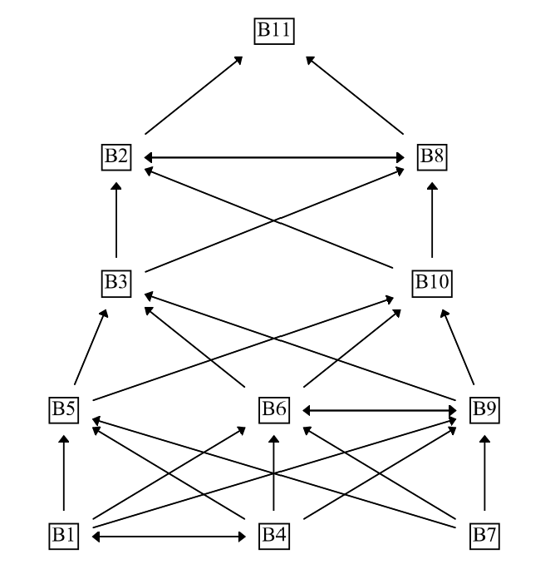
Three barriers occupy the foundational Level 5: Absence of a Unified Framework (B1), Governance Gaps & Lack of Enforcement (B4), and Financial Barriers (B7). Because Level 5 sits at the base of the hierarchy, these three factors are the structural root causes from which every other barrier is, directly or indirectly, reachable; Compliance Fatigue (B11), at the apex Level 1, is the most dependent factor, consistent with its conceptual status as a downstream symptom of unresolved governance and reporting weaknesses rather than an independent obstacle in its own right.

4.4 ISM Hierarchical Structure: Opportunities
The equivalent level-partitioning procedure applied to the ten ESG opportunities produced a four-level hierarchy for the all-groups panel, summarized in Table 6 and Figure 21.
Table 6
ISM Level Partitioning - Opportunities (All Groups, n = 27)
Level | Code(s) | Factor(s) | Interpretation
4 | O3, O4, O5 | Policy Alignment; Standard Refinement; Targeted Investment | Root-cause enablers
3 | O7, O9 | Low-carbon Transition; Innovation & Digital Integration | Capacity drivers
2 | O1, O10 | Strategic Resilience; Green Finance & Sustainability-Linked Bonds | Intermediate outcomes
1 | O2, O6, O8 | Investor Attraction; Holistic Value Assessment; Long-term Value Creation | Top-level outcomes

Figure 21
ISM Hierarchical Structure - Opportunities (All Groups)
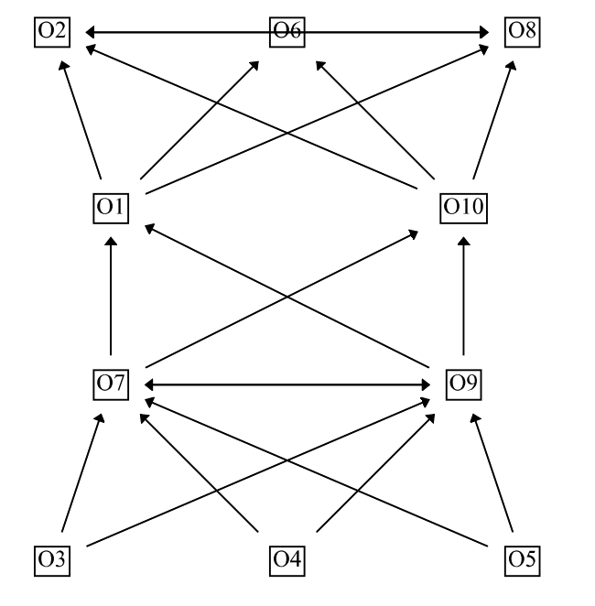
Policy Alignment (O3), Standard Refinement (O4), and Targeted Investment (O5) occupy the foundational Level 4. Structurally, these three opportunities must be activated first: they are the precondition for the capacity-building gains at Level 3 (low-carbon transition, digital integration), which in turn enable the intermediate outcomes at Level 2, ultimately driving the top-level value-creation outcomes (Investor Attraction, Holistic Value Assessment, Long-term Value Creation) at Level 1.

4.5 ISM Structure Across Stakeholder Groups
Beyond the pooled all-groups analysis, an independent ISM hierarchy was computed from each stakeholder group's own Structural Self-Interaction Matrix. Table 7 compares the resulting hierarchy depth and root-level (highest-level) driver(s) for both barriers and opportunities across all seven groups.

Table 7
ISM Hierarchy Comparison Across Stakeholder Groups
Group | n | Barrier Levels | Top Barrier Driver(s) | Opp. Levels | Top Opp. Driver(s)
All Groups | 27 | 5 | B1, B4, B7 | 4 | O3, O4, O5
Government | 7 | 4 | B1, B4, B7 | 5 | O4
Consultants | 8 | 7 | B1, B4, B7 | 8 | O4, O5
Contractors | 8 | 5 | B1, B4, B7 | 5 | O5
Developers | 2 | 4 | B1, B4 | 2 | O5
CSR Specialist | 1 | 2 | (9 of 11 tied) | 2 | O3
Academic | 1 | 2 | B7 | 3 | O4

The three largest and most statistically stable groups in the panel - Government, Consultants, and Contractors - independently converge on the identical root-cause barrier set (B1, B4, B7), despite each group's hierarchy being computed from an entirely separate Structural Self-Interaction Matrix. This convergence across independently-constructed hierarchies is treated as the primary evidence of structural robustness in this study. The single-respondent groups (CSR Specialist, Academic) necessarily produce flatter hierarchies - an expected statistical artefact of an n = 1 sample rather than a substantive contradiction of the pooled result; this is addressed further as a limitation in Chapter 6.

4.6 MICMAC Classification: Barriers
Figure 22 and Table 8 classify the eleven barriers by driving power (the number of other barriers a given barrier influences) and dependence power (the number of barriers that influence it), computed from the direct reachability matrix for the all-groups panel.
Table 8
MICMAC Classification - Barriers (All Groups, n = 27)
ID | Barrier | Driving Power | Dependence Power | Quadrant
B1 | Absence of Unified Framework | 10 | 2 | IV - Independent (Driving)
B2 | Inconsistent Reporting | 2 | 10 | II - Dependent
B3 | E-centric Bias | 4 | 7 | II - Dependent
B4 | Governance Gaps & Lack of Enforcement | 10 | 2 | IV - Independent (Driving)
B5 | Lack of Local Metrics | 6 | 4 | IV - Independent (Driving)
B6 | Skill Shortage | 7 | 5 | IV - Independent (Driving)
B7 | Financial Barriers | 9 | 1 | IV - Independent (Driving)
ID | Barrier | Driving Power | Dependence Power | Quadrant
B8 | Over-reliance on Traditional Metrics | 3 | 10 | II - Dependent
B9 | Carbon-intensive Pathways Lock-in | 6 | 5 | IV - Independent (Driving)
B10 | Late-Stage ESG Integration | 4 | 7 | II - Dependent
B11 | Compliance Fatigue | 1 | 9 | II - Dependent

Figure 22
MICMAC Classification - Barriers (All Groups)
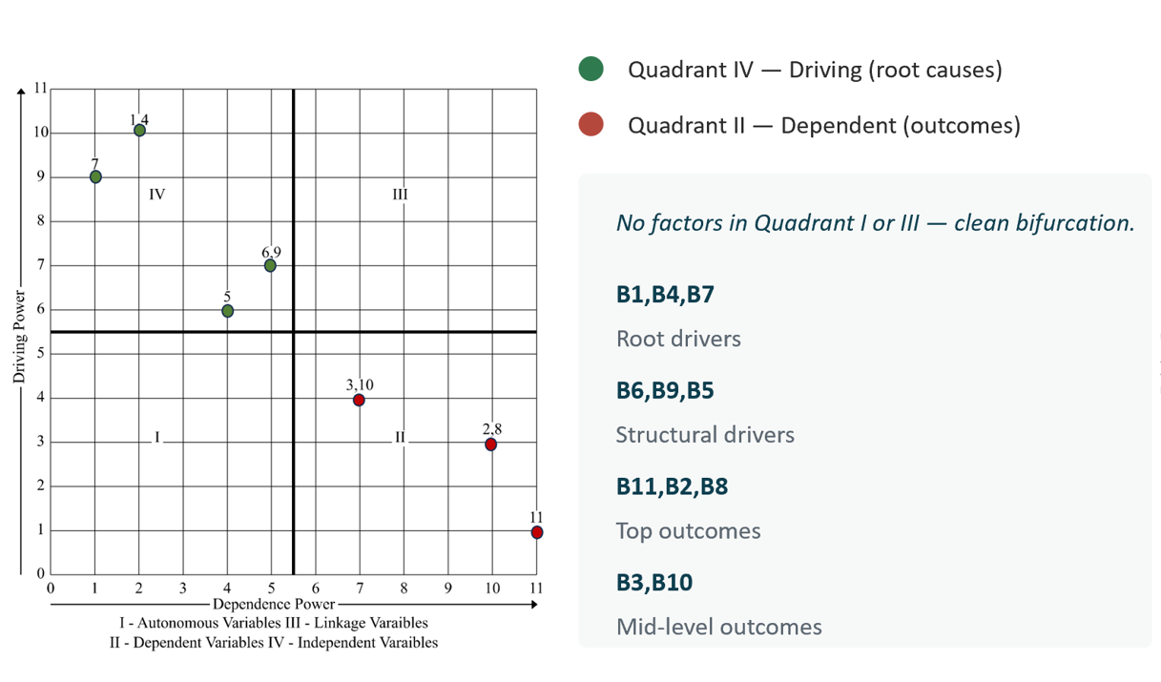

No barrier falls into Quadrant I (Autonomous) or Quadrant III (Linkage): all eleven barriers split cleanly into six driving factors (B1, B4, B5, B6, B7, B9) and five dependent factors (B2, B3, B8, B10, B11). This complete absence of autonomous or linkage factors is an unusually clean bifurcation that is discussed further in Chapter 5 as evidence that the barrier structure is genuinely well-defined rather than an artifact of the modeling choice.

4.7 MICMAC Classification: Opportunities
The same procedure applied to the ten opportunities is summarized in Table 9 and Figure 23.
Table 9
MICMAC Classification - Opportunities (All Groups, n = 27)
ID | Opportunity | Driving Power | Dependence Power | Quadrant
O1 | Strategic Resilience | 4 | 6 | II - Dependent
O2 | Investor Attraction | 2 | 9 | II - Dependent
O3 | Policy Alignment | 8 | 1 | IV - Independent (Driving)
O4 | Standard Refinement | 8 | 1 | IV - Independent (Driving)
O5 | Targeted Investment | 8 | 1 | IV - Independent (Driving)
O6 | Holistic Value Assessment | 1 | 8 | II - Dependent
O7 | Low-carbon Transition | 7 | 5 | IV - Independent (Driving)
ID | Opportunity | Driving Power | Dependence Power | Quadrant
O8 | Long-term Value Creation | 2 | 9 | II - Dependent
O9 | Innovation & Digital Integration | 7 | 5 | IV - Independent (Driving)
O10 | Green Finance & Sustainability-Linked Bonds | 4 | 6 | II - Dependent

Figure 23
MICMAC Classification - Opportunities (All Groups)
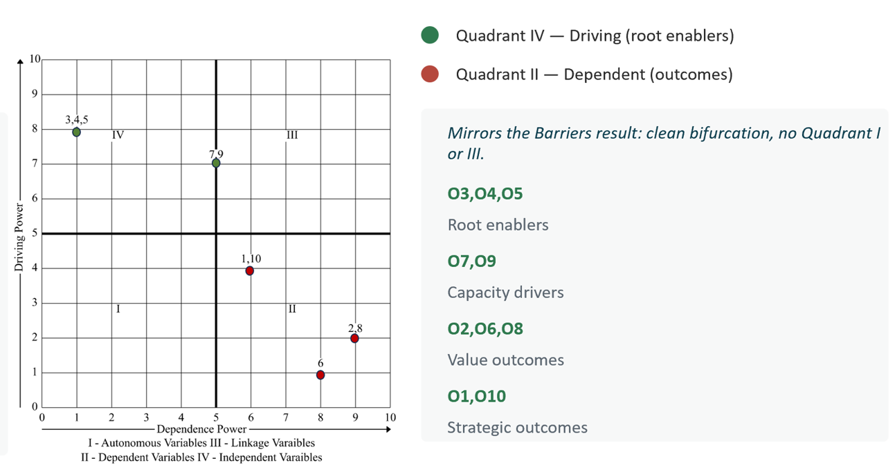

The opportunities panel mirrors the barriers result exactly: zero factors occupy Quadrant I or III. Five opportunities are driving factors (O3, O4, O5, O7, O9) and five are dependent outcomes (O1, O2, O6, O8, O10). Low-carbon Transition (O7) and Innovation & Digital Integration (O9) sit close to the vertical boundary (dependence power = 5, against a panel midpoint of 5) but are classified as driving factors because their driving power (7) exceeds their dependence power; this boundary case is noted here for transparency.

4.8 DEMATEL Cause-Effect Analysis: Barriers
DEMATEL quantifies the strength and direction of influence among the eleven barriers. D (the row sum of the Total-Relation Matrix) is the influence a factor exerts on the system; R (the column sum) is the influence it receives; D+R is Prominence (overall system importance); and D-R is Relation, with positive values identifying net causal factors and negative values identifying net dependent (effect) factors. Table 10 and Figure 24 present the full results for the all-groups panel.
Table 10
DEMATEL Cause-Effect Analysis - Barriers (All Groups, n = 27)
ID | Barrier | D | R | D+R | D-R | Cause/Effect | Rank
B1 | Absence of Unified Framework | 2.36 | 0.85 | 3.20 | +1.51 | CAUSE | 5
B2 | Inconsistent Reporting | 0.80 | 2.43 | 3.23 | -1.63 | EFFECT | 4
B3 | E-centric Bias | 1.28 | 1.86 | 3.14 | -0.57 | EFFECT | 11
B4 | Governance Gaps & Lack of Enforcement | 2.41 | 0.89 | 3.31 | +1.52 | CAUSE | 1
B5 | Lack of Local Metrics | 1.82 | 1.33 | 3.15 | +0.50 | CAUSE | 10
B6 | Skill Shortage | 1.87 | 1.41 | 3.28 | +0.46 | CAUSE | 2
B7 | Financial Barriers | 2.24 | 0.93 | 3.17 | +1.31 | CAUSE | 8
B8 | Over-reliance on Traditional Metrics | 0.87 | 2.41 | 3.28 | -1.53 | EFFECT | 3
ID | Barrier | D | R | D+R | D-R | Cause/Effect | Rank
B9 | Carbon-intensive Pathways Lock-in | 1.85 | 1.31 | 3.16 | +0.55 | CAUSE | 9
B10 | Late-Stage ESG Integration | 1.32 | 1.87 | 3.19 | -0.55 | EFFECT | 7
B11 | Compliance Fatigue | 0.82 | 2.38 | 3.20 | -1.56 | EFFECT | 6

Figure 24
DEMATEL Cause-Effect Diagram - Barriers (All Groups)
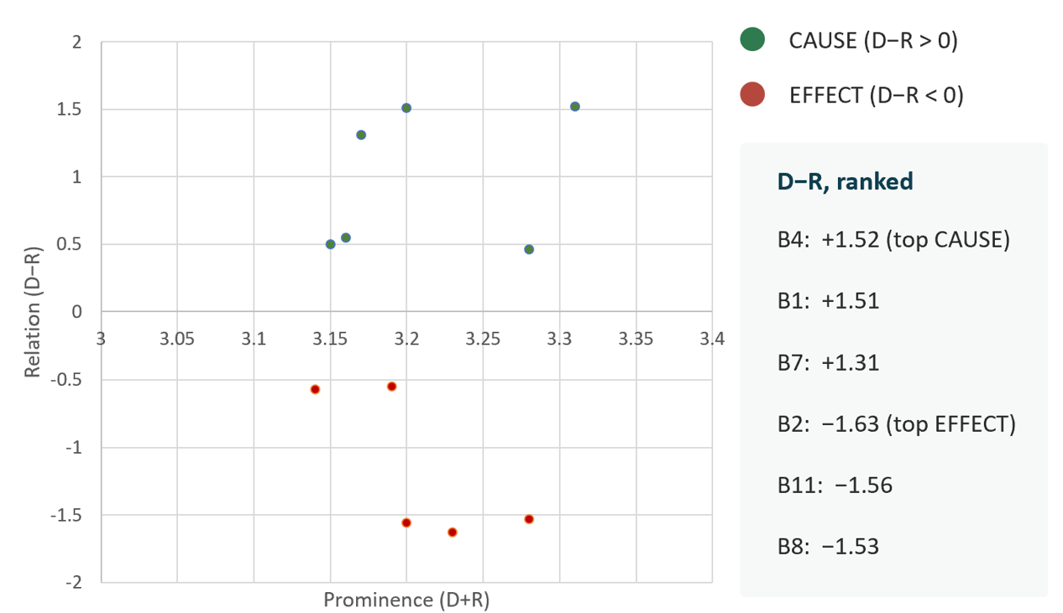

Governance Gaps & Lack of Enforcement (B4, D-R = +1.52) and Absence of a Unified Framework (B1, D-R = +1.51) are the two strongest net-causal barriers, followed by Financial Barriers (B7, D-R = +1.31) - the identical three factors identified as the structural root causes by the ISM hierarchy in Section 4.3. At the opposite pole, Inconsistent Reporting (B2, D-R = -1.63), Compliance Fatigue (B11, D-R = -1.56), and Over-reliance on Traditional Metrics (B8, D-R = -1.53) are the strongest net-effect barriers, confirming that they are symptoms of upstream governance and data weaknesses rather than independent obstacles.

4.9 DEMATEL Cause-Effect Analysis: Opportunities
Table 11 and Figure 25 present the equivalent DEMATEL analysis for the ten opportunities.
Table 11
DEMATEL Cause-Effect Analysis - Opportunities (All Groups, n = 27)
ID | Opportunity | D | R | D+R | D-R | Cause/Effect | Rank
O1 | Strategic Resilience | 1.30 | 1.85 | 3.15 | -0.56 | EFFECT | 6
O2 | Investor Attraction | 0.75 | 2.32 | 3.07 | -1.57 | EFFECT | 9
O3 | Policy Alignment | 2.38 | 0.78 | 3.16 | +1.60 | CAUSE | 5
O4 | Standard Refinement | 2.36 | 0.83 | 3.19 | +1.53 | CAUSE | 2
O5 | Targeted Investment | 2.29 | 0.85 | 3.15 | +1.44 | CAUSE | 7
O6 | Holistic Value Assessment | 0.86 | 2.28 | 3.14 | -1.42 | EFFECT | 8
O7 | Low-carbon Transition | 1.80 | 1.25 | 3.05 | +0.54 | CAUSE | 10
O8 | Long-term Value Creation | 0.80 | 2.38 | 3.17 | -1.58 | EFFECT | 4
O9 | Innovation & Digital Integration | 1.91 | 1.30 | 3.21 | +0.61 | CAUSE | 1
O10 | Green Finance & Sustainability-Linked Bonds | 1.28 | 1.90 | 3.18 | -0.62 | EFFECT | 3

Figure 25
DEMATEL Cause-Effect Diagram - Opportunities (All Groups)
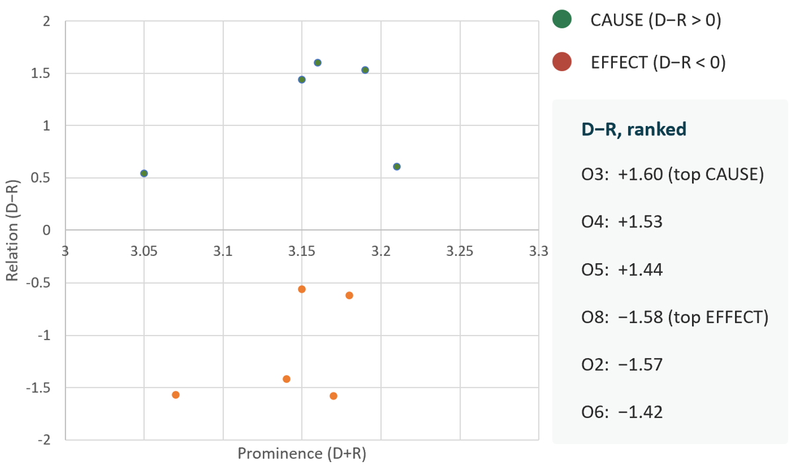

Policy Alignment (O3, D-R = +1.60) is the strongest net-causal opportunity, followed by Standard Refinement (O4, D-R = +1.53) and Targeted Investment (O5, D-R = +1.44) - again the identical three factors identified as root-level enablers by the ISM hierarchy in Section 4.4. Long-term Value Creation (O8, D-R = -1.58) and Investor Attraction (O2, D-R = -1.57) are the strongest net-effect opportunities, confirming that they are downstream outcomes rather than levers that can be pursued directly.

4.10 Cross-Stakeholder Comparison
Table 12 consolidates the root-level (highest ISM level) barrier and opportunity driver(s) identified independently by each stakeholder group, drawing on the per-group hierarchies first presented in Table 7.
Table 12
Strongest Barrier(s) and Opportunity(ies) by Stakeholder Group
Group | n | Strongest Barrier(s) | Strongest Opportunity(ies)
All Groups | 27 | B1, B4, B7 | O3, O4, O5
Government | 7 | B1, B4, B7 | O4
Consultants | 8 | B1, B4, B7 | O4, O5
Contractors | 8 | B1, B4, B7 | O5
Developers | 2 | B1, B4 | O5
CSR Specialist | 1 | (9 of 11 tied) | O3
Academic | 1 | B7 | O4

Government, Consultants, and Contractors converge on the identical root-cause barrier set (B1, B4, B7), despite each group's hierarchy being computed independently. A nuance emerges on the opportunity side: the two cost-exposed delivery groups - Contractors and Developers - independently identify Targeted Investment (O5) as their sole root-level opportunity driver, while the two policy-facing groups - Government and Academic - independently identify Standard Refinement (O4). Consultants, who interface with both delivery and policy functions, are the only group for which O4 and O5 are tied at the root level. This pattern suggests that while the underlying causal barriers are shared across the sector, the preferred entry point for intervention differs systematically by stakeholder role: delivery-side groups gravitate toward direct financial levers, while policy-side groups gravitate toward standards-based levers.

4.11 Summary of Key Findings
Three independent analytical methods - ISM, MICMAC, and DEMATEL - converge on a consistent structural account of ESG implementation in the Abu Dhabi infrastructure sector. Absence of a Unified Framework (B1), Governance Gaps & Lack of Enforcement (B4), and Financial Barriers (B7) are identified as the structural root causes by all three methods and by every adequately-sized stakeholder group; Compliance Fatigue (B11), Inconsistent Reporting (B2), and Over-reliance on Traditional Metrics (B8) are consistently identified as downstream symptoms. On the opportunity side, Policy Alignment (O3), Standard Refinement (O4), and Targeted Investment (O5) form a consistent triad of foundational, root-level enablers, while Investor Attraction (O2) and Long-term Value Creation (O8) are confirmed as downstream outcomes that follow from - rather than precede - action on the foundational triad. The complete absence of Quadrant I (Autonomous) and Quadrant III (Linkage) factors in both MICMAC analyses is a further indication that this structure is well-defined rather than an artefact of the analytical choices made. These findings, and their implications for theory and practice, are interpreted in Chapter 5.

Chapter 5: Discussion

5.1 Introduction and Chapter Overview
Chapter 4 presented the empirical results of the hybrid ISM-DEMATEL-MICMAC analysis. This chapter interprets those results in three steps. Section 5.2 examines what the convergence of three independent analytical methods on the same structural account actually means, methodologically and substantively. Section 5.3 and 5.4 position the findings against the existing peer-reviewed literature on ESG barriers and opportunities, identifying where this study confirms, extends, or departs from prior work. Sections 5.5 and 5.6 then draw out the theoretical and practical implications of the findings, directly answering the three research questions posed in Chapter 1.

5.2 Triangulated Convergence Across the Three Methods
Four observations emerge from reading the ISM, MICMAC, and DEMATEL results in Chapter 4 together rather than in isolation.
First, Governance Gaps & Lack of Enforcement (B4) and Absence of a Unified Framework (B1) are identified as the most fundamental root-cause barriers by every method applied in this study: they occupy the deepest level of the ISM hierarchy (Section 4.3), they are classified as strong drivers in the MICMAC analysis (Section 4.6), and they carry the two highest positive D-R scores in the DEMATEL analysis (Section 4.8). This convergence held not only for the pooled panel but independently for Government, Consultants, and Contractors - the three largest and most statistically stable stakeholder groups (Section 4.5). Triangulation of this kind, in which structurally distinct methods operating on the same underlying judgments arrive at the same answer, is treated in this study as the principal evidence that the governance-and-framework root cause is a genuine structural feature of the sector rather than an artefact of any single technique.
Second, Compliance Fatigue (B11) and Inconsistent Reporting (B2) are symptoms rather than independent obstacles. Both sit at the most dependent end of every analysis: Level 1-2 in the ISM hierarchy, Quadrant II in MICMAC, and the most negative D-R scores in DEMATEL. The practical implication is that treating either factor as a stand-alone target for intervention - for example, by introducing a new reporting template to address inconsistent reporting - addresses a downstream symptom while leaving the upstream governance and framework deficit untouched.
Third, Policy Alignment (O3), Standard Refinement (O4), and Targeted Investment (O5) form a consistent triad of foundational opportunities. They occupy the deepest ISM level for opportunities, they are classified as driving factors in the opportunities MICMAC analysis, and they carry the three highest D-R scores in the opportunities DEMATEL analysis. This mirrors the barriers finding almost exactly: just as the barrier structure resolves to a small governance-and-framework root, the opportunity structure resolves to a small policy-and-standards root.
Fourth, the complete absence of Quadrant I (Autonomous) and Quadrant III (Linkage) factors in both MICMAC analyses (Sections 4.6 and 4.7) is an unusually clean bifurcation. In most published MICMAC applications, at least some factors fall into the Linkage quadrant - factors that are simultaneously high-driving and high-dependence, and therefore unstable, since any intervention on them is likely to ripple unpredictably through the rest of the system (Warfield, 1974). The absence of any such factor here, for both barriers and opportunities, suggests that ESG implementation in Abu Dhabi's infrastructure sector is governed by a genuinely two-tier structure - a small set of root drivers and a larger set of dependent outcomes - rather than a tangled, mutually-reinforcing system. This is a favourable finding for practice, because it implies that the root drivers can be acted upon with a reasonable expectation that the dependent factors will improve in response, without the kind of unpredictable feedback that a Linkage-heavy structure would imply.

5.3 Discussion Against Existing Literature: Barriers
Table 13 maps the three root-cause barriers identified in Chapter 4 onto independent, peer-reviewed evidence published outside this study.
Table 13
Root-Cause Barriers Compared Against Independent Literature
Barrier | Independent Source | Point of Alignment
B1 - Absence of a Unified Framework | Cort & Esty (2020), Organization & Environment | Documents the lack of convergence among GRI, SASB, and other ESG disclosure standards as a persistent, sector-wide structural problem, not specific to any one industry or region.
B4 - Governance Gaps & Lack of Enforcement | Sheehan, Fox, Klassen, & Vaidyanathan (2023), Business Horizons | Frames ESG underperformance as primarily a board-level oversight and accountability failure, proposing a board-led 'ESG mindset' — rather than added reporting requirements — as the corrective lever.
B7 - Financial Barriers | Dzomonda (2022), Sustainability | Finds environmental sustainability commitment significantly predicts access to external financing among South African SMEs, consistent with this study's classification of B7 as a driving rather than dependent barrier.
The convergence with Cort and Esty (2020) is particularly direct: their account of disclosure-standard fragmentation as a structural barrier to ESG comparability, written about global corporate reporting generally, reproduces almost exactly the role this study finds for B1 within the narrower context of Abu Dhabi infrastructure. Sheehan et al. (2023) likewise locate the central obstacle to ESG performance at the level of board governance and mindset rather than technical capacity - the same conclusion this study reaches independently through ISM, MICMAC, and DEMATEL applied to an infrastructure-sector expert panel. Dzomonda (2022) provides a financial mechanism that is consistent with, though not identical to, this study's classification of B7: if sustainability commitment predicts access to financing, then financial barriers are plausibly downstream of - and resolvable through - the same governance and framework improvements that address B1 and B4, rather than requiring a separate financial intervention in their own right.

5.4 Discussion Against Existing Literature: Opportunities
Table 14 performs the equivalent comparison for the three root-level opportunities identified in Chapter 4.

Table 14
Root-Level Opportunities Compared Against Independent Literature
Opportunity | Independent Source | Point of Alignment
O3 - Policy Alignment | Zaid & Issa (2023) | Outlines a roadmap for converging global ESG disclosure standards, reducing the policy fragmentation that this study identifies as a downstream driver of compliance burden.
O5 - Targeted Investment | Bai & Wang (2024), Humanities and Social Sciences Communications | Across 12 Chinese provinces (2015-2022), found that a 1% increase in green bond issuance correlates with a 0.33% increase in ESG investment, providing a directly quantified mechanism for O5 as a causal lever.
O9 - Innovation & Digital Integration | Tumpa, Naeni, Afzal, & Ghanbaripour (2025), Management Decision | In a qualitative study of infrastructure professionals, found that digital transformation improves ESG performance specifically through real-time, informed decision-making and reduced manual data processing - the same infrastructure-project context as this study.

The alignment with Tumpa et al. (2025) is notable for being the closest contextual match in the literature reviewed for this study: their qualitative interviews with infrastructure professionals on digital transformation and ESG reach a finding - that digital tools improve ESG performance primarily through better real-time decision-making rather than through automation per se - that corroborates this study's placement of O9 as a root-level enabler rather than a downstream outcome. The Bai and Wang (2024) finding quantifies the O5 relationship in a different national context (China) but at a comparable infrastructure-adjacent scale (provincial green bond markets), lending external validity to this study's identification of targeted, instrument-linked investment as a structural lever rather than a generic encouragement to 'invest more in ESG'.

5.5 Theoretical Implications

5.5.1 A Reproducible Methodological Precedent
This study contributes a fully reproducible hybrid ISM-DEMATEL-MICMAC pipeline for ESG barrier and opportunity research, externally validated against the independent, peer-reviewed SmartISM tool (Ahmad & Qahmash, 2021), which reproduced identical reachability structures for both the barriers and opportunities datasets (Section 4.1). Within the ESG literature specifically, most prior applications of ISM or DEMATEL to sustainability barriers report only the all-groups result (see, for example, Parameswar et al., 2023, on TISM applied to ESG adoption barriers). This study extends that precedent by computing and reporting independent hierarchies for six separate stakeholder groups and demonstrating that the root-cause structure survives that independent recomputation.

5.5.2 Systemic, Not Isolated, Framing
The findings reframe ESG barriers as a structured hierarchy of root causes and downstream symptoms, rather than as a flat list of equally-weighted obstacles. Much of the applied ESG-barriers literature (see the methodological review in Chapter 3, Section 3.2.2) treats barriers as a set to be ranked by frequency of mention or perceived severity. The ISM-DEMATEL-MICMAC triangulation applied here instead identifies which barriers are causes and which are effects - a distinction with direct consequences for where intervention effort should be directed, discussed further in Section 5.6.

5.5.3 Cross-Stakeholder Structural Validation
This study is, to the candidate's knowledge, among the first to validate an ESG structural model independently across multiple stakeholder groups within a single GCC infrastructure context, rather than relying on a single pooled expert panel. The convergence of Government, Consultants, and Contractors on an identical root-cause barrier set (Section 4.5), computed from three entirely separate Structural Self-Interaction Matrices, provides a form of internal replication that is uncommon in the published ISM-DEMATEL literature and strengthens confidence that the root-cause finding is a property of the sector rather than of any one respondent group's framing.

5.6 Practical Implications

5.6.1 For Regulators
The results imply a validated priority order for regulatory action: address the Absence of a Unified Framework (B1) and Governance Gaps (B4) before investing further in downstream reporting infrastructure. A regulator that introduces a new reporting template or compliance portal without first resolving the underlying framework fragmentation is, on this study's evidence, intervening on a Level 1-2 symptom (Inconsistent Reporting, Compliance Fatigue) while leaving the Level 5 root cause unaddressed.

5.6.2 For Project Teams and Contractors
For delivery-side practitioners, the findings offer a diagnostic lens: where ESG implementation is visibly struggling on a project, the proximate symptom - inconsistent reporting, compliance fatigue, over-reliance on traditional metrics - is, on this study's evidence, more likely to trace back to upstream governance and framework gaps than to be resolvable in isolation. The cross-stakeholder comparison in Section 4.10 further suggests that Contractors and Developers specifically should expect Targeted Investment (O5) to be the most directly actionable lever available to them, given that it is their independently-identified root-level opportunity driver.

5.6.3 For Investors and Rating Agencies
Policy Alignment (O3) and Standard Refinement (O4) are structurally upstream of Investor Attraction (O2) in every analysis performed in this study (Sections 4.4 and 4.9): O2 sits at the most dependent ISM level and carries the second-most-negative DEMATEL D-R score among the ten opportunities. Investors and rating agencies seeking to influence ESG outcomes in this sector are therefore better positioned by engaging upstream on policy alignment and standards than by focusing engagement directly on the metrics that determine investment attractiveness, since the latter are themselves an outcome of the former.

5.6.4 For Academic and Research Institutions
Academic & Research is the only stakeholder group in this study's panel for which Financial Barriers (B7) alone, rather than the B1/B4/B7 triad, is the sole root-level barrier driver (Section 4.5), and the only group whose independently-computed root-level opportunity is Standard Refinement (O4) rather than Policy Alignment (O3) or Targeted Investment (O5). This divergence suggests that future research agendas in this space may be most productive if they target governance-and-framework questions specifically, complementing rather than duplicating the financial-barrier perspective that the Academic group's own structural model already emphasizes.

5.7 Chapter Summary
The discussion in this chapter has shown that the structural findings reported in Chapter 4 are not an artefact of any single analytical method: ISM, MICMAC, and DEMATEL converge independently on Governance Gaps (B4) and Absence of a Unified Framework (B1) as the root-cause barriers, and on Policy Alignment (O3), Standard Refinement (O4), and Targeted Investment (O5) as the root-level opportunities. These findings are corroborated, factor by factor, by independent peer-reviewed literature spanning general ESG governance research (Cort & Esty, 2020; Sheehan et al., 2023), SME finance (Dzomonda, 2022), green finance in an unrelated national context (Bai & Wang, 2024), and - most directly - qualitative infrastructure-sector research on digital transformation (Tumpa et al., 2025). The theoretical and practical implications that follow from this convergence are addressed to specific stakeholder groups in Section 5.6 and are revisited as concrete, prioritized actions in the Recommendations presented in Chapter 6.

Chapter 6: Conclusion and Future Work

6.1 Introduction and Chapter Overview
This final chapter brings the dissertation to a close. Section 6.2 summarizes the findings of Chapters 4 and 5 against the research aim and objectives set out in Chapter 1. Section 6.3 sets out the boundaries within which these findings should be interpreted. Section 6.4 translates the findings into stakeholder-specific recommendations for practice, and Section 6.5 identifies directions for future research that would extend or stress-test the conclusions reached here.

6.2 Summary of Findings
Chapter 1 set out the aim of this dissertation as identifying and critically analyzing the barriers impeding ESG integration in Abu Dhabi's infrastructure sector, exploring the opportunities and strategic benefits of robust ESG adoption, and proposing a set of empirically validated recommendations to facilitate integration and overcome those barriers. This aim was pursued through five specific objectives, each of which is addressed in turn below.
Objective 1, Policy and Literature Synthesis, called for a critical analysis of global ESG best practice and its alignment with Abu Dhabi's regulatory landscape. Chapter 2 met this objective through a systematic review spanning the conceptual evolution of ESG, the principal theoretical frameworks (stakeholder, legitimacy, resource-based, and institutional theory), and a detailed analysis of Estidama against international frameworks such as GRI and SASB, identifying the Governance Gap and the sector's "E-centric" bias as the central points of divergence.Objective 2, Barrier and Enabler Identification, called for the systematic identification and characterization of the barriers hindering ESG adoption. This objective was met through the pilot-validated set of eleven barriers (B1-B11) presented in Chapter 3, and the structural analysis of those barriers in Chapter 4: ISM level partitioning, MICMAC classification, and DEMATEL cause-effect analysis converged independently on the Absence of a Unified Framework (B1), Governance Gaps & Lack of Enforcement (B4), and Financial Barriers (B7) as the sector's structural root causes, with this convergence holding across every adequately-sized stakeholder group.
Objective 3, Opportunity Assessment, called for an investigation of the opportunities and strategic benefits that ESG integration could confer. This objective was met through the equivalent analysis of ten opportunities (O1-O10) in Chapter 4, which identified Policy Alignment (O3), Standard Refinement (O4), and Targeted Investment (O5) as a structurally validated triad of root-level enablers, each mapping directly onto one of the three root-cause barriers.
Objective 4, Strategic Recommendations, called for a set of recommendations to overcome the identified barriers and leverage the identified opportunities. This objective is met by the stakeholder-specific recommendations presented in Section 6.4, each mapped directly to the structural results of Chapter 4 and the discussion in Chapter 5.
Objective 5, Expert Validation, called for validation of the identified barriers, opportunities, and recommendations through structured engagement with senior industry experts. This objective was met through the 27-participant expert panel described in Chapter 3, spanning six stakeholder categories, and through external validation of the ISM results against the independent, peer-reviewed SmartISM tool (Chapter 4), which reproduced identical hierarchy structures.
Taken together, these findings confirm the dissertation's aim was achieved: the essential barriers to ESG implementation in Abu Dhabi's infrastructure sector have been identified and structurally analyzed, the opportunities capable of accelerating adoption have been assessed and linked directly to those barriers, and the resulting recommendations have been grounded in, and validated against, the judgment of senior industry experts. The dissertation's central contribution is the demonstration that ESG implementation in this sector is best advanced not by treating barriers as a flat, undifferentiated list, but by recognizing the small set of upstream governance, framework, and financial root causes from which most other obstacles - and most available opportunities - follow.

6.3 Limitations of the Study
Four limitations, identified during the research process and confirmed in supervisory review, bound the interpretation of the findings presented in this dissertation:
- Stakeholder coverage. No respondent from the International ESG Investors / Rating Agencies category completed the research instrument, and Local Communities are not directly represented (the CSR Specialist respondent serves only as an approximate proxy); the findings should be read as representative of the delivery-and-policy side of the sector rather than a validated investor or community account.
- Sample size imbalance. Consultants and Contractors together account for 59% of the realized panel, while the CSR Specialist and Academic categories are each represented by a single respondent; their group-level hierarchies are indicative rather than statistically robust.
- Context specificity. The substantive findings reflect Abu Dhabi's specific regulatory landscape, market structure, and expert panel; extension to other GCC jurisdictions or sectors would require independent validation rather than direct transfer.
- Methodological scope. This study models structural relationships between literature-derived barriers and opportunities; it does not develop a new ESG rating system or score individual projects. Two respondents' consent documentation remained in administrative processing at the time of analysis, and several invited academic and engineering participants declined to take part, citing institutional policy constraints.

6.4 Recommendations
The following recommendations are mapped directly to the structural results reported in Chapter 4 and interpreted in Chapter 5. Each is addressed to the stakeholder group best positioned to act on it.

6.4.1 For Government
Government entities should develop a unified, mandatory ESG framework that explicitly maps Estidama credits onto international disclosure standards such as GRI and SASB, directly targeting the Absence of a Unified Framework (B1) and Governance Gaps (B4) that this study identifies as the sector's structural root causes. Strengthening formal oversight and enforcement mechanisms should accompany framework development, since B4 specifically denotes a lack of enforcement rather than a lack of stated policy. Government is also one of only two stakeholder groups (with Academic) for which Standard Refinement (O4) is the independently-identified root-level opportunity driver (Section 4.10); Government is accordingly well placed to lead the standard-refinement agenda rather than waiting for it to emerge from industry.

6.4.2 For Engineering Consultancies
Consultancies sit at Level 7 of the all-groups-comparable ISM hierarchy - the deepest of any group computed in this study (Table 7, Chapter 4) - indicating a more granular, multi-layered view of the barrier structure than other groups. Practically, this group should build internal capacity to navigate the dual-reporting burden reflected in Inconsistent Reporting (B2) and Compliance Fatigue (B11), and should use its position as the only group for which Standard Refinement (O4) and Targeted Investment (O5) are tied at the root level (Section 4.10) to advocate jointly for both, rather than treating them as competing priorities.

6.4.3 For Contractors, Suppliers, and Developers
Contractors and Developers independently identify Targeted Investment (O5) as their sole root-level opportunity driver (Section 4.10), distinguishing them from the policy-facing groups for whom Standard Refinement (O4) is the priority. This group should therefore engage proactively with green and sustainability-linked finance instruments specifically, rather than general ESG capacity-building, as the most directly actionable lever available to them. Concurrently, given that Skill Shortage (B6) is classified as a driving barrier in the MICMAC analysis (Section 4.6) and is the root-level barrier for the Contractors group specifically alongside B1, B4, and B7, investment in ESG-related skill development should be treated as a parallel priority rather than a secondary concern.

6.4.4 For Investors and Rating Agencies
Although no respondent from this category completed the research instrument (Section 6.3), the structural results have direct implications for this group. Investor Attraction (O2) occupies the most dependent ISM level and carries the second-most-negative DEMATEL D-R score among the ten opportunities (Section 4.9), confirming it as a downstream outcome rather than a lever. Investors and rating agencies seeking to influence ESG outcomes in this sector are better positioned by engaging upstream, on Policy Alignment (O3) and Standard Refinement (O4), than by focusing engagement directly on the metrics that determine investment attractiveness.

6.4.5 For Academic and Research Institutions
Academic and research institutions should prioritize research that targets the Governance Gap (B4) specifically, given its consistent identification as a root cause across every method and group in this study. Institutions are also well placed to address the stakeholder-coverage limitation identified in Section 6.3 directly, by designing follow-up studies that deliberately recruit Local Community and Rating Agency respondents - the two categories absent or under-represented in this study's panel.

6.5 Future Work
Expand stakeholder coverage. Future studies should deliberately recruit International ESG Investors / Rating Agencies and direct Local Community respondents, the two stakeholder perspectives absent or only indirectly represented in this study's panel (Section 6.3), to test whether the root-cause structure identified here holds when those perspectives are included directly.
Test generalizability across the GCC. Because this study's substantive findings are specific to the Abu Dhabi infrastructure sector (Section 6.3), replicating the same ISM-DEMATEL-MICMAC design in other GCC jurisdictions - which share elements of regulatory context but differ in market structure and standard adoption (Chapter 2, Section 2.19) - would establish whether the Governance Gap and Unified Framework root causes are a regional pattern or specific to the Emirate.
Longitudinal validation. This study's structural model is cross-sectional. A longitudinal follow-up that tracks whether targeted intervention on the root-cause barriers (B1, B4, B7) produces measurable improvement in the dependent factors (B2, B8, B11) over time would provide a stronger causal test than the cross-sectional DEMATEL relation scores alone can offer.
Sector extension. Future work could apply the same validated hybrid methodology to other capital-intensive sectors in Abu Dhabi or the wider UAE - energy, real estate, or logistics - to test whether the governance-and-framework root cause identified here is specific to infrastructure delivery or reflects a broader pattern in how ESG is implemented across project-based industries in the region.

References
Abu Dhabi Council for Economic Development. (2008). Abu Dhabi Economic Vision 2030. Retrieved from https://u.ae/en/about-the-uae/strategies-initiatives-and-awards/strategies-plans-and-visions/finance-and-economy/abu-dhabi-economic-vision-2030
Abu Dhabi Global Market. (2023). Abu Dhabi Global Market. Retrieved from Sustainable Finance Regulatory Framework: https://www.adgm.com/initiatives/sustainable-finance
Al Omairi, M. (2025). Navigating ESG Challenges in GCC Family-Owned. Emirati Journal of Business, Economics and Social Studies.
Al-Amin, A., & Filho, W. (2015). The challenges of sustainability in business: how governments may ensure sustainability for offshore firms. Technological and Economic Development of Economy, 108-140.
Alawbathani, M., & Suraya, A. (2023). Critical Success Factors Toward the UAE Construction Project Development. International Journal of Business Society.
Alharbi, F., & Csala, D. (2024). GCC Countries’ Renewable Energy Penetration and the Progress of Their Energy Sector Projects. IEEE Access.
Alobaidi, K., & et al. (2015). Sustainability Achievement and Estidama Green Building Regulations in Abu Dhabi Vision 2030. Mediterranean Journal of Social Sciences, 509-517.
Al-Sarihi, A. (2018). Integrating Climate Change Policies With Economic Diversification Strategies: Challenges and Opportunities in Oman and the UAE. LSE Middle East Centre Paper Series.
Alzara, M., Elnasser, A., Abdelshakor, A., & Ehab, M. (2025). Circular economy transition barriers in the construction and demolition sector. PLOS.
Ashish, L. (2020). ESG and the cost of capital. Retrieved from MSCI: https://www.msci.com/research-and-insights/blog-post/esg-and-the-cost-of-capital
Awadh, O. (2018). Estidama Pearl building rating system of Abu Dhabi and Al Sa'fat of Dubai: Comparison and analysis. In Proceedings of 3rd International Sustainable Buildings Symposium. Springer.
Bai, M., & Wang, W. (2024). Role of green bonds in developing ESG projects in Eastern provinces of China. Humanities and Social Sciences Communications, 11(1), 1742.
Barham, D., Matarneh, S., & Tezel, A. (2025). Opportunities and challenges of digital twin applications in the Middle East construction industry. . Urbanization, Sustainability and Society.
Barney, J., & Delwyn , N. (2007). Firm resources and sustained competitive advantage. In Resource-Based Theory.
Barney, J., & Delwyn, N. (2023). Resource-Based Theory: Creating and Sustaining Competitive Advantage.
Beerannavar, C. (2020). The Role of Corporations in Achieving Ecological Sustainability. Evaluating the Environmental Performance of Corporations.
BREATH ESG. (2025). BREATH ESG. Retrieved from ESG Evolution in the UAE and GCC: https://www.breatheesg.com/
Busch, T., Bauer, R., & Orlitzky, M. (2016). Sustainable Development and Financial Markets. Old Paths and New Avenues.Business & Society.
Cabeza, L., & et al. (2014). Life cycle assessment (LCA) and life cycle energy analysis (LCEA) of buildings: A review. Renewable and Sustainable Energy Reviews, 394-416.
Carbon Leadership Forum. (2023). Carbon Leadership Forum. Retrieved from LCA Practice Guide: https://carbonleadershipforum.org/lca-practice-guide/
Carbon Training International. (2024, May 9). The Genesis of ESG in the 1960s: A Turning Point in Corporate Accountability. Retrieved from Carbon Training International: https://co2ti.com/esg-history/
Climate Bonds Initiative. (2023). Climate Bonds Initiative. Retrieved from 2022 Green Bond Market Summary: https://www.climatebonds.net/files/documents/publications/Global-State-of-the-Market-Report-2023.pdf
Climate Bonds Initiative. (2024). Global State of the Market Report.
Cort, T., & Esty, D. (2020). ESG standards: Looming challenges and pathways forward. Organization & Environment, 33(4), 491–510.
Cridibl. (2023). The Evolution of ESG Reporting: From Voluntary to Mandatory. Retrieved from Cridibl: https://www.crediblesg.com/blogs/the-evolution-of-esg-reporting-from-voluntary-to-mandatory/
Department of Municipalities and Transport, . (2010). Department of Municipalities and Transport, Abu Dhabi. Retrieved from The Pearl Rating System for Estidama.
Department of Municipalities and Transport. (2010). The Pearl Rating System for Estidama. Retrieved from https://www.dmt.gov.ae/-/media/Project/DMT/DMT/E-Library/0001-Manuals/PRRS/PRRS-Version-10.pdf
DiMaggio, P., & Powell, W. (1983). The iron cage revisited: Institutional isomorphism and collective rationality in organizational fields. American Sociological Review, 147–160.
Drempetic, S., Christian, K., & Bernhard, Z. (2020). The influence of firm size on the ESG score: Corporate sustainability ratings under review. Journal of Business Ethics, 167(2),, 333-360.
Duperrin, J. C., & Godet, M. (1973). Méthode de hiérarchisation des éléments d'un système. Rapport Économique du CEA, Paris.

Drempetic, S., Klein, C., & Zwergel, B. (2020). The Influence of Firm Size on the ESG Score: Corporate Sustainability Ratings Under Review. Journal of Business Ethics.
Dzomonda, O. (2022). Environmental sustainability commitment and access to finance by small and medium enterprises: The role of financial performance and corporate governance. Sustainability, 14(14), 8863.
Eccles, R., & Serafeim, G. (2013). The performance frontier: Innovating for a sustainable strategy. Harvard Business Review, 50-60.
Ehlers, T., & Packer, F. (2017). Green bond finance and certification. BIS Quarterly Review.
Elkington, J. (1994). Towards the sustainable corporation: Win-win-win business strategies for sustainable development. California Management Review, 90-100.
Elkington, J. (1997). Cannibals with Forks: The Triple Bottom Line of 21st Century Business. Capstone Publishing.
Feitosa, A., Coutinho de Melo, F., Gonzaga de Albuquerque, A., Antunis de Rezende, N., & Dumke de Medeiros, D. (2026). Exploratory Analysis of Sustainable Consumption and Production Factors in Services: Insights From Four Case Studies Using Interpretive Structural Modeling. Sustainable Development.
Fontela, E., & Gabus, A. (1976). The DEMATEL Observer. Battelle Geneva Research Center.

Freeman, R. (2001). Stakeholder theory of the modern corporation. Perspectives in Business Ethics.
Freeman, R. (2001). Strategic Management: A Stakeholder Approach. Pitman.
Friede, G., Busch, T., & Bassen, A. (2015). ESG and financial performance: aggregated evidence from more than 2000 empirical studies. Journal of Sustainable Finance & Investment, 5(4), 210–233.
Gabriele, P. (2023). How are ESG scores and cost of debt related? A quantitative analysis based on companies’ fundamentals. UNIVERSITÀ DEGLI STUDI DEL PIEMONTE ORIENTALE.
Georgiadou, M., et al. (2025). Social Value and Corporate Social Responsibility (CSR) Through Inclusive Stakeholder Engagement in the UK Architecture, Engineering, and Construction (AEC) Sector. Corporate Social Responsibility and Environmental Management.
Global Reporting Initiative. (n.d.). GRI Standards. Retrieved from https://www.globalreporting.org/standards
Globe News Wire. (2025). Globe News Wire. Retrieved from Global Green Skills Gap Research Report, Survey and Forecasts 2025-2030: Green Job Growth Dramatically Outpacing Skilling of Workforce, Jeopardising Climate Targets: https://www.globenewswire.com/news-release/2025/03/12/3041578/28124/en/Global-Green-Skills-Gap-Research-Report-Survey-and-Forecasts-2025-2030-Green-Job-Growth-Dramatically-Outpacing-Skilling-of-Workforce-Jeopardising-Climate-Targets.html
Grand View Research. (2025). Grand View Research;. Retrieved from UAE Esg Investing Market Size & Outlook, 2025-2030: https://www.grandviewresearch.com/horizon/outlook/esg-investing-market/uae#:~:text=The%20esg%20investing%20market%20in,UAE
Greenwood, M. (2007). Stakeholder engagement: Beyond the rhetoric. Journal of Business Ethics, 315-327.
GRI & SASB. (2021). A Practical Guide to Sustainability Reporting Using GRI and SASB Standards. Retrieved from GRI & SASB: https://www.globalreporting.org/media/mlkjpn1i/gri-sasb-joint-publication-april-2021.pdf
Gupta, A., Manoj, K., & Anil, M. (2026). Transparency and Accountability Essential to ESG Performance in the Supply Chain: A Fuzzy DEMATEL Approach. Cleaner Logistics and Supply Chain .
Hummel, K., & Schlick, C. (2016). The relationship between sustainability performance and sustainability disclosure. Journal of Accounting and Public Policy, 455-476.
Ibrahim, M. (2025). Analyzing the Challenges Facing the ESG Practices in the UAE. .Journal of Applied Business Research, 1-15.
ISO. (2006). International Organization for Standardization. Retrieved from ISO 14040:2006 Environmental management — Life cycle assessment — Principles and framework.: https://www.iso.org/standard/37456.html
Kolk, A., & Pinkse, J. (2010). The integration of corporate governance with corporate social responsibility: exploring the mechanisms. Journal of Business Ethics, 437-448.
Kolk, A. (2008). Sustainability, accountability and corporate governance. Business Strategy and the Environment, 1-15.
Komeily, A., & Srinivasan, R. (2015). A need for balanced approach to neighborhood sustainability assessments. Sustainable Cities and Society, 17-33.
Li, X., Feng, W., Liu, X., & Yang, Y. (2023). A comparative analysis of green building rating systems in China and the United States. Sustainable Cities and Society, 257-269.
Lin, S., Hanif, M. W., Makhdoom, Z. H., & Xia, D. (2025). Bridging Policy, Governance and Technical Barriers to Energy Resilience in China. Geological Journal.
Liou, J., Liu, P., & Huang, S.-W. (2023). Exploring the key barriers to ESG adoption in enterprises. Systems and Soft Computing.
Loorbach, D., & Rotmans, J. (2010). The practice of transition management: Examples and lessons from four distinct cases. Futures, 237-246.
Loorbach, D., & Rotmans, J. (2010). Transition management in public policy. The Oxford Handbook of Public Policy.
Müller, R., Caron, M., Drouin, N., & Lereim, J. (2025). Governance of ESG implementations: governance dimensions and their structural implementation . .International Journal of Managing Projects in Business,.
Nguyen, P., et al. (2025). Toward sustainable logistics in emerging economies: Identifying ESG barriers using neutrosophic Delphi-DEMATEL model. Journal of Open Innovation: Technology, Market, and Complexity.
Omodu, H.-e. (2026). Environmental Social and Governance: An Evaluation of the Impact of Corporate Social Responsibility on Organizational Performance in United Bank of Africa. INTERNATIONAL JOURNAL OF RESEARCH AND INNOVATION IN SOCIAL SCIENCE (IJRISS).
Pambudi, J., Dayana, I., & Alfirman, D. (2023). Accelerating Indonesia sustainable infrastructure development through ESG initiatives in PPP ecosystem. InIOP Conference Series: Earth and Environmental Science.
Parameswar, N., Hasan, Z., & Shri, C. (2023). Exploring the barriers to ESG adoption using modified TISM approach. Kybernetes.
Paridhi , & Ritika. (2024). Unveiling key factors influencing corporate ESG reporting adoption: a TISM and MICMAC analysis. Afro-Asian Journal of Finance and Accounting,.
Pillai, R., Islam, M., & Aminul , S. (2024). Comparative analysis of environmental, social and governance (ESG) ratings: do sectors and regions differ? Journal of Management and Governance.
Rishi, M., Dwivedi, P., & Ghosal, A. (2022). Application of RBV Theory in Business Management - A Bibliometric Analysis . Acta Universitatis Bohemiae Meridionalis, 138-161.
Salim, A., & Abu Dabous, S. (2018). Assaf, S., & Nour, Quantitative analysis of sustainable housing energy systems based on Estidama pearl rating system. .International Journal of Green Energy.
Santos , P., Renata , V., Lucas G. , Z., & Nascimento, R. (2025). Exploring ESG Indicators and the Sustainable Development Goals: A Fuzzy Multi-Criteria Approach to Cause-and-Effect Analysis. Business Strategy & Development.
Schiopoiu Burlea, A., & Popa, I. (2015). Legitimacy Theory. Encyclopedia of Corporate Social Responsibility.
Senge, P. (1990). The Fifth Discipline: The Art & Practice of the Learning Organization. Doubleday.
Shaikh, A., Qazi, A., & Appolloni, A. (2023). Analyzing the barriers to sustainable procurement in an emerging economy: an interpretive structural modeling approach. International Journal of Emerging Markets.
Shan, M., & Hwang, B. (2018). Green building rating systems: Global reviews of practices and research efforts. .Sustainable Cities and Society, , 172-180.
Sheehan, N. T., Fox, K. A., Klassen, M., & Vaidyanathan, G. (2023). Making the invisible visible: Overcoming barriers to ESG performance with an ESG mindset. Business Horizons, 66(2), 265–276.
Shima, E., & Taqi, A. (2025). Toward Effective Advertising: A Diagnostic. Journal of Business, Communication & Technology.
Sica, F., Tajani, F., Sáez-Pérez, M., & Marín-Nicolás,, J. (2023). Taxonomy and indicators for ESG . Investments.Sustainability.
Silu, C., & Wenyao , H. (2026). When stakeholders are neighbors: How local communities influence corporate social responsibility. Global Finance Journal.
Srivastava , S., Narkhede, B., SrivastRaut, R., & Mishra, N. (2025). Examination of adoption barriers of digitalization of maritime logistics: a DEMATEL approach. Journal of Modelling in Management.
Strand, R. (2014). Strategic leadership of corporate sustainability. .Journal of Business Ethics, 687-706.
Suchman, M. (1995). Managing legitimacy: Strategic and institutional approaches. Academy of Management Review, 571-610.
Sumrit, D., & Rodsak , K. (2026). Identifying and analyzing obstacles to ESG-driven sustainable transition in third-party logistics: A WINGS–ISM approach under interval-valued spherical fuzzy modeling. Cleaner Engineering and Technology.
Sustainability Accounting Standards Board. (n.d.). Sustainability Accounting Standards Board. . Retrieved from SASB Standards: https://www.globalreporting.org/news/news-center/gri-and-sasb-reporting-complement-each-other/?utm_source=google&utm_medium=Grants&utm_campaign=AfC_EN_Competitors&utm_term=sasb%20standards&utm_content=178775202381&utm_term=sasb%20standards&utm_campaign=Af
Tang, S, & et al. . (2019). A review of building information modeling (BIM) and the internet of things (IoT) devices integration: Present status and future trends. Automation in Construction, 127-139.
Tate, W., Ellram, L., & Kirchoff, J. (2010). Corporate social responsibility reports: a thematic analysis related to supply chain management. .Journal of Supply Chain Management, 19-44.
Tumpa, R. J., Naeni, L. M., Afzal, F., & Ghanbaripour, A. N. (2025). Leveraging digital technology to improve environmental, social, and governance performance of infrastructure projects. Management Decision, 63(13), 455–496.
UAE Ministry of Climate Change and Environment. (2021). UAE Net Zero by 2050 Strategic Initiative. Retrieved from https://moccae.gov.ae/en/media-center/news/16/11/2023/climate-neutrality-a-national-priority-as-uae-net-zero-2050-strategy-accelerated-following-the-annou
Uhl-Bien, M., Marion, R., & McKelvey, B. (2007). Complexity leadership theory. The Leadership Quarterly, 298-318.
United Nations. (2015). Transforming our world: the 2030 Agenda for Sustainable Development. Retrieved from https://sdgs.un.org/2030agenda
Villabruna, V., Hluszko, C., & Rossi, D. (2024). Barriers and strategies for green investments in environmental, social and governance: a seaport companies' study. Management of Environmental Quality: An International Journal,.
Wang, Y., Hu, H., & Du, W. (2025). Communication-efficient personalized federated learning with evolutionary strategies and cluster-aware knowledge transfer. Knowledge-Based Systems.
Warfield, D. (1974). Toward Interpretation of Complex Structural Modeling. IEEE Transportation Systems Man Cybernet, 405-417.
Wolfgang , S., Tommaso , C., & Manuel, H. (2020). BankingHub. Retrieved from ESG investing: the rise of a new standard: http://bankinghub.eu/research-markets/esg-investments-current-trends
Wu, Z., Islam, S., & Tang, L. (2025). Visualizing ESG Performance in an Integrated GIS–BIM. IoT Platform for Strategic Urban Planning.Buildings.
Yang , C.-C., Wang , C.-C., Fu, M.-W., & Giovanni, I. (2026). An ANP-Based Decision Framework for ESG-Driven Green Supply Chain Management with Proposed Neural Feature Extraction. Sustainability.
Yubo, G., Chuan , C., Xiaowei , L., & Igor, M. (2024). Critical drivers and barriers of digital twin adoption in water infrastructure: An environmental, social, governance, and financial perspective. Sustainable Development.
Zaid, M. A., & Issa, A. (2023). A roadmap for triggering the convergence of global ESG disclosure standards: Lessons from the IFRS foundation and stakeholder engagement. Corporate Governance, 23(7), 1648–1669.
Zatonatska, T., Soboliev, O., Artyukhov, A., Zatonatskyi, D., et al. (2025). Sustainable Energy Investments: ESG-Centric Evaluation and Planning of Energy Projects. Energies, 2024.
Özer, Özalp, Zheng, Y., & Donohue, K. (2018). Trust and Trustworthiness. The Handbook of Behavioral Operations., 489-523.
Zighan, S., Alkalha, Z., & Jum'a, L. (2025). Barriers to Circular Economy Transitions in Emerging Markets: Insights From the GCC and Implications for Sustainable Development. . Sustainable Development.
Zyglidopoulos, S., & et al. (2016). The corporate social performance of developing country multinationals. Business Ethics Quarterly, 379-406.

Appendices
Appendix 1: Sustainability Rating Systems Launch Timeline
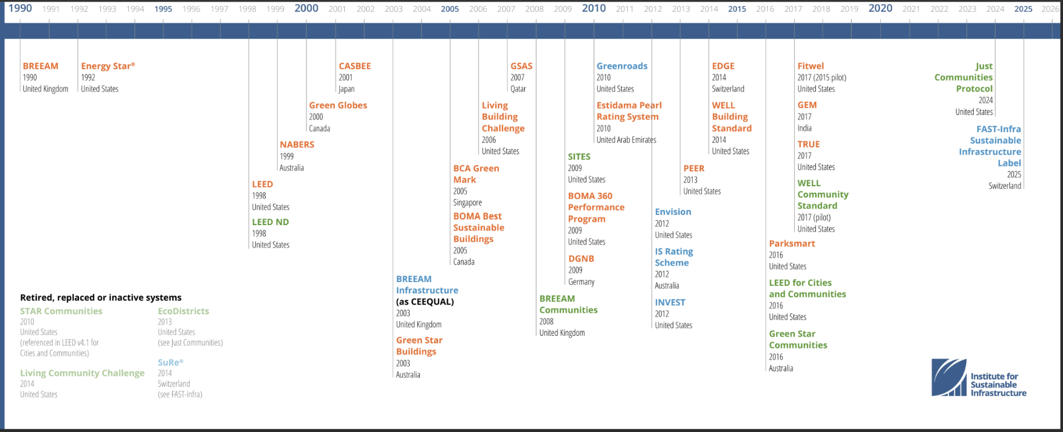

Appendix 2: Infrastructure Rating Systems Overview

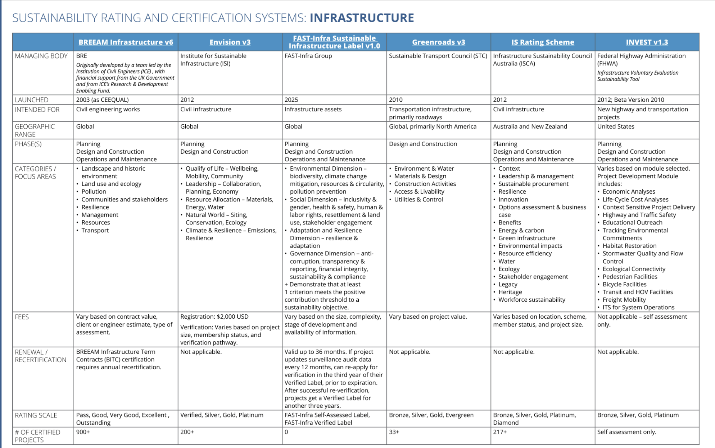

Appendix A: Participant Consent Form

Research Title: Analysis of Environmental, Social, and Governance (ESG) Barriers and Opportunities in Infrastructure Projects Using ISM–DEMATEL Approach

Researcher: Deema Rami Darwish
Institution: The British University in Dubai (BUiD)

- Invitation to Participate
You are hereby requested to participate in the above-mentioned study whose objective is to determine the main barriers and opportunities associated with (ESGs) in infrastructure project development within the Emirate of Abu Dhabi.
- Objective of the Research
This study seeks to determine the important aspects of ESGs as well as to determine relationships among various factors associated with ESGs. Professional opinions on such issues are much appreciated and helpful.
- Process of Participation
Participating in this study would entail attending an interview that would take about 45-60 minutes, although the time frame may differ depending on the extent of the conversation. Through the interview, the professional opinion of the respondent on the barriers and opportunities of implementing ESGs would be gathered.
- Data Anonymity and Confidentiality
Your answers and personal data in this study will remain anonymous. Although you will provide your name as part of the informed consent process, no personal identifiers like your name, the name of your firm, and your firm's specific procedures will be shared in any research findings, documents, or presentations derived from this study. Your participation will remain anonymous via the use of pseudonyms or by grouping data when necessary.
- Right to Withdraw and Participate Voluntarily
Your decision to participate in this research is absolutely voluntary. You are also free to withdraw from this research whenever you want and without any adverse consequences. If necessary, you may refuse answering some questions.
- Potential Risks and Rewards
There is no considerable risk involved in this research. The questions posed might deal with the problematic issues that you face as a professional, yet you can always avoid answering such questions if you find them challenging. Your participation will help conduct research contributing to the effective implementation of ESG in infrastructure projects.
- Storage of Data
Data that will be gathered will be stored in a password-protected machine and will be accessed by only the researcher. Data will be utilized strictly for academic use.
- Contact Information for Questions
Should you have any questions or issues regarding this study, your involvement in the study, or your rights as a participant, you are encouraged to freely contact the researcher, Deema Rami Darwish, by email or call.
- Consent Statement
I hereby state that:
- I have understood the details stated above.
- I have been given ample time to ask for clarification regarding the details.
- I fully realize that my participation is voluntary.
- I consent to join the study.

Participant Name: ___________________________
Signature: _________________________________
Date: _____________________________________

Researcher Name: Deema Rami Darwish
Signature: _________________________________
Date: _____________________________________

Appendix B: Expert Panel Roster
Table A1 lists the full realized expert panel (N = 27) whose responses underpin the Structural Self-Interaction Matrices, the Direct-Relation Matrices, and all subsequent analysis presented in Chapters 3 and 4. Years of experience and ESG reporting involvement are self-reported by each participant during the data collection process described in Section 3.5.

Table A1
Realized Expert Panel Roster (N = 27)
# | Group | Position | Yrs | ESG Involvement
1 | Government | Engineer, Department of Municipalities and Transport | 12 | Indirect
2 | Government | Infrastructure Policy Engineer, Urban Planning Council | 11 | Indirect
3 | Government | Principal Engineer, Government Sustainability Office | 21 | Indirect
4 | Government | Senior Civil Engineer, Government Public Works Authority | 11 | Indirect
5 | Government | Engineer, Department of Energy & Climate Change | 16 | Direct
6 | Government | Senior Infrastructure Engineer, Ministry of Energy & Infrastructure | 10 | Direct
7 | Government | Senior Project Engineer, Federal Infrastructure Authority | 13 | Direct
8 | Consultants | Senior Sustainability Engineer, International Consulting Firm | 19 | Direct
9 | Consultants | Associate Director, ESG Advisory Consulting | 22 | Direct
10 | Consultants | Principal Engineer-Consultant, Infrastructure Strategy Group | 22 | Direct
11 | Consultants | Lead Consultant, Environmental & Engineering Advisory | 21 | Direct
# | Group | Position | Yrs | ESG Involvement
13 | Consultants | Principal Consultant, Infrastructure Advisory Services | 12 | Direct
14 | Consultants | Senior Engineering Consultant, Infrastructure Practice | 22 | Direct
15 | Consultants | Senior ESG Consultant, Global Engineering Consultancy | 11 | Direct
16 | Contractors | Lead Engineer, Infrastructure Construction Group | 18 | Indirect
17 | Contractors | Project Engineer, Major Construction Contractor | 24 | Direct
18 | Contractors | Technical Director, Civil Engineering Contractor | 11 | Indirect
19 | Contractors | Senior Project Manager, General Contracting Company | 14 | Indirect
20 | Contractors | Construction Engineering Manager, Building Contractor | 19 | Direct
21 | Contractors | Senior Construction Manager, Civil Contracting Firm | 19 | Indirect
22 | Contractors | Senior Site Engineer, Infrastructure Contracting Company | 21 | Indirect
23 | Contractors | Senior Field Engineer, Infrastructure Contractor | 10 | Indirect
24 | Developers | Project Director, Infrastructure Development Firm | 22 | Direct
25 | Developers | Senior Development Engineer, Real Estate Development Company | 11 | Direct
26 | CSR Specialist | Senior CSR & Sustainability Specialist, Corporate ESG Office | 23 | Direct
27 | Academic | Associate Professor, Civil & Infrastructure Engineering | 16 | Indirect

Note. 'Direct' involvement denotes participants whose role directly entails preparing, reviewing, or approving ESG reporting or compliance submissions; 'Indirect' denotes participants whose role is subject to ESG requirements set by others.

Appendix C: SmartISM Independent Validation Output
As described in Section 3.7, the ISM results reported in Chapter 4 were independently reproduced using the peer-reviewed SmartISM tool (Ahmad & Qahmash, 2021), run separately for the all-groups panel and for each of the six stakeholder groups, for both the barriers and the opportunities datasets - fourteen runs in total. Figures B1-B14 reproduce every SmartISM output screen, each showing the Structural Self-Interaction Matrix, the Reachability Matrix, and the Final Reachability Matrix with driving and dependence power, computed entirely independently of the Excel workbook used elsewhere in this dissertation. The hierarchy levels and quadrant classifications obtained from this independent tool matched those reported in Chapter 4 exactly, for every group and for both datasets.

Figure B1
SmartISM Output – Barriers, All Groups (n = 27)


Figure B2
SmartISM Output – Barriers, Government (n = 7)


Figure B3
SmartISM Output – Barriers, Consultants (n = 8)


Figure B4
SmartISM Output – Barriers, Contractors (n = 8)


Figure B5
SmartISM Output – Barriers, Developers (n = 2)


Figure B6
SmartISM Output – Barriers, CSR Specialist (n = 1)
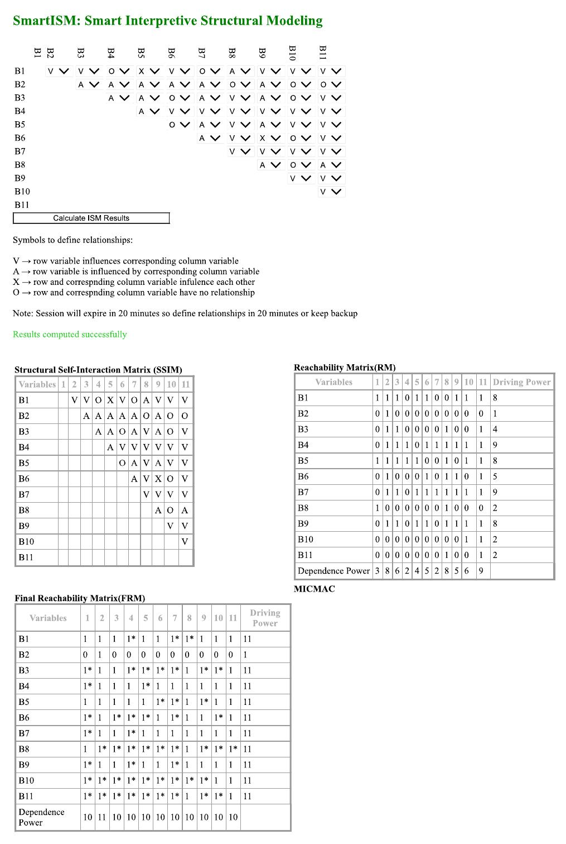

Figure B7
SmartISM Output – Barriers, Academic (n = 1)
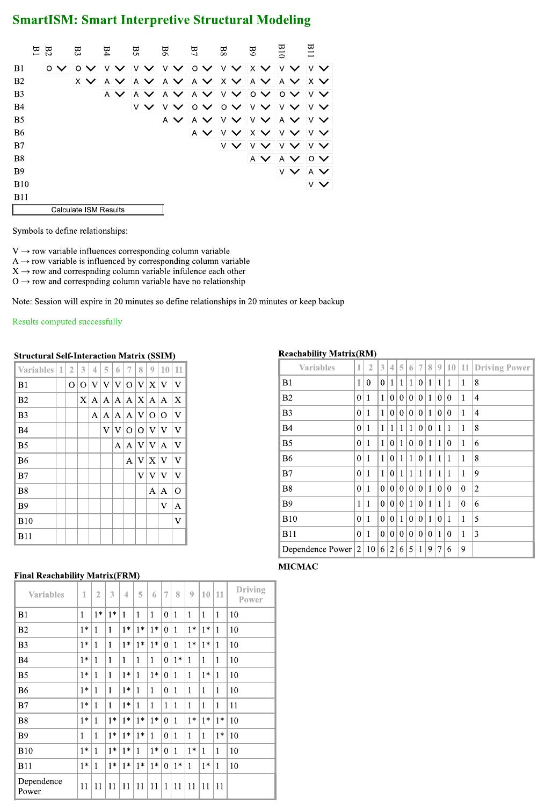

Figure B8
SmartISM Output – Opportunities, All Groups (n = 27)
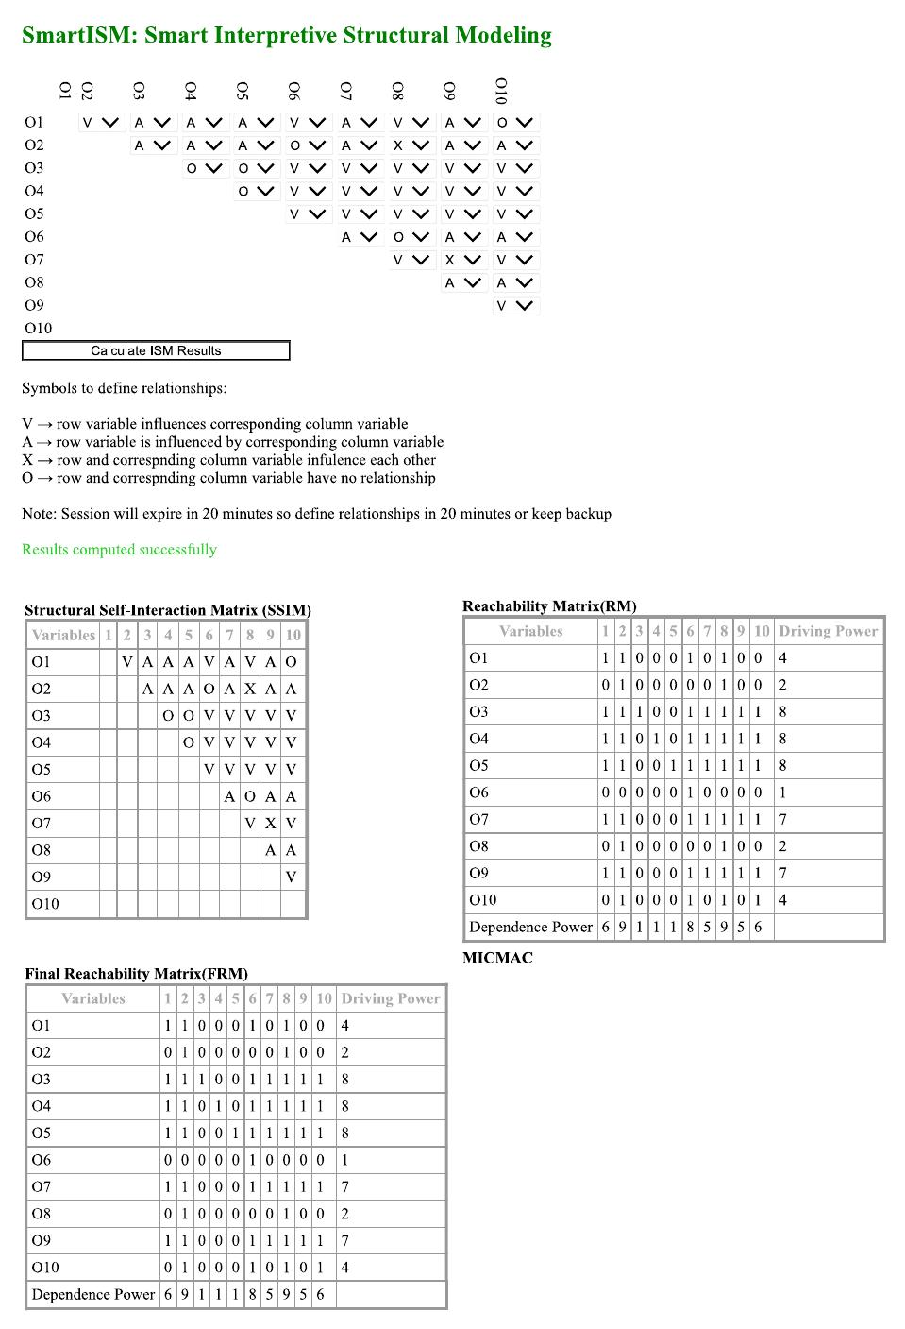

Figure B9
SmartISM Output – Opportunities, Government (n = 7)
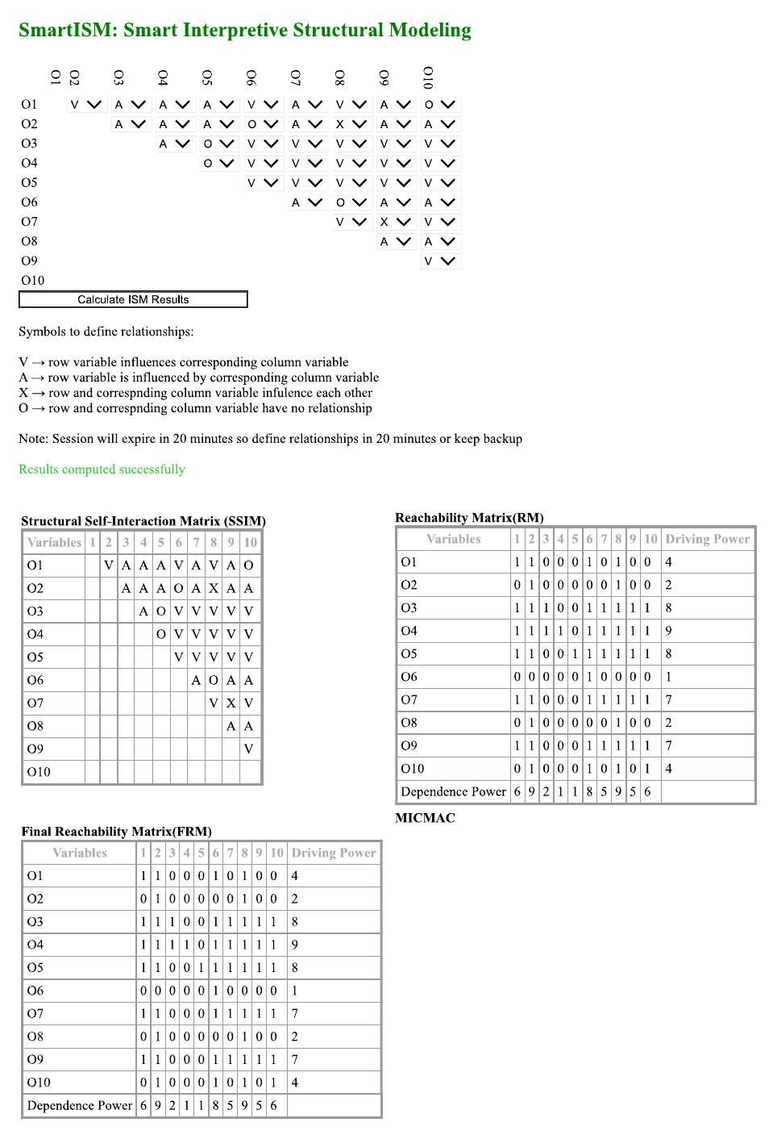

Figure B10
SmartISM Output – Opportunities, Consultants (n = 8)
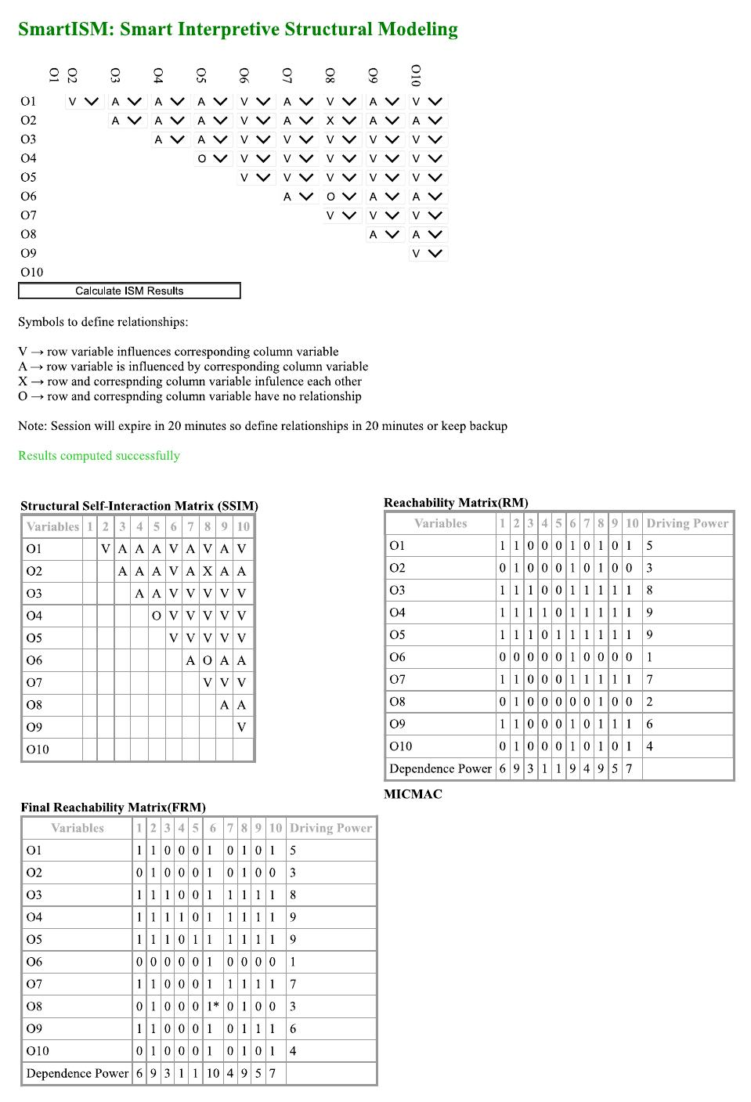

Figure B11
SmartISM Output – Opportunities, Contractors (n = 8)
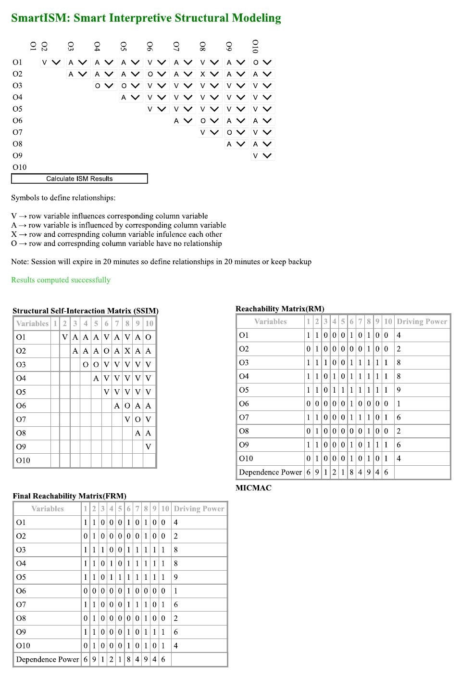

Figure B12
SmartISM Output – Opportunities, Developers (n = 2)
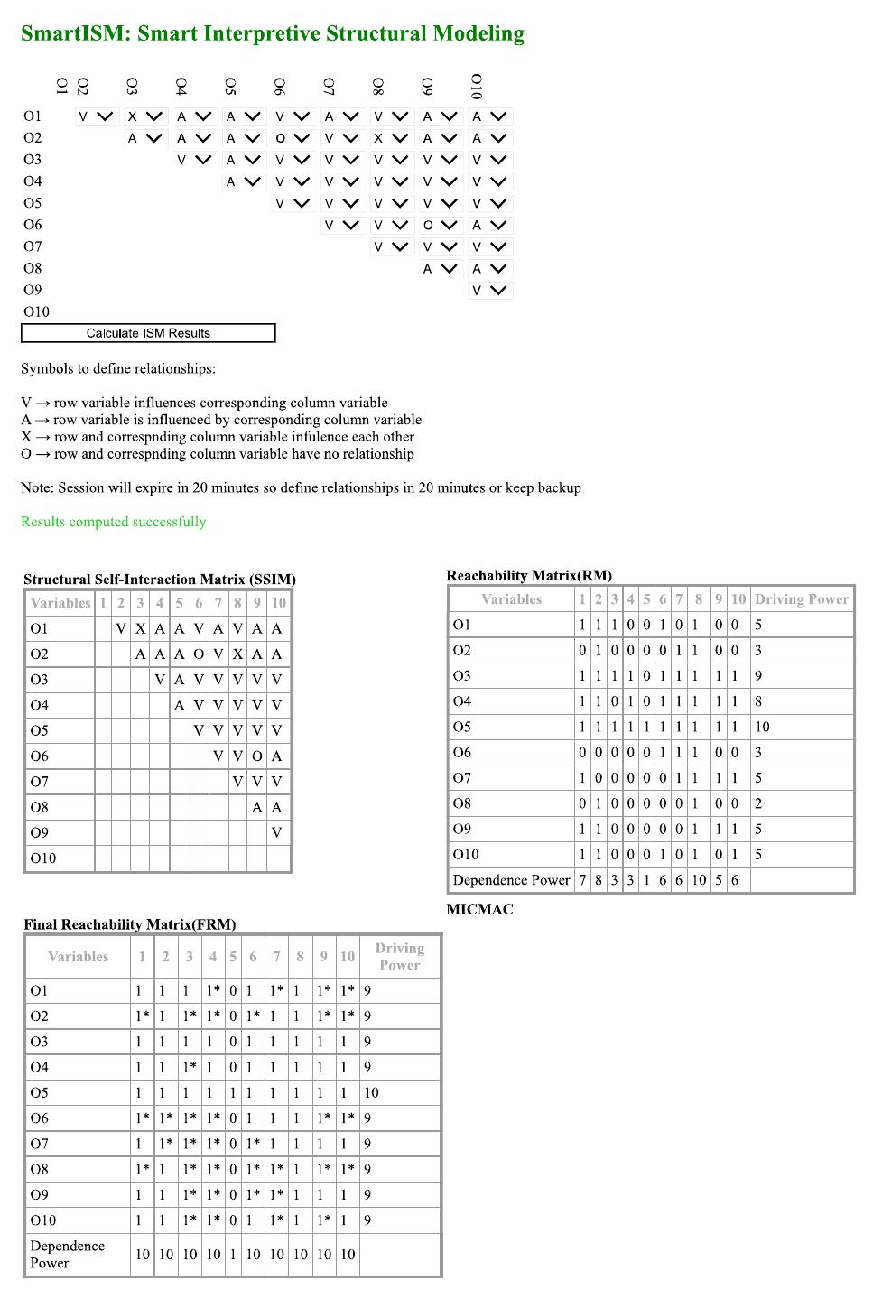

Figure B13
SmartISM Output – Opportunities, CSR Specialist (n = 1)
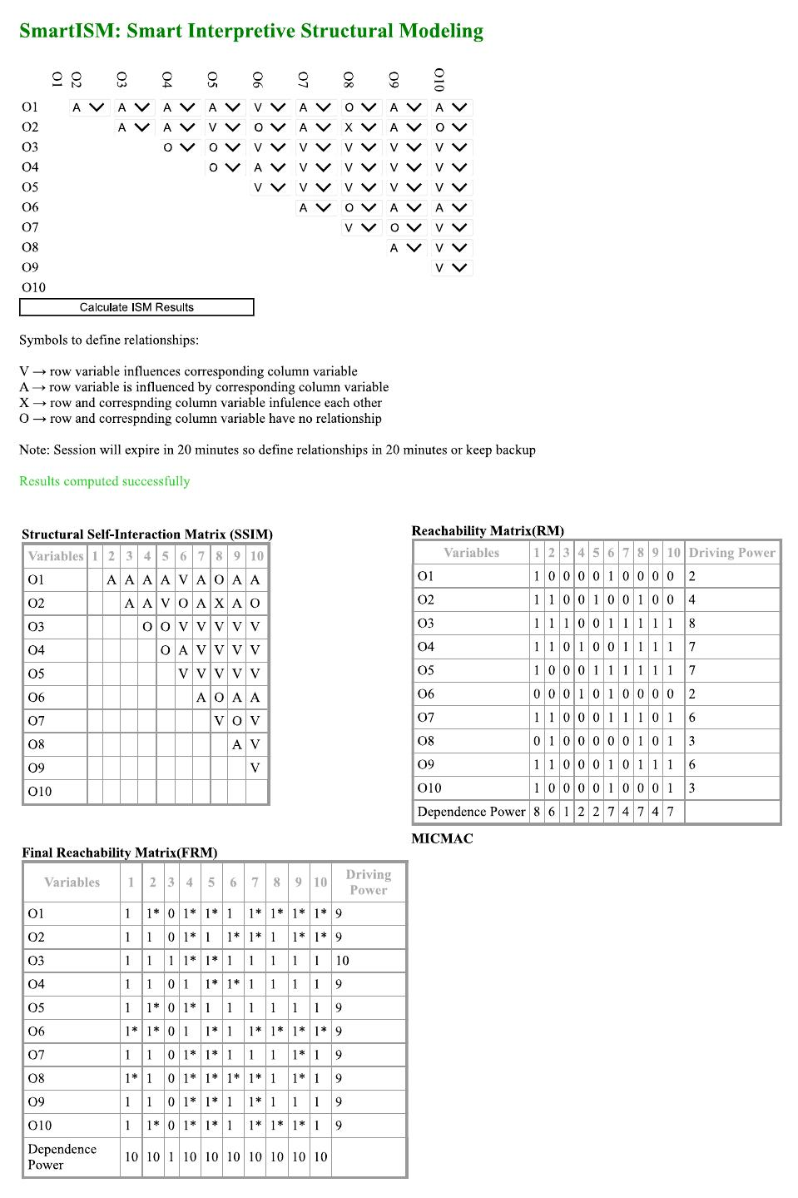

Figure B14
SmartISM Output – Opportunities, Academic (n = 1)
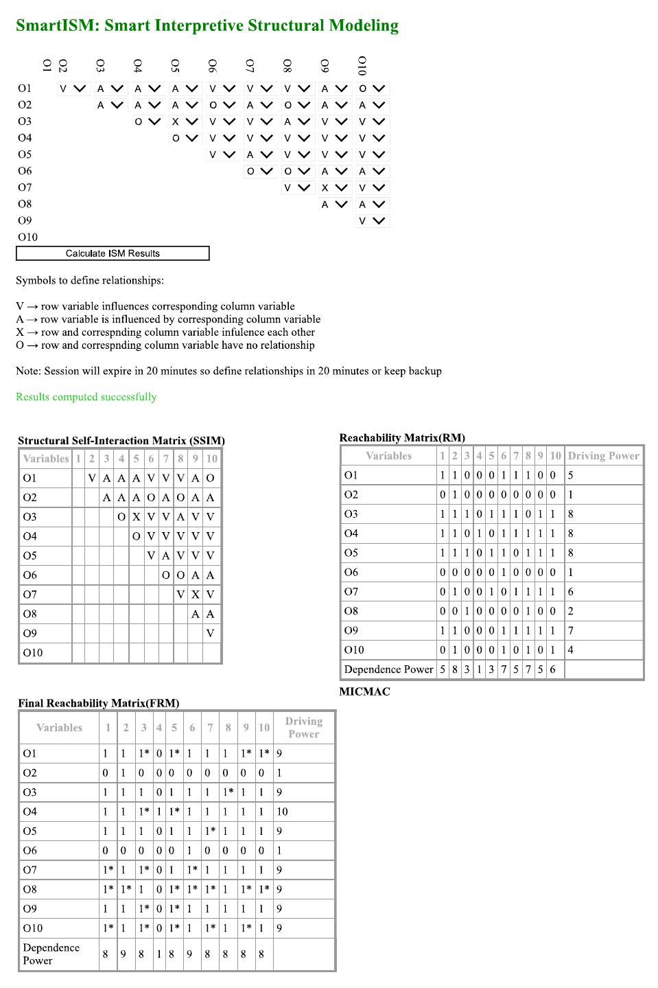

Appendix D: Supplementary Per-Group DEMATEL Results
Tables C1 and C2 report the full DEMATEL Relation (D-R) score for every barrier and opportunity, computed independently for each of the six stakeholder groups, underlying the summary comparisons presented in Section 4.5 and Section 4.10.
Table C1
DEMATEL Relation (D-R) by Barrier and Stakeholder Group
ID | All | Govt | Cons | Cont | Dev | CSR | Acad
B1 | +1.51 | +1.59 | +1.48 | +1.30 | +1.29 | +1.10 | +1.09
B2 | -1.63 | -1.65 | -1.35 | -1.55 | -1.58 | -1.69 | -1.51
B3 | -0.57 | -0.38 | -0.68 | -0.54 | -0.64 | -0.32 | -0.42
B4 | +1.52 | +1.44 | +1.36 | +1.43 | +1.54 | +1.06 | +1.83
B5 | +0.50 | +0.26 | +0.61 | +0.39 | +0.97 | +0.21 | +0.52
B6 | +0.46 | +0.27 | +0.15 | +0.88 | +0.47 | +0.35 | +0.27
B7 | +1.31 | +1.08 | +1.39 | +1.08 | +1.48 | +1.36 | +1.32
B8 | -1.53 | -1.47 | -1.42 | -1.46 | -1.67 | -1.01 | -1.02
B9 | +0.55 | +0.40 | +0.38 | +0.77 | +0.43 | +0.60 | +0.42
B10 | -0.55 | -0.43 | -0.38 | -0.66 | -0.63 | -0.43 | -0.94
B11 | -1.56 | -1.11 | -1.55 | -1.64 | -1.65 | -1.23 | -1.55

Table C2
DEMATEL Relation (D-R) by Opportunity and Stakeholder Group
ID | All | Govt | Cons | Cont | Dev | CSR | Acad
O1 | -0.56 | -0.45 | -0.60 | -0.51 | -0.61 | -0.62 | -0.05
O2 | -1.57 | -1.49 | -1.46 | -1.54 | -1.21 | -1.20 | -1.18
O3 | +1.60 | +1.49 | +1.43 | +1.56 | +1.62 | +1.58 | +1.00
O4 | +1.53 | +1.38 | +1.58 | +1.31 | +1.30 | +1.31 | +1.45
O5 | +1.44 | +1.30 | +1.19 | +1.52 | +1.52 | +1.30 | +0.90
O6 | -1.42 | -1.35 | -1.13 | -1.49 | -1.38 | -1.29 | -0.99
O7 | +0.54 | +0.56 | +0.35 | +0.69 | +0.43 | +0.36 | +0.23
O8 | -1.58 | -1.47 | -1.45 | -1.56 | -1.40 | -1.13 | -1.18
O9 | +0.61 | +0.64 | +0.61 | +0.67 | +0.07 | +0.43 | +0.22
O10 | -0.62 | -0.61 | -0.51 | -0.66 | -0.34 | -0.72 | -0.39

Note. Values are D-R (Relation) scores; positive values (+) indicate a net causal factor and negative values (-) indicate a net effect factor within each group's independently-computed Total-Relation Matrix. Govt = Government; Cons = Consultants; Cont = Contractors; Dev = Developers; CSR = CSR Specialist; Acad = Academic

